Geology of the Archeological Hills and Monuments, Examples from Iraq
Varoujan K. Sissakian, Ayda D. Abdul Ahad, Nadhir Al-Ansari³and Sven Knutsson

Abstract
Iraq is the cradle of many civilizations; therefore, it is very rich in archeological sites, which are represented in different forms; among them are the archeological hills and monuments. Hundreds of archeological hills and monuments are located in different parts of Iraq, but the majority of the hills are located in the Mesopotamia and Low Mountainous Province; with less abundant in the Jazira Province. The isolated archeological hills are of two different forms: Either are in form of dumping soil to a certain height to build the hill, or has gained their heights due to the presence of multi stories of civilizations. In both cases, the geological setting has played a big role in the formation of the isolated archeological hills. The archeological isolated hills, which are built by soil dumping are usually of conical shape; flat topped and limited sizes; with heights not more than 10 m and base diameter of (20 – 100) m. They can be seen from far distances that attain to few kilometers. Since they are usually built in flat areas and are believed to be used as watching towers. However, those which are present in the Mesopotamia Province are smaller in size; not more than (3 – 5) m in height and about 10 m in base diameter; also with conical shape, they are called as "Ishan". The isolated archeological sites, which are built by multi stories, are either in form of citadels (castles) like Arbeel and Kirkuk castles, or built as a certain form and used for religious purposes; called "Zaqoorah", like Aqarqoof and Ur Zaqooras. Tens of monuments were discovered in different parts of Iraq witnessing different civilizations. Some of the monuments are built and/ or sculptured from rocks. Usually, the nearby exposed rocks were used; however, locally rocks were transported from few tens of kilometers. The most common used rocks are gypsum and limestone; however, very rarely basalt was used too. In certain locations, the geology of the quarried rocks is given too.
Keywords: Hills, monuments, Archeology, Iraq

- Introduction
Iraq is the cradle of many ancient civilizations; therefore, it is very rich in ancient archeological sites. Some of them are in form of castles, monuments, isolated hills. Depending on the geology of the area, the type of the exposed rocks and/ or the present soil type, the ancient people have used different rock types and soils for building their cities, homes, monuments, statues…. etc.
The most used rocks are limestone and gypsum; however, basalt was used too in very rare cases. Moreover, soil also was used either in form of bricks or by dumping to construct their sites.
Although Iraq is very rich in archeological sites, but involved geological studies in which the used rock types are very rare; if not totally absent. However, [1-6] presented some archeological sites in the compiled geological maps. Larsen and Evans [7] also reported about some archeological sites in the Mesopotamia Plain. Sissakian et al. [8] reported about Sha'nider cave in Bradost Mountain; NW of Rawandooz city, referring to Wright [9] in detecting the age of the found skeletons and bones, which belong to Neanderthal man. Sissakian et al. [10] presented many isolated archeological hills in different parts of Iraq.
In this research, all important archeological sites were investigated and their geology described in details.
- Materials and Methods
In order to achieve the main aim of this study, which is to discuss and describe the geology of these hills, available topographical and geological maps of different scales and Google Earth images were used. The geological maps with the Google Earth and Satellite images were used to recognize the main archeological sites. Different geological maps at scale 1:250,000 were reviewed to observe the type of the exposed rocks and/ or soil types in the sites. Moreover, some scientific and historical books were reviewed too. In addition, data acquired during field work in different parts of Iraq for the period 1984 – 2012 were also used as well as reviewing articles and historical books relevant to these sites.
- Archeological Sites
Hundreds of archeological sites occur in different parts of Iraq. In order to describe examples from different parts and types, the physiographic provinces in Iraq are considered, and few examples are selected from each province.

3.1 Mesopotamia Province
This is the richest province from archeological point of view, since many civilizations were created there. Tens of monuments, castles, statues, isolated hills and "ziqqurat"s witness for that. Since there is no exposed rocks in this province; therefore, all archeological sites were built from bricks, although locally, tar and/ or tree leaves were used with the bricks. Many examples are given hereinafter.

-Babylon:Babylon was originally a small Semitic Akkadian city dating from the period of the Akkadian Empire circa 2300 BC. Hammurabi created the first short lived Babylonian Empire in the 18th century BC. Babylon grew and South Mesopotamia came to be known as Babylonia (Fig.1). It is located about 85 km south of Baghdad.

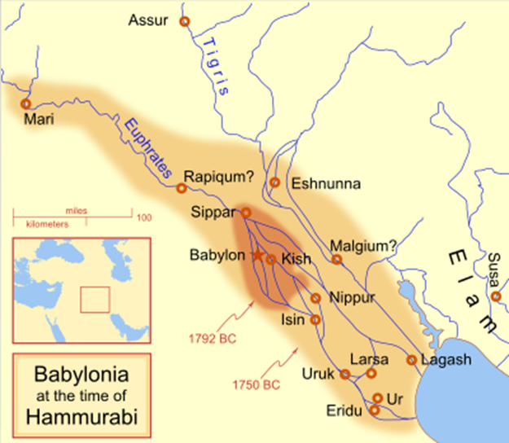
Fig.1: Babylonia at the time of Hammurabi.

The city is built by bricks (Fig.2); dried under sun's heat; however, locally tar was used for enforcement. Most probably, the tar was brought from Heet, which is the nearest locality where tar is available. Therefore, the remnants of the city are almost vanished due to weathering and erosion processes. However, the Ishtar Gate is almost still keeping its original shape with ornamentation (Fig.2 Right), the glazing and used colours are of unknown origin.
The site at Babylon; nowadays, consists of a number of mounds covering an area of about (2 X 1) km, oriented north to south, with the Euphrates River to the west. Originally, the river roughly bisected the city, but the course of the river has since shifted so that much of the remains of the former western part of the city are now inundated. Some portions of the city wall to the west of the river also remain. The shifting of the river course can be obviously seen in Landsat images.
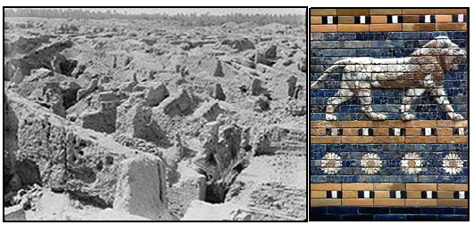

Fig.2: Left) Remnants of the city, which was built by bricks. Right) Ishtar Gate, note the glazing and color ornamentation.

The remains of the city include:
- Kasr, also called Palace or Castle; it is the location of the Neo-Babylonian ziggurat Etemenanki and lies in the centre of the site.
- Amran Ibn Ali, the highest of the mounds at 25 m, to the south. It is the site of Esagila, a temple of Marduk, which also contained shrines to Ea and Nabu.
- Homera, a reddish coloured mound on the west side. Most of the Hellenistic remains are here.
- Babil, a mound about 22 m high at the northern end of the site. Its bricks have been subject to looting since ancient times. It held a palace built by Nebuchadnezzar.

The water table in the region has risen greatly over the centuries and artefacts from the time before the Neo-Babylonian Empire are unavailable to current standard archaeological methods. Additionally, the Neo-Babylonians conducted significant rebuilding projects in the city, which destroyed or obscured much of the earlier record. Babylon was pillaged numerous times after revolting against foreign rule, most notably by the Hittites and Elamites in the 2nd millennium, then by the Neo-Assyrian Empire and the Achaemenid Empire in the 1st millennium. Much of the western half of the city is now beneath the river, and other parts of the site have been mined for commercial building materials.
- Ur
Ur was an important Sumerian city-state in ancient Mesopotamia, located at the site of modern Tell el-Muqayyar in south Iraq's Dhi Qar Governorate. Although Ur was once a coastal city near the mouth of the Euphrates on the Arabian Gulf, the coastline has shifted and the city is now well inland, south of the Euphrates on its right bank, 16 km from Nasiriyah.

The city dates from the Ubaid Period circa 3800 BC, and is recorded in written history as a City State from the 26th century BC, its first recorded king being Mesh-Ane-pada. The city's patron deity was Nanna (in Akkadian, Sin), the Sumerian and Akkadian (Assyrian-Babylonian) moon god, and the name of the city is in origin derived from the god's name, URIM. It is one of the oldest cities in Mesopotamia; it was an important centre of Sumerian culture after circa 3000 BC and is mentioned in the Bible as the birthplace of Abraham. The city declined after the sixth century BC.

Though some of the areas that were cleared during modern excavations have sanded over again, the Great Ziggurat (Fig.3) is fully cleared and stands as the best-preserved and most visible landmark at the site. The famous Royal tombs, also called the Neo-Sumerian Mausolea, located about 250 m southeast of the Great Ziggurat in the corner of the wall that surrounds the city, are nearly totally cleared. Parts of the tomb area appear to be in need of structural consolidation or stabilization [11]. This is attributed to the used materials in building, which were clayey bricks; dried by Sun heat. The clayey brick, which is silty was certainly quarried from the flood plain of the Euphrates River was the only available building material there, although limestone beds of different formations (Dammam and Euphrates) are exposed south of Ur about (25 – 45) km [12].

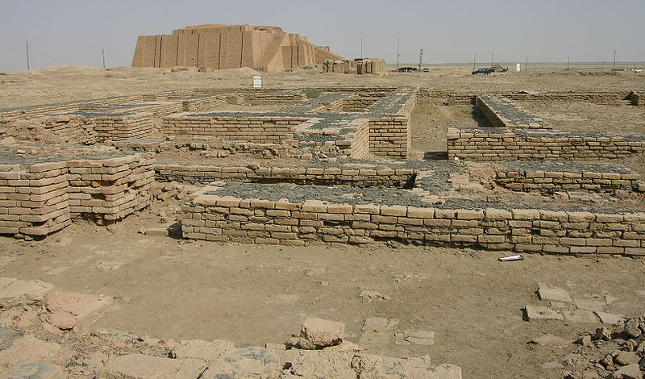

Fig.3: The Ziqurrat of Ur; at the back ground and the excavated part of the city.

Evidence of a flood was also discovered in the ruins of the city, leading some to believe that it may have been the origin of flood legends from throughout the region, including the story of the Great Flood contained in the Biblical book of Genesis. However, most archaeologists doubt that this could have imprinted so heavily on the region's literature, as the flood was probably not all that large, and small floods around the Euphrates were likely not that uncommon.

After the Chaldean dynasty was established in Babylonia, King Nebuchadnezzar II initiated a new period of building activity at Ur. The last Babylonian king, Nabonidus (reigned 556 – 539 BC), embellished the temples and entirely remodelled the Ziggurat of Nanna increasing its height to 7 stages, making it rival even the temple of Marduk at Babylon. After Babylonia came under the control of Persia, Ur began to decline. By the 4th century BC, the city was practically forgotten, possibly as a result of a shift in the course of the Euphrates River. Moreover, because the all constructions were built by clayey bricks, which have very low resistance to weathering and erosional processes (Fig.4).

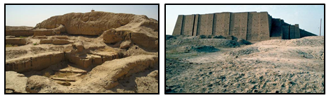

Fig.4: Left) Excavated part of Ur, note the clayey bricks, which are already weatherd. Right) Rebuilt part of the Zigurrat

- Ctesiphon
Ctesiphon also known as "Taq-i Kisra or Taq Kasra" and also called "Ivān-e Kisrā" and "Eyvān-e Kasra" is a Sassanid-era Persian monument in Al-Mada'in, which is the only visible remaining structure of the ancient city of Ctesiphon. It is the largest brick built arch in the world [13] and located near the modern town of Salman Pak, which is about 45 km SE of Baghdad, Iraq. Construction began during the reign of Khosrau; after a campaign against the Byzantines in 540 AD. The arched iwan hall, open on the facade side, was about 37 m high; 26 m across and 50 m long, the largest vault ever constructed at the time (Fig.5).

The arch was part of the imperial palace complex. The throne room; presumably under or behind the arch was more than 30 m high and covered an area of 24 m wide by 48 m long. The top of the arch is about 1 m thick, while the walls at the base are up to 7 m thick [14]. It is the largest vault ever constructed in the world. The inverse catenary arch was built without centering. In order to make this possible a number of techniques were used. The bricks were laid about 18 degrees from the vertical which allowed them to be partially supported by the rear wall during construction. The quick drying cement used as mortar allowed the fresh bricks to be quickly supported by those that were previously laid [14]. The Taq-i Kisra is now all that remains above ground of a city that was, for seven centuries; from the 2nd century BC to the 7th century AD; the main capital of the Iranian successor dynasties of the Seleucids, the Parthians and Sassanids. The structure; however, started to collapse; part after part and the majority of the arc is now collapse down (Fig. 6), due to weathering and erosional processes that attack the clayey bricks, which are from clays silt, as the only available building material in nearby areas; quarried from the flood plain sediments of the Tigris River.
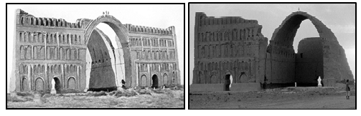
Fig.5: Left) Remains of the White Palace at Ctesiphon, Iraq, with the famous Arch of Ctesiphon, taken in 1864, before the collapse of the right-hand façade.
Right) The ruins of Ctesiphon, note the difference between the remains of the arch
- Ishan
Ishans are small isolated hills located densely in the Mesopotamia Plain; representing archeological sites. Most probably, the word "ishan" is the same as 'ivan" or "eyvan" from the Persian language; as referring to "ivan" like "Ivan-i- Kisra". They are scarcely covered by pottery, brick fragments and other artefact remains; witnessing being archeological sites in ancient dynasties. "Ishan" is a local term used in the Mesopotamia Plain only; by the local people, and have either geographical or personal names. Now, they are not more than (3 – 6) m high; having conical shape. The slopes are smoothed due to water and wind erosion. Nowadays, all those hills form well-standing elevated areas in vast plain of the Mesopotamia; therefore, some of them are used as triangulation points of different orders in the topographical maps (Fig.7).

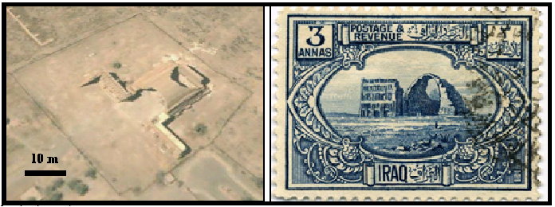

Fig.6: Left) Google Earth image of the Cestaisaphon (2002). Note the cloopased arch from both sides. Right) Iraqi postage stamp, featuring the arch (1923)

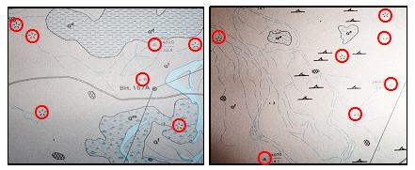

Figure 7: Parts of geological maps; scale 1:250 000 Left) Sooq Al-Shiyookh Quadrangle (After [15], Right) Al-Nasiriyah Quadrangle (After [16]). Note the encircled Ishans (in red)
3.2 Low Mountainous Province
This province is also very rich in archeological sites in form of castles and/ or isolated hills, since many civilizations were created there, among them the oldest and most widely spread was the Assyrian. Tens of monuments, castles, statues, and isolated hills witness for that. Since this province includes different types of exposed rocks; therefore, all archeological sites were built from rocks, like limestone and gypsum. Many examples are given hereinafter.

- Erbil
Also called Arbi or Erbeel, it is now the capital of the Kurdistan Region; it is located 350 km NW of Baghdad. The citadel is located in the center of Erbil city, with coordinates 36.191° N and 44.009° E. It is assigned by the UNESCO as World Heritage Site; Official name is Erbil Citadel, cultural type, designated in 2014, reference No. 1437 at Iraq in the Middle East. The built is unknown; however, the earliest evidence for occupation of the citadel mound dates to the 5th millennium BC, and possibly earlier. It appears for the first time in historical sources during the Ur III Period, and gained particular importance during the Neo-Assyrian period. West of the citadel at Ary Kon quarter, a chamber tomb dating to the Neo-Assyrian period has been excavated [17]. During the Sassanian period and the Abbasid Caliphate, Erbil was an important center for Christianity and the Assyrians. After the Mongols captured the citadel in 1258, Erbil's importance began to decline.

The Erbil Citadel is a hill or occupied mound, and the historical city center of Erbeel city. It has been claimed that the site is the oldest continuously inhabited town in the world [18]. The citadel has been inscribed on the World Heritage List since 21 June 2014. The earliest evidence for occupation of the citadel mound dates to the 5th millennium BC, and possibly earlier. It appears for the first time in historical sources in the Ebla tablets around 2,300 BC, and gained particular importance during the Neo-Assyrian Period. During the Sassanian period and the Abbasid Caliphate, Erbil was an important center for Christianity. After the Mongols captured the citadel in 1258, the importance of Erbil declined. Since 2007, archaeological research and restoration works have been carried out at and around the tell by various international teams and in cooperation with local specialists.

The buildings on top of the tell stretch over a roughly oval area of (430 X 340) m; occupying 102,000 m². The mound rises between 25 and 32 m from the surrounding plain (Fig.8). The mound consists mainly of loam, clay bricks and small stone blocks can be seen with the loam, which may indicate historical buildings. The mound is in a plain covered by loam or clayey soil [5,12], which is used to build up the mound. It is surrounded by a steep earthen mound in all directions, which made it very difficult for any attacker to scale it. The houses that are built on the perimeter are contiguous and form a solid wall very similar to fortified citadels of medieval times (Fig.9).

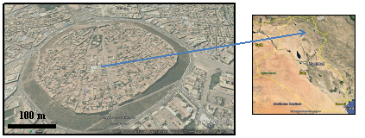

Fig.8: Google Earth image of Erbil citadel

There are several conjectural possibilities as how Erbil citadel originated and developed to its present form, these are [19]:
1- Gradual Accumulation: The mound represents gradual accumulation of historical settlement layers rising slowly to reach to its present height, which is about 30 m. If the age is assumed to be 6000 years, then this means the mound was rising 1 m per every 200 years. Although this rate is very slow, but it is reasonable when compared with archeological evidences.

2- Assyrian Settlement: It may have been Assyrian settlement with "ziqqurat" in the middle surrounded by temples. And when was destroyed and abandoned, it returned to heap of ruins. Then a later stage, it compacted and presented itself as a very useful "tell" and defensible ground for human habitation.

3- Man-made Mound: The mound was artificially created by people who desired to live in this fertile land, but needed to fortified site.
The author; however, believes that the first possibility is the most likely.
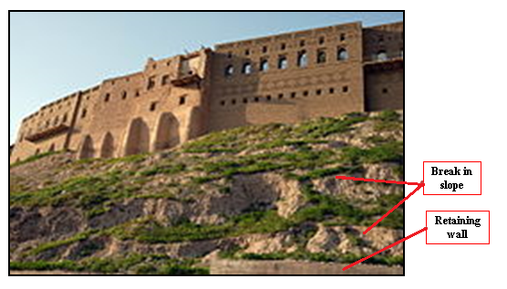
Fig.9: Houses built on the perimeter form a solid wall very similar to fortified citadels of medieval times. Note the recent break in the slopes due to cut of the slopes for road construction purposes, also note part of retaining wall in the lower left corner.

- Kirkuk Citadel
Kirkuk is a city in the north of Iraq, 236 km north of, Baghdad; it is the capital of Kirkuk Governorate. The city sits on the site of the ancient Hurrian southern capital of Arrapha [20,21], which sits near the Khasa River on the ruins of a 5,000-year-old settlement (Kirkuk Citadel) (Fig.10). It became known as Arrapha under the domination of the Hurrians. Ancient Arrapkha was then part of Sargon of Akkad's Empire [20]

The city reached great importance again under the later, but short-lived Assyrians in the 10th and 11th centuries BC. Because of the strategic geographical location of the city, Kirkuk was the battle ground for three empires; the Neo-Assyrian Empire, Babylonia, and Media, which controlled the city at various times.

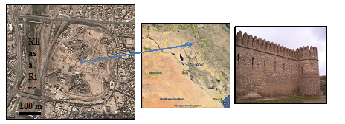

Fig.10: Left) Google Earth image of Kirkuk citadel,
Right) Part of the wall of the citadel

The citadel stands on an artificial mound 35 m high located on a plateau across the Khasa River (Fig.11, left). The mound, or tell, is believed to have been built by King Ashurnasirpal II between 884 and 858 BCE as a military defense line of Arrapha. Later King Sluks [22] built a strong rampart with 72 towers around the 72 streets and the two entries to the citadel (Fig.11, Right). A jewel of the citadel is the so-called "Red Church", with traces of pre-Muslim mosaics. It is believed that Timur visited the citadel in 1393 during his military expedition. The modern walls (Fig.11, Left) go back to the Ottoman period.
Kirkuk Citadel is built on an area covered by the Fatha Formation (Middle Miocene), which consists of cyclic deposits, each cycle includes marl, reddish brown claystone, limestone and gypsum [6,12]. Therefore, the main used building stone is the gypsum (Fig.12), which forms one of the main lithological constituents of the Fatha Formation. The cementing material is also extracted from gypsum; as Paris Plaster by burning and crushing of the gypsum to powder (Fig.11, Left). The limestone is rarely used because the beds are thin. However, the mound is built by gradual accumulation of historical settlement layers rising to its present height, as it is the case of Erbil Citadel (Fig.11, Left).
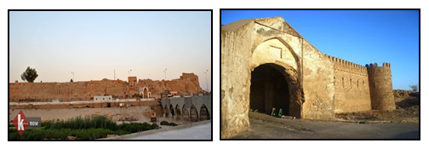
Fig.11) Left) A view of Kirkuk Citadel; near Kassa River,
Right) Kirkuk Citadel Entrance and part of the renewed wall
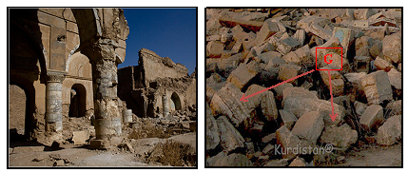

Fig.12: Left) A ruined Chaldean church, on Kirkuk’s Citadel, note the pillars are made of nodular and banded gypsum, Right) Banded gypsum blocks (G) used in ancient buildings, which are collapsed now.

- Hatra
Hatra (in Arabic language is known as al-Hadr, a name which appears once in ancient inscriptions, and it was in the ancient Persian province of Khvarvaran. The city lies 290 km northwest of Baghdad and 110 km southwest of Mosul. Hatra was probably built in the 3rd or 2nd century BC by the Seleucid Empire. After its capture by the Parthian Empire, it flourished during the 1st and 2nd centuries AD as a religious and trading center. Later on, the city became the capital of possibly the first Arab Kingdom in the chain of Arab cities running from Hatra, in the northeast, via Palmyra, Baalbek and Petra, in the southwest. In 1985 Hatra was designated a UNESCO World Heritage site

Hatra became an important fortified frontier city (Fig.13) and was the best preserved and most informative example of a Parthian city. It was encircled by inner and outer walls (Fig.13, Right) nearly 6 km in circumference and supported by more than 160 towers. The temples covered some 1.2 hectares and were dominated by the Great Temple, an enormous structure with vaults and columns that once rose to 30 m (Fig.14), all constructed by limestone, which was quarried from the Fatha Formation.
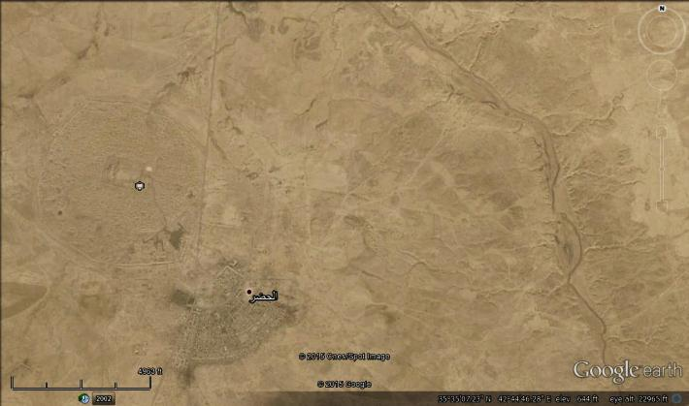
Hatra
Al-Tharthar valley

Fig.13: Google Earth image, Up) Hatra city and Al-Tharthar valley, Right) Details of Hatra city.
The entire city of Hatra was constructed from limestone, which was quarried from Al-Tharthar valley, the remnants of the quarried limestone is still noticeable in the valley; east of the city [23] (Fig.13). The limestone is quarried from the Fatha Formation (Middle Miocene), which is widely exposed in Hatra vicinity, as well in Al-Tharthar valley [2,12]. The Fatha Formation includes limestone beds that are not more 1 m in thickness; therefore, in all constructed columns, walls (Fig.14) and statues (Fig.15) the used partitions are clearly seen, which are less than 1 m in thickness.

The location of Hatra city near to Al-Tharthar valley may also confirm that the valley was originally the course of ancient Hurmas River [24,25,26,27], which was crossing Sinjar Mountain, flowing NE ward and merging with Tigris River near the location of nowadays Tikrit city. The Hatra city should has a source for water supply that was Al-Tharthar valley, which was a flowing stream; otherwise what was the source of the water in domestic uses for the people, although there are many hand dug water wells inside the ancient city and are still visible, but the water is undrinkable; due to the dissolved salts that originate from the widely exposed gypsum rocks within the Fatha Formation.

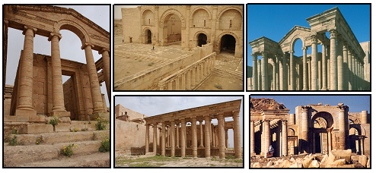

Fig.14: Different parts of Hatra city. Note that all columns, walls, floor tiles
are constructed from limestone

The collapse of Hatra city in 241 according to the traditional stories was by Sassanid Empire of Shapur I; however, according to [28], Hatra city was destroyed by earthquake. It is worth mentioning that ISIS bulldozed the ruins of Hatra on 07 March, 2015.
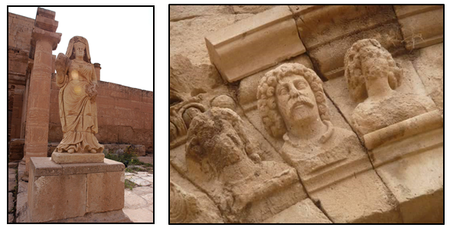

Fig.15: Left) The statue of the Queen, note the thickness of the individual partition, which represents individual bedding of the limestone,
Right) Heads of men sculptured from single bed of limestone.

- Nimrud
Nimrud is the later Arab name for an ancient Assyrian city located 30 km south of the city of Mosul, in the Nineveh plains in northern Mesopotamia. It was a major Assyrian city between about 1250 BC and 610 BC (Fig.16). The city is located in a strategic position 10 km north of the point that the river Tigris meets its tributary the Great Zab. The city covered an area of 360 hectares (890 acres).

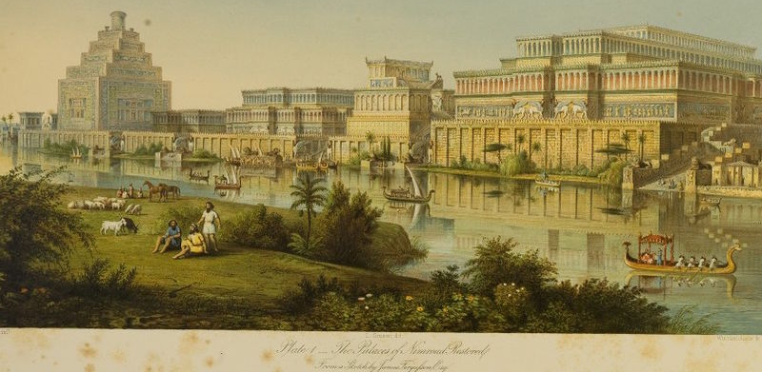

Fig.16: The Palaces at Nimrud Restored, 1853, imagined by the city's first excavator, Austen Henry Layard and architectural historian James Fergusson
Archaeological excavations at the site began in 1845, and were conducted at intervals between then and 1879, and then from 1949 onwards (Fig.17, Left). Many important pieces were discovered, with most being moved to museums in Iraq and abroad. Among the most common pieces are the "Lamassus" (Fig.17), which are sculptured from gypsum. In Arabic it is called "Al-Thour Al-Mujan'nah", which means the "winged bull".
The used gypsum (Fig.18) in sculpturing of the "lamassues" is quarried from the Fatha Formation. From the geological mapping of Mosul vicinity [2, thick gypsum beds occur only in the informal unit called "Unit B" introduced by Al-Mubarak and Youkhanna [29]. The thickness of the gypsum beds reaches up to 17 m, whereas the thickness of the individual beds range from (1 – 5) m [31].The excavation of the "lamassu" in the 18th Century is presented by two drawings (Fig.19), which indicate that very hard work was carried out to excavate and transport the "lamassues", by removing the overburden thick soil deposits and then to transfer them since the weight of each is about (20 – 40) tons [32].
- (Dur-SHARRUKIN) Khorsabad
Dur-Sharrukin the Fortress of Sargon, present day Khorsabad, was the Assyrian capital in the time of Sargon II of Assyria. Khorsabad is a village in northern Iraq, 15 km northeast of Mosul (Fig.20). The great city was entirely built in the decade preceding 717 – 707 BCE [33]. After the unexpected death of Sargon in battle, the capital was shifted 20 km south to Nineveh, which is Nimrud. Khorsabad was abandoned after his death in 705 B.C. It is worth mentioning that ISIS bulldozed the ruins in 12 /03 / 205 (Dominic Evans, Reuters, Baghdad).

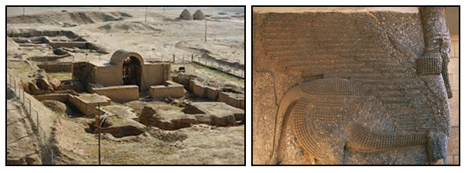
Fig.17: Left) Excavated ruins of Nimrud,
Right) Lamassu; sculptured from nodular gypsum.
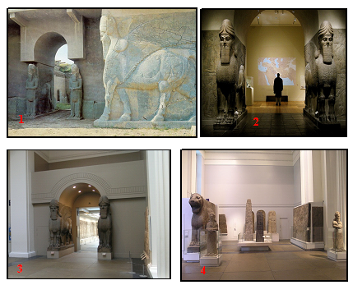
Fig.18: Excavated lamassu from Nimrud. 1) At Nimrud, 2) Metropolitan Museum,
3 and 4) British Museum. All are sculptured from gypsum.
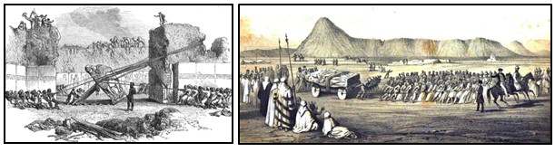
Fig.19: Sketch of Layard's expedition for lamassu excavation.
Left) Removing (1949), Right) Transporting (1951).

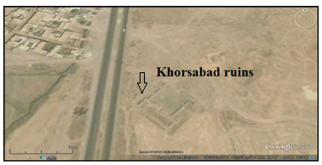

Fig.20: Google Earth image of Khorsabad (Dur-Sharrukin)

The town was of rectangular layout (Fig.20); measured (1758.6 X 1635) m. The enclosed area comprised 3 km². The city walls were massive; 24 m thick and 157 towers protected its sides. Seven gates entered the city from all directions. A temple tower, ziqqurat, was also constructed. The palace was adorned with sculptures and wall reliefs, and the gates were flanked with winged-bull shedu statues (Fig.21) weighing up to 40 tons. Sargon supposedly lost at least one of these winged bulls in the river [33,34].

The ancient city is located in area where the Injana Formation (Upper Miocene) is exposed; it consists of cyclic deposits of sandstone, siltstone and claystone [35]. The walls and foundations of the ancient city are constructed from limestone (Fig.21) quarried from the Fatha Formation, which includes limestone beds up to 1 m in thickness, as individual bedding [36]. It is worth mentioning that the excavated statues are sculptured from gypsum (Figs.22 and 23); quarried from the Fatha Formation. The sculpturing of the statues from gypsum not limestone is attributed to size of the beddings in gypsum rock and its plasticity during sculpturing, besides the bedding size of limestone beds in the Fatha Formation are not more than 1 m; however, the thickness of the limestone beds in the Pila Spi Formation, which is exposed NE of Khorsabad [12,36] is more than 1 m, but they are usually marly and/ or finely dolomitized, which are not favorable for sculpturing.
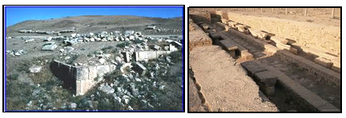

Fig.21: Walls and foundations of Khorsabsd, note all of them are constructed from limestone of the Fatha Formation.
- Nineveh
Nineveh; in Arabic languae Ninawa is an ancient Mesopotamian city on the eastern bank of the Tigris River, and capital of the Neo-Assyrian Empire. It was the largest city in the world for some fifty years [37] until, after a bitter period of civil war in Assyria itself, it was sacked by an unusual coalition of former subject peoples, the Babylonians, Medes, Persians, Chaldeans, Scythians and Cimmerians in 612 BC. Its ruins are across the river from the modern-day major city of Mosul, in the Ninawa Governorate of Iraq (Fig.24). The two main tells, or mound-ruins, within the walls are Kouyunjik, the Northern Palace, and Tell Nabī Yūnus (Fig.25). The walls are reconstructed by limestone blocks; some of which are the original blocks (Fig.25). The ruins are engulfed by the modern city of Mosul, wich is constructed on an area built up by the Fatha Formation [12,36].

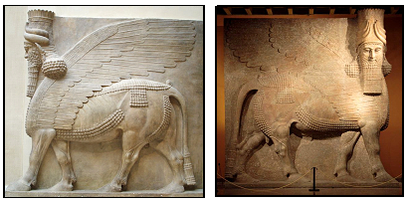
Fig.22: The Assyrian Lamassu of 40 tons sculptured from gypsum, approximately 2700 years old (Oriental Institute Museum at the University of Chicago).

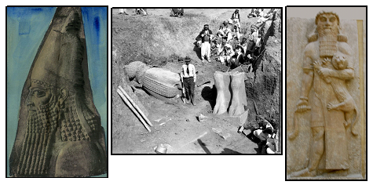

Fig23: Left) Statue; head of Sargon II, Middle) Excavation in Khorsabad (1929), Right) Statue of hero and lion, all are sculptured from gypsum

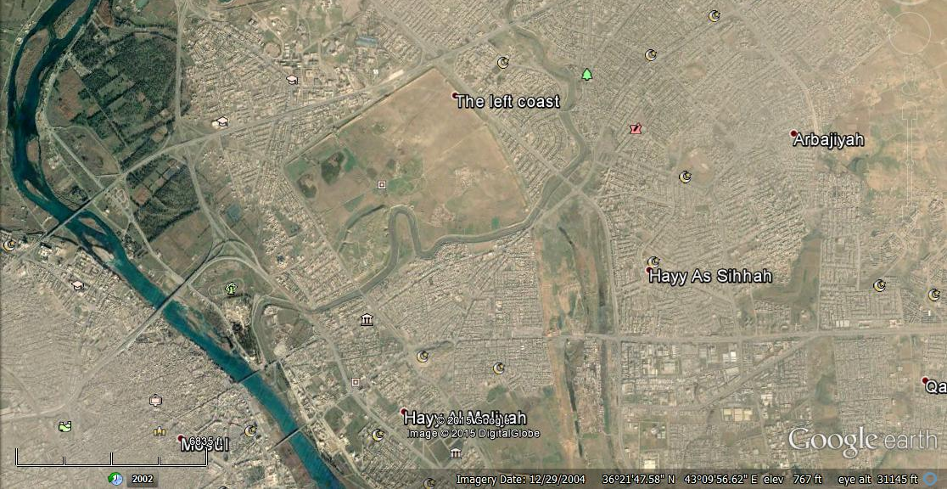

Fig.24: Google Earth image of Nineveh ruins within Mosul city

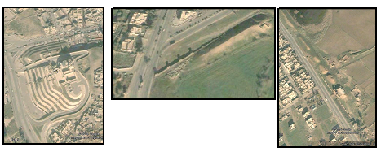

Fig.25: Google Earth images, Left) Reconstructed Naby Younis Mosque,
Middle and Right) Reconstructed walls of Nineveh

It was Sennacherib who made Nineveh a truly magnificent city (c. 700 BC). He laid out new streets and squares and built within it the famous "palace without a rival", the plan of which has been mostly recovered and has overall dimensions of about (503 X 242) m. It comprised at least 80 rooms, many of which were lined with sculpture. A large number of cuneiform tablets were found in the palace. The solid foundation was made out of limestone blocks and mud bricks; it was 22 m tall. In total, the foundation is made of roughly 2,680,000 cubic meters of clayey bricks (approximately 160 million bricks). The walls on top, made out of mud brick, were an additional 20 m tall. Some of the principal doorways were flanked by colossal stone door figures weighing up to 30,000 kg (30 t); they included many winged lions or bulls with a man's head. These were transported 50 km from quarries at Balatai and they had to be lifted up 20 m once they arrived at the site, presumably by a ramp. There are also 3,000 m of stone panels carved in bas-relief, that include pictorial records documenting different events, battle scenes (Fig.26) and every construction step including carving the statues and transporting them on a barge. Once the statues arrived at their destination, the final carving was done. Most of the statues weigh between 9,000 and 27,000 kg (9 and 27 tons) [38].

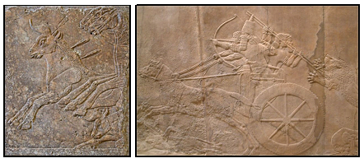

Fig.26: Left) Refined low-relief section of a bull-hunt frieze from Nineveh, alabaster (c. 695 BC) (Pergamon Museum), Berlin. Right) The king hunting lion from the North Palace, Nineveh (British Museum). Both sculptured from gypsum.

The total area of Nineveh comprised about 7 km², and fifteen great gates penetrated its walls. An elaborate system of eighteen canals brought water from the hills to Nineveh, and several sections of a magnificently constructed aqueduct erected by Sennacherib were discovered at Jerwan, about 65 km distant [39]. However, Nineveh's greatness was short-lived. In around 627 BC, after the death of its last great king Ashurbanipal, the Neo-Assyrian empire began to unravel due to a series of bitter civil wars, and in 616 BC Assyria was attacked by its former vassals, the Babylonians, Chaldeans, Medes, Persians, Scythians and Cimmerians. In about 616 BC Kalhu was sacked, the allied forces eventually reached Nineveh, besieging and sacking the city in 612 BC, following bitter house-to-house fighting, after which it was razed to the ground.
One of the most remarkable discoveries is that of the library of King Assur-bani-pal, which consists of about ten thousand flat bricks or tablets, all written over with Assyrian characters. These strange clay leaves found in the royal library form the most valuable of all the treasuries of the literature of the old world. All these clay leaves were made from the reddish brown claystone of the Fatha Formation and/ or the reddish brown clayey soil, above which the city was constructed.
Following the defeat in 612 BC, the site remained largely unoccupied for centuries with only a scattering of Assyrians living amid the ruins until the Sassanian period, although Assyrians continue to live in the surrounding area to this day. From the Arab conquest in 637 AD until the modern period, the city of Mosul on the opposite bank of the river Tigris became the successor of ancient Nineveh. It is worth mentioning that on 26th February, 2015 ISIS destroyed majority of statues kept in Mosul Museum and other sculptures, monuments and ruins, such as Naby Younis Mosque, which was razed on 25th July, 2014 (Fig.28). It was built in 1393; erected atop the ruins of an old Christian church, which itself was built at the site of an ancient palace once located near the town of Nineveh.

As the ruins witness, all the constructions were maid of limestone blocks (Fig.27), whereas the statues, lamassues and other sculptures are made of gypsum (Figs.26 and 29 ). Both types of rocks are quarried from the Fatha Formation, which is widely exposed in the site [12,36]. The limestone blocks are mainly from informal unit called "Unit C", which covers large parts of the modern city of Mosul, whereas the gypsum blocks are quarried from the informal unit called "Unit B" [40].
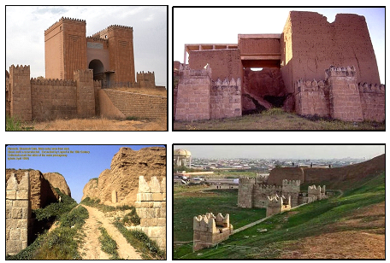
Fig.27: Walls and gates of Nineveh. Left, up) The Mashki Gate, the lower stones are original, Right up) The Adad Gate, reconstructed on original foundation,
Left down) The Shamash Gate, Right down) Part of the reconstructed wall

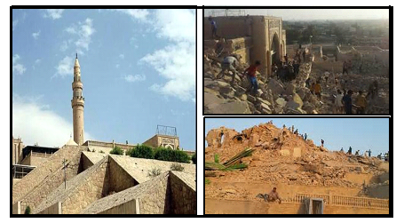
Fig.28: Left) Naby Younis Mosque, Right) After explosion by ISIS on 25th July, 2014

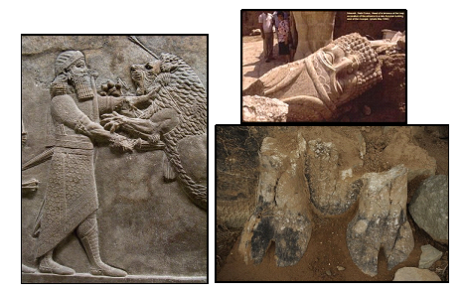
Fig.29: Left) A sculptured relief from Ashurbanipal's palace (Courtesy British Museum), Right up) Bull man excavated at Naby Yuunis by Iraq archeologists,
Right down) The crumbling remains of a palace sculpture. All are sculptured from gypsum; quarried from the Fatha Formation (Unit B).

- Isolated Archeological Hills
Tens of isolated archeological sites occur at the Low Mountainous Province and Al-Jazira Province. They all are distributed almost in flat lying areas; therefore, can be seen from far distances. They have different terminology at different parts of Iraq; however, the most common one is "Tal". The word "tal" or "tell" is from the Arabic language, meaning mound or mount. Ancient cities, like modern ones, experience natural and cultural disasters, such as fires, earthquakes, and assaults from enemies. If a city's structures were demolished in prehistory, there was no way to remove all the demolition rubble; people built right on top of the ruins [41]. In many of the hills (tals) there are many many layers of old building debris, as citizens rebuilt again and again in the same locations. Archaeologists call the layers in an archaeological site the 'stratigraphy'.

The isolated archeological hills are usually of conical shape with flat top, scarcely covered by poetry, brick fragments and artifacts. The height and radius of the base is different from hill to another (Fig.30). The height ranges from (3 – 10) m, whereas the diameter ranges from (100 – 200) m, they are built by dumping silty clayey soil, which give them more heights and more steep slope angles, as compared to those in the Mesopotamia Province.

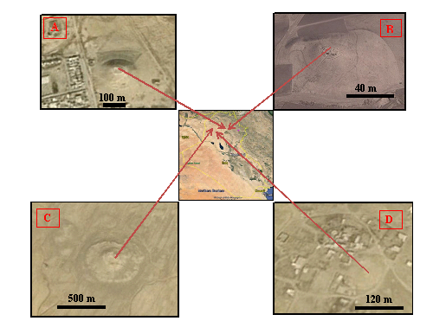

Fig.30: Google Earth images of isolated archeological hills.
A: Qoosh Tappa, B: Yarimjah, C: Bashmana, D: Tal Al-Khazaf

The isolated archeological hills are densely distributed in the Low Mountainous, Al-Jazira and Mesopotamia Provinces (Figs. 31, 32 and 32) indicating and witnessing active civilizations in different parts of Iraq. Those isolated hills are constructed by dumping soil to a certain height to use the hill for certain purpose, usually as watching towers. In the Low Mountainous and Al-Jazira Provinces, the hills are used usually as grave yards, whereas in the Mesopotamia Province, they were used for living places. In all areas, usually they are used as triangulation points of different orders, since they can be seen from far distances.

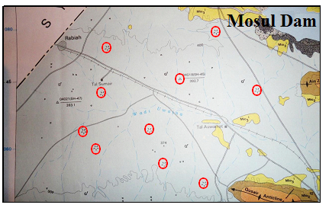

Fig.31: Geological Map of Mosul Quadrangle (after [36],
note the artificial isolated hills (encircled in red), in the Northwest Mosul Plain

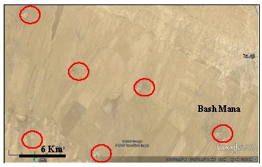

Figure 32: Google Earth image of SW Mosul, note the densely distributed
isolated hiss (encircled by red),
- Artifacts and Statues
Although the majority of the statues and artifacts were sculptured from limestone and gypsum, but some of them were constructed or sculptured from metallic minerals, which are not available in Iraq, such as gold, silver, basalt. In many archeological sites valuable treasures were discovered preserved in excellent situation witnessing very skill work. A good example is the golden treasure found in Nimrud, which consist of hundreds golden pieces (Fig.33) and other artifacts made of different minerals and other materials (Figs.34, 35 and 36). All the used minerals are not present in Iraq, since Iraq is poor in such metallic minerals [42]. This means that gold, silver and bronze were mined either from Iran or Turkey, as the nearest locations where they are present in nature. Moreover, this means that the ancient Iraqis were good miners and excellent handcrafts, especially as goldsmiths.

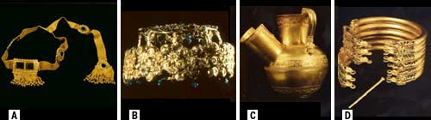

Fig.33: The royal tombs at Nimrud contained spectacularly crafted gold objects. Among the most impressive are (A) a mesh diadem with tiger eye agate, lapis lazuli, and a fringe of tiny gold pomegranates; (B) a child's crown decorated with vine leaves, grapes, and winged female deities; (C) a pouring vessel showing scenes of hunting and warfare; and (D) a bracelet inlaid with semiprecious stones and held in place by two pins. (Courtesy of the State Board of Antiquities and Heritage, Baghdad).
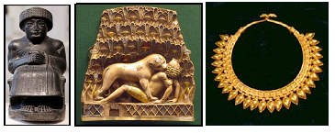
Fig.34: Left) Gudea of Lagash, diorite statue found at Girsu (Louvre Museum),
Middle) Nimrud ivory plaque, with original gold leaf and paint (British Museum), Right) Golden necklet from the Royal tomb in Nimrud

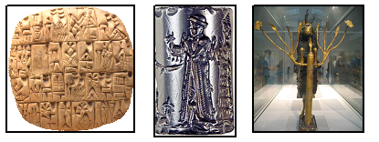
Fig.35: Left) Summary account of silver for the governor written in Sumerian Cuneiform on a clay tablet. From Shuruppak, Iraq, circa 2500 BCE (British Museum), Middle) Old Babylonian Cylinder Seal, hematite. This seal was probably made in a workshop at Sippar, about 65 km north of Babylon
Right) Ram in a Thicket, from From Ur, about 2600 – 2400 BC.

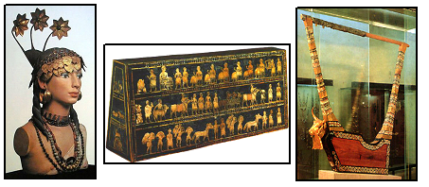

Fig.36: Left) Bust of Lady Pu-abi. Reconstructed with golden earrings and elaborate headdress, a confection of golden leaves, golden ribbons, and rosettes set of with lapis lazuli, Middle) The Standard of Ur. The "Peace" part on the hollow box. Sumerian, 2,650 – 2,400 B.C. (British Museum, London), Right) Lyre of Queen Shub-Ad. Sumerian, 2,600 B.C. The head of the bull is from silver.
- Discussion
The presence of huge number of archeological sites in Iraq indicates and confirms that Iraq was the creedal of civilization. The geological characteristics of the sites and near surroundings has great influence on the choosing the site and type of their buildings, statues, artefacts, also has influenced; partly on their demolishing and abandoning them.

In the Mesopotamia Province, where many civilizations were developed, the majority of their buildings were constructed from clayey bricks; sunburnt, because the areas are covered by flood plain sediments and no rocks are exposed there [12]. Therefore, the ruins are usually collapsed down, due to the weak resistance of the clayey bricks to weathering and erosional process through thousands years of their existence and only clayey ruins are visible (Fig.37). Good examples are Babylon (Fig.2), Ur (Figs. 3 and 4) and Ctesiphon (Figs. 5 and 6).
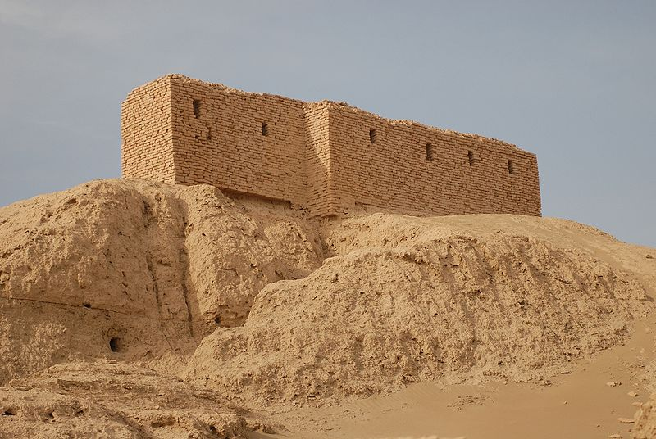

Fig. 37: Ruins from a temple in Naffur (ancient Nippur), south Iraq, are said to be the site for the meeting of Sumerian gods, as well as the place that man was created.

The used materials; however, in sculpturing of their statues and other artefacts were brought from far areas that extends for few hundred and thousand kilometres. They have used gold, silver, bronze (Figs.33, 34, 35 and 36) and some rock types (Fig.34 Left), which are not present in Iraq [12,42], respectively.

The used metallic minerals indicate that the ancient Iraqi people were skilled in mineral investigation, mineral processing and using them as artefacts (gold smiths). Since the minerals are not present in nature as ready for use, moreover the used rocks need special treatment to be sculptured and smoothed.

In the Low Mountainous and Al-Jazira Provinces, where the majority of the exposed rocks are limestone and gypsum of the Fatha Formation [12], the used materials are limestone and gypsum. The former were used in construction of the buildings and walls (Figs.9, 10, 11, 13, 14, 21, 25 and 27), since they are more resistance to climatic factors (weathering and erosion) then the gypsum. The statues; however, were sculptured from gypsum, this is attributed to: 1) Gypsum behaves more plastically than the limestone; during sculpturing, 2) The individual bedding in gypsum rocks is thicker than the bedding in limestone rocks; as the Fatha Formation is concerned, and because they preferred to have large statues; example the lamasusses (Figs.17, 18, 19 and 22), which are about 40 tons; each, and 3) The gypsum rock has more shiny surface when is polished, as compared with the available limestone in the sites and near surroundings, and more easy in sculpturing needed details of the statues (Figs. 23, 26 and 29). Limestone; however, was used too in sculpturing of statues in some archeological sites, like in Hatra, where the statues of the queen and many other small statues were sculptured from the limestone (Fig.15), even though, the used limestone differs from a statue to another; it is very clear from their resistance to weathering and erosion, as it is expressed on the arched walls of Hatra ruins, where three heads of statues are sculptured from limestone, but because they are of different types; therefore, they have different resistance to climatic factors (Fig.15, Right). Gypsum was not used in the statues of Hatra because the Upper Member of the Fatha Formation is exposed there [12] and it does not include thick gypsum beds as it is the case in the Lower Member of the formation.
As in the Mesopotamia Province, gold, silver and bronze were used in the Low Mountainous Province in artefacts. These metallic minerals are also not present in the near surroundings of the archeological sites, which means they were brought from Turkey and/ or more northwards, indicating the great extension of the Assyrian Empire, and their skill crafting golden objects (Fis.33 and 34).

Another significant geological impact is the isolated archeological sites, which are constructed by soil dumping. In the Mesopotamia Province, the height of the hills ranges from (3 – 6) m, whereas those in the Low Mountainous and Al-Jazira Provinces the height ranges from (3 – 10) m and may be more, except those of Erbil and Kirkuk citadels, where the height is about 35 m. The shape is the same; conical with flat top (Fig.30), the diameter is also smaller in the hills of the Mesopotamia Province than those in the Low Mountainous and Al-Jazira Provinces. This is attributed to the height and slope angles, in the first case; the height is lower with lower slope angle than those in the second case. This is attributed to the type of the used soil. In the first case, it is from the alluvial plain sediments [12], whereas in the second case, it is either from the residual red clay or silty clay of polygenetic origin [12]. As the clay ratio is higher in the soil, as the angle of the repose is higher; therefore, steep slopes remain stable in the second case, consequently, higher hills were constructed.
The geological impacts on the demolishing of the archeological sites are having also played a big role. In Ur and Babylon and many other ancient cities in the Mesopotamia Province, the changing of the course of the Euphrates River has played a big role in abandoning the cities; suffering from the draught; however, other factors, like invading by other civilization and burning and destroying them.

The ancient city of Hatra, was collapsed by an earthquake [28], besides the changing of Al-Hirmaz River to it course due to continuous growth of Sinjar anticline [24,25,26,27,43], consequently, the remaining course of the river, which is expressed nowadays by Al-Tharthar valley was dried and the city starred suffering from draught.

- Conclusions
The following can be concluded from this article:
- The available soil and/ or rock types were used in building of the cities; consequently, the size of the remaining ruins is controlled.
- The main rock of building the cities and walls in the Low Mountainous and Al-Jazira Provinces is limestone of the Fatha Formation, whereas in the Mesopotamia Province is clayey bricks.
- The main rock used in sculpturing of the statues is gypsum, since it is more easily sculptured than the limestone; moreover, it can be polished and give shiny surface.
- The bedding plane of gypsum rocks is thicker than those of limestone; therefore, big statues were sculptured from gypsum; like the lamassu, besides, the nodular and banded gypsum give more impressive shape to the statue.
- Metallic minerals; such as gold, silver and bronze were brought from far distances from where they were found, since no such minerals exist in nearby the sites.
- Changing of the Euphrates river to its course in the Mesopotamia Province had played big role in demolishing of many ancient cites, like Ur and Babylon; suffering from draught. Moreover, earthquake also had caused collapsing of Hatra city.

References

[1]Domas, J., 1983, The Geology of Karbala Kut and Ali Al-Gharbi Area. Iraq Geological Survey (GEOSURV) Library report no. 1384.
[2]Sissakian, V.K., 1995, Geological Map of Mosul Quadrangle, scale 1: 250000. Iraq Geological Survey Publications, Baghdad, Iraq.
[3]Yacoub, S.Y. Othman, A.A. and Kadhum, T.H., 2011, Geomorphology. In: Geology of the Low Folded Zone. Iraqi Bulletin of Geology and Mining (ISSN- 1811.4539), Special Issue No.5, p. 7 – 38.
[4]Yacoub, S.Y., 2011, Geomorphology of the Mesopotamia Plain. In: Geology of the Mesopotamia Plain. Iraqi Bulletin of Geology and Mining (ISSN- 1811.4539), Special Issue No.4, p. 7 – 56.
[5] Sissakian, V.K. and Foaud, S.F., 2014, Geological Map of Erbil and Mahabad Quadrangles, scale 1: 250000, 2nd edition. Iraq Geological Survey Publications, Baghdad, Iraq.
[6] Sissakian, V.K. and Foaud, S.F., 2014, Geological Map of Kirkuk Quadrangle, scale 1: 250000, 2nd edition. Iraq Geological Survey Publications, Baghdad, Iraq.
[7]Larsen, C.E. and Evans, G., 1978, The Holocene Geological History of the Tigris – Euphrates – Karun Delta. In: W.C., Price (Ed.). The Environmental History of the Near and Middle East. Academic Press, London, p. 227 – 244.
[8]Sissakian, V.K., Kadhum, T.H. and Abdul Jabbar, M.F., 2014, Geomorphology. In: Geology of the High Folded Zone. Iraqi Bulletin of Geology and Mining (ISSN- 1811.4539). Special Issue No.6, p. 7 – 32.
[9]Wright, H.E., 1986, Pleistocene Glaciation in Kurdistan. Translated to Arabic by: Khorshid, F.H. Al-Bidleesi Book Shop, Baghdad, 88pp.
[10]Sissakian, V.K., Al-Ansari, N. and Knutson, S., 2015, B. The Origin of Different Types of Isolated Hills, Examples from Iraq (in press).
[11]Morrey, P.R. S., 1984, Where did they bury the Kings of Iraq?, Iraq, 46,1, 1-18, British Institute for the Study of Iraq.
[12]Sissakian, V.K. and Foaud, S.F., 2012, Geological Map of Iraq, scale 1: 1000000, 4th edition. Iraq Geological Survey Publications, Baghdad, Iraq.
[13]Chris, 2008 (Ed.). Taq-I-Kisra (Arch of Ctesiphon). worldheritagesite. Internet data.
[14]Julian, S.C., 1999 (Ed.), The Seventy Wonders of the Ancient World The Great Monuments and how they were built. Thames and Hudson. P. 185 –186. ISBN 0-500-05096-1.
[15]Deikran, D.B., 1995, Geological Map of Sooq Al-Shiyookh Quadrangle, scale 1: 250000. Iraq Geological Survey publications, Baghdad, Iraq.
[16]Deikran, D.B., 1995, Geological Map of Al-Nasiriyah Quadrangle, scale 1: 250000. Iraq Geological Survey publications, Baghdad, Iraq.
[17]D.A.E. (Directorate Antiquities of Erbil), 2010, Guide Brochure, produced by General Directorate of Antiquities, KRG, Ministry of Tourism
[18]UNESCO World Heritage Centre, 2010, Erbil Citadel. whc.unesco.org. Retrieved 30 August 2010.
[19]H.C.E.C.R. (High Commission for Erbil Citadel Revitalization), 2009, History of Erbil Citadel. www.erbilcitadel.org/ErbilCitadel/history.php.
[20]East, W.G., Hermann, O. and Spate, K., 1961, The Changing Map of Asia: A Political Geography, 436 pages, p: 105.
[21]Boardman, J., Edwards, I. E. S., Sollberger, E. and (Editor), Hammond, N.G.L. (Editors), 1992, Babylonian Empires and Other States of the Near East, from the Eighth to the Sixth Centuries BC.
[22]Bosworth, C.E., 1954, The Encyclopaedia of Islam Vol. V. Brill. pp. 144–147. ISBN 90-04-06056-1.
[23]Ma'ala, K.A., 1977, Report on the Regional Geological Mapping of Sinjar Area. Iraq Geological Survey Library report no. 860.
[24]Soosa, A., 1965, Floods of Baghdad in History, Vol.1, 3rd edit. Al-Adeeb Press, Baghdad, Iraq (in Arabic).
[25]Soosa, A., 1966, Floods of Baghdad in History, Vol.3. Al-Adeeb Press, Baghdad, Iraq (in Arabic).
[26]Al-Sakini, J.A., 1993, New Look on the History of the Old Tigris and Euphrates Rivers, in Light of Geological Evidences, Recent Archeological Discoveries and Historical Sources. Ministry of Oil, Iraq (in Arabic).
[27]Sissakian, V.K., Abdul Jab'bar, M.F., Al-Ansari, N. and Knutson, S., 2015, The Origin and Evolution of Wadi Al-Ajeej, Al-Jazira vicinity, NW Iraq. Journal of Earth Sciences and Geotechnical Engineering, Vol. 5, No.14, 2015, 69-83 ISSN: 1792-9040 (print), 1792-9660 (online), Scienpress Ltd., 2015.
[28]ATOMENERGEXPORT, 1985, Feasibility study of site selection for Nuclear Power Plant location in Iraq. Book 3. Ex-Iraqi Atomic Energy Commission library, Baghdad, Iraq.
[29]Al-Mubarak, M.A. and Youkhanna, R.Y., 1976, Report on the regional geological mapping of Al-Fatha – Mosul Area. Iraq Geological Survey Library report no. 753.
[31]Sissakian, V.K. and Salih, H.A., 1999, Series of Geological Report on the Exposed Formations in Iraq. The FATHA Formation. Iraq Geological Survey library report No. 2515.
[32]Poebel, A., 1942, The Assyrian King-List from Khorsabad, Journal of Near Eastern Studies, Vol. 1, No. 3, p. 247–306.
[33]Encyclopedia Britannica, 2014, Hatra, ancient city in Iraq. Internet data. Retrieved 14 December 2013.
[34]Albenda, A., 1986, The palace of Sargon, King of Assyria: Monumental wall reliefs at Dur-Sharrukin, from original drawings made at the time of their discovery in 1843–1844 by Botta and Flandin, Editions Recherche sur les civilisations, ISBN 2-86538-152-8. Internet data.
[35]Sissakian, V.K. and Saeed, Z.B., 2012, Lithological Map of Iraq, Compiled using GIS Techniques. Iraqi Bulletin of Geology and Mining (ISSN- 1811.4539), Vol. 8, No.3, p. 1 – 13.
[36]Sissakian, V.K., Hagopian, D.H. and Hassan, E. A., 2013, Geological Map of Mosul Quadrangle, scale 1: 250000, 2nd edition. Iraq Geological Survey Publications, Baghdad, Iraq.
[37]Rosenberg, M.T., 2013, Largest Cities Through History. geography.about.com. Retrieved 6 May 2013.
[38]Scarre, C., 1999 (Ed.), The Seventy Wonders of the Ancient World (Thames and Hudson)
[39]Jacobsen, T. and Lloyd, S., 1935. Sennacherib's Aqueduct at Jerwan, Oriental Institute Publication 24, University of Chicago Press.
[40]Mohi Al-Deen, R.M., Sissakian, V.K., Yousif, N.S., Amin, R.M. and Rofa, S.H., 1977, Report on the Regional Geological mapping of Mosul – Tel Afar Area. Iraq Geological Survey Library report No. 831.
[41]Hirst, K.K., 2012, What is a 'Tell". Internet data. Archaeology.about.com.
[42]Al-Bassam, K.S., 2013, Mineral resources of Kurdistan Region, Iraq. Iraqi Bulletin of Geology and Mining (ISSN- 1811.4539), Vol. 9, No. 3, p. 103 – 128.
[43]Sissakian, V.K., 2011, Origin of the Tharthar Depression, Central part of Iraq. Iraqi Bulletin of Geology and Mining (ISSN- 1811.4539), Vol. 7, No.3, p. 47 – 62.

Private Consultant, Erbil, Iraq. e-mail: varoujan49@yahoo.com
Iraq Geological Survey; Baghdad. e-mail: ayda1955@yahoo.com
Lulea University of Technology, Lulea, Sweden. e-mail: nadhir.alansari@ltu.se, Sven.Knutsson@ltu.se Article Info: Received : January 10, 2011. Published online : July 17, 2012

