**GROUNDWATER POTENTIAL OF MANDO, KADUNA, CRYSTALLINE BASEMENT COMPLEX, NIGERIA**

**G. I. Alaminiokuma and M. S. Chaanda**

Department of Earth Sciences,

Federal University of Petroleum Resources, Effurun

P.M.B. 1221, Effurun, Nigeria

+234 (0) 8053658299

Corresponding Author: *alaminiokuma.godswill@fupre.edu.ng*

**ABSTRACT**

Vertical Electrical Sounding (VES) was conducted to explore the groundwater potential in Mando, located within the Crystalline Basement Complex of Nigeria. Four VES traverses were investigated employing the Schlumberger configuration with a maximum half current electrodes separation of 90m. WINRESIST software was employed for the iteration and inversion processes of computing resistivities, depths and thicknesses of the various layers and the curve types. The results show that the area is characterized by four to five geoelectric subsurface layers inferred differently at the VES traverses. An ***unconfined shallow aquifer zone*** is delineated. This potential groundwater aquifer zone found at all the VES locations has shallow overburden depth ranging between 7.1–10.9m with coarse-grained sand columns having thicknesses ranging between 6.0–9.6m. These results suggest that groundwater occurrence in Mando lies within the weathered overburden (WO) composed of coarse-grained sands which forms a level below the loose clayey laterite. These WO consist of sands or gravels derived from the weathering of the crystalline rocks. Based on these results, it is suggested that boreholes for sustainable groundwater supply in the study area should be drilled to a depth of about 10.0m. Though, this falls within the unconfined shallow aquifer zone, however, it has potentials for groundwater occurrence but may be susceptible to contamination. It is recommended that geoelectrical logging and other hydrogeological analyses be conducted to properly delineate prolific aquifers and determine the Total Dissolved Solids (TDS) to avoid possible contamination in the water before any borehole(s) are completed for potable groundwater supply.

**KEYWORDS: Vertical Electrical Sounding, Aquifer, Groundwater, Crystalline Basement Complex, Mando**

**INTRODUCTION**

In order to meet the target of the Sustainable Development Goals (SDG) of the United Nations (UN) as set by the Rio+2012 convention especially Goal 6 (synthesis report on water and sanitation by 2030) and the UN General Assembly convention of 2015 formally tagged **“Ensure availability and management of Water and Sanitation for all”**,the need for appraisal of groundwater cannot be overemphasized.

The ever-increasing demand for water, especially for domestic purposes, has led to widespread and very intensive search in all parts of Nigeria, particularly in the Crystalline Basement Complex where occurrences of groundwater are considered low and generally to be under the control of geological structures and weathered overburden.

Most rural communities in different parts of Kaduna State depend largely on groundwater through hand-dug wells and boreholes for their water needs, since most surface sources are more susceptible to pollution and are expensive to develop. Mando is a very small community in Igabi Local Government Area of Kaduna State with less of social amenities and infrastructure situated at the northern part of Kaduna along Lagos road. It is occupied basically by retired personnel, wages earners, military men and women. Hence, the development of a good water scheme to serve this community which has no access to good source of potable water is imperative.

Several researches, tools and techniques among which Vertical Electrical Sounding, one of the surface geophysical methods, had been employed to better investigate the properties of aquifers and groundwater potential in the Crystalline Basement Complex. Researchers such as [1] , [2], [3], [4], [5], [6] and [7] have undertaken numerous works that attempted to solve the perennial water scarcity in most of parts of Kaduna and environs, while at the same time looking at the level of contamination of both surface and groundwater.

This research aims at unravelling the groundwater potential of the aquifer system associated with the weathered overburden in Mando area as a way of providing sustainable, clean and potable water to Mando and its environs via a systematic survey and critical analyses of the data acquired. Hence, Vertical Electrical Sounding has been conducted in order to assess and describe the existing hydrogeology and groundwater conditions in Mando, Kaduna in the Crystalline Basement Complex of Nigeria. The aquifer type, depth, thickness, lithology and resistivities of the various soil layers bearing water have also been determined.

**LOCATION, GEOGRAPHY, GEOLOGY AND HDROGEOLOGY OF THE STUDY AREA**

**Location**

The study area is located in Mando area, Kaduna, Crystalline Basement Complex, Nigeria (Figure 1).

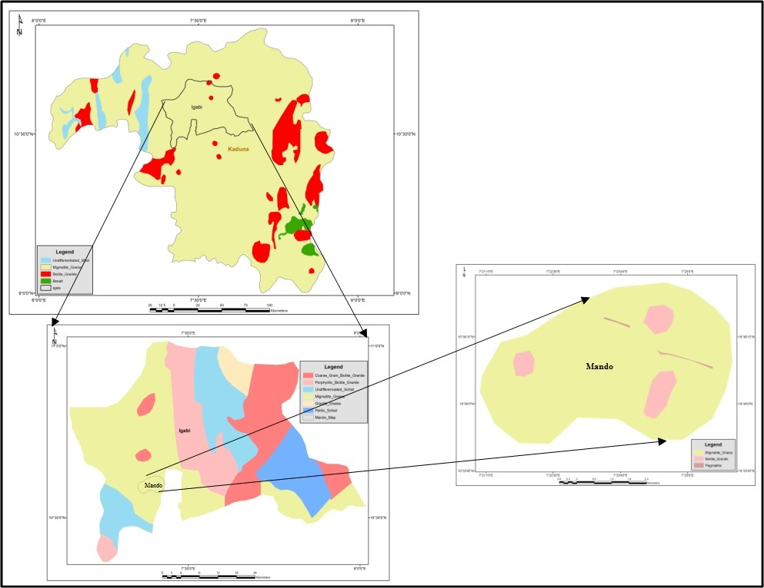

**Fig. 1: Generalized Geological Map of Igabi Local Government Area, Kaduna State, Nigeria. (With an Insert of the Study Area, Mando)**

**Geography**

The study area is located in the humid, wet-dry tropics, in the northern reaches of the Guinea Savannah. Geologically, the area under investigation lies within the Crystalline Basement Complex. In the study area, the average rainfall is 1350 mm per annum, and is distributed within four to eight months, usually from March to October [8].

**Geology and Hydrogeology**

The southern parts of Kaduna in the north-central Nigeria forms a part of the West African mobile zone which extends from east to west from Nigeria and Ghana, where it is “sutured” to the West African craton by the Pan African Dahomeyan (Beninian) belt. The whole ensemble of rocks in this zone had undergone an extensive episode of “remobilization and reactivation” during the Pan-African thermotectonic event some 600 my ago [9].

The entire land area is underlain by Precambrian migmatite-gneiss complex, metasediments/metavolcanics (mostly schists, quartzite, and banded iron formations). Pan African granitoids and calc-alkaline granites, and volcanics of Jurassic age. These various rock units, especially the gneisses and the schists, have been affected by many periods of orogenic movements, resulting in extensive deformation and migmatization. [10] reported that the oldest rocks of the area are the gneisses and older metasediments believed to be Birrimian in age (about 2500 my). The igneous and metamorphic rocks constituting the Basement Complex of Nigeria as a whole, has an undeserved reputation as poor aquifers ([11]; [12]. This thermotectonic event has virtually obliterated the imprints of earlier events but left its own structural earmarks, which include: filing, fracturing, shearing, granitic emplacement and granitization. The Migmatic-Gneiss Complex which underlies most of the Kaduna-Zaria area and typifies the area of investigation is characterized by spectacular exposure of well-defined Migmatite around Kudenda, Kakau, Sabon Tasha, Kabala east and west areas in Kaduna metropolis [13]. A very close geological mapping of the study area reveals that the most dominant rock type in this area is Migmatite-Gneiss and Biotite-Granite and some few pegmatitic veins towards the north-eastern area of Mando (Figure 1). These materials are usually liable to form aquitard and permeable zones to the bedrocks in the country rocks of the area. Associated with the crystalline rocks are the presence of structures like fractures, fissures, veins, joint and such other structural deformations of the basement complex which controls the flow of groundwater and also influence the rate of recharge and discharge of the main aquiferous units [14].

Groundwater occurrence in the area can be grouped into three: The Weathered/Fractured Basement Complex; the Newer Basalts and the River Alluvium.

**METHODOLOGY**

**Field Data Acquisition**

The Schlumberger configuration with a maximum half current electrodes separation of 90m was used for the profiling and vertical electrical sounding (Figure 2). In employing this configuration, the current electrodes separated by *AB* are symmetric about the potential electrodes *MN*. Four traverses with different spreads of current electrodes, AB were investigated leading to different probe depths (Table 1). Ohmega 1000 Resistivity Meter with its accessories was employed in the data acquisition. Readings were repeated at each point and a total of 4 cycles were taken and the average was recorded.



**Fig. 2: Schlumberger Array for Data Acquisition**

**Computation of Soil Resistivity, ρ**

Soil resistivities are obtained from field resistance values using the equation:

$ρ=\frac{π\left({s^{2}-a^{2}}/4\right)R}{a}$ (1)

Where ρ is resistivity, R is the measured resistance, *s* = Distance between current electrodes, *a* = Distance between potential electrodes

**DATA ANALYSIS**

With the WINRESIST software, apparent resistivity, ρa values were fitted against half current electrode spread, AB/2 to obtain the curve type. In fitting the best curves, the iteration process was conducted until the least root mean square (RMS) errors between 2.5 and 6.8% were obtained. The resistivities were computed, the thicknesses and depths of the various layers were delineated while the curve type was determined by standard automated matching techniques.

**RESULTS**

Table 1 below shows the results of the vertical electrical sounding conducted in Mando, Kaduna while Figures 3 - 6 show the geoelectric sections for the four VES stations. Generally, the KH type curve were observed in the study area. Table 2 is a summary of the interpretation of the results of the Vertical Electrical Sounding in the study area. The results show that the area is characterized by four to five geoelectric subsurface layers.

**Table 1: Vertical Electrical Sounding Data Acquired in Mando, Kaduna**

|  |  |  |  |  |  |  |  |  |  |  |  |  |  |  |  |
| --- | --- | --- | --- | --- | --- | --- | --- | --- | --- | --- | --- | --- | --- | --- | --- |
| **VES 1**  **Lat. N10 35' 11.8" N; Long. 007 25' 13.5" E; Elevation 629m** | | | | **VES 2**  **Lat. 10°35'16.7" N;**  **Long. 007°25'10.4" E; Elevation 626m** | | | | **VES 3**  **Lat. 10°35'18.2" N; Long. 007°25'11.0" E; Elevation 623m** | | | | **VES 4**  **Lat. 10°35'22.8"N; Long. 007°25'13.4" E; Elevation 621m** | | | |
| **AB/2 (m)** | **MN/2 (m)** | **R ($Ω$)** | $ρ_{a}$**($Ω$ m)** | **AB/2**  **(m)** | **MN/2**  **(m)** | **R ($Ω$)** | $ρ_{a}$**($Ω$ m)** | **AB/2**  **(m)** | **MN/2**  **(m)** | **R ($Ω$)** | $ρ_{a}$**($Ω$ m)** | **AB/2**  **(m)** | **MN/2**  **(m)** | **R ($Ω$)** | $ρ_{a}$**($Ω$ m)** |
| 1 | 0.2 | 25.84 | 194.916288 | 1 | 0.2 | 36.61 | 276.156552 | 1 | 0.2 | 49.78 | 375.500496 | 1 | 0.2 | 44.15 | 333.03228 |
| 2 | 0.2 | 7.788 | 242.3290716 | 2 | 0.2 | 11.77 | 366.231789 | 2 | 0.2 | 18.1 | 563.19417 | 2 | 0.2 | 13.2 | 410.72724 |
| 3 | 0.2 | 3.493 | 245.9183776 | 3 | 0.2 | 5.666 | 398.9045312 | 3 | 0.2 | 8.347 | 587.6555104 | 3 | 0.2 | 7.474 | 526.1935168 |
| 6 | 0.2 | 0.985 | 278.3173645 | 6 | 0.2 | 1.909 | 539.3988313 | 6 | 0.2 | 2.173 | 613.9935361 | 6 | 0.2 | 2.498 | 705.8241386 |
| 6 | 0.6 | 3.087 | 288.1624977 | 9 | 0.2 | 1.086 | 690.8515152 | 9 | 0.2 | 0.791 | 503.1892712 | 9 | 0.2 | 1.289 | 819.9885848 |
| 9 | 0.6 | 1.462 | 308.7884352 | 12 | 0.2 | 0.6814 | 770.776308 | 9 | 0.6 | 2.427 | 512.6056992 | 12 | 0.6 | 0.7677 | 288.8218677 |
| 12 | 0.6 | 0.8002 | 301.0489234 | 12 | 0.6 | 1.878 | 706.5357138 | 12 | 0.6 | 1.127 | 423.9966717 | 16 | 0.6 | 2.223 | 836.3306133 |
| 16 | 0.6 | 0.3808 | 254.9698823 | 16 | 0.6 | 1.056 | 707.0593376 | 16 | 0.6 | 0.4417 | 295.7463157 | 20 | 0.6 | 1.127 | 754.598365 |
| 20 | 0.6 | 0.2163 | 226.4063507 | 20 | 0.6 | 0.5768 | 603.7502686 | 16 | 2 | 2.254 | 446.312286 | 20 | 0.6 | 0.6468 | 677.0209323 |
| 20 | 2 | 0.9957 | 309.8190249 | 20 | 2 | 2.142 | 666.498294 | 20 | 2 | 1.066 | 331.693362 | 25 | 2 | 2.345 | 729.663165 |
| 25 | 2 | 0.5743 | 280.2301157 | 25 | 2 | 1.106 | 539.6735295 | 25 | 2 | 0.5128 | 250.2211446 | 30 | 2 | 1.259 | 614.3299943 |
| 30 | 2 | 0.3429 | 241.4125728 | 30 | 2 | 0.591 | 416.082912 | 25 | 2.6 | 0.6956 | 259.9307807 | 35 | 2 | 1.025 | 721.6328 |
| 35 | 2 | 0.2313 | 221.9093935 | 30 | 2.6 | 0.7738 | 417.7706498 | 39 | 2.6 | 0.2244 | 205.380215 | 35 | 2 | 0.3716 | 356.5133187 |
| 40 | 2 | 0.1589 | 199.2696573 | 35 | 2.6 | 0.4671 | 343.9408497 | 40 | 2.6 | 0.2142 | 206.2726771 | 40 | 2.6 | 0.4498 | 331.2022997 |
| 45 | 2 | 0.1196 | 189.9248897 | 40 | 2.6 | 0.3046 | 293.3270656 | 45 | 2.6 | 0.1624 | 198.1070229 | 45 | 2.6 | 0.3097 | 298.2383198 |
| 50 | 2 | 0.08905 | 174.6477096 | 45 | 2.6 | 0.2274 | 277.3986269 | 50 | 2.6 | 0.133 | 200.4272484 | 50 | 2.6 | 0.2386 | 291.0611802 |
| 55 | 2 | 0.07717 | 183.1823454 | 50 | 2.6 | 0.1706 | 257.0893878 | 55 | 2.6 | 0.1015 | 185.1658316 | 55 | 2.6 | 0.1878 | 283.0093026 |
| 60 | 2 | 0.06895 | 194.8221552 | 55 | 2.6 | 0.1398 | 255.0362883 | 60 | 2.6 | 0.09362 | 203.3273965 | 60 | 2.6 | 0.1117 | 203.7736295 |
| 65 | 2 | 0.06306 | 209.1479963 | 60 | 2.6 | 0.1076 | 233.6896802 | 65 | 2.6 | 0.08601 | 219.2912336 | 65 | 2.6 | 0.09819 | 213.2526924 |
| 70 | 2 | 0.05625 | 216.39555 | 65 | 2.6 | 0.09876 | 251.798654 | 70 | 2.6 | 0.07839 | 231.8452588 | 70 | 2.6 | 0.05158 | 131.5084505 |
| 75 | 2 | 0.05239 | 231.3909523 | 70 | 2.6 | 0.09011 | 266.5081805 | 75 | 2.6 | 0.07331 | 248.9456514 | 75 | 2.6 | 0.07859 | 232.4367762 |
| 80 | 2 | 0.0463 | 232.6879191 | 75 | 2.6 | 0.08398 | 285.1787724 | 80 | 2.6 | 0.06671 | 257.7822358 | 80 | 2.6 | 0.07159 | 243.1048859 |
| 85 | 2 | 0.04346 | 246.5877266 | 80 | 2.6 | 0.08167 | 315.5909938 | 85 | 2.6 | 0.06255 | 272.8975705 | 85 | 2.6 | 0.06468 | 249.9378655 |
| 90 | 2 | 0.04122 | 262.218227 | 85 | 2.6 | 0.07422 | 323.8122731 | 90 | 2.6 | 0.06052 | 296.0481667 | - | - | - | - |
| - | - | - | - | 90 | 2.6 | 0.06839 | 334.5461686 | - | - | - | - | - | - | - | - |

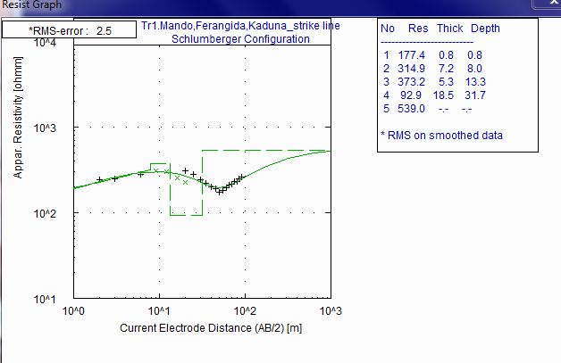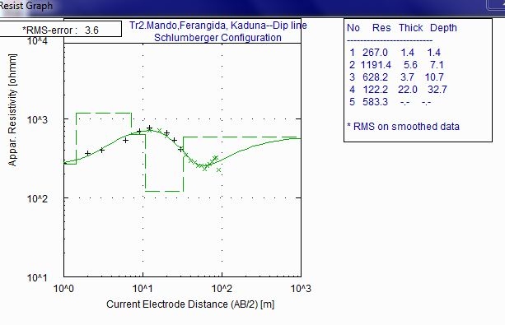

**Fig. 3: Geoelectric Section for Traverse 1 Fig. 4: Geoelectric Section for Traverse 2**

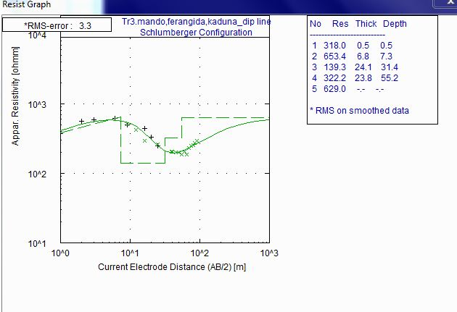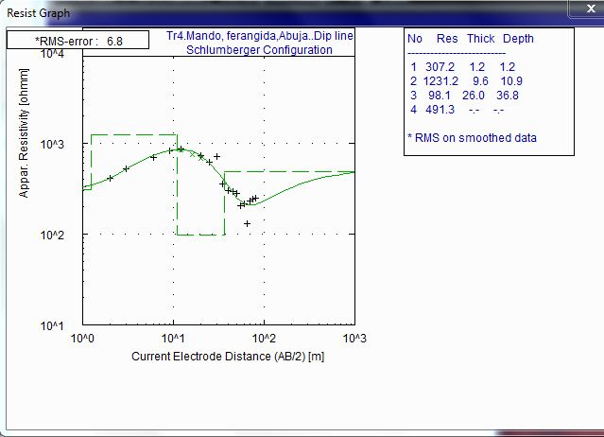

**Fig. 5: Geoelectric Section for Traverse 3 Fig. 6: Geoelectric Section for Traverse 4**

**Table 2: VES Data Interpretation Results in the Study Area**

|  |  |  |  |  |  |  |
| --- | --- | --- | --- | --- | --- | --- |
| **Sounding Locations** | **Geoelectric**  **Layers** | **Resistivity,**  **ρ(Ωm)** | **Thickness,**  ***h(*m)** | **Depth,**  **D(m)** | **Inferred**  **Lithology** | **Curve Type** |
| **VES 1** | **I** | 177.4 | 0.8 | 0.8 | Clayey Topsoil | KH |
| **II** | 314.9 | 7.2 | 8.0 | Coarse-grained sand |
| **III** | 373.2 | 5.3 | 13.3 | Lateritic clay |
| **IV** | 92.9 | 18.5 | 31.7 | Wet clay |
| **V** | 539.0 | - | - | Weathered Basement rock |
| **VES 2** | **I** | 267.0 | 1.4 | 1.4 | Clayey Topsoil | KH |
| **II** | 1191.4 | 5.6 | 7.1 | Sand |
| **III** | 628.2 | 3.7 | 10.7 | Clayey sand |
| **IV** | 122.2 | 22.0 | 32.7 | Clay |
| **V** | 583.3 | - | - | Weathered Basement rock |
| **VES 3** | I | 318.0 | 0.5 | 0.5 | Lateritic Topsoil | KH |
| **II** | 653.4 | 6.8 | 7.3 | Coarse-grained sand |
| **III** | 139.3 | 24.1 | 31.4 | Clay |
| **IV** | 322.2 | 23.8 | 55.2 | Sandy Clay |
| **V** | 629.0 | - | - | Weathered Basement rock |
| **VES 4** | **I** | 307.2 | 1.2 | 1.2 | Clayey Topsoil | KH |
| **II** | 1231.2 | 9.6 | 10.9 | Coarse-grained Sand |
| **III** | 98.1 | 26.0 | 36.8 | Wet clay |
| **IV** | 491.3 | - | - | Weathered Basement rock |

**DISCUSSION OF RESULTS**

**VES STATION 1:** Five geoelectric layers of KH curve type are delineated at this location. Lithologies arecharacterized by a 0.8m thick clayey topsoil with resistivity of 177.4 Ωm at a depth of 0.8m. Below this formation is a 7.2m thick coarse-grained sand at a depth of 8.0m. This is a ***shallow aquifer zone*** with resistivity value of 314.9Ωm. This is followed by two layers of clayey formations: a 5.3m thick lateritic clay with resistivity of 373.2Ωm at a depth of 13.3m and an 18.5m thick wet clay with resistivity of 92.9Ωm a at depth of 31.7m. Underlying this zone is the weathered basement rock with resistivity of 539.0 Ωm with undetermined thickness and depth since it constitutes the last layer.

**VES STATION 2:** Five geoelectric layers of KH curve type are delineated at this location. The topmost sediment with a thickness of 1.4mat a depth of 1.4m is characterized by clayey topsoil with resistivity of 267.0Ωm. Underlying this layer are a 5.6m thick sand at a depth of 7.1m with resistivity of 628.2Ωm and a 22.0m thick clay at a depth of 32.7m with resistivity of 122.2Ωm. The second layer constitutes a ***shallow aquifer zone***. Below these zones is the weathered basement rock having a resistivity of 583.3Ωm with undetermined thickness and depth.

**VES STATION 3:** Five geoelectric layers of KH curve type are delineated at this location. Soil layers here arecharacterized by lateritic topsoil with resistivity of 318.0Ωm and thickness of 0.5m at a depth of 0.5m. Below this layer is a 6.8m thick coarse-grained sand at a depth of 7.3m. This is a ***shallow aquifer zone*** with resistivity value of 653.4Ωm. This is underlain by a 24.1m thick clay with resistivity value of 139.3Ωm at a depth of 31.4m followed by a 2.38m thick sand clay with a resistivity of 322.2 Ωm at a depth of 55.2m. Below these zones is the weathered basement rock having a resistivity of 629.0Ωm with undetermined thickness and depth.

**VES STATION 4:** Four geoelectric layers of KH curve type are delineated at this location. Lithologies here arecharacterized by clayey topsoil with resistivity of 307.2Ωm and thickness of 1.2m at a depth of 1.2m. Underlying this layer is a 9.6m thick coarse-grained sand at a depth of 10.9m. This is a ***shallow aquifer zone*** with resistivity value of 1231.2Ωm. This is followed by a 26.0m thick wet clay with resistivity value of 98.1Ωm at a depth of 36.8m. Below these zones is the weathered basement rock having a resistivity of 491.3Ωm with undetermined thickness and depth.

**CONCLUSION AND RECOMMENDATION**

An ***unconfined shallow aquifer zone*** has been delineated. This potential groundwater aquifer zone found at all the VES locations has shallow overburden depth ranging between 7.1 – 10.9m with coarse-grained sand columns having thicknesses ranging between 6 – 9.6m.

These results suggest that groundwater occurrence in the study area lies within the weathered granular sandy zone which is composed of coarse-grained sands, which forms a level below the loose clayey laterite. These granular sands consist of sands or gravels derived from the disintegrations of the crystalline rocks. These are good prospects for groundwater production in the horizon of the intermediate zones with an average thickness of about 6m [15]. The water table during the dry season investigated in some wells and hand-dug wells in the study area terminate in this horizon (see Table 3 below).

**Table 3: Groundwater Sampling Data**

|  |  |  |  |  |  |
| --- | --- | --- | --- | --- | --- |
| **S/N** | **Description** | **Coordinates** | | **Well**  **Depth (m)** | **Water Table (m)** |
| 1 | Borehole at St Francis Church | 10o 35' 15.6" | 007o 25' 05.3" | 21.0 | 3.35 |
| 2 | Hand Dug Well, Mando Area | 10o 34' 55.4" | 007o 24' 54.3" | 10.6 | 4.72 |
| 3 | Borehole at Farin Gida Mando, Kaduna | 10o 34' 51.4" | 007o 24' 59.3" | 18.0 | 6.04 |
| 4 | Borehole at Mando Farm | 10o 35' 54.9" | 007o 23' 58.5" | 24.0 | 5.69 |
| 5 | Hand Dug Well | 10o 35' 45.6" | 007o 23' 57.5" | 11.2 | 5.61 |

These results generally suggest that boreholes for sustainable groundwater supply in the study area should be drilled to a depth of about 10.0m after electrical resistivity survey, though this falls within the unconfined shallow aquifer zone. It is recommended that geoelectrical logging and other hydrogeological analyses be conducted to properly delineate prolific aquifer and determine the presence of Total Dissolved Solids (TDS) in the water before any borehole(s) are cased and screened for potable groundwater supply to avoid possible contamination.

**REFERENCES**

[1] A. H. Gandu, S. B. Ojo and D. E. Ajakaiye, “A gravity study of the Precambrian rocks in the Malumfashi area of Kaduna State, Nigeria”. *Tectonophysics*, vol. *126, no.* 2-4, 1986, pp.181-194.

[2] E. A. Adanu, “Source and recharge of groundwater in the basement terrain in the Zaria-Kaduna area, Nigeria: applying stable isotopes”. *Journal of African Earth Sciences (and the Middle East)*, vol. *13,* no. 2, 1991, pp. 229-234.

[3] O. Olaniyan and T. O. Olabode, “Assessment of the Groundwater Potentials of a Typical Fadama Area, Kaduna State, Nigeria”. Journal of Engineering, vol 1, no. 2, 1998, pp. 86-92.

[4] S. M. A. Adelana, P. I. Olasehinde, R. B. Bale, P.Vrbka, A. E. Edet and I. B. Goni, “An overview of the geology and hydrogeology of Nigeria”. *Applied Groundwater Studies in Africa*, vol. *13*, 2008, pp. 171-197.

[5] G. K. Anudu, S. E. Obrike, L. N. Onuba, and A. E. Ikpokonte, “Hydro-Geochemical Evaluation of Groundwater Resources from Hand-Dug Wells Around Kakuri and Its Environs, Kaduna State, North-central Nigeria”. *Journal of Mining and geology*, vol. *47, no.* 2, 2011, pp. 75-85.

[6] B. S. Jatau, S. I. Fadele and A. G. Agelaga, “Groundwater Investigation in Parts of Kaduna South and Environs using Wenner Offset Method of Electrical Resistivity Sounding”. *J. Earth Sci. Geotech. Eng*, vol. *3,* no. 1, 2013, pp. 41-54.

[7] A. N. Amadi, N. O. Okoye, A. D. Alabi, A.Tukur and E. M. Angwa, “Quality Assessment of Soil and Groundwater near Kaduna Refinery and Petrochemical Company, Northwest Nigeria”. *Journal of Scientific Research & Reports*, vol. *3*, 2014, pp. 884-893.

[8] M. O. Eduvie, “Exploration, Evaluation and Development of Groundwater in Southern Kaduna State, Nigeria”, Ph.D. Thesis, Ahmadu Bello Univ., Zaria Nigeria. 2004, p. 247.

[9] M. C. Mbonu, “Contribution to Knowledge Relative to the Hydrogeology of the Basement Rocks of North-Central Nigeria”, A Paper Presented at the University Pierre et Marie Gurie, Paris VI, Paris-France, 1989.

[10] P. McCurry, “The Geology of the Precambrian to Lower Palaeozoic Rocks of Northern Nigeria”, Geology of Nigeria, Edited by CA Kogbe, 1975.

[11] B. C. E. Egboka, “The Hydrogeological Provinces of Nigeria”, Water Quality Bull. vol. 13, no. 4, 1988, pp. 117-125.

[12] J. R. T. Hazell, C. R. Cratchley and C. R. C. Jones, “The Hydrogeology of Crystalline Aquifers in Northern Nigeria and Geophysical Techniques used in their Exploration”. In: Wright, E.P. and Burges, W.G. A Publication of Geological Society Publication No.66, 1992.

[13] M. E. Offodile, “Ground Water Resources of Nigeria”. Medico Limited, Jos, Nigeria, 1992.

[14] A. E. Ogezi, “Geochemistry and Geochronology of Basement Rocks from North Western Nigeria”. Unpublished Ph.D. Thesis, University of Leeds, 1998.

[15] M. J. Jones, “The Weathered Zones Aquifers of Basement Complex Area of African”. Quarterly Journal of Engineering Geology, London Vol. 18, 1985, pp. 35-45.