**Impact of an integrated glucose, food intake and activity tracker with physician-authored daily feedback on glycaemia, body composition and behaviour in subjects with diabetes**

**Short title: Daily feedback on diet and activity in diabetes**

Gilfillan, C.P.**, Mohammad Ebrahim, M.**, Flynn, D.^, Hwang, I. ^, Xie-Ku, F. ^, Dinh, T.^, Potter, E. ^, Raisi, F.^^, Goh, T.^^, Burstein, F.^^

**Eastern Health Clinical school, Monash University

^ Monash Art, Design and Architecture, Monash University

^^ Faculty of Information Technology, Monash University

**Corresponding Author**

Professor Christopher Paul Gilfillan

Director of Endocrinology, Eastern Health Clinical School, Monash University

Level 2, 5 Arnold Street Box Hill, Victoria , Australia

Mobile +61412560235

Phone +61390926752

Email [chris.gilfillan@easternhealth.org.au](mailto:chris.gilfillan@easternhealth.org.au)

**Abstract**

**Background**

In view of the expected epidemic of type 2 diabetes, there is an urgent need for large-scale interventions that can prevent the progression from pre-diabetes to diabetes through encouraging change in health-related behaviours. We have set out to test the acceptability of receiving daily physician’s feedback informed by wearable continuous monitoring of subjects’ activity, food choices and glucose profiles with the aim of encouraging healthier behaviours in subjects with diabetes.

**Methods**

Fifteen subjects with type 2 diabetes wore a continuous glucose monitor and an Apple Watch for 12 days. Uploaded data were integrated into an App which also enabled the recording of activity and food consumed. A physician provided text-based daily feedback to each individual, based upon their data from each day of the study. At the beginning and the end of the study, data were collected on vital signs, anthropometry, and Hba1c, Fructosamine and fasting lipids. Subjects were also interviewed at the beginning and the end of the study to assess acceptability of the intervention.

**Results**

Over the 12 days of the study there was a significant fall in Hba1c of 0.22%. There were favourable changes in fructosamine and lipid fractions but none reached significance. There was a fall in body weight of 0.65 kg with favourable falls in blood pressure and pulse rate that did not reach significance. Analysis of interviews showed high levels of acceptance of the technology.

**Conclusions**

We have demonstrated that daily physician-generated personalised feedback based on wearable sensor information and recorded food intake can produce favourable changes in glycaemic and cardiovascular risk parameters even in the short term. The subjects found that the experience was acceptable and provided opportunity for positive behaviour change.

**Keywords**

Diabetes

Glucose monitoring

Activity tracking

Feedback

Health-related behaviours

**Background**

There is increasing concern over the increasing incidence of diabetes and the ballooning healthcare costs of managing diabetes and its complications. Additionally the high incidence of pre-diabetes amplifies this concern as these subjects are destined to develop diabetes in the future and also intrinsically carry increased cardiovascular risk. Australian estimates put the prevalence of pre-diabetes at 10% (approximately 2 million people) with a conversion rate to diabetes of 2-3% per year. Known type 2 diabetes affects 1.2 million Australians, with a further 500,000 undiagnosed, and healthcare costs are estimated at $14.6 billion [1].

A lack of exercise and poor food choices are at the core of the development of the current epidemic of obesity and increased risk of diabetes with consequent cardiovascular disease [2, 3]. In subjects with pre-diabetes altering health-related behaviours can prevent the development or progression of diabetes and reduce the incidence of cardiovascular disease [4, 5]. Health-related behaviours can only be altered by intense interventions that are not sustainable outside a clinical trial [6-8]. Current models of health care involve periodic review by healthcare professionals and delivery of education at a long interval of several months. This model often to provide sustained changes in health-related behaviours. It is crucial that new technologies are brought to bear to facilitate behaviour change both through providing real-time visibility of blood glucose profiles and also by providing nudging messages to reinforce the positive messages on a frequent (daily) basis.

Nudge theory was first developed by Thaler and Sunstein [9]. Briefly, decisions about certain behaviours are made in a choice architecture which can be manipulated to favour a particular choice to be the most likely outcome, whilst maintaining freedom of choice. This approach stands in contrast to a more restrictive system such as the banning of certain foods or the prohibition of alcohol or smoking. The daily messaging in our study was intended to be advisory and as much as possible suggesting positive choices rather than stimulating guilt over poor choices.

In addition, advice on behaviour change is often based on average responses of groups to particular foods not on individual responses. It has become clear recently that there are large differences in between individual glycaemic responses to food and that approaches based on average responses such a glycaemic index may be inherently flawed [10-12]. A system that uses individual glycaemic responses as the basis of dietary recommendations therefore has appeal.

We have set out to develop and test wearable sensor technology that will inform daily feedback and encourage behaviour change with the aim of diabetes prevention. This study uses subjects with diabetes as a test bed for this technology as we were more likely to see the effects of the intervention in this group over a shorter time scale, enabling us to draw conclusions that may inform the application of this approach to subjects with pre-diabetes in a future much larger study.

We believe regular, frequent, positive and suggestive feedback using the strategy of ‘nudging’ will, over time, significantly modify behaviour and improve the management of diabetes (Hba1c and glycaemic variability), reduce other cardiovascular risk factors such as hypertension and hypercholesterolaemia and lead to weight loss or a positive change in body fatness.

**Methods**

Our proposal was to use wearable technology to gather data on activity, exercise, pulse rate, interstitial fluid glucose and food intake and provide daily text-based feedback that would provide short advisory comments (nudges) on food intake and activity based on the previous day’s data.

Between February and July 2019, Eastern Health Clinical School (Box Hill Hospital, Melbourne) lead a clinical study in the public health domain to test the hypothesis that wearable devices with real-time feedback might motivate behaviour change in participants with type 2 diabetes. The study used wearable sensor technology to track the glucose profiles, medication, insulin dose, food/drink intake (through self-reported photographs of every meal), and activity levels of participants with type 2 diabetes. Participants were provided with individualised feedback from a clinician who had access to all the study participants’ collected data. The study aimed to evaluate patient satisfaction with the wearable technology and the Glook! app as well as their readiness for behaviour change concerning their diet, activity and health choices.

An iOS application (the GLOOK! App) was developed and installed on an Apple iPhone which was provided to the subjects. Subject also wore an Apple Watch linked to the phone providing data on pulse rate and steps. A Guardian Connect continuous glucose monitor (Medtronic Pty. Ltd., Dublin, Ireland.) was applied to the skin as per manufacturer’s instructions and provide 24 hour continuous glucose monitoring for 6 days and the end of 6 days another continuous glucose monitor was applied giving a total of 12 days of data. All sensor data was combined for display in the GLOOK! App. The app also enabled the subject to record activities and episode of planned exercise as well as recording all meals and snacks with a text description and a photograph. A selection of screen shots from the App are displayed in Figure 1.

All data in the App was mirrored on a webpage that was accessed by the clinician who would review the previous days data each morning and provide text -based feedback which would appear in the app and also as a notification. There was no opportunity for 2-way communication with the clinician. Feedback was limited to 2 -3 sentences and was to concentrate on 2-3 aspects of health-related behaviour with the aim of providing positive recommendations for change. Examples of the daily feedback responses are listed in Table 1.

All subjects completed an extensive structured interview at the beginning (day 1) and end (day 12) of the study. The open, conversational interview style that defines empathy interviewing [13] encouraged participants to offer personal narratives and describe their lived experiences. The interviews covered participants’ background, their experience of managing their diabetes before and after the study, their digital literacy, their attitudes to their health and diet, and their satisfaction with using digital eHealth technology (specifically the *GLOOK*! app). Two interactive activities were designed as part of the interview. These methods aimed to help us find out what was important to the study participants and gave us a better idea about how they actually behaved around diet and exercise rather than how they *said* they behaved. The first activity required participants to visually recreate their most frequently-consumed evening meal using physical materials to represent food groups and portion sizes as a way to talk about their food choices and routines. The second activity was a card sort, where participants were invited to select any cards that resonated with their feelings about managing their own health. After sorting and clustering the cards, participants suggested themes for these groups; the themes prompted further discussion about what those themes meant to them and why they chose them.

Blood was drawn for biochemical analysis and measurements of blood pressure, weight, height and bioelectric impedance analysis was also performed at day one and 12.

**Results**

We recruited 15 diabetic patients from the database of the Eastern Clinical Research Unit, Eastern Health Clinical School, Monash University, and the clinics of Eastern Health. All patients completed the 12 day trial. All data was collected at the 3 study visits. Electronic data collected by the by wearable array was incomplete due to a variety of technical reasons. It is estimated that 80% of the glucose trace and 75% of the activity and pulse rate data was available for analysis. There was sufficient data for a feedback response on 85% of days.

**Baseline characteristics**

The baseline characteristics of the study population are given in table 2. There were 4 females and 11 males. The average age was 54.07 years with an average weight of 98 kg and a BMI of 31.9 kg/m2. Average waist-hip ratio was 0.98 meters. The average Hba1c was 7.94% (63.3 mmol/mol) and fructosamine 295.8 mmol/L. Total cholesterol average was 4.78 mmol/L and Triglycerides 2.39 mmol/L with an HDL cholesterol of 1.19 mmol/L. Baseline body composition by bioelectrical impedance revealed an average percent body fat of 29.4% and percent lean 68.6%.

Two (13.3%) subjects were on insulin and 14 (93.3%) were on metformin. There were a range of other medications in use including those known to cause weight loss; 40% on a glucagon-like peptide -1 (GLP-1) agonist and 20% on a sodium-glucose co-transporter type 1 inhibitor (SGLT-2). No-one was taking a thiazolidinedione.

**The effect of the intervention**

Patient characteristics were compared from the baseline to the final visit. In addition, activity levels (steps), average blood sugar, glucose variability, glucose time in range and resting pulse rate were compared from the first 4 days of the study to the final 4 days of the study.

The effect of the intervention on anthropometry and parameters derived from the bioelectrical impedance are displayed in table 3. Body weight fell 0.65 kg on average (from 98.1 to 97.45 kg. This just failed to reach significance with a P value of 0.055. There were also falls in systolic blood pressure, diastolic blood pressure (4.47 and 2.93 mmHg respectively) and heart rate by 1.67 beats per minute but these did not reach significance. There were no significant changes in in waist circumference and waist-hip ratio. Bioelectrical impedance analysis revealed falls in both lean mass and fat mass with the fat mass decline exceeding the lean mass decline (3.47kg vrs 0.57 kg). None of these changes or changes in other bioelectrical impedance parameters reached significance in this small study.

The change between visit 1 and visit 3 in the blood parameters and vital signs are also shown in table 3. Hba1c fell by 0.22% (p=0.004). Fructosamine fell by 10.36 mmol/L but this did not reach significance. There were favourable movements down in total cholesterol, triglycerides and LDL cholesterol and up in HDL cholesterol but none of these changes reached significance.

Activity was assessed by the number of steps per hour as measured by the Apple Watch. Average steps per hour declined from 442 in the first 4 days to 399 in the last 4 days of the study and this did not reach significance. Heart rate as measured by the Apple watch was analysed for changes in maximum heart rate, standard deviation of heart rate and resting heart rate (as defined as heart rate at 5 am ) comparing first 4 days of the intervention to the last 4 days of the intervention and there were no significant changes.

Changes in the continuous blood glucose trace were examined from the first 4 days of the study (day 1-4) and compared with the last 4 days of the study (day 9-12). There was no change in average blood glucose (9.18mmol/L vrs 9.15 mmol/L, p NS, figure 2a). There was no change in glucose variability a measured by standard deviation (1.90 vrs 1.76, p NS). There was no change in time in range, defined as the number of glucose data points greater than or equal to 4.0 mmol/L and less than 10 mmol/L (636 data points vrs 736 data points, p=0.16). There was one subject who had no data points in range and 2 subjects who had all data points in range. If very poorly controlled or very well controlled patients are removed from the analysis then there is a significant improvement in time in range (figure 2b).

**Interview outcomes**

Analysis of interviews showed that participants were curious about their personal health information and were keen to learn how they could use real-time tracked information to manage their health. Even though they tended to have a long-standing relationship with their family doctor, they felt that the depth of information about their diabetes from scheduled GP check-ups was limited. Most participants planned their meals, with family and convenience rather than nutrition influencing meal choices and quantities. Activity levels varied; fewer than half engaged in planned exercise and only two were ‘high level’ exercisers. Almost all participants expressed general satisfaction with the study. They felt they had learned something about how their dietary habits in particular had affected their glucose levels. They appreciated having to be accountable to the clinician providing them with daily feedback, but would only want to continue using the Glook app if its usability was improved. Learnings from specific domains include:

**Experience with digital health technology.** Six of 15 (40%) participants had used health tracking devices before. Ten of 15 (66%) had used smartphone applications before to monitor their health. Eleven of 15 (73%) had sought additional information from the internet during the study.

**Engagement with traditional healthcare.** All patients had a GP who they had been seeing from 3-20 year., and saw 3-4 times per year to renew scripts. Many had been referred to dieticians and other allied health professionals but did not follow-up regularly after initial education after diagnosis of diabetes.

**Diet.** Eleven of 15 (73%) were cooking for themselves at least part of the time. For many family requirements restricted their free choice of meals. Convenience outweighed nutrition in meal choice and most felt that their diet could be improved.

**Exercise**. Only 4 subject were actively engaged in moderate planned exercise and only 2 in high level exercise. Only one subject felt that the study had encouraged them to engage in more planned exercise.

**Satisfaction with the App**. 13 of 15 (87%) would have been happy to continue using the Glook! app and felt that using it for longer would have enabled them to get a better sense of patterns in their personal data. Two subjects would not have continued as they felt the Guardian Connect device was too invasive. Specific comments regarding usability of the app included the need for; faster uploads, an icon visible to indicate that the app was processing data, and the ability to zoom in on the data. Some felt photographing food was difficult to do in public and others would like to have had 2 way communication with the physician. We were able to record usage of various aspects of the App and this data will inform future iterations . Engagement with the App could also be measured by the amount of time spent on App screens. the most engagement was with the food record and the Feedback functions whereas activity recording and medication recording were less well used.

**Satisfaction with the feedback.** All participants were satisfied with the tone of the feedback. Some thought the information was already known to them others felt they got new insights.

Two subjects noted an increase in positivity and wellbeing following the study and some felt participation increased discussion around healthy food choices in the family. Others determined that they would be measuring their blood sugar more often as a result of being in the study.

**Conclusion**

This pilot study has demonstrated that subjects with diabetes can engage with new wearable technology to monitor their health progress and receive feedback. Overall they found the process helpful and the majority felt that they would continue to use the technology if the App’s reliability could be improved. There was evidence of a significant reduction in Hba1c but improvements in health parameters such as body weight, total body fat, blood pressure, heart rate fail failed to reach significance. However, all movements in the point estimates were in the positive direction for improved health outcomes. In this small study we were not able to show evidence of a change in the continuous glucose trace or in activity (steps or heart rate). In a number of subjects there was an expressed intention to change behaviour as a result of being in the study.

There have been a number of previous studies that have attempted to change health-related behaviour in diabetes via automated text-messaging systems [14]. A recent meta-analysis has shown an effect of lowering Hba1c by about 0.5%. These trials have been conducted in areas of socio-economic disadvantage and poor levels of health service delivery. They have relied entirely on self-reported data rather that sensor-derived data such as in our study, and have had a lower frequency of messaging. Increased frequency of messaging was found to be the characteristic favoured most by a population of Latino patients as improving the efficacy of messaging [15].

Interviews with the subjects have provided important insights into how the experience could be made more engaging and presumably more effective. These learning points will be incorporated in the design of new integrated wearable technology that will enable the use of newer and less invasive sensor technology and the use of an artificial intelligence approach to the generation of feedback. This new technology will be what is needed to allow sufficient upscaling of this approach to have an impact on the incidence and community cost of diabetes.

**Declarations**

**Ethics approval and consent to participate**

This study was approved by the Research and Ethics Committee of Eastern Health, Victoria. All patients provided fully informed consent according to IHC/GCP.

**Consent for publication**

All authors give consent for this paper be presented for publication.

**Availability of data and materials**

All data can be made available by contacting the corresponding author.

**Competing interests**

All authors have no competing interests to declare.

**Funding**

This study was supported by a seeding grant from the Monash Institute of Medical Engineering. Additional funds were sourced from the private practice fund of the Endocrine Department of Eastern Health, Melbourne and the research funds of the Faculty of Information Technology, Monash University.

**Authors’ contribution**

All authors contributed to the design and execution of the study, design of the app and supporting IT software and preparation of the manuscript.

**Acknowledgements**

The authors would like to thank Yuxin Zhang of the faculty of Information Technology , Monash University, for his invaluable assistance with the development of the Glook App.

References

1. Schofield, D., et al., *The costs of diabetes among Australians aged 45-64 years from 2015 to 2030: projections of lost productive life years (PLYs), lost personal income, lost taxation revenue, extra welfare payments and lost gross domestic product from Health&WealthMOD2030.* BMJ Open, 2017. **7**(1): p. e013158.

2. Ericson, U., et al., *Food patterns in relation to weight change and incidence of type 2 diabetes, coronary events and stroke in the Malmo Diet and Cancer cohort.* Eur J Nutr, 2019. **58**(5): p. 1801-1814.

3. Williams, E.D., et al., *Risk of cardiovascular and all-cause mortality: impact of impaired health-related functioning and diabetes: the Australian Diabetes, Obesity and Lifestyle (AusDiab) study.* Diabetes Care, 2012. **35**(5): p. 1067-73.

4. Roberts, S., et al., *Preventing type 2 diabetes: systematic review of studies of cost-effectiveness of lifestyle programmes and metformin, with and without screening, for pre-diabetes.* BMJ Open, 2017. **7**(11): p. e017184.

5. Knowler, W.C., et al., *Reduction in the incidence of type 2 diabetes with lifestyle intervention or metformin.* N Engl J Med, 2002. **346**(6): p. 393-403.

6. Diabetes Prevention Program Outcomes Study Research, G., et al., *Long-term effects of the Diabetes Prevention Program interventions on cardiovascular risk factors: a report from the DPP Outcomes Study.* Diabet Med, 2013. **30**(1): p. 46-55.

7. Diabetes Prevention Program Research, G., et al., *10-year follow-up of diabetes incidence and weight loss in the Diabetes Prevention Program Outcomes Study.* Lancet, 2009. **374**(9702): p. 1677-86.

8. Li, G., et al., *Cardiovascular mortality, all-cause mortality, and diabetes incidence after lifestyle intervention for people with impaired glucose tolerance in the Da Qing Diabetes Prevention Study: a 23-year follow-up study.* Lancet Diabetes Endocrinol, 2014. **2**(6): p. 474-80.

9. Richard Thaler, C.S., *Nudge: improving decisions about health, wealth and happiness*. 2008: Yale University Press.

10. Mendes-Soares, H., et al., *Model of personalized postprandial glycemic response to food developed for an Israeli cohort predicts responses in Midwestern American individuals.* Am J Clin Nutr, 2019.

11. Mendes-Soares, H., et al., *Assessment of a Personalized Approach to Predicting Postprandial Glycemic Responses to Food Among Individuals Without Diabetes.* JAMA Netw Open, 2019. **2**(2): p. e188102.

12. Zeevi, D., et al., *Personalized Nutrition by Prediction of Glycemic Responses.* Cell, 2015. **163**(5): p. 1079-1094.

13. Jones, P.H., *Design for care : innovating healthcare experience.* 2013, Brooklyn, NY: Rosenfeld Media.

14. Arambepola, C., et al., *The Impact of Automated Brief Messages Promoting Lifestyle Changes Delivered Via Mobile Devices to People with Type 2 Diabetes: A Systematic Literature Review and Meta-Analysis of Controlled Trials.* J Med Internet Res, 2016. **18**(4): p. e86.

15. Ramirez, M., S. Wu, and E. Beale, *Designing a Text Messaging Intervention to Improve Physical Activity Behavior Among Low-Income Latino Patients With Diabetes: A Discrete-Choice Experiment, Los Angeles, 2014-2015.* Prev Chronic Dis, 2016. **13**: p. E171.

**Figure 1**

**Title**

Screen shots from the Glook! App showing Daily statistics for pulse rate, glucose and steps as well as the page for recording food intake

**Legend**

Panel 1: Daily summary statistics – glucose. Panel 2: Daily summary statistics - Heart rate. Panel 3: Daily summary statistics – Steps. Panel 3: Meal record -text and photograph

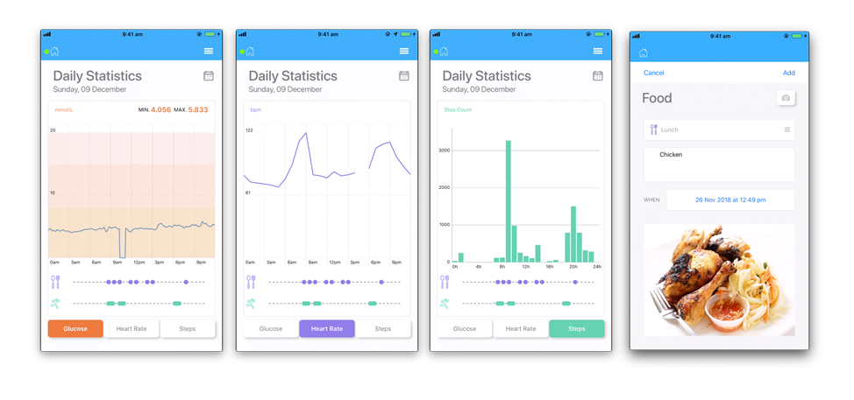

**Figure 2 a and 2 b**

**Title**

Change in mean glucose and time in range from day 1-4 to day 8-12.

**Legend**

2a Mean interstitial glucose recorded over the first 4 days of the study compared to last 4 days of the study. 2b Change in time in range for those subjects with intermediate control (n=7)(mean 636 datapoints vrs 671 datapoints p =0.019).

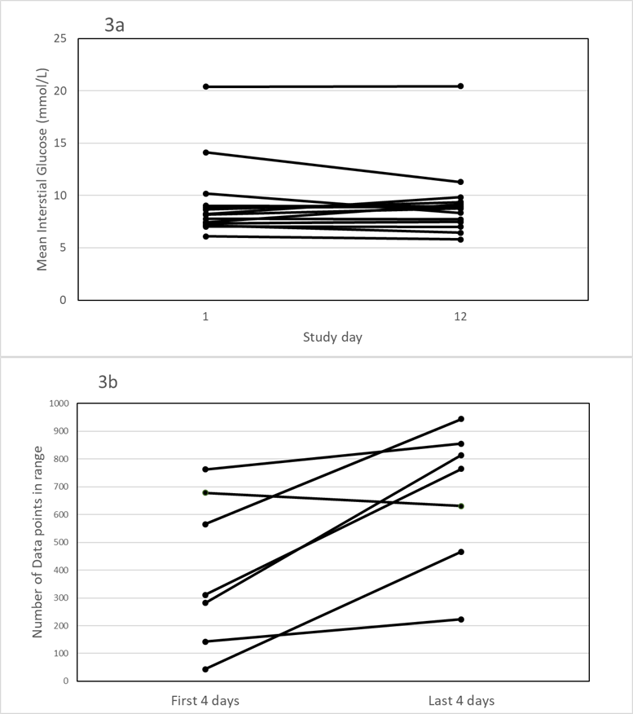

Table 1

Examples of feedback given by physician after review of previous days data.



Table 2

Baseline characterises of 15 subjects

|  |  |  |  |  |  |
| --- | --- | --- | --- | --- | --- |
|  |  |  |  |  |  |
|  |  |  |  |  |  |
|  | N | Minimum | Maximum | Mean | Std. Dev. |
|  |  |  |  |  |  |
|  |  |  |  |  |  |
| Age (y) | 15 | 41 | 65 | 54.07 | 7.16 |
|  |  |  |  |  |  |
| F:M | 15 |  |  | 4:11 |  |
|  |  |  |  |  |  |
| Height (cm) | 15 | 110 | 158 | 135.67 | 12.44 |
|  |  |  |  |  |  |
| Weight (kg) | 15 | 80.8 | 115.6 | 98.09 | 10.50 |
|  |  |  |  |  |  |
| Systolic BP (mmHg) | 15 | 110 | 158 | 135.67 | 12.44 |
|  |  |  |  |  |  |
| Diastolic BP (mmHg) | 15 | 71 | 103 | 85.07 | 9.11 |
|  |  |  |  |  |  |
| BMI (kg/m2) | 15 | 26.0 | 40.1 | 31.95 | 3.64 |
|  |  |  |  |  |  |
| Waist-Hip ratio | 13 | 0.91 | 1.06 | 0.98 | 0.04 |
|  |  |  |  |  |  |
| Hba1c (%(mmol/mol))) | 15 | 5.8 (40) | 13.6 (125) | 7.94 (63.3) | 2.14 (23.4) |
|  |  |  |  |  |  |
| Fructosamine (mmol/L) | 15 | 221 | 545 | 295.80 | 80.78 |
|  |  |  |  |  |  |
| Total Cholesterol (mmol/L) | 15 | 3.70 | 6.70 | 4.78 | 0.89 |
|  |  |  |  |  |  |
| HDL cholesterol (mmol/L) | 15 | 0.90 | 4.70 | 2.39 | 1.06 |
|  |  |  |  |  |  |
| Triglycerides (mmol/L) | 15 | 0.90 | 1.87 | 1.19 | 0.22 |
|  |  |  |  |  |  |
| Creatinine (µmol/l) | 15 | 39 | 163 | 82.27 | 34.30 |
|  |  |  |  |  |  |
|  |  |  |  |  |  |

Table 3

Changes in measured parameters from day 1 to day 12 of the study

|  |  |  |
| --- | --- | --- |
| Parameter | Change day 1 to day 12 | p-value |
| Systolic BP (mmHg) | -4.47 | 0.214 |
| Diastolic BP (mmHg) | -2.93 | 0.085 |
| Heart Rate (beats/min) | -1.67 | 0.41 |
| Weight (kg) | -0.64 | 0.055 |
| BMI (kg/m2) | -0.91 | 0.195 |
| Waist hip ratio | 0.01 | 0.27 |
| Hba1c (%) | -0.22 | 0.004 |
| Fructosamine (mmol/L) | -10.36 | 0.164 |
| Creatinine (µmol/L) | 3.27 | 0.098 |
| Total cholesterol (mmol/L) | -0.25 | 0.149 |
| LDL cholesterol (mmol/l) | -0.15 | 0.295 |
| Triglycerides (mmol/L) | -0.24 | 0.426 |
| HDL cholesterol (mmol/L) | 0.01 | 0.655 |