**GIS-based spatial accessibility to Islamic facilities for Muslim community in the Melbourne Metropolitan Area**

Khlood Ghalib Alrasheedi[1], Gang June Lue[2], Sultana Nasrin Baby[3]and Nadhir Al-Ansari [4]

Abstract

The Geographic Information System (GIS) technology has not been widely used in Islamic facilities including mosques, Islamic schools and Halal butchers is an important issue for the Muslims communities in the Melbourne, Australia. This study applied spatial methods to analyze the spatial accessibility to Muslim facilities of the population in Melbourne city. Spatial accessibility to this is because Muslim people believe that they must pray in the mosques, buy halal food and educate their children in Islamic environment. Therefore, this study aimed to (i) Identify spatial accessibility by car to the above-mentioned Muslim facilities and (ii) identify disadvantaged Muslim communities and facilities using census data at the fine spatial resolution (i.e. at Mesh Block level). The disadvantaged Muslim commonalities in the Melbourne Metropolitan Area (MMA) were delineated in GIS environment using such techniques as spatial and hot spot analysis, network analysis, mean center and standard distance methods were applied using ArcGIS 10.3. The spatial accessibility was assessed in terms of travel distance and time to highlight their differences. This study highlighted the most affected Muslim communities in terms of spatial accessibility, which are located in Hume, Whittlesea, and Melton and Casey suburbs. Furthermore, this study stressed that there is a lack of Mosques and Islamic Schools in the MMA, as approx. 5000 Muslims do not have proper access to this kind of facilities. The findings of this study could be used by Muslim community when choosing a suburb for their families. Therefore, it is recommended that the urban and regional planners should take the obtained results into consideration to achieve fair and better distribution of Islamic facilities in the Melbourne city.

**Keywords:** accessibility, Muslim facilities, Analysis by GIS, hotspot, Road network, Islamic school, halal butchers, Mosques

1. Introduction

The Muslim population in the Australian cities the 2016 census reports state that 30.2% of the Muslim population in Australia lives in Melbourne [1]. As per the Australian Buearu of Statistics (ABS) census 2016, the suburbs with the highest numbers of Muslim population in Melbourne have been identified as Meadow Heights, Reservoir, Dallas, Noble Park, Coburg, St. Albans, Broad meadows, Lalor and Dandenong. Given this large and substantially scattered Muslim population, it is essential to see if all the facilities and services needed by this population are available around the areas they dwell in. Spatial accessibility to places of worship and services and facilities including mosques, educational institutions, halal butchers is an important issue for the Muslims communities in Melbourne because they believe that they must attend their mosques [2], buy meat from halal butchers [3] and educate their children in Islamic environment [4]. Therefore, easy accessibility to places of worship and other services and facilities is crucial for the Muslims communities and surrounding suburbs (Euro – Islam info 2016). A number of minority religions (for example, Islam) in big countries like Australia have special significance to their religious identity [5]. [6] Remarked that it is very important to gain an understanding about the minority communities and their religious requirements as it moulds the society, they live in. Realizing the importance of religion and religious practices in daily life, it can be stated that the places of worship will have a huge importance in humane lives [6] Therefore, the places of worship for Muslims are very important and are parts of their social identity [13]. Similarly, other facilities for the Muslim community such as Islamic schools and halal shops will also have significant influence in their lives, because, for example, Muslims believe that they must consume meat from halal butchers. Thus, they practice their religion as guidance in their daily life which influences their choices of settlement and residence [7].

Spatial studies hold an important place in the research on religion because they provide an opportunity to explore both the spatial distribution of the faith followers as well as the religion facilities [8]. [9] Reported that many spatial studies have explored the places of worship. For example, [10] conducted spatial studies on Mosques. In addition, [9] conducted spatial studies that focused on Muslims and their identity. [11] Demonstrated that Geographic Information System (GIS) can be used to explore the distribution of worship places in the urban areas. GIS has also been used to identify disadvantaged areas and different aspects of accessibility to different places [12, 13, 14] established that when religions are studied from the geographical perspective, several concepts are used and comprehended in different ways. These concepts include access, accessibility, mobility, spatial cluster etc. Numerous studies on intra urban accessibility have been conducted in the fields of urban planning, transportation planning, geography sciences etc. [15]. The purpose of this study is to explore distribution and spatial accessibility to places of worship (i.e. mosque), Islamic schools and halal butchers for the Muslim communities in the Melbourne Metropolitan Area (MMA) using GIS.

1. Related work

After reviewing the previous and current work by geographers relating to religion and spirituality and faith, four overlapping themes have emerged: spatial distribution, landscape, social considerations, and cultural aspects of religions reflecting varied combinations of the topic and its related methodologies [16].The most significant area of growth in the geographies of religion is influenced by the “cultural turn”. In geography over the last two decades, the study focused on the cultural dimensions of political, social processes and economic [17].

It has been stated by [18] that geography’s distinctive contribution lies with the discipline’s core principles of space, place and scale. The geography of religion concerns itself with how religious ideologies, sites, institutions, activities, experiences etc. that are manifested across space, in different places and on a variety of scales, from corporeal and institutional to geopolitical [18].

Previous studies also involved spatial analysis on the relationship between faith followers and their places of worship, shopping, dining, education and services, and religious organizations that provide significant social services to communities [19]. The relationship is established after identifying the extent of service offerings within such communities, and location characteristics (i.e. similarities or differences), as against secular community-based organizations, faith-based organizations and religious congregations that offer services to low-income urban communities [19].

Employing qualitative and quantitative approaches together with survey data from religious and secular organizations, [19] demonstrated that religious institutions, specifically places of worship and faith-based organizations, had an important community attendance in their offerings, presence and locations. These religious institutions provided a substantial level of service to individuals, and hence operated as “silent partners” within their communities, providing important, even though often private, “institutional capital” to local development in urban America [19].

Research in the field of geography, in connection with religion, found that the consideration of religions, in terms of community space, or buildings and locations, helps us to understand certain risk factors that may cause conflict within ethnically diverse societies [20] The geographical study of religions also explains how particular social institutions, services, and organisations can use geographic concepts in religion (sacred sites, temples, churches, etc.) to improve the social environment and promote the value of tolerance. Through the investigation of some city’s religious landscapes, it was shown that in addressing the diversity issues, the urban, socio-cultural and political aspects are interrelated and the exclusion of any of these aspects from management practices often reduce the opportunity for the efficiency associated with diverse regulation [20]. Muslim population have increased tremendously in the past two decades in Australia, mainly because of the migration as well as natural increase. There were 604,200 Muslims in Australia, of which 40% were Australian born [21]. Total Australian population 2.6, an increase of over 15 percent of its earlier population share of 2.2% informed in the previous census 5 years earlier.

The remaining Muslim population is from the 183 countries all around the globe. This has resulted in Australian Muslims being one of the most ethnically and nationally heterogeneous religious communities [13, 22]. The study will focus on Muslim population distribution and will conduct a spatial analysis to investigate the spatial accessibility to the places of worships and Islamic facilities in the MMA, Australia.

1. Study area

Melbourne Metropolitan Area (MMA) in Australia was chosen as the study area. It has a total population of 5 million people, out of which 3.2% are Muslim [2]. MMA was selected as the study area for the following reasons:

* The MMA has Islamic facilities across the urban and regional areas, while Muslim communities have accessibility to these facilities by cars.
* The datasets required for the research were available from different government, non-government and educational organisations. Section 3.1 will provide a summary of the relevant features of the study area

The study area including land use, population distribution, the spatial distribution of Islamic facilities including Islamic schools, mosques and halal butchers and spatial accessibility to these facilities is presented. The land use is presented to understand the distribution and clustering of different land types in the MMA. The distributions of total and Muslim population at Statistical Mesh Block (MB) levels is also presented, while density (per km2) and ratio of Muslim to total population is presented at MB level only. Finally, the spatial locations of disadvantaged Muslim communities in terms of their access to the above-mentioned facilities are also highlighted. The largest area in the MMA is devoted for agricultural use and constitutes 48.34% followed by parklands (26.39%) and residential areas (19.35%). The remaining area of land is used for other purposes including industrial (2.68%), commercial (1.49 %), education (0.65%), transport (0.26%), water (0.66%) and other purposes (0.13%) [21]. Figures 1and 2 highlights that major portion of land use belongs to residential, agricultural and parklands usages.



Figure 1. Percentage of land use in the MMA.

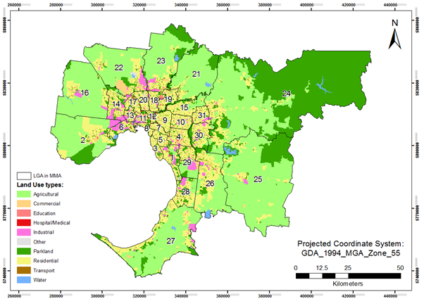

Figure 2. Land use distribution in the MMA basedon LGA.

1. Methodology and Data Processing

This research will identify Islamic facilities: mosques, halal butchers, Islamic schools using GIS techniques. Spatial variations of the Muslim population and the ratio of the Muslim population to the total population will be mapped to highlight areas of high and low spatial accessibility to Islamic facilities. The analysis will be performed at the finest spatial resolution, i.e. Mesh Block (MB) level [23]. Population data will be upscaled from SA1 to MB level using residential address locations. The high and low spatial accessibility from the locations of the Muslim population based on the travel distance and travel time to the Islamic facilities will also be analysed. Finally, the spatial configuration of the road infrastructure in the MMA will be mapped, including arterial, sub-arterial, collector and local roads. Thematic maps will be created using ArcGIS 10.4 to visualize and analyse the variations in Muslim population, densities and Muslim to total population ratios, spatial accessibility to Islamic facilities, hot spots in terms of distance and travel time and disadvantaged areas.

It was assumed that the existence of spatial variation in the distribution of population, Islamic facilities and road infrastructure has influence on the spatial accessibility to the Islamic facilities. Therefore, it was necessary to analyse spatial variations in accessibility to Islamic facilities at the finest available spatial resolution.

***4.1 Data Collection and pre-processing data***

For measuring and evaluating the spatial accessibility to the Islamic facilities, the data on Muslim population, locations of the Islamic facilities and road network were required. The data on population, including various attributes, i.e. age, religion, were acquired directly from the Australian Bureau of Statistics [21] (see: <http://www.abs.gov.au>). The Islamic facility data, including the locations of Halal butchers, Islamic schools and Mosques were obtained from the Islamic council of Victoria (see: <http://www.icv.org.au/> ) as a table. The datasets on Local Government Area boundaries and road networks were downloaded from the Victorian Government database (see: <https://www.data.vic.gov.au>) in vector format.

***4.2 Geocoding locations of Islamic facilities***

The data for the mosques, islamic schools and halal butchers were processed in an Excel spread sheet and further geocoded to allow its use in a GIS environment. It is necessary to have street address and reference datasets for geocoding [24]. Moreover, the correct spelling of addresses was checked to avoid errors in geocoding [24]. [24] theorized and demonstrated three steps for the geocoding process as: Pre-processing, Matching, After collecting the data from their respective sources, each address was checked in Google maps in Google Street view (<https://www.google.com.au/map/>) to verify addresses retrieved were the actual addresses and street photos. This verification is an additional precaution taken to get error free data. Some of the addresses extracted from the sources did not exist, and thus were removed from the database. The website (<http://mynasadata.larc.nasa.gov/latitudelongitude-finder>) was further used as a tool to convert address layer information into corresponding latitude and longitude coordinates for the Islamic facilities.

***4.3 Mapping the spatial distribution of the Muslim population***

The ABS in Australia is the nation’s statistical agency and served as a source of population data used in this study. These data were available at various spatial levels. The population data for 2016 were downloaded at the finest available resolution, i.e. SA1 level. The availability of address data and MB level spatial units made the estimation of spatial accessibility at a much finer resolution possible. In this study the 2016 SA1 level population data were disaggregated into their corresponding MB units. The merits of conducting such intricate spatial analysis at a much finer resolution of MB rests with the research focus, which can be performed explicitly for residential areas [14].

There are numerous methodologies for spatial data disaggregation. This research is focusing on interpolating data using the address-weighted method to disaggregate population data from SA1 to MB level in MMA. There were two assumptions made for the creation of the disaggregated population datasets:

• The population distribution is even among residential addresses within the SA1 layer.

• There is variation of population across urban space, the density of cumulative residential address points can be considered and recognized as proxies for the given population density.

The equations used for disaggregation of the 2016 SA1 level population to their corresponding MB units are given below [14]:

$\frac{{MB}_{addi}}{{SA1}_{add}}=\frac{{MB}_{pi}}{{SA1}_{p}}$ (1)

${MB}_{pi}=\frac{{MB}_{addi}}{{SA1}_{add}}{SA1}_{p}=\frac{{MB}_{addi}}{{\sum_{i=1}^{n}{MB}}_{add}}{SA1}_{p}$ (2)

*MBpi* is the population of residential *MBi*, *SA1p* is the population of the *SA1* that contains *MBi, MBaddi* is the number of residential address points that are located within *MBi*, *SA1add* is the number of residential address points located within the *SA1* that contains *MBi*.

The above-mentioned analysis was performed separately for Islamic and total population in the MMA. In addition, the densities of Islamic and total population and their ratios were calculated.

The population density was calculated as:

${MB}_{population density}=\frac{{MB}_{total population}}{{MB}_{area}}$ (3)

The ratio of the population was calculated as:

${MB}_{ratio population}=\frac{{MB}_{islamic population}}{{MB}_{total population}}$ (4)

The information that was extracted using the above mentioned calculations was mapped to demonstrate spatial variations of total Muslim populations, density and the Muslim to total population ratio.

***4.4 Measuring spatial accessibility to Islamic facilities***

Two road network datasets were available for this study. The first was complete containing all road types, and the second was missing some minor roads, but contained information on speed limits. After performing spatial adjustment procedures using Transfer Attributes function in ArcGIS, speed limit attributes were transferred to the complete road network dataset. Road network was further refined by removing bicycle paths, walking tracks and proposed roads, as we were interested in car accessibility only. The speed limits for road segments with missing speed sign attributes were calculated by averaging speed signs per road type, as follows: freeways: 93 km/h, highways: 78 km/h, arterial roads: 70 km/h, sub-arterial roads: 70 km/h, collector roads: 56 km/h, local roads: 52 km/h, 2WD tracks: 83 km/h and 4WD tracks: 99 km/h. As average speed limits for 2WD and 4WD tracks were unreasonable, we defaulted them to 60 km/h. In order to ensure that all the roads were connected we also processed it through the Integrate tool in ArcGIS 10.4. The final road network was also Split at Vertices to ensure snapping of MB centroids in the network Analyst (ArcGIS 10.4). It is also important to note that in this study such factors as the road condition and congestion times were ignored.

The shortest network distance and travel time were measured from the centre of each MB to the closest facility. The distance was measured in metres, while travel time was calculated in minutes. Firstly, the measurement of travel distance was calculated using network Analyst capabilities. The spatial accessibility in terms of distance was further categorized into the following five classes: < 3000 m, 3000-6000 m, 9000-16000 m and > 16000 m. Secondly, the conversion of travel distances to travel time was carried out using the speed limit sign information. The following formula was used to calculate travel time:

$Travel time= \frac{Distance(m)}{Speed Limit(\frac{km}{h})*1000}*Speed(\frac{Km}{h})$ (5)

Then, the travel times to mosques, halal butchers and islamic schools was also transformed into the following five classes: <5 min; 5-10 min; 10-15 min; 15-20 min and >20 min using Python capabilities in the field calculator of ArcGIS using the following expression (in this example for mosques):



***4.5 Conducting Hot Spots analysis based on travel time and travel distance***

The Hot Spot Analysis tool in ArcGIS calculates the Getis-Ord Gi* statistic (pronounced G-i-star) for each feature in a dataset. To be considered as a hot spot which is statistically significant it must be surrounded with areas of high values as well. The sum of the local values for a feature and its neighbours is compared equally to the sum of all features.

Cluster analysis was based on hot spot analysis (Getis-Ord Gi*) implemented in ArcGIS Spatial Statistics toolbox [25]. Hot spot analysis was performed for both Muslim to the total population ratio as well as spatial accessibility to Islamic facilities in terms of distance and travel times.

*Identifying disadvantaged locations*

In order to identify areas of disadvantaged Muslim populations, we overlaid spatial clusters of MBs with high Muslim to total population ratio, i.e. high ratio of Muslim population, with clusters of MBs with high travel times and distances to Islamic facilities, i.e. low spatial accessibility. The Intersect tool from ArcGIS 10.4 was used to perform this procedure of hot spots of Muslim to total population ratio and spatial accessibility to Muslim facilities. Then disadvantaged areas were grouped into seven categories, such as disadvantaged in terms of accessibility to (1) mosques, (2) halal butchers, (3) Islamic schools. This research discusses the methods and techniques used to analyse spatial accessibility to the Islamic facilities for Muslim communities living in the MMA using ArcGIS 10.4. The step-by-step methodology of this research is presented in the flowchart (Figure 3).

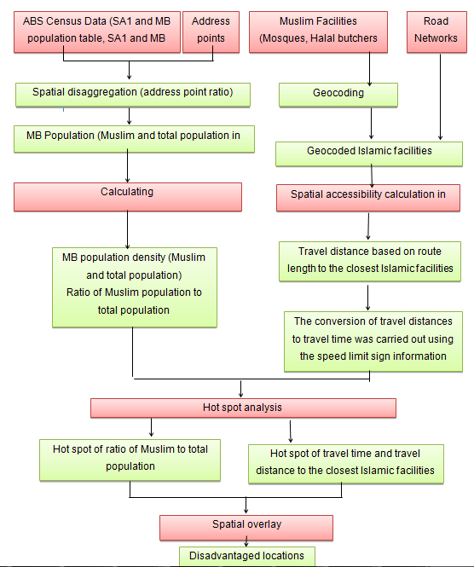

Figure 3. Flow chart describing the methodology used in this study.

1. Results and Discussion

The land use is presented in order to understand the distribution and clustering of different land types in the MMA. The distributions of total and Muslim populations at Statistical Area Level 1 (SA1) and Mesh Block (MB) levels are also presented, while density (per km2) and ratio of Muslim to total population is presented at MB level only. Finally, the spatial locations of disadvantaged Muslim communities in terms of their access to the above-mentioned facilities are also highlighted.

***5.1Muslim population density at MB level***

The Muslim population density (persons/km2) in the study area was calculated and mapped in Figures 4 and 5.

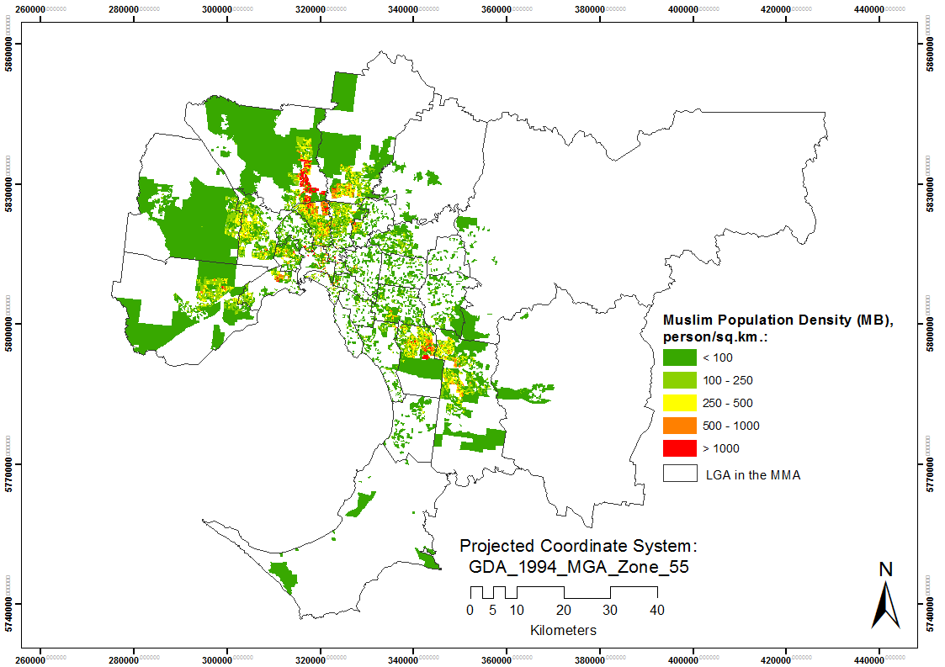

Figure 4. Muslim population density based at MB level

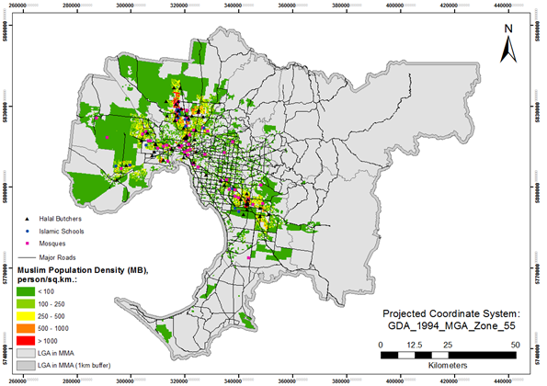

Figure 5. Spatial distribution of Islamic facilities in the MMA

Figures 4 and 5 shows the Muslim population density distribution at MB level with less than 100 to more than 1000 persons/km2. First and second density classes (less than 250 persons/km2) are the most common and are scattered all over the MMA with large clusters in the northern, western and south-western parts of the MMA. In contrast, second, to fifth classes, with densities of more than 250 persons/km2, are predominantly distributed in the northern, western and south-eastern parts of the MMA with insignificant occurrence in other areas. The locations of densely populated Muslim MBs are similar to those of Muslims in total populations (Figure 4), and thus both could be used for identification of hot spots of highly populated areas.

*5.2. Spatial distribution of Islamic facilities in the MMA*

Islamic facilities data were retrieved from the Islamic Council of Vitoria website (http://www.icv.org.au/). The locations of the Islamic facilities were geocoded using the address layer of the VicMap database and verified using Google Map and high-resolution aerial images accessible through ArcGIS base maps. The travel time calculation, as discussed in Section 3, was carried out based on travel distance model by car. Figure 2 shows the distributions of 65 halal butchers, 14 Islamic schools and 60 mosques, Muslim population density and the major roads in the MMA.

From Figure 5 the Melbourne city and Port Phillip, northern suburban areas (i.e. Moonee valley, Moreland and Hume) and south-eastern suburban areas (i.e. Greater Dandenong) have the majority of halal butchers, Islamic schools and mosques. These areas also correspond to the most densely populated regions. There are also Islamic services and facilities in the Western suburbs (i.e. Hobsons bay, Maribyrnong and Brimbank). There are few facilities in Melton, Wyndham, Werribee, Point Cook and Tarneit, while the furthest mosque from the Melbourne CBD is at Frankston. Travel distances in metres from the MB centroids to the mosques were classified into five categories (Figure 6).

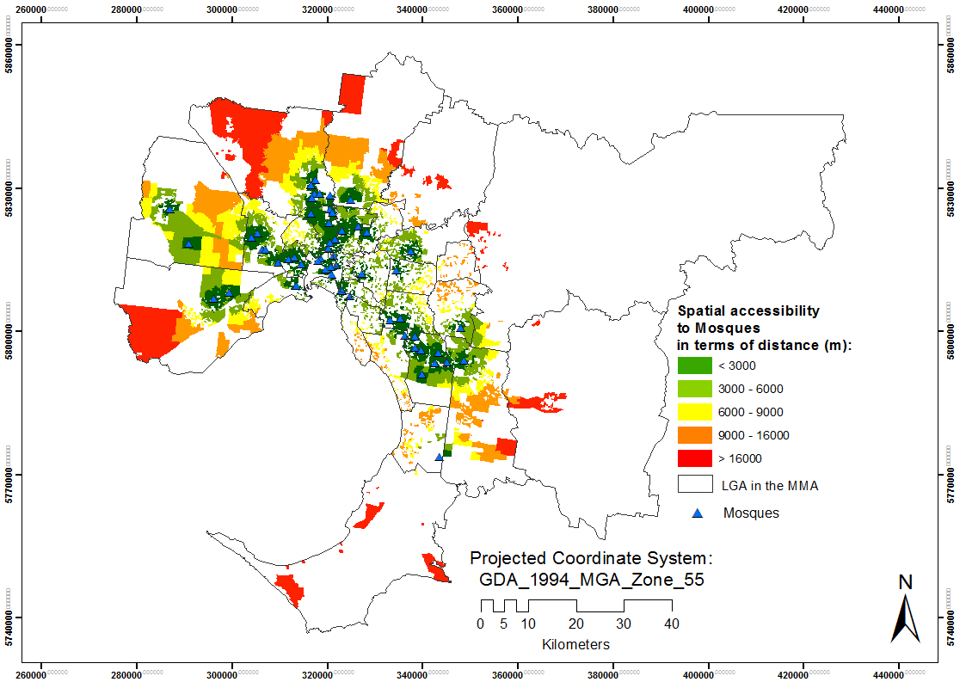

**Figure 6.** Spatial accessibility to Mosques in terms of travel distance.

The first distance class represents areas of less than 3000 m from the MB centroids to the mosques. These areas are indicated by dark green, and are in the northern, western and south-eastern areas of the MMA, and correspond to the locations of the mosques. The second, third and fourth classes are evenly distributed away from the mosque locations, and represent MBs within 3000-6000 m, 6000-9000 m and 9000-16000 m of the mosques, respectively. The fifth class in red corresponds to areas located the furthest away (>16000 m) from the mosques, which is mainly located at the outskirts of the MMA.

* 1. *Spatial accessibility to Islamic facilities based on travel time*

The second parameter used for determining spatial accessibility is based on travel time. For the calculation of travel time various variables such as congestion zones as well as parking time were ignored.

*Travel time to mosques*

Travel time (in minutes) by car to reach the closest mosque from MB centroids is presented in figure 7. Similarly, to the travel distance, the travel times were classified into five categories.

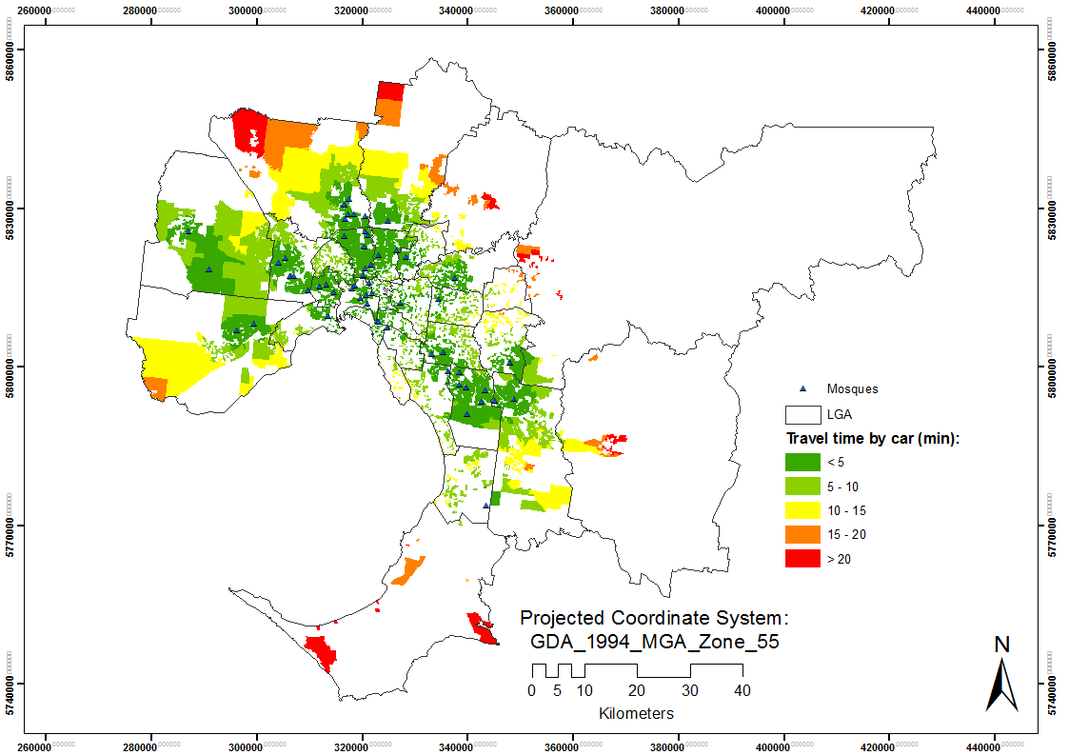

Figure 7. Spatial accessibility to mosques in terms of travel time

The first and second classes corresponds to the areas with travel times less than 10 minutes. These areas indicated by green and are mainly found in the Northern, western and south-eastern areas of the MMA. These areas have the best accessibility to mosques in the MMA. The third, fourth and fifth classes in yellow, orange and red correspond to travel times of more than 10 minutes. These areas are concentrated on the outskirts of the MMA, and are mainly scattered as minor patches in the outer northern, south-eastern and southern regions of the MMA.

*Clustering of Muslim to total population ratio*

To identify regions with highly populated MBs the hot spot analysis of Muslim to total population ratio showed a, substantial part is occupied by the Muslim population. Cold and hot spots are characterized by the ratio of Muslim populations to total populations having negative and positive Z score, respectively.

As can be seen in Figure 8 cold spots are scattered in the outskirts of the MMA, while hot spots are concentrated mainly in the south-eastern and north-western regions of the MMA. Hot spots represent clusters where there are significant Muslim populations, whereas cold spots represent areas where the Islamic population is very low compared to the total population. It can be seen that most Muslims live in the hot spots (62%), while the Muslim population that lives in cold spots is very low (0.1%). However, there are 5639 MBs (21.7%) in hot spots, whereas there are 7641 MBs (29.4 %) in cold spots. The area of hot spots is also substantially lower than that of cold spots (594 km2 vs 1554 km2).

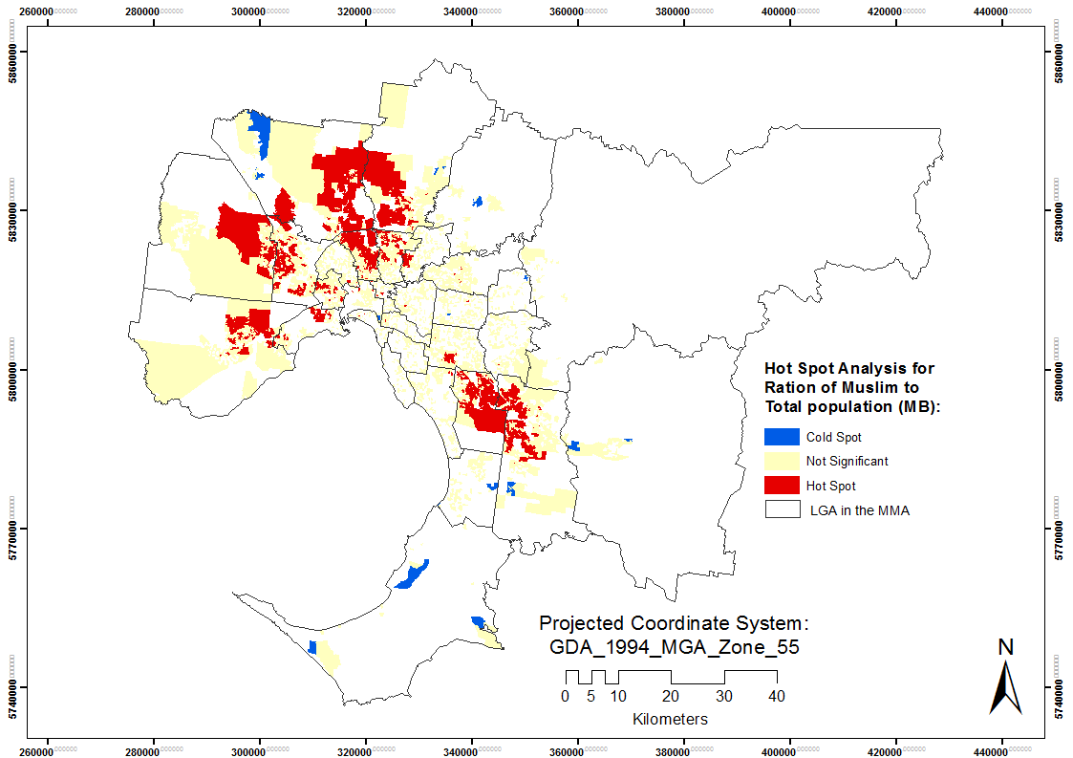

Figure 8. Clustering of Muslim to total population ratio in the MMA

*Clustering of travel time spatial accessibility to mosques*

Figure 9 shows clustering of spatial accessibility to mosques in terms of travel time. It is evident that cold and not-significant spots are in the inner sides of the MMA, while hot spots are predominantly located in the North-Western and South-Western parts of the MMA.

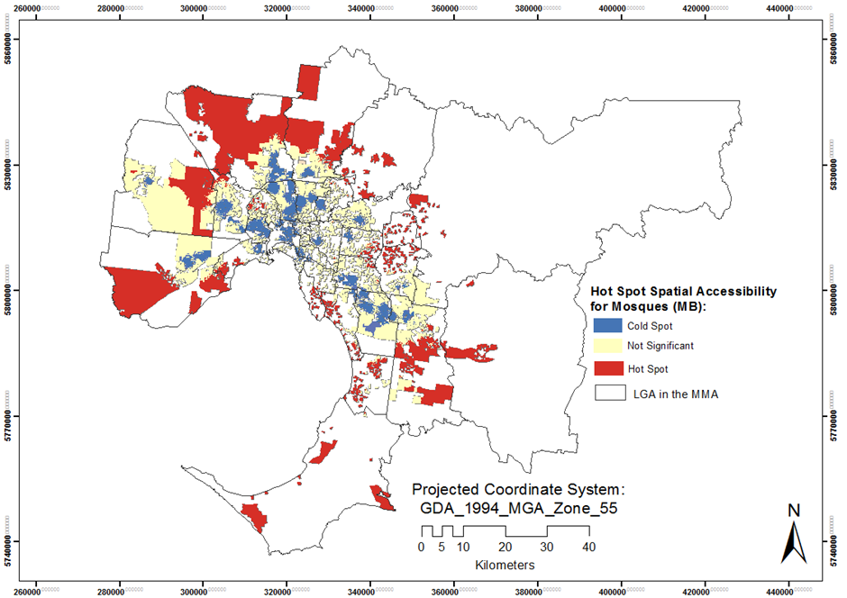

Figure 9. Hot spot analysis of spatial accessibility to mosques based on travel time.

Hot spots of spatial accessibility to mosques refer to areas with high travel times, while cold spots refer to areas with low travel times.

The hot spots account for an area of 908 km2 covering 4901 MBs, which is substantially higher in comparison with the cold spot areas which occupy 201 km2 and cover 7074 MBs. Cold, not significant and hot spots account for 42%, 47% and 12% of the total Islamic population, respectively.

The distributions of cold and hot spots are like that of Islamic Schools. However, cold spots are much more localised around Mosques and occupy a smaller area.

* 1. *Identifying disadvantaged Muslim communities*

Disadvantaged areas are defined as areas with low spatial accessibility to closest Muslim facilities and high Muslim to total population ratios. Figure 10 shows these disadvantaged locations based on travel time by car. On average disadvantaged locations are located 9.3 minutes, 11.2 minutes and 15.1 minutes from mosques, halal butchers and Islamic schools, respectively.

Figure 10 shows disadvantaged locations of low spatial accessibility in terms of travel time and high Muslim populations to various Islamic facilities. The disadvantaged locations can be mainly found in the northern and north-western areas of the MMA. As it can be seen, most of the disadvantaged population in the northern regions have difficulty accessing mosques and Islamic schools, and in the north-west they have difficulty accessing Islamic schools and Halal butchers. Similarly, disadvantaged locations of low spatial accessibility in terms of travel distance and high Muslim populations are presented in figure 10. Disadvantaged areas represent locations within MMA where there is a high proportion of Muslims with low spatial accessibility to essential facilities reside. On average disadvantaged locations are located 9093 m, 11530 m, 14988 m from mosques, Halal butchers and Islamic schools, respectively.

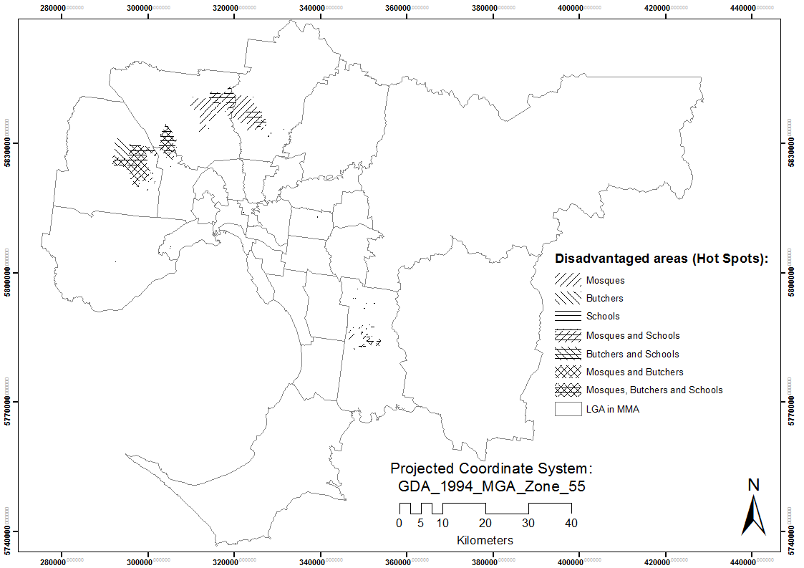

Figure 10. Disadvantaged locations of Muslim populations in terms of travel time accessibility.

1. **Conclusions and outlook**

This research provides an insight into Muslim population distribution and spatial accessibility in terms of travel distance and time to Islamic facilities in the MMA. GIS confirmed to be a robust approach to extract accurate information on spatial accessibility. This study also highlighted the most affected Muslim communities in terms of spatial accessibility, which are in Hume, Whittlesea, Melton and Casey suburbs. It is also clear that there is a lack of mosques and Islamic schools in the MMA, with approx. 5000 Muslims not having convenient access to this kind of facility. The findings of this study could be used by Muslim communities when choosing a suburb for their families. The urban and regional planners could also use the findings of this research while considering the development of Islamic facilities.

References

1]Nayak, A. (2012), Race, religion and British multiculturalism: The political responses of Black and Minority Ethnic voluntary organisations to multicultural cohesion, Journal Political Geography, 31, 7, 454-463.

[2]Australian Buearu of Statistics (2017), 2016 Census data reveals “no religion” is rising fast (<http://www.abs.gov.au/>).

[3]Bonne, K., & Verbeke, W. (2008). Muslim consumer trust in halal meat status and control in Belgium. Meat science, 79,1, 113-123.

[4]Ahmad, I., & Szpara, M. Y. (2003), Muslim children in urban America: The New York city schools experience, J. of Muslim Minority Affairs, 23,2, 295-301.

[5]Woodlock, R. (2010). Praying where they don't belong: female muslim converts and access to mosques in Melbourne, Australia. Journal of Muslim Minority Affairs, 30, 2, 265-278.

[6]Muñoz, S. A. (2010), Geographies of faith: the differing residential patterns of the Indian‐Hindu, Indian‐Sikh and Indian‐Muslim populations of Dundee and Glasgow, J. Population, space and place, 16, 4, 269-285.

[7]Beckford, J. A. (2019), Religions and migrations–old and new, J. Quaderni di Sociologia, 15-32. https://doi.org/10.4000/qds.2599

[8]Mourad, H. (2009), The development and land use impacts of local mosques. B. Planningthesis, Unpublished. Sydney: The University of New South Wales. https://www.be.unsw.edu.au/sites/default/files/upload/pdf/schools_and_engagement/resources/_notes/5A4_5.pdf

[9]Khan, A. A. (1992), An integrated approach to measuring potential spatial access to health care services, J. Socio-economic planning sciences, 26, 4, 275-287.

[10]Nayak, A. (2012), Race, religion and British multiculturalism: The political responses of Black and Minority Ethnic voluntary organisations to multicultural cohesion, J. Political Geography, 31, 7, 454-463.

[11]Ayhan, I., & Cubukcu, K. M. (2010), Explaining historical urban development using the locations of mosques: A GIS/spatial statistics-based approach, J. Applied Geography, 30,2, 229-238.

[12]Allan, D. P. (2014), Catchments of general practice in different countries–a literature review, International J. of health geographics, 13,1, 32.

[13]Ball, W., & Beckford, J. A. (2018), Religion, education and city politics: A case study of community mobilisation, In Jewson N. and Macgregor S. (Editors), Transforming Cities , part 4, chapter 14(pp. 193-204). Taylor and Francis Group, Routledge.ISBN: 9781351169486

[14]Ahmad, S. (2012), A GIS based investigation of spatial accessibility to health care facilities by local communities within an urban fringe area of Melbourne, Master Thesis, Mathematical and Geospatial Sciences, RMIT University, Melbourne, Australia.

[15]Geurs, K., Zondag, B., De Jong, G., & de Bok, M. (2010),Accessibility appraisal of land-use/transport policy strategies: More than just adding up travel-time savings, J. Transportation Research Part D: Transport and Environment, 15, 7, 382-393.

[16]Kumar, D., Singh, A., Jha, R. K., Sahoo, S. K., & Jha, V. (2018), Using spatial statistics to identify the uranium hotspot in groundwater in the mid-eastern Gangetic plain, India, J. Environmental Earth Sciences, 77,19, 702.

[17]Bisin, A., Patacchini, E., Verdier, T., & Zenou, Y. (2008), Are Muslim immigrants different in terms of cultural integration?, J. the European Economic Association, 6,2-3, 445-456.

[18]Julian Holloway, Oliver Valins. (2002), [Editorial: Placing religion and spirituality in geography](https://www.tandfonline.com/doi/abs/10.1080/14649360120114107), J. Social & Cultural Geography 3,1, 5-9. DOI: 10.1080/14649360120114107

[19]Botchwey, N. D. (2007), The religious sector's presence in local community development, J. Planning Education and Research, 27,1, 36-48.

[20]Yang, F., & Ebaugh, H. R. (2001), Religion and ethnicity among new immigrants: The impact of majority/minority status in home and host countries, J. the scientific study of religion, 40, 3, 367-378.

[21]Australian Bureau of Statistics (2011), ‘Census of Population and Housing 2006 and 2011’, Australian Bureau of Statistics ABS, Canberra. https://www.abs.gov.au/ausstats/abs@.nsf/ViewContent?readform&view=productsbyCatalogue&Action=Expand&Num=2.1

[22]Akbarzadeh, S. (2001), Unity or fragmentation? In Saeed, A. and Akbarzadeh S. (Eds.), Muslim Communities in Australia, Sydney NSW Australia: University of New South Wales Press Ltd., pp. 228 - 234. ISBN:0868405809

[23]Mavoa, S., Witten, K., McCreanor, T., & O’sullivan, D. (2012), GIS based destination accessibility via public transit and walking in Auckland, New Zealand, J. Transport geography, 20, 1, 15-22.

[24]Chan, D. V., Gopal, S., & Helfrich, C. A. (2014). Accessibility patterns and community integration among previously homeless adults: A Geographic Information Systems (GIS) approach. Social Science & Medicine, 120, 142-152.

[25]Kong, L. (2010), Global shifts, theoretical shifts: Changing geographies of religion, J. Progress in Human Geography, 34, 6, 755-776.

1. Department of Geospatial, Royal Melbourne institute of technology (RMIT University), Melbourne, Victoria, Australia. s3415582@student.rmit.edu.au
2. Department of Geospatial, Royal Melbourne institute of technology (RMIT University), Melbourne, Victoria, Australia. gang-jun.liu@rmit.edu.au
3. Department of Geospatial, Royal Melbourne institute of technology (RMIT University), Melbourne, Victoria, Australia.snb.sdml@gmail.com
4. Lulea University of Technology, Lulea 971 87, Sweden. nadhir.alansari@ltu.se