Achieving Financial Inclusion through Agent Banking: An Inventiveness to Bank the Unbanked People
Md. Khaled Bin Amir
Abstract: The main purpose of this research is to reflect the attainment of financial involvement through agent banking. To achieve the key purpose trends and growth forecast of agent banking both in countryside and urban area have been displayed with mentioning male and female users. Number of accounts, amount of deposits and loans, frequency and amount in remittance inflow and number of agents have followed an increasing trend over 2015 to 2020 clearly showing more geographically disbursed unbanked people come under banking facilities through agent banking. The study has found significant impact of deposits amount, remittance inflow and number of agents on financial inclusion, indicated by number of accounts in agent banking in Bangladesh. Data is free from multicollinearity problem as VIF for each independent variable is within accepted range and study reveals random effect model, observing the Hausman test.
1.0 Introduction
Over time, banking activities have been easier, faster, and wider throughout the world and many new services are introduced for accelerating the process. Agent banking is simply the outcome of this process where the main purpose is to blowout banking services to the unbanked and rural people of a country. So that they can enjoy basic banking services. Agent banking also makes it possible to spread banking services outside the physical banking structure which helps a large portion of the population to fulfill their financial needs in the disbursed area.
Besides the traditional structure of the banking system, this new invention is rapidly introduced in many developing countries. In Bangladesh, the government took the initiative of opening agent banking activities in 2013, and to implement that Bangladesh Bank introduced necessary guidelines to regulate and instruct the banks about the details of agent banking.
As agent banking is a unique banking system, many banks are interested to offer it to both in rural and urban areas distressed and unprivileged people in Bangladesh. Services include deposit collection, loan disbursement, collecting inward remittance, utility bill payments, and all these services are offered by an authorized agent. This agent is a third party owner who is responsible for doing the banking transactions on behalf of the respective bank. Agent banking always focuses on providing regular banking services with the help of agents to help the rural people to transact their necessary transactions through a formal structure and help the economy to use the scatter money for a greater purpose.
In Bangladesh, about 41% of workforces are involved in the agricultural sector and the bulk of them lives in a rural area where a formal banking structure is impossible to establish. Agent banking is helping in this situation by fulfilling basic banking needs and leading to financial inclusion. As most of the rural people are uneducated, providing banking services through agents is the easiest way to achieve the goal of financial inclusion.
1.1 Objectives of the report
The broad objective of this report is to see how agent banking is opening a new scope of achieving financial inclusion in Bangladesh.
To achieve the broad objective of this report, the following specific objectives are focused on the report-
- To know the trend and growth of agent banking by emphasizing on the numbers of banks and their agent banking facilities dividing into male, female, urban and rural segments for promoting financial inclusion.
- To assess the amount of deposit collection, inward remittances, number of agents and loan disbursement through agent banking for the customers outside the bank premises.
2.0 Literature Review
In developing countries about 28 percent of adult people are under banking channel and an estimated account rate per adult is 0.9. Financial services can bring a positive result in people’s lives on the way to financial inclusion (Kendall, 2010). Furthermore poor people's lives are changing as they are getting basic financial services like savings, making payments, credit which is making a positive difference in the way of financial inclusion (Dupas and Robinson, 2009). Financial inclusion is a blessing to small and medium firms as they face fewer obstacles to flourishing the business. Besides, there have been many arguments regarding the conviction of financial exclusion as an obstacle to the development of the economy and promoting financial inclusion in the system (Schiffer and Weder, 2001).
In 2013, Bangladesh Bank introduced agent banking defining banking services out of traditional banking structure through a branchless process and engaging agents under a rational agency agreement where the central bank has the target to serve the underserved and impoverished segments of the population focusing to reach geographically dispersed places (Bangladesh Bank, 2018).
In Colombia there had been seen relationship between financial inclusion and branchless banking which significantly reduce delivery and set up cost, operating cost, cash in and out the cost and wider range of service cost. Both rural and urban people feel more ease in banking transaction rather than in bank premises because of agent banking (Ivatury and Pickens, 2006). It was also shown that a broader range of social and economic inclusion was possible if the bank continued to offer fundamental services through agents.
In 2009, the World Bank found that the meaning of financial inclusion is different in developed countries as they included advanced tax savings accounts, basic accounts, government payments (World Bank, 2008). A study made by Financial Sector Development -FSD in 2000 showed that the UK had boosted towards financial inclusion due to change in regulations in financial markets, and development in information technology (Leyshon and Thirft, 1995).
Many studies have been conducted to show the relationship between financial inclusion and agent banking and degree of effectiveness in developing countries. Cost structure and high cost per branch are the key barriers in financial inclusion which could only be solved by agent banking. If there is no concept of agent banking then the bank has to establish different branches with full empowerment in different remote places which is costlier process (Gardeva and Rhynea, 2011).
Generally bank needs to bear high initial cost while opening branches in several areas which lengthen the breakeven tenure. So the introduction of banking services through agents is a better way to do business across the country where potentially less number of people live and less volume of the transaction will occur. If agents will be available for a longer period, local people will be at ease to do the transactions and it will increase the bank's profit and indirectly improve productivity by increasing customer base and decreasing branch costing (Morgan P, 2014). Agent banking solves the liquidity crisis in the countryside where lack of liquidity is not a widespread problem among the low-income people becoming less sensitive to these occasional shortfalls as they are getting continuous service without waiting in a queue (Musau, 2013). Regulatory amendments are placed in one institution and the regulations are in favorable conditions of the banks which drives the financial inclusion (Sarker, Ghosh and Palit, 2015). Besides banks can reach potential customers like low-income people, rural people through this fixed cost system and simply transferring some operating power to the agents without the high cost of branch management (Camara, Tuesta and Urbiola, 2015).
Day to day banks are becoming interested in agent banking because of some motivating factors like desiring to connect remote areas by exploring new market segments and wide-spreading geographical customers through digitalized services as banks don’t need to expand an entire branch with a heavy investment in infrastructure (Santu, 2017). Moreover, agent banking produces less cost for the banks than branch banking (Hass, 2015). This study also found that branch banking is 58% costlier than agent banking because agents of several banks do not need huge human resources as well as infrastructures which lower the overall operating and maintenance costs also banks have to pay fewer commissions to the agents compared to salaries offering to regular employees
Agent banking can help low-income and disadvantaged people leading them towards taking credits and deposits on an easy process and this helps on the way to financial inclusion. Agent banking services help the banks to uphold the financial and economic process even in macroeconomic crises which surrounds continuous financial system around unprivileged people (Hanning and Jansen, 2010). It also expands employment opportunities as local people get loan easily, flourishing their SME businesses avoiding less unfavorable conditions than before (Achagamonu, 2016).
In most cases, customers are not aware about facilities of the formal financial system, also they can't afford them for high costs in transactions involving the cost of information, transportation, and opportunity. Sometimes offered services and products don't match with their needs and wants and make them abstain from this formal system as they are less creditworthy according to established characteristics of being a bank customer (Singh, 2014). As agent banking is less time consuming, more efficient, and less expensive than formal banking services, potential of flourishing agent banking in differen countries is very high (Ahmed JU and Ahmed A, 2018). Through innovation of agent banking process for connecting unbanked people can be a great initiative for financial inclusion. Agrani Bank was able to connect poor people to access financial services using Ansoff’s Growth Matrix also known as product market matrix which focus on evaluating chances for corporations to upsurge their sales through displaying alternate amalgamations for new markets by market penetration strategy, market development strategy, product development strategy and diversification strategy (Abdin.J, 2016). Another study shows, there is a possibility of interaction between financial inclusion and agent banking through some external influences like political, economic, and government policies (Afande, 2015). Some success factors towards a succession of agent banking in Bangladesh like innovations, new technologies, and banking structure (Mujeri, MK, 2018).
2.1 Agent banking in Bangladesh
Any contract entered into between a bank and an agent or juristic person shall comply with these guidelines and any other relevant laws in force. Furthermore an agent can operate more than an outlet to provide a framework for offering branchless banking services and promote financial inclusion within a safe and sound financial system environment (Guidelines for agent banking by Bangladesh Bank, 2017). Besides these, from the inception of agent banking in the formal banking sector to till 2020, agent banking grows day by day to bring the unbanked and underprivileged people within the banking system and this growth can be seen through analyzing some of the variables of agent banking in Bangladesh through trend analysis.
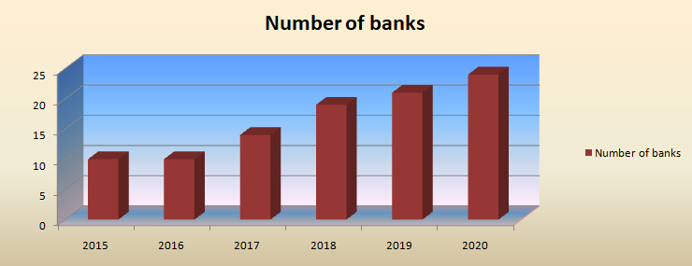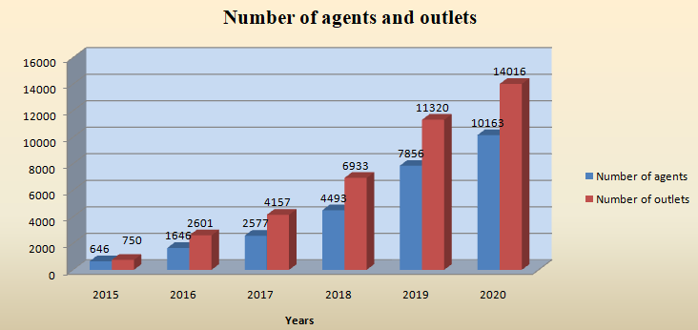
Figure 1: Number of banks, agents and outlets (Source: Bangladesh Bank)
Above graph shows in 2015, there are only 10 banks in this field but now in 2020, the number turns to increase at 24 and outlets reached at 14016, indicates more banks are engaging in this potential sector. Initially, both the number of agents and outlets were growing at a slow pace but from 2018 the number has begun to grow compared to consecutive previous years.
2.2 Male and female accounts
Agent banking service has a specific goal when started its journey in Bangladesh only purpose to connect more underprivileged male and female people both in urban and rural areas in the form of formal banking channels. Below charts clearly displays that male and female both are alike concern on agent banking but people in rural area are getting more facilities than urban areas over the period.
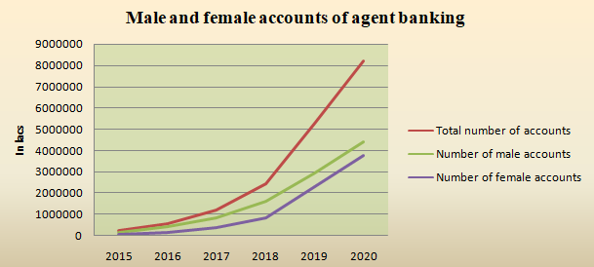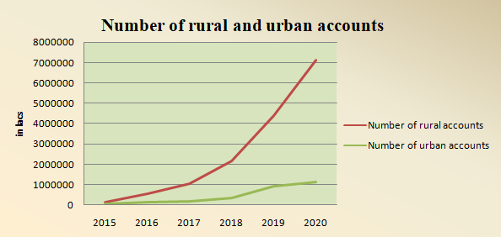
Figure 2: Male-female and rural-urban accounts of agent banking (Source: Bangladesh Bank)
2.3 Deposits overview
The following graphs show amount of deposit collection is increasing enormously in 2017 which was far better than 2015 and 2016. The amount reached from 5851.82 to 1304061.72 lakh in 2020 and hope to increasing further. Additionally 77% of rural people are now depositing their money through agent banking which is higher than urban people.
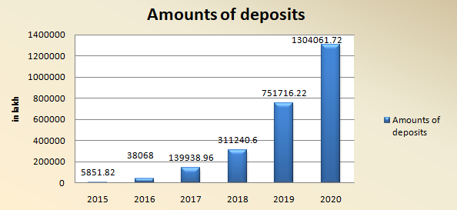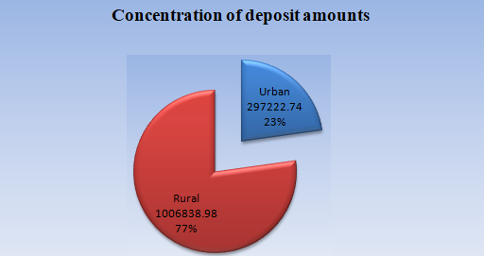
Figure 3: Amount of deposits and Concentration of deposit amounts (Source: Bangladesh Bank)
2.4 Loan Overview
Though all 24 banks are offering loan services through agent banking to the people which are very few compared to all banks in banking industry of Bangladesh. Very few are offering lending services to the customers through agent banking. Following graph shows that lending is very significant in 2019 and 2020 which are doubled than 2015. Besides people who are taking loans are mostly from the rural area. On the other hand urban area, 35% of people are enjoying loan facilities of agent banking.
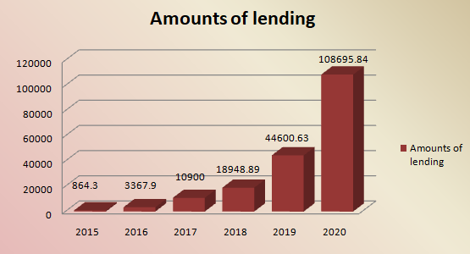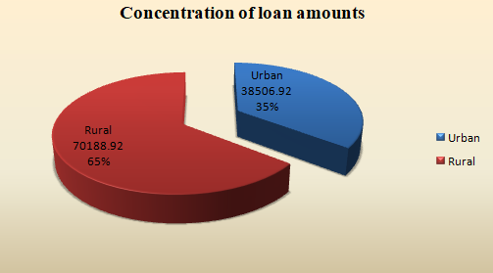
Figure 4: Amounts of lending and concentration of loan amounts through agent banking (Source: Bangladesh Bank)
2.5 Remittances overview
Observing the following graphs, significant change has been seen in earning remittance through agent banking from 2015 to 2020. Due to the inception of agent banking, remittance is easily reached to unbanked people through a proper banking channel. According to agent banking report of Bangladesh Bank, around 90% rural and 10% urban people are getting remittance facilities who are out of main stream banking channel. The facility of getting remittance through banking channel is enjoyed mostly by the rural person which is 90% of total remittance and only 10% people from the urban area are taking this facility.
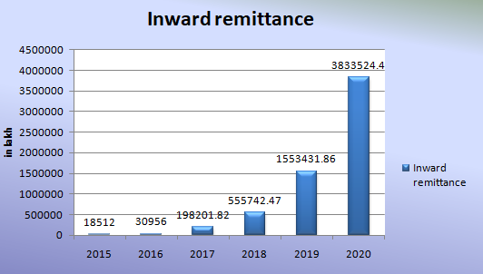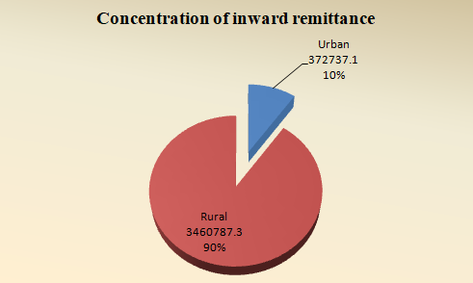Figure 5: Inward remittance and concentration of inward remittances (Source: Bangladesh Bank)
3.0 Research Methodology
The methodology section mainly focus on the research type, sources of data, sampling and data collection procedures, statistical tools in addition to data analysis procedures which are used to attain the objectives of the study.
3.1 Research type
This is essentially a quantitative research that implies the potential link between financial inclusion and agent banking by which unbanked rural and urban both male and female people will get banking facilities in Bangladesh.
3.2 Data and sampling
For conducting the study secondary data has been used, collected from annual reports of the banks and report from Bangladesh Bank. According to Bangladesh Bank’s report (2020) twenty four (24) commercial banks are operating agent banking services in Bangladesh out of 64 banks. So, 24 commercial banks have been considered from the population of 64 banks. The research study has used data from 2016 to 2020. The data has also been collected from Bangladesh bank’s website, several publications, books, magazines, journals and websites of the respective banks.
3.3 Regression model for the study
Observing literature reviews and type of data set, an empirical model is developed to show the link between the role of agent banking and financial inclusion.
To estimate the model specification for the panel data, a multiple regression equation has developed to clarify the appropriateness between random and fixed-effect model, by the Hausman test where
H₀= Random effect model is appropriate
H₁= Fixed effect model is appropriate

Basically Hausman test is a model specification tests in which one proposed estimator of a parameter is both consistent and efficient under the null hypothesis and inconsistent under the alternative hypothesis. If the P-value is less than 0.05 then null hypothesis would be rejected that means data has fixed effects reflected by inconsistent estimator. On the other hand if the P-value is more than 0.05 then data has random effects reflected by estimators are consistent and efficient over the years. The regression model is mentioned here to show the role of agent banking in financial inclusion-
Y = α₀ + α₁X₁ + α₂X₂ + α₃X₃ + ε
Where,
Y = Financial Inclusion which is measured in terms of the total number of accounts (numacc)
α₀= Constant variable
α_{1,} α_{2,} α₃= Regression coefficients for the amount of deposits, amount of remittance, number of agents respectively.
X₁= Amount of deposits (deposits) | X₃= Number of agents (numagents)
X₂= Amount of remittance (remittance) | ε= Error term

3.4 Research design
Financial inclusion is a diversified issue. Number of accounts has been taken as indicator of financial inclusion in terms of agent banking in this research study. The data analysis portion has divided into several segments. Descriptive statistics in table-2 show the summary of all the variables and showing a clear concept about total observation, mean values, minimum and maximum values of the observation. Second, regression analysis is done with the collected panel data set by using STATA software to show the relation between financial inclusion and agent banking activities in Bangladesh. Variance inflation factor (VIF) test and correlation matrix test are done to show the correlation among the independent variables as these tests are used. Both fixed and random effect models are run which are appropriate in the panel data set to get the result of the research question. Finally, the Hausman test has done to get idea about more acceptable model between the fixed effect model and random effect model to represent the relation between agent banking and financial inclusion.
3.5 Variables
To show the association between financial inclusion and agent banking, the pooled Ordinary least Square (OLS) method, fixed effect method and random effect model are used to analyze a panel data set. In the regression test has done where financial inclusion indicated by total number of bank accounts has chosen as dependent variable and amount of deposits, remittances and number of agents are selected as independent variables are listed below.

Table 1: List of variables
Variables | Name
Dependent variables | Number of accounts
Independent variables | Amount of deposits
 | Amount of remittance
 | Number of agents

4.0 Data Analysis and Findings
The statistics showed in the following table represent the numerical summary of all types of variables used in this research study.
4.1 Descriptive statistics
Table 2: Descriptive statistics
Variables | Observation | Mean | Minimum | Maximum
year (years) | 90 | 2018 | 2016 | 2020
numacc (number of accounts) | 90 | 187390.90 | 55.0 | 3007612
deposits (amount of deposits) | 90 | 119273 | 0.15 | 8272291
lendings (amount of lendings) | 34 | 5595.283 | 9.00 | 55375.08
remittance (amount of remittance) | 90 | 68611.61 | 1.23 | 1726530
numagents (number of agents) | 77 | 341.7403 | 1.00 | 3889
Numoutlets (number of outlet | 77 | 500.8182 | 2.00 | 4231
Source: Author’s calculation

The result illustrates the number of accounts has a total of 90 observations with a mean value of 187390.90 where the minimum number of accounts is 55 and the maximum is 3007612. One of the independent variables of this panel data set is the amount of deposits which has a mean value of 119273 and has a maximum value of 8272291. Total 34 observations are found for the amount of lending which is much lower than other observations and the minimum value is only 9 thousands taka where the maximum value of lending is 55375.08. In the case of remittance, the mean value is 68611.61 for the collected panel data set and the highest value is 1726530. Both numbers of agents and outlets have the same number of observations which is 77 and maximum values are 3889 and 4231 respectively.
4.2 Regression result
To know the significance of agent banking for the financial inclusion in Bangladesh, a multiple regression test has been done. Panel data set has used covering the period of 2016 to 2020 in this research paper. Here the number of total accounts is considered as a measure of financial inclusion and deposits, remittance, numbers of agents are considered as independent variables. The pooled OLS model shows that all the three independent variables have a positive correlation with the dependent variables and the model is significant at a 5% significant level. The R square value is 72.23% which indicates that the model can explain the relationship between financial inclusion and agent banking up to 72.23%.
Table 3: Outcomes of pooled OLS, fixed effect, and random effect models
Variables | Pooled OLS |  | Fixed Effect Model |  | Random Effect Model
 | Coefficients | P>|t|  (Significant at 5%) | Coefficients | P>|t|  (Significant at 5%) | Coefficients | P>|t|  (Significant at 5%)
deposits | .089949 | 0.016 | -.0112347 | 0.729 | .089949 | 0.013
remittance | .7660475 | 0.000 | .4729763 | 0.005 | .7660475 | 0.000
numagents | 464.8668 | 0.000 | .4729763 | 0.000 | 464.8668 | 0.000
constants | -14136.46 | 0.710 | -43353.36 | 0.263 | -14136.46 | 0.709
Number of observations | 77 |  | 77 |  | 77
R Square | 0.7223 |  | .6686 (overall) |  | .7223 ( overall)
Prob> F | 0.0000 |  | 0.0000
Hausman Test |  |  | chi2 (3) = 14.18 (Prob > chi2 = 00.1456)
Source: Author’s calculation

As more people are connecting through this agent banking, this is promoting the goal of financial inclusion. Thus it can be said that more number of accounts under agent banking services will promote financial inclusion more.
In the fixed-effect model, deposits show a negative relationship, and the other two variables show a positive relationship with the number of accounts. In this model, the R square is 66.86% which says that the independent variables can explain 66.86% of the dependent variables called the number of accounts.
In the Random Effect model, all the independent variables show a strong positive relationship with the number of accounts at a 5% significant level. The R square is 72.23% in this model. To measure which model is accepted between the Fixed Effect and Random Effect model, the Hausman test is appropriate. According to the developed hypothesis in the methodology section, the random effect will be accepted under the null hypothesis. Here, at 5% significance level the P-value is 14.56 for which null hypothesis is accepted, indicates random effect model is preferable. From the above data analysis, it can be said that agent banking services like deposits and remittance are promoting financial inclusion in Bangladesh. Besides the increasing number of agents are also helping agent banking to reach the remote area of people with simple banking activities.
4.3 Multicollinearity test
Table 4: Multicollinearity test
Variables | VIF | 1/VIF
Deposits | 1.02 | 0.983614
remittance | 1.36 | 0.737301
numagents | 1.35 | 0.741490
Mean VIF | 1.24
Source: Author’s calculation

Multicollinearity test has been done here to see whether the independent variables are affected by the highly inter correlation or not. From the above table-4, it can be seen that the mean VIF is 1.24 which is less than 5, so it can be said that the data set is free from the multicollinearity problem.

Heteroscedasticity test

Table 5: Heteroscedasticity test

numacc | Coef. | Std. Err | t | P>|t| | [95% Conf. Interval]
deposits | .010686 | .0216846 | 49.89 | 0.002 | .325415 | .0539136
remittance | .1507926 | .0026517 | 14.77 | 0.021 | .538398 | .8554249
numagents | 5.34301 | .06532 | 11.11 | 0.001 | .7344229 | .8735322
Cons | 5.34301 | 1.55 | 2.73 | 0.040 | 1.14345 | 7.88
Breusch-Pagan / Cook-Weisberg test for heteroscedasticity
H_{0 :} Constatnt Variance |  |  |  | Variables: fitted values of numacc
 |  |  |  | chi2(1) = 1.81
 |  |  |  | Prob > chi2 = .1778
Source: Author’s calculation
The above heteroscedasticity displays that individual P value of the variables are less than .05 and individual coefficients are significant. Furthermore H₀ indicates constants Variance and Prob > chi2 is 0.1778, more than .05. So null hypothesis is accepted that means data is free from heteroscedasticity problem.
5.0 Conclusion
Accumulating savings, providing loans, providing inward remittances, enhancing number of agents and augmentation of economic transaction conveniently both in rural and urban zone has been seen through agent banking activities are regular phenomenon in Bangladesh . As a result, the promotion of financial inclusion is greatly accelerated in Bangladesh by offering expedient banking services to unbanked people. The empirical model of this report shows that deposit amounts, inward remittance, and the number of agents are positively influencing on the number of opening accounts. As more accounts are opening, the more unbanked people are coming under the umbrella of the banking system and contributing to the economy and fulfilling the objectives of financial inclusion. Gradually enormous areas of services like different bill payments facilities, various loans for rural people can be added under existing agent banking activities. Agent banking already signs a significant impact in Nigeria, Kenya, and Malaysia which has revealed in above literature review. Likewise Bangladesh is on the right track to becoming an emerging country, has huge scope to explore agent banking for the unprivileged and unbanked people. Since the inception of agent banking in 2013, till now only 24 conventional banks come into this prospective sector which is very low number. So this paper tries to show the importance and impact of agent banking in our financial system and how financial inclusion like agent banking can expedite deposit balance, number of transactions, volume of transactions and inward foreign remittances etc. which may attract other banking institutions to expand their business in this area and help the government to flourish the economy. This study also has certain limitations. Firstly, due to a scarcity of time, exact data collection is quite difficult. Selecting a greater number of themes to encounter the requirement of a big sample size. Secondly there are sixty-one conventional banks in the banking industry but only 24 banks are offering agent banking which is very few in sample size. Thirdly, only three independent variables have been used because data of other variables (amount of landings and number of outlets) are not available over 2015 to 2020. Further research can be done on how agent banking helps in the profitability of a bank as well as how it is gaining customers' confidence as an alternative delivery channel of the traditional branch banking system. To continue this journey, more banks are encouraged to engage in agent banking.
References
[1]Abdin, J (2016), ‘Financial development and poverty reduction: exploring the links between the issues using evidence from Bangladesh’, International Journal of Financial Research, vol. 7 no.4, pp. 44-65
[2]Achugamonu, BU, Taiwo, JN, Ikpefan, OA, Olurinola, IO, &Okorie, UE (2016), ‘Agent Bankingand Financial Inclusion: The Nigerian Experience’ Conference Proceeding at Seville, Spain.
[3]Afande, F., O. and Mbugua, S., W. (2015). Role of Agent Banking Services in Promotion ofFinancial Inclusion in Nyeri Town, Kenya. Journal of Finance and Accounting, 6(3).
[4]Ahmed, JU, & Ahmed, A (2018), ‘Agrani Doer Banking: Agent Banking Business in Bangladesh. Business Perspectives and Research’, vol. 6, no.2, pp. 154-164
[5]Bangladesh Bank (2018), Prudential Guidelines for agent banking operation in Bangladesh. Available from https://bb.org.bd/openpdf.php [3 June 2019]
[6]Barreto, H. (1989) The entrepreneur in microeconomic theory: Disappearance and explanation. Routledge (London and New York)
[7]Beck, et al (2008), “Financing Patterns around the World: Are Small Firms Different?”,Journal of Financial Economics 89, 467-87.
[8]Cámara, Tuesta&Urbiola (2015), ‘Extending access to the formal financial system: the bankingcorrespondent business model’, BBVA Research Working Paper no. 15/10.
[9]Cantillon, R. (1755). An Essay on Economic Theory. Auburn, Alabama: Ludwig von Mises Institute.
[10]Dupas, P. and Robinson, J., (2009). Savings Constraints and Microenterprise Development. Cambridge, MA: NBER.
[11]Gardeva, A. and Rhyne, E. (2011). Opportunities and Obstacles to Financial Inclusion. Center for Financial Inclusion. Publication 12
[12]Haas, E. (2015). How Do Innovative Banking Channels Reduce Costs in Downscaling?. SSRN Electronic Journal. doi: 10.2139/ssrn.2568415
[13]Hannig A & Jansen S (2010), ‘Financial inclusion and financial stability: current policy issues’, ADBI Working Paper No. 259. Tokyo: Asian Development Bank Institute
[14]Hebert, R. F., & Link, A. N. 1988. The Entrepreneur: Mainstream Views and Radical Critiques (2ed.). New York: Praeger.
[15]Honohan, P. and King, M., (2012). Cause and Effect of Financial Access. Dublin: IIIS.
[16]Ivatury, G. and Pickens, M., (2006), Mobile Phone Banking and Low-Income Customers. Washington, D.C.: Consultative Group to Assist the Poor.
[17]Johnson, S. (2010). Emerging norms in economic governance: An examination of authority structures and the growing importance of new forms of governance in liberalized India (Doctor of Philosophy). Rutgers, the State University of New Jersey.
[18]Kendall, J., Ponce, A., & Mylenko, N. (2010). Measuring Financial Access around the World (pp. 176-179). Jake Kendall, Alejandro Ponce, Nataliya Mylenko: World Bank Group. Retrieved from https://doi.org/10.1596/1813-9450-5253
[19]Kirzner. (1973). Competition and Entrepreneureship. Chicago: Chicago University press. Kirzner. (1992). the meaning of the market process. New York: Routledge.
[20]Klinger, T., & Teply, P. (2017). Agent-Based Risk Assessment Model of the European Banking Network. SSRN Electronic Journal, (CERGE-EI Working Paper Series No. 602), 5-7. https://doi.org/10.2139/ssrn.3014576
[21]Leyshon, A. and Thrift, N. (1995): Geographies of financial exclusion: financial abandonment in Britain and the United States. Transactions, Institute of British Geographers NS 20,312- 41.1999: Lists come alive: electronic systems of knowledge and the rise of credit scoring in retail banking. Economy and Society 28,434-66.
[22]Morgan P &Pontines V (2014), ‘Financial stability and financial inclusion’, ADBI Working Paper No.488, Tokyo: Asian Development Bank Institute.
[23]Mujeri, MK (2018), ‘Role of Digital Financial Services in Promoting Inclusive Growth in Bangladesh: Challenges and Opportunities.’
[24]Musau, S. (2013), an analysis of the utilization of agency banking on performance of selected banks in Nairobi County, Kenya, Kenyatta University.
[25]Santu, TVC, Mawanza, W, &Muredzi, V (2017), ‘An Evaluation of the Agency Banking ModelAdopted by Zimbabwean Commercial Banks’ Journal of Finance and Bank Management, vol. 5, pp. 58-66
[26]Sarker, S., Ghosh, S. and Palit, M., (2015). Role of Banking-Sector to Inclusive Growth through Inclusive Finance In Bangladesh. Studies in Business and Economics, 10(2), pp.145-159.
[27]Schiffer, M. and Weder, B., (2001). Firm Size and the Business Environment. Washington, D.C.: World Bank.
[28]Schoppe et al (1995). International Review o f National Physical Activity Policy. New South Wales Centre for Physical Activity and Health, Sydney, Australia, CPAH04-0002.
[29]Singh, S. (2014). The Impact and Adoption of Mobile Banking in Delhi. International Research Journal Of Business And Management – IRJBM, Volume No – I(January - 2014), 7-9. Retrieved 4 April 2021, from.
[30]Teece, D. et al (1997) Dynamic Capabilities and Strategic Management", Strategic Management Journal, 18:7. 509-533
[31]Word Bank. (2008). Banking the Poor (pp. 46-49). Washington DC 20433: World Bank.

Appendix
Correlation Matrix

Correlation matrix of coefficients of regress model
Descriptive Statistics

Variable | Obs Mean Std. Dev. Min Max
-------------+--------------------------------------------------------
numacc | 90 187390.9 514247.3 55 3007612
year | 90 2018 1.422136 2016 2020
deposits | 90 119273 871370.7 .15 8272291
lendings | 34 5595.283 11763.54 9 55375.08
remittance | 90 68611.61 233567.9 1.23 1726530
-------------+--------------------------------------------------------
numagents | 77 341.7403 689.998 1 3889
numoutlets | 77 500.8182 939.1951 2 4231

Pooled OLS Regression

. regress numacc deposits remittance numagents

Source | SS df MS Number of obs = 77
-------------+------------------------------ F( 3, 73) = 63.28
Model | 1.6623e+13 3 5.5409e+12 Prob > F = 0.0000
Residual | 6.3923e+12 73 8.7565e+10 R-squared = 0.7223
-------------+------------------------------ Adj R-squared = 0.7108
Total | 2.3015e+13 76 3.0283e+11 Root MSE = 3.0e+05

------------------------------------------------------------------------------
numacc | Coef. Std. Err. t P>|t| [95% Conf. Interval]
-------------+----------------------------------------------------------------
deposits | .089949 .0363531 2.47 0.016 .0174974 .1624006
remittance | .7660475 .1575551 4.86 0.000 .4520406 1.080054
numagents | 464.8668 57.12921 8.14 0.000 351.0085 578.7252
_cons | -14136.46 37912.23 -0.37 0.710 -89695.43 61422.51

Multicollinearity Test

. vif

Variable | VIF 1/VIF
-------------+----------------------
remittance | 1.36 0.737301
numagents | 1.35 0.741490
deposits | 1.02 0.983614
-------------+----------------------
Mean VIF | 1.24

Correlation Matrix

Correlation matrix of coefficients of regress model

e(V) | deposits remitt~e numage~s _cons
-------------+----------------------------------------
deposits | 1.0000
remittance | -0.0851 1.0000
numagents | -0.0400 -0.5016 1.0000
_cons | -0.0846 -0.0634 -0.3425 1.0000

Fixed effect Model

. xtreg numacc deposits remittance numagents, fe

Fixed-effects (within) regression Number of obs = 77
Group variable: C Number of groups = 18

R-sq: within = 0.6738 Obs per group: min = 2
between = 0.6793 avg = 4.3
overall = 0.6686 max = 5

F(3,56) = 38.55
corr(u_i, Xb) = -0.2921 Prob > F = 0.0000

------------------------------------------------------------------------------
numacc | Coef. Std. Err. t P>|t| [95% Conf. Interval]
-------------+----------------------------------------------------------------
deposits | -.0112347 .0322217 -0.35 0.729 -.0757825 .053313
remittance | .4729763 .1612037 2.93 0.005 .1500465 .7959062
numagents | 660.3322 95.28163 6.93 0.000 469.4602 851.2043
_cons | -43353.36 38358.08 -1.13 0.263 -120193.8 33487.12
-------------+----------------------------------------------------------------
sigma_u | 246230.26
sigma_e | 233867.79
rho | .52573281 (fraction of variance due to u_i)
------------------------------------------------------------------------------
F test that all u_i=0: F(17, 56) = 3.58 Prob > F = 0.0002

Random Effect Model

. xtreg numacc deposits remittance numagents, re

Random-effects GLS regression Number of obs = 77
Group variable: C Number of groups = 18

R-sq: within = 0.5976 Obs per group: min = 2
between = 0.8018 avg = 4.3
overall = 0.7223 max = 5

Wald chi2(3) = 189.83
corr(u_i, X) = 0 (assumed) Prob > chi2 = 0.0000

------------------------------------------------------------------------------
numacc | Coef. Std. Err. z P>|z| [95% Conf. Interval]
-------------+----------------------------------------------------------------
Deposits | .089949 .0363531 2.47 0.013 .0186983 .1611997
Remittance | .7660475 .1575551 4.86 0.000 .4572451 1.07485
numagents | 464.8668 57.12921 8.14 0.000 352.8956 576.838
_cons | -14136.46 37912.23 -0.37 0.709 -88443.07 60170.15
-------------+----------------------------------------------------------------
sigma_u | 0
sigma_e | 233867.79
rho | 0 (fraction of variance due to u_i)

Hausman Test

. hausman fe re

---- Coefficients ----
| (b) (B) (b-B) sqrt(diag(V_b-V_B))
| fe re Difference S.E.
-------------+----------------------------------------------------------------
deposits | -.0112347 .089949 -.1011838 .
remittance | .4729763 .7660475 -.2930711 .0341031
numagents | 660.3322 464.8668 195.4654 76.25512
------------------------------------------------------------------------------
b = consistent under Ho and Ha; obtained from xtreg
B = inconsistent under Ha, efficient under Ho; obtained from xtreg

Test: Ho: difference in coefficients not systematic

chi2(3) = (b-B)'[(V_b-V_B)^(-1)](b-B)
= 14.18
Prob>chi2 = 00.1456
(V_b-V_B is not positive definite)

Heteroscedasticity test

--------------------------------------------------------------------------
numacc | Coef. Std. Err. t P>|t| [95% Conf. Interval]
-------------+----------------------------------------------------------------
deposits | .010686 .0216846 49.89 0.002 .325415 .0539136
remittance | .1507926 .0026517 14.77 0.021 .538398 .8554249
numagents | 5.34301 .06532 11.11 0.001 .7344229 .8735322
_cons | 67.72 1.55 2.73 0.040 1.14345 7.88
------------------------------------ ------------------------------------------

. estat hettest

Breusch-Pagan / Cook-Weisberg test for heteroskedasticity
Ho: Constant variance
Variables: fitted values of numacc

chi2(1) = 1.81
Prob > chi2 = .1778

