Financial Evaluation and Efficiency of Microfinance Institutions:
A cross-country analysis

Dr. Kyriazopoulos Georgios

Assistant Professor
Vice President of International Conference of Development and Economy I.CO.D.ECON
Department of Accounting and Finance
Technological Educational Institute of Western Macedonia,
GR- 50100 Koila, Kozani, Greece
Emails: kyriazog@teiwm.gr
kyriazopoulosg@yahoo.com

Abstract
Microfinance Institutions (MFIs) are special financial institutions, which have both a social nature and a for-profit nature. This differentiates them from the regular financial institutes, but still MFIs are interested about their profitability and efficiency. The main role of MFI is expanding economic opportunity and financial market to the poor, which is considered as effective solution in achieving poverty reduction and other socioeconomic benefits. But how can we assess if a MFI is efficient, how should we compare MFIs. The aim of the current study is the financial evaluation and efficiency of Microfinance Institutions with the use of Data Envelopment Analysis (DEA).
Keywords: Microfinance Institutions (MFIs), Financial evaluation &, efficiency, Data Envelopment Analysis (DEA).
JEL Classification: G20, G21, C67

1. Introduction – Literature Review
Access to credit and lending is not an easy task for all the citizens. Financial institutions pose strict criteria in order to give a loan. Microfinance has been one of the solutions for the above situation. It addresses formal banking system failure in eradicating vicious circle of poverty, by extending financing to the poor, or ‘the unbankable’ who are deemed too risky thus excluded by formal banking.
The sample consists of international MFIs, available at Bankscope database. The examined period is from 2010 to 2015. The results depict an average efficiency level up to 85%, which show that the examined institutions perform in an efficient way. Microfinance appeared as an integral part of developmental policy and an effective poverty reduction tool from late 1970’s (Johnson et al., 2009). Microfinance has been also shown to have an impact on recipients’ income, savings, expenditure, and the accumulation of assets, as well as non-financial outcomes including health, nutrition, food security, education, child labor, housing job creation, and social cohesion (Ghalib et al., 2012; Mazumder and Lu, 2015). McIntosh et al., (2011) noted that access to credit is associated with moderate increases in variables associated with household welfare. According to Duvendack, et al., 2011, microfinance has been shown to have a positive impact on the education of clients’ children.
Chowdhury, 2009 mention that microfinance is not a panacea for poverty reduction, which needs both complementary supply-side and demand-side factors. Supply – side factors are necessary in order to make enterprises more effective. For example, talented micro entrepreneurs could increase their clientele. On the other side, demand-side factors play a crucial role. Without a holistic political supportive background, these enterprises would not be able to increase their size.
A microfinance institution (MFI), specializes in customers that are poor and coming from rural areas. These customers are more vulnerable and harder to get financed than traditional bank clients.
Access, to microfinance is multidimensional and requires a review of the following issues: (a) the range of financial services provided—and target groups served—by several tiers of formal, semiformal, and informal financial institutions; (b) the demand for financial services from households, microenterprises, and small businesses at different levels of the income levels; and (c) the different combinations of financial service providers.
Microfinance is built on a compelling logic: hundreds of millions of poor and very poor households seek capital to build small businesses, but their lack of collateral restricts access to loans. Innovative “microbanks” meet the demand with more flexible collateral requirements and thus unleash untapped productive power (Counts 2008; Johnston and Morduch, 2008).
The notion of millions of unbanked households accords with evidence of most formal banks’ shallow outreach to the poor (Armendariz and Morduch 2005; World Bank 2008). But a lack of use does not imply a lack of access. Some among the “unbanked” may be excluded despite having worthy uses for capital. Others may simply not be creditworthy or in some cases may be creditworthy but not interested in taking on debt.
According to Yunus (2009), the key features of microcredit include the idea that the loans are designed “to help the poor families to help themselves to overcome poverty”. In this category of loans, the word “trust” is of utmost importance, as these clients cannot provide collaterals in the vast majority of the cases.
Microcredit is most often extended without traditional collateral. Because borrowers do not have physical capital, MFIs focus on using social collateral, via group lending (Wenner 1995). In this way, each group member is responsible for the repayment of all member loans. This means that if someone defaults the rest of the group should pay his debt. If this does not happen, then all group loses its access to future loans. Under this condition, each member has an incentive to participate actively in the above mentioned scheme.
Recently, a number of studies (Gonzalez, 2007; Krauss and Walter, 2008; Ahlin et al., 2011), have explicitly investigated the relationship between MFIs’ performance and changes in the macro environment of the country in which they operate. These studies recognize that the macroeconomic environment is an important determinant for MFI outreach and performance in addition to institution-specific characteristics.
Some authors mention MFIs’ ‘mission drift’, i.e. the fear is that MFIs shift away from their original mission as the sector increasingly commercializes (Armendariz and Szafarz, 2009; Kono and Takahashi, 2010).
For example, Cull et al. (2009) show the more commercially oriented MFI focus on a better off clientele and offer higher loan sizes. MFIs seem in this way to act more and more as pure commercial banks. In this process it has become increasingly unclear which MFIs are actually serving and which objectives they are pursuing (Fernando, 2006).
Hermes et al., (2008) demonstrate a trade-off between depth of outreach and efficiency. They define cost efficiency in terms of how close the actual costs of the lending activities of an MFI are to what the costs of a best-practice MFI would have been. They conclude that if MFIs focus on maximizing efficiency, mission drift might be stimulated, since MFIs serving the poorer parts of the population are less efficient.
Mersland and Strøm (2010), who study the evolution of average loan sizes offered by MFIs, argue the other way around: MFIs should increase efficiency to offer smaller loan sizes. They claim that costs aspects are crucial in the assessment of mission drift and argue that average loan sizes may be increased due to inefficient management of the organizations and not by a shift in markets the MFIs serve.
Gutierrez-Nieto et al. (2007) emphasize that it is important to use different efficiency measures, because the conclusions are dependent on the kind of efficiency measured.
Also, Armendariz and Szafarz (2009) argue that overall financial sector development is an important factor to take into account when evaluating which MFIs are actually serving. They argue that MFIs offering higher loan sizes, one of the determinants to assess the level of poorness of clients served, does not necessarily mean that MFIs are shifting away from their mission. MFIs can simply be cross subsidizing. This is more probable with a larger unbanked population.
Kono and Takahashi (2010) argue that limited access to financial services is a major bottleneck for people in developing countries wanting to improve their livelihoods. The promotion of MFIs has been viewed as a development policy able to address the market failures in the traditional banking system and has received increased attention as a tool for poverty-reduction.
Hermes et al., 2009, found a negative relation between microfinance and the development of the formal banking sector relates to competition between the two sectors
Rosenberg et al., 2009, showed that MFIs’ interest rates are traditionally higher than the interest rates asked by commercial banks due to the high transaction costs MFIs bear. In this case many MFIs clients would switch to commercial banks.
The following table (Table 1) depicts a selection of recent studies done the last decade, regarding MFIs efficiency and evaluation together with the purpose of these studies.

Table 1. List of Studies
 | Authors | Purpose of Study
1 | Gutiérrez-Nieto et al., (2007) | Data envelopment analysis (DEA) approach to measure the efficiency of MFIs
2 | Hartarska and Nadolnyak (2007) | Impact of regulation on MFI performance using regulatory, macroeconomic and institutional variables.
3 | Hartarska and Nadolnyak (2008) | Investigate whether microfinance rating agencies were able to impose market discipline on microfinance institutions (MFIs) during the period 1998–2002
4 | Gutiérrez-Nieto et al., (2009) | Measure the efficiency of MFIs in relation to financial and social outputs using data envelopment analysis
5 | Haq et al.,(2010) | Cost efficiency of 39 microfinance institutions across Africa, Asia and the Latin America using non-parametric data envelopment analysis
6 | Hudon (2010) | Management of microfinance institutions (MFIs) and its relationship with donors’ subsidies
7 | Louis et al., (2013) | Association between social efficiency and financial performance of microfinance institutions
8 | Widiarto and Emrouznejad (2015) | Two-stage analysis (DEA and other non-parametric tests) to measure Islamic Microfinance institutions (IMFIs) performance by comparing them to conventional MFIs
9 | Gaganis (2016) | Assess the performance of MFIs using PROMETHEE II multicriteria method and regression analysis

As mentioned in the abstract, the aim of the current study is the financial evaluation and efficiency of MFIs, with the use of a non-parametric method, namely Data Envelopment Analysis (DEA).
The rest of the paper is organized as following. Section 2, presents some basic elements of DEA method. Section 3, describes the dataset and the application of the method in the sample of MFIs, whereas Section 4 summarizes the basic findings of this study.

2. Methodology
Data Envelopment Analysis (DEA) is a mathematical programming technique for the development of production frontiers and the measurement of efficiency relative to these frontiers.
Regarding the mathematical formulation, suppose we want to evaluate the technical efficiency of MFIs through the DEA model. If we have “n” basic microfinancing inputs and “m” basic microfinancing outputs for each institution, then the model would be the following:

Min θ subject to Y_{τ} ≥ Y₀
θ, τ X_{τ} ≤ θ X₀ (1)
e^{T} _{τ} = 1
τ ≥ 0_{n}
where:
Y is the matrix of output vectors
X is the matrix of input vectors
(X₀, Y₀) is the unit being rated
e^{T} denotes a row-vector of 1’s
τ is the vector of intensity variables and
θ is the so-called efficiency score-a quantity between 0 and 1.
If θ < 1, a proportional decrease of all inputs is required in order to achieve the efficient frontier. This decrease is given by (1-θ) X₀, which means that the projected unit given by (θ X₀, Y₀) is efficient in Debreu-Farrell terminology or weakly efficient in DEA terminology. No further radial decrease of all inputs is possible given the current amount of outputs. It is possible that, in order DEA to be efficient, further individual reduction in some inputs and/or increase in some outputs is required.
DEA can estimate the technical efficiency of each DMU under the hypothesis of constant returns to scale (CRS) or variable returns to scale (VRS).
The decision regarding which orientation to use should be based on information concerning which factors (inputs or outputs) the firm managers have most control over (Coelli et al., 2005).
In many applications, input and output oriented measures give similar results (Coelli et al., 2005).
Nowadays, this method has become widely known in measuring efficiency for different reasons.
- First, it is easy to incorporate different inputs and outputs in a DEA model. Thus, DEA is particularly well-suited for efficiency analysis of MFIs as it considers multiple inputs and produces multiple outputs
- Second, regarding the production function it is not necessary to specify a parametric functional form
- Third, in contrast to parametric approaches, DEA does not require any price information for dual cost function
- Fourth, a characteristic of DEA model is the ability to provide useful information to the managers regarding the improvement of the productive efficiency of the company
- Finally, DEA can handle inputs – outputs under CRS (constant return to scale) and VRS (variable return to scale) mode, within a convex piecewise linear best practice frontier
In this model approach, we have the Decision Making Units (DMUs), which are the units that convert inputs to outputs. Moreover, the efficiency value for a DMU is determined related to the other examined DMUs. This, according to (Casu & Molyneux, 2003), makes the approach different from the parametric ones, which require particular functional form.
According to Pasiouras (2008), DEA can estimate the technical efficiency of each DMU under the hypothesis of constant returns to scale (CRS) or variable returns to scale (VRS). The examined units are separated in two groups, efficient (units that are on the effective frontier) and non- efficient (units that are below the effective frontier). Efficient units, use the given sources in an effective way, while non- efficient could use their sources in a more effective and productive way. Each unit receives a score from 1 (efficient units) till 0. (Wozniewska, 2008). A unit closer to 1, is easier to get converted to an efficient one, while a unit close to 0, should do radical changes in order to become efficient. Here, we should mention that efficiency score could change regarding the examined set of units

3. Dataset Description – Results
In this study we measure the efficiency of 33 international MFIs over the period 2010-2015. The data obtained from the Bankscope database, which is a commercial database specialized in financial sector. The criteria for choosing the above institutions referred to data availability for all examined years. Input oriented model was chosen in crs mode. This option is according to literature, as it is easier and more realistic to control and minimize inside factors than trying to maximize external and not easy to control factors. Moreover, constant return to scale (crs) mode was chosen which means that a specific change in an input will cause the same change to the output. For the efficiency analysis, the software “Frontier Analyst professional” was used which is provided by Banxia Holdings Ltd. Table 2, depicts the variables used for the analysis, which have been selected through literature survey and data availability.

Table 2. Variables used in the analysis
Inputs | Outputs
Personnel Expenses | Net Income
Total Non-Interest Expenses | Gross Loans
Total Assets | Gross Interest and Dividend Income

Table 3, presents the average values for the examined variables, expressed in thousand $. If we want to make some general comments for the below variables, we can see that all inputs follow an upward trend from 2010-2013, in 2014 there is a significant fall and in 2015 there is a slight increase. The same exists for gross loans and gross interest and dividend income from the outputs. The rest output, net income, presents a significant fall from 2010 to 2011, mainly due to increases expenses appeared that year, whereas in the following years there is an increase till 2015.

Table 3. Average values of examined variables
Year | Inputs (th. $) |  |  | Outputs (th. $)
 | Personnel Expenses | Total  Non-Interest Expenses | Total Assets | Net Income | Gross Loans | Gross Interest and Dividend Income
2010 | 26,091.25 | 52,612.24 | 684,977 | 57,278.35 | 489,872.1 | 91,823.56
2011 | 28,193.37 | 56,780.8 | 754,769.6 | 17,319.18 | 559,812.5 | 99,770.32
2012 | 32,534.12 | 63,492.49 | 848,535 | 21,477.92 | 617,304.6 | 113,666
2013 | 34,235.39 | 67,265.09 | 957,769.4 | 38,876.75 | 660,988.9 | 119,486.7
2014 | 31,224.27 | 62,795.45 | 917,424.8 | 38,562.27 | 649,032.4 | 113,789.2
2015 | 30,247.59 | 63,307.18 | 975,461.4 | 51,703.63 | 665,630.7 | 118,777.7

Figure 1, depicts the average results of efficiency for the examined period. As we can see on average, the efficiency levels are between 85.93% to 88.5%. As a general finding, we can say that there is robustness in the results, as there is a small deviation among the years. In 2010 and 2011, the efficiency is close to 87%, there is an increase in 2012, where we can find the higher value (88.5%), whereas in 2013 and 2014 there is a fall, in 2014 we can find the lower value (85.93%). Finally, in 2015 there is a slight increase.

Figure 1. Average Results of Efficiency
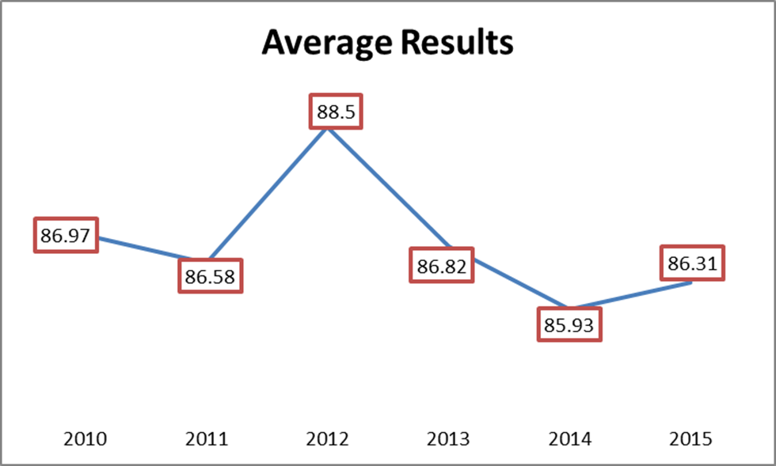
Source: Writers' Construction

Table 4, shows the MFIs that are found efficient per year. As we can observe, the lower number found in 2014 and 2015 (8 MFIs), where in 2012 we can see the greatest number (11 MFIs). The rest years the number of efficient institutions ranges from 9 to 10. In this table we provide an additional information, regarding the number of MFIs that are very far from being efficient (< 50% efficiency level). As we can see, in all years this number varies between 1 to 2 institutions. This is an interesting fact, as even the non-efficient institutions are closer to efficient ones, which means that they operate in a proper way.

Table 4. Efficiency level per Year
 | 2010 | 2011 | 2012 | 2013 | 2014 | 2015
Number of Units | 33 | 33 | 33 | 33 | 33 | 33
Efficient (100%) | 10 | 9 | 11 | 10 | 8 | 8
Non - Efficient <50% | 1 | 2 | 2 | 2 | 1 | 1

Out of the efficient units, four of them are efficient throughout the period, revealing a stable situation regarding efficiency.
Another interesting finding of the study, has to do with the potential improvements that should be done to non- efficient units in order to achieve efficiency level of 100% (Table 5). As we can see, the criterion which has to be dramatically changed is net income. This is quite normal, as an increase in income would cause the increase in efficiency levels. There should also be changes in the other criteria, but in lower percentages. For example, in 2011, personnel expenses should be decreased by round 15%, whereas total non-interest expenses should be reduced by about 14%. The same year gross interest and dividend income should be increased by almost 10%.

Table 5. Potential Improvements (%)
 | 2010 | 2011 | 2012 | 2013 | 2014 | 2015
Personnel Expenses | -9.97 | -15.13 | -6.99 | -4.26 | -1.09 | -5.01
Total Non-Interest Expenses | -8.29 | -13.48 | -6.55 | -4.72 | -1.44 | -6.68
Total Assets | -7.98 | -10.26 | -4.87 | -3.8 | -0.88 | -4.41
Net Income | 65.98 | 50.86 | 75.54 | 84.68 | 95.92 | 81.2
Gross Loans | 1.15 | 0.82 | 0.47 | 0.61 | 0.22 | 0.75
Gross Interest and Dividend Income | 6.63 | 9.44 | 5.59 | 1.93 | 0.45 | 1.95

The same information can be depicted in a figure (Figure 2). As we said before, the critical criterion is net income followed by personnel expenses.

Figure 2. Total Potential Improvements
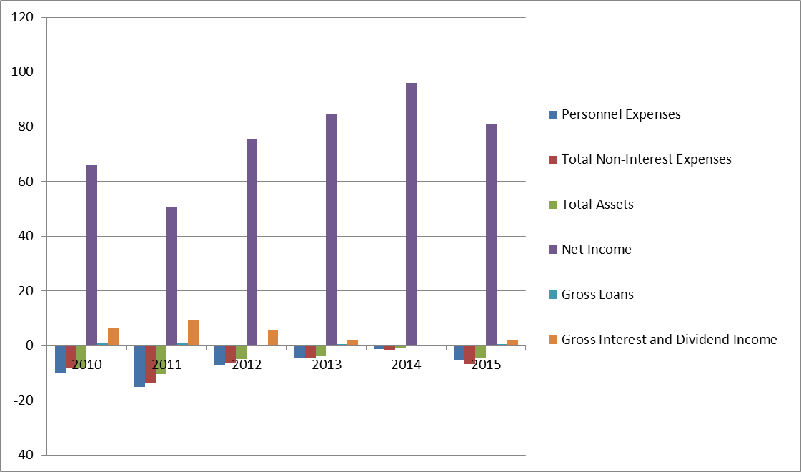
Source: Writers' Construction

4. Results – Discussion
This study tries to evaluate the efficiency of international MFIs, found on Bankscope database. Based on previous studies, we employ the data envelopment analysis (DEA) method on annual data to construct efficiency frontiers. We examine the performance of institutions which operate in global level, by using a sample of 33 micro financial institutions. The examined period is the years 2010-2015, which is a period starting after the recent financial crisis the years 2008-2009.
The results show that the DEA efficiency scores, characterize significant number of MFIs as efficient (on average 30% of MFIs found efficient). The number of efficient institutions ranges from 8 (in 2014 and 2015) to 12 (in 2012). The rest of the years (2010 and 2013) the efficient MFIs are 10. Additionally, most of the efficient institutions in 2010 are found efficient in the following years. Regarding the average efficient score, we can see that is between 86% to 88.5%. This small gap, depicts the robustness of the examined MFIs. An additional interesting finding, is the small number (1 to 2) of MFIs that achieve efficiency level lower to 50%. This shows, that even the non-efficient MFIs with specific changes to inputs- outputs could achieve efficiency levels close to 100%.
Moving to the changes that should be done in order non-efficient units to become efficient, this focus mostly on an output (Net Income), an increase of it could give a boost to a significant number of MFIs to become efficient. Additional changes, should be done to the examined inputs, but in lower levels (for example in Personnel Expenses, for the years 2010-2012).
As a general comment, we can say that the examined MFIs performed in a satisfactory level. In this point, we should take into consideration, that we choose MFIs from an international dataset, with available data, which means that are well – known institutions and we expected to find such results.
The rapid evolutions of the last years in the global economy and as efficient financial systems (part of which are MFIs) contribute in an extensive way for higher economic growth in any country, lead to the conclusion that analysis of this nature is absolutely essential for regulators, investors, borrowers and many others who are interested in the microfinance sector.
In this way, the efficient financial institutions become able to meet the increasing and more sophisticated demands from consumers and businesses, to adapt and adjust to the technological advances, to face the challenges of globalization and liberalization, and to withstand the economic cycle, thereby contributing to the overall economic growth and stability.
The DEA model, could be extended in various ways. Firstly, we can assume other set of inputs and outputs. Secondly, there could be an extension to variables associated with social welfare or “environmental” variables. As it is referred in Casu & Molyneux (2003), examples of such factors could be the ownership of the financial institution (public or private), the location and under which government regulations the examined institution operates. Moreover, a comparison of different approaches (such as Stochastic Frontier Analysis (SFA), Thick Frontier Approach (TFA), Distribution Free Approach (DFA) could be executed in order to enrich the analysis.

5. References
Journal Articles
Ahlin, C., Lin, J., & Maio, M. (2011). "Where does microfinance flourish? Microfinance institutions’ performance in macroeconomic context", Journal of Development Economics, Vol. 95; 105–120.
Armendariz, B., & Szafarz, A. (2009). "On mission drift of microfinance institutions", ECB Working Papers Series No. Vol. 09 (No. 15), Universite Libre de Bruxelles, Brussels
Casu, B. and Molyneux, Ph. (2003) "A comparative study of efficiency in European banking", Applied Economics, Vol. 35, (No. 17); 1865 – 1876.
Coelli, T. J., Rao, D. S. P., O'Donnell, C. J., & Battese, G. E. (2005). "An introduction to efficiency and productivity analysis". Springer Science & Business Media.
Cull, R., Demirguc¸-Kunt, A., & Morduch, J. (2009). "Microfinance tradeoffs: regulation, competition, and financing". World Bank Policy Research Working Paper No. 5086, Available at http://ssrn.com/abstract=1492566
Chowdhury, A. (2009). "Microfinance as a Poverty Reduction Tool—A Critical Assessment". United Nations, Department of Economics and Social Affairs. DESA Working Paper No. 89 ST/ESA/2009/DWP/89 Available at http://www.un.org/esa/desa/papers/2009/wp89_2009.pdf
Fernando, J. (2006). "Introduction Microcredit and empowerment of women: blurring the boundary between development and capitalism". Microfinance Perils and Prospects (Ed.) J. Fernando, Routledge Studies, Oxon. ISBN 0415328748.; 1-42
Gaganis, C. (2016). "Assessing the overall performance of microfinance institutions". International Journal of Banking, Accounting and Finance, Vol. 7 (No.1); 52-83.
Ghalib, A. K., Malik, I., & Katsushi, S. I. (2012). "Microfinance and its role in household poverty reduction: findings from Pakistan". Working paper no. Vol. 173 Brooks World Poverty Institute (BWPI).
Gonzalez, A. (2007). "Resilience of microfinance institutions to macroeconomic events". MIX Discussion Paper Vol. 1, The MIX, Washington, DC. Available at: https://www.themix.org/publications/microbanking- bulletin/2007/11/resilience-microfinance-institutions-macroeconomic-events
Gutierrez-Nieto, B., Serrano-Cinca, C., & Molinero, C. M. (2007). "Microfinance institutions and efficiency". Omega, Vol. 35; 131–142.
Gutiérrez-Nieto, B., Serrano-Cinca, C., & Mar Molinero, C. (2009). "Social efficiency in microfinance institutions". Journal of the operational research society, Vol. 60 (No.1); 104-119.
Haq, M., Skully, M., & Pathan, S. (2010). "Efficiency of microfinance institutions: A data envelopment analysis". Asia- Pacific Financial Markets, Vol. 17 (No 1); 63-97.
Hartarska, V., & Nadolnyak, D. (2007). "Do regulated microfinance institutions achieve better sustainability and outreach? Cross-country evidence". Applied Economics, Vol. 39 (No. 10); 1207-1222.
Hartarska, V., & Nadolnyak, D. (2008). "Does rating help microfinance institutions raise funds? Cross-country evidence". International Review of Economics & Finance, Vol. 17 (No. 4); 558-571.
Hermes, N., Lensink, R., & Meesters, A. (2008). "Outreach and efficiency of microfinance institutions". Working Paper, Groningen Universiteit, Groningen. Available at: SSRN: http://ssrn.com/abstract=1143925
Hermes, N., Lensink, R., & Meesters, A. (2009). "Financial development and the efficiency of microfinance institutions". Working Paper, Groningen Universiteit, Groningen. Available at: http://ssrn.com/abstract=1396202
Hudon, M. (2010). "Management of microfinance institutions: Do subsidies matter"? Journal of International Development, Vol. 22 (No. 7); 890-905.
Johnson, N., Garcia, J., Rubiano, J.E., Quintero, M., Estrada, R.D., & Mwangi, E. (2009). "Water and poverty in two Colombian watersheds", Water Alternatives, Vol. 2 (No. 1); 34–52.
Johnston Jr, D., & Morduch, J. (2008). "The unbanked: evidence from Indonesia". The World Bank Economic Review, Vol. 22 (3); 517-537.
Kono, H. & Takahashi, K. (2010). "Microfinance revolution: its effects, innovations and challenges", The Developing Economies, Vol. 48; 15–73.
Krauss, N. A., & Walter, I. (2008). "Can microfinance reduce portfolio volatility?", Working Paper. Available at: http://ssrn.com/abstract=943786
Louis, P., Seret, A., & Baesens, B. (2013). "Financial efficiency and social impact of microfinance institutions using self-organizing maps". World Development, Vol. 46; 197-210.
Mazumder, M., Lu, W. (2015). "What Impact Does Microfinance Have on Rural Livelihood? A Comparison of Governmental and Non-Governmental Microfinance Programs in Bangladesh", World Development, Vol. 68; 336-354,
McIntosh, C. Villaran, G., & Wydick, B. (2011). "Microfinance and home improvement: Using retrospective panel data to measure program effects on fundamental events" World Development, Vol. 39; 922–937.
Mersland, R. & Strøm,. (2010). Microfinance mission drift?, World Development, Vol. 38; 28–36.
Pasiouras, F. (2008). Estimating the technical and scale efficiency of Greek commercial banks: the impact of credit risk, off-balance sheet activities, and international operations. Research in International Business and Finance, Vol. 22 (No. 3); 301-318.
Rosenberg, R., Gonzalez, A., & Narain, S. (2009). The new moneylenders: are the poor being exploited by high microcredit interest rates? In Moving beyond storytelling: Emerging research in microfinance Vol. 92; 145- 181. Emerald Group Publishing Limited.
Wenner, M. (1995). Group credit: A means to improve information transfer and loan repayment performance”, Journal of Development Studies, Vol. 32; 263-281.
Widiarto, I., & Emrouznejad, A. (2015). Social and financial efficiency of Islamic microfinance institutions: A Data Envelopment Analysis application. Socio-Economic Planning Sciences, Vol. 50; 1-17.
Wozniewska, G. (2008) Methods of measuring the efficiency of commercial banks: an example of Polish banks, Economika, Vol. 84; 81-91.
Yunus, M. (2009). Creating a world without poverty: Social business and the future of capitalism. Global Urban Development Vol. 4 (No. 2) Public Affairs. Available at: https://www.globalurban.org/GUDMag08Vol4Iss2/Yunus.pdf
Books
Armendariz, B., & Morduch, J. (2005). "The Economics of Microfinance". Cambridge, Mass.: MIT Press. Counts, A. (2008). Small Loans, Big Dreams. Hoboken, NJ: John Wiley.
Duvendack, M., Palmer-Jones, R., Copestake, J. G., Hooper, L., Loke, Y., & Rao, N. (2011). "What is the evidence of the impact of microfinance on the well-being of poor people?" EPPI Centre, Social Science Research Unit, Institute of Education, University of London, London.
World Bank. (2008). "Finance for All? Policies and Pitfalls in Expanding Access". A World Bank Policy Research Report. Washington, DC

Corresponding Author

