Geology of Wadi Hauran, the Largest Valley in Iraqi Western Desert
Varoujan K. Sissakian, Ayda Abdul Ahad, Nadhir Al-Ansari^{3,} and Sven Knutsson

Abstract

Wadi (valley) Hauran is the largest valley not only in the Iraqi Western Desert but the whole Iraqi Territory. The length of the valley inside Iraq is about 420 Km, whereas the drainage basin area inside Iraq is 16550 Km2. The valley exhibits different forms along its course; like shallow and wide, deep and wide, and canyon. The valley starts from the Iraqi – Saudi Arabian international borders and even inside Saudi Arabia and runs generally northeast wards; with slight changes in its main course trend, exhibiting many right angle meanders.

The oldest exposed rocks along the course and banks of wadi Hauran belong to the Upper Triassic Zor Hauran Formation, whereas the youngest exposed rocks belong to the Middle Miocene Nfayil Formation. Different Quaternary sediments occur in the valleys course and banks. The main structural elements along the course of wadi Hauran are a set of NW – SE trending faults, beside extensive jointing of the rocks, especially in the left bank northwest of Rutbah town. Different geomorphological units and forms are developed along the course of the valley and on its banks.

From economical point of view, enormous amounts of sand and gravel are developed as valley fill sediments. Limestone for cement industry and many other metallurgical industries with huge geological reserves is available in different formations, like Ratga and Euphrates. Pure silica for glass and crystal industry is available in Rutbah Formation. Bauxite and sedimentary iron are available in Hussainiyat Formation. Clays for different industrial uses are available in different formations; like Ubaid, Hussainiyat, Muhaiwir, Hartha, Tayarat and Akashat formations.

The different forms of wadi Hauran along its course with different exposed rocks and developed different slopes along its banks have developed different mass wasting phenomena in different parts. Among the most common forms are: Toppling, rock fall, slumping, creep and very rare sliding.

Keywords: Wadi (valley) Hauran; Fluvial Units; Fault; Mass Wasting Forms; Iraq.
1 Introduction
1.1. General
Wadi Hauran is the longest valley in Iraq, its length is about 420 Km. It starts south of the Iraqi – Saudi Arabian International borders; south of Rutbah town in the extreme southwestern part of Iraq and merges with the Euphrates River north of Al-Baghdadi town (Fig.1). The main trend of the valley in its lower reaches is towards NNE then changes in its middle part towards east and then towards NEE with many slight changes in the trend in form of right angle bends. The coverage area of the catchment area of wadi Hauran with its large tributaries like, Hussainiyat, Mihzam, Saqqar, Amij is about 16550 Km².
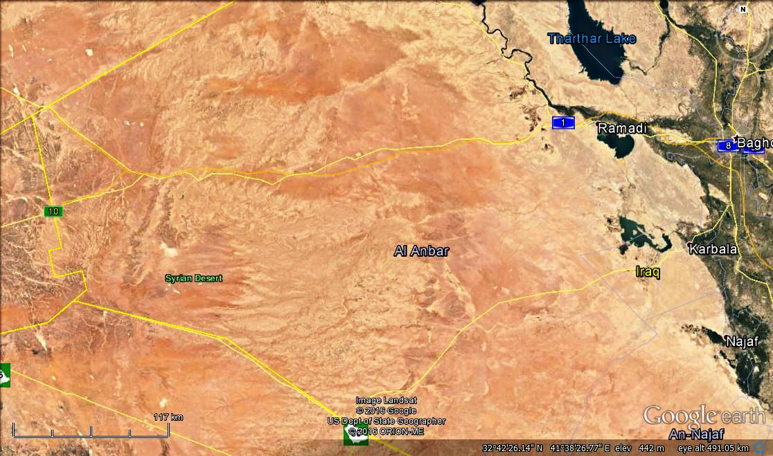
120 Km

1
Wadi Hauran
3
4
2
Rutbah
Al-Baghdadi
Wadi Hauran

Figure 1: Google Earth image of the study area showing wadi Hauran
The aim of this study is to explain the geology of wadi Hauran in different aspects including geomorphology, tectonics and structural geology, stratigraphy and economic geology. Moreover, to discuss its main trends as related to the regional tectonics.

1.2. Previous Studies
The coverage area of wadi Hauran is very large; therefore, the area is covered by different studies. Moreover, it is the type locality of many geological formations, the most significant studies are:
Henson (1941) in[1]recognized the Tayarat Formation from Jabal Tayarat, south of Rutbah town.
Dunnington (1951) in [1] recognized the Zor Hauran Formation in wadi Hauran near Muhaiwir police post.
Witzel (1951) in [1] recognized the Muhaiwir Formation in wadi Hauran near Qasir Muhaiwir.
Dunnington (1954) in [1] recognized the Ubaid Formation in the junction of wadi Hussainiyat with wadi Hauran.
[2] announced the Hussainiyat Formation in wadi Al-Hussainiyat; however, it was first recognized by [3].
[4] announced the Amij Formation; however, it was first recognized by [3].
[5,6,7,8,9,10,11,12,13] reported about the geology of wadi Hauran; including the exposed geological formations and different Quaternary sediments along wadi Hauran and its banks.

1.3. Materials and Methods
In order to achieve the main aim of this study, the following materials were used:
- Topographic and geological maps of different scales.
- Google Earth, HERE maps, Flash Earth images.
- Relevant published articles.

Using the available topographical and geological maps of different scales with the help of Google Earth, HERE Maps and Flash Earth images, the parameters of the studied area were measured. No field work was carried out in the current study; all presented data is achieved from the interpretation of the satellite images depending on the experience of the authors and the acquired data from the available geological mapping reports and other published relevant articles.

In order to simplify the explanation of different aspects, the whole valley length is divided into four main parts (Fig. 1). The first part is of shallow and wide form with length of 143 Km with SSW – NEE trend. The second part is wide and deep form with length of about 124 Km with NE – E trend. The third part exhibits canyon form with length of about 61 Km, with SW – NE trend and the forth part is wide and shallow form with length of about 92 Km, with NE – E trend.

2. Geological Setting
The geology of wadi Hauran is very complex this is attributed to the exposed rocks that have wide age range; from Upper Triassic to Miocene. The large lithological similarity between different exposed formations, old karstification processes with high undulation nature and thick Quaternary cover of the rocks mislead the recognition of the formations. Therefore, for long years there was a lot of debate about the exposed formation between different authors. One of the main tasks of this study is to give the best accepted ideas as the geological aspects are concerned and approved by the Iraq Geological Survey. To fulfil this task all the available geological reports of different aspects were reviewed and discussed. Among the main studies and geological maps are those conducted by [7,14,15,16,17,18,19,20,21].
2.1. Geomorphology
Among the fluvial units the following are well developed along the course of wadi Hauran:
- Terraces (Pleistocene): Although wadi Hauran is the largest and longest valley in Iraq, but terraces along its course are very rare. The oldest terrace stage is preserved only in Part 3 of the valley’s course, south of H1 oil pumping station, where the valley exhibits canyon form with depth of (95 – 120) m (Fig.2). The youngest terrace stage; however, is well preserved above the recent valley flood plain (Fig.2) almost everywhere along the course of the valley. The thickness of the terraces range from (2 – 7) m, pebbles are in different shapes, sizes and lithology. The main lithology of pebbles is silicified limestone, dolostone and sandstone; mainly rounded with size ranges from (2 – 35) cm; however, pebbles up to one meter occur in the youngest stage, which exhibit graded bedding and cross bedding.
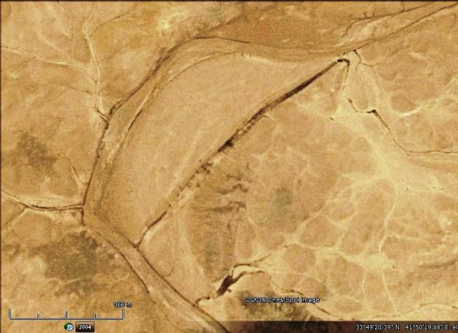
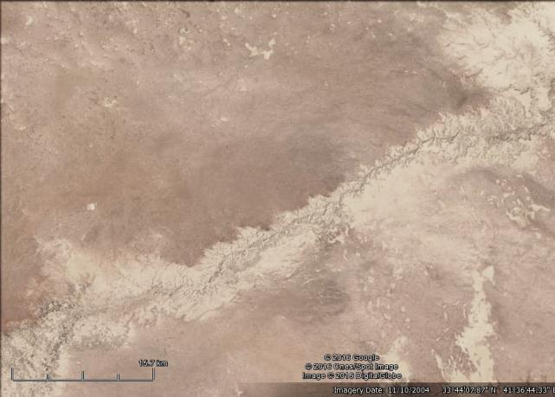
350 m

20 Km

Fp
Tr
Tr
Tr
Tr

Figure 2: Google Earth image, terraces (Tr) of wadi Hauran, Left) South of H1 oil pumping station; within Part 2, Right) in Part 1; also note the flood plain (Fp)

- Flood Plain (Holocene): Flood plain is well preserved along the whole course of wadi Hauran (Fig. 3); locally two stages can be seen. The composition of the flood plain is mainly coarse sand, silt and very rare clay; very rarely some pebbles are present too. The top layer; however, is usually covered by silty clayey soil, which interfingers with the hill wash sediments derived from adjacent cliffs (Fig.4, Part 2). In Part 1, the valley’s course is clearly seen within the flood plain with common meandering, which is the same in Part 2, but will wide meanders and less often. In Part 3, the course is almost straight; without wide meandering. In Part 4, the course is almost straight within a wide flood plain. Locally, abandoned valley channels occur within the flood plain (Fig.3, Part 2). The thickness varies from (1 – 2) m, but may reach 3 m.

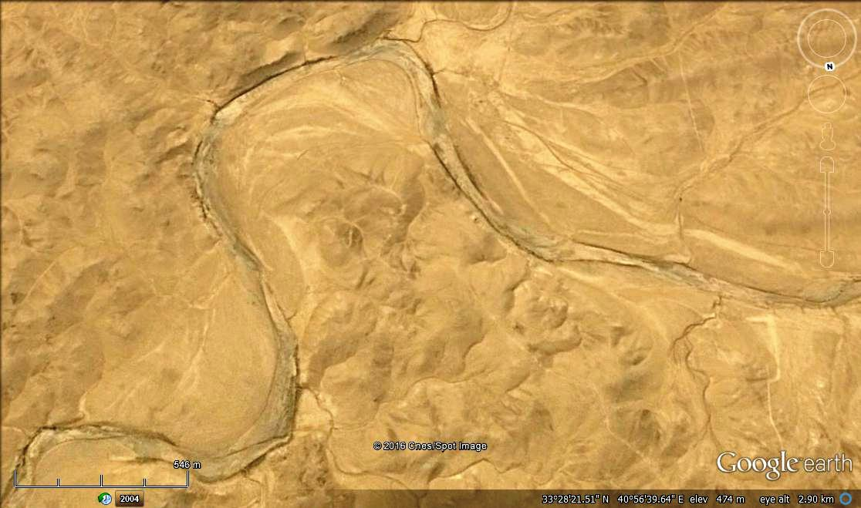
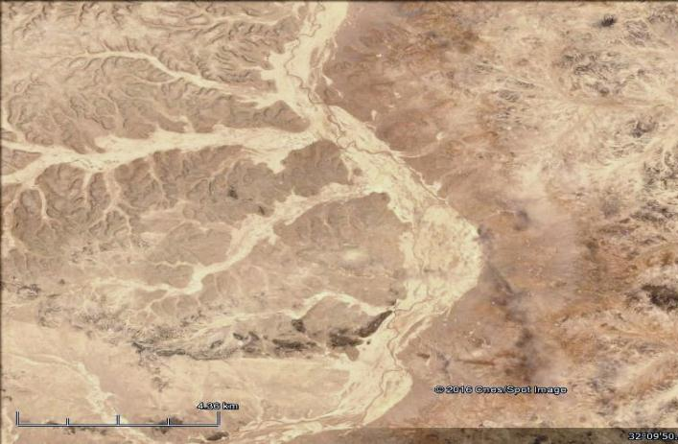
1.5 Km

1 Km

Part 2
Part 1

Part 4
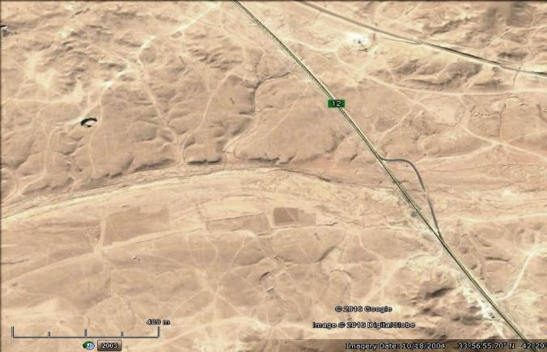
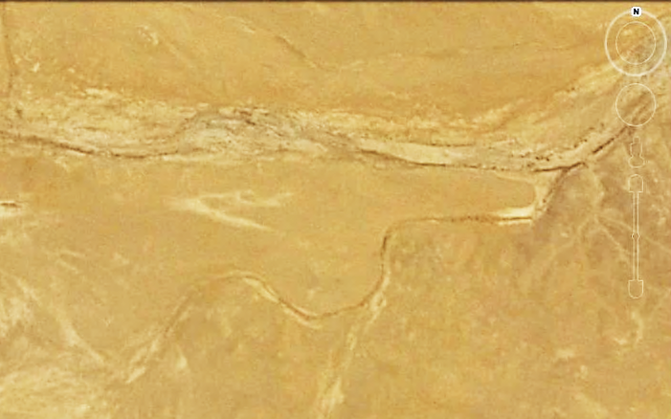
1 Km

500 m

Part 3

Figure 3: Google Earth image of Flood plains in four different parts of wadi Hauran
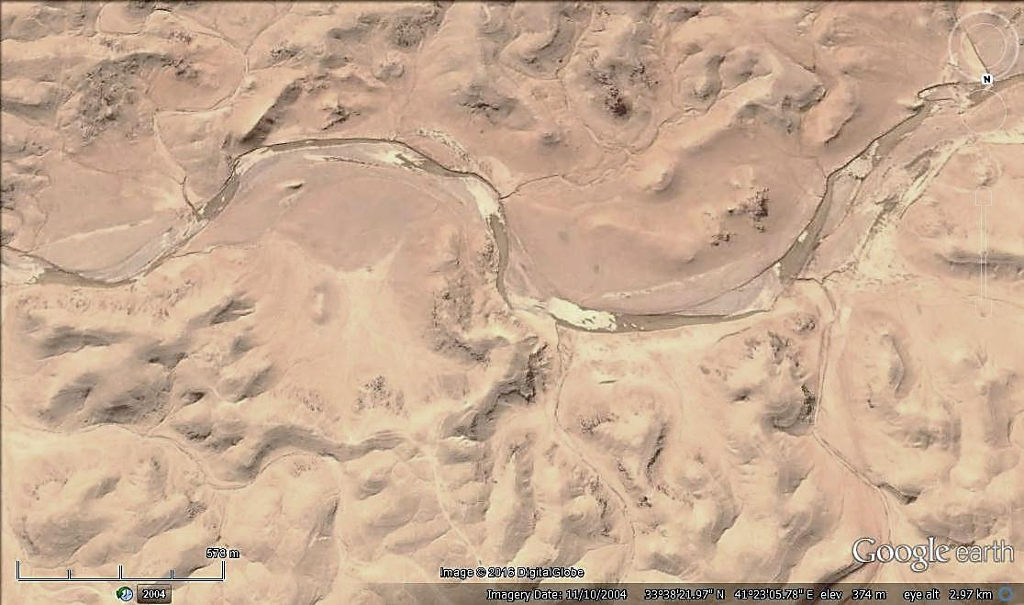
500 m

Fp2
Fp1
Hw
Hw
Fp
Fp
Hw

Figure 4: Google Earth image of wadi Hauran Part 2. Note the interfingering of the hill wash sediments (Hw) with the flood plain sediments (Fp). Also note two stages of flood plain (Fp 1 and Fp 2)

Alluvial Fans (Holocene): Flood plains of Holocene age are very common along the course of wadi Hauran. They are developed when large branches of the valley merge to the main course (Fig. 5); locally leads to shift the valley’s course forming wide meandering (Fig. 6). The composition is almost like the flood plain sediments, but without grading and sub-rounded in form. The thickness is variable, usually ranges in few meters.

Valley Fill (Holocene): Along the whole course of wadi Hauran, valley fill sediments are well developed (Fig. 6). The main constituents are gravels and coarse sand. The gravels are limestone, dolostone and silicified sandstone, rounded in shape and range in size from few centimetres up to 35 cm, but may reach more than 50 cm and very rarely up to 100 cm. Usually, not well cemented; loose, showing cross bedding structure. The thickness is highly variable along the course and even in nearby areas, it ranges up to 8 m, but as average ranges from (2 – 5) m.

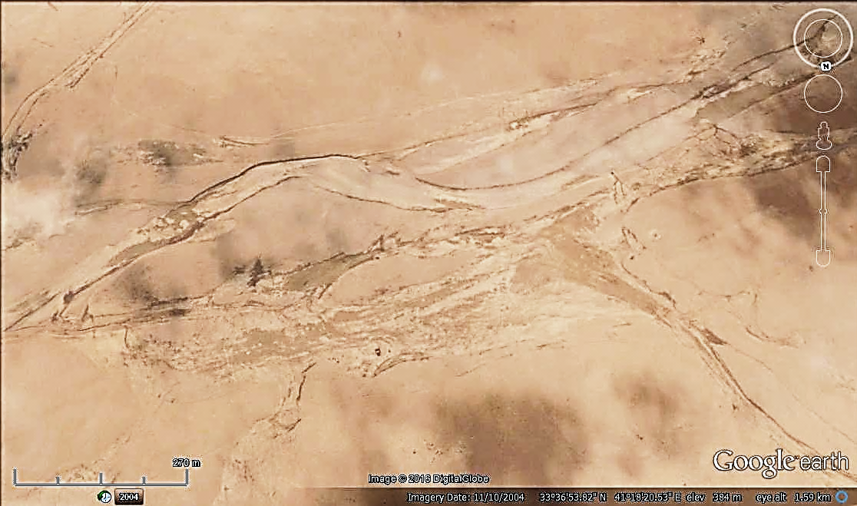
2 Km

Vf
Af
Fp

Figure 5: Google Earth image, an alluvial fan (Af), flood plain (Fp) and
valley fill (Vf) along the course of wadi Hauran (Part 2).

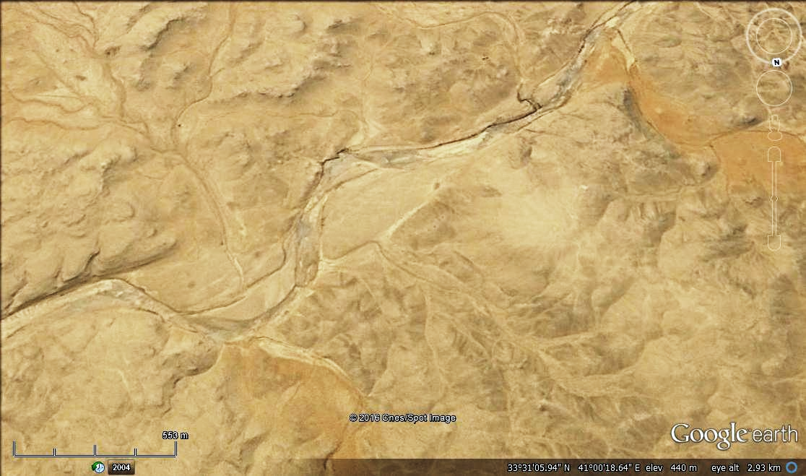
500 m

Af
Af

Figure 6: Google Earth image showing two branches depositing alluvial fans (Af) in their merging to the main course of wadi Hauran

2.1.2. Glacis (Holocene): Both depositional and erosional glacis are developed on the slopes along the course of wadi Hauran. Their constituents are highly variable depending on the type of the exposed rocks. In Parts 1, 2 and 4, the constituents are carbonates, sand and clay, whereas, in Part 3 it is only carbonates. They are partly cemented with thickness ranges from (1 – 5) m increasing downslopes.

2.1.3. Solution and Evaporation Units
The following units are developed:
Sinkholes: These are well developed in different parts of wadi Hauran, but more concentrated in Part 4 (Fig.7). They all are of collapse type with circular apertures and either cylindrical or oval shapes. The diameters range from few meters up to 45 m; whereas, the depth ranges from few meters up to 22 m. All are active type with many chambers in the floor.
Karst Forms: Very old karst forms exist in wadi Hauran, especially in Parts 1 and 2. The ages of the karsts are Jurassic and Cretaceous. In the former, formations of the Upper Jurassic are deposited in karst forms developed in the formations of Lower Jurassic age; whereas, in the latter formations of the Upper Cretaceous are deposited in karst forms developed in the formations of Lower Cretaceous age. This complex karst forms have complicated the stratigraphy of the exposed formations and caused misleading of recognizing different exposed formations in the karstified area.

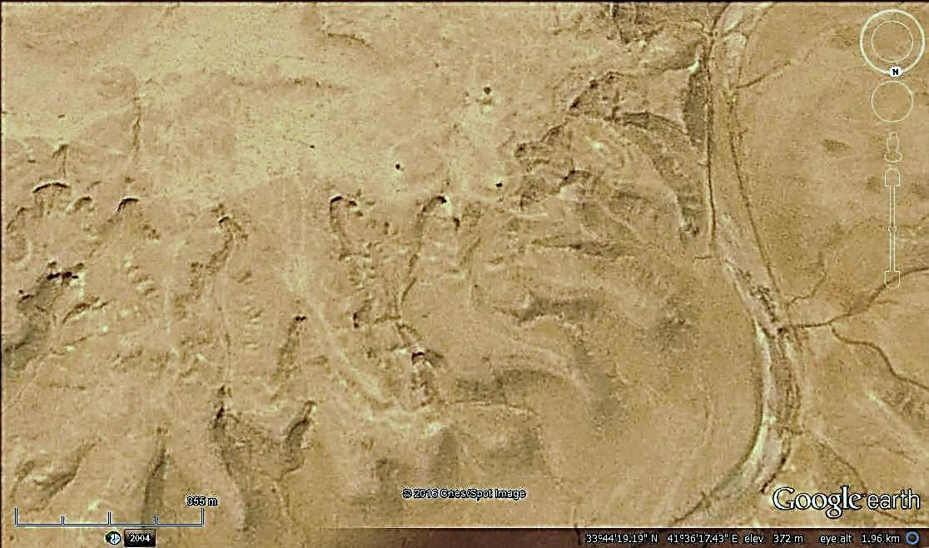
250 m

Figure 7: Google Earth image showing sinkholes in Part 4

The detailed geological mapping in those karstified areas had led recognizing and announcing of many new geological formations [2,3,4].

Calcrete: Calcrete is developed in Parts 1, 2 and 4, consists of heterogeneous rock fragments of variable composition cemented by silty, sandy calcareous materials. Locally, they are very hard due to silica cement and exhibit circular rings of reddish brown colour as a sedimentary structure. The thickness ranges from (1 – 5) m.

2.1.4. Aeolian Unit
In different parts of wadi Hauran, accumulation of aeolian sand occurs either in form of sand sheets or Nabkhas. In both cases they are not more than 1 m in height, usually of very fine sand with pale yellowish brown in color.

2.2.1. Weathering and Erosion
Weathering and erosion processes were very active during Pleistocene and even in Holocene, especially during the wet phases of both periods [22]. The development of the wadi Hauran with its main tributaries and hundreds of minor tributaries are good indication for the active processes that developed such a large valley [23,24].

The weathering and erosion resistant of the exposed rocks in different geological formations along the course of wadi Hauran has caused development of different landscapes in the valley. Therefore, the valley is divided into four main forms, Part 1, 2, 3 and 4 (Fig. 1).

The main erosional types are:
Gulley Erosion: Is the main type of erosion along the course of wadi Hauran, especially in meandering areas (Fig.8). In such areas, under bank and over bank erosion are common; usually associated with rock toppling in the former case and channeling in the flood plain sediments in the latter case.
Sheet Erosion: This type of erosion is very rare in wadi Hauran’s course and along its banks; it acts on flat areas of wide flood plains (Figs. 5, 7 and 9), as well on the top parts of the banks, especially in Part 3 (Figs. 1 and 2), where the surface is very flat covered by residual soil and pebbles od terraces.

Rill Erosion: This type of erosion is very common in Parts 1, 2 and 4, where the soft rocks dominate over the hard rocks; therefore, the main landscape is hummocky with dense cliffs of different sizes (Figs. 4, 6, 7 and 9); along the slopes of those cliffs the rill erosion is very active.

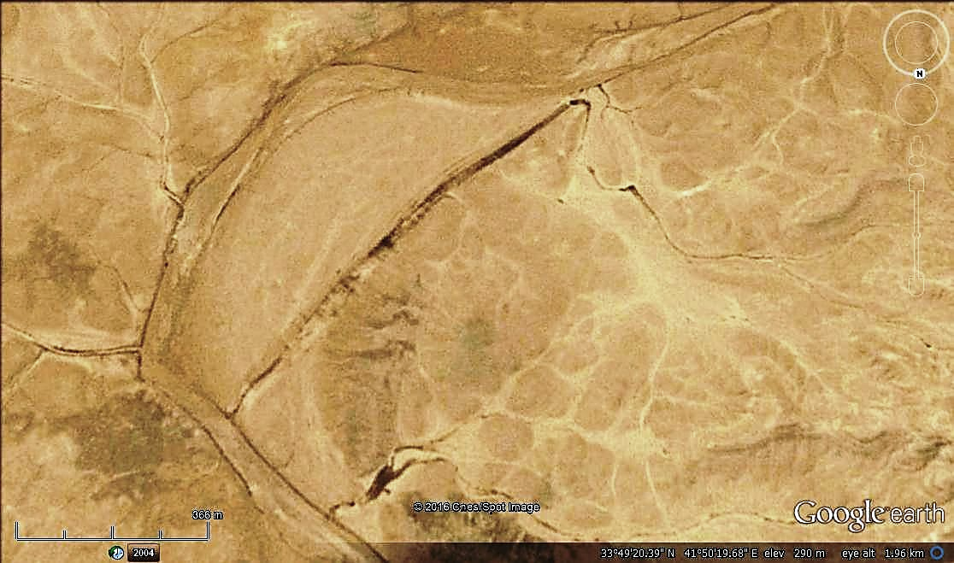
250 m
Ob
Ob
Ge

Figure 8: Google Earth image showing gulley erosion (Ge) along a meander in
wadi Hauran, also note over bank erosion (Ob) traces during high floods

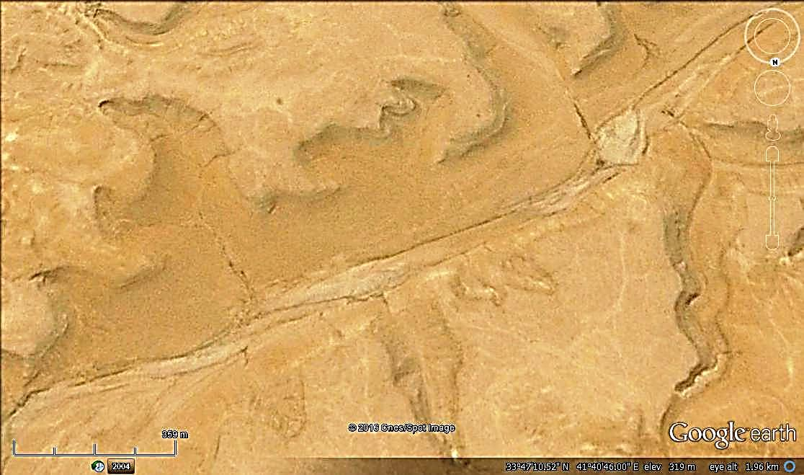
300 m

Re

Figure 9: Google Earth image showing rill erosion (Re) along slopes of cliffs along wadi Hauran

2.2.2. Geomorphological Forms
From the common geomorphological forms that are developed along the course of wadi Hauran are the following:
Mesa and Butte: These are developed due to differential weathering. Both are developed in Parts 1, 2 and 4 (Figs. 4 and 10). They are formed in Rutba, Tayarat, Hartha formations, which include soft and hard rocks in alternation style. The height of these forms range from few meters up to 15 m, usually capped by hard limestone or silicified sandstone.

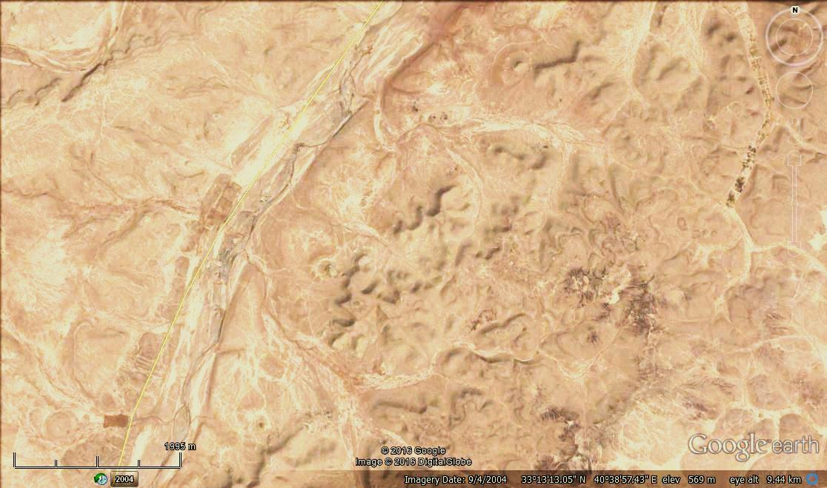
2 Km

Figure 10: Google Earth image of wadi Hauran Part 2,
showing mesa and butte morphology

Hamada and Sarir: These two forms are formed where there is limestone pavement on the upper parts of wadi Hauran’s banks. The size of the blocks depends on the distance to the valley course, the original thickness of the limestone beds and the joint intensity.

Residual Soil: This type of soil is very well developed on the upper most part of wadi Hauran’s banks, especially in Part 3 (Figs. 1 and 2, Left). The developed residual soil is reddish brown in color, silty clay, not compacted, the thickness varies from (< 0.5 – 1.5) m; however, locally may reach 2 m. Towards the bedrock, small fragments of limestone occur in the soil.

2.2.3. Mass Movements
Different types of mass movements occur in different parts of wadi Hauran; however, the abundant movements are in Part 3. This is attributed to the presence of high cliffs forming the banks of the valley. Other parts of the valley suffer from fewer movements. The most common movements are:
Toppling: This type of movement occurs on the cliffs along the bank of wadi Hauran and other main branches and even on small tributaries. The toppled blocks range in size from (< 1 – 3) m³; however, locally and very rarely larger blocks may topple down. Other areas where toppling may occur are in exposures along meandering of the valley, especially when the meanders are in form of acute angles. The undercut erosion will cause toppling of the rocks.
Rock Fall: This type of movement is very rare and restricted to Part 3 only within rocks of Ratga and Euphrates formations, where high vertical and / or very steep slopes occur along which rock fall may occur. The involved areas range up to (10 – 120) m².
Creep: This type is also very rare, restricted to Parts 1, 2 and 4, where soft rocks; like marl and clay occur along slopes and may suffer from creep, especially during wet seasons.
2.2.4. Drainage Patterns
Different types of drainage patterns are developed along the course of wadi Huran. The most common types are:
Dendritic Drainage Pattern: This type of drainage is developed in all parts of wadi Hauran, but not along the main course of the valley, especially in the upper parts of the cliffs where the majority of the rocks are not hard, although some hard rocks exist within the exposed successions (Figs. 2, 3 and 10). The majority of the tributaries; however, exhibit dendritic in their upper reaches (Fig.11).
Annular Drainage Pattern: This type of drainage pattern is developed in restricted areas along the course of wadi Hauran, especially near the course of the valley where patchy pattern of rock exposures occur due to high weathering and erosional processes (Fig. 2, 4, 6 and 8).

Parallel Drainage Pattern: This type of drainage is very rarely developed along the slopes of some cliffs that under the influence of rill erosion, especially where soft rocks are exposed along the slopes.
2.2.5. Valley Forms and Meanders
Wadi Hauran exhibits different forms along its course; this is attributed to the lithology of the exposed formation along the course and their thicknesses. The following forms are developed:
Wide and Shallow Valley Form: In Parts 1 and 4 of wadi Hauran (Fig.1), the course of the valley is wide and shallow with very gentle and wide banks. Table (1) includes numerical data about the maximum and minimum elevation of both banks and the floor of the valley.
Wide and Deep Valley Form: In Part 2 of wadi Hauran (Fig.1), the course of the valley is wide and shallow with gentle and deep banks. Table (1) includes numerical data about the maximum and minimum elevation of both banks and the floor of the valley.
Narrow and Deep Valley Form: In Part 3 of wadi Hauran (Fig.1), the course of the valley is narrow and shallow with very steep and narrow banks; canyon like. Table (1) includes numerical data about the maximum and minimum elevation of both banks and the floor of the valley.
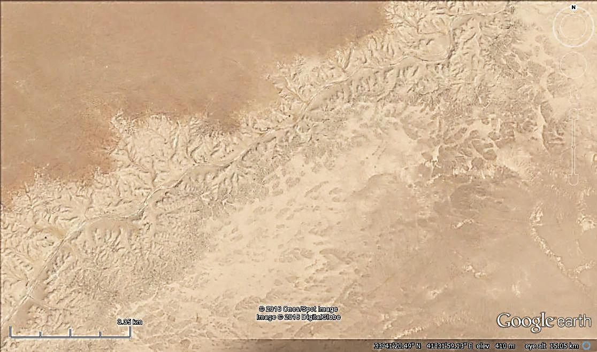
3 Km
Wadi Hauran

Figure 11: Google Earth image showing typical dendritic drainage pattern in
wadi Hauran, Part 3
Table 1: Numerical data about the course and banks of wadi Hauran
Part | Height of the banks (m) |  |  |  | Distance between the banks (Km) |  | Height of the floor (m) |  | Length (Km) | Floor height difference (m) | Thalweg Gradient (%)
 | Left |  | Right
 | Max. | Min. | Max. | Min. | Max. | Min. | Max. | Min.
1 | 915 | 764 | 812 | 143 | 35 | 15 | 890 | 645 | 143 | 245 | 1.72
2 | 764 | 454 | 758 | 124 | 56 | 42 | 645 | 434 | 124 | 211 | 1.73
3 | 454 | 369 | 434 | 336 | 11 | 7 | 434 | 299 | 61 | 135 | 2.21
4 | 369 | 92 | 347 | 92 | 24 | 14 | 299 | 84 | 92 | 215 | 2.34
Meanders: Wadi Hauran exhibits along its course different forms of meandering (Fig. 12), some of them are normal meandering others are not (Fig. 12.2 and 12.6). The main branches of wadi Hauran exhibits as well different meandering forms (Fig.12.1 and 12.5). Some of the meanders are formed due to over bank flooding of the valley (Fig.12.2), witnessing the great erosion ability of the valley, especially during large floods. In other cases of large floods, the flood water carves the course in the flood plain leaving the meandering course to a new straight course (Fig.8).
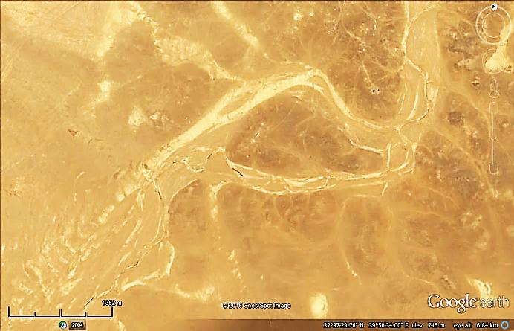
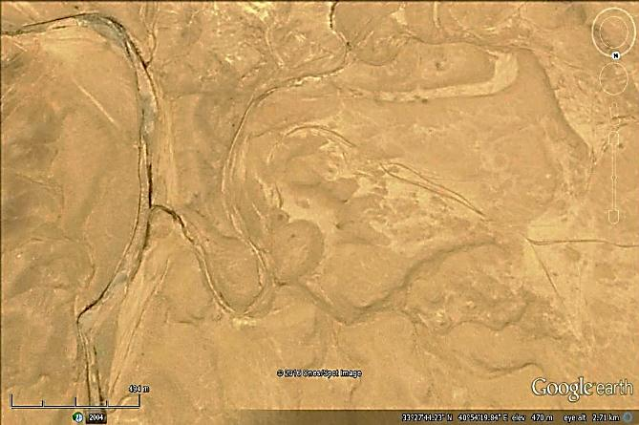
1500 m
200 m
2
1

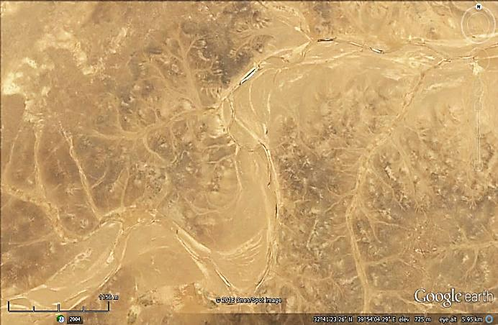
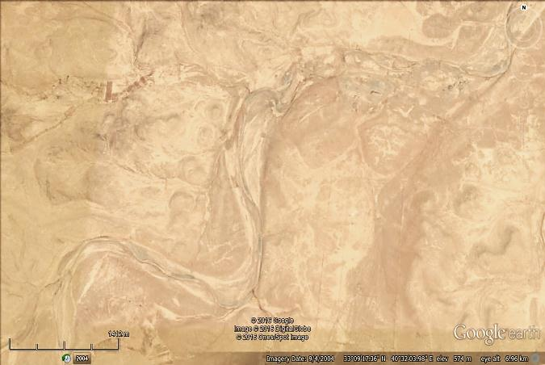
1.5 Km
3
4
1 Km

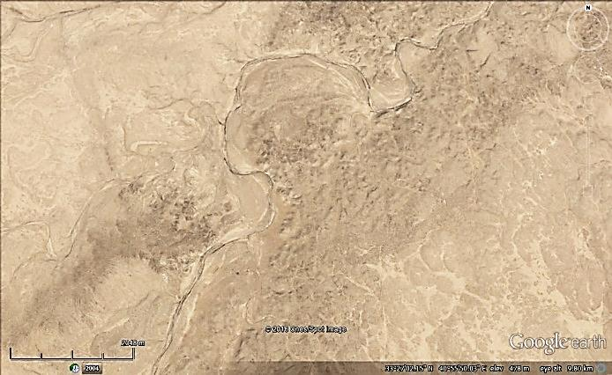
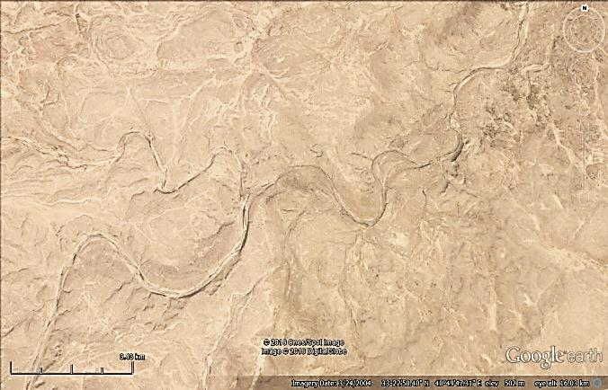
2 Km
3 Km
6
5

Figure 12: Google Earth images of different parts of wadi Hauran exhibiting different forms of meandering

2.3. Tectonics and Structural Geology
The whole course of wadi Hauran is located in the Western Desert Subzone within the Inner Platform of the Arabian Plate [21]. The subzone is generally characterized by simple tectonic scheme and almost no structural geological features, apart from faults of different types [20]. Some of those faults reach the course of the valley (Fig.13) and had caused displacements of some geological formations. The displacement ranges within magnitude of few tens of meters; majority of them are strike slip faults, few of the existing faults had shifted the course of the valley (Fig.13).

From reviewing the geological maps and the existing faults (Fig. 13), it is clear that the majority of the large and acute meanders of wadi Hauran are not related to tectonic activity.

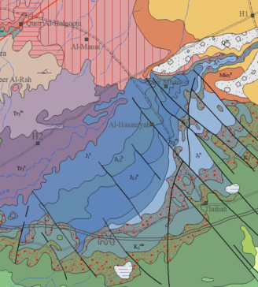
10 Km

Figure 13: Geological Map showing the existing faults along the course of
wadi Hauran (The main course is marked by red color to be more obvious)
For the legend, refer to Figure 14 (After [20])

2.4. Stratigraphy
The exposed rocks along the course of wadi Hauran range in age from Upper Triassic to Middle Miocene with many large unconformities. This wide range of age includes 20 geological formations with wide variety of rocks within the formations and locally within the same formation. Consequently, this diversity in the lithology has formed different forms of the valley along its course and banks (Fig. 1).

The exposed geological formations are described very briefly depending on [25]; their geographical distribution is shown in Figure (14).
Zor Hauran Formation (Upper Triassic): The author of the formation is Dunnington (1951) in [1]. The formation consists of yellow marl, green gypsiferous marl and marly limestone. The thickness ranges between (45 – 150) m. The formation is overlain unconformably by the Ubaid Formation.
Ubaid Formation (Lower Jurassic): The author of the formation is Dunnington (1954) in [1]. The formation consists of varicolored dolostone. The thickness ranges between (23 – 89) m. The formation is overlain unconformably by the Hussainiyat Formation.
Hussainiyat Formation (Lower Jurassic): The formation was recognized and described for the first time by [3], however, it was officially announced by [2]. Previously, the involved sequence was included within the Uba’id Formation. The formation consists of reddish brown fine clastics overlain by thick dolostone. The thickness ranges between (10 – 20) m. The formation is overlain unconformably by the Amij Formation.

Amij Formation (Upper Jurassic): The Amij Formation is recently added to the stratigraphic column of Iraq. Previously, the involved sequence was included within the Muhaiwir Formation. The formation was recognized and described for the first time by [8]. However, [3] also recognized the formation, but they named it as Upper Butmah Formation, then they abandoned the name and used Amij Formation; however, the formation was announced officially by [4]. The formation consists of reddish brown fine clastics overlain by dolomitic marl and fossiliferous limestone, with common yellow and pink colors. The thickness ranges between (21 – 54) m. The formation is overlain unconformably by the Muhaiwir Formation.
Muhaiwir Formation (Upper Jurassic): The author of the formation is Witzel (1951) in [1]. The formation consists of yellow sandstone overlain by yellow limestone; then yellow and green clastics overlain by yellow and pink dolostone and limestone. The thickness ranges between (21 – 94) m. The formation is overlain unconformably by the Najmah Formation.
Najmah Formation (Upper Jurassic): The author of the formation is Dunnington (1953) in [1]. The formation consists of conglomerate and yellow sandstone overlain by reddish brown and pink limestone. The thickness ranges between (30 – 45) m. The formation is overlain unconformably by the Nahr Umr Formation.

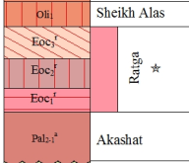
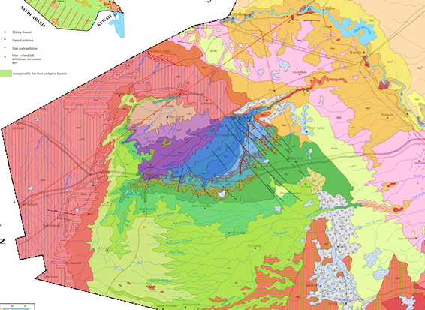
50 Km

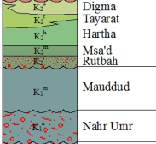
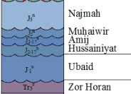

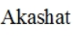

Figure 14: Geological Map along wadi Hauran (After Sissakian and Fouad, 2012)

Nahr Umr Formation (Lower Cretaceous): The author of the formation is Glynn Jones (1948) in [1]. However, the formation was recognized in the Iraqi Western Desert for the first time by [3]. The formation consists of varicolored sandstone overlain by reddish brown marl. The thickness ranges between (23 – 35) m. The formation is overlain unconformably by the Mauddud Formation.
Mauddud Formation (Lower Cretaceous): The author of the formation is Henson (1940) in [1]. However, the formation was recognized in the Iraqi Western Desert for the first time by [3]. The formation consists of marl and marly limestone. The thickness ranges between (9 – 14) m. The formation is overlain unconformably by the Rutbah Formation.
Rutbah Formation (Upper Cretaceous): The authors of the formation are Foran and Keller (1937) in [1]. The formation consists of white and ferruginous sandstone. The thickness ranges between (23 – 33) m. The formation is overlain unconformably by the M”sad Formation.
M’sad Formation (Upper Cretaceous): The author of the formation is Henson (1940) in [1]. The formation consists of varicolored sandy dolostone, and dolostone. The thickness ranges between (8 – 65) m. The formation is overlain unconformably by the Hartha Formation.
Hartha Formation (Upper Cretaceous): The author of the formation is Rabanit (1952) in [1]. However, the formation was recognized in the Iraqi Western Desert for the first time by [3]. The formation consists of conglomerate and sandstone overlain by marl and dolostone. The thickness ranges between (85 – 162) m. The formation is overlain conformably by the Tayarat Formation and locally interfingers with it.
Tayarat Formation (Upper Cretaceous): The author of the formation is Henson (1940) in [1]. The formation consists of rusty sandy siltstone with hematitic concretions. Overlain by marl, siltstone and sandstone with chert nodules, followed by reddish or varicolored detrital limestone with Loftusia. The thickness ranges between (10 – 50) m. The formation is overlain conformably by the Digma Formation and locally interfingers with it.
Digma Formation (Upper Cretaceous): The author of the formation is Dunnington (1953) in [1]. The Digma Formation was recognized in the Iraqi Western Desert for the first time by Sattran and Mansour (1975) in [8]. [10] however, mapped the formation as "Safra Beds" for the first time in the Western Desert. The formation consists of white to creamy limestone, dolostone with phosphorite horizon and green to ocher papery shale, with oyster shell horizon. The thickness ranges between (12 – 40) m. The formation is overlain unconformably by the Akashat Formation.
Akashat Formation (Paleocene): The Akashat Formation is recently added to the stratigraphic column of Iraq. Formerly, the succession was considered as the Umm Er Radhuma Formation. It was officially announced by [26]. The formation consists of alternation of grey phosphorites and limestones. The thickness of the formation ranges between (30 – 54) m. The formation is overlain conformably by the Ratga Formation.
Ratga Formation (Eocene): The Ratga Formation is recently added to the stratigraphic column of Iraq. Formerly, the succession was considered as the Dammam Formation. It was officially announced by [27]. The formation consists of nummulitic limestone, phosphorite and phosphatic limestone, fine crystalline limestone, with several chert horizons. The thickness of the formation ranges between (90 – 100) m. The formation is overlain unconformably by the Sheikh Alas Formation.
Sheikh Alas Formation (Lower Oligocene): The author of the formation is van Bellen (1956) in [1].The formation consists of creamy, yellowish white, porous, limestones, locally contain fine nummulites. The thickness of the formation ranges between (15 – 20) m. The formation is overlain conformably by the Shurau Formation.
Shurau Formation (Lower Oligocene): The author of the formation is van Bellen (1956) in [1].The formation consists of creamy white nummulitic limestone. The thickness of the formation ranges between (12 – 18) m. The formation is overlain unconformably by the Euphrates Formation.
Ghar Formation (Lower Miocene): The authors of the formation are Own and Nasr (1958) in [1]. The formation consists of pebbly sandstone, followed by interbedding of pink and yellowish grey, slightly fossiliferous and sandy limestone with soft marly sandstone, overlain by alternation of yellow thick beds of sandy marl with thin yellow and pink burrowed limestone. The thickness of the formation ranges between (13 – 22) m. The formation is overlain conformably by the Euphrates Formation and locally exhibits interfingers with it.
Euphrates Formation (Lower Miocene): The author of the formation is de Boeckh et al. (1929) (part), emended by van Bellen (1957) in [1]. The formation consists of grey and white, fossiliferous limestone, dolostone and dolomitic limestone, very rarely green marl horizon, may occur, with basal conglomerate in the base. The thickness of the formation ranges between (30 – 55) m. The formation is overlain conformably by the Nfayil Formation.
Nfayil Formation (Middle Miocene): The Nfayil Formation is recently added to the stratigraphic column of Iraq. Formerly, the succession was considered as the Euphrates Formation. It was officially announced by [28]. The formation consists of alternation of green marl and limestone in three cycles. The thickness of the formation ranges between (12 – 18) m. The formation is the youngest succession along wadi Hauran.
Quaternary Sediments: Different types of Quaternary sediments occur along the course of wadi Hauran of Pleistocene and Holocene ages. Their types and composition are given within the description of Geomorphological units.

2.5. Economic Potential
Different industrial rocks and minerals are available along the course of wadi Hauran and its banks, majority of them are non-metallic; however, metallic minerals occur too. The main industrial rocks and minerals are described briefly; hereinafter.
Ironstone: Ironstone is developed within the Hussainiyat Formation, especially along the banks of Hussainiyat valleys, which is one of the major branches of wadi Hauran. The Hussainiyat ironstone deposit (Jurassic) is mainly pisolitic, intraclastic and concretionary in texture, associated with kaolinite mudstones and/or with qurtzose sandstone. The ironstone consists mainly of goethite, hematite, kaolinite and quartz. The percentage of Fe₂O₃ reaches 36 % but as an average it is 28 % [29]. The sedimentary iron was quarried from Hussainiyat valley and widely used in cement plants. The reserves are estimated by about 60 m.t. [30].
Bauxite: Karst-filling bauxite of Cretaceous age is developed widely in the eastern bank of wadi Hauran, especially in the location of merging Hussainiyat valley with wadi Hauran. Karstified carbonate host rocks represented by the dolostone of the Ubaid Formation (Early Jurassic) contain bauxite lenses preserved inside the karsts up to 70 m depth; together with kaolinitic bauxite, kaolinitic clays and sands, which belong to the Lower Clastic Unit of the overlying Hussainiyat Formation (Lower Jurassic). Normative mineralogy reveals that boehmite (up to 47%) and to a lesser extent gibbsite (up to 19%) are the main bauxitic minerals with kaolinite (28%), hematite (2.8%), anatase (up to 4.1%) and calcite (0.4%) as the main accessory minerals (Mohammed, 2013). The bauxite is used in refractories production. The reserves are about 1 m.t. (Mustafa et al., 1994).
Kaolinitic Claystone: This type of claystone is present in the lower parts of the Hussainiyat Formation (Early Jurassic) along Wadi Hussainiyat and in the Amij Formation (Middle Jurassic) at Wadi Amij. The Jurassic kaolinites are highly ferruginous and of lower grade. Flint-clays are known as karst-fill deposits of Early Cretaceous age in association with bauxite and bauxitic clay [31].
Montmorillonite and Palygorskite Claystones: Extensive montmorillonite-rich marine sedimentary claystones are known in the Digma Formation (Late Cretaceous) and to a lesser extent in the Akashat Formation (Paleocene) in association with phosphorites [29]. These claystones are originally black shales, rich in carbonaceous matter (Al-Bassam and Al-Haba, 1990, in [32]. They were oxidized to yellow and green claystones in surface and near-surface sections. These claystones are used in many industries. The reserves are estimated by about 22 m.t. [32].
Porcelanite: These are siliceous rocks, composed of opal-CT and are derived from biogenic (mostly diatoms) amorphous opalline silica. They are part of the phosphorites-bearing sequences of the Maastrichtian and Paleocene in the Western Desert (Digma and Akashat formations, respectively). The reserves are estimated by about 1.8 m.t. [32].
Limestone: Huge reserves of limestone suitable for cement industry occur in Ratga and Euphrates formation with average CaO % of 54.20 and 53.50 respectively, whereas the average of MgO % is 0.24 and 0.65, respectively [32]. Limestone with such specifications can also be used in other industries; like paper, paints, chemicals and also for building.
Dolomite: The main dolomite deposits in the Western Desert are found in Zor Hauran formation (Upper Triassic), Ubaid, Hussainiyat and Amij formations (Jurassic), M’sad and Hartha (Cretaceous) and Euphrates (Lower Miocene). High quality dolomites, suitable for industrial purposes, are available in many of these rock units. The average of MgO % in Zor Hauran, Hussainiyat and Euphrates formations is 20.62, 19.50, 18.35, respectively (Al-Bassam, 2007). Huge reserves occur in wadi Hauran and its banks.
Quartz-sand: Huge deposits of quartz-sands are encountered in the Nahr Umr (Albian) and Rutbah (Cenomanian) formations; estimated by about 75 m.t. [33]. The thickness of the deposit is 20 m thick. The sandstone consists of (95 – 99) % quartz [32].
Heavy Minerals Sandstones: Heavy minerals sandstones’ occur in the Amij Formation. They consist of (54 – 76) % opaques, (7 – 19) % zircon, (5 – 15) % monazite and (3 – 11) % rutile. The zircon is rich in Hf, Y and Th, whereas the rutile is rich in Cr [32].
Gravels and Sands: These fluvial sediments are developed within the valley fill and flood plain sediments of wadi Hauran and its main branches, and even in large tributaries with enormous amounts since the thickness may reach up to 10 m, but in general it ranges from (2 – 6) m. These sediments are quarried (Fig. 15) and used in different constructions of strategic projects, like highways and rail ways. They are free from SO₃ with sizes ranging from silt to gravel.
Geodes: Geodes occur in Tayarat and Hartha formations; as well in the valley fill and flood sediments of wadi Hauran. They range in size from few centimetres up to 35 cm, although exceptionally may reach 50 cm. They are of silica type, in which quartz crystals are grown inside the inner hallow. They can be used for ornamentation and decoration.

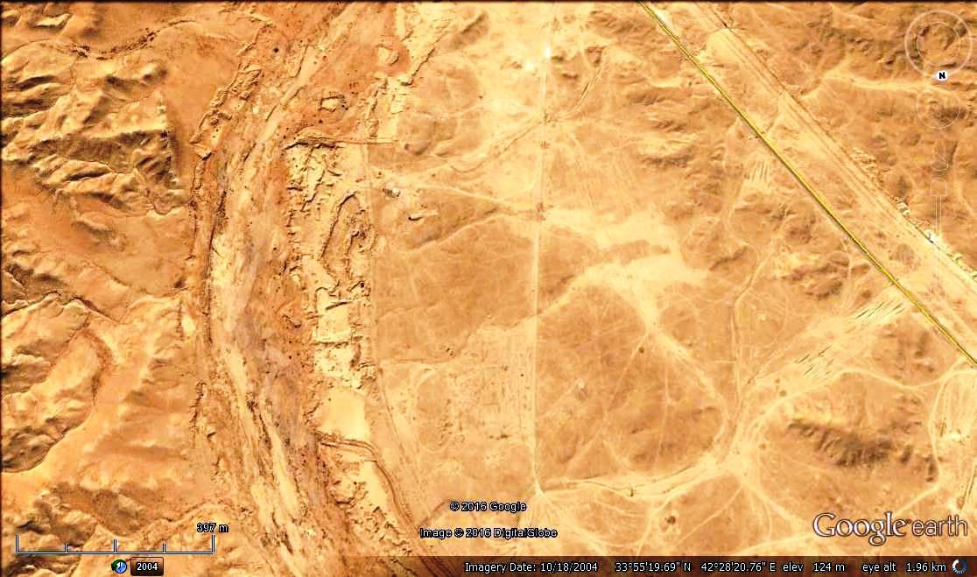
400 m

Figure 15: Google Earth image showing quarries in wadi Hauran.

2.6. Hydrogeology
Wadi Hauran is excellent source for feeding the ground water during rainy seasons. This is attributed to its length and width beside its main branches and tributaries. The thickness of the recent sediments in the course of the valley; ranges between (2 – 5) m and locally more thick with gentle gradient along its course; range from (1.72 – 2.34) % (Table 1) contribute in decreasing the surface run off and increase infiltration and recharging the aquifers along the course of the valley. Moreover many earth fill dams are constructed along the course of the valley and its main branches (Fig.16).

According to [34], Mulussi, Ubaid, Muhaiwir, Rutbah, M’sad, Hartha, Tayarat, Akashat, Ratga, Euphrates, formations and Quaternary sediments are good aquifers to yield fresh water. The groundwater level varies from about 300 m below ground surface, in the southern parts to artesian (Fig. 17) or near ground surface, in recharge zones along the Euphrates River. Salinity of the water increases with depth and also towards discharge zones. It ranges from fresh in the western parts to very high salinity in discharge areas. Water type also varies from bicarbonate or mixed to mainly chloride or sulphatic in the discharge zones [34].

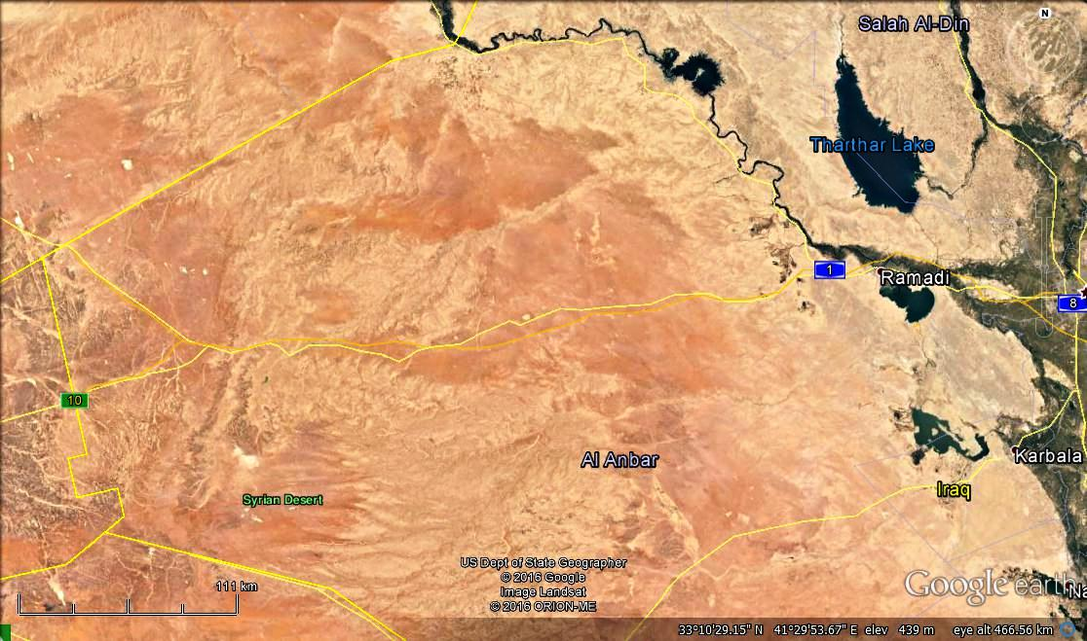
110 Km
Rutbah

Figure 16: Google Earth image showing the locations of constructed dams along the course of wadi Hauran and its main branches

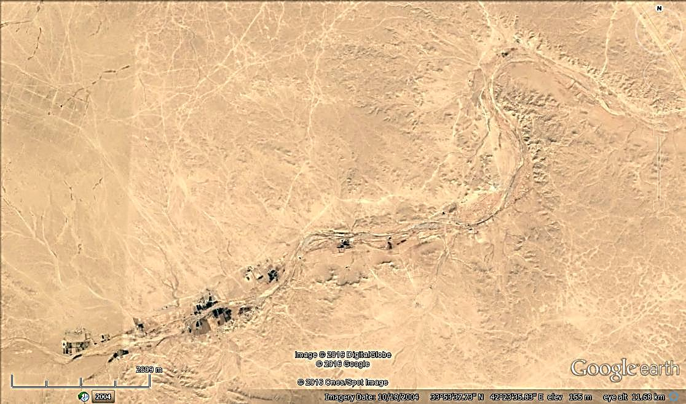
2. 5 Km

Figure 17: Google Earth image showing springs (encircled in blue color)
in wadi Hauran along its lower reaches; before merging in the Euphrates River

3. Discussion
Different geomorphological and stratigraphical aspects are discussed hereinafter.

3.1. Geomorphological Aspects
Terraces: Although wadi Hauran is the largest valley in Iraq; carving its course in different rock types and having different valley forms, but the preserved terraces are very poor. This can be attributed to type of the rocks along which its course is running. In parts 1, 2 and 4, where the valley runs in almost soft rocks with very wide banks (Fig.1), the deposited terraces most probably are weathered and washed down to the valley during weathering and erosion of the banks; after incision of the valley. In contrary, where the valley runs in hard rocks with canyon shape (Part 2) and the banks are very close to the course, which means the rocks are hard and not weathered, clear terraces can be seen on the top. Some (50 – 60) m above the present course with thickness of up to 5 m, with wide covered area where residual gravels still are preserved (Fig. 2).
Meanderings: Wadi Hauran exhibits different types of normal and abnormal meanders along its course (Figs. 8 and 12). Those abnormal meanders are most probably tectonically controlled, although no clear structural forms occur in the concerned areas. A good example is the multi meandering of the valley course before merging to the Euphrates River (Fig.18). The meanders coincide with three lineaments that have controlled the meanders of the Euphrates River and developed straight valleys west of wadi Hauran.

Another example of controlled meanders are along its main course with lineaments of NW – SE trend (Fig. 19). The lineaments are even affected the terrace accumulation on the top flat area along banks of the valley.

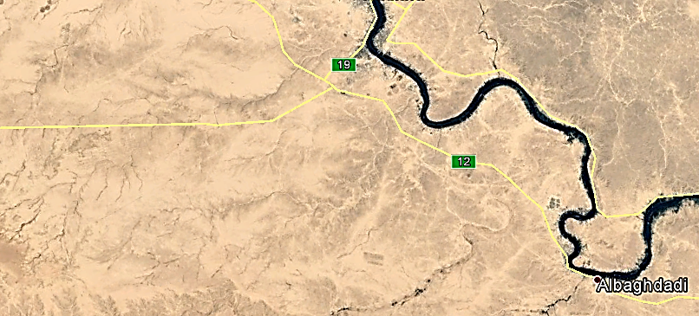
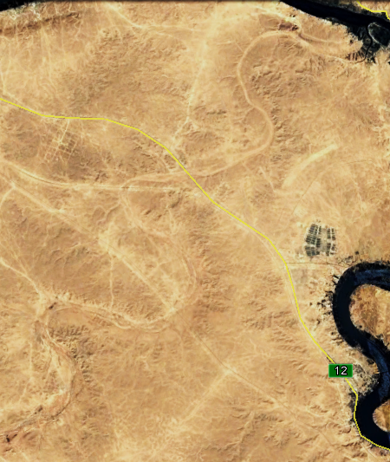
6 Km
2 Km

Figure 18: Google Earth image of wadi Hauran in Part 4.
Note the multi meandering and the existing lineaments
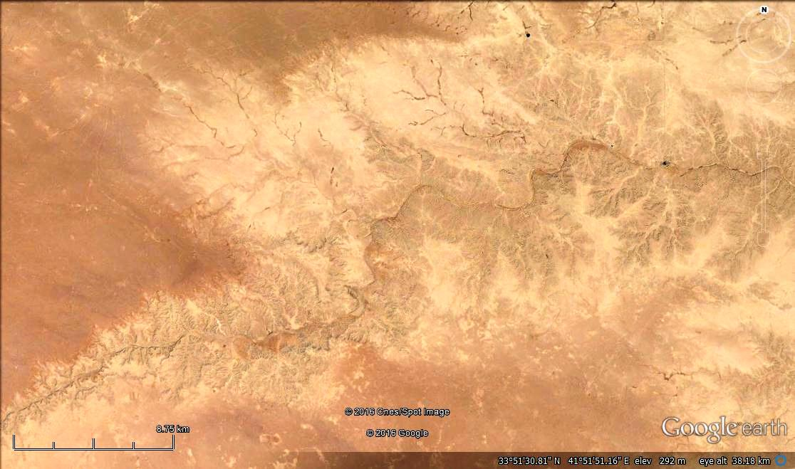
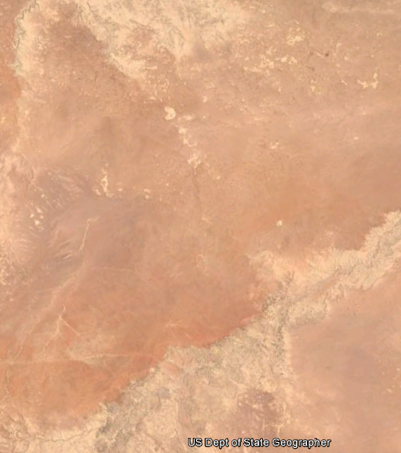
10 Km
9 Km
Wadi Hauran
Wadi Hauran

Figure 19: Left and Right) Google Earth image showing the effect of the lineaments on the meandering of wadi Hauran

3.2. Stratigraphical Aspects
The large lithological similarities between different formations; like Nahr Umr and Rutbah, Hussainiyat and Amij, beside the existence of lower clastic part and upper carbonate part of many formations along the course of wadi Hauran have led confusing of many formations and consequently misleading their recognition. Moreover, the Jurassic and Cretaceous karstification has led complicated stratigraphical position of many formations; those which were deposited in old karst depressions.

The detailed geological mapping of [13] for those karstified areas has detected all previously misleading cases; as the stratigraphic succession is concerned. Moreover, two formations were recognized and announced after detecting the true stratigraphic succession of those karst filling successions.

The quarrying of the ironstone in Hussainiyat Formation and karst bauxite in karst depressions has revealed and confirmed the recognized and announced two new formations and indicted the correct lithology of Ubaid, Hussainiyat, Muhaiwir and Amij formations.

The exposed Euphrates Formation in wadi Hauran has different lithological facies than in the type locality. The brecciated unit and overlying undulated limestone unit in the type locality and alongside the Euphrates River are not developed in the exposures of the Euphrates Formation in wadi Hauran. This is attributed to the tectonic rest in the area; just the reverse of the area alongside of the Euphrates River that suffers from tectonic unrest [35] because it represents the contact between the Inner and Outer Platforms [21].

3.3. Tectonic and Neotectonic Aspects
Although the whole course of wadi Hauran is located tectonically within the Inner Platform of the Arabian Plate [21], which is known to be tectonically undisturbed, but still clear lineaments are developed in the concerned area. The lineaments have NW – SE trend with very clear indications. Among those indications are: 1) meandering of the valley in abnormal forms (Figs. 6, 18 and 19), 2) straight tributaries along the lineaments (Figs. 18 and 19), 3) along terrace accumulations (Figs. 18 and 19), 4) presence of straight cliffs (Fig. 19 Right) and 5) fault system east of the valley (Fig. 14), since the existing faults coincide with the lineaments.

The presence of NW – SE trending lineaments and their effect on the: 1) meandering of the main course, 2) straight form of fine tributaries, 3) dislocation of the accumulated terraces and 4) presence of cliffs are good indications for Neotectonic activity.

The S – N trend of the upper reach course of wadi Hauran (Part 1, Fig. 1) may be an indication for Nabitah Fault System; a system that prevails in Saudi Arabia and extends in the southern part of Iraq [19]. The change of the main course of the valley towards northeast may be an indication for the main transversal fault and regional lineaments system [36].

3.4. Hydrogeological Aspects
The long courses of wadi Hauran with different exposed rocks along its course and banks, beside thick valley fill sediments have increased the infiltration of surface runoff water during heavy floods. The peak runoff; however, reaches after few hours from heavy rain showers, this is attributed to the large drain basin of the valley and its main branches and tributaries. Annually, large floods occur in the valley recharging the aquifers as well drain enormous quantities of flood water into the Euphrates River. Exceptionally, very heavy floods are developed each few years that have large damaging ability, destroying the bridges, culverts and road embankments along the valley’s course. According to local people near the mouth of the valley where it merges into the Euphrates River, the flood of wadi Hauran drops its carried load during those exceptional flood on the left bank of the Euphrates River indicating the amount of the flooded water and its velocity. Moreover, they added that the flooded water in wadi Hauran was acting as a barrier in the Euphrates River preventing the normal water flow in the river. This case; however, was before the construction of earth fill dams (Fig. 16) on the main course of the valley and its main branches.

3.5. Age Estimation of wadi Hauran
In age estimation of wadi Hauran, the exposure age determination method is used [37]. Wadi Hauran as the largest valley in Iraq witnesses intensive erosion that have carved the course of the valley with its banks width up to 35 Km and maximum depth of about 60 m, indicates long period of erosion. Therefore, Pleistocene age is not relevant as almost all valleys in near surroundings are. This is attributed to the following facts: 1) the size of the valley and the large coverage area of the draining basin, 2) carving of very hard rocks of the Ratga Formation along its course in depth of up to 60 m forming canyon shape of the valley, 3) erosion of its terraces among its course; except in Part 3 by incision and extending of its width; both valley course and banks, 4) depositing thick valley fill sediments up to 10 m and 5) coating of some rocks of the Rutbah and Ratga formations, and terrace pebbles in Part 3 by desert varnish. When considering the required time span to develop and form the aforementioned aspects, then Pliocene age is more relevant than Pleistocene.

4. Conclusions
The course of wadi Hauran is tectonically controlled, in its uppermost reach its trend is almost S – N; following Nabitah Fault system. Farther on, it changes its trend towards northeast following the main transversal fault and lineament system. Along its course, tens of normal and abnormal large meanderings occur. Those which are abnormal are controlled tectonically, as revealed from the existing lineaments of NW – SE trend. The lineaments are very clear with many indications for Neotectonic activities; among the indications are: 1) meandering of the main course, 2) straight form of fine tributaries, 3) dislocation of the accumulated terraces, 4) presence of cliffs and 5) presence of strike slip faults; their extensions towards northwest coincide with some lineaments.

The form of the valley course of wadi Hauran can be divided into four parts: 1) shallow and wide, 2) wide and deep, 3) canyon form and 4) wide and shallow. These four different forms are developed as a result of difference in lithology of the exposed rocks along the valley course and its banks. The type and strength of the uppermost exposed rocks along the valley course have played significant role in the valley form.

The intense karstification during Jurassic and Cretaceous Periods has complicated the stratigraphic succession of the exposed rocks leading to confusing the true succession of many geological formations. Regional and detailed geological mapping has revealed the true stratigraphic succession; consequently, two new geological formations were announced.

The intense karstification during Cretaceous Period has led the deposition of many non-metallic minerals, like bauxite, porcelanite and flint clay. Many other non-metallic minerals are deposited in different environment; mainly marine, like montmorillonite, kaolinite and palygorskite. Continental environment with shallow marine environment; however, has also deposited quartsoze sandstone of the Rutbah Formation.

The estimated age of wadi Hauran using exposure age estimating method is Pliocene. This estimation depends on many aspects that are developed in the valley and its banks.

References
[1] Bellen, R.C. van, Dunnington, H.V., Wetzel, R., and Morton, D., 1959. Lexique Stratigraphic International. Asie, Fasc. 10a, Iraq, Paris.
[2] Hassan, K.M., 1997. The Hussainiyat Formation: A new name for the Jurassic Lithostratigraphic Unit in the Western Desert of Iraq. Iraqi Geological Journal, Vol. 30, No. 1, p. 15 – 21.
[3] Al-Mubarak, M. and Amin, R.M., 1983. Report on the regional geological mapping of the eastern part of the Western Desert and western part of the Southern Desert. Iraq Geological Survey (GEOSURV) Library report no. 1380.
[4] Al-Azzawi, A.M., 1997. The Amij Formation: a new name for the Jurassic Lithostratigraphic Unit in the Western Desert of Iraq. Iraqi Geological Journal, Vol.30, No.1, p. 7 – 14 .
[5] Al-Jumaily, R.M., 1974. The Regional geological mapping of the area between Iraqi – Syrian Borders, T1 Oil pumping station (Western Desert). Iraq Geological Survey (GEOSURV) Library report no. 653.
[6] Tyracek, J. and Youbert, Y., 1975. Report on the regional geological survey of Western Desert between T1 Oil pumping station and wadi Hauran. Iraq Geological Survey (GEOSURV) Library report no. 673.
[7] Hamza, N.M., 1975. Regional geological mapping of Al-Tharthar – Hit – Qasr Al-Khubaz area. Iraq Geological Survey (GEOSURV) Library report no. 678.
[8] Buday, T., and Hak, J., 1980. Report on geological survey of the western part of the Western Desert, Iraq. Iraq Geological Survey (GEOSURV) Library report no. 1000.
[9] Al-Naqib, S.Q., Said, L.K., Taha, Y.M., Al-Sharbati, F.A., Yakta, S.A., Hussain, M.S., Yacuob, I.I. and Al-Mukhtar, L., 1986. Detailed geological survey of Rutba area. Iraq Geological Survey (GEOSURV) Library report no. 1560.
[10] Al-Bassam Kh.S., Karim, S., Mahmoud, K., Yakta, S., Saeed, L. and Salman, M., 1990. Geological survey of the Upper Cretaceous Lower Tertiary phosphorite bearing sequences, Western Desert. Iraq Geological Survey (GEOSURV) Library report no. 2008.
[12] Qaseer, M.R., Al-Marsoomi, A.M., Ma'ala, Kh.A., Karim, S.M. Hassan, F.A., Basi, M.A., Al-Mukhtar, L.A., and Dawood, R.M., 1992. Final report on the detailed geological survey for Al-Hussainiyat area. Iraq Geological Survey (GEOSURV) Library report no. 2089 (in Arabic).
[13] Al-Azzawi, A.M.N. and Dawood, R.M., 1996. Report on detailed geological survey in northwest of Kilo 160 – Rutbah area. Iraq Geological Survey (GEOSURV) Library report no. 2491.
[14] Jassim, S.Z., Karim, S.A., Basi, M.A., Al-Mubarak, M. and Munir, J., 1984. Final report on the regional geological survey of Iraq, Vol. 3, Stratigraphy. Iraq Geological Survey (GEOSURV) Library report no. 1447.
[15] Jassim, S.Z., Hagopian, D.H. and Al-Hashimi, H.A., 1986. Geological Map of Iraq, scale 1: 1 000000, 1st edition. Iraq Geological Survey (GEOSURV) Publications, Baghdad, Iraq.
[16] Jassim, S.Z., Hagopian, D.H. and Al-Hashimi, H.A., 1990. Geological Map of Iraq, scale 1: 1 000000, 2nd editition. Iraq Geological Survey (GEOSURV) Publications, Baghdad, Iraq.
[17] Fouad, S.F., 2007. Tectonics and Structural evolution. In: Geology of the Iraqi Western Desert. Iraqi Journal of Geology and Mining, Special Issue No.1, p. 29 – 50.
[18] Sissakian, V.K., 2000. Geological Map of Iraq, 3rd eddition, scale 1: 1 000 000, Iraq Geological Survey (GEOSURV) Publications, Baghdad, Iraq.
[19] Jassim, S.Z. and Goff, J.C., 2006. Geology of Iraq. Dolin, Prague and Moravian Museum, Brno.
[20] Sissakian, V.K. and Fouad, S.F., 2012. Geological Map of Iraq, 4th eddition, scale 1: 1 000 000, Iraq Geological Survey (GEOSURV) Publications, Baghdad, Iraq.
[21] Fouad, S.F.A., 2012, Tectonic Map of Iraq scales 1: 1000 000, 3rd edition, Iraq Geological Survey (GEOSURV) publications, Baghdad, Iraq.
[22] Jado, A.R. and Zofl, J.G., 1978. Quaternary Period in Saudi Arabia, Vol.2. Springer Verlag, New York, p. 280 – 294.
[23] Ritter, D.F., R. Craig, K.R., and Jerry R. Miller, J.R., 2002. Process Geomorphology, 4th edition. New York: McGraw-Hill.
[24] Bierman, P.R. and Montgomery, D.R., 2014. Key Concepts in Geomorphology, 14th edition. W.H. Freeman Publisher. ISBN13: 978-1429238601
[25] Sissakian, V.K. and Mohammed, B.S., 2007. Stratigraphy. In: The Geology of the Iraqi Western Desert. Iraqi Journal of Geology and Mining, Special Issue No.1, p. 51 – 124
[26] Al-Bassam, K.S. and Karim, S.A., 1997. The Akashat Formation: A new name for the Paleocene Lithostratigraphic Unit in the Western Desert of Iraq. Iraqi Geological Journal, Vol. 30, No.1, p. 22 – 35.
[27] Karim, S.A., and Al-Bassam, K. S., 1997. The Ratga Formation: a new name for the Eocene Lithostratigraphic Unit in the Western Desert of Iraq. Iraqi Geological Journal, Vol.30, No. 1, p. 46 – 60.
[28] Sissakian, V.K., Mahdi, A.I., Amin, R.M. and Salman, B.M., 1997. The Nfayil Formation: a new lithostratigraphic unit in the Western Desert of Iraq. Iraqi Geological Journal, Vol. 30, No.1, p. 61 – 65.
[29] Al-Bassam, Kh.S and Tamar-Agha, M.Y., 1998. Genesis of the Hussainiyat ironstone deposit, Western Desert, Iraq. Mineral Deposita, 33: 266. doi:10.1007/s001260050146
[30] Etabi, W., Aboud, A. and Houbi, W., 1984. Report on mineral investigation of the Hussainiyat iron ore deposits. Stage II, Part 1: Geology and reserve estimation. Iraq Geological Survey (GEOSURV) Library report no. 1441.
[31] Mustafa, M., Naif, A., Jibrail, A., Hussain, D. Ahmad, M., Al-Kadhimi, J., Misconi, H., Saeed, L., Zarrag, G. and Abdul Sattar, M., 1994. The results of prospecting – exploration on bauxite deposits in Northern Hussainiyat, Western Desert. Iraq Geological Survey (GEOSURV) Library report no. 2276.
[32] Al-Basam, K.S., 2007. Mineral Resources. In: Geology of the Iraqi Western Desert. Iraqi Journal of Geology and Mining, Special Issue No. 1, p. 145 – 168.
[33] Etabi, W., Abdeen, F., Abdul Jabbar, M. and Faleh, K., 1986. A study of quartz sand, east of Rutba. Iraq Geological Survey (GEOSURV) Library report no. 1536.
[34] Al-Juburi, H.T. and Al-Basrawi, N.H., 2007. Hydrogeology. In: Geology of the Iraqi Western Desert. Iraqi Journal of Geology and Mining, Special Issue No. 1, p. 125 – 144.
[35] Sissakian, V.K., Karim, S.M., Al-Kubaisy, K.N., Al-Ansari, N. and Knutsson, S., 2016. The Miocene Sequence in Iraq, a Review and Discussion, with emphasize on the Stratigraphy, Paleogeography and Economic Potential. Journal of Earth Sciences and Geotechnical Engineering, Vol.6, No. 3, P. 271 – 317. ISSN: 1792-9040 (print version), 1792-9660 (online) Scienpress Ltd.
[36] Sissakian, V.K., Al-Ansari, N. and Knutsson, S., 2014. Origin of Some Transversal Linear Features of NE-SW Trend in Iraq, and Their Geological Characters. Natural Science, Vol. 6, p. 996 – 1011. SciRes. http://www.scirp.org/journal/ns. http://dx.doi.org/10.4236/ns.2014.612091
[37] Keller, E. A., and Pinter, N. 2002. Active Tectonics, Earthquakes, Uplift and Landscape, 2nd edition. New Jersey: Prentice Hall.

Private Consultant, Erbil, Iraq. e-mail: varoujan49@yahoo.com
Iraq Geological Survey; Baghdad.
Lulea University of Technology, Lulea, Sweden. e-mail: nadhir.alansari@ltu.se, Sven.Knutsson@ltu.se Article Info: Received : January 10, 2011. Published online : July 17, 2012

