GROUNDWATER POLLUTION POTENTIAL IN PART OF THE WESTERN DESERT, IRAQ
Hussain M. Hussain¹, Nadhir A. Al-Ansari² and Sven Knutsson³
¹ Dep. of Geology, Faculty of Science, University of Kufa , Iraq
^{2&3}Dep. Of Civil, Environmental and natural Resources Engineering, Lulea University of Technology, Sweden
Emails: hussainm.alshimmary@uokufa.edu.iq,nadhir.alansari@ltu,se,Sven.Knutsson@ltu.se

Abstract
The growth of human population often corresponds with change in land use, including expansion of urban areas, which necessitates increasing the available amount of drinking water. As the surface water sources are more amenable to pollution, it has become necessary to use groundwater at an increasing rate. Groundwater is normally abundant in the alluvial region where the urban areas are often located. Such areas face a greater risk of pollution of groundwater due to several factors.
Surface water resources are becoming more scares in Iraq which gave a tendency to use groundwater. In this research, groundwater vulnerability in part of the western desert had been studied. It was noticed that the area has low risk for the contamination of ground water.

Key words: Groundwater vulnerability, Iraq, Western desert, DRASTIC model.

- Introduction
Iraq is located in the Middle East. It covers an area of 433,970 square kilometers populated by about 32 million inhabitants (Figure 1) [1,2] Iraq is bordered by Turkey from the north, 352 km, Iran from the east, 1458 km, Syria and Syria from the west, 605 km and 181 km, respectively and Saudi Arabia and Kuwait from the south, 814 km and 240km respectively (Figure 1). Topographically, Iraq is divided into 4 regions (Figure 1). The mountain region occupies 5% of the total area of Iraq, restricted at the north and north eastern part of the country. This region is part of Taurus -Zagrus mountain range. Plateau and Hills Regions is the second region and it represents 15% of the total area of Iraq. This region is bordered by the mountainous region at the north and the Mesopotamian plain from the south. The Mesopotamian plain is the third region and it is restricted between the main two Rivers, Tigris and Euphrates. It occupies 20% of the total area of Iraq. This plain extends from north at Samara, on the Tigris, to Hit, on the Euphrates, toward the Gulf in the south. The remainder area of Iraq which forms about 60% of the total area is referred to as the Jazera and Western desert.
The Rivers Tigris and Euphrates form the main water resources of Iraq. They join together in the south forming what is referred to as the Shat Alarab, which drains towards the Gulf (Figure 1).
Iraq was considered to be rich in its water resources compared with other countries where the annual allocation per capita reached 6029 m³ in 1995 and expected to be 2100 m³in 2015 [3]. Now, Iraq is suffering from water shortage problems. This is due to the construction of dams on the Tigris and Euphrates and their tributaries outside the border of Iraq, the effect of global climate change and mismanagement of water resources are the main factors in the water shortage problems in Iraq [1]. Restoring the marshes [4,5] and the growing demand for water in Turkey and Syria will lead to dry the Tigris and Euphrates Rivers in 2040 [4]. Furthermore, the supply will be 43 and 17.61 BCM in 2015 and 2025 respectively while current demand is estimated between 66.8 to 77 BCM. The World Bank [3] stated that 100% of the Euphrates water comes from outside the borders of Iraq while 67% of the Tigris water also comes from outside sources. They also stated that groundwater resources are about 1.2 BCM and form about 2% of the total water resources of Iraq.
To overcome these problems in Iraq, there is a great need for prudent management of water resources, utilizing ground water and the adaptation of non- conventional techniques to augment water resources [1,6]. Groundwater use is relatively low where it ranges from 2 to 9 % in Iraq [7-10].There were number of attempts to study the ground water resources in the Iraqi deserts (e.g.[11-16]). These studies proved that this region has number of aquifers that possess good quality and quantity of water.In this research groundwater resources in part of the western desert had been studied using DRASTIC model to investigate the vulnerability of the aquifer in the studied area to pollution.

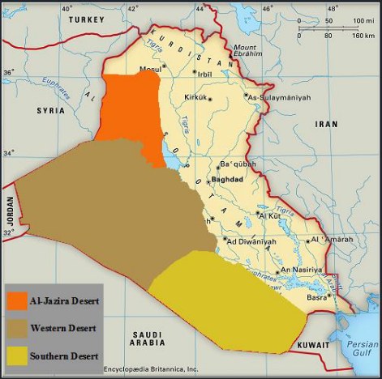

Figure 1: Map of Iraq showing its rivers and desert areas.

- Study area
The studied area represents the north-east part of wadi Al Abaith basin and wadi Al Ghadaf basin which is located within the Western Desert of Iraq between longitudes (40º 15' 45" – 43º 47' 39") East and latitudes (31º 29' 10" – 33º 6' 17") North, (Figure 2 & 3). This region covers an area of about 47173 km². It is bordered from the northwest by the Iraqi-Syrian border, from the west by the Iraqi-Jordanian border, from the southwest by Saudi Arabia, from the southeast by Kuwait and the Euphrates River from its northern border. This region forms a plain area with no marked physiographic features. The slope of the area is directed from the Iraqi-Saudi Arabia border in the south west towards the Euphrates River in the north east; and from the Iraqi-Syriaian border in the west toward the Euphrates River in the east. The maximum altitude reaches 900m above sea level near the Iraq-Syria border while the minimum is less than 50m above sea level near the Hamar marsh [17,18,19].
The area is characterized by its large number of seasonal streams and lakes. The Khir valley divides the region into what is known as the north Badia and the south Badia. Groundwater forms the main source of water in this area and it can be found in different geologic formations. Generally groundwater movement is toward the northeastern part of the desert where in some places it runs to the surface in the form of springs [19]. The annual rainfall is low, ranging from 100 - 150 mm and the mean annual temperature is ranging from 13°C to 30°C [17].

The geological map of the area (Figure 4) show that the oldest exposed rocks are of upper Cretaceous age (Tayarat Formation) which are located within the western part of the area. Dibdiba Formation (Pliocene – Pleistocene) is exposed east the area near Razaza lake [20,21]. In the south west of the area near the Iraqi-Saudi border Um Er Radhuma Formation (Middle – Late Paleocene) are exposed [20]. East the area Dammam Formation (Early – Late Eocene) is exposed. Early Miocene rocks represented by Euphrates Formation are exposed south west Razaza Lake while Middle Miocene rocks are exposed west of the lake represented by Fatha Formation. Upper Miocene rocks are exposed north-East the lake represented by Injana Formation. Quaternary deposits (Pleistocene – Holocene) are confined to the central part of the area represented by river terraces and valley deposits [21].

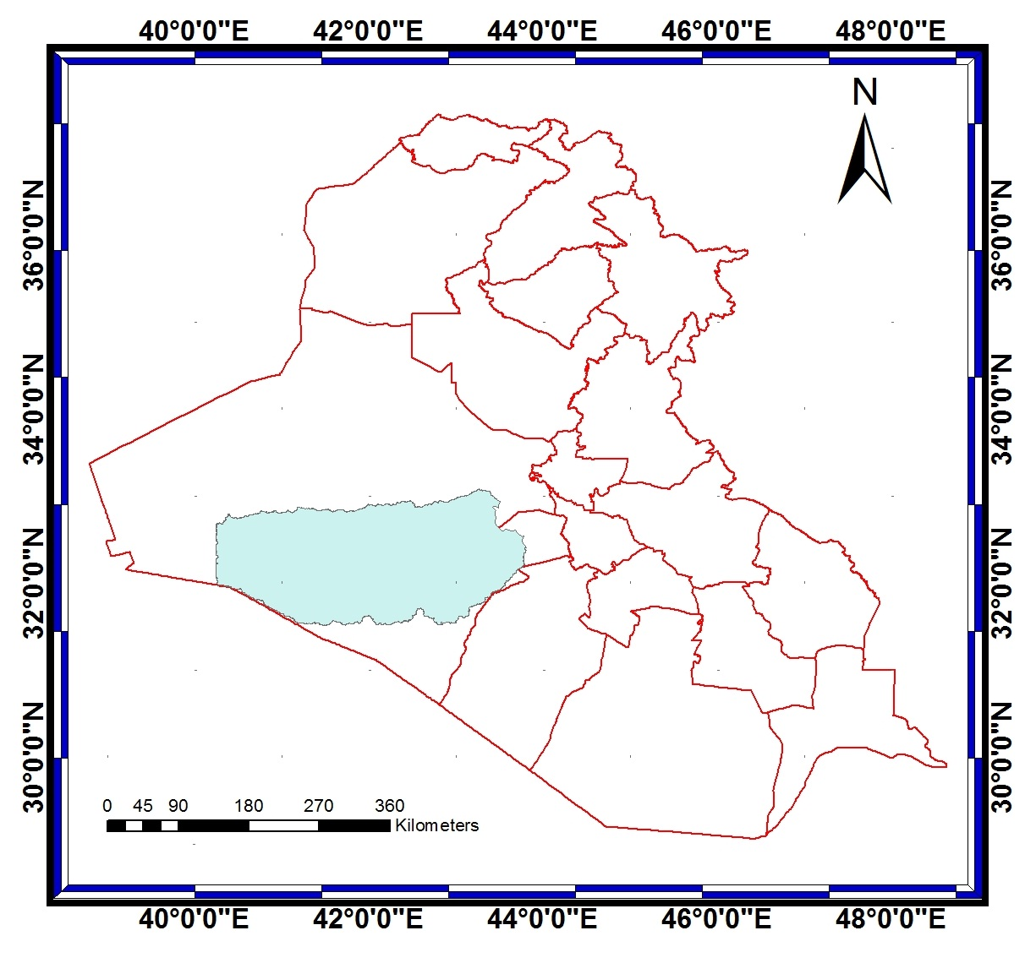

Figure 2: Map of Iraq showing the study area.

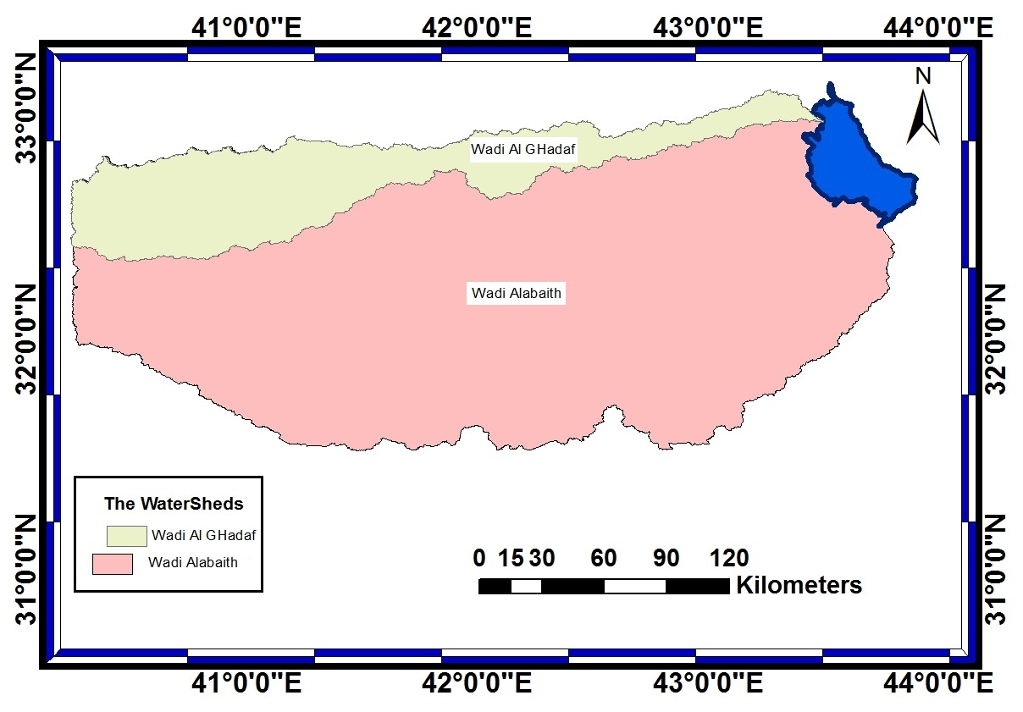

Figure 3: Map wadi Al Abaith basin and wadi Al Ghadaf basin

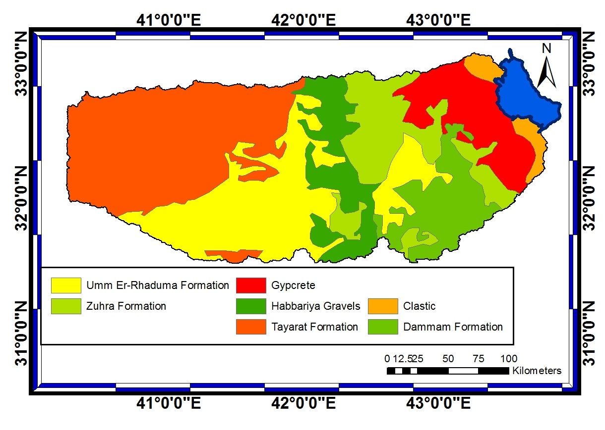

Figure 4: Geological map for the study area

- Methodology:

To implement this work the following data were collected:
- Satellite imageries and geological maps for the study area were prepared. The scale of the geological maps was 1:250000 and 1:100000. In addition, topographic maps (scale 1:100000) were also used.
- All the coordinates of the maps were corrected for their latitude and longitude to correspond to the international coordinates using ERDAS Imagine version 8.5. Mosaic maps were prepared using geologic and topographic maps.
- Topographic, soil, and geologic maps were manually digitized through ERDAS software to convert them to digital format.
- Field visits were conducted to find out the location of some wells so that their locations can be drawn on the maps.
- Collecting metrological data.
- Preparing the “Thematic map” required for the model. This includes recharge of ground water, types of rocks of the aquifers, soil types, ground surface slopes, types of rocks in the unsaturated zone and aquifer’s transmissivity.

Then DRASTIC model was applied. This model is a relative evaluation tool, which was designed for producing pollution potential maps of the entire U.S.A by a standardized non-subjective method to compare pollution vulnerability over different areas. For this reason, weight classes and ratings were considered as constants that could not be changed; otherwise comparison between different areas would not have been possible. Only two parameters, aquifer media and impact of the vadose zone, were assigned a typical rating and a variable rating, wherein the variable rating permitted to select a typical value or to adjust the value as a function of more specific knowledge. The application of this method in the study area is discussed in the following sections.
The DRASTIC parameters were entered into software ArcView GIS as vector map layers. The ratings and weights were assigned to the DRASTIC parameters, as given by Aller et al. [22]. The ratings for all DRASTIC parameters were subsequently added to obtain the total cell rating. For each parameter, overlays were made between original layers and the layer of 100 m² cells and the average parameter rating for each cell was calculated. For all parameters, the maps illustrate a rating variation from 1-10, darker shades indicating higher ratings. The process details in respect of all these parameters are presented in the following section.
- Results and Discussion:

The DRASTIC stands for the seven parameters used in the model (Table 1) [22]. The first is the depth to water that mean the depth from the ground surface to the water table, deeper water table levels imply lesser chance for contamination to occur. The second is the net Recharge represents the amount of water, which penetrates the ground surface and reaches the water table; recharge water represents the vehicle for transporting pollutants. The third is the aquifer media refers to the saturated zone material properties, which controls the pollutant attenuation processes. The fourth is the soil media represents the uppermost weathered portion of the unsaturated zone and controls the amount of recharge that can infiltrate downward. Topography is the fifth parameter and it refers to slope or steepness; areas with low slope tend to retain water for longer; this allows a greater inﬁltration of recharge of water and a greater potential for contaminant migration. Impact of the vadose zone (the unsaturated zone material) is the sixth parameter and it controls the passage and attenuation of the contaminated material to the saturated zone. Finally, the hydraulic conductivity is the seventh parameter and it indicates the ability of aquifer formation to transmit water; an aquifer with high conductivity is vulnerable to substantial contamination (Table 1).

DRASTIC assigns a rating to each parameter, on a scale of 1 to 10, based on functional curves. This rating is then scaled by a weighting factor, and the weighted ratings are summed to obtain the DRASTIC index (DI). The parameters are weighted according to their relative susceptibility to the pollutant. Each DRASTIC parameter has been assigned a relative weight ranging from 1 to 5, according to their relative susceptibility to pollutants. The most significant parameters have weights of 5, and the least significant is assigned a weight of 1.

The final vulnerability map was based on the DRASTIC index (DI) which w computed as the weighted sum overlay of the seven layers, using Equation (1):
DI = Dr*Dw + Rr*Rw + Ar*Ar + Sr*Sw + Tr*Tw + Ir*Iw + Cr*Cw (1)
Where
D, R, A, S, T, I, and C are the seven parameters;

4.1 Depth to the water table: Represents the depth from the ground water table levels implies lesser chance surface to the water table, deeper for contamination to occur [23]. The depth of water table ranges between 50 to 500 m at the eastern and the western part of the study area respectively (Figure 5). Water table depths were given ranges and for each range a rating value was assigned (Table 1). Rating 10 is given to the range that is most capable of getting contaminants to the ground water while rating 1 is the least possible depth to get contaminants to groundwater.
In view of the nature of groundwater depth within the studied area, all water depths were more than 30m and consequently were given a value of 1 (Figure 6).

Table 1: DRASTIC parameters and their rating scale [22].

Parameters | Weight scale  (w) | Range | Rating  ( r ) | Index scale  (r * w)
Depth to the water table | 5 | 0-1.5 | 10 | 50
Depth to the water table | 5 | 1.5-4.5 | 9 | 45
Depth to the water table | 5 | 4.5-9.1 | 7 | 35
Depth to the water table | 5 | 9.1-15.2 | 5 | 25
Depth to the water table | 5 | 15.2-22.9 | 3 | 15
Depth to the water table | 5 | 22.9-30.5 | 2 | 10
Depth to the water table | 5 | > 30.5 | 1 | 5
Net Recharge of aquifer | 4 | 0-50.8 | 1 | 4
Net Recharge of aquifer | 4 | 50.8-101.6 | 3 | 12
Net Recharge of aquifer | 4 | 101.6-177.8 | 6 | 24
Net Recharge of aquifer | 4 | 177.8-254.0 | 8 | 32
Net Recharge of aquifer | 4 | > 254.0 | 9 | 36
Aquifer media | 3 | Massive Shale | 2 | 6
Aquifer media | 3 | Metamorphic / Igneous | 3 | 9
Aquifer media | 3 | Weathered Metamorphic/ Igneous | 4 | 12
Aquifer media | 3 | Thin Bedded Sandstone, Limestone, Shale Sequences | 6 | 18
Aquifer media | 3 | Massive Sandstone | 6 | 18
Aquifer media | 3 | Massive Limestone | 6 | 18
Aquifer media | 3 | Sand and Gravel | 8 | 24
Aquifer media | 3 | Basalt | 9 | 27
Aquifer media | 3 | Karst Limestone | 10 | 30
Soil media | 2 | Thin or Absent | 10 | 20
Soil media | 2 | Gravel | 10 | 20
Soil media | 2 | Sand | 9 | 18
Soil media | 2 | Peat | 8 | 16
Soil media | 2 | Shrinking and /or Aggregated Clay | 7 | 14
Soil media | 2 | Sandy Loam | 6 | 12
Soil media | 2 | Loam | 5 | 10
Soil media | 2 | Silty Loam | 4 | 8
Soil media | 2 | Clay Loam | 3 | 6
Soil media | 2 | Muck | 2 | 4
Soil media | 2 | Nonshrinking and Nonaggregated Clay | 1 | 2
Topography | 1 | 0 -2 | 10 | 10
Topography | 1 | 2-6 | 9 | 9
Topography | 1 | 6-12 | 5 | 5
Topography | 1 | 12-18 | 3 | 3
Topography | 1 | >18 | 1 | 1
Impact of Vadose Zone | 5 | Silt/Clay | 1 | 5
Impact of Vadose Zone | 5 | Shale | 3 | 15
Impact of Vadose Zone | 5 | Limestone | 6 | 30
Impact of Vadose Zone | 5 | Sandstone | 6 | 30
Impact of Vadose Zone | 5 | Bedded Sandstone, Limestone, Shale | 6 | 30
Impact of Vadose Zone | 5 | Sand and Gravel with significant Silt and Clay | 6 | 30
Impact of Vadose Zone | 5 | Metamorphic / Igneous | 4 | 20
Impact of Vadose Zone | 5 | Sand and Gravel | 8 | 40
Impact of Vadose Zone | 5 | Basalt | 9 | 45
Impact of Vadose Zone | 5 | Karst Limestone | 10 | 50
Hydraulic Conductivity | 3 | 0.005-0.5 | 1 | 3
Hydraulic Conductivity | 3 | 0.5-1.5 | 2 | 6
Hydraulic Conductivity | 3 | 1.5-3.5 | 4 | 12
Hydraulic Conductivity | 3 | 3.5-5.0 | 6 | 18
Hydraulic Conductivity | 3 | 5.0-10.0 | 8 | 24
Hydraulic Conductivity | 3 | > 10.0 | 10 | 30

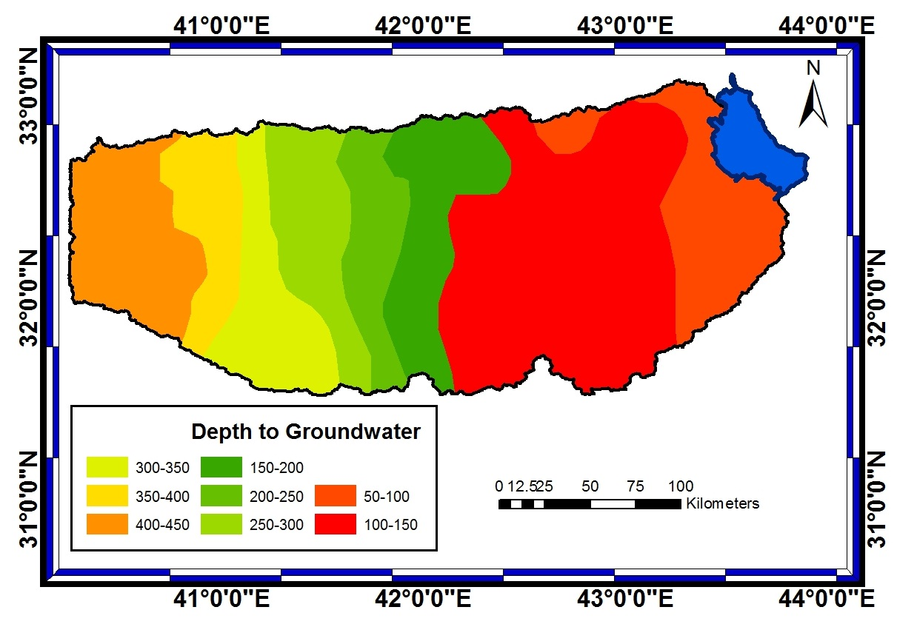

Figure 5: Depth to groundwater.

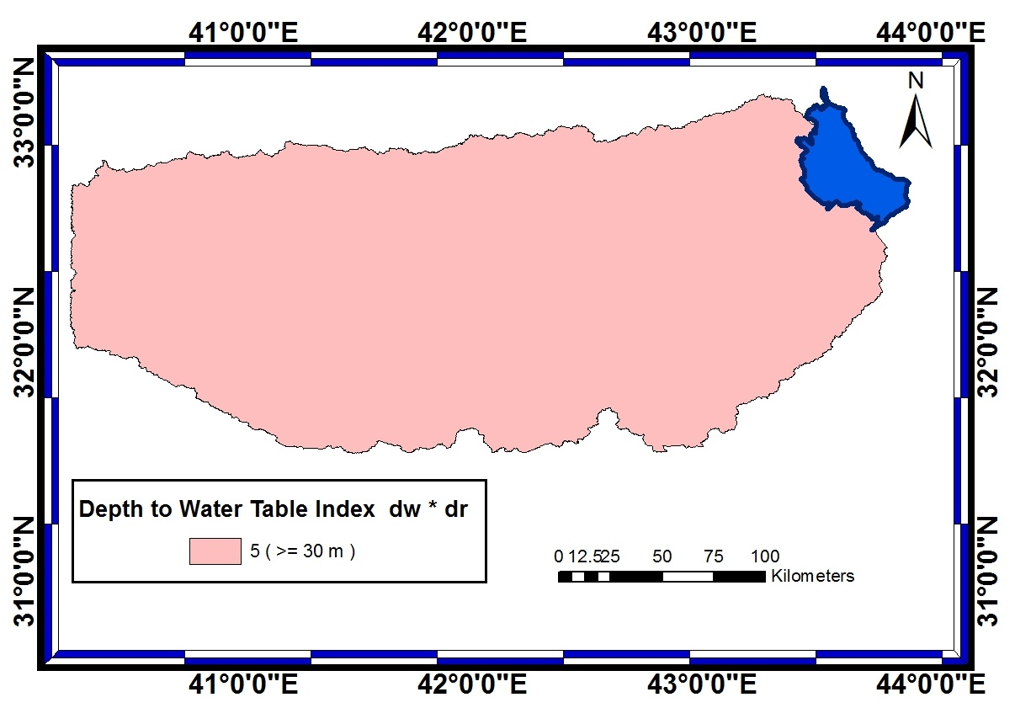

Figure 6. Index map for depth to groundwater.

4.2 Net Recharge: Represents the amount of water which penetrates the ground surface and reaches the water table, recharge water represents the vehicle for transporting pollutants [23]. The range and rating of each range for net recharge of ground water are tabulated in Table 1. According to this rating, three different locations were distinguished (Figure 7) and from these results a map was constructed (Figure 8).

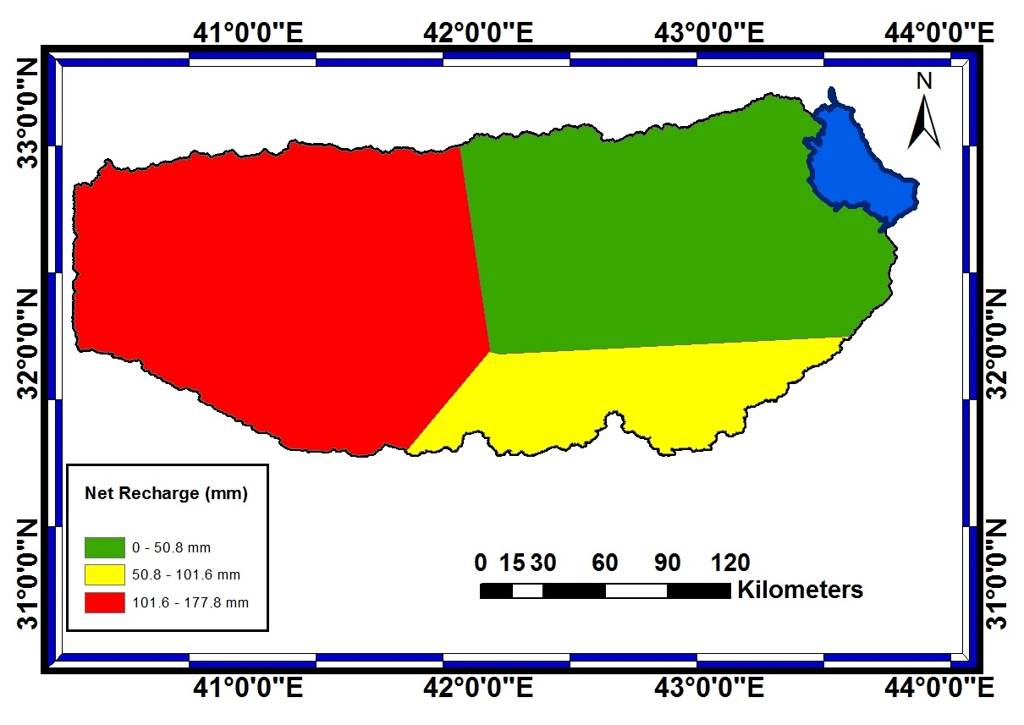

Figure 7: Net recharge map.
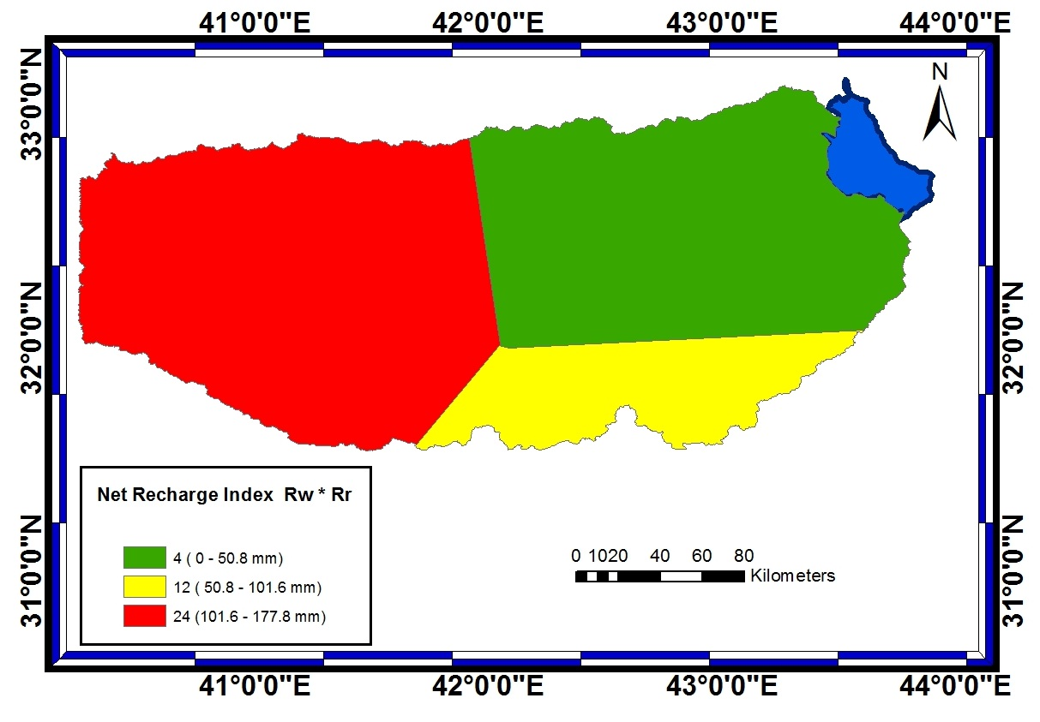

Figure 8: Index map of net recharge.

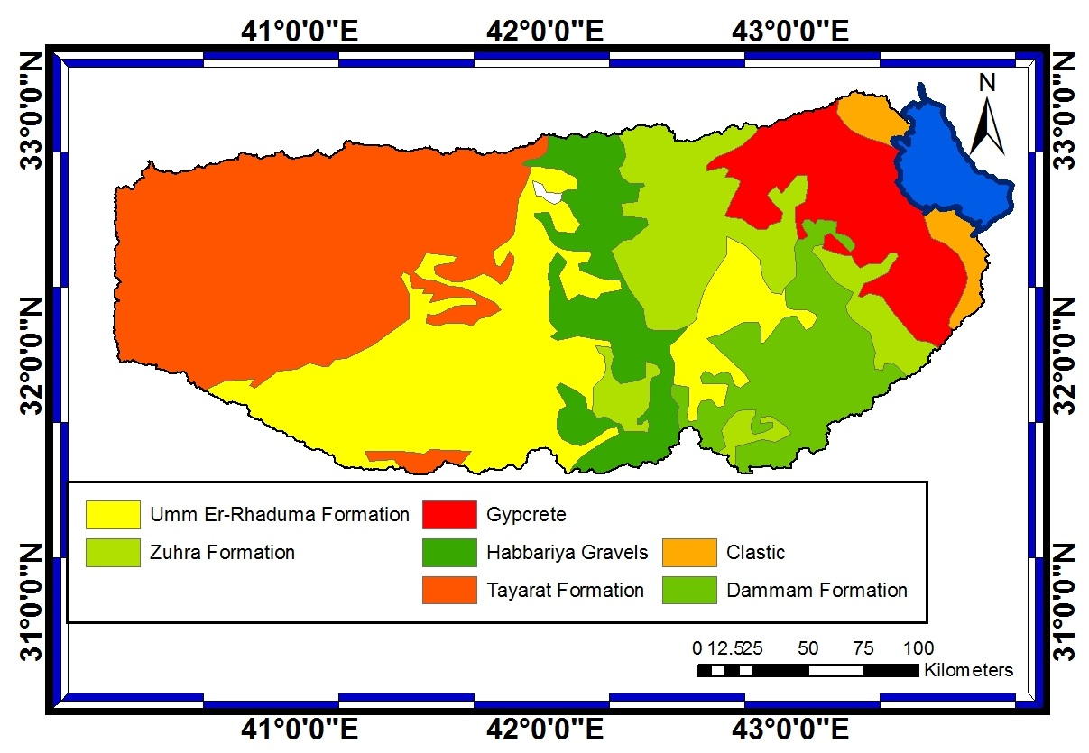
4.3 Aquifer media: Refers to the saturated zone material properties, which controls the pollutant attenuation processes [23]. Using the geologic map (Figure 9), it can be noticed that three types of exposed rocks are recognized. These are Karstified limestones, sand and gravel and clastic deposits. Using table 1, three different ratings were used (7,8,10) to construct the required map (Figure 10).

Figure 9: Map of aquifer media.

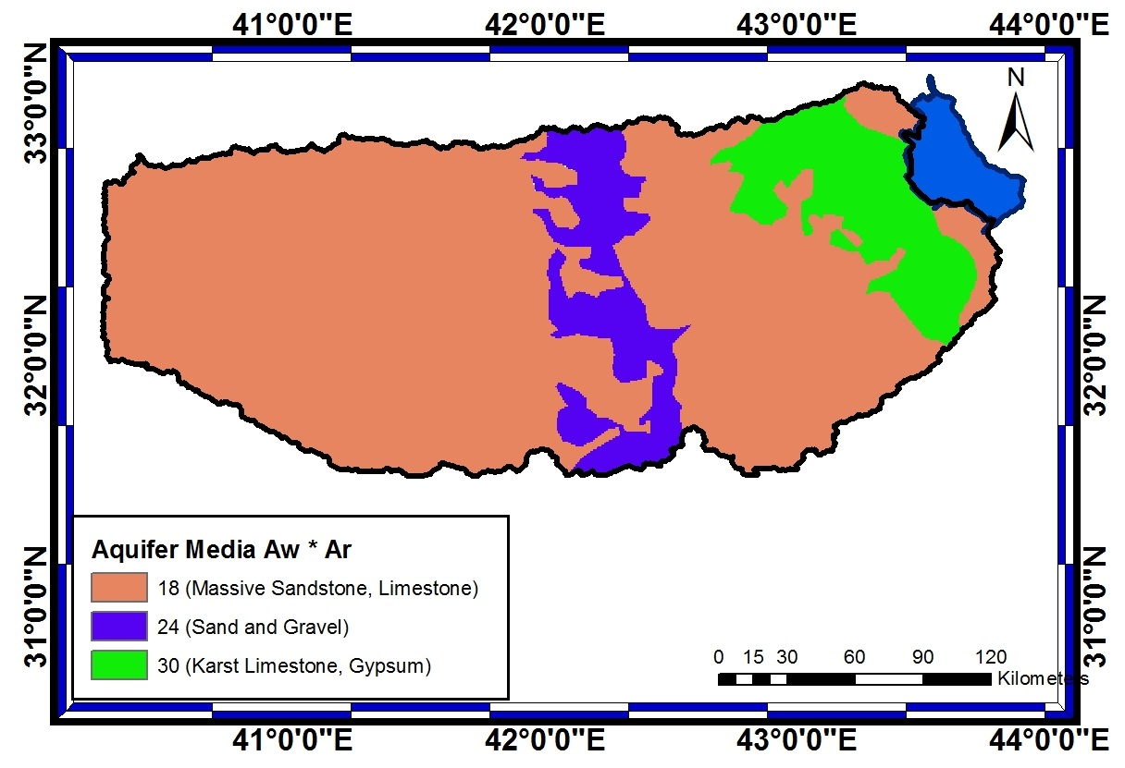

Figure 10: Index map of aquifer media.

4.4 Soil media: Represents the uppermost weathered portion of the unsaturated zone and controls the amount of recharge that can infiltrate downward [23]. Using the soil types map (Figure 11), it can be noticed that eight types of soil were found within the study area and according to table 1, six types of ratings are represented which were used to construct the soil type rating map (Figure 12).
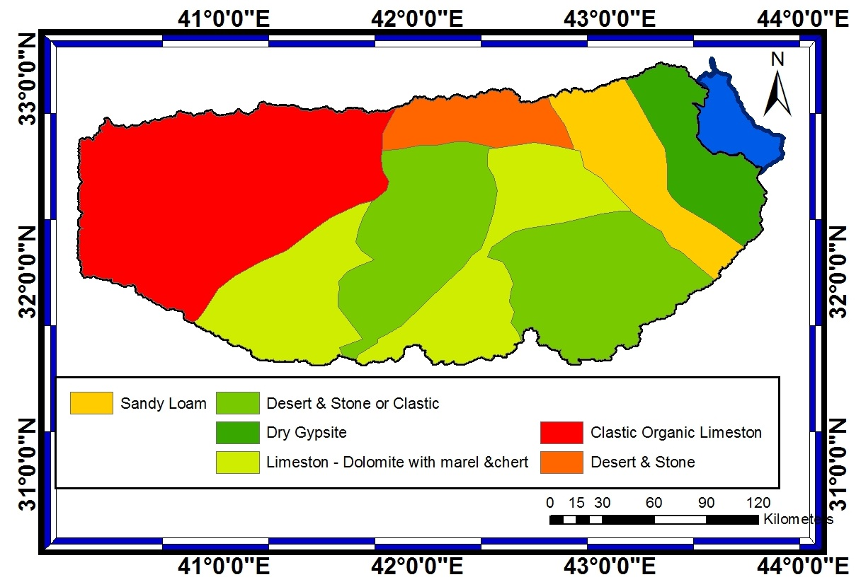

Figure 11: Map of soil media.
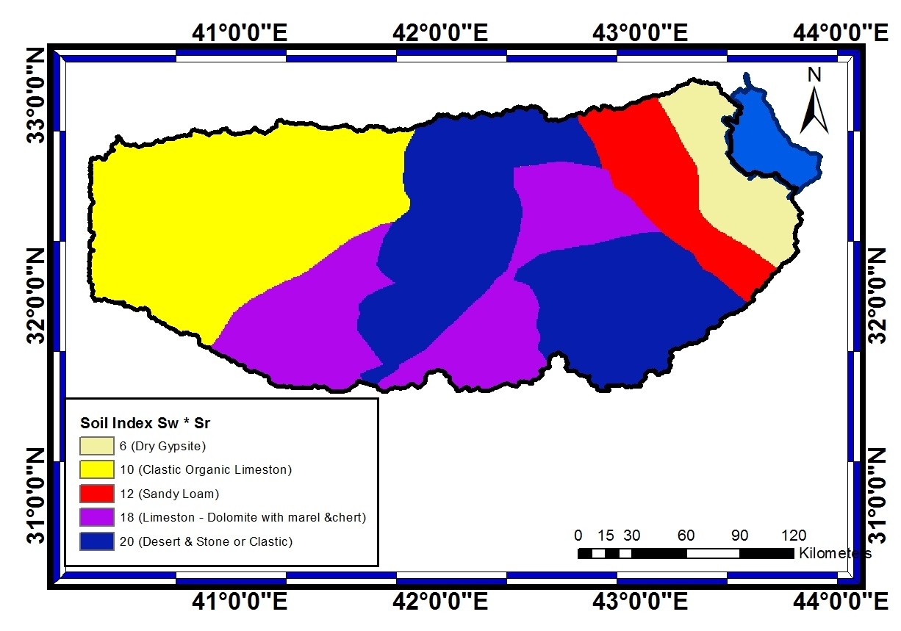

Figure 12: Index map of soil media.

4.5 Topography: Refers to the slope of the land surface, it dictates whether the runoff will remain on the surface to allow contaminant percolation to the saturated zone [23]. The study area is characterized by its very gentle slope that does not exceed 1% in general apart from local heights and valleys. Using table 1 a new topographic map was constructed (Figure 13). Using figure 13, the rating map of the topography for the area was constructed (Figure 14).
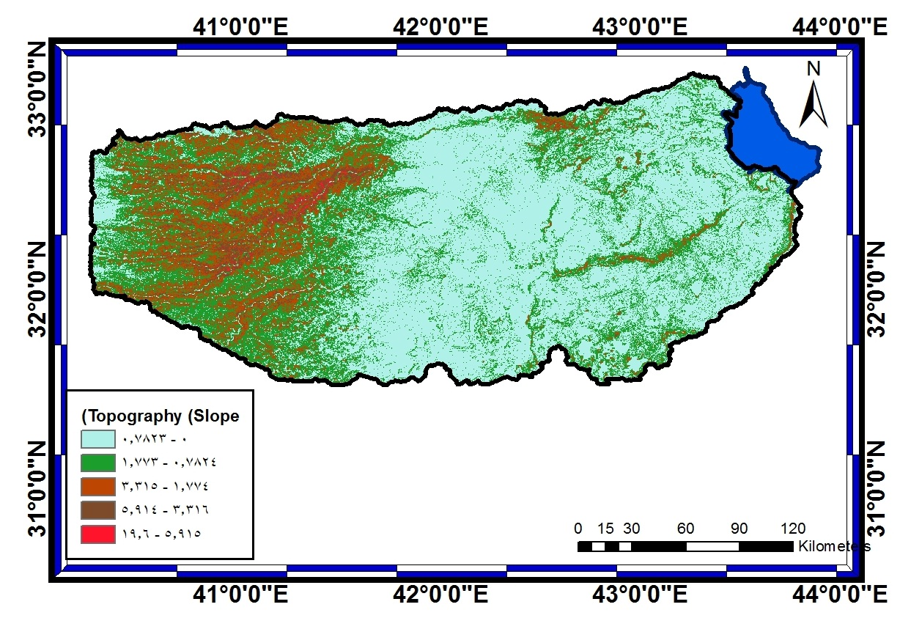

Figure 13: Topographic map.
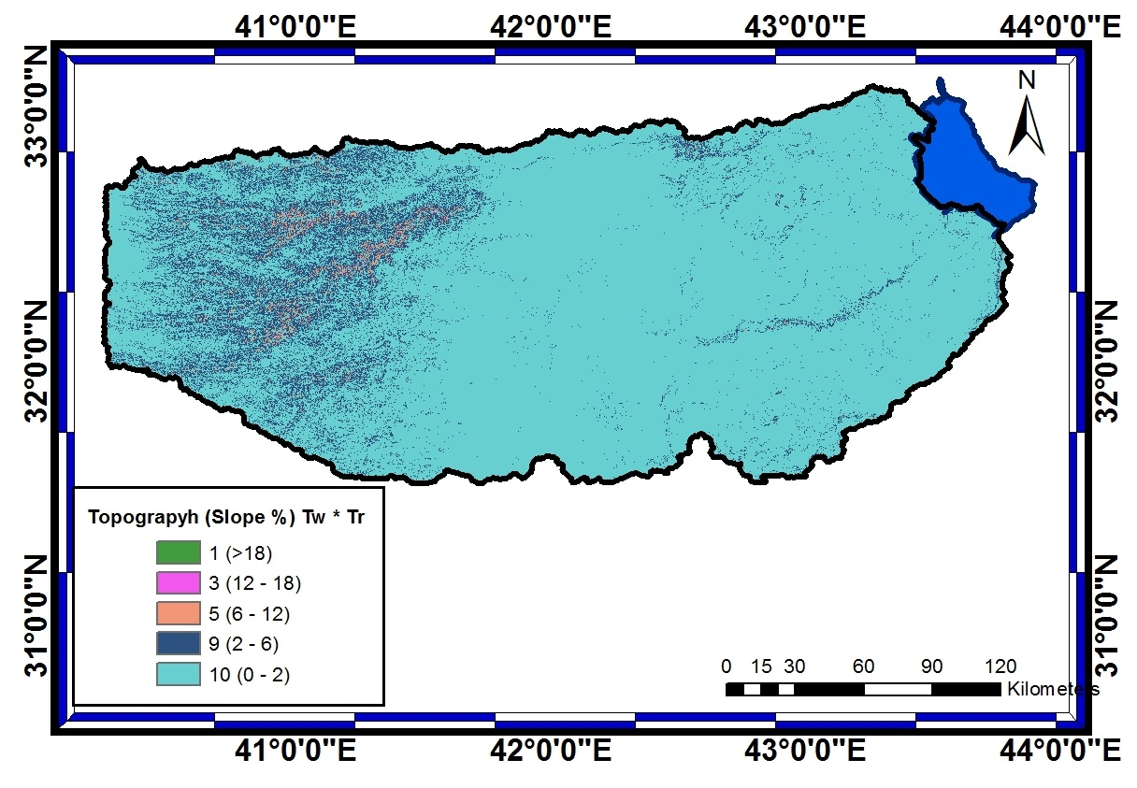

Figure 14: Index map of topographic.

4.6 Impact of vadose zone: Is defined as the unsaturated zone material, it controls the passage and attenuation of the contaminated material to the saturated zone [23]. Three types of rocks and sediment are notice within the unsaturated zone in the area. They are, karstified limestones (Figure 15). According to table 1 they were given the rating of 6 and then map representing the ranges of these rocks were constructed (Figure 16).
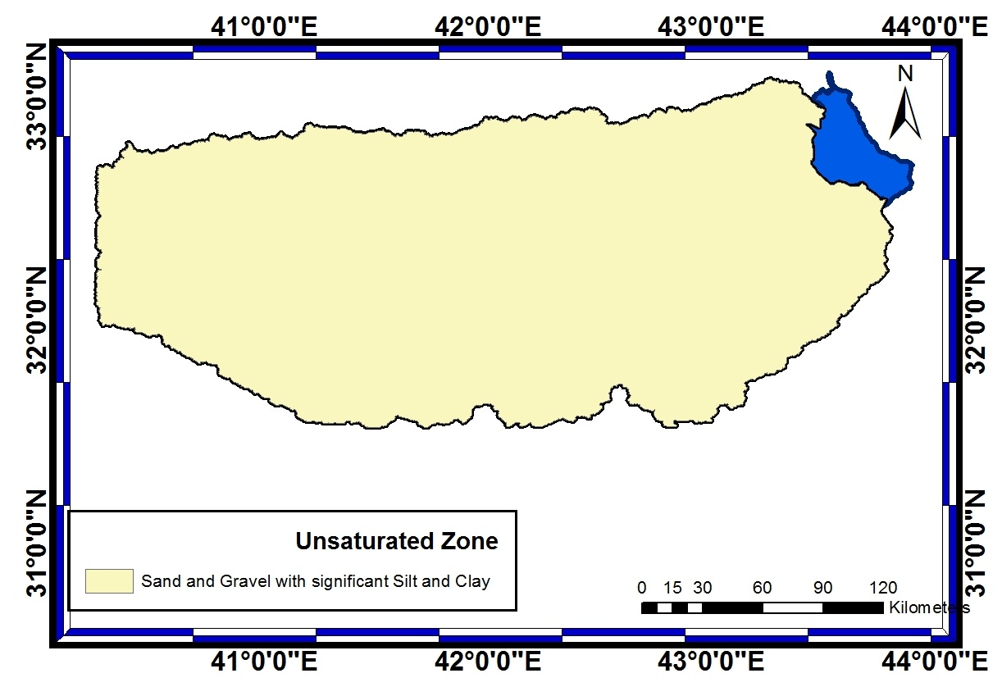

Figure 15: Map of unsaturated zone.

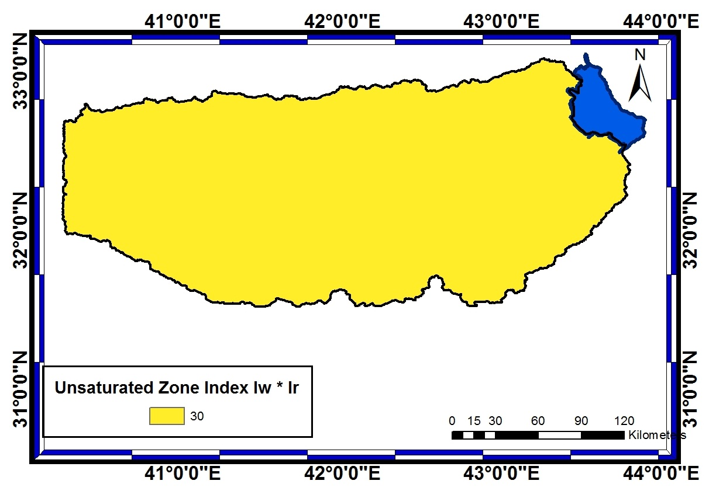

Figure 16: Index map of unsaturated zone.

4.7 Hydraulic Conductivity: Indicates the ability of the aquifer to transmit water, hence determines the rate of flow of contaminant material within the groundwater system [23]. Figure 17 shows the hydraulic conductivity within the study area. Most of the area is having a hydraulic conductivity of less than 11 m/day apart from some areas where it exceeded 20 m/day. Using table 1, the hydraulic conductivity map of the area was constructed (Figure 18).

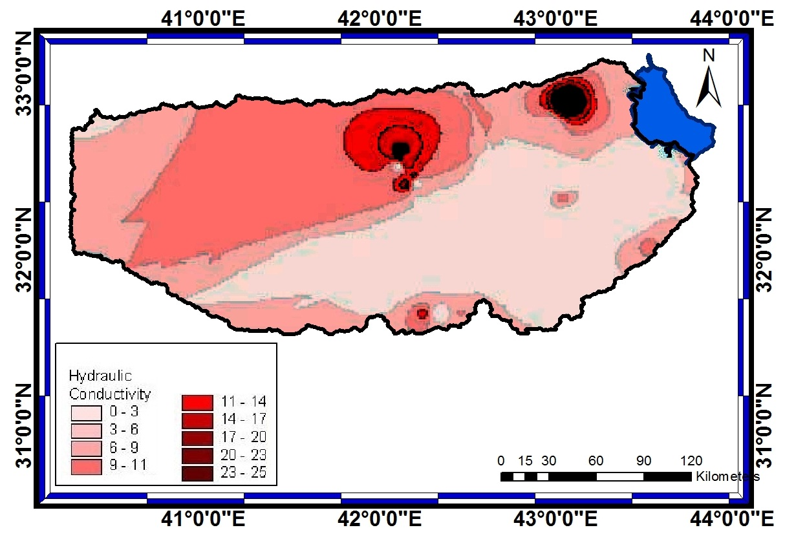

Figure 17: Map of hydraulic conductivity.
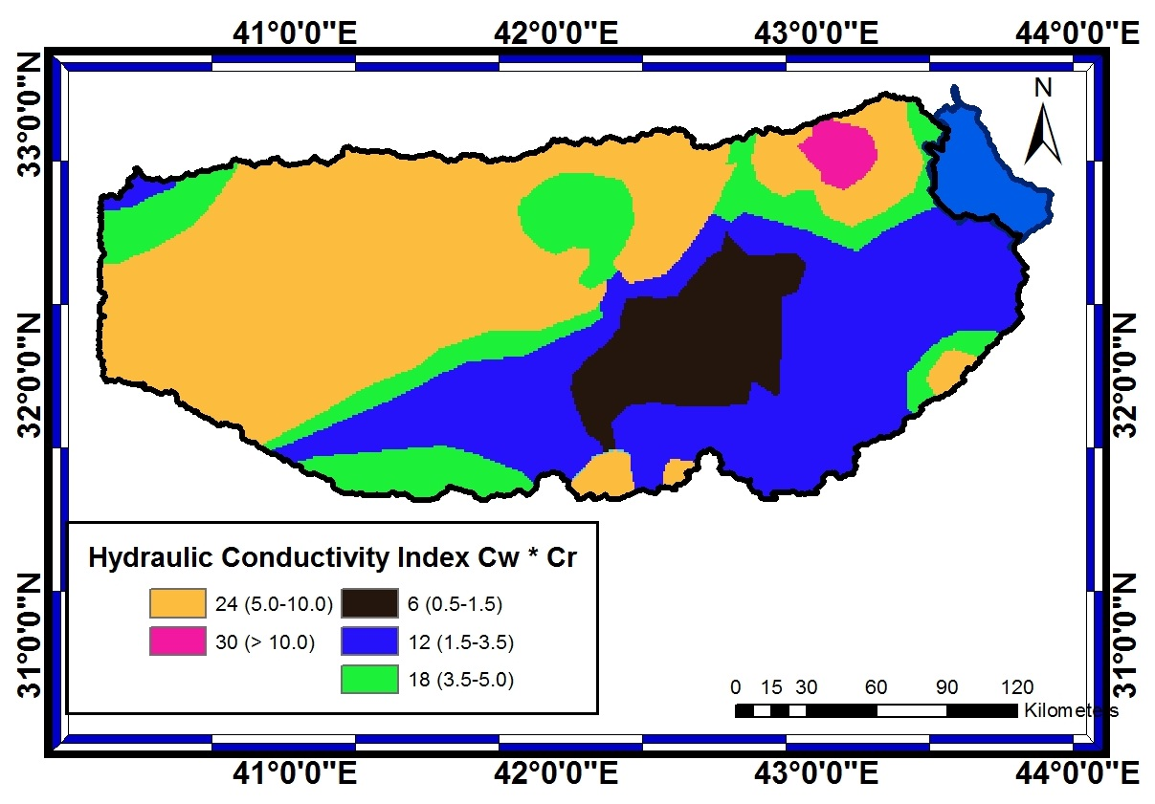

Figure 18: Index map of hydraulic conductivity.

In DRASTIC method it is assumed that: (1) the contaminant is introduced at the ground surface; (2) the contaminant is flushed into the groundwater by precipitation; (3) the contaminant has the mobility of water; and (4) the area evaluated is 100 acres or larger [22]. In addition, the numerical weights and ratings, which were established using the Delphi technique [22], are well deﬁned and had been used worldwide [23-28]. The Delphi technique uses the practical and research experiences of professionals in the area of interest to assess levels of risk.
Once the DRASTIC Index is computed, it is possible to identify areas that are more likely to be susceptible to groundwater contamination, compared to other areas. The higher the DRASTIC Index is, the greater the groundwater pollution potential.
The seven sets of data layers were digitized and converted to raster data sets that were processed using integrated ArcGIS 9.2 (Figure 19). Using Table 2 the final map indicates that most of the area has low risk for the contamination of ground water (Figure 20). Furthermore, the remainder of the area is of moderate risk apart from a small area in the center due to the types of aquifer, unsaturated zone and the hydraulic conductivity. According to the results obtained, utilization of groundwater is recommended in this part of the desert and can greatly help in developing the area.

Table 2: DRASTIC index Categories

Vulnerability class | DRASTIC index
No | 24 – 61
Low | 62 – 99
Moderate | 100 – 137
High | 138 - 175

- Conclusions

Iraq used to depend to a large extent on its surface water resources (93%). Now, it is facing water scarcity problem in its rivers. For this reason, there is a tendency to utilize more of its groundwater resources. To do so, requires careful utilization of this resource.
In this research, part of an area in the western desert of Iraq was studied for its groundwater vulnerability. DRASTIC model was used and the resultant map indicates that most of the area has low risk for ground water contamination and there is a small part of the area which showed moderate risk of contamination.

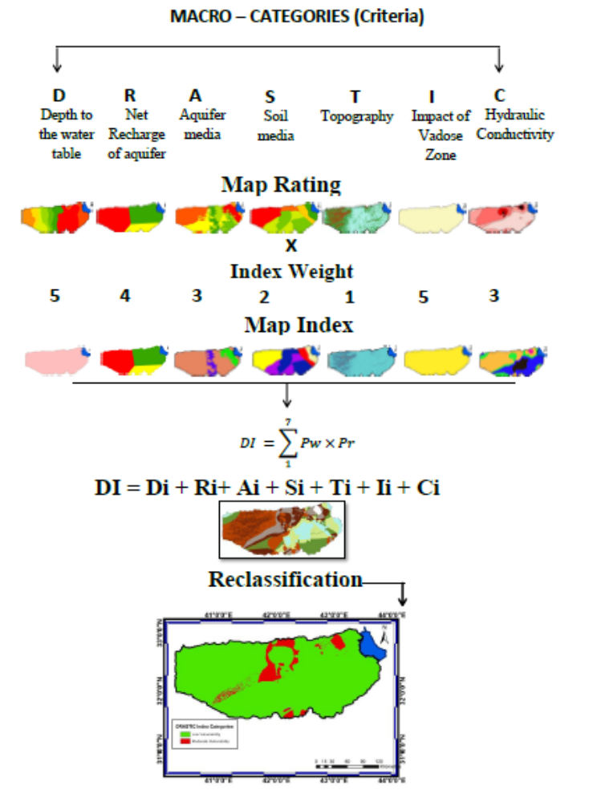

Figure 19: Summary of the whole process: first the maps for each criteria, reclassification and multiplying by the weight and the resulting Index map for all the potential criteria, summation and producing the final DRASTIC vulnerability map, reclassification.

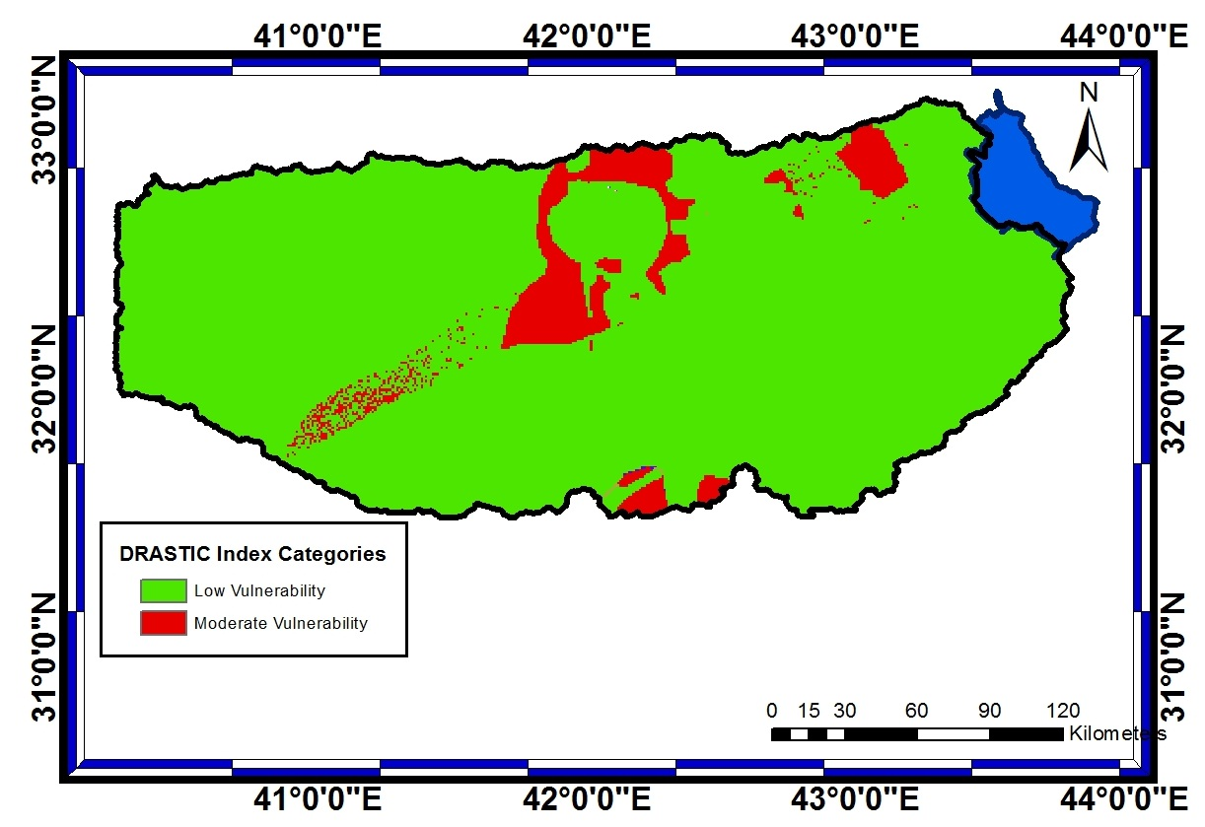

Figure 20: DRASTIC Vulnerability map Classes of Groundwater

References:

[1] Al-Ansari, N.A., Management of Water Resources in Iraq: Perspectives and Prognoses, J. Engineering, V.5, 8, 667-68, 2013.
[2] ESCWA (Economic and Social Commission for Western Asia), Inventory of Shared Water Resources in Western Asia, Salim Dabbous Printing Co., Beirut, Lebanon, 626p,2013.
[3] Postel, S., Last Oasis – Facing Water Scarcity. New York: Worldwatch Institute WW Norton & Co, 1992.
[4] UN, Water Resources Management White Paper, United Nations Assistance Mission for Iraq, United Nations Country Team in Iraq, 20 p, 2010. http://iq.one.un.org/documents/100/white%20paper-eng_Small.pdf
[5] Al-Ansari, N.A., Knutsson, S. and Ali, A., Restoring the Garden of Eden, Iraq, J. Earth Science and Geotechnical Engineering, 2 , 1,53-88, 2012.
[6] Al-Ansari, N.A. and Knutsson, S., Toward Prudent management of Water Resources in Iraq, J. Advanced Science and Engineering Research, 1,53-67,2011.
[7] Roger, P. and Lydon, P. (eds.), Water in the Arab World, Massachusetts, USA: Harvard University Press,1994.
[8] Al-Ansari, N. A., Water as Strategic Resource in the Arab Countries, AL- Nadwa, 7,20-41,1996,.
[9] UN, Water in Iraq, fact sheet,2014. http://www.jauiraq.org/documents/1866/Water-Factsheet.pdf
[10] FAO, Water Resources in Iraq, fact sheet, 2014,.
http://www.fao.org/nr/water/aquastat/data/wrs/readPdf.html?f=IRQ-WRS_eng.pdf
[11] Alsam, S., Jassim, S.Z. and Hanna, F., Water balance of Iraq: stage 2, geological and hydrogeologi-cal conditions, Report, Ministry of Irrigation, Iraq,1990.
[12] Al-Ansari, N. A., Dhari, M., Assad, N., Al-Shama, A., and Al-Jubori, S., Agricultural use of deserts using ground water, J. Water Res., 12, 113-124,1993.
[13] Al-Ansari, N. A., Rushdi , B., AL-Shamma , A., Utilization of ground water for agricultural activities, South Nakhaib area, Western desert (IRAQ), Int. Conf. On Water Resources Management in Arid Regions, Sultanate of Oman, 450-456, 1995.
[14] Al-Ansari, N. A., and Al-Shama, A., Long term utilization of ground water in Liefiya-Lusuf area, Western Desert, Iraqi Sc. J., V.36, 282-313,1995.
[15] Al-Ansari, N. A., Ibrahim , K. Iskandar ,N., Hydraulic parameters of Dammam formation in Western desert (IRAQ), Iraqi Science J., 36, 314-325,1995.
[16] Krasny, J., Alsam, S., and Jassim, S. Z., Hydrogeology, In Geology of Iraq. 1st ed. Published by Dolin, Prague and Moravian Museum. Prague, 2006.
[17] Sissakian, V.K., General information, Western Desert, Special issue Iraqi Bulletin of Geology and Mining, 3, 5-8, 2007.
[18] Hamza, N., Geomorphology, Western Desert, Special issue Iraqi Bulletin of Geology and Mining, 3, 9-28, 2007.
[19] Al-Ansari, N.A., Knutsson, S., Almuqdadi, K., Engineering solution for Radioactive Waste in IRAQ, J. of Advanced Science and Engineering Research V 4, 1, 18-36,2014.
[20] Jassim, R.Z. and. Al-Jiburi, B. S., Stratigraphy, Iraqi Bull. Geol. Min. Special Issue, Geology of Iraqi Southern Desert, 53− 76,2009.
[21] Sissakian, V. anf Mohammed, B., Stratigraphy, Western Desert, Special issue Iraqi Bulletin of Geology and Mining, 3, 51-124, 2007.
[22] Aller, L., Bennett, T., Lehr, J.H., Petty, R.J. and Hackett, G., DRASTIC: A standardized system for evaluation groundwater pollution potential using hydrogeologic setting. EPA-600/2-87-035. Ada, Oklahoma: U.S. Environmental Protection Agency, 1987.
[23] Babiker I., Mohamed A., Terao H., Kato K., and Ohta K., Assessment of groundwater contamination by nitrate leaching from intensive vegetable cultivation using geographical information system. Environ Int; 29(8):1009 – 17, 2004.
[24] Al-Adamat, R.A.N., Foster, I.D.L. and Baban, S.M.J., Groundwater vulnerability and risk mapping for the Basaltic aquifer of the Azraq basin of Jordan using GIS, Remote sensing and DRASTIC." Applied Geography, 23, 303-324, 2003.
[25] Chandrashekhar, H., Adiga, S., Lakshminarayana, V., Jagdeesha, C. J. and Nataraju, C., A Case Study Using the Model ‘DRASTIC’ for Assessment of Groundwater Pollution Potential, Proceedings of the ISRS National Symposium on Remote Sensing Applications for Natural Resources, Indian Society of Remote Sensing, Bagalore, 19-21 June 1999, 414-417, 1999.
[26] Dixon B., Groundwater Vulnerability Mapping: A GIS and Fuzzy Rule Based Integrated Tool, Applied Geography, 25, 4, 2005, 327-347. doi:10.1016/j.apgeog.2005.07.002.
[27] Napolitano, P. and Fabbri, A., Single-Parameter Sensitivity Analysis for Aquifer Vulnerability Assessment Using DRASTIC and SINTACS, Proceedings of the Vienna conference on HydroGIS 96: Application of geographic information systems in hydrology and water resources management, IAHS, 235, 559-566, 1996.
[28] Al-Rawabdeh, A., Al-Ansari N., Al-Taani, A. and Knutsson, S., A GIS-based DRASTIC model for assessing aquifer vulnerability in Amman-Zerqa groundwater basin, Jordan, J. Engineering, 5,490-504, 2013.

