Origin of a Circular Morphological Form in
Lolan Valley, Khwakoork Area, North Iraq
Varoujan K. Sissakian, Ayda D. Abdul Ahad, Nadhir Al-Ansari³and Sven Knutsson

Abstract
The northern and northeastern parts of Iraq are mountainous area with very rugged topography that includes high and steep cliffs, deep valleys; locally canyon shape, and rare wide and flat plains. The main exposed rocks over all the area are the carbonates, especially limestone and dolostone of different varieties. Tens of geological formations consist of very think limestones and/ or dolostone.
This article deals with the origin of a circular form developed in one of the main valleys called Lolan Valley in Khwakurk area, northern part of Iraq. Different geomorphological, lithological, structural and stratigraphical indications are used to conclude the origin of the circular form, which is confirmed to be a sinkhole due to karstification of thick carbonate rocks.
The outer diameter of the circular form is 386 m; the width of the valley ranges from (35 – 150) m, the length of the circular form is 1045 m, which means the length to valley width ration is 20.9 times, the ratio of the radius to the width is 4 times. These two ratios are other indications that the meander of Lolan valley is not a normal meander, but a meander formed due to the collapse of existed sinkhole alongside the valley.
Keywords: Karstification, Sinkhole, Limestone, Lateral erosion, Iraq

- Introduction
A very interesting and rare morphological circular form was seen in a touristic post card; indicating it is within Lolan valley at Khwakurk vicinity in the northern part of Iraq, Kurdistan Region (Fig.1). The exact location of the involved circular form was found; using Google Earth image (Fig.2) after thorough inspection of the whole Khwakurk vicinity and asking geologist colleagues; the center of the circular form is located at Latitude 36° 57' 58.49" N and Longitude 44° 46' 15.23" E (Fig.2).

The aim of this study is to indicate the origin of the uniform circular form located alongside Lolan valley, which is characterized by many acute meanders forming many loops (Fig.2). To indicate the origin of the circular form, Google Earth images, Topographic maps at scale of 1:100 000 are used to measure the morphometric characters of the circular form and geological maps at scale of 1:250 000 and 1:100 000 are used to indicate the geological setting of the circular form area. The photograph of the circular form (in a touristic post card) is used to recognize and indicate the morphological, structural and lithological characters of the form and near surroundings and to interpret and discuss the origin of the circular form.

2 Geological Setting
The studied circular form, which is within Lolan valley is built up by the Naopurdan Group [1, 2 and 3] (Sissakian and Fouad, 2012, and 2013a and b), which consists generally of grey shale, coralline limestone, tuffaceous slates, felsitic volcanics, grey wakes and shale, and basic conglomerate [4 and 2] (Jassim and Goff, 2006 and Sissakian and Fouad 2013a). It is located within the Imbricate Zone of the Outer Platform of the Arabian Plate [5] (Fouad, 2012), nearby to many small anticlines, which run NNE – SSW [2] (Sissakian and Fouad, 2013a). The carbonate and clastic rocks are visible in the photograph, they are well bedded, some are thinly bedded others are thickly bedded (Fig.1).
As the geomorphology of the area is concerned, the main geomorphological features are the steep cliffs (Fig.1), as well rounded steep slopes (Fig.2), which are formed due to the existence of soft to medium hard clastic rocks within the Naopurdan Group in two main lithological units, besides the conglomerate [6]. The meandering streams in the study area and near surroundings are common, and good example is Lolan valley. The meanders are formed as the stream erodes downwards; its established meandering pattern will remain as a deep valley known as an incised meander or entrenched meander [7 and 8]. The technical description of a meandering watercourse is termed meander geometry or meander planform geometry.

3 Description of the Circular Form
Swinging valleys with horse shoe-shape are very common in the surroundings of the study area (Fig.2) and elsewhere. A good example is the Shamdinan River west of the study area and the Greater Zab River, both of them exhibit acute horse shoe shape forms (Fig.3). However, uniform circular form in valleys; like the one dealt in this study is not a usual one.

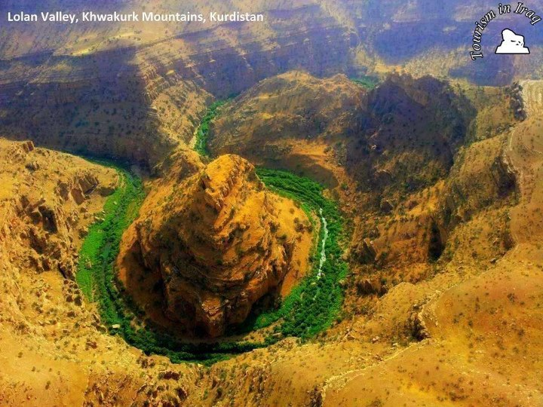

Fig.1: A touristic post card of the circular valley form (Facing south).

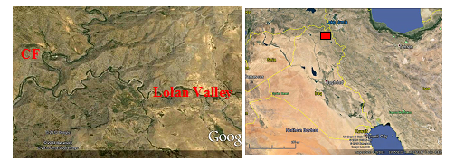

Fig2: Google Earth image facing north, Left) Lolan valley showing the location of the circular form (CF), Right) Location of the study area in Iraq.

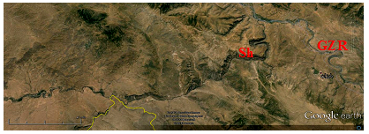

Fig.3: Google Earth image facing south of the Greater Zab (GZR) and
Shamdinan (ShR) rivers. Note the acute horse shoe swings.

Meander formation is a result of natural factors and processes. The waveform configuration of a stream is constantly changing. Fluid flows around a bend in a vortex [9]. Once a channel begins to follow a sinusoidal path, the amplitude and concavity of the loops increase dramatically due to the effect of helical flow sweeping dense eroded material towards the inside of the bend, and leaving the outside of the bend unprotected and therefore vulnerable to accelerated erosion, forming a positive feedback loop [10].
The uniform circular form in Lolan valley (Figs.1 and 4) is a very rare morphological feature developed within the valley course, especially in a rocky nature of the ground. Some rivers, streams and rarely large valleys may exhibit such forms, when abandoning their courses and developing of ox bow lakes [11 and 12] (Mayer, 1990 and Singh, 2010), but still the shape is not a uniform circular form as it is the case in Lolan valley. In rocky areas, usually the rivers, streams and valleys follow the plunge of anticlines, when the rocks are folded, or exhibit swinging when the gradient is very low, consequently the straight incision of the rocks is very rare [13] (Ritter et al., 2002).
The outer diameter of the circular form is about 386 m; elevation of the center of the circular form is 1360 m, whereas the base of the circular form is at elevation of 1310 m, which means the height of the central mass is about 50 m. The width of the valley ranges from (35 – 150) m, whereas the elevation of the rims of the circular form range from (1400 – 1500) m. These data are acquired from the topographical map of Rawandouz Quadrangle, at scale of 1: 100 000 after imposing the circular form on the topographic map.

4 Discussions

- Shape of the Valley
The circular form in Lolan valley most probably represents a sinkhole rim of Holokarst type [14]. The sinkhole was conjugated with the valley, after collapsing of the wall facing the valley. The valley was blocked in the conjugate area (Point FM in Fig.4), therefore, the valley shifted its course to follow the space formed by the sinkhole and then continued to its original course out of the sinkhole to continue flowing down stream (left hand side in Fig.4). On the inside of a meander is a gentle slope of sedimentation referred to as the slip-off slope. It is often marked by a point bar in the river. Since there is no any indication for slip-off slope; therefore, a karst origin of the circular form is more likely.

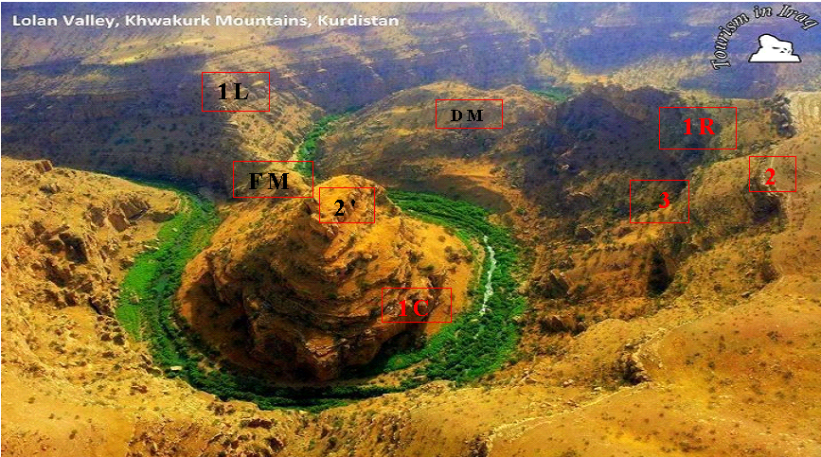

Fig.4: The studied circular form in Lolan valley, Khwakurk vicinity.
Thickly bedded succession in the left and right side limbs and in the top of the circular form (1L, 1R and 1C, respectively) .Thinly bedded succession with columnar feature on the right side limb (2) and on the top of the circular form (2').
Note dipping of the rocks toward right and left of the circular form.

The preservation of the collapsed central mass in a sinkhole, although is not a common feature, but it is possible. A good example for such existing well known sinkhole is the Salman Rosa sinkhole, west of Hadith town, Iraqi Western Desert (Fig.5). Sissakian et al. [15 and 16] (1984 and 1987), reported about this sinkhole in which the collapsed body still exists, the diameter and depth of the sinkhole is 53 m, and 34 m, respectively, located in coordinates of 34° 07′ 55.25′ N′ 42° 16′ 41.26′′ E.
A stream of any volume may assume a meandering course, alternately eroding sediments from the outside of a bend and depositing them on the inside. Therefore, usually a circular cliff is formed on the outside bend called “cut bank”. The result is a snaking pattern as the stream meanders back and forth across its down-valley axis. This is the normal case, especially when a valley runs in soft sediments with low gradient.
The meander characterized as an irregular waveform. Ideal waveforms, such as a sine wave, are one line thick, but in the case of a stream the width must be taken into consideration. The bankfull width is the distance across the bed at an average cross-section at the full-stream level, typically estimated by the line of lowest vegetation. As a waveform the meandering stream follows the down-valley axis, a straight line fitted to the curve such that the sum of all the amplitudes measured from it is zero. This axis represents the overall direction of the stream. Therefore, the sinuosity of the meanders is usually in one direction, but when it is not, then the possibility of the meanders represent a set of sinkholes is more likely.

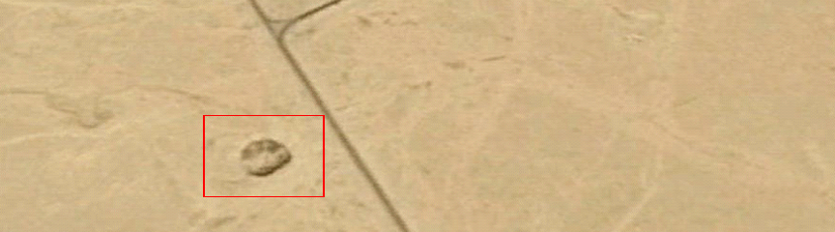

Fig.5: Google Earth image, note the collapsed block (light colored mass) in the central part of Salman Rosa sinkhole (the surroundings have dark tone)

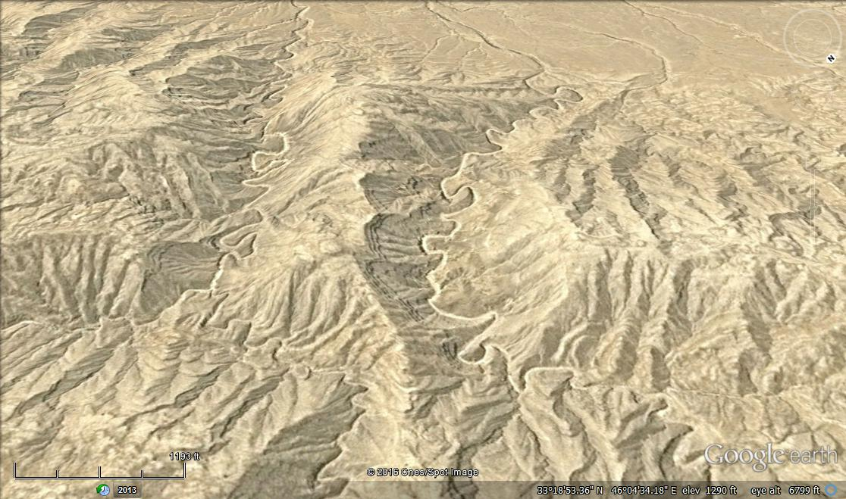

Fig.6: Google Earth image, facing SE. Note the continuous meandering of the valleys in a tectonically active area, east of Iraq.

- Shifting of the Valley Course
Lolan valley was flowing from the right side (NE) to the left side (SW) (Figs.1, 2 and 4), almost in a core of the anticline. The NW and SE limbs are clear in Fig. (4). A sink hole with well circular aperture was located just nearby to the valley; the rim of the sinkhole was at the area marked as FM (Fig.4). After collapsing of the wall of the sinkhole, which faces the valley, due to undercut erosion, the valley course was blocked by the fallen material, near the point FM in Fig.(4). When looking carefully, it is clear that there is no outcrop in that area; because it was the course of Lolan valley. Due to the blockage of the valley, the valley has shifted its course to follow the outer rim of the floor of the sink hole, which has a circular form. Therefore, the shape of the valley course is changed to a circular form.

- Indication for the Presence of the Sink Hole
Indications for the presence of the sink hole are: 1) Location of the rock beds in the collapsed sinkhole as compared with the both limbs of the anticline. When inspecting thoroughly the rock sequence in the collapsed mass; marked as 1C (Fig.4) and comparing its position with the surrounding rocks, in the left and right side limbs (1L and 1R, respectively in Fig.4), it can be seen that the the succession in the central part is lower, which means it is subsided; because in normal case the core of an anticline should be higher. Another marker is a thinly bedded succession with columnar feature on the right side limb (at point 2 in Fig.4) and comparing its location on the top of the circular form (2' in Fig.4), it also indicates that the central part is subsided. 2) When inspecting thoroughly the contact area between the former valley course and the collapsed side of the sink hole (FM in Fig.4), it can be seen that no rocks exist there, which means that the rocks there were eroded, because they were within the former valley course. 3) Accumulated debris (AD) in the upper right side of the circular form of the valley, indicate that these debris may represent an old land slide from the upper right corner of the scene, the scar is still present (LS in Fig.7). The presence of hummocky surface is an indication for landslide [18 and 19]. The debris had also blocked the course of the valley, which accelerated the undercut erosion, consequently accelerating the collapse of the northern side of the sink hole, and 4) The beds in the central mass represent the core of the anticline, but they are now in a lower position than those present on both limbs, the location of a hard carbonate bed? with vertical joints at the point 1C, as compared to the same bed at points 1R and 1L, and another hard carbonate bed with vertical joints at point 2' as compared to the same bed at point 2 (Fig.4), and 5) Nearby to the circular form, there is another circular form, just south of it (Fig.8), this may represent another sink hole, which is either not developed yet (Merokarst) or it is already filled with Quaternary sediments.

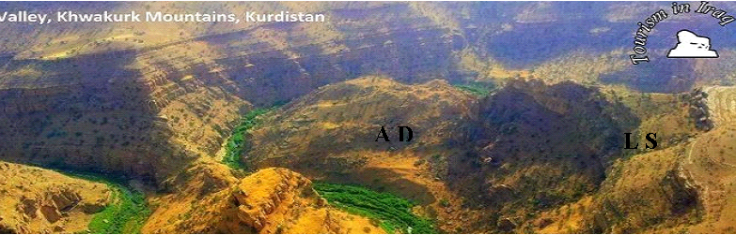
Fig.7: Accumulated debris (AD) may indicate an old land slide,
LS is the scar of the old landslide.

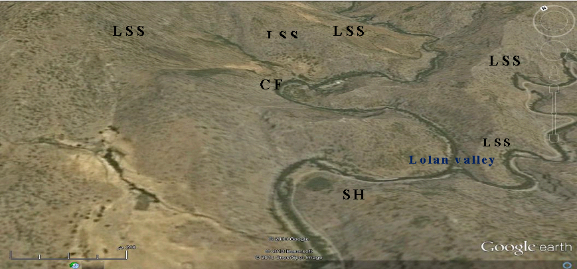
Fig.8: Google Earth image of the circular form in Lolan valley (facing NNW).
CF= The studied circular form, SH= Sink hole (Probably Halokarst or Merokarst).
Note that the form in the image is not circular as in the touristic photograph card,
due to the tilting of the image and related distortion.
Also note scares of many landslides (LSS) that represent active undercut
erosion areas; forming horse shoe shapes in Lolan valley

- Reasons of the Karstification
The Naopurdan Group includes limestone and some clastic beds, with basal conglomerate [2 and 4]. The coralline limestone beds are most probably those shown in point 1C (Fig.4), which show vertical jointing and/ or fracturing; giving the beds a blocky shape. These beds are underlain and overlain by soft thinly bedded clastics (3 in Fig.4) with presence of basal conglomerate. The presence of conglomerate in the floor of valleys is a significant factor in development of karst forms. At Hadith vicinity, in the Iraqi Western Desert, Sissakian et al. [15 and 16] have recognized that the exposed basal conglomerate between Anah and Euphrates formations is the main factor for development of the karst forms in Haditha vicinity, especially those karst forms which are developed near valleys.

Lolan valley, which runs through the rocks of Naopurdan Group [1 and 2]; in the study area had eroded the rocks; consequently, the conglomerate was exposed in the valley floor, leading to acceleration of the flowing rain water that inters the sink hole and flows out to the valley; through the voids and other weakness zones in the conglomerate. The out flown water, also contributes in disintegration of the conglomerate, due to washing of the cementing materials, which forms large voids in the conglomerate bed, besides the dissolving of the coralline limestone, consequently the top layers are collapsed down due to their hanging weight. After development of the sink hole, the circulated water from inside of the sinkhole outwards, besides the flowing water in the valley have accelerated the side and undercut erosion; consequently, accelerated the collapsing of the sinkhole's northern wall in the valley and the its blockage valley.

- Waveform Meander Length Ratio
The waveform of a normal meander depends ultimately on the characteristics of the flow but the parameters are independent of it and apparently are caused by geologic factors. In general the meander length is (10 – 14) times, with an average 11 times, the fullbank channel width and (3 to 5) times, with an average of 4.7 times, the radius of curvature at the apex. This radius is (2 to 3) times the channel width [20]. The radius of the circular form at the apex is about 200 m, whereas the average width of the valley is 50 m, this means the ratio of the radius to the width is 4 times, which means more than the normal ration. The length of the circular form is 1045 m, which means the length to valley width ration is 20.9 times, which is far from the usual meander length to valley width ratio. These two ratios are other indications that the meander of Lolan valley is not a normal meander, but a meander formed due to the collapse of existed sinkhole alongside the valley.

- Other Indications
In sine waves of a meandering stream or valley, the loops of a meandering stream are more nearly circular. The curvature varies from a maximum at the apex to zero at a crossing point (straight line), also called an inflection, because the curvature changes direction in that vicinity. The radius of the loop is the straight line perpendicular to the down-valley axis intersecting the sinuous axis at the apex. As the loop is not ideal, which is the case of the the circular form involved in this study; additional information is needed to characterize it [20]. Therefore, the karst origin characterizes the circular form rather than a normal meander.

Most of the meanders occur in the region of a river channel with shallow gradients, a well-developed floodplain, and cohesive floodplain material. Therefore, deposition of sediment occurs on the inner edge, because the secondary flow of the river sweeps and rolls sand, rocks and other submerged objects across the bed of the river towards the inside radius of the river bend [21]. Since in the study area, the mentioned factors are not available along Lolan valley; therefore, the circular developed form is a collapsed sinkhole rather than a normal meander.

5 Conclusion
The following can be concluded
- The circular form in Lolan valley represents existing sink hole, which was very close to the valley bank, with the collapsed central mass still existing in the sink hole.
- The wall of the sink hole, facing the valley was collapsed due to undercut erosion, consequently the valley was blocked and the valley shifted its course to follow the circular form of the floor of the sinkhole and returned to its original course after the blocked area.
- The existing accumulated debris represents an old land slide, which had also blocked the valley, before collapsing of the sink hole's wall. The blockage of the valley had accelerated the undercut erosion and contributed in the collapse of the wall.
- The conglomerate and coralline limestone beds within the Naopurdan Group are the main reason for development of the sink hole. Moreover, the conglomerate had contributed also in the collapse of the sink hole's wall.
- Such a circular form in a valley, most probably may represent a sink hole, which is collapsed and merged into the valley forming the meanders.
- The ratio of radius of a meander to the width of the valley and the ratio of the length of a meander to the width of valley are also far from the normal known ratios of normal meanders. These two ratios are also other indications that the circular form is not a normal meander.

REFERENCES

[1] Sissakian, V.K. and Fouad, S.F., 2012. Geological Map of Iraq, scale 1: 1000 000, 4th edit. GEOSURV, Baghdad, Iraq.
[2] Sissakian, V.K. and Fouad, S.F., 2013a. Geological Map of Erbil and Mahabad Quadrangles, scale 1: 250 000, 2nd edit. GEOSURV, Baghdad, Iraq.
[3] Sissakian, V.K. and Fouad, S.F., 2013b. Geological Map of Rawandouz Quadrangles, scale 1: 100 000, 2nd edit. GEOSURV, unpublished maps.
[4] Jassim, S.Z. and Goff, J.C., 2006. Geology of Iraq. Dolin, Prague and Moravian Museum, Brno.
[5] Fouad, S.F., 2012. Tectonic Map of Iraq, scale 1: 1000 000, 3rd edit. GEOSURV, Baghdad, Iraq.
[6] Sissakian, V.K. and Saeed, Z.B., 2012. Lithological Map of Iraq, Compiled using GIS Techniques. Iraqi Bull. Geol. Min., Vol. 8, No.3, p. 1 – 13.
[7] Graf, W.,1984. Hydraulics of Sediment Transport. Water Resources Publications. pp. 261–265. ISBN 0-918334-56-X.
[8] Julean, P. Y., 2002. River Mechanics. Cambridge University press. pp. 179–184. ISBN 0-521-52970-0.
[9] Lewalle, J., 2006. Flow Separation and Secondary Flow: Section 9.1". Lecture Notes in Incompressible Fluid Dynamics: Phenomenology, Concepts and Analytical Tools. Syracuse, NY: Syracuse University.
[10] Wood, E.A., 1975. Science from Your Airplane Window: 2nd Revised Edition. New York: Courier Dover Publications. p. 45. ISBN 0-486-23205-0.
[11] Mayer, L., 1990. Introduction to Quantitative Geomorphology.Prentice Hall, Englewood, Cliffs, NJ.
[12] Singh, S., 2010. Geomorphology, 4th reprint. Prayag Pustak Bhawan India, p. 355 – 384.
[13] Ritter, D.F., Kochel, R.C. and Miller, J.R., 2002. Process Geomorphology.McGraw Hill, Higher Education, 560pp.
[14] Gams, I., 2003. Karst in Slovenia in Space and Time.ISBN 9616500456.
[15] Sissakian, V.K, Mashkoor, M., Al-Ani, S.Sh.,Yassin, M.J. and Abdul Ahad, A.D., 1984. Report on Haditha Project, PartП, Engineering Geological Survey. GEOSURV, int. rep. no. 1524.
[16] Sissakian, V.K., Ibrahim, A.M and Amin, R.M., 1986. Sinkholes of Haditha Area.Jour. Water Resources, Vol.5, No.1, p. 707 – 714.
[17] Sissakian, V.K., Al-Ansari, N. and Knutsson, S., 2015. Karst forms in Iraq. Journal of Earth Sciences and Geotechnical Engineering, vol. 5, no.4, 2015, 1-26 ISSN: 1792-9040 (print), 1792-9660 (online) Scienpress Ltd, 2015
[18] Zaruba, Q. and Menchel, V., 1982. Landslides and their Control. Burlington, Elsevier Science.
[19] U.S.G.S., 2004. Landslides Types and Processes. U.S. Department of the Interior.
URL: http://pubs.usgs.gov/fs/2004/3072/fs-2004-3072.html.
[20] Hickin, E.J., 2003. Meandering Channels. In: Middleton, Gerard V. Encyclopedia of Sediments and Sedimentary Rocks. Kluwer Academic Encyclopedia of Earth Sciences. Dordrecht; Boston: Kluwer Academic Publishers. pp. 430–434. ISBN 1-4020-0872-4.
[21] Chant, Robert J. (2002). "Secondary circulation in a region of flow curvature: Relationship with tidal forcing and river discharge". Journal of Geophysical Research, 107. Bibcode: 2002JGRC..107.3131C. doi:10.1029/2001jc001082.

The Dokan Dam is a multi-purpose concrete single arch dam (Fig.17) in Sulaimaniyah Governorate, NE Iraq. It impounds the Little Zab River, thereby creating Lake Dokan. The Dokan Dam was built between 1954 and 1959, whereas its power station became fully operational in 1979. The dam is 360 m long and 116.5 m high, width at the base and crest is 34.3 m and 6.2 m, respectively with volume of 370 000 m³. The total capacity of the reservoir is 6.970 x 10 ⁶ m ³, the active capacity is 6.100 x 10 ⁶ m ³, whereas the inactive capacity is 790 x 10 ⁶ m ³, with surface area of 270 Km² at elevation of 511 m (a.s.l.). The hydroelectric power station has a maximum capacity of 400 MW.

4 Discussion

REFERENCES
[1] Fouad, S.F., 2012. Tectonic Map of Iraq, scale 1: 1000000, 3rd edition. Iraq Geological Survey Publications (GEOSURV), Baghdad, Iraq.
[2] Sissakian, V.K. and Fouad, S.F., 2012. Geological Map of Iraq, scale 1: 1000000, 4th edition. Iraq Geological Survey Publications (GEOSURV), Baghdad, Iraq.
[3] Jassim, S.Z. and Goff, J.C., 2006. Geology of Iraq. Dolin, Prague and Moravian Museum, Brno.
[4] Sharland, P.R., Archer, R., Casey, D.M., Dvis, R.B., Hall, S., Heward, A., Horbury, A. and Simmons, M.D., 2001. Arabian Plate Sequence Stratigraphy. GeoArabia, Special Publication, No.2. Gulf Pertolink, Bahrain, 389pp.
[5] Bolton, C.M.G., 1954a. Geological Map of Kurdistan Series, scale 1:100 000, sheet K4, Ranya. Iraq Geological Survey Library report No. 276.
[6] Bellen, R.C. van, Dunnington, H.V., Wetzel, R., and Morton, D., 1959. Lexique Stratigraphic International. Asie, Fasc. 10a, Iraq, Paris.
[7] Aqrawi, A.A.M., Goff, J.C., Horbury, A.D. and Sadooni, F.N., 2010. The Petroleum Geology of Iraq. Scientific Press Ltd., 424pp.
[8] Jassim, S.Z., Karim, S.A., Basi, M.A., Al-Mubarak, M. and Munir, J., 1984. Final report on the regional geological survey of Iraq, Vol. 3, Stratigraphy. Iraq Geological Survey Library report No. 1447.
[9] Dunnington, H.V., Wetzel, R. and Morton, D.M., 1959. Mesozoic and Paleozoic: In: R.C., Bellen, van, H.V., Dunnington, R., Wetzel and D., Morton, (Eds.) 1959. Lexique Stratigraphic International. Asie, Fasc. 10a, Iraq, Paris.
[10] Bolton, C.M.G., 1954b. Geological Map of Kurdistan Series, scale 1:100 000, sheet K5, Chwarta. Iraq Geological Survey Library report No. 277.
[11] Al-Shwialy, A.Kh., Al-Mosawi, H.A., Al-Saffi, I.K., Bashir, W.Ph., Ibrahim, A.A., Al-Jubouri, B.S., Al-Kubaisi, K.N., Mahmood, A.A. and Al-Shawi, S.A., 2011. Semi detailed geological mapping of Sulaimaniyah – Surdash area. Iraq Geological Survey Library report No. 3340.
[12] Al-Qayim, B., Omer, A. and Koyi, H., 2012. Tectonostratigraphic overview of the Zagros Suture Zone, Kurdistan Region, Northeast Iraq. GeoArabia, Vol.7, No.4, p. 109 – 156.
[13] Fouad, S.F. and Nasir, W.A.A., 2009. Tectonic and structural evolution of Al-Jazira Area. Iraqi Bulletin of Geology and Mining, Special Issue No.3, p. 33 – 48.
[14] Al-Qayim, B.A. and Saadallah, A., 1994. Sedimentary facies and evolution of an active margin of building up Aqra – Bekhme Formation. Iraqi Geological Journal, Vol. 27, No.1, p. 1 – 28.
[15] Taha, Z.A. and Karim, K.H., 2009. New ideas about Gulneri Formation (Early Turonian) in Dokan area, Kurdistan Region, NE Iraq. Iraqi Bulletin of Geology and Mining, Vol.5, No.2, p. 29 – 39.
[16] Sissakian, V.K. and Youkhanna, R.Y., 1979. Report on the regional geological mapping of Erbil – Shaqlawa – Koi Sanjaq – Raidar Area. Iraq Geological Survey Library report No. 975.
[17] Kassab, I.I.M., 1972. Micropaleontology of the Upper Cretaceous – Lower Tertiary of North Iraq. Unpub. Ph.D. Thesis, University of London.
[18] Youkhanna, R.Y. and Sissakian, V.K., 1986. Anew lithological unit within Qamchuqa Formation, Shaqlawa area. Journal of Iraqi Geological Society, Vol. 19, No.1.
[19] Al-Shaibani, Sh., Al-Qayim, B.A. and Salman, L., 1986. Stratigraphic analysis of Cretaceous / Tertiary contact, Dokan Area, North Iraq. Journal of Iraqi Geol. Society, Vol.19, No.2, p. 101 – 110.
[20] Sissakian, V.K. and Al-Jiburi, B. M., 2014. Stratigraphy. In: Geology of the High Folded Zone. Iraqi Bulletin of Geology and Mining, Special Issue No.6, p. 73 – 161.
[21] Karim, K.H. and Taha, Z.A., 2012. The origin of Conglomeratic Limestone "Dokan Conglomerate" in Dokan Area, Kurdistan Region, NE Iraq. Iraqi Bulletin of Geology and Mining, Vol.8, No.3, p. 15 – 24.
[22] Sissakian, V.K., Al-Musawi, H.A, Al-Ansari, N. and Knootson, S., 2016. The origin and genesis of the Dokan Conglomerate, NW of Sulaimaniyah, NE Iraq. Earth Sciences and Geotechnical Engineering (in press).
[23] Sissakian, V.K. and Fouad, S.F., 2014. Geological Map of Erbil and Mahabad Quadrangles, scale 1: 250000, 2nd edition. Iraq Geological Survey Publications (GEOSURV), Baghdad, Iraq.
[24] Sissakian, V.K. and Saeed, Z.B., 2012. Lithological Map of Iraq, Compiled using GIS Techniques. Iraqi Bulletin of Geology and Mining, Vol. 8, No.3, p. 1 – 13.

Private Consultant, Erbil, Iraq. e-mail: varoujan49@yahoo.com
Iraq Geological Survey; Baghdad.
Lulea University of Technology, Lulea, Sweden. e-mail: nadhir.alansari@ltu.se, Sven.Knutsson@ltu.se Article Info: Received : January 10, 2011. Published online : July 17, 2012

