Groundwater Hydrology in Iraq

Sabbar A. Saleh , Nadhir Al-Ansari and Twana Abdullah

Abstract

In the current work, the spatial distribution of the precipitation in Iraq were reviewed, as it is considered as one of the most important parameter that controls groundwater recharging. In addition, the physiographical divisions of Iraq had been assessed as it is contributing in determining the groundwater aquifers, as well as a review of the division of the main groundwater aquifers.
Subsequently, a review of the level and depths of groundwater, the regional trends of its flow, the variation of its specific quality (especially salinity), and its suitability for multipurpose, throughout of the Iraqi territory had been conducted.
The characteristics of each region were highlighted separately, including the detailed aspects that relate to the groundwater recharge, quality flow of groundwater, the hydraulic characteristics of the groundwater aquifers, the problems facing the groundwater sector, and the development of recommendation in terms of the optimal investment and development of groundwater resources in each region.

Keywords: Aquifer; Climate; Geology; Hydrogeology; Iraq.

1 Introduction
The pressures resulting from the high demand for water resources, and the continued decline in their quantity rates have led to major changes in the hydrological condition in Iraq during the past 30 years. The decrease in surface water levels and precipitation during these three decades reflects the drop in the levels of water reservoirs, lakes and rivers to the unexpected levels. The level of main country's water source, Tigris and Euphrates Rivers, has fallen to less than a third of its natural levels. As storage capacity depreciates, the government estimates that its water reserves have been reduced precariously. According to the survey from the Ministry of Water Resources, millions of Iraqi people have faced a severe shortage of drinking water.
These shortages in the water resources have had negative impacts on the agricultural sector in Iraq to the extent that Iraq has subsequently moved from a major wheat exporter to its largest importers in the world. The traditional and unbalanced irrigation and drainage systems have led to a great waste of water resources, pointing to the fact that more than 90 percent of all Iraqi water is consumed in the agricultural sector, which provides only a small percentage of the country's food requirements.
Despite of the Iraqi experience and precious expertise in the field of hydrology, decisions linked to water resources management in Iraq are made based on data achieved from previous scientific mechanisms and techniques. The Accredited and adopted research and studies on this subject are not up to date, and the currently used scientific framework contains many time and spatial gaps, which prevent the approaching of the optimal results required for planning, monitoring and exploitation. Given the terrible coordination and interconnection between the various concerned organizations and directorates, it is difficult to carry out a comprehensive and integrated evaluation process. Consequently, there is a lack of understanding of Iraqi groundwater resources and required to the reassessment of water demand through applying the most useful and modern technologies.
Prior to undertaking any advanced hydrogeological survey in order to update the accessible data, there is a vital require to collect the available data and observations on groundwater resources in Iraq in a single reference that contributes to achieve a more integrated database, historical and current knowledge concerning the water resources in the country, especially traditional survey methods and groundwater extent. They are essential contribution for deeply and an accurate reconnaissance hydrogeological survey which contributes to the establishment of the database for those concerned in a better understanding of water sources in Iraq.
There are some facts about the water system in Iraq that can be reviewed prior to entering into the groundwater resources details, including the annual average of precipitation ranges between more than 100 – to 1000 mm, and the majority of the annual precipitation occurs from October to April, the average annual water surfaces evaporation is 1300 mm in the north, 2000 mm in the center and 2400 mm in southern Iraq (it may reach 3000 mm per month during July and August).
The national water resources reach 40% of the total amount, including 8% of groundwater sources. The annual precipitation fluctuates from year to year with the possibility of drought crisis, in addition to quantitative fluctuations in surface runoff. Lack of prior knowledge of the mode of operation in the water resource from recharging countries of rivers which is equivalent of 60 % of Iraq’s water resources. Iraq must depend on its water resources storage collected during a period of several months of the year.
The usual water resources currently available, including surface water entering Iraq and surface water created inside Iraq and renewable groundwater reach 70.86 billion m3 / year, and the current agricultural, industrial and municipal consumption quantity and evaporation from reservoirs, marshes and environmental runoff to the Shatt Al-Arab reach to 72.12 billion m3 / year.
As for the future perspective, the available conventional water resources in the year 2035 will decrease to 55.51 billion m3 / year, which indicate the seriousness of the water resources condition in Iraq.
Reports from the Ministry of Water Resources indicate that the current consumption of groundwater resources, which represents the storage that can be release sustainably by 5% for municipal and industrial purposes and by 67% for agricultural purposes. Thus the remaining that can be withdrawn, is 28%.
Many detailed studies and hydrogeological surveys were conducted regarding groundwater basins and aquifers in Iraq, while some of these studies were regional. These studies were carried out by:
1. The General Groundwater Authority of the Ministry of Water Resources.
2. Groundwater department of the General Authority for Geological Survey and Mining.
3. Academic authorities represented by the departments of geology in Iraqi universities.
4. Research centers in the Ministry of Science and Technology.
5. Despite the great importance of the detailed studies that were conducted on the secondary basins, whether they were hydrogeological, hydraulic or hydrochemical studies or simulating these basins and evaluating and predicting their future through mathematical models, however such studies cannot be included in a single paper, because they need specialized books that discuses all previously mentioned elements for each basin.
In this work, a final summary of these studies was classified, sorted, summarized, and focused on the following themes:
1. Groundwater recharge and renewability.
2. Aquifers system.
3. Hydraulic characteristics of groundwater aquifers.
4. Groundwater quality.
The following data sources were reliance in preparing this summary:
1. Hydrogeological and hydrochemical data from a hydrogeological database and recent researches conducted in Iraq.
2. Available hydrogeological maps with various scales.
3. Geological and topographic maps of Iraq.
4. Weather forecast data.
The objectives of this work are:
1. Discuss the hydrological conditions of the main groundwater aquifers in the hydrogeological region of Iraq.
2. Clarify the general region of groundwater resources.
3. Explain the groundwater levels in Iraq, the directions of their flow, and explain the flow net that clarifies the general trends of groundwater flow.
4. Detect the region of recharge and discharge area.
5. Illustrate the qualitative characteristics of groundwater, with a focus on salinity as a basic criterion for the qualitative assessment of groundwater.
6. To come up with a clear vision for the development of the groundwater sector, and to develop an optimal plan for the groundwater investment.

2. Climatic characteristics and their implications on groundwater recharge
The hydrogeological conditions of the groundwater aquifers are directly affected by the climatic factors of the areas of these aquifers. Precipitation is the main source of groundwater recharges, which effect on the other metrological characteristics such as temperature, relative humidity, speed and direction of wind. According to the recorded data of [1], the highest possible annual average temperatures are in southern Iraq, reaching 24 degrees Celsius and decreasing to the north and west till reach 20 degrees in the faraway west of Iraq, and up to 18 degrees in the faraway northeast. While the annual rates of relative humidity ranged between about 35% in the south to about 48% in the north. Evaporation recorded the highest annual rates of more than 3500 mm annually in southern Iraq and decreased in the north till it reached about 1900 mm annually in the faraway north, (Figure 1). Therefore, the rates of these elements are reflected in the recharge rates from precipitation, in which its rate reached as low as possible in the faraway south, up to 50 mm annually, while in the north and northeast of Iraq, they exceed more than 1000 mm annually [1], (Figure 2).
Consequently, the recharge is almost absent in the faraway south and the falling precipitation does not evaporate, and mainly is running off, and it does not exceed the soil moisture. Whilst a high percentage of precipitation water recharges the groundwater in the central and western Iraq to replenish its storage. In the north and northeast of Iraq, a high percentage of precipitation plays an important role in replenishing the groundwater aquifers, and the nature of the earth surface, soil and groundwater aquifers contributes significantly in increasing the recharge rate.
The rate of recharge and rejuvenation should be taken into consideration by those in charge of the groundwater sector in evaluating and developing groundwater investment and outlining their future strategies.

3. Hydrogeological characteristics of groundwater in Iraq
3.1 The main hydrogeological region in Iraq
Iraq was divided from the hydrogeological point of view into seven zones by [2], according to the physiological, structural, geological and hydrogeological characteristics. Each zone has specific hydrogeological and hydrochemical characteristics. These zones can be briefly described as follow (Figure 3):
1. The Mesopotamian Foredeep (Mesopotamian)
2. Low Folded Zone
3. High Folds Zone
4. Suture and Thrust Zone
5. Al-Jazira Zone
6. Western Desert Zone
7. Southern Desert Zone

While groundwater aquifers system in Iraq divided into several major hydrogeological units by [3], as follow, (Figure 4):
1. Foothill Aquifer System.
2. Al-Jazira Aquifer System.
3. Mandali-Badra-Teeb Aquifer System.
4. Mesopotamian Aquifer System.
5. Desert Aquifer system, which includes two aquifers subsystem, the northern and southern.
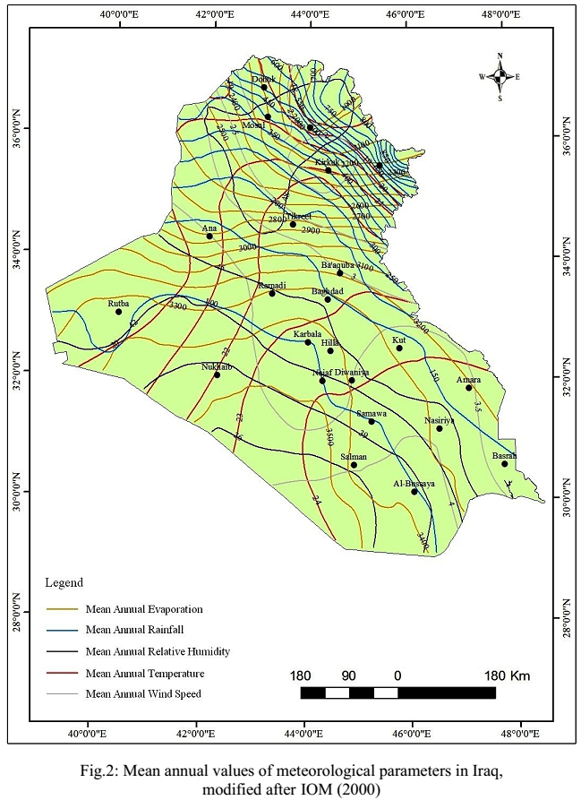
Figure 1. Annual averages of climatic elements in Iraq, [1].

3.2 Major groundwater aquifers in Iraq
Geological, structural, and lithological conditions govern spatial distribution and extensions of hydrogeologicacomponents in terms of aquifers and aquitards, and their hydrological characteristics.
Depending on the above-mentioned parameters and on the relationship with the geological formations that storing the groundwater, fourteen major aquifers (or group of aquifers) have been recognized and classified by [3] in Iraq. The surface or near-surface spatial extent of these aquifers is illustrated in (Figure 5) as follow:
1. Cretaceous-Tertiary limestone Aquifers, that are characterized by dense fractures and fissures, which represent the secondary porosity in the formations of Tayarat, Akashat and Ratgha, in the faraway west of Western Desert (west of Rutba).
2. The Permian Sandstone Aquifers, are represented by the formations of Al-aqraa and Beer Al Rah in the Al Rutba Sub-zone in the west of the Western Desert, to the northeast of the aquifers mentioned in the first aquifer group, (Figure 6).

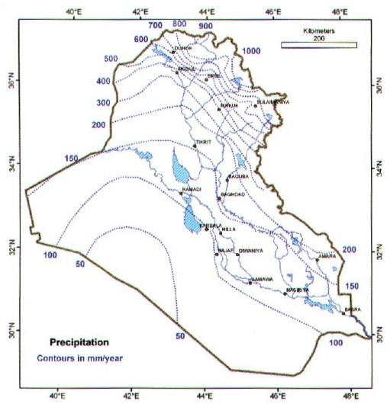

Figure 2. Annual rates of precipitation in Iraq, after [1]
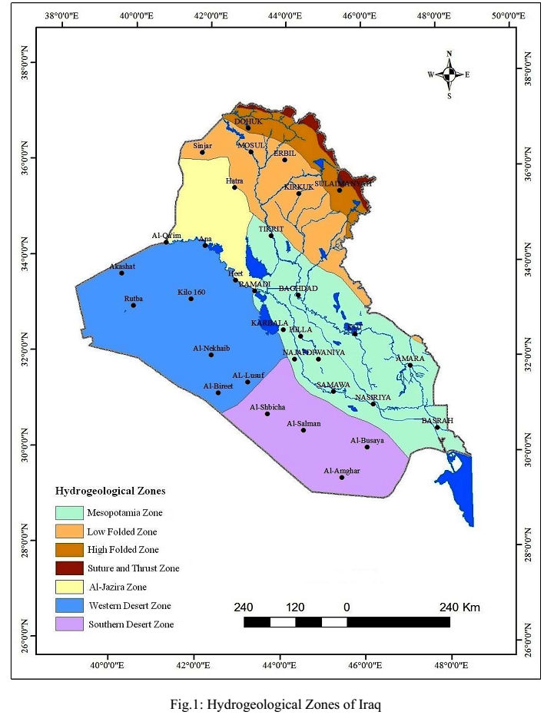
Figure 3. The main hydrogeological zones in Iraq, [2]

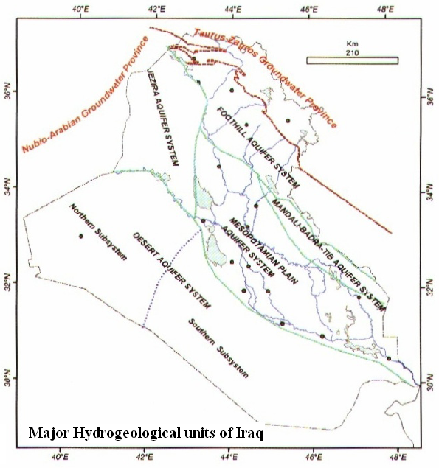

Figure 4. The main hydrogeological systems in Iraq [3]
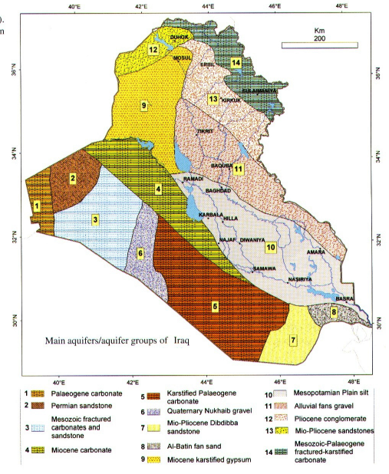
Figure 5. The Major groundwater aquifers in Iraq [3].
3. Triassic-Cretaceous aquifer in limestone-sandy rocks with dense fractures and fissures, and these aquifers are existing in Molusa formations, Zur-Horan, Ubaid, Al-Hussainiyat, Amij, Muhaiwir, Sakar, Nahr Umar, Rutba-Masaad, Harthah, Tayarat, within the Rutba Sub-zone, to the southeast of the aquifers mentioned in the first aquifer group.
4. The limestone aquifers in Paleogene - Neogene, which are found in the formations of the Euphrates, the Kirkuk group, and the formation of laurel, and extend from the Western Desert to the Southern Desert, within the areas of Rutba and Salman Subzones, to the west of the Euphrates River and to the east of the previous three mentioned aquifer groups, (Figure 7) .
5. Karstified Paleogenic Carbonate Aquifers, that are characterized by dense fractures and karst gaps that are found in the formations of Umm Erdhumah, Jil and Dammam, in the Salman area in the southern Desert.
6. Sandstone aquifers and masseuses in the Miocene -Pliocene, which are found in the formations of Ghar,Zahra and sedimentary deposits of Nakheb subsidence, in the subzone of Rutba and Salman zone, in the western and southern Desert.
7. Mio-Pliocene Dibdiba sandstone aquifers, within the Salman Zone in the Southern Desert, the faraway south of Iraq.
8. Gravel sand fans aquifers, in Wadi Al-Batain in the southern desert within the Mesopotamian zone, in the faraway south of Iraq.
9. Karst aquifers in the gypsum and limestone rocks in the middle Miocene within Fatha formation in the subzone of Ga’ara in northwestern of Iraq.
10. The aquifers of the flood plain, within the sandy deposits in the Quaternary, in central and southern Iraq, in the Mesopotamian Foredeep.
11. Gravel and sand deposition aquifers within the quadrilateral river fans, along a series of Makhoul and Hamrin folds, in the central and southern Iraq, along the eastern borders of the Foothill and Mesopotamian.
12. Sandstone aquifers within the Injana (Miocene-Pliocene) and Muqdadiya (Pliocene) formations in the north and northeast of Iraq, within the foothill zone.
13. The conglomerates aquifers in the Quaternary and Pliocene within the formation of Bai Hassan, in the synclines in northeastern Iraq, within the range of foothill and parts of the high fold zone, (Figure 8).
14. Limestone rock aquifers between the Mesozoic and Triassic, and igneous and metamorphic rocks, which are characterized by the intensity of fractures and fissures, in the mountainous areas within the High Folded Zone, northern and eastern Iraq, (Figure 8).
15. Some comprehensive studies indicated that several groundwater aquifers extend or (share) more than one of the groups of aquifers that mentioned within this classification, and some of these area significantly important , in which some of them illustrated by [7], which is divided the extend of the Umm Rudhuma aquifer ( Mentioned in group 5 of this classification) west of the Euphrates in the southern desert and the eastern part of the Western Desert into two parts. The first part is a confined aquifer that extends along the West Bank of the Euphrates and extends from Basra in the south to the easternmost part of the Western Desert. While, the second part, which represents the unconfined aquifer, it will be on Stripe shape that extend parallel to the first part and to the west of it, and these two aquifers of the most important invested aquifer extensively in the southern desert and east of the Western Desert (Figure 9).
In addition, it was considered by [8], both Umm Rudhuma and Dammam having the same hydrogeological system, while a study of [9] confirmed that the eastern part of the Dammam formation adjacent to the West Bank of the Euphrates River in the southern desert, represents a confined aquifer, and the second part parallel to it in the west of Southern Desert, which represents an unconfined aquifer that extends to the Saudi border, (Figure 10).
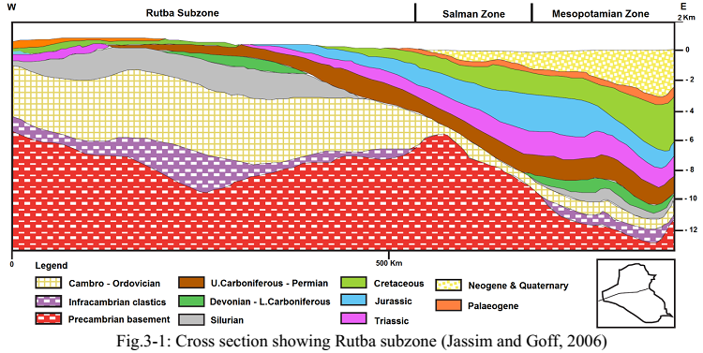
Figure 6. Cross section showing the stratigraphic sequence of the Subzone Rutba Zone, after [3] in [4].

Figure 7. Stratified section of Western Desert in Iraq, after [5] in [4].
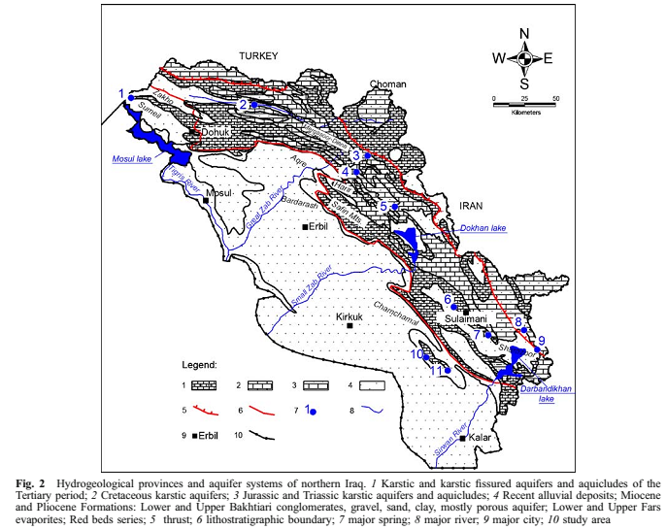
Figure 8. Hydrogeological cross-section and groundwater aquifer systems in northern Iraq, 1. Karstic water aquifers are characterized by the presence of fractures and fissures, and the con-fined layers between them, refer to the Tertiary 2. Karst-karst groundwater aquifers 3. Karst groundwater aquifer, Jurassic and Triassic and the confined stratum between them 4. Quater-nary alluvial deposits and Miocene and Pliocene compositions, which consist of the Muqdadi-yah and Bai Hassan conglomerates, which are a mixture of gravel, sand and silt and are highly effective porosity aquifers. This zone also includes strata of Fatha Formation, which consist of gypsum and limestone and layers of clay and alluvial deposits, and the formation of Injana, which consists of sequences of sandstone, siltstone and claystone, and the zone also includes a series of red clay beds 5. Thrust fault 6. Formation borders 7. Major springs 8. Major river 9. Major city 10. Studied area. [6].
Further examples of highly important to mentioning them in which illustrated by [10], [11], [12] and [13] regarding extension of the Dibdiba aquifer formation (mentioned in group 7 of this classification) as one of the most reliable groundwater aquifers in investing groundwater in South of Basra (southern Iraq) between Safwan and Zubair, as well as in the Karbala-Najaf plateau, Figures 11 and 12.
The hydrogeological system of the Dibdiba sandy aquifer in the Safwan Al-Zubair regions described by [13], he stated that it is characterised by unconfined aquifer interspersed with solid lenses of clay with a limited local lateral extension at the top of the aquifer that may cause to existing of local groundwater level. In addition, it characterised in the bottom by a solid layer of clay with regional extension, leads to isolates it from the deeper aquifer, Figure 13.
Referring to the study by [14] and [15], the extension of the same formation as an important aquifer for groundwater investment in the Karbala - Najaf plateau in central Iraq.
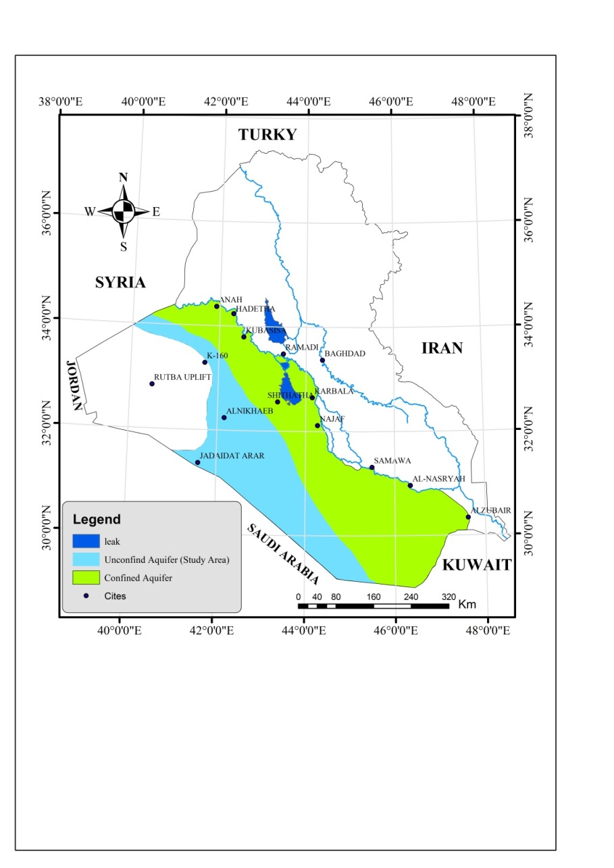
Figure 9. Extension of the Umm Rudhuma Aquifer, with its confined and unconfined divisions of the southern desert and the eastern part of the Western Desert [7].

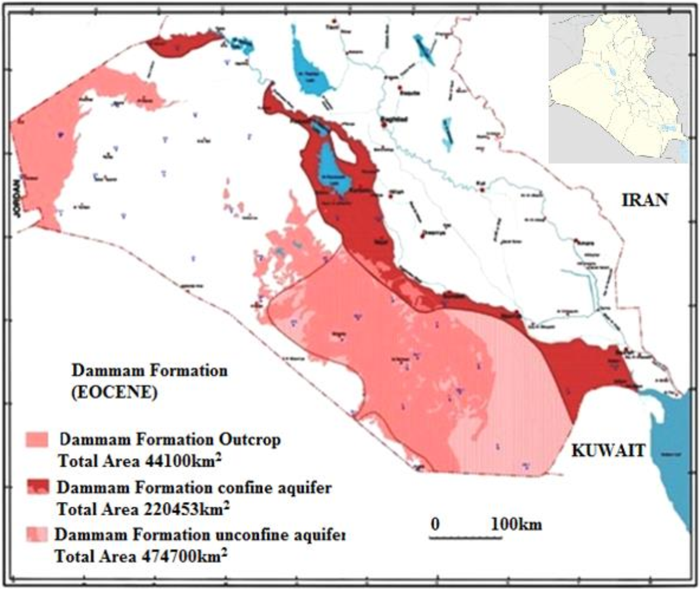
Figure 10. The extensions of the Dammam formation aquifer in the eastern (confined) and western (unconfined) divisions in the southern desert [9]. Compared the extensions of the formation divisions with the extensions of the Umm Rudhuma formation in the same area in the previous figure. The comparison confirms the opinion of [8] as both limestone formation characterized by the same hydrogeological system.

3.3 Major trends of groundwater flow in Iraq:
The directions of groundwater flow in Iraq differ from one place to another according to the conditions of the underground aquifers, in terms of hydraulic characteristics, the hydraulic slope, and the hydrogeological borders of the basins that contain these aquifers.
The flow of groundwater depends on the difference between the levels of the groundwater in the groundwater aquifers and the inclination of the aquifers [16].
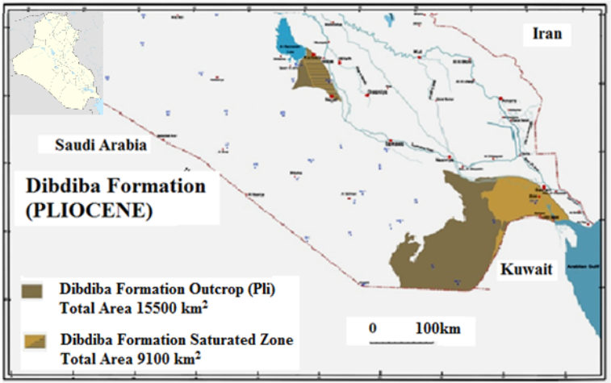

Figure 11. Outcrops of the formation of Dibdibah in the faraway south of Iraq and the boundaries of the area saturated with groundwater in the Safwan-Al-Zubair region and in the Karbala-Najaf region [10].
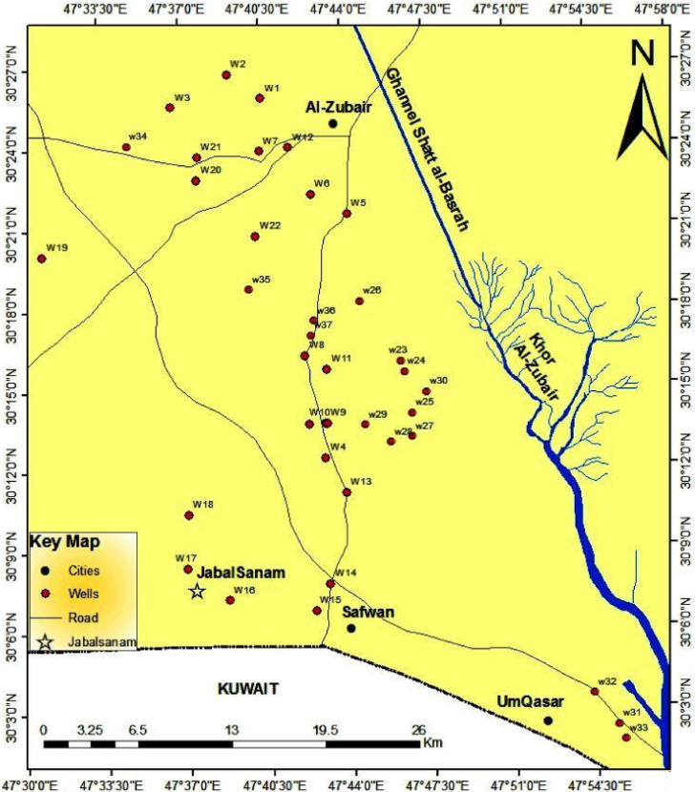
Figure 12. The extension area of the Dibdibah sandy formation, which represents one of the most important groundwater aquifers in southern Basra (southern Iraq) between Safwan and Al-Zubair [11].
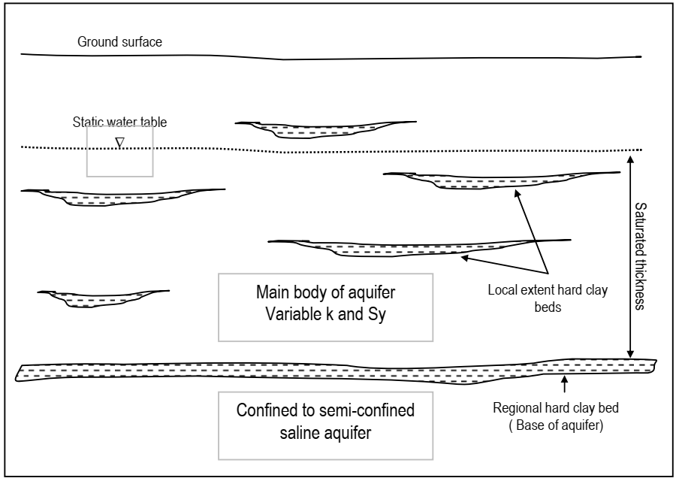
Figure 13. The hydrogeological system of Dibdibah sandy aquifer in the Safwan Al-Zubair region. Clay lenses with a limited local lateral extension are observed at the top of the aquifer, and the clay layer with a regional extension at the bottom of the aquifer, represents its base which insulates it from the deeper aquifers [13].

Several maps developed by [3] and [2], demonstrate groundwater levels in the upper aquifers, and general trends of groundwater flow in each of the major groundwater regions in Iraq.
These trends can be summarized as follows:
1. In the Mesopotamian aquifers, the direction of groundwater flow within this range is from all adjacent region. It represents the entire regional drainage area for the hydrogeological system in Iraq, Figure 14.
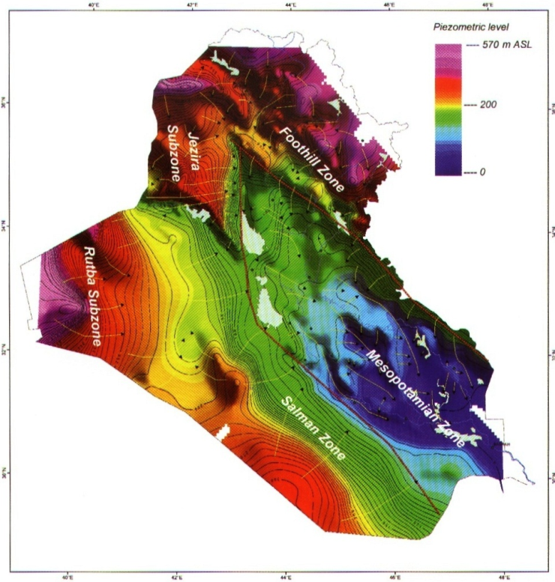
Figure 14. Groundwater levels in Iraq in meters (a.m.s.l) [3].

2. The general trend of groundwater flow in the western part of the Low Folded Zone (to the west of the Tigris River), is mainly from the north and northwest to the south and southeast, with the exception of the area in the north of Sinjar Mountain, where the flow direction is to the north and west, towards the Iraqi - Syrian border. While, the direction of the groundwater flow in the eastern parts of the Low Folded Zone (east of the Tigris River), it will be from the north and northeast, towards the south and southwest, with a local variation in the flow directions, due to the topographic and structural characteristics of the area, Figure 14.
3. The general trend of groundwater flow in the High Folded Zone, towards the southwest and south, with different local trends due to the presence of multiple hydrogeological boundaries within this zone, in addition to the complexity of the structures and topography of this region. Thus, groundwater moves from this zone to the low folded zone as a drainage area, Figure 14.
4. The regional trend of groundwater flow in all aquifers of the Al-Jazira Zone is generally from north to south and southeast in the northern part of the zone, but in the southern part of the range the dominant direction of flow is from west to east. However, there are different local trends of flow, depending on the geological condition and topographical and structural features, Figures 14 and 15.
The regional direction of groundwater flow in the Western Desert is generally to the east and northeast, to the drainage area represented on the right (western) bank of the Euphrates River, but there are different local directions for flowing through the region depending on the geological background of the region and its topographical and structural features, Figures 14 and 16 .

5. The general direction of groundwater flow in the south of Al-Jazira area and the upper Mesopotamian, Figures 14 and 17, is towards the drainage areas represented by the Tigris River and the subsidence of Tharthar lake, as separate between drainage subsurface border areas , which represented by the subsurface convex folds, including the Tikrit Fold, which is also s represents a topographic rise area that acts as a groundwater recharge area, its mostly in line with the topography of the region, where high areas form groundwater recharge areas while areas of the Mesopotamian form drainage areas.
6. The general trend of groundwater flow within the southern desert region, towards the east and northeast, which, towards the drainage area along the right (western) bank of the Euphrates, al-Hammar Marshes and Shatt al-Arab. However, there are local flow trends, as groundwater runs in different directions in the region depending on the geological background and topographic and structural characteristics, Figures 14 and 18. A map of groundwater flow in the southern desert and the eastern part of Western Deseret has been developed by [7] within the Umm Rudhuma Formation, which is the same general direction from west to east, and it is noticed that there is a boundary at which the regional direction of flow changes between the southern and western desert, which is almost parallel to Wadi Al-Khar, Fig. 19.
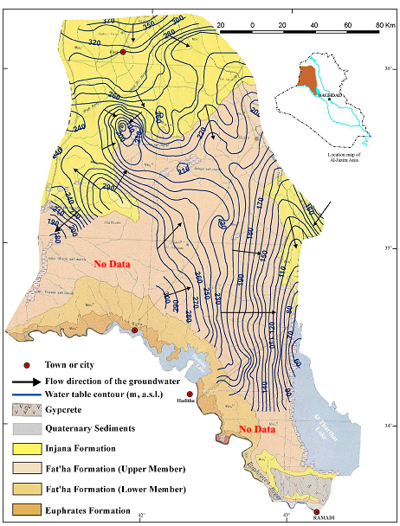
Figure 15. Groundwater levels and directions of flow within Al-Jazira Zone [17].
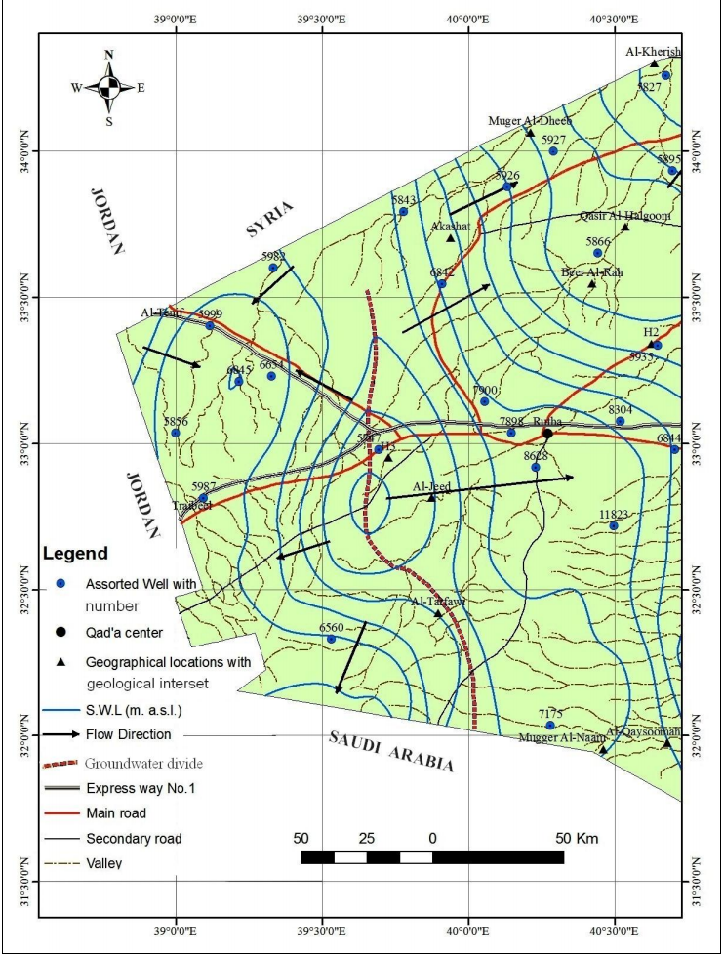
Figure 16. The direction of groundwater flow in the Western Desert [18].
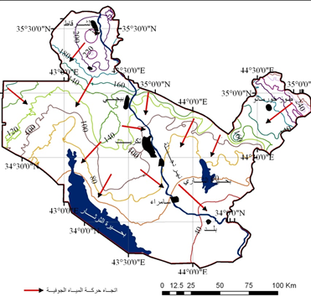
Figure 17. Map of groundwater levels (a.m.s.l) and their direction of flow in the south of Al-Jazira and upper of the Mesopotamian (Salahaldeen Governorate) [19].

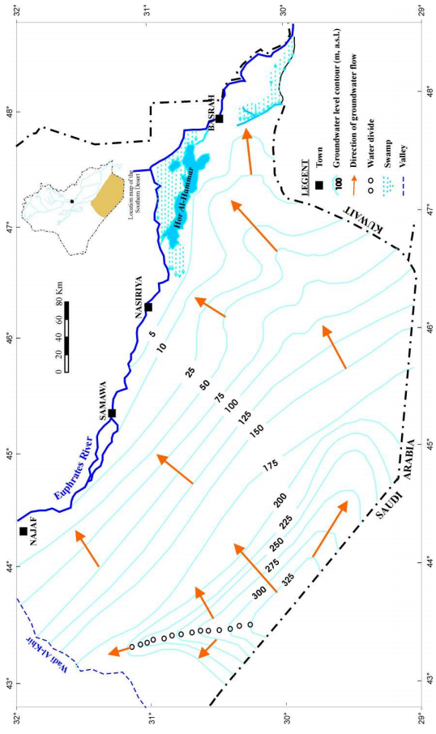

Figure 18. Groundwater levels and directions of flow in the southern desert of Iraqi [20].
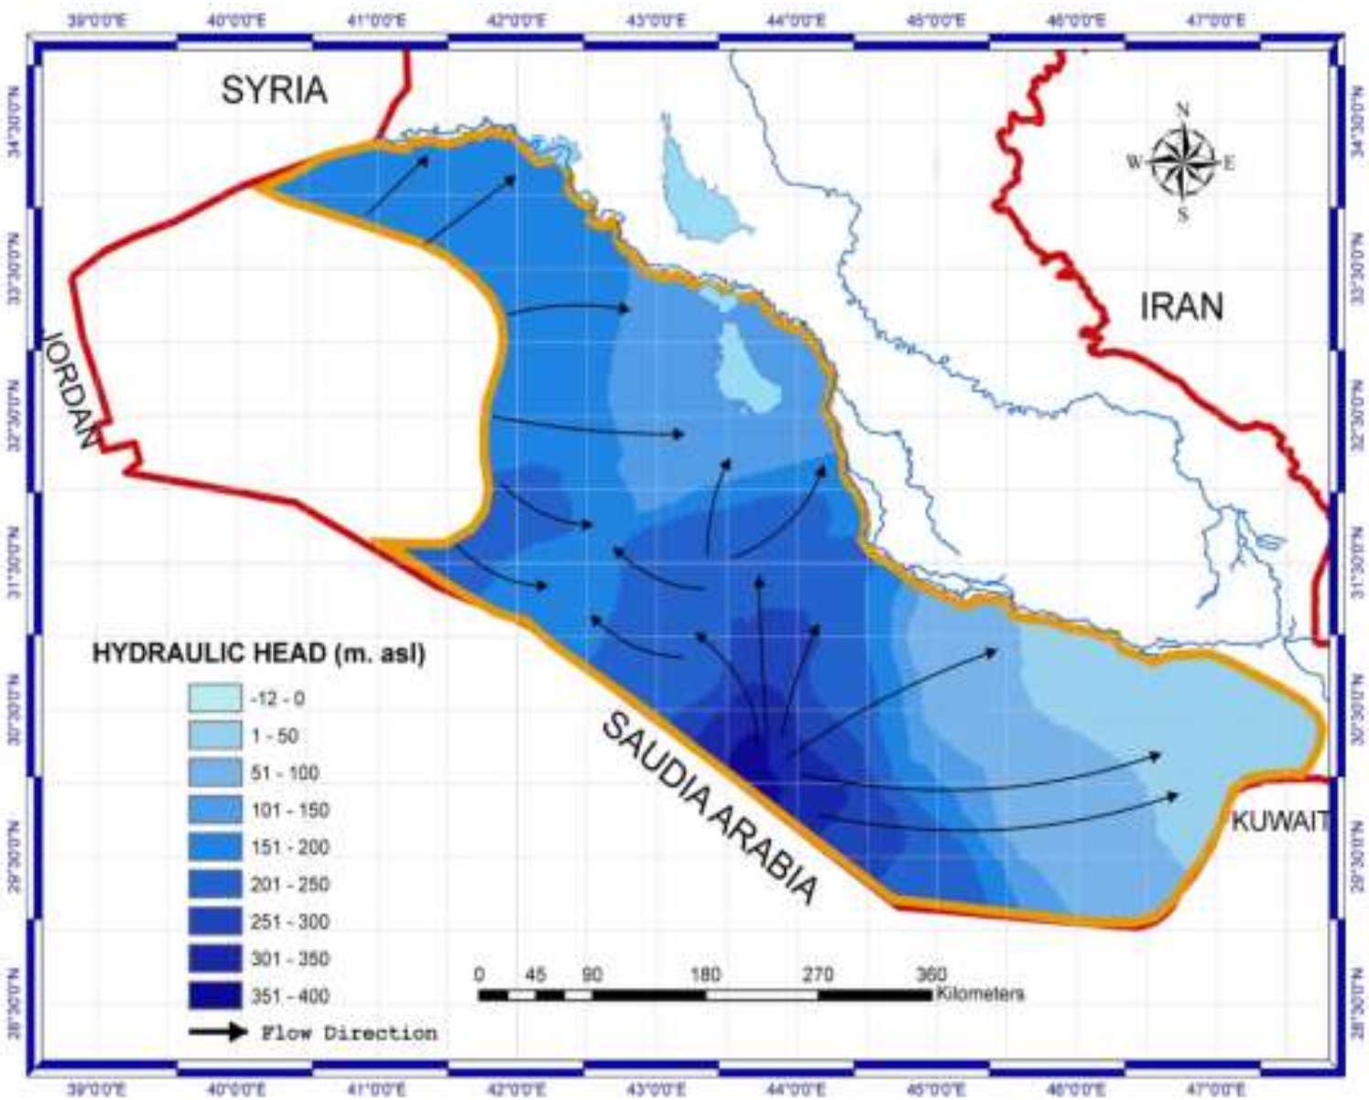

Figure 19. Groundwater flow within the formation of Umm Rudhuma aquifer in the Southern Desert and the eastern part of the Western Desert [7].

7. The direction of groundwater flow in the Badra Jassan basin in the east of central Iraq, will be in two basic directions, from the east to the west in the north of the basin, and from the northeast to the southwest in the central and southern areas of the basin, and effect of the drainage of the Kalal River that penetrates the basin and divides it into two parts, is in changing the general trend of groundwater runoff, as local trends are generated for this runoff in the adjacent banks of the river, Figures 14 and 20.
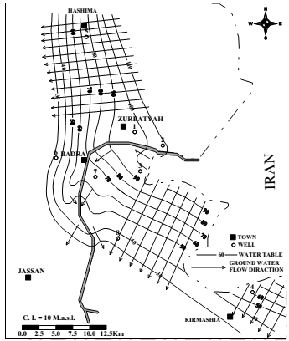
Figure 20. Groundwater flow net in the Badra – Jassan Basin [21].
8. The direction of groundwater flow in northeastern Messan is from the northeast to the southwest, and it is consistent with the direction of the topographic elevation. The north and north-eastern regions represent the recharging area, while the south and southwest regions represent the discharge areas, Figures 14 and 21.
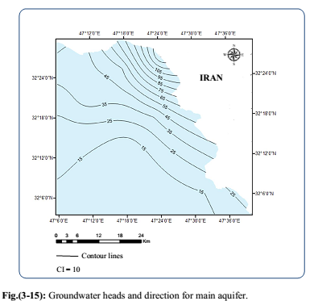
Figure 21. Groundwater levels and direction of flow in northeastern Messan [22].
9. The groundwater in the Karbala region moves under the influence of the surface topography and the inclination of the aquifer layers. The flow is radial in all directions, but the final direction of the flow is to the east of the region. And the nature of the quaternary deposits causes the formation of the Dibdibah to accelerate the filtering and penetration of precipitation water to recharge this underground aquifer despite the low annual rate of precipitation in the region [15], Figures 14 and 22. While, in the area of south of Najaf Sea and the southwest of Najaf, the groundwater moves from a level of about 35 meters above the sea level in the southwest , towards the northeast, until it reaches a level of about 15 meters above the sea level at the edges of Tar Al-Najaf and the city of Najaf and Abu Sakhir, Fig. 23 .
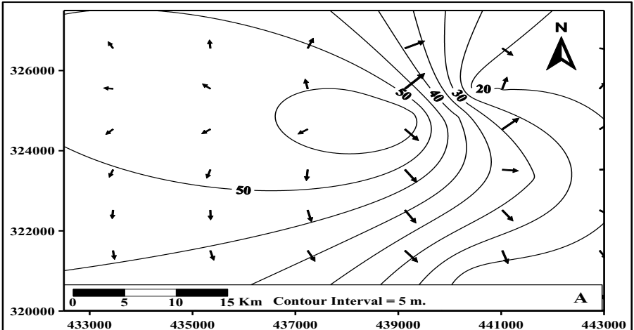
Figure 22. Groundwater levels and direction of flow in Karbala [15].
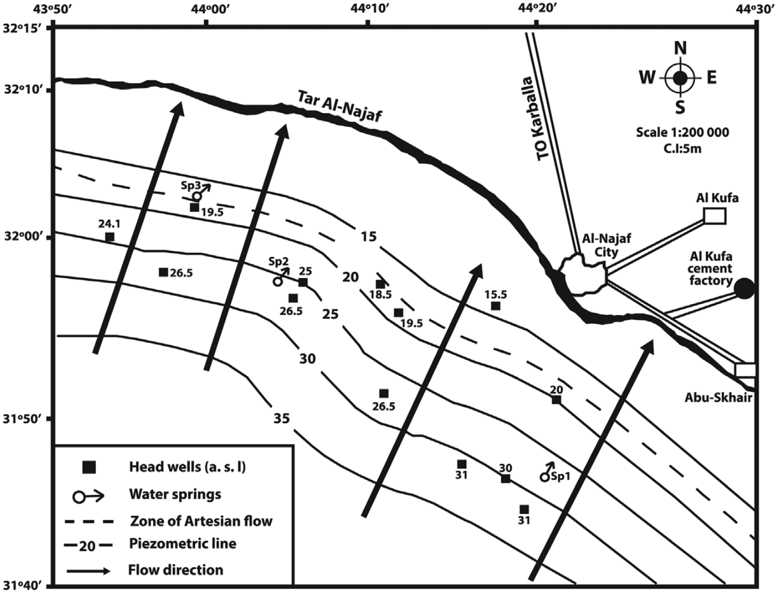
Figure 23. General levels and trends of groundwater runoff in the sea of al-Najaf region [23].
10. Groundwater is invested in the Zubair-Safwan area within the formation of Dibdibah, and this water moves from the recharging area in the west, towards the discharge area in the Khor Al-Zubair in the east. The characteristics of the sediment of Dibdibah formation allow the precipitation water to filter and penetrate to recharge this underground aquifer, despite the low annual rate of precipitation in the region, (Figures 14, 24 and 25).
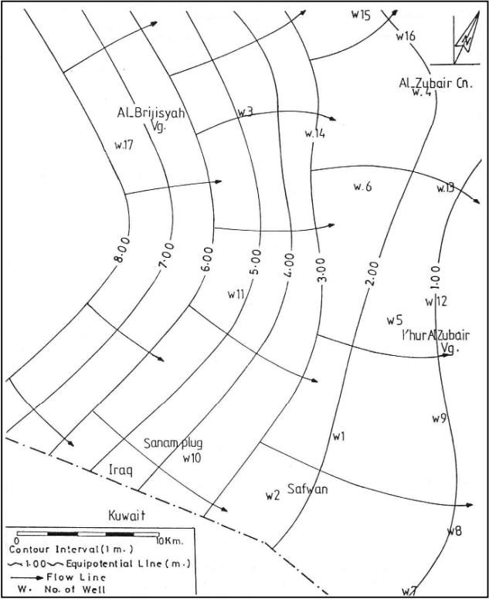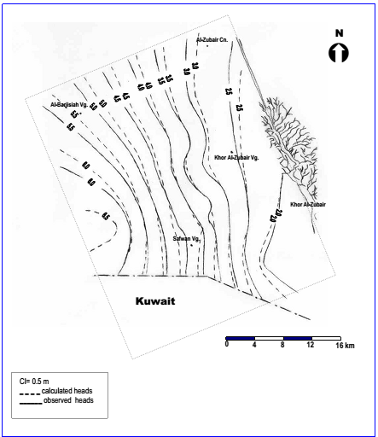
Figure 24. Groundwater levels and direction of flow in the Safwan - Al Zubair Basin, in the right [24] and in the left [25].
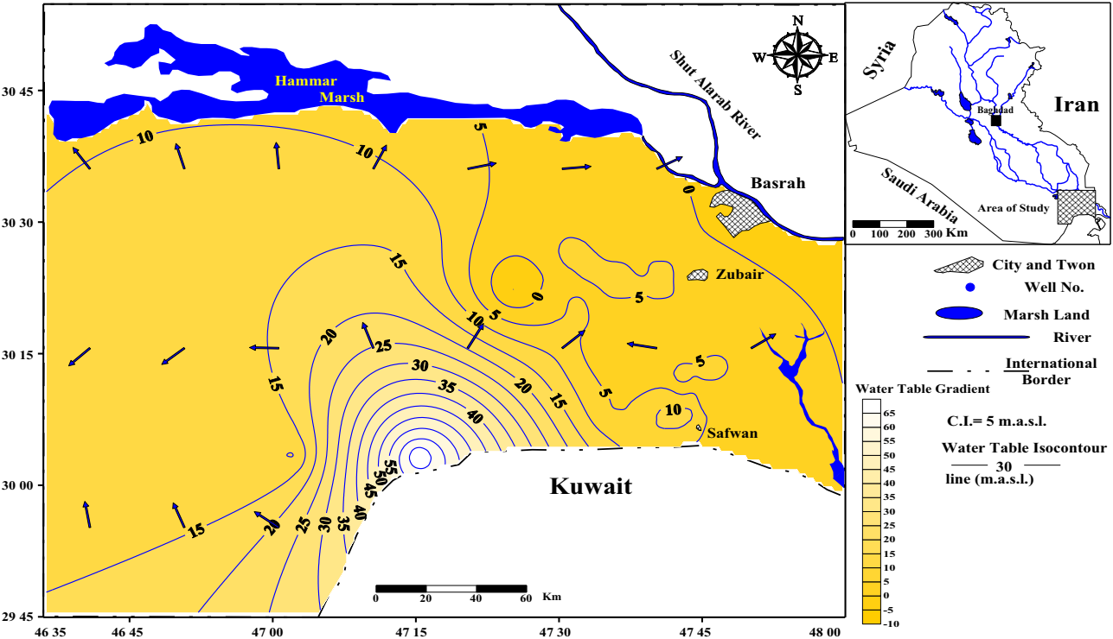
Figure 25 Groundwater levels and flow in Safwan - Al Zubair, West Basra [26].

3.4. The depths of groundwater in Iraq.

The depths of the presence of groundwater beneath the earth surface are very crucial factors in investing groundwater, and its uses. Furthermore, it’s very important as well in estimating the costs of drilling, the type of drilling rigs, drilling methods, well designs and the type of pumping equipment.
A map of the groundwater depths in Iraq is constructed by [3], Figure 26. It has been established from the map, these depths increase in the western desert toward west, with range from 10 meters along the banks of the Euphrates River to more than 250 meters at the Iraqi-Jordanian and Saudi borders, either near The Euphrates River, and along the Euphrates fault, the water table drops sharply towards the Mesopotamian.
In the Al-Jazeera region, depths of groundwater ranges between 10-20 meters, while in the range of foothill, these depths range between 20-30 meters, and these depths between Baghdad and Kut range from 1-5 meters, while depths are shallow in the Mesopotamian, in which sometimes reaching less one meter. Due to the presence of high salinity in the soil of this area, therefore, groundwater was faced a major problem in the Mesopotamian.
Likewise, another map was developed by [2], in which they indicated the variation of the groundwater depths from one basin to another and from one aquifer to another and from one place to another in Iraq, Figure 27, it ranges between more than 300 meters in the faraway western desert while not more than 10 meters in the Mesopotamian. This map is identical with the previous one in terms of the general spatial distribution of groundwater depths in Iraq, but it gave more specificity and gives further weight to the local groundwater depths.
In the western part of the Western Desert there are three zones of groundwater depths, the first zone is very small adjacent to the Iraqi-Jordanian borders in which depths exceed 300 meters while in the second middle zone it ranges between 200-300 meters, and the third zone is the broadest extension in which depths range between 100- 200 meters. Whilst, in the Western Desert, the depth ranges shall be parallel stripes starting from more than 50 meters, and the depths decreases eastward towards the Upper Euphrates until they reach about 20 meters at its banks.
In the Southern Desert, the depths of the groundwater will be within 50-100 meters, along the Saudi border in the western part of the Salman range, but these depths will decrease eastward towards the middle and southern Euphrates, so that the depth ranges will also be parallel stripes starting at about 40 meters and ending at the banks of the river within 10 meters.
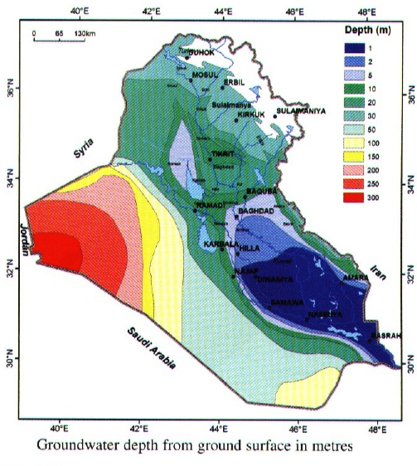

Figure 26. Groundwater depths below the earth surface h (m) [3].
In northern Iraq, the depths vary significantly due to topological complications and ranges between 10-40 meters. In General, drilling recorded data is often taken from wells drilled in low topographical areas.
Depths in the upper Al-Jazira range are about 40 meters, but they are reduced southward, and they are within 20-30 meters along the top of the Wadi Al- Tharthar, reaching 10 meters at the shores of Tharthar Lake.
While, in the Mesopotamian between the Tigris and Euphrates, the depths of the groundwater will be less than 10 meters from the south of Baghdad, and these depths will decrease to the south until they reach up to one meter in some areas of Basra.
Some comprehensive studies conducted in Iraq regarding these basins, especially those conducted by academic organizations, have developed maps of the groundwater depths, which showed more accurately local positional variations of these depths.
In the southern part of Al-Jazera region and the northern part of the Mesopotamian, the depths of the ground water are varied and ranges from less than 10 meters to more than 70 meters, (Figure 28), in the central part of the region in the parts surrounding the southern of the Wadi Al- Tharthar, and on both sides of the Tigris River ,south of Al-Fatha, the groundwater depths ranges from 10-20 meters, and the depths increase towards the higher topographical areas, until these depths reach about 70 meters in the middle of Makhul and Hamrin and at the borders of the Belkana fold.
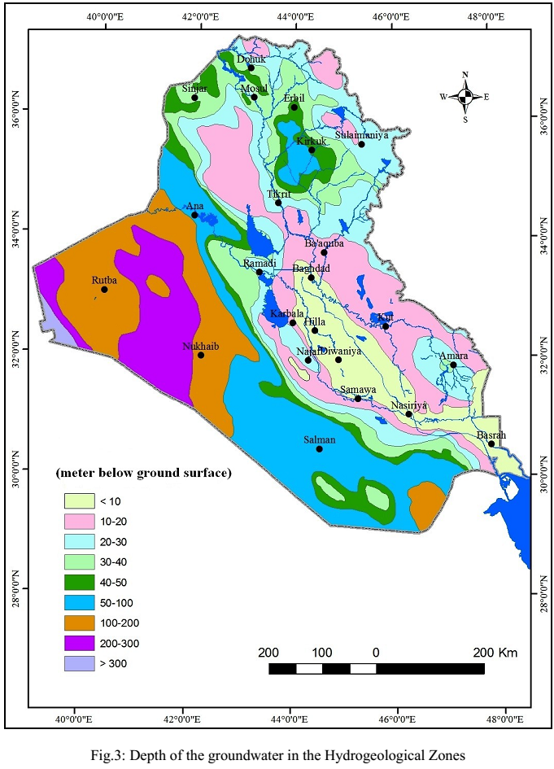
Figure 27. Groundwater depths in different zones in Iraq [2].

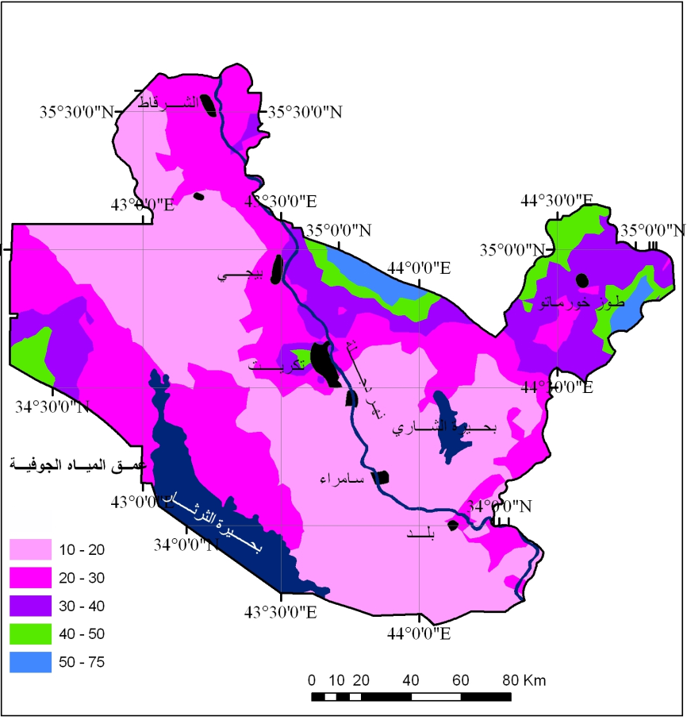

Figure 28. Map of groundwater depth in the south of Al-Jazera and Upper Mesopotamian (meters below the earth surface) [19].

In the eastern part of Iraq, among Badra, Jassan, and eastern Kut to Amara, the depths of the water range from 10-20 meters, and this range will be in the form of a wide strip that runs parallel to the east of the Tigris extending to the Iraqi-Iranian border.
Regarding East Amara, a study of [22], (Figure 29), indicates that the depths of groundwater range from 9-15 meters, and in its southeastern part the depths decrease to 4-9 meters, with pouches in which the depth decreases to 1-4 meters, and others depth increases to 15-22 meters depending on conditions of the groundwater aquifers and topographical situation.

3.5. Hydraulic characteristics of groundwater tanks
The hydraulic properties of groundwater-carrying layers refer to evaluate the hydrogeological properties of aquifers, and a key to many important processes and steps such as selecting the best suitable sites for drilling wells, methods of investing groundwater, the well types , pumping equipment and the quality of the invested aquifers. These properties will be achieved from the results of experimental pumping wells, which helps in finding the hydraulic characteristics of the aquifers, in addition to provide information regarding the well characteristics, in terms of productivity and drawdown level. The most important hydraulic characteristics of the layers carrying the groundwater that must be approached, which affect the flow of water from the wells and the water drawdown level during the pumping test are:
1. Transmissivity Coefficient (T).
2. Hydraulic Conductivity (K).
3. Pumping Rate (Q).

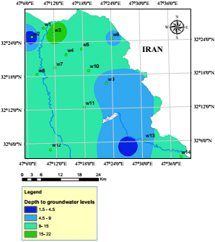

Figure 29. The depths to groundwater in East Messan Region [22].

These properties vary from one aquifer to another and from one basin to another according to the nature of the rocks that carrying water, which represent the porous medium in which water is stored and moves through it.
The above-mentioned hydraulic characteristics values, in the representative of the most extended aquifers in Iraq and those other characteristics were discussed in the context of this study, seem to be encouraging values for the groundwater investment, on condition that its uses are rationing for drinking (as raw water or after torment or distillation) or for irrigation, with note that this resource is replenished and that appropriate recharge levels are preserve this resources.
They are high in aquifers of gravel and sandy fragment nature and in geological formations that are characterized by the intensity of fractures, fissures, and karstic gaps, and are reduced in confined clay layers or impermeable crystalline layers in which there are no fractures and fissures.
Several studies were conducted to evaluate these characteristics in terms of groundwater aquifers in the basins or sub-basins, which can be summarized in Table 1.

Table 1. Hydraulic characteristics of some of the extensive groundwater aquifers in Iraq.

Aquifer | Area | T  m²/day | K  m/day | Pumping rate m³/day
Akashat | ^{[18]}Western Desert | 2 – 620 | 0.1 – 5.2 | 53 – 475
Tayarat and Digma |  | 2.2 – 120 | 0.2 – 2.6 | 33 – 272
Tayarat |  | 202 – 15529 | 0.2 – 25.6 | 43 – 2590
Ms'ad |  | 15 – 104 | 0.2 – 1.1 | 207 – 648
Muhaiwir |  | 9 – 1243 | 0.1 – 9.3 | 46 – 1296
Mulussa |  | 0.8 – 81 | 0.03 – 3 | 22 – 864
Ga'ara |  | 0.5 – 620 | 0.1 – 19 | 48 – 2872
Suffi |  | 36 – 350 | 0.14 – 11 | 535 – 1000
Hartha | ^{[20]}Southern Desert | 163.3 |  | 1097
Umm Er Radhuma |  | 3 – 2100 | 0.1 – 21.1 | 33 – 3266
Dammam |  | 3.1 – 4752 | 0.1 – 100 | 26 – 6542
Ghar – Euphrates |  | 21 – 246 | 1.3 – 14 | 99 – 881
Dibdibba |  | 15 – 265 | 0.3 – 25.1 | 86 – 1037
Quaternary |  | 14 – 964 | 2.9 – 74 | 12 – 1166
Fat'ha | ^{[17]}  AlJazirah | 2 – 246 | 0.1 – 6.3 | 276 – 1555
Injana |  | 2 – 1274 | 0.1 – 20 | 11 – 3960
Quaternary |  | 5 – 257 | 0.2 – 24.7 | 26 – 660
Tertiary | ^{[22]}  Missan | 400 – 500 | 2 – 25
Quaternary |  | 12 – 290 | 0.5 – 15.5
Dibdibba | ^{[15]}Karbala | 29.21-426.61

4. Hydro-chemical properties of groundwater in Iraq

4.1. Groundwater Salinity
A map prepared by [3] for the variations of groundwater salinity in Iraq, (Figure 30), demonstrated that there are six levels of groundwater quality in the groundwater aquifers nearby the earth surface, these levels are as follow:
- Drinking water, salinity would be less than 1 g/liter.
- Irrigation water, salinity would be between 1-3 g/liter.
- Limited use irrigation water, salinity would be between 3-5 g/liter.
- Rarely use irrigation water, salinity would be between 5-10 g/liter.
- Unused groundwater, salinity would be between of 10-20 g/liter.
- Salty water (Hypersaline), salinity would be more than 50 g/liter.
Salinity increases in the Mesopotamian Foredeep in central and southern Iraq, as it reaches 10 g/liter in the upper Mesopotamian in the north, then the salinity of groundwater starts to increase gradually towards the south until it reaches 20 g /liter in the south of Baghdad and to the north of Kut and Samawa with pouches of groundwater that is not usable, then continues to increase until it reaches more than 50 g/litre in some areas of the south.
In the faraway north of the Aljazera range, the salinity of the groundwater ranges between 3-10 g/liter, as it is found in the salty and gypsum evaporates rocks represented by rocks of Fatha formation, and then the salinity decreases southward in the Aljazira regions within the Tharthar basin and is in the range of 2-4 g/liter.
In the Western Desert, the salinity of groundwater ranges between 1-3 g/liter and is within the limits of irrigation water, but pouches of fresh groundwater are present within the limits of drinking water of less than 1 g/liter in the wet and shallow depressions.
From the Southern Desert, the salinity of the groundwater increases significantly compared to the Western Desert, as it ranges between 3-5 g/liter in its western part and increases more in the eastern part of the Southern Desert, adjacent to the Mesopotamian Foredeep.
In the higher topographical regions of north and northeastern Iraq, the salinity of groundwater is within the limits of fresh drinking water and it concentrates less than 1 g/liter of salts, but in some areas of high folded zone and the greater part of the foothill zones, especially the eastern part of this range, salinity is within the limits of irrigation water that have a salinity of less than 3 g/liter.
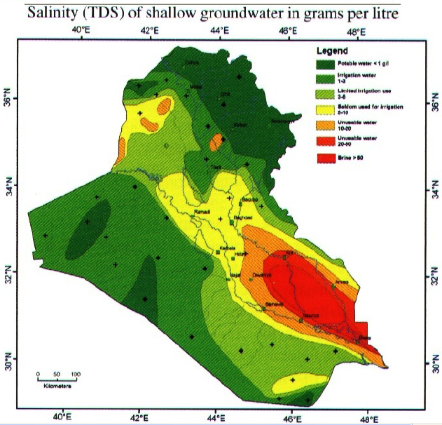

Figure 30. Spatial variations of groundwater salinity in Iraq [3].
In addition, a further detailed map developed by [17], on the salinity of groundwater in Al-Jazira region, in which they clarified the presence of a small pouches of fresh groundwater in the area of south Sinjar, followed by a south strip along the mountain of Sinjar which characterized by is lesser salt, either in the center and south of Aljazira region in the valley and West of Tharthar Lake, the water is salty with limited use, and there are pouches of high salinity (rare use), Figures (30 and 31).
The same researchers also developed a map of the spatial distribution of the salinity of groundwater in the southern desert[20], which was more detailed than the map that covered all parts of Iraq, as this map showed that the groundwater in the eastern part of this region adjacent to the Saudi border is of low salinity 1-3 g/liter, and the salinity increases in this zone eastward towards the Euphrates River, the water is salty within the range of 3-5 g/liter, while the southern part of the Southern Desert has a higher salinity or salty water, limited with rare to use, with pouches of water that are not usable, (Figures 30 and 32).
[8] developed a map of the spatial distribution of groundwater salinity for the Southern Desert region, but included the southern part of the southern desert and was almost similar to the region of salt heterogeneity in the previous map, as the salinity ranged between 1-5 g/liter, but it increases towards Basra Governorate and ranges between 5 -10 g/liter, (Figure, 33).

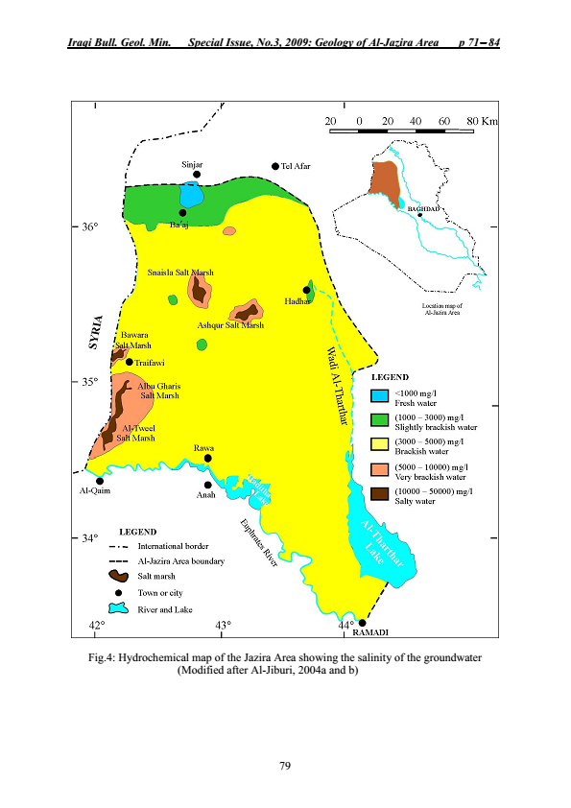

Figure 31. Hydrochemical map of Aljazira region showing the spatial distribution of groundwater salinity [17].

Figure 32. Hydrochemical map of the Southern Desert showing the spatial distribution of groundwater salinity [20].

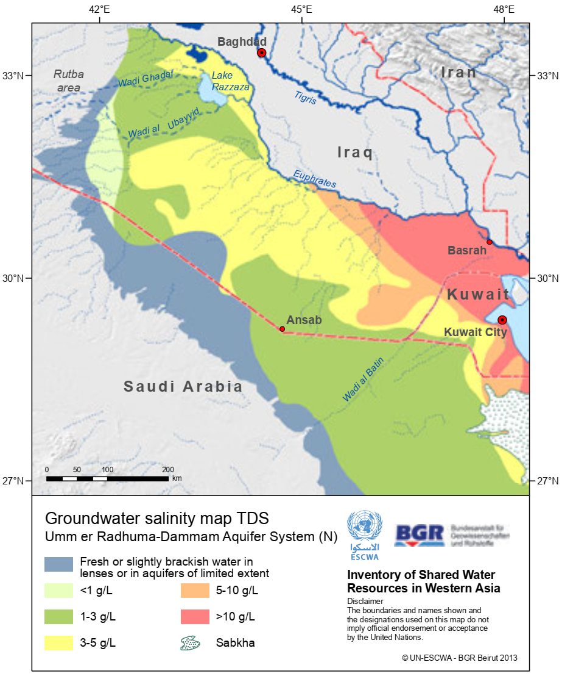
Figure 33. Groundwater Salinity Map in the Umm Rudhuma - Dammam Aquifer in the Southern Desert of Iraq [8].
In the southern part of Aljazira region and the upper Mesopotamian, the salinity of the groundwater is different, in the south of Aljazira region ,the salinity is in the range of 3-5 g/liter, due to presence of the gypsum rocks that hostess the groundwater, and it is of limited use for irrigation due to its sulfate content, but it is used for irrigation strategic crops that tolerate salinity, either on the sides of the Tigris River ,south of Al-Fatha, and western Tharthar, the salinity of groundwater is within 1-3 g/litre, which is within the limits of irrigation water and widely used for agriculture, especially for strategic crops, with small pouches of negligible water Fresh, but the salinity gets thicker towards the Mesopotamian until it reaches about 10 g/litre, [19], Figure 34.

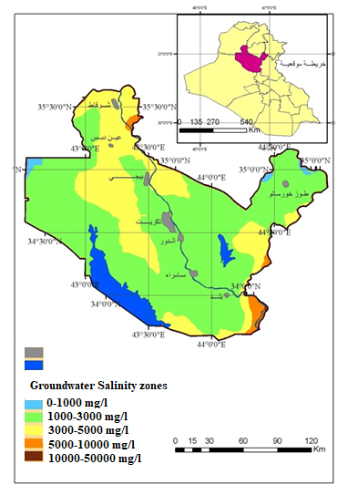
Figure 34. Salinity distribution map areas (mg /l), in the upper aquifers waters, in the south of Aljazira and upper Mesopotamian (Salahaldin) [19].

4.2. Classification of groundwater quality
It is noted from Figure 35, the groundwater classes in the upper recharge areas are generally of low salinity Bicarbonate water type, especially in the north and northeast of Iraq and pouches in Sinjar and the western and southern desert, While it does not penetrate and move rapidly towards sub-surface to change its quality and increase its salinity.
In the Western Desert, the water quality is generally Bicarbonate-Chloride water type, but in the middle of this desert is Bicarbona-Sulphate water type, and this results from its interaction with carrying rocks in the geological formations that storing groundwater. A more detailed map in the western part of the Western Desert developed by [18], Figure 36, in which he combined the type of groundwater with its salinity. The map showed that the groundwater in the part adjacent to the Jordanian border is a sulfate waters of low salinity, while in the northeastern part is a chloride of low salinity as well, and the waters of the southern and southeastern parts are fresh and bicarbonate.

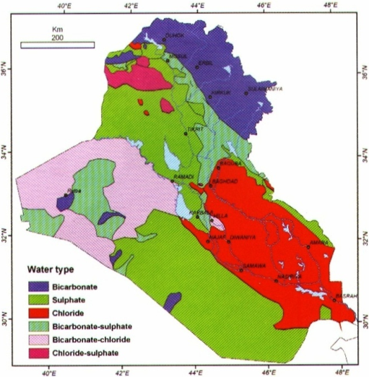

Figure 35. Classification of groundwater quality near to the earth surface in Iraq [3].

The groundwater in the area of ​​the Low Folded Zone and Foothill is a bicarbonate-Sulphate water type, and this results from its interaction with gypsum rocks or gypsum-rich rocks as a binder, especially in the formation of the Fatha, which leads to a deterioration in the groundwater quality.
Generally, in the Southern Desert and central and southern region of Al-Jazira and the strip adjacent to the Iranian border in eastern Iraq, the groundwater will be Sulphate water type and this is due to the presence of gypsum rocks in the aquifer rocks or rocks through which the groundwater passes during its vertical or horizontal movement, moreover in the narrow zone of the upper Al-Jazira near the Sinjar Mountain will be the Chloride-Sulphate water type, and the Mesopotamian area represents the collective area of ​​salts that washed out by groundwater in Iraq, during its movement towards the Downstream areas, and it often contains high concentrations of a Chloride water type.

4.3 Groundwater assessment for agricultural purposes

An assessment of the suitability of groundwater for agricultural purposes was made in the hydrogeological region of Iraq based on the Richard classification (1954) by [2], this evaluation was represented in (Figure 37). The map reflects the variation in water and soil salinity, in addition to assessment of groundwater for irrigation purposes. This evaluation was developed in combination with the soil properties in the various hydrogeological regions by [27].
Accordingly, the groundwater is suitable significantly for agricultural purposes in the northeastern borderline of Iraq and is good and suitable for all crops and soils in the High Folded Zone.
While, in the Low Folded zone, the western part of Western Desert, and the north part of the Southern Desert, their use will be permissible. In the eastern part of the Western Desert and southern part of Southern Desert, and the ranges of Al-Jazira, the Foothill, upper Mesopotamian and eastern Iraq from Badra to the south of Messan and Safwan-Zubair, their water will be of low quantity, but they are used for strategic crops that tolerate salinity.
However, in the southern part of the Mesopotamian, the groundwater is of very low quantity and is not suitable for irrigation for all types of crops.
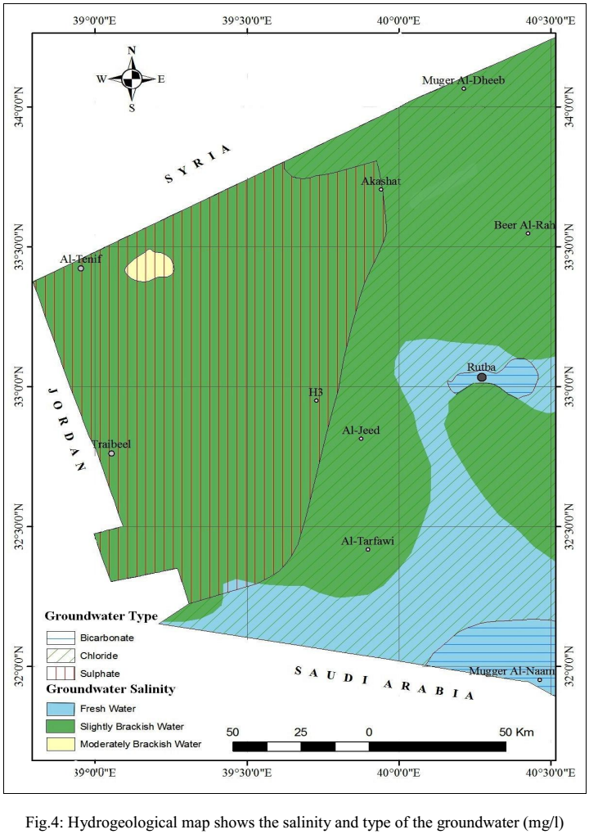
Figure 36. Water Quality and Water Salinity Classification in the Western Desert of Iraq [18].
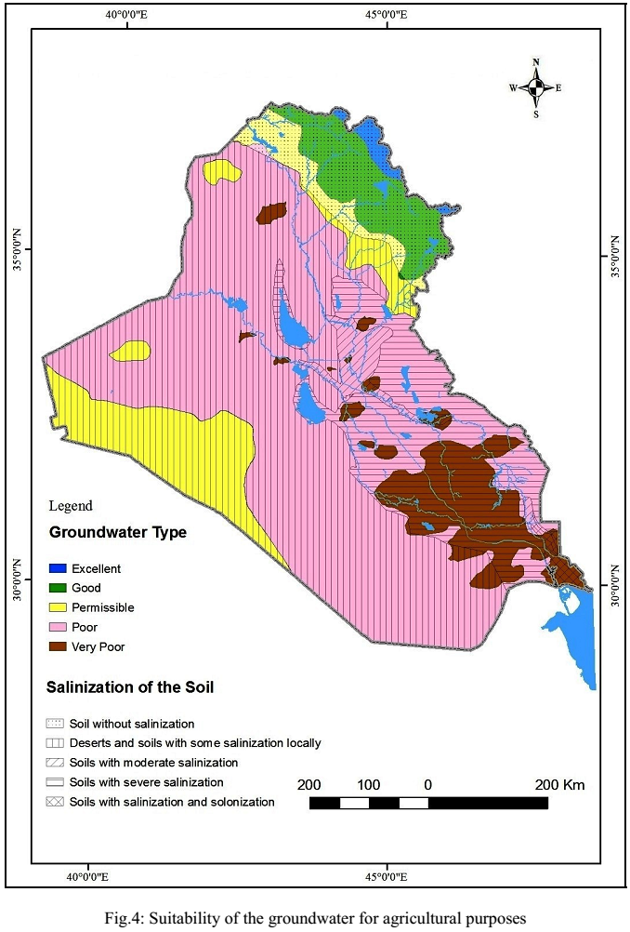
Figure 37. Groundwater suitability for irrigation purposes [2].

5. Conclusion

1. Most regions of Iraq, excepting the north and northeast, suffer from a lack of precipitation, particularly in its southern, western and central parts, and consequently the annual precipitation is not almost sufficient in some areas to moist the soil (soil moisture), while in some other area , the rate may be increase, in which is divided between surface runoff and groundwater recharging. By comparing the recharge rate with the discharge rate from subsurface aquifers in these areas, the difference notifies a risk of depletion of these aquifers.
2. The research There must be a search for alternatives to address the depletion of some reservoirs, and among these alternatives are artificial recharge and Subsurface Dams, and there are shy experiences conducted by the World Food and Agriculture Organization in northern Iraq.
3. Several subsurface aquifers suffering from over discharging (discharge more than annual recharging).
4. The capacity of drilling wells is higher than the capability of subsurface aquifers in many Iraqi regions.
5. Some organizations drill without a permit (the farmer drill without achieving drilling permission), and there are many unlicensed well drilling rigs.
6. Some farmers still use groundwater based on the traditional irrigation methods, which leads a terrific waste of groundwater.
7. The salinity percentage exceeds the permissible limits in the waters of many subsurface aquifers in the region of Al-Jazeera, Western and Southern Desert, the Middle Euphrates and Eastern Iraq, except for the northern and northeastern basins of Iraq. However, some unlicensed organizations are still drilling wells in these aquifers, without taking hydrological studies recommendations into consideration to stop drilling deep wells to ensure that saltwater aquifers are not penetrated.
8. The groundwater is not suitable for domestic use in most parts of Iraq except the north and northeast, but there are some pouches somewhere in the Western and Southern Desert, which requires accurate investigation of these pouches in order to investing them in an optimal way.
9. Through some of groundwater qualitative characteristics studies and its chemical properties, there is a proper opportunity for the success of small to create a success small distillation projects for domestic uses in faraway areas.
10. There is an opportunity to expand the cultivation of crops that tolerate salinity, especially in the proper soils in many Iraqi regions, particularly in the circumstance of appropriate application of agricultural courses.

6. Recommendations:
1. Strict establishment for the drilling setting and processes.
2. Development of the drilling techniques in the General Groundwater Authority.
3. Accurate modeling of water, sediments and rocks during well drilling processes, in order to confirm the accurate evaluation, and for creating an accurate database.
4. Initiate industrial recharging projects in the Western and Southern Desert and Al-Jazira region, depending on the available valleys water in the region, and exploiting the karstic features of an aquifer, as they deteriorate from the problem of lack of recharge and rejuvenation.
5. Initiate industrial recharging projects in the northeast of Messan, depending on the waters of the eastern valleys that flow into the region, as they suffer from the problem of lack of recharge and inadequate quality.
6. Initiate industrial recharging projects in Safwan - Al-Zubair.
7. Initiation of major subsurface dam projects in designated areas of Iraq.
8. Developing the distillation of groundwater in the faraway areas, with consideration of the qualitative and quantitative restrictions of the productive wells.
9. Developing the completion of experimental studies in the field of using salty water in the cultivation of strategic crops.
10. Developing studies of small dams on valleys as an industrial recharging technique.
11. Initiate the development of investment opportunities in Iraq in the field of manufacturing modern irrigation equipment such as sprinkler and trickle systems, to prepare them to operators with the commensurate costs and considerate as an important step to neglect the traditional irrigation system that leads a significant waste of water resources.

References

[1] Iraqi Organization for Meteorological Information (IOM), 2000. Atlas of climate of Iraq for the years (1981 – 2000), Baghdad, Iraq.
[2] Al-Jiburi, H.K. and Al-Basrawi, N.H., 2015. Hydrogeological map of Iraq, scale 1: 1000 000, 2nd edition, Iraqi Bulletin of Geology and Mining, Vol.11, No.1, p. 17-26.
[3] Krasny, J., Alsam, S. and Jassim, S.Z., Hydrology, in Jassim, S.Z. and Goff, J.C. (ed), 2006. Geology of Iraq, Czechrepublic, Brno, pp. 251-287.
[4] Al-Muqdadi, S.W., 2012. Groundwater investigation and modeling -
western desert of Iraq, Faculty of Geosciences, Geo-Engineering and Mining, Technical university, Hydrogeology institute, Freiberg – Germany, PhD. Thesis, 115 p.
[5] Buday, T., and Hak,J. , 1980. The geological survey of the Western part of the Western Desert. No.1000, Geosurv. Iraq., IRAQ (Unpublished).
[6] Stevanovic, Z. and Iurkiewicz, A., 2009. Groundwater management in northern Iraq, Hydrogeology Journal Vol.17, p. 367–378.
[7] Al-Fatlawi, A.N., 2010. Geological and Hydrogeological Characteristics of Umm Er Radhuma aquifer West of Iraq, Euphrates Journal of Agriculture Science, Vol. 2, No. 4 p. 263-275.
[8] UN-ESCWA and BGR (United Nations Economic and Social Commission for Western Asia; Bundesanstalt für Geowissenschaften und Rohstoffe), (1999). Groundwater Resources in Paleogene Carbonate Aquifers in the ESCWA Region: Preliminary Evaluation. New York.
[9] Al Jawad S.B. and Ridha S.A. (2008). Evaluation of Groundwater Resources in Iraq and Their Management. Unpublished report in Arabic. Ministry of Water Resources, Baghdad.
[10] Al-Jawad, S., Al-Ansari1, N. Adamo, N. Sissakian, V.K., Laue, J. and Knutsson, S. (2018). Groundwater Quality and Their Uses in Iraq, Journal of Earth Sciences and Geotechnical Engineering, Voll . 8, No. 3, P. 123-144.
[11] Al-Mallah, I.A. and Abdulameer, M.H., (2018). Evaluation of groundwater quality and the hydrogeochemical processes of shallow Dibdibba aquifer in Basra Governorate, southern Iraq, Journal of Basrah Researches (Sciences) Vol.44, No.1, p. 96-121.
[12] Ghalib, H.B., (2008). Simulation Study of the effect of artificial recharge on the water quality of shallow Dibdibba Clastic Aquifer in Zubair-Safwan area, south of Iraq, Journal Basrah Researches (Sciences), Vol.34, No. 4, p. 47-57.
[13] Atiaa, A.M., and Al-Asadiy, A., (2007). Management of Groundwater
Reseource of Dibdibba Sandy Aquifer in Safwan- Zubair Area, South of Iraq, Journal of the College of Arts. University of Basrah, No.42, p. 30-49.
[14] Al-Kubaisi, Q.Y.,Al-Abadi, A.M., and Al-Ghanimy, M.A. (2018). Estimation of Groundwater recharge by groundwater level fluctuation
method of Dibdibba aquifer at ‎Karbala- Najaf plateau, central of Iraq, Iraqi Journal of Science, Vol.59, No.4A, p. 1899-1909, DOI:10.24996/ijs.2018.59.4A.14.
[15] Al-Sudani, H.I.Z., 2018. Hydrogeological Properties of Groundwater in Karbala’a Governorate – Iraq, Journal of University of Babylon, Engineering Sciences, Vol.26, No.4, p. 70-84.
[16] Domemico, P.A. and Schwartz, F.W., 1998. Physical and chemical hydrogeology, John Wiely and Sons. Inc., New York. 506 p.
[17] Al-Jiburi, H.K. and Al-Basrawi, N.H., 2009a. Geology of Al-Jazira Area, hydrogeology Al-Jazira Area, Iraqi Bulletin of Geology and Mining, special issue, No.3, p. 71-84.
[18] Al-Jiburi, H.K. and Al-Basrawi, N.H., 2014. Hydrogeology of the western part of the Iraqi western desert, Iraqi Bulletin of Geology and Mining, Vol.10, No.2, p. 1-20.
[19] Albasrawi N. and Zaki S., 2010, Groundwater situation and its uses in Salahaldin Governorate, Internal Report, State Organization of Geological Survey, Baghdad, Iraq.
[20] Al-Jiburi, H.K. and Al-Basrawi, N.H., 2009b. Geology of Iraqi southern desert, hydrogeology, Iraqi Bulletin of Geology and Mining, special issue, p. 77-91.
[21] Alshamaa A. and Alazawi B., 2012, Relationship of surface water and Groundwater in Badra and Jassan Catchment, Iraqi Journal of Science, V. 53, 2, 335-340.
[22] Al-Abadi, A.M.A., 2011. Hydrological and hydrogeological analysis of northeast Missan governorate, south of Iraq, using geographic information system, department of geology, college of science, University of Baghdad, Ph. D thesis, 189 p.
[23] Al-Azawi, A.A.O., and Ward, F. A., (2016). Groundwater use and policy options for sustainable management in Southern Iraq, International Journal of Water Resources Development, p. 1-21. http://dx.doi.org/10.1080/07900627.2016.1213705
[24] Al-Abadi, M.A., (2002). Optimum management model of groundwater resources in Safwan-Zubair area, south of Iraq, Unpub. M.Sc. Thesis, College of Science, University of Basrah, 110p.
[25] Atiaa, A.M. and Al-Aboodi, A.H., 2006. Simulation of Flow Regime of Dibdibba Dandy Aquifer in Safwan-Zubair Area, South of Iraq, Iraqi Journal of Science, Vol.47, No.1, p. 119-137.
[26] Al Sudani, H.I.Z., (2019). Groundwater system of Dibdibba sandstone aquifer in south of Iraq, Applied Water Science, Vol.72, No.9, p. 1-11. doi.org/10.1007/s13201-019-0952-6.
[27] Buringh, P., 1960. Soils and soil condition in Iraq. Ministry of Agriculture, Baghdad, Iraq.

Department of Applied Geology, College of Science, Tikrit University
^{, 3} Lulea University of Technology, Lulea 971 87, Sweden. nadhir.alansari@ltu.se,
Article Info: Received : January 10, 2011. Published online : July 17, 2012

