Factors Controlling the Karstification Process in the Fatha Formation in Iraq
Varoujan K. Sissakian, Ayda D. Abdul Ahad, Nadhir Al-Ansari³and Sven Knutsson

Abstract
The Fatha Formation (ex-Lower Fars) is Middle Miocene of age and consists of cyclic sediments, each ideal cycle consists of marl, limestone and gypsum. However, in the upper half part of the formation, reddish brown claystone occur in the cycles. Moreover, in the uppermost part of the formation, fine reddish brown siltstone and claystone occur in the cycles too. The formation is divided into two members depending on the lithological constituents. Lower Member and Upper Member, the former is characterised by the absence of red clastic in the cycles and presence of thick gypsum beds, whereas the latter is characterised by the presence of fine red clastic with subordinate limestone beds.
The Fatah Formation covers considerable parts of the Iraqi territory, especially in the central western part and the central northern part too. In the former area, the formation usually crops out in a horizontal beds, whereas in the latter area; it is exposed in the limbs of anticlines and occasionally in their cores.
The Fatha Formation is one of the main problematic geological formations in Iraq. Due to intense karstification, the rocks of the formation have caused severe damages to the constructed structures built on its exposure areas.
This article deals with the factors controlling the karstification process in the rocks of the Fatha Formation and shade light why karstification is not distributed over all the exposure areas of the formation in Iraq. The study concluded that the main factors that control the karstification process in the Fatha Formation are lithological and tectonic factors.
Keywords: Karstification, Sinkhole, Gypsum, Fatha Formation, Iraq

- Introduction
The Fatha Formation (ex-Lower Fars) is of Middle Miocene age. The formation consists of cyclic sediments; repeated in rhythmic system and being divided into two members [1,2]. The Lower Member consists of three lithological gypsum dominated units, whereas, the Upper Member consist of three lithological units too; but red fine clastic dominate the units, especially in the uppermost part.
The aim of this study is to elucidate the factors that control the karstification process in the Fatha Formation in Iraq. Moreover, to discuss why not everywhere the Fatha Formation does not exhibit karstification.
The study area covers all parts within the Iraqi territory; where the Fatha Formation is exposed (Fig.1). However, those parts where the gypsum is not present as one of the main constituents of the formations are excluded and clearly mentioned in the current study.
1.1 Previous Studies
Although many studies have dealt with the karstification in Iraq, but majority of them didn’t discuss the factors that have controlled the karstification Process. A good example is the study of Jassim et al. [3]; they studied the karst forms in west of Mosul area and concluded that the gypsum and limestone beds of the Fatha Formation are highly karstified. However, Sissakian and Abdul Jab’bar [4] conducted a special work using GIS technique to discover the reason of the large karst forms in the western part of Iraq, Jazira area and have attributed their development to tectonic effects. Moreover, Sissakian [5] attributed the origin of Al-Tharthar Lake to be controlled by karstification and tectonic effect. Among other studied that dealt with karstification in Turkey and Iran are those of Atalya [6] and Shafiei Motlaq and Lashkaripour [7], respectively, but they also didn’t refer to the controlling factors of the karstification process. Sissakian and Abdul Jab’bar [8] reported about the site selection problems in the Fatha Formation and Sissakian and Al-Mousawi [9] reported about the problems induced by karstification in Iraq, but both studies didn’t refer directly to the factors that control the karstification. Moreover, Robert et al. [10], Dubois et al. [11] and Gutiérrez et al. [12] studied the effect of the tectonics on karstification and concluded that majority of karst forms and karst springs in their studied areas are formed due to intense jointing and fracturing.

1.2 Materials Used and Methodology
To achieve the main aim of this study, which is to shade light on the factors controlling the karstification process in the Fatha Formation, the following materials were used:
- Geological maps of different scales.
- Google Earth and FLASH Earth images.
- Different geological published articles and reports.
- Field observation data.
Using the available geological maps of different scales with the help of FLASH Earth and Google Earth images, the main karstified area within the exposure areas of the Fatha Formation are well observed and checked in order to know the factors that have contributed and controlled the karstification process in some parts of the exposure areas of the Fatha Formation and did not in others.
Different geological reports and published articles are reviewed to determine the reasons of karstification in the Fatha Formation in certain parts; consequently, to discover the factors that have controlled the karstification process.
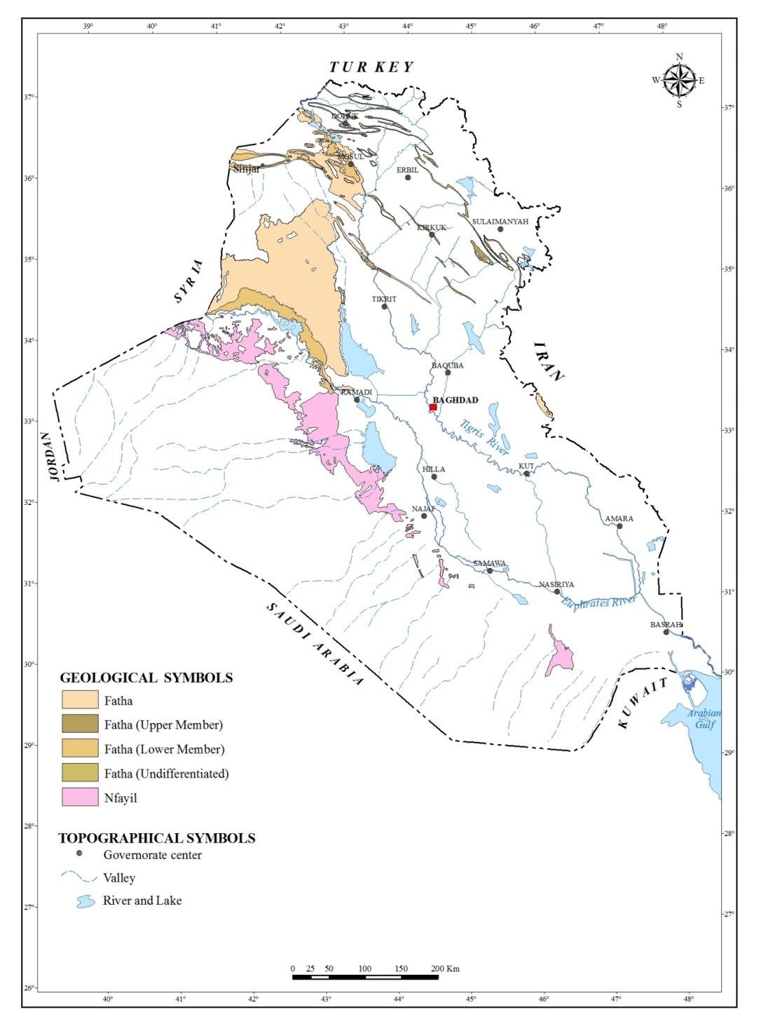
Figure 1: Location map of the exposure areas of the Fatha Formation; divided into four tentative lithological zones (A, B, C and D)
2 The Fatha Formation
The Fatha Formation was formerly known as the Lower Fars Formation, it was defined by Busk and Mayo in 1918, without mentioning the type locality. However, Ion et al. 1918 in Bellen et al. [12] described the formation from Agha Jari oil field of southwest Iran. It is worth mentioning that the Lower Fars Formation is abandoned in Iran and is renamed as Gachsaran Formation. Jassim et al. [14] introduced the name of Fatha Formation; however, Al-Rawi et al. [15] announced, officially the name of the Fatha Formation.
The Fatha Formation in the type section consists of "Cyclic sediments, each ideal cycle consists of green marl, limestone and gypsum, however, in the upper half part of the formation, reddish brown claystone is present over the green marl, moreover, in the uppermost parts; reddish brown clastics are developed within the cycles too. The cycles, however may be incomplete in many areas, then one of the main constituents might be absent. The three main constituents show large variations in their characteristics and thicknesses, manifesting the basin configuration, in certain areas [16 and 17].
Many authors have introduced different subdivisions for the rocks of the Fatha Formation, however, the most used and applicable one is that introduced by Al-Mubarak and Youkhanna [2] in Fatha – Mosul vicinity; latter on it was used almost in different parts of Iraq, although some modifications were introduced in many localities. The details of the subdivision are mentioned hereinafter briefly:
Unit A: This unit is characterized by the dominance of thick gypsum beds, usually (2 – 3) cycles are developed. Occasionally, the gypsum is replaced by limestone or bitumen and sulphur.
Unit B: This unit is characterized by very thick gypsum beds (usually more than 10 m) alternated with very thin (20 – 25 cm) limestone beds.
Unit C: This unit is characterized by its mono-lithology; being consists of limestone beds only. This unit is used as a marker for dividing the Fatha Formation into two members; its upper contact represents the lower contact of the Upper Member.
Unit D: This unit is characterized by cyclic nature (about 8 – 12 cycles were recorded in different localities), each cycle consists of gypsum, green marl, reddish brown claystone and limestone, moreover, it is a gypsum dominant unit, where the gypsum beds are very thick; up to 40 m in Pulkhana anticline [18].
Unit E: This unit is characterized by thick claystone (6 – 8 m) and gypsum (5 – 8 m) beds and thin limestone (0.1 – 0.7 m) beds, usually (2 – 3) cycles are developed. The reddish brown claystone beds changes upwards to green marl, in the uppermost parts; sandstone lenses and/ or horizons (0.5 – 1 m thick) may occur.
Unit F: This unit is characterized by thick gypsum beds that range between (8 – 20) m and its cyclic nature, usually (3 – 6) cycles are developed, each cycle consists of relatively thin (2 – 5 m) reddish brown claystone and green marl, limestone (0.2 – 0.4 m thick). In the uppermost parts, the claystone beds contain lenses and/ or thin horizons (0.15 – 2 m) of reddish brown or greenish grey siltstone and sandstone, which very rarely include thin beds (0.5 – 1 m) of white gypsum.
From reviewing the lithological details of the Fatha Formation it is clear that it is gypsum dominated stratigraphic unit with increasing of the claystone beds in the Upper Member. The presence of such thick gypsum beds is one of the main reasons for intense karstification in different parts of the exposure areas in Iraq. The formation is also well known karstified formation in Iran [7] and Turkey [6] too.
3 Karstification
The karstification of a landscape may result in a variety of large- or small-scale features both on the surface and beneath. Within the exposed areas of the Fatha Formation, different types and sizes of karst forms are developed, on the exposed surfaces; small features may include flutes, runnels, clints and grikes, collectively called karren or lapiez. Medium-sized surface features may include sinkholes or cenotes (closed basins), vertical shafts, foibe (inverted funnel shaped sinkholes), disappearing streams, and reappearing springs.
Sinkholes are either active or inactive. Those, which are still active have one or more outlet in their floors, which extend into shallow funnel shaped caves [19] this means that the active sinkholes have the ability to drain the infilling water to deeper horizons, or ground water runs through them. These types of sinkholes are certainly more problematic.
One of the main reasons of the karstification is dissolving of the limestone by carbonic acid, which is formed by reaction of the water with carbon dioxide. However, gypsum is dissolved by sulfuric acid, which is formed by reaction of the oxygen with H2S. As oxygen (O2)-rich surface waters seep into deep anoxic karst systems, it brings oxygen which reacts with sulfide present in the system (H2S) to form sulfuric acid (H2SO4). Sulfuric acid then reacts with calcium carbonate causing increased erosion within the limestone formation. This chain of reactions is:
H₂S + 2 O₂ → H2SO4 (sulfide oxidation)
H₂SO₄ + 2 H₂O → SO₄^{2–} + 2 H₃O+ (sulfuric acid dissociation)
CaCO₃ + 2 H₃O+ → Ca²+ + H₂CO₃ + 2 H₂O (calcium carbonate dissolution)
CaCO₃ + H₂SO₄ → CaSO4 + H₂CO₃ (global reaction leading to calcium sulfate)
CaSO₄ + 2 H₂O → CaSO₄ · 2 H₂O (hydration and gypsum formation)

It is worth mentioning that the Fatha Formation is an excellent source for H2S, which is emitted due to the presence of native sulfur; almost everywhere in the formation.
The main karst feature in the Fatha Formation is the sinkholes, which are developed in limestones and gypsum beds. Those developed in the limestone beds are mainly of collapse type and have regular forms, either with circular or elliptical apertures, bowl or cylindrical shape, the diameter ranges from (< 1 – 20) m, and the depth rages from (< 1 – 15) m. Whereas, those developed in gypsum beds are mainly of solution type and have irregular apertures with clear dissolving indications, the diameter ranges from (< 1 – 3) m, whereas the depth rages from (< 1 – 8) m [9].

4 Factors Controlling the Karstification in the Fatha Formation

The Fatha Formation is well known to include karstified rocks; such as gypsum and limestone [3, 4 and 9]. However, not all outcrops of the Fatha Formation exhibit karstification although include very thick gypsum beds, about 40 m [18]. This is attributed to the absence of the factors that induce karstification, among them are:

4.1 Lithological Factor
As it is aforementioned, gypsum and limestone the main constituents of the Fatha Formation. However, in the Upper Member of the Formation thick reddish brown claystone beds are developed in each cycle, beside the green marl. It is noticed in the field that no karst forma exist in those areas where reddish brown claystone beds occur in the cycles (Upper Member).

4.2 Structural and Tectonic Factor
In all areas where the Fatha Formation is not folded, like the Jazira area (Fig.1), karst forms are developed even in the Upper Member, which includes reddish brown claystone in the cycles. However, in folded areas, it was noticed that as the dip amount increases, as the karst forms decreases. This fact was noticed by Jassim et al. [3] too in west of Mosul area.

4.3 Other Factors
Other factors that contribute in development of karst forms, such as humidity, surface and ground water, presence of superficial cover and factors that increase water circulation are beyond the scope of this study. This is attributed to the fact that almost all the exposure areas of the Fatha Formation are under the same mentioned factors; therefore, they are not considered as particular or significant controlling factors.

5 Discussions
The factors that control the karstification process in the Fatha Formation in different parts of Iraq are discussed in details; hereinafter.

5.1 Lithological Factor
As aforementioned, the rocks of the Lower Member of the Fatha Formation are karstified only, whereas those of the Upper Member are not. This is attributed to the fact that the constituents of the cycles of the Lower Member are gypsum dominated, especially Units A and B [2]. Beside the gypsum, limestone is the second dominant rock in the cycles of the Lower Member. Moreover, green marl is present in some of the cycles, but with low thicknesses that did not exceed (1 – 3) m [1,2, 9 16, 17 and 18].
In the Upper Member, the reddish brown claystone are also dominated in the cycles beside the gypsum, especially in the uppermost part of the formation, Unit E and F [1,2, 9 16, 17 and 18] (Fig.2).
The presence of thick gypsum beds with thin beds of limestone and green marl, in the Lower Member has accelerated the circulation of the surface and ground water, since the thin beds of the marl cannot form barriers as they are not totally impervious; therefore, water can circulate and consequently will dissolve the gypsum and limestone beds, consequently karstification is developed (Fig. 3, in Zone A; Fig.1)). In contrary, the reddish brown claystone beds (3 – 12 m thick) in the cycles of the Upper Member [1,2, 9 16, 17 and 18] (Fig. 2) can perform as barriers for the circulation of both surface and groundwater, since the claystone is almost totally impervious; consequently, preventing the dissolution of the gypsum, beds and partly those of limestone, consequently no karstification is developed (Figs. 4, and 1, Zone B).
The effect of the lithology as a controlling factor of karstification is observed mainly west of the Tigris River and partly near east of the river (Fig.1, Zone A). However, in Al-Jazira area (Fig.1; Zone C), where the beds are unfolded; the Upper Member of the Fatha Formation shows intense karst forms (Fig. 5), although the reddish brown claystone beds exist in the cycles. This is attributed to the fact that since the beds are horizontal; and when the exposed bed on the surface is the thick gypsum; therefore, the surface water can dissolve the gypsum; consequently, small irregular solution forms; not more than (1 – 3) m are formed, with clear indication of solution forms around the holes [4 and 9]. Such small and irregular solution forms are very rarely developed in other parts of the exposure areas of the Fatha Formation; confirming the attributed reason for karstification.
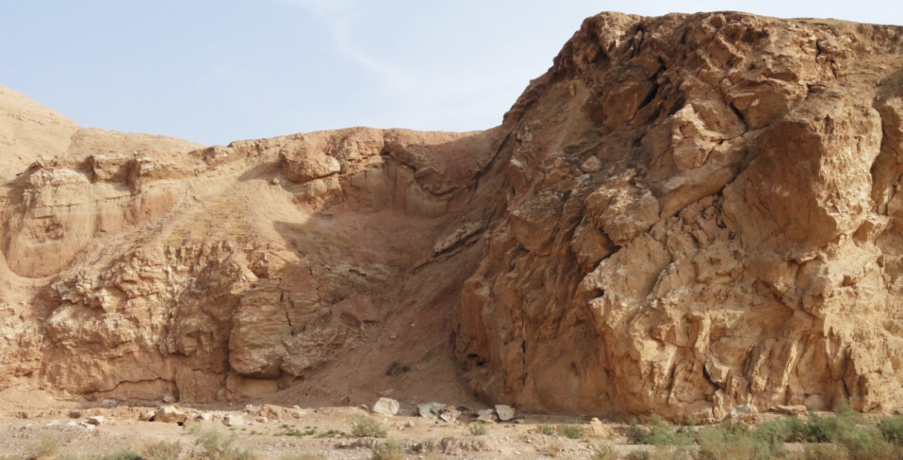

Fig.2: Thick claystone interbedded with thick gypsum along Tuz Chai stream

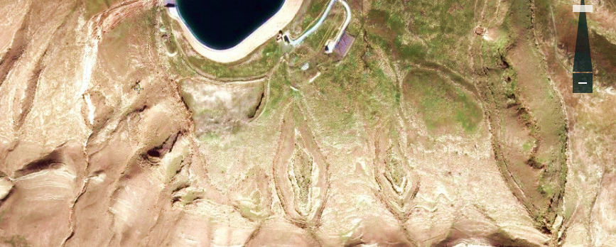

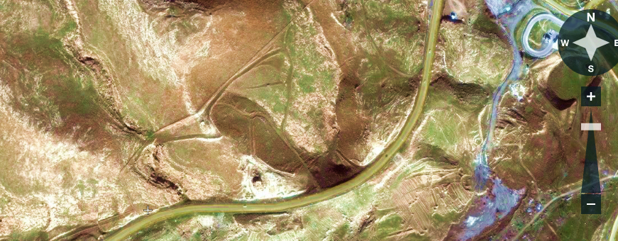

Figure 3: Flash Earth image west of Mosul Dam (Up and Down), note the developed sinkholes in the Lower Member of the Fatha Formation (encircled by red colour)

Figure 4: Falsh Earth images facing south, west of Kifri town. Note the absence of karstification in the Upper Member of the Fatha Formation; due to the presence of thick reddish brown claystone beds interbedded with very thick gypsum beds.
Also note the high dip amount in the cenral part of the right image.

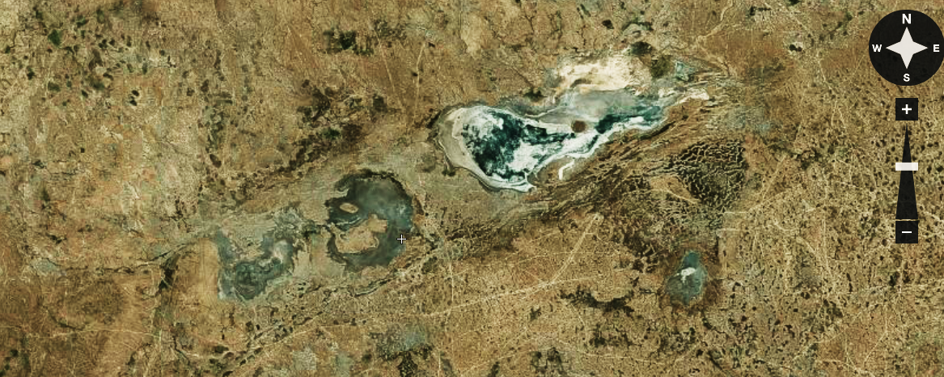
A D

Figure 5: Flash Earth image of Al-Jazira area. Note intense karstification in the Upper Member of the Fatha Formation, and note the structurally controlled
extremely large karst phenomenon of Ashqar Depression (AD)

The Fatha Formation in the northern parts of Iraq (Fig.1, Zone D) has special lithological development; since gypsum beds are very rare and disappear farther northwards (Fig.6); the formation changes to clastic facies consists mainly of reddish brown claystone and sandstone [20]. Therefore, no karstification is developed there.

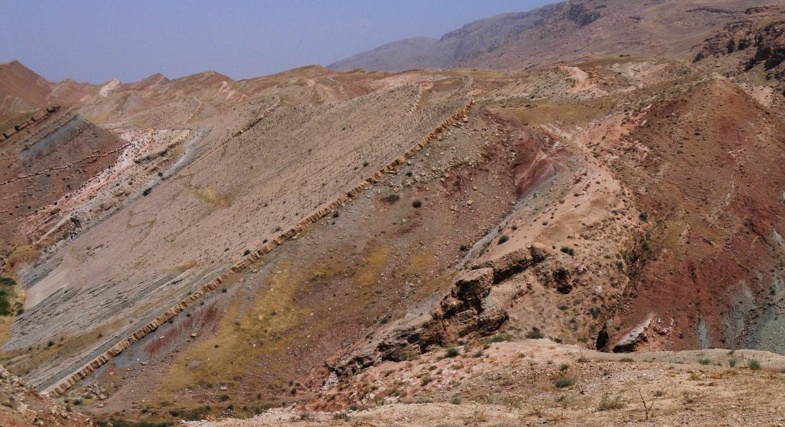

Fig.6: The Fatha Formation south of Sulaiamainyah (Zone D), note there is no gypsum

5.2 Structural and Tectonic Factor
This is the second significant factor that controls the karstification process in the Fatha Formation. In order to be in coincidence with this factor as dealt with in different countries; many published articles were reviewed, among them are Bosák [21], Ekmeci [22], Rodet et al. [23] and Dubios et al. [11]. The most relevant is the study of Ekmeci [22] in which he revealed the karstification of Turkey that has close relation with the current study. He considered the neotectonic activity and paleogeography as main factors controlling the karstification process in Turkey. The authors are in accordance with the furnished results of Ekmeci [22].
According to Dubios et al. [11] the effect of the tectonics on the karstification process is expressed as “The process integrates chemical weathering and mechanical erosion and extends a number of existing theories pertaining to continental landscape development. It is a two stage process that differs in many respects from the traditional single-stage process of karstification by total removal. The first stage is characterised by chemical dissolution and removal of the soluble species. It requires low hydrodynamic energy and creates a ghost-rock feature filled with residual laterite. The second stage is characterised by mechanical erosion of the un-dissolved particles. It requires high hydrodynamic energy and it is only then that open galleries are created. The transition from the first stage to the second is driven by the amount of energy within the thermodynamic system. The authors are in accordance with the thermodynamic system that was existing during karstification process that was started since Early Pleistocene and possibly Pliocene and continued until now. Because the Zone A has suffered more energy as compared to the Zone B due to higher uplift rate during starting of the Neotectonic phase; therefore, the former suffers more karstification than the latter.
It was noticed during the field observations in different parts of the exposure areas of the Fatha Formation that the karstification intensity decreases with increase of the dip amount; except in Al-Jazira area (Zone D). This assumption is valid in all other areas (Zones A and B) where the gypsum is the main constituent of the Fatha Formation.
In Zone C; western and north central parts of Iraq (Fig.1), in all existing anticlines, the northeastern limb is thrusted over the southwestern limbs [24 and 25] causing the disappearance of the latter limb; moreover, disappearance of the Lower Member of the Fatha Formation. This is attributed to the presence of thick salt layers in the Lower Member of the Fatha Formation within Kirkuk Embayment [25], which have played the role of detachment. In those particular areas, no karstification is developed; this is attributed to the high dip angles (caused by thrusting of the beds near the thrust plane, Fig. 2) that reach up to 45° (Fig.4) and occasionally more. The high dip amount accelerates the flowing of the surface and ground water, especially along the bedding planes; therefore, the water cannot cover for long periods the gypsum and/ or limestone beds to dissolve them, consequently no karstification is developed (Figs. 2 and 4). This phenomenon was observed by Jassim et al. [3] west of Mosul; too.

In Zone D (Fig.1), the role of the structure and tectonics in the karstification process differs from that in Zones A and B (Fig.1). In this area, the beds are almost horizontal; since the area belongs tectonically to the Inner Platform (Stable Shelf) [25]; therefore, the role of the structure and tectonic is not the amount of dipping of the beds. In this area, extremely large karst forms are developed, a good example is Ashqar Depression (Salt marsh). Those karst forms are developed due to tectonic subsidence in form of large grabens (Fig. 5) [4]. According to Fouad [26], the area is characterized by subsurface grabens, which were inverted to anticlines during the Late Cretaceous – Early Paleocene. The limits of the subsurface graben can be seen clearly on the surface as indicated by two lineaments (Fig.5), which extend for about 65 Km. Ashqar Depression and many other such big depressions (salt marshes) are proved to be originated due to the effect of tectonics and karstification [4].
Another example for role of the tectonics and karstification in Zone D (Fig.1) is the Tharthar Depression. Sissakian [27] proved that the Tharthar Depression is formed by karstification controlled by tectonic features; subsurface graben that was inverted to anticline during Late Cretaceous – Early Paleocene.
The effect of Neotectonic in karstification is also discussed in Turkey [22]. Those areas which have received more uplift suffer more intense karstification [22]. When reviewing the Neotectonic Map of Iraq (Fig.7) it is clear that the Middle Miocene – Late Miocene boundary that represents the beginning of Neotectonics in Iraq [28] in Zones A and D are more uplifted than the Zone B. Therefore, both zones have subjected to more forces as compared to Zone D; consequently, more fractured and jointed, hence more karstified.

6 Conclusions
From the current study the following can be concluded:
- The Fatha Formation exhibit different karst phenomena in different parts of its exposure areas in Iraq.
- The main karst forms in the Fatha Formation are the sinkholes, either solution or collapse types.
- Two main factors control the karstification process in the Fatha Formation, the lithological and tectonic factors.
- In those areas within the exposure areas of the Fatha Formation, which have suffered from more Neotectonic uplifts; exhibit more intense karstification.
- In those areas where only the Upper Member of the Fatha Formation is exposed, no karstification is developed, except in the Jazira area. This is attributed to the tectonic factor.
- The intensity of the karstification decreases in the Fatha Formation with increasing the dip amount of the beds.

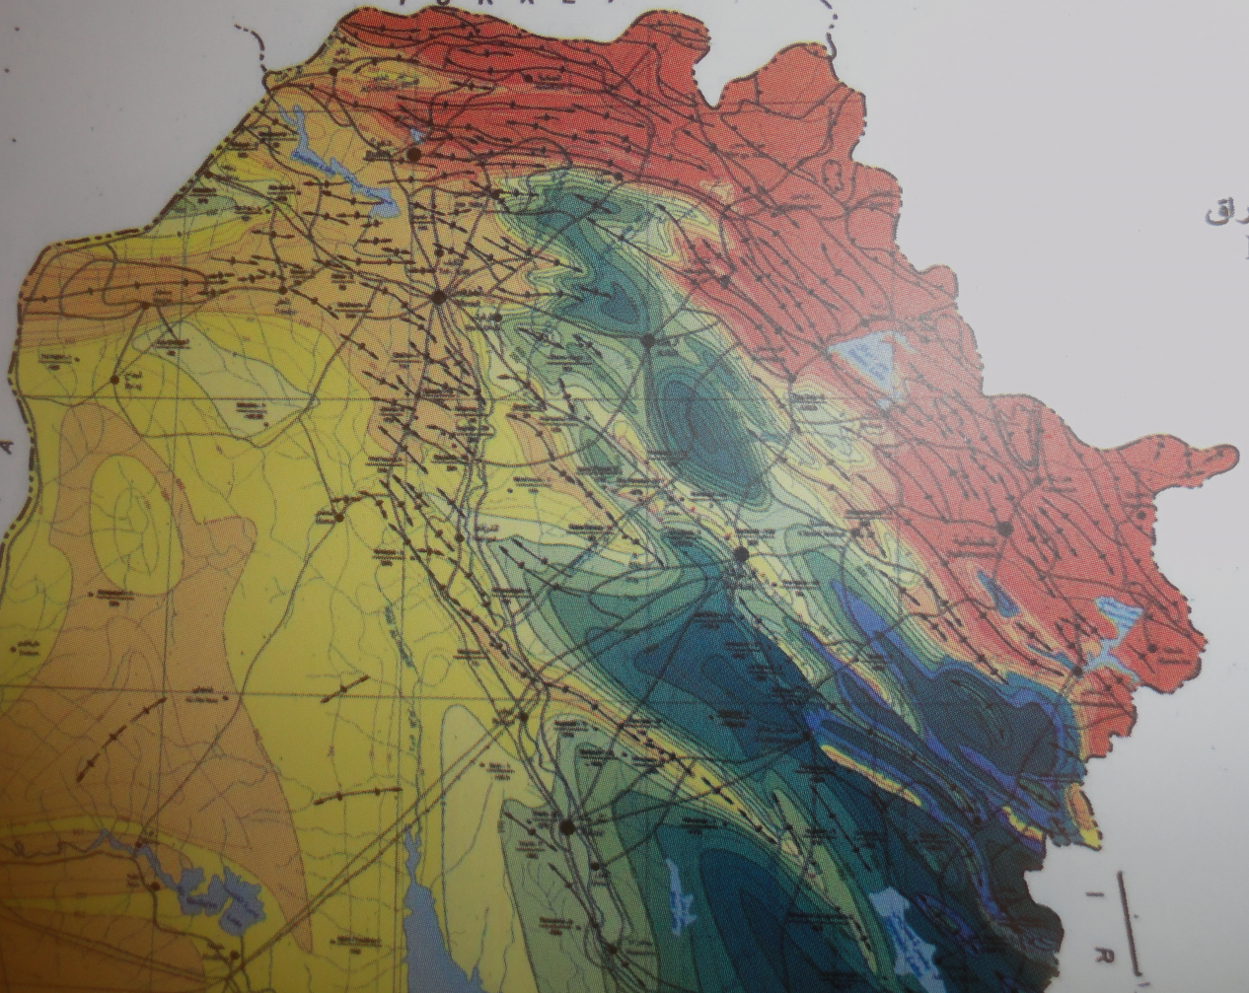
Z o n e D
Z o n e C
Z o n e B
Z o n e A

Figure 7: Part of the Neotectonic Map of Iraq (After [27])
Yellow, orange and reddish brown colours indicate uplifted areas.
Green and blue colours indicate the down warp areas
in Neotectonic consideration

References
[1] Al-Ansari, N.A., 1972, Geology of the southern part of Jabal Makhul, M.Sc. Thesis, Baghdad University.
[2] Al-Mubarak, M.A. and Youkhanna, R.Y., 1976. Report on the regional geological mapping of Al-Fatha – Mosul Area. Iraq Geological Survey (GEOSURV) Library report no. 753.
[3] Jassim, S.Z., Jibril, A.S. and Numan, N.M.S., 1997. Gypsum Karstification in the Middle Miocene Fatha Formation, Mosul area, northern Iraq. Geomorphology, Vol. 18, No.2, p. 137 – 149.
[4] Sissakian, V.K. and Abdul-Jabbar, M.F., 2009. Remote sensing techniques and GIS applications in detecting Geohazards in the Jazira Area, West Iraq. Iraqi Bulletin of Geology and Mining, Vol.5, No.1, p.47 – 62.
[5] Sissakian, V.K., 2011. Origin of the Tharthar Depression, Central part of Iraq. Iraqi
[6] Atalya, I., 2003. Effects of the Tectonic Movements in the Karstification in Anatolia, Turkey. Acta Carsologica, Vol. 32, No.2, p. 196 – 203.
[7] Shafiei Motlaq, Kh. and Lashkaripour, G.R., 2010. Tectonic Control on the appearance of Karst springs in Kooh-e- Siah (Dehdasht, southwest Iran). The 1st International Applied Geological Congress, Department of Geology, Islamic Azad University - Mashad Branch, Iran, 26 – 28 April, 2010.
[8] Sissakian, V.K. and Abdul-Jabbar, M.F., 2005. Site selection problems in gypsum-bearing formations. A case study from north of Iraq. Iraqi Bull. Geol. Min., Vol.1, No.2, p. 45 – 52.
[9] Sissakian, V.K. and Al-Musawi, H.A., 2007. Karstification and related problems, examples from Iraq. Iraqi Bull. Geol. Min., Vol.3, No.2, p.1 – 12.
[10] Rodet, J., Kun Ma, K. and Viard, J.P., 2013. Incidence of the tectonics in the karstification of chalk limestones in the western Paris Basin: Example from the Petites Dales Cave (Saint Martin Aux Buneaux, France). Karst and Caves in Carbonate Rocks, Salt and Gypsum – oral, 2013 ICS Proceedings.
[11] Dubois, C., Quinif, C., Baele, J.M., Barriquand, L., Bini, A., Bruxelles, L., Dandurand, G., Havron, C., Kaufmann, O., Lans, B., Maire, R., Martin, J., Rodet, J., , M.D., Tognini, P. and Vergari, V., 2014. The process of ghost-rock karstification and its role in the formation of cave systems. Earth Science Review, Vol. 131, p. 116 – 148.
[12] Gutiérrez, F., Fabregat, I., Roqué, C., Carbonel, D., Guerrero, J., García-Hermoso, F., Mario Zarroca and Linares, R., 2016. Sinkholes and caves related to evaporite dissolution in a stratigraphically and structurally complex setting, Fluvia Valley, eastern Spanish Pyrenees. Geological, geomorphological and environmental implications. Geomorphology, 267, p. 76 – 97.
[13] Bellen, R.C. van, Dunnington, H.V., Wetzel, R., and Morton, D., 1959. Lexique Stratigraphic International. Asie, Fasc. 10a, Iraq, Paris.
[14] Jassim, S.Z., Karim, S.A., Basi, M.A., Al-Mubarak, M. and Munir, J., 1984. Final report on the regional geological survey of Iraq, Vol. 3, Stratigraphy. Iraq Geological Survey Library report no. 1447.
[15] Al-Rawi, Y.T., Sayyab, A.S., Al-Jassim, J.A., Tamar-Agha M., Al-Sammarai, A.H.I., Karim, S.A., Basi, M.A., Hagopian, D., Hassan, K.M., Al-Mubarak, M., Al-Badri, A., Dhiab, S.H., Faris, F.M. and Anwar, F., 1992. New names for some of the Middle Miocene – Pliocene formations of Iraq. (Fatha, Injana, Mukdadiya and Bai Hassan formations). Iraqi Geological Journal, Vol.25, No.1, (issued 1993), p. 1 – 17.
[16] Sissakian, V.K. and Al-Jiburi, B.S.M., 2014. The Geology of Iraq, Stratigraphy. In: Stratigraphy of the Low Folded Zone. Iraqi Bulletin of Geology and Mining, Special Issue No.5, p. 63 – 132.
[17] Sissakian, V.K. and Al-Jiburi, B.S.M., 2014. The Geology of Iraq, Stratigraphy. In: Stratigraphy of the High Folded Zone. Iraqi Bulletin of Geology and Mining, Special Issue No.6, p. 73 – 161.
[18] Sissakian, V.K., 1978. Report on the regional geological mapping of Tuz Khurmatu – Kifri and Kalar Area. Iraq Geological Survey Library report no. 902.
[19] Sissakian, V.K., Ibrahim, A.M and Amin, R.M., 1986. Sinkholes of Haditha area. Journal of Water Resources, Vo. 5, No. 1, p. 707 – 714.
[20] Sissakian, V.K. and Saeed, Z.B., 2012. Lithological Map of Iraq, Compiled using GIS Techniques. Iraqi Bulletin of Geology and Mining, Vol. 8, No.3, p. 1 – 13.
[21] Bosák, P., 2002. Karst processes from the beginning to the end: How can they be dated?. Speleogenesis and Evolution of Karst Aquifers. The Virtual Scientific Journal. Postojna-Ljubljana, Zalozba ZRC, p. 155-190.
[22] Ekmekci, M., 2003. Review of Turkish Karst with emphasis on tectonic and paelogeographic controls. Acta Carsologica, 32/2, 17, p. 205- 218. Ljubljama.
[23] Rodet, J., Kun Ma, K. and Viard, J.P., 2013. Incidences of the tectonics in the karstification of chalk limestone in the western Paris Basin: Example from the Petities Dales Cave )Saint Martin Aux Buneaux, France. Karst and Caves in Carbonate Rocks, Salt and Gypsum – oral, ICS Proceedings.
[24] Sissakian, V.K. and Fouad, S.F., 2012. Geological Map of Iraq, scale 1:1000000, 4th edition. Iraq Geological Survey Publications, Baghdad, Iraq.
[25] Fouad, S.F., 2012. Tectonic Map of Iraq, scale 1:1000000, 3rd edition. Iraq Geological Survey Publications, Baghdad, Iraq.
[26] Fouad, S.F. and Nasir, W.A.A., 2009. The Geology of Iraq, Tectonic and Structural Evolution of Al-Jazira Area. Iraqi Bulletin of Geology and Mining, Special Issue No.3, p. 33 – 48.
[27] Sissakian, V.K., 2011. Origin of the Tharthar Depression, Central part of Iraq. Iraqi Bulletin of Geology and Mining, Vol. 7, No.3, p. 47 – 62.
[28] Sissakian, V.K. and Deikran, D.B., 1998. Neotectonic Map of Iraq, scale 1:1000000. Iraq Geological Survey Publications, Baghdad, Iraq.

Private Consultant, Erbil, Iraq. e-mail: varoujan49@yahoo.com
Iraq Geological Survey; Baghdad.
Lulea University of Technology, Lulea, Sweden. e-mail: nadhir.alansari@ltu.se, Sven.Knutsson@ltu.se Article Info: Received : January 10, 2011. Published online : July 17, 2012

