Explaining Stock Returns in Nepal: Application of single and multi-factor models
Dipesh Karki and Dr. Binam Ghimire

ABSTRACT
This paper investigates the relevance of CAPM single factor and Fama-French three factor (Fama-French) models to explain the return for cross sectional portfolios in the context of Nepalese stock market. We use stock market data and treasury bill rate over the period of August 2007 to July 2013 and estimate the factor models after correcting for the violation of classical linear regression assumptions. Our results show that in all five portfolios (B/L, B/M, B/H, S/M, S/H), three factor model has better explanatory power over CAPM. The estimations of Fame-French showed that Excess market return (ER) and Value factor are more significant than Size factor in model fitting. Finally, the study tested for the seasonality in Nepalese stock return using the dummy variable. The results showed significant seasonality effect for fiscal year end thus indicating possibility of tax loss effect in Nepalese stock market but unlike in previous studies, seasonality effect on account of festival period is insignificant.
Key words: Stock market returns Nepal, NEPSE, Fama and French, CAPM

INTRODUCTION
Stock market is not very new in Nepal. Established in 1976, Nepal Stock Exchange is the second oldest stock market among the exchanges of 49 least developed countries [1]. The history of exchange market in Nepal goes further back to 1936 when the shares of Biratnagar Jute Mills Ltd was floated to raise capital. The Security Exchange Centre was later established which operated under the Security Exchange Act that was enforced in 1984.However, growth in capital market activities and listing of companies only took place after the adoption of economic liberalization in the early 90s. In 1993 after the establishment of multi-party democratic system the SEC was restructured and policy level was divided into two distinct entities Security Board Of Nepal (SEBON) and Nepal Stock Exchange (NEPSE). Since January 13, 1994 NEPSE began its trading floor using "open out-cry" system for transactions. Further, rise of Initial Public Offering and simultaneous increase in trading in both volume and transaction at secondary market, has substantially expanded the capital market with current total market capitalization worth approximately Rs. 503,500 million. Today there are in total 228 companies listed in Nepal Stock Exchange that encompasses several industries viz- Commercial Banks, Finance Companies, Development Bank, Hotels, Hydropower and Manufacturing Sector. Further 50 different brokers are involved in day to day trading in stock exchange. As a result Nepal Stock Exchange now has sizable data that can be test bed for analyzing and verifying several established Portfolio Theories used in Fundamental Analysis of Capital Market. Besides the Nepalese stock market being characterized by mostly naïve investors, lack of information and market inefficiency provide unique perspective for testing different financial models which hitherto has been performed only in developed market scenario. Further , NEPSE being an emerging market having existed for only over one and half decade, there hasn't been much study regarding the risk return relationship among its trade, especially in context of size and value proxy, thus affirming the relevancy of three factor model in Nepalese context. On this regard this study is an attempt to test and analyze Nepalese Stock Market using both single factor CAPM model and multi-factor Fama-French Three Factor Model, developed by Fama and French [1], and to determine its efficacy and relevancy in Nepalese context.

Capital Asset Pricing Model by Sharpe [2], Lintner [3], Mossin [4] provides a simple yet powerful framework to explain the relationship between expected return on an asset and various components of risk associated with it. The theory builds upon mean variance optimization of portfolio first suggested by Markowitz [5] and explains that return premium of any financial asset over risk free return is directly proportional to the systematic or non-diversifiable risk of given asset. The quantum of which is measured by evaluating covariance of asset return with overall market portfolio. But despite its popularity its empirical validity was questioned since early stages. For instance Miller and Scholes [6] highlighted the statistical errors associated in using individual securities for testing CAPM. Later the problem was overcome in study by Black, Jensen and Scholes [7] by constructing portfolio of all the securities listed in Newyork stock exchange. Thus using portfolios rather than individual securities greatly increased the precision of beta. However the CAPM model relied too much in unrealistic assumption thus Roll [8] claimed that CAPM cannot be validly tested unless true market portfolio is known.

Later on Fama and French [1] showed that CAPM failed to explain the cross section of average return in US stock from 1962- 1990. According to them the risk premium of security is influenced by multifactor instead of single market factor as proposed by CAPM. These factors include size, value of the firm and market risk. Thus exposure to market, size and value acts as proxy for sensitivity to risk factors in the return. This assertion corroborated with Banz [9] which had indicated that size effect of stock as statistically significant in explaining return alongside its betas. The study had shown that over period of 1936-1977 on an average return from holding small stocks was large. Similarly Rosenberg, Reid and Lanstein [10] had shown that firms with high ratios of book value to the market value of common equity have higher returns than those with low book to market ratios. This was supported by Davis [11] that found the relationship between average return and BE/ME in US stocks extends back till 1941. Fama and French [12] provided an economic foundation for the empirical relationship between average stock return and size, and average stock return and book-to-market equity. The study explained that the size and BE/ME proxy are directly correlated to profitability and hence were able to better explain cross-section of average return as described in Fama and French[13].
Several studies across various international market has since been carried out that have either supported or contradicted the three factor model. For instance Aksu and Onder [14] showed that size and value effect were proxy for firm specific risk in Istanbul Stock Exchange. [15] Gaunt(2004) while studying the application of three factor model in Australian market found beta to be less than one and HML factor playing significant role in asset pricing. Also [16] Ajili suggests three factor model being superior to CAPM in modeling stock returns in French market. Similarly Connor and Sehgal [17] found that all three Fama-French factors, market, size and value have pervasive returns in Indian Stock market. Bahl [18] on the basis of adjusted coefficient of determination ($R^{2}$) confirmed the efficacy of three factor model over CAPM in explaining common variation in stock returns in Indian Stock Exchange. The study showed that the adjusted $R^{2}$ for three factor model being 87% meanwhile CAPM being just 76%. Taneja [19] indicated that though the efficiency of three factor model as being good predictor cannot be ruled out in Indian context , there appears high degree of correlation between the size and value factor returns.
Besides these studies on three factor models, literature expostulate several other studies that details various specific parameters that strengthens multifactor model especially in emerging markets. For instance Allen et al. [20] showed that stocks with low beta yield better premium in Malaysian Market. Meanwhile there study confirms that both Size and value factors were significant. Similarly, using the methodology suggested by Pettengil [21]. Daniel et al. [22] showed significant beta exposed to size and value factor together with co-moment.Meanwhile study by Lam et al. [23] in Hong Kong stock over the period from July 1981 to June 2001 showed that Augmented F&F model that considers fourth factor of momentum as an explanatory variable in addition to size and value provides high adjusted coefficient of determination of around 44 to 88 %.

DATA AND ESTIMATIONS

Data
Unlike in most exchanges around the world where trading is fully electronic and high speed where automated buy and sell order can be placed, Nepalese Stock Exchange is still use screen-based trading that spans wide area network where brokers are connected. Besides before August 2007 it employed open-out cry system. Therefore there is no centrally available database for accessing the stock prices of given trading day. Hence in order to collect the data we manually pick the data hence employing documentary method of data collection. All the documents containing the data pertaining to Nepalese Stock market from 2002 to 2013 , available in the official website of Nepalese Stock Exchange were collected. Meanwhile the risk free rate of return of the prevailing government treasury bill for the period of 2007 Aug to 2013 Jul is available in the official website of central bank of Nepal (www.nrb.org.np) were also collected in excel sheet.
Since the study requires both the stock returns and the risk free rate the study period was thus selected from August 2007 to Jul 2013. The list of enlisted companies in NEPSE for the study period were first enumerated from the website in an excel sheet. From among them A listed companies with their financial information regarding book value at the end of year were selected for the study. Table 1 shows the number of company that were listed and number of company with available book value during each fiscal year for which study was carried out.

<<Table1: Listed Companies>>
The data included were monthly stock returns of the company, yearly market capitalization, yearend book value of A listed companies and the risk free rate of return for the period of 72 months.

Data Validation
For the purpose of data validation financial data such as book value was cross check against the annual reports of the five random companies viz- Nabil Bank Ltd, Nepal telecom, Laxmi Bank, Siddhartha Insurance and KIST bank. All the figures in annual report were matched with the data recorded from Nepal Stock Exchange. The validation showed consistent observation thus justifying the validity of data.

Construction of size and value portfolio:
As required by the Fama -French Model the Factor portfolios based on Size and Value was constructed using following steps Bahl [18]:
Step1: For each financial year ( July of year 't' to June of year 't+1' ) of given sample period the stocks was split into two group on the basis of size. - Small (S) and Big(B) . Where the small stocks comprises of those whose market capitalization lie below the median value of included stock and Big comprise those which are above the median.
Step2: For each financial year ( July of year 't' to June of year 't+1' ) of given sample period the stocks on the basis of value will be split into three BE/ME groups- Low(L), Medium (M), High (H) ; where L represents lower 30%, M represents middle 40% and H represents upper 30% of the value of BE/ME for the stocks of sample.

Step3: The six different portfolios- S/L, S/M, S/H, B/L, B/M, B/H was constructed by intersecting the stocks in two size and three value groups as computed from Step1 and Step3. From among them three companies were randomly selected from each intersection set to construct sample portfolio of all six types.
Step4: Small Minus Big (SMB) factor which is meant to mimic the risk associated with the size was obtained by subtracting the average monthly return of three Big portfolios by average return of three small portfolios as given by following relation:
SMB = (S/L +S/M +S/H)/3 - (B/L+B/M+B/H)/3 ................i)

Step 5: High Minus Low (HML) factor which is meant to mimic the risk associated with the value was be obtained by subtracting the average monthly return of two Low Portfolio from average return of two High portfolio as given by following relation:
HML = (S/H + B/H) /2 - (S/L+B/L)/2 .......................ii)

Seasonality Check
Technical analysis of US stocks especially shows the so called January effect where the small stocks outperform broader market as indicated by tax-loss selling hypothesis by Keim [24] (This implies a general practice by which investors sell stock at loss in order to offset gains from other profitable venture in order to decrease the income tax liability. Similarly Connor and Shegal [17] indicate Diwali effect that correlates to selling stock during festivities. In this context it was pertinent to perform seasonality check in context of Nepalese stock as well. Generally there is intuition that in month of October during time of national festival Dashain there may be seasonality.

Fitting Fama-French Model
The study tested Fama-French Model using the standard multivariate linear regression model as explained in Campbell, Lo and Mackinlay [25]. The linear regression model is given by following relation
$R_{jt}-R_{ft}=a_{j}+ m_{j}\left(R_{mt}-R_{ft}\right)+ s_{j}{SMB}_{t}+ h_{j}{HML}_{t}+ ∈_{t}$ ............... iii)
where $R_{jt}-R_{ft}$: excess return on jth portfolio on time 't'
$R_{mt}-R_{ft}$: excess market return on jth portfolio on time 't'
${SMB}_{t}$: return on size factor portfolio on time 't'
${HML}_{t}$: return on value factor portfolio
$m_{j},s_{j, }h_{j}$: market, size and value factor exposure
$a_{j}$: intercept that indicates abnormal return on portfolio
$∈_{t}$: mean zero asset specific return of portfolio 'j'
The hypothesized model thus illustrated above requires that $a_{j}$ term be zero and $∈_{t}$ be independently and identically distributed as a normal distribution with zero mean and constant variance. Therefore $∈_{t}$ is a purely random or white noise process , Gujrati [26]. Further by forcefully setting the factor exposure parameters to zero several different variant of Fama French model can be obtained.

Multicollinearity Check
Multicollinearity check before fitting data is essential as its presence will violate basic assumption of ordinary least square . Variance Inflating Factor (VIF) is the best tool for detecting its presence.

Heteroscedasticity Check
The ordinary least square assumes that the underlying data be homoscesdastic that is the variance of error term should be constant for all the observation. The absence of homoscesdastic condition will result in heteroscesdasticity which similar to multicollinearity and autocorrelation will cause the ordinary least square estimates unbiased and inefficient. The basic method for detecting heteroscesdasticty is the scatter plot between predicted value and the residuals. If pattern appears then it indicates presence of heteroscesdasticty. Further Breusch-pagan & Koenker test can be used to verify the existence of heteroscedasticity. If heteroscesdasticity were to exist then the heteroscesdasticity adjusted regression needs to be evaluated performed using the HC0, HC1, HC2, HC3 and HC4 method by Hayes and Cai [27]

Discussion
i. Descriptive Analysis
<<Table 2: Descriptive Analysis>>
Table 2 shows that the due to downward trend in share prices from 2007 onwards median market cap has been falling and similarly the book to market ratio has been rising thus indicating the undervalue of stocks in general. But in 2012-2013 the trend has appeared to reversed
<<Table 3: Average Monthly Return of various portfolio between August 2007 to July 2013>>

Table 3 shows that in the given period the average return of big portfolio is greater than that of small portfolio which is contrary to the Fama and French [1]. Meanwhile in context of value stocks in both big and small group it appears that the average return increases from the Low to Medium and then fall in case of High return. This observation is again in contrary to Fama and French [1] but is very much in line with Bahl [18] that reports similar phenomena in context of Indian stocks.
Table 3 also shows that the average excess market return (Rm-Rf) is negative but the portfolio B/M , S/L and S/M has shown positive gains which indicates that the market is not efficient.. Further the Kurtosis value is significantly greater than zero which indicates that the returns are not normally distributed.
Likewise the analysis of Pearson correlation as shown in Table 4 indicates significant negative correlation among Excess market return (Rm-Rf) and Size factor (SMB) meanwhile there is no correlation between HML with other two factors. This result is also very much similar to that of Bahl [18]. Further insignificant correlation between SMB and HML shows that the Size stocks are free of BE/ME effect and Value stock is immune from size. This finding is reflective of similar finding by Davis, Fama and French [28] (1999).
<< Table 4: Correlation Between Three Factors>>

ii. Seasonality Check
The table 5 shows the regression result of return in all the six portfolio and the three factor portfolio on dummy variable that is 1 in month off October and 0 in other month. Seasonality is indicated if the coefficient of b is significant. The result shows that none of the portfolio shows significant seasonality.
<< Table 5: Seasonality Check with Dashain Festival (Rt = a+b October(t)]>>

Similarly in Nepal the fiscal year ends in month of July when all tax filing needs to be done. Thus the seasonality check was done by regressing the returns of portfolio on dummy variable of July as 1. The result is tabulated in Table 6 which shows that the seasonality thus exist among Excess Market Return (Rm-Rf) , B/L portfolio. This indicates possible tax-loss hypothesis being applicable in Nepalese context as well.
<<Table 6: Seasonality Check with July [Rt =a +b July (t)]>>

iii. Checking Multicollinearity
<<Table 7: MultiCollinearity Test using Variance Inflating Factor>>

Since as table 7 indicates all the Variance Inflating Factor are below 5 it is safe to conclude that the data doesn't suffer from multicollinearity
iv. Test of Autocorrelation
Table 8 shows the test of Autocorrelation using Durbin-Watson statistics, Durbin and Watsom [29]. It shows that portfolios B/H, B/L and S/H has DW value between two critical values of 1.5 < d < 2.5 and therefore we can assume that there is no first order linear auto-correlation in the data. But the portfolio S/M with d= 1.002 and
portfolio B/M with d=1.15 indicates negative autocorrelation. This suggest possible misspecification of the model that can be due to omission of certain explanatory variable or
inappropriate mathematical model.
<<Table 8: Durbin Watson Test for Autocorrelation>>
v. Scatter Plot

<<Table 9: Scatter Plot>>
The five panels in table 9 illustrates the scatter plot between the predicted value and the residuals for all five portfolios. All the plots so some inherent pattern thus justifying need for testing the hetersoscesdasticity. Breusch-Pagan and Koenker test thus were employed with null hypothesis assumption of Homosecesdasticity gave following result depicted in table 10

<<Table 10: Breusch-Pagan and Koenker test>>

The result shows that except for S/M portfolio all other portfolio suffer from the significant heteroscesdasticity with p-value less than 0.05. Meanwhile since B/H data was available only for 60 months heteroscesdasticity test couldn't be performed. Hence heteroscesdasticity adjusted regression was performed using the methods HC0,HC1, HC2, HC3 and HC4 method by Hayes and Cai [27] whose results are shown in table 11.

v. Analysis of Significance of factor coefficient
The findings in table 11 show that different portfolios demonstrate varying degree of response according to factors. For instance the analysis shows that return on B/L portfolio variation can be best explained by market return and value factor. In the meantime the size factor has been relegated to insignificant. Likewise B/H factor also is influenced only by market return and value parameters. S/H can be best explained only by value factors. On the other hand B/M factor remained dependent on size while S/M portfolio was independent from all three factors. . On the other hand S/L data wasn't estimated as there wasn't enough data. Further in none of the portfolio the constant term is significant indicating that there is no abnormal profit in any portfolio.
<<Table 11: Heteroscedasticity Consistent regression of Excess Return Vs Market, Size and Value>>
ix. Analysis of Coefficient Of Determination
The analysis shows that depending on the portfolio the coefficient of determination varies considerably. From table 11 it is possible to discern that the B/H portfolio can be best explained by the three factor model as 88.79 % of its excess return variation can be explained by the model. Meanwhile only 35.49% of S/M portfolio can be explained by the Fama-French model. This variation in finding necessitates that all the cross section returns be regressed using single factor CAPM model as well as inclusion of other factors independently so as to identify which model best fits the stock returns.

x. CAPM analysis.
Regressing the excess return on portfolio against excess market return using the following relation
$R_{jt}-R_{ft}=a_{j}+ m_{j}\left(R_{mt}-R_{ft}\right)$ .......... viii)
we obtained following result as shown in table 12

<<Table 12: CAPM Analysis>>

The result tabulated in table 12 shows that all five portfolio (B/L, B/H, B/M), S/H and S/M) are consistent with CAPM model with significant market exposure. Comparing the result in table 12 with table 11 in terms of coefficient of determination it is apparent that the Fama-French model better explain the variation in portfolio returns than CAPM model in all five portfolios. For instance in B/H portfolio the R2 in three factor model is 88.47% % while that of CAPM model is simply 38.5%. So the result shows the superiority of Fama-French model over the conventional CAPM model in explaining cross-sectional market return.

CONCLUSION
The study has checked the relevance of Fama-French three factor model in context of Nepalese stock exchange. Further study also compared and contrasted three factor model and CAPM in their ability to explain the return of cross sectional portfolio as well as individual stock. It can be concluded from the results based on coefficient of determination as discussed in Result section shows the superiority of Fama French model over CAPM in explaining the variation in the return of portfolios. In all five portfolios (B/L, B/M, B/H, S/M, S/H) three factor model has better explanatory power. However the result also indicated that Excess market Return and Value factor are apparently more significant than Size factor in model fitting.
The analysis also showed that the intercept term in the model was insignificant in all portfolios. Hence it can be concluded that none of the portfolio yields abnormal excess return over the market.
Besides the study also checked for the Multicollinearity, Heteroscesdasticity and Autocorrelation for possible violation of ordinary least square assumption. The data showed significant heteroscesdasticity which was corrected to determine the three-factor model.
Also the study tested for the seasonality in Nepalese stock return using the dummy regression model. The result showed that there is significant seasonality in month of July thus indicating possibility of tax loss effect in Nepalese stock market. Study also showed that festive season of November there is no seasonality effect.
Further the study has thoroughly enumerated the steps required to carry out the research and thus provides the methodological guidelines for similar studies to be undertaken in future.

REFERENCES
[1] E. F. Fama and K. R. French., "The Cross Section of Expected Stock Returns", "The Journal of Finance", vol. 4, no. 2, June 1992, pp. 427-465.

[2] W. F. Sharpe. , " Capital Asset Prices: A theory of Market Equilibrium under Conditions of Risk" , "Journal of Finance", vol. 19, no. 3, September 1964, pp. 425-442.

[3] J. Lintner. , "The Valuation of Risk Assets and The Selection of Risky Investments in Stock Portfolios and Capital Budgets"," Review of Economics and Statistics", Vol. 47, No. 1, February 1965, pp. 13-37.

[4] J. Mossin. , "Optimal Multiperiod Portfolio Policies", "The Journal of Business", Vol. 41, No. 2, April 1968, pp. 215-229

[5] H. Markowitz. , "Portfolio Selection", "The Journal of Finance", vol. 7, no. 1., March 1952, pp. 77-91.

[6] M. Miller. and M. Scholes. , "Rates of return in relation to risk: A reexamination of some recent findings". "Studies in Theory of Capital Markets", 1972, pp. r47-78
[7] F. Black, M. C. Jensen, and M. Scholes. , "The Capital Asset Pricing Model: Some Empirical Tests." , "In Studies in the Theory of Capital Markets", 1972
[8] R. Roll, "A critique of the asset pricing theory's tests Part I: On past and potential testability of the theory", " Journal of Financial Economics", vol. 4, no. 2, March 1977 pp 129–176
[9] R. W. Banz., "The Relationship between Return and Market Value of Common Stock", "Journal of Financial Economics", vol. 9, 1981 , pp.3-18.

[10] B. Rosenberg, , R. Kenneth and L. Ronald., "Persuasive Evidence of Market Inefficiency", " Journal of Portfolio Management", vol. 11, 1985, pp. 9-17.

[11] J. L. Davis., "The cross-section of realized stock returns: The pre-COMPUSTAT evidence", "Journal of Finance", vol. 49, no. 5, December 1994, pp. 1579-1593.

[12] E. F. Fama and K. R. French Fama, "The Cross Section of Expected Stock Returns", "The Journal of Finance", vol. 47, pp.427-465
[13] E. F. Fama and K. R. French. "Common Risk Factors in the Return on Stocks and Bonds", "Journal of Financial Economics", vol. 33, no. 1 , pp.3-56
[14] M. H. Aksu and T. Onder, "The Size and Book to-Market Effects and their Role as Risk Proxies in the Istanbul Stock Exchange", " EFMA 2000 Athens; Koc University, Graduate School of Business, Working Paper No. 2000-04 ", January 2003

[15] C. Gaunt. , "Size and Book to Market Effects and The Fama French Three Factor Asset Pricing Model: Evidence from the Australian stock market" , "Accounting and Finance", vol. 44, pp. 27-44.

[16] S. Ajili., "The Capital Asset Pricing Model and the Three Factor Model of Fama and French Revisited in the Case of France, Working Paper.", "CEREG-University of Paris Dauphine, France", April 2003 . http://ssrn.com/ abstract=250919
[17] G. Connor. and S. Sehgal," Tests of the Fama and French Model in India "," Financial Markets Group Discussion paper", No.379, pp.1-19.

[18] B. Bahl., "Testing the Fama and French Three Factor Model and Its Variants for the Indian Stock Returns", 2001. http://ssrn.com/abstract=950899
[19] Y. P. Taneja., "Revisiting Fama French Three Factor Model in Indian Stock Market", "The Journal of Business Perspective", vol. 14, 2010, pp. 267 - 274.
[20] D. E. Allen. and F. Cleary, "Determinants of the Cross-Section of Stock Returns in Malaysian Stock Market", "International Review Of Financial Analysis", vol. 7 , no. 3, 1998

[21] G. Pettengill, S. Sundaram and I. Mathur, "The Conditional Relationbetween Beta and Returns", "Journal of Financial and Quantitative Analysis", vol. 30, no. 1, March 1995, pp. 101–16.

[22] K. Daniel, K. and S. Titman S., "Testing Factor-Model Explanations of Market Anomalies. Working Paper", Northwestern University, 2005.

[23] K.S.K Lam, F. K. Li and So, S.M.S (2010),"On the validity of the augmented Fama and French’s (1993) model: evidence from the Hong Kong stockmarket", "Rev Quant FinanAcc", vol25, 2010, pp. 89–111

[24] D. B. Keim.," Size-related anomalies and stock return seasonality : Further empirical evidence", "Journal of Financial Economics" , vol. 12, no. 1, June 1983, pp.

[25] J. Y. Cambell, A. W. Lo. , A. C. Mackinlay, "The Econometrics of Financial Markets", "Princeton University Press" , Princeton N.J , U.S.A, 1997

[26] D.N. Gujarati, " Basic Econometrics" , "Tata McGraw-Hill", 2007

[27] A.F. Hayes and L. Cai. , "Using heteroscedasticity-consistent standard error estimators in OLS regression: An introduction and software implementation.", "Behavior Research Methods", vol 39, pp. 709-722

[28] J. L. Davis, E. F. Fama and K.R. French, " Characteristics, Covariances, and Average Returns: 1929-1997 ", " The Center for Research in Security Prices Working Paper No. 471", February 1999. http://papers.ssrn.com/sol3/papers.cfm?abstract_id=98678

[29] J. Durbin and G.S. Watson , "Testing for serial Correlation in Least- Squares Regression", "Biometrika" , vol. 38, 1951, pp 159-171

Tables and Figures

Table 1: Data Listed Companies
 | 2007-2008 | 2008-2009 | 2009-2010 | 2010-2011 | 2011-2012 | 2012-2013
No. of Enlisted Company | 142 | 159 | 176 | 207 | 216
No. of A listed company with available book value | 67 | 71 | 62 | 116 | 116 | 120

Table 2: Overview
Year | No. of Companies Selected | Median Market Cap | BE/ME
 |  |  | 30th percentile | 70th percentile
Aug 2007- Jul 2008 | 67 | Rs. 379348000 | 0.119772 | 0.41848
Aug 2008- Jul 2009 | 71 | Rs. 504900000 | 0.148514 | 0.369939
Aug 2009- Jul 2010 | 62 | Rs. 401700000 | 0.321645 | 0.56899
Aug 2010- Jul 2011 | 116 | Rs. 314825040 | 0.526424 | 0.84915
Aug 2011- Jul 2012 | 116 | Rs. 191867550 | 0.676166 | 1.057019
Aug 2012- Jul 2013 | 120 | Rs. 285518688 | 0.614514 | 1.101852

Table 3: Average Monthly Return of various portfolio between August 2007 to July 2013
Portfolios | Mean | Std. Deviation | Skewness | Kurtosis
B/L return | 0.018639 | .1027935 | 1.141 | .956
B/M return | .006701 | .0878171 | 1.671 | 4.205
B/H Return | -.027162 | .1346883 | 1.480 | 5.086
S/L Return | -.003267 | .0615861 | .221 | 2.076
S/M return | .019092 | .0954148 | 1.944 | 5.808
S/H Return | -.011121 | .0515001 | .090 | 0.045
Rm-Rf | -.045966 | .0952858 | .363 | -.296
SMB | -.001085 | .0787084 | .270 | .940
HML | -.025653 | .0692685 | 1.013 | 4.011

Table 4: Correlation Between Three Factors
 |  | Rm-Rf | SMB | HML
Rm-Rf, | Pearson Correlation | 1 | -.512** | -.213
 | Sig. (2-tailed) |  | .000 | .073
 | N | 72 | 72 | 72
SMB | Pearson Correlation | -.512** | 1 | -.017
 | Sig. (2-tailed) | .000 |  | .885
 | N | 72 | 72 | 72
HML | Pearson Correlation | -.213 | -.017 | 1
 | Sig. (2-tailed) | .073 | .885
 | N | 72 | 72 | 72
**. Correlation is significant at the 0.01 level (2-tailed).

Table 5: Seasonality Check with Dashain Festival (Rt = a+b October(t)]
Portfolios | A | B | sig(a) | sig(b)
B/L | -.027 | .004 | .066 | .941
B/M | -.040 | .027 | .002 | .539
B/H | -.074 | .020 | .000 | .771
S/M | -.025 | -.010 | .060 | .827
S/H | -.058 | .019 | .000 | .502
Excess Market | -.047 | .007 | .000 | .866
SMB | .000 | -.010 | .980 | .765
HML | -.027 | .018 | .002 | .552

Table 6: Seasonality Check with July [Rt =a +b July (t)]
 | A | B | sig(a) | sig(b)
Excess B/L | -.035 | .100 | .014 | .040
Excess B/M | -.044 | .070 | .001 | .103
Excess B/H | -.075 | .032 | .000 | .645
Excess S/M | -.029 | .041 | .027 | .360
Excess S/H | -.007 | .006 | .549 | .876
Excess Market | -.056 | .123 | .000 | .002
SMB | .002 | -.033 | .866 | .333
HML | -.021 | -.050 | .013 | .090

Table 7: MultiCollinearity Test using Variance Inflating Factor
Factors | Rm-Rf | SMB | HML
VIF | 1.00 | 1.047 | 1.355

Table 8 : Durbin Watson Test for Autocorrelation
Portfolio | Durbin-Watson | Autocorrelation Status
S/M | 1.002 | yes
S/L | 1.41 | yes
B/L | 1.904
B/M | 1.15 | yes
B/H | 1.883

Table 9: Scatter Plot
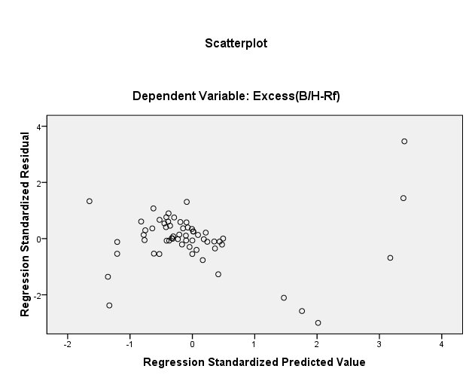 | 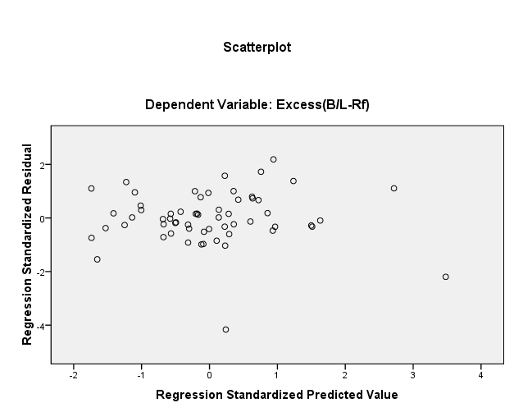
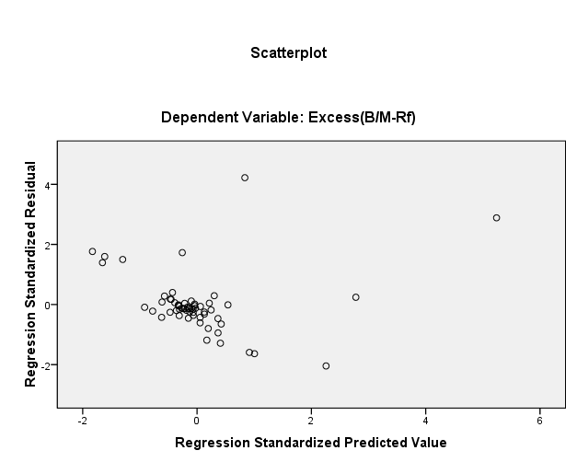 | 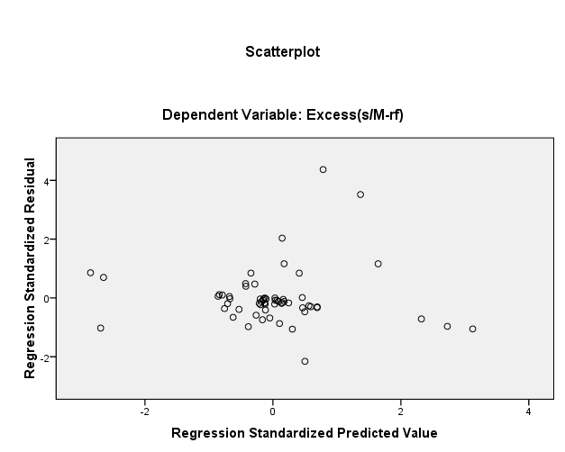
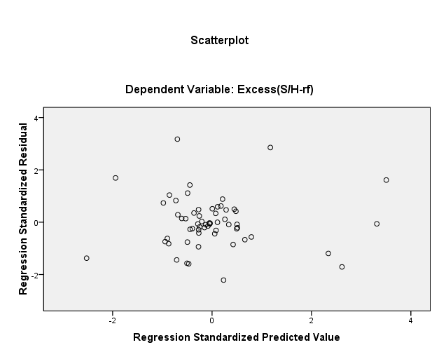

Table 10: Breusch-Pagan and Koenker test
 | Breusch_Pagan | Koenker test | Heteroscesdasticity status
 | p-value | p-value
B/L | .0001 | .2350 | True
B/M | 0.000 | 0.011 | True
B/H | NA | NA | False
S/M | 0.8307 | 0.9568 | False
S/H | 0.000 | 0.0076 | True

Table 11: Heteroscedasticity Consistent regression of Excess Return Vs Market, Size and Value
Portfolio | α_{it} |  | β_{iM} |  | β_{is} |  | β_{ih} |  | AdjustedR-Square
 | Coeff | p-val | Coeff | p-val | Coeff | p-val | Coeff | p-val
B/L | .0042 | .5942 | .8289 | .0000 | -.3328 | .0063 | -.2849 | .0435 | .7637
B/H | .0004 | .9578 | .6884 | .0000 | -.6382 | .0000 | 1.3381 | .0000 | .8879
B/M | -.0094 | .4253 | .5535 | .0455 | -.2719 | .4511 | .1424 | .2540 | .4226
S/H | -0.0026 | 0.8023 | 0.2761 | 0.0611 | 0.1295 | 0.4926 | 0.5469 | 0.0018 | 0.3549
S/M | .027 | .023 | .861 | .000 | .764 | .000 | .502 | .001 | .446
S/L | Not Available

Table 12: CAPM Analysis
Portfolio | α_{it} |  | β_{iM} |  | R square | Adjusted  R-Square
 | Coeff | p-val | Coeff | p-val
B/L | -.028 | .131 | .841 | .0000 | 0.294 | .0.282
B/H | -0.04 | .704 | .712 | .0000 | 0.396 | .385
B/M | -.009 | 0.421 | .646 | .000 | 0.375 | .366
S/H | -.041 | .000 | .333 | .000 | 0.226 | 0.215
S/M | -.005 | .712 | .460 | .000 | .173 | .161
S/L | Not Available

Central Institute of Science and Technology (CIST) college, New Baneshwor, Kathmandu, Nepal
Newcastle Business School, Northumbria University, City Campus East, Newcastle upon Tyne NE1 8ST

