Geotechnical Assessment of Subsoil in Wuye District, Abuja, Nigeria for Construction Purposes

¹Olasehinde, P. I., *¹Amadi, A. N., ¹Enwedo, E. O., ²Okunlola, I. A. and ³Dan-Hassan, M. A.
¹Department of Geology, Federal University of Technology, Minna, Nigeria
²Department of Chemical and Geological Sciences, Al-Hikmah University, Ilorin, Nigeria
³Rural Water Supply and Sanitation Department, FCT Water Board, Abuja, Nigeria

*Corresponding Author’s emails: geoama76@gmail.com, or an.amadi@futminna.edu.ng
Phone Number: +234-8037729977
Abstract
A detailed assessment of the geotechnical properties of subsoil in Wuye area of Abuja, Nigerian Federal Capital Territory was executed in this study. The analysis carried out on the disturbed soil samples include: Sieve Analysis, Liquid Limit, Plastic Limit, Plasticity Index, Linear Shrinkage Limit, Compaction test, California Bearing Ratio (CBR) test and soil pH, while for the undisturbed soil samples, hydrometer test, direct shear box test and consolidation tests were carried out. The average percentage of fines passing sieve 75 micron is 35.6%. The average liquid limit is 37.8%, the plastic limit is 24.97%, plasticity index is 14.4%, the shrinkage limit is 6.7% while CBR value is 21.11%. The pH of the soil is almost neutral, which implies that the strength of the cement used for foundation in the area will not be attacked by weak acid arising from low pH values (< 7). The average clay fraction obtained from hydrometer analysis is 20.7%. The dominant clay mineral in the area is kaolinite and it is responsible for the low to medium shrinkage potential of the soil. The average settlement value of 42.2 mm falls within the acceptable settlement value of between 20 to 300 mm for foundations. The average allowable bearing capacity of 3250.3 KN/m³ obtained greatly exceeds the required allowable bearing capacity of 150.0 KN/m³ for shallow foundations. The information from the data obtained shows that the study area can be broadly divided into two categories: areas underlain by suitable and competent subsoil that will support any super structure, occupying the north-west and south-east portion of the study area as well as those underlain by less suitable subsoil, covering the south-west and north-east part of the area. The study further revealed that the suitability and the competence of the subsoil is a function of their respective lithology. Based on the results of the investigation, it is recommended that high rise engineering structures should not be located on the regions with low soil bearing capacity in order to avoid failure. Replacement of less competent soil with more competent ones before any construction is advocated.

Keywords: Geotechnical Assessment, Subsoil Characterization, Construction, Wuye District,
Abuja, Nigeria

Introduction
According to Bell (2007), geology is one of the most important factors in construction since construction takes place either at or below the ground surface. Hence, geology has an influence on most construction operations because it helps determine their nature, form and cost. Most civil engineering construction works include; open excavations, tunnels, underground caverns, shafts and raises, reservoirs, dams, highways, railways, bridges and building foundations. In order to accomplish an economical and hazard free construction, the character of the rocks and soils involved and their geological setting must be investigated. Certainly, the stability and successful completion of every construction is greatly influenced by the local geology of the area (Kentli et al., 2005).

Civil engineering structures are long time projects therefore it is vital to know the characteristics of the geologic materials underlying any proposed structural site (Olorunfemi et al., 2002). The subsoil serves as the foundation bed for most civil engineering structures (Faleye and Omosuyi, 2011), hence the need for a detailed subsoil investigation in order to assess the suitability of a site for the proposed structure (Amadi et al., 2015). This is necessary because the longevity and safety of every structure lies on its foundation. Every load in any structure is transferred to its foundation and the foundation imposes the load to the subsoil thereby maintaining equilibrium. Distortion of this balance leads to structural failures which results to loss of lives, economy, time and psychological trauma (Amadi et al., 2012). There are many types of foundations and the choice of foundation design depends on the nature of the structure that will rest on it and the subsoil on which it will rest upon. Therefore it is vital to know the characteristics of the geologic materials underlying any proposed structural site before the construction and this is the target of the present study.

Fang and Daniels (2005) stated that geotechniques are concerned with the engineering behaviour of earth materials and every engineering work that is concerned with construction on or within ground. Geotechnical analysis usually uses principles of soil mechanics and rock mechanics to investigate subsurface conditions and materials, determine the relevant physical/mechanical and chemical properties of these materials, evaluate stability of natural slopes and man-made soil deposits, assess risks posed by site conditions, design earthworks and structure foundations, and monitor site conditions, earthwork and foundation construction. According to Mitchell et al. (2005), the engineering properties of soils are affected by four main factors: the predominant size of the mineral particles, the type of mineral particles, the grain size distribution, and the relative quantities of mineral, water and air present in the soil matrix.

This assessment can be best achieved by integration of both subsurface and surface techniques such as geotechnical, structural and geological methods which produce results that delineate different layers of geologic materials and their structural properties that are beneath the surface. Therefore assessment of the subsoil involves exploring the ground conditions below and sometimes at the surface. A sufficient assessment of geologic and geotechnical properties of subsoil prior to any engineering construction, is one of the most significant parts of a structure safety evaluation. Assessment of the safety of any infrastructure demands among other things, that its foundation bed (subsoil) be properly studied so that, it is as totally comprehended as possible. Every engineering structure: roads, buildings, bridges, dams or railways, have their foundation directly or indirectly on the subsoil, which makes it a very important factor to be considered in the design of any of these structures (Faleye and Omosuyi, 2011).

The stability and durability of these structures depend absolutely on the strength, bearing capacity and sustainability of the subsoil underlying them. Subsequently, the key factor is the foundation and the ability of the subsoil to uphold the weight enforced by the overlying structure (Oyedele, 2009; Nwankwoala and Oborie, 2014). In any foundation studies, it is vital to investigate the detailed foundation conditions at the site (Hawkins, 1971). This is because the effect of the imposed weight is intensified by the thickness and consistency of the compressible layer (Nwankwoala and Warmate, 2014). This, in addition to other critical features adds to the collapse of civil engineering structures (Amadi et al., 2012; Youdeowei and Nwankwoala, 2013).

Assessment of the properties of the subsurface materials on which engineering structures sit is crucial to all construction works. Building collapse is no longer news in Nigeria as it now occurs in almost every part of Nigeria. The rate at which the development and urbanization (bridges, railway, buildings and roads) is occurring in Wuye area of Abuja, is very alarming. Such magnitude of engineering construction both commercial and residential calls for proper assessment of the subsoil to ensure the safety of lives and properties and this is what led to the study. The uncertainties associated with subsoil resulting in the risks of buildings collapse and failures of other engineering infrastructures require the assessment of the geotechnical properties of the subsoil to ascertain the degree of its competence and stability. The geotechnical and structural assessment of subsoil condition of Wuye District, Abuja, Nigeria is crucial in producing significant data inputs for the design and construction of foundations for anticipated structures.

Materials and Methods
Study Area Description
Wuye District is one of the fourteen residential districts of Abuja phase II in the Federal Capital Territory (Fig. 1). The residential districts are divided into four sectors, in which Wuye District is grouped in sector B alongside Utako, Jabi and Dakibiyu Districts. The study area falls within latitudes 9°01'30''N to 9°04'15''N of the Equator and longitudes 7°24̍'52''E to 7°27̍'55''E of the Meridian. The total area extent is approximately 28 km². The study area is bounded in the east by Ring Road 1 and Wuse district of Phase I, in the north by Utako District, in the west by Dakibiyu District and south by the Kukwaba recreational park. The area is accessible through Nnamdi Azikiwe express way and Jabi road and 1km from Julius Begger roundabout (Fig. 1). The study area falls within Gwagwa Plains of the FCT. The area is characterized by the gently undulating terrain interlaced by river valleys. The general altitude ranges from 430 meters to 530 meters above the sea level with a relative height of about 35 meter. The dominant feature within the study area is the flood plains and river valleys of River Jabi and Wuye that bounded the area and runs through the north-western boundary with its numerous tributaries and are structurally controlled. The Kukwaba recreational park (Wonder Land) attracts attention to the area.

Geotechnical Analysis
Forty geotechnical trial pits were bored using a 100 mm diameter hand-auger, advanced to a depth of about 1.5 m below the existing ground surface and ten undisturbed samples were obtained at depth interval of 1.5 m (Fig. 1). Also thirty representative disturbed samples were taken at regular intervals of 1.5 m depth and also when a change in soil type was observed. A GPS was used to mark the locations of the holes. All soil samples obtained in the field were cautiously preserved and taken to the laboratory where they were subjected to more detailed visual inspection and descriptions. Thereafter, representative samples were selected from trial pit for laboratory analysis in accordance with relevant geotechnical engineering standards (British Standard 1377, 1996). Disturbed samples so selected were subjected to the following laboratory classification tests such as: Sieve analysis, Atterberg limits, Compaction test and California Bearing Ratio (CBR) test. The undisturbed and mostly cohesive samples collected in the course of boring were subjected to hydrometer test, direct shear box test, and oedometer consolidation test.
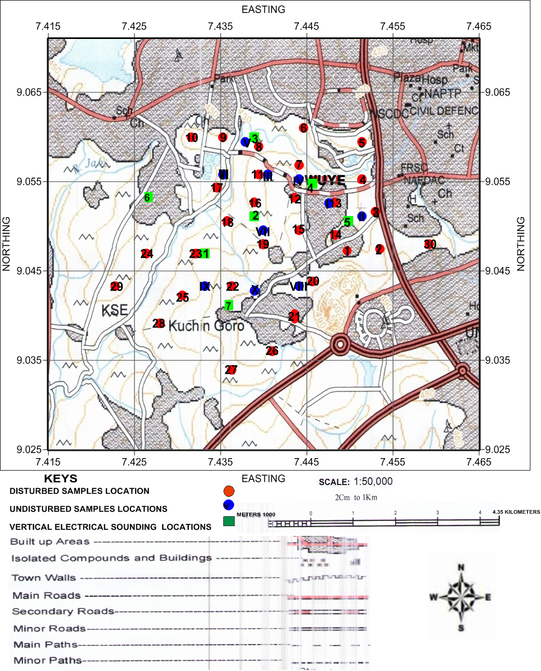
Fig. 1: Topographical map of Wuye and Environs showing the sampled points

Geology of the Area
The study area falls within the Basement Complex of North Central Nigeria which comprises of three rock types namely: Migmatite-gneiss, low grade schist belt and older granites (Ajibade and Wright, 1988). The main rock units in the study area are banded gneiss and porphyroblastic gneiss (Fig. 2). Majority of the rocks has been weathered into reddish sandy-clay to clay soils and capped by laterite. The gneiss consists of banded dark and light coloured minerals (Plate 1). There are folding, fractruring and flow structures in most of the outcrops (Plate 1). Some of the joints are filled with either quartz or feldspar. The principal joint direction from the rose diagram trends in NNE-SSW direction (Fig. 3).

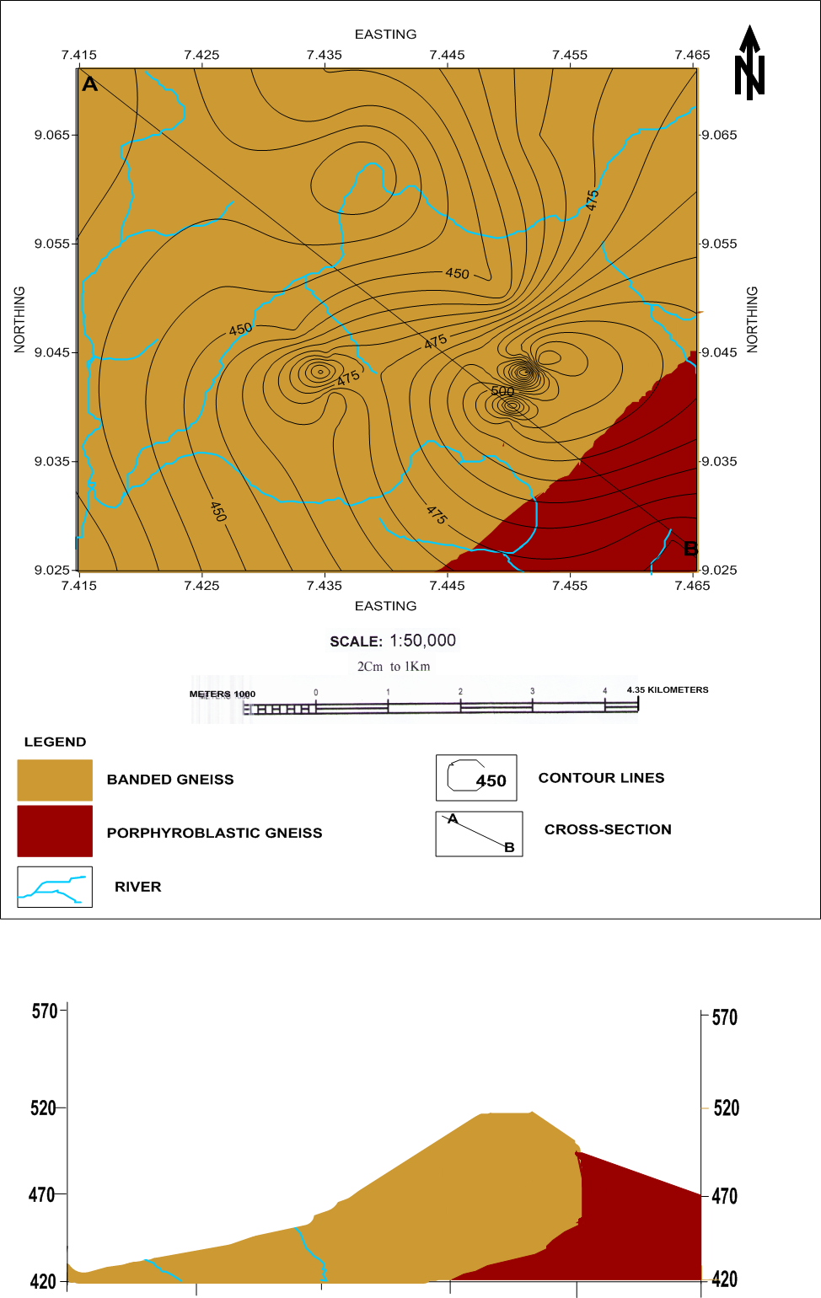
Fig. 2: Geology map of Wuye and Environs, Abuja

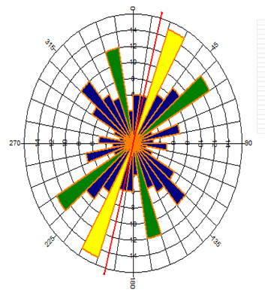
Fig. 3: Rose diagram of the study area showing the principal joint direction
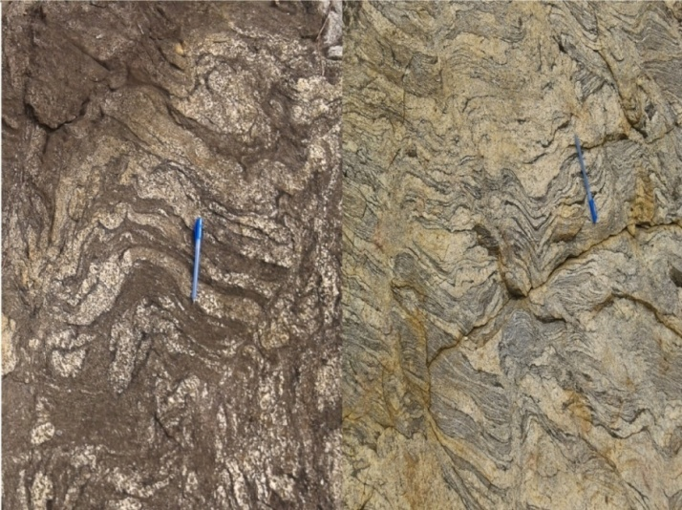
Plate 1: Banded gneiss from Wuye area, Abuja

Sieve Analysis
This method covers the quantitative determination of the particle size distribution in a soil. This method helps to obtain the combined fraction of clay and silt. The procedure involves the preparation of the samples by wet sieving to remove the silt and clay sized particles followed by dry sieving the remaining coarser materials. The following procedures were adopted in carrying out this test: The soil samples obtained from the test pits were oven dried until the moisture content was eradicated and the sample dried. The samples were then passed through BS test sieve 20 mm and the fraction passing through the sieve were weighed to a convenient mass of 500 gram. The dominant soil texture is shown in particle distribution curves (Fig. 4).
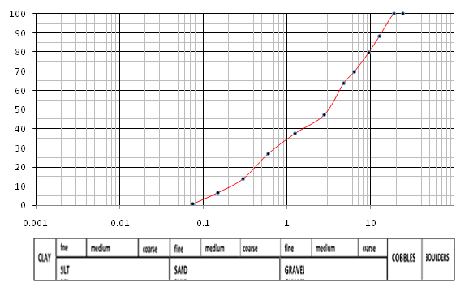
Fig. 4: Particle size distribution curve
Atterberg Limit
The liquid limit of the soil ranged from 0.0 – 58.9%, with an average value of 37.8%. The plastic limit of the soil varied from 0.0 – 37.4% with an average of approximately 25.0%, while the plasticity index is of the order of 0.0 – 14.4% (Table 1). The shrinkage limit falls within 0 to 14%, with the average value of 6.7% (Table 1). Majority of the soil samples in the study area are tagged non plastic because it consists of sandy and silt soil with high mica flakes (Fig. 5). About 54 % of the sample fall within the required liquid limit value of 40% and about 70 % of the soil samples meet with the 20% required plasticity index value recommended (Federal Ministry of Works and Housing, 1972), for filling and base material of any construction work. The value of the Atterberg Limit is illustrated in the plasticity chart (Fig. 6). The results of these geotechnical analyses suggest that the clay component in the soil samples from the area meets the requirement for a base course, sub-base and sub-grade materials (Fig. 7). Fine grained soil with clay content above 10% implies low permeability (Amadi et al., 2015). The soil is classified as unsuitable, subgrade and sub-base material (Fig. 7).

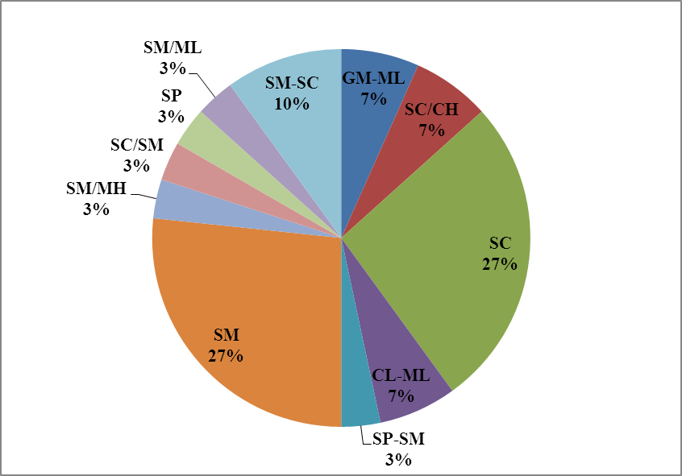
Fig. 5: Soil Classification using Unified Soil Classification Scheme in Wuye area, Abuja

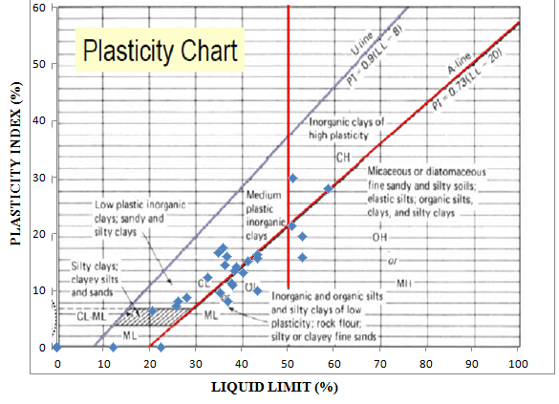
Fig. 6: Plasticity chart of the soil samples from Wuye area, Abuja
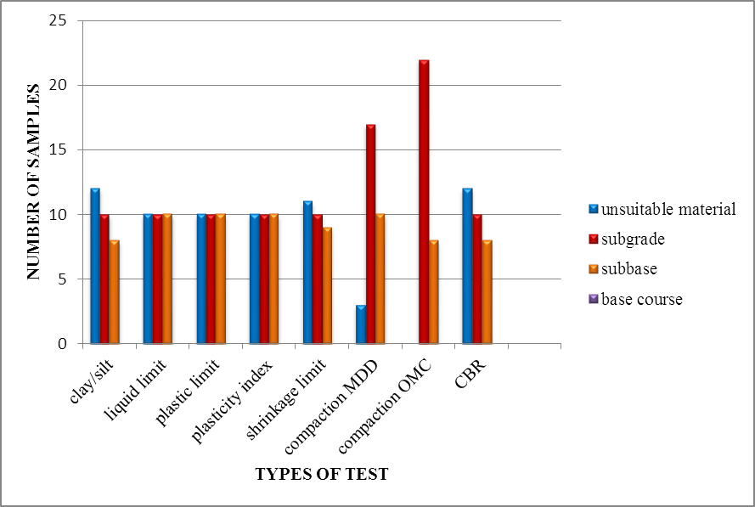

Fig. 7: Classification of the soil types in Wuye based on FMWH Standard

Table 1: Statistical Summary of the Geotechnical Analysis of Soil Samples from Wuye District
Geotechnical Properties | Minimum | Maximum | Average
Natural moisture content (%) | 17.7 | 24.3 | 26.0
Soil pH | 5.8 | 6.9 | 6.6
Liquid Limit (%) | NP | 58.9 | 37.8
Plastic Limit (%) | NP | 37.4 | 25
Plasticity Index (%) | NP | 29.8 | 14.4
Shrinkage limit (%) | 0 | 14 | 6.7
Fines passing sieve 200 (%) | 9.2 | 7.2 | 35.6
MDD(kg/cm3) | 1.553 | 2.108 | 1.8
OMC (%) | 10 | 18.2 | 14.4
C.B.R (%) | 1.9 | 44.6 | 21.1
Clay fraction (%) | 10 | 30 | 20.7
Cohesion (kN/m2) | 0.8 | 19.5 | 12.4
Angel of friction ϕ (°) | 29.9 | 58.3 | 46.5
Void ratio | 0.48 | 0.62 | 0.5
Coefficient of consolidation Cv (in²/min) | 6.91616E-12 | 2.076646E-11 | 1.59072E-11

Estimation of the Clay Mineral in the Soil Samples
Two methods were adopted in inferring the type of clay mineral present in the soil of the study area. They include the activity value of minerals, which is the ratio of plasticity index to clay fraction of a soil. The activity value is an important index property which is being used for determining the swelling potential of a given soil (Skempton, 1953). The second method is according to Bain (1971), which stated that a plot of plastic limit against plasticity index will place the soil in its clay category (Fig. 8). The suspected dominant clay mineral in the area is inferred to be kaolinite which is characterised by plastic limit value below 40% and plasticity index of either above 10% for plastic kaolinite or below 10% for non-plastic kaolinite. This corresponds with the calculated activity value of clay which falls within the activity value of kaolinite. Gribble (1991) stated that clay minerals are formed from the weathering of rock forming mineral feldspar. He further stated that montimorillonite which are expansive in nature, are formed when plagioclase feldspar react with water, while excess interaction of water with Plagioclase Feldspar gives rise to kaolinite which is a stable clay mineral as the final product. Due to the low activity value of kaolinite, it is classified as inactive clay and as such has low shrinkage potentials. The Estimated shrinkage potential of the study area (Table 1) falls within low and medium potentials (Stanciu et al., 2011; Nwankwoala et al., 2015).
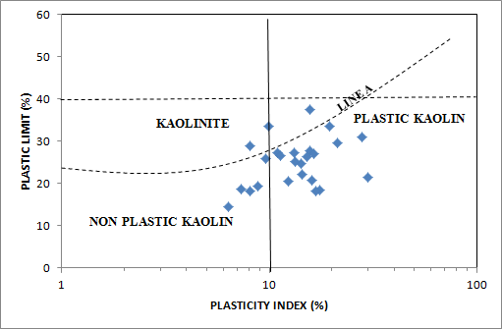
Fig. 8: Graph of Plastic Limit versus Plasticity Index for classifying Clay Minerals
(Modified After Bain, 1971)

Compaction Test
The results of the compaction test of the soil comprise of the optimum moisture content and the maximum dry density. The optimum moisture content (OMC) of the soil ranged from 10.0 to 18.2 % with total average value of 14.4 %, while the maximum dry density (MDD) varied from 1.553 to 2.108 kg/cm³ with a mean value of 1.8 kg/cm³ (Table 1). The best soil for foundation is the soil with high MDD at low OMC (Jegede, 1999; Amadi et al., 2015). About 8% of the entire sample exceeded the required OMC of 18% while about 10 % has low MDD which is not suitable for a good foundation material.

California Bearing Ratio Test Results
The result of the California bearing ratio test are summarised in the Table 1. The CBR results ranged between 1.95 to 44.6 %, with an average value of 21.1 %. The Federal Ministry of Works and Housing (1972) recommends soaked CBR value above 15 % for a filling material and above 30 % for sub-base material for any construction work. Any CBR value that is less than 15% is considered unsuitable but the quality of such soil can be enhanced with cement, lime or ash as the case may be. About 55% of the soil samples met with the required specification and the CBR result is a confirmation of the Atterberg Limit results already discussed.

Soil pH
The pH of the soil samples are shown in the Table 1. It ranged from 5.8 to 6.9, with a mean value of 6.62 as against the recommended value of 7.0. This implies that the soil in the area is slightly acidic to neutral. Acidic soils weaken the foundation of engineering structures thereby reducing the lifespan of such structures (Nwankwoala and Amadi, 2013).

Hydrometer Analysis
The results of hydrometer analysis are summarised in Table 1. The percentage of clay fraction (< 2µm) were obtained which ranges from 10 to 30%, with an average value of 20.7%. The silt fraction ranges from 12 to 40% with an average value of 30.7%. Sand falls between 30 to 73% with an average of 46.5% and the gravel is between 0 to 5% and has an average of 2.1%.

Direct Shear Box Test Results
The result of the direct shear box test is summarised in the Table 1. The parameters obtained are the bulk density, dry density, degree of saturation, cohesion and the angle of friction of the undisturbed soil samples of the study area. The cohesive force and friction angle values ranged from 0.8 to 19.5 KN/m² and 29.9 to 58.3 degrees respectively. The result shows that the study area is made up of sandy-clay, silty-sand, and clayey-sand. Clays and plastic silt have high cohesive force but low angle of internal friction and are therefore referred as cohesive soil, while sand, gravel and non-plastic silt have high angle of friction and no cohesive force. It is important to note that the higher the angle of friction, the higher the bearing capacity of the soil. Soil with higher cohesive force implies high compressibility and low bearing capacity.

Consolidation Test
The results of the consolidation test are summarised in the Table 1. The specific gravity of the soil samples ranged from 12.49 to 13.6 mm, with an average of 13.0 mm. The void ratio varied from 0.48 to 0.62, with an average value of 0.5, the degree of saturation is between 86.9 to 112 % and with an average of 94.6 %, while the value of the dry density of the soil samples ranged from 1.6 to 1.76 g/cm³ and with a mean value of 1.7 g/cm³. The coefficient of consolidation of the soil is of the order of 1.38323 x 10⁻¹¹ to 6.91616 x 10⁻¹² in²/min with an average of 1.59072E-11 in²/min. The void ratio is moderately small which is an indication that the soil is moderately dense and as a result there will be no much effect on the volume of the soil upon loading. The values of the coefficient of consolidation of the soil, shows that soil samples are of low to medium compressibility.
Classification of Soils in Wuye District
Classification and distribution of the soil using the Unified soil classification scheme (Fig. 5) in shows the study area is mainly dominated by brown clayey-sand with gravel and brown silty-claysand with gravel as well as silty-clay, silty-gravel and sand in some locations. The plasticity chart (Fig. 6) shows that soil in the study area falls within three categories: cohesionless soil, clay soil and silt soil. About 35% of the soil falls below LINE A on the plasticity chart which is the silt region, 45% falls above the LINE A, which is the clay region, 12% falls within cohesion less soil and 8% falls on the LINE A which are the soil that contains approximate equal amount of clay and silt (Fig. 6). The clay ranges from inorganic clays of low, medium to high plasticity while the silt ranges from inorganic silt of low, medium to high compressibility and some organic soil. The soil is further classified based on its suitability for road construction using the FMWH soil specification (Fig. 7).

Conclusion
The geotechnical properties of subsoil of Wuye district Abuja, for engineering purposes was investigated in this study. Disturbed and undisturbed soil samples were obtained and analysed in order to obtain information on the profile, type, and competence of the subsoil in the study area. The results of the disturbed samples were used to classify the soil which corresponds to the strength analysis of the undisturbed soil samples. The calculated allowable bearing capacity of the soils using the direct shear box test ranged from 165.4 KN/m³ to 5619.9 KN/m³ and these values are higher than the allowable bearing capacity of 150 KN/m³ for shallow foundations which is an indication the soil in the area are competent.. But using a factor of safety of ‘5’ for a worst case scenario, the allowable bearing capacity for test pit five will be less than 100 KN/m³ allowable bearing capacity for deep foundations. The allowable settlement value of the soil samples which ranged from 24.1 to 103.1 mm was obtained from the consolidation test of the soil samples, these falls within the allowed settlement value for structures. The information from the data obtained shows that the study area can be broadly divided into two categories: those underlain by competent geologic material lying on the north western part of the study area and those underlain by incompetent geologic material on the south west and north east of the area.

Recommendation
Since the study area comprises of areas underlain with competent geologic materials and those with incompetent geologic materials as gathered from the integrated analysis. For any construction such as buildings or roads, to take place in areas underlain by incompetent geologic material, the soil should be excavated and replaced with more suitable soil. Also the weak and sensitive soil can be stabilised using cement grout or lime, as these would reduce the void ratio in the soil and enhance its bearing capacity. Base on the information obtained from the analysis, both shallow and deep foundation types are recommended in accordance to the regulations of British standard code of practice for foundation. The shallow foundation and light structures are recommended for areas with incompetent soils while the deep foundation and high rise building should be dominated in the region with very competent soils.

Reference

Ajibade, A. C., & Wright, J. B. (1988). Structural Relationship in Schist Belts of Northwestern Nigeria. In P. O. Oluyide, W. C. Mbonu, A. E. Ogezi, I. G. Egbuniwe, A. C. Ajibade and A. C. Umeji (Eds.), Precambrian Geology of Nigeria, (pp. 103-110). Kaduna, Geological Survey of Nigeria

Amadi, A. N., Eze, C. J., Igwe, C. O., Okunlola, I. A., & Okoye, N. O. (2012). Architect’s and geologist’s view on the causes of building failures in Nigeria. Modern Applied Science, 6 (6), 31 – 38 Doi: 10.5539/mas.v6n6p31

Amadi A. N., Akande W. G., Okunlola I. A., Jimoh M.O., Francis Deborah G., (2015).
Assessment of the Geotechnical Properties of Lateritic Soils in Minna, North Central
Nigeria for Road design and Construction. American Journal of Mining and Metallurgy,
3(1), 15 – 20, doi: 10.12691/ajmm-3-1-3.

Bain, J. A. (1971). A Plasticity Chart as an Aid to the Identification and Assessment of Industrial Clays. Paper presented at the spring meeting of the clay minerals group and the basic science section of the British ceramic society, at Cambridge. 9(1), 64-78

Bell, F. G. (2007). Engineering Geology. Jordan Hill, Butterworth-Heinemann

British Standard Institute. (1996). Methods of Test for soils for Civil Engineering Purposes. B.S
1377 (Part 2). London, UK: British Standards Institution.

Faleye, E. T., & Omosuyi, G. O. (2011). Geophysical and Geotechnical Characterisation of Foundation Beds at Kuchiyaku, Kuje Area, Abuja, Nigeria. Journal of Emerging Trends in Engineering and Applied Sciences, 2(5), 864-870. Retrieved from http://www. jetaes.scholarlinkresearch.org

Fang, H. Y., & Daniels, J. (2005). Introductory Geotechnical Engineering : An Environmental Perspective, New York, NK: McGraw-hill

Federal Ministry of Works and Housing. (1972). Highway Manual for Road Design (Part 1). Lagos, Nigeria: Federal Ministry of Works and Housing

Gribble, C. D. (1991). Modification of the Formula Used in the Determination of the ten Percent Fines Value of Aggregate. Quarterly Journal of Engineering Geology and Hydrogeology. 24(1), 167. http://dx.doi.org/10.1144/ GSL.QJEG.1991.024.01.17

Hawkins, L. V. (1971). Seismic Refraction Surveys for civil Engineering. ABEM Geophysical Memo 2(69), 12.

Jegede, G. (1999). Engineering Geological Significance of the Superficial Deposits in Carrington Hill Area, Country Conc, Ireland. Nigeria Journal of Sciences 28, 153 – 158

Kentli, B., & Topal, T. (2004). Evaluation of Rock Excavatability and Slope Stability along a Segment of Motorway, Pozanti, Turkey. Environmental Geology, 46(1), 83–95, doi: 10.1007/s00254-004-1017-0

Mitchell, James, K., & Soga, K. (2005). Fundamentals of Soil Behaviour. New York, NK: John Wiley & Sons Inc

Nwankwoala, H. O., & Amadi, A. N. (2013). Geotechnical Investigation of Sub-soil and Rock Characteristics in parts of Shiroro-Muya-Chanchaga Area of Niger State, Nigeria. International Journal of Earth Sciences and Engineering, 6(1), 8 – 17

Nwankwoala, H. O., & Oborie, E. (2014). Geo-technical Investigation and Characterization of Sub-soils in Yenagoa, Bayelsa State, Central Niger Delta, Nigeria. American Journal of Research Communication. Retrieved from www.usa-journals.com

Nwankwoala, H. O., & Warmate, T. (2014). Geo-technical Assessment of Foundation Conditions of a Site in Ubima, Ikwerre Local Government Area, Rivers State, Nigeria. International Journal of Engineering Research and Development, 9(8), 50-63

Nwankwoala, H. O., Amadi, A. N., Warmate, T. and Jimoh, M. O., (2015). Geotechnical
Properties of Sub- Soils in Escravos Estuary, Western Niger Delta, Nigeria. American
Journal of Civil Engineering and Architecture, 3(1), 8 – 14, doi: 10.12691/ajcea-3-1-2.

Olorunfemi, M. O., Ojo, J. S., & Ojelabi, E. A. (2002). Geophysical Site Investigation of the premises of Idu Flow Station. Nigerian Agip Company (NAOC) Ltd. Technical report, for Multipurpose Oil Services Company Ltd, Port Harcourt

Oyedele, K. F. (2009). Engineering Geophysical Approach to Progressive or Sudden Collapse of Engineering Structures in Lagos, Nigeria. The Journal of American Science, 5(5), 91-100

Skempton, A. W. (1953). The Colloidal activities of Clays, Proceedings third International Conference on Soil Mechanics and Foundation Engineering, Zurich, 1, 57-61

Stanciu, A., Lungu, I., Ciobanita, L., & Aniculaesi, M. (2011). A New Concept to Identify and Characterise Active Clays, proceeding of the 15th European Conference on Soil Mechanics and Geotechnical Engineering, Athens, Greece.

Youdeowei, P. O., & Nwankwoala, H. O. (2013). Suitability of soils as bearing media at a freshwater swamp terrain in the Niger Delta. Journal of Geology and Mining Research, 5 (3), 58 – 64

