Short-term Interest Rate Model:

Calibration of the Vasicek Process to Ghana’s Treasury Rate

Emmanuel Thompson, Gideon Mensah Engmann, and Austin Butorac

Abstract

This paper calibrates model parameters of the Vasicek process to Ghana’s Treasury bill rate. The calibration was done by both the methods of least squares and maximum likelihood. The key objective is to propose a simple but an appropriate short-term interest rate model that could be used to value any security that depends on Ghana’s Treasury bill rate. The 91 day Treasury bill rate dataset from January 1988 to June 2015 were used. A major finding of the study was that, the method of maximum likelihood resulted in a much lower estimate for the volatility as compared to the method of least squares. It therefore follows that, the process contingent on the least squares appears to be more volatile and exhibits some probability of negative rates as compared to the model centered on the method of maximum likelihood. Vasicek model is one member of the family of one-factor short-term interest rate models. Future research needs to compare the Vasicek to other members of the family.

JEL classification numbers: G12, C32, G24
Keywords: Calibration, Orstein-Uhlenbeck process, Short-term interest rate, Vasicek process

1 Introduction
In 2014, the Ghanaian economy encountered major challenges in the form of a severe currency depreciation, extending energy crisis, worsening macroeconomic imbalances, and increasing inflation and interest rates (see [1], [2]). One major impediment in conducting business in Ghana is high interest rate (see [3]). The current high lending rates in the country is not boosting investments and the development of the private sector and economic growth in general (see [3]). On March 19, 2015, Moody’s Investors Service downgraded Ghana’s sovereign credit rating from B2 to B3 and the outlook on rating was flagged negative. The agency assigned deteriorating debt dynamics and increased government liquidity risks basically for the downgrade (see [4]). Credit rating is a measure used by a lender to measure how likely a borrower is able to make scheduled payments on a loan. It is therefore an evaluation of the credit worthiness of a company or a government but not individual consumers (see [5]). The governor of bank of Ghana has articulated the need for a more effective regulation on interest rates by the central bank, as a way of reducing the high cost of credit in the country (see [3]). From the above accounts, it is obvious that interest rate and its dynamics play a very crucial role in the Ghanaian economy. Quite apart from that, generations of reliable and economically acceptable future interest rate scenarios are essential either for determination of capital requirements, for risk management purposes or for pricing of financial instruments. A literature search regarding studies on calibration of parameters of one-factor short-term interest rate models to Ghana’s Treasury rate proved unproductive. Also, per the bank of Ghana’s governor’s call for an effective regulation on interest rates, we contribute to the debate by proposing a short-term interest rate model for valuing any security that depends on Ghana’s Treasury rate. Interest rates on debt instruments such as Treasury bill (T-bill) with maturities less than a year are referred to as short-term interest rates. In the literature, many short-term interest rate models have been proposed; for instance Tables 5.1 and 5.2 in [6] show most common known models and their properties. In pricing some securities such as options, using the standard Black and Scholes (see [7]) and Merton (see [8]) model, the short-term interest rate is known to be constant but this is too restrictive in real world situation. Also, if one were able to predict the future, the reasonable interest rate would simply be the average of the daily observed interest rate up to maturity. Since this is not the case, mathematical models come into play. Therefore, it is extremely important to find a good model that captures closely, the changes in interest rate over time. For practical purposes, it is appropriate to model interest rates using stochastic processes. In this study, model parameters were calibrated using the Vasicek process to Ghana’s Treasury rate. Calibration facilitated via the methods of least squares (LS) and maximum likelihood (ML). We used the 91 day T-bill rate dataset from January 1988 to June 2015 housed by the central bank of Ghana ([9]). Two reasons informed our choice of the 91 day T-bill rate dataset. First, in practice, the three-month rate is considered a better approximation of short rate since overnight loan rates are affected by factors that short-term interest rate models do not aim to capture (see [10]). Second the 91 day T-bill rate has become a generally accepted benchmark for banks rates.
The rest of the paper is organized as follows: Section 2 briefly outlines the Vasicek process including the calibrating methods. Section 3 gives the main results, and section 4 concludes.

2 Vasicek Process
One-factor models are a prevalent class of short-term interest rate models in investment and risk management. One-factor models are represented by the following stochastic differential equation (SDE):
$$dr_{t}=φ\left(t,r_{t}\right)dt+ω\left(t,r_{t}\right)dW_{t} (1)$$
where $φ$ and $ω$are the drift and the diffusion terms of the interest rate process respectively. W is a Brownian motion. The Vasicek model belongs to the class of one-factor models. In spite of many extensions of the model in the literature, it is still popular because of its tractability and its closed form solution. Vasicek (1977) assumed that the instantaneous spot rate under the real world measure evolves as an Orstein-Uhlenbeck (OU) process with constant coefficients. The SDE for the Vasicek process is given by:
$$dr_{t}=λ\left(μ-r_{t}\right)dt+σdW_{t} (2)$$
where $μ$ the long term mean, $λ$ the mean reversion rate or the speed of adjustment to long term average, and $σ$ the volatility. If $r_{t}<μ$ the short-term rate is expected to increase and if $r_{t}>μ$, the short-term rate is expected to decline. It can easily be shown using Itȏ’s Lemma ([11]) with $Y_{t}=e^{λt}r_{t}$ that the exact discrete model corresponding to (2) is given by:
$$r_{t+δ}={r_{t}e}^{-λδ}+μ\left(1-e^{-λδ}\right)+σe^{-λδ\left(t+δ\right)}\int_{t}^{t+δ}{e^{-λδ}dW_{t}} (3)$$
where $δ$ represents time step. A simulation equation version of (3) for generating sample paths which is an exact solution of the SDE in (2) is given as follows:
$$r_{k+1}=r_{k}e^{-λδ}+μ\left(1-e^{-λδ}\right)+σ\sqrt{\frac{1-e^{-2λδ}}{2λ}}N_{0,1} (4)$$
where $N_{0,1}$ is a random number.

2.1 Calibration Methods
The LS and the maximum likelihood estimation (MLE) methods were used to estimate the parameters of the OU process to the 91 day T-bill rate dataset. The estimation of these parameters is called calibration. In what follows, we discuss the two methods.

- Method of Least Squares
Assume a linear relationship between $r_{k+1}$ and $r_{k}$ with an error term $ϵ$ as follows:
$$r_{k+1}=θ_{0}+θ_{1}r_{k}+ϵ (5)$$
$θ_{0}$ and $θ_{1}$ are easily estimated using the well-known ordinary least squares (OLS) method. Note that $ϵ$ is independent and identically distributed Gaussian random variable. The OLS estimates and the standard deviation of the error term are given by:
$$θ_{1}=\frac{nr_{xy}-r_{x}r_{y}}{nr_{xx}-r_{x}^{2}}; θ_{0}=\frac{r_{y}}{n}-θ_{1}\left(\frac{r_{x}}{n}\right);s\left(ϵ\right)=\sqrt{\frac{nr_{yy}-r_{y}^{2}-θ_{1}\left(nr_{xy}-r_{x}r_{y}\right)}{n\left(n-2\right)}}$$
where $r_{x}=\sum_{k=1}^{n}{r_{k-1}}, r_{y}=\sum_{k=1}^{n}{r_{k}}, r_{xx}=\sum_{k=1}^{n}{r_{k-1}^{2}}, r_{xy}=\sum_{k=1}^{n}{r_{k-1}r_{k}}, r_{yy}=\sum_{k=1}^{n}{r_{k}^{2}}.$
The relationship between (4) and (5) is as follows:
$$θ_{1}=e^{-λδ}⟹λ=-ln\frac{θ_{1}}{δ},$$
$$θ_{0}=μ\left(1-e^{-λδ}\right)⟹μ=\frac{θ_{0}}{1-θ_{1}},$$
and
$$s\left(ϵ\right)=σ\sqrt{\frac{1-e^{-2λδ}}{2λ}}⟹σ=s\left(ϵ\right)\sqrt{\frac{-2lnθ_{1}}{δ\left(1-θ_{1}^{2}\right)}}.$$

- Method of Maximum Likelihood
Assume $N_{0,1}$ in (4) has a standard normal distribution, then the conditional distribution of $r_{k+1}$ given $r_{k}$ is given by:
$$f\left(r_{k+1}|r_{k}; μ,λ,\hat{σ}\right)=\frac{1}{\sqrt{2π{\hat{σ}}^{2}}}exp\left[-\frac{{\left(r_{k}-r_{k-1}e^{-λδ}-μ\left(1-e^{-λδ}\right)\right)}^{2}}{2{\hat{σ}}^{2}}\right] (6)$$
where
$${\hat{σ}}^{2}=\frac{1-e^{-2λδ}}{2λ}.$$

The log-likelihood function of ${\left\{r_{k}\right\}}_{k=0}^{n}$ (see 6) is given by:
$$l\left(μ,λ,\hat{σ}\right)=\sum_{k=1}^{n}{\ln{f\left[r_{k}|r_{k-1};μ,λ,\hat{σ}\right]}}=-\frac{n}{2}ln\left(2π\right)-nln\left(\hat{σ}\right)-\frac{1}{\sqrt{2π{\hat{σ}}^{2}}}\sum_{k=1}^{n}{{\left[r_{k}-r_{k-1}e^{-λδ}-μ\left(1-e^{-λδ}\right)\right]}^{2}.} (7)$$
To obtain the MLEs of $μ, λ$ and ${\hat{σ}}^{2}$, we take the partial derivative of (7) with respect to $μ, λ$ and ${\hat{σ}}^{2}$ and then set each of them to zero as follows:
$$\frac{∂l\left(μ,λ,\hat{σ}\right)}{∂μ}=0; \frac{∂l\left(μ,λ,\hat{σ}\right)}{∂λ}=0; \frac{∂l\left(μ,λ,\hat{σ}\right)}{∂\hat{σ}}=0.$$
The MLEs are then given as:
$$μ=\frac{\sum_{k=1}^{n}{\left(r_{k}-r_{k-1}e^{-λδ}\right)}}{n\left(1-e^{-λδ}\right)},$$
$$λ=-\frac{1}{δ}ln\frac{\sum_{k=1}^{n}{\left(r_{k}-μ\right)\left(r_{k-1}-μ\right)}}{\sum_{k=1}^{n}{{\left(r_{k-1}-μ\right)}^{2}}},$$
and
$${\hat{σ}}^{2}=\frac{1}{n}\sum_{k=1}^{n}{{\left[r_{k}-μ-e^{-λδ}\left(r_{k-1}-μ\right)\right]}^{2}}.$$
With little algebra and appropriate substitutions of previously defined quantities, it is easy to arrive at the following ML equations:
$$μ=\frac{r_{y}r_{xx}-r_{x}r_{xy}}{n\left(r_{xx}-r_{xy}\right)-\left(r_{x}^{2}-r_{x}r_{y}\right)},$$
$$λ=-\frac{1}{δ}ln\frac{r_{xy}-μr_{y}+nμ^{2}}{r_{xx}-2μr_{x}+nμ^{2}},$$
and
$$σ^{2}=\frac{2λ}{n\left(1-ρ\right)}\left[r_{yy}-2ρr_{xy}+ρ^{2}r_{xx}-2μ\left(1-ρ\right)\left(r_{y}-ρr_{x}\right)+nμ{\left(1-ρ\right)}^{2}\right].$$
Where $ρ=e^{-λδ}$.

3 Main Results
Figure 1 shows the time plot of Ghana’s 91 day T-bill rate dataset from January 1988 to June 2015. Broadly speaking, the rate exhibited both increasing and decreasing trends within the period in retrospect. The minimum rate of 0.0913 (9.13%) was recorded in October 2011 while the maximum rate of 0.4793 (47.93%) was observed from January 1997 to November 1997. Distributional analyses indicate that the rate data was not only moderately skewed to the right (coefficient of skewness = 0.40) but also platykurtic with a kurtosis measure of -0.72. A distribution is said to be platykurtic if the kurtosis is less than 3 implying less kurtosis than the normal distribution.
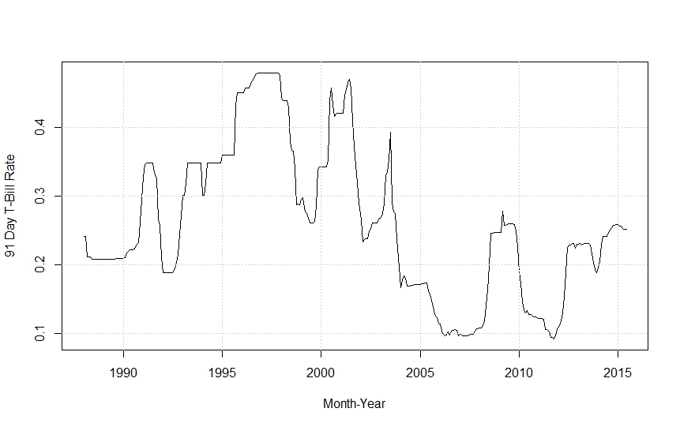
Figure 1: Time plot of Ghana’s 91 day T-bill rate

The summation quantities from the 91 day T-bill rate dataset are as follows:
$r_{x}=85.71789$, $r_{y}=85.70719$, $r_{xx}=26.33226$, $r_{xy}=26.28565$ and$r_{yy}=26.32699$.
These quantities make it possible to retrieve the Vasicek model parameters in (2). Table 1 compares these parameter estimates based on the LS and the ML methods. The retrieved parameters based on the LS are shown in the first three rows of column 2 of the table, while the ones based on the ML are displayed in the first three rows of the third column. Both LS and ML methods resulted in the same values for $μ$ and $λ$. However, the method of ML produced a much lower $σ$ value as compared to the method of LS.

Table 1: Comparison of Calibration Methods
Parameters | LS | ML
$$μ$$ | 0.25674 | 0.25674
$$λ$$ | 0.13001 | 0.13001
$$σ$$ | 0.05687 | 0.00837
$$θ_{0}$$ | 0.00277 | -
$$θ_{1}$$ | 0.98922 | -
$$s\left(ϵ\right)$$ | 0.01633 | -

Figure 2 displays plots of some trajectories of the Vasicek process using the parameters displayed in table 1 and assuming the current short-term rate $r_{t},$ is the June 2015 rate of 0.2517 (25.17%). The first plot illustrates the process based on the LS calibration method while the second plot shows the evolution of the process emanating from the ML method. The process contingent on the LS appears to be more volatile and exhibits some probability of negative rates as compared to the model centered on the ML method.
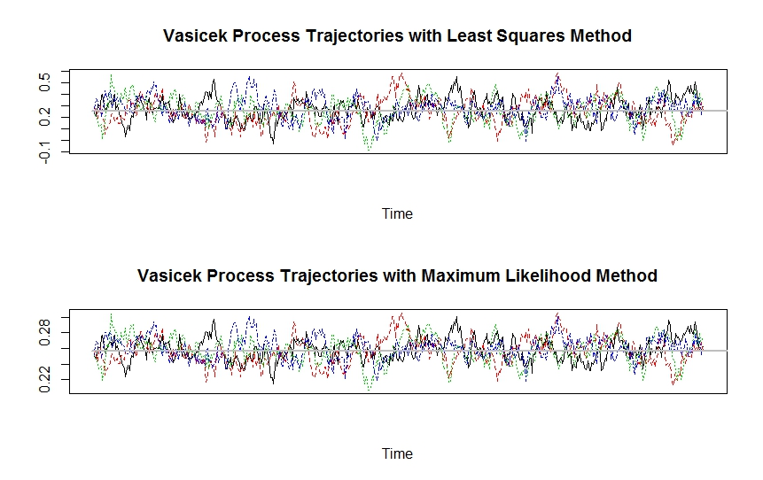 Figure 2: Vasicek Process Trajectories

4 Conclusion
Results of the study suggests the Vasicek process with calibration via either LS or ML as a potentially effective short-term interest rate model for valuing any security that rely on Ghana’s T-bill rate. A major finding of the study was that, the method of ML resulted in a much lower estimate for the volatility as compared to the method of LS. It therefore follows that, the process contingent on the LS appears to be more volatile and exhibits some probability of negative rates as compared to the model centered on the method of ML. The findings herein have implications for future research. First, the current study did not take into consideration other short-term interest rates such as the 182 day T-bill rate. The inclusion of the 182 day T-bill rate for a complete appreciation of short-term interest rates dynamics in Ghana is warranted. Second, the Vasicek model is one member of the family of one-factor short-term interest rate models. Future research needs to compare the Vasicek model to other members of the family.

References
[1] Africa Economic Outlook. Ghana 2015.
http://www.africaneconomicoutlook.org/en/country-notes/west-africa/ghana. Accessed 26 Dec 2015.
[2] Bank of Ghana Monetary Policy Report: Inflation outlook & analysis, September 2015.https://www.bog.gov.gh/privatecontent/MPC_Press_Releases/Inflation%20Outlook%20Report%20-%20September%202014.pdf. Accessed 28 Dec 2015.
[3] Ghana’s interest rate highest in the world: Business news of Tuesday, 6 October 2015. http://www.ghanaweb.com/GhanaHomePage/NewsArchive/Ghana-s-interest-rate-highest-in-the-world-386092. Assessed 23 Dec 2015.
[4] Moody’s downgrades Ghana’s sovereign rating to B3; outlook negative: Global credit research – 19 Mar 2015. https://www.moodys.com/research/Moodys-downgrades-Ghanas-sovereign-rating-to-B3-outlook-negative--PR_321192. Accessed 23 Dec 2015.
[5] Credit rating. https://en.wikipedia.org/wiki/Credit_rating. Accessed 23 Dec 2015.
[6] S. M. Iacus, Option pricing and estimation of financial models with R, John Wiley & Sons, West Sussex, 2011.
[7] F. Black, and M. Scholes, The Pricing of options and corporate liabilities, Journal of Political Economy, 81(3), (1973), 637-654.
[8] R. C. Merton, Theory of option pricing, Bell Journal of Economics and Management Science, 4(1), 1973, 141 – 83.
[9] Bank of Ghana. 91 day Treasury bill rate dataset. https://www.bog.gov.gh/. Accessed 28 Dec 2015.
[10] J. M. Schumacher, Syllabus Financial Models, Tilburg University, Tilburg, The Netherlands, 2009.
[11] S. E. Shreve, Stochastic calculus for finance II: Continuous-time models, Vol. 2, Springer, New York, 2004.

Department of Mathematics, Southeast Missouri State University, Cape Girardeau, Missouri, USA. e-mail: ethompson@semo.edu
Department of Statistics, Faculty of Mathematical Sciences, University for Development Studies, P. O. Box 24, Navrongo, Ghana. e-mail: gengmann@uds.edu.gh
Department of Mathematics, Southeast Missouri State University, Cape Girardeau, Missouri, USA. e-mail: atbutorac1s@student.semo.edu

