Economic Impact of Maternal Mortality in Africa: A Panel Data Approach

Emmanuel Thompson¹ and Seidu Sofo²

¹Assistant Professor, Department of Mathematics, Southeast Missouri State University, USA,
e-mail: ethompson@semo.edu
²Professor, Department of HHPR, Southeast Missouri State University, USA,
e-mail: ssofo@semo,edu

Abstract
[2] used cross-sectional data on 45 of the 46 countries in the WHO African region to test the hypothesis that Gross Domestic Product (GDP) per Capita was inversely related to Maternal Mortality Ratio (MMR). However, the cross-sectional technique was unable to capture both the individual country and time specific heterogeneity. Therefore, the aim of the present study was to use Panel Data models to test the hypothesis and to further estimate the economic loss due to MMR in the WHO Africa Region. Findings from the study would be beneficial to governments seeking to minimize the impact of MMR on the growth of their economies. Regarding statistical methodology, the study was intended to demonstrate to practitioners the potential of Panel Data Models as more practical approaches to fitting data with cross-section and time series behavior. The estimated model with country dummy was found to be a potentially effective analytical tool for estimating economic loss due to MMR in the WHO Africa Region.

JEL classification numbers: I14, I18, B23, C11, C12
Keywords: Maternal Mortality Ratio, Pooled Ordinary Least Squares, Least Squares Dummy Variable, Panel Data, Mid-Year Population

1 Introduction
The Millennium Development Goals (MDGs), a United Nations Millennium Declaration, aimed at promoting human development and reducing global inequalities. The MDGs include eight ambitious goals to be achieved by 2015. One of the goals, MDG 5, is aimed at reducing Maternal Mortality Ratio (MMR) by 75% by 2015. MMR signifies the number of women who die annually from pregnancy and childbirth related issues. Thus it measures the number of women who die from complications of pregnancy and childbirth per 100,000 live births. As at 1990, the global ratio was around 543,000 and by 2010 it was around 287,000 resulting in about 89.2% decline. Despite this progress, rates are still 15 time higher in developing regions (see [1]). It is reported that about 800 women die every day from complications related to pregnancy and child births (see [1]). It is important to mention that, Africa has the highest ratio of maternal deaths in the world (see [1]). Despite some progress, it is uncertain if most sub-Saharan African countries can reduce MMR by three-quarters (MDG 5) come 2015.
The economic contributions of women to the sub-Saharan African household cannot be overemphasized. The mortality of mothers in the active labour force may result in the reduction of household personal savings and resources necessary for investment (see [2]). Therefore, it is important to focus on the economic influences of MMR. Gross Domestic Product (GDP) is a key economic indicator of development. Thus, the impact of MMR on Gross Domestic Product (GDP) per Capita, especially for sub-Saharan countries should be of immense interest to development experts. Using cross-sectional data, [2] concluded that MMR had a significant inverse relationship with GDP per Capita for 45 States in the WHO African region. The purposes of this study therefore, were to further establish whether GDP per Capita and MMR are inversely related in the light of recent data. To identify a statistical/econometric model for estimating loss in GDP per Capita due to MMR and to estimate the total annual economic loss due to MMR in the WHO Africa Region. To capture both the individual countries and year specific heterogeneities, the present study employed the panel data approach. Information collected over time on the same subject, individual, city, region, country etc. form what is known as panel data. The panel data methodology was introduced in academic research as far back as 1940 by Paul F. Lazarsfeld (see [3] and [4]). The choice of the functional form of the model used in the current study was informed by the characteristics of the data rather than making a nonlinearity assumption. [5] is among few references that list many benefits of using panel data. One benefit of using the panel data approach is that it captures both the cross-sectional and time-series dimensions. Examples of panel data are panel study of Income Dynamics and National Longitudinal Survey on Labor Force in USA (see [6]).

2 Data
The WHO and UNICEF 2013 report (see [1]), World Development Indicators (see [7]), and the African Statistics Year Book 2013 (see [8]) served as the main sources of data. The response and predictor variables were GDP per Capita in US$ and MMR respectively. Mid-Year Population (see [8]) were used as an input in arriving at the total annual economic loss for each country. In estimating the relationship between GDP per Capita and MMR, 42 out of 46 countries were used due to missing observations and the years considered were 1990, 2000 and 2010 per country.

3 Panel Data Models
The Panel Data models considered were Pooled Ordinary Least Squares (Pooled OLS) and the Least Squares Dummy Variable (LSDV) Regression Models (see [6] and [9]).

3.1 The Pooled OLS and LSDV Regression Models
The Pooled OLS and the LSDV regression models are given by (1) and (2) respectively.
$y_{it}=α+x_{it}^{'}β+ϵ_{it}, i=1,2,…,N; t=1,2,…,T$ (1)
$y_{it}$ and $x_{it}$ are the response and predictor variables respectively. $α$ represents the restricted intercepts. $β$ is the slope parameter and $ϵ_{it}$ are the error components.
$y_{it}=x_{it}^{'}β+α_{i}+u_{it}, i=1,2,…,N; t=1,2,…,T$ (2)
$y_{it}$ and $x_{it}$ are the response and predictor variables respectively. $α_{i}$ are the unrestricted intercepts, all may be different, $β$ is the slope parameter, and $u_{it}$ are the error components. Both (1) and (2) are estimated by the OLS method. In an event that the country-specific fixed effects are statistically significant in (2), the estimated parameters for (1) will be biased and inconsistent as pointed out by [10] and [11]. The procedure for the choice of either (1) or (2) is the simple chow test. The$α_{i}$’s are treated as $N-1$ dummy variables then a joint significance of these dummies are tested. The steps for the hypothesis testing are as follows:
$$H_{0}: α_{1}=…=α_{N-1}=0,$$
$$H_{a}: α_{i}≠0 for some i≠j.$$
The test statistics is the F-statistic defined as:
$$F_{0}=\frac{{R_{2}^{2}-R_{1}^{2}}/{\left(N-1\right)}}{{1-R_{2}^{2}}/{\left(NT-N-K\right)}}\sim F\left(N-1, NT-N-K\right)$$
where $R_{1}^{2}$ and $R_{2}^{2}$ are the R-squared from (1) and (2) respectively and K is the number of predictor variables. The test rejects $H_{0}$ if $F_{0}>F$.

4 Economic Impact Formulas
The loss per death (LD) reflecting the burden of MMR on GDP per Capita was estimated as follows:

$LD=\left({\overline{GDP}}/{\overline{MMR}}\right)×{\hat{β}}_{M}$ (3)
where $\overline{GDP}$ and $\overline{MMR}$ are the averages of GDP per Capita and MMR respectively. The ${\hat{β}}_{M}$ estimates $β$ from either (1) or (2). $β$ measures the percentage change in GDP per Capita for a given small change in MMR. The estimated amount of GDP per Capita loss due to MMR for the i^{th} country in the t^{th} year was obtained by multiplying the LD by MMR for that i^{th} country in the t^{th} year. The total annual economic loss for the i^{th} country in the t^{th} year $\left({TAEL}_{it}\right)$was estimated with the following formula:
${TAEL}_{it}=\left[\left(\frac{P_{it}-P_{it-1}}{100,000}\right)×{MMR}_{it}\right]×LD$ (4)
where $P_{it}$ is the mid-year population for the i^{th} country in the t^{th} year. $P_{it-1}$ is the mid-year population for the i^{th} country in the (t-1)^{st} year (See [2]).

5 Results
Table 1 clearly shows that on the average MMR was on a decline. In 1990 the ratio stood at 740. As at 2010, it was at 464.48 resulting in a decline of about 37%. Another important remark is that, the shape of the distribution of MMR has changed significantly. It was skewed to the left in 1990; however from 2000 till the end of 2010, it shifted to the right.

Table 1: Maternal Mortality Ratio
Year | Average | St. Dev | Skewness | 95% CI
1990 | 740 | 332.33 | -0.14 | (643.96,836.04)
2000 | 641.3 | 292.34 | 0.26 | (556.82,725.78)
2010 | 464.48 | 243.84 | 0.61 | (394.02,534.94)
Source: Researchers calculation

GDP per Capita on the average was on ascendency. In 1990 it was at $720.27 and by the close of 2010, it rose to $1851.03 indicating a growth of over one and half fold as evidenced by table 2.

Table 2: GDP Per Capita
Year | Average | St. Dev | Skewness | 95% CI
1990 | 720.27 | 1047.63 | 3.83 | (410.71,1029.83)
2000 | 677.5 | 884.68 | 2.44 | (419.02,935.98)
2010 | 1851.03 | 3129.17 | 3.39 | (926.42,2775.64)
Source: Researchers calculation

It is abundantly clear that for the period under review, the growth in GDP per Capita by far outstripped the decline in MMR.
Figure 1 shows the scatterplot of GDP per Capita against MMR when the panel structure was ignored. The figure presents four (4) case scenarios. Case 1 (a) examines the scatterplot where the response variable is GDP per Capita and the predictor variable is MMR. It is evident from the figure that no relationship was obvious. We further examined the relationship between the logarithm transformation of MMR and GDP per Capita as indicated by case 1 (b). Again, no clear pattern was discernable from that. Again, we transformed only GDP per Capita and re-examined the relationship as shown in figure 1 (c). This time around, the relationship looks somewhat obvious. Rising MMR was associated with falling Log (GDP per Capita). Similarly, a much clearer relationship is shown in figure 1 (d) when we transformed both variables. This relationship could be deceptive if the country-specific fixed effects are statistically significant.

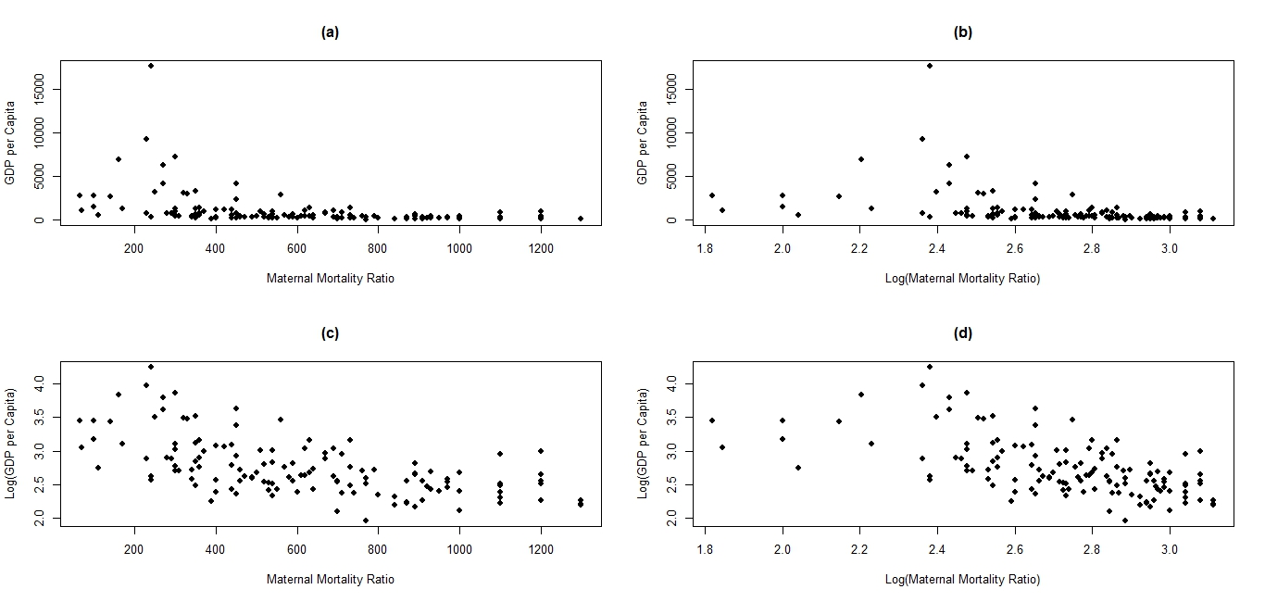
Figure 1: Scatterplot Ignoring Panel Structure

Figures 2-4 show the scatterplots for 1990, 2000 and 2010 respectively. Focusing more on figure (d) for the individual years, one can say some sort of inverse relationship existed between Log (GDP per Capita) and Log (MMR). The steepness of the relationship was not too different year on year.

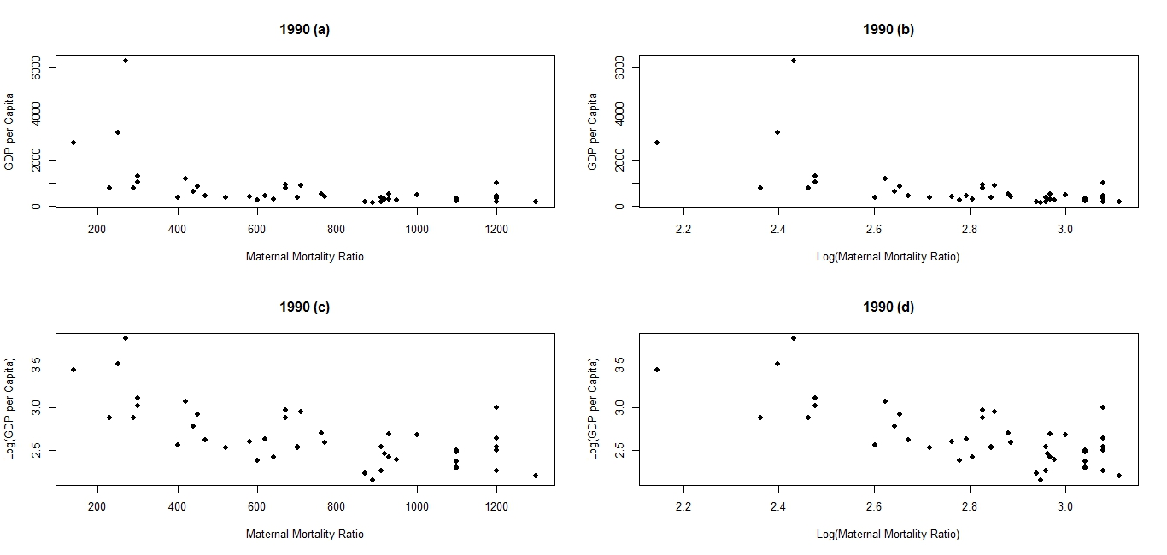

Figure 2: Scatterplot for 1990

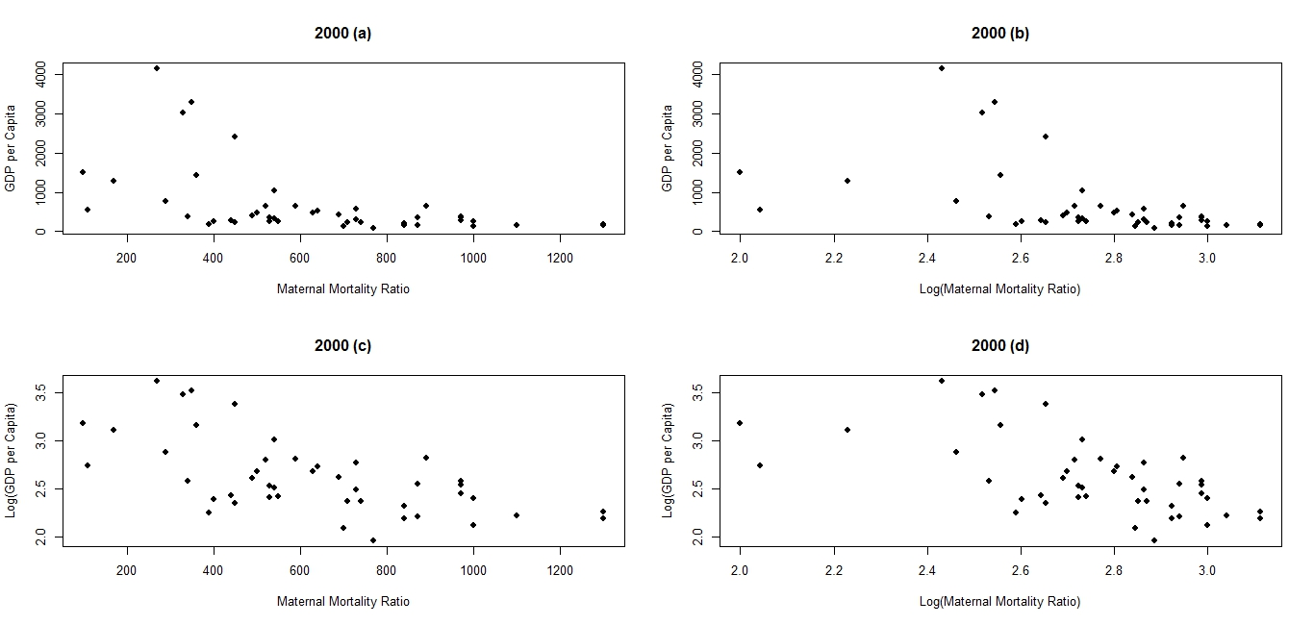

Figure 3: Scatterplot for 2000

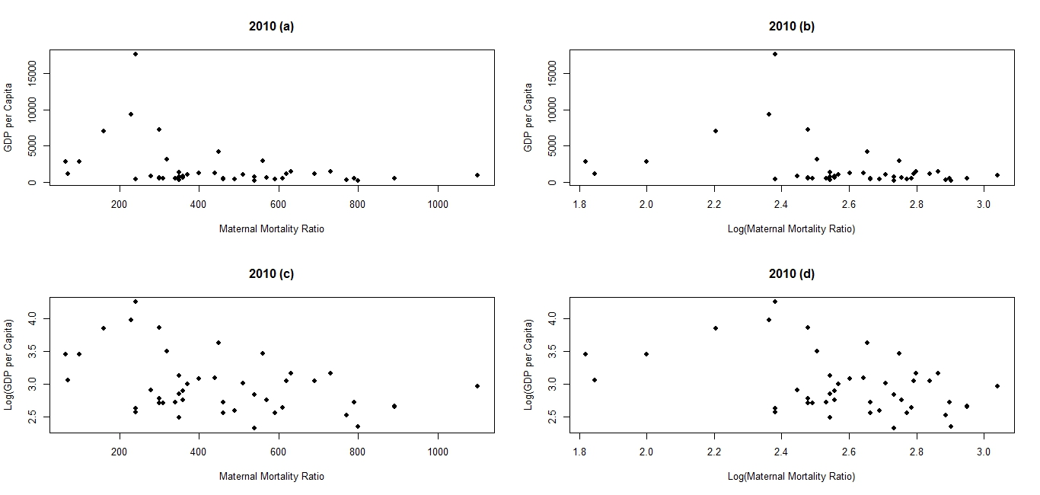

Figure 4: Scatterplot for 2010

Table 3 displays the regression results for both the Pooled OLS and the LSDV models. In both models, the Log (MMR) was statistically significant at 1% and 5% levels (the standard errors are in parentheses). The LSDV model explained 99.7% of the variability in the Log (GDP), however, only 43.1% of the variability in the Log (GDP) was explained by the Pooled OLS model.

Table 3: Regression Table
 | Pooled OLS | LSDV
Intercept | 5.874*** | -
 | (0.323) | -
Log (MMR) | -1.138*** | -1.075***
 | (0.117) | (0.146)
 | 0.431 | 0.997
*** p-value < 0.001

The chow test indicated that the null hypothesis can be rejected since the F-value computed from the sample data was significantly greater than the F-value obtained from the F-table (F₀ =381.935 > F_{41, 83}(0.05) = 1.535; p-value = 0.000). The statistical implication is that, the country specific fixed effects cannot be discarded therefore, we used the estimated coefficient of Log (MMR) from the LSDV model for the rest of the estimation process. Further, by (3) we obtained the LD as follows:
${\hat{β}}_{M}=-1.075$, $\overline{GDP}=\$1903.535$, $\overline{MMR}=472.763$
$$LD=\frac{\$1903.535}{472.763}×-1.075=-\$4.33.$$
The interpretation is that, if maternal mortality goes up by 1 person per year, GDP per Capita decreases by $4.33 on the average. This is the burden of MMR on GDP per Capita. Example of estimating total annual economic loss in the case of Ghana
- MMR in 2010 was 350
- Mid-Year Population in 2009 was 23,824,000
- Mid-Year Population in 2010 was 24,392,000
Therefore, the estimated loss in GDP per Capita for Ghana in 2010 was $\$4.33×350=\$1,515.50.$ From (4), the total annual economic loss for Ghana in 2010 was estimated at $8,653.51. For the rest of the countries see Table 4 (in Appendix). The distribution of estimated loss in GDP per Capita and total annual economic loss due to MMR by East, Middle, North, South, and West Africa are shown in both table 5 and figure 5. It is evident from the table and the figure that the economic impact was higher within the West African Sub-region, followed by East Africa and then Middle Africa. The total estimated loss in GDP per Capita and total annual economic loss due to MMR among the 42 WHO African countries for 2010 amounted to $85, 97648 and $470,732.31respectively.

Table 5: Distribution of Estimated Loss in GDP per Capita and Total Annual Economic
Loss by Region
Region | Number of Countries | Estimated Loss in GDP per Capita due to MMR (US$) | Total Annual Economic Loss (US$)
South Africa | 4 | 6,062.00 | 8,191.49
North Africa | 3 | 3,879.68 | 30,554.04
Middle Africa | 8 | 20,351.00 | 87,672.54
East Africa | 12 | 22,083.00 | 147,871.23
West Africa | 15 | 33,600.80 | 196,443.01

Figure 5: Distribution of Estimated Loss in GDP per Capita and Total Annual Economic Loss by Region

6 Conclusion
The present study investigated the economic impact of MMR on GDP per Capita for the WHO Africa region. The results indicate that the LSDV with country dummy is a potentially effective analytic tool for estimating economic loss due to MMR in Africa. The data showed that MMR had an inverse relationship with GDP per Capita. As [2] noted, MMR is both an indicator and a cause of underdevelopment. Consequently, some development professionals have called for MMR to be considered as a development indicator (see [12]). Hopefully, policy-makers in sub-Saharan Africa would heed to this call and consider MMR as a key development index.

References

[1] WHO and UNICEF, “Accountability for maternal, newborn and child survival,” 2013.

[2] J. M. Kirigia, D. Oluwole, G. M. Mwabu, D. Gatwiri, and L. H. Kainyu, “Effects of maternal mortality on gross domestic product (GDP) in the WHO African region,” Afr J Health Sci., 13, 2006, 86-95.

[3] P. F. Lazarsfeld and M. Fiske, “The panel as a new tool for measuring opinion,” Public Opinion Quarterly, 2, 1938, 596-612.

[4] P. F. Lazarsfeld, “Panel studies,” Public opinion quarterly, 4, 1940, 122-128.

[5] C. Hasiao, “Analysis of paned data,” Cambridge University Press, Cambridge, 2003.

[6] B. H. Baltagi, “Econometric Analysis of Panel Data,” John Wiley & Sons, Inc., New York, 2008.

[7] World Bank, GDP per Capita (current US$) for 1990, 2000 and 2010. [Online] Available: http://data.worldbank.org/indicator/NY.GDP.PCAP.CD?page=4 (February 16, 2014).

[8] African Development Bank (AfDB), the African Union Commission (AUC), and the
United Nations Economic Commission for Africa (ECA), “African statistical year book,” 2013. [Online] Available: http://www.afdb.org/fileadmin/uploads/afdb/Documents/Publications/African%20Statistical%20Yearbook%202013.pdf (February 16, 2014).

[9] J. P. Elhorst, “Spatial econometrics: From cross-sectional data to spatial panels,” Springer: Berlin, New York, Dordrecht, London, 2014.

[10] J. Neyman and E. L. Scott, “Consistent estimation from partially consistent observations,” Econometrica, vol. 16, 1948, 1-32.

[11] T. Lancaster, “The incidental parameter problem since 1948,” Journal of Econometrics, vol. 95, 2000, 391-413.

[12] F. T Sai, “Maternal mortality, index for development,” 2014. [Online] Available: http://www.ghanaweb.com/GhanaHomePage/health/artikel.php?ID=305208 (April 4, 2014).

Appendix

Table 4: Distribution of Estimated Loss in GDP per Capita and Total Annual Economic Loss by Country
Country | Total Mid-Year Population in Thousands for 2010 | Estimated Loss in GDP per Capita due to MMR (US$) | Total Annual Economic Loss (US$)
Angola | 19,549 | 1,948.50 | 12,119.67
Benin | 9,510 | 1,515.50 | 4,076.70
Botswana | 1,969 | 692.8 | 117.78
Burkina Faso | 15,540 | 1,299.00 | 5,780.55
Burundi | 9,233 | 3,464.00 | 10,599.84
Cameroon | 20,624 | 2,987.70 | 15,536.04
Central African Republic | 488 | 3,853.70 | 77.07
Chad | 11,721 | 4,763.00 | 16,670.50
Comoros | 683 | 1,212.40 | 206.11
Congo | 4,112 | 2,424.80 | 2,837.02
Ivory Coast | 18,977 | 1,732.00 | 6,512.32
Democratic Republic of the Congo | 62,191 | 2,338.20 | 39,866.31
Egypt | 78,076 | 285.78 | 3,718.00
Equatorial Guinea | 696 | 1,039.20 | 197.45
Ethiopia | 87,095 | 1,515.50 | 34,204.84
Gabon | 1,556 | 995.9 | 368.48
Gambia | 1,681 | 1,558.80 | 826.16
Ghana | 24,263 | 1,515.50 | 8,653.51
Guinea | 10,876 | 2,641.30 | 7,474.88
Guinea-Bissau | 1,587 | 3,420.70 | 1,231.45
Kenya | 40,909 | 1,558.80 | 16,897.39
Lesotho | 2,009 | 2,684.60 | 510.07
Liberia | 3,958 | 3,334.10 | 4,567.72
Madagascar | 21,080 | 1,039.20 | 6,068.93
Malawi | 15,014 | 1,991.80 | 8,783.84
Mali | 13,986 | 2,338.20 | 9,984.11
Mauritania | 3,609 | 2,208.30 | 1,987.47
Morocco | 31,642 | 433 | 1,580.45
Mozambique | 23,967 | 2,121.70 | 12,857.50
Niger | 15,894 | 2,554.70 | 15,098.28
Nigeria | 159,708 | 2,727.90 | 118,036.23
Rwanda | 10,837 | 1,472.20 | 4,519.65
Senegal | 12,951 | 1,602.10 | 5,831.64
Sierra Leone | 5,752 | 3,853.70 | 4,277.61
South Africa | 51,452 | 1,299.00 | 7,300.38
Sudan | 35,652 | 3,160.90 | 25,255.59
Swaziland | 1,193 | 1,385.60 | 263.26
Tanzania | 44,973 | 1,991.80 | 26,550.69
Togo | 6,306 | 1,299.00 | 2,104.38
Uganda | 33,987 | 1,342.30 | 15,074.03
Zambia | 13,217 | 1,905.20 | 7,468.38
Zimbabwe | 13,077 | 2,468.10 | 4,640.03

