A Research on the Dual Value Model of Individual Transaction Decision in Ethnic Chinese Society

Yen, Ghi-Feng and Tsao, Hai-Ying
Abstract
In ethnic Chinese society, interpersonal relationships significantly influence transaction decisions, contrasting with Western economic rationality which often neglects the role of "human relationships". This research introduces a Dual Value Model (DVM) to explore how Chinese individuals navigate these complex interpersonal dynamics in transaction decisions. It highlights the integration of Potential Social Value (PSV), stemming from the counterparty's social status (vertical relationship) and emotional closeness (horizontal relationship), with Potential Economic Value (PEV), focusing on the economic outcomes of the transaction. These two potential values ​​are defined through expectancy theory to facilitate communal comparison. This duality necessitates a balance, demonstrating a unique economic-social tradeoff where individuals might accept lower economic benefits in favor of enhancing or maintaining favorable “Guanxi.” The concept of "guanxi mark-down (GMD)" and "Compensatory Mark-up (CMU)" are introduced as strategies employed to steer this balance, reflecting the social etiquette and economic pragmatism within Chinese transactional behavior. The research aims to provide a nuanced understanding of Chinese transaction decision-making, offering insights for guiding interpersonal relationships and economic considerations in a socio-cultural context deeply influenced by Confucian principles.
Keywords: Transaction decision; Dual value model (DVM); Potential social value (PSV); Potential economic value (PEV); Guanxi; Expectancy theory

- Introduction
From the perspective of behavioral science, societies influenced by different cultures possess distinct values and manifest behaviors (Adler & Bartholomew, 1992). In ethnic Chinese society, the complex concept of guanxi can be defined as a Chinese social concept established on the exchange of personal favors, in which particular relationships are sometimes considered more important than laws, regulations and written agreements. Which underscores personal connections, reciprocal obligations, and the significance of trust in interpersonal relationships (Luo, 1997, 2000). This concept hence presents a challenging notion to Westerners who are accustomed to rationalism and individualism. Chinese guanxi, unlike the more formalized and contractual nature of many Western business relations, is often predicated on implicit understanding and mutual aid, forming a network of social rights and obligations deeply rooted in Chinese culture. Guanxi typically establishes long-term and trust-based relationships rather than being driven by short-term transactional considerations (Barbalet, 2021). For instance, historically, Chinese enterprises have relied on guanxi due to an imperfect legal framework, making property rights and contract law untrustworthy; hence, personal behavior and trust have become the primary foundations for business transactions between Chinese firms’ managers (Lee & Dawes, 2005). In contrast, traditional Western culture respects the individual as an autonomous entity, with relationships being more direct and emphasizing the spirit of contract. Therefore, transaction behavior models developed from the concept of social exchange in Western society often lead to significant misunderstandings when applied to explain transaction behaviors in Chinese contexts. Consequently, this research aims to integrate the essence of Western management theories while taking into account the environment, customs, and national character of ethnic Chinese society, rethinking theoretical perspectives that more precisely explain individual transaction behaviors within Chinese communities.
Considering the cultural milieu of Chinese society, it is indisputable that cultural factors impact the national character, with psychological perspectives agreeing that sociocultural factors are the most significant influencers of national temperament. For over two millennia, Chinese people have been deeply influenced by Confucian thought, whose central idea is benevolence. The character for "benevolence" is composed of two radicals representing two individuals (dyad), symbolizing that true humanity and love can only exist in the context of ethical relationships between two persons (Wen, 1990). This emphasis on cardinal relationships and corresponding appropriate behaviors has notably shaped interactions in Chinese society, emphasizing the pattern of guanxi in interpersonal dealings, which inevitably impacts decision-making in transactions. Thus, existing Western theories that analyze the individual as the unit of analysis and emphasize rational decision-making are insufficient to fully explain transaction behaviors among Chinese people. It is essential to consider the influence of traditional Confucian thought on guanxi and, through analysis of such dyadic relationships, elucidate transaction behaviors among Chinese individuals (Yen & Liao, 1995).
When analyzing whether a transaction is completed from a rational perspective, the primary consideration lies in whether both parties believe the expected benefits of post-transaction exceed those of pre-transaction. While traditional Western economic perspectives tend to consider purely transactional benefits (i.e. economic premise), Chinese individuals often first assess the guanxi with the transaction counterparty (i.e. social premise) before determining an appropriate course of action. Relative to Western norms, Chinese people are inclined to consider long-term orientation and holistic value (Hofstede, 1980; 2011; Fang, 2003; Lee & Dawes, 2005; Wu, 2006), viewing guanxi as a form of social capital that holds significant social value for individuals as well as organizations. This social value is reflected in the establishment and maintenance of interpersonal guanxi, facilitating the formation of social networks and resource sharing (Lee & Dawes, 2005). Pursuing the maximization of long-term value, Chinese individuals balance the overall optimization of both economic and social values. As every transaction partner is unique, the decision-making process must consider and demonstrate a high degree of flexibility in the coexistence of dual potential values (ambidexterity of dual values). This flexibility represents an “appropriate holistic rational consideration”, rather than merely an economic rationality. In transactions, the value of the transaction counterparty, affecting social rewards, and the value of the transactional object, affecting expected economic returns, are subject to a hierarchy of priorities and tradeoffs, with the measured aspect within the transaction counterparty being the degree of vertical and horizontal social guanxi.
In light of the aforementioned context, this research proposes to explore the social and cultural underpinnings that can reasonably describe transaction behaviors among ethnic Chinese individuals. Hence, this research examines the following three issues: (1) analyzing the impact of interpersonal guanxi on transaction behaviors within Chinese societal and cultural contexts; (2) constructing a dual value decision model that balances the social-emotional and economic benefits of interpersonal guanxi in individual transactions within Chinese society; (3) conducting a conceptual analysis comparing social-emotional factors and economic benefits, and providing recommendations that promote successful transactions.
- Epistemology and Methodology
As this research probes into the transaction decision-making behavior within Chinese society from a fundamental socio-cultural basis, it is imperative to first clarify the theoretical perspective underpinning this investigation, i.e., to “define the stance and angle from which the researchers observe individuals, behaviors, or phenomena”. In simpler terms, when a researcher observes an individual, the behavioral data encompasses constants, population parameters (certainties), systematic variations (probabilities), and nonsystematic changes (contingencies), aligning with the concepts of population parameters, sample means, and error terms in statistical statement. From a behavioral science viewpoint, observation of human behavior includes both the fact of being a biological organism (certainty) and the influence of culture (probability) (Yen, 1992a). According to Parsons' (1949) “voluntaristic theory of action”, every action a person exhibits in society is “motivated” and “purposeful”. The means or methods used to achieve an end are influenced by two factors. Firstly, there are constraints inherent to the organism itself, intrinsic traits that do not vary with social or cultural differences, such as self-interest, survival, and species preservation. The second factor is the “norms” and “values” imposed by society and culture, which restrict the actor's final choice of means to achieve an end. Thus, from an epistemological viewpoint, this research fundamentally postulates that Chinese individuals are shaped by both Confucian ethical norms (culturality) and self-interest (biological nature), creating unique cultural characteristics and a collective character. To use Freud's analogy (Lapsley & Stey, 2011), the organism's self-interest corresponds to the id, while Confucian ethical norms belong to the superego, and their synthesis manifests the ego. Confucian thought has long influenced Chinese ways of thinking, playing a role in Chinese society and serving functions similar to “The Protestant Ethic” in its impact on Western capitalist societies (Fischoff, 1944; Weber & Kalberg, 2013).
From the foregoing discussion, it is apparent that the unit of analysis for personal transaction decisions for Chinese individuals is primarily the dyad; hence, individuals not only calculate the economic benefits of the transaction (goods or services) but also consider the social guanxi (related persons) with the other party. Given the exploratory nature of this research subject, the methodology intends to use logical reasoning of concepts to link the overall pivotal relationships between key concepts, constructing a theoretical analysis model (Yen, 1992a) to elucidate the ideas expressed in this research. At the methodological level, this research draws upon Weber's notion of “ideal types” (Sciulli & Gerstein, 1985) to illustrate two distinct psychological constructs of pure types: firstly, the “social-oriented individual” who values social norms and factors under the influence of traditional Confucian culture, and secondly, the “economic-oriented individual” who emphasizes economic benefits and rational calculation under the influence of Western rationalism. Through a comparative analysis of these two types of human behavior, the research investigates typical transaction behaviors integratedly. Ideal/pure types are essentially abstract concepts, much like Theory X and Theory Y are used to describe human nature (work behavior) in enterprises, yet in practice, no individual is purely X or Y, as any person's behavior may fall between the two (McGregor, 1960; Kopelman, Prottas, & Falk, 2012). Similarly, the constructs of “economically-oriented” and “socially-oriented” individuals serve as fundamental pure concepts for describing transaction behaviors of Chinese individuals in this research, further deducing the dual value tradeoffs involved in actual transaction decision-making.
- Socio-Cultural Foundations, National Character, and their Impact on Individual’s Transaction Decision-making
The merit of management theories, or any theory for that matter, lies in their explanatory power over factual phenomena. Western management theories are fundamentally derived from general laws (theories) through empirical induction within Western management practices. That is, induction and deduction must be used interactively within the same system (e.g. American socio-cultural system) to avoid misunderstandings and distortions. If this statement is correct, then under the logic that “culture shapes value systems, value systems affect internal attitudes, and internal attitudes influence manifest behaviors” (Adler & Aycan, 2018), different cultures will result in different manifest behaviors. The fact that “cultural differences” exist already predicates the variation in individual behavior and elucidates that Eastern and Western social systems are different. Hence, when we attempt to use Western management theories to deduce phenomena in Chinese society but ignore the differences in cultural systems, we are prone to fallacious reasoning (Gerlach & Eriksson, 2021). This research posits that “localization” most crucially needs to grasp those phenomena that are “taken for granted” in practice yet “overlooked or undervalued” in theory. The meaning of being “taken for granted” is that it possesses significant explanatory power for practical phenomena, and the issue of being “overlooked” stems from sometimes neglecting to reflect on the potent yet habitual “tacit rules” in our lives. Thus, capturing the meanings and structures of these tacit rules lays a foundation for localized theoretical research. This research constructs its arguments based on the aforementioned epistemological foundation, namely, from the perspective that combines Confucian ethical norms with human self-interest to explore the impact of interpersonal guanxi patterns on transactional behavior in Chinese society. Since Confucian thought is the most dominant ideology in Chinese society, its influence on the national character is profound. Although Confucian thought has undergone varying degrees of change in Taiwan and mainland China (the primary ethnic Chinese societies), it still maintains a dominant position across all Chinese societies (Yen, 1992 b; Wu, 2006; Wong, Shaw, & Ng, 2010; Giordano, 2017). The ethical norms emphasized by the five cardinal relationships and ten appropriate conducts in Confucian culture have undergone formal changes in modern society but still possess substantive guiding significance for interpersonal interactions. For different counterparties, one determines the appropriate approach based on the power gap (vertical aspect) and the closeness or distance (horizontal aspect) within the dyadic guanxi, aligning with the demands for interest, propriety, and overall value maximization. Improper handling of these aspects may result in a dilemma between “losing benefits (economic aspect) and losing face (social aspect)”.
In Western societies, the development of social exchange theory initially emphasized the exploration of economic benefits that could be rationally calculated. Over time, this theory evolved to include more intangible concepts such as "love" and "status" (Homans, 1958; Foa & Foa, 1980, 2012; Blau, 1964; Emerson, 1976). This progression in social exchange theory aligns well with explaining the Chinese societal concept of "Reciprocity," which encompasses both positive acts of gratitude and negative acts of revenge. Common examples include "the practice of exchanging favors," "one must reciprocate the actions of others to be considered polite or good-mannered," and "a gentleman's revenge is not too late if taken three (or ten) years later." Furthermore, the expectancy theory within social exchange theory effectively explains interpersonal interactions through the concepts of "valence" and "probability of success," thereby explaining the motivations behind these interactions (Homans, 1958; Vroom, 1964; Vroom, Porter, & Lawler, 2015). In ethnic Chinese society, decision-making in transactions requires consideration of both social and economic aspects, with decisions made after joint consideration and tradeoffs (Yen & Liao, 1995). This balance between appropriateness in interpersonal interactions and economic benefits can be further interpreted through social exchange theory and delved into more deeply via expectancy theory. Chinese culture places significant importance on the different approaches taken with various "guanxi types," which fundamentally differs from Western individualism. From an exchange perspective, the expected value of an exchange is primarily determined by the "valence" and "probability" of exchange (Vroom, 1964; Porter & Lawler, 1968), represented mathematically as E(V) = Σ (V_{i} × P_{i}), where E(V) is the expected value of the exchange benefit, V_{i} represents the value of the exchange, and P_{i} the probability of successful exchange. Therefore, if the power or status of the counterparty is significantly higher than one's own, the expected exchange value obtained from them (V_{i}) will be greater. Conversely, the closer the guanxi between the two parties, the higher the probability of a successful exchange (P_{i}), and consequently the higher the expected benefit value. Empirical studies from early Taiwan have shown that Chinese behavioral orientations are indeed influenced by both vertical hierarchy and horizontal guanxi (Wei, 1992; Yen, Zhuo, & Lee, 2014; Zhuo et al., 2018), confirming the practical significance of these concepts in real world exchanges.
To elaborate specifically, when Chinese individuals handle interpersonal guanxi, they tend to prioritize "the type of guanxi between both parties" as the basis for their response, using this dyadic guanxi as a foundation to clarify and ascertain their vertical and horizontal guanxi types (Yen, 1992a; Barbalet, 2017; 2021). Inevitably influenced by self-interest, under the combined effect of self-interest and Confucian norms, Chinese individuals display a cultural characteristic that values "power, status, and hierarchy" (vertical aspect), "the closeness of personal tie" (horizontal aspect), and "a sense of shame and concern for face" (self-aspect). These cultural traits influence the Chinese character, resulting in a national disposition characterized by an emphasis on authority (emphasis on power), emotional ties (emphasis on sentiment), and other-directed self-esteem (emphasis on shame) (Yen, 1992a; Orth & Robins, 2014). The three major factors influencing ethnic Chinese character are briefly discussed as follows.
- Firstly, in terms of "vertical relationships," individuals measure their position (power) relative to others. Individuals use themselves as a reference to evaluate whether the other party is of higher or lower status. The concept of status here is not merely absolute but relative, reflecting the Chinese authoritative personality, which in interpersonal relationships underscores hierarchical relations, demonstrating attitudes of obedience to superiors and domination over subordinates. That is, individuals consider factors such as age, generation, gender (inherent power bases), as well as authority, rewards, and punishments (achieved power bases), to rank others' status; likewise, individuals must establish their own relative status to engage appropriately while maintain decorum and proportion (the expression of particularism). Hofstede's (1980; 2011) cross-cultural studies confirm a higher perceived power distance among Taiwanese and Mainland Chinese individuals, indicating a heightened sensitivity and emphasis on power. Yang & Bond's (1990) research on Chinese implicit personality theory explores cultural impacts from indigenous or imported constructs, noting that while some aspects can be explained by common factors, there are indeed indigenous, unique theoretical contents. Subsequent research by Bond (1993) in Hong Kong further indicates that "the power structure and context around individuals" readily affects their decision-making and conduct when interacting with others.
- Secondly, under Confucian "hierarchy of kinship," individual and others' "horizontal relationships" range from close to distant, encompassing three types of interpersonal relationships: "affective ties," "mixed ties," and "instrumental ties" (Huang, 1988; Huang & Hu, 2005). In traditional Chinese society, strong affection ties can transcend and even resist the law (Weber & Kalberg, 2013). Therefore, in cultures where legal concepts are relatively undervalued, the governing power of affections plays a crucial role, and individuals resort to "instrumental rationality" only when there is no affective connection with the other. Under the premise of aligning affection and reasonability, within guanxi groups of "kin and extended familial relations" such as clans, hometown fellows, classmates, colleagues, and other relatively closed guanxi, Chinese tend toward collective social or altruistic behavior; in contrast, with strangers or those without guanxi, they are more inclined to act in self-interested ways (Sangren, 1984; Yang, 1993). For the general public, when resources for living or survival are fixed, the sacrifices made for loved ones (those with affectional guanxi) are compensated from strangers (Yen & Liao, 1995; Qi, 2013). This situation can lead to "greater cohesion within the inner circle, resulting in greater exclusion towards the outer circle," making "personal relations and guanxi" play a key role in Chinese society (Gold, Guthrie, & Wank, 2002; Fan, 2002; Barbalet, 2017). Under this notion of proximity, there arises a centrically expanding hierarchy of guanxi, with each layer becoming thinner as it extends outward. The demarcation between "insiders" and "outsiders" depends on the context, without absolute standards. Fei described this rippling, self-centric interpersonal network as a "differential network of affiliation" (Fei, 2020 [1946]; Li, 1993; Tsui & Farh, 1997; Yan, 2006; Ma, 2007).
- And lastly, on the self-aspect of social exchange behavior, Chinese individuals typically prioritize the group over the individual, making them exceptionally sensitive to others' presence and opinions, which forms what sociologists term a "shame culture" as opposed to the "guilt culture" prevalent in the West (Zhang & Jin, 1999; Bedford, 2004). This cultural difference is particularly evident in issues of "face" (i.e. other-directed self-esteem), where every culture has notions of face, but it is most prominent among Chinese who fear "losing face" in public (Li, Wang, & Fischer, 2004). Thus, Bedford & Hwang (2003) contend that, from a certain perspective, the Chinese sense of right and wrong is not self-determined (autonomous) comparable in the West, but is contingent upon whether others are aware or present (heteronomous).
Under the combined influence that places importance on "power (vertical aspect), affection (horizontal aspect), and shame (self-aspect)," individuals in Chinese societies, shaped by traditional Confucian thought, can be viewed as predominantly socially-oriented. Such individuals are largely motivated by the pursuit of social and emotional fulfillment. This social satisfaction in transactions or exchanges must be obtained through "maintaining good guanxi with the transaction counterparty." Interpersonal guanxi and trust are considered extremely significant in Chinese society, essential for business negotiation decisions and bilateral cooperation. Hence, sustaining good guanxi with the exchange counterparty is perceived as a critical factor for success (Adler & Aycan, 2018), and managing the nuances of good guanxi with various counterparties is particularly crucial. Thus, during a transaction, if there is a noticeable power gap between oneself and the counterparty (the higher the status and power of the counterparty), if the sentimental guanxi with the other party is closer, or if both parties place a high value on face, it signifies that the PSV of the other party to oneself is greater, meaning PSV is influenced by concepts of power, affection, and shame. Western rationalism posits that human behavior should prioritize benefit maximization, and any decision should conform to rational decision-making modes; this perspective of economically-oriented individuals is founded on self-interest and the pursuit of maximal benefit goals. In transactions, an economically rational person will extensively gather information to achieve economic objectives, aiming to optimize the PEV in the transaction (Yen & Liao, 1995). The definitions of socially-oriented and economically-oriented individuals in this research slightly differ from past research, which emphasizes the contrast between individual orientation and societal orientation (Lu & Gilmour, 2004). This research suggests that, beyond the theoretical pure/ideal types, typical Chinese individuals concurrently consider both social and economic aspects, with the social aspect being approached from the perspective of "dyadic relationship under particularism" (Parsons, 1960; Blau, 1962; Sato et al., 2010).
Social psychologists believe that the process of individuals influencing others through "power" is fundamentally a process of social exchange (Cook & Emerson, 1978; Baldwin, 1978). Individuals exert power over others primarily because doing so allows them to obtain certain social resources controlled by the counterparty to satisfy their own needs. Likewise, the counterparty is willing to accept the individual's influence and improve their attitudes, motivations, or behaviors because they expect that such change will bring them rewards or help them avoid undesired punishments (Huang, 1988; Balliet, Mulder, & Van Lange, 2011). Thus, power status (including inherent and achieved powers) represents the value (or valence) of PSV in transactions, while the closeness of the dyadic guanxi affects the probability of a successful transaction; similarly, economic benefits represent the value (or valence) of PEV in transactions, while effective information gathering impacts the transaction's success probability (probability). Both PSV and PEV as potential values in transactions influence individual transactional decisions as well as related behaviors. This phenomenon is especially evident in the practical operation of the "weighted relationships of affection and interest" of small and medium enterprise owners in Taiwan (Chen, 1994). Starting from the dyadic guanxi between two individuals, this research attempts to explain the influence of the unique "guanxi" culture on transactional behavior in Chinese society, a phenomenon that has received increasing academic attention in recent years, yet still necessitates further exploration at the socio-cultural level to seek a model that can describe Chinese transactional behavior both rationally and systematically.
- Dual Value Model of Transaction Decision-Making and the Tradeoff Analysis
4.1 Initial construct of dual value model
Under the traditional cultural influence, the success and method of transactional behaviors among Chinese individuals are contingent on their mutual guanxi. The "transactional relationship" refers to a complex communication channel that integrates sentimentality, ethics, as well as instrumentalism, and the concept of guanxi is modeled as a latent construct with three dimensions: reciprocal favor, face preserving, and emotion (Chen, 1994; Lee & Dawes, 2005). Therefore, it can be stated that interpersonal transactional relationships factually encompass both emotional (social aspect) and interest (economic aspect), impacting actual transactional behaviors through the weighted operation of these two dimensions. If individuals purely from an interest perspective seek to maximize transactional profits (purely economically-oriented individuals), transactions will not occur if the anticipated benefits fall below their acceptable threshold. On the other hand, if individuals purely from a social-emotional standpoint seek to fulfill emotional relationships through transactions (purely socially-oriented individuals), transactions will also not occur if the expected emotional rewards are below their acceptable level. If we set PSV as the vertical axis (Y-axis) and PEV as the horizontal axis (X-axis), the psychological construct of purely economically-oriented individuals’ decision-making would be a line parallel to the Y-axis, intersecting the X-axis at the value of their expected economic interest threshold (E_{e}), indicating the expected value of optimal economic benefits in the transaction. Conversely, the psychological construct of purely socially-oriented individuals’ decision-making would be a line parallel to the X-axis, intersecting the Y-axis at the value of their expected social satisfaction threshold (S_{e}), indicating the expected value of optimal social-emotional guanxi in the transactional relationship. These two scenarios are represented in this research by the concept of a psychological construct (Michie et al., 2005; Kelly, 2017) to signify the transaction decision-making of two distinct pure types of individuals. The concepts of purely economically-oriented individuals and purely socially-oriented individuals are methodologically adopted as pure/ideal types for further exploration and classification. In reality, most individuals in the majority of transactions consider both economic and social factors. Thus, a simplified model of typical transactional behavior for the general populace might resemble (see Figure 1). The expression method of Figure 1 is akin to a dual concern model of conflict resolution/transaction negotiation, assessing the guanxi from one's perspective and evaluating potential strategies (Carnevale, & Pruitt 1992; Sorenson, Morse, & Savage, 1999). For both parties in transaction negotiations, finding a solution that simultaneously resolves conflict and enhances mutual value represents the optimal outcome (De Dreu, 2014).
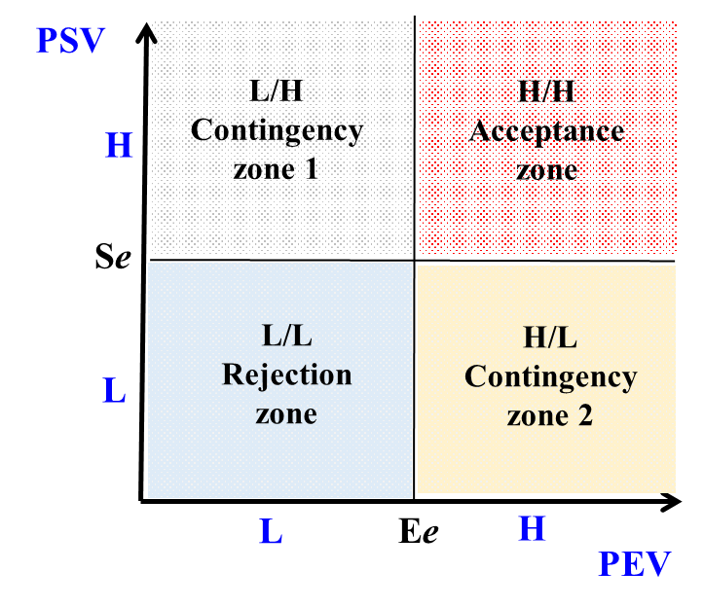
Figure 1: Initial construct of dual value model of transaction decision

In Figure 1, the "threshold of expected economic benefits (E_{e})" and the "threshold of expected social-emotional satisfaction (S_{e})" serve as the demarcation points that differentiate between high and low levels of PEV and PSV. When an individual assesses both PEV and PSV as high, engaging in the transaction with the counterparty is likely to bring dual satisfaction, both economically and socially, thus facilitating the completion of the transaction (within the acceptance zone in Figure 1). On the contrary, when both PEV and PSV are low, the transaction is unlikely to occur (within the rejection zone in Figure 1). Situated in the "high PEV/low PSV" or "low PEV/high PSV" contingency zones, individuals will decide whether to accept based on their internal psychological constructs, or under what conditions to accept the transaction. In contingency zone 1, where PSV is higher and PEV lower, individuals are in a "high personal favor dilemma" decision-making state (Huang, 1988; Huang & Hu, 2005; Zhu & He, 2008), where the economic benefit is low (specific benefit of this transaction is not high), but the social guanxi between parties is good (possibly due to past good relations or for future long-term dealings), making it difficult or inconvenient to refuse. In contingency zone 2, with lower PSV and higher PEV, individuals face a "low personal trust dilemma" decision-making state, despite the high economic benefit, due to insufficient understanding of the counterparty or past negative experiences, leading to a suspicion dilemma (Parks, Henager, & Scamahorn, 1996; Govier, 1998; Kramer & Cook, 2004; Evans & Krueger, 2014).
4.2 Modified dual value model
By further processing the contents of Figure 1, we can obtain a modified dual value model of individual transaction decision-making evaluation as shown in Figure 2. Figure 2 presents a concave curve towards the origin, with its slope at the intersection with the vertical axis (Y-axis) being the lowest, indicating that when an individual assesses the highest amount of PSV, their willingness to exchange PSV for PEV will be the lowest; similarly, when an individual has the most PEV, their willingness to exchange PEV for PSV will also be the lowest. In this transaction decision, PEV and PSV are interchangeable values, with a transaction being viable as long as acceptable conditions are met. The concavity of this indifference curve, similar to the "production possibility curve" concept (Lizondo, Johnson, & Yeh, 1981), suggests that both PEV and PSV are scarce resources (limited) for the individual, and these two values will not change in the expected transaction process (fixed technological constraints). The higher the PSV, the lower the willingness to use PEV (i.e. opportunity cost arises), and individuals' efficiency in combining these two values differs. Allocating more resources to the value with lower production efficiency will lead to an increased opportunity cost for using that value. This characteristic of diminishing marginal returns explains the concavity of the indifference curve. In the transformation process of the indifference curve in Figure 2, this research marks three areas: the rejection zone (RZ), the contingency zone (CZ), and the acceptance zone (AZ), with curves A and B representing two separate indifference curves for discrepancy. The conceptual content of these three areas is similar to the matrix diagram in Figure 1, but in addition to the previously mentioned two contingency zones, in real situations, there is also a contingency zone 3, where both PSV and PEV are of a moderate level, termed the "stuck in the middle dilemma." Normally, when individuals are in the contingency zone during typical transactional behaviors, they have more intent and need to exert effort; the rejection zone theoretically exists but is usually not worth the individual's effort to address, while the acceptance zone is an area of mutual satisfaction, requiring no effort to address.
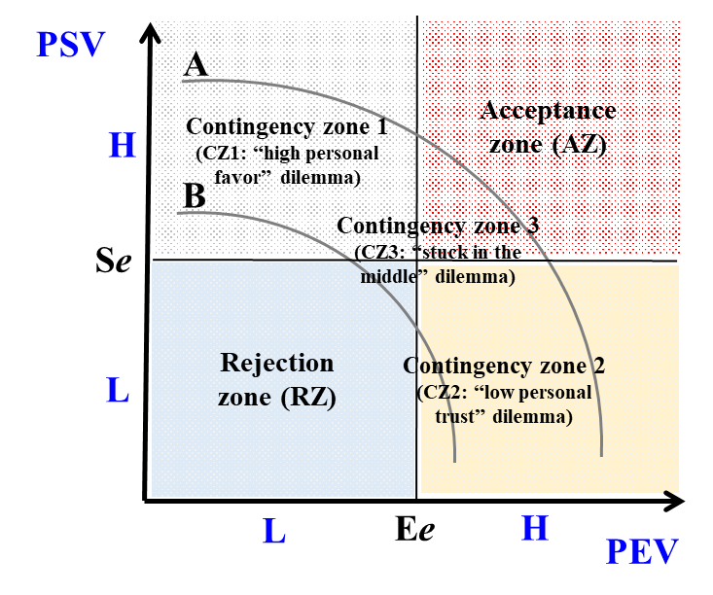
Figure 2: Modified dual value model of transaction decision-making

4.3 Marginal analysis of dual value model
Thus, in transaction decision-making, individuals need to exert resources mainly in the area between curves A and B, the contingency zones (CZ1 to CZ3). When the conditions of the concave indifference curve in the contingency zone reach a specific combination of PSV and PEV, the individual can accept the transaction (reaching curve A). In Figure 3, we can express this guanxi more precisely. For instance, point χ₁ indicates stronger social guanxi with the counterparty, higher PSV, but relatively lower PEV (i.e. the high personal favor dilemma in the CZ1), where individuals usually start by increasing PSV to facilitate the transaction's completion (at this time, ∆PSV₁<∆PEV₁, or ∆PSV₁/∆PEV₁ < 1), meaning changing ∆PSV₁ is easier to achieve (the change from χ₁ to χ₁₁ is smaller). On the other hand, the χ₂ point indicates that the economic benefits of the transaction itself are wishful and the PEV is relatively high, but the social guanxi between two parties is weak and thus the PSV is low. The transaction conditions and the execution of the commitments by both parties cannot be confirmed, so the transaction cost is higher (CZ2: ​​low personal trust dilemma), at this time the individual will tend to increase PEV to ensure the completion of the transaction (at this time ΔPEV₂ < ΔPSV₂, or ΔPEV₂ /ΔPSV₂ < 1), that is, to increase the value from χ₂ to χ₂₂ (i.e. changing ΔPEV₂) is smaller and easier to achieve. At the χ₃ point, it means that the individual is faced with a dilemma that is difficult to effectively evaluate. At this time, ΔPSV₃ and ΔPEV₃ have a nearly equal tradeoff relationship, that is, ΔPSV₃ /ΔPEV₃ ≈ 1, which means that the individual can start from PSV and PEV at the same time, but at this time, individuals may be stuck in the middle and are not like at χ₁ or χ₂ where they can have a clear direction of strategic approach.
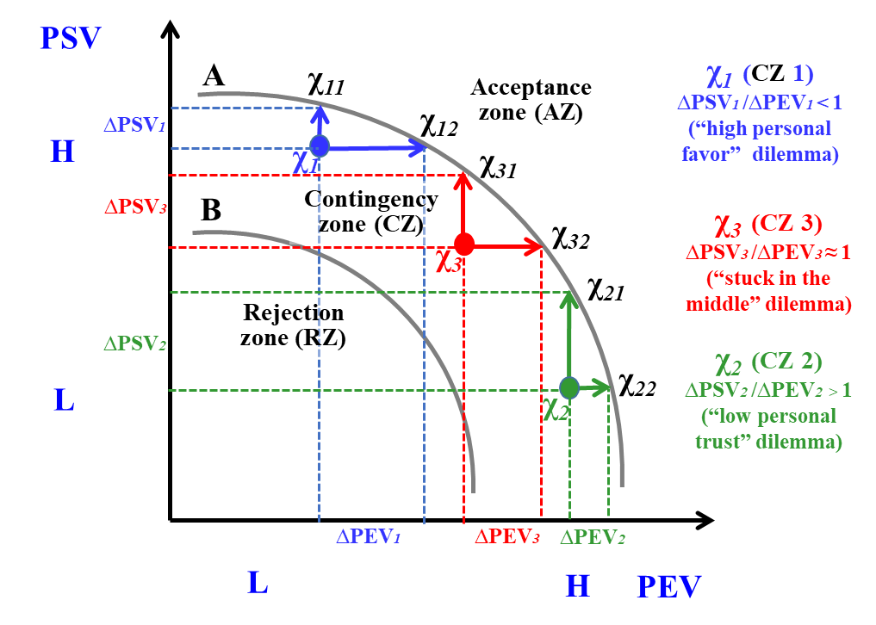
Figure 3: Marginal analysis of each contingency point/zone in the dual value model

4.4 Analysis of mark-ups and mark-downs
Due to the differential response of Chinese people to others, the processing and judgment of the same transaction will also vary from person to person. Especially in ethnic Chinese society, there is possibly a greater emphasis on PSV, sometimes even prioritizing it in decision-making, thus affecting people's decisions in each specific situational condition. From Figure 3, it is observable that points χ₁₁, χ₁₂, χ₂₁, χ₂₂, χ₃₁, and χ₃₂ all lie on the acceptance curve (indifference curve A), indicating scenarios where individuals can accept the transaction after a combined evaluation of the PSV and PEV. Marginal analysis at point χ₁ in the upper left of the diagram shows that when ∆PSV₁ < ∆PEV₁, more PEV is needed to substitute for less PSV. As for how people decide between PSV and PEV, that is, how much PEV they are willing to sacrifice for PSV in decision-making, is represented by the difference between them, termed as "Guanxi Mark-Down (GMD)," which denotes the "acceptable economic loss" individuals are willing to incur due to the counterparties' guanxi (Yen, 1989). Since χ₁₁ and χ₁₂ are points of acceptance and χ₁χ₁₂ − χ₁χ₁₁ > 0 which represents the economic interest portion individuals are willing to forego. Similarly, since χ₂₁ and χ₂₂ are points of acceptance, and χ₂χ₂₁ − χ₂χ₂₂ > 0, it indicates that the counterparty must increase ∆PSV₂ more for the individual to forfeit less ∆PEV₂, which means the individual gives a lower GMD under these contingent conditions.
Overall, in ethnic Chinese society, individuals tend to offer more GMD for counterparties with higher PSV; on the contrary, for counterparties with lower PSV, individuals tend to claim more economic benefits. The reasons for such decision reactions are twofold: one is the basic human mentality of pursuing benefits (demanding higher benefits involves less emotional pressure and risk at this moment), and the other is individuals' acts of "raising prices to compensate for benefits" to cover the overall GMD loss, ensuring the individual's total transactional interest. This behavior of claiming higher economic benefits for counterparties with lower PSV is termed "Compensatory Mark-Up (CMU)," denoting the individual's "claim for benefits" exceeding the original "expected interest (E_{e})" (Yen & Liao, 1995), as illustrated in Figure 4. Traditional transactional purchasing habits in ethnic Chinese society, such as "comparing at least three vendors (to acknowledge price differences)" and "buying from acquaintances (to reduce one's payment of CMU premium, enhancing the counterparty’s willingness to offer GMD)," hence often involve noticeable habits of purchasing through referrals or trusted channels. In other words, after an individual sets an expected economic interest (E_{e}) in a specific transaction decision, they consider offering higher GMD for some counterparties with higher PSV (as shown in Figure 4 with arrows pointing left above) and charging more CMU for some with lower PSV (as shown in Figure 4 with arrows pointing right below). This refined individual transaction decision model more accurately explains personal transactional habits in ethnic Chinese society, where the existence of GMD elucidates the substantial significance of "building personal guanxi networks," and the presence of CMU explains the psychological and behavioral response of "exerting to upsurge trust level to break away CMU." For an analysis of the tradeoffs between mark-ups and mark-downs, refer to the explanations in Figure 4.
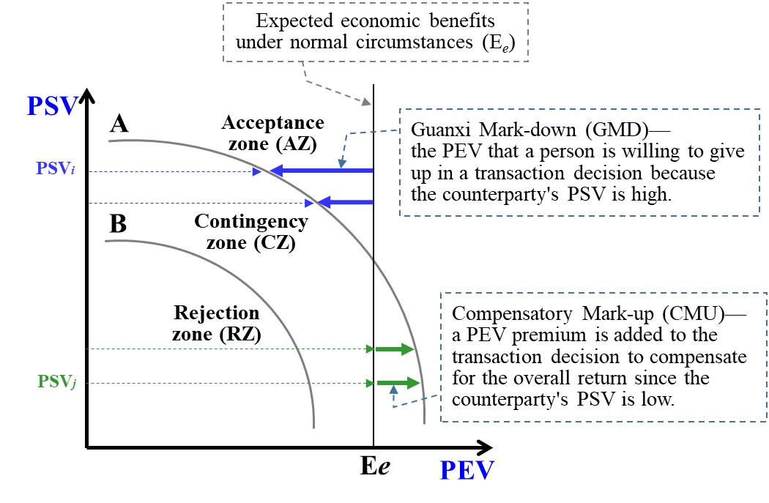
Figure 4: Analysis of mark-ups and mark-downs in the dual value model

4.5 Extended discussions on the dual value model
In addition to the aforementioned modified transaction decision dual value model and its related analyses, this research will also employ the initial model to explore several extended discussion topics, attempting to further integrate theoretical and practical aspects.
- Step-like indifference curves
This research analyzes using smooth and standard indifference curves as shown in Figure 4. If the counterparty has a higher PSV, as shown in upper part of Figure 4, the individual will provide more GMD, indicating that individual is willing to sacrifice more economic benefits to complete the transaction. On the contrary, when the counterparty's PSV is lower, the individual is more likely to demand better premium conditions (as shown in lower part of Figure 4), meaning the individual will demand a higher CMU to balance or even increase his own benefits. However, in real-world practice, these indifference curves are not smooth but step-like. In ethnic Chinese societies, individuals present varying step-like indifference curves for each counterparty based on the type of guanxi (determined by both vertical and horizontal aspects). The various step shapes also reflect the conventional as well as situational relationships between the trading parties, where the quality of guanxi, closeness, past experiences, future developments, and the absolute amount of economic benefits, all influence the shape of these indifference curves. Unlike Westerners, the shape of the curves for Chinese individuals is highly flexible, which does not indicate a lack of rationality but shows that Chinese consider the reasonableness of dual values in an adaptable manner.
- Indifference curves of quasi economically-oriented individuals and socially-oriented individuals
In the preceding discussion, this research analyzes from the perspective of standard indifference curves. However, in practice, the parties involved in a transaction are not purely economic or purely social beings (as described in the initial model constructed in Figure 1), but are more likely to be quasi economically-oriented individuals or quasi socially-oriented individuals. The former places a high value on economic benefits and is unlikely to make concessions unless facing a counterpart with profound guanxi; while the latter values social connections with their counterpart, with economic benefits being of relative lesser importance. This is further illustrated by the indifference curves of quasi economically-oriented and quasi socially-oriented individuals (as shown in Figures 5-1 and 5-2, respectively), where the C curve in Figure 5-1 and the D curve in Figure 5-2 represent the original standard transaction indifference curves (both figures are simplified diagrams), and the C’ curve in Figure 5-1 and the D’ curve in Figure 5-2 respectively represent the transaction curves of quasi economically-oriented and quasi socially-oriented individuals. In Figure 5-1, the greater distance between curves C and C’ in the upper left indicates the need for a higher PSV to reach the acceptance zone, while in the lower right, the small gap between the two curves suggests that quasi economically-oriented individuals have low elasticity in their PEV requirements and will not compromise if the target is not met. In Figure 5-2, the larger gap in the lower right indicates that, for quasi socially-oriented individuals, a significantly high PEV is required to overcome their commitment to social connections, whereas the low elasticity in PSV requirements in the upper left indicates a firm threshold for social connections. The explanation of these extended transaction indifference curves serves to provide a conceptual framework for observing different types of individuals in real life.

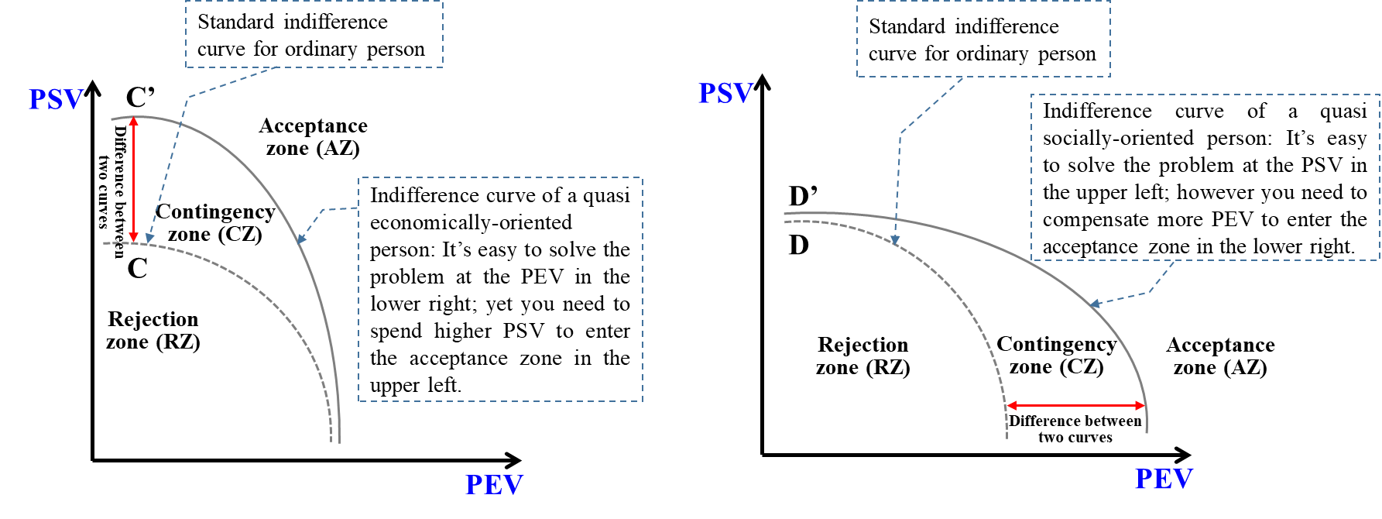

- Integrated analysis of quasi economically-oriented individuals and quasi socially-oriented individuals
The preceding Figures 5-1 and 5-2 illustrate the transaction decisions of individuals with tendencies towards being quasi-economic or quasi-social. When both parties are of the standard type, the modified dual value model from Figure 2 can be used for revelation, and marginal analysis from Figure 3 to suggest strategies for transaction decisions. When both parties are either quasi-economic or quasi-social, the strategic direction of their decisions essentially remains the same, albeit with differences in the absolute quantities of trade-offs involved. A more complex scenario arises when the transaction involves both quasi economically-oriented and quasi socially-oriented individuals simultaneously, necessitating an integrated analysis that accommodates both perspectives, as shown in Figure 6. In this simplified illustration, the overlapping of curves C’ and D’ outlines four zones, each representing different transactional dynamics compared to the concepts in Figures 1 and 2. Both the acceptance and rejection zones represent unanimous choices by both parties, but the zone in the upper left (zone around point χ_{a}) is where the quasi socially-oriented individual is agreeable, while the quasi economically-oriented individual faces a "high personal favor dilemma." Thus, the strategic recommendation involves the quasi socially-oriented individual actively addressing the PEV concerns of the quasi economically-oriented individual, moving from point χ_{a} rightwards to achieve a mutually acceptable outcome. Conversely, the zone in the lower right (zone around point χ_{b}) is where the quasi economically-oriented individual is agreeable, while the quasi socially-oriented individual faces a "low personal trust dilemma." Here, the strategy involves the quasi economically-oriented individual initiating actions to enhance the PSV of the quasi socially-oriented individual, moving from point χ_{b} upwards to reach a consensus. Although both parties can adopt proactive strategies, from a rational standpoint, the party already within the acceptance zone is more motivated to facilitate the completion of the transaction, unless they harbor hidden agendas or deceptive intentions.
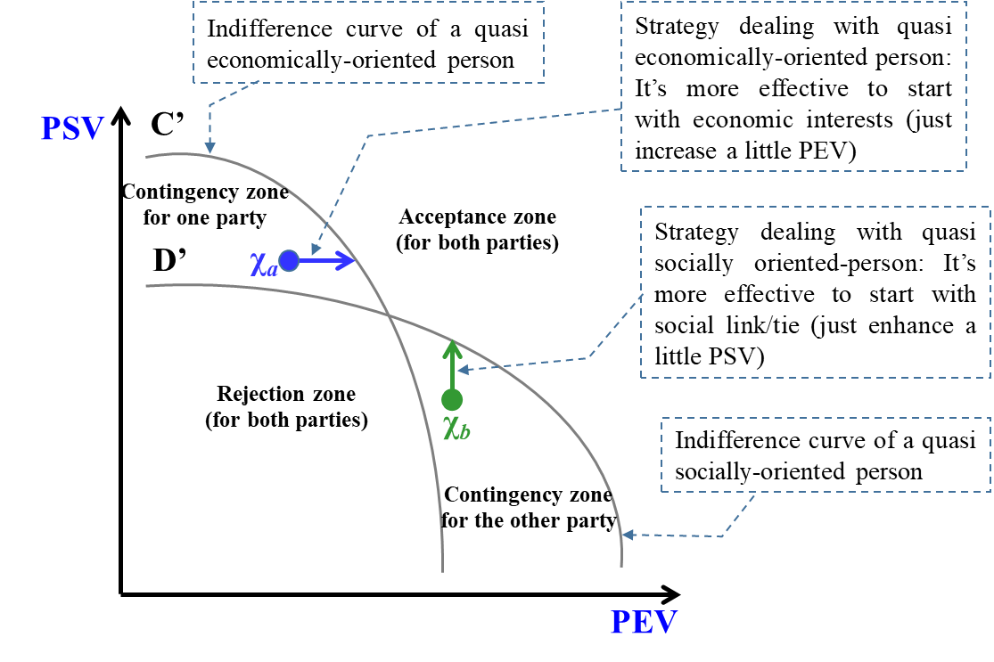
Figure 6: Integrated analysis for two different oriented individuals in the dual value model

- Conclusion and Recommendations
This research primarily focuses on illustrating under the specific socio-cultural foundation of ethnic Chinese society, interpersonal relationships have a justifiable and profound influence, with interpersonal relationship itself possessing inherent value and priority in individual transaction decisions. From the perspective of Western economics or sociology, economics emphasizes rationality and excludes the factor of "variable people in real life" in the process of transactions; whereas sociology, when discussing interpersonal relationships, tends to lean towards Universalistic protocol rather than Particularistic norm. In contrast, Chinese culture places special emphasis on human relationships (the Five Cardinal Relationships: five types of dyadic role relationships) and corresponding normative behaviors (the Ten Righteousness: ten types of appropriate behavior in each specific role), thus in transaction relationships, the specific "individual" factor is valued, considering the vertical hierarchy and horizontal intimacy of the relationship with the other party to determine the type of guanxi and its corresponding inherent value. The concept of guanxi in general Chinese cultural studies emphasizes the degree of closeness and trust on a horizontal level, whereas this research considers both the vertical hierarchy and horizontal intimacy in guanxi types in transaction decisions, forming the unique inherent value of that "particular individual," which marks a fundamental difference of this research. In practical operations within ethnic Chinese society, outside this scope of guanxi type, a rational self-interested instrumental attitude is inclined to be adopted.
Therefore, this research emphasizes that individual transaction decisions are differently influenced by the combined potential values of both the transaction counterparty and the transaction itself, requiring careful and particular treatment. From a Western Christian perspective, humans are created in God's own image, suggesting that men are created equal, hence, each individual is considered independent and equal in religious beliefs. However, in Confucian traditional culture, no one exists in isolation but is defined through relationships with others, defining appropriate rites and behaviors through various vertical and horizontal relationships. More directly, while Western theory analyzes individual (as the unit of analysis) and emphasizes universal moral norms, Chinese analysis starts from dyadic role relationships, hence the five dyadic role relationships, emphasizing ethical norms for different and particular responses, thus diverse appropriate behaviors for ten roles. Weber thus believed that the Chinese lack a unified personality (Hamilton & Hamilton, 1998); he felt that the Chinese have different expressions and statements for the same thing depending on the other person, seeming chaotic and disordered. However, the viewpoint of this research is that in ethnic Chinese society, different situations naturally have different appropriate behaviors, fitting into rites. In other words, the chaos under the Western view of equal individuals is orderly under the Chinese dyadic view, showing consistent normative behavior towards different types of guanxi.
Hence, in constructing the DVM, this research discusses the phenomenon of Particularism in ethnic Chinese society from the perspective of Expectancy Theory, that is, the power and social status of the transaction counterparty (vertical interpersonal hierarchy), and the emotional and trust relationship between the parties (horizontal interpersonal intimacy), representing the PSV of the counterparty to oneself; while the economic rewards and success probability of the transaction itself represent the PEV. Since both hold potential values in transaction decisions for Chinese people, they present a relationship of ambidexterity and trade-offs, explaining why in ethnic Chinese society, one might demand different economic benefits from different counterparties (this research does not take account of illegal or deceptive actions), and in most cases, it is considered natural and fitting into social norms, and this GMD represents the acceptable economic loss for an individual in that transaction, differing from the concept of cash or quantity discounts. On the other hand, one tends to demand a higher premium from counterparties with low PSV, in other words, he demands more CMU to compensate for others' GMD. This research analyzed these concepts and constructed a model of transaction decisions, attempting to describe the essence of Chinese transaction decisions based on the overall trade-off relationship between these two values, capturing the “universal essence of these particularistic behaviors,” and providing recommendations for Chinese people in making transaction decisions.
In terms of strategic recommendations, under general standardized conditions of indifference curves, marginal analysis in Figure 3 can assist in making transaction decisions; however, under combinations of economically-oriented and socially-oriented individuals, decision analysis should be conducted through the concept in Figure 6. Essentially, for both parties to complete a transaction, it is necessary to enhance the social emotional satisfaction (vertical upward shift) and/or the economic benefits (horizontal rightward shift) available to the other party. Initially, at least, the relationship between the two parties should be elevated above the rejection zone, entering the contingent zone to increase the chances of a successful transaction, or else it should be abandoned. This research identifies three contingent zones, corresponding to three different strategic recommendations, utilizing these methods to position oneself within the counterparty's acceptance zone, thus enabling the transaction to be completed smoothly. Therefore, if the transaction counterparty is socially-oriented, entering their acceptance zone smoothly during the transaction process requires spending considerable time and economic cost on building social and emotional relationships. Once the relationship is established, if one's position enters the acceptance zone in the counterparty's mind, the chance of a successful transaction significantly increases. Furthermore, once the guanxi is stable, it also positively affects subsequent transaction behaviors, as both parties no longer need to spend time and effort on collecting and evaluating information, thereby helping to reduce future transaction costs and improve efficiency. Taiwanese enterprises have always been known for their hard work and flexibility, a significant part of which is based on the entrepreneurs' personal networks. Therefore, if the transaction relationship is long-term, regardless of whether for the buyer or seller, establishing and maintaining a good social connection (through trust and commitment to ensure flexibility) will be greatly beneficial to both enterprises and individuals' operations. These cases have played a substantial yet unspoken role in past SMEs’ (small and medium-sized enterprises’) collaborative networks, industrial clusters, to the current industrial chains. Similarly, citing Weber's perspective, the legitimacy basis of PEV lies in the calculation of economic rationality (possessing logical and consistent formal rationality), while the legitimacy basis of PSV lies in traditional customs and norms, which are implicitly accepted standards or tacit rules in society (corresponding with substantive rationality aligned with ultimate value systems). Starting from the type of interpersonal guanxi and considering both types of inherent values might offer a higher explanatory power for transaction decisions in ethnic Chinese society. The semi-quantitative model constructed in this research is a starting point, hoping that subsequent research can develop some detailed indicators to facilitate quantitative analysis of PSV, providing a method to measure economically-oriented individuals and socially-oriented individuals, thereby promoting the achievement of transactions.

References
[1] Adler, N. J., & Aycan, Z. (2018). Cross-cultural interaction: What we know and what we need to know. Annual Review of Organizational Psychology and Organizational Behavior, 5, 307-333.
[2] Adler, N. J., & Bartholomew, S. (1992). Managing globally competent people. Academy of Management Review, 6(3), 52-65.
[3] Baldwin, D. A. (1978). Power and social exchange. American Political Science Review, 72(4), 1229-1242.
[4] Balliet, D., Mulder, L. B., & Van Lange, P. A. (2011). Reward, punishment, and cooperation: a meta-analysis. Psychological bulletin, 137(4), 594.
[5] Barbalet, J. (2017). Dyadic characteristics of guanxi and their consequences. Journal for the Theory of Social Behaviour, 47(3), 332-347.
[6] Barbalet, J. (2021). The Theory of Guanxi and Chinese Society. Oxford University Press.
[7] Bedford, O. A. (2004). The individual experience of guilt and shame in Chinese culture. Culture & Psychology, 10(1), 29-52.
[8] Bedford, O., & Hwang, K. K. (2003). Guilt and shame in Chinese culture: A cross‐cultural framework from the perspective of morality and identity. Journal for the Theory of Social Behaviour, 33(2), 127-144.
[9] Blau, P. M. (1962). Operationalizing a conceptual scheme: The universalism-particularism pattern variable. American Sociological Review, 159-169.
[10] Blau, P. M. (1964). Exchange and Power in Social Life. Piscataway.
[11] Bond, M. H. (1993). Emotions and their expression in Chinese culture. Journal of Nonverbal Behavior, 17, 245-262.
[12] Carnevale, P. J., & Pruitt, D. G. (1992). Negotiation and mediation. Annual Review of Psychology, 43(1), 531-582.
[13] Chen, J. X. (1994). Collaborative Networks and Life Structure: Socio-Economic Analysis of Small and Medium Enterprises in Taiwan. Linking Publishing Company. (in Chinese)
[14] Cook, K. S., & Emerson, R. M. (1978). Power, equity and commitment in exchange networks. American Sociological Review, 721-739.
[15] De Dreu, C. K. (2014). Negotiating deals and settling conflict can create value for both sides. Policy Insights from the Behavioral and Brain Sciences, 1(1), 156-163.
[16] Emerson, R. M. (1976). Social exchange theory. Annual Review of Sociology. 2:335-362.
[17] Evans, A. M., & Krueger, J. I. (2014). Outcomes and expectations in dilemmas of trust. Judgment and Decision making, 9(2), 90-103.
[18] Fan, Y. (2002). Questioning guanxi: definition, classification and implications. International Business Review, 11(5), 543-561.
[19] Fang, T. (2003). A critique of Hofstede’s fifth national culture dimension. International Journal of Cross Cultural Management, 3(3), 347-368.
[20] Fei, X. T. (2020 [1946]). From the Soil: The Foundations of Chinese Society. RuShi Culture Company. (in Chinese)
[21] Fischoff, E. (1944). The Protestant ethic and the spirit of capitalism: the history of a controversy. Social Research, 53-77.
[22] Foa, E. B., & Foa, U. G. (1980). Resource theory: Interpersonal behavior as exchange. Social Exchange: Advances in Theory and Research, 77-94.
[23] Foa, E. B., & Foa, U. G. (2012). Resource theory of social exchange. Handbook of Social Resource Theory: Theoretical Extensions, Empirical Insights, and Social Applications, 15-32.
[24] Gerlach, P., & Eriksson, K. (2021). Measuring cultural dimensions: external validity and internal consistency of Hofstede's VSM 2013 Scales. Frontiers in Psychology, 12, 662604.
[25] Giordano, P. J. (2017). Individual personality is best understood as process, not structure: A Confucian-inspired perspective. Culture & Psychology, 23(4), 502-518.
[26] Gold, T., Guthrie, D., & Wank, D. (2002). An introduction to the study of guanxi. Social Connections in China: Institutions, Culture, and the Changing Nature of Guanxi, 3.
[27] Govier, T. (1998). Dilemmas of Trust. McGill-Queen's Press-MQUP.
[28] Hamilton, M. B., & Hamilton, M. B. (1998). Chinese religions: Confucianism and Taoism. Sociology and the World’s Religions, 108-132.
[29] Hofstede, G. (1980). Culture’s Consequences: International Differences in Work-related Values. Beverly Hills, CA: Sage.
[30] Hofstede, G. (2011). Dimensionalizing cultures: The Hofstede model in context. Online Readings in Psychology and Culture, 2(1), 8.
[31] Homans, G. C. (1958). Social behavior as exchange. American Journal of Sociology, 63(6), 597-606.
[32] Huang, G. G., & Hu, X. J. (2005). Favor and face: The power game of the Chinese. Leadership Digest, (7), 162-166. (in Chinese)
[33] Huang, G. G., (1988). Favor and face: The power game of the Chinese. The Power Game of the Chinese, 7-55. (in Chinese)
[34] Kelly, G. A. (2017). A brief introduction to personal construct theory. Costruttivismi, 4, 3-25. doi:10.23826/2017.01.003.025
[35] Koleśnik, K. (2013). The role of culture in accounting in the light of Hofstede's, Gray's and Schwartz's cultural dimensions theories: A literature review. E-Finanse: Financial Internet Quarterly, 9(3), 33-41.
[36] Kopelman, R. E., Prottas, D. J., & Falk, D. W. (2012). Further development of a measure of Theory X and Y managerial assumptions. Journal of Managerial Issues, 450-470.
[37] Kramer, R. M., & Cook, K. S. (Eds.). (2004). Trust and Distrust in Organizations: Dilemmas and Approaches. Russell Sage Foundation.
[38] Lapsley, D. K., & Stey, P. C. (2011). Id, ego, and superego. Encyclopedia of Human Behavior, 2.
[39] Lee, D. Y., & Dawes, P. L. (2005). Guanxi, trust, and long-term orientation in Chinese business markets. Journal of International Marketing, 13(2), 28-56.
[40] Li, J., Wang, L., & Fischer, K. (2004). The organisation of Chinese shame concepts. Cognition and emotion, 18(6), 767-797.
[41] Li, M. Z. (1993). Understanding the boundaries of self-other relationships in Chinese culture through research on fairness judgments. Indigenous Psychological Research, (1), 267-300. (in Chinese)
[42] Lizondo, J. S., Johnson, H. G., & Yeh, Y. H. (1981). Factor intensities and the shape of the production possibility curve. Economica, 48(190), 199-202.
[43] Lu, L., & Gilmour, R. (2004). Culture and conceptions of happiness: Individual oriented and social oriented SWB. Journal of Happiness Studies, 5, 269-291.
[44] Luo, Y. (1997). Guanxi: Principles, philosophies, and implications. Human Systems Management, 16, 43-52.
[45] Luo, Y. (2000). Guanxi and Business. Asia-Pacific Business Series.
[46] Ma, R. (2007). The pattern of differences in order. Interpretation of the Structure of Traditional Chinese Society and Chinese Behavior, 2. (in Chinese)
[47] McGregor, D. (1960). Theory X and theory Y. Organization Theory, 358(374), 5.
[48] Michie, S., Johnston, M., Abraham, C., Lawton, R., Parker, D., & Walker, A. (2005). Making psychological theory useful for implementing evidence based practice: a consensus approach. Quality & Safety in Health Care, 14(1), 26.
[49] Orth, U., & Robins, R. W. (2014). The development of self-esteem. Current Directions in Psychological Science, 23(5), 381-387.
[50] Parks, C. D., Henager, R. F., & Scamahorn, S. D. (1996). Trust and reactions to messages of intent in social dilemmas. Journal of Conflict Resolution, 40(1), 134-151.
[51] Parsons, T. (1949). The structure of social action (Vol. 491). New York: Free press.
[52] Parsons, T. (1960). Pattern variables revisited: A response to Robert Dubin. American Sociological Review, 467-483.
[53] Porter, L. & Lawler, E. (1968), Managerial Attitudes and Performance, Homewood, Ill: Irwin Dorsey
[54] Pye, L. (1968). Hostility and authority in Chinese politics. Probs. Communism, 17, 10.
[55] Qi, X. (2013). Guanxi, social capital theory and beyond: Toward a globalized social science. The British Journal of Sociology, 64(2), 308-324.
[56] Sangren, P. S. (1984). Traditional Chinese corporations: beyond kinship. The Journal of Asian Studies, 43(3), 391-415.
[57] Sato, Y., Burawoy, M., Chang, M., & Hsieh, M. F. (2010). Are Asian sociologies possible? Universalism versus particularism. Facing an Unequal World: Challenges for a Global Sociology, 2, 192-200.
[58] Sciulli, D., & Gerstein, D. (1985). Social Theory and Talcott Parsons in the 1980. Annual Review of Sociology, 11(1), 369-387.
[59] Soares, A. M., Farhangmehr, M., & Shoham, A. (2007). Hofstede's dimensions of culture in international marketing studies. Journal of Business Research, 60(3), 277-284.
[60] Sorenson, R. L., Morse, E. A., & Savage, G. T. (1999). A test of the motivations underlying choice of conflict strategies in the dual‐concern model. International Journal of Conflict Management, 10(1), 25-44.
[61] Tsui, A. S., & Farh, J. L. L. (1997). Where guanxi matters: Relational demography and guanxi in the Chinese context. Work and occupations, 24(1), 56-79.
[62] Vroom, V. H. (1964). Work and Motivation. New York, NY: Wiley & Sons.
[63] Vroom, V., Porter, L., & Lawler, E. (2015). Expectancy theories. Organizational Behavior, 1, 94-113.
[64] Weber, M., & Kalberg, S. (2013). The Protestant Ethic and the Spirit of Capitalism. Routledge.
[65] Wei, J. T. (1992). A Study on the Influence of Interpersonal Relationship Types on Individual Behavioral Orientation, Master's Thesis, Department of Business Administration, Chung Yuan Christian University. (in Chinese)
[66] Wen, C.Y. (Ed.). (1990). Chinese People: Concepts and Behavior. Taipei: Juliu Publishing.
[67] Wong, A. L. Y., Shaw, G. H., & Ng, D. K. (2010). Taiwan Chinese managers' personality: is Confucian influence on the wane? The International Journal of Human Resource Management, 21(7), 1108-1123.
[68] Wu, M. (2006). Hofstede's cultural dimensions 30 years later: A study of Taiwan and the United States. Intercultural Communication Studies, 15(1), 33.
[69] Yan, Y. X. (2006). The differential mode of association and the concept of hierarchy in Chinese culture. Sociological Research, 4, 201-213. (in Chinese)
[70] Yang, C. F. (1993). On how to deepen indigenous psychology research: Including a review of current research achievements. Indigenous Psychological Research, (1), 122-183. (in Chinese)
[71] Yang, K. S., & Bond, M. H. (1990). Exploring implicit personality theories with indigenous or imported constructs: The Chinese case. Journal of Personality and Social Psychology, 58(6), 1087.
[72] Yen, G. F. (1992a). Preliminary exploration of establishing management theories: Themes and methodologies in behavioral science, Proceedings of the 4th Republic of China Management Education Conference, Taipei: National Chengchi University, 613-626. (in Chinese)
[73] Yen, G. F. (1992b). Psychological Positioning Theory - An Exploration of National Character and Its Implications for Management, Taipei: National Science Council Special Research, November 1992. (in Chinese)
[74] Yen, G. F., & Liao P. C. (1995). A study on the impact of interpersonal relationships on indigenous individual business transaction behavior - A trade-off decision-making model of the potential values of social transaction and economic transaction, Chung Yuan Journal, 23, 35-42. (in Chinese)
[75] Yen, G. F., Zhuo, M. D., & Lee Y. C. (2014). A study on the relationship between leader positioning, leadership behavior, and subordinate satisfaction with supervisors: A contextual perspective of Chinese dyadic relations. Journal of Strategy and Management, 6(2), 105-132. (in Chinese)
[76] Zhang, D. S., & Jin, Y. J. (1999). Confucian merchants study: Confucian ethics and modern society. Sociological Research, 3, 37-47. (in Chinese)
[77] Zhu, H., & He, X. (2008). The emotional dilemmas of family businesses. Entrepreneurs World: Mid-Monthly, (001), 66-66. (in Chinese)
[78] Zhuo, M. D., Yen, G. F., Hong, Z. K., & Lee, Y. C. (2018). Soldiers follow the commander: Exploring follower behavior from a follower positioning perspective. Organization and Management, 11(1), 33-62. (in Chinese)

Honorary Professor, Department of Business Administration, Chung Yuan Christian University, Taiwan.
Ph.D. Candidate, Department of Business Administration, Chung Yuan Christian University, Taiwan.

