FISCAL POLICY AND ECONOMIC GROWTH: NIGERIA PERSPECTIVE

IFEOMA MARIA IHEGBORO Ph.D.

Department of Banking and Finance, Faculty of Business Administration, University of Nigeria, Enugu Campus.

ABSTRACT
This study examined the impact of fiscal policy instrument on economic growth in Nigeria using time series annual data from 2010-2019 which constitutes 9 years observations. This study used secondary data obtained from the CBN annual statistical bulletin. Fiscal policy instrument was proxied with government recurrent expenditure, government capital expenditure, public domestic debt, and public external debt while economic growth was proxied with Gross Domestic Product (GDP). The data were analysed using Ordinary Least Square method and vector error correction mechanism was conducted. The study found that recurrent expenditure and public domestic debt exert negative relationship while the capital expenditure and external debt exert positive relationship in the long run on the economic growth (GDP) and in the short-run the entire variables are having positive influence except REC (recurrent expenditure) on the economic growth (GDP). The study recommends that the government should put in place effective debt management strategies and fight the problem of corruption because without a reduction of the level of corruption in the country, fiscal policy components will not achieve the required level of economic growth in Nigeria.
Keywords: Recurrent Expenditure, Capital Expenditure, Public Domestic Debt, Public External Debt

1. INTRODUCTION
Fiscal policy is the means by which a government adjusts its level of spending to monitor and influence a nation’s economy. It is used along with the monetary policy, which the central bank uses to influence money supply in a nation. These two policies are used to achieve macroeconomic goals in a nation. These goals include price stability, full employment, reduction of poverty levels, high and sustainable economic growth, favorable balance of payment, and reduction in a nation’s debt. Nigeria’s potential for growth and poverty reduction is yet to be realized. A key constraint has been the recent conduct of macroeconomics, particularly fiscal and monetary policies. This has led to rising inflation and decline in real incomes.
National economic management became a Herculean task as the economy has to contend with volatility of revenue and expenditure. The widespread lack of fiscal discipline was further exacerbated by poor co-ordination of fiscal policy among the three tiers of government. Also, there is a weak revenue base arising from high-marginal tax rate with very narrow tax base, resulting in low tax compliance. As a result of these and other factors, serious macroeconomic imbalances have emerged in Nigeria.
A review of these macroeconomic indices shows that inflation has accelerated to double-digit levels in 2000 and 2001. It increased from 6.94 to 18.87, respectively. This double-digit inflation continued up to 2005, and decreased to single digit in 2006 and 2007. In 2008, the inflation rate reverted to double digit (11.58) and continued to increase, and in 2010, it was 13.72% (International Monetary Fund [IMF], 2011). Unemployment is a major political and economic issue in most countries. In Nigeria, the years of corruption, civil war, military rule, and mismanagement have hindered economic growth of the country.
Nigeria is endowed with diverse and huge resources both human and material. However, years of negligence and adverse policies have led to the udder-utilization of these resources (Economic Watch, 2010), and this has contributed to the increasing unemployment rate in Nigeria. In 2000, the unemployment rate was 13.1%, and 21.10% in 2010. On the average, there has been an upward trend (CBN, 2005, 2006, 2009; Nigerian Bureau of Statistics, 2010).
The use of government revenues and expenditures to influence macroeconomic variables developed as a result of the Great Depression when the previous laissez-faire approach to economic management became discredited. Fiscal policy is based on the theories of the British economist John Maynard Keynes, whose Keynesian economics indicated that government changes in the levels of taxation and government spending influences aggregate demand and the level of economic activity.
Fiscal and monetary policy are the key strategies used by a country’s government and central bank to advance its economic objectives. The combination of these policies enables these authorities to target the inflation (which is considered “healthy” at the level in the range of 2%-3%) and to increase employment. Additionally, it is designed to try to keep GDP growth at 2%-3% and the unemployment rate near, the natural unemployment rate of 4%-5%. This implies that fiscal policy is used to stabilize the economy over the course of the business cycle.
Fiscal Policy as a tool of macroeconomic management used by the government to control the economy via its revenue and expenditure portfolios is an important concept in economics. The revenue portfolio consists of components like tax revenue, trade surplus, and foreign aid, while the expenditure portfolio consists of recurrent and capital expenditure. In other words, fiscal policy is the government’s deliberate actions towards spending money and for levying taxes aimed at influencing macro-economic variables so as to achieve desired macroeconomic objectives. The relationship between fiscal policy and economic growth has been discussed extensively in the literature using empirical analysis.
According to Tanzi and Zee (2017), there are three cardinal indicators of fiscal policy government expenditure, taxes, and deficits. There have been macroeconomic imbalances of varying degrees in Nigeria. Inappropriate public expenditure and revenue policies, a large deficit• in the public sector have been identified by experts as responsible for the macroeconomic disequilibrium (Ajisafe and Folorunso, 2015). Evidence reveals that there was a substantial increase in government spending, primary deficit, and debt in Nigeria between 1991 and 2005 (CBN Statistical Bulletin, 2012).
This was a result of the oil windfall between 1991 and 1992 which was followed by rapid growth in government spending with an average of about 21 percent of GDP during that period. However, as the oil market weakened in subsequent years, oil receipts were not adequate to meet increasing levels of demands and expenditures as being reinforced by political pressures.
Although the democratically-elected government in 1999 adopted policies to restore fiscal discipline, the rapid monetization of foreign exchange earnings between 2000 and 2004 and another era of oil windfall resulted in large increases in government spending. In 2005 alone, the government spending alone increased to 19 percent of GDP from 14 percent in 2000, extraordinary budgetary outlays not initially included in the budget increased (CBN Statistical Bulletin, 2012).
The growth and development of the Nigerian economy have not been stable over the years. As a result, the country’s economy has witnessed so many shoks and disturbances both internally and externally over the decades. Internally, the unstable investment and consumption patterns, as well as the improper implementation of public policies, changes in future expectations, and the accelerator, are some of the factors responsible for1 it. Similarly, the external factors identified are wars, revolutions, population growth rates and migration, technological transfer and changes, as well as the openness of the country’s economy are some of the factors responsible. Fiscal policy is a major economic stabilization weapon that involves measures taken to regulate and control the volume, cost, and availability, as well as direction of money in an economy to achieve some specified macroeconomic policy objective and to counteract undesirable trends in the Nigerian economy (Gbosi, 2016).
Therefore, economic stabilization cannot be left to the market forces of demand and supply and as well, other instruments of stabilization such as monetary and exchange rate policies among others, are used to counteract the problems identified (Ndiyo and Udah, 2013). This may include either an increase or a decrease in taxes, government expenditures, as well as public debt which Constitute the bedrock of fiscal policy but in reality, government policy requires a mixture of both fiscal and monetary policy instruments to stabilize an economy because none of these single instruments can cure all the problems in an economy (Ndiyo and Udah, 2013).

2. Literature Review
Empirical Review
Researchers have attempted to examine the effect of fiscal policy on economic growth in different countries and periods, using different techniques. Amongst many others are the following:
Khosravi and Karimi (2010) studied the relationship between monetary policy, fiscal policy, and economic growth in Iran for the period 1960 to 2006 using Autoregressive Distributed Lag (ARDL) cointegration approach and they found out that the impact of exchange rate and inflation on growth was negative, but government expenditure was found to have a significant positive impact on growth.
Olawunmi and Tajudeen (2007) used so low growth model and ordinary least squares method in analyzing the impact of fiscal policy on the Nigerian economic growth between 1981 and 2004, they found out that there is no significant impact of fiscal policy variables on economic growth in Nigeria.
Onyemaechi (2014) studied the impact of fiscal policy components on economic growth in Nigeria using Augmented Dickey-Fuller (ADF) test model and cointegration test and he found out that government expenditure on economic services and transfer payments have not yielded positive results as regards economic growth in Nigeria though statistically insignificant, expenditures on administration as well as social and community services yielded positive results in improving economic growth in Nigeria.
Ozougwo (2012) assessed the impact of fiscal policy on the economic growth of Nigerian for the period 1978 to 2011 using the Augmented Dickey-Fuller (ADF) test of stationarity and granger causality test. The result showed that taxation has an insignificant negative influence on economic growth although it granger causes economic growth. On the other hand, deficit financing revealed an insignificant positive effect and a bi-directional causality on economic growth while government expenditure has an indisputable, significant, and positive effect (but lacks causality) on economic growth in Nigeria.

3. Methodology
The study adopted an ex-post facto design as it dealt with data that has already been compiled.
EG = f(FIS. POL)
Where EG = Economic growth proxied by Gross Domestic Product (GDP)
FIS.POL = Fiscal Policy proxied by Government Expenditure, Government Revenue and Total Debt.
The Model for test of the individual hypothesis and in line with the Autoregressive Distributed Model form of regression is presented thus:
Hypothesis One
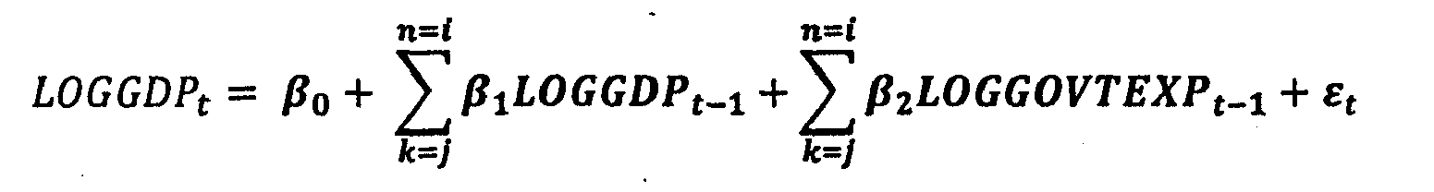
Where.
GDP = Gross Domestic Product
GOVTEXP =Government Expenditure
β₂,β2 = Coefficients of the explanatory variables
β₀ = Constant term or the intercept
ε = Error term
Hypothesis Two
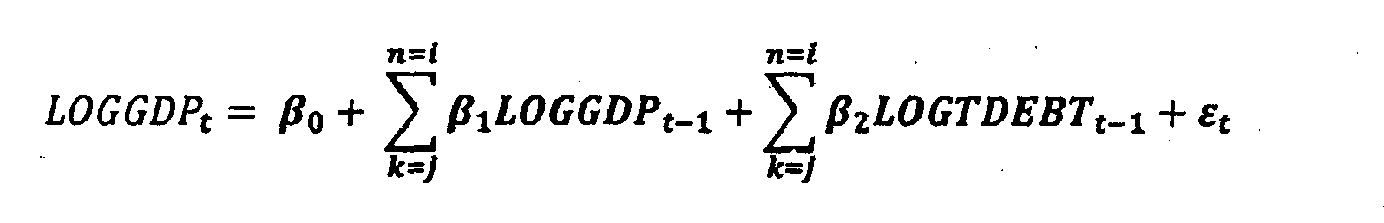
Where
GDP = Gross Domestic Product
TDEBT Total Debt
β₂ , β₂ = Coefficients of the explanatory variables
βo = Constant term or the intercept
ε = Error term
Hypothesis Three
Where
GDP Gross Domestic Product
GREY = Government Revenue
β₂, β₂ = Coefficients of the explanatory variables
β₀ = Constant term or the intercept
ε = Error term

4. Result and Discussion
Data Presentation
Table 4.1: Data were presented in accordance with study variable both dependent and independent variables.
YEAR | GREV | GEXP | GDP | EXTDEBT | DDEBT | TDBT
1981 | 13.29 | 11.41 | 144.83 | ‘2.33 | 11.19 | 13.52
1982 | 11.43 | 11.92 | 154.98 | 8.82 | 15.01 | 23.83
1983 | 10.51 | 9.64 | 163.00 | 10.58 | 22.22 | 32.80
1984 | 11.25 | 9.93 | 170.38 | 14.81 | 25.67 | 40.48
1985 | 15.05 | 13.04 | 192.27 | 17.30 | 27.95 | 45.25
1986 | 12.60 | 16.22 | 202.44 | 41.45 | 28.44 | 69.89
1987 | 25.38 | 22.02 | 249.44 | 100.79 | 36.79 | 137.58
1988 | 27.60 | 27.75 | 320.33 | 133.96 | 47.03 | 180.99
1989 | 53.87 | 41.03 | 419.20 | 240.39 | 47.05 | 287.44
1990 | 98.10 | 60.27 | 499.68 | 298.61 | 84.09 | 382.71
1991 | 100.99 | 66.58 | 596.04 | 328.45 | 116.20 | 444.65
1992 | 190.45 | 92.80 | 909.80 | 544.26 | 177.96 | 722.23
1993 | 192.77 | 191.23 | 1,259.07 | 633.14 | 273.84 | 906.98
1994 | 201.91 | 160.89 | 1,762.81 | 648.81 | 407.58 | 1,056.40
1995 | 459.99 | 248.77 | 2,895.20 | 716.87 | 477.73 | 1,194.60
1996 | 523.60 | 337.22 | 3,779.13 | 17.32 | 419.98 | 1,037.30
1997 | 582.81 | 428.22 | 4,111.64 | 595.93 | 501.75 | 1,097.68
1998 | 463.61 | 487.11 | 4,588.99 | 633.02 | 560.83 | 1,193.85
1999 | 949.19 | 947.69 | 5,307.36 | 2,577.37 | 794.81 | 3,372.18
2000 | 1,906.16 | 701.05 | 6,897.48 | 3,097.38 | 898.25 | 3,995.63
2001 | 2,231.60 | 1,018.00 | 8,134.14 | 3,176.29 | 1,016.98 | 4,193.27
2002 | 1,731.84 | 1,018.18 | 11,332.25 | 3,932.88 | 1,166.00 | 5,098.89
2003 | 2,575.10 | 1,225.99 | 13,301.56 | 4,478.33 | 1,329.68 | 5,808.01
2004 | 3,920.50 | 1,426.20 | 17,321.30 | 4,890.27 | 1,370.33 | 6,260.59
2005 | 5,547.50 | 1,822.10 | 22,269.98 | 2,695.07 | 1,525.91 | 4,220.98
2006 | 5,965.10 | 1,938.00 | 28,662.47 | 451.46 | 1,753.26 | 2,204.72
2007 | 5,727.51 | 2,450.90 | 32,995.38 | 438.89 | 2,169.63 | 2,608.52
2008 | 7,866.60 | 3,240.82 | 39,157.88 | 523.25 | 2,320.31 | 2,843.56
2009 | 4,844.59 | 3,452.99 | 44,285.56 | 590.44 | 3,228.03 | 3,818.47
2010 | 7,303.67 | 4,194.58 | 54,612.26 | 689.84 | 4,551.82 | 5,241.66
2011 | 11,116.85 | 4,712.06 | 62,980.40 | 96.85 | 5,622.84 | 6,519.69
2012 | 10,654.75 | 4,605.39 | 71,713.94 | 1,026.90 | 6,537.53 | 7,564.43
2013 | 9,759.79 | 5,185.32 | 80,092.56 | 1,387.33 | 7,118.97 | 8,506.30
2014 | 10,068.85 | 4,587.39 | 89,043.62 | 1,631.50 | 7,904.02 | 9,535.52
2015 | 6,912.50
2016 | 5,616.40 | 4,988.86 | 94,144.96 | 2111.51 | 8,837.00 | 8,837.00
2017 | 7,445.00 | 5,858.56 | 101,489.49 | 3,478.91 | 11,058.20 | 11,058.20
2018 | 9,551.80 | 6,456.70 | 113,711.63 | 5,787.51 | 12,589.50 | 12,589.50
2019 | 10,262.30 | 7,813.74 | 127,762.55 | 7,759.20 | 12,774.40 | 12,774.40
Source: Author’s computation from CBN Statistic Bulletin
4.2 Data Description
Table 4.1 Summary of Descriptive Statistics
 | GDP | DDEBT | EXTDEBT | GEXP | GREV | TDEBT
Mean | 30560.17 | 2874.908 | 1698.217 | 2040.908 | 3460.328 | 4573.125
Median | 6897.482 | 898.2500 | 633.1444 | 947.6900 | 1731.838 | 2608.519
Maximum | 144210.5 | 14272.63 | 9022.422 | 2714.843 | 11116.85 | 23295.05
Minimum | 144.8312 | 11.19260 | 2.331200 | 9.636500 | 10.50870 | 13.52380
Std.Dev. | 41656.94 | 4124.125 | 2195.768 | 2544.412 | 3878.490 | 5876.218
Skewness | 1.292677 | 1.523873 | 1.763094 | 1.252951 | 0.694254 | 1.765196
Kurtosis | 3.429367 | 4.050832 | 5.585451 | 3.716125 | 1.961447 | 5.480081
Jargue-Bera | 11.16117 | 16.88863 | 31.06767 | 11.03762 | 4.885635 | 30.24850
Probability | 0.003770 | 0.0002 15 | 0.000000 | 0.004011 | 0.0869 16 | 0.000000
Observations | 39 | 39 | 39 | 39 | 39 | 39
Source: Central Bank statistic Bulletin of Various Years.
Table 4.1 explains the statistical description of the variables in our model. The result revealed that GDP averaged 30560.17 and ranged between 144.8312 and 144210.5 betweenl98l to 2019.The mean of GEXP, GREV and TDEPT was2O4O.908, 3460.328 and 4573.125 respectively. It also shows that GEXP,TDEPT and GDP are not normally distributed, which is indicated by the p-value of Jarque-Bera(J.B) Statistics, all of which are insignificant except GRE, which is normally distributed as indicated by the p-value of the Jarque-Bera( J.B) statistics.

The statistical relationship between GDP and the explanatory variables is further shown in the
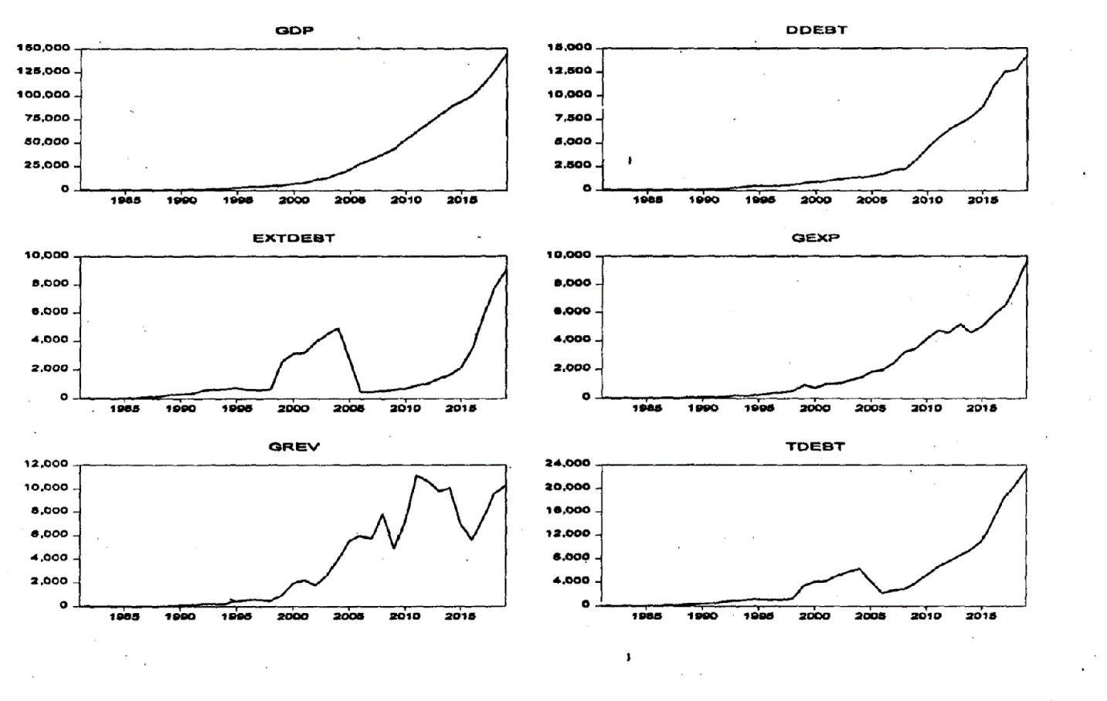
graph.
Figure: 1 A line graph showing the alteration on economic growth and the three variants of government expenditure under study. The slope of the graph shows that there is alteration existence between GDP and other explanatory variables over the period under study.

4.3 Correlation Analysis
Table 4.3 Correlation Matrix
correlation
-Statistic
Probability | GDP | DDEBT | EXTDEBT | GEXP | GREV | TDEBT
DDEBT | 1.000000
 | 0.990638 | 1.000000
 | 44.13990 | ………..
EXTDEBT | 0.0000 | ……………
 | 0.661466 | 0.701229 | 1.000000
 | 5.364905 | 5.982885 | -------
GEXP | 0.0000 | 0.0000 | -------
 | 0.988009 | 0.970335 | 0.678818 | 1.000000
 | 38.92533 | 24.41367 | 5.623116 | --------
 | 0.0000 | 0.0000 | 0.0000 | --------
GREV | 0.872678 | 0.812549 | 0.471 197 | 0.898847 | 1.000000
 | 10.87105 | 8.479343 | 3.249537 | 12.47533 | --------
 | 0.0000 | 0.0000 | 0.0025 | 0.0000 | --------
TDEBT | 0.942433 | 0.963862 | 0.865816 | 0.934668 | 1746347 | 1.000000
 | 17.14316 | 22.00780 | 10.52549 | 15.99157 | 5.821 121 | --------
 | 0.0000 | 0.0000 | 0.0000 | 10000 | 0.0000 | --------
Source: Author’s Computation from E-views 10.00
From the result, It can be concluded that a positive linear association exists between DDEBT and Gross Domestic Product (99%,t=44.13 with pv of 0.0000), EXTDEBT and GDP (66%, t= 5.36, with pv of 0.000), GEXP and GDP (99%, t38.92 with pv of 0.0000), GEXP and DDEBT (97%, t=24.41 with pv of 0.0000), GEXP and EXTDEBT (68%, t5.62 with pv of 0.0000), GREV and GDP (87%, t=10.87 with pv of 0.0000), GREV and DDEBT (8 1%, t=8.47 with pv of 0.0000), GREV and EXIDEBT (47%, t=t3.24 with pv of 0.002), GREV and GEXP (90%, t=12.47 with pv of 0.0000), TDEBT and GDP (94%, t17.14, with pv of 0.0000), TDEBT and DDEBT (96%, t=22.07), TDEBT and EXIDEBT (87%, t10.53, with pv of 0.0000), TDEBT and GEXP (93%, t=15.99 with pv of 0.0000) and TDEBT and GREV (75%, t 6.82 with pv of 0.0000). all share positive and significant correlation with Gross Domestic Product. This however is not the major estimation technique, given that correlation does not suggest impact or causation.
4.4 ARDL Regression Model
Table 4.4 Summary of ARDL Regression Results
Variable | Coefficient | Std. Error | t-Statistic | Prob *
GEXP | 0.757639 | 0.443122 | 1.709774 | 0.1055
GEXP(-1) | 1.771726 | 0.596256 | 2.971416 | 0.0086
GEXP(-2) | -3.147398 | 1.105559 | -2.846884 | 0.0111
GEXP(-3) | -6.685437 | 1.013710 | -6.595022 | 0.0000
GEXP(-4) | -3.410485 | 0.726629 | -4.693572 | 0.0002
GREV | 0.990673 | 0.133937 | 7.396558 | 0.0000
GREV(-1) | 0.009895 | 0.199069 | 0.049708 | 0.9609
GREV(-2) | 0.823911 | 0.219571 | 3.752373 | 0.0016
GREV(-3) | 0.698809 | 0.190200 | 3.674070 | 0.0019
GREV(-4) | 0.303765 | 0.099525 | 3.052149 | 0.0072
TDEBT | 0.186498 | 0.195317 | 0.954847 | 0.3530
TDEBT(-1) | 0.142159 | 0.211527 | 0.672058 | 0.5106
TDEBT(-2) | 0.632461 | 0.229744 | 2.752900 | 0.0136
TDEBT(-3) | 0.665623 | 0.261504 | 2.545368 | 0.0209
TDEBT(-4) | -1.584545 | 0.295677 | -5.359032 | 0.0001
C | -80.57691 | 109.5452 | -0.735559 | 0.4720
R-squared 0.999963 OR 99%
Adjusted R-squared 0.999926 OR 99%
F-statistic  27066.31(0.00000) | Durbin –Watson stat 2.22
Source: Author’s Computation from E-views 10.00

The test results for hypotheses one are presented in box 4.5 below:
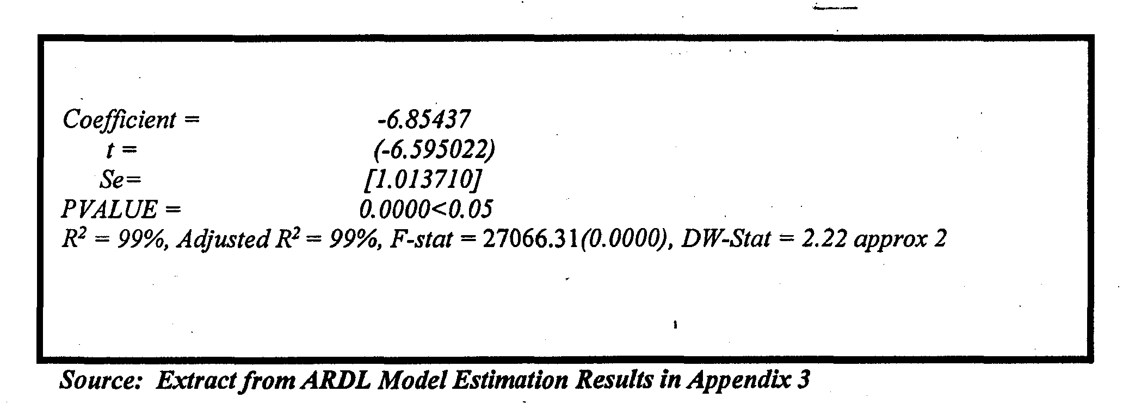
From the result, it was established that GEXP (-1) has negative and significant relationship with GDP, implies that the previous values of GEXP positively improves the later value of GDP. It was established that the model has goodness of fit as R-Squared suggests 99%. The decision was based on 0.05 level of significance. From the result, it was recognized that the coefficient of GOVTEXP (coefficient -6.85437) was negatively signed and p-value (0.0000) was significant, thereby rejecting the null hypothesis and concluding that GOVTEXP negatively and significantly impacted on GDP. The result also shows that a unit change in GOVTEXP causes a -6.85% decrease in Gross Domestic Product. This shows that 99% of the variation in the dependent variable is accounted for by the independent, variables, with an unexplained variation of about 1%. The result further indicated that F-Statistics showed overall statistically significant of the regression/model. The Durbin Watson stat is also approximately 2.0, thereby indicating that there is no existence of autocorrelation.

Given the coefficient value of Government expenditure (2.249635) and the probability of. t-statistics 0.0000<0.05 being significant, we reject the null hypothesis and conclude that Government expenditure negatively and significantly impact on GDP.

The test results for hypotheses two are presented in box 4.5 below:
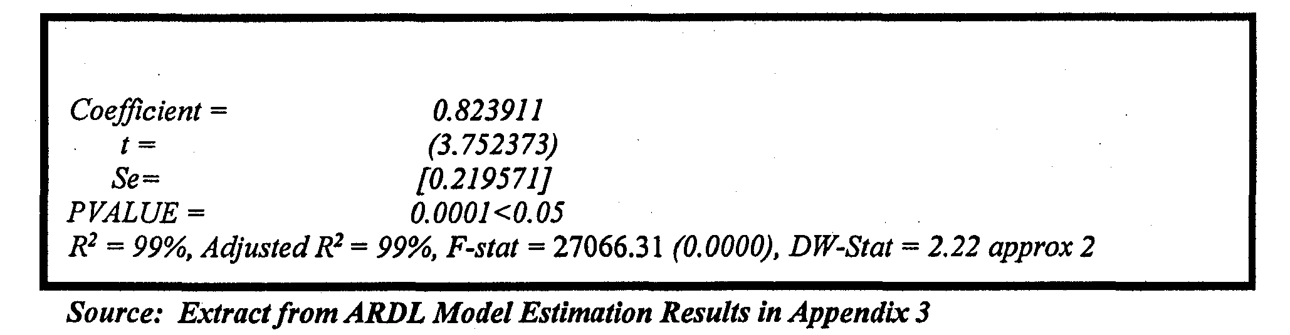
From the result, it can be deduced that Government revenue (-2) has positive and significant relationship with GDP, implies that the previous value of Government revenue positively improves the later value of GDP. It was established that the model has goodness of fit as the R-squared suggests. This shows that 99% of the variation in dependent variable is accounted for by the independent variables, with an unexplained variation of about 1%. From the result, it was recognized that the coefficient of Government revenue (coefficient= 0.823911) was positively signed and p-value (0.00001) was significant, thereby rejecting the null hypothesis and concluding that Government revenue positively and significantly impacted on GDP. The results further indicated that F-Statistics showed the overall statically significant of the regression model. The Durbin Watson stat is also approximately 2.22, thereby indicating that, there is no existence of autocorrelation.
Given the coefficient value of Government revenue (-2)(0. 82391 1)and the probability of t statistics 0.00001<0.05 being significant, we reject the null hypothesis and conclude that Government revenue positively and significantly impact on GDP.

The test results for hypotheses three are presented in box 4.5 below:
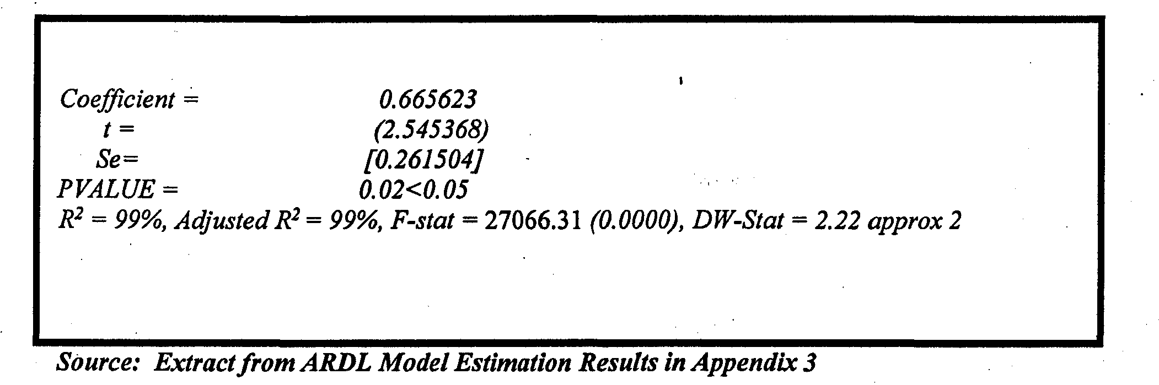
From the result, it can be deduced that TDEBT (-3) has positive and significant relationship with GDP, implies that the previous value of TDEPT positively improves the later value of GDP. It was established that the model has goodness of fit as the R-squared suggests. This shows that 99% of the variation in dependent variable is accounted for by the independent variables, with an unexplained variation of about 1%. From the result, it was recognized that the coefficient of TDEBT (coefficient= 0.665623) was positively signed and p-value (0.002) was significant, thereby rejecting the null hypothesis and concluding that TDEBT negatively and significantly impacted on GDP. The results further indicated that F-Statistics showed the overall statically significant of the regression/model. The Durbin Watson stat is also approximately 2.22, thereby indicating that, there is no existence of autocorrelation.
Step Three: The decision involving the rejection or acceptance of the null hypothesis based on the decision criterion of the techniques of analysis is made thus:
Given the coefficient value of Total debt (0.665623) and the probability of t-statistics 0.002<0.05 being significant, we reject the null hypothesis and conclude that Total debt positively and significantly impact on GDP.

5. Conclusion and Recommendation
This paper has examined the relationship between fiscal policy and economic growth in Nigeria between 2010 and 2019 using Bound Test, ARDL and ECM model. The findings of this study could be summarized below; the error correction term showed that about 39% of the total disequilibrium in the previous year due to shack was corrected in the current year. Government revenue and economic growth have a significant positive relationship in Nigeria in the short run but negative in the long run, though not significant. However, recurrent expenditure has a significant negative relationship with economic growth in the short run but the result becomes insignificant in the long run.
Capital expenditure has an insignificant positive impact on economic growth both in the short run and long run. Furthermore, inflation rate has a significant positive relationship with economic growth in both short run and long run. It could be concluded that government revenue and capital expenditure have a positive impact on economic growth in Nigeria; therefore, this study submits that fiscal policy has the tendency to stimulate economic growth in the country. As a result of the findings that emerged in this study, it is imperative that the following recommendations are made for the makers in Nigeria that if the economic growth is the target of the policy makers, manipulating fiscal policy variables such as government revenue, capital expenditure and inflation rate will increase economic growth in the short run and the long run. Also, capital expenditure should be chandelled towards more productive sectors of the economy to ensure a sustainable economic growth in the country.

REFERENCES
Abu, N. and Abdulahi, U. (2010). “Government Expenditure and Economic Growth in Nigeria, 1970-2008: A Disaggregated Analysis”, Business and Economic Journal, 4(3): 237-330.

Adefeso, H. A., Mobalaji, H. I. (2010). The fiscal-monetary policy and economic growth in Nigeria: Further empirical evidence Pakistan. Journal of Social Sciences, 7(2), 137-142.

Adeoye, T. (2006). Fiscal policy and growth of the Nigerian economy: An empirical perspective (NISER Monograph Series, P 10). Ibadan, Nigeria: Nigerian Institute of Social and Economic Research.

Amin, A. A. (1999). An examination of the sources of economic growth in Cameroon’s economy (AERC revised final report). Nairobi, Kenya: African Economic Research Consortium.

Barro, R. J. (1991). Economic growth in a cross section of countries. Quarterly Journal of Economics, 18, 769-783.

Cardoso, M., & Domencho, R. (2010, December 13). The sovereign debt crisis: Structural reforms and country risks. Available from VoxEu.org CCBCBN Statistical Bulletin. (2007). Nigeria statistical fact sheet on economic and social development (Vol. 1). Nigeria: Federal Office of Statistics.

Chuku, A. C. (2010). Monetary and fiscal policy interactions in Nigeria: An application of a state-space model with Markov switching. Journal of Applied Statistics, 1, 39-51.

Cooray, A. (2009). Government expenditure, governance and economic growth. Comparative Economic Studies, 51, 401-418.

Davis, J. M., Ossowski, R., & Fedelino, A. (2003). Fiscal policy formulation and implementation in oil-producing countries. International Monetary Fund. Retrieved from http://www.imf.
org/external/pubs/nft/2003/fispol/

Easterly, W., & Rebelo, S. (1993). Fiscal policy and economic growth: An empirical investigation. Journal of Monetary Economic, 32, 417-458.

Economic Watch. (2010). 2010 Economic Statistics and Indicators. Retrieved from http://www.economywatch.com/economicstatistics/ year/2010/

Fazel, S. (2005), Consumers’ expectations and consumption expenditure. Journal for Economic Educators, 5(2), 1-5.

Hassan, 0. M (2016). Effect of interest rate on commercial bank deposits in Nigeria (2000. 2013). proceeding of the first American academic-research conference on global business, economies, finance and social sciences (imf).

Hilderbrand, P. (2013, April 3). Europe needs to focus more on reforms, not just austerity. The A- List.

Okwara, C. C., & Amori, 0. M. (2017). Impact of tax revenue on economic growth in Nigeria. International Journal of Advanced Scientific Research, 2(2), 90-102. Retrieved from http:/Iinternationalpolicybrief.org/joumalsfijasr-online-journals/intl-irnI-of-sciresearch-in-social-sciencesm gt-studies-vol2-no2-dec-20 17

Mukui, G.K. (2013). Effect of external public debt on economic growth in Kenya. Retrieved on June 5, 2019. CBN (2017). Unemployment Rate. www.cbn.gov.ng.

