Do Female CFOs Reduce Disclosure Violations in Listed Companies?
——Empirical evidence from China's capital market
Huizheng Liu, Jiaqi Zhou
College of Economics and Management，Beijing University of Technology，Beijing 100124

Abstract: This paper selects the data of China's listed companies from 2007 to 2016 as the sample and uses the binary logit regression method to explore whether the gender of the CFO has an impact on the company's information disclosure violations. The results show that female CFOs significantly reduce the probability and number of information disclosure violations of listed companies, and the stronger their own ability, female CFOs have a significant incremental impact on restraining information disclosure violations of listed companies. The research conclusion provides a reference for enterprises to select and hire CFOs.
Keywords: CFO; Female executives; Violation of information disclosure

1. Introduction
Compared with Western countries, China's securities market started late. After decades of development, the relevant systems, laws and regulations have been continuously improved, but illegal acts by listed enterprises are still repeatedly committed. According to the "20 typical illegal cases inspected by the CSRC in 2020" reported by the China Securities Regulatory Commission (CSRC), financial fraud cases involving fictitious businesses, forging bank documents, falsifying and tampering with value-added tax invoices and adjusting profits by "full of tricks" behavior are carried out, seriously infringing on the legitimate rights and interests of investors. Of the 20 public cases, as many as 11 involved issues related to information disclosure.
As shown in Figure 1, from 2007 to 2016, the number and proportion of information disclosure violations of listed companies in the A-share market showed an overall upward trend.

Figure 1 Number and proportion of information disclosure violations of Chinese listed companies from 2007 to 2016
Data source: Guotai’an Database

In line with the new securities law of the People's Republic of China promulgated and implemented in March 2020, the CSRC issued the revised Measures for the Administration of Information Disclosure of Listed Companies in March 2021. Among them, violations of information disclosure mainly include fictitious profits, fictitious assets, false records, delayed disclosure, major omissions, false disclosure and improper general accounting treatment, which mainly reflect company financial problems.
In the business behavior of enterprises, in addition to external supervision, the personal background characteristics of company executives are important factors that affect the production and operation of enterprises and even the stability of the market. The chief financial officer (CFO) is not only the person with primary responsibility for the company's financial information but also the leading participant in the company's major business decisions. The CFO grasps the overall operation process of the company's financial situation and is closely involved in information disclosure violations in corporate finance. With the improvement of women's social status, the characteristics of women's professionalization are becoming increasingly evident. The increase in the proportion of female executives has prompted an increasing number of scholars to pay attention to the impact of female executives on business behavior. As shown in Figure 2, the proportion of women CFOs in Chinese listed companies from 2007 to 2016 increased, reaching 33.32% in 2016.

Figure 2 Proportion of female CFOs in Chinese listed companies from 2007 to 2016
Data source: Guotai’an Database
Gender affects the psychology and behavior of decision-makers. For company executives, these impacts will involve the company's business decisions. Male executives are more likely to be overconfident and make radical decisions, leading to corporate financial restatement ^{[1]}, while female executives have a significant inhibitory effect on violations of information disclosure ^{[2-3]}. Therefore, this paper focuses on the impact of female CFOs on the information disclosure violations of listed companies and the performance of this impact under different CFO tenures.
The structure of the remainder of the article is as follows: section 2 presents the literature review; section 3 provides the theoretical analysis and hypothesis development; section 4 presents the research design; section 5 presents the empirical test and analysis of the results; and the last part provides the conclusion.

2. Literature review
2.1. Research related to female executives
Today, with the increasing promotion of women's rights and interests, women's career development has received increasing attention. Research on female executives in other countries started earlier than in China. Norway, Sweden, Spain, France and other European countries have even passed legislation explicitly requiring a certain proportion of female directors on the boards of directors of listed companies. Although the proportion of female executives is still relatively low among the executives of large listed companies in the world, research has confirmed that female executives have played a positive role in the healthy development of firms. Adams et al. ^{[4]} analyzed the sample companies of the Standard & Poor's 500, medium-sized shares and small share indices in the United States from 1996 to 2003 and found that female directors attended board meetings more frequently than men, while directors obtained effective information to perform their obligations by attending board meetings. Therefore, corporate governance mechanisms with a higher proportion of female directors are more effective. Through a sample survey of American companies, Zalata et al. ^{[5]} found that female directors in monitoring roles reduced the opportunism of management. Belaounia et al. ^{[6]} used the data of a multinational group composed of 1,986 listed companies from 24 countries or regions for ten years and found that companies with greater representation of females on boards of directors showed higher overall performance, less earnings management and less excessive risk-taking. Balsam et al. ^{[7]} assumed that the performance impact of independent female directors depends on the company's information environment. They found that in opaque (transparent) companies, independent female directors have a negative (positive) impact on performance, which is greater than that of independent male directors. Tosun et al. ^{[8]} found that there were more women on the boards of firms with overconfident CEOs, offsetting the trend of these CEOs to reduce their cash holdings below the optimal level. At present, some scholars in China have considered the gender of executives of listed companies ^{[1]}, such as directors and CEOs, as the starting point to study their impact on corporate risk-taking ^{[9]}, over investment and corporate value ^{[10]}, financing constraints ^{[11]}, capital allocation ^{[12]}, corporate performance^{[13]}, degree of earnings management ^{[14]}, and performance of social responsibility ^{[15]}. On the whole, the research affirms the positive impact of female executives on the business behavior of listed companies. For example, Wang Xia et al. ^{[16]} selected domestic financial restated companies as samples and found that CFOs with the status of certified public accountants have higher accounting information quality and affirmed the positive role of CFOs in financial reporting.

2.2. Research on information disclosure violations of listed companies
Wu Guoping ^{[17]} and Hu Yan ^{[18]} divided information disclosure violations into false statements and delayed disclosures according to the manifestations of violations and further divided false statements into false records, misleading statements and major omissions. False records are divided into fictitious profits, fictitious assets and false statements. At present, according to the classification standards of the CSRC and Guotai’an Database, the types of violations of listed companies include fictitious profits, false assets, false records (misleading statements), delayed disclosure, major omissions, false disclosure (others), improper general accounting treatment, fraudulent listings, illegal capital contributions, unauthorized change of capital use, occupation of company assets, insider trading, illegal trading of stocks, manipulation of stock price, and illegal guarantees. Referring to the practice of Lu Jun ^{[3]}, the article classifies the first seven items as information disclosure violations.
Yu Xuelian et al. ^{[19]} sorted the data of A-share listed companies in the Shanghai and Shenzhen exchanges from 2009 to 2014 and used a logistic regression model and principal component analysis to explore whether the professional level, salary motivation and position power of CFOs have an impact on the number and degree of violations in financial reporting. The study found that the stronger the professional ability of CFOs, the higher the reward, and the lower the possibility and severity of the company's financial violations.
In addition to the personal abilities of executives, there are many studies exploring the relationship between executive gender and company violations. Lu Jun ^{[3]} took China's A-share listed companies from 2004 to 2012 as a sample, conducted an empirical study on the violation probability of women's participation in corporate governance, and found that female executives and their proportion and gender diversity among executives have a significant negative effect on the violation probability of enterprises. This shows that female executives significantly reduce the occurrence of corporate violations compared with men and further found that female executives significantly reduce the probability of corporate information disclosure violations. Gan Weiyu et al. ^{[20]} took 327 companies listed only in shares from 2006 to 2011 that were publicly handled by relevant regulators to varying degrees due to violations as a sample. The empirical study found that when there are female members in senior management positions or their proportion increases, the possibility of anti-ethical and rational violations by the company is significantly reduced. Lu Xin et al. ^{[21]} selected listed companies and comparative enterprises punished by the CSRC for financial fraud from 2001 to 2013 as samples. The study found that listed companies with a higher proportion of men on the senior management team are more prone to financial fraud. The above literature shows the positive effect of female executives on corporate finance and information disclosure. However, some studies draw the opposite conclusion. Lin Changquan et al. ^{[22]} took the data of Shanghai and Shenzhen A-share listed companies from 2007 to 2013 as a sample to study the impact of the gender of directors and secretaries on the quality of enterprise information disclosure. The results show that in large enterprises, women as directors and secretaries of listed companies significantly reduce the quality of information disclosure. The reasons for this phenomenon may be that women directors and secretaries do not play a substantive role, and the female characteristics of directors and secretaries are weakened due to the high proportion of male directors.
The existing literature generally affirms the positive impact of female executives on the business behavior and effectiveness of listed companies, which establishes the foundation for the writing of this paper. At present, the research on information disclosure violations of women and listed companies studies the impact of female executives, female CEOs and female secretaries on the company's finances, the quality of information disclosure and illegal operations. The relevant literature on the company's information disclosure violations from the gender perspective of CFOs has not been found, and there are still deficiencies in the existing research results. First, information disclosure violations are mainly related to the company's financial problems, and the directly related enterprise decision-makers are CFOs, which are generally studied from the perspective of company executives, female CEOs or secretaries. It is easy to lead to biased regression results. The second is to study the impact of the number of female executives on the overall ability of the company to disclose information.
In view of the above analysis, the possible marginal contributions of this paper are as follows: (1) from the perspective of the CFOs of listed companies, we explore the impact of female CFOs on corporate information disclosure violations; and (2) from the perspective of female CFO competency, we deeply examine the impact of female executives' own competency characteristics on a company's information disclosure violations.

3. Theoretical analysis and hypothesis proposal
Kuklick et al. ^{[23]} put forward the theory of groupthink, according to which groups with high cohesion usually believe in the correctness of their decisions, and to maintain this consistency, all members of the group support the decisions made by the group and ignore inconsistent information. One of the conditions of groupthink is homogeneity (the degree of heterogeneity or dispersion in the management team is low), which limits the divergence of thinking and will eventually lead to low-quality decision-making.
On this basis, Hambrick et al. ^{[24]} put forward the high-order theory and incorporated the characteristics, organizational performance and strategic choice of senior managers into the research model, emphasizing the role of demographic characteristics on managers' cognitive model and its impact on organizational performance. The theory holds that individual differences exist in senior management teams, and both psychological and ability differences will lead to team heterogeneity. Senior members of a company, such as directors, CEOs and CFOs, are the main participants in the company's business decision-making. Their personal characteristics and working ability are developed through practice, which is closely related to the business situation of their particular company.
Gender, as an important personal characteristic, has an obvious impact on an individual’s psychology and behavior. A large number of studies have shown that women have greater risk aversion and lower self-confidence than men. Many behavioral and psychological studies show that women are more cautious when facing uncertainty. The gender distribution of senior management teams is an important factor affecting a company's risk preference. The literature on psychology and sociology shows that women's lower risk preference is such that they pay more attention to risk avoidance. In companies where women participate in senior leadership teams, the financial leverage is relatively lower and the cash ratio is higher, so the probability of continuous operation of the company is also greater. Webster et al. ^{[25]} studied the differences between different genders in the field of financial analysis and found that men's self-confidence was significantly higher than women's. Therefore, compared with men, female executives are likely to have greater self-discipline and vigilance against possible risks due to their risk aversion and lower level of confidence in the company. At the same time, the greater the abilities of female executives, the more significant the effect of supervision and influence on male executives, reducing the possibility of information disclosure violations. Based on these considerations, this paper puts forward the following assumptions:
Hypothesis 1: Female CFOs inhibit the information disclosure violations of listed companies.
Hypothesis 2: The ability of female CFOs further strengthens their effect on restraining information disclosure violations of listed companies.

4. Research design
4.1. Model construction
This paper studies the impact of CFO gender of listed companies on corporate information disclosure and explores whether women CFOs improve a company's information disclosure violations. The model construction is as follows:
First, it studies whether the gender of the CFO will have an impact on the company's information disclosure violations and the frequency of violations. Since whether there are information disclosure violations is a 0-1 variable, the logit model is used for its regression, and the ordered logit model is used for the regression of the frequency of information disclosure violations. The industry and annual effects are controlled in the regression process, and robust standard error handling is adopted. The specific regression model is as follows:
$Violation/FreViolation=β_{0}+β_{1}Female+\sum{control}+\sum{year}+\sum{industry}+ε$ （1）
where control refers to the control variable, and year and industry represent the year and industry fixed effects, respectively.
Furthermore, this paper will study the incremental impact of the CFOs’ own ability and set the intersection term of CFO gender and tenure. The specific model is as follows:
$Violation=β_{0}+β_{1}Female+β_{2}Female×Tenure+β_{3}Tenure+\sum{control}+ε$ （2）
4.2. Variable selection
4.2.1. Explained variable
This paper takes whether listed companies have information disclosure violations and the frequency of information disclosure violations as the main explanatory variables. If a listed company commits information disclosure violations in a certain year, such as fictitious profits, false assets, false records (misleading statements), delayed disclosure, major omissions, false disclosure (other), or improper general accounting treatment, and is punished by securities regulatory authorities such as the CSRC and its branches or stock exchanges, the violation will be assigned a value of 1 in the year in which the violation occurs; otherwise, it will be 0. Freviolation is used to measure the number of information disclosure violations of listed companies punished by securities regulatory authorities such as the CSRC and its branches or stock exchanges in an accounting year. Since the records of violations of listed companies in a certain year may increase, it is more reasonable to use relative value to measure the number of violations of information disclosure. If this value is 0, it means that there is no violation of information disclosure; 1 represents one to three violations of information disclosure, considered few violations of information disclosure; 2 represents 4 to 7 information disclosure violations, considered more information disclosure violations; and 3 represents 8 or more violations of information disclosure, considered many violations of information disclosure.
4.2.2. Explanatory variables
This paper uses the gender of CFOs of listed companies as the main explanatory variable. In the CSMAR database, the personal characteristics documents of directors, supervisors and senior executives (hereafter referred to as directors, supervisors and senior executives) and the appointment table of directors, supervisors and senior executives include chief financial officer, general financial manager, chief accountant, financial principal and their agents. If more than one person in an enterprise has worked as CFO in the same year (that is, the company changes CFO in that year), we compare their tenures and take the individual with longer tenure as the CFO of the company in that year. In further research, the interaction items between CFO gender and the CFO's own ability are included to explore its incremental impact. Among them, the CFO's own ability includes the CFO's term of office and whether he or she holds a concurrent post in the shareholder unit.
4.2.3. Control variables
Referring to Lu Jun ^{[3]}, Lin Changquan et al. ^{[22]}, Zhu Wenli et al. ^{[15]}, Xiao Jinli et al. ^{[9]}, and Wang Yunqian et al. ^{[26]}, this paper selects the background characteristics of CFOs (tenure, age, etc.), whether to concurrently serve in the shareholder unit as IsCocurP, whether to hold the company's stock IsShar, the number of board meetings, whether the chairman concurrently serves as general manager, the attention paid by analysts AnaAttention, whether auditors come from the Big 4 auditing firms BIG 4, the proportion of independent directors IndeProp, the shareholding proportion of institutional investors InstSharprop, the company size (logarithm), equity concentration Top1Ratio, corporate profitability ROA and asset liability ratio ALR as control variables. At the same time, the effects of industry and year are further controlled in the regression. The specific variable definitions are shown in Table 1.

Table 1 Variable definitions
variable | Definition
Violation | Information disclosure violations: 1 means yes and 0 means no
FreViolation | Frequency of information disclosure violations
Female | Gender of CFO: 1 is female and 0 is male
Tenure | CFO's term of office is the term of office from the statistical deadline. If the CFO left before that date, it is the term of office from the date of departure
IsCocurP | If CFO holds concurrent positions in shareholder units, 1 means yes and 0 means no
InstSharprop | Shareholding ratio of institutional investors
Age | Age of CFO
IsShar | CFO's holding of the company's shares: 1 is yes and 0 is none
BoardMeeting | Number of board meetings
IsDuality | The chairman of the board concurrently serves as the general manager. 1 is yes and 0 is no
AnaAttention | Number of teams that have tracked and analyzed the company within one year
Big4 | Auditors from four major accounting firms: 1 is yes and 0 is no
IndeProp | Proportion of independent directors, the number of Independent Directors divided by the number of directors
Size | Company size, natural logarithm of total assets at the end of the year
Top1Ratio | Ownership concentration, shareholding ratio of the company's largest shareholder
ROA | Profitability of the company, net profit at the end of the year divided by total assets
ALR | Asset liability ratio, total liabilities at the end of the year divided by total assets
Year | Involving 10 years
Industry | Refer to the industry classification standard of China Securities Regulatory Commission

4.3 Sample selection and data source
Considering that the CSRC issued the departmental rules of the measures for the administration of information disclosure of listed companies in January 2007, this paper selects listed companies in the Shanghai and Shenzhen stock markets from 2007 to 2016 as a sample to explore the impact of the gender of the CFO on the company's information disclosure violations. After excluding the data of the financial and insurance industries, missing observations and non-A shares, the extreme values of continuous variables were reduced by 1% up and down, and a total of 21,612 observations on the gender, tenure and age of CFOs of 3,060 listed companies were finally obtained. A total of 8,432 violation details were found in the violation records. Referring to the practice of Lu Jun ^{[3]}, 2,371 relevant data points of information disclosure violations were selected from 3,685 violation records during the sample investigation period. The data in this paper mainly come from the Guotai’an Database and some from the wind (Wande) financial database.

5. Empirical test and result analysis
Table 2 lists the descriptive statistical results of each variable used in this paper. It can be seen that the average value of whether there is an information disclosure violation is 0.154; that is, approximately 15.4% of the enterprises in the sample have been punished for information disclosure violations. This value shows that the probability of Information Disclosure Violation of Listed Companies in China is not low. It can be seen that the maximum values of InstSharProp, ROA, ALR and other variables are quite different from the 75th quantile, and there may be abnormal values. Therefore, in the regression process, the continuous variables are subject to a 1% up-and-down tail reduction to reduce the impact of abnormal values on the regression results.

Table 2 Descriptive statistical results of variables
variable | min | Lower Quartile | Median | Mean | Upper Quartile | Max | Std Dev
Violation | 0 | 0 | 0 | 0.154 | 0 | 1 | 0.361
FreViolation | 0 | 0 | 0 | 0.163 | 0 | 3 | 0.396
Female | 0 | 0 | 0 | 0.302 | 1 | 1 | 0.459
Tenure | 0 | 15 | 31 | 40.070 | 57 | 227 | 33.040
IsCocurP | 0 | 0 | 0 | 0.051 | 0 | 1 | 0.221
InstSharProp | 0 | 28.970 | 48.730 | 46.640 | 65.260 | 101.100 | 23.940
Age | 27 | 40 | 44 | 44.810 | 49 | 70 | 6.492
IsShar | 0 | 0 | 0 | 0.409 | 1 | 1 | 0.492
BoardMeeting | 0 | 7 | 9 | 9.461 | 11 | 57 | 3.937
IsDuality | 0 | 0 | 0 | 0.246 | 0 | 1 | 0.431
AnaAttention | 0 | 1 | 4 | 7.252 | 11 | 65 | 8.778
Big4 | 0 | 0 | 0 | 0.055 | 0 | 1 | 0.228
IndeProp | 0.091 | 0.333 | 0.333 | 0.371 | 0.400 | 0.800 | 0.054
Size | 10.840 | 20.900 | 21.670 | 21.820 | 22.560 | 28.510 | 1.359
Top1Ratio | 0.290 | 23.440 | 33.720 | 35.660 | 46.400 | 100 | 15.480
ROA | -51.950 | 0.014 | 0.038 | 1.169 | 0.068 | 23,510 | 160.200
ALR | -0.195 | 0.267 | 0.438 | 0.509 | 0.611 | 142.7 | 2.077
5.1 Empirical regression results
Table 3 shows the impact of CFO gender on whether the company violates the rules and the number of violations. After controlling the annual effect and industry effect, the first model’s regression results of CFO gender on illegal company information disclosure is negative at the significance level of 5%, indicating that increasing the number of CFO women in senior management can significantly reduce the probability of information disclosure violations, which supports Hypothesis 1 and argues in favor of employing more female CFOs in listed companies. In the second model, the gender of the CFO is also negatively correlated with the number of violations of corporate information disclosure at the significance level of 5%, indicating that increasing the number of CFO women can also significantly reduce the number of violations of corporate information disclosure. On the other hand, it also supports the hypothesis. We also note that the shareholding ratio of institutional investors, whether they hold company shares, the number of meetings of the board of directors, whether the chairman concurrently serves as the general manager, the attention of analysts, and whether the auditors come from the Big 4 accounting firms, the regression coefficients of financial indicators such as ownership concentration, corporate profitability and asset-liability ratio are highly significant in the two models, which has a very strong explanatory power.
Table 3 Impact of CFO gender on whether the company violates information disclosure and the number of violations
variable | Violation | FreViolation
Female | -0.092** | -0.093**
 | (0.046) | (0.046)
Tenure | 0.001 | 0.001
 | (0.001) | (0.001)
IsCocurP | -0.194* | -0.202**
 | (0.102) | (0.102)
InstSharProp | -0.003*** | -0.003***
 | (0.001) | (0.001)
Age | 0.003 | 0.003
 | (0.003) | (0.004)
IsShar | -0.124*** | -0.122***
 | (0.046) | (0.046)
BoardMeeting | 0.045*** | 0.047***
 | (0.006) | (0.006)
IsDuality | 0.206*** | 0.199***
 | (0.048) | (0.048)
AnaAttention | -0.026*** | -0.026***
 | (0.004) | (0.004)
Big4 | -0.382*** | -0.374***
 | (0.131) | (0.131)
IndeProp | -0.741* | -0.737*
 | (0.422) | (0.423)
Size | -0.077*** | -0.085***
 | (0.022) | (0.023)
Top1Ratio | -0.012*** | -0.012***
 | (0.002) | (0.002)
ROA | -2.761*** | -2.890***
 | (0.391) | (0.398)
ALR | 0.862*** | 0.883***
 | (0.111) | (0.112)
_cons | 0.009
 | (1.294)
N | 18924 | 18924
Pseudo$R^{2}$ | 0.051 | 0.049
Industry | Yes | Yes
Year | Yes | Yes
Standard errors in parentheses
* p < 0.1, ** p < 0.05, *** p < 0.01
5.2 Incremental effect of CFO's own ability
Based on the basic assumption that CFO gender will affect the degree of likelihood of violation of corporate information disclosure standards, this paper establishes a cross-term addition model of CFO gender and CFO tenure to verify its incremental impact. Considering that the logit model used in the regression is a nonlinear model, it is not suitable to use a simple linear model to measure the interaction effect. Therefore, the interference technology of AI et al. ^{[27]} is used to test the joint significance of these interactions and their composite variables. It shows that all values of the logit model, whether on average or for a single observation, have statistical significance, as shown in Table 4.
From Figure 3, we find that the intersection term of CFO gender and tenure is significantly negative because there is a mutually reinforcing effect between the two; that is, female CFOs with longer tenure have a more obvious inhibitory effect on corporate violations. In contrast, female CFOs with shorter tenure may have relatively less power, and the restraining effect on corporate violations is less. The absolute value distribution of the Z statistical value in Figure 4 is basically greater than 1.96, indicating that the result is significant.
Overall, the regression results verify Hypothesis 2; that is, the cross effect of CFOs’ personal ability and CFOs’ gender is very significant, and the role of female CFOs with a strong personal ability to inhibit information disclosure violations of their listed companies is more evident.

Table 4 Interaction between CFO tenure and CFO gender
 | Obs | Mean | Std.Dev. | Min | Max
_logit_ie | 19359 | -0.00037 | 0.00013 | -0.00073 | -0.00003
_logit_se | 19359 | 0.00017 | 0.00006 | 0.00001 | 0.00034
_logit_z | 19359 | -2.14922 | 0.06487 | -2.40866 | -1.95175

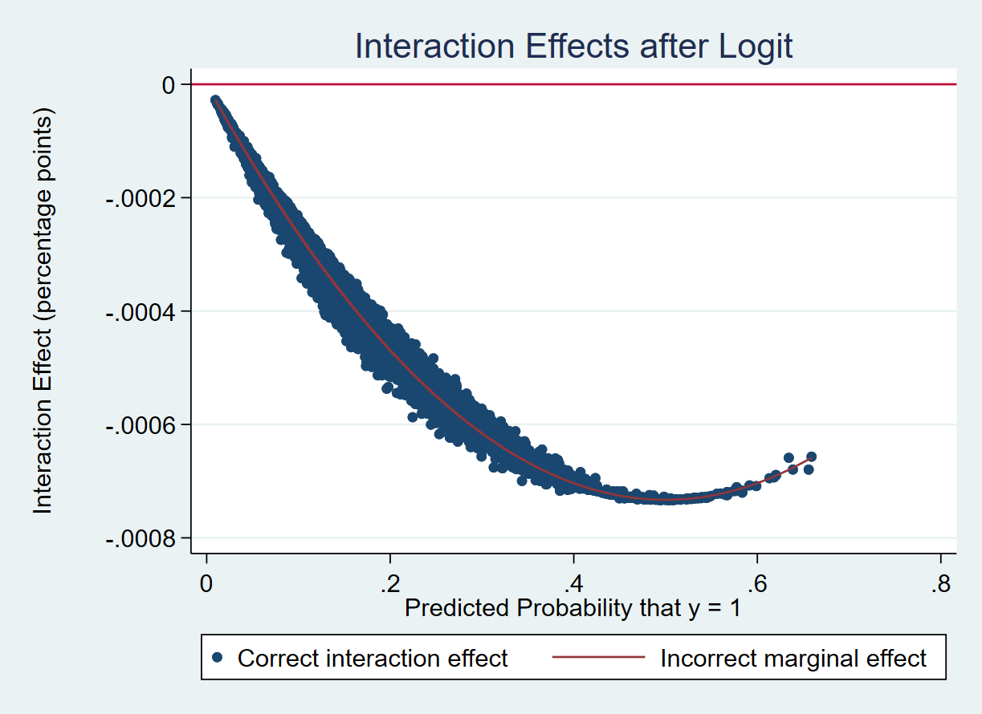
Figure 3 Interaction effect after logit regression

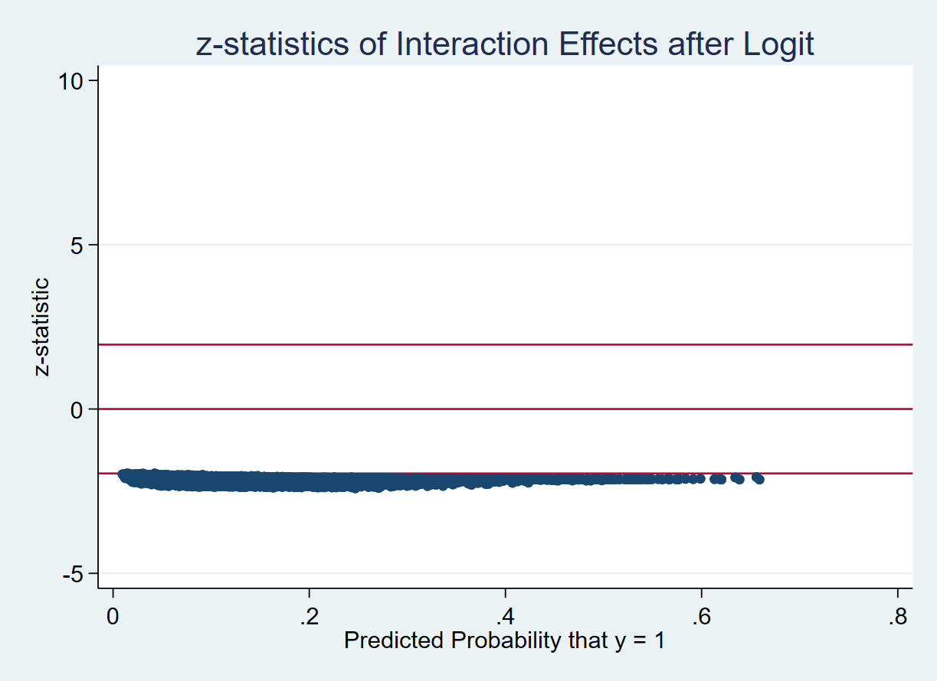
Fig. 4 Z statistical value of the interaction effect after logit regression

5.3 Robustness test
This paper tests the robustness through the following two methods.
5.3.1. Conduct robustness test by propensity score matching;
Referring to the methods of Huang et al. ^{[28]} and Li Xiaorong et al. ^{[29]}, we first use the logistic model to regress the female CFO (female) on company size (Size), debt (ALR), profitability (ROA), industry (Industry) and year (Year) and then use the propensity score estimated by the logistic model to find the closest company for one-to-one pairing; a total of 8,598 samples were obtained. Table 5 shows the regression results of paired samples. Table 5 shows that female CFOs can significantly inhibit a company's information disclosure violations (the significance level is 5%), indicating that the results are robust.

Table 5 Impact of CFO gender on information disclosure violations after pairing
variable | Violation | FreViolation
Female | -0.144** | -0.144**
 | (0.065) | (0.065)
Tenure | -0.001 | -0.001
 | (0.001) | (0.001)
IsCocurP | -0.373** | -0.375**
 | (0.165) | (0.165)
InstSharProp | -0.001 | -0.001
 | (0.002) | (0.002)
Age | 0.010* | 0.009*
 | (0.005) | (0.005)
IsShar | -0.062 | -0.057
 | (0.068) | (0.068)
BoardMeeting | 0.040*** | 0.041***
 | (0.009) | (0.009)
IsDuality | 0.211*** | 0.197***
 | (0.071) | (0.071)
AnaAttention | -0.031*** | -0.030***
 | (0.006) | (0.006)
Big4 | -0.525** | -0.522**
 | (0.208) | (0.207)
IndeProp | -1.074* | -1.050*
 | (0.635) | (0.636)
Size | -0.054 | -0.065*
 | (0.034) | (0.035)
Top1Ratio | -0.014*** | -0.015***
 | (0.003) | (0.003)
ROA | -3.764*** | -3.802***
 | (0.592) | (0.595)
ALR | 0.857*** | 0.895***
 | (0.166) | (0.169)
_cons | -0.582
 | (1.456)
N | 8598 | 8598
r2_p | 0.062 | 0.059
Industry | Yes | Yes
Year | Yes | Yes

5.3.2. Conduct a robustness test by eliminating specially treated samples.
To enhance the robustness of the research conclusion, the possible influence of St samples is also considered in this paper. The test is carried out after St-related companies are excluded from this paper. The results are shown in Table 6. The results show that the conclusion that female CFOs negatively affect information disclosure violations is still valid.

Table 6 Inspection after excluding specially treated samples
variable | Violation | FreViolation
Female | -0.100** | -0.100**
 | (0.049) | (0.049)
Tenure | 0.001* | 0.001*
 | (0.001) | (0.001)
IsCocurP | -0.189* | -0.195*
 | (0.108) | (0.107)
InstSharProp | -0.003*** | -0.003***
 | (0.001) | (0.001)
Age | 0.005 | 0.005
 | (0.004) | (0.004)
IsShar | -0.096** | -0.096**
 | (0.049) | (0.049)
BoardMeeting | 0.042*** | 0.043***
 | (0.006) | (0.006)
IsDuality | 0.171*** | 0.169***
 | (0.053) | (0.053)
AnaAttention | -0.026*** | -0.026***
 | (0.004) | (0.004)
Big4 | -0.287** | -0.282**
 | (0.132) | (0.133)
IndeProp | -0.596 | -0.616
 | (0.451) | (0.452)
Size | -0.095*** | -0.100***
 | (0.024) | (0.025)
Top1Ratio | -0.010*** | -0.010***
 | (0.002) | (0.002)
ROA | -2.646*** | -2.710***
 | (0.433) | (0.436)
ALR | 0.894*** | 0.916***
 | (0.123) | (0.125)
_cons | 0.155
 | (1.308)
N | 17407 | 17407
r2_p | 0.047 | 0.046
Industry | Yes | Yes
Year | Yes | Yes

6. Conclusion and insights
The information disclosure system is the cornerstone of the healthy development of the securities market and the basis of the principle of openness. Investors understand the operation status and investment value of listed companies through company information disclosure and make investment decisions based on the information. Therefore, listed companies must disclose information truthfully, accurately, completely and timely in strict accordance with the requirements of laws and regulations so that investors' right to know can be fully guaranteed. However, to meet this specific purpose, some listed companies in the market make false records and major omissions and whitewash their performance with the intention of misleading investors. These behaviors seriously damage the legitimate rights and interests of investors.
This paper takes listed companies in China from 2007 to 2016 as the research object to study the relationship between CFO gender and whether the company's information disclosures are illegal and the number of violations. Women CFOs were less likely to violate information disclosure regulations than men. By employing more female CFOs, listed companies can reduce the occurrence of corporate violations to a certain extent. At present, the proportion of female executives in China's listed companies is relatively low, and the phenomenon of the "female ceiling" still exists. Increasing the proportion of female executives can promote team heterogeneity and improve the efficiency of team cooperation. Women's natural risk aversion provides for a better supervisory role of corporate governance, reducing the probability of violations. In addition, this paper also discusses the effect of CFO tenure and finds that CFO tenure has a significant incremental effect; the longer CFO tenure, the more obvious the role of the CFO in restraining corporate violations.
The conclusion of this paper provides two insights. First, listed companies should fully consider the important role of women when selecting CFOs and other senior management positions and pay attention to the opinions of female employees when making important decisions. Second, from the perspective of macro governance, the overall proportion of female CFOs in China's listed companies is not high. With the increasing ability of female CFOs and other executives to manage the company, the state should continue to promote equal employment between men and women and provide a friendlier employment environment and opportunities for the promotion of female employees.

Reference
- He W.F, Liu Q.L, “Research on the Background Characteristics and Financial Restatement Behavior of Executives of Listed Companies in China,” Management World, 2010, (07), 144-155.
- Gu L., Liu Z.J, “Empirical Study on The Relationship Between Characteristics of TMTs and Governance Violation of China's Listed Companies,” Science of Science and Management of S.&.T., 2013, 34 (02), 152-164.
- Lu J., “Do Female Executives Inhibit Corporate Fraud? — Empirical evidence from Chinese capital market,” China Economic Studies, 2015, (05), 66-81.
- Adams, R. B., Ferreira, D., “Women in the boardroom and the impact on governance and performance,” Journal of Financial Economics, 2009, 94(2), 291–309.
- Zalata, A. M., Ntim, C. G., Choudhry, T., “Hassanein, A., Elzahar, H., Female directors and managerial opportunism: Monitoring versus advisory female directors,” The Leadership Quarterly, 2019, 30(5).
- Belaounia, S., Tao, R., Zhao, F., Zhou, G. G., “Gender equality's impact on female directors’ efficacy: A multi-country study,” International Business Review, 2020, 29(5).
- Balsam, S., Puthenpurackal, J., Upadhyay, A., “Corporate opacity and effectiveness of independent female directors,” Journal of Corporate Finance, 2021, 69.
- Tosun, O. K., Kalak, I. E., Hudson, R., “How female directors help firms to attain optimal cash holdings,” International Review of Financial Analysis, 2022, 80.
- Xiao J.L, Pan Y., Dai Y.Y, “Couples' Joint Holdings and Corporate Risk-taking,” Economic Research Journal, 2018, 53 (05), 190-204.
- Li S.G, “Female Managers, Over-Investment and Corporate Value—Evidence from Chinese Capital Market,” Business Management Journal, 2013, 35 (07), 74-84.
- Hu Z.Y, “Female CEO, Social Trust and Corporate Financing Constraints,” Economic Management, 2015, 37 (08), 88-98.
- Li X.R, Liu X., Fu D.G, “CFO Gender, Cash Holdings, and the Value of Cash Holdings: Evidence from China,” Business Management Journal, 2013, 35 (12), 100-110.
- Ren T., Wang Z., “Female Participation in TMT and Firm Performance: Evidence from Chinese Private Enterprises,” Nankai Business review, 2010, 13 (05), 81-91.
- Zhou Z. J, Xiu Z. F, “Can Female Executives Decrease Earnings Management Level? An Empirical Evidence from China's Capital Market,” Journal of Zhongnan University of Economics and Law, 2014 , (05), 95-102 + 132 + 159-160.
- Zhu W. L, Deng L., “Can Female Executives Promote Corporate Social Responsibility?—Evidence form Listed Firms in China,” China Economic Studies, 2017, (04), 119-135
- Wang X., Xue Y., Yu X. Q, “The Background Characteristics of CFOs and the Quality of Accounting Information: Evidence from China's Companies with Financial Restatement,” Journal of Finance and Economics, 2011, 37 (09), 123-133 + 144.
- Wu G. P, “Types and Main Characteristics of Information Disclosure Violations of Listed Companies,” Contemporary Economic Research, 2009, (07), 68-71.
- Hu Y. , Bian Y., Li J.L, “Discussion on the Violation of Information Disclosure of Listed Companies in China,” Finance & Accounting, 2011, (10), 33-34.
- Yu X. L, Fu Y. L, “CFO Background Characteristics, Internal Control and Corporate Financial Violations -- An Empirical Study Based on Logistic Model,” Fujian Tribune(The Humanities & Social Sciences Monthly), 2017, (02), 74-80.
- Gan W. Y, Xu X. X, Lin D. J, “Executive Gender, Power structure and Corporate Unethical Behavior: An Empirical Test Based on PSM Data of Corporate Fraud,” Foreign Economies and Management, 2015, 37 (10), 18-31.
- Lu X., Li H.M, Chen S. H, “Top Managers' Characteristics and Financial Fraud Behavior: Empirical Evidence from Chinese Listed Firms,” Audit & Economy Research, 2015, 30 (06), 58-68.
- Lin C. Q, Mao X. S, Liu K. X, “On the Gender of Secretary of the Board of Directors and the Quality of Information Disclosure: Evidence from Shanghai and Shenzhen A Shares Market,” Journal of Financial Research, 2016, (09), 193-206.
- Kuklick B., Janis I L., “Victims of Groupthink: A Psychological Study of Foreign-Policy Decisions and Fiascoes,” Journal of Politics, 1972, 60(3), 857.
- Hambrick D C, Mason P A., “Upper Echelons: The Organization as a Reflection of Its Top Managers,” Academy of Management Review, 1984, 9(2), 193-206.
- Webster R L, Ellis T S., “Men's and women's self-confidence in performing financial analysis,” Psychological Reports, 1996, 79(3f), 1251-1254.
- Wang Y. Q, Wang Y. H, “Does CFO Serving as a Board Secretary Improve the Quality of Accounting Information?” Accounting Research, 2019, (008), 32-39.
- Ai C., Norton E. C., “Interaction terms in logit and probit models,” Economics Letters, 2003, 80(1), 123-129.
- Huang J.K., Kisgen D. J., “Gender and corporate finance: Are male executives overconfident relative to female executives?” Journal of Financial Economics, 2013, 108(3), 822-839.
- Li X. R, Liu X., “CEO vs CFO: gender and stock price crash risk,” The Journal of World Economy, 2012, 35 (12), 102-129.

