Biostratigraphy of the Eocene succession in Southern, Iraq
Saleh A. Lazam
College of science – Muthanna University
sala@mu.edu.iq
Key words: south Iraq , Dammam Formations ,Eocene, Paleoecology,. Biostratigraphy, Digenesis

Abstract
Petorographic Microfacies study has been done 43 surface samples were collected for the paleontologically study; these samples include 10 sections (44 samples) of Dammam Formation (Eocene) in the, Southern Desert, Iraq. The study showed that This formation has been divided paleontologically into two members: In general the middle part of Dammam Formation is characterized by limestone, dolomitic limestone, biomold dolomitic limestone, algal limestone, silicified fossiliferous dolomitic limestone the depositional environment of the Middle Member of the dammam Formation as shallow marine tropical- subtropical with depth not more 100m. The upper part of Dammam Formation consists of limestone, dolomitic limestone, recrystallized fossiliferous limestone, biomold limestone and dolomite. deposited under shallowing or regression, lithoral and lagoonal condition date to highly occuranece of miliolids and penerplis faunal assemblage. The assemblage fauna above the typical restricted marine platform (lagoon) facies.

Introduction

Dammam Formation is the only exposed formation of Paleogene Epoch in the study area. It was first described by Sander (1941) in the Dammam dome in Saudi Arabia (Bellen et al., 1959)(Fig 2). The supplementary type section in Iraq was described by Owen and Nasr (1958) from B.P.C. oil well Zubair 3 in Basra area (Bellen et al., 1959).
petrology decription of the formation Upper Member (12m) Late Eocene: covers a considerably wide part of the project area: At the base an exposure of 3.0 m of light grey to grey in some parts of limestone beds, medium tough becomes tough in the upper part medium crystalline, contains fossils or vugs after fossils and becomes fossiliferous in the upper 2.0 meters. Overlain by 1.5 m of white limestone, tough, medium bedded, splintery fracture with black dots and few fossils in the lower part, followed by light grey dolomite about 1.5m thick, tough, medium bedded, fossiliferous and affected by two sets of joints. Overlain by 3.0 m of grey limestone bed, tough, medium crystalline, thinly to medium bedded in the lower 1.0 m with few fossils and become thickly bedded fossiliferous in the upper 2.0 meters.
The entire sequence is overlain by 3.0m of dolomitic limestone, light grey, tough, thickly bedded, medium crystalline with few fossils.
All the prementioned beds are recrystallized, sharp contact and usually appear with cliff forms.
The sequence is rich in larger Nummulite species which is abstains to specify the contact between middle and Upper Member beside to the appearance of chalky dolomite of the upper member.
The upper contact between this member and Euphrates Formation which based on the appearance of highly pebbly cross bedded fossiliferous limestone of Euphrates
Formation was firstly distinguishedin Wadi Abu - Mri .The beds of thismember are affected by sever diagenetic processes and extremely
high weathering, so they rarely appeared
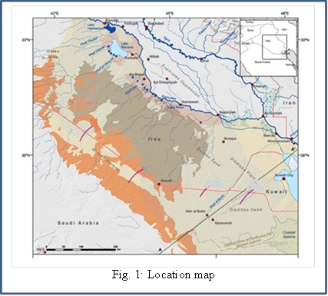
with fresh appearance. This member also
crops out in the north of the study area.

We believe that the cropping out of this
member in these two sheets in spite of the
regional dipping is belonging to structural
reason.
The lower contact with the Middle
Member of Dammam Formation is
specified on the first appearance of large
Nummulite Species and the absence of
chalky appear light soft beds.
Thickness of this member was difficult to
determined due to the extensive severe
weathering and erosion processes and the
Quaternary cover, the thickness of this
member is ranging around (50.0 m). So the
total thickness of Dammam Formation
exposed beds in the study area is about
(62.0 m).The studied area (fig1) is located between, Latitude 32˚22 '30' '---- 30˚30' 00 " Longitude 43˚30 '00--- 46˚45' 00 ''.
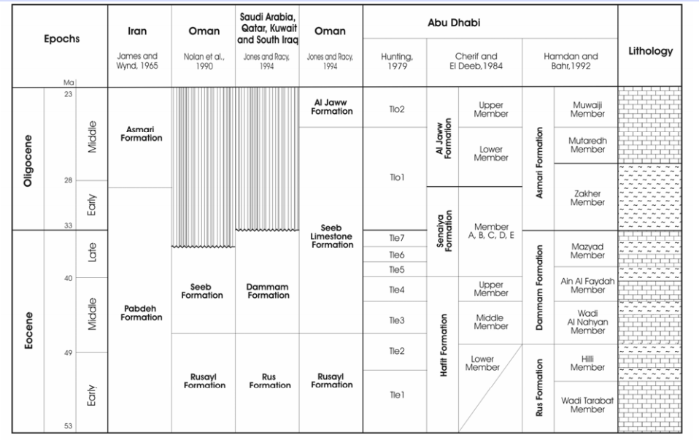
Fig .2: Lithostratigraaphic correlation chart of south Iraq and neighbouring countries ( based on Hamdan & Bahr ,1992)

Biostratigraphy & paleeoecology

It represents the oldest rock units exposed in the studied area. This formation has been divided paleontologically into two members( Fig.3). These are:
Middle member In general the middle part of Dammam Formation is characterized by limestone, dolomitic limestone, biomold dolomitic limestone, algal limestone, silicified fossiliferous dolomitic limestone (plate 1-1) and dolomite. Fossils: The following fossils were recorded within the Middle Member of Dammam Formation

Rhapydionina urensis HENSON (plate. 1.2 and 1.3)
Coskinolina balsilliei DAVIES (plate. 1.4),
Praerhpydionina huberi HENSON (plate. 1.5 and 1.6).

Depositional environment: According to Al-Hashimi (1973) and Amer (1980) the sediment of Middle Dammam Formation deposited in a neretic sublittoral fore reef shoal zone of shallow warm water temperature. Al-Mubarak and Amin (1983) described the depositional environment of the Middle Member of the Dammam Formation as shallow marine tropical- subtropical with depth not more 100m.
The upper part of Dammam Formation consists of limestone, dolomitic limestone, recrystallized fossiliferous limestone, biomold limestone and dolomite.
Fossils: The following fossils were recorded within the upper member of the formation:
Peneroplis gervillei D'ORBIGNY (plate. 1.7) Peneroplis sp.(plate.1.8), Nummulites sp , Articulina sp. ,Spirolculina sp. ,Valvulina sp. ,Rotalia sp. ,Miliolids, rotalids, shell fragments, echinoids, ostracods and corals.
Depositional environments: According to Pokorny (1958) and Bonefous and Bismuth (1982), the presences of miliolids and penerplis are good indicter of lagoon (back reef) environment
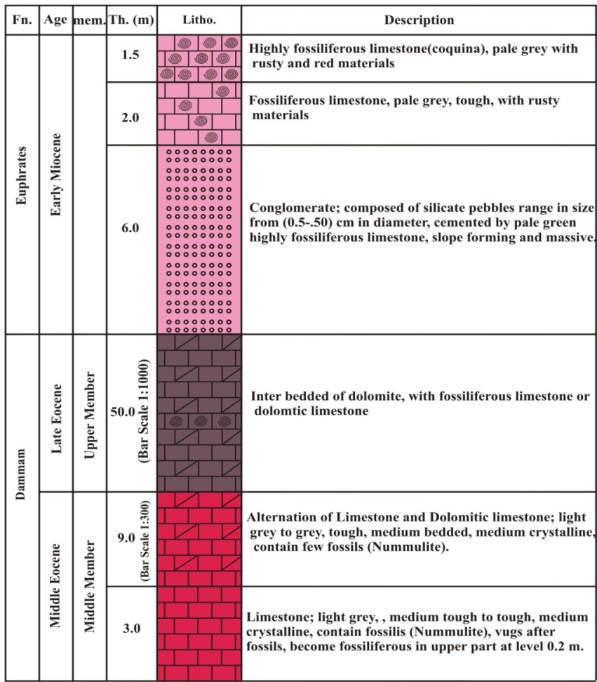
.

Fig. 3 :Litho stratigraphic column section for the Dammam Fn.
According to Al-Hashimi (1972 and 1973), the sediment of Upper Dammam Formation deposited under shallowing or regression, lithoral and lagoonal condition date to highlyoccuranece of miliolids and penerplis faunal assemblage. The assemblage faunaabovethetypical restricted marine platform (lagoon) facies characterized the Upper Eocene (Dammam Formation) in the studied area (Al-Hashimi and Amer, 1985).

Petrographic & Depositional Environments:
The major identified microfacies of this formation are mudstone, wackestone, packstone, grainstone and floatstone. Each type consists of several submicrofacies depending on their components:
Mudstone microfacies It consists mainly of micrite as groundmass. This microfacies is divided into the following submicrofacies. These are:
Dolomudstone : Petrographically, the groundmass consists of micrite that completely replaced by very fine to fine dolomite. The dolomite crystals are present as rhombohedral and euhedral forms. Some of them have inclusion of black materials and others have zoning. Diagenetic processes such as early dolomitization and selective cementation affect the rocks of this submicrofacies. This submicrofacies relates to SMF23 and tidal flat (FZ8) and evaporitic coasts (FZ9A) as categorized by Flugel (2004).(Fig:4):
Bioclastic dolomudstone : Microscopically, it is mainly composed of bioclasts 8% floating in a micritic groundmass that completely replaced by very fine dolomite. The bioclasts are badly preserved as a result of severe dolomitization and remains as ghosts and biomolds such as miliolids and molds of pelecypods. Early dolomitization, dissolution, and selective cementation by gypsum are the main digenetic processes affect this rock. This submicrofacies characterize (FZ8).
Bioclastic mudstone : Petrographically, the rock is characterized by the presence of fossils<10% embedded in a microsparitic matrix that selectively dolomitized by very fine dolomite. Most of the fossils are badly preserved and present as biomolds and ghosts. The recorded fossils are ostracods, pelecypods and other recrystallized fossils. This submicrofacies contains quartz grains of silt to very fine and medium size as well as iron oxides present as patches, inclusion within calcite crystals and coating some fossils. The main diagenetic processes influenced this submicrofacies are recrystallization, partial dedolomitization dissolution and cementation. This submicrofacies occurs in restricted environment (FZ8).
Wackestone microfacies :This microfacies consists of micrite as groundmass with fossils >10%. It is divided into the following submicrofacies:
Bioclastic dolowackestone : Petrographically, it is characterized by the presence of abundant fossils mostly affected by dissolution and remains as biomolds embedded in a micritic matrix that completely dolomitized by very fine to fine anhedral to euhedral and rhombohedral crystal of dolomite. The recorded fossils are few Textularia sp., echinoid spine, pelecypods and algae. Intraclasts 3% are also present, composed of aphanocrystalline dolomite and with size ranging from fine to medium and coarse (0.2-0.7 and 2) mm. The diagenetic affects this submicrofacies are early dolomitization, dissolution and selective cementation by calcite. This submicrofacies corresponds to SMF9 and shallow subtidal environment with open circulation FZ7.
Peloidal bioclastic dolowackestone: Petrographically, the rock consists of bioclasts (mostly biomoldic) in addition to peloids 10% embedded in a micritic matrix that completely dolomitized by very fine to fine dolomite. The peloids are spherical and elliptical in shape, medium size (0.16-0.24) mm. Early dolomitization, dissolution and selective cementation are the main digenetic processes affect this submicrofacies. Following Wilson (1975), this submicrofacies type is interpreted to have been formed in a restricted circulation on marine platform and low energy environment (SMF19 andFZ8).
Bioclastic wackestone : Petrographically, the rock is characterized by the presence of fossils (10%) embedded in a micritic groundmass that partially recrystallized to microsparite. The recorded fossils are abundant shell fragments of pelecypods, echinoderm plates, ostracods, algae, and recrystallized fossils. Few quartz grains of silt to very fine sand are present within this submicrofacies. Partial recrystallization, dissolution and selective cementation of veins by calcite are the main diagenetic processes affect this submicrofacies. This submicrofacies corresponds to SMF12 and formed in restricted platforms and tidal flats (FZ8) and open platform (FZ7).
Packstone microfacies :The following submicrofacies are recognized:
Shelly dolopackstone: Petrographically, shell fragments form the predominant components of this microfacies but their identification is difficult due to severe diagenetic processes such as dolomitization, dissolution and selective cementation. Only pelecypods are recognized. This submicrofacies is comparable to SMF12-S and restricted platform and tidal flats (FZ8) of Flugel (2004).
Fenestral algal dolopackstone :Petrographically, this submicrofacies is characterized by the presence of algae with fenesrtal porosity within finely crystalline dolomitic groundmass. Dolomitization and dissolution are the main diagenetic affect this submicrofacies. This submicrofacies corresponds SMF21 and FZ8 &FZ9 as categorized by Flugel (2004).
Silicified foraminiferal bioclastic dolopackstone :Microscopically, it is characterized by the presence of abundant bioclasts such as foraminifera (Nummulite sp., Coskinalina sp. and Rhapydionina sp.), pelecypods and ostracods. These fossils are mostly affected by late diagenetic dolomitization, (Fig. 5.1). This is indicated by the presence of fine to medium and euhedral to rhombohedral dolomite. This submicrofacies is also severely affected by dissolution leaving biomolds which latterly reduced by authigenic silica. This submicrofacies indicate deposition in restricted circulation on marine platform, shallow lagoon of hypersaline water Al Hashimi (1985).
Silicified bioclastic intraclastic dolograinstone: Petrographically, bioclasts and intraclasts form the main components with fine to medium dolomite as cement. The dolomite crystals are euhedral to rhombohedral. Some of them show zoning. Foraminifera such as Praerhapydionina sp. Peneroplis sp. and fragment of corals represent the bioclasts. Intraclasts are composed of aphanocrystalline dolomite and with average size is 0.64mm. Late dolomitization, dissolution and partial cementation by authigenic silica (megaquartz) are most diagenetic changes affect the rock of this submicrofacies. This submicrofacies relates to SMF24 and FZ8 as categorized by Flugel (2004).
Floatstone microfacies: According to Embry and Klovan (1971), this microfacies consists of>10% grains of more than 2mm in size embedded in a micritic groundmass. Two submicrofacies are recognized. These are:
Dolomitic bioclastic intraclastic floatstone Petrographically, the dominant component of this submicrofacies is intraclasts in addition to algae and few shells of pelecypods imbedded in a micritic groundmass that partially replaced by very fine dolomite. The size of intraclasts ranges from sand size to gravel size (>2-24) mm. These intraclasts are calcitic in composition and composed mainly of micrite with pelecypods, partially recrystallized micrite to microsparite and biomicrite intersected by many veinltes and enclosing recrystallized ostracods and microsparitic grains. This submicrofacies contains few quartz of very fine to medium sand (0.1-0.5) mm. Partial dolomitization only affects groundmass. This submicrofacies relates to SMF24 and FZ8 of Flugel (2004) which represents restricted platform environment.
Peloidal bioclastic floatstone Petrographically, it is composed of bioclasts in addition to peloids embedded in a microsparitic groundmass. The bioclasts 72% are represented by abundant gastropods, miliolids, pelecypods, Elphidum sp. and Nummulites. Peloids 15% are very fine and micritic in composition, (plate.1.2).
The main diagenetic processes affect this submicrofacies are recrystallization, dissolution and cementation. This submicrofacies relates to SMF8 and FZ7 (shallow open marine environment).
Algal dolobindstone :Microscopically, this submicrofacies is characterized by the presence of algal structure that organically bounded during deposition with micritic groundmass that completely dolomitized by very fine dolomite (Fig. 3). Early dolomitization and dissolution are the main diagenetic changes affect this rock. This submicrofacies is attributes to SMF 21 and restricted lagoons (FZ8) and evaporitic lagoons (FZ9A).
Crystalline dolostone lithofacies Petrographic investigation reveals that dolomite is considered the main components 99%. The dolomite present is fine (0.05mm), euhedral to rhombohedral with zoning (plate.1-3). The main diagenetic processes affect this lithofacies are late dolomitization, dissolution and selective cementation by gypsum. This lithofacies is considered to be deposited in a shallow marine of relatively high salinity.
Sandy calcareous claystone lithofacies Petrographically, ferruginous clay forms the main components 50%, containing a considerable amount of calcite 33%.Most of the calcite is most probably formed after replacement of gypsum where the original shape of the gypsum is still preserved (lozenge and rosey). The lithofacies contain quartz grains 15%. The quartz grains are of silt size to fine and medium, anhedral to subhedral and euhedral and with subangular to subrounded outlines. Replacement of gypsum by calcite and filling the pore space by gypsum are the main diagenetic affect this lithofacies. This lithofacies represents platform evaporites facies, where salt lagoon, intensive heat and arid conditions were prevailed.

Fig. 4: Depositional environments of Dammam Formations according to Flugel (2004).( Wafa'a Ph. Basher1,etc ,2015)

Diagensis Processes

Early diagenetic dolomitization
The majority of dolomite rocks in the study area are of early origin. This process is confirmed by the presence of aphanocrystalline and very finely crystalline dolomite that completely or partially replaced micritic matrix in mudstone, wackestone, packstone and floatstone and relatively rare in grainstone submicrofacies. It has affected the Dammam Formations .Many factors are responsible for the replacement of sediment by dolomite. These factors are (1) predolomitization mineralogy, (2) particle size, (3) permeability variations and (4) organic matter (AL – Hashimi, 1972). In the study area, the mineralogy of sediments and the particle size are perhaps the most important factors in causing dolomitization and noticed in most rocks of the study formations. The unstable aragonite and high mg-calcite could be more susceptible to dolomitization than low-mg calcite. Schmidt (1965) noticed that aragonite bioclasts were partially or completely dolomitized while calcitic bioclasts were less affected. Algae, miliolids, peneroplis, mollusks and micritic envelope are more susceptible to dolomitization than other fossils (plate.2-4). In addition, the micritic groundmass is more susceptible to dolomitization than sand sized particles because of the reactivity differences. The type of dolomite in Dammam Formations is supported to form in a restricted warm lagoon (sabkha-environment) by the transformation of aragonite and calcite due to dense hypersaline brines formed from the increase of mg/ca ratio. This fluid could seep into the underlying carbonate sediments and dolomitized them by seepage refluxion.

Late diagenetic dolomitization
The effect of this process on the rocks of the study area is very limited. In Dammam Formation, Only three submicrofacies are affected by this process (silicified foraminiferal bioclastic dolopackstone, silicified bioclastic dolograinstone and crystalline dolostone). This process is indicated by the presence of fine to medium euhedral to rhombohedral interlocking crystals of dolomite. Most of them have zoning. This process is formed under hypersaline environment, (plate 2-5).

. Dedolomitization
It is a diagenetic replacement of dolomite by calcite. This process is very limited in the study area. this process is selectively replaced the micritic groundmass. It is indicated by the presence of rhombohedra isolated crystals of fine size floating porphyrotopically within a micritic or microsparitic groundmass. This process is formed under the influence of meteoric freshwater in lacustrine environment.

Neomorphism
This process involves recrystallization (transformation of calcite to calcite) and inversion (transformation of aragonite to calcite).

Recrystallization
This process is indicated by the presence of microsparite (4-10) µ and sparry calcite>10µ. In Dammam Formation, the recrystallization partially affects both groundmass and fossils of some rocks (Fig.2.6), the recrystallization either is partially or completely affects the rocks of few facies as noticed in ooidal bioclastic peloidal grainstone and crystalline limestone lithofacies. The complete recrystallization is accompanied by partial or complete destruction of pre-existing rock texture.

Micritization
It is the first diagenetic alteration produces a micritic envelope around skeletal grains that originally composed of aragonite and / or high mg calcite, (Fig.2.8). The existence of micrite envelope is important for the preservation of grain shapes. Molluscan, miliolids and Peneroplis sp., are the most noticed fossils affected by this process. This process is produced by the combination of boring algae penetrates inward from the exterior of the skeletal particles and precipitation where the waters are supersaturated by calcium carbonate (Bathurst, 1966, 1975). Such a process was found to be most common in intertidal and supratidal environments (e.g. Bathurst, 1966; Taylor and Illing, 1969).

Results & Discussion
Upper member of Dammam Formation covers a considerably wide part of the study area:
The upper contact between this member and Euphrates Formation which based on the appearance of highly pebbly cross bedded fossiliferous limestone of Euphrates Formation was firstly distinguished in Wadi Abu – Mris ,the beds of this member are affected by sever diagenetic processes and extremely high weathering (Fig.5), so they rarely appeared with fresh appearance. This member also crops out in the north of the study area, We believe that the cropping out of this member in these two sheets in spite of the regional dipping is belonging to structural reason.The Upper Member of Dammam Formation consists of intercalation of finely crystalline dolomite, white to grayish white, medium tough, chalky appearance, with algae and black dots with vugs after fossils and rarely coexisting small size Nummulites species and trace of coral pieces, alternate with fossiliferous limestone or dolomitic limestone, white, medium tough, medium to thickly bedded, recrystallized with vugs, rusty and red band, sometimes appears cavernous. These beds seem to be harder and darker in some sections due to digenetic processes in some levels of the sequence big crystals of calcite appear due to recrystallization processes.
The lower contact with the Middle Member of Dammam Formation is specified on the first appearance of large Nummulite Species and the absence of chalky appear light soft beds.
Thickness of this member was difficult to determined due to the extensive severe weathering and erosion processes and the Quaternary cover, proximately by the correlation between basic sections and depending on the drilled well in the study area, the thickness of this member is ranging around (50.0 m). So the total thickness of Dammam Formation exposed beds in the project area is about (62.0 m).The recognized fossils assemblages in the Dammam Formation in the study area are:Nummulite Sp. , Coskinolina sp. , Rhapydiominase Sp. , coral , Algea , Echinoids.The given age for Dammam beds in study area was middle – Late Eocene.
According to Al-Mubarak and Amin (1983), the Nummulites sp. indicates a shoal facies of tropical or sub tropical quiet marine environment with depth not more than 100 m.
The fossils assemblages are more similar to the Middle Eocene (Upper Latetian) in middle part, which were recognized in the supplementary type section in Iraq, in Al-Hajara section, S.W.Iraq, in well Zabair-3(subsurface section) Southern Iraq and in wade Swab, Ratba and Hauran area, Western Desert and in Samawa area (Bellen et al., 1959, Al-Hashimi, 1972, 1973, 1974 and Jassim et al., 1984). The age of the formation is estimated as Upper Eocene (Lower Priabonia) depending on the assemblage fauna (Jassim et al., 1984). Al-Hashimi (1974), Mahmood (1984), Salman (1984) and Al-Mutter (1985) pointed out that the upper part of Dammam Formation which characterized by an abundant of miliolids, peneroplids faunal assemblage represent the terminal phase of Middle-Late Eocene sedimentary cycle.

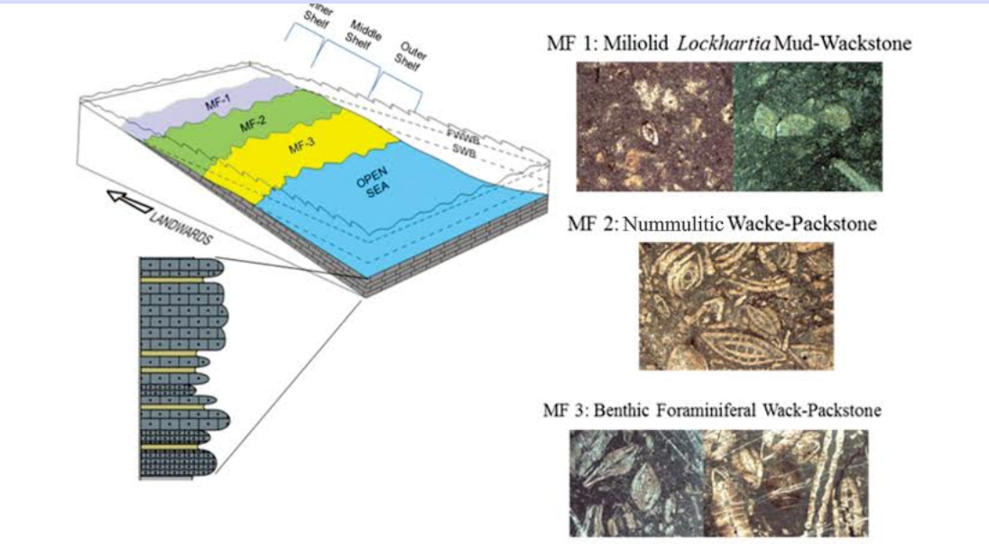

Fig.5 Depositional setting of Dammam formation. FWWB= Fair weather wave base, SWB= Strom wave base.

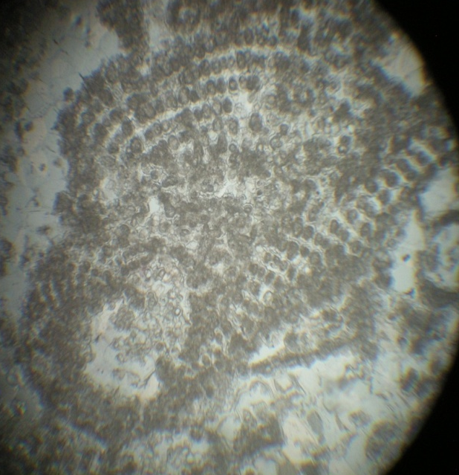
Plate 1

3
2
1

6
5
4
4

7
8

Plate 1.1 : Silicified fossiliferous dolomitic limestone facies, X6.3.
Plate 1.2 Rhapydionina urensis HENSON, X6.3.
Plate 1.3 Rhapydionina urensis HENSON, X2.5.
Plate 1.4 Coskinolina balsilliei DAVIES, X2.5.
Plate 1.5 Praerhpydionina huberi HENSON, X2.5.
Plate 1.6 Praerhpydionina huberi HENSON, X2.5.
Plate 1.7 Peneroplis gervillei D'ORBIGNY, X6.3.
Plate 1.8 Peneroplis sp., X6.3.

Plate 2
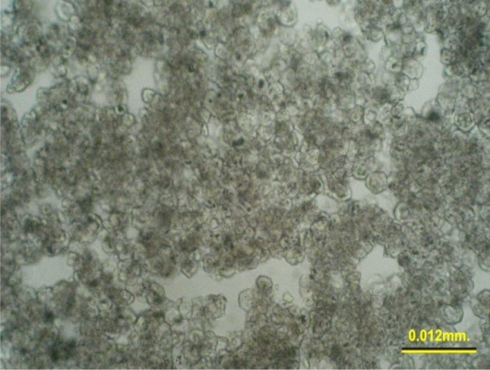
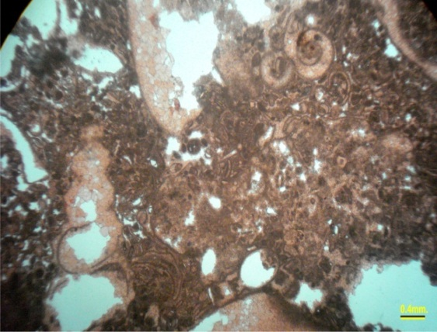
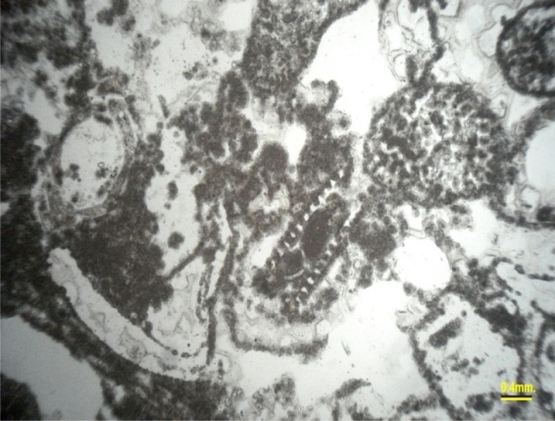

2
1
3

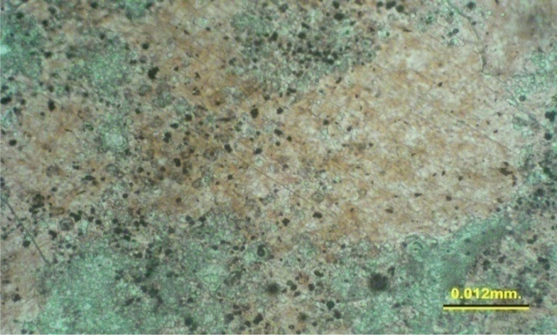
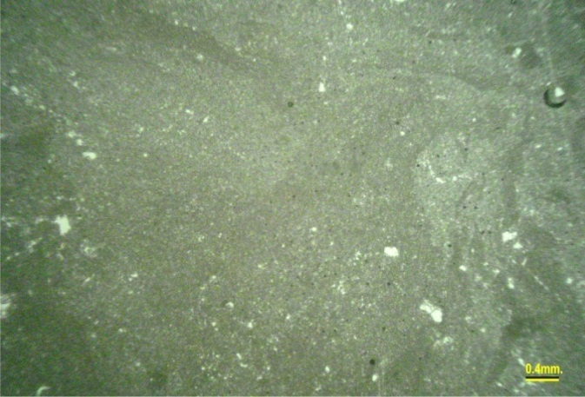

5
4

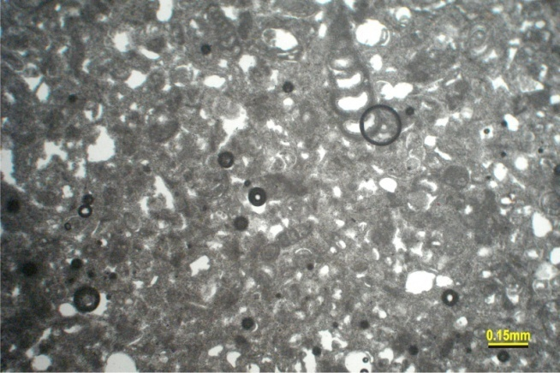

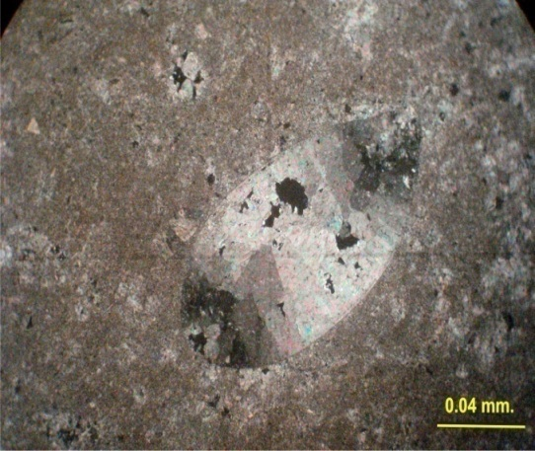

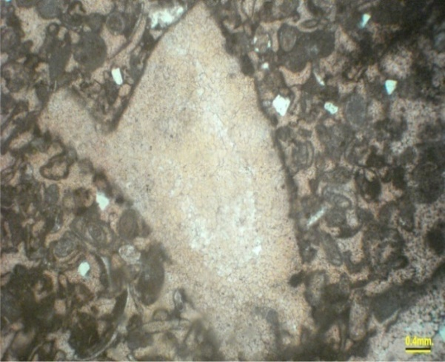

8

7

6

Plate 2.1 Silicified foraminiferal bioclastic dolopackstone.
Plate 2.2 Peloidal bioclastic floatstone
Plate 2.3 Crystalline dolostone
Plate 2.4 Early diagenetic dolomitization affects groundmass and algae
Plate 2.5 Late diagenetic dolomitization
Plate 2.6 Recrystallization affects fossils
Plate 2.7 Inversion affects ostracoda
Plate 2.8 Micritization affects fossils

References
-(Al-Hashimi and Amer 1985)Al-Hashimi, H.A.J., 1972. Foraminiferida of the Dammam Formation (Eocene) in Iraq. Ph.D. Thesis. Unpablishe. University of Landon.
-Al-Hashimi, H.A.J., 1973. The sedimentary facies and depositional environment of the Eocene Dammam and Rus formations. Jour. Geol. Soc. Iraq. Vol. VI, p1-18.
-Al-Khateeb A. A. Ibrahiam, (1999) Series of Geological Report on the Exposed Formation In Iraq, The Zahra Formation.
Al-Khateeb A. (2008) Series of Geological Report on the Exposed Formation In Iraq, The Zahra Formation.
-Al-Mutter, S.S.., 1983. Biostratigraphic study of the South Najaf area, GEOSURV, int. rep. no. 1322.
-Amer, R.M., 1980. Biostratigraphic and micropaleontologic study of West Najaf-Nukhaib area, West Desert Iraq. GEOSURV, int. rep. no. 1097.
-Al-Mubarak M. A and Amin R. M., (1983) Regional Geological mapping of the western part of the southern desert and presented the mapping of rock units in a geological map scale of 1:25000.
-Al-Ani, M.Q. and Ma'ala, K.A., 1983a. Report on the regional geological mapping of South Samawa area. GEOSURV, int. rep. no. 1348.
-Al-Ani, M.Q. and Ma'ala, K.A., 1983b. Report on the regional geological mapping of North of Busaiya area. GEOSURV, int. rep. no. 1349.
Bathurst,R.G.C.,1975: Carbonate sedimentation and their diagnosis: Elsevier, Amsterdam, 620p. -Bandy, O.L., 1964.General Correlation of Foraminiferal Structtule with Environment, in Approaches to Paleoecology edited by John I.Mbric 75pp, 9Figs.
Buday, T., 1980: The regional geology of Iraq, Vol.1, stratigraphy and paleontology, 445pp.Khassab, I.I.M. And Jassim, S.Z.( edts ) S.O.M., Baghdad.
-Behnam, H.A., 1984.Study on stratigraphy and paleontology of Bahr En Najaf area. GEOSURV, int. rep. no. 1328.
Bellen, R.C., Daunnigton, H.V., Wetzel, R. and Morton, D., 1959. Lexique Stratigraphic International, Asia, Face 10a, Iraq, Paris.
Bathurst, R.G.C.,1975. Carbonate sediments and their diageneses, Elsvier, Amsterdam, 658pp.
Choquette,P.D. and Pray, L.C., 1970. Geological nomenclature and classification of porosity in sedimentary carbonates: Bull. Am. Ass. Petro., Vol., 45, p. 207-250.
Ctyroky,P. and Karim,S.A.,1971:Stratigraphy and Paleontology of the Oligocene and Miocene strata near Anah, Euphrates Valley, W. Iraq. NIMCO Report, S.O.M. Lib. Baghdad.
Dunham,R.J.,1962:Classification of carbonate rocks according to depositional texture. In: Ham, W.E.(ed.),Classification of carbonate rocks:A.A.P.G.Memoir,p.108-121.en.wikipedia.org/ wiki/ Dunham classification-18K.
Embry, A.F., and Klovan,J.E.,1971: A Late Devonian reef tract on Northeastern Banks Island, NWT: Canadian Petroleum Geology Bulletin,Vol.19,p.730-781.
- Evamy, B.D., 1967. Dedolomitization and the development of rhombohedral pores in limestone, Jour. Sed. Pertro, no. 37, p. 1204-1215.
Flugel,E.,1982:Microfacies analysis of Limestone. translated by K. Christenson, Berline Heidelberg-NewYork.Springer Verlage,63p.,53pl.,78figs.58pls.
-Flugel, E., 2004. Microfacies of carbonate rocks, Sprmger- Verlag Berlin Heideberg.
Folk,R.L.,1959,Practical petrographic classification of limestone:A.A.P.G.Bulletin,Vol.43,p.1-38.en.wikipedia.org/wiki /Dunham Classification-18K.
Friedman,G.M.,1971,Staining.In:Carver,R.G.(ed.),Procedures in Sedimentary Petrology, John Wiley and Sons, Inc.,Newyork,653p.
Ghosh,A.M.,2002:Cenozoic coralline algal assemblage from southwestern Kutch and its importance in palaeoenvironment and palaeobathymetry. Current science, Vol.83, No.2, pp.153-158.
Hallock, P.,1999 :Symbiont-bearing foraminifera. In: Gupta, B.K.S.(Ed.),Modern Foraminifera Kluwer Academic.pp.123-139.
Ireland, H.A.,1958, Insoluble residues .In: Haun, J.D. and LeRoy, L.W.(eds.),Subsurface Geology in Petroleum Exploration. Johnson Publ.Co.,Colorado,887p.
Ireland,H.A.,1971,Insoluble residue. In: Carver,R.E.(ed.),Procedures in Sedimentary Petrology. John Wiley and Sons,Inc.,Newyork,653p.
- James, N. P. & Choquette, P. W.,1983. Diagenesis 6. Limestones- the Sea Floor Diagenetic Environment. Geoscience Canada 10, p. 162-179.
-Jassim, R.Z. and Al-Jiburi, B.S., 2O09. Stratigraphy, Special Issue, Geology of the Iraq Southern Desert, Iraqe Bulletin of Geology and Mining, p53-76.
-Jassim, S. Z. and Goff, J., 2006. Geology of Iraq. Dolin and Morarian Museum, Prague, 341.
-Jassim, S.Z., Karim, S.A., Basi, M.A., Al-Mubarak, M. A. and Munir, J., 1984. Final report on the regional geological survey of Iraq. Vol.3 "Stratigraphy ". GEOSURV, int. rep. no. 1447.
Maill,A.D.,1984: Principle of sedimentary basin analysis. Springer, New York. en.wikipedia.org/ wiki/Dunham classification-18K.
Muller,G.,1967,Methods in Sedimentary Petrology,Havner,Newyork,283p.
Perry,T.C.,2000:Factors controlling sediment preservation on aNorth Jamaica Fringing Reef: AProcess-based approach to microfacies analysis. Jour. of Sed. Res. Vol.70, No.3,pp.633--Muniem, A.A., 1983. Biostratigraphy of Lower Eocene-Upper Miocene of West Samawa area, Southern Desert, Iraq. GEOSURV, int. rep. no. 1387. .
-Muniem, A.A., 1984. Micropaleontological study and biostratigraphy of West Nukhaib area.GEOSURV, int. rep. no. 1325.
Pomar,L.,2001:Ecological control of sedimentary accommodation:evolution from a carbonate ramp to rimmed shelf, Upper Miocene, Balearic Islands. Palaeogeography, Palaeoclimatology, Paleoecology Vol.175,pp.249-272.
-Raji, W. and Said, V.V., 1984. Primary study on paleontology of Dammam and Zahra Formations in south Samawa area. GEOSURV, int. rep. no. 1387.
-Salman, B., 1993. Revision of the Zahra Formation. GEOSURV, int. rep. no. 2199.
Scholle, P.A. and Ulmer-Scholle,D.S.,2003:AColor Guide to the Petrography of Carbonate Rocks :AAPG Memoir 77,474p. www.eos.ubc.ca/courses/eosc221/sed/carb/exercise/exer191.html2k.
-Salman, B., 1984. Biostratigraphic and Paleoecology of North Busaiya area. GEOSURV, int. rep. no. 1390.
Van,Bellen,R.C.,1956:The Stratigraphy of the «Main Limestone» of the Kirkuk, Bai Hassan and Qarah Chauq Dagh structures in north Iraq. Jour. Inst. Petrol., Vol.42, pp.233-263.
Van, Bellen, R.C., Dunnington, H.V., Wetzel, R. and Morton,D.M.,1959:Lexiqe Stratigrahique International, V.III, Asie. In: Dubertret, L., (director), fasc.10c.Iraq, Centre Nat. Researcher Scietifique,(Paris),333p.

