Abstract
Introduction: A deep vein thrombosis (DVT) is a type of cardiovascular disease that may be associated with fatal complications such as pulmonary embolism (PE). The objective of this study was to assess the prevalence of DVT in Al- medina and to compare the findings between male and females. Methods: Records of 432 patients were reviewed in this retrospective study. Pearson Chi-Square test, cross-tabulation correlations were applied to analyze and obtain the statistical values for study variables’ associations. Results: Out of 432 patients, 17.8 %( n=77) had DVT. The acute DVT had the highest frequency 64.9% (N=50). The DVT was more prevalent in female than male (P=0.0001). The highest frequency of acute DVT was observed in popliteal vein. While the highest frequency of chronic DVT was demonstrated in the superficial femoral and common femoral veins. The DVT was more prevalent in the left leg (51.9%). No significant statistical association between the DVT and age P = 0.431.
Conclusion:
Incidence of DVT in Medina is high. DVT is more prevalent in females than males and affects the left leg more than the Rt. No significant statistical association between DVT and the age.

Keywords: Deep, Vein, Thrombosis, Ultrasound, Al-Medina

Introduction:
A deep vein thrombosis (DVT) is a type of vascular defect that results from the occlusion of the venous lumen due to venous stasis, vascular injury, and/ or hypercoagulability. [1] The actual incidence of DVT is unclear although some studies have shown that it is 1-2/1000.[2] There many risk factors that increase the incidence DVT such as; previous DVT, immobilization longer than three days, congestive heart failure (CHF), obesity, Pregnancy and the postpartum period, certain types of cancer and lower extremity fractures. [3] There are several clinical symptoms of DVT such as; pain or tenderness, swelling, warmth, redness or discoloration, and distention of surface veins. Some times no associated clinical symptoms with the DVT.[4,5] cellulitis, Baker’s cyst, and superficial thrombophlebitis are the most common differential diagnoses for DVT in cases of persistent calf pain. [6] The DVT may lead to some complications and the common serious complications include chronic venous insufficiency, post- phlebitis syndrome, and pulmonary embolism (PE). [4] Some authors [7] have indicated that PE results in 70.6% of DVT patients.
Both computed tomography venography (CTV) and magnetic resonance venography (MRV) are alternatives to ultrasound (U/S) in diagnosing DVT. Some studies suggested that U/S could identify DVTs in the large vein above the knee more accurately (about 95%) than in the calves (60-70%). [5, 8] The current study aims to assess the prevalence of DVT in Al- medina and to compare the findings between male and female gender. Also, to assess the effect of age on DVT.

Materials and Methods:
432 patients’ records were reviewed in a descriptive retrospective study on ultrasound assessment of DVT. The study was conducted at the Radiology department of King Fahad hospital in Madinah, Saudi Arabia. The duration of the study was during the period from January to March 2020.
The collected data source was Philips U/S system, model IU22 with linear probe 9M. The inclusion criteria include any participant has one or more of the following clinical symptoms; lower limb swelling, hotness, redness or pain.
Data collection
The study data was collected from the picture archiving communication system (PACS). A data collection sheet was prepared to collect the demographic, clinical and U/S imaging data such as; patient’s age, gender, and symptoms as well as the U/S findings.
Data analysis
Statistical Package for Social Sciences (SPSS) - (IBM version 20, Armonk, NY, USA) software was used to analyse the study data. For descriptive statistics, data were presented in mean ± standard deviation and percentages. Pearson Chi-Square test, cross-tabulation and Pearson correlations were applied to obtain the statistical values for study variables’ associations. A statistical associations were considered significant if the P- value < 0.05.
Ethical considerations:
This study was approved by the institutional review board in the General Directorate of Health Affairs in Almadinah Almunawwarah the (IRB) was H-03-M-084. The informed consent was waived out due to the retrospective nature of the study. The confidentiality of the participant's information was assured. No identifying information of the selected participants were included.

Results:
The study included 432 subjects out of these 17.8 % (n = 77) were diagnosed as positive DVT cases. The mean age of the selected subjects was 48.2±20.3 a statistical analysis revealed that no statistical association between the age and DVT (P = 0.431) - (See Table 6). Table1 summarizes the symptoms of the participants; the common symptom was swelling which is 46.7% (out of 77), followed by leg pain 15.5% (n =12), the hotness and redness had the lowest frequencies of symptoms (1%). Table2 summarizes the DVT status frequencies, the acute DVT was noted in 64.9% (n = 50), the chronic was observed in 29.8% (n = 23), and 5.1% (n =4) were sub-acute DVT. Table3 shows a cross-ablution between the DVT status and the gender, the DVT was more prevalent in females than males. Pearson Chi-Square test showed significant statistical association between gender and DVT (P = 0.001). Table 4 presents a cross-tabulation of the status of DVT with the venous site. The highest frequency (39.0 % (out of 50)) of the acute DVT was noted in the popliteal vein. Followed by the common femoral vein (16%), and the lowest frequency of DVT was demonstrated in posterior tibial vein (4%). The highest frequency (39.1 % (out of 23)) of the chronic DVT was noted in the superficial femoral vein, the common femoral vein (30.4 %). Statistical analysis revealed a significant association between the status of DVT and the venous site P = 0.0001.
Table 5 presents a cross-tabulation of the status of DVT with the participants’ clinical symptoms, 56% of the acute DVT was associated with swelling, and 20% was associated with pain & tenderness. 65.2% of the chronic DVT was associated with swelling. Pearson Chi-Square test demonstrated significant statistical association P = 0.0001.
Figure 1 shows the relation between the DVT findings and their side of the location. All three types of detected DVT were more prevalent in the Lt. Leg than the Rt. P = 0.001.
Figure 2 demonstrates the venous site of the DVT. The highest frequency of DVT was noted in the popliteal vein, then the common femoral and iliac veins. The lowest frequency was observed in the posterior tibial vein.
Figures 3 through 5 present U/S sample images of the DVT findings; the normal venous color flow appearance in the right common femoral vein "CFV" seen in Figure 3. Acute DVT in left popliteal vein "PV" noted in Figure 4. Absence of blood flow due to acute DVT in the left common femoral vein "CFV" seen in figure 5.
Table 1: Symptoms of the participants
Symptoms | Frequency | %
Swelling | 36 | 46.7
Hotness | 1 | 1.2
Redness | 1 | 1.2
Pain & tenderness | 19 | 24.5
Swelling + redness | 2 | 2.5
Swelling + pain | 11 | 14.2
Redness + pain | 3 | 3.8
Swelling + pain + tenderness | 4 | 5.10
Total | 77 | 100

Table 2: Status of DVT
Status of DVT | Frequency  (n) | Percentage  (%)
Acute | 50 | 64.9
Sub-acute | 4 | 5.1
Chronic | 23 | 29.8
Total | 77 | 100.0

Table 3: Cross-tabulation of the status of DVT and gender
Status of DVT | male | female | Total
Acute | 18 | 32 | 50
Sub-acute | 2 | 2 | 4
Chronic | 9 | 14 | 23
Total | 29 | 48 | 77

Table 4: Cross-tabulation of the status of DVT and venous site

Venous Site | Acute | Sub-acute | Chronic | Total
Iliac vein | 6 | 0 | 1 | 7
Common femoral vein | 8 | 1 | 7 | 16
Superficial femoral vein | 2 | 0 | 4 | 6
Popliteal vein | 19 | 2 | 2 | 23
Iliac vein + Superficial femoral vein | 0 | 0 | 5 | 5
Superficial femoral vein+ Popliteal vein | 8 | 1 | 2 | 11
Iliac vein + Popliteal vein | 3 | 0 | 1 | 4
Common femoral vein + Popliteal vein | 2 | 0 | 0 | 2
Popliteal vein + Posterior tibial vein | 2 | 0 | 1 | 3
Total | 50 | 4 | 23 | 77

Table 5: Cross-tabulation for the association of DVT and clinical symptoms
Symptoms | DVT Status
 | Acute | Subacute | chronic | Total
Swelling | 28 | 1 | 7 | 36
Hotness | 1 | 0 | 0 | 1
Redness | 1 | 0 | 0 | 1
Pain in leg + tenderness | 10 | 1 | 7 | 18
Swelling + redness | 1 | 0 | 1 | 2
Swelling + pain | 5 | 1 | 6 | 12
Redness + pain | 1 | 1 | 1 | 3
Swelling + pain + tenderness | 3 | 0 | 1 | 4
Total | 50 | 4 | 23 | 77

Table 6: Chi-Square Test for the association of DVT and age
 | Value | df | Asymptotic Significance (2-sided)
Pearson Chi-Square | 89.638ª | 88 | .431
Likelihood Ratio | 71.468 | 88 | .900
N of Valid Cases | 77

Figure1: Findings of DVT in relation to the side of the location

Figure2: A graph showing the frequency of DVT according to the venous site

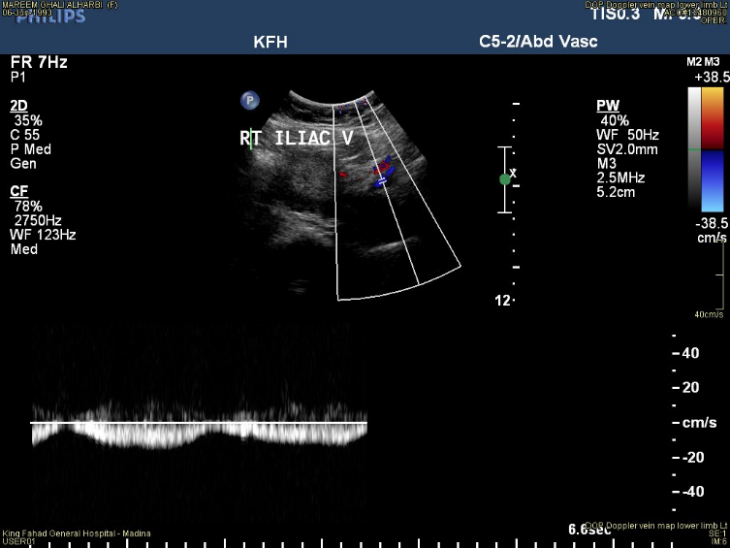
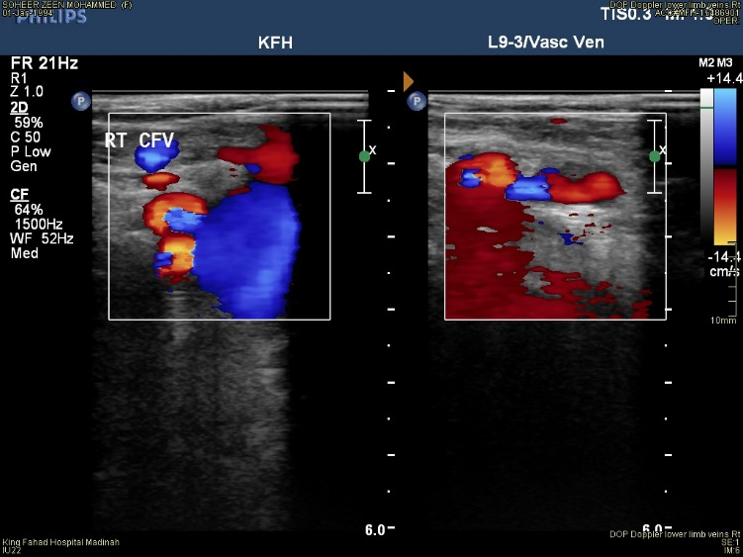

Figure3: Normal venous flow appearance of the right common femoral vein "CFV" and the right iliac vein

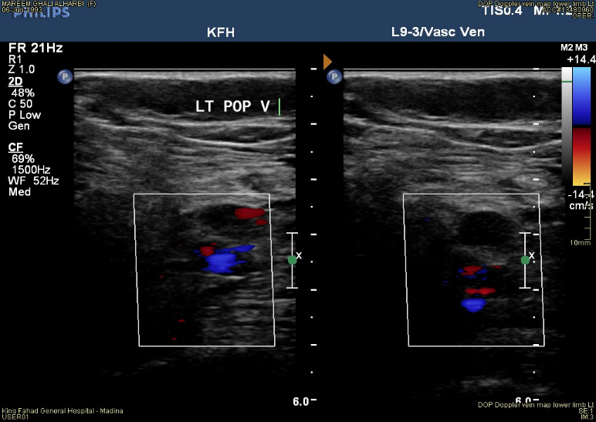
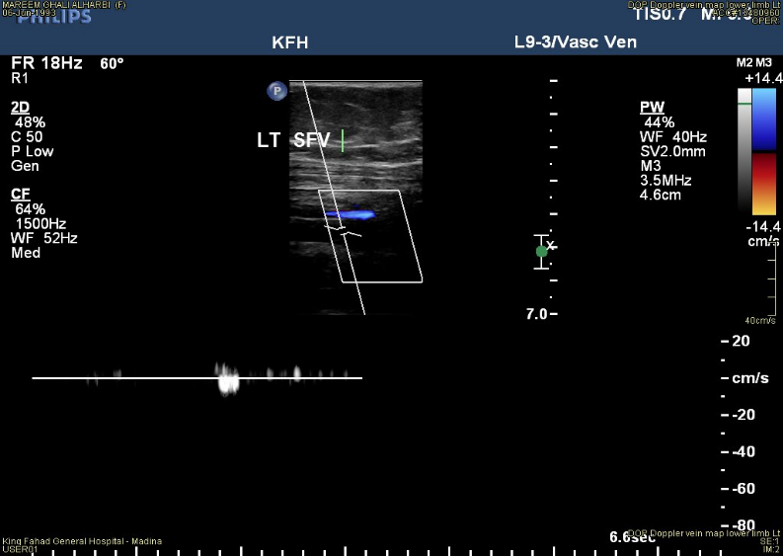
Figure4: Absence of blood flow due to DVT in left superficial femoral vein "SFV" and left popliteal vein "PV"
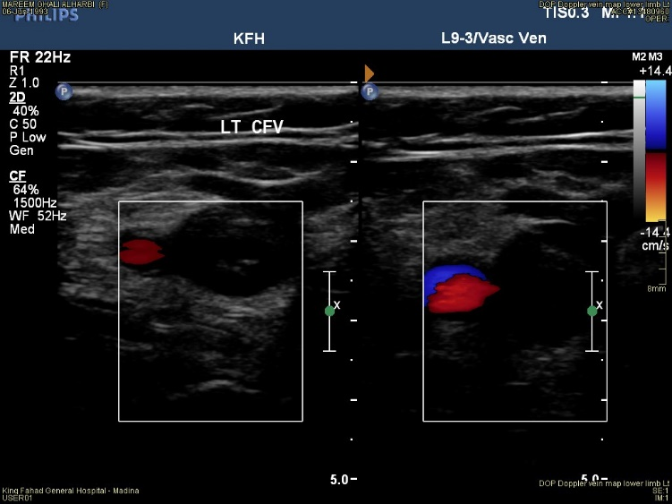

Figure5: Absence of blood flow due to acute DVT in the left common femoral vein "CFV"

Discussion:
The objective of this study was to see the prevalence of DVT in Madinah and to compare the findings between genders. On the base of the study results, the prevalence of DVT was observed in 17.8 % (out of 432). The acute DVT had the highest frequency 64.9%. The DVT was more prevalent in female than male. The highest frequency of DVT was noted in popliteal vein. The DVT was more prevalent in the left leg. Some authors [9] from the KSA proposed that the incidence of DVT is 15.7 % among the bedridden patients these results support the current study findings.
Regarding the relation of DVT with age, the current study showed that there was no statistical association between the DVT and participants’ age (P= 0.431). These results were agree with Alanazi, et al [10] who had shown that there were no association between the DVT and the age of the participants. In contrast, Cushman M et al [11] and Elkhadir A et al [12] had proposed that DVT increase with age increase.
Regarding the relation of DVT with clinical symptoms, the current study showed that the common symptom of DVT was swelling which was 46.7% (out of 77), followed by leg pain 15.5% (n =12), the hotness and redness had the lowest frequencies of symptoms. [See Table 5] These results agree with Harding, M. et al [13] who showed that leg swelling is a common associated symptom occurs as a result of DVT in the leg.
Regarding the relation of DVT with gender, the results of the current study suggested that the DVT was more prevalent in females than males. [See Table 3]. These results agree with several studies such as; Kharaba A[14] who has stated that 50.2 % of the DVT was found in females, Ho, E et al[15] who have suggested that DVT was more common in females (56.9%) than males (43.1%). Catterick, D et al [16] demonstrated that regarding the DVT, the female’s cases were more than males . Contrary, Decosta L et al [17] have concluded that sex, age, body mass index, ethnicity, and comorbidities of diabetes and/or hypertension were not significant predictors of observing a DVT.
Regarding the relation of DVT with the venous site, Yamada N et al [18] have indicated that the most common site for DVT is soleal vein (71.9%). The current study showed another view it concluded that the acute DVT was more prevalent in the popliteal vein than the other veins. It added that the chronic DVT was more prevalent in the superficial femoral vein and then the common femoral vein [See Table4 & Figure2].
Regarding the DVT side of location Ho, E et al (15) and Li, Q et al [19] have concluded that the left leg was affected by DVT more than the right leg. These findings support the current study which presented the same conclusion [See Figure1]. In contrast Vululi, S et al [20] have proposed that the left leg is less affected by DVT than the right.
Conclusion:
The study concluded that the incidence of DVT in Medina is approximately high. There is an increased incidence of the DVT in the females than men. The results indicated that the most common symptoms associated with the DVT was swelling and the DVT occurs more frequent in the left leg than the Rt. No statistical association between the age and DVT. The U/S is good and sensitive diagnostic method for diagnosing DVT. Prospective studies through a well- established methodology in the similar issue were recommended to provide sufficient and complete useful data about the DVT.
Limitations:
There were some limitations for this study that include; the sample size was small, there was no available U/S images’ of good quality demonstrating the measurements for the detected thrombosis in the PACs.
Declaration:
The researchers declare that no conflict of interest and this research did not receive any specific grant from funding agencies in the public, commercial, or not-for-profit sectors.

References
- Kushner A. Virchow Triad. StatPearls. U.S. National Library of Medicine, https://www.ncbi.nlm.nih.gov/books/NBK539697/; 2019 [accessed 29 Mar 2020].
- Beckman MG, Hooper WC, Critchley SE, Ortel TL. Venous thromboembolism: a public health concern. American journal of preventive medicine. U.S. National Library of Medicine, https://www.ncbi.nlm.nih.gov/pubmed/20331949; 2010 [accessed 4 Apr 2020].
- What are the risk factors for deep venous thrombosis (DVT)? Latest Medical News, Clinical Trials, Guidelines - Today on Medscape, https://www.medscape.com/answers/1911303-23022/what-are-the-risk-factors-for-deep-venous-thrombosis-dvt; 2019 [accessed 4 Apr 2020].
- Yamaki T. Deep Vein Thrombosis: Symptoms, Diagnosis and Treatments. Nova Science Publishers, Incorporated, Recent Advances in Hematology Research, https://books.google.com.sa/books?id=XwtYLwEACAAJ; 2013 [accessed 5 Apr 2020].
- Wang K-L, Chu P-H, Lee C-H, Pai P-Y, Lin P-Y, Shyu K-G, et al. Management of Venous Thromboembolisms: Part I. The Consensus for Deep Vein Thrombosis. Acta Cardiologica Sinica. Taiwan Society of Cardiology, https://www.ncbi.nlm.nih.gov/pmc/articles/PMC4804936/ Holden LB; 2016 [accessed 4 Apr 2020].
- Linda B. Pyomyositis: A Differential Diagnosis for Venous Thrombosis. J DIAGN MED SONOGRAPHY, Vol.17, 2001 PP. 258-262. https://doi.org/10.1177/875647930101700502·
- Hirmerova J, Seidlerova J, Chudacek Z. The Prevalence of Concomitant Deep Vein Thrombosis, Symptomatic or Asymptomatic, Proximal or Distal, in Patients with Symptomatic Pulmonary Embolism . Clinical and applied thrombosis/hemostasis: official journal of the International Academy of Clinical and Applied Thrombosis/Hemostasis. SAGE Publications, https://www.ncbi.nlm.nih.gov/pmc/articles/PMC6714772/; 2018 [accessed 4 Apr 2020].
- Chong L-Y, Fenu E, Stansby G, Hodgkinson S. Management of venous thromboembolic diseases and the role of thrombophilia testing: summary of NICE guidance. Bmj. 2012; 344:e3979. https://doi.org/10.1136/bmj.e3979.
- Alaskar FA, Albahili FK, Hussain MA. Acute Lower Limb Deep Venous Thrombosis Diagnosed by Doppler Ultrasound among Bedridden Patients. The Egyptian Journal of Hospital Medicine, Vol. 70, 2018 PP.1748–751. UR-https://ejhm.journals.ekb.eg/article_10261.html.
- Alanazi OA, El-Fetoh NMA, Mohammed NA, Alanizy TMA, Alanazi YW, Alanazi MS, et al. Deep Venous Thrombosis among hypertensive patients in King Abdulaziz University (KAU) Hospital, Jeddah, Kingdom of Saudi Arabia. Electron physician, Vol.9, 2017 PP. 5472–54777. https://doi.org/10.19082/5472. eCollection 2017 Oct.
- Cushman M. Epidemiology and risk factors for venous thrombosis. In: Seminars in hematology. Elsevier, Vol.44, 2007 pp.62–69. https://doi.org/10.1053/j.seminhematol.2007.02.004.
- Elkhadir A, Wazzan M, Abduljabbar A, Badwi NM, Hendi FM, Al-Shomrani KM, et al. Prevalence of Deep Venous Thrombosis (DVT) in Jeddah. Int. j. med. sci. clin. Invent, Vol.5, 2018 PP. 4089-4091. https://doi.org/10.18535/ijmsci/v5i10.03.
- Harding M. Swollen Legs. Make definite diagnosis for Swollen Legs. Patientinfo, https://patient.info/doctor/swollen-legs; 2016 [accessed 23 March 2020].
- Kharaba A, Al Aboud M, Kharabah MR, Alyami K, Al Beihany A. Venous thromboembolism risks and prophylaxis in King Fahad Hospital, Madinah, Saudi Arabia. J Epidemiol Glob Health, Vol.7, 2017 PP.295–298. https://doi.org/10.1016/j.jegh.2017.09.003.
- Ho E, Omari A. Prevalence of acute deep vein thrombosis in patients with ankle and foot fractures treated with nonoperative management—a pilot study. Int J Angiol, Vol.26, 2017 PP. 53–59. https://doi.org/10.1055/s-0035-1556054. Epub 2015.
- Catterick D, Hunt BJ. Impact of the national venous thromboembolism risk assessment tool in secondary care in England: retrospective population-based database study. Blood Coagul Fibrinolysis, Vol. 25, 2014 PP. 571-576. https://doi.org/10.1097/MBC.0000000000000100
- Decosta L, Guthrie JD. Role of B-color and Resolution Sonography Presets for the Diagnosis of Lower Extremity Deep Vein Thrombosis. J DIAGN MED SONOGRAPHY, Vol.3, 2014 PP. 54–61. https://doi.org/10.1177/8756479314563540.
- Yamada N, Hanzawa K, Ota S, et al. Occurrence of Deep Vein Thrombosis among Hospitalized Non-Surgical Japanese Patients. Ann Vasc Dis, Vol.8, 2015 PP. 203–209. https://doi.org/10.3400/avd.oa.14-00132.
- Li Q, Wu H, Yan M, Guo J. Prevalence and potential risk factor of deep vein thrombosis in Chinese patients undergoing knee arthroscopy surgery without thromboprophylaxis in routine clinical practice: A retrospective study. Biomed Res, Vol.28, 2017 PP. 1408-1412.
- Vululi ST, Bugeza S, Zeridah M, Ddungu H, Openy AB, Frank M, et al. Prevalence of lower limb deep venous thrombosis among adult HIV positive patients attending an outpatient clinic at Mulago Hospital. AIDS Res Ther. Vol.15, 2018 PP. 3. https://doi.org/10.1186/s12981-018-0191-1.

