**Development of a Transition Matrix model of credit rating of companies based on**

**forecasted macro factors: the case of Greece**

**J. Leventides, K. Lefkaditis, A. Donatou, E. Melas, C. Poulios**

Department of Economics, Faculty of Economics and Political Sciences,

National and Kapodistrian University of Athens (NKUA)

**Abstract**

In this paper, we develop a model for the rating transition matrices for corporates. These matrices quantify the credit quality of the business sector and, hence, they are related to the financial stability and growth of the economy. The main objective is to estimate how a corporate portfolio behaves under various macroeconomic conditions and (to show the link between the quality of a corporate portfolio with macro variables) and to build a new transition matrix based on specific forecasted macroeconomic variables according to IFRS 9 requirements for the calculation of ECL. The model has been developed based on historical transition rates of credit risk assessments provided by ICAP SA and historical values of various macro factors provided by Hellenic Statistical Authority (ΕΛΣΤΑΤ).

**Keywords:** Rating transition matrices, credit quality, business sector, macroeconomic factors.

**JEL classification:** G2, M1.

1. **Introduction**

According to IFRS 9, a financial institution should regularly measure expected credit losses (ECL) of a financial instrument. The ECL model should be a forward-looking model, using forecasts of future economic conditions. The financial institution should also estimate the risk parameters (PD, LGD) for the calculation of ECL using future macro variables. Twelve (12) month expected credit losses are recognized in loans classified in Stage 1, while lifetime expected credit losses are recognized in loans classified in Stages 2 and 3 (non-performing).

Twelve-month ECL is the portion of lifetime ECLs associated with the possibility of a loan defaulting in the next 12 months. It is not the expected cash shortfalls over the next 12 months but the effect of the entire credit loss on a loan over its lifetime, weighted by the probability that this loss will occur in the next 12 months. It is also not the credit losses on loans that are forecast to actually default in the next 12 months. If the bank can identify such loans or a portfolio of such loans that are expected to have increased significantly in credit risk since initial recognition, lifetime ECLs are recognized.

The probability of default (PD) is one of the first key risk parameters necessary for the assessment of credit risk. It is defined in the capital regulatory requirement document (CRR) as the probability of default of a counterparty over a one-year period or over remaining time to maturity depending on either we are applying respectively the 1-year PD or the lifetime PD. In other words, this is the likelihood that a loan will not be repaid in its entirety and will fall into default.

Transition matrices indicate the likelihood of a transition rating change upward or downward over a specific time period that is usually one year, see Colquitt (2007). The concept of credit migration is a modern credit application that is important for several reasons in that it is intended to manage the expected changes in borrower’s credit quality. A change in credit quality can affect how the borrower’s debt is valued based on a rating upgrade or downgrade and relative to their exposure to default and credit-related events. Credit rating migration models provide a measurement tool to estimate the probability of a transition upward or downward of borrowers over a given time.

The 1-year Rating Transition Matrix constitutes a key element of the Markov Chain methodology. In particular, the 1-year Rating Transition Matrix includes the probabilities of a facility to either migrate from a credit rating to another credit rating or to remain to its current credit rating at the end of the 1-year observation period. It is a square matrix with its rows representing the credit rating of a facility at the starting point of the 1-year observation period and its columns the potential credit rating of the facility at the end of the 1-year observation period. The elements of the 1-year Transition Matrix are produced by the ratios of the number of obligors migrating from one rating to another within the 1-year observation period over the number of obligors in the initial rating at the beginning of the 1-year observation period.

The basic characteristics of a typical transition matrix used in the Markov Chain methodology are presented below:

* The sum of probabilities in each row must be equal to 100%.
* The rows/ columns correspond to credit rating grades which are ordered by descending credit quality, with the first row/ column corresponding to the highest credit quality and the last row/ column corresponding to the lowest credit quality.
* The last row/ column of the transition matrix demonstrates the Default state, which is an absorbing state, meaning that once a facility migrates to the Default state it is not allowed to migrate again to any of the previous states.
* The elements of the last column of the transition matrix (Default state) are the probabilities of default per rating grade and they should be monotonically increasing when moving from higher quality rating grades to lower quality rating grades.
* The transition matrix is diagonally heavy, which indicates that the highest transition probabilities of each row are observed in the diagonal of the transition matrix and the transition probabilities are decreasing when moving further away from the diagonal of each row.

**Literature Review**

There are many reasons that contribute to the importance of the credit risk measurement. The recent crises and the fast moving changes in the economy and the borrowers’ conditions made the need for early-warning models even more urgent. In response to this need, academics, researchers and practitioners have developed sophisticated models utilizing various scientific state-of-the-art tools. We refer to Greene (1997) for several econometric methodologies. The literature in credit risk modeling is vast and it cannot be exhausted. For the purposes of this article, we refer to some representative classical works.

Altman and Saunders (1998) present several credit rating and scoring approaches of individual loans or companies as well as their evolution over the years. For credit risk portfolio models and their comparison, we refer to Gordy (2000). The bankruptcy process has also been characterized as a finite state Markov process and, consequently, Markov models for credit risk have been launched as by Jarrow et al. (1997),

Especially for credit transition models we have a number of papers and methodologies, including (but not limited to) Wang et al. (2017), Keifer and Larson (2004), Nickell et al. (2000), Jones (2005), Lando and Skødeberg (2002). According to Wang et al. (2017), the use of historical transition matrices to predict credit migrations (and, therefore, default) is reasonable, however it has some clear limitations. Firstly, credit transitions depend on the economic cycle and several macroeconomic parameters. Secondly, the credit migration depends not only on the state of the previous year, but also on the historical data, that is, in general, it may be non-Markovian.

**Data**

ICAP SA provided the 1-year transition matrix of ICAP credit risk assessments for the period 2010-2017 (8 years) based on empirical observations of historical ratings and default data from its database (all rated companies). The ratings used in the transition matrix ranging from the highest credit quality to the lowest quality are AA, A, BB, B, C, D, E, F, G, H, SD (Soft Default, companies where the Uniform Default Definition criteria apply, excluding the bankruptcy), Inactive, HD (Bankrupt) and Not Rated. For the scope of this project, we used only the first 10 categories. ICAP SA also provided the average PDs per rating and the number of companies per each rating, per year.[1]

During the process of IFRS 9 ECL calculation, banks dedicate most of their efforts to technical and methodological issues—in particular, how to incorporate forward-looking assumptions and macroeconomic scenarios into their existing models and approaches [6]. The aim of macroeconomic risk-scenarios is to increase the availability of forward-looking macroeconomic information required to assess the expected credit losses.

In our analysis, the following macroeconomic variables have been examined:

* Gross Domestic product (GDP)
* Unemployment Rate (UR)
* GDP Deflator (Price Def)
* Consumer Price Index (CPI)

Macroeconomic impacts are expected to affect ECLs as they represent changes in the economic environment and can therefore affect obligors’ ability to pay their debt.

Rating transition matrices for corporates, which are going to be studied in this work, can be viewed as a quantification of the credit quality of the companies that are rated. Consequently, their significance stems from the interconnection between the credit ability of businesses and the real state of the economy. High credit ratings indicate that companies are financial stable, which makes it easier for them to obtain financing for new projects and investments. This feeds back the economy leading to growth.

Furthermore, these corporates are more likely to hire more employees and to pay higher salaries. Therefore, the economy is more likely to witness reduced unemployment rates and increased levels of consumption. These, in turn, stimulate the economic growth.

As a consequence, one can observe that there is a two-way relationship between the credit quality of the business sector and the economy: a stable economy is more likely to finance projects of companies and, conversely, credit worth business sector feeds back the financial development.

On the other hand, poor credit quality of companies increases the systemic risk and contributes to the vulnerability of the banking sector and the economy in general. In such cases, it is important for governments and policy makers to take proactive measures in order to support the business sector.

Finally, the inability of the measurement tools to detect the vulnerability of the system and to locate the bubbles in recent economic crises has created a continuing need for new tools which provide mapping and measurement of systemic risk factors, see Brunnermeier and Krishnamurthy (1997).

In this paper, we develop and elaborate a modelling for the rating transition matrices of companies. This model is based on the transition matrix of the previous year, it also takes into account some macroeconomic factors (as the ones mentioned above), and its ambition is to predict the transition matrix over the next 12 months. In the next sections, we present this model, we apply the model in the case of Greece and we discuss its limitations.

1. **Development of the model**

In order to build the model that will predict the new PD based on future macroeconomic conditions, we need historical data. The sources of our data were provided, as mentioned above, from ICAP.

Then, the percentage changes for some of the above macros [Δ(GDP), UR Δ(Price Defl), Δ(CPI)] was calculated between two consequent years (e.g. 2009-2010, 2010-2011, etc.).

We use this macroeconomic data as independent variables and the predicted PD (pdq) calculated via the transition matrices as the dependent variable. The model describing the evolution of the credit portfolio is given as follows.

Let $x_{t}$ be the state vector comprising of 14 variables: 11 being the shares of the portfolio at the rated components (AA, A, BB…, H, SD) and 3 containing the shares of the portfolio at the components, Inactive, HD (bankrupt), Not Rated. The index $t$ defines time.

The dynamical system describing the evolution (or transition) of the companies is given by:

$$x_{t+1}5=\left[\begin{matrix}M_{t}^{1} & 0_{11×3} \\ M_{t}^{2} & 0_{3×3}\end{matrix}\right]⋅x_{t}+\left[\begin{matrix}u_{t} \\ 0_{3×1}\end{matrix}\right],$$

where $M_{t}^{1}$ and $M_{t}^{2}$ are $11×11$ and $3×11$ matrices, $0_{m×n}$ denotes the $m×n$ zero matrix and $u_{t}$ is a vector in $R_{+}^{11}$ which denotes the new companies.

If we partition $x_{t}$ as

$$x_{t}=\left[\begin{matrix}x_{t}^{r} \\ x_{t}^{'}\end{matrix}\right], x_{t}^{r}∈R^{11},$$

We would like to estimate

$$pdq_{t}=〈pd, x_{t}〉=〈pd^{r},x_{t}^{r}〉+〈pd^{'}, x_{t}^{'}〉.$$

Where $pdq_{t}$ is the average pd of the credit portfolio and can be used as an aggregate measure of credit quality. The vector ***pd*** contains averages of pds for all company credit categories. However, **(a) $pd^{r}$** is only given(ie pd estimates for the rated companies); **(b)** a big part of $x_{t}^{'}$ contains unrated companies; and **(c)** the defaulted companies are not compatible with the $pd^{r}$ information.

To this end, we simplify the model by using only

$$y_{t}=x_{t}^{r}, M_{t}=M_{t}^{1}, pd^{r}$$

and by rescaling $M_{t}^{1}$ so that it is row stochastic. Hence, we obtain

$$y_{t+1}=M_{t}⋅y_{t}, \text{and} pdq_{t}=〈pd^{r},y_{t}〉.$$

For the years given, i.e. 2010-2017, $pdq_{t}$ can be calculated. Then, by regressing it with the macroeconomic variables, we produce a model relating the $pdq$ (quality of portfolio) to the macroeconomic variables (i.e. GDP-growth and unemployment rate).

The model for the estimation of $pdq$ from macroeconomic variables can be used to predict an estimated quality of the portfolio and not the real PD which is unobserved (not given in the data we have). Furthermore, a source of error is the credit condition of the unrated companies (which is also unobserved). Having that in mind the $pdq$ model can be used for the prediction of the credit quality of the portfolio under various macroeconomic conditions.

The index $pdq_{t}$ is an aggregate index and after estimating it we need to estimate a Markov matrix $M_{t}$ corresponding to this $pdq_{t}$. To do that we have two options:

1. To use a Z-shift of the matrix $M_{t-1}$ assuming that transitions are driven by a standard normally distributed variable. By calculating this Z-shift we are able to obtain $M_{t}$ by the predicted $pdq_{t}$ and the Markov matrix $M_{t-1}$ of the previous period. The Z-shift is calculated by solving the optimization problem:

$$Z_{1}=\text{argmin}({avg(DR}_{0}^{'}\left(i\right))-{PD}_{1})$$

where

$${DR}_{0}^{'}\left(i\right)=Φ\left(Φ^{-1}\left({DR}_{0}\left(i\right)\right)+Z_{1}\right)$$

and

* Φ is the standard normal cumulative distribution function,
* $Φ^{-1}$ is the inverse of the standard normal cumulative distribution,
* ${DR}_{0}\left(i\right)$ is the Default rate per credit rating grade i of the Transition Matrix $TM_{0}=M_{t-1}$**,**
* ${DR}_{0}^{'}\left(i\right)$ is the Default rate per credit rating grade i of the adjusted Transition Matrix ${TM}_{0}^{'}=M_{t}$,
* ${PD}_{1}$ is the target PD for the first time point in the calculation,
* Z1 is the Z-shift calculated for the first adjustment of the initial Transition Matrix $TM_{0}=M_{t-1}$.

As presented above, the Z-shift $Z_{1}$ is calculated by minimizing the difference between the average DR $〖avg{(DR〗}_{0}^{'})$ of the adjusted Transition Matrix ${TM}_{0}^{'}=M_{t}$ and the target PD at the respective time point PD1 of the first adjustment of the initial Transition Matrix $TM_{0}$.

Once the Z-shift $Z_{1}$ at the respective time point is calculated, the Transition Matrix $TM_{0}$ is adjusted by applying the calculated Z-shift in order to derive the adjusted Transition Matrix ${TM}_{0}^{'}$ at the first time point after the calculation reference date.

The aforementioned process is then applied for the next time point in the Lifetime PD calculation. Namely, the target PD at the next time point PD2 is derived and the previously derived transition matrix ${TM}_{0}^{'}$ is used as the initial transition matrix of the next time point ${{TM}_{1}=TM}_{0}^{'}$. The transition matrix TM1 is adjusted to the transition matrix ${TM}_{1}^{'}$ by applying a Z-shift $Z_{2}$, the value of which is calculated by the minimization of the average DR ${DR}_{1}^{'}$ of the previously derived transition matrix TM1and the target PD PD2 at the current time point in the Lifetime PD calculation. The previously derived transition matrix $TM_{1}$ is adjusted by applying the newly calculated Z-shift $Z_{2}$ to derive the new adjusted Transition Matrix ${TM}_{1}^{'}$ at the current time point in the Lifetime PD calculation.

All the steps in the Lifetime PD calculation described above are repeated for all the time points over the remaining maturity in order to derive the Lifetime PD curves per rating.

After the calculation of all the 1-year Transition Matrix TMi at each time point i over the remaining maturity, the Cumulative Lifetime PD curves per rating can be derived. The Cumulative PDs at each time point per rating can be derived by the serial multiplication of the 1-year Transition Matrices TMi derived for each time point. Hence, the construction of a multi-year Transition Matrix TMT for T-years was derived as follows:

$${TM}_{T}= {TM}_{0}*{TM}_{1}*{TM}_{2}*…*{TM}_{T-1}$$

The Default rates per credit rating grade in the multi-year Transition Matrix TMT for T-years represent the Cumulative PDs at time T, which describe a facility’s probability to default over the multi-year time horizon T.

1. The second approach is to use a non-parametric method, i.e. define a constrained optimization method for the allowed deviation $DM_{t}$ of $M_{t-1}$

$$M_{t}=M_{t-1}+DM_{t}.$$

The feasible area for $DM_{t}$ is defined by:

* $M_{t-1}+DM_{t}≥0$ ( $M_{t}$ is a positive transition Markov matrix)
* $1⋅DM_{t}=0$ ( $M_{t}$ is stochastic)
* $〈pd^{r}, DM_{t}W_{t-1}〉=pdq_{t}-pdq_{t-1}$ (the $pdq$ at time $t$ is $pdq_{t}$), where $W_{t-1}$ is the distribution vector of companies on the 11 rating categories at time $t-1$.

The objective function to be minimized is given by

$$\left\|W⋅DM_{t}\right\|,$$

Where $W$ is selected so that the transition is smooth, for example

$$W_{ij}=e^{-a\left|i-j\right|}, i,j=1,2,…, 11$$

and $\left\|⋅\right\|$ is an appropriately selected norm.

If $\left\|⋅\right\|$ is the Frobenius norm then the above problem is a quadratic programming problem and can be solved efficiently.

For the purposes of this work, we select the second approach as it involves more numerous degrees of freedom (optimization variables) and it can be adapted so that is accommodates various different assumptions.

Note that as is, the second approach may suffer from empty feasibility set if the deviation $\left|Δpdq\right|=\left|pdq_{t}-pdq_{t-1}\right|$ is large (if there are abrupt changes in the macroeconomic conditions). In fact, $\left|Δpdq\right|$ is constrained according to the solution of the following LP problem

$$\text{minimize (or maximize)} 〈pd^{r}, DM_{t}W_{t-1}〉$$

such that

$$M_{t-1}+DM_{t}≥0 \text{and} 1⋅DM_{t}=0.$$

In such case, if the above sequential method (b) terminates before the end of the horizon $H$ of the application, one can define a more general (nonlinear) dynamic optimization problem in line to the above assumptions and solve for all $DM_{t}$, $t∈H$, and not sequentially.

1. **A predictive model for transition matrices**

One of the main objectives of this work is to study the rating transition matrices. This objective is twofold and it can be broken down into two parts; (a) Firstly, we want to highlight the connection between transition matrices and macroeconomic magnitudes; (b) Secondly, using this knowledge, we wish to make predictions about the transition matrices over the next years based on the macroeconomics scenarios for the country.

In this article, we use corporates which are classified into 11 categories based on their creditworthiness. The portfolio, which has been used, contains facilities that keep Class C Books. The data have been provided by ICAP incorporation, which has also rated these facilities. The data concerns the period from 2010 up to 2017.

Thus, for every year we obtain a $11×11$ transition matrix which contains the rates of companies that migrate from one credit rating to another or remain to their current credit rating. Because these matrices refer to large segments of businesses in Greece, it is reasonable to expect that the universal behavior reflected in the matrices depends on the country's macroeconomic figures in the corresponding or previous years. We want to study this connection with the ultimate goal of making predictions about the matrices for the future years based on the macroeconomic scenarios for the country.

The model that is developed contains the following steps.

1. Each matrix is normalized to become stochastic.
2. For each (normalized) matrix, we calculate a weighted average probability of default. This quantity reflects the quality of the portfolio in the respective year. We call it **Probability of Default Quality (PDQ).**
3. Then, we use PDQ as the independent variable and macroeconomic parameters as dependent variables. Namely, we use the Gross Domestic Product (GDP) and the unemployment rate. We train a regression model that predicts PDQ based on the percentage change in GDP and the unemployment rate for that year. (We also constructed a model based on Machine Learning techniques, namely random forest, which, however, we do not use, for reasons that are going to be explained.)
4. Finally, let any macroeconomic scenario for the reference country (Greece) be given. Using the previous model, we are able to predict the Probability of Default Quality. Furthermore, by solving a quadratic programming problem, we predict the transition matrix for the given scenario.

Figure 1 shows the plot of PDQ versus the unemployment rate for the year 2010 (for all the years 2010-2017, the plots can be found in Appendix A). As it is expected, PDQ increases when the unemployment increases. However, due to lack of data, the random forest interpolation does not provide satisfactory results for big values of unemployment rate. This behavior is also witnessed when we use Random Forest Interpolation in order to plot PDQ versus the growth of the Gross Domestic Product (see Figure 2 for the year 2010, and Appendix B, for the years 2010-2017).



Figure 1: Random forest interpolation of PDQ versus unemployment rate for the year 2010



Figure 2: Random forest interpolation of PDQ versus GDP growth for the year 2010

Figure 3 shows the plot of PDQ versus unemployment rate and GPD growth for the year 2010 (Appendix C contains the diagrams for years 2010-2017) which has been obtained by linear regression methods. These methods provide us with the following model describing the connection between PDQ and the independent macroeconomic parameters.

$$PDQ=-0.28011-0.464702⋅r_{GDP}+1.06594⋅r_{U}, \left(1\right)$$

where $r_{GDP}$ and $r_{U}$ denote the growth of GPD and the unemployment rate respectively.





(b)

(a)

Figure 3: Linear regression model of PDQ versus (a) unemployment rate and (b) GDP growth, for the year 2010

Given the linear model $\left(1\right)$ and a specific scenario for the macroeconomic parameters of the economy (i.e. GDP growth and rate of unemployment), one can predict the values of PDQ for the upcoming years. Figure 3 shows the plot of PDQ for the years 2010-2023. The part of the graph between 2010-2017 corresponds to real values of PDQ, while the part of the years 2018-2023 is the prediction based on the linear model.



Figure 4: Prediction of PDQ for the years 2018-2023 based on the linear model $\left(1\right)$ and a given macroeconomic scenario for the reference country.

Figure 6: The transition matrix of the year 2017

For these estimated pdqs we applied the optimization procedure (b) which terminated after three iterations. The transition matrix for the year 2018 is given in Figure 7.

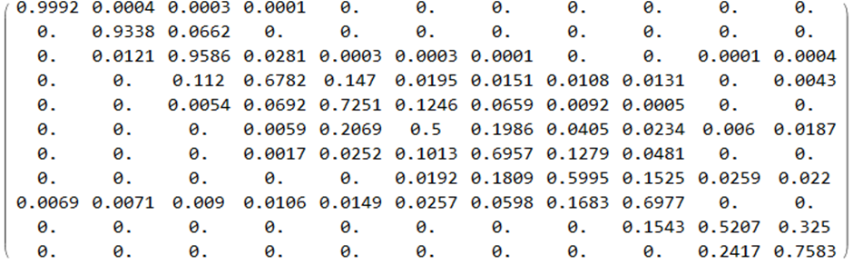

Figure 7: The expected transition matrix for the year 2018. Its calculation is based on the transition matrix of 2017 and the predicting change in PDQ given by the model $\left(1\right)$ and the macroeconomic parameters scenario

Furthermore we were able to estimate the evolution credit ratings distribution of the portfolio which is depicted in Figure 8.

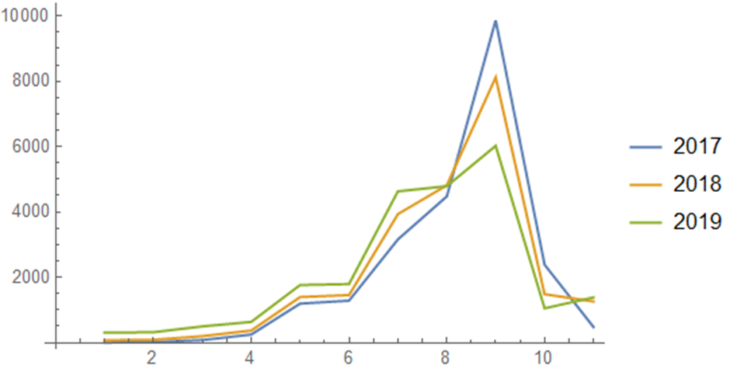

Figure 8: Estimation of the evolution credit ratings distribution of the portfolio

The series of transition matrices corresponding to these macroeconomic scenarios were also calculated, however, they can be used to approximate evolution of credit risk distribution rather than long term pds as for these Markov matrices there is no default state or some other equivalent terminal state. However we must say that if the data is appropriate then this method can accommodate long term pd calculation as well as ECL.

As it is, this method is constrained by the quality of the data which at the present moment contain two components that may create significant error. Firstly, every year some companies become unrated and secondly there are new entries. Both numbers are important and they may create enormous deviations to the companies distribution method demonstrated previously in this paper.

To be able to present more reliable results, we may consider transitions (or flows) with respect to the population of companies at every rating category rather than transitions of distributions. This is supported form the fact that the total number of rated companies varies according to macroeconomic conditions.

To this end, we built a model relating the number of rated companies ${nrc}_{t}$ (dependent variable) to the size of GDP (${GDP}_{t}$) of the same year as well as the unemployment rate of the same year. The results of the prediction of this model for the horizon 2010-2023 are depicted in the diagram of Figure 9.

Figure 9: Predicted total number of rated loans for the time period 2010-2023

Knowing ${nrc}_{t+1}$ and ${pdq}_{t+1}$, we can predict $y_{t+1}$ and $M_{t,t+1}$ from $y_{t}$ and $M_{t-1,t}$ by solving

$$\underset{{,M_{t,t+1,}y}_{t+1}}{\underbrace{\text{min}}} (\left\|y_{t+1}-y_{t}\right\|^2+\left\|W\left(M_{t,t+1}-M_{t-1,t}\right)\right\|^2)$$

such that $〈pd^{r},y_{t+1}〉/{nrc}_{t+1}=pdq_{t+1}$ and $〈1,y_{t+1}〉={nrc}_{t+1}$.

$1⋅M_{t,t+1}≤1$, $M_{t,t+1}≥0$ and $M_{t,t+1}y_{t}-\hat{ur_{t}}=y_{t+1}$,

where $\hat{ur_{t}}$  is an estimate vector for the population of companies that become unrated.

1. **Conclusions-Epilogue**

Modern challenges in economics and finance (for instance, the 2007-2010 crisis, the COVID-19 pandemic, the interconnectedness of the financial institutions etc) have highlighted the need for timely identification and report of credit losses and assess of credit and systemic risk. Furthermore, not only an early diagnosis of an existing problematic situation is desirable, but also an as accurate as possible prediction of the upcoming challenges of the near future.

In this sense, the 1-year transition matrix for corporates could play a key-role. This transition matrix contains the probabilities for a facility to migrate in another credit rating (or to remain to the same). Hence, it is reasonable that the transition matrix is connected with the macroeconomic parameters of the economy. A shift of this matrix for the worse is associated with serious problems in the economic environment. It may signal some failures in conceptual payments towards credit institutions and it may trigger a series of problems in economy in general.

In this work, we gathered data for Greek companies for the period 2010-2017. This period is important for the course of the Greek economy, due to the fiscal crisis, and the data we have collected shows how the creditworthiness of companies changes from year to year. Then, we develop two models. The first one associates macroeconomic parameters with the quality of the portfolios. We use this model in order to predict the quality index (pdq) for the next years.

The second model estimates the transition matrices and it is also based on macroeconomic factors of the reference country.

The proposed methodology can be used in (a) economic analyses of the state of a country’s businesses; (b) credit portfolio NPL (non-performing loans) forecasts; (c) long-term forecasts and stress tests of credit portfolios which are now required to calculate provisions on bank balance sheets.

Future work may contain: (a) the investigation of the relation between transition matrices and other macroeconomic parameters; (b) the elaboration of model that may utilize more data and other techniques (for example, artificial intelligence tools).

**References**

1. Altman, E., Saunders, A. (1997). *Credit Risk Measurement: Developments Over the Last 20 Years*, Journal of Banking and Finance, Vol. **21**, pp. 1721–42.
2. Bangia, A., Diebold, F., Schuermann, T., (2002). *Ratings migration and the business cycle with applications to credit portfolio stress testing*, Journal of Banking and Finance, Vol. **24**, pp. 445-472.
3. Brunnermeier, M., Krishnamurthy, A. (Eds.), *Risk Topography*, University of Chicago Press, 2014.
4. Costabile, A., Schmude, M., *Credit Risk: Default, Migration and Correlation Shocks*, Stress Testing Market Report, October 2012.
5. Colquitt, J. *Credit Risk Management*, McGraw-Hill, 2007.
6. Das, S.R., Duffie, D., Kapadia, N., Saita, L., (2007). *Common failings: how corporate defaults are correlated*, Journal of Finance, Vol. **62**, pp. 93-117.
7. Ferretti, C., Gabbi G., Ganugi P., Sist F., Vozzella P. (2019). *Credit Risk Migration and Economic Cycles*. Risks, Vol. **7**(4):109. <https://doi.org/10.3390/risks7040109>
8. Gordy, M., (2000). *A comparative anatomy of credit risk models*, Journal of Banking and Finance, Vol. **24**, pp. 119-149.
9. Greene, W. H., *Econometric Analysis*, Prentice Hall, 3rd edition, 1997.
10. Hwang, R.-C., Chu, C.-K., Chen, Y.-C., (2023). *Predicting credit ratings and transition probabilities: a simple cumulative link model with firm-specific frailty*, Quantitative Finance, Vol **23**:1, pp. 149-168.

DOI: [10.1080/14697688.2022.2125820](https://doi.org/10.1080/14697688.2022.2125820)

1. Jarrow, R.A., Lando D., Turnbull, S., (1997). *A Markov model for the term structure of credit risk spreads*, Review of Financial Studies, Vol. **19**, pp. 481-523.
2. Jones, M. T., (2005). *Estimating Markov Transition Matrices Using Proportions Data: An Application to Credit Risk*, IMF Working Papers, 2005/219, International Monetary Fund.
3. Kiefer, N. M., Lando, C.E. (2004). *Testing simple Markov structures for credit rating transitions*, working paper, Cornell University.
4. Lando, D., Skødeberg, T. M. (2002). Analyzing rating transitions and rating drift with continuous observations. Journal of Banking and Finance, Vol. **26**(2), pp. 423–444.
5. Mckinsey & Company, 2017. Available at:

<https://www.mckinsey.com/capabilities/risk-and-resilience/our-insights/ifrs-9-a-silent-revolution-in-banks-business-models>

1. Nickell, P., Perraudin, W., Varotto, S., (2000). *Stability of Rating Transitions, Journal of Banking and Finance*, Vol. **24**, pp. 203-27.
2. Violi, R., *Credit Ratings Transition in Structured Finance*, CGFS Working Group on Ratings in Structured Finance, December 2004.
3. Wang, Y., Ding, M., Pan, J.J., Malone, S., *Credit transition model 2017 update: Methodology and performance review*, Moody’s Analytics, report number 186801, October 2017.

**Appendix A**

The figures in this Appendix contain the random forest interpolation (sensitivity analysis) of PDQ versus unemployment rate for the yeas 2010-2017. The diagrams exhibit the expected behavior (when the unemployment rate increases, so does PDQ). However, due to lack of data, the interpolation is satisfactory only for a small window of values for the unemployment rate.

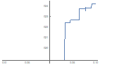

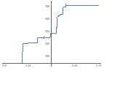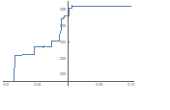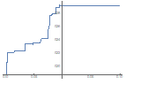

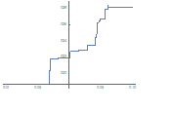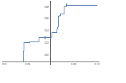

**Appendix B**

The figures in this Appendix contain the random forest interpolation (sensitivity analysis) of PDQ versus growth rate of GDP for the years 2010-2017. We again observe the expected behavior (when GDP increase, PDQ is reduced). However, as in the previous case, the results are satisfactory only for a small window of values of GDP growth.

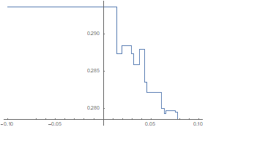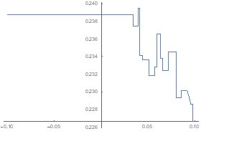

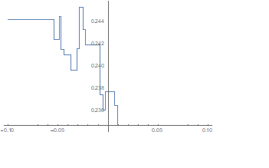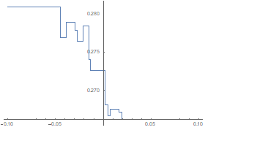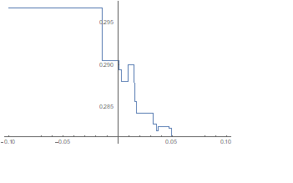

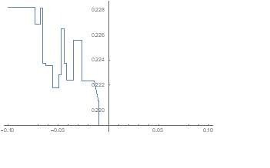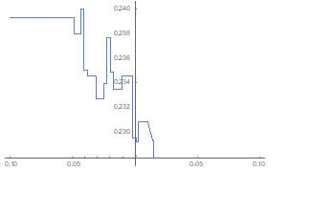

**Appendix C**

The figures in this Appendix show the sensitivity analysis of PDQ versus the unemployment rate for the years 2010-2017 which has been obtained by linear interpolation.









Similarly, using linear interpolation, we can obtain the plot of PDQ versus the GDP grwoth rate for the years 2010-2017.







1. ICAP definition of default is not directly linked to bank’s definition of default