Construction CSFs for ISO international
quality management system

Li-Min Chuang¹ and Yu-Po Lee^{2*}

¹The Department of International Business, Chang Jung Christian University, Tainan City, 711301, Taiwan
²The Ph.D. Program in Business and Operations Management, College of Management,
Chang Jung Christian University, Tainan City, 711301, Taiwan
*Corresponding author.
Abstract
This study aims to discuss the critical success factors of introducing ISO international quality management system, so as to provide reference for Taiwan's traditional industries when they introduce the ISO international quality management system, and reduce various costs and time process of the introduction. Firstly, this study collects constructs from a number of relevant literatures, and categorizes 5 primary constructs and 20 secondary constructs based on the actual business situation of Taiwan’s traditional industry. In the second stage, Likert’s five-point scale is used to extract 3 secondary constructs with the highest scores under the 5 primary constructs respectively. The Fuzzy Analytic Hierarchy Process (FAHP) is used to carry out questionnaire survey and obtain the relative weights of various primary and secondary constructs. It obtains the relative weights of 5 primary constructs and a number of secondary constructs, the primary constructs are “policy-related factors”, “technology-related actors”, “people-related factors”, “documents and data”, and “management review”. Furthermore, it extracts 15 secondary constructs and puts forth 6 propositions as research conclusion. It is hoped that the findings can provide important reference basis for the introduction of ISO international quality management system in Taiwan’s manufacturing industry, and thus speed up the time process and reduce cost of the introduction.
JEL classification numbers: C83, M15, O31
Keywords: manufacturing industry, ISO, critical success factors
- Research motivations and relevant studies
Taiwan is an island economy relying on foreign trade, its manufacturing industry is affected by energy shortage, higher wage, rising environmental protection awareness, and various factors coupled with international competition, and is confronted with business difficulties. Informatization management has become an important anchor for enterprise transformation in order to increase production efficiency, improve product quality, and boost profitability. It is fair to say that the manufacturing industry is an important pillar supporting Taiwan’s economy amid the COVID-19 pandemic. In Q1 of 2021, the manufacturing industry’s output reached NTD 3.5581 trillion with a year-on-year increase of 14.62%, marking the highest growth rate since Q2 of 2020 and registering positive growth for 2 quarters consecutively. In recent years, the realization of digitized enterprise management system has drawn considerable attention in the study of information technology (IT) system. As time goes by, such interest has led to a substantial amount of research. Among which, the ISO system has become an important anchor for executives, and enterprises use this system to control and reach deals. ISO is headquartered in Geneva of Switzerland and has 165 member countries currently. The ISO 9001 quality management system presenting systematic requirements for quality management was adopted and implemented by ISO in March, 1987. Countries around the world adopted this ISO standard one after another and converted it into the national standard of their own countries. A large number of enterprises and buyers consider this ISO international quality system certification as a basic requirement and quality control code for business exchanges between buyers and sellers, which gradually become a global trend. In the current market, besides ISO 9000 quality management system, there are also ISO 14000 environment management system, ISO 18000 safety and health management system, ISO 22000 food safety management system, ISO 50000 energy management system, etc., which all originate from ISO 9000 quality management system and are closely related. Therefore, whether the manufacturing industry can smoothly, quickly, and effectively introduce the ISO system has become an important topic for Taiwan’s manufacturing industry.
In view of the fact that introducing ISO system has become an important topic for Taiwan’s manufacturing industry, it is found that the findings of previous empirical studies are inconsistent. Napitupulu [1] systematically reviewed and analyzed the literature concerning key success factors for small and medium-sized enterprises (SMEs) to promote ISO system, sorting out 125 key concepts of 17 papers, for example, the 10 factors put forth by Matsoso and Benedict [2], namely, leadership, process control, customer orientation, Resource, Employee involvement, employee training, use of IT, supplier relations, team building, and Benchmarking. Mardani et al. [3] put forward 8 factors, namely, continuous improvement, strategic planning, team working, process management, customer focus, employee empowerment, employee involvement, and leadership. Juanzon and Muhi [4] proposed motivation internal and external as the key factor. Gopal and Attri [5] suggested 7 factors, communication, top management commitment, training and education, employee support and involvement, teamwork, motivation, and internal audit. Sahoo and Yadav suggested 6 factors, know-how and knowledge, commitment of management, enough budget, employee acceptance, training, and enough time. Bounabri et al. [6] put forth 4 factors, communication, top management commitment, training, and people acceptance. Based on the summary and analysis, the research results of Napitupulu [1] pointed out 20 key success factors for SMEs to promote the ISO system. Waxin, Knuteson and Bartholomew [7] discussed the key success factors of promoting ISO 14001 in gulf countries along the Arabian sea, and analyzed the 5 key success factors of environment management system, namely, management support and commitment [8,9,10], awareness, training, and input of employees [9,10,11], internal motivation [12,13], effective communication and collaborative cooperation [14,15], other vein factors [16,17] and so forth. Based on the above literature, there are different analysis dimensions for analyzing the critical factors of introducing ISO system in the manufacturing industry. In light of the shortcoming of the Analytic Hierarchy Process (AHP), that is, it cannot overcome fuzziness in decision-making, Laarhoven and Pedrycz [18] further developed the traditional AHP proposed by Saaty [19], and put forth the Fuzzy Analytic Hierarchy Process (FAHP). Therefore, this study utilizes the analytic technique of expert group decision-making, and establish the weight matrix of critical success factors of introducing the ISO system.
- The establishment of CSFs for ISO international quality management system
This study adopts qualitative and quantitative research methods. In summary of the five foreign essays concerning the introducing of ISO international quality management system in enterprises [20,21,22,23,24], this study develops 5 primary constructs and 20 primary constructs. The research objects are enterprises that succeed in introducing the ISO international quality management system, and senior ISO 9000 lead assessors. Likert scales are distributed as predicative questionnaires to extract 3 secondary constructs respectively from the 5 primary constructs, totaling 15 secondary constructs. Then, the FAHP is used to calculate the weight of each construct, so as to obtain the critical success factors of introducing the ISO international quality management system in Taiwan’s manufacturing industry.

Table 1: Critical success factors for ISO international quality management system
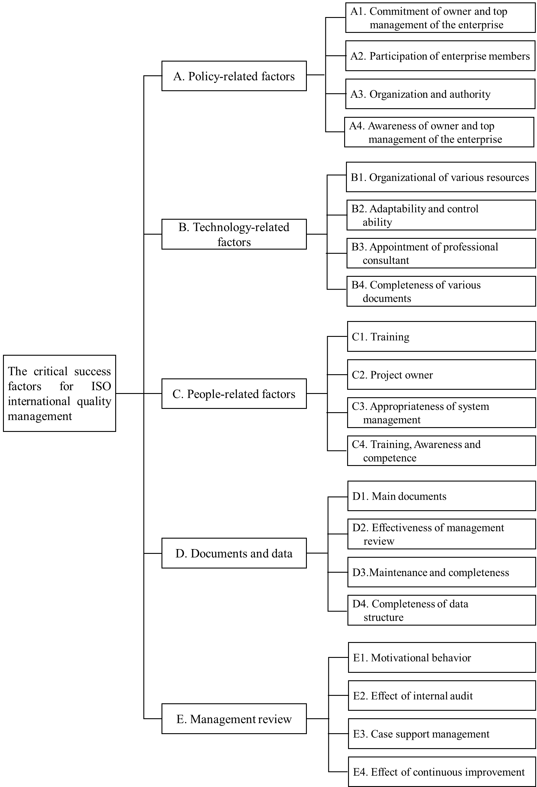
- Empirical results analysis
This study takes 3 secondary constructs with the highest scores under each primary construct and uses them as measured samples, and distributes FAHP questionnaires to mid/high level executives in charge of the introducing of the ISO international quality management system in 6 enterprises, as well as 6 senior ISO international quality management system consultants, with 12 copies of questionnaires recovered. The consistency test shows that all C.R. values are ≦0.1 [19]. According to the calculation results of this test, these 12 FAHP questionnaires are all effective.
With respect to various “primary constructs” and “secondary constructs”, this study uses Microsoft Excel to calculate their relative weights. Based on the calculation results of relative weight, the implications of various weight indicators are illustrated. In the primary constructs, the order of relative weight is as follows: the construct of “policy-related factors” (0.2783), the construct of “people-related factors”, (0.2356), the construct of “management review” (0.2207), the construct of “technology-related factors” (0.2203), and the construct of “documents and data” (0.0451). Among the secondary constructs under policy-related factors, the order of relative weight is as follows: the construct of “commitment of owner and top management of the enterprise” (0.3935), the construct of “participation of enterprise members” (0.3168), and the construct of “awareness of owner and top management of the enterprise” (0.2198). Among the secondary constructs under people-related factors, the order of relative weight is as follows: the construct of “training” (0.3108), the construct of “project owner” (0.2993), and the construct of “appropriateness of system management” (0.2100). Among the secondary constructs under management review, the order of relative weight is as follows: the construct of “motivational behavior” (0.6804), the construct of “the effect of internal audit” (0.1699), and the construct of “case support management” (0.1496). Among the secondary constructs under technology-related factors, the order of relative weight is as follows: the construct of “appointment of professional consultant” (0.7033), the construct of “organizational utilization of various resources” (0.1649), and “completeness of various documents” (0.1318); Among the secondary constructs under documents and data, the order of relative weight is as follows: the construct of “maintenance and completeness” (0.5452), the construct of “completeness of data structure” (0.3464), and the construct of “main documents” (0.1084). After integrating the weights of all primary and secondary constructs, the 5 constructs with the highest scores are, “maintenance and completeness” (0.2849), “commitment of owner and top management of the enterprise” (0.1541), “training” (0.1011), “appointment of professional consultant” (0.0789), and “completeness of data structure” (0.0719).

Table 2: The overall evaluation results of critical success factors for
ISO international quality management system
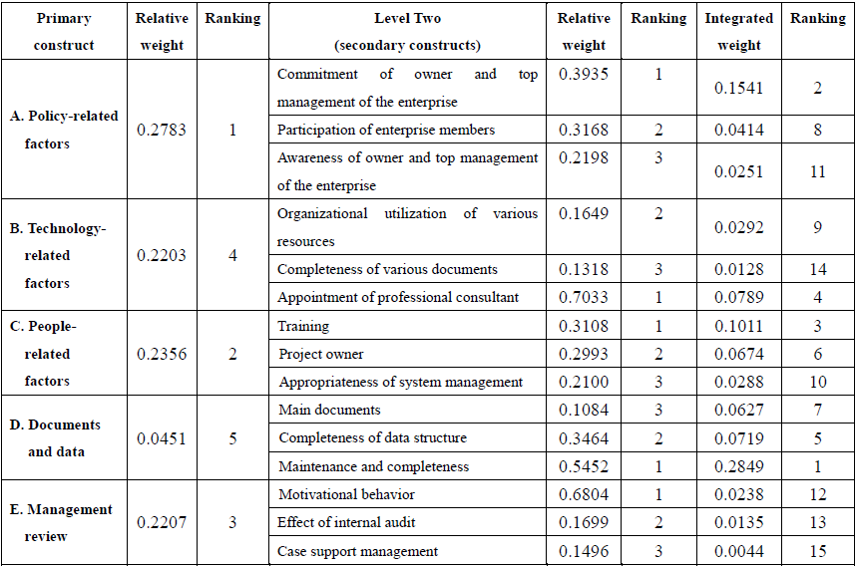
Data source: summarized by this study
- Conclusions and recommendations
4.1 Research conclusions and propositions
According to the analysis results, this study sums up the conclusions concerning the research on “critical success factors of introducing ISO international quality management system”, and illustrates the findings based on their weights:
Proposition 1: Among the constructs of “critical success factors of introducing ISO international quality management system in manufacturing industry”, the construct of “policy-related factors” is relatively more important than the constructs of “people-related factors”, “management review”, “technology-related factors”, and “documents and data”. We suggest that owners and top management of enterprises should implement various constructs, including “people-related factors”, “management review”, “technology-related factors”, and “documents and data”, thereby establishing solid structures within the enterprise.
Proposition 2: Under the construct of “policy-related factors”, the construct of “commitment of owners and top management of the enterprise” is relative more important than the constructs of “participation of enterprise members” and “awareness of owners and top management of the enterprise”. This indicates that the participation of all members in the enterprise system is an important condition for introducing the ISO system, and for sure, the “commitment of owners and top management of the enterprise” is a critical indicator leading the organization to success.
Proposition 3: Under the construct of “technology-related factors”, the construct of “appointment of professional consultant” has an absolute weight of 0.7033, compared to the constructs of “organizational utilization of various resources” and “completeness of various documents”.
This shows that under this construct, the “appointment of professional consultant” is a particularly important task for the establishment of a stable and applicable management system. An enterprise can seize opportunity of system establishment faster than others if it has a professional consultant.
Proposition 4: Under the construct of “people-related factors”, the construct of “training” is relatively more critical than the constructs of “project owner” and “appropriateness of system management”. A solid personnel education and training system can not only help the enterprise carry out a range of planning and functions, but also reserve energy for future upgrade of the enterprise, and thus it is an irreplaceable critical resource.
Proposition 5: Under the construct of “documents and data”, the construct of “maintenance and completeness” is relatively more critical than the constructs of “completeness of data structure” and “main documents”. This suggests that maintaining complete documents and data has a huge positive impact on system introduction.
Proposition 6: Under the construct of “management review”, the construct of “motivational behavior” is relatively more critical than the constructs of “effect of internal audit” and “case support management. This implies that employees must receive motivation from the enterprise for their hard work. For dedicated employees, whether the motivation is financial incentives or an honor, it is not only a reward for this employee’s effort, but also an inducement for other employees to work hard.
4.2 Recommendations for future researchers
This study firstly refers to relevant literature to develop theoretical basis. Likert’s scale is used as the predicative questionnaire to identify the various critical success factors of introducing the ISO system in Taiwan’s manufacturing industry and to complete the development of questionnaire. FAHP is adopted to evaluate the questionnaires. We gather the opinions of executives of enterprises that have introduced the system and senior consultants’ suggestions, thereby summarizing the critical success factors of introducing the ISO system, hoping to provide reference for Taiwan’s manufacturers that intend to introduce this system:
(a) Select research objects carefully so as to obtain more accurate research results
This study takes executives of enterprises that have introduced the system and senior consultants as research objects, and summarizes various constructs and their weights. Nonetheless, the success of introducing ISO quality management system is not only related to the enterprise itself, if more guidance can be incorporated (e.g., the enterprise resource planning (ERP) system developed by the enterprise originally, or seeking suitable consultants, experts, and scholars), then different results may be concluded. We recommend future researchers select other research objects.
(b) Continue to explore the impact of critical success factors on the subsequent performance of the enterprise based on the findings of this study
For enterprises, the introduction of ISO international quality management system is just a beginning, and it is the execution outcome after the system introduction that will truly contribute to the enterprise. The continuity and effectiveness of the system performance is an objective worth pursuing by enterprises, and enterprises should continuously introduce new skills by implementing employee training and education [25]. We recommend future researchers to conduct follow-up research on the business performance of enterprises after they introduce the ISO international quality management system, introducing the system is just a beginning, and the real outcome is to utilize the system to realize sustainable management of the enterprise.
Acknowledgements
The authors report there are no competing interests to declare.
This research received no specific grant from any funding agency in the public, commercial, or not-for-profit sectors

References
- D. Napitupulu, “Key Success Factors of ISO 9001 Implementation for Small Medium Enterprise: Systematic Literature Review,” Proceedings the 1st Unimed International Conference on Economics Education and Social Science (UNICEES 2018), Indonesia, October 2018, pp. 5-12.
- M. L. Matsoso and O. H. Benedict, “Critical success factors towards the implementation of total quality management in small medium enterprises: A comparative study of franchise and manufacturing businesses in Cape Town,” Investment Management and Financial Innovations, vol. 12, no.3, 2015, pp. 163-174.
- A. Mardani, A. Jusoh, M. M. Bagheri and M. Kazemilari, “A Combined Hybrid Fuzzy Multiple Criteria Decision-making Approach to Evaluating of QM Critical Success Factors in SME’s Hotels Firms,” Procedia - Social and Behavioral Sciences, vol. 172, 2015, pp. 786-793.
- J. B. P. Juanzon and M. M. Muhi, “Significant Factors to Motivate Small and Medium Enterprise (SME) Construction Firms in the Philippines to Implement ISO9001:2008,” Procedia Engineering, vol. 171, 2017, pp. 354-361.
- Gopal and R. Attri, “A Literature Review on Factors Affecting ISO 9001 Implementation in SMEs,” International Review of Business and Finance, vol. 9, no.1, 2017, pp. 41-44.
- N. Bounabri, A. A. El oumri, E. Saad, L. Zerrouk and A. Ibnlfassi, “Barriers to ISO 9001 implementation in moroccan organizations: Empirical study,” Journal of Industrial Engineering and Management, vol. 11, no.1, 2018, pp. 34-56.
- M.-F. Waxin, S. L. Knuteson and A. Bartholomew, “Outcomes and Key Factors of Success for ISO 14001 Certification: Evidence from an Emerging Arab Gulf Country,” Sustainability, vol. 12, no.1, 2020, pp. 258. https://www.mdpi.com/2071-1050/12/1/258
- M. A. Massoud, R. Fayad, R. Kamleh and M. El-Fadel, “Environmental management system (ISO 14001) certification in developing countries: Challenges and implementation strategies,” Environmental Science & Technology, vol. 44, no. 6, 2010, pp. 1884-1887.
- O. Boiral, “Managing with ISO Systems: Lessons from Practice,” Long Range Plan, vol. 44, 2011, pp. 197-220.
- H. Kaur, “Impact of human resource factors on perceived environmental performance: An empirical analysis of a sample of ISO 14001 EMS companies in Malaysia,” Journal of Sustainable Development, vol. 4, 2011, pp. 188-211.
- B. Poksinska, J. J. Dahlgaard and J. A. Eklund, “Implementing ISO 14000 in Sweden: Motives, benefits and comparisons with ISO 9000,” International Journal of Quality & Reliability Management, vol. 20, no. 5, 2003, pp. 585-606.
- I. Heras-Saizarbitoria, G. A. Landín and J. F. Molina-Azorín, “Do drivers matter for the benefits of ISO 14001?” International Journal of Operations & Production Management, vol. 31, no. 2, 2011, pp. 192-216.
- V. Ferrón-Vílchez, “Does symbolism benefit environmental and business performance in the adoption of ISO 14001?” Journal of Environmental Management, vol. 183, 2016, pp. 882-894.
- Q. Zhu, J. Sarkis, J. J. Cordeiro and K. H. Lai, “Firm-level correlates of emergent green supply chain management practices in the Chinese context,” Omega, vol. 36, 2008, pp. 577-591.
- A. Arab, I. Ghasemian Sahebi, M. Modarresi and M. Ajalli, “A Grey DEMATEL Approach for Ranking the KSFs of Environmental Management System Implementation (ISO 14001),” Quality - Access to Success, vol. 18, no. 160, 2017, 18, pp. 115-123.
- L. M. S. Campos, “Environmental management systems (EMS) for small companies: A study in Southern Brazil,” Journal of Cleaner Production, vol. 32, 2012, pp. 141-148.
- O. Boiral, L. Guillaumie, I. Heras-Saizarbitoria and C. V. Tayo Tene, “Adoption and Outcomes of ISO 14001: A Systematic Review,” International Journal of Management Reviews, vol. 20, 2018, pp. 411-432.
- P. J. M. van Laarhoven, W. Pedrycz, “A fuzzy extension of Saaty's priority theory,” Fuzzy Sets and Systems, Vol. 11, no. 1-3, 1983, pp. 229-241.
- T. L. Saaty, “The Analytic Hierarchy Process,” McGraw-Hill, 1980.
- W. H. Hoffmann and R. Schlosser, “Success Factors of strategic alliances in small and medium-sized enterprises—An empirical survey,” Long Range Planning, vol. 34, 2001, pp. 357-381.
- L. Yasenchak, “Supply-chain integration critical to ISO9001:2000,” Applince Manufacturer, vol. 49, no. 5, 2001, pp. 80-82.
- T. K. Sung, “E-commerce critical success factors: east vs. west, Technological Forecasting & Social Change,” vol. 73, 2006, pp. 1161-1177.
- M. Sambasivan and N. Y. Fei, “Evaluation of critical success factors of implementation of ISO 14001 using analytic hierarchy process (AHP): a case study from Malaysia,” Journal of Cleaner Production, vol. 16, 2008, pp. 1424-1433.
- R. S. Tabrizi, N. Ebrahimi and M. Delpisheh, “KM criteria and success of KM Programs: an assessment on criteria from importance and effectiveness perspectives,” Procedia Computer Science, vol. 3, 2011, pp. 691-697.
- S. Sahoo and S. Yadav, “Entrepreneurial orientation of SMEs, total quality management and firm performance,” Journal of Manufacturing Technology Management, vol. 28, no. 7, 2017, pp. 892-912.

