Comparative Analysis of Some Volatility Estimators: An Application to Historical Data from the Nigerian Stock Exchange Market
Benjamin Oyediran Oyelami¹
Department of Mathematics, Plateau State University, Bokkos, Nigeria
Email: boyelami2000@yahoo.com
1. Corresponding author.
Eric Erenam Sambo
Nigerian Export Promotion Bank Abuja, Nigeria

ABSTRACT
Several models exist for estimating volatility of stocks. In this paper, comparisons are made for the performance characteristics of seven volatility estimators using the data for eleven Banks from the Nigerian Stock Exchange (NSE) daily prices for the period 3rd January 2006 to 31st December 2008. The estimations computed are: Standard Deviation, Historical Close-to-Close, Parkinson, Garman-Klass, Rogers-Satchell, Modified Garman-Klass and Yang Zhang volatility estimators. The volatility computations for the estimators employed the open, high, low and close values of daily prices using 5, 10 and 20 days intervals with no overlapping. The Models are automated using Microsoft Visual Basic Express Edition with the volatilities output generated by the estimators further analyzed using SPSS and Microsoft Excel software packages. The criteria used to evaluate the performances of these volatility estimators are the Mean Absolute Deviation (MAD), Standard Error (STDERR) and Efficiency. The Efficiency test compares the relative uncertainty of the various estimators using standard deviation as the benchmark while the MAD and STDERR are used to find the mean absolute deviation and the standard error of the estimators respectively. In terms of MAD and STDERR, the Parkinson model performs better than other estimators while the Garman-Klass performs better than other estimators in Efficiency. The only common finding is that the Standard Deviation estimator is the least performing of the estimators. Finally, the levels of correlation between volatility estimators are found to be very high.
Keywords
Historical volatility, stock price, estimators & efficiency

INTRODUCTION
Many research works are being carried out to make inquiry on volatility in the stock market worldwide. Volatility is the market instrument that when used properly can increase trading profits and reduce risks to investments. Volatility is traditionally associated with chaos and instability. Naturally, there are very few things that are consistent enough not to exhibit volatility (Fontanills and Gentile (2003)).

Daye et. al. (2001) stated that volatility is the most basic statistical risk measure. It can be used to measure the market risk of a single instrument or an entire portfolio of instruments. It can be expressed in different ways; the typical definition used in finance is the standard deviation of a financial random variable (Oyelami and Ademola (2014), Ejiofor (2014)).
Brandt and Kingsley (2003) stated that Volatility estimation is of central importance to risk management, pricing and Portfolio construction. A number of attempts have been made in the last three decades to improve upon the classical standard deviation of daily returns as an estimator of asset volatility. Many of these estimators, are those developed by Parkinson (1980), Garman and Klass (1980), Rogers and Satchell (1991, 1994) and make use of information on daily trading.
Volatility generally stems from the arrival of new information. For example when investors received news concerning corporate profits, interest rates, dividends or the economy, they use that information to make buying and selling decisions(Oyelami and Adedoyin (2014)).
Historical volatility is computed using past stock prices. It can be calculated using the standard deviation of stock’s price changes from close to close of trading going back a specified number of days. Although 5, 10, 20, and 90 days are often used. Classically, historical volatility is computed as the standard deviation of daily returns within a certain period. It is unrealistic to assume that the volatility of asset returns remains constant during a long period; therefore the volatility estimated with the classical estimator is essentially the average volatility over the specified period.
The volatility of various asset returns lies in the center of option pricing, portfolio allocation, and risk management problems. Any financial economist or expert has to pay a huge amount of attention to the study on the measurement and forecasting methods of volatility, because the volatility measures the risk of an investment in a stock. It is an important piece of information in constructing an optimal portfolio. Historical volatility is also used by option traders as a proxy for future volatility in evaluating options. Its value is directly related to the benchmark value of the option. There is no doubt that volatility is a central concept in the theory and application of quantitative finance. Therefore, correct modeling of volatility is always desirable to both practitioners and researchers (Oyelami and Adedoyin (2015)).
Historical volatility is the most frequently used one, can be estimated as the simple standard deviation of returns based on closing prices for a certain period. The idea of using information on the daily high and low prices, as well as the opening and closing prices, goes back a long way, to (Parkinson, 1980) and (Garman and Klass, 1980) at least, with further contributions by (Beckers, 1983), (Ball and Torous, 1984), (Rogers and Satchell,1991) and (Yang and Zhang, 2000) among others. These volatility estimators are classified as range estimators because they use information on daily trading range.
Recently, Alizadeh, et.al. (2002) extended the range-based estimators to estimate stochastic volatility models. Theoretically, range estimators are more efficient than the classical close-to-close estimator. It has been proven that the Parkinson estimator is five times more efficient than the classical estimator and the Yang and Zhang estimator is 7.3 times more efficient than the classical volatility estimator. However, range estimators are built on the strict assumption that an asset price follows a geometric Brownian motion, which is certainly not the case in real markets. People often use the range estimators to study the volatility patterns of market data without taking into account the assumptions made on developing the range estimators. It is obvious that deviation from a geometric Brownian motion will affect the accuracy and efficiency of range estimators, but it is important to know the extent to which they remain useful in the analysis of real market behavior.
Another merit of range volatility estimators could be the greater informational contents because they are calculated with opening prices, the highest prices, the lowest prices as well as closing prices. In spite of these appeals, the strict assumptions of log-normal asset returns distribution and continuous trading have been a big obstacle for attracting enough attention. For instance, Marsh and Rosenfeld (2003) and Wiggins (1991, 1992) show that the analyses using range volatility estimators succeed in enhancing efficiency but fail to reduce biasness. The main cause of this finding is the low liquidity of the assets under their studies which lead to the violation of continuous trading assumption.
Furthermore, recent development of Information Technology (IT) and advance of financial Statistics have made researchers jump over these obstacles with the availability of high frequency data. Quite useful results have been reported that the assumption of log-normal asset returns distribution is not necessary (Andersen and Bollerslev (1998), Andersen et.al. (2001, 2002), Andreou and Ghysels (2002), Barndorff et.al (2002)). For instance, Bali and Weinbaum (2005) and Shu and Zhang (2006) found that the range volatility estimators were not significantly biased and were also robust to microstructure errors like bid-ask spread. The relative efficiency and simplicity of range volatility estimators make a strong case for evaluating their performance further (Vipul and Jacob (2007).
The motivation for study in this paper is to develop automated Microsoft Visual Basic programs which can be used for calculating volatility on daily basis for the Nigerian Stock Exchange market prices. This will guide stakeholders, investors, stockbrokers, Government etc to have the opportunity of having enough and available information about the market for decision making. The volatility we will consider in this paper is with respect to the share price and the programs tested using the historical data for thirteen banks listed in the Nigerian stock market.

Volatility is often used as a measure of market quality in microstructure research, and there are a number of ways in which it can be measured. Hence, it is important to determine how best to measure volatility (Sambo (2009)). Since an in-depth knowledge of the stock market volatility is of paramount importance to the stock market players. This study has tried to make an analysis of the concept for easy understanding by the players. The paper is significant because it has used the basic historical volatility estimators to cause an understanding of the various aspects of the concept. Computer programs are used to automate the models. It is important that an investor be very knowledgeable of this concept to enable him take a buy or a sell decision. The study in this paper is expected to provide such medium.
- Statement of the Problem
The primary aim of this paper is to compare the performance of seven volatility estimators which employs opening, closing, high and low values of daily prices on the Nigerian Stock Exchange banking stocks for the period 3rd January 2006 to 31st December 2008. It is hoped that after the analysis, useful suggestions can be given as to which type of volatility estimator is most suited for the Nigerian Stock Exchange Banking sector.
The knowledge of the capital market by the operators is limited to a very few professionals, particularly that of volatility and volatility estimators. The teeming investors rely so much on their stockbrokers for the market analysis of their stocks. Therefore, the understanding of the volatility of the prices of stocks becomes pertinent. Hence this paper seeks to demonstrate the importance of understanding of the volatility of stocks prices using various estimators, since investment decisions cannot be made in a vacuum.

Notations
Throughout this paper we will make use of the following notations:
 | Volatility
Z | Number of closing prices in a year
n | Number of historical prices used for the volatility estimate
 | The opening price
 | The high price
 | The low price
 | The close price
n | Number of historical days used in the volatility estimate
 | Log return on the ith day
We shall also use the following notations too:
σ = Standard Deviation
r_{i}= closing prices of an asset
= mean of all closing prices in the period t=1 to n

METHODOLOGY
Volatility can be estimated using various estimators ranging from ordinary standard deviation to more sophisticated estimators. In this study we shall be looking at the following well known volatility estimators to analyze the performance and efficiency of the estimators using the historical data of eleven Banks listed in the Nigerian Stock Exchange Market.

3.1 The standard deviation
The easiest method to evaluate volatility is simply using the classical definition of standard deviation.

The simplest method to estimate volatility and it will be used as the benchmark.

Another simple model for estimating volatility that reflects the past price movement of the underlying asset is the close-to-close volatility estimator.

The Close-to-Close volatility estimator

The close-to-closed volatility reflects the pas price movements of the underlying asset. It is also referred to as the asset’s actual volatility and it is given as:

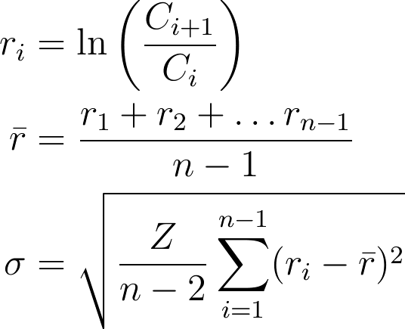

The Parkinson volatility estimator
The Parkinson model uses daily High and Low prices and has no drift term. Its efficiency intuitively comes from the fact that the price range of intraday gives more information regarding the future volatility than two arbitrary points in the series. It uses range the highest value –the lowest value variance instead of a widely used method for estimating variance of
Log- transformed stock returns. The Parkinson volatility estimator is given as :

The Garman & Klass Volatility Estimator
The Garman & Klass volatility estimator which make use of daily Opening, Closing, High and Low prices of the stock. The estimator assumes the underlying process is govern by Brownian motion with zero drift and has no opening jump. The Garman & Klass Volatility Estimator is given as:

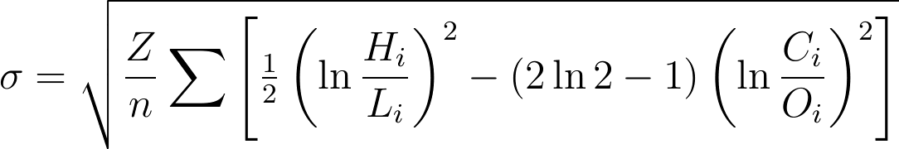

Yang Zhang Volatility Estimator
The Yang Zhang volatility estimator is an extension of Garman-Klass which allows for opening jump with zero drift. The estimator uses Opening, Closing, High and Low prices. Yang Zhang volatility estimator is give as

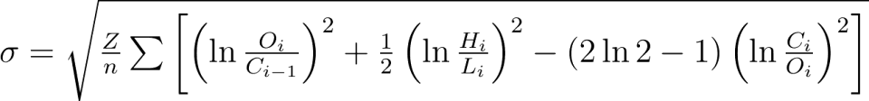

The Rogers & Satchell Volatility Estimator
Our next estimator which is independent of the drift and Independent of opening gaps weighted average is the Rogers-Satchell. The estimator makes use of the Open-Close volatility and Close-Open volatility. When the estimator is heavily dominated by opening jumps, its performance degrades to the classical Close-to-Close estimator. The Rogers-Satchel estimator is given as

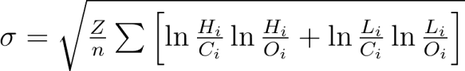

Yang Zhang Volatility Estimator
Yang Zhang volatility estimator has the following properties:
- Independent of the drift;
- Independent of opening gaps weighted average of Rogers-Satchell, Open-Close and Close-Open volatility;
- When heavily dominated by opening jumps, the performance degrades to classical Close-to-Close volatility estimator.

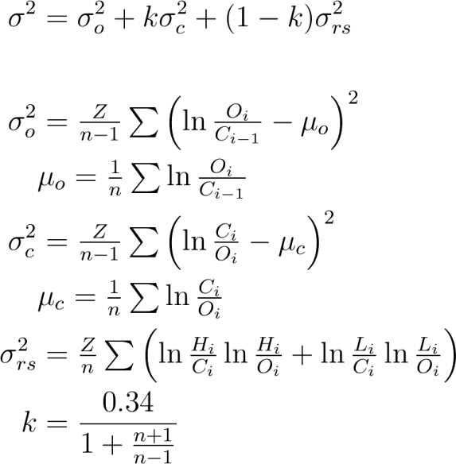

D
H

3.8 Data
The baseline data used to evaluate the volatility estimators comprises of the NSE daily returns for eleven Banks for the period 3rd January 2006 to 31st December 2008. The data was downloaded from the www.cashcraft.com website. The Banks were: Access, Afribank, FCMB, Fidelity, Firstbank, Guaranty, IBTC, Intercontinental, UBA, Wema and Zenith Banks.
The models are automated using Microsoft Visual Basic 2008 Express edition and the volatilities output generated using the data by the estimators models are further analyzed using the SPSS and the Microsoft Excel software packages. The program can accept any number of sample size n-day, with no overlapping.
Here the focus of interest is on the relative performance of the aforementioned estimators on the dataset. The estimators are calculated using samples of 5, 10 and 20 days interval on the dataset and with no overlapping.

3.9 Empirical Test
The empirical test of the performance of the estimators on the baseline data is carried out on year by year basis and for (i) 5-day daily returns interval, (ii) 10-day daily returns interval and (iii) 20-day daily returns interval.
The measures used to access the performance of the estimators on the baseline data are as follows:

3.9.1 MAD (Mean Absolute Deviation)
MAD $=$
Where
= estimated volatility for the i^{th} Bank
= mean value for, i=1 to N
N = total no of Banks used for the analysis

3.9.2 Standard Errors Mean
S.E. =
Where
= Standard deviation of, for i=1 to N
N = total number of Banks collated in the data

3.9.3 Efficiency
Efficiency
Where
= volatility obtained by using the classical definition of standard deviation
= the respective volatility obtained for the estimator K under consideration, e.g. K = Parkinson estimator. The mean volatilities for each of the estimators are compared using the classical standard deviation as a benchmark.

RESULTS and DISCUSSION

4.1 Performance Statistics on 5-day Interval Volatility Estimation
The summary of the performance statistic for the volatility estimators used in the 5-day interval with no overlapping is as tabulated in Table 1.
Generally, the volatilities recorded by the estimators in 2008 are higher than the percentages in 2006 and 2007 respectively. This may be attributed to the bear run (downward stocks prices market trends) recorded in the 3rd and 4th quarter of 2008. On the other hand, the volatilities obtained for 2006 are higher than 2007 with the exception of Standard deviation. This may be as result of the Banks consolidation exercise that was concluded in December 2005. Immediately after the exercise, there was a bull run (upward stocks prices market trends).
The MAD values for 2006 are the highest, followed by 2007 values with the exception of CC. This may also be due to the Bull Run. Similarly, the STDERR percentages for 2006 are higher followed by 2007 and 2008.
Generally, the efficiency values for 2007 are the highest when compared to 2006 and 2008. This is followed by 2008 with the exception of the CC values. This could be attributed to stability assumed after the consolidation exercise. The 2008 efficiency is low may be because of the financial meltdown.
VOLATILITY ESTIMATORS
Year | STDEV |  |  | CC |  | PARK | GK | GKYZ | RS |  | YZ |  | Ranking in Ascending order
2006 | 48.16% |  |  | 40.45% |  | 29.63% | 28.02% | 48.61% | 34.51% |  | 63.29% |  | GK, PARK, RS, CC, STDEV,GKYZ, YZ
2007 | 60.08% |  |  | 33.78% |  | 27.49% | 25.57% | 42.36% | 29.68% |  | 52.27% |  | GK, PARK, RS, CC, GKYZ, YZ, STDEV
2008 | 76.91% |  |  | 72.68% |  | 34.00% | 29.62% | 69.55% | 38.21% |  | 95.61% |  | GK, PARK, RS, GKYZ,CC, STDEV, YZ
MAD
Year |  | STDEV | CC |  | PARK |  | GK | GKYZ | RS | YZ |  | Ranking in Ascending order
2006 |  | 3.99 | 2.01 |  | 1.12 |  | 1.25 | 1.70 | 1.55 | 2.35 |  | PARK, GK, RS, GKYZ, CC, YZ, STDEV
2007 |  | 3.74 | 0.99 |  | 0.91 |  | 0.87 | 1.21 | 1.04 | 1.42 |  | GK, PARK, CC, RS, GKYZ, YZ, STDEV
2008 |  | 2.79 | 1.26 |  | 0.55 |  | 0.64 | 0.94 | 0.77 | 1.17 |  | PARK, GK, RS, GKYZ, YZ, CC, STDEV
STDERR
Year |  | STDEV |  | CC | PARK |  | GK | GKYZ | RS | YZ |  | Ranking in Ascending order
2006 |  | 13.4% |  | 6.40% | 3.77% |  | 4.32% | 5.39% | 5.42% | 7.19% |  | PARK, GK, GKYZ, RS, CC, YZ, STDEV
2007 |  | 10.23% |  | 3.38% | 3.14% |  | 3.00% | 4.14% | 3.54% | 5.08% |  | GK, PARK, CC, RS, GKYZ, YZ, STDEV
2008 |  | 8.82% |  | 3.64% | 1.42% |  | 1.72% | 2.81% | 2.16% | 3.54% |  | PARK, GK, RS, GKYZ, YZ, CC, STDEV
Efficiency
Year |  | STDEV | CC |  | PARK |  | GK | GKYZ | RS | YZ |  | Ranking in Descending order
2006 |  |  | 1.19 |  | 1.63 |  | 1.72 | 0.99 | 1.40 | 0.76 |  | GK, PARK, RS, CC, GKYZ, YZ
2007 |  |  | 1.78 |  | 2.19 |  | 2.35 | 1.42 | 2.02 | 1.15 |  | GK, PARK, RS, CC, GKYZ, YZ
2008 |  |  | 1.06 |  | 2.26 |  | 2.60 | 1.11 | 2.01 | 0.80 |  | GK, PARK, RS, GKYZ, CC, YZ
Table 1: 5-day Interval Performance Statistic Summary

4.2 Performance Statistic on 10-day Interval Volatility Estimation
The summary of the performance statistic for the volatility estimators in the 10-day intervals with no overlapping is tabulated in Table 2.
Generally the volatilities estimated for 2008 are the highest, followed by that of 2006 with 2007 having the lowest. This may be attributed to the bear run (downward stocks prices market trends) recorded in the 3rd and 4th Quarter of 2008. Again, the volatilities obtained for 2006 are higher than 2007. This may be as result of the consolidation exercise in 2005 where there was a bull run (upward stocks prices market trends) after the exercise.
The MAD values for 2006 are generally higher than that of 2007 and 2008 with the exception of the standard deviation where values for 2007 are higher. The standard errors percentages for 2006 are also higher than the respective percentages in 2007 and 2008 with the exception of standard deviation. Efficiency values are higher in 2007 as compared to the respective values in 2006 and 2008. However, those of 2008 are also higher than the respective values in 2006.
VOLATILITY
Year | STDEV | CC | PARK | GK | GKYZ | RS | YZ | Ranking in Ascending order
2006 | 46.75% | 41.81% | 30.37% | 28.57% | 51.65% | 36.30% | 64.60% | GK, PARK, RS, CC, STDEV, GKYZ, YZ
2007 | 145.37% | 35.78% | 29.80% | 26.64% | 45.69% | 32.53% | 52.43% | GK, PARK, RS, CC, GKYZ, YZ, STDEV
2008 | 122.09% | 71.10% | 34.39% | 29.21% | 70.70% | 38.89% | 90.48% | GK, PARK, RS, GKYZ, CC, YZ, STDEV
MAD
Year | STDEV | CC | PARK | GK | GKYZ | RS | YZ | Ranking in Ascending order
2006 | 4.43 | 2.22 | 1.21 | 1.41 | 2.01 | 1.76 | 2.70 | PARK, GK, RS, GKYZ, CC, YZ, STDEV
2007 | 6.31 | 0.64 | 0.62 | 0.61 | 0.81 | 0.71 | 0.86 | GK, PARK, CC, RS, GKYZ, YZ, STDEV
2008 | 4.93 | 1.32 | 0.55 | 0.70 | 0.97 | 0.77 | 1.20 | PARK, GK, RS, GKYZ, YZ, CC, STDEV
STDERR
Year | STDEV | CC | PARK | GK | GKYZ | RS | YZ | Ranking in Ascending order
2006 | 15.06% | 7.28% | 4.22% | 4.83% | 6.43% | 6.22% | 8.60% | PARK, GK, RS, GKYZ, CC, YZ, STDEV
2007 | 20.10% | 2.32% | 2.38% | 2.49% | 3.08% | 2.87% | 3.21% | CC, PARK, GK, RS, GKYZ, YZ, STDEV
2008 | 15.18% | 3.74% | 1.43% | 1.92% | 2.86% | 2.18% | 3.55% | PARK, GK, RS, GKYZ, YZ, CC, STDEV
Efficiency
Year | STDEV | CC | PARK | GK | GKYZ | RS | YZ | Ranking in Descending order
2006 |  | 1.12 | 1.54 | 1.64 | 0.91 | 1.29 | 0.72 | GK, PARK, RS, CC, GKYZ, YZ
2007 |  | 4.06 | 4.88 | 5.46 | 3.18 | 4.47 | 2.77 | GK, PARK, RS, CC, GKYZ, YZ
2008 |  | 1.72 | 3.55 | 4.18 | 1.73 | 3.14 | 1.35 | GK, PARK, RS, GKYZ, CC, YZ

Table 2: 10-day Interval Performance Statistic summary

4.3 Performance Statistics on 20-day Interval Volatility Estimation
The summary of the performance statistics for the volatility estimators in the 10-day intervals with no overlapping is tabulated in table 3.
It follows also, that volatilities obtained in 2008 are generally higher than the respective percentages in year 2006 and 2007 with the exception of standard deviation values which are highest in 2007. Note also that the values for 2006 are higher than those obtained in 2007.
The MAD values obtained for 2006 are higher than the values obtained in 2007 and 2008. Those for 2008 are higher than the respective values in 2007. The only exception is the standard deviation.
The standard errors are also peaked in 2006 as compared to 2007 and 2008. There are some variants with respect to the values obtained in 2007 and 2008.
The efficiency coefficients in 2007 are generally higher than the values obtained in 2006 and 2008. However, some variations are noticeable in 2006 and 2008.
Volatility
Year | STDEV | CC | PARK | GK | GKYZ | RS | YZ | Ranking in Ascending order
2006 | 112.57% | 43.26% | 30.29% | 27.65% | 53.19% | 36.89% | 64.88% | GK, PARK, RS, CC, GKYZ, YZ, STDEV
2007 | 212.99% | 35.73% | 29.39% | 24.93% | 45.66% | 32.47% | 49.86% | GK, PARK, RS, CC, GKYZ, YZ, STDEV
2008 | 154.58% | 69.10% | 33.94% | 27.57% | 72.77% | 38.69% | 88.26% | GK, PARK, RS, CC, GKYZ, YZ, STDEV
MAD
Year | STDEV | CC | PARK | GK | GKYZ | RS | YZ | Ranking in Ascending order
2006 | 9.47 | 3.00 | 1.56 | 1.75 | 2.85 | 2.31 | 3.87 | PARK, GK, RS, GKYZ, CC, YZ, STDEV
2007 | 13.74 | 1.31 | 1.20 | 1.12 | 1.73 | 1.35 | 1.82 | GK, PARK, CC, RS, GKYZ, YZ, STDEV
2008 | 7.57 | 1.86 | 0.87 | 1.00 | 1.90 | 1.14 | 2.37 | PARK, GK, RS, CC, GKYZ, YZ, STDEV
STDERR
Year | STDEV | CC | PARK | GK | GKYZ | RS | YZ | Ranking in Ascending order
2006 | 28.06% | 8.46% | 4.61% | 5.05% | 7.34% | 7.01% | 9.90% | PARK, GK, RS, GKYZ, CC, YZ, STDEV
2007 | 31.34% | 2.08% | 2.39% | 2.65% | 3.06% | 3.00% | 3.13% | CC, PARK, GK, RS, GKYZ, YZ, STDEV
2008 | 18.08% | 3.38% | 1.37% | 1.96% | 3.34% | 2.15% | 4.22% | PARK, GK, RS, GKYZ, CC, YZ, STDEV
Efficiency
Year | STDEV | CC | PARK | GK | GKYZ | RS | YZ | Ranking in Descending order
2006 |  | 2.60 | 3.72 | 4.07 | 2.12 | 3.05 | 1.74 | GK, PARK, RS, CC, GKYZ, YZ
2007 |  | 5.96 | 7.25 | 8.54 | 4.66 | 6.56 | 4.27 | GK, PARK, RS, CC, GKYZ, YZ
2008 |  | 2.24 | 4.55 | 5.61 | 2.12 | 4.00 | 1.75 | GK, PARK, RS, CC, GKYZ, YZ
Table 3: 20-day Interval Performance Statistic Summary

Figure 1: Volatility Estimators Vs Banks: 2006 5-Day Interval

Figure 2: Volatility Estimators Vs Banks: 2007 5-Day Interval

Figure 3: Volatility Estimators Vs Banks: 2008 5-Day Interval

Figure 4: Volatility Estimators Vs Banks: 2007 10-Day Interval

Figure 5: Volatility Estimators Vs Banks: 2008 10-Day Interval

Figure 6: Volatility Estimators Vs Banks: 2006 20-Day Interval

Figure 7: Volatility Estimators Vs Banks: 2007 20-Day Interval

Figure 8: Volatility Estimators Vs Banks: 2008 20-Day Interval

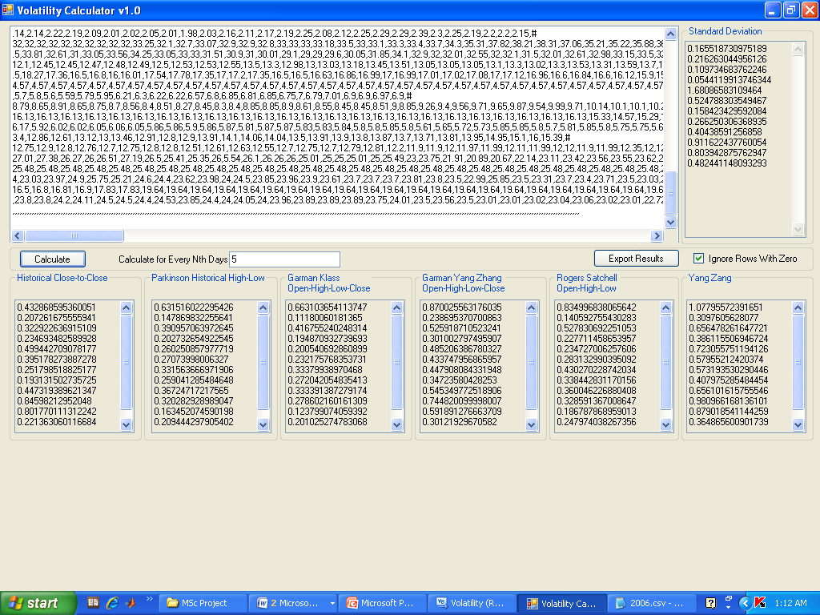
Figure 9: The deployment of Microsoft Visual Basic Platform for computation for the volatility estimator

4.2 Correlation

4.2.1 5-day interval correlation
Tables 4 to 6 show the correlation coefficients of the estimators for 5-day interval. The correlation of the estimators are computed for 10-day interval and the 20-day interval (see Table 7 to 9 and Table 10 to 12) respectively. There is high significance correlation between Garman-Klass/Parkinson, Rogers-Satchell/Parkinson, Rogers-Satchell/Garman-Klass and GKYZ/Yang-Zhang in 2006. In general, the correlation coefficient between CC and other estimators is almost zero with the exception of GYYZ and YZ.
In 2007, there is high significance correlation between all the estimators. Also in 2008, the estimators are highly correlated but of lower values as compared to 2007.
Pearson Correlation 2006 5-Day Interval
 | CC | PARK | GK | GKYZ | RS | YZ
CC | 1 | 0.07 | -0.03 | 0.69 | -0.03 | 0.80
PARK |  | 1 | 0.99 | 0.76 | 0.97 | 0.64
GK |  |  | 1 | 0.69 | 0.99 | 0.55
GKYZ |  |  |  | 1 | 0.69 | 0.98
RS |  |  |  |  | 1 | 0.56
YZ |  |  |  |  |  | 1
Table 4: Correlation 2006 5-Day Interval

Pearson Correlation 2007 5-Day Interval
 | CC | PARK | GK | GKYZ | RS | YZ
CC | 1 | 0.94 | 0.91 | 0.96 | 0.89 | 0.98
PARK |  | 1 | 0.99 | 1.00 | 0.99 | 0.98
GK |  |  | 1 | 0.98 | 1.00 | 0.97
GKYZ |  |  |  | 1 | 0.97 | 0.99
RS |  |  |  |  | 1 | 0.96
YZ |  |  |  |  |  | 1
Table 5: Correlation 2007 5-Day Interval
Pearson Correlation 2008 5-Day Interval
 | CC | PARK | GK | GKYZ | RS | YZ
CC | 1 | 0.61 | 0.65 | 0.91 | 0.61 | 0.96
PARK |  | 1 | 0.93 | 0.87 | 0.91 | 0.74
GK |  |  | 1 | 0.86 | 0.95 | 0.72
GKYZ |  |  |  | 1 | 0.82 | 0.96
RS |  |  |  |  | 1 | 0.70
YZ |  |  |  |  |  | 1
Table 6: Correlation 2008 5-Day Interval

4.2.2 10-day interval correlation
Table 7 to 9 show the correlation coefficients of the estimators in 10-day interval.
The coefficients follow similar patterns as recorded in the 5-day interval.
Pearson Correlation 2006 10-Day Interval
 | CC | PARK | GK | GKYZ | RS | YZ
CC | 1 | 0.03 | -0.10 | 0.74 | -0.05 | 0.80
PARK |  | 1 | 0.98 | 0.69 | 0.98 | 0.59
GK |  |  | 1 | 0.59 | 0.99 | 0.49
GKYZ |  |  |  | 1 | 0.63 | 0.99
RS |  |  |  |  | 1 | 0.55
YZ |  |  |  |  |  | 1
Table 7: Correlation 2006 10-Day Interval

Pearson Correlation 2007 10-Day Interval
 | CC | PARK | GK | GKYZ | RS | YZ
CC | 1 | 0.86 | 0.76 | 0.92 | 0.76 | 0.93
PARK |  | 1 | 0.98 | 0.98 | 0.97 | 0.98
GK |  |  | 1 | 0.94 | 0.99 | 0.92
GKYZ |  |  |  | 1 | 0.94 | 0.99
RS |  |  |  |  | 1 | 0.93
YZ |  |  |  |  |  | 1
Table 8: Correlation 2007 10-Day Interval
Pearson Correlation 2008 10-Day Interval
 | CC | PARK | GK | GKYZ | RS | YZ
CC | 1 | 0.67 | 0.64 | 0.93 | 0.63 | 0.92
PARK |  | 1 | 0.91 | 0.87 | 0.90 | 0.81
GK |  |  | 1 | 0.82 | 0.95 | 0.76
GKYZ |  |  |  | 1 | 0.80 | 0.98
RS |  |  |  |  | 1 | 0.78
YZ |  |  |  |  |  | 1
Table 9: Correlation 2008 10-Day Interval

4.2.2 20-day interval correlation
Tables 10 to12 shows the correlation coefficients of the estimators in 20-day interval.
The coefficients follow similar patterns as recorded in the 5-day interval and 10-day interval.

Pearson Correlation 2006 20-Day Interval
 | CC | PARK | GK | GKYZ | RS | YZ
CC | 1 | 0.02 | -0.16 | 0.79 | -0.04 | 0.83
PARK |  | 1 | 0.98 | 0.62 | 0.98 | 0.53
GK |  |  | 1 | 0.46 | 0.98 | 0.38
GKYZ |  |  |  | 1 | 0.57 | 0.99
RS |  |  |  |  | 1 | 0.51
YZ |  |  |  |  |  | 1
Table 10: Correlation 2006 20-Day Interval

Pearson Correlation 2007 20-Day Interval
 | CC | PARK | GK | GKYZ | RS | YZ
CC | 1 | 0.78 | 0.63 | 0.88 | 0.66 | 0.84
PARK |  | 1 | 0.97 | 0.98 | 0.98 | 0.98
GK |  |  | 1 | 0.91 | 0.99 | 0.93
GKYZ |  |  |  | 1 | 0.93 | 0.99
RS |  |  |  |  | 1 | 0.95
YZ |  |  |  |  |  | 1
Table 11: Correlation 2007 20-Day Interval

Pearson Correlation 2008 20-Day Interval
 | CC | PARK | GK | GKYZ | RS | YZ
CC | 1 | 0.65 | 0.55 | 0.96 | 0.56 | 0.96
PARK |  | 1 | 0.91 | 0.81 | 0.89 | 0.73
GK |  |  | 1 | 0.75 | 0.92 | 0.70
GKYZ |  |  |  | 1 | 0.74 | 0.98
RS |  |  |  |  | 1 | 0.73
YZ |  |  |  |  |  | 1
Table 12: Correlation 2008 20-Day Interval

Generally, in terms of MAD and STDERR, the Parkinson is found to outperform other estimators with respect to the minimum average values recorded for the dataset. For Efficiency, the Garman-Klass outperforms other estimators in which the maximum average Efficiency coefficients are recorded for the dataset. The only common finding is that the Standard Deviation is the least performed estimator used.

Furthermore, the levels of correlation between volatility estimators are very high with the exception of some few cases with respect to the Close-to-Close estimator. It was also noted that the particular period analyzed – 3/01/2006 to 31/12/2008 – were marked by strong market swings due to the banking sector consolidation exercise in Nigeria which was concluded in December 2005 and the world-wide economic meltdown which commenced in 2008. Due to the fragility of the market at the period, the volatility estimates evaluated tend to exhibit high values especially in 2006 and 2008. This is attributed to the bull run (upward stocks prices market trends) in 2006 especially in banking stocks where banks stocks prices keep increasing and the bear run (downward stocks prices market trends) which started in 2008 due to the world-wide economic meltdown.

- Conclusion
In this study we compared the performance characteristics of a number of volatility estimators in an empirical test on historical data from eleven Banks listed Nigerian Stock Exchange .The price movement for Banks were analysed from January 3, 2006 to December 31, 2008. The estimators used were: Standard Deviation, Close-to-Close, Parkinson, and Garman-Klass, Garman-Klass modified by Yang-Zhang, Rogers-Satchell and Yang-Zang volatility estimators. The estimators used to evaluate the performances of the volatility estimators are the Mean Absolute Deviation (MAD), Standard Error (STDERR) and Efficiency using Standard Deviation as the benchmark.

Conclusively, one can appreciate that there is no “right” model and at the best what one can do is to pick a model that mimics the most important behavior of the market with minimum MAD, STDERR and maximum Efficiency. Previous findings suggest that the standard deviation is not necessarily the best measure of stock price volatility with daily stock price changes because of the statistical properties of stock market returns and this study has equally confirmed that.

From the conclusion above, it is found that the standard errors generated from the estimators are generally high. Even the more recently developed models like the Yang-Zhang and Rogers-Satchells which have been tested and proven to be more efficient on other indices world-wide were not in conformity with the data used. This in our own opinion may require further modeling and or development of newer models that will generate minimum STDERR and MAD values and higher efficiency particularly for Nigerian Stock Exchange Index.

Authors’ Contributions
The first author proposed the topic and the volatility estimators used and behavioural analysis using the historical volatility data and the literature review. The second author implemented the Visual basic programs used together with experimental data used. The two authors jointly did the analysis of the data and interpretation of results obtained and made inputs into the writing of this paper.
The authors declare that no conflict of interests.
References
Anderson, T. G. and T. Bollerslev, (1998). Answering the Skeptics: Yes, Standard Volatility Models do provide Accurate Forecasts, International Economic Review, 39, 885-905.

Anderson, T. G., T. Bollerslev, F. X. Diebold, and P. Labys, (2001). The Distribution of Exchange Rate Volatility, Journal of the American Statistical Association, 96, 42-55.

Anderson, T. G., T. Bollerslev, F. X. Diebold, and P. Labys, (2002). Parametric and Nonparametric Volatility Measurement, NBER working paper, 279.

Andreou, E. and E. Ghysels, (2002). Rolling-Sample Volatility Estimators Some New Theoretical Simulation and Empirical Results, Journal of Business and Economic Statistics, 20, 363-376.

Alison E., eBook (2002). A Course in Financial Calculus, Cambridge University Press, New York.

Alizadeh, S., Brandt, W. M., and Diebold, X.F., (2002). Range-based Estimation of Stochastic Volatility Models. Journal of Finance 57: 1047-1091.

Alizadeh, S., M. W. Brandt, and F. X. Diebold, (1999). Range-Based Estimator of Stochastic Volatility Models, working paper, University of Pennsylvania.

Barndorff-Nielsen O. E and Shepherd N. (2002).Econometric analysis of realized volatility and its use in estimating stochastic volatility models. Journal of the Royal Statistical Society series B, 64,253-280.
.
Bali, T. G. and D. Weinbaum, (2005). A Comparative Study of Alternative Extreme-Value Volatility Estimators, Journal of Futures Markets, 25, 873-892.

Ball, C.A., and Torous, W., (1984). The Maximum Likelihood Estimation of Security Price Volatility: Theory, Evidence, and Application to Option Pricing, Journal of Business, 57, 97-112.

Beckers, S. (1983). Variance of security price returns based on high, low and closing prices. Journal of Business, 56:97–112.

Brandt, M. and Kinsley, J., (2003). Estimating Historical Volatility, Journal of Business.

Daye, Z. J., Leow, K. and Ding, S., (2001). Empirical evaluation of Volatility estimation.

Ejiofor Ezinne Joy (2014). Comparative analysis of models for pricing and hedging exotic options using stochastic volatility.M.sc dissertation submitted university of Abuja, Nigeria.

Fontanills, G. A. and Gentile, T., (2003). The Volatility Course Workbook, John Wiley & Sons Inc., Hoboken, New Jersey.

Fontanills, G. A. and Gentile, T., (2003). The Volatility Course, John Wiley & Sons Inc., Hoboken, New Jersey.

Garman, M., and Klass, M., (1980). On The Estimation of Security Price Volatilities from Historical Data. Journal of Business 53: 67-78.

Marsh, T. A. and E. R. Rosenfeld, (2003). Non-trading, market making, and Estimates of Stock Price Volatility, Journal of Financial Economics, 15, 359-372.

Oyelami Benjamin Oyediran and Ademola Adewumi Adedoyin (2015).Simulation for Pricing Electricity consumption and hedging of generating and transmission cost. American journal of modelling and optimization, vol.1, no.1: 7-21.doi:10.12691/ajmo-3-1-2.

Oyelami Benjamin Oyediran and Ademola Adewumi Adedoyin (2014). Models for pricing the demand for electricity in Nigeria. American Journal of Modelling and optimization, Vol2 (2), 2014.,25-http:/dx.doi.org/10.12691/ajmo-2-1-4
Parkinson, M., (1980). The Extreme Value method for Estimating the Variance of The Rate of Return. Journal of Business 53: 61-68.

Rogers L. C. G., and Satchell, S. E., and Yoon, Y., (1994). Estimating the Volatility of Stock prices: a comparison of methods that use high and low prices. Applied Financial Economics 4: 241-247.

Rogers, L. C. G., and Satchell, S. E., (1991). Estimating Variance from High, Low and Closing Prices. Annals of Applied Probability 1: 504-512.

Sambo Eric Erenam (2009). A comparative analysis of some volatility estimators: An application to historical data from the Nigerian Stock Exchange Market. Msc. Dissertation submitted to the University of Abuja, Nigeria.

Shu, J. and J. E. Zhang, (2006). Testing Range Estimators of Historical Volatility, Journal of Future.

Vipul and J. Jacob, (2007). Forecasting Performance of Extreme-Value Volatility Estimators, Journal of Futures Markets, 27, 1085-1105.

Wiggins J .B (1991).Empirical tests of the Bias and efficiency of the extreme-value variance estimator for common stocks. Journal of Business 64,417-432.

Wiggins J .B (1991).Estimating the volatility of S&P 500 Future prices using the extreme-value method .Journal of Futures markets, Vol.2, pp265-273.

Yang, D., and Zhang Q., (2000). Drift Independent Volatility Estimation Based on High, Low, Open and Close Prices. Journal of Business 73: 477-491.

Zhang, L., P. A. Mykland and Y. Aït-Sahalia, (2005). A Tale of Two Time Scales： Determining Integrated Volatility with Noisy High-Frequency Data, Journal of American Statistical Association, 100, 1394-1411.

