Climate Change and a mysterious Fever
Md. Saddam Hossain ¹, Sumaiya Akter^{1*},
¹BRAC University, saddam.hossain@bracu.ac.bd
^{1*}University of Dhaka, Urmi_dhabi@yahoo.com
* Correspondence: saddam8089@gmail.com

Abstract: In 10 December 2015, Officials from various international organizations gathered to discuss one of the biggest threats facing humanity. The group of experts who developed the list represented a range of disciplines, including virology, microbiology, immunology, public health, clinical medicine, mathematical and computational modeling, product development, and respiratory and severe emerging infections. The diseases were designated as serious, requiring action by WHO to promote research and development as soon as possible, among them one was Chikungunya. Recently, people of Bangladesh, have been experiencing a mysterious fever with acute joint pain sometimes known as chikungunya. Since Chikungunya is a vector-borne infectious disease, and Climate change has a strong effect in changing the status of vector-borne diseases, that is why, in this current study we will be analyzing how climate change is directly related with this mysterious outbreaks. Our data analysis reveals that we have to adopt new prevention and control strategies to counter the potential consequences of climate change on incidence of chikungunya.

Keywords: CHIKV; IEDCR; Climate Change; DTR; Aedes aegypti; Epidemics; R&D.

Introduction:
Climate change is global, increases unknown risk to human health and, burden of the diseases. It has a strong effect in changes in the status of vector-borne diseases not only in Bangladesh but also globally. Climate change is intrinsically linked to public health and nowadays it taking a toll from Bangladeshi people. In the last two consecutive year (2017 and 2018), we have been experiencing a mysterious fever, mostly in the capital city Dhaka, Bangladesh. An investigation team from the Institute of Epidemiology, Disease Control and Research (IEDCR) and International Centre for Diarrhoeal Disease Research, Bangladesh (ICDDR, B) investigated the cases and latter declares an outbreak of chikungunya fever.

The incident rate increases from May 1 to July 2 of 2017, drastically. The outbreak spread beyond the capital Dhaka [1]. The impact of the disease was really fatal and around 737 people get affected by CHIKV between April and July. Although CHIKV infection was first reported in Bangladesh on December 2008, virus has been neglected until recent epidemics. In 10 December 2015, Officials from various International organizations recently gathered to discuss one of the biggest threats facing humanity. The group of experts who developed the list represented a range of disciplines, including virology, microbiology, immunology, public health, clinical medicine, mathematical and computational modeling, product development, and respiratory and severe emerging infections. Three diseases were designated as serious, requiring action by WHO to promote R&D as soon as possible; these were CHIKV, severe fever with thrombocytopenia syndrome, and Zika [2-5].

Discussion and Data Analysis:
Bangladesh is located in the tropical monsoon region and its climate is characterized by high temperature, heavy rainfall, often excessive humidity, and fairly marked seasonal variations. There are three distinct seasons in Bangladesh namely Hot, Humid Summer from March to June, Heavy Raining Monsoon from June to October, and Cool, Dry Winter from October to March. In January the average atmospheric pressure is 1020 millibars, and 1005 millibars from March to September [6-7]. Usually January is the coldest month in Bangladesh. Average temperature in the country during July is about 27℃ to 29℃ [6-11]. Generally maximum summer (March to June) temperature ranges between 32℃ to 38℃ [8-9]. During June to September, relative humidity all over Bangladesh is 80% [6-11].
According to researchers, the infectiousness of vector-borne disease get increases when the diurnal temperature range (DTR) decreases and they also say decreases of DTR is evidence of climate change [12]. A study on Dengue virus shows that, diurnal temperature range (DTR) has a direct effect on the infectivity of Aedes aegypti with dengue virus. A high diurnal temperature range (20°C) reduced the probability of infection while a low range (10°C) increased the rate of infection [12].
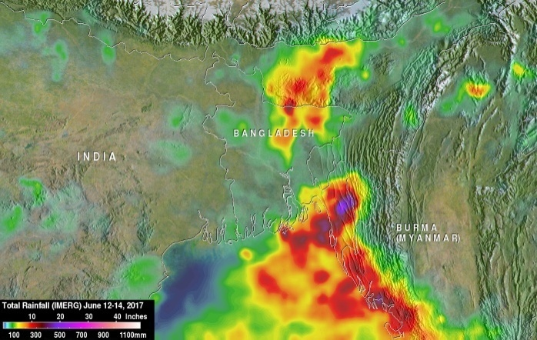

Figur 1: From June 12 to 14, 2017 heaviest rainfall accumulation estimates (purple) by IMERG were located over southeastern Bangladesh. IMERG estimates indicated that landslide inducing rainfall totals there were greater than 510 mm (20 inches). Credits: NASA/JAXA, Hal Pierce.

A study on Dengue virus shows that, diurnal temperature range (DTR) has a direct effect on the infectivity of Aedes aegypti with dengue virus. A high diurnal temperature range (20°C) reduced the probability of infection while a low range (10°C) increased the rate of infection [12].

In 2017and 2018 during monsoon from June to September, the temperature was unbearable and rain fall was unprecedented [13-15]. We noticed that, the rate of vector-borne diseases was high. People got highly infected, by Chikungunya and Dengue virus, and also other diseases. During the second week of June, 2017 rainfall accumulation estimates by IMERG were located over southeastern Bangladesh. This estimation indicates that, there was more than 510 mm rainfall including landslide. At least 156 people killed during that week by landslides and floods caused by heavy rainfall. In April, 2017 during the first three week nearly 9000 mm rain recorded, according to Meteorologist office statistic officer this rainfall was highest in 35 years also 119.7 percent higher than the average April rainfall [13-14]. According to weather experts, it is known as "climate variability".

Conclusion: In recent time we, Bangladeshi peoples, have been facing a severe problem that is the above addressed unknown mysterious fever, sometimes known as chikungunya. We are working to control mosquitoes. Control focuses on management of vectors, although these efforts have typically had limited effectiveness in preventing outbreaks of this mysterious fever. We have to adopt new prevention and control strategies to counter the potential consequences of climate change on incidence of chikungunya.

Conflict of interest statement: We declare that there is no conflict of interests regarding the publication of this paper.

Author’s contributions: Conceptualization: Md. Saddam Hossain; Investigation: Md. Saddam Hossain; Methodology: Sumaiya Akter; Supervision: Md. Saddam Hossain; Validation, Md. Saddam Hossain; Writing – original draft: Sumaiya Akter; Writing – review & editing: Md. Saddam Hossain.

References:
- Institute of Epidemiology and Disease Control and Research. Chikungunya News Letter. (accessed Sept 7, 2017).)http://www.iedcr.gov.bd/index.php/chikungunya/chikungunya-newsletter Date: Sept 7, 2017

- https://www.vox.com/2017/11/30/16720794/scarlet-fever-return

- https://www.smithsonianmag.com/smart-news/these-are-worlds-most-dangerous-new-pathogens-according-who-180957541/

- http://www.who.int/medicines/ebola-treatment/WHO-list-of-top-emerging-diseases/en/

- https://www.sciencealert.com/mysterious-disease-x-next-deadly-global-epidemic-who-warns-virus-pathogen

- https://www.timeanddate.com/weather/bangladesh/dhaka/historic?month=9&year=2017

- https://www.accuweather.com/en/bd/dhaka/28143/allergies-weather/28143

- https://www.timeanddate.com/weather/bangladesh/dhaka/historic?month=5&year=2018

- https://www.dhakatribune.com/bangladesh/nation/2018/01/08/temperature-panchagarh-hits-50-year-low

- https://tradingeconomics.com/bangladesh/temperature

- https://www.thedailystar.net/country/lowest-temperature-in-bangladesh-bd-on-january-8-2018-recorded-3-degree-celsius-in-nilphamari-1516666

- Githeko, Andrew Karanja, Lindsay, Steve W, Confalonieri, Ulisses E & Patz, Jonathan A. (‎2000)‎. Climate change and vector-borne diseases : a regional analysis / Andrew K. Githek.et.l http://www.who.int/iris/handle/10665/57713

- https://bdnews24.com/bangladesh/2017/04/25/bangladesh-sees-highest-rainfall-for-35-years-recorded-in-april

- https://floodobservatory.colorado.edu/Events/2017Bangladesh4466/2017Bangladesh4466.html

- https://reliefweb.int/disaster/fl-2018-000105-bgd

