Intrauterine Spontaneous Subdural Hematoma with Hydrocephalus

Dr MOHAMMED NOORULDEEN JABBAR
FEBNS, FIBMS-NS, FACS, MBChB
Specialist Neurosurgeon, Canadian Specialist Hospital – Dubai, UAE
Email: mohammed.nooraldeen@yahoo.com
Mobile: +971567935922
ORCID number: 0000-0002-1382-1030

Dr FIDAN NADMI NADIM ALHURMUZI
CABOG, FIBMS, DOG, MB ChB
Specialist Obstetrician and Gynecologist
Dubai London Hospital - Dubai, UAE
Email: fidan_hurmuz@yahoo.com
Mobile: +971567935837

Abstract:
Subdural hematoma in newborn baby is associated with history of maternal trauma, complicated vaginal delivery, instrumental delivery, foetal / maternal thrombocytopenia, coagulopathy, hepatic disease, infection or using drugs during the pregnancy; but in the absence of the above, intrauterine subdural hematoma is a rare event.
We present a newborn delivered to a healthy mother at 38 weeks by elective caesarean section after he had been diagnosed with macrocephaly by routine obstetric growth scan ultrasound at 35 weeks of gestational age. The baby’s APGAR score was 4 at 1 minute, he was pale, his fontanel was tense and his Occipitofrontal circumference (OFC) was 46 cm, therefore, he was intubated immediately and transferred to Neonatal Intensive Care Unit (NICU). Brain Computed tomography (CT –scan) revealed huge right sided subacute subdural hematoma that was almost occupying the entire right hemicranial space and severely compressing the underlying brain tissue. In addition, there was marked dilatation of the left lateral ventricle with blood clots at the occipital horn.
Subdural hematoma was evacuated by two burr holes surgery, followed by repeated subdural tap. Intraventricular haemorrhage treated by repeated ventricular tap until Cerebrospinal Fluid (CSF) became clear, then ventriculoperitoneal shunt surgery was done for him.
The baby has been discharged from the hospital in stable condition and he is on continues follow up in outpatient (OPD) clinics.

Keywords:
Subdural hematoma, Newborn, Hydrocephalus, Burr hole, Shunt surgery

Consent for Publication:
Consent obtained from the patient’s father.

Funding:
None.

Conflict of Interest:
No conflict of interest.

Aim:
Raising awareness of the health care providers about spontaneous intrauterine hematoma as a cause of macrocephaly.

Introduction:
Neonatal subdural hematoma (SDH) is due to shearing of bridging veins or other venous structures caused by trauma during vaginal delivery especially when Forceps or Vacuum extraction device has been used, and it is the most serious complications related to birth trauma. Birth trauma that result in SDH is usually detected by imaging (ultrasonography, CT-scan) when an infant develops seizure, apnea, bradycardia or neurological deficits.. However, SDH existing prior to delivery is rare [1-7].
Periventricular-intraventricular hemorrhage in the newborn occurs primarily in premature infants [2], while Intraventricular hemorrhage in term infant is rare [3]; this is because the highly vascular germinal matrix is located just beneath the ependymal lining of the lateral ventricles and undergoes progressive involution until 36 weeks gestational age, so in premature infants the matrix may persist out of utero. A disproportionate amount of the total cerebral blood flow perfuses the periventricular circulation through these capillaries which are immature and fragile and have impaired autoregulation [2]. However, subdural hematoma is rare in premature newborn because of underdeveloped bridging veins [1].

Case Presentation:
Full term baby delivered by elective caesarean section to a healthy 39-year- old, G2P1A0, woman who had regular uneventful antenatal care. At 26 weeks of gestation, obstetric ultrasound did not show any abnormal finding. Routine obstetrical growth scan at 35 weeks of gestation revealed enlarged fetal head parameters due to hydrocephalus and right subdural collection with midline shift.
At 38 weeks of gestation, elective caesarean section done by the obstetrician, and a male baby was born with APGAR score 4 at 1 minute, his birth weight was 2.895 kg, length 44 cm, fronto-occipital circumference (OFC) was 46 cm, heart rate 120/min, pale, no spontaneous breathing, so he was intubated, received vitamin K and transferred to neonatal intensive care unit (NICU) for further management.
As his anterior fontanel was tense bulging, ventricular tap done and revealed hemorrhagic CSF. Packed red blood cells transfusion done as his hemoglobin level was 4.7 g/dl. Brain CT –scan revealed huge right sided, extra axial, subdural hematoma that was almost occupying the entire right hemicranial space with severely compressing the underlying brain tissue and right lateral ventricle. In addition, there was marked dilatation of the left lateral ventricle with some blood clots at the occipital horn (Figure 1 and 2). Apart from above findings, all the investigations done for the baby and the mother were unremarkable.
Right sided, frontal and parietal burr holes done using diamond burr, the dura matter opened after coagulation and brownish (motor oil) fluid ejected under high pressure, then irrigation through and through with saline until the fluid became clear. This operation followed by repeated subdural tap through the burr holes over the following few days, then new CT-scan of brain done (Figure 3 and 4).
The CSF was not clear, so repeated ventricular tap done on alternative days with CSF analysis until the CSF became clear and protein drop down to 95.3 mg/dl. Ventriculo-peritoneal shunt surgery done for him and he was discharged from the hospital one week after the surgery in stable condition. The baby is under regular follow up in outpatient clinic; he is improving but has delayed milestone. No CT-scan done for him after the shunt surgery as his parents reluctant to do so.

Discussion:
Intrauterine subdural hematoma (SDH) is a rare event with high mortality rate. Trauma is the primary cause of in utero foetal SDH [4, 5,6,8,9, 10,11], as a case reported after maternal road traffic accident by KY Kwok et al. [12]. Newborns with SDH of Pacific Island origin were reported due to maternal trauma by traditional abdominal massage [8, 13]. Other causes of intrauterine SDH include fetal or maternal thrombocytopenia, hepatic disease, infection [14, 15, 16] or exposure to drugs as a case reported by F Bauder et al for a mother treated with low molecular weight heparin [17].
Our presenting patient had spontaneous intrauterine SDH; which means fetal SDH without any evidence of obvious cause or predisposing factors [5, 8, 11, 18-22]. The first spontaneous intrauterine SDH reported case was by MacDonald et al. in 1977 [19], followed by a case reported by Gunn et al. in 1985 but the newborn was died at third day [8], then a case by Mateos et al. in 1987 who was died at 14th day [12]. Comparing with the case reported by Cigdem et al. ,our patient’s head circumference was 46 cm, while their patient’s head circumference was 35.5 cm [5]. In addition, in our case, the baby had Intraventricular hemorrhage that needed repeated ventricular tap to clear the cerebrospinal fluid (CSF) that followed by ventriculoperitoneal (V-P) shunt. A case reported by Galen et al. was preterm with Intraventricular hemorrhage/ SDH, and treated by applying bilateral Rickham reservoirs, tapping them twice, then removing them at one month age [23].

Conclusion:
Spontaneous intrauterine subdural hematoma with or without Intraventricular hemorrhage/ hydrocephalus is a rare cause of macrocephaly that could be treated by good cooperation among obstetrician, neonatologist and neurosurgeon, but needs more study to find the cause of this condition so we can prevent its occurrence.

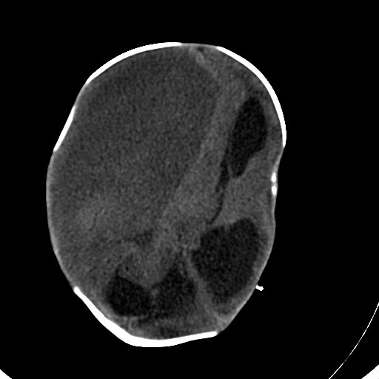
Figure 1:
Brain CT-scan without contrast, axial view, showing right sided subdural collection compressing the brain at left side. In addition, there is marked dilatation of the ventricles.

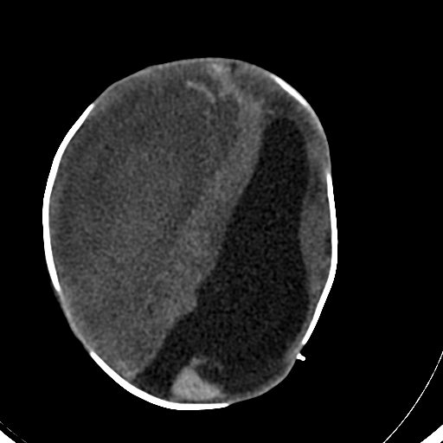
Figure 2:
Brain CT-scan without contrast, axial view, showing intraventricular blood, plus right subdural collection.

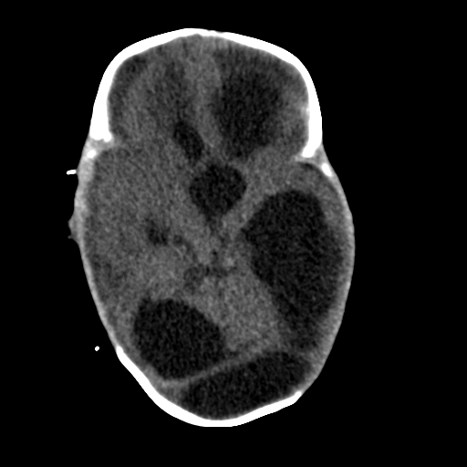
Figure 3:
Brain CT-scan without contrast, axial view, showing hydrocephalus.

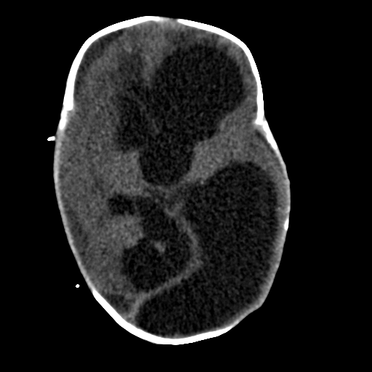
Figure 4:
Brain CT-scan showing hydrocephalus.

References:
- Avinash Mohan, Robin M. Bowman. Birth Head Trauma. Youmans Neurological Surgery, 6th edition. 212: 2187.
- Mark S. Greenberg. Intracerebral Hemorrhage. Handbook of Neurosurgery. 2016; 87: 1346.
- Yin C. Hu, Shakeel A. Chowdhry, Shenandoah Robinson. Youmans Neurological Surgery, 6th edition. Infantile Posthemorrhagic Hydrocephalus. 187: 1987.
- Volpe JJ. (1995) Intracranial hemorrhage: subdural, primary subarachnoid, intracerebellar, Intraventricular (term infant), and miscellaneous. In: Volpe JJ, editor. Neurology of the Newborn. Philadelphia: WB Saunders. P 373-402.
- Cigdem Inan Akman, Joan Cracco. Intrauterine subdural hemorrhage. Developmental Medicine & Child Neurology 2000, 42: 843-846.
- Stephens RP, Richards AC, Lewin JS. (1997) Bilateral subdural hematomas in a Newborn infant. Pediatrics 99:619-21.
- Pollina J, Dias MS, Li V, Kachurek D, Arbesman M. Cranial birth injuries in term newborn infants. Pediatr Neurosrg 2001; 35: 113-119 (Medline)
- Gunn TR, Mok PM, Becroft DM. Subdural hemorrhage in utero. Pediatrics. 1985; 76:605-10
- Akman CI, Cracco J. Intrauterine subdural hemorrhage. Dev Med Child Neurol. 2000; 42: 843-6
- Vergani P, Strobelt N, Locatelli A, et al. Clinical significance of fetal intracranial hemorrhage. Am J Obstet Gynecol. 1996; 175: 536-43
- Nogueira GJ. Chronic subdural hematoma in utero. Report of a case with survival after treatment. Childs Nerv Syst. 1992; 8: 462-4
- Intrauterine Foetal Subdural Haemorrhage Visible on Computed Tomography Scan. KY Kwok, SSM Lo, SQH Chou, KS Tse, YL Cheung. Queen Elizabeth Hospital, Hong Kong
- Sokal MM, Katz M, Lell M-E, et al (1980) Neonatal survival after traumatic subdural hematoma. J Reported Med 24: 131-133
- Atluru VL, Kumar IR, (1987). Intrauterine chronic subdural hematomas with postoperative tension pneumocephalus. Pediatric Neurology. 3: 306-9
- Hanigan WC, Ali MB, Cusack TJ, Miller TC, Shah JJ. (1985). Diagnosis of subdural hemorrhage in utero. Journal of Neurosurgery. 63: 977-9
- Rotmensch S, Grannum PA, Nores J, Hall C, Keller MS, Mc Carthy S, Hobbins JC. (1991). In utero diagnosis and management of fetal subdural hematoma. American Journal of Obstetric and Gynecology. 164: 1246-8
- Bauder F, Beinder E, Arlettaz R, Albisetti M, Boltshauser E, Gessler P. Intrauterine subdural hemorrhage in a preterm neonate possibly associated with maternal low-molecular weight heparin treatment.
- Sohda S, Hamada H, Takanami Y, Kuba T. (1996). Prenatal diagnosis of fetal subdural hematomas. British Journal of Obstetrics and Gynaecology. 103:89-90
- Mac Donald JT, Weitz R, Sher PK. (1977). Intrauterine chronic subdural hematoma. Archives of Neurology. 34: 777-8
- Kawabata I, Imai A, Tamaya T. (1993) Antenatal subdural hemorrhage causing fetal death before labor. International Journal of Gynaecology and Obstetrics 43:57-60
- Mateos F, Esteban JT, Martin Puerto MJ, Ozaita G, Martinez Portillo J. (1987). Fetal subdural hematoma diagnosis in utero. Pediatric Neuroscience. 13: 125-8
- Demir RH, Gleicher N, Myers SA. (1989). Atraumatic antepartum subdural hematoma causing fetal death. American Journal of Obstetric and Gynaecology. 160: 619-20
- Galen N. Breningstall, Richard J. Patterson. Intrauterine subdural hematoma. Pediatr Radiol (2000). 30: 630-631.

