COVID-19 Virus Pneumonia’s Economic Effect in Different Industries: A Case Study in China

Yuhan Cheng, Dongqi Cui and Zixuan Li

Abstract
Starting from late 2019, COVID-19 virus pneumonia has swept mainland China during the whole Spring Festival. In order to prevent the spread of the virus, people have to stay at home and avoid going out. This has affected the economic development of many industries to some extent, especially tourism and services, which relied on high population mobility to make profits during the Spring Festival holiday in the past. We use the event study method to explore the impact of pneumonia on A-share listed companies’ stock returns in different industries in China. Results show that there indeed some negative effect on economy, and vary in different industries.

Keywords: COVID-19, event study, stock return

1. Introduction
As we all know, since the end of 2019, COVID-19 epidemic has swept through more than 200 countries and regions in the world, bringing huge impact. As of March 2020, we have counted the cumulative number of confirmed COVID-19 cases in countries around the world (Figure 1) and provinces in China (Figure 2).

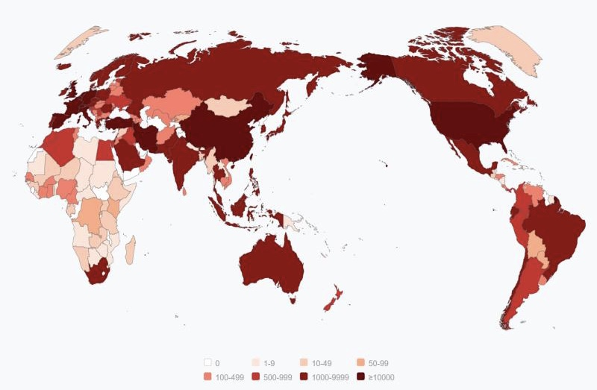
Figure 1: confirmed COVID-19 cases around the world

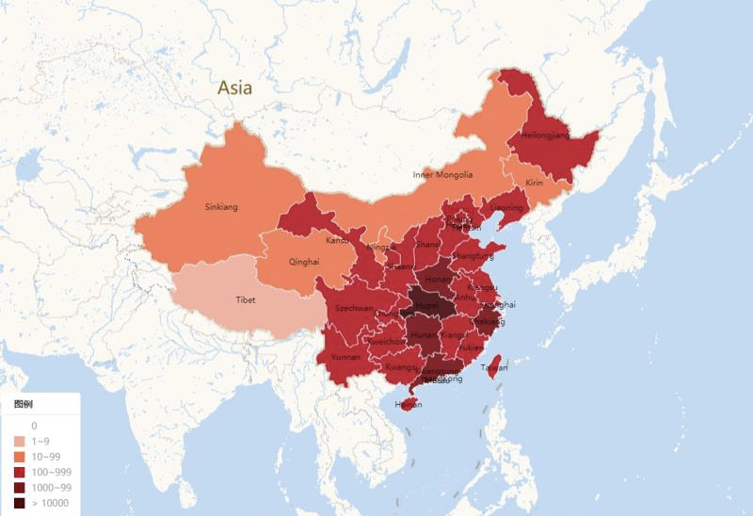
Figure 2: confirmed COVID-19 cases in China

In both figures, the darker the area, the greater the number of confirmed patients. We can see that worldwide, more than 10,000 people have been diagnosed in China, the United States and European countries, respectively. As for China itself, there’s no doubt that Hubei province is the most serious area, and the coastal provinces of the south-east are generally worse off than the north-west because they are densely populated and has highly mobility.
Covid-19 is a highly infectious virus and can be transmitted from person to person in airborne droplets. As a result, many governments, including China's, have urged people to stay at home and go out less, which has had an impact on economic and social development. Using a sample of all A-share listed companies in mainland China, we examined the impact of the outbreak on market performance in different sectors using the event study method. Overall, the disease has had a negative impact on the whole market, but there still some industry classifications benefit from this event, such as pharmaceutical manufacturing and telecommunication.
The rest of the paper is organized as follows. Section 2 discusses the economic background and the related literature. Section 3 discusses study methods and sample selection. Section 4 presents the empirical results. Section 5 discusses and concludes.

2. The Economic Background and Literature Review
As is known to all, China is a populous country, and the economic development of many industries in China is based on population density. However, the outbreak of the virus pneumonia seriously prevented people from moving around during the Spring Festival holiday, thus affecting the profitability of many industries. For example, the railway transportation industry should have a large passenger flow during the Spring Festival (due to the unique Spring Festival travel culture of the Chinese people and the rework tide after the Spring Festival holiday), but due to the epidemic, many migrant workers did not go home, or those who have gone home need to be isolated and cannot return to work immediately after the holiday.
On the other hand, we would expect that other industries will not be affected so much, such as e-commerce industries. The strongly infectious virus made people afraid to go to supermarket which has high people density to buy necessities, but people need to make a living so online shopping ushered in a new upsurge during the epidemic period. Industries such as steel should also suffer less because workers only need to work with machines, so it is possible for them to get back to work on time.
There is little research literature on the impact of the epidemic situation on China's economy, given that the last major epidemic was SARS in 2003. Wong and Siu (2005) found that as the SARS outbreak exploded in a number of east and south-east Asian countries, the short-term economic growth outlook in the region dimmed. The conditions of a sustained economic recovery into 2003 began to look less favorable. Year-on-year GDP growth rates in 2003Q1 and 2003Q2 were respectively –0.1% and –6.3% in Hong Kong, 0.9% and –2.0% in Taiwan, and 1.2% and –5.6% in Singapore. Siu and Wong (2014) also found that in Hong Kong, restaurants and retail outlets were hit hard, with sales dropping by 10 to 50 percent. Land transport declined by 10–20 percent because people stayed home. There was also a 50 percent drop in the use of the Airport Express Line, which indicated a reduction in air travel.
As for mainland China, Beutels, Jia and Zhou (2009) investigated the impact of SARS in Beijing, China. They showed that especially leisure activities, local and international transport and tourism were affected by SARS particularly in May 2003. Much of this consumption was merely postponed; but irrecoverable losses to the tourist sector alone were estimated at about US$ 1.4 bn, or 300 times the cost of treatment for SARS cases in Beijing. Another paper estimated that the total costs of the epidemic would be about 1.5 percent of GDP for China during the height of the SARS outbreak, which indicated the strong need to improve both the public health system and the governance structure in Asia (Hanna and Huang, 2014).
Our paper makes a number of contributions to the existed study: First, the pneumonia outbreak was an exogenous shock that no one knew about in advance, and we studied its economic impact using the event approach, which avoided the endogenous problem. Second, we studied the impact of the outbreak on different industries from the micro level and provided policy suggestions for the government to implement targeted assistance.

3. Study Methods and Sample Selection
3.1 Study Methods
Since first appearance in late 2019, the development of pneumonia was rapid and complex. China's first case of COVID-19 virus infection occurred on December 1, 2019, but this has not caused people’s concern or alarm, as authorities in Hubei and Wuhan claim that the spread of the virus can be prevented and controlled, and there is no evidence of human-to-human transmission. It was not until January 20, 2020, when Chinese infectious disease expert Zhong Nanshan publicly confirmed that the virus had spread from person to person, that the public had a comprehensive understanding of the pneumonia epidemic for the first time and the government began to call for people to stay indoors.
In order to determine the date of the event, we searched the Baidu index for “新冠肺炎” (COVID-19)、“新型冠状病毒” (novel coronavirus)、“肺炎” (pneumonia) and“疫情” (outbreak). Baidu is the largest search engine in China (similar to Google in the United States), and the keyword search index can reflect the public's concern about the pneumonia epidemic, so as to determine which day is really affected by the people. Figures are listed below.

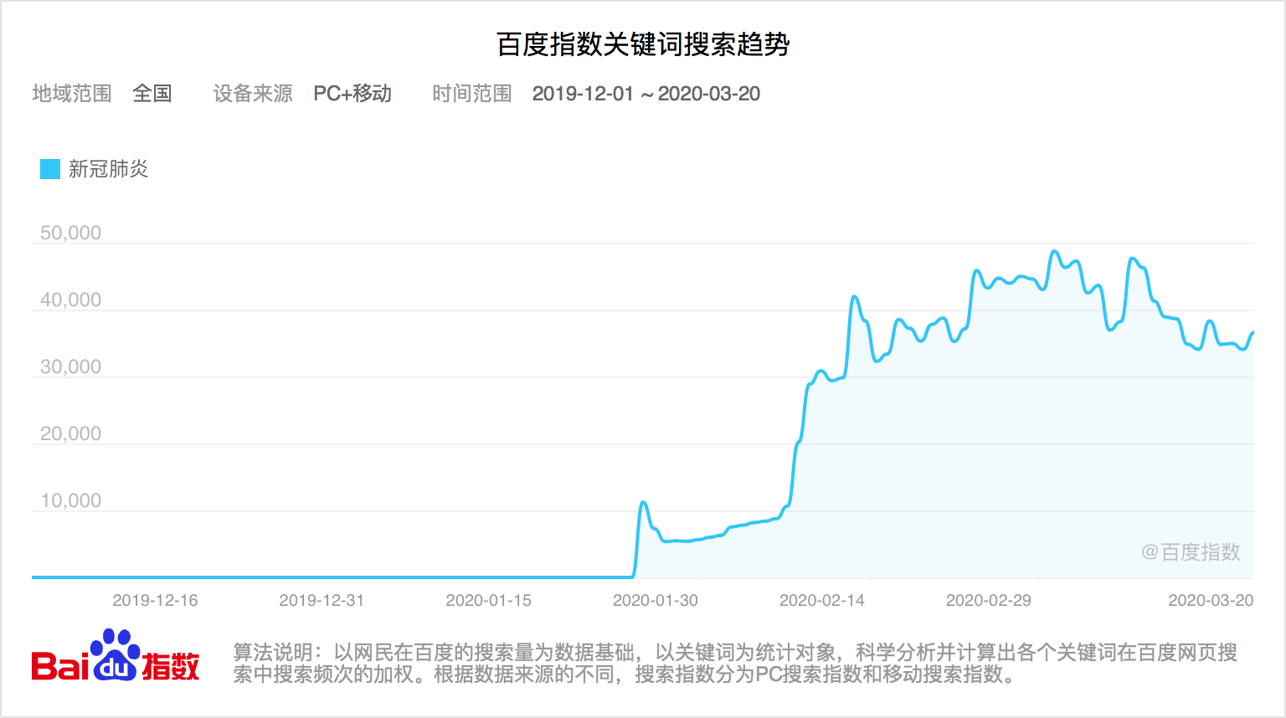
Figure 3: Baidu index for “新冠肺炎” (COVID-19)

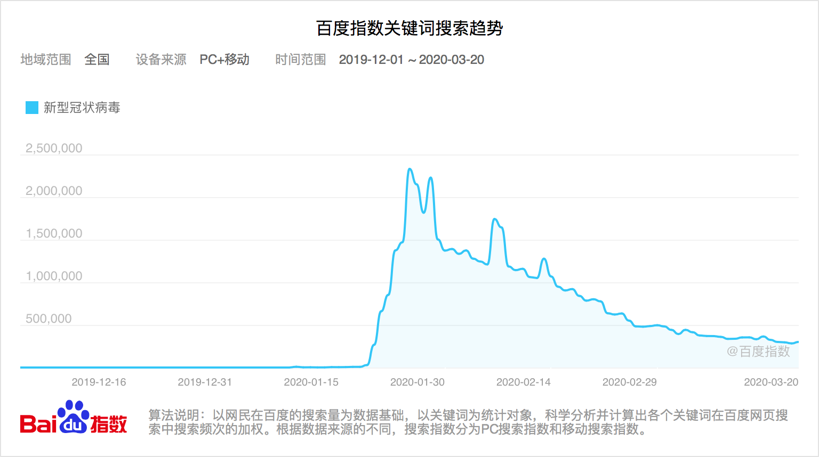
Figure 4: Baidu index for “新型冠状病毒” (novel coronavirus)

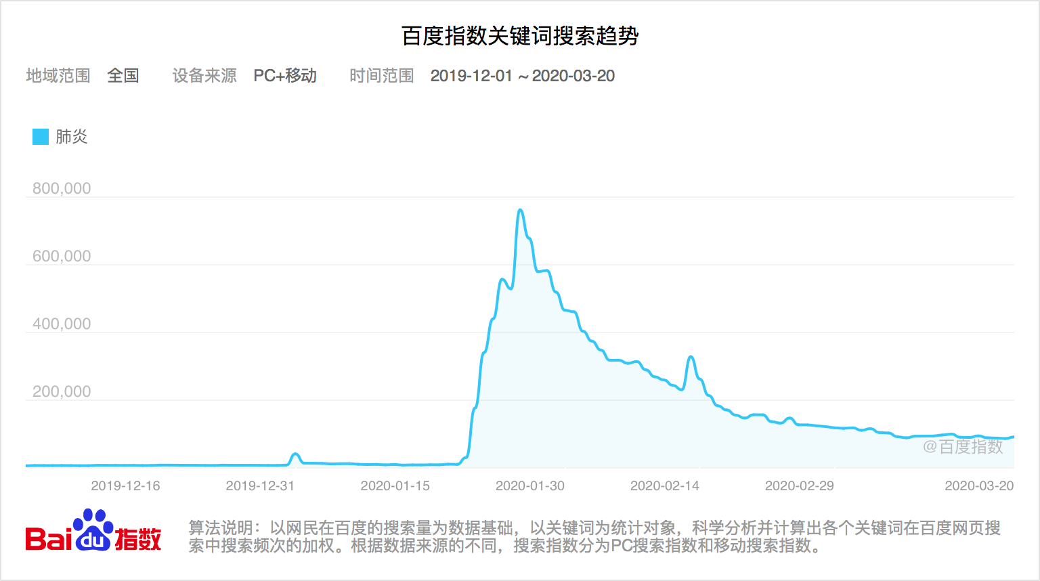
Figure 5: Baidu index for “肺炎” (pneumonia)

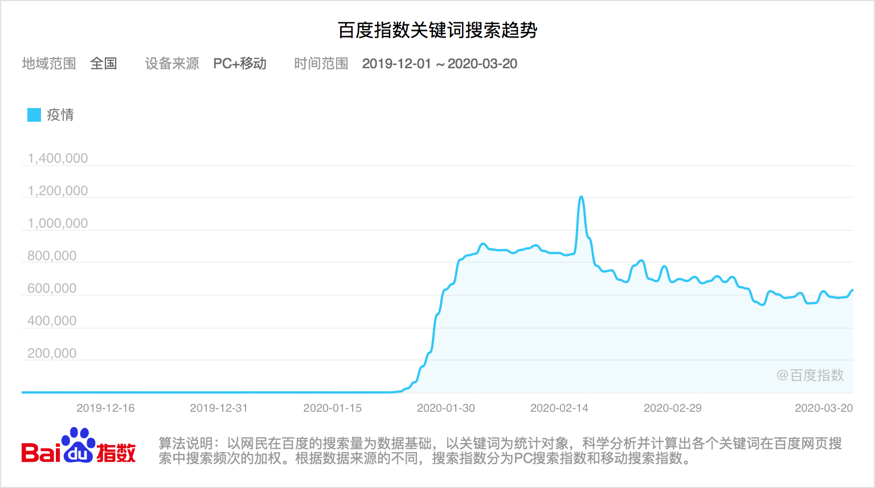
Figure 6: Baidu index for “疫情” (outbreak)
Notes: Figures 3-6 reports Baidu search volumes from PC and mobile all over China, during December 2019 to March 2020.
From figures we can see that January 20, 2020, is a clear date, and the spike in searches for the above keywords indicates that the public has become very concerned about the pneumonia outbreak, and may be followed by panic. Another evidence is that Wuhan was closed 2 days later, which means things are getting very serious.
Following the standard event study approach, we first calculate the CAR in the window [d1, d2] around the event for each firm in our sample. This is done by aggregating daily abnormal returns from day d1 to day d2:
$$CAR=\sum_{t=d1}^{d2}{{AR}_{t}}$$
In which day 0 is the event day above ((January 20, 2020)). Daily abnormal returns are estimated with the market model and a 181-day estimation window (day -210 to day -30). We choose market model for its brevity and great representative during the event:
$${stock_return}_{i,t}=α+β{market_return}_{t}+ε_{i,t}$$
We obtain the estimated coefficients $α$ and $β$ from the [-210, -30] window, and use them to predict the “normal” return in the event window. And the difference between “normal” return and the true stock return is the abnormal return defined above.
3.2 Sample Selection
In this paper, we use all listed A-share firms in China Stock Market & Accounting Research Database. All information was downloaded from CSMAR including stock daily return, daily trading shares, and industry classification. Especially, we use CSRC 2012 industry classification to divide firms into 19 different industries, and each industry also has several more accurate classifications. We estimated different impact of pneumonia outbreak on different industries, except which has too small a sample size to be accurately estimated. All industry names are listed in Table 1.

Table 1: Different industries
Industries
A. Agriculture, forestry, animal husbandry and fishery industries
A01. Agriculture
A02. Forestry
A03. Husbandry
A04. Fishery
B. Mining industry
B06. Coal mining and washing
B07. Oil and gas exploration
B08. Ferrous metal mining
B09. Nonferrous metal mining
B11. Mining auxiliary activity
C. Manufacturing industry
C13. Agricultural and sideline food processing
C14. Food manufacturing
C15. Wine, beverage and refined tea manufacturing
C17. Textile industry
C18. Textile clothing and clothing industry
C19. Leather, fur, feather and other products
C20. Wood processing and wood, bamboo, rattan, brown, grass products industry
C21. Furniture manufacturing
C22. Papermaking and paper products
C23. Reproduction of printing and recording media
C24. Culture and education, industrial beauty, sports and entertainment goods manufacturing
C25. Petroleum processing, coking and nuclear fuel processing
C26. Chemical raw materials and chemical products manufacturing
C27. Pharmaceutical manufacturing
C28. Chemical fibre manufacturing
C29. Rubber and plastic products
C30. Nonmetallic mineral products
C31. Ferrous metal smelting and rolling processing
C32. Nonferrous metal smelting and rolling processing
C33. Metal products
C34. General equipment manufacturing
C35. Special equipment manufacturing
C36. Automobile manufacturing
C37. Manufacturing of railways, ships, aerospace and other transport equipment
C38. Electrical machinery and equipment manufacturing
C39. Manufacturing of computers, communications and other electronic equipment
C40. Instrumentation manufacturing
C41. Other manufacturing
C42. Comprehensive utilization of waste resources
D. Electricity, heat, gas and water production and supply industries
D44. Electricity and heat production and supply
D45. Gas production and supply
D46. Water production and supply
E. Construction industry
E47. Housing construction
E48. Civil engineering construction
E50. Building decoration and other construction
F. Wholesale and retail industry
F51. Wholesaling
F52. Retail
G. Transportation, warehousing and postal services industries
G53. Railway transport
G54. Road transport
G55. Water transport
G56. Air transport
G58. Handling and transportation agency
G59. Warehousing
G60. Postal service
H. Accommodation and catering industries
H61. Lodging industry
H62. Restaurant industry
I. Information transmission, software and information technology services industries
I63. Telecommunications, broadcast television and satellite transmission services
I64. Internet and related services
I65. Software and information technology services
J. Financial industry
J66. Monetary and financial services
J67. Capital market services
J68. Insurance industry
J69. Other financial sectors
K. Real estate industry
L. Leasing and business services industries
L71. Rental
L72. Business services
M. Scientific research and technical services industries
M73. Research and experimental development
M74. Professional and technical service
N. Water, environment and utilities management industries
N77. Ecological protection and environmental management
N78. Public facilities management
O. Residential services, repairs and other services industries
P. Education industry
Q. Health and social work industries
R. Culture, sport and entertainment industries
R85. News and publishing
R86. Radio, television, film and television recording production
R87. Arts and culture
S. Comprehensive industries

4. Empirical Results
4.1 Empirical Results for 19 categories
Given estimation window as [-210, -30] (210 to 30 days before the event day January 20), we chose shorter event windows such as [-1, +1], [-3, +3] and [-5, +5] to calculate the CARs for different industries, and a longer event window, [-30, +30], to draw a trend of CAAR (Cumulative Average Abnormal Return) for the 61days during the whole event. CARs for the 19 different categories are listed in Table 2.

Table 2: CARs for different industries
industry number | event window | [-1,1] | [-3,3] | [-5,5]
A | mean car | -0.017** | -0.054*** | -0.108***
 | t-stat | (-2.52) | (-4.18) | (-6.00)
B | mean car | -0.001 | -0.013 | -0.044***
 | t-stat | (-0.21) | (-1.59) | (-4.54)
C | mean car | 0.009*** | 0.013*** | 0.007**
 | t-stat | (7.76) | (7.60) | (2.41)
D | mean car | -0.006** | -0.009*** | -0.043***
 | t-stat | (-2.55) | (-3.09) | (-7.94)
E | mean car | -0.001 | 0.003 | -0.044***
 | t-stat | (-0.41) | (0.69) | (-6.35)
F | mean car | 0.002 | -0.003 | -0.018
 | t-stat | (0.60) | (-0.52) | (-1.65)
G | mean car | -0.001 | -0.007 | -0.056***
 | t-stat | (-0.26) | (-1.18) | (-8.11)
H | mean car | -0.027** | -0.022 | -0.102***
 | t-stat | (-1.63) | (-1.59) | (-8.48)
I | mean car | -0.001 | 0.023*** | 0.027***
 | t-stat | (0.34) | (4.30) | (3.18)
J | mean car | 0.003** | 0.005 | -0.011**
 | t-stat | (1.63) | (1.39) | (-2.25)
K | mean car | -0.005* | -0.009** | -0.053***
 | t-stat | (-1.70) | (-2.08) | (-9.49)
L | mean car | -0.028*** | -0.020** | -0.059***
 | t-stat | (-5.10) | (-2.10) | (-4.77)
M | mean car | -0.011* | -0.024*** | 0.019
 | t-stat | (-1.96) | (-3.00) | (1.14)
N | mean car | -0.002*** | -0.015* | -0.033
 | t-stat | (-3.28) | (-1.94) | (-2.48)
O | mean car | -0.006 | -0.35 | -0.128
 | t-stat | (0.00) | (0.00) | (0.00)
P | mean car | -0.019 | -0.056*** | -0.021
 | t-stat | (-1.40) | (-3.54) | (-0.73)
Q | mean car | 0.021 | -0.008 | 0.019
 | t-stat | (1.76) | (-0.44) | (0.66)
R | mean car | -0.018** | -0.023 | -0.027
 | t-stat | (-2.02) | (-1.54) | (-1.34)
S | mean car | 0.013 | 0.013 | 0.006
 | t-stat | (1.11) | (0.52) | (0.14)
Notes: ***, **, * represent significance level of 1%, 5% and 10% respectively.

We can see some interesting things from the table above. Generally speaking, the pneumonia outbreak affected all social sectors, because almost all cumulative abnormal returns were negative during the epidemic, which is consistent with our intuition. From the micro perspective, however, the time and duration of the effect of outbreak were different for different industries, some suffering a lot while others may not be affected so much.
Some industries, such as agriculture and forestry, real estate and business services, all three CARs are significantly negative, suggesting that these industries were hit at the beginning of the outbreak, and continued to be so. The reason may be that they are labor-intensive industries, or which require close communication with others, and the government's policy to let people stay at home has cut off the profit chain for these firms, resulting in a drop of their performance.
For other industries, such as culture and entertainment, education, scientific research and technical services, the CARs are significantly negative in the early stage, but not continues. These industries may be hit at the start of the epidemic when people stopped participating, but quickly discovered patterns that allowed people to consume without leaving their homes, such as distance education and VR movies. Other industries, on the contrary, performed better at first but yields have fallen markedly over time. Representative industries contain mining, construction and transportation. What they have in common is that they are not directly dependent on the dense flow of population, but as the basic industry of other industries, they are gradually affected as downstream enterprises are hit by the epidemic and their orders drop.
There also some other industries, however, not suffer from the pneumonia outbreak at all and have significantly positive CARs during the disease. One of the industries is manufacturing, mainly because employees only need to working with machines instead of other people. Information transmission, software and information technology services also benefit from the whole epidemic and it can be easily understood that because everyone need to work at home, technology of telecommuting get a great development and pursuit.
For a more intuitive understanding, we then draw trend of CAAR of different industries for about 1 month before and after the pneumonia outbreak. The figures are listed below and we can see that the results reflected in figures are nearly the same as that in Table 2, which shows the robustness of our statements.
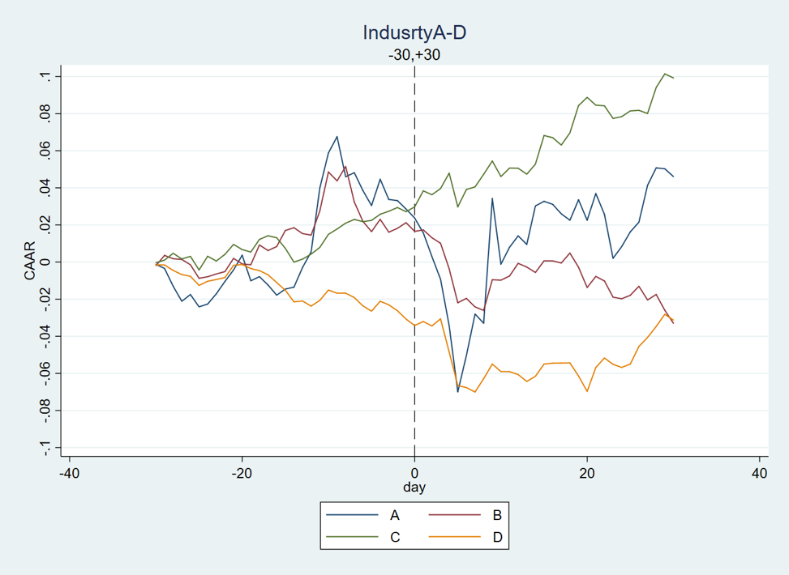
Figure 7: CAAR for Industry A-D

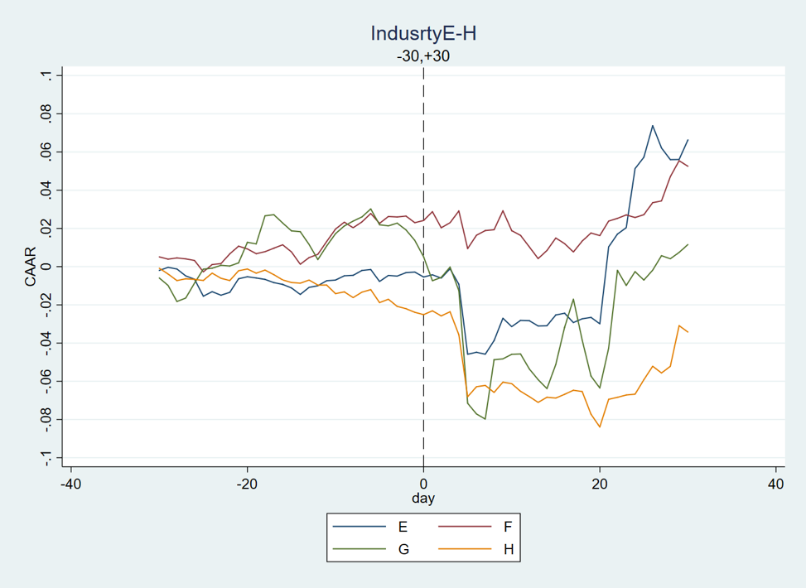
Figure 8: CAAR for Industry E-H

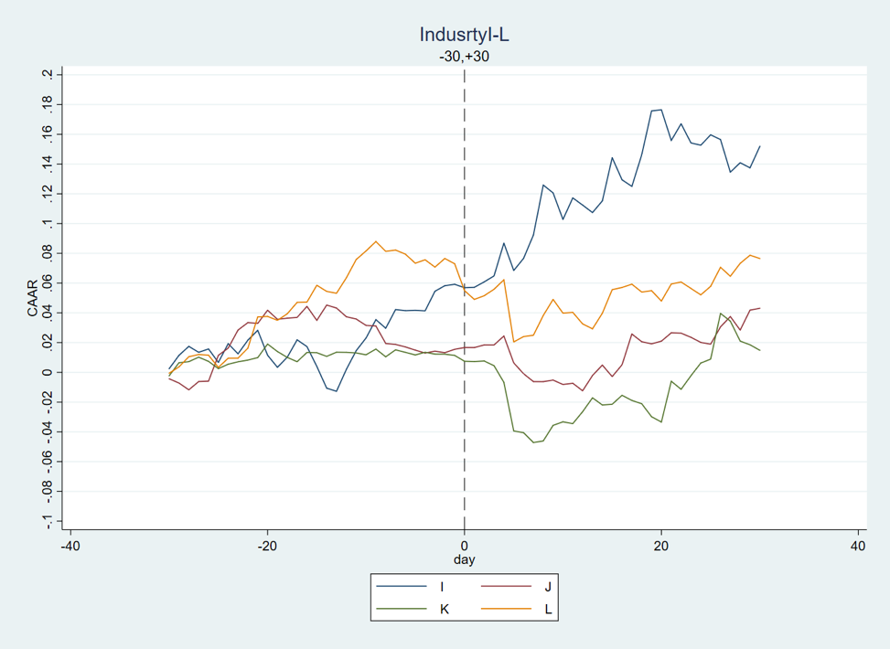
Figure 9: CAAR for Industry I-L

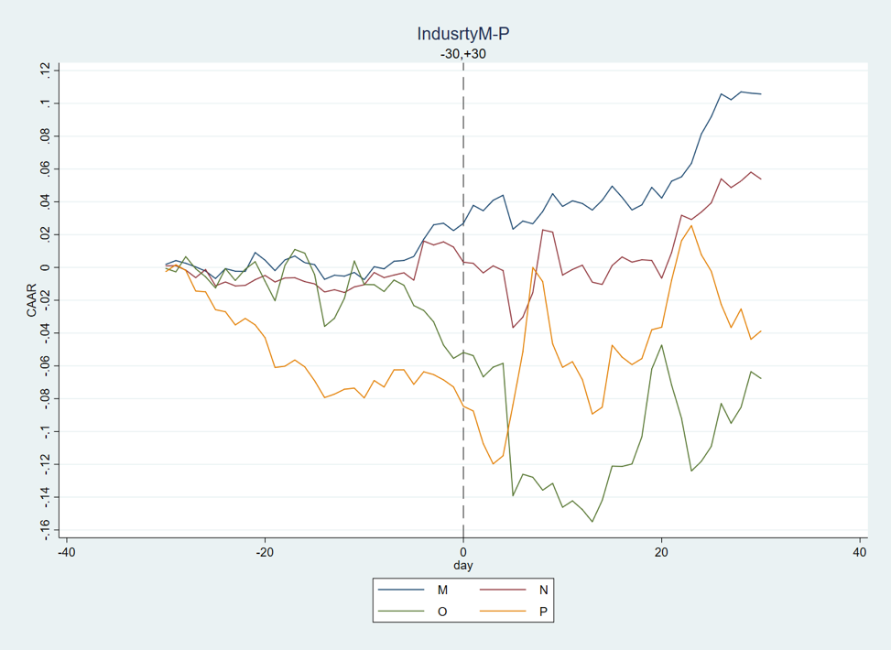
Figure 10: CAAR for Industry M-P

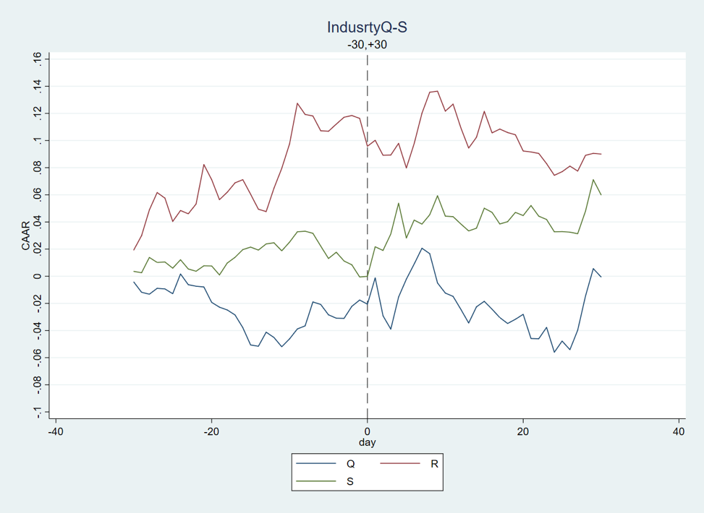
Figure 11: CAAR for Industry Q-S

4.2 Empirical Results for accurate classifications
We then estimate the CARs for each accurate classification contained in the 19 categories, and the results are reported in Table 3. We use ***, **, * to represent significance level of 1%, 5% and 10% respectively as above and omit the value of t-Statistic for brevity.

Table 3: CARs for accurate classification
industry number |  | event window | [-1,1] | [-3,3] | [-5,5]
A | A01 | mean car | -0.022 | -0.062* | -0.081
 | A02 | mean car | -0.011 | -0.004 | -0.133
 | A03 | mean car | -0.014 | -0.074** | -0.142***
 | A04 | mean car | -0.011 | -0.016 | -0.074**
B | B06 | mean car | -0.009*** | -0.021*** | -0.053***
 | B07 | mean car | -0.005 | -0.018 | -0.079***
 | B08 | mean car | 0.025 | 0.012 | 0.013
 | B09 | mean car | -0.010 | -0.030 | -0.055*
 | B11 | mean car | 0.018 | 0.009 | -0.028
C | C13 | mean car | -0.019*** | -0.046*** | -0.080***
 | C14 | mean car | -0.003 | 0.000 | 0.000
 | C15 | mean car | -0.019*** | -0.015* | -0.069***
 | C17 | mean car | 0.011 | 0.009 | 0.014
 | C18 | mean car | -0.011 | -0.013 | -0.040
 | C19 | mean car | -0.020 | -0.003 | -0.026
 | C20 | mean car | 0.001 | -0.023 | -0.076*
 | C21 | mean car | 0.010 | -0.018 | -0.065***
 | C22 | mean car | 0.003 | 0.004 | -0.004
 | C23 | mean car | 0.001 | 0.009 | -0.021
 | C24 | mean car | 0.001 | -0.002 | -0.010
 | C25 | mean car | -0.013 | -0.009 | -0.026
 | C26 | mean car | 0.003 | 0.005 | -0.004
 | C27 | mean car | 0.072*** | 0.069*** | 0.158***
 | C28 | mean car | 0.030** | 0.014 | 0.031
 | C29 | mean car | 0.004 | 0.003 | -0.017
 | C30 | mean car | -0.008* | -0.013* | -0.022*
 | C31 | mean car | -0.010** | -0.010 | -0.032**
 | C32 | mean car | -0.007 | -0.007 | -0.026*
 | C33 | mean car | -0.000 | 0.002 | -0.031*
 | C34 | mean car | -0.002 | -0.004 | -0.036***
 | C35 | mean car | 0.010* | 0.019** | 0.021
 | C36 | mean car | -0.002 | 0.004 | -0.018
 | C37 | mean car | 0.000 | 0.006 | -0.031
 | C38 | mean car | 0.003 | 0.011* | -0.007
 | C39 | mean car | 0.011*** | 0.037*** | 0.027***
 | C40 | mean car | 0.007 | 0.005 | -0.012
 | C41 | mean car | -0.011 | -0.035 | -0.088***
 | C42 | mean car | -0.018 | -0.001 | 0.045
D | D44 | mean car | -0.008* | -0.011** | -0.042***
 | D45 | mean car | -0.007 | -0.017** | -0.072***
 | D46 | mean car | 0.006 | 0.013 | -0.001
E | E47 | mean car | -0.002 | 0.004 | -0.053
 | E48 | mean car | 0.002 | 0.007 | -0.034***
 | E50 | mean car | -0.008 | -0.005 | -0.068***
F | F51 | mean car | 0.009 | 0.018* | 0.014
 | F52 | mean car | -0.003 | -0.022** | -0.047**
G | G53 | mean car | 0.003 | -0.017 | -0.068**
 | G54 | mean car | -0.002 | -0.004 | -0.054***
 | G55 | mean car | -0.005 | -0.003 | -0.074***
 | G56 | mean car | -0.037*** | -0.051*** | -0.085***
 | G58 | mean car | 0.035 | 0.017 | -0.016
 | G59 | mean car | 0.001 | -0.011 | -0.061
 | G60 | mean car | 0.050* | 0.038 | 0.056
H | H61 | mean car | -0.035 | -0.027 | -0.091**
 | H62 | mean car | -0.010 | -0.011* | -0.123**
I | I63 | mean car | -0.004 | -0.022* | -0.024
 | I64 | mean car | -0.017** | 0.002 | 0.019
 | I65 | mean car | 0.004 | 0.034*** | 0.034**
J | J66 | mean car | -0.004* | -0.014*** | -0.026***
 | J67 | mean car | 0.012*** | 0.027*** | 0.004
 | J68 | mean car | 0.000 | -0.008 | 0.004
 | J69 | mean car | -0.003 | -0.014 | -0.032
L | L71 | mean car | 0.003 | 0.041 | -0.015
 | L72 | mean car | -0.029*** | -0.024* | -0.062***
M | M73 | mean car | 0.035 | 0.050 | 0.110*
 | M74 | mean car | 0.007 | 0.022* | 0.006
N | N77 | mean car | -0.004 | 0.000 | 0.002
 | N78 | mean car | -0.034*** | -0.052*** | -0.120***
R | R85 | mean car | -0.015 | 0.001 | 0.030
 | R86 | mean car | -0.020 | -0.033 | -0.067
 | R87 | mean car | -0.021 | -0.051 | -0.052

We can see some more interesting things in Table 3. For example, different classifications in the same category may have different, or opposite reaction to the pneumonia outbreak.
Category C, manufacturing industry, is the biggest category which contained most classifications in our sample. As for different classifications belonging to it, C13, agricultural and sideline food processing, and C15, wine, beverage and refined tea manufacturing, both has significantly negative CARs in all three event windows. However, for other classifications, such as C27, pharmaceutical manufacturing and C39, manufacturing of computers, communications and other electronic equipment, the CARs are positive and statistically significant during the development process of the disease. It is not hard to understand the reasons behind it: for classifications C13 and C15, their upstream business is farming and animal husbandry, which is contained in category A whose reaction to the outbreak is always negative (see section 4.1). Thus, the former two classifications should suffer pressure from suppliers, and have poor performance in the market. On the contrary, pharmaceutical manufacturing and manufacturing of computers or communications are vital for medical relief and remote communication between people during the pneumonia outbreak, and have obtained strong support from the whole society, thus perform better in this special time.
We also can see that within a category, some classification experiences negative impact seriously, while others are not affected at all. The representative is Category F. Wholesaling is little affected by the disease, maybe because it has relied on contactless distribution for a long time, and the transport was not blocked by the pneumonia. However, retail has a strongly negative CAR as the disease’s spread, which may result from government’s advice that people all stay at home and avoid unnecessary trips, and shopping.
Overall, the results obtained by calculating CARs for accurate classifications and large categories are similar, and the epidemic has brought some negative effects on the whole economic development. Some industries have positive reaction and better performance due to its special characteristics, such as close relation with healthcare industry.

5. Discussion and Conclusion
We estimated the economic effects of pneumonia outbreak on the mainland China by calculating CARs for different industry categories and accurate classifications. We choose January 20, 2020 as the event day considering epidemic development and public opinion ferment.
Because of the virus's high infectivity, the Chinese government has advocated people to stay at home and reduce unnecessary travel, which has triggered a series of socio-economic impacts. Some labor-intensive industries, or industries that rely on highly population mobility, have been negatively hit by the outbreak, such as agriculture and forestry, real estate and retail. Some other industries, however, whose products strongly contribute to medical treatment or contactless communication, perform better for that increasing people have realized their social value.
On the macro level, our study suggests that when faced with the same social event, different industries of different nature will be affected differently, resulting in different performances. Thus, the government should introduce targeted policies on different industries to promote coordinated social development.

References
[1] Ahmad, A. , Krumkamp, R. , & Reintjes, R. . (2009). Controlling sars: a review on china’s response compared with other sars-affected countries. , 14(Supplement s1), 36-45.
[2] Bank, A. D. . (2010). Asian Development Outlook 2003. Asian development outlook.. Asian Development Bank.
[3] Beutels, P. , Edmunds, W. J. , & Smith, R. D. . (2008). Partially wrong? partial equilibrium and the economic analysis of public health emergencies of international concern. Health Economics,17(11), 1317-1322.
[4] Beutels, P. , Jia, N. , Zhou, Q. Y. , Smith, R. , & Vlas, S. J. D. . (2009). The economic impact of sars in beijing, china. Tropical Medicine & International Health, 14 Suppl 1(s1), 85-91.
[5] Keogh-Brown, M. R. , & Smith, R. D. . (2008). The economic impact of sars: how does the reality match the predictions?. Health Policy,88(1), 0-120.
[6] Listed, N. A. . (2003). From the centers for disease control and prevention. outbreak of severe acute respiratory syndrome--worldwide, 2003. jama the journal of the american medical association, 289(14), 1775-6.
[7] Pang, & Xinghuo. (2003). Evaluation of control measures implemented in the severe acute respiratory syndrome outbreak in beijing, 2003. JAMA, 290(24), 3215.
[8] Peck, K. R. (2006). Sars: how a global epidemic was stopped. Global Public Health, 21(5), 963-963.
[9] Tan, C. C. . (2008). Public Health Response: A View from Singapore. Severe Acute Respiratory Syndrome. Blackwell Publishing Ltd.
[10] Wong, Y. R. , & Siu, A. . (2008). Counting the Economic Cost of SARS. Severe Acute Respiratory Syndrome. John Wiley & Sons, Ltd.

