Empirical Analysis of Relationship between Treasury Bills, Inflation and Exchange Rates: A Co-integration Approach.
Luguterah Albert¹ & Logubayom Anuwoje Ida^{2*}
^{1, 2} Department of Statistics, University for Development Studies, P. O. Box 24, Navrongo, Ghana, West Africa.
^{2*:} Corresponding Author’s Email: idalogubayom@yahoo.com

Abstract The interaction among some macroeconomic variables such as Treasury bills, inflation, and exchange rates among others, affects investment in other securities as well as the economic growth of a country. Identifying the nature of existing relationships among these macroeconomic variables of a country plays a central role in its securities pricing as well as in maintaining economic growth. This research used the Johansen’s multivariate co-integration test to investigate the existence of co-integration; that is long-run equilibrium relationships among some macroeconomic variables such as the 91-day T-bills rate, the 182-day T-bills rate, the inflation rate and the exchange rate in Ghana. The findings of this study revealed that, the four set of rates; the 91-day T-bill, the 182-day T-bill, the inflation rate and the exchange rates are co-integrated, thus showing existence of long run equilibrium relationship between them. This further indicates that, they rates move together over time and do not drift too far from each other. The study also revealed that, there are two linearly independent co-integrating equations describing the relationship among the four set of rates. An implication of these two co-integrating equations is that, two non-stationary common stochastic trends underlies the time behavior of each rate.
Keywords: Macroeconomic variables, Treasury Bills (T-bills), Inflation Rate, Exchange Rate, Co-integration.

- Introduction
The forward-looking aspect of monetary policy requires that monetary authorities have knowledge of where macroeconomic variables, such as inflation, T-bills, exchange rate and output are heading in the future so that policies can be engineered to attain desired objectives since the future is uncertain [1].

Understanding the relationships between some of these macroeconomic variables therefore play a central role in predicting future movements of these variables which serve as a guide in the formulation of appropriate policies for the development of a country. Several linkages have been hypothesized to exist between these macroeconomic variables by the bivariate analyses of these variables: These include among others the work by [2] who revealed that inflation tends to benefit borrowers at the expense of lenders whenever its rate is underestimated over the life of a loan; [3] who identified that for open-economy countries, inflation comes from domestic factors and overseas factors. The sources of external factors are the increase in the world commodity prices or real exchange rate fluctuation. The influence of real exchange rate towards inflation itself depends on the choice of real exchange rate regime in the country.
A topic which is also frequently discussed in structural literature is that of the relationship between yields associated with bonds of different maturities. Generally, Arbitrage arguments, usually augmented by considering the risk, are used to justify such relationships. The explanation of the empirical observation that yields of different maturities appear to co-move together however remains problematic. Formal analysis of these relationships between yields of different maturities is not straightforward because nominal yields are not generally considered to be stochastically stationary. [4] however formalized the concept that sets of non-stationary variables move together over time. Numerous empirical studies have investigated the different theory of the term structure of interest rates. A number of authors have argued that T-bills rate move together because they are linked by the expectation hypothesis [5, 6, 7, 8]. Regardless of whether the expectation hypothesis holds, other empirical literature [9] has provided evidence that interest rates co-move in the long run and are co-integrated.
According to the “Fisher effect” expected nominal rates of interest on financial assets should move one-to-one with expected inflation [10]. In the system of floating exchange rates, exchange rate fluctuations can have a strong impact on the level of prices through the aggregate demand and aggregate supply [11]. The weakening of exchange rate will raise the price of inputs, thus contributing to a higher cost of production. Manufacturers will certainly increase the cost to the price of goods that will be paid by consumers. As a result, the price level aggregate in the country increases thus causing inflation [11].
As more data has become available, recent works have shifted focus on studying relational time-series properties of many macroeconomics factors such interest rates, inflation, exchange rate among others, to determine the effects of uncertain real life factors such as inflation rate and exchange rate, which individually can greatly affect the outcome of investment in Treasury bills.
This study therefore used historical data on two important short-term T-bills interest rates in Ghana’s financial market, the 91-days and the 182-days T-bills interest rates, as well as the inflation rate and the exchange rate, all from the Bank of Ghana, to test the existence of long-run equilibrium relationship (co-integration) between them. The Johansen’s concept of co-integration was therefore used in this study to test the existence of this long run equilibrium relationship between these two default-risk free securities, the inflation rate and the exchange rate. Determining the long run equilibrium relationship gives an indication of whether or not these variables move together over time.

- Materials and Methods of Data Analysis
2.1 Data and Source
This study used secondary data on monthly 91-days and 182 days T-bills interest rates, inflation rate and exchange rate from 2000 to 2011 obtained from the Bank of Ghana (BoG) database.

2.2 Methodology
In order to establish or not the co-integration among these variables, four (4) tests were conducted, the Augmented Dickey-Fuller test, Trend Analysis, Lag Order Selection and the Johansen’s Co-integration test.

2.2.1 Augmented Dickey Fuller (ADF) Unit Root Test
In empirical analysis using time series data, it is essential to establish the presence or absence of unit root in the data set. It is necessary to consider the nature of the processes that generates the time series data: Contemporary econometrics indicates that regression analysis using time series data with unit root produces spurious regression results; Also, as a requirement for co-integration analysis, the original data has to be tested for stationarity and the order of integration of each variable. This study therefore employed the Augmented Dickey-Fuller (ADF) test to determine whether or not the individual rates had unit-root (non-stationary) or were covariance stationary. The Dickey and Fuller [12] regression equation is given by;
$∆r_{t}=φr_{t-1}+\sum_{j=1}^{p}{γ_{j}∆r_{t-j}}+u_{t}, t=(1,…..,T) (3.1)$
If the intercept and time trend $(β+αt)$ is included, then the regression equation is written as;
$∆r_{t}=φr_{t-1}+\sum_{j=1}^{p}{γ_{j}∆r_{t-j}}+ β+αt+u_{t}, t=(1,…..,T) \left(3.2\right)$
where $φ= Φ-1$, $Φ$is the characteristic root of an AR polynomial, $β$ is a intercept, $α$ defines the coefficient of the time trend factor, $\sum_{j=1}^{p}{γ_{j}∆r_{t-j}}$ defines the sum of the lagged values of the response variable $∆r_{t}$ and p is the order of the autoregressive process. If $φ$ of the Augmented Dickey Fuller is zero ($0)$, then there exist a unit root in the time series variable hence the series is not covariance stationary.
The ADF test statistic is given by;
$F_{τ}=\frac{\hat{δ}}{SE(\hat{δ})} (3.3)$
where $\hat{δ}$is the estimate of $φ$. $SE(\hat{δ})$ is the standard error of the least square estimate of $\hat{δ}$. The null hypothesis ($H_{0})$is rejected if the $p-value<α$ (the significance level).

2.2.2 Lag Order Selection
An important step in co-integration analysis is to determine the optimal lag for conducting the co-integration test. This study used the Akaike Information Criterion [13], the Schwarz Bayesian Information Criterion [14] and the Hannan-Quinn Information Criterions [15] to determine the optimum lag order for the co-integration test of the set of rates. These criteria are given by;

$AIC=\ln\left|\hat{\sum_{u}{(p)}}\right|+\frac{2}{T}pK^{2 } (3.4)$
$HQIC=\ln\left|\hat{\sum_{u}{(p)}}\right|+\frac{2\ln{\ln{(T)}}}{T}pK^{2} (3.5)$
$SIC=\ln\left|\hat{\sum_{u}{(p)}}\right|+\frac{\ln{(T)}}{T}pK^{2} (3.6)$
where $T$ denotes the number of observations in the data, $p$ assigns the lag order, $\hat{\sum_{u}{(p)}}=T^{-1}\sum_{t=1}^{T}{\hat{u_{t}}\hat{u_{t}^{'}}}$ and K is the number of parameters in the statistical model.

2.2.3 Co-integration Test
This study employed the Johansen’s maximum likelihood co-integration concept [16] to determine if there exist’s, long run equilibrium relationships between the 91-day T-bills interest rate, the 182-day T-bills interest rate, the inflation and the exchange rates. Co-integration is often applied in instances where the times series variables measured are not covariance stationary but their first difference, or more, are stationary.

A $(k ×1)$vector $R_{t}=(r_{1t},……, r_{kt})'$ of $I(1)$ time series variables are said to be co-integrated if there exist a $\left(k ×1\right)$vector ${ β}_{i}$such that ${β'R}_{t}$ is a trend stationary vector ($I(0))$. $β =({ β}_{1}, ….., { β}_{r})'$ are the parameters in the co-integrating equation and is called the co-integrating matrix.
Mathematically,$R_{t}$ is co-integrated if there exists a $(k ×1)$ vector $β =({ β}_{1}, ….., { β}_{k})'$ such that;
${β'R}_{t} ={ β}_{1}r_{1t}+ …..+{ β}_{r} r_{kt} \sim I\left(0\right) (3.7)$

The linear combination ${β'R}_{t}$is referred to as a long-run equilibrium relationship. If some elements of $β$ are equal to zero then only a subset of the time series in $R_{t}$ with non-zero coefficients is co-integrated. $I\left(1\right)$ time series with a long-run equilibrium relationship cannot drift too far apart from the equilibrium because economic forces will act to restore the equilibrium relationship.
If the $\left(k ×1\right)$ vector $R_{t}$ is co-integrated there may be $0<r<k$ linearly independent co-integrating vectors. If $R_{t}$ is co-integrated with $0<r<k$ co-integrating vectors, then there are $k-1$ common $I(1)$ common stochastic trends. To examine the vector rank that tests how many non-zero characteristic roots existed in the vector, we use the maximum co-integrated value statistic.
$λ_{max}\left(r, r+1\right)= -T In \left(1-ƛ_{r+1}\right) (3.8)$

And test the hypothesis;
$H_{0 }: rank \left(π\right) ≤r (at most r cointegrated vector)$ against
$$H_{1 }: rank \left(π\right)>r (at least r+1 cointegrated vector)$$

If the test fails to reject${ H}_{0 }$, then the variables have $r$ co-integrated vector. Johansen ‘s testing starts with the test for zero co-integrating equations, that is for $r=0$ (a matrix of zero ranks) and then accepts the first null hypothesis that is not rejected. If the test fails to reject the null hypothesis at rank $r$, then the variables have$r$ co-integrated vectors.

3. Results and Discussion
3.1 Descriptive Statistics
Table 3.1 presents the descriptive statistics for each of the macroeconomic variables used in this study. It is evident that, for the entire period of the study the 91-day T-bill interest rate have a larger variability than the 182-day T-bill interest rate, the inflation rate and the exchange rate as measured by their coefficient of variations (CV), (CV(%) of 50.21, 48.00, 49.29 and 32.08 respectively). Generally, the 91-day T-bill interest rate, the 182-day Treasury bill interest rate and exchange rate have negative excess kurtosis values of -0.19, -0.22 and -0.38 respectively for the study period, which indicates that the rates for the period were platykurtic in nature. The entire inflation rate series however had a positive excess kurtosis value of 0.68 indicating a leptokurtic series. All the four rates for the study period were positively skewed. The Kolmorov-Smirnov test for normality, which is significant at the 5% level of significance for the four rates, leads to a rejection of the null hypothesis of a normally distributed data set. This is consistent with the excess kurtosis and skewdness observed of the data and therefore the rates are not normally distributed and are sensitive to periodic changes. The time series plots of the four rates, shown in Figure 3.1, showed that the rate of exchange positively increases continuously over time whiles that of the two Treasury bills and inflation fluctuates over time.

3.2 Trend Analysis
To determine the long term movement of the time series for the individual variables, four trend models, the Linear, Quadratic, Log-linear and Log-quadratic trends were fitted for each series. The results, as shown in Table 3.2, indicates that both the 91-day and 182-day T-bill interest, as well as the inflation rate are best modeled by a Log-quadratic trend since this trend model specification had the least AIC, BIC and HQIC values as well as the maximum R-squared adjusted value: This authenticates the presence of curvature in these rates. The best trend for the exchange rate was however the Log-linear model since this had the smallest values of AIC, BIC and HQIC indicating a linear exponential growth in the exchange rate series.

3.3 Augmented Dickey-Fuller Test of Stationarity
The Augmented Dickey-fuller test statistic for testing the original series, with only constant, as shown in Table 3.3 for the 91-day T-bill interest rate was -2.166 (p-value=0.219), -2.267(p-value=0.183) for the 182-day T-bill, -1.833(p-value=0.365) for the Inflation rate and 0.422 (p-value=0.985) for exchange rate and for tests involving both constant and time trend, the ADF test statistic was -2.333 (p-value=0.415) for the 91-day T-bill interest rate, -2.662(p-value=0.252) for the 182-day T-bill interest rate, -2.241(p-value=0.466) for the Inflation rate and 0.1.908 (p-value=0.65) for the exchange rate. These are insignificant at 5% significance level affirming the presence of unit root and hence the non-stationarity for each series: This indicates that the four variables do not have a time-invariant mean, variance and covariance structure.

A first difference of each rate was therefore done to stabilize the mean. An ADF test of the first differenced series, for each of the rates, as shown in Table 3.4 for both test with constant only and test with constant and time trend, indicates that they were now covariance stationary at 5% significance level thus indicates that the four rates; the 91-day T-bill interest rate, the 182-day T-bill interest rate, the inflation rate and the exchange rate were integrated of order one (1); The individual time series plots of the first differenced series as seen in Figure 3.6, confirms this.

3.4 Co-integration Analysis
Since the four rates are stationary only after first differencing, they are individually I(1) processes and gives credence for co-integration analysis. The presence of long run equilibrium relationship among the variables was therefore tested using Johansen’s (1988) maximum likelihood co-integration test technique. The examination of each series, shown by their individual plots and their trend analysis, indicate that there is curvature in the 91-day, 182-day and inflation rates while the exchange rate exhibits a behaviour of exponential linearity; the test therefore was done with an unrestricted trend that makes room for quadratic trends in the levels of the variables and the stationary around time trend for the co-integration equations..

The AIC, HQIC, SBIC and Finite Prediction Error (FPC) information criteria were used to determine the optimal maximum lag order to be included in the co-integration tests among the set of rates. As shown in Table 3.5, these criteria, selected an optimum lag of two (2) to be included in the test; Since Lag order two (2) had the minimum AIC value of -16.436, SBIC value of -15.738, HQIC value of -16.152 and FPC value of 9.3e -13.

Table 3.6 shows the results of the test of co-integrating relationship with unrestricted trend between the four rates studied using Johansen’s method. At a 5% significance level, the null hypothesis of no co-integrating relationship (rank of zero) and the null hypothesis of at most one co-integrating equation (rank of 1) among the four set of variables, were rejected; However, we fail to reject the null hypothesis of at most two (2) (rank of two) co-integrating equations. This is supported by the trace statistic: The trace statistic at zero (0) rank is 85.433 and at rank one (1) is 37.044 which are greater than the 5% critical value of 54.64 and 35.550 respectively and therefore calls for the rejection of the null hypothesis of no co-integration and also at most one co-integrating equations. However, the trace statistic at rank two (2) is 14.822 which is less than the 5% critical value of 18.17 thus confirming our failure to reject the null hypothesis of at most two (2) co-integrating equation. Furthermore, using the SBIC, HQIC and AIC criteria, the optimal rank of co-integration is determined to be two (2), since they give the least values of -14.87, -15.32 and -15.65 respectively.

This implies that, the Ghanaian T-bill interest rates, inflation rate and Exchange rate are co-integrated, that is there exist a long term equilibrium relationship between these rates and that the rates move together over time and do not deviate so much from each other. This result agrees with views by [4] that sets of non-stationary variables move together over time. It also support existing relationship between T-bills of different maturities as revealed by researchers such as [5, 6, 7, 8, 9, 12]. Also it supports relationship between interest rates and inflation rate as theotorised by [10] and relationship between inflation and exchange rate as revealed by [11] among others.

The co-integration rank of two implies that there exist two linearly independent co-integrating vectors (equations) between the rates. This also implies that, there are two (2) non-stationary ($I(1)$ ) common stochastic trends underlying the term behaviour of each rate. If some elements of the co-integrating equations are equal to zero, then only the subset of the time series in $R_{t}$ with non-zero coefficients are co-integrated. As shown in Table 3.8, the two co-integrating vectors (equations) describing the long-run equilibrium relationship existing between the rates are given by:

$β_{1}^{'}=(1 0 -0.5908 -2.7559)$ and

$β_{2}^{'}=(0 1 -0.6394 -2.6291)$

Vector $β_{1}$ implies that, the 91-day T-bill interest, inflation and exchange rates are co-integrated whiles in vector $β_{2}$, the 182-day T-bill interest, inflation and exchange rates are co-integrated. This implies that the two T-bills rates are not jointly co-integrated with inflation and exchange rates but they are individually co-integration with them.
For co-integrating vector $β_{1}$, the long-run equilibrium relationship given as $β_{1}^{'}Y_{t}$is;

$β^{'}Y_{t}=y_{1t}-0.5908y_{3t}-2.7559y_{4t}\sim I(0)$

$y_{1t}=0.5908y_{3t}+2.7559y_{4t }+u_{t}$, ${ u}_{t}\sim I(0)$,

And for co-integrating vector $β_{2}$, the long-run equilibrium relationship obtained is;

$β^{'}Y_{t}=y_{2t}-0.6394y_{3t}-2.6291y_{4t}\sim I(0)$

$y_{2t}=0.0.6394y_{3t}+2.6291y_{4t }+u_{t}$, $u_{t}\sim I(0)$,

$u_{t}$ is the disequilibrium error (co-integrating residual). In a long-run equilibrium,$u_{t}=0$, and the long-run equilibrium relationships with vectors $β_{1}$ and $β_{2}$ becomes;

$y_{1t}=0.5908y_{3t}+2.7559y_{4t }$ and

$y_{2t}=0.0.6394y_{3t}+2.6291y_{4t }$ respectively.

Conclusion
In this study, we employed the Johansen’s co-integration test to determine the existence of long run equilibrium relationship between the T-bills rates, inflation rate and exchange rate in Ghana. The study revealed that, there is a long run equilibrium relationship among the T-bills rates, inflation rate and exchange rate in Ghana, as shown by the trace statistic and the information criteria. Also, there exist two linearly independent co-integrating equations among the rates studied.

Reference
[1] Atta-Mensah J. and Mahamadu B., (2003). A Simple Vector Error Correction Forecasting Model for Ghana. Working Paper, WP/BOG 2003/01.
[2] Ofori T. and Ephraim L., (2012). Vagaries of the Ghanaian Inflation Rates: Application Of Exponential Smoothing Technique. International Journal of Research in Environmental Science and Technology, 2(4): 150-160.
[3] Nguyen, T. and Seiichi, F., (2007). Impact of the Real Exchange Rate on Output and Inflation in Vietnam. A VAR approach, Discussion Paper No.0625.
[4] Engle, R. F., and Granger, C. W. J., (1987). Cointegration and Error Correction: Representation, Estimation and Testing. Econometrica, 55:251-276.
[5] Cook, T. and Hahn T., (1989). The effects of change in the federal funds rate on the market interest rates in the 1970s. Journal of monetary economics, 24: 331-352.
[6] Goodfriend M., (1991). Interest rates and the conduct of monetary policy. Carnegie-Rochester Series on public policy, 34:7-30.
[7] Poole, W. (1991). Interest Rates and the Conduct of Monetary Policy: A Comment. Carnegie-Rochester Series on public policy, 34:31-39.

[8] Woodford M., (1999). Optimal Monetary Policy Inertia. NBER Working Paper 7261.

[9] Lucio S. and Daniel L. T., (2001). The Dynamic Relationship between the Federal Funds Rate and the Treasury Bill Rate: An Empirical Investigation. Working Paper series, 2000-2032.

[10] Fisher, (1930). The Rate of Interest, Macmillan, New York, 1930.

[11] Noer, A. A., Arie J. F., and Piter, A., (2010). The Relationship between Inflation and Real Exchange Rate: Comparative Study between Asian+3, the EU and North America. European Journal of Economics, Finance and Administrative Sciences ISSN, Issue 18: 1450-2887.

[12] Dickey, D. A., and Fuller, W. A. (1979). Distribution of the Estimators for Autoregressive Time Series with a Unit-root. Journal of American Statistical Association, 74: 427-431.

[13] Akaike, H. (1974). A new look at the statistical model identification. IEEE Translation on Automatic Control, AC-19:716-723.

[14] Schwarz G. (1978). Estimating the Dimension of a Model. Annals of Statistics, 6:461-464.

[15] Hannan, E. and Quinn, B., (1979). The Determination of the Order of an Autoregression. J. Roy. Statist. Soc. Ser. B 41, 190–195.

[16] Johansen S. (1988). Statistical Analysis of Co-integration Vectors. Journal of Economic Dynamics and Control, 12:231-254.

Appendix 1: Tables
Table 3.1 Descriptive Statistics of 91, 182-day T-bill, Inflation and exchange rate
 |  | Variable
Statistic | 91-day T-bill | 182-day T-bill | Inflation Rate | Exchange Rate
Mean | 20.97 | 21.69 | 17.49 | 1.06
Std. Dev. | 10.53 | 10.41 | 8.62 | 0.34
CV (%) | 50.21 | 48.00 | 49.29 | 32.08
Minimum | 9.14 | 9.85 | 6.34 | 0.36
Maximum | 47.00 | 48.45 | 41.9 | 1.89
Skewness | 0.86 | 0.80 | 1.22 | 0.66
Kurtosis | -0.91 | -0.22 | 0.68 | -0.38
Kolmogorov-Smirnov test | 0.14 | 0.14 | 0.17 | 0.24
Probability | <0.01* | <0.01* | <0.01* | <0.01*
Number of Observation | 154 | 154 | 154 | 154
* denotes that the null hypothesis of normality was rejected at 5% significance level.
Table 3.2: Trend Analysis of rates
Model | R-squared Adjusted | AIC | BIC | HQIC
91-day T-bill rate
Linear | 0.434 | 1076.416 | 1082.489 | 1078.883
Quadratic | 0.660 | 997.612 | 1006.802 | 1001.392
Log-Linear | 0.390 | 142.42 | 148.49 | 144.888
Log-quadratic | 0.663* | 86.744* | 95.855* | 90.445*
182-day T-bill rate
Linear | 0.399 | 1082.293 | 1088.367 | 1084.76
Quadratic | 0.570 | 1028.184 | 1037.294 | 1031.884
Log-Linear | 0.368 | 136.632 | 142.706 | 139.099
Log-quadratic | 0.581* | 94.984* | 104.096* | 98.686*
Inflation rate
Linear | 0.46 | 1007.614 | 1013.688 | 1010.081
Quadratic | 0.469 | 1006.106 | 1015.217 | 1009.807
Log-Linear | 0.533 | 74.303* | 85.477 | 80.771
Log-quadratic | 0.534* | 76.299 | 85.41* | 80.009*
Exchange rate
Linear | 0.874 | -208.238 | -202.164 | -205.771
Quadratic | 0.922 | -244.529 | -238.418 | -241.974
Log-Linear | 0.890* | -281.529* | -272.418* | -277.821*
Log-quadratic | 0.890 | -245.864 | -236.754 | -242.164
*means model selected by criteria
Table 3.3: Augmented Dickey Fuller Test of Undifferenced Series
 |  | Only Constant |  | Constant and Trend
Category | Lags | Test Statistic | p-value | Test Statistic | p-value
91-day T-Bill Rate | 3 | -1.895 | 0.335 | -2.370 | 0.395
182-day T-Bill Rate | 9 | -3.307 | 0.170 | -2.660 | 0.254
Inflation Rate | 12 | -1.673 | 0.445 | -2.142 | 0.523
Exchange rate | 12 | -0.056 | 0.952 | -1.5581 | 0.809

Table 3.4: Augmented Dickey Fuller Test of first differenced Series
 | ADF Test of First Difference Data
Category | Lags | Only Constant |  | Constant and Trend
 |  | Test Statistic | p-value | Test Statistic | p-value
91-day T-Bill Rate | 5 | -5.000 | 2.04e-005* | -5.057 | 0.000*
182-day T-Bill Rate | 5 | -7.074 | 3.87e-008* | -7.049 | 4.93e-008*
Inflation Rate | 12 | -4.701 | 7.69e-005* | -4.703 | 0.0006*
Exchange rate | 11 | -3.323 | 0.0134* | -3.350 | 0.036*
*means significant at 5% significance level
Table 3.5: Lag Order Selection for Co-integration Analysis
Lag | FPE | AIC | HQIC | SBIC
1 | $$1.9e^{-12}$$ | -15.647 | -15.505 | -15.298
2 | $$9.3e^{-13}*$$ | -16.436** | -16.152** | -15.738**
3 | $$8.0e^{-13}$$ | -16.322 | -15.896 | -15.274
4 | $$1.1e^{-12}$$ | -16.222 | -15.654 | -14.824
5 | $$1.2e^{-12}$$ | -16.114 | -15.404 | -14.367
6 | $$1.3e^{-12}$$ | -16.070 | -15.218 | -13.973
7 | $$1.1e^{-12}$$ | -16.193 | -15.199 | -13.747
8 | $$1.2e^{-12}$$ | -16.131 | -14.995 | -13.336
9 | $$1.4e^{-12}$$ | -15.992 | -14.714 | -12.847
10 | $$1.5e^{-12}$$ | -15.963 | -14.543 | -12.469
11 | $$1.6e^{-12}$$ | -15.917 | -14.355 | -12.073
12 | $$1.6e^{-12}$$ | -15.919 | -14.215 | -11.725
** means Lag selected by criterion

Table 3.6: Unrestricted Trend Co-integration Test-Johansen’s Approach
Co-integration rank | Eigenvalues | Trace Statistic | 5% Critical value | SBIC | HQIC | AIC
0 |  | 85.433 | 54.64 | -14.78 | -15.07 | -15.28
1 | 0.289 | 37.0441 | 34.55 | -14.85 | -15.26 | -15.52
2 | 0.145 | 14.822** | 18.17 | -14.87* | -15.32* | -15.65*
3 | 0.058 | 6.301 | 3.74 | -14.81 | -15.29 | -16.61
4 | 0.043 |  |  | -14.82 | -15.31 | -15.62
*means co-integration rank selected by the information criteria
** means significant at 5% critical value

Table 3.7: Vector Error Correction (VEC (2)) Model
Equations | Variables | Coefficient | Std. Error | t-ratio | P-value>ltl
 | Constant | 0.0291 | 0.063 | 0.4612 | 0.645
91-day T-bill | 91-day T-bill rate | 0.2837 | 0.241 | 1.176 | 0.2416
 | 182-day T-bill rate | 0.2452 | 0.242 | 1.012 | 0.3133
 | Inflation Rate | 0.0375 | 0.049 | 0.7595 | 0.449
 | Exchange Rate | 0.218 | 0.366 | 0.5943 | 0.553
 | Time | -0.00019 | 0.0005 | -0.4197 | 0.675
 | EC 1 | 0.1842 | 0.1726 | 1.067 | 0.288
 | EC 2 | -0.2141 | 0.188 | -1.14 | 0.256
 | Constant | 0.0298 | 0.0601 | 0.4945 | 0.6217
182-day T-bill | 91-day T-bill rate | 0.423 | 0.2299 | 1.0678 | 0.0678*
 | 182-day T-bill rate | 0.1197 | 0.231 | 0.5183 | 0.466
 | Inflation rate | 0.0344 | 0.047 | 0.7309 | 0.5349
 | Exchange rate | 0.2174 | 0.3494 | 0.622 | 0.5349
 | Time | -0.0009 | 0.0005 | -0.4095 | 0.683
 | EC 1 | 0.4414 | 0.1646 | 2.682 | 0.0082**
 | EC 2 | -0.49 | 0.179 | -2.739 | 0.007**
 | Constant | -0.2398 | 0.112 | -2.126 | 0.0354**
Inflation rate | 91-day T-bill rate | 0.366 | 0.431 | 0.849 | 0.3974
 | 182-day T-bill rate | -0.0917 | 0.433 | -0.2119 | 0.8325
 | Inflation Rate | 0.061 | 0.088 | 0.6903 | 0.4912
 | Exchange Rate | 0.115 | 0.055 | 0.1752 | 0.8612
 | Time | 0.0016 | 0.0008 | 1.949 | 0.0536*
 | EC 1 | -0.0536 | 0.3086 | -0.174 | 0.8624
 | EC 2 | 0.1498 | 0.3356 | 0.446 | 0.6561
 | Constant | -0.0701 | 0.0127 | -5.21 | 0.000**
Exchange Rate | 91-day T-bill rate | 0.0011 | 0.049 | 0.0244 | 0.9806
 | 182-day T-bill rate | -0.0051 | 0.049 | -0.1052 | 0.9164
 | Inflation Rate | 0.0075 | 0.0099 | 0.757 | 0.4504
 | Exchange Rate | 0.386 | 0.0738 | 5.233 | 0.000**
 | Time | 0.005 | 0.00009 | 5.6 | 0.000**
 | EC 1 | 0.077 | 0.0347 | 2.22 | 0.0281
 | EC 2 | -0.054 | 0.0378 | -1.424 | 0.1567
 | HQIC = -15.2001 SBIC = -14.7155
AIC = -15.2082
 | Log likelihood = 1104.920

Table 3.8 Co-integrating Vectors (Two linearly independent vectors)
 | Equation | Vector ($β)$ | SE
1 | 91-day T-bill rate | 1 | 0
 | 182-day T-bill rate | 0 | 0
 | Inflation Rate | -0.5908 | 0.1146
 | Exchange Rate | -2.7559 | 0.3772
2 | 91-day T-bill rate | 0 | 0
 | 182-day T-bill rate | 1 | 0
 | Inflation Rate | -0.639 | 0.10768
 | Exchange Rate | -2.6291 | 0.3542

Table 3.9: VEC (2) Model Stability Condition Test
Eigenvalues | Modulus
1 | 1
1 | 1
0.849 | 0.849
0.598 + 0.0769i | 0.6024
0.598 - 0.0769i | 0.6024
0.48226 | 0.48226
-0.1692 | 0.1692
0.0517 | 0.0517

Appendix 2: Figures
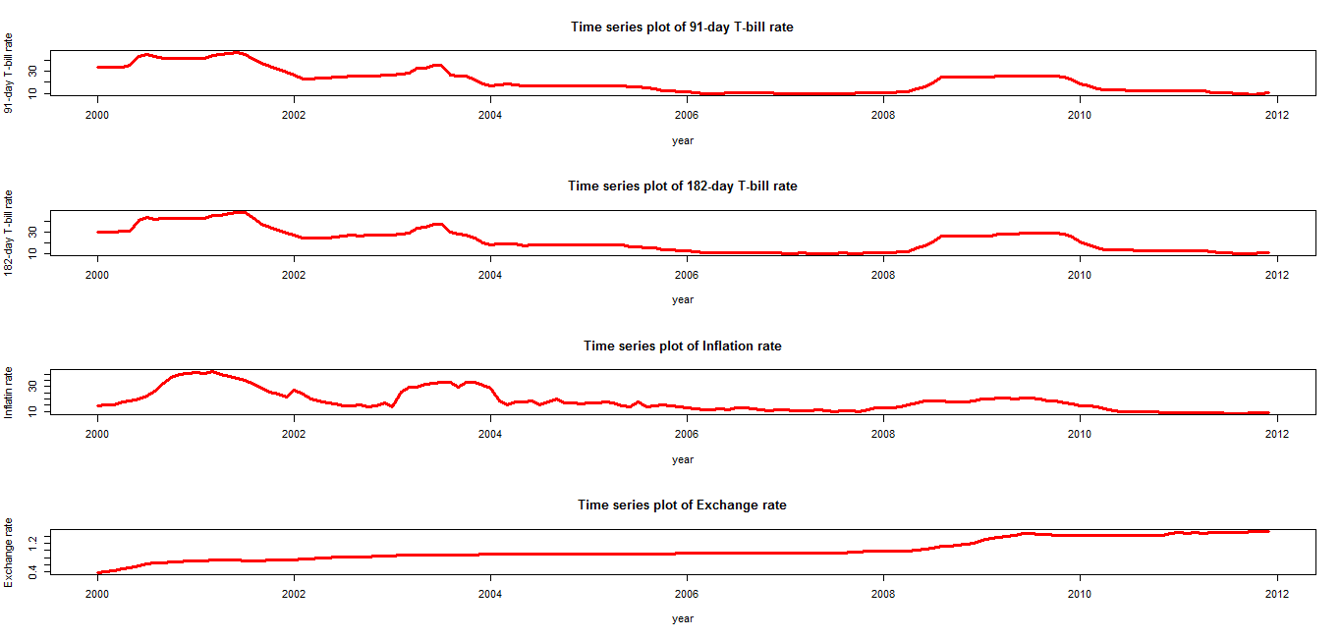
Figure 3.1: Time series plots of 91-day, 182-day T-bill interest rates, inflation rate and Exchange rate

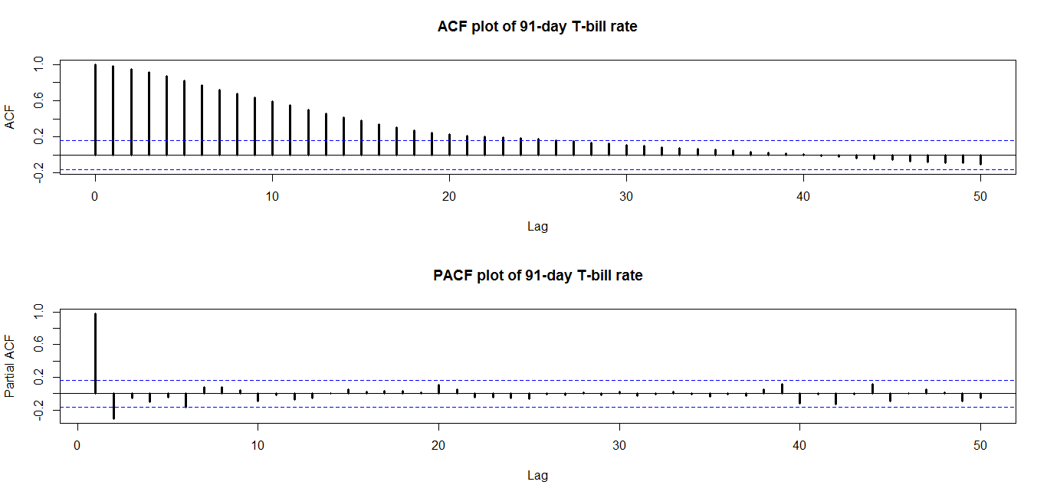
Figure 3.2: ACF and PACF plot of the 91-day T-bill interest rates
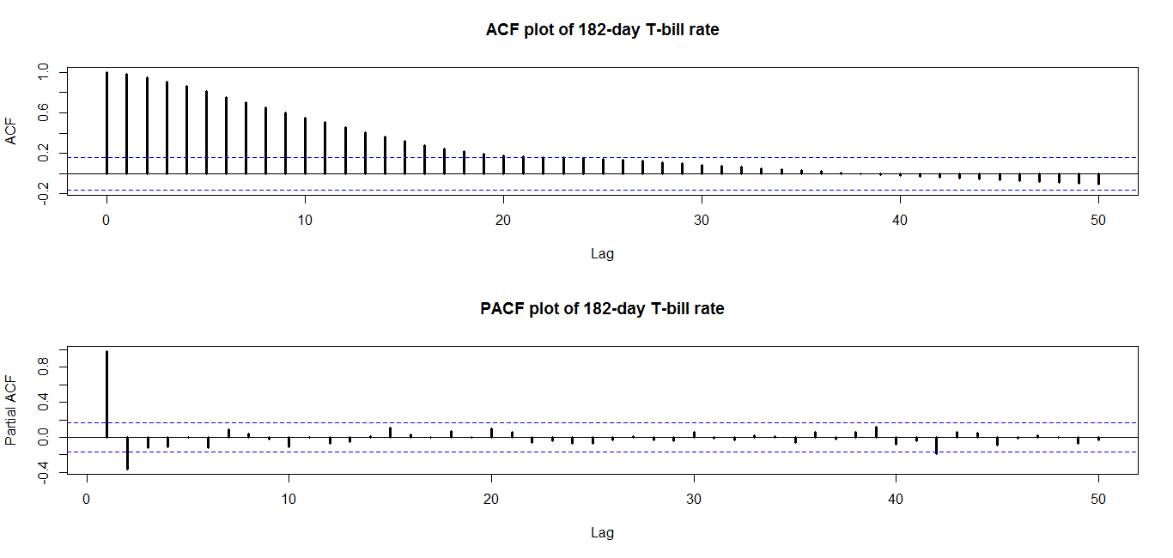
Figure 3.3: ACF and PACF plot of the 182-day T-bill interest rate
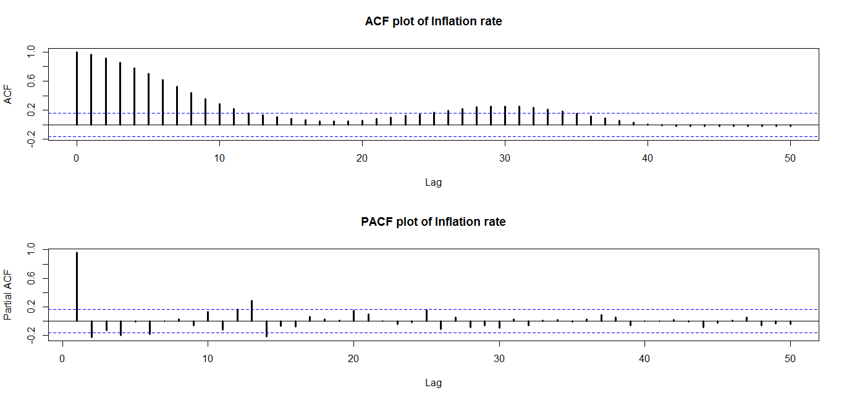
Figure 3.4: ACF and PACF plot of Year of Year Inflation rate
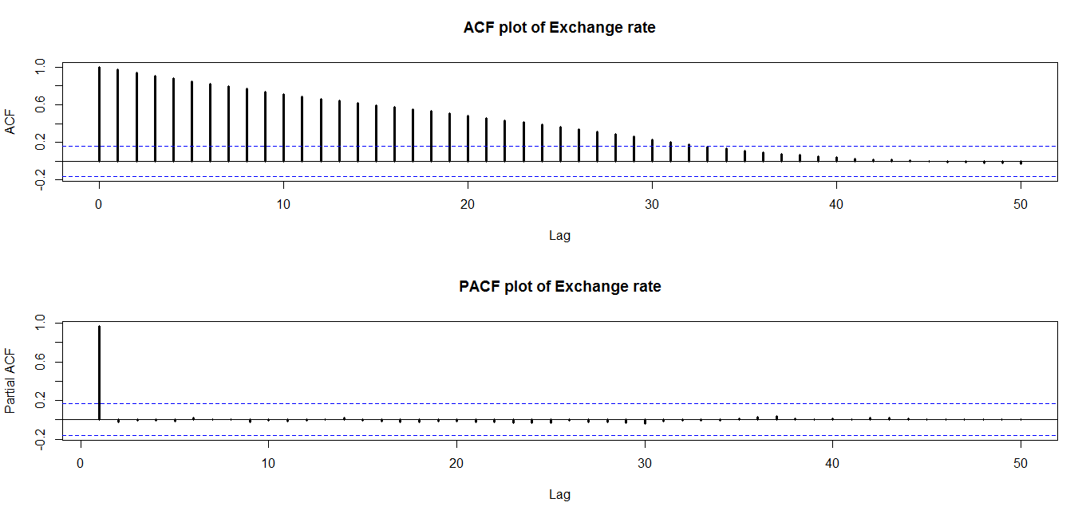
Figure 3.5: ACF and PACF plot of Exchange rate
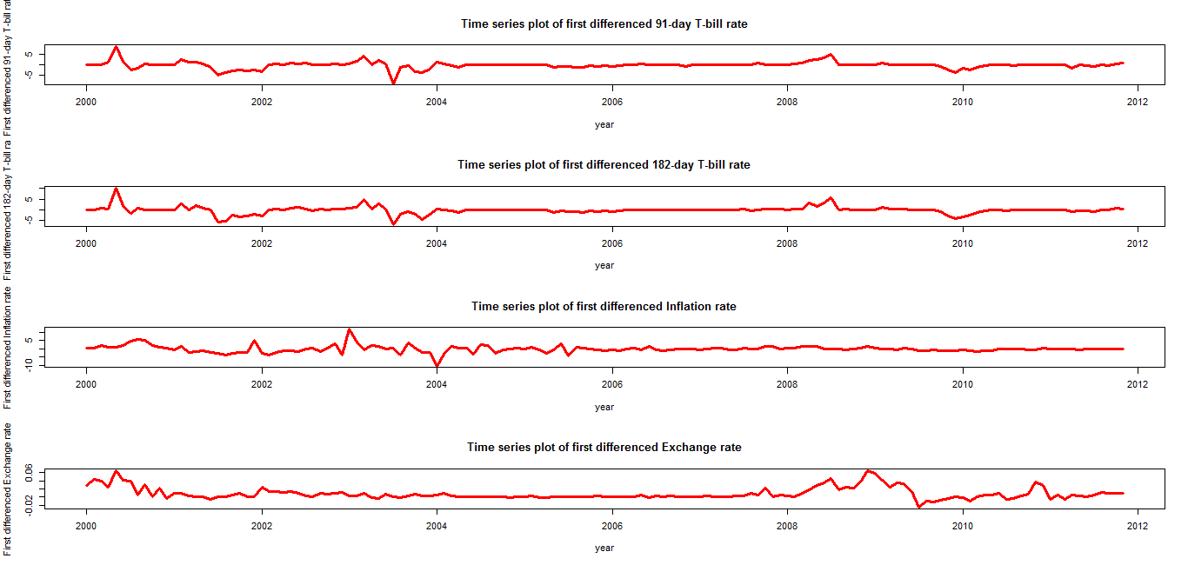
Figure 3.6: Time series plots of first difference of the rates

