Pullout Capacity of H-Shaped Multi-Plate Anchor in Sand
Rakesh Kumar Dutta, Professor, Department of Civil Engineering, NIT Hamirpur, Himachal Pradesh, India, E-mail: rkd@nith.ac.in
Vikas Rawat, PG student, Department of Civil Engineering NIT Hamirpur, Himachal Pradesh, India, E-mail: 21mce016@nith.ac.in
Abstract
The objective of this study is to present a numerical analysis using ABAQUS to estimate the pullout capacity of H shaped multiple plate horizontal anchors embedded in sand. Important parameters that were taken into consideration include embedment depth, anchor plate thickness, spacing, and anchor plate diameter provisioned in sands of varying relative density. The study characterises pullout load-displacement behaviour by expressing pullout capacity. The paper compares H shaped multi-plate anchors to studies carried out on square shaped anchors. The results reveals that the pullout capacity increases with increase in embedment depth, number of plates, plate thickness, critical spacing and the sand relative density whereas it decreases with the increase in the diameter of the tie rod. H shaped double and triple plate anchor has higher pullout capacity in comparison to the single square plate anchor.
Keywords: ABAQUS, H shaped multi plate anchor, Numerical analysis, Pullout capacity, Sand, Square plate anchor.
- INTRODUCTION
Civil engineering constructions need foundation system solutions that are economically feasible, safe and use greener building practices. The replacement of concrete with lighter-weight components appears a feasible solution. Anchors are lightweight foundation structures that are designed and built to withstand overturning moment imposed on the structure by outward soil movement. Plate anchors can withstand tensile forces, wind forces, and wave action. Depending on load orientation, the kind of structure that needs support, plate anchors might be horizontal, vertical, or inclined. An anchor may be constructed of steel, precast or cast-in-place concrete, or timber. The anchors provide passive resistance to tensile force by mobilizing the volume of soil enclosed by the plate [1]. A horizontal plate anchor is installed by excavating to the necessary depth, setting the anchor, and then backfilling the hole with soil[2]. Anchors are used in several civil engineering projects, such as bridges, underground structures, transmission towers, and offshore structures. Investigation of behavior of anchors can be of three types: experimental, numerical, and analytical. Several researchers have conducted laboratory models, field experiments and numerical analysis to comprehend the failure process, impact of embedding, impact of anchor size and shape, and impact of friction angle. The failure process was assumed in the bulk of these investigations, and the pullout capacity was derived by fulfilling the equilibrium of the soil mass contained by failure surface. This study's purpose is to provide a numerical analysis using the ABAQUS to find out the pullout capacity of H shaped multi plate horizontal anchors embedded in sand.
- BACKGROUND
There are two approaches for investigating the behaviour of anchors in sand: through experimentation or through numerical-theoretical analyses. Furthermore, investigations [1] on helical anchors and helical screw piles provide a load-carrying mechanism comparison with multi-plate anchors. A more selected assessment of research with the greatest relevance to this study is offered rather than an attempt to provide a thorough bibliography of all studies. Although no substitute for full-scale field testing exists, laboratory studies offer benefits of permitting close control of at least some of the factors experienced in practise. Hence, trends and behaviour patterns seen in the laboratory can be utilised to establish a comprehension of performance on a larger scale. Furthermore, to create semi-empirical hypotheses, laboratory testing observations might be combined with mathematical research. Then, a wider variety of issues can be addressed using these theories [2]. The two main procedures used in experimental studies of plate anchor behaviour are centrifuge systems or conventional methods. However, there are advantages and disadvantages to both approaches, and it is important to keep them in mind when analysing the results of experimental studies of anchor behaviour. Researchers [3] provided an approximate theory for predicting the pullout capacity of a strip footing. The analysis was expanded to include circular and rectangular footings by incorporating shape parameters. The resistance of the soil to an elevating foundation was a combination of the soil's weight and the shear resistance mobilised inside a defined border or failure region [1]. The conventional experimental tests were conducted in laboratory chambers. Researchers[4-5] investigate the pullout capacity of horizontal plate anchors in sand through a series of single gravity model laboratory tests. The studies indicate that the pullout capacity of horizontal plate anchors increases with an increase in anchor size, embedment depth, and sand bed density[1]. Researcher [6] observed oscillatory load behaviour at considerable displacements caused by sand collapse into the void created beneath the anchor with each upward displacement. Centrifuge experiment on horizontal plate anchors revealed that anchor geometry has a significant effect on dimensionless breakout factors and failure displacements. The plate anchors were arranged in a group to test the effect of plate spacing. Investigator [7] suggested a potential approach for predicting how interaction would affect the pullout capacity of both model and full-scale anchors in a row arrangement. For all the pullout studies, a displacement restrained loading mechanism was used to record post-peak behaviour in detail. Numerous researchers [8] evaluated the impact of varying sand bed relative density. The authors arranged strata of dense and loose sand in various configurations to determine the effect on anchors' pullout capacity. Researcher [9] suggested considering frictional resistance for limited-width anchors. Previous research [7] was conducted in smaller tanks and was limited to a small range of plate diameters. A combination of sand weight and shear resistance that was mobilised inside a predefined boundary or failure surface offered soil resistance to anchor plate. The pullout forces of anchors in frictional soils are calculated using a numerical approach that considers a broad range of anchor sizes, soil characteristics, embedment ratios, and analysis techniques. The numerical analyses, which take into consideration the roughness of the plate anchor, offer space for comprehension with a larger number of situations and enhanced combinations. Prior numerical investigations [10] of anchors in sand have mainly used straight forward analytical techniques like limit analysis, cavity expansion, and limiting equilibrium. Utilizing limit analysis techniques, the capacity of horizontal and vertical anchors in sand has been estimated [11]. Researcher [12] presented a novel rigorous limiting stress field solution. The above literature reveals that many numerical studies on square, circular, and strip anchors have been conducted. The H-shaped anchor has not been the subject of any research till date. The authors intend to fill this research gap. In this study, the pullout capacity of H-shaped multi-plate anchors has been investigated numerically using the ABAQUS, and comparisons has been made with the square plate anchors.
- PROBLEM DEFINITION AND PARAMETERS VARIED
Anchor plate used in the present study were SPA, DPA, TPA as shown in Fig.1. In the research, several horizontal plate anchors models of differing thickness (t) and different diameters of tie rods (d) are embedded in a sand bed of varying relative densities, such as loose, medium, and dense sand, at variable embedment depths (h). The horizontal plate anchors used are single-plate anchors, double-plate anchors, and triple-plate anchors. Numerous anchor plates are placed in various positions by varying the spacing between them. Numerical analyses are carried out to determine the pullout capacity of the H shaped multi-plate anchor and to compare them to the H shaped single-plate anchor and to prior studies on the square plate anchors. The dimensions of the sand model are 13m long, 13m wide, and 60 m deep. The anchor plate size used was 2m long, 2m wide as shown in Fig 2(a) and Fig. 2(b), and have a variable thickness (0.1m, 0.25m, and 0,50m). The unit weight, friction angle, modulus of elasticity, dilation angles and poisons ratio of the sand used in modelling are given in Table 1 whereas the properties for the anchor plates are given in Table 2.
- BOUNDARY CONDITION AND MESH CONVERGENCE STUDY
ABAQUS was used to develop a three-dimensional finite element model of H shaped plate anchor embedded in sand. Sand and the anchor plate were in rigid contact. The friction coefficient between the plate anchor and the soil is assumed to be 0.2 as per [4]. To simulate real world soil conditions, the model shown in Fig. 3 was exposed to geostatic static tension, which restrains it in all directions. In comparison to other soil hardening models, the simulation was carried out using the Mohr Coulomb model, which, by predicting a constant average stiffness, gives a "first order" approximation of the behaviour of the sands and reduces simulation time to obtain a preliminary estimate of deformations[4]. A multi-plate anchor's pullout capacity is determined in two steps. In the first step, the model's initial ground stress balance was established, and the initial consolidation state of the sand was simulated. The plate anchor was then a given uniform upward displacement in the second phase, which causes it to be pulled up uniformly. The meshing was carried out in such a way that while moving toward the anchor, the meshing gets finer as shown in Fig. 4(a) and for anchor plate meshing adopted was shown in Fig. 4(b). The mesh convergence investigation reveals that 27400 was the optimal number of elements for this study. Beyond this, there was not a noticeable change in the pullout capacity of the anchor.
- RESULTS AND DISCUSSIONS
5.1 Pullout Capacity of Single Plate Anchor
The pullout capacity versus displacement curves for the square and the H shaped single plate anchors corresponding to a tie rod length of 15m, 30m, and 45m are shown in Fig. 5(a) and Fig. 5(b) respectively. It is pertinent to mention that the anchor plate thickness (10 mm) and the tie rod diameter (25 mm) was kept constant. Study of Fig. 5(a) and Fig. 5(b) reveals that the pullout load increased from 129.64MPa to 150.90MPa and then to 141.07MPa for the square shape single plate anchor whereas it increased from 94.53 MPa to 100.02 MPa and then to 117.62 MPa for the H-shaped single-plate anchor corresponding to a tie rod length change from 15 m to 30 m and then to 45 m respectively. This increase in the pullout load with the increase in the length of the tie rod is attributed to the increase in the weight of the sand on the anchor plate resulting higher pullout load. In addition, Fig. 6(a) and Fig. 6(b) depict the effect of the diameter of the tie rod on the pullout load for the square and H-shaped single plate anchors, respectively. The pullout load decreased from 129.64 MPa to 84.05 MPa to 56.83 MPa for the square-shaped single-plate anchor, while it decreased from 94.53 MPa to 56.77 MPa to 41.67 MPa for the H-shaped single-plate anchor. This corresponds to a variation in the diameter of the tie rod from 25 mm to 32 mm and then to 40 mm as evident from Fig. 6(a) and Fig. (b). This decrease in pullout load can be attributed to the reduction in sand weight on the anchor plate, which led to a reduction in pullout load. This decrease in pullout load resulted from increasing the diameter of the tie rod. Additionally, Fig. 7(a) and Fig. 7(b) show, for the square and H-shaped single plate anchors, respectively, how the anchor plate thickness affects the pullout load. In the case of the square-shaped single-plate anchor, the pullout load went from 91.77 MPa to 129.64 MPa and then to 142.02 MPa, but in the case of the H-shaped single-plate anchor, the pullout load increased from 71.43 MPa to 94.53 MPa and then to 119.29 MPa. This results in the anchor plate's thickness changing from 10 mm to 25 mm, then to 50 mm, as evident from Fig. 7(a) and Fig. 7(b), respectively. This increase in pullout load can be ascribed to the weight of the anchor plate going up due to increase in the anchor plate thickness, which in turn increasing the pullout load. To determine how the relative density of the sand influences the pullout load, a block of sand with three distinct densities was employed. As shown in Fig. 8, as the relative density of the sand block increases, the pullout load of square and H-shaped single plate anchors increases. These loads correspond to 129.64 MPa, 169.70 MPa, and 343.19 MPa for square anchors and 71.4336 MPa, 118.56 MPa, and 217 MPa for H-shaped anchors, which correspond to 30%, 50%, and 85% relative densities, respectively. The increase in pullout load as the relative density of the sand increases can be attributed to the increased compactness of the sand, which results in a strong bond and increased strength between the tie rod material and surrounding sand. The summary of the results obtained for the single plate anchors are shown in Table 3.
5.2 Pullout Capacity of Multi Plate Anchor
In this study, square- and H-shaped multiplate anchors were numerically analysed to determine their pullout capacities. Numerous parameters, including the length of the tie rod, the diameter of the tie rod, the thickness of the anchor plate, the relative density of the sand, and the distance between the plates, were adjusted to determine these capacities. Fig. 9 demonstrates that the pullout capacity of square- and H-shaped anchor plates increases with the number of plates to which they are attached. To determine the influence of the length of the tie rod on the pullout capacity, 15-meter, 30-meter, and 45-meter-long tie rods were considered. The resistance to drawing out of a square or H-shaped multiplate anchor increases in proportion to the length of the tie rod. Because an increase in rod length or embedment depth results in an increase in the soil weight sustained by the plates, the pullout capacity increases accordingly. To determine how the diameter of the tie rod affects its pullout capacity, tie rods of three distinct diameters (0.25m, 0.32m, and 0.40m) were examined. The pullout capacity of square and H-shaped multiplate anchors decreases dramatically as the diameter increases. Because the larger diameter of the tie rod covered a larger surface area, the soil pressure on the anchor plates decreased as the diameter of the rod increased. This was caused by the larger diameter of the tie rod, which decreased its pullout capacity. Various thicknesses of anchor plates (0.10 m, 0.25 m, and 0.50 m) were considered to investigate the relationship between anchor plate thickness and pullout capacity. The results lead to the conclusion that the pullout capacity of square- and H-shaped multiplate anchors increases as the plate anchor's thickness increases. To examine the effect of sand relative density on pullout capacity, a block of sand with varying relative densities (30%, 50%, and 85%) was considered. When the relative density of the sand block increases, the pullout capacity of both a square-shaped and an H-shaped multiplate anchor increases as well. To examine how the distance between anchor plates effects pullout capacity, various anchor plates with differing distances between them (1d, 2d, 3d, and 4d) were examined and the results were presented in Fig. 10. Study of this figure reveals that the pullout capacity of square and H-shaped multiplate anchors increases with increasing spacing between multiplate anchors up to a critical spacing, after which it decreases further. This phenomenon occurs as the distance between multiplate anchors grows. The results of this investigation are presented in Table 4.
  - Comparison
Fig. 11 depicts the comparative study of square- and H-shaped single- and multi-plate horizontal anchors. According to the study's findings, the pullout capacity of square-shaped single-plate and multi-plate anchors is greater than that of horizontal H-shaped anchor plates, which have lesser values. Nonetheless, the pullout capacities of square and H-shaped single and multi-plate anchors behave identically when the relative density (illustrated in Fig. 11(a)), thickness of anchor plate (illustrated in Fig. 11(b)), diameter of tie rod (illustrated in Fig. 11(c)), and embedment depth (illustrated in Fig. 11(d)) are varied. In areas with loose sand, the H-shaped single-point anchor's (SPA) pullout capacity can be reduced by up to 44.90% compared to the square single-plate anchor. As soil density increases, however, this percentage decreases to 36.77 %. H-shaped SPAs have a pullout capacity that is between 16 % and 22.16 % lower compared to square SPAs of varying thicknesses. However, this can range from 30.35 % to 27.08 % depending on the diameter. Since the pullout capacity of square and plus-shaped SPAs increases with increasing embedment depth. Nonetheless, depending on the embedding depth, the percentage of reduction in these values ranges from 27.08 to 16.62 %. The percentage of decrease in pullout capacity of H-shaped anchors because of increasing plate spacing in multi-plate anchors varies somewhat. This is since pullout capacity initially increases with increasing spacing and then decreases as spacing increases. The 3 m maximum separation between multi-plate square anchors increases the pullout capacity of the anchors. This value, however, increases up to 3 m, after which it begins to decrease when H-shaped multi-plate anchors are considered. In terms of TPA, the percentage of diminished pullout capacity decreases from 40.58 % to 26.1 %. Fig. 12 compares the SPA, DPA, and TPA for square and H-shaped plate anchors, individually which reveals that the TPA has the highest pullout capacity in comparison to the DPA and SPA in case of square and H shaped plate anchors. Further study of Fig. 12 reveals that the H shaped double (plan area = 6.125 m²) and triple (plan area = 9.1875 m²) plate anchor has higher pullout capacity in comparison to the single square plate anchor (plan area = 4 m²). In terms of pullout capacity, an H-shaped double or triple plate anchor can be a viable alternative to a single square plate anchor, albeit at a substantially higher cost.
  - Failure Pattern
At an embedment depth of 15 metres, the failure patterns depicted in Fig. 13 are typical for single-plate and multi-plate configurations of square and H-shaped plate anchors. Fig. 13(a), Fig. 13(b), Fig. 13(c), and Fig. 13(d) depict the failure patterns, respectively. Fig. 13 depicts the total contour of the stress, which is significant because it can be used to ascertain the actual stress induced by the application of pullout load. To determine whether the stress in the sand above the anchor plate lies within the permissible limits when a pullout load is applied, it is necessary to have the information described in this section. In both Fig. 13 (a) and Fig. 13 (b), the stress contours reveal that the square single plate anchor is more resistant to pullout than the H-shaped single plate anchor. In the case of triple square and H shaped anchors, the stress contours in Fig. 13 (c) and Fig. 13 (d) disclose that square multi-plate anchors exhibited greater resistance to pullout loads than H shaped multi-plate anchors. A localised failure mechanism, on the other hand, produces a failure surface that encompasses only a portion of the soil located above the horizontal anchor plate. In addition, the surface of the failure does not reach the surface of the sand layer's topmost layer. When examining Fig. 13 in detail, it was found that the stress contours for the square and H-shaped triple plate anchors remained firmly established within the selected lateral and vertical limitations. The results of additional investigation on this figure indicate that the highest stress levels were observed directly above the anchor plate. Despite this, local shear failure above the plates was found to be the most prevalent cause of failure for both square and H-shaped multiplate anchors in all the investigated cases.
- Conclusion
In this paper, a numerical study using the ABAQUS software was conducted to determine the pullout capacity of single and multiple H-shaped anchor plates embedded in sand of various relative densities by varying several parameters, including the length of the tie rod, diameter of the tie rod, thickness of the anchor plate, and spacing between the anchor plates. The results were compared to square anchor plates. The following are the main findings:
- The pullout capacity of square and H-shaped single or multi-plate anchor increases along with changes in tie rod length, diameter, thickness, and relative sand density. Multi-plate anchors have a larger pullout capacity than single plate anchors.
- As plate spacing increases, pullout capacity rises until a critical gap is reached and then falls off.
- In all circumstances, H-shaped multiplate anchors have a lower pullout capacity than square plate anchors.
- H-shaped single plate anchor has a pullout capacity that is between 16 % and 22.16 % lower compared to square plate anchor of varying thicknesses. However, this can range from 30.35 % to 27.08 % depending on the diameter.
- H shaped double and triple plate anchor has higher pullout capacity in comparison to the single square plate anchor.
References
- B. V. Tilak and N. K. Samadhiya, “Pullout capacity of multi-plate horizontal anchors in sand: an experimental study,” Acta Geotech., vol. 16, no. 9, pp. 2851–2875, Sep. 2021, doi: 10.1007/s11440-021-01173-1.
- T. Feng, J. Zong, W. Jiang, J. Zhang, and J. Song, “Ultimate Pullout Capacity of a Square Plate Anchor in Clay with an Interbedded Stiff Layer,” Adv. Civ. Eng., vol. 2020, pp. 1–10, Sep. 2020, doi: 10.1155/2020/8867678.
- R. S. Merifield and S. W. Sloan, “The ultimate pullout capacity of anchors in frictional soils,” Can. Geotech. J., vol. 43, no. 8, pp. 852–868, Aug. 2006, doi: 10.1139/t06-052.
- B. M. Das and G. R. Seeley, “Breakout Resistance of Shallow Horizontal Anchors,” J. Geotech. Eng. Div., vol. 101, no. 9, pp. 999–1003, Sep. 1975, doi: 10.1061/AJGEB6.0000202.
- Md. Rokonuzzaman and T. Sakai, “Model Tests and 3D Finite Element Simulations of Pullout Resistance of Shallow Rectangular Anchor Foundations,” Int. J. Geomech., vol. 12, no. 2, pp. 105–112, Apr. 2012, doi: 10.1061/(ASCE)GM.1943-5622.0000119.
- E. A. Dickin and M. Laman, “Pullout response of strip anchors in cohesionless soil,” Adv. Eng. Softw., vol. 38, no. 8–9, pp. 618–625, Aug. 2007, doi: 10.1016/j.advengsoft.2006.08.041.
- J. D. Geddes and E. J. Murray, “Plate Anchor Groups Pulled Vertically in Sand,” J. Geotech. Eng., vol. 122, no. 7, pp. 509–516, Jul. 1996, doi: 10.1061/(ASCE)0733-9410(1996)122:7(509).
- S. Mukherjee, A. K. Choudhary, and G. L. Sivakumar Babu, “Three-dimensional analysis of inclined anchors in reinforced sand,” Geosynth. Int., pp. 1–15, Nov. 2022, doi: 10.1680/jgein.22.00318.
- Bhattacharya, P., Roy, A. (2016), “Variation of Horizontal Pullout Capacity with Width of Vertical Anchor Plate.” International Journal of Geomechanics. Vol. 16, Issue 5 (October 2016). https://doi.org/10.1061/(ASCE)GM.1943-5622.0000639
- Mokhbi, H., Mellas, M., Mabrouki, A., Pereira, J.M. (2018), “Three-dimensional numerical and analytical study of horizontal group of square anchor plates in sand.” Acta Geotech. 13, 159–174 (2018). https://doi.org/10.1007/s11440-017-0557-x
- Kumar, J., Sahoo, J.P. (2012). "Upper bound solution for pullout capacity of vertical anchors in sand using finite elements and limit analysis." International Journal of Geomechanics. 12(3), https://doi.org/10.1061/(ASCE)GM.1943-5622.0000160
- Jadid, R., Shahriar, A.R., Rahman, M.R., Imtiaz, T. (2019), “Evaluation of theoretical Models to predict the pullout capacity of a vertical anchor embedded in cohesionless soil.” Geotech Geol Eng 37, 3567–3586 (2019). https://doi.org/10.1007/s10706-019-00870-9

Table 1 Properties of sand
Type of Soil | Relative density (%) | Friction angle | Dilation angle | Density  (kN/m³) | Poisson’s ratio | Young’s modulus (MPa) | Type of Soil
Loose | 30 | 35 | 5 | 16.5 | 0.31 | 38.4 | Loose
Medium | 50 | 38 | 8 | 18 | 0.30 | 54.8 | Medium
Dense | 85 | 46 | 16 | 22 | 0.20 | 120.0 | Dense

Table 2 Properties of anchor
Type of Anchor | Embedment depth (m) | Spacing | Thickness of plate (mm) | Diameter of tie rod (mm)
Single plate | 15,30,45 | - | 10, 25, 50 | 25, 32, 40
Double plate | 15,30,45 | 1d,2d,3d | 10, 25, 50 | 25, 32, 40
Triple plate | 15,30,45 | 1d,2d,3d,4d | 10, 25, 50 | 25, 32, 40

Table 3 Pullout capacity of single plate anchor with varying parameters
Parameter |  | Pullout capacity (MPa)
 |  | Square | H-shaped
Embedment depth | 15m | 129.64 | 94.53
 | 30m | 150.90 | 100.02
 | 45m | 141.07 | 117.62
Thickness | 10mm | 91.77 | 71.43
 | 25mm | 129.64 | 94.53
 | 50mm | 142.02 | 119.29
Diameter | 25mm | 129.64 | 94.53
 | 32mm | 84.05 | 56.77
 | 40mm | 56.83 | 41.67
Relative density | 30% | 129.64 | 71.43
 | 50% | 169.70 | 118.56
 | 85% | 343.19 | 217.00

Table 4 Pullout capacity of square and H shaped multiplate anchors
Spacing | Pullout capacity (MPa)
 | Square | H-shaped
1d | 307.28 | 182.56
2d | 340.54 | 238.56
3d | 360.57 | 265.02
4d | 343.45 | 253.55

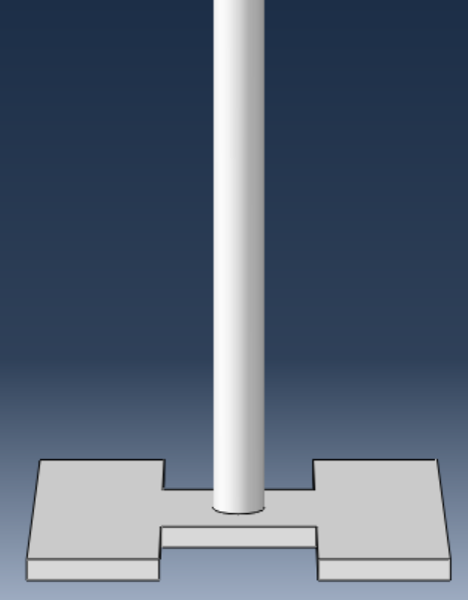  (a) | 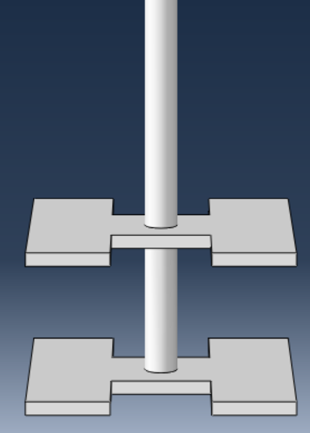  (b) | 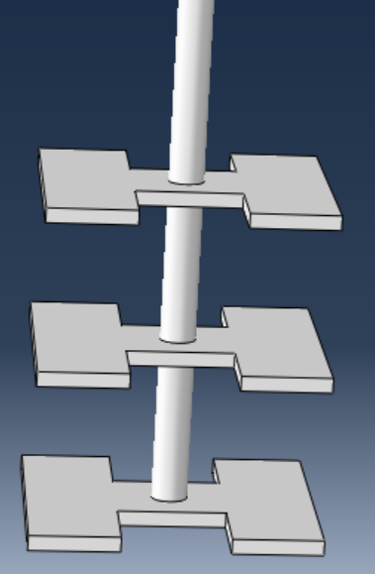  (c)
Fig. 1 H-shaped (a) single plate anchor (b) double plate anchor (c) triple plate anchor

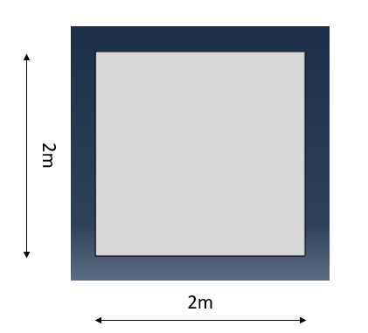  (a) | 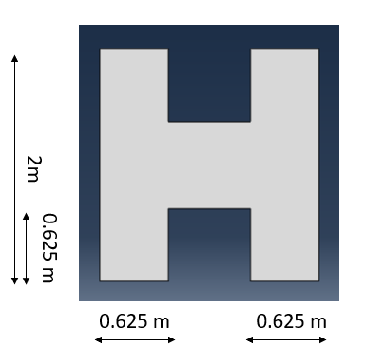  (b)
Fig. 2 Dimension of anchor plate (a) square shape (b) H shape

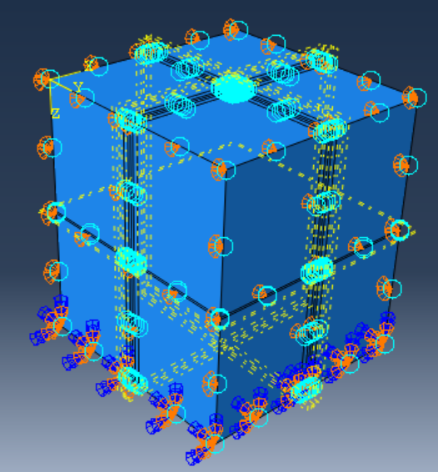
Fig. 3 Visualization of loading

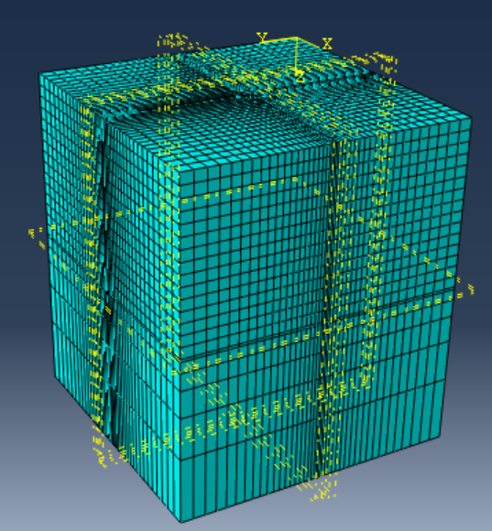  (a) | 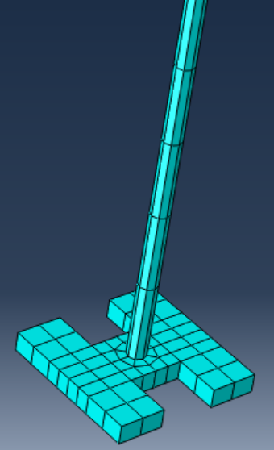  (b)
Fig. 4 Meshing of (a) sand block (b) H-shaped anchor plate

(a) | (b)
Fig. 5 Pullout capacity versus displacement curve (a) Square plate anchor (b) H-shaped plate anchor

(a) | (b)
Fig. 6 Pullout capacity versus displacement curve (a) Square plate anchor (b) H-shaped plate anchor

(a) | (b)
Fig. 7 Pullout capacity versus displacement curve (a) Square plate anchor (b) H-shaped plate anchor

(a) | (b)
Fig. 8 Pullout capacity versus displacement curve (a) Square plate anchor (b) H-shaped plate anchor

(a) | (b)
Fig. 9 Pullout capacity versus displacement curve (a) Square plate anchor (b) H-shaped plate anchor

(a) | (b)
Fig. 10 Pullout capacity versus displacement curve (a) Square plate anchor (b) H-shaped plate anchor

(a) | (b)
(c) | (d)
Fig. 11 Curves for the variation of pullout capacity square and H shaped plate anchors with (a) relative density (b) thickness of anchor plate (c) diameter of tie rod (d) embedment depth

(a) | (b)
Fig.12 Pullout capacity versus displacement curve for SPA, DPA and TPA (a) Square anchor plate (b) H-shaped anchor plate

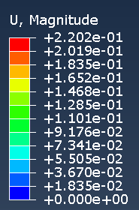 | 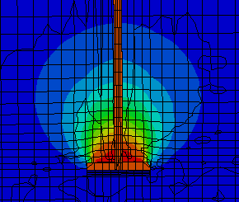  (a) | 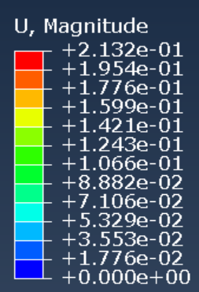 | 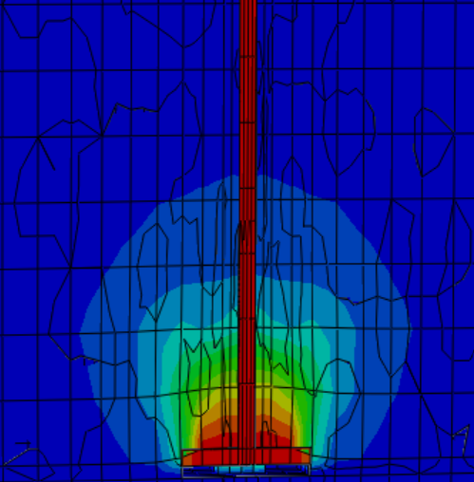  (b)
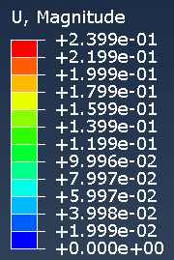 | 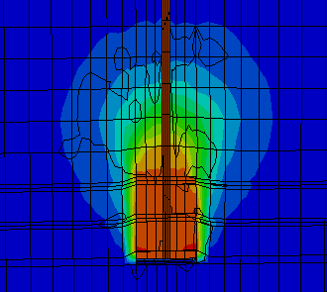  (c) | 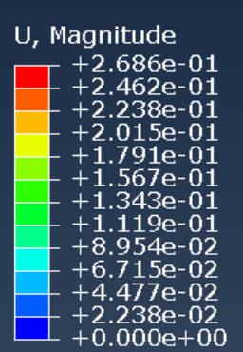 | 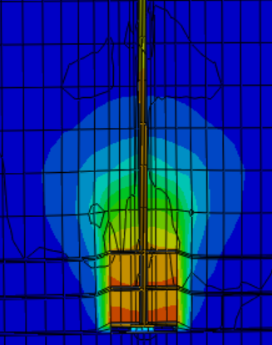  (d)
Fig. 13 Failure pattern (a) Square single plate anchor (b) H-shaped single plate anchor (c) Triple square plate anchor (d) H-shaped triple plate anchor

