IDENTIFICATION OF A SCHIST-MICASCHIST TRANSITION UNDER A LATERALITIC COVER OF THE BAFIA GROUP, CENTRE CAMEROON, USING DC ELECTRICAL RESISTIVITY SOUNDINGS.

BISSO D. ^{1,*}, GOUSSI NGALAMO J. F¹., NGUIYA S.² and TOKAM K. A. P.³
1. Dept. of Geology, University of Yaoundé 1
2. Faculty of Industrial Engineering, University of Douala
3. Dept. of Physics, University of Yaounde 1. Now at School of Geosciences, University of the Witwatersrand
* Corresponding author: dbisso2002@yahoo.fr

ABSTRACT
The shallow subsurface structure along a profile on the Bafia Group in Cameroon has been investigated using data from both DC electric method and pedologic logs. The combination of these approaches aims to resolve the non-uniqueness of solution inherent to inverse problems in geosciences. Results show that the bedrock is located at depth between 11 and 25 m along the line and is overlain from the surface by a thin organo-mineral lateritic cover, an aggregated sandy clay layer, and an altered schistose layer. However, the bedrock displays a change in electrical properties moving from the south (1400 Ωm) to the north (2500 Ωm) of the profile. This observation is correlated with the presence of mica minerals found in logs of pit 1, located in the south of the profile, and its absence in pit 2 in the north. The change in composition resulting to the variation in electrical propertities of the bedrock could be associated to the shallow effect of the Sanaga Faults, known as a major tectonic structure crossing the region. The sandy-clay layers with thicknesses range 1-5 m is believed to represent a potential thin aquifer, due to the resistivities range 15-100 Ωm, common to some aquifers.

KEYWORDS: Bafia group, DC electrical soundings, lateritic cover, schist, micaschist, Aquifer, logs.

1. Introduction
The wet intertropical region is characterized by an important thick lateritic cover which overlies unaltered geological structures. This lateritic cover has been setting since millions or years due to the evolution of the climate and the vegetation. This pedologic feature occupies the major part of the soil of the South Cameroon Plateau which extends south to the Adamawa Plateau and east to the Cameroon Volcanic Line, and is known as the largest topographical feature of Cameroon.
The pedology of the South Cameroon Plateau has been investigated in the past with the main focus on the organization and the evolution of alteration profiles [1, 2, 3, 4, 5]. However, the presence of indurate layers as well as the spatial heterogeneity and the great thickness of the soils did not facilitate the realization of pits useful for their entire characterizations. Therefore, the alternative solution to the digging of pits is the geophysical approach which can provide information on the structure of the subsurface through the study of the variation of a single physical parameter. The Direct Current (DC) electrical method, which is worldwide used to investigate soils [6, 7, 8, 9], has been applied to various areas of the South Cameroon Plateau to obtain significant information on the thickness, depth, nature and lateral variation of the different layers and interfaces of the subsurface [1, 10, 11].
The area under investigation in this study is located in Balamba-Bombato, lying between latitude 4°20’ and 4°30’ North and longitude 11°10’ and 11°20’ East, in the administrative region of Centre in Cameroon. It has been recently surveyed using magnetotellurics [12] and teledetection [13] methods. Results from these geophysical studies provided useful information on the location, the structure and the tectonic setting of the Sanaga Faults, known as the main tectonic feature crossing the area. However, due to the lateritic cover, surface evidence of the presence of these faults is missing [13]. Additional to these surveys, some other geosciences related studies are reported in the area [14, 15, 16, 17]. These works revealed an incomplete lithological map of the region due to the thick soil, dense vegetal cover and uneven spatial distribution of outcrops, which resulted to imprecise delineation of areas of contact between the various lithological formations settled after different tectonic events. The aim of this study is therefore to investigate the structure and the composition of the soil under the lateritic cover in order to infer the tectonic history and the average depth of the substratum of the region, using both DC electric soundings and pedologic logs. By combining the two datasets, we expect to uniquely characterize the vertical and lateral distribution of rock materials over the study area, and characterize the aquifer to understand the difficulties of the local population in accessing ground water throughout the year.

2. Geological Settings and previous works
The study area belongs to the Bafia group, which is located in the southern part of the Panafrican Belt in Cameroon, also referred as the South Cameroon Plateau [Fig. 1]. The South Cameroon Plateau is thought to have been formed during the Eocene [17]. The lateritic cover found within the region, as seen in the Mbere Trough in Cameroon and widely in Africa, is also dated from Eocene [18]. It has a complex geomorphology that had impacted on the composition of the rocks found in the region. In fact, the succession of mountains and plains are respectively reflecting the alternation of quartzite and gneisses [19].
The Panafrican mobile Belt also called Oubanguides [20], or North Equatorial Panafrican Belt [21, 22] is a megastructure limited in the South by the Congo Craton. The dominant climate in the area is a transitional tropical type with four seasons. The average rainfall is 2518 mm/year with average annual temperature 31.03°C.
The Bafia unit extends between the Sanaga lineaments in the south, the lineaments of Adamawa in the north and those of Kribi in the southwest [Fig. 2, 16]. It represents a large bedrock shell, carted tangentially eastward on the the micaschist series of Sa'a, and lying themselves on the shistosic series of Mbalmayo following a layer tectonics [23, 24, 25].
Recent studies in the area revealed the presence of juvenile alkaline basalts and granitoides. The basalts have been interpreted as evidence of a paleoproterozoic [26] and a neoproterozoic [27] crustal extension, while granitoides were found as characteristics of an active margin [27]. Earlier, [28] showed that the tectonic history of the region is associated to two phases of deformation, a ductile phase characterized by syn-metamorphic folding and an abrupt phase dominated by vertical movements. These observations were improved later by [16] and [29] who identified two ductile phases D1 and D2 and one abrupt phase D3. The D1 is thought to be responsible of the foliation along the area while D2 is at the origin of the formation of map-scale folds, shear planes and the L2 stretching lineation, which indicates SSW-ward thrusting onto the Congo Craton. The third deformation phase was brittle.
The remote sensing data was used to suggest the western extension of the Bozoum-N’dele faults (Central African Republic) across Cameroon towards Atlantic Ocean [13]; these faults are presumed to cross the study area. This fractures which partially follows the River Sanaga bed has been interpreted later by [12] and [30] using magnetotellurics data as the Sanaga faults. These authors revealed a large area of electric anomaly near Ebebda (close to this present study area) which was presumed to be originated by the fault system.
The presence of this electric anomaly coupled to the necessity of quantitatively characterized the shallow subsurface motivated the choice of this area for further investigations.

3. Data and Methodology
Two sets of data have been used in this study. The first set consists of DC electrical soundings performed with a Schlumberger geometry AMNB on 11 sounding sites (Figs 2 & 3) from which the measured parameter, the apparent resistivity has been deduced. The other set consists of pedological profiles performed on two pits located at two sites along the DC profile. These data were collected in 2010 during a field experiment conducted by the geophysical unit of the Department of Geology.
The interpretation of DC data is based on the inversion of the electric apparent resistivity measured on the field. For a homogeneous isotropic earth, the Schlumberger apparent resistivity $ρ$_{app,} is obtained using the following relation
$$ρ_{app}=π\frac{(d^{2}-a^{2})}{2a}\frac{∆V}{I}$$
Where d is the distance from the centre of the array to the current electrodes A and B, a is the distance from the centre of the array to the potential electrodes M and N, $∆V$ is the potential difference between electrodes M and N and I is the electric current measured between electrodes A and B. In reality, the subsurface is much more complicated and the apparent resistivity is usually computed assuming that the subsurface is composed of sets of horizontal layers with various resistivity and thickness. Therefore, the approach is to invert the data which are represented as $ρ$_{app}$=f(\frac{AB}{2})$ to find the probable distribution of subsurface layers, AB being the current electrode spacing. The technique used for this study is the inversion of data using least square method as developed by [31]. Therefore, the logs from pedological pits become a complementary source of information to choose among various possible solutions.

4. Results and discussions
4.1. Results
4.1.1. Pedological observations from pits
Two pits F1 and F2 of depths 1.5 m and 1.7 m respectively, have been dug from which two pedological profiles have been derived (Fig. 4). From the size of grains analysis, results of the experiment show a predominance of clays, sands and silts in both pits (tables 1 and 2). Three layers have been identified in Pit 1 (Fig. 4; Table 1). The first and third layers are found riche in clay which composed over 60% of the composition of the samples.
Pit 2, in contrast to the first pit has a greater depth and displays five layers (Fig. 4; Table 2). We can observe similar composition and thickness of the top layer of this pit as in pit1, but from the second to the fourth layer (at approximately similar thickness as layer 2 in pit 1), the nature of these clay layers differs. Furthermore, the decomposed rocks found at the bottom of both pits are enriched in mica specks in pit 2.
Due to the shallow presence of the aquifer, it was not possible to go deeper. However, observations from the pits did not provide information on the composition of the bedrock in the area, but other studies [16] suggested it is mainly composed of schist. In the pits F2, we found some mica traces which suggest that mica may be among minerals that composed the substratum in this area that is a micaschist substratum. The absence of mica in pits F1 therefore suggests a difference in composition of the substratum beneath the pits. Due to the difficulty of making more pits between F1 and F2, we expected DC electrical soundings to contribute in clarifying the lateral extension of the presence of this mica.

    - DC electrical soundings
12 sounding have been performed on 11 sites. At one site, two sounding SE6 and SE12 were done, one on the main orientation of the electric line, the other at the perpendicular direction. At each sounding operation, 12 measurements of resistivities were done while varying AB/2 from 1 m to 50 m for soundings SE1 to SE11, and 1 to 400 m for SE12. To interpret the observations, field data are first presented as apparent resistivity profiling, followed by the plot of apparent resistivity pseudosection. The data are later inverted to assess quantitatively the geological and pedological structures beneath the area under study.
a) Profiling and pseudosections
In the profiling, the apparent resistivity is plotted against distance for each electrode spacing AB/2 along a profile (Fig. 5). For sake of clarity, the plots have been divided into three electrode spacing groups (1-4 m, 5-20 m, 25 – 50 m). For shallower structures that are structures sounded with AB/2 between 1 and 4 m, there are peaks of over 500 Ωm of resistivity between stations SE4 and SE7 and between SE9 and SE11. These peaks are attenuated at mid-depth (that is AB/2 between 5 and 20 m) where resistivity drops below 350 Ωm. At deepest depths, the peak is again perceived between SE7 and SE9 where it reaches 600 Ωm. The anomaly observed between SE4 and SE7 seems to have shifted at depth between SE7 and SE9, and could indicate a shallow effect of a fault.
The pseudosections are curves of isoresistivity plotted along a profile showing both lateral and vertical variations of resistivities. In this work, the kriging algorithm is used to plot the observations (Fig. 6). The contour lines tend to be rather parallel and vertical between SE4 and SE9 where a lateral change in resistivity is observed with an important gradient. The variation is smooth elsewhere, suggesting that this area is probable zone of transition between two structures.
b) 1D inverted models
Results from the 1D inversion show that four layer models fits the solutions for all the soundings (Fig. 7). The experimental sounding curves for all sounding points have approximately a parabolic shape which indicates that structures beneath these points are alternately conductive and resistive. The resistivities of each layer range between 20 Ωm for conductive layers and over 1000 to 2800 Ωm for bedrocks. The top of the bedrock is identified at all sounding and could be found between 11 and 25 m (Fig. 8).

4.2. Discussion
Using the observations from pits and the direct observations from the pits, the geoelectric sections and its lithologic interpretation have been made. The four layers that cover the survey site are from the top to the bottom:
- A soft clay cover which is resistive (200 – 850 Ωm) with variable thickness, interpreted as the organo-mineral lateritic cover which is characteristic of Sudano-Guinean zones;
- A thin conductive layer of sandy-clay (15 – 100 Ωm) which thicknesses are generally below 2 m;
- A thick schistose substratum which is partially altered, and relatively conductive;
- The schistose preserved bedrock, which can be separated into two blocks. The southern block which contains mica minerals (micaschist) with resistivity below 1400 Ωm and the northern block which is essentially schist and characterized by layer of resistivity above 2500 Ωm.
The change in resistivities between SE4 and SE6 which is associated to the change in lithology may represent the shallow response to the transition from the schist to micaschist. Due to the fact that this area belongs to the fault system known as Sanaga Faults, this transition could also be interpreted as the shallow effect of one of the branches of these faults.
The water table identified in the pits may be located on average between 1 and 5 m of depth. It is represented by the sandy-clay conductive layer which is hydrogeological known as potential aquifer. However, the water table could also extend in the altered substratum since it is partially conductive. This hypothesis is consistent with a previous study in Evindissi, a region which also has a schistose substratum [32, 33] (Manguelle-Dicoum et al., 1987; Manguelle-Dicoum, 1988).
To assess the lateral electric behaviour of the study area, the inverted models of the soundings SE6 and SE12 have been compared, knowing that these soundings are done on two perpendicular orientation of the electric line. There is an insignificant difference in layer thicknesses and investigation depth for both models (Fig. 9), however the change in resistivity is significant, particularly in the altered schistose layers. The layer is much more conductive for sounding SE6 (~ 200 Ωm) while it is resistive for SE12 (~ 980 Ωm) suggesting that the orientation N110 (which the orientation line for the sounding SE6) might be closer to the schistosity plan.
Many recent works have pointed out the existence or the extension of faults in the studied area, although the traces of these faults are not observed on the surface [12, 13]. The region around Ebebda has been surveyed using magnetotellurics (MT) data and results showed evidence of these tectonic features through several MT profiles [12, 30]. Therefore this DC electric investigation of the subsurface on a profile crossing one of the fault trace suggested by [30] provides new evidence of the existence of Sanaga Faults. This tectonic feature is marked in this study by the differential collapse on about 1 km of the bedrock along with the resistivity contrast that highlighted the change in bedrock composition. These observations are also confirmed in pits where at one side of the fault, the mica has been found while it doesn’t appear at the other side.

5. Conclusion
The altered lateritic cover of the Balamba-Bombato area has been characterized using data from the DC electrical soundings and direct observations from pits. It is constituted of three distinct layers of distinct proprieties characterized by their thicknesses and resistivities. The first layer is mainly composed of soft clay, the second is composed of sandy clay and constitutes the main aquifer, the third is a schistose altered layer which could also be part of the aquifer in the region. The study revealed a differential collapse of the bedrock along the 1km profile. This collapse associated to the evidence of two bedrock lithologies (schist and micaschist) provided clue to point out the shallow trace of the Sanaga Faults across the profile. The lateral electric behaviour of the structure for the soundings SE6 and SE12 brings to the conclusion that the schistosity plan may be closer to the orientation N110.
The identified main aquifer is enriched of clay and could explain the rarefaction of potable water in the area. In fact, the water used by the population in this area has yellow couloured appearance due to the contact to the lateritic layer and therefore is not suitable for direct consumption. In addition, this aquifer is relatively thin and rain dependent. Future work should be done in order to identify possible aquifers in the fractures of the substratum that could solve problem of durable water resource.

6. Acknowledgement
We thanks Mr. Nouanga Philippe, Director of LABOGENIE for assistance with the survey equipment, Mr Malongue Vincent for his help during the data acquisition and Pr. Alain Tabbag from the University Pierre et Marie Curie for his academic advices and the assistance with the geophysical software.

7. References

[1] H. Robain, M. Descloitres, M. Ritz and J. Q. Yene Atangana, “A multiscale electrical survey of a lateritic soil system of the rain forest of, Cameroon”, Journal of Applied Geophysics, vol. 34, 1996, pp. 237-253.
[2] B. Nyeck, P. Bilong and S. M. Eno Belinga, “Séquence d’évolution des sols sur granite dans le sud Cameroun : Cas de Zoetélé", Annales de la Faculté des Sciences, Université de Yaoundé, vol. 1, 1993, pp. 254-277.
[3] Y. Tardy, "Pétrologie des latérites et des sols tropicaux", Masson, 1993.
[4] P. Bilong, "Genèse et développement des sols ferralitiques sur syénite alcaline potassique en milieu forestier du Centre Sud Cameroun. Comparaison avec les sols ferralitiques développés sur roche basique", Thèse de Doctorat d’Etat, University of Yaoundé, 1988.
[5] R. Yongue-Fouateu, "Contribution à l’étude pétrologique de l’altération et des faciès de cuirassement ferrugineux des gneiss migmatitiques de la région de Yaoundé", Thèse de Doctorat 3e Cycle. University of Yaoundé. 1986.
[6] Beauvais, A., M. Ritz, J-C. Pasot, M. Dukhan and C. Bantsimba, 1999. Analysis of poorly stratified lateritic terrains overlying granitic bedrock in West Africa, using 2-D electrical resistivity tomography. Earth and planetary Letters,173, 413-424.
[7] Samouelian, A, I. Cousin, A. Tabbagh, A. Bruand and G. Richard, 2005. Electrical resistivity survey in soil science: a review. Soil & Tillage Research, 83, 173–193.
[8] Koussoube Y., S. Nakolendousse, P. Bazie and A. N. Savadogo, 2003. Typologie des courbes de sondages électriques verticaux pour la reconnaissance des formations superficielles et leur incidence en hydrogéologie de socle cristallin du Burkina Faso. Sud Sciences et Technologies, 10, 26-32.
[9] S. Bakkali and J. Boualaouf, "Essai d’optimisation de la capacité de retenue d’eau d’un lac par caractérisation géophysique du recouvrement argileux", African Journal of Science and Technology, vol. 6, no. 2, 2005, pp. 12-22.
[10] M. Ritz, H. Robain, E. Pervago, Y. Albouy, C. Camerlynck, D. M. Descloitres and A. Mariko, “Improvement to resistivity pseudo section modelling by removal of near-durface inhomogeneity effects: application to a soil system in south Cameroun”, Geoelectrical prospecting, vol. 47, 1999, pp. 1-10.
[11] W. M. Telford, L.P. Geldaart and R. E. Sheriff, “Applied Geophysics 2nd edition”, Cambridge University Press, 1990.
[12] D. Bisso, E. Manguele-Dicoum, T. Ndougsa Mbarga, C.T. Tabod and N.P. Njandjock, “Geophysical determination of the sanaga fault using audio-magnétotelluric soundings in Ebebda Région, Cameroun (Central Africa)”, SEGMITE International, vol. 1, no.1, 2004, pp. 31-34.
[13] J.F. Dumont, "Identification par télédétection de l’accident de la Sanaga (Cameroun) : Sa position dans le contexte des grands accidents d’Afrique Centrale et de la limite Nord du craton congolais", Géodynamique, vol. 2, no. 1, 1986, pp. 55-68.
[14] S. Owona, B. Schulz, L. Ratschbacher, J. Mvondo Ondoa, G. E. Ekodeck, M. F. Tchoua and P. Affaton, “Pan-African metamorphic evolution in the southern Yaounde Group (Oubanguide Complex, Cameroon) as revealed by EMP-monazite dating and thermobarometry of garnet metapelite”, Journal of African Earth Sciences, vol. 59, 2011, pp. 125-139.
[15] S. Owona, J. Mvondo Ondoa, Ratschbacher, L., Mbola Ndzana, S.P., Tchoua, M.F., Ekodeck, G.E., “The geometry of the Archean, Paleo- and Neoproterozoic tectonics in the Southwest Cameroon”, Comptes Rendus Geoscience, vol. 343, 2011, pp. 312–322.
[16] J. Mvondo Ondoua, "Caractérisation des évènements tectoniques dans le domaine Sud de la Chaine Panafricaine au Cameroun : styles tectoniques et géochronologiques des séries de Yaoundé et de Bafia", PhD thesis, University of Yaoundé I, 2009.
[17] P. Segalen, "Les sols et la géomorphologie du Cameroun". Cahier ORSTOM Série Pédologie, vol. IV, no. 2, 1967, pp. 137-187.
[18] M. S. Tchouatcha, P. R. Njiké, M. S. Mahmoud, A.S. Deaf and E. G. Ekodeck, “Existence of “late continental” deposits in the Mbere and Djerem sedimentary basins (North Cameroon): Palynologic and stratigraphic evidence”. Journal of Geology and Mining Research, vol. 2, no. 6, 2010, 159-169.
[19] G. Noizet, "Disposition géologique des régions de Yaoundé et Bafia", Annales de la Faculté des sciences, Université de Yaoundé, vol. 1, 1982, pp. 95-103.
[20] R. Trompette, “Geology of western Gondwana (2000-500 Ma). Pan-African Brasiliano aggregation of South America and Africa”, A. A. Balkema Edition - Rotterdam, 1994.
[21] I. Davison and R. A. Santos, “Tectonic evolution of the Sergipano Fold Belt, NE Brazil, during the Braziliano Orogeny”, Precambrian Research, vol. 45, 1989, pp. 319-342..
[22] J. P. Nzenti, P. Barbey, J. Macaudiere and D. Soba, “Origin and evolution of the late Précambrian high-grade Yaoundé gneisses (Cameroon)”, Precambrian research, vol. 38, 1988, pp. 91-109.
[23] A. Nédelec, J. Macaudiere, J. P. Nzenti and P. Barbey, "Evolution structurale et métamorphique des schistes de Mbalmayo (Cameroun). Informations sur la structure de la zone mobile Panafricaine d’Afrique centrale au contact du craton du Congo", Comptes Rendus Académie des Sciences, vol. 303, no. II, 1986, pp. 75-80.
[24] J. P. Nzenti, P. Barbey, P. Jegouzo and C. Moreau, "Un nouvel exemple de ceinture granulitique dans une chaîne protérozoïque de transition : les migmatites de Yaoundé au Cameroun", Comptes Rendu Académie des Sciences Paris, vol. 299, no. 17, 1984, pp. 1197-1199.
[25] E. Ball, J.P. Bard and D. Soba, "Tectonique tangentielle dans la catazone du Cameroun: les gneiss de Yaoundé", Journal of African Earth Science, vol. 2, no. 2, 1984, pp. 91-95.
[26] J. Tchakounte, "Etude géologique de la région d’Etoundou-Bayomen dans la série de Bafia (Province du Centre): tectonique, géochimie-métamorphisme". PhD Thesis, University of Yaoundé I, 1999.
[27] A. A. Ganwa, "Contribution à l’étude géologique de la région de Kombé II – Mayabo dans la série panafricaine de Bafia : Géomorphologie structurale, Tectonique, Pétrologie", Thèse de Doctorat 3e Cycle, Université de Yaoundé I, 1998.
[28] G. Weecksteen, "Carte géologique de reconnaissance à l’échelle de 1/500 000. Levés effectués de 1949 à 1956. Notice explicative sur la feuille Douala-Est", Imprimerie Nationale Yaoundé, 1957.
[29] A. A. Ganwa, W. Frisch, W. Siebel, C. k. Shang, J. Mvondo Ondoa, M. Satir and J. Tchakounte Numbem, “Zircon 207Pb/206Pb evaporation ages of Panafrican metasedimentary rocks in the Kombé-II area (Bafia Group, Cameroon): Constraints on protolith age and provenance”, Journal of African Earth Sciences, vol. 51, 2008, pp. 77–88.
[30] D. Bisso, "Etude de la faille de la Sanaga (région de Bafia-Ntui) par les méthodes géophysiques", PhD Thesis, University of Yaoundé 1, 2006.
[31] G. Gabalda and J. Tabbagh,"PISE, programme d’interprétation de sondages électriques", Laboratoire de géophysique ORSTOM, 1994.
[32] Manguelle-Dicoum, E., M. T. E. Kwende, A. S. Bokossah and B. J. Mbongo 1987. Etude de la couverture du sous-sol schisteux de la région d’Evindissi (1) par la méthode électrique en courant continu. Annales de la Faculté des Sciences Terre, IV, 3-4, 1981-191.
[33] Manguelle-Dicoum, E., 1988. Etude géophysique des structures superficielles et profondes de la région de Mbalmayo (Cameroun). Thèse de doctorat d’Etat ès Sciences, Université de Yaoundé, 220p.

.

Table 1: Types and characteristic material observed from pit 1

Pedological sections | Argile (%) | Silt (%) | Sand (%) | Gravel (%) | Pebbles (%)
Organo-mineral layer  0-0.25 cm | 62.2 | 15.07 | 18.5 | 3.93 | 00
Soft Clay layer  30-85 cm | 13.6 | 10.7 | 8.2 | 19.1 | 48.4
Decomposed rock  85-100 cm | 62.5 | 24.4 | 9.9 | 2.2 | 00

Table 2: Types and characteristic material observed from pit 2

Pedological sections | Argile (%) | Silt (%) | Sand (%) | Gravel (%) | Pebbles (%)
Organo-mineral layer  0-0.25m | 63.1 | 16.1 | 16.4 | 1.4 | 00
Gray clay  25-40 cm | 44.6 | 4.2 | 36.2 | 8.4 | 00
Lateritic clay  40-80 cm | 23.8 | 3.9 | 6.2 | 60.9 | 4.6
Yellow-brown clay  80-150 cm | 55 | 16 | 13 | 16 | 00
Decomposed rock  150-170 cm | 38.8 | 25.9 | 37.5 | 7.8 | 00

Figures Captions

Fig. 1 – (a) Position of the Bafia Group in the Pan-Africain fold belt of Cameroun. LC: Cameroon line; FS: Sanaga Fault; CCC: “Centre Cameroon Shear Zone”. Modified from Nzenti et al., 1984. (b) Geological sketch map of Bafia area (redrawn after Weecksteen (1961). 1-Tertiary volcanism; 2- Cretaceous Sediments; 3-Granite; 4-“Embrechite gneiss”; 5-Micaschist and quartzite; 6-Undiferenciated gneisses; 7-Amphibolites, pyroxenites; 8-Hypersthene granulite facies; 9-Dip and strike; 10- Tectonic lines; 11-Faults.
Fig. 2: Lithologic map with foliation trajectory of Bafia region (modified from Mvondo Ondoua 2009).
Fig. 3: Diagram of the DC resistivity electrical profile showing the sounding points (labelled SEi) and the position of the pits.
Fig. 4: Pedological profiles obtained from the two pits, 1 and 2
Fig. 5: Apparent resistivity profile showing electric anomaly zones (a, b, c)
Fig. 6 : Pseudosection obained for the profile showing possible fractures due to the Sanaga fault.
Fig. 7: Results of Inversion for the 12 sounding curves.
Fig. 8: Geoelectric section and lithologic interpretation of the subsoil at Bombato-Balamba and her resistivity.
Fig. 9: Geolectric sections and lithologic interpretation of sounding SE6 and SE12 which are conducted at the same sounding point with two different orientation of the electric line.

-a-
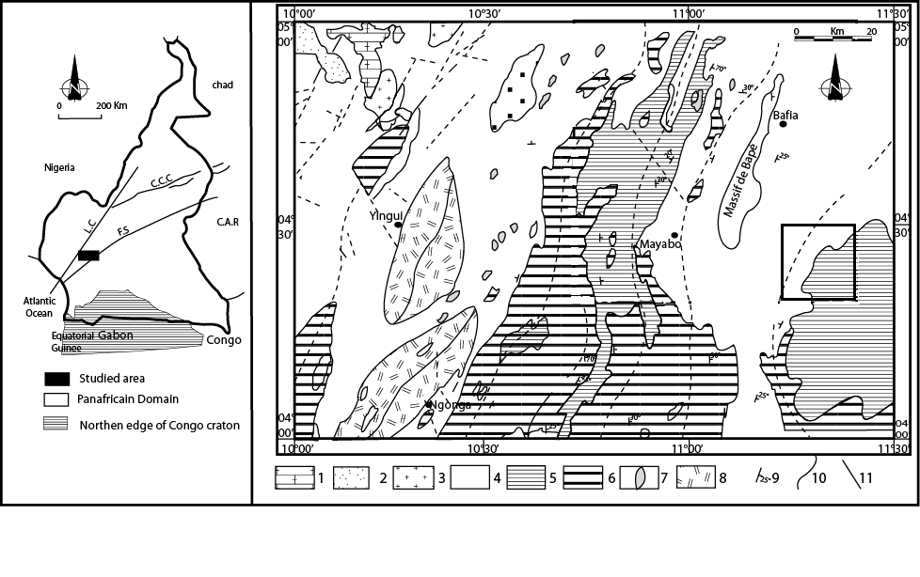
-b-

Fig. 1 – a) Localisation de la zone de Bafia au sein de la chaîne Pan- Africano- Brésilienne (modifié d’après Castaning et al., 1993) ; b) Carte géologique de la région de Bafia (d’aprèsWeecksteen, 1957).

Fig. 1 – a) Localisation de la zone de Bafia au sein de la chaîne Pan- Africano- Brésilienne (modifié d’après Castaning et al., 1993) ; b) Carte géologique de la région de Bafia (d’aprèsWeecksteen, 1957).

Fig. 1.

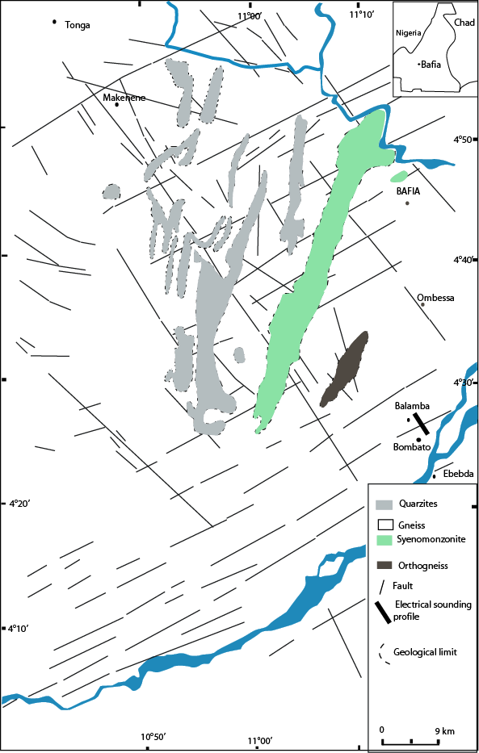
Fig. 2.

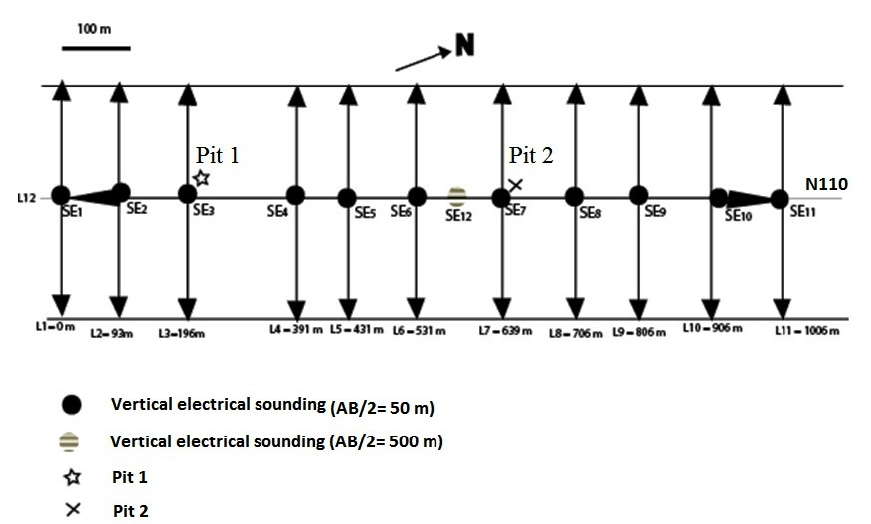

Fig. 3.

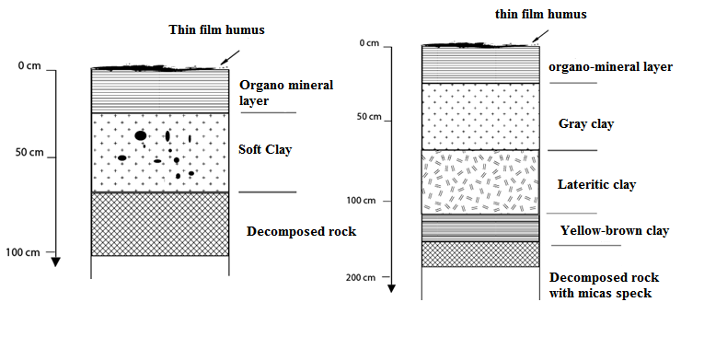

b: Pit 2
a : Pit 1

Fig. 4:

Attenuation of the amplitude of the conductive area
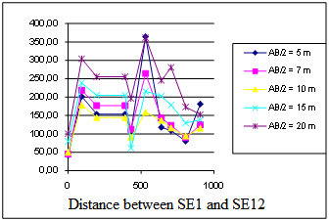
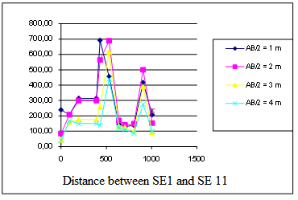
Conductive areas

Zones de discontinuité conductrice

(b)

Conductive area

(c)

Fig. 5.

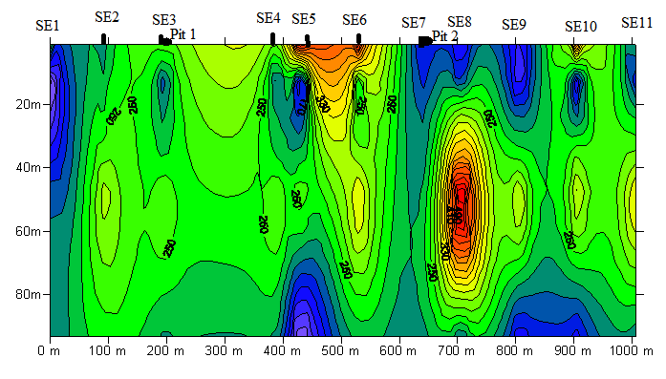
Shear zone
Bombato
Balamba

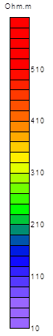

Distance entre les stations de S.E

Fig. 6.

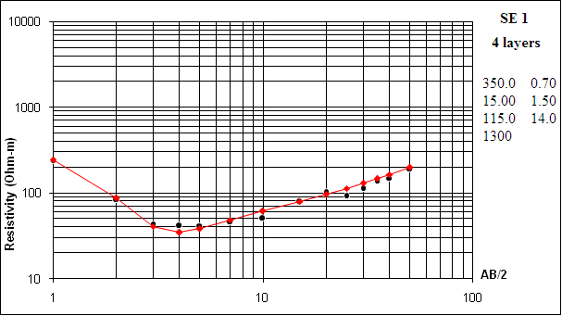 | 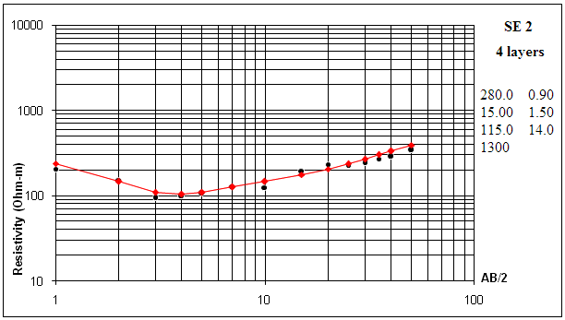
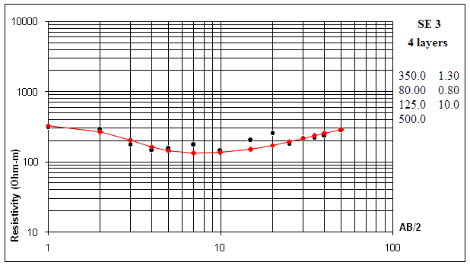 | 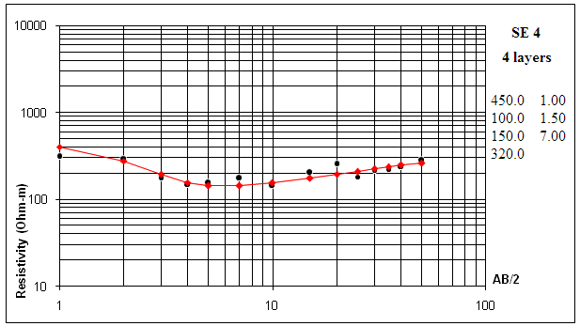
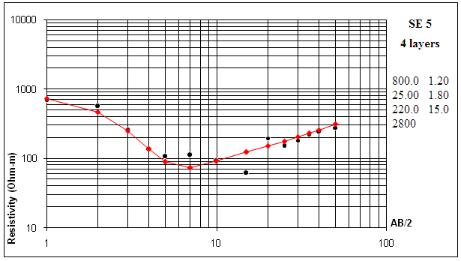 | 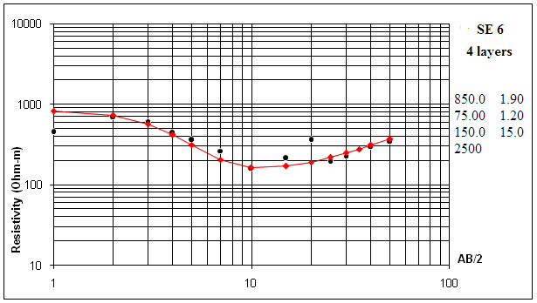
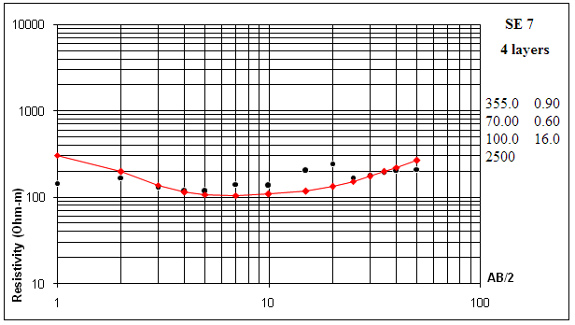 | 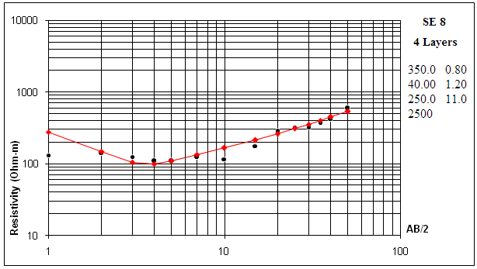
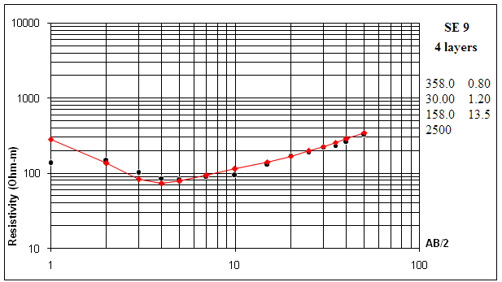 | 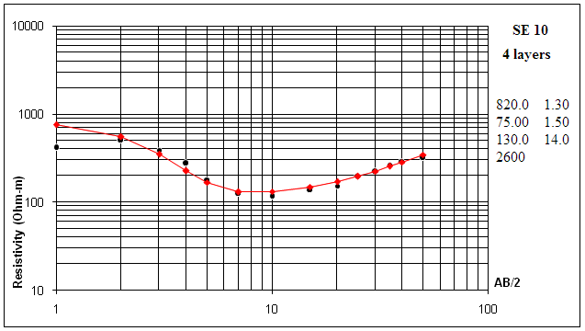
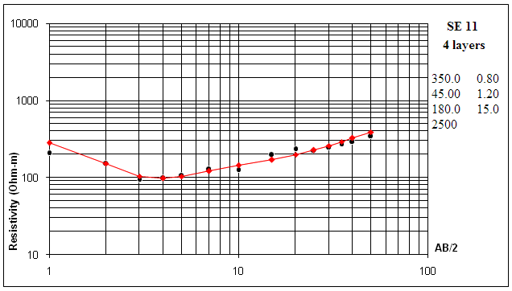 | 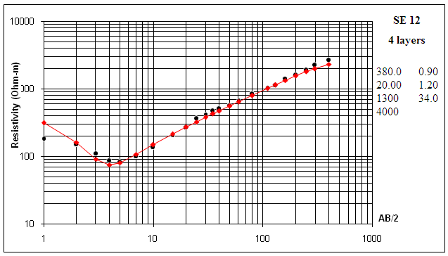

Fig. 7.

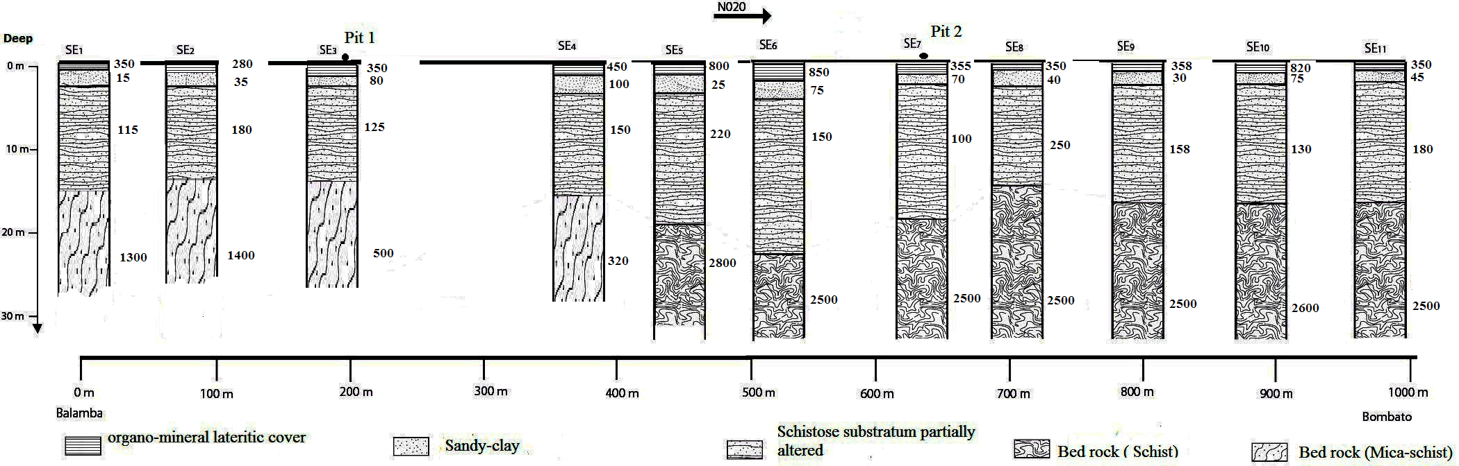

Fig. 8:

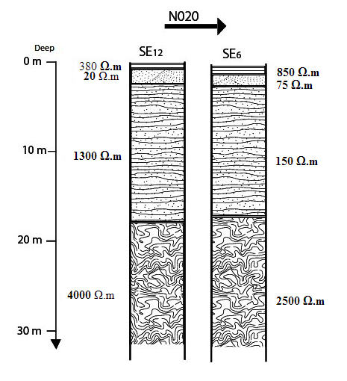

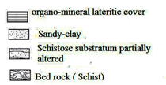

Fig. 9:

