Benefits of advanced constitutive modelling when estimating deformations in a tailings dam
Roger Knutsson*, Peter Viklander and Sven Knutsson
Department of Civil, Environmental and Natural Resources Engineering,
Luleå University of Technology
SE 971 87 Luleå, Sweden.
*Corresponding author:
Tel: +46 920 493478
E-mail: roger.knutsson@ltu.se

Abstract
Behaviour of tailings dams are often controlled in dam surveillance programs where horizontal deformation is one of the key aspects. When evaluating field data, there is a necessity for comparison with anticipated deformations in order to relate field behaviour to dam stability. With numerical modelling, these predictions can be made. This paper presents a case where horizontal deformations in a tailings dam have been simulated for a six-year period, using two-dimensional finite element modelling. Yearly dam raises have been simulated as staged constructions according to activities at site. Tailings materials have been simulated with an elasto-plastic constitutive model with isotropic hardening, called Hardening Soil and the conventional linear-elastic, perfectly plastic Mohr-Coulomb model. Soil parameters used for input were calibrated to laboratory data. Results from simulations were compared with data obtained in situ by a slope inclinometer. Results obtained by the Hardening Soil model indicate good agreement with respect to field measurements. However, this was not reached with the Mohr-Coulomb model. The results presented indicate benefits by using an advanced constitutive model for tailings in order to estimate in situ deformations in a tailings dam. The methodology presented can be used for prediction of future deformations, in order to relate the dam behaviour to its stability. This is important in dam safety assessment, and will lead to a better understanding of the dam safety, being of great importance for the dam owner and the society in general.
Keywords:
tailings, field measurements, FE-model, inclinometer, Hardening Soil model, dam safety

Introduction
From mining industry, large amounts of waste materials are generated, and a sustainable strategy of managing such products is essential. The most fine-grained residues, referred as tailings, are normally stored in facilities with surrounding dams/embankments. Methods on how to handle and manage tailings and tailings dam are described in guidelines, e.g. [1-3]. In order to maintain the needed degree of safety for these dams, they are normally subjected to slope stability analyses. In many situations corresponding strengthening actions are needed. In addition, field measurements are taken in order to monitor the behaviour of the structure. Deformations, pore water pressure and seepage are examples of such monitoring properties. But the assessment of the measured data, i.e. how the monitored properties are used to control the structure varies. A common approach in dam engineering is to assess data in terms of trends over time. Expected behaviour is then based on previous trends. If there are no clear criteria to assess and interpret new data, engineers have to rely on personal judgment and personal experience [4]. Other more methodical approaches are to assess data for updated design or in observational methods. Safety risks [5,6], stability assessment [7] or warning criteria [8] are then established with the help of field data. Another approach is to use field measurements for back-analyses with the aim to find soil parameters that correspond to field behaviour. The parameters can then be used in further modelling for estimating structure behaviour. Examples of the latter are studies presented in [9-12].
Since dam surveillance and field monitoring are regular elements in dam safety management, e.g. [1,3], prediction of soil and structure behaviour are needed in order to compare with field data. Without any predictions or anticipated values, no abnormalities will be recognized from the field data [13] and the assessment in terms of dam safety gets vague. For estimating “normal” deformation behaviour in embankment dams, Hunter and Fell [4] used an extensive database with reported cases to provide dam owners with methods on how to relate their deformation magnitudes, rates or trends. Duncan [14] summarized an extensive list of cases where finite element modelling was used for stability purposes and/or estimation of deformations in embankment dams. He also discussed the balance between simplicity and accuracy when it comes to choosing constitutive models. While simpler models might be suitable for stress analyses, more advanced models are needed to capture accurate deformation behaviour. The latter is also emphasized in [15,16].
For tailings dams, the number of published studies regarding numerical modelling is very limited compared to regular water retention dams. For stability purposes, examples of studies are given by [17-20]. Regarding deformation analyses where comparison is made to field measurements, examples are given by [7,21,22]. For these studies though, comparisons to field data have mainly focused on underground deformations, such as shear planes or creep behaviour in the foundation beneath the tailings dams. Jamiolkowski [7] noted “rotational movements” in a tailings dam (measured by inclinometers) where displacements at the surface were less than the displacements measured along the depth. The deformations indicate similarities to the differential lateral deformations in zoned embankments simulated by Hunter and Fell [4]. However, no case studies of tailings dams are presented in the literature where focus has been on the comparison between simulated tailings behaviour and field measurements. Such comparison is important in dam safety operations, where both modelling and its comparison to field measurements are needed to fully control the dam safety. There is therefore a need for a methodology in order to set up an advanced model that can simulate deformations in tailings and tailings dams with time. With accurate modelling, predictions for future dam behaviour can be made. The predictions are needed in order to observe abnormalities in field data, and correspondingly to relate field data to anticipated behaviour. This is desirable, especially for tailings facilities and their dams/embankments, with continuous operations such as dam raises and remedial works.
This paper presents a case where horizontal deformations in a tailings dam are simulated. Tailings material is modelled with the advanced constitutive model Hardening Soil [26], and also with the conventional Mohr-Coulomb model. Simulated behaviour is then compared to field measurements from a slope inclinometer, covering a six-year period. Results show the benefits by using advanced constitutive modelling, and the methodology is recommended for use in dam safety assessments and operations.

Site description
For this study, Aitik tailings facility has been used as a case. Aitik is an open pit copper mine managed by the company Boliden AB, located outside Gällivare in northern Sweden, see Fig. 1. The yearly production rate is 36Mtonnes (2016) and more than 99% of the extracted ore is considered as mine waste. The tailings are hydraulically transported into the impoundment.
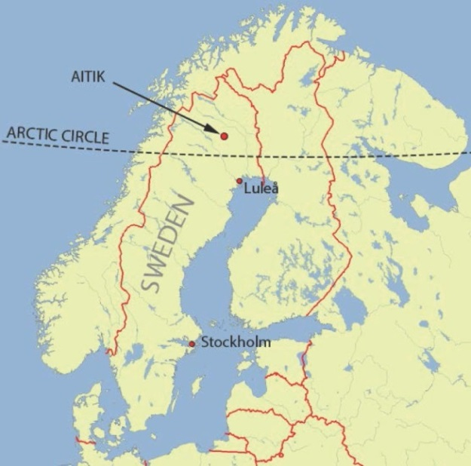
Fig. 1 Map of Scandinavian Peninsula and location of Aitik mine
An overview of the Aitik tailings facility is presented in Fig. 2. The area of the tailings impoundment is approximately 13km², where the tailings slurry is deposited by the ”spigot” method [1] from the dams. The dams are raised annually with a height of approximately three meters in the upstream direction, i.e. on the previously deposited tailings. Maximum dam height is currently 65m (2016).
The tailings facility has been in operation since 1968 [23]. During the first decades of operation, the tailings slurry was discharged from a stationary outlet (end-pipe discharge) at the eastern part of the impoundment, mainly from dam A-B (see Fig. 2). This led to settling of the most fine grained tailings particles, i.e. fractions as silt and clay, close to the outlet and the western dams (dams E-F and G-H). At that time the dam raises were performed in the downstream direction (outwards). By time, both deposition and dam raising methods have changed into today’s methods. Therefore, the grain sizes in the deposited tailings are decreasing with depth close to the western dams [24]. These regions are of extra concern in terms of strength and stiffness, and the related consequences on stability of the dams.
Fig. 2 Aitik tailings facility overview

Field measurements
The Aitik dams are regularly monitored with geotechnical instruments. Pore water pressure is measured by standpipes and piezometers installed along the dams at different elevations. Horizontal deformations are measured via inclinometers, placed along the dams at different cross-sections. In total, the tailings dams are currently monitored by 61 standpipes, 62 piezometers and 6 inclinometers. This study is focused on horizontal deformations in dam E-F, see Fig. 2. The location of the studied cross-section is presented in Fig. 3, and corresponds to where the dam is highest. The inclinometer casing was installed 2007, as the first casing at the site. None of the other five inclinometers have been in use sufficiently long time to be used in this study. The bottom of the casing is fixed (by grouting) 0.5m into the bedrock beneath the tailings impoundment. The casing penetrates (from bottom up) 5.5m of glacial till (natural ground), 27m of tailings, 7m of compacted till and 1m of rockfill support on top, see cross-section in Fig. 4.
Fig. 3 Plan with location of inclinometer in dam E-F
Fig. 4 Cross-section with location of inclinometer
With an inclinometer probe containing biaxial servo-accelerometers, the inclination of the casing relative the vertical axis, have been measured twice a year since November 2007. For all readings, the same probe has been used, operated by the same field engineer. For each reading, the inclinations have been measured in two perpendicular directions (A- and B-direction). The directions of the grooves for the A-axis (A0) and B-axis (B0) are N68°W and N22°E respectively, see Fig. 3.
Based on the inclination of the casing, conversion is made to horizontal displacement where the first reading is considered as the reference value. Due to the tilt in both A-axis and B-axis, a resultant cumulative displacement curve is calculated and presented, according to methodology in [13], see Fig. 5. The different curves in Fig. 5 represent the cumulative displacement at different times. In Fig. 5 “rotational movements” can be seen, where the maximum displacement is not located at the top of the structure, but some distance below the surface. At the bottom the displacement is zero, with a negligible displacement within the glacial till. In the tailings, the displacements are increasing with increased elevation up to maximum value. Maximum displacements are located between elevation +349 and +356 for most of the readings, i.e. 19.5-24.5m below surface. On higher elevations, the displacements are smaller.
Fig. 5 Cumulative displacement versus depth
The resultant direction of movement is calculated by trigonometry from A- and B-direction readings, and presented in Fig. 6a. The different curves represent the direction of movement at different times. The circular isochrones represent depth of the inclinometer casing (0m in the centre, 40m as the outer circle). It is seen in Fig. 6a that the directions of movement are parallel to the direction to the studied cross-section (downstream direction).
The cumulative displacements at certain depths are illustrated in Fig. 6b. The different curves represent different elevations (+360 and below), and show the cumulative displacements versus time. From Fig. 6b it can be concluded that the cumulative displacement rate is 4-6mm/year in general. In the upper part of the natural glacial till (elevation +340.5) there is a nearly constant rate of deformation of 2mm/year.
Previous analyses of deformations in Aitik follow the today principles for dam safety assessment, i.e. control of deformation rates with time as depicted in Fig. 6b. No explicit criteria exist for the maximum acceptable displacements in relation to a specific degree of safety of the structure. Neither causes, nor corresponding effects regarding the rotational movements are analysed. In Sweden normally safety improvements are considered not needed as long as deformations follow the same displacement trends (or slower) as before. However, even if the displacement trend is constant by time, the dam safety striven for may not be fulfilled. The displacement rate just might be too large. Sophisticated predictions of future deformations are therefore needed in order to use field data to check the level of dam safety.
a) | b)
Fig. 6 a) Direction of movement b) Cumulative displacement versus time for different elevations

Finite Element Modelling
The cross-section of dam E-F was modelled in the finite element program PLAXIS 2D [26]. Plane strain condition was assumed. Although the studied cross-section is located close to a vertex in the dam alignment (see Fig. 3), plane strain assumption is here considered valid. This assumption is supported by the inclinometer readings showing deformations in the same direction as the studied cross-section, see Fig. 6a.
The analysis was performed as a staged construction analysis, where historical activities such as embankment constructions, increased impoundment levels and remedial works such as construction of rockfill support on the downstream slope were taken into consideration. The geometry of the cross-section was imported into PLAXIS based on “as-built drawings” and data from airborne surveys, giving history of impoundment levels. As initial stage in the analysis, the dam geometry that prevailed in September 1992 was used. This is the first year from which airborne data is available. The rate of dam raise at that time was low, smaller than 0.5 meter per year. This is considered as sufficiently low for a valid assumption with no presence of excess pore water pressure in the dam.
According to documented history of dam activities between 1992 and 2013, these stages were modelled. Activities between 1992 and 2007 were included in order to estimate initial conditions for the date when the inclinometer was installed. In total, 65 staged constructions were added. The stresses and deformations were simulated in the dam/impoundment for the time period. Elevations for the simulated dam crests and impoundment levels for the time period 2007-2013 are presented in Fig. 7.
Fig. 7 Elevation of dam crest and impoundment level vs. time for staged constructions, 2007-2013.
CPTu-tests were used to capture the tailings stratigraphy in the impoundment close to dam E-F. In general, the tailings consist of nearly horizontal layers, due to the historical changes in the deposition technique. The CPTu-results were used to assign tailings properties into regions with similar constitutive behaviour, and not for evaluation of soil parameters. Assigned materials are presented in Fig. 8 (named A, B, C etc.). The soil properties were evaluated from laboratory data, see chapter Constitutive Modelling.
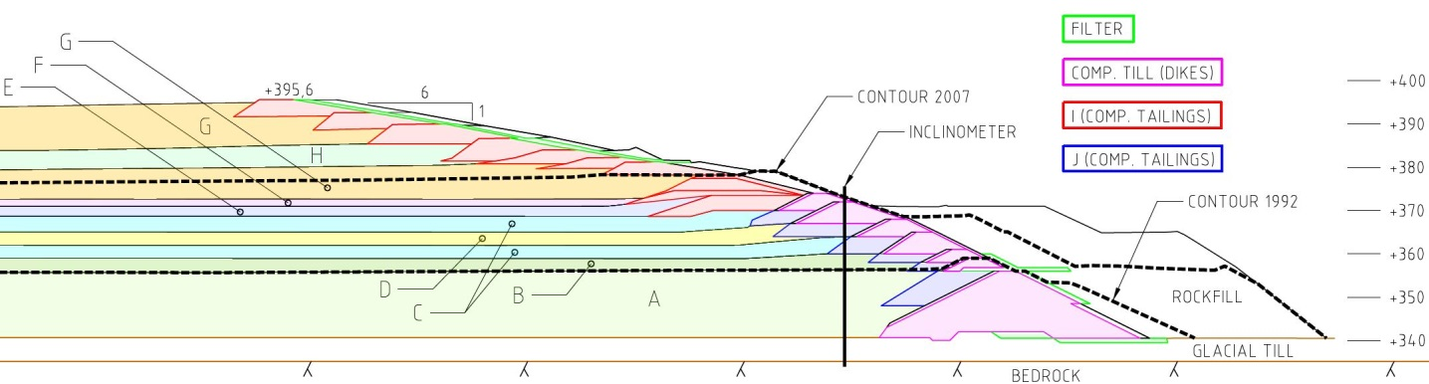
Fig. 8 Tailings stratigraphy with regions used for simulations. Dashed lines correspond to dam contours in 1992 and 2007.
The model geometry was discretized into 15-noded triangular elements, containing 12 stress interpolation (gauss-) points in each element. Due to the relatively thin layers of tailings in the impoundment (see Fig. 8), the number of elements is automatically high. Total number was 15 747. A trial simulation with denser mesh was performed, but showed no significant changes in the results. The chosen mesh density is therefore considered as sufficient.

Constitutive modelling
In this study, two cases were simulated. Firstly, the Hardening Soil model and secondly the conventional Mohr-Coulomb model was used. Model parameters were evaluated from laboratory test results on Aitik tailings from 2007 and 2013 [27-29]. The laboratory tests were performed as consolidated drained triaxial compression tests and standard oedometer tests. Undisturbed samples were taken by a thin-wall piston sampler at depths in the impoundment ranging from 7 to 47 meters. The Hardening Soil model encounters for strain hardening effects, meaning decreasing stiffness and irreversible plastic strains when subject to primary loading [26]. It is a cone-cap model, with yield surface not fixed in principal stress space and with possible expansion due to plastic straining [30]. Shear hardening, or expansion of the cone, models plastic strains due to primary deviatoric loading. Compression hardening, or expansion of the cap, models plastic strains due to primary compression (isotropic loading). The limiting stress states for the cone part are described by the strength parameters friction angle ϕ’ and cohesion c’, defined according to the Mohr-Coulomb failure criterion. The plastic volumetric strains (triaxial states of stress) are controlled by the angle of dilatancy (ψ) [26]. Stiffness parameters in the Hardening Soil model are E₅₀^{ref} (triaxial secant stiffness), E_{ur}^{ref} (unloading-reloading stiffness) and E_{oed}^{ref} (oedometer tangent stiffness). The superscript ref indicates that the stiffness value corresponds to a reference confining pressure (p_{ref}) and the stress dependency of soil stiffness is controlled by a power law with the power exponent m [26]. In triaxial (primary) loading, the model describes the soil stiffness with a hyperbolic stress-strain relationship [30]. The failure ratio R_{f} is used for the relation between a failure stress (from the Mohr-Coulomb failure criterion) and a higher stress representing the asymptote for the hyperbola. In in the unloading-reloading state, the stress-strain relationship is linear and controlled with E_{ur} (Young’s modulus for unloading-reloading) and ν_{ur} (Poisson’s ratio for unloading-reloading). Schematic stress-strain relationships for a) triaxial simulation and b) oedometer simulation are presented in Fig. 9.
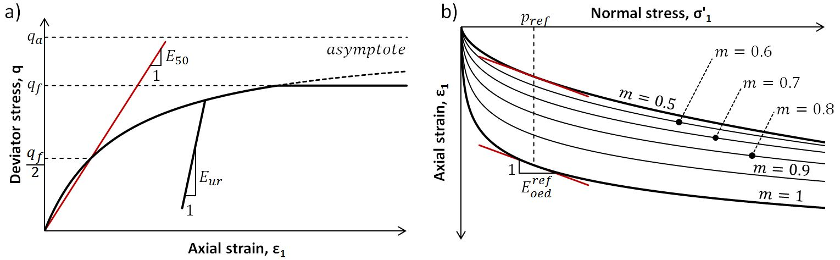
Fig. 9 a) Schematic presentation of hyperbola in drained triaxial test. b) Schematic presentation of stress dependency in an oedometer test
The stress dependency of stiffness is presented for the oedometer simulation in Fig. 9b. Here, the effect of the power exponent m, ranging from 0.5 to 1, is presented as well. According to data presented in literature, soils such as silt and sand are reported to have values close to 0.5, whilst soft clays tend to have logarithmic behaviour with m-value equal to 1 [26].
In order to calibrate model parameters to laboratory results as function of stresses, the SoilTest application in PLAXIS was used. SoilTest simulates laboratory tests of soils according to chosen constitutive model and soil parameters [26]. Triaxial and oedometer simulations were performed, similar to the tests performed at lab. Representative plots from a best fit calibration of a series in triaxial tests and an oedometer test is presented in Fig. 10 (results correspond to material type D in Table 1). As shown in Fig. 10, full agreement between simulations and lab data was not reached. Best agreement was reached for the oedometer test, but for the triaxial simulations the varying stiffness was partly incorrect compared to lab-data. At small axial strains the simulated stiffness was too high, and for high axial strains it was too low.
By simulating materials with lower stiffness than “real” behaviour, simulations would overestimate the deformations. This is a common approach in design, predicting “worst case” deformations. With such simulations in dam safety management, comparisons to field data would overestimate the safety (it is then believed that field deformations can be larger than they should). Instead the stiffness used here is chosen to slightly underestimate the deformations in the tailings. When then comparing with field measurements, there will be a small safety margin when determining allowable deformations in terms of dam safety. For this simulation, the soil model and the corresponding parameters were considered acceptable in order to model the tailings’ deformation behaviour on a constitutive level.
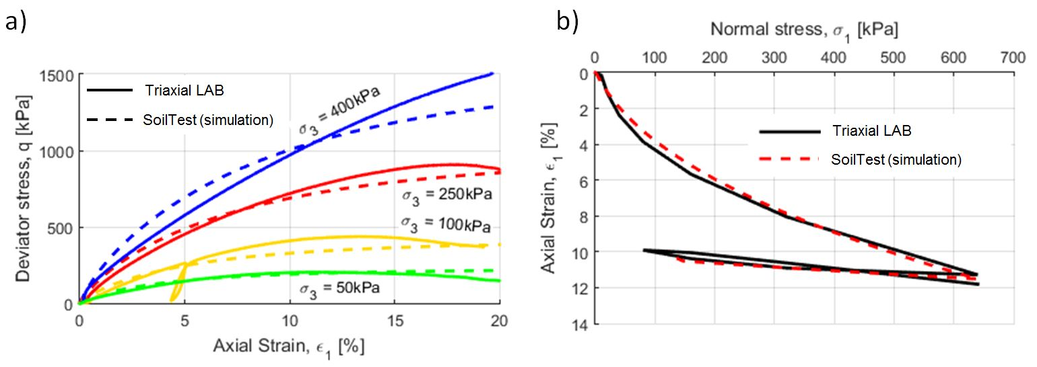
Fig. 10 a) Lab-data vs. simulations for a series of triaxial tests. Solid lines represent lab-data and dashed lines represent SoilTest simulations. b) Lab-data vs. simulations, oedometer test.
For the tailings regions in the model, parameters for the Hardening Soil model are presented in Table 1. In total, the Hardening Soil parameters given in Table 1 are based on 22 laboratory tests (triaxial and oedometer tests). Values for density are taken according to [24,27], and values for hydraulic conductivity are based on [31].
The friction angles (ϕ’) presented in Table 1, are found to be in a narrow range (38-40.7°) indicating similar strength. But the stiffness varies largely. For example, material D, E and F have triaxial stiffness values less than 50% of the stiffness in material I and J for the same reference pressure. The variation in stiffness is mainly due to historical deposition techniques and its resulting stratigraphy in terms of both grain size distribution and porosity [25].
A comparative simulation was made where the tailings were simulated with the Mohr-Coulomb model. Mohr-Coulomb is a well-known linear elastic, perfectly plastic model [26]. The same strength parameters for c’ and ϕ’ as in Table 1 were used. For the Poisson’s ratio (ν), the same values as in Table 1 (ν_{ur}) were used. For Young’s modulus (E) in the Mohr-Coulomb case, the value for each soil layer was calculated as the triaxial secant stiffness (E₅₀) from Table 1. For this the power law associated with Hardening Soil model was used [26]. For calculating the stiffness (E), the minor principle effective stress (σ’₃) in the middle of the corresponding soil region was used. The minor principle effective stresses were evaluated from the Hardening Soil simulation. Although the stiffness in Hardening Soil model and Mohr-Coulomb model differ significantly, this methodology was chosen in order to reduce the effects from Mohr-Coulomb’s lack in stress-dependent stiffness. Stiffness values used in the Mohr-Coulomb model are presents in Table 2.

Table 1. Soil parameters for tailings when using Hardening Soil model.
 |  | Material names
Parameter |  | A | B | C | D | E | F | G | H | I | J
E₅₀^{ref} | kPa | 8 254 | 8 254 | 10 520 | 6 032 | 5 500 | 5 500 | 12 090 | 6 900 | 12 250 | 12 250
E_{oed}^{ref} | kPa | 6 000 | 6 000 | 5 000 | 3 500 | 3 950 | 3 950 | 7 239 | 4 000 | 8 500 | 8 500
E_{ur}^{ref} | kPa | 40 000 | 40 000 | 30 000 | 32 600 | 22 000 | 22 000 | 31 820 | 20 000 | 25 000 | 25 000
m | - | 0.5 | 0.5 | 0.5 | 0.6 | 0.57 | 0.57 | 0.467 | 0.7 | 0.45 | 0.45
p_{ref} | kPa | 100 | 100 | 140 | 100 | 100 | 100 | 100 | 100 | 100 | 100
ν’_{ur} | - | 0.3 | 0.3 | 0.3 | 0.15 | 0.15 | 0.15 | 0.3 | 0.3 | 0.3 | 0.3
c’ | kPa | 0 | 0 | 0 | 7.57 | 0 | 0 | 2.3 | 0 | 0 | 0
ϕ’ |  | 38.66 | 38.66 | 40.7 | 40.16 | 40 | 40 | 38.5 | 39.5 | 38 | 38
ψ |  | 1 | 1 | 12 | 2.5 | 2.5 | 2.5 | 16 | 2 | 2 | 2
R_{f} | - | 0,9 | 0.9 | 0.8 | 0,9 | 0.9 | 0.9 | 0.9 | 0.8 | 0.8 | 0,8
γ_{unsat} | kN/m³ | 14.3 | 14.3 | 15.45 | 16.2 | 15.7 | 15.7 | 12.3 | 14.9 | 16 | 16
γ_{sat} | kN/m³ | 19.3 | 19.3 | 20 | 20,5 | 20.1 | 20.1 | 18 | 19.5 | 19 | 19
k_{x} | m/s  [10⁻⁸] | 10 | 55 | 100 | 55 | 55 | 55 | 100 | 55 | 550 | 100
k_{y} | m/s  [10⁻⁸] | 1 | 5.5 | 10 | 5.5 | 5.5 | 5.5 | 10 | 5.5 | 55 | 10
Note: γ_{unsat}, unit weight above phreatic level; γ_{sat}, unit weight below phreatic level; k_{x}, hydraulic conductivity in horizontal direction; k_{y}, hydraulic conductivity in vertical direction

Table 2. Young’s modulus for tailings in the simulation using Mohr-Coulomb model.
 |  | Material names
Parameter |  | A | B | C | D | E | F | G | H | I | J
E | kPa | 10 109 | 9 228 | 8 891¹/  8 435² | 6 032 | 4 843 | 4 843 | 4 247 | 8 035 | 8 111 | 8 111
Note: ¹Stiffness in layer at elevation +359 (lower layer with material C), ²Stiffness in layer at elevation +365 (upper layer with material C).

For materials such as filters, till and rockfill support, the Mohr-Coulomb model was used where the soil properties were based on earlier geotechnical investigations [31], see Table 3.
Table 3. Soil parameters for other materials than tailings, using Mohr-Coulomb model.
 |  | Glacial till (underground) | Till  (compacted dykes) | Filter | Rockfill
Parameter
E | kPa | 20 000 | 20 000 | 20 000 | 40 000
ν | - | 0.33 | 0.33 | 0.33 | 0.33
c’ | kPa | 1 | 1 | 1 | 1
ϕ’ |  | 37 | 35 | 32 | 42
ψ |  | 0 | 0 | 0 | 0
γ_{unsat} | kN/m³ | 20 | 20 | 18 | 18
γ_{sat} | kN/m³ | 22 | 22 | 20 | 20
k_{x} | m/s | 5x10⁻⁸ | 1x10⁻⁷ | 1x10⁻³ | 1x10⁻¹
k_{y} | m/s | 1x10⁻⁸ | 5x10⁸ | 1x10⁻³ | 1x10⁻¹

All simulations were performed as “consolidation analyses” in PLAXIS, where excess pore water pressure is allowed to be generated or dissipated. Input parameters are given in term of effective stresses [26].

Results
Fig. 11 presents a comparison in horizontal deformations between results from the numerical simulations and field measurements. In the figure, comparison is made for field data representing November 2013. Since the inclinometer casing was installed in November 2007, the deformations computed in the numerical simulations are restricted to those developed during November 2007-November 2013, assuming the deformations at November 2007 as the reference values. In the figure, it is clear that the results from the simulation with Mohr-Coulomb parameters, largely overestimate the deformations in the upper part of the tailings. The general agreement to the field data is weak, with a coefficient of determination of R²=0.29. The same data as in Fig. 11a are presented in Fig. 11b with a different scale for the horizontal axis to facilitate comparison between Hardening Soil simulations and inclinometer field data. For the Hardening Soil model, much stronger agreement is seen (R²=0.94) to the field data. In addition, the Hardening Soil was able to capture the rotational behaviour among in the displacements.
A notable difference between numerical results and field data is seen for the natural glacial till (underground). Deformations simulated in the interface tailings-till show good agreement to the inclinometer, which deformations mainly are due to the relatively lower stiffness in the tailings compared to the till. In the bottom of the model, the fixed boundary condition results in no deformations. The till was modelled with a linear elastic, perfectly plastic model and is therefore the reason why deformations in the till are linear and overestimated compared to in the inclinometer.
In Fig. 12, the development of horizontal deformations with time is shown for numerical results and field measurements. Solid lines represent measured data and dotted lines numerical results. In Fig. 12a, results obtained by Hardening Soil are presented, whereas in Fig. 12b results correspond to Mohr-Coulomb. The simulations indicate zigzag behaviour with altering displacements in both upstream and downstream directions, but with a clear trend of increased displacements in downstream direction with time. Major displacements in the downstream direction are occurring when dam crests are raised (see Fig. 7). Best agreements between simulations and field data is clearly obtained by the Hardening Soil model, where the magnitudes of displacements correspond to those obtained in field. This is not seen for the Mohr-Coulomb simulation, where the displacements deviate largely from the field data.
Fig. 11 a) Displacement 2013, inclinometer vs. numerical results. b) As figure a) but horizontal axis restricted to 40mm.

Fig. 12 Comparison of displacements with time. Solid lines represent field data (inclinometer) and dotted lines represent numerical results. Colours according to elevations, see legend.
a) Hardening Soil simulation, b) Mohr-Coulomb simulation.

Discussion
The results presented in Figs. 11-12 show that simulations with the constitutive model Hardening Soil resulted in much stronger agreement to field observations compared to the results obtained by the Mohr-Coulomb model. For the six-year period used for comparison, the Hardening Soil model was able to model deformations in the right magnitude, whereas the Mohr-Coulomb model largely overestimates the deformations.
In addition to the magnitude, the simulated deformations with Hardening Soil model show the same rotational behaviour as the field deformations, with the largest deformations close to the middle of the tailings height. Similar behaviours in tailings have been reported by Jamiolkowski [7]. The rotational movements were not obtained by the simulation with Mohr-Coulomb. Here, the simulated deformations constantly increase towards the ground surface and deviate largely to field observations.
In general the computations indicate a direction of movement in downstream direction, mainly due to increased load upstream the inclinometer caused by increased impoundment and dam levels. The simulated deformations have an obvious zigzag pattern as shown in Fig. 12, which cannot be seen in field data. This can be explained by a lack of details in documented historical events, e.g. exact dates of when the different activities were performed are missing. The different activities being modelled as staged constructions linked separately one after one might at site have been built simultaneously. If this had been taken into consideration it would have resulted in smoother curves in Fig. 12.
For the glacial till (underground), less emphasis was given on its constitutive modelling. The linear elastic, perfectly plastic relationship is therefore the reason behind the simulated linear deformations. Detailed constitutive modelling of till have been outside the scope of this study, and have therefore not been further analysed.
Although the Mohr-Coulomb model is simpler and demands less input parameters than Hardening Soil, it is concluded that a linear elastic model is not appropriate for estimating deformations in a tailings dam. Instead, more advanced constitutive models are needed. With the Hardening Soil model, strong agreement was found on both the magnitude and the rotational deformations. This was reached with features such as stress dependency in stiffness and strain hardening behaviour. Even though perfect match was not reached to the laboratory tests (SoilTest simulations), the evaluated parameters implied simulations with strong agreement to field observations.
By using the methodology presented in this study, i.e advanced constitutive modelling and by simulating staged construction activities, accurate predictions can be made of future deformations. The need for sampling and corresponding laboratory work is obvious since more qualitative geotechnical parameters are needed compared to the use of simpler models, but generates on the other hand more accurate results. This is in agreement with Duncan [14] regarding simplicity versus accuracy in choosing constitutive models. Accurate predictions are important in dam safety management when it comes to evaluation of monitored deformations. Deformation monitoring gives good information of the dam behaviour. By relating the dam behaviour (e.g. horizontal deformations) to stability analyses, the dam’s true degree of safety can be evaluated. Stability analyses have been outside the scope of this study, but can be done according to the methodology in [32].

Conclusions
From this study, it is concluded that there are clear benefits of using advanced constitutive modelling when estimating deformations in a tailings dam. With the Hardening Soil model, strong agreement between simulations and inclinometer data is seen, both in terms of magnitude and rotational movements. With the Mohr-Coulomb model, the agreement is weak due to largely overestimated deformations, and not recommended for use when estimating deformations. Although more qualitative geotechnical parameters are needed for advanced models compared to simpler models, more accurate predictions of future deformations can be simulated. Such predictions are important in order to relate field data to anticipated dam behaviour and correspondingly to its stability. This methodology is recommended for use in dam safety assessments and operations.

Acknowledgments
The authors would like to express sincere thanks to Boliden AB, Sweden for giving us the opportunity to carry out the presented study regarding the tailings dams at the Aitik mine and its disposal facilities and for giving access to site information. The work was initiated by Boliden AB, and the financial support to the study given by Boliden AB and Luleå University of Technology (LTU) is highly acknowledged.
Mr. Riaz Bhanbhro at Luleå University of Technology (LTU), Sweden is to be acknowledged for performing laboratory tests and for evaluation of material parameters and Mr. Fredrik Jonasson at Sweco Energuide AB, Sweden for providing information from field data. Sweco Civil AB is acknowledged for performing the field sampling.
The research presented has been carried out within the environment of "Swedish Hydropower Centre - SVC" at LTU. The support from the SVC environment is highly appreciated and acknowledged for. SVC has been established by the Swedish Energy Agency, Elforsk and Svenska Kraftnät together with Luleå University of Technology, The Royal Institute of Technology, Chalmers University of Technology and Uppsala University. www.svc.nu.

References
[1] ICOLD, 1996. “A Guide to Tailings Dams and Impoundments: Design, Construction, Use and Rehabilitation”, ICOLD, Committee on Mine and Industrial Tailings Dams, Paris.
[2] ICOLD, 2011. “Improving Tailings Dam Safety: Critical Aspects of Management, Design, Operation and Closure”, ICOLD, Committee on Tailings Dams, Paris.
[3] SveMin, 2012. ”GruvRIDAS - Gruvindustrins Riktlinjer för Dammsäkerhet”. SveMin, Stockholm. [In Swedish]
[4] G. Hunter and R. Fell, 2003. “Deformation Behaviour of Embankment Dams”, UNICIV Report No. R-416, The University of New South Wales, School of Civil and Environmental Engineering, New South Wales.
[5] A. Corsini, A. Pasuto, M. Soldati, and A. Zannoni, 2005. “Field monitoring of the Corvara landslide (Dolomites, Italy) and its relevance for hazard assessment”, Geomorphology, 66(1-4): 149-165.
[6] M.D. Scott, R.C. Lo and T. Thavaraj, 2007. “Use of instrumentation to safeguard stability of a tailings dam”. In 7th International Symposium on Field Measurements in Geomechanics (FMGM), Boston.
[7] M. Jamiolkowski, 2014. “Soil mechanics and the observational method: Challenges at the Zelazny Most copper tailings disposal facility”, Géotechnique, 64(8): 590-618.
[8] Y. Yin, H. Wang, Y. Gao and X. Li, 2010. “Real-time monitoring and early warning of landslides at relocated Wushan town, The three Gorges reservoir, China”, Landslides, 7(3): 339-349.
[9] P. Vahdati, S. Levasseur, H. Mattsson and S. Knutsson, 2013. “Inverse Mohr-Coulomb soil parameter identification of an earth and rockfill dam by genetic algorithm optimization”, Electronic Journal of Geotechnical Engineering, 18(10): 1-2.
[10] P. Vahdati, S. Levasseur, H. Mattsson and S. Knutsson, 2014. “Inverse hardening soil parameter identification of an earth and rockfill dam by genetic algorithm optimization”, Electronic Journal of Geotechnical Engineering, 19: 3327-3349.
[11] G. Marcato, M. Mantovani, A. Pasuto, L. Zabuski and L. Borgatti, 2012. “Monitoring, numerical modelling and hazard mitigation of the Moscardo landslide (Eastern Italian Alps)”, Engineering Geology, 128: 95-107.
[12] S. Oztoprak and S.F. Cinicioglu, 2005. “Soil behaviour through field instrumentation”, Canadian Geotechnical Journal, 42(2): 475-490.
[13] J. Dunnicliff, 1988. “Geotechnical Instrumentation for Monitoring Field Performance”, John Wiley & Sons, New York, NY, United States (USA).
[14] J.M. Duncan, 1996. “State of the art: Limit equilibrium and finite-element analysis of slopes”, Journal of Geotechnical Engineering, 122(7): 577-596.
[15] N. Kovacevic, D.M. Potts and P.R. Vaughan, 2008. “Recent advances in the numerical modelling of embankment dams”. In 15th Biennal BDS Conference, Warwick.
[16] P. Pramthawee, P. Jongpradist, and W. Kongkitkul, 2011. “Evaluation of hardening soil model on numerical simulation of behaviors of high rockfill dams”, Songklanakarin Journal of Science and Technology, 33(3): 325.
[17] A. Gens and E.E. Alonso, 2006. “Aznalcóllar dam failure. Part 2: Stability conditions and failure mechanism”, Géotechnique, 56(3): 185-201.
[18] L. Ormann, M.A. Zardari, H. Mattsson, A. Bjelkevik and S. Knutsson, 2013. ”Numerical analysis of strengthening by rockfill embankments on an upstream tailings dam”, Canadian Geotechnical Journal, 50(4): 391-399
[19] C. Priscu, H.S. Mitri and H. Keira, 1998. “Behavior of mine tailings dams under high tailings deposition rates”. In Tailings and Mine Waste ´98, Fort Collins, Colorado.
[20] P.N. Psarropoulos and Y. Tsompanakis, 2008. “Stability of tailings dams under static and seismic loading”, Canadian Geotechnical Journal, 45(5): 663-675.
[21] M.M. Morsy, N.R. Morgenstern and D.H Chan, 1995. “Simulation of creep deformation in the foundation of tar island dyke”, Canadian Geotechnical Journal, 32(6): 1002-1023.
[22] A.M.P. Wedage, N.R. Morgenstern and D.H. Chan, 1998. “Simulation of time-dependent movements in syncrude tailing dyke foundation”, Canadian Geotechnical Journal, 35(2): 284-298.
[23] S. Andersson, 2013. “PM Deponeringshistorik 1966-2012”. Tailings Consultants Scandinavia, Stockholm. [In Swedish]
[24] R. Bhanbhro, R. Knutsson, J. Rodriguez, T. Edeskär, and S. Knutsson, 2013. “Basic description of tailings from Aitik focusing on mechanical behavior”, International Journal of Emerging Technology and Advanced Engineering, 3(12): 65-69.
[25] R. Bhanbhro, 2014. “Mechanical properties of Tailings: Laboratory Tests from a Swedish Tailings Dam”. Doctoral Dissertation, Luleå University of Technology, Luleå.
[26] R.B.J. Brinkgreve, E. Enging, and W.M. Swolfs, 2014. “PLAXIS User's Manual”, Plaxis bv., Delft, The Netherlands.
[27] K. Pousette, 2007. ”Laboratorieförsök på anrikningssand från Aitik”, Internal document, Luleå University of Technology, Luleå. [In Swedish]
[28] R. Knutsson, 2013. “Triaxial tests - Aitik tailings dam”, Internal document, Luleå University of Technology, Luleå.
[29] R. Bhanbhro, 2013. “Oedometer tests - Aitik tailings dam”, Internal document, Luleå University of Technology, Luleå.
[30] T. Schanz, P.A. Vermeer and P.G. Bonnier, 1999. “The hardening soil model: Formulation and verification”. In Beyond 2000 in Computer Geotechnics - 10 Years of PLAXIS international, Amsterdam.
[31] SWECO, 2008. ”Förslag på materialparametrar för "övriga material" vid beräkning i PLAXIS” internal document, SWECO VBB, Luleå. [In Swedish]
[32] R. Knutsson, P. Viklander and S. Knutsson, 2015. “The use of numerical modeling in alert level set-up for instrumentation in tailings dams”, In Twenty-fifth congress on large dams - International commission on large dams, Stavanger.

