Modelling Heteroscedasticity in Exchange Rates and the Response of Exchange Rate to Oil Shocks

David UMORU
Department of Economics,
Faculty of Arts, Management & Social Sciences,
Edo State University Uzairue,
KM 7, Auchi-Abuja Expressway, Iyamho,
Edo State, Nigeria.
david.umoru’edouniversity.edu.ng

Rafat HUSSAINI
Department of Economics,
Faculty of Arts, Management & Social Sciences,
Edo State University Uzairue,
KM 7, Auchi-Abuja Expressway, Iyamho,
Edo State, Nigeria.

&
Kasimu Awenegieme Osigbeme, ESHEMOGIE
Department of Vocational and Technical Education
Faculty of Education, University of Benin,
Benin City, Nigeria.

Abstract
This study investigates comparative modeling of heteroscedasticity in monthly exchange rates in ten (10) African countries from January 2000 to December 2021. Exchange rate heteroscedasticity was modelled using GARCH models while Structural Vector Autoregression (SVAR) was adopted to examining the response of exchange rates to oil price shocks. The descriptive result showed Ghana exchange rate is the most relatively stable currencies whereas Malawi domestic currency is the most volatile currencies among the studies countries. The heteroscedasticity test indicated Ghana, Kenya, Morocco and Zambia exchange rate poses heteroscedasticity worthy to be examined using the GARCH models whereas countries like Egypt, Malawi, Mauritius, Namibia, Nigeria and South Africa do not possess any ARCH term that can be examined in the GARCH specification. Ghana and Kenya exchange rate are best forecasted and examined using the EGARCH whereas the standard GARCH may be more efficient in estimating the volatility of Morocco and Zambia exchange rates. The results indicated the VAR models for all the countries are stable since the root of the models are less than unity indicating the SVAR system is stable and robust. For Ghana and Kenya, the arch and GARCH effect and the leverage effects are all statistically significant indicating the magnitude of the impact of good news in this market is significantly different from that of bad news. The arch effects of Morocco and Zambia are not statistically significant. However, the GARCH effect is statistically significant for Morocco but not significant for Zambia. This study recommends the need for these countries to intensify effort on their diversification drive of their economies, for purpose of realizing a stable exchange rate management.

Key words: Monthly exchange rates, shocks, EGARCH, sGARCH, heteroscedatsicity

INTRODUCTION
Modelling exchange rate volatility has remained weighty because of its economic implications when it comes to taking decisions that bores on final and oil markets respectively. According to Umoru (2022), in financial econometrics, shocks are reported as news (in form of exchange rate speculations) but measured as volatility in a series which could be a financial series or a macroeconomic time series. The volatility is measured in terms of variance as modelled by the autoregressive conditional heteroscedasticity (ARCH) and the generalized autoregressive conditional heteroscedasticity (GARCH) models together with its variants, the T-GARCH, and the E-GARCH models. Nevertheless, the variance is modelled conditionally on its history. The reason is that the homoscedasticity assumption which is basically the constant variance assumption in econometric analysis is difficult to observe in real life situations because of the heterogeneity and variation that characterizes the behavioral patterns of cross sectional units. For example, each member of the Organization of Petroleum Exporting Countries (OPEC) has some country-specific characteristics that could be measured in terms of geographical location, trade policy, economic reforms, and policy regime shift (floating exchange rate system or fixed exchange rate regime, low interest rate regime or high interest rate regime as the case may be).

Local currencies of African countries have over time declined in value relative to the US dollar. Though, exchange rates constantly moved based on supply and demand. However, the movement also reflects variations in international competitiveness and interest rate differentials in different countries of the world. Going forward therefore, this study sought to identify and estimate the effect of heteroskedasticity in monthly exchange rate of ten (10) African countries as well as the response of exchange rates these countries to global oil price shock. In line with study objectives, we hypothesize that no heteroskedasticity exists in monthly exchange rates of the selected African countries. The findings of the study when added to extant literature will be a valuable guide to various economies and policy market on policies to adopt to enhance their exchange rates based on the empirical evidence.

The remainder of this study is congregated into four sections. The first section is a review of extent literature relating of study concepts and underlying theoretical perceptions from relevant schools of thought, previous empirical works published in relation to the study objectives are examined to identify existing gap in previous studies e. The next section spells out the econometric estimation methodology deployed in the study. It contains theoretical framework adopted data sources, methods of estimation employed and model specification. Data analysis and interpretation makes up the third section. Data extracted from requisite sources are analysed using the tools mentioned in methodology section. Results are interpreted and policy implication of findings explained. The concluding section contains summary of research findings, recommendations and concluding section.

LITERATURE REVIEW
There is a vast literature regarding exchange rate volatility or shocks in form of speculations (news). However, we have chosen to review only a few of them for sake of brevity. Deploying the GARCH modelling techniques, Olowe & Ayodeji (2009) obtained persistent volatility of Naira/US Dollar exchange rate. Their study overruled leverage effect. Basing their analysis on daily exchange rates, Rofael & Hosni (2015) forecasted and estimated exchange rate volatility in Egypt using ARCH and state space (SS) models. The results of their study favoured volatility clustering in Egypt’s exchange rate returns, as well as a risk of divergence between exchange rates and the stock market. To Umaru & Davies (2018) real exchange rate is statistically significant and negatively related to GDP in West African countries. The volatility of real exchange rate for the period January 1993 to December 2009 in Kenya was established based on Generalized Method Moments (GMM) by Musyoki, Pokhariyal & Pundo (2012). The study found that RER was very volatile for the entire study period. Kenya’s RER generally exhibited an appreciation and volatility trend, implying that the country’s international competitiveness deteriorated over the study period. The RER Volatility reflected a negative impact on economic growth of Kenya.

According to Dhamija & Bhalla (2010), integrated GARCH and threshold GARCH models performed better than others when forecasting the volatility of five daily currencies: the British pound, German mark, Japanese yen, Indian rupee, and Euro. Brooks & Burke (1998) assessed the exhibition of several out-of-sample models using weekly exchange rate returns for the Canadian dollar, German mark, and Japanese yen versus the US dollar from March 1973 to September 1989. They discovered that the models' out-of-sample forecasting accuracy was comparable to that of frequently used GARCH(1, 1) models on mean absolute errors but not on mean squared errors. In 2014, Pelinescu (2014) found that exchange rates consisted of ARCH processes, and exchange returns were correlated with volatility for the Romanian economy. Hansen & Lunde (2005) conducted an out-of-sample analysis of 330 distinct GARCH family models. Different models were determined to be the most effective at forecasting the volatility of the two categories of assets. GARCH (1, 1) model had superior predicting accuracy while models with leverage effects outperformed GARCH for IBM stock prices.

From 1975 through 1998, Herwartz & Reimers (2002) looked at daily exchange rate movements between the Deutsche mark (DM) and the US dollar, as well as the DM and the Japanese yen (JPY). To capture volatility clustering, they utilized a GARCH model with leptokurtic modification, and they discovered that the detected sites of structural change were susceptible to variation in monetary policy in the US and Japan. Alayan, Ün, & Dayolu (2013) used asymmetric GARCH models to predict the exchange rate volatility of Indonesia, Mexico, Turkey and South Korea against dollar. They investigated leverage effects and fat-tailed characteristics using monthly exchange rate data from 1993 to 2013 and reported that the exchange rates of MIST nations versus the US dollar had uneven and leveraging effects. Review of literature reveals that research has been conducted on individual economies examining the effect on exchange rate volatility on economic growth. While some other literature also reveals examined effect of exchange rate volatility on economic group of West African countries from this a gap in knowledge identified. The present study simultaneously uses the GARCH and SVAR to determine the heteroskedasticity in monthly exchange rate movements in ten African countries.

THEORETICAL FRAMEWORK
The study adopted the generalized autoregressive conditional heteroskedasticity (GARCH) model (Bollerslev, 1986) which extends the ARCH models and it uses values of the past squared returns and past variances to model the current variance of a financial or macroeconomic data. The GARCH model is a model that predicts changes (volatility) in conditional variance (heteroskedasticity) in a time series dataset. Usually, GARCH models (either decreasing or increasing) volatility that occurs due to time. Calculated variance of the dependent variable in a model is modelled as a function of past values (lags) of the dependent and independent variable (E-views, 2019). GARCH poses an advantage of reducing the cumbersomeness of determining the optimum lag length for a dataset which ARCH presents. The conditional variance is measured using lag values and squared lag values of the error or disturbance term (Atoi, 2014). However, the model is flawed for violating non-negativity constraints to parameters; weak results in highly stationary data; and the symmetric nature that causes non-sensitivity to asymmetric volatility shocks (Atoi, 2014).

The Structural Vector Auto Regressive (SVAR) model was introduced by Sims in 1980. It is used in the analysis of fluctuations in business cycles and to identify the influence of individual monetary policy shocks. A SVAR uses additional identifying restrictions and estimation of structural matrices to transform VAR errors into uncorrelated structural shocks (E-views, 2019). To Sims (1980), SVAR models delivers methodical style for imposing economic restrictions, which could enable the researcher to capture econometrical consistencies.

Model Specification
The standard GARCH model as developed by Bollerslev (1986) is thus specified as for the study as follows:
$$σ_{t}^{2}= γ +\sum_{i}^{p}{μ_{i}e_{t-i}^{2}}+\sum_{j}^{q}{ρ_{j}σ_{t-j}^{2}} (1)$$Where $q$ is the autoregressive term and $p$ is the moving average term, $σ_{t}^{}$ is the standard deviation estimated from the ARMA equation and its square is the variance also known as volatility and it is used as proxy for heteroscedasticity, $γ_{}$ is constant, $μ_{i}$ is the ARCH effect term which is the coefficient of the estimated residual from the exchange rate mean equation, $ρ_{j}$ is the GARCH effect. An alternative to equation (1) is the Exponential GARCH (EGARCH) model offered by Nelson (1991) The specification is as follows:
$$\ln\left(σ_{t}^{2}\right)=γ+\sum_{j}^{p}{ρ_{j}\log\left(σ_{t-j}^{2}\right)}+\sum_{i}^{q}{μ_{i}}\frac{\left|e_{t-i}^{2}\right|+{∅_{i}ω}_{t-i}^{2}}{σ_{t-i}} (2)$$
Where ln is logarithm of the volatility $∅_{i}$ is leverage effect. The EGARCH is different from standard GARCH with the introduction of leverage term. So equation is asymmetric GARCH while equation 1 is symmetric. Both models are adopted based on the one which best suite each country modelling of the heteroscedasticity. Structural vector auto regression (SVAR) initially developed by Sims (1980) and has gained wide application in examining the dynamic structural impact of shocks on an economy. We begin with, a VAR model specification is specified as
$QM_{t}=∂_{ij}M_{t-j}+Gϵ_{it}$ (3)
Where Q is a 3 by 3 vector matrix, $V_{t}$ is a 3$x 1$ vector variables. The variable adopted are exchange rate, average crude oil price, and oil supply, $∂_{ij}$ is a vector of 3 by 3 coefficient matrix and $j$ is the lag order of the VAR, $G$ is an identity matrix of the error term, $ϵ_{it}$ is the error term. Equation 3 is over identified and so to be able to estimate it, we need to impose restriction on Q matrix while G matrix is said to be identity. The restriction impose is recursive. Accordingly, a SVAR model with recursive identification restriction is presented in matrix form as:
$\left[\begin{matrix}{e_{1}}^{oilprice} \\ {e_{2}}^{oilsupply} \\ {e_{3}}^{exrate}\end{matrix}\right]=\left[\begin{matrix}1 & 0 & 0 \\ { G}_{21} & 1 & 0 \\ { G}_{31} & { G}_{32} & 1\end{matrix}\right]\left[\begin{matrix}{e_{1}}^{oilprice} \\ e^{oilsupply} \\ e^{exrate}\end{matrix}\right]$ (4)
Where oilprice is average oil price, oilsupply is oil production and exrate is exchange rate. The SVAR model specification is in line with Basher et a. (2016). A recursive identification of our SVAR is in line with existing studies like Basher (2016). Our assumptions include the fact that shocks to oil price has a contemporaneous impact on exchange rate while shock to oil production which serves as proxy for world oil supply has a contemporaneous effect on exchange rate returns also similar to the identification of Basher et al. (2016).

Estimation Techniques
The standard GARCH and the exponential GARCH model is adopted to examine the heteroscedasticity of the exchange rate returns for these countries. The Structural Vector Autoregressive (SVAR) model is adopted to examine the structural impact of shocks to oil price on exchange rate volatility among the countries.

Data Sources
This study adopts monthly data from January 2000 to December 2021 for 10 developing and emerging economies in Africa. These countries include, Egypt, Ghana, Kenya, Malawi, Mauritius, Morocco, Namibia, Nigeria, South Africa, and Zambia. The exchange rates where sourced from international financial statistics of IMF. The average global oil price was adopted from World Bank commodity price data and oil production is was sourced from EIA is Energy International Agency. The variables are log differenced.

Table 1: Variable definition
Variable | Definition | Proxy | Source
oilprice | Crude oil, average ($/bbl) | Monthly oil price | World Bank Commodity Price Data (The Pink Sheet)
Oilsupply | U.S. Field Production of Crude Oil (Thousand Barrels per Day) | Monthly oil supply | EIA
Note: IMF is International Monetary Funds, EIA is Energy International Agency

DATA PRESENTATION AND ANALYSIS

Descriptive statistics
The study descriptive statistics are reported in Table 2. The mean value of Malawi nominal exchange rate to a dollar is the largest compared to other emerging and developing countries. This is followed by Nigeria, Kenya and Mauritius having the mean value of 187.44, 86.42 and 31.86 respectively. Country with the least mean value are Ghana and Zambia having the mean value of 2.34 and 7.2 respectively. However, the countries having the least volatility is Morocco and Ghana with the standard deviation of 0.99 1.75 respectively. This shows Ghana exchange rate to dollar is the most relatively stable currencies in terms of variability among the reviewed countries. In addition, Malawi domestic currency is the most volatile currencies among the studies countries.

Table 2: Descriptive statistics
 | Mean | SD | Min | Max | Sample Size | kurtosis
Egypt | 8.43 | 4.77 | 3.4 | 18.73 | 264 | -0.46
Ghana | 2.34 | 1.75 | 0.36 | 5.9 | 262 | -0.98
Kenya | 86.42 | 13.06 | 62.03 | 113.14 | 264 | -1.14
Malawi | 333.43 | 272.93 | 46.6 | 822.17 | 261 | -1.32
Mauritius | 31.86 | 3.95 | 25.35 | 43.53 | 264 | 0.42
Morocco | 9.17 | 0.99 | 7.26 | 11.97 | 264 | 0.1
Namibia | 10 | 3.29 | 5.63 | 18.13 | 264 | -1
Nigeria | 187.44 | 87 | 98.9 | 411.25 | 262 | -0.08
South Africa | 10 | 3.28 | 5.63 | 18.06 | 264 | -1.01
Zambia | 7.2 | 4.69 | 2.66 | 22.64 | 264 | 1.98

The unit root test is presented in Table 3 below. The countries exchange rates are represented with respective countries names. Other variables considered are average crude oil price and oil production in the US. The results from the ADF showed variables are station at first difference. Further, the PP test also showed and corroborated the conclusion the variable are stationary at first difference.

Unit root test Results

The unit root test based on ADF and PP test methods are as shown below
Table 3: Unit root test
 | ADF |  | PP
Variables | Constant | constant and trend | constant | constant and trend
Egypt | -10.94** | -10.92** | -16.44** | -16.41**
Ghana | -8.07** | -8.04** | -16.4** | -16.47**
Kenya | -12.23** | -12.23** | -13.36** | -13.34**
Malawi | -10.45** | -10.46** | -12.85** | -12.85**
Mauritius | -10.51** | -10.5** | -15.88** | -15.87**
Morocco | -11.18** | -11.18** | -15.65** | -15.64**
Namibia | -10.96** | -10.94** | -16.18** | -16.15**
Nigeria | -11.17** | -11.22** | -13.43** | -13.46**
South Africa | -10.89** | -10.87** | -16.2** | -16.17**
Zambia | -11.32** | -11.31** | -15.28** | -15.25**
Oilprice | -10.67** | -10.65** | -11.37** | -11.35**
Oilprod | -13.63** | -13.69** | -18.64** | -18.73**
Note: ** (5%) *** (1%) significance levels

Breitung Panel Unit root test
The panel unit root test was conducted based Breitung unit root method. The results are as shown in the following tables.
Table 4: Unit Root test for Exchange Rate
Series: EXRATE
Sample: 2000M01 2021M12
Total number of observations: 2573
Cross-sections included: 10
Method |  |  | Statistic | Prob.**
Breitung t-stat |  |  | 0.54703 | 0.7078
** Probabilities are computed assuming asympotic normality
Series: D(EXRATE)
Sample: 2000M01 2021M12
Total number of observations: 2563
Cross-sections included: 10
Method |  |  | Statistic | Prob.**
Breitung t-stat |  |  | -11.2313 | 0.0000
** Probabilities are computed assuming asympotic normality
Table 5: Unit Root test for Oil Price
Series: OILPRICE
Date: 03/31/22 Time: 13:09
Sample: 2000M01 2021M12
Total number of observations: 2573
Cross-sections included: 10
Method |  |  | Statistic | Prob.**
Breitung t-stat |  |  | -3.69621 | 0.0001
** Probabilities are computed assuming asympotic normality
Series: D(OILPRICE)
Sample: 2000M01 2021M12
Total number of observations: 2563
Cross-sections included: 10
Method |  |  | Statistic | Prob.**
Breitung t-stat |  |  | -10.9162 | 0.0000
** Probabilities are computed assuming asympotic normality
Table 6: Unit Root test for Oil Production (Supply)
Series: D(OILPROD)
Sample: 2000M01 2021M12
Total number of observations: 2563
Cross-sections included: 10
Method |  |  | Statistic | Prob.**
Breitung t-stat |  |  | -7.86603 | 0.0000
** Probabilities are computed assuming asympotic normality
The Breitung test for unit root test is presented in the appendix. The null hypothesis implies a panel time series has a unit root process indicating the variable is not stationary. The results for the exchange rate indicate at level exchange rate is not stationary. After differencing the variable becomes stationary. Oil price is stationary at level and same time stationary at first differenced. Oil production is has a unit root at level. But after differencing, it become stationary.

Co-integration test Results
The co-integration test was conducted based on the Pedroni residual co-integration method. The results are as presented in the table below:

Pedroni Residual Cointegration Test
Series: DLEXRATE DLOILPRICE DLOILPROD
Sample: 2000M01 2021M12
Alternative hypothesis: common AR coefs. (within-dimension)
 |  |  |  | Weighted
 |  | Statistic | Prob. | Statistic | Prob.
Panel v-Statistic |  | 0.957697 | 0.1691 | -0.007823 | 0.5031
Panel rho-Statistic |  | -105.8799 | 0.0000 | -107.5023 | 0.0000
Panel PP-Statistic |  | -44.61277 | 0.0000 | -44.32707 | 0.0000
Panel ADF-Statistic |  | -43.57093 | 0.0000 | -42.25527 | 0.0000
Alternative hypothesis: individual AR coefs. (between-dimension)
 |  | Statistic | Prob.
Group rho-Statistic |  | -111.0293 | 0.0000
Group PP-Statistic |  | -53.82496 | 0.0000
Group ADF-Statistic |  | -49.07713 | 0.0000
The panel test for cointegration is presented in Table above. The null hypothesis is no cointegration. For establishing whether cointegration, six of the seven statistics has to be statistically significant at 5% or 1% significance level with exception to Panel v-Statistic which has to be non-significance at these level. As in this case, we clearly reject the null hypothesis of no cointegration and conclude, the variables adopted by this study are cointegrated.
Heteroscedasticity Test
The test for heteroscedasticity is of relevance when conducting GARCH modelling analysis. A series without any Autoregressive Conditional Heteroscedasticity (ARCH) effect cannot be examined using the GARCH modelling. To know if a series has an ARCH effect, the Breuch LM test for Heteroscedasticity is to be adopted having the null hypothesis of No ARCH term or effect. The test is presented in Table 7 below.

Heteroscedasticity test Results
Table 7: Heteroscedasticity test
 | Stat [p-val] | Stat [p-val] | Stat [p-val]
 | lag 1 | lag 2 | lag 3
Egypt | 0[0.963] | 0.01[0.997] | 0.78[0.855]
Ghana | 69.14[0] | 69.89[0] | 68.52[0]
Kenya | 4.99[0.026] | 34.58[0] | 34.52[0]
Malawi | 0[0.984] | 0.02[0.99] | 0.03[0.999]
Mauritius | 0.37[0.544] | 7.37[0.025] | 8.54[0.036]
Morocco | 0.83[0.362] | 34.09[0] | 37.3[0]
Namibia | 1.4[0.238] | 1.66[0.435] | 2.26[0.52]
Nigeria | 1.15[0.284] | 1.19[0.553] | 1.21[0.751]
South Africa | 1.44[0.23] | 2.06[0.357] | 2.7[0.44]
Zambia | 2.06[0.152] | 8.33[0.016] | 8.27[0.041]

The results in Table 7 shows Ghana, Kenya, Morocco and Zambia exchange rate poses heteroscedasticity worthy to be examined using the GARCH models. Other countries like Egypt, Malawi, Mauritius, Namibia, Nigeria and South Africa do not possess any ARCH term that can be examined in GARCH specification. The countries whose exchange rate poses ARCH term is thus examined using the standard GARCH and the exponential GARCH. The best mean and variance equations are presented in Table 5.

GARCH Models estimated
From the Table 8, both the Akaike Information Criteria (AIC) and the Bayesian Information Criteria (BIC) shows for Ghana and Kenya, the exponential GARCH is more efficient than the standard GARCH. Also, for Morocco and Zambia, the AIC and BIC unanimously indicated the simple standard GARCH model perform well in examining the heteroscedasticity of exchange rate.
In conclusion, for Ghana and Kenya, the exponential GARCH is more efficient than the standard GARCH which more efficient in estimating the volatility of Morocco and Zambia exchange rates

Table 8: Best GARCH models specification
Country | Information Criteria | mean model | variance model | Distribution
Ghana | AIC | ARMA(1,1) | EGARCH(1,1) | Std
Ghana | BIC | ARMA(1,1) | EGARCH(1,1) | Std
Kenya | AIC | ARMA(1,0) | EGARCH(1,1) | Std
Kenya | BIC | ARMA(1,0) | EGARCH(1,1) | Std
Morocco | AIC | ARMA(0,0) | SGARCH(1,1) | std
Morocco | BIC | ARMA(0,0) | SGARCH(1,1) | std
Zambia | AIC | ARMA(0,0) | SGARCH(1,1) | std
Zambia | BIC | ARMA(0,0) | SGARCH(1,1) | std
NOTE: std is student t distribution

GARCH Model estimates
Table 9 report estimates of the mean and variance equation for the emerging and developing economies using the most suitable GARCH models presented in 5. Beginning with Ghana, the ARCH and GARCH effect are both statistically significant. This indicate the volatility of exchange rate is influenced by innovation in its heteroscedasticity (residual error) and shocks of previous volatility of the emerging market exchange rate affects the current volatility. The level of persistence of this shock is high equivalent to 0.91. This indicate, the volatility does not decay very fast.

On the asymmetric impact of good and bad news in the emerging market on the current foreign exchange market volatility, the leverage shows the magnitude of the impact of good news in this market is significantly different from that of bad news. For Kenya, the ARCH and GARCH effect are both statistically significant. This indicate the volatility of exchange rate is influenced by innovation in its heteroscedasticity (residual error) and that shock in previous volatility of the emerging market exchange rate affects the current volatility. The level of persistence of this shock is high equivalent and equal to 0.88. This indicate, the volatility does not decay very fast. The leverage effect for Kenya shows the magnitude of the impact of good news in this market is significantly different from that of bad news.

Table 9: Estimated GARCH and ARMA equations
 | Ghana | Kenya | Morocco | Zambia
arma const | 0.189* | 0.161* | -0.071 | 0.538**
 | (0.08) | (0.06) | (0.11) | (0.19)
first_order AR | 0.759 | 0.171**
 | (0.49) | (0.06)
first_order MA | -0.329
 | (0.93)
Variance_ const | -0.034 | 0.126 | 0.114 | 8.357
 | (0.09) | (0.09) | (0.14) | (5.42)
arch effect1 | 0.364* | 0.163* | 0.093 | 0.58
 | (0.18) | (0.08) | (0.05) | (0.32)
garch effect | 0.913*** | 0.878*** | 0.886*** | 0.419
 | (0.06) | (0.05) | (0.06) | (0.25)
leverage | 0.838* | 0.683***
 | (0.36) | (0.19)
Shape | 2.461*** | 3.006*** | 5.577** | 2.652***
 | (0.46) | (0.62) | (1.81) | (0.33)
Persistence | 0.913 | 0.878 | 0.979 | 0.999
Total observations | 261 | 263 | 263 | 263
Log likelihood | -360.092 | -458.6 | -557.637 | -755.253
AIC | 2.821 | 3.541 | 4.279 | 5.781
BIC | 2.93 | 3.636 | 4.347 | 5.849
Note: ***p < 0.001; **p < 0.01; *p < 0.05 significance level

The standard GARCH is applicable for Morocco and Zambia. For Morocco, the ARCH effect is not statistically significant whereas the GARCH effect is statistically significant. This indicate the current volatility of exchange rate in Morocco is not significantly influenced by shocks to its innovation. The significance of GARCH effect is indicate that shock in previous volatility of Morocco foreign exchange market affects the current volatility. The level of persistence of this shock is high equivalent and equal to 0.98. For Zambia, the ARCH and GARCH effects are not statistically significant. This indicate the current volatility of exchange rate in Morocco is not significantly influenced by shocks to its innovation. Same applies to shock in its innovations. The lack of significance of GARCH effect indicate that shock in previous volatility of Zambia foreign exchange market does not affects the current volatility. The level of persistence of this shock is close to 1 indicate the exchange rate in Zambia may be hard to forecast and if at, the GARCH model might not have reliable estimates.

SVAR Results

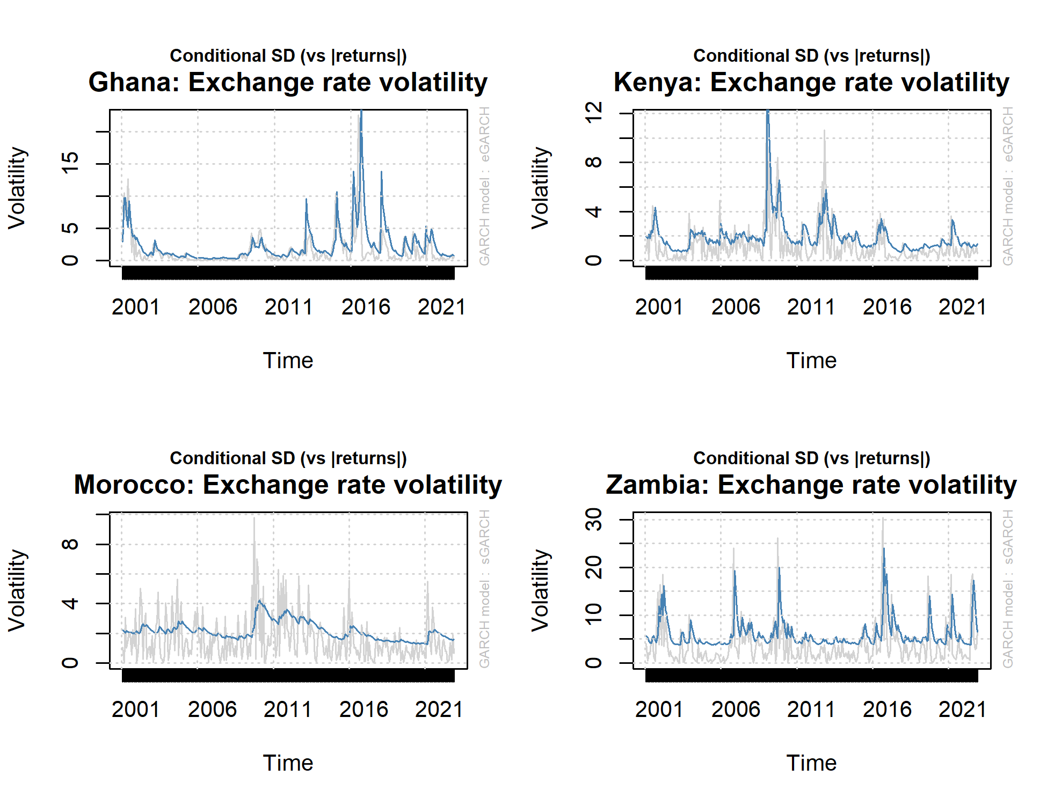
Figure 1: Volatilitiy Plots Below are the volatility plots, impulse response and variance decomposition under the SVAR estimation.
Figure 1: Volatilities
The graphs for volatility is presented in Figure 1. The exchange rate volatility in Ghana had an initial spike with mild clustering in the part of the sample. Later maintain stability between 2003 and pre-2008 financial crisis. Some spike occurred in 2008. From 2011 onward, there has been series of random spike in exchange rate volatility. The Kenya exchange are had a much stronger spike with the 2008 financial crisis. However, there is relative tranquillity during the 2020 covid-19 crisis compared to the previous financial crisis. Morocco exchange rate is quite stability with no significant spike in volatility compared to countries like Ghana and Kenya and Zambia. The case of the later country, there tends not be much prolong volatility clustering. However, the volatility spike coincides with the prominent economic and health crisis recorded within the sample range.
Figure 2: Trends of Exchange Rate Movement
Figurer 2 shows the various trends of exchange rate returns. The Ghana exchange rate has relative stable movement between 2001 and 2013. Subsequent periods has had significant fluctuation in its movement. For Kenya, the spike in exchange is more prominent around 2008. Morocco exchange rate has significant random fluctuations through. The Zambia exchange rate movement has had episode of ups and downs though not prolong for long periods of months. Same movement appears for Nigeria. However, the fluctuation is mild compared to Zambia. Similarly, a significant spike in the exchange rate after the first major spike with coincide in 2008 crisis occurred around 2016. The Nigeria economy suffered recession with the study period.

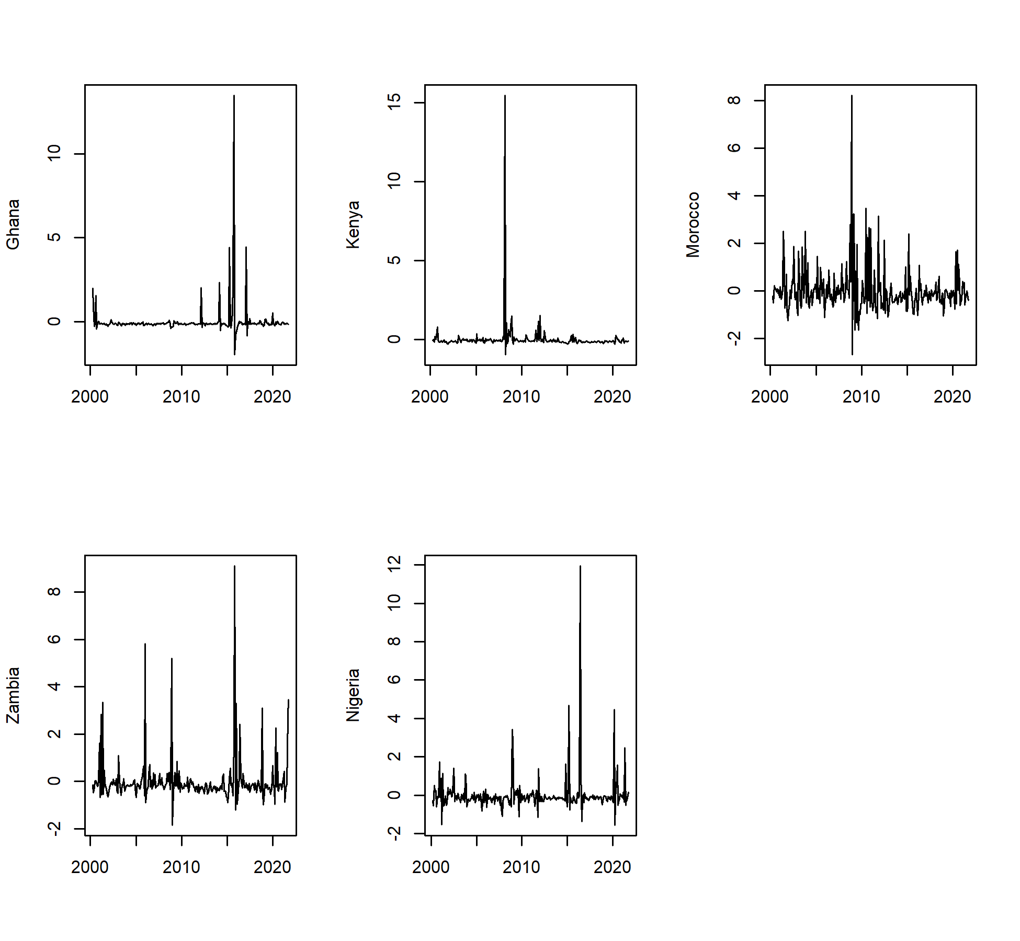
Figure 2: Shocks to exchange rate among the emerging economies in Africa

Impulse Response Results
The results of the response of exchange rate to one standard deviation shock to oil price is exhibited in Figure 3 and 4. The exchange rate of Kenya, Ghana, Zambia, and Morocco adopted in the SVAR was obtained from the GARCH estimation except for Nigeria.
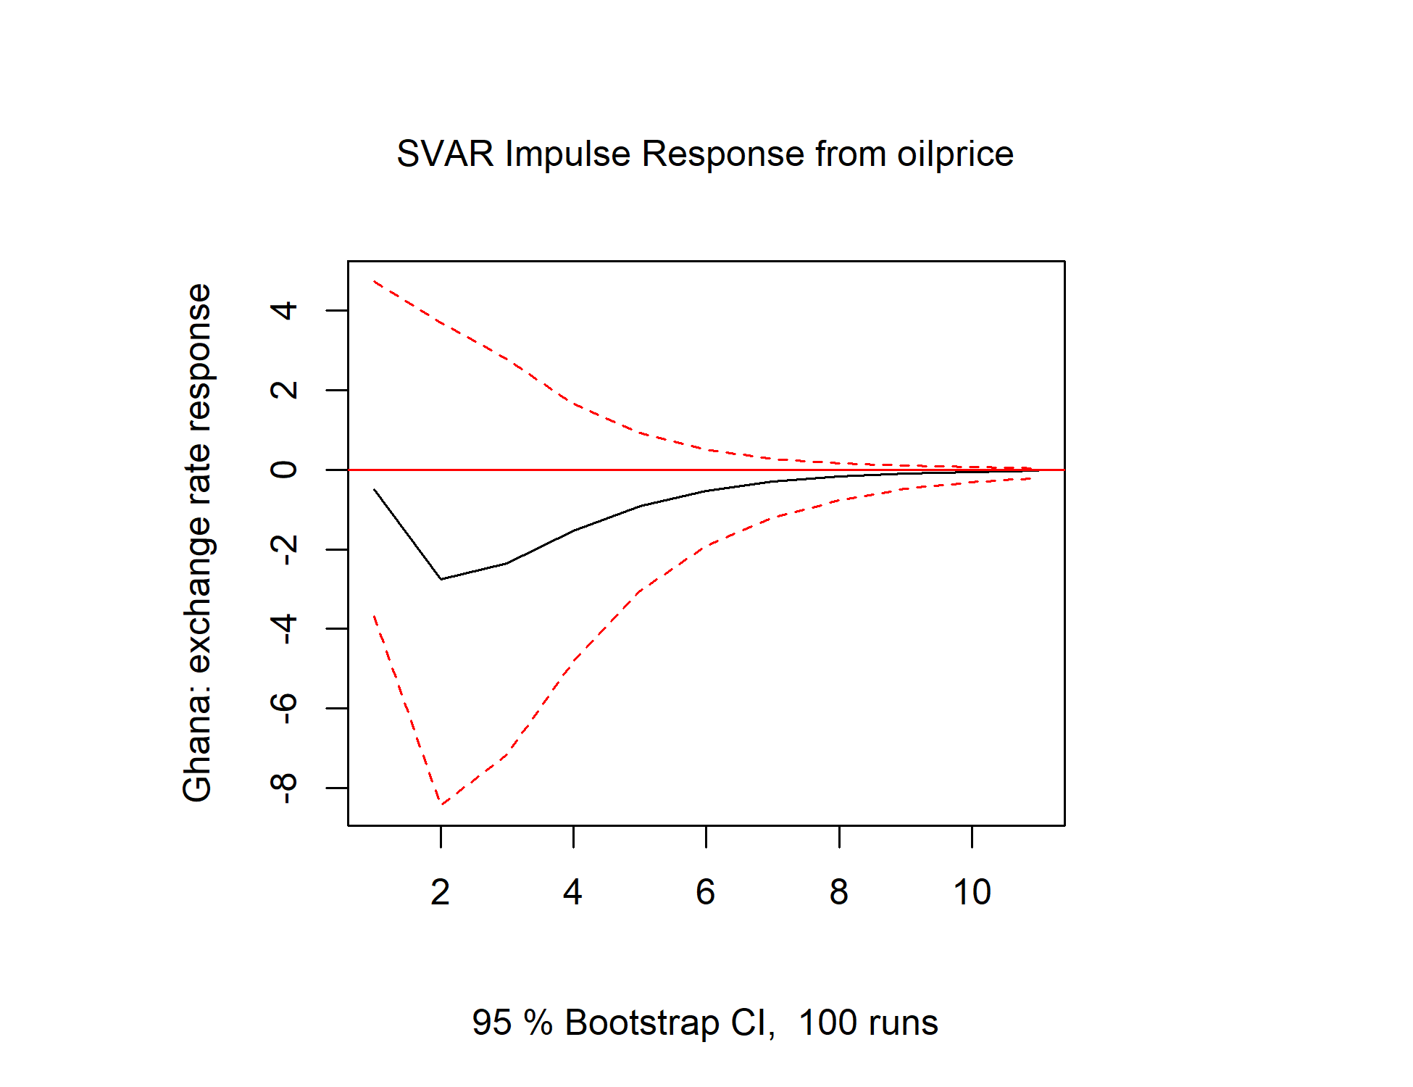
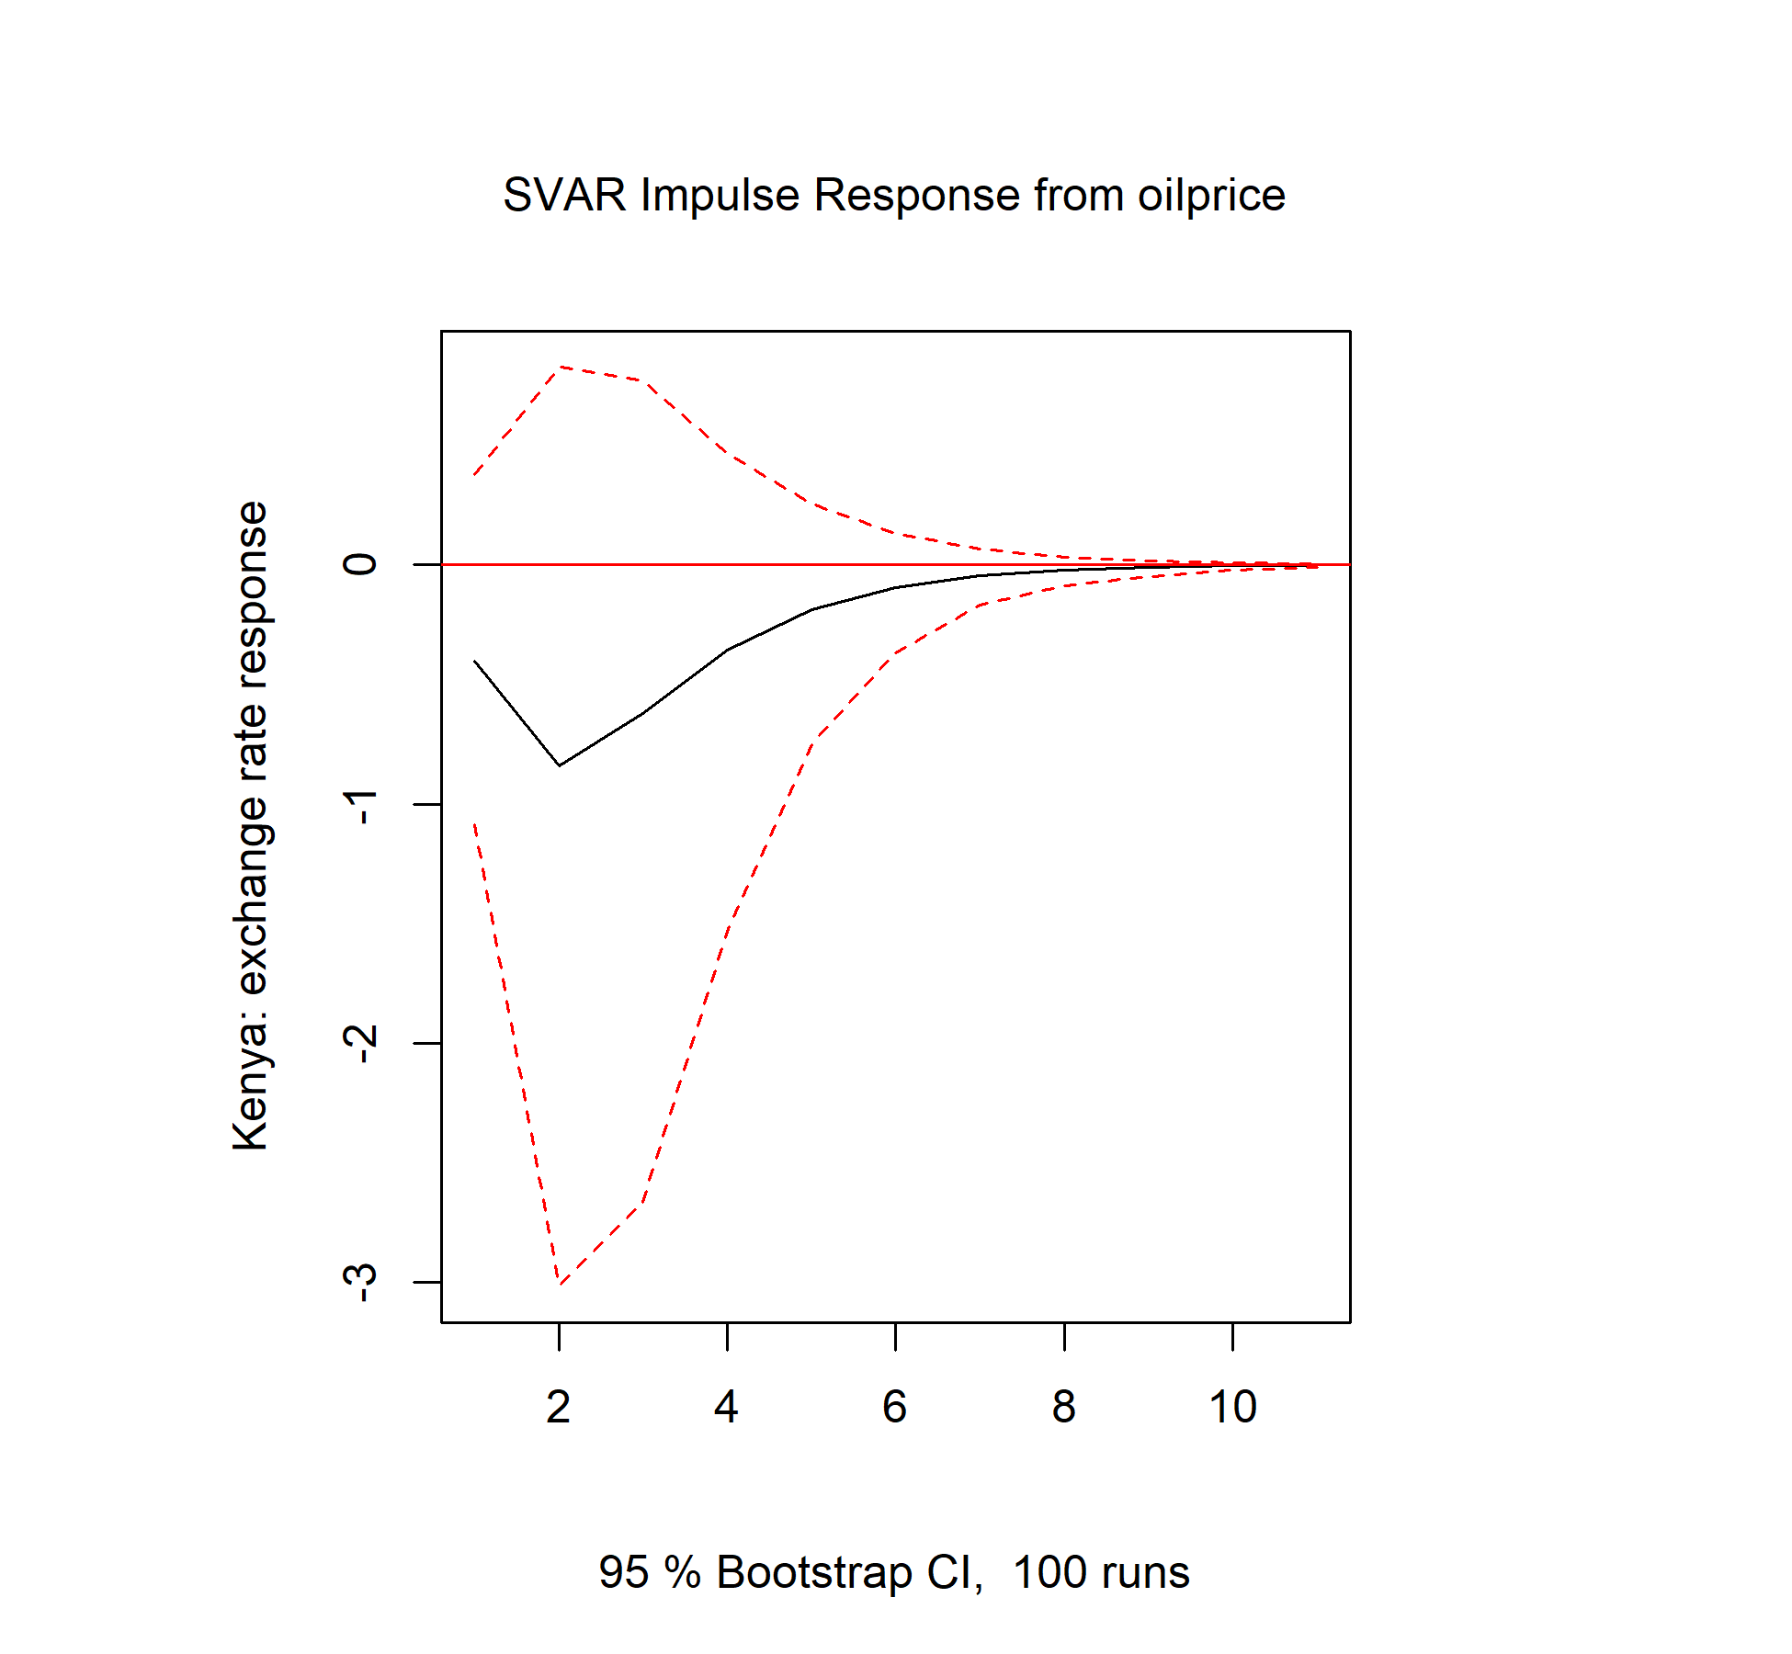
Figure 3: Impulse response for Kenya and Ghana
A standard deviation shock to oil price produce, though statistically insignificant appreciation of Kenya and Ghana exchange rate within the sample period in the first and second periods. Subsequently, these impact dies out around the 6th periods for Kenya and 7 periods for Ghana.

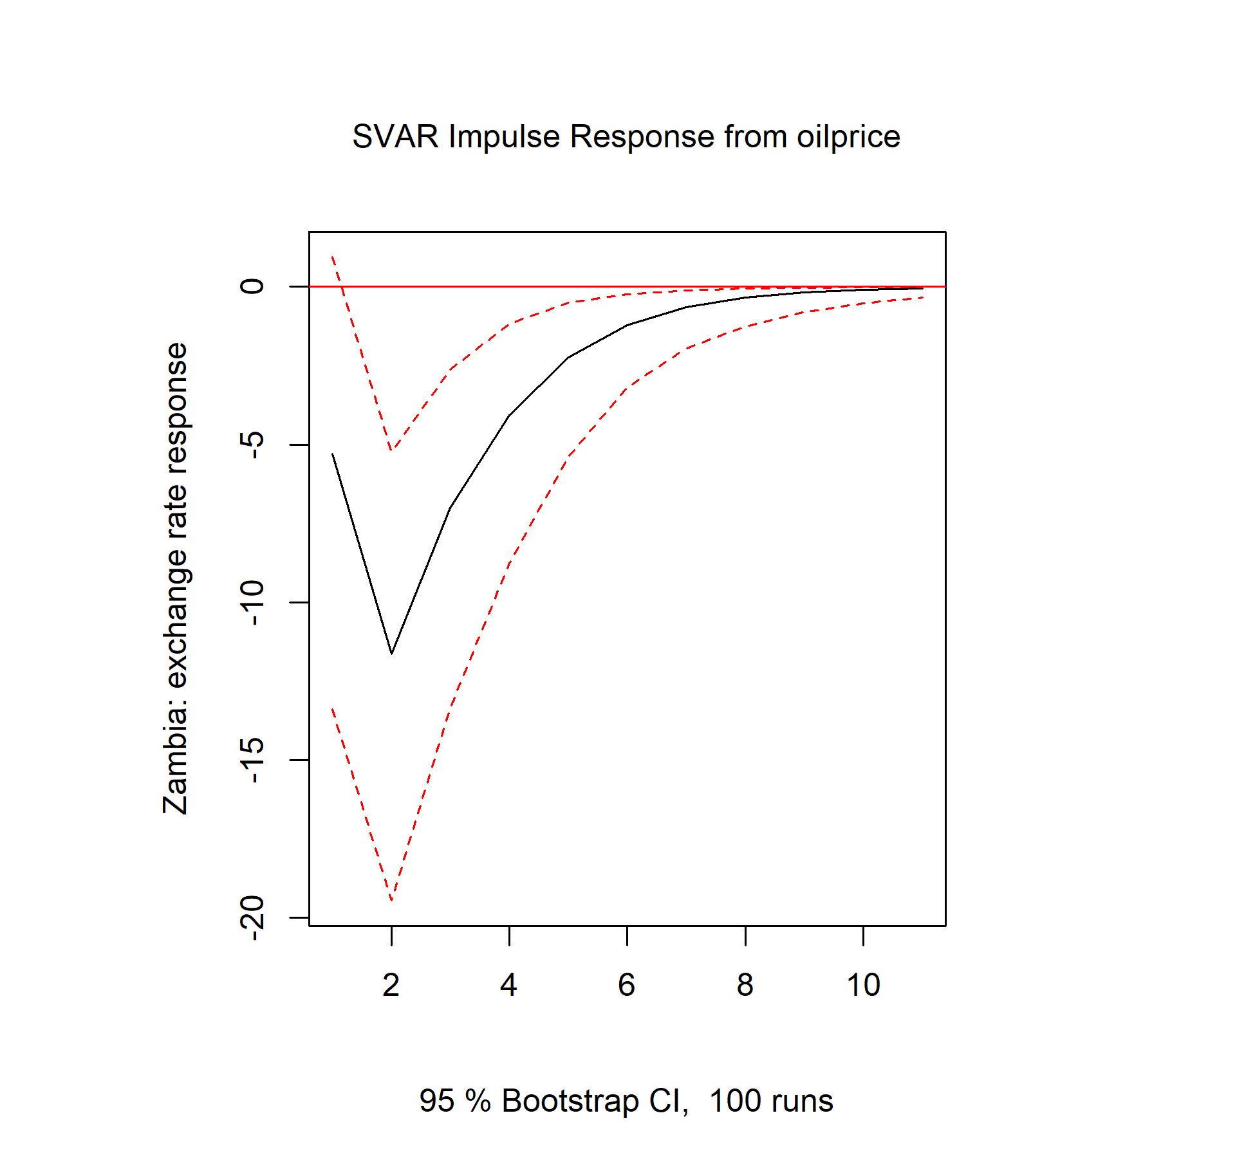
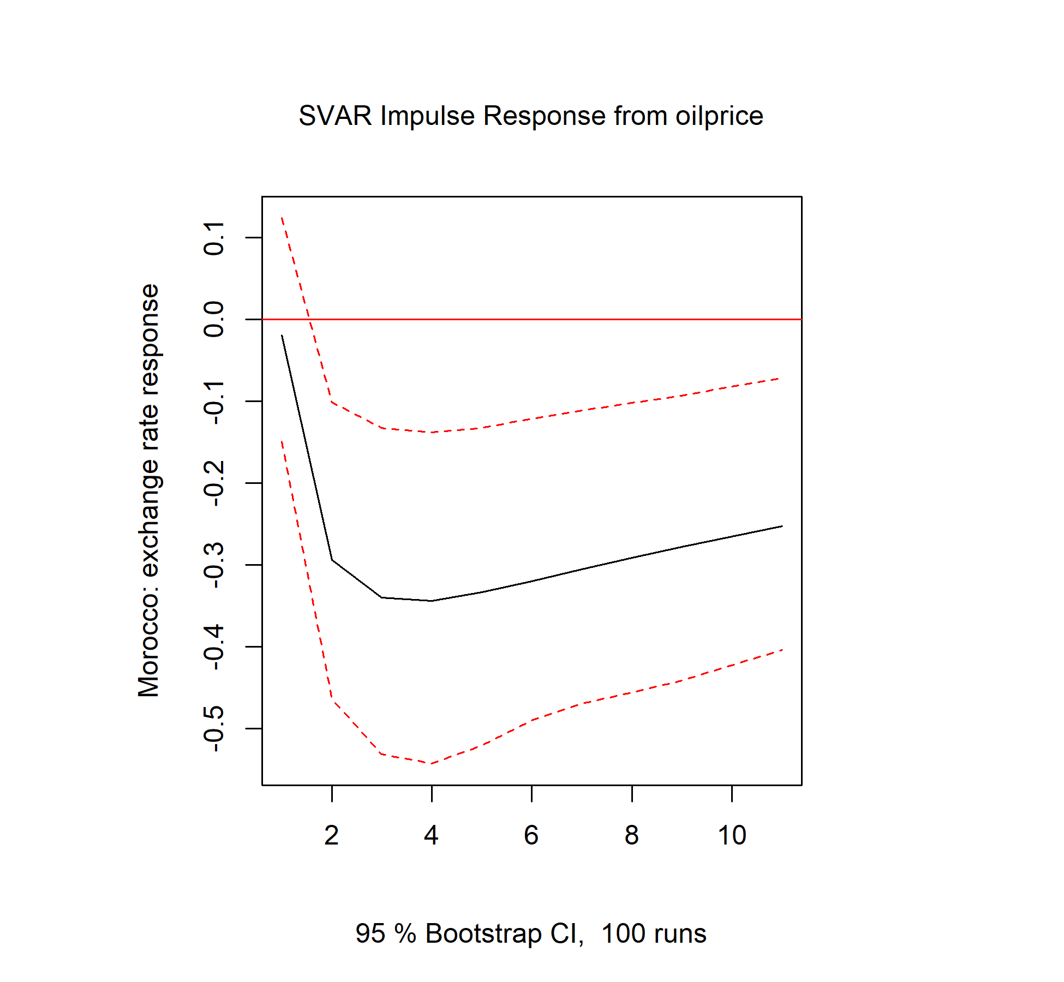
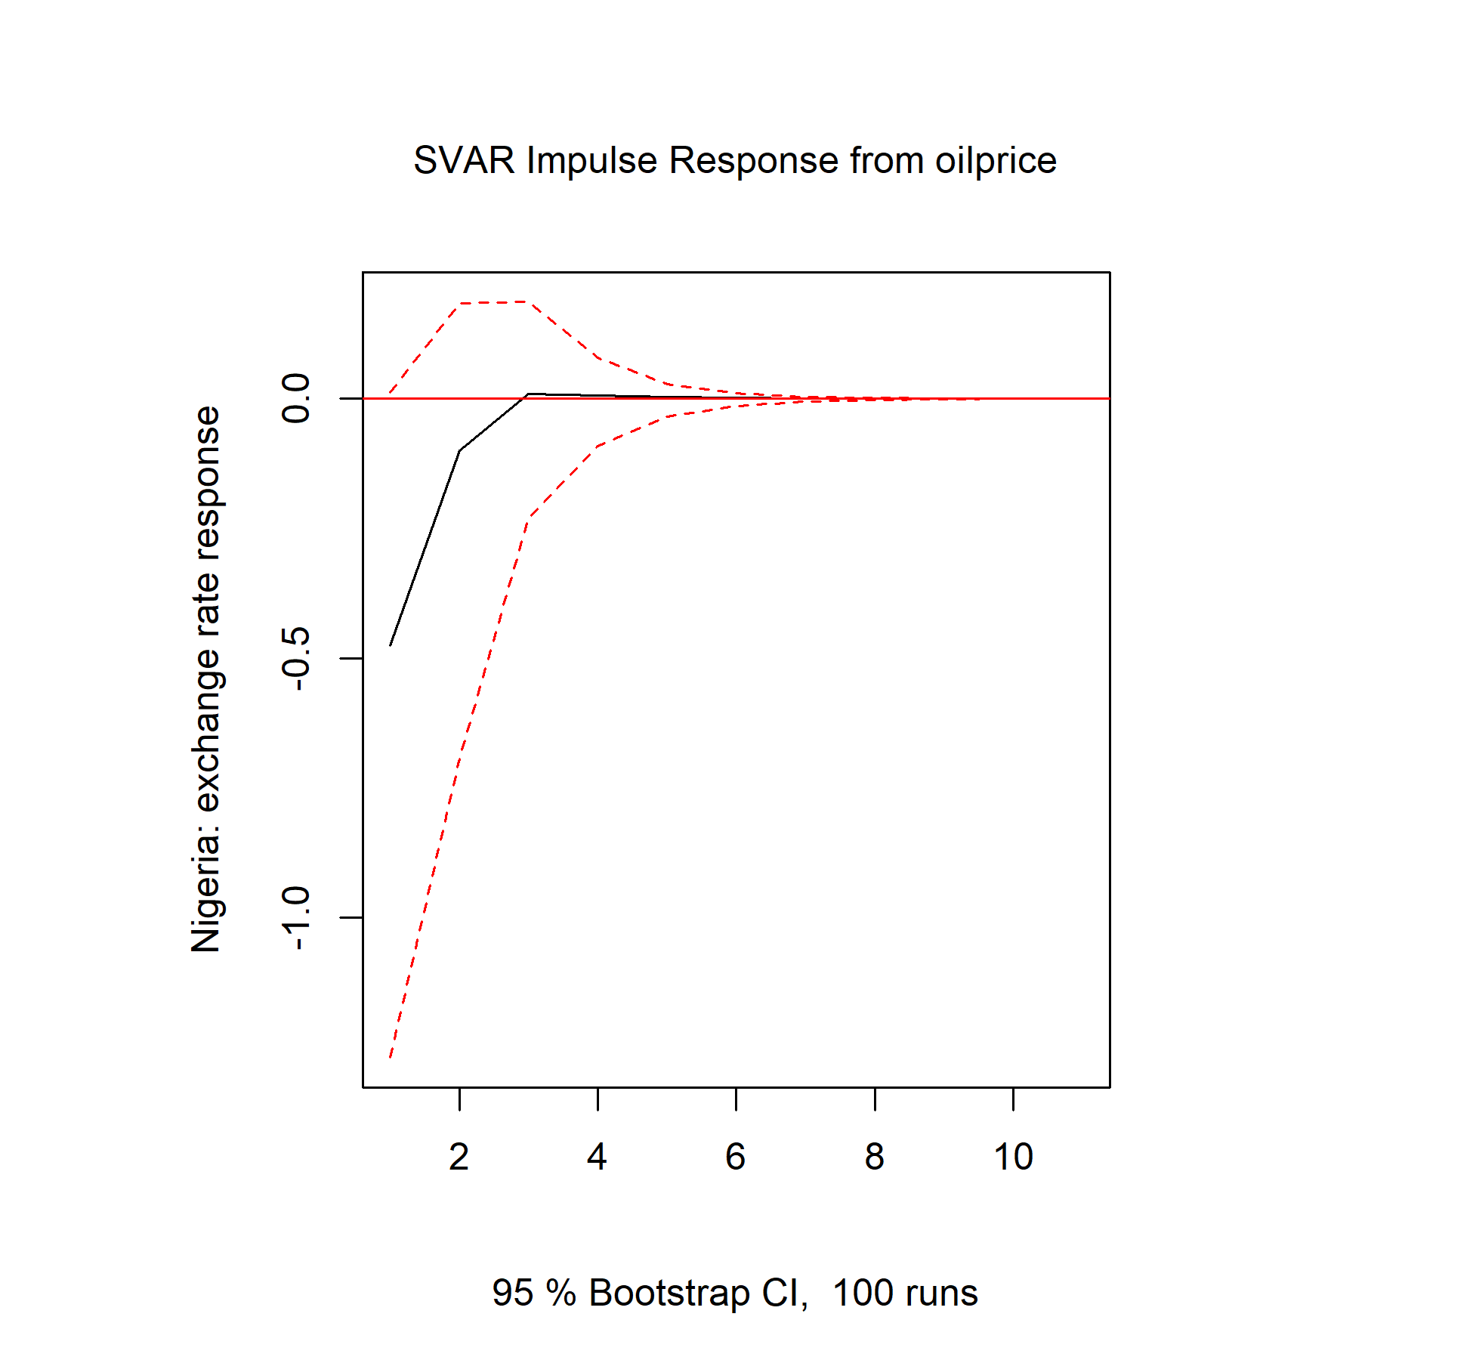
Figure 4: Impulse response of Exchange rate in Zambia, Morocco and Nigeria

Figure 4 also shows the response of Zambia, Morocco and Nigeria. There is contemporaneous appreciation of exchange rate in Zambia due to a one standard deviation positive shock to oil price. Same applies to Morocco and Nigeria. However, Zambia shock fizzle out subsequently after some lags. Morocco exchange rate response does stabilize around 0.3 whereas Nigeria exchange rate contemporaneous decrease fizzles out subsequently rendering the positive shock increase in oil price to be transitory.

Variance Decomposition Results
Table 10 present the variance decomposition for innovation in oil price. Innovation in oil price has a strong direct impact on its own movement throughout the period. Innovation in oil price has no contemporaneous effect on oil production. Starting from the third period, oil production maintains a stable 0.0013 changes in oil production. For exchange rate, innovation in oil price has no direct impact on exchange rate in the first and second periods. Subsequently, exchange rate response ranges around 0.0004 for Ghana, 0.003, 0.005 for Zambia and 0.006 for Nigeria.

Table 10: Variance Decomposition Results
 |  | Ghana |  |  | Kenya
Period |  | oil price | oil production | exchange rate | oil price | oil production | exchange rate
1 |  | 1.000 | 0.000 | 0.000 | 1.000 | 0.000 | 0.000
2 |  | 0.9985 | 0.0013 | 0.0002 | 0.9970 | 0.0012 | 0.0018
3 |  | 0.9984 | 0.0013 | 0.0003 | 0.9959 | 0.0013 | 0.0028
4 |  | 0.9983 | 0.0013 | 0.0004 | 0.9955 | 0.0013 | 0.0032
5 |  | 0.9983 | 0.0013 | 0.0004 | 0.9954 | 0.0013 | 0.0033
6 |  | 0.9983 | 0.0013 | 0.0004 | 0.9954 | 0.0013 | 0.0033
7 |  | 0.9983 | 0.0013 | 0.0004 | 0.9954 | 0.0013 | 0.0033

 | Zambia |  |  | Nigeria
Period | oil price | oil production | exchange rate | oil price | oil production | exchange rate
1 | 1.0000 | 0.0000 | 0.0000 | 1.0000 | 0.0000 | 0.0000
2 | 0.9957 | 0.0016 | 0.0026 | 0.9939 | 0.0015 | 0.0046
3 | 0.9940 | 0.0019 | 0.0041 | 0.9929 | 0.0016 | 0.0055
4 | 0.9934 | 0.0019 | 0.0047 | 0.9928 | 0.0016 | 0.0056
5 | 0.9932 | 0.0019 | 0.0049 | 0.9928 | 0.0016 | 0.0056
6 | 0.9931 | 0.0020 | 0.0049 | 0.9928 | 0.0016 | 0.0056
7 | 0.9931 | 0.0020 | 0.0050 | 0.9928 | 0.0016 | 0.0056

VAR Stability
The structural VAR was adopted to examine the responses of exchange rate to shocks in key variables like oil price while incorporating other variables like oil production as endogenous variables. To proceed, we begin with the VAR estimation. The table 11 present the stability test of the VAR model. The results indicated the VAR models for all the countries are stable since the root of the models are less than unity. So the estimates are stable and robust. The results for the Variance decomposition and the Impulse Response Function (IRF) are presented in the appendix section.

Table 11: VAR stability test
 | root1 | root2 | root3
Ghana | 0.56 | 0.29 | 0.1
Kenya | 0.47 | 0.3 | 0.1
Morocco | 0.95 | 0.29 | 0.1
Zambia | 0.53 | 0.26 | 0.09
Nigeria | 0.26 | 0.19 | 0.11

CONCLUSION
This study models and estimates heteroscedasticity in monthly exchange rates and also examined shocks of exchange rate shocks to global oil prices in ten African countries from January 2000 to December 2021. Heteroscedasticity was modelled using GARCH models. Structural Vector Auto regression (SVAR) was adopted to examining the response of exchange rate to shocks in global oil prices and oil production quota. The summary of the findings showed
- This shows Ghana exchange rate to dollar is the most relatively stable currencies in terms of variability among the reviewed countries. In addition, Malawi domestic currency is the most volatile currencies among the countries examined.
- Ghana, Kenya, Morocco and Zambia exchange rate poses heteroscedasticity worthy to be examined using the GARCH models. Other countries like Egypt, Malawi, Mauritius, Namibia, Nigeria and South Africa do not possess any ARCH term that can be examined in GARCH specification.
- Ghana and Kenya exchange rate are best forecast and examined using the exponential GARCH
- The standard GARCH may be more efficient in estimating the volatility of Morocco and Zambia exchange rates
- The results indicated the VAR models for all the countries are stable since the root of the models are less than unity indicating the SVAR system is stable and robust.
- For Ghana and Kenya, the arch and GARCH effect are both statistically significant indicating the volatility of exchange rate is influenced by its innovation and that shock in previous volatility and the rate of decay is very slow. The leverage effects in these countries indicated the magnitude of the impact of good news in this market is significantly different from that of bad news.
- The standard GARCH is applicable for Morocco and Zambia. For Morocco and Zambia, the arch effects were not statistically significant. This indicated the current volatility of exchange rate in Morocco is not significantly influenced by shocks to its innovation. However, the GARCH effect is statistically significant for Morocco but not significant for Zambia.

In conclusion, using EGARCH is more powerful tool to examined Ghana and Kenya exchange rate and standard GARCH may be more efficient in estimating the volatility of Morocco and Zambia exchange rates. We recommends the need for African countries to intensify efforts on diversification of production base in order drive enhance their exchange rate stability.

REFERENCES
Aliyu, S. U. R. (2010). Exchange rate volatility and export trade in Nigeria: An Empirical Investigation. Applied Financial Economics, 20(13), 1071-1084.
Arise, A. C., Osang, T., & Slottje, D. J. (2000). Exchange rate volatility and foreign trade: Evidence from Thirteen LDC's. J. Bus. Econ. Stat. 12 (1), 10–17.
Atoi, N.V. (2014) Testing volatility in Nigeria stock market using GARCH models. CBN
Journal of Applied Statistics, 5(2), 65-93
Basher, S. A., Haug, A. A., & Sadorsky, P. (2016). The impact of oil shocks on exchange rates: A Markov-switching approach. Energy Economics, 54, 11–23. doi:10.1016/j.eneco.2015.12.004 10.1016/j.eneco.2015.12.004
Bleaney, M., and Greenaway, D. (2001). The impact of terms of trade and real exchange rate volatility on investment and growth in sub-Saharan Africa. Journal of Development Economics, 65(2), 491–500. https://doi.org/10.1016/S0304-3878(01)00147-X.
Bollerslev T. (1986). Generalized autoregressive conditional heteroskedasticity. Journal of Econometrics, 31(3), 307–327. doi:10.1016/0304-4076(86)90063-1.
CBN (2010). Monetary Policy Transmission Mechanism in Nigeria, Research Department, Central Bank of Nigeria, Abuja.
Central Bank of Nigeria (2010). Statistical Bulletin, 50 years Special Anniversary Edition, Abuja
Central Bank of Nigeria (2011). Guideline for the operation of the foreign exchange market: wholesale dutch auction system forwards (WDAS-FWD).
Dickson, O. O., & Andrew, U. (2013). Exchange Rate Volatility Effect on Trade Variations in Nigeria. Mediterranean Journal of Social Sciences, 4(6), 401.
Ibrahim, M. H. (2005). Sectoral Effects of Monetary Policy: Evidence from Malaysia. Asian Economic Journal, 19(1), 83-102.
Kasman, A., & Kasman, S. (2005). Exchange Rate Uncertainty in Turkey and its Impact on Export Volume. METU Studies in Development, 32(1), 41–53.
Musyoki, D., Pokhariyal, G. P., & Pundo, M. (2012). The Impact of real exchange rate misalignment on economic Growth: Kenyan evidence. Research Journal of Finance and Accounting, 7(1), 59–75.
Nelson D.B (1991). Conditional heteroskedasticity in asset returns: A new approach. Econometrica, 59(2), 347–370. doi:10.2307/2938260.
Olowe, Ayodwji R (2009). Modelling Naira/dollar exchange rate volatility: Application of GARCH and Assymetric Models. Int. Rev. Bus. Res. Papers, 5(3): 377-398.
Pelinescu E. (2014) Volatility analysis of the Romanian exchange rate. Procedia Economics and. Finance 8:543–549.
Poon SH, Granger, C.W.J. (2003). Forecasting volatility in financial markets: A Review. J. Econ. Lit., 41: 478-539.
Rahman, Mohammad Mafizur, & Mohammad Abul Kashem (2017). Carbon emissions, energy consumption and industrial growth in Bangladesh: Empirical evidence from ARDL cointegration and Granger causality analysis. Energy Policy 110: 600–8.
Ramasamy R, Shanmugam Munisamy D (2012) Predictive accuracy of GARCH, GJR and EGARCH models select exchange rates application. Glob J Manag Bus Res, 12(15):89–100.
Rofael D, Hosni R (2015) Modeling exchange rate dynamics in Egypt: observed and unobserved volatility. Mod Econ 6(01): 65.
Serenis, D., & Tsounis, N. (2014). Exchange rate volatility and aggregate exports: evidence from two small countries. ISRN Economics, 2014(2014).
Umaru, H., A, A. N., and Davies, N. O. (2018). The effects of exchange rate volatility on economic growth of West African English-speaking countries. International Journal of Academic Research in Accounting, Finance and Management Sciences, 8(4), 131–143. https://doi.org/10.6007/IJARAFMS/v8-i4/5470
Umoru D. (2022), Devaluation of Naira, Shocks, and Realities: Evidence Disciplining Strength. 4th Inaugural Lecture Series of Edo State University Uzairue, Nigeria.

