GEOLOGICAL MAPPING AND MINERALIZATION POTENTIALS IN POLYPHASE DEFORMED BASEMENT ROCKS, EAST OF OKEMESI FOLD
BELT, SOUTHWESTERN NIGERIA
*Ayodele Olusiji Samuel *Ajigo Isaac Ominyi
*Department of Applied Geology, The Federal University of Technology Akure, Nigeria
Corresponding Email: osayodele@futa.edu.ng; samuelayodeleolusiji@yahoo.com

ABSTRACT
The study area covers Ikogosi, Igbara odo, Ipole, Erijiyan and Araromi Ekiti respectively which are underlain by basement rocks that have undergone several episodes of tectonic deformation culminating into different styles of folding, migmatization and granitization with large scale occurrences of deep seated structures such as fractures, joints, foliations and steep angle dips, which are the manifestations of the pervasive Pan African orogeny in the studied area. Geological mapping of the rocks was carried out at a scale of 1:25000 with a view to understanding their geologic and structural settings as well as unravel their economic mineral potentials. The study area lies between longitudes 4°59'0"E and 5°5'0" E and latitudes 7°31'0"N and 7°36'0"N respectively, covering a total surface area of approximately 48km². The underlying lithologic units in the study area include; migmatites, granites, granite-gneiss, quartzites (massive and schistose types) as well as pegmatites which are the late intrusives and occurred as veins and dykes varying lengths and sizes. The cross-sectional map of the area confirmed folding episodes which are polyphaser in nature and the type of folds recognized are ptygmatic, asymmetrical, tight, and isoclinal to overturned antiformal folds. Others structures are joints, micro faults, xenoliths, fractures and sheared surfaces arising from brittle to ductile deformational events.. The rose diagram produced showed that the dominant trend of the tectonic forces are from NW-SE directions. A total of 22 rock samples were carefully selected from the fifty-two (52) bulk samples picked at a sampling interval of 100m-200m. These samples were prepared for thin sections and mounted on the microscopic stage for study. The dominant minerals observed in the slides and photomicrographs produced revealed some rock forming minerals such as quartz, feldspar (microcline, plagioclase and orthoclase), biotite and muscovite and opaque mineral such as iron oxide. Some gem minerals such as garnets, blue and green tourmaline crystals were also discovered from mining sites and abandoned pits. However, the studied areas exhibit potentials for gemstones and other specialty minerals. However, the study area is recommended for further probing to discover hidden ore bodies and delineate their zones for possible exploration.
Keywords: Ikogosi; Lithologic Units; Deformation; Gemstones; Exploration

INTRODUCTION
Gemstones are specialty minerals usually hosted by pegmatites especially the complex ones which normally exhibit zoning. The pegmatites are specialized types of rocks that occurred as late stage intrusive rocks. They intrude pre-existing rocks such as granites, migmatites, gneisses, schists etc. They are widely distributed in Precambrian terrains such as those in Southwestern Nigeria and Ekiti State in particular. The Precambrian Basement of Southwestern Nigeria has undergone several episodes of deformation and metamorphism. (Rahaman, 1988). The general north-south trend of major fractures and foliations within the Basement complex is as a result of deformation (Odeyemi, 1992). Odeyemi (1977) noted that the rocks in the study area show evidence of polyphase deformation with the plutonic episode of the Pan African event being the most pervasive. Rahman, (1988) also noted that the south western basement complex of Nigeria lies within the rest of the Precambrian rocks in Nigeria, He grouped the rocks in this region as migmatite – gneiss – quartzite complex comprising largely of sedimentary series with associated minor igneous rock intrusions which have been altered by metamorphic, migmatitic and granitic processes. Oluyide, (1988) suggested that almost all the foliation exhibited by rocks of southwestern Nigeria excluding the intrusive are tectonic in origin, because pre-existing primary structures have been obliterated by subsequent deformation. Anifowose, (2006) also noted that joints ranging from minor to major ones are found in all the rock types, some of which are filled with quartz, feldspars or a combination of both which lie generally in the NE-SW direction, while (Ajibade, 1986; Rahman, 1988) suggested that the south western basement complex of Nigeria has been affected by two phases of deformation namely D1, D2, the first phase (D1) produced tight to isoclinals folds while the second phase (D2) is characterized by more open folds of variable style and large vertical NNE-SSW trending fault. One author gave evidence that within the basement complex, tectonic deformation has completely obliterated primary structures except in a few places where they survived deformation (Okonkwo, 1992). Geologic mapping has been carried out in the Erijiyan axis to map the quartzites and the quartz-schists (Ayodele and Ajigo, 2019), while there is paucity of information or no information at all on the nature and type of pegmatite bodies in Ikogosi and its environs which is assumed to be mineralized. Therefore, this research is aimed at carrying out detailed geological mapping and exploration for gemstones in the deformed Precambrian rocks of the study area.

THE STUDY AREA
The study area covering Ikogosi, Ogotun, Apapolu, Erijiyan, Araromi, Ipole and Igbara-Odo, all in Ekiti Southwest local government area, is situated in the eastern part of Okemesi Fold Belt (Figure 1). It lies within longitudes 4°57'0"E and 5°5'0" E and latitudes 7°31'0"N and 7°37'0"N, covering an estimated area of 48km². The study area is accessible through major road network and footpaths. Traversing the area was also made easy with the assistance of the local settlers who helped to locate existing outcrops in initially inaccessible areas. Stream channels were also useful indicators. Topography is characterized by ridges, undulating hills and valleys (Figure 2). The mapped area is characterized by high and low relief which is generally referred to as “rolling topography” as indicated by the hills, valleys and gently undulating plains (Figure 2). Also, the area has a rugged topography, as some of the hills are high while others are relatively lower. The uneven topography is caused by the crystalline nature of the different rocks found in the area and their differential responses to weathering. The highest topographic height encountered was about 1800m above mean sea level. Also, the study area is characterized by relatively dense drainage which is of dendritic and trellis patterns. The rocks mapped in the delineated sites are not suitable for geochemical analysis due to the intensity of chemical weathering and as a result of the tropical nature of the climate which is always associated with high rate of rainfall which has rendered the rocks fabric weak, thereby shattering easily under the force of geologic hammer.
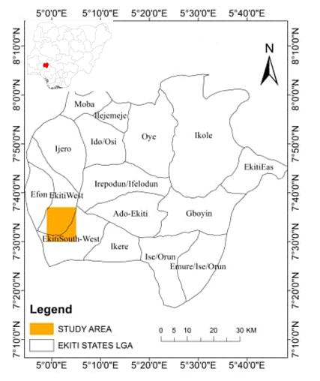
Figure 1: Map showing location of the study area. (Adapted from map of Nigeria/LGA map)
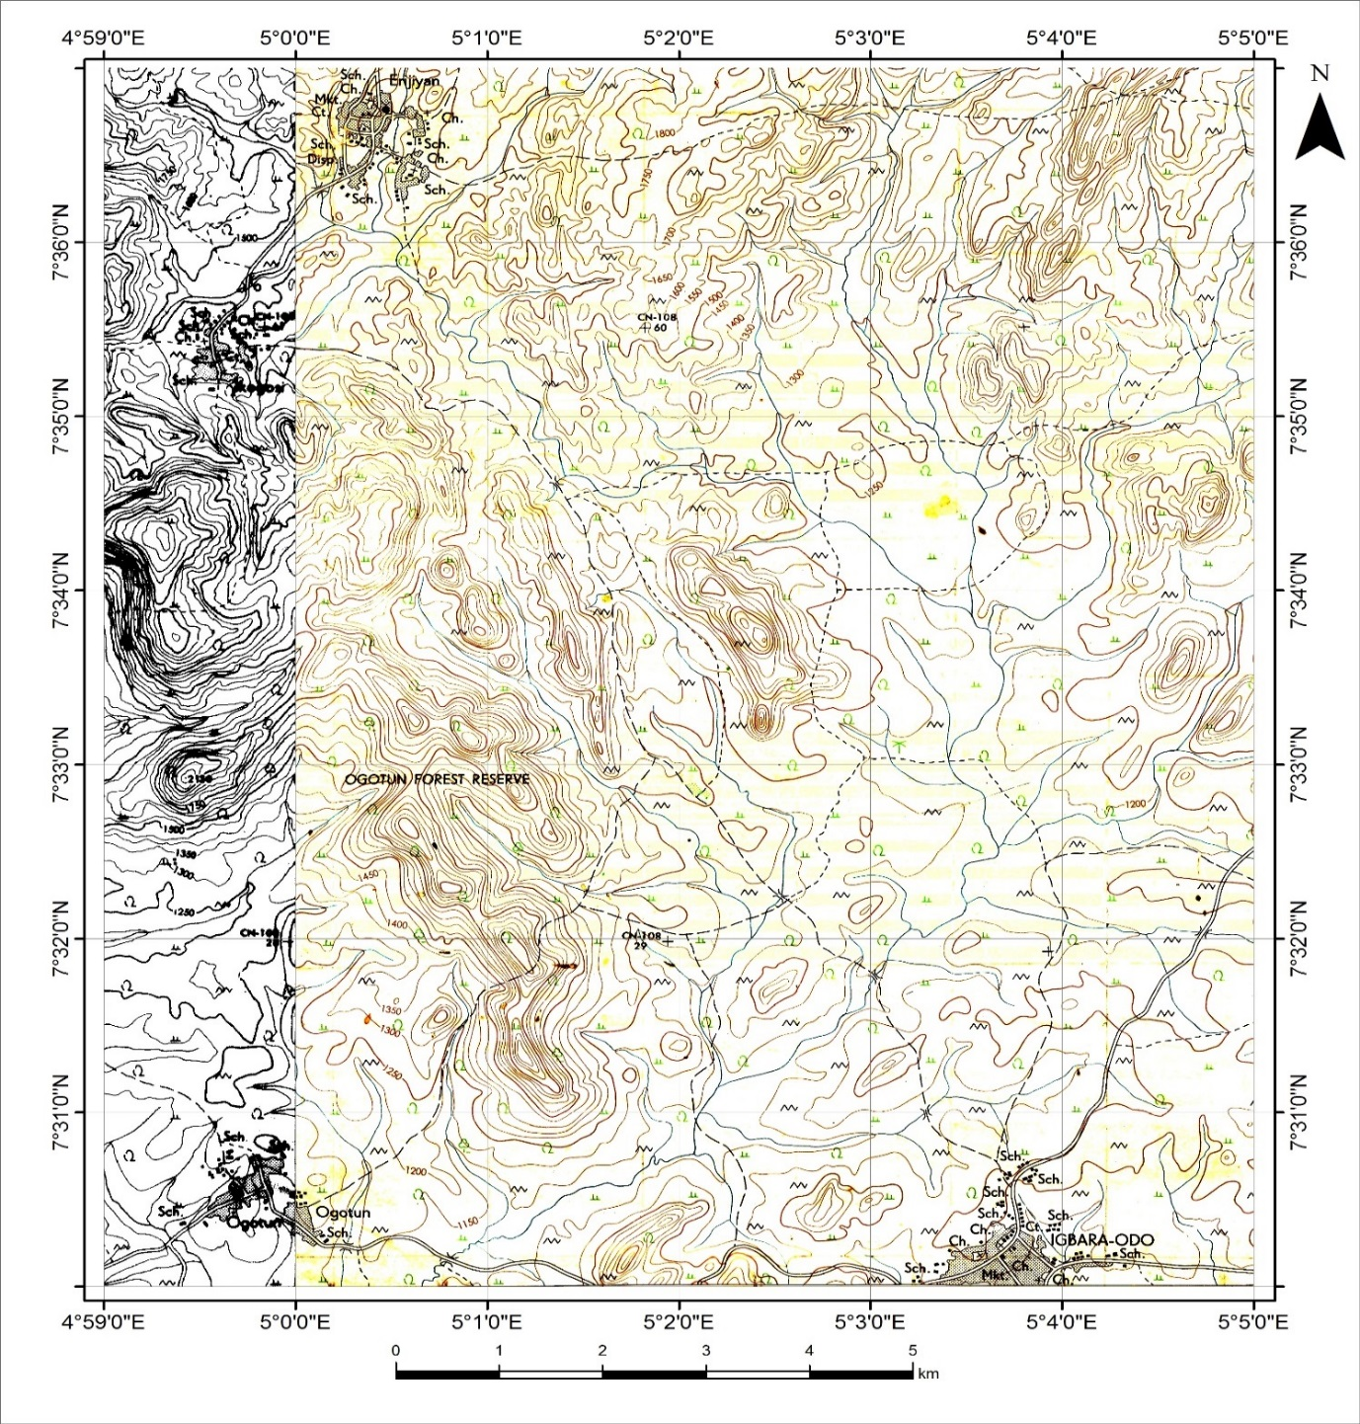
Figure 2: Topographic (Base) Map of the study area GSN, 2006)
MATERIALS METHOD
The method of study for this investigation can be divided into two parts namely: Field Investigation and Laboratory Investigation. The field investigation involves geological mapping and collection of samples. Geological mapping was carried out with the aid of the topographic (base) map of the study areas acquired at a scale of 1:25,000 (Figures 2 3). The rocks encountered in the area include quartzites (massive and schistose), migmatite-gneiss, granites, granite-gneiss and pegmatites which intruded majorly on the quartzites, granites and granite-gneisses as dykes and veins. Their accurate geographical positions were determined with the global positioning systems (GPS) and recorded in the field notebook. Structures such as folds, fractures, joints were also mapped on the different rocks and their orientations were measured and recorded also in the field notebook. The attitude (dip and strike) of the rocks were measured using the Compass clinometer. The method of sampling adopted is systematic in order to effectively cover the study areas. Rock samples were picked at intervals of two hundred meters (200m) to ensure uniformity in sampling. However, sampling was very difficult to carry out based on the degree of weathering of the rocks and inaccessibility to some areas due to its relief and sharp depressions. At the end, fifty-two (52) samples were collected for the next stage of investigation. All the samples collected were labeled and bagged. The geographical coordinates of the various locations and other field data collected and tabulated.
The petrographic studies were carried out with the aid of the following; Binocular Polarizing Microscope with Toupcam Digital Camera (3.1MP), and Computer.
The laboratory analysis was carried out at the Petrology laboratory of the Department of Applied Geology, The Federal University of Technology, Akure. The rock samples were thoroughly washed and rinsed with distilled water. After allowing the bulk samples to be air dried. Twenty-two (22) rock samples were carefully selected based on their degree of weathering for laboratory investigation. They were later cut into thin sections using manual thin section method and prepared as rock slides with necessary materials and reagents using the standard procedures and techniques. The rock slides were mounted on stage of the Petrological Binocular Microscope for viewing under transmitted light to detect and study the mineral composition of the rocks. Attached with the microscope is the Topcam digital camera (3.1MP). The purpose of the camera is to take snapshots of the slides and produce the photomicrographs of the different minerals, while analysis and identification is carried out on the desktop computer attached to the camera which brings out the optical behavior and character of these minerals under plane polarized and crossed polarized light

RESULTS AND DISCUSSION
- Field investigation
The geological map presents the various rock units and their distribution patterns in the study area. Six major lithologic units were identified which includes the granite-gneiss (oldest) to the pegmatite (youngest) occupying strategic locations with well-delineated boundaries. The pegmatites are the late-stage intrusives occurring as dykes and veins on the pre-existing rocks which are products of the Pan African orogeny (Figure 3a). The cross-sectional maps as revealed by the dipping angles of the rocks also reveal this fact (Figures 3a&b). The folding episodes affected the schistose quartzites, granite gneiss and the granite. This can be attributed to the compressive tectonics which occurred during the deformation episodes, (Tables 1a & b). This also confirmed that fracturing postdated the folding episodes in the studied area. The various rock types mapped and their delineated boundaries were used to produce a geological and cross-sectional maps of the studied area (Figure 3).

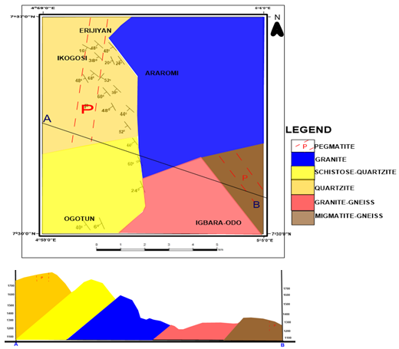Figure 3a: Geological and cross-sectional map of the area
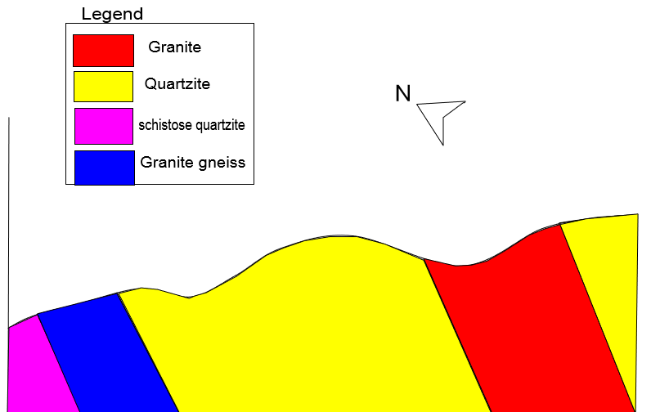
Figure 3b: A cross section of Asymmetric fold profile generated from dip plots
Table1a. Summary of Field Data
Location | Latitude | Longitude | Rock Names | Strike and dip measurements | Joint and fractures orientations | Rock types
1 | N 07⁰ 35’ 22’’ | E 05⁰ 0’ 36’’ | Schistose Quartzite | 284⁰ W, 30⁰ E | Weathered | Metamorphic
2 | N 07⁰ 35’ 22’’ | E 05⁰ 0’ 38’’ | Quartzite | - | Weathered | Metamorphic
3 | N 07⁰ 35’ 10’’ | E 05⁰ 0’ 53’’ | Mine site for tourmaline;Quartzite with pegmatite intrusion. | - | Mining pit | Metamorphic
4 | N 07⁰ 35’ 00’’ | E 05⁰ 1’ 14’’ | Quartzite | - | Weathered | Metamorphic
5 | N 07⁰ 34’ 58’’ | E 05⁰ 1’ 15’’ | Quartzite | 341⁰ NW, 75⁰W | Weathered | Metamorphic
6 | N 07⁰ 34’ 43’’ | E 05⁰ 1’ 16’’ | Quartzite | - | Weathered | Metamorphic
7 | N 07⁰ 34’ 44’’ | E 05⁰ 1’ 17’’ | Quartzite | - | Weathered | Metamorphic
8A | N 07⁰ 30’ 07’’ | E 05⁰ 2’ 42’’ | Granite | - | Pegmatite Veins | Igneous
8B | N 07⁰ 30’ 07’’ | E 05⁰ 2’ 41’’ | Granite | - | Joints and folds | Igneous
8C | N 07⁰ 30’ 05’’ | E 05⁰ 2’ 41’’ | Granite | - | Joints and folds | Igneous
9 | N 07⁰ 30’ 08’’ | E 05⁰ 3’ 30’’ | Granite | - | Xenoliths folds and fractures | Igneous
10 | N 07⁰ 30’ 08’’ | E 05⁰ 2’ 41’’ | Granite | - | Joints and folds | Igneous
11 | N 07⁰ 30’ 11’’ | E 05⁰ 3’ 30’’ | Granite | - | Joints and folds | Igneous
12 | N 07⁰ 30’ 24’’ | E 05⁰ 3’ 38’’ | Granite | - | Joints and fractures | Igneous
13 | N 07⁰ 30’ 35’’ | E 05⁰ 3’ 44’’ | Contact of Granite and Migmatite Gneiss |  | 315⁰ NW, 313⁰ NW, 308⁰ NW, 311⁰ NW, 321⁰ NW | Igneous and Metamorphic
14 | N 07⁰ 30’ 36’’ | E 05⁰ 3’ 41’’ | Contact of Granite and Migmatite-Gneiss | - | 332⁰ NW, 314⁰ NW, 318⁰ NW, 117⁰ SE, 264⁰ SW, 132⁰ SE | Igneous and Metamorphic
15 | N 07⁰ 30’ 45’’ | E 05⁰ 3’ 35’’ | Granite | - | Xenolith | Igneous
16 | N 07⁰ 36’ 09’’ | E 04⁰ 59’ 55’’ | Quartzite | - | Weathered | Metamorphic
17 | N 07⁰ 36’ 47’’ | E 05⁰ 0’ 25’’ | Quartzite | - | Weathered | Metamorphic
18 | N 07⁰ 36’ 49’’ | E 05⁰ 0’ 25’’ | Quartzite | - | Weathered | Metamorphic
19 | N 07⁰ 36’ 50’’ | E 05⁰ 0’ 39’’ | Quartzite | - | Weathered | Metamorphic
20 | N 07⁰ 36’ 38’’ | E 05⁰ 0’ 39’’ | Granite | - | 184⁰ SE, 342⁰ NW | Igneous
21 | N 07⁰35’20.6’’ | E 05⁰ 0’40.5’’ | Schistose Quartzite | 342⁰ NE 68⁰ E | Weathered | Metamorphic
22 | N 07⁰ 36’ 15’’ | E 04⁰ 59’ 57’’ | Quartzite | - | Weathered | Metamorphic

Table1b. Summary of Field Data continued
Location | Longitude | Latitude | Lithology | Strike | Dip | Texture | Structure
23 | 05⁰ 0 40.5''E | 07⁰35'20.6''N | Schistose Quartzite | 342⁰ NE | 68⁰ E | Schistocity | Veins, Joints
24 | 05⁰ 0'38.1''E | 07⁰35'22.3''N | Schistose Quartzite | 156⁰, 148⁰ SE | 60⁰, 48⁰ E | Schistocity | Veins, Joints
25 | 05⁰ 0'36''E | 07⁰35'22''N | Schistose Quartzite |  |  | Schistocity | Veins, Joints
26 | 05⁰ 0'37.9''E | 07⁰35'21.7''N | Schistose Quartzite |  |  | Schistocity | Joints
27 | 05⁰ 0'38.8''E | 07⁰35'21.7''N | Schistose Quartzite | 352⁰ NE | 52⁰ E | Schistocity | Veins, Folds
28 | 05⁰ 0'39.8''E | 07⁰35'21.0''N | Schistose Quartzite | 354⁰ | 60⁰ W | Schistocity | Veins, foliation planes, folds
29 | 05⁰ 0'44''E | 07⁰36'25''N | Granite |  |  | Fine to medium grained | Veins, solution holes, exfoliation
30 | 04⁰ 58'47.1''E | 07⁰35'19.0''N | Schistose Quartzite |  |  | Schistocity | Foliation planes, joints, folds
31 | 04⁰ 58'29.5''E | 07⁰35'30.9''N | Schistose Quartzite | 290⁰, 291⁰ NW | 38⁰, 48⁰ W | Schistocity | Fractures
32 | 04⁰ 58'30''E | 07⁰35'33''N | Schistose Quartzite | 232⁰, 230⁰ NW | 20⁰, 24⁰ W | Schistocity | Fractures
33 | 04⁰ 58'26''E | 07⁰35'34''N | Schistose Quartzite |  |  | Schistocity | Fractures
34 | 04⁰ 58'06''E | 07⁰35'39''N | Schistose Quartzite | 336⁰, 322⁰ NW | 16⁰, 16⁰ W | Schistocity | Fractures
35 | 04⁰ 55'42.7''E | 07⁰33'56.0''N | Quartzite |  |  | Gritic | Joints
36 | 04⁰ 55'42.6''E | 07⁰33'55.1''N | Quartzite | NE-SW | E |  | Fractures
37 | 04⁰ 55'43.2''E | 07⁰33'19.4''N | Quartzite | 320⁰ NW | 52⁰ E | Sugary | Fractures
38 | 05⁰ 00'16''E | 07⁰36'47''N | Quartzite |  |  | Fine to medium grained | Veins, joints
39 | 04⁰ 59'57''E | 07⁰ 36'15''N | Quartzite |  |  | Fine to medium grained | Veins, joints
40 | 05⁰ 00'35''E | 07⁰ 35'23''N | Quartzite | 178⁰,174⁰, 168⁰, 171⁰ SE | 38⁰, 42⁰, 44⁰, 46⁰ E | Fine to medium grained | Veins, joints
41 | 04⁰ 55'41''E | 07⁰ 33'05''N | Quartzite |  |  | Fine to medium grained | Joints
42 | 04⁰ 55'40''E | 07⁰ 33'09''N | Quartzite |  |  | Fine to medium grained | Joints
43 | 04⁰ 57'21''E | 07⁰ 34'26''N | Granite gneiss
44 | 04⁰ 57'53''E | 07⁰ 33'56''N | Granite gneiss |  |  |  | Joints, folds
45 | 04⁰ 57'49''E | 07⁰ 33'56''N | Granite |  |  |  | Joints, folds
46 | 04⁰ 57'46''E | 07⁰ 34'05''N | Granite |  |  |  | Joints, folds
47 | 04⁰57'19''E | 07⁰ 34'25''N |  |  |  |  | Xenolith, folds, fractures
48 | 04⁰58'08''E | 07⁰ 34'37''N | Quartzite
49 | 04⁰57'11''E | 07⁰ 34'37''N | Quartzite
50 | 04⁰00'06''E | 07⁰ 36'30''N | Quartzite
51 | 04⁰00'36''E | 07⁰ 35'22''N | Quartzite
52 | 05⁰ 0'53''E | 07⁰ 35'10''N | Quartzite

Granite Gneiss were found mostly in contact with the granites and occurred as low-lying rocks. They display quartz and pegmatite veins and conjugate fractures because the fractures are parallel to the foliation plane followed by another fracture sets at angle to the other. Pegmatite dykes were also seen on the outcrop. They represent the oldest rocks in the investigated locations. There are series of folding observed on the outcrop which are superimposed which is suggestive of different folding episodes. Other observable features are veins and joints. The texture of the granite-gneiss ranges between medium grained to coarse- grained. Observable minerals with the eyes include biotite, quartz and plagioclase feldspar.
Quartzite is a major rock type in the study area, occupying relatively a large portion than granite. Two types of quartzites (massive and schistose) dominated the studied area. It was discovered in the north eastern to the central part of the area. The massive ones are dark to reddish brown in colour and extensive. Some road cut outcrops mapped are highly weathered and showed the presence of muscovite foliations, pegmatite veins. Folding occurred on these outcrops based on the dipping angles of their limbs in opposite directions (Tables 1). Such folds include ptygmatic and recumbent folds. However, the schistose quartzite dominated 40% of the studied area. They are intensely weathered and crumbles easily. It is found in the North eastern part of the map. The quartzite is buried beside a farmland making them very difficult to see but their presence is recognized by the quartz rubble seen along footpaths and ridges. It was highly weathered and there were no observable features. Schistose Quartzite occur as low-lying beside the road. The rock is highly weathered, though the foliation planes are still clearly observable. The dip directions of the outcrop suggest multiple folding episodes followed by numerous pegmatite intrusions occurring as veins.
Granites are the second most dominant rock type in the area. They are fine grained, low-lying outcrops with fractures and joints. They occur in form of dislodged boulders. They contain dark brown colored weathered surface and minerals such as quartz, feldspar and biotite. Also present are quartz and pegmatite veins with xenoliths showing relics of the oldest rock.
Migmatite-gneiss occurs at the western part of the study area, it occurs as a low-lying outcrop and extensive. It is medium grained with mineralogical banding of quartz, biotite and feldspar. It is the contact rock with the granite, structures mapped includes pegmatite intrusion in form of veins, ptygmatic and chevron folds with fractures and solution holes.
Pegmatite occurs as late stage intrusions in the studied area mostly as veins and not as massive as other rocks. In terms of their nature, both simple and complex types are present but in the studied area. However, field observations revealed that complex pegmatite dominated areas outside the designated locations. This paved way to extending sampling to abandoned pits and active mining sites, and samples recovered from these sites revealed that actual mining of gemstones is confined to certain locations where complex pegmatites are found. Remnants collected from these sites showed that they contain blue and green tourmaline, feldspars and garnets.

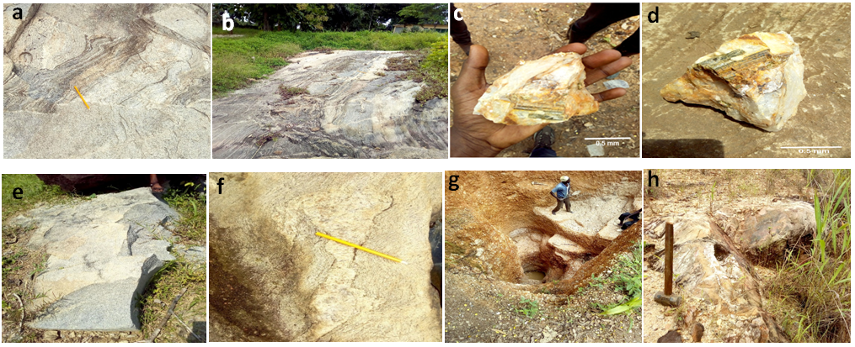
Figure 4: (a & b) Granitic and migmatitic gneisses displaying several structures; (c & d) Hand specimen tourmaline inclusion in quartzite; (e & f) folded intrusive quartzo-feldspathic bodies on granite; (g &h) Occurrence and mining pit for tourmaline.

- Laboratory Investigation
Petrographic investigations of the various rock units in the locations revealed the following rock forming minerals: biotite mica, muscovite mica, plagioclase feldspar, hornblende, microcline feldspar, (locations 1 and 2), quartz (showing angular shape) and opaque minerals (probably iron oxide). The distribution of the different minerals is presented in Table 2. The photomicrographs of the different rocks are shown in slides Figure 5 a, b & c. They are presented as slides. Observations were made under plane polarized light (PPL) and crossed polarized light (CPL). They displayed diagnostic minerals present in each slides. Generally, the minerals identified are typical of the major rock forming minerals such as quartz, feldspar (plagioclase, orthoclase and microcline), hornblende, muscovite etc. Only locations Ik1, Ik2 and Ik3 slides have tourmaline and garneti-ferous minerals because the rocks in these areas are intruded with complex pegmatites. These locations have potentials for gemstones mineralization. Petrographic studies of thin sections shows the distribution of mineral and it is observed that quartz is the most dominant followed by biotite and muscovite, microcline and other minerals which suggest that quartzite is the most prevalent rock in the study area.

Table 2: Mineral Composition of the Slides
Slide Number | Mineral(s) | Rock Name
L1 | Muscovite Microcline Feldspar Quartz | Weathered Gneiss
L2 | Quartz | Quartzite
L3 | Quartz | Quartzite
L5 | Quartz, Muscovite | Quartz-Mica Schist
L6 | Quartz | Quartzite
L7 | Biotite Opaque Mineral Muscovite Plagioclase | Biotite Schist
L8 | Biotite Quartz Plagioclase | Granitic Gneiss
L8A | Biotite, Hornblende, Muscovite  Microcline, Feldspar, Quartz | Fine Grained Granite
L9 | Biotite, Muscovite, Microcline Feldspar, Quartz | Gneiss
L13A | Biotite, Plagioclase, Quartz | Granite
IK1 | Quartz, Tourmaline, garnets | quartzite
IK2 | Quartz, Tourmaline, garnets | Quartzite
IK3 | Quartz, Tourmaline, Garnets | Complex Pegmatite
IK4 | Quartz Muscovite | Weathered Quartz-Mica Schist
IK5 | Quartz | Quartzite
IK6 | Quartz | Quartzite
IK7 | Quartz Muscovite | Quartzite
IK8 | Quartz | Quartzite
IK9 | Quartz | Quartzite
IK10 | Muscovite, Quartz | Quartzite
IK13 | Biotite, Muscovite, Quartz  Microcline, Feldspar | Weathered Granitic Gneiss

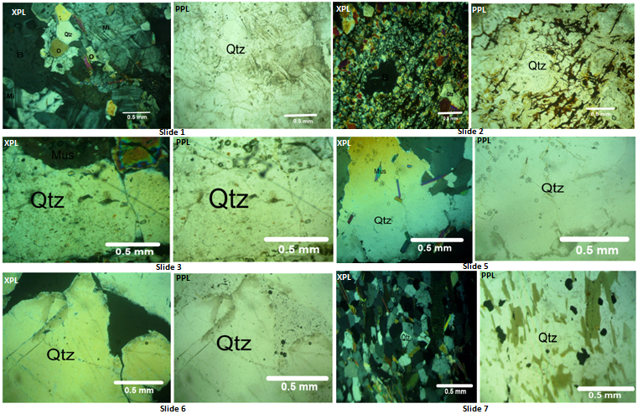
Figure 5a: Photomicrographs from thin section of selected rock samples
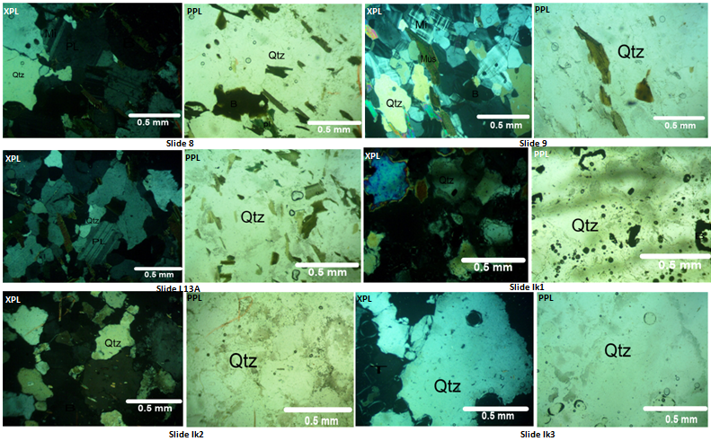
Figure 5b: Photomicrographs from thin section of selected rock samples
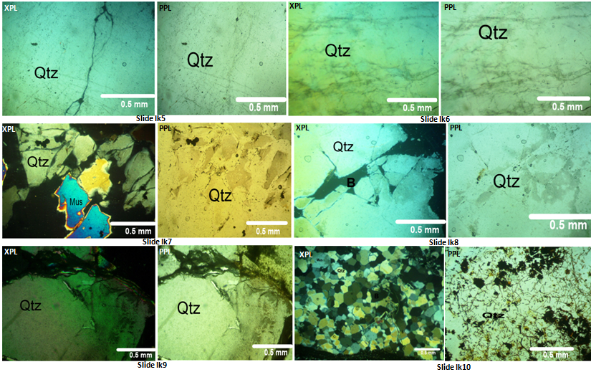
Figure 5c: Photomicrographs from thin section of selected rock samples
Microcline – Mi; Quartz- Qtz; Muscovite – Mus; Hornblende – Hbl; Orthoclase – O; Biotite – B; Tourmaline – T; Gt- garnets; MC- Mineral composition, XPL- Crossed Polarized light, PPL- Plane polarized light

- Structural analysis of the study area
Most of the basement complex rocks of Nigeria have been affected by polycyclic deformation which has led to the re-orientation of the initial structural grain of the basement complex (Oluyide, 1988). These deformations left their imprints on the rocks affected which can be used to re-write the geological history of those rocks. Most of the quartzites and granites and gneisses in Nigeria have been affected by one orogeny or the other, the latest being the Pan African orogeny 600±150 Ma (Burke and Dewey, 1972, Dada, 2006) resulting in formation of structural features like fold, fractures, and joints etc. Structural elements such as veins, fractures, folds, foliations and faults were observed and mapped in the rocks of the study area. The structures occurred mainly on all the rock types but prominent on the granite-gneiss. From analysis of structural data collected, it can be inferred that at least three major orogenic cycles of deformation, metamorphism and remobilization have affected the area followed by a last stage of tectonic jointing and faulting which led to the formation of the fractures and veins in the gneisses.
The outcrops of gneissic origin and the schistose quartzites exhibit folded surfaces from tight, ptygmatic and isoclinal folds to recumbent and overturn antiformal folds. In some of the outcrops mapped, it was noted that some of these folds are older than the joints that cut across, and some folds are younger than the fractures which also confirmed the three episodes of tectonic deformation earlier proposed. Most of the folds observed are composite, asymmetrical, parasitic and isoclinal folds. These could be attributed to series of deformation and metamorphic episodes that have pervaded the studied area which led to successive restructuring of the inherent minerals in the rocks. Also, from field observations and studies, it could be inferred that the gneiss outcrops have been affected by three episodes of deformation denoted as D1, D2 and D3. The D1 deformation produces tight to isoclinals and asymmetrical folds. The second D2, produces ptygmatic and disharmonic folds, this is characterized by steep to moderately inclined axial planes while the third D3 deformation produces refolded folds which superimposed on the ptygmatic fold (Figures 4f).
Several fracture orientations were obtained from the rocks at different locations on the field and their measurements were used to produce a rose diagram which indicated that the direction of the tectonic force is in the NW-SE. These fractures were clearly displayed and observed on the schistose quartzite, granite-gneiss and on most the quartzite materials. However, some fractures are linked with mineralization especially the NW-SE, NE-SW, E-W, NNS and N-S fractures Wright, (1976). The granitic rocks are synonymous with N-S fractures and are mostly interconnected. Quartzites are common with E-W fractures known for gold mineralization Anifowose et al. (2006) while the schists and gneisses have paucity of fractures due to their ductile nature. The topographically generated fracture is shown.
Joints are present in nearly all rock surface and are generally more toward the vertical than the horizontal. The most prevalent causes of jointing are tensional and shearing stress forces set up by crustal movement within the earth’s crust. Although, they can occur singly, they most frequently occur as joint sets and systems. In some folded rocks, the joints that lie at the right angles to the fold hinges are known as cross joint. The joint orientations gathered on the field were used in plotting rose diagrams for the joint sets (Figure 6). Joints were mostly observed on the granitic gneiss outcrop.
The veins present in the study area are majorly of pegmatite, quartz and quartzo-feldspathic composition which are commonly associated with the gneiss as late intrusions. These veins can be thin or large, long or short, continuous or discontinuous. Some of the veins are cross cutting each other, they are sometimes absent in few of the outcrops. The most abundant of the veins are the quartz veins. A majority of the veins are concordant to the trend of foliation of the rock in which they occur. Some are crosscutting and do not follow the general trend of the outcrops. On some outcrops, the direction of some veins cannot be easily deduced because of the fact that the rocks in which they form has undergone deformation, hence distorting the rocks’ foliation and fabric and also distorting the orientation of the veins present. However, it should be noted that a large percentage of all the veins are in the same direction as the general trend of foliation of the rocks on which they exist. The boundary between the veins and the rocks are sharp, though there are few exceptions on some of the rocks where the boundaries between the rocks and the veins are gradational. Some of the veins are very long, extending up to 15m throughout the length of the outcrops on which they occur, while some of them are short extending only a few centimeters. Also, some are relatively wide and some are thin. Most of the veins were formed after the rock was formed. While a few of them were segregated during the cooling of the rock. The formation of most of the concordant and discordant quartz veins are associated with the late faulting and fracturing in the area (Gandu et al., 1986). The foliation planes which are pervasive planar surfaces within a rock are well developed in the gneisses (figure7). But due to extensive weathering condition in the area there is limited foliation surface for the measurement of strike and dip. But strike and dip values were recorded at points of good foliation planes. The general dip direction is towards the east and is slightly dipping. The strike direction is slightly varying depending on the position in the area. These structures are only observed as gneissosity and foliation in the shear zones of gneissic outcrops. This foliation is as a result of the pervasive parallel arrangement of the platy minerals in the rocks.

Figure 6: rose diagrams plotted from joint orientations measured in the field.

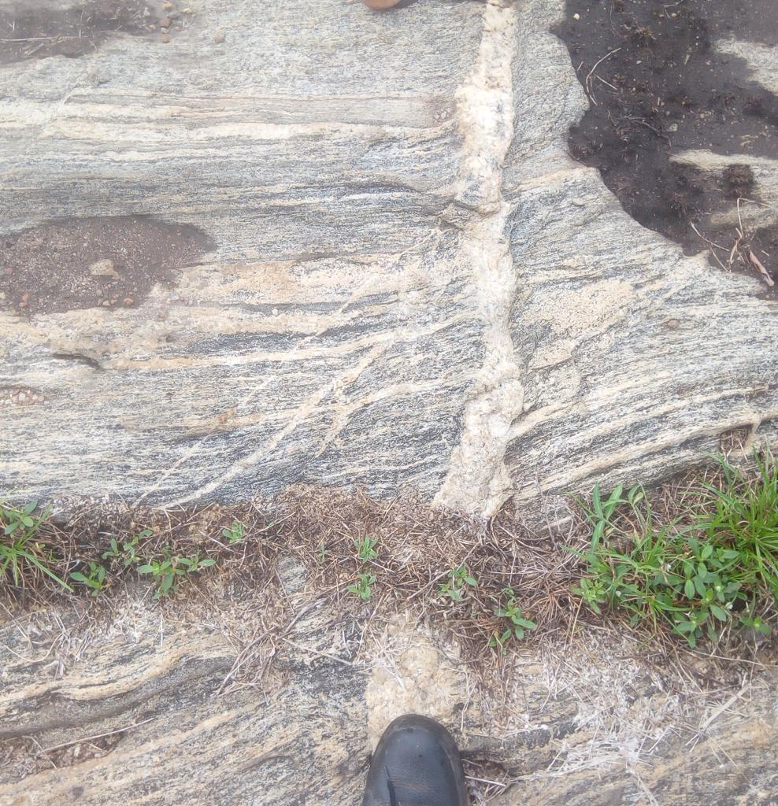
Figure 7: Different generations of veins as observed in the field.

GEMSTONES EXPLORATION
Gemstones are formed in different geological environments in the earth, resulting in various types of deposits including magmatic, pneumatolytic, metamorphic, sedimentary (alluvial), hydrothermal, pegmatites and greissen gems. For the formation of each kind of gem a specific, and unlikely, combination of five factors are required in their respective environments. These are: temperature, pressure, space, chemical elements, and time. In other words, gems are in general rare but some are rarer than others, (Nyako et al 2014). For example, silicon and oxygen are the two most abundant elements of the earth’s crust and the conditions for the formation of quartz (Si02) are relatively common so it is understandable that quartz is found widely, while Axinite on the other hand, which is also a silicate gem requires (in addition to silicon and Oxygen) Ca, Fe, Mg, B, and Al for its formation, this makes such a gem rarer than quartz, (Abaa, 1990). These rare conditions in cracks, fractures, faults and shear zones which gemstones are formed make them very rare to find, and so are termed precious. They are used for ornamentation and as jewelleries when cut and polished. Some traditions are connected with sentiments, beliefs and superstitions associated with gems, to the effect that some gems carry the power of driving out evil spirits and providing all sorts of luck or fortunes, (Aga and Ashano, 2008).
Geological exploration for gemstones and other specialty minerals was carried out in the study areas as part of the investigation. There are two types of pegmatite mapped in the locations which are the mineralized and non-mineralized types. The mineralized types are often the targets of local and artisan miners in the studied area because of the gemstones and other specialty minerals found in them. Many pits and mine sites were discovered in the process of mapping and traversing and as a result of this, sampling was extended beyond the initial locations to ensure wider coverage. This led to the discovery of potential sites of gemstones mineralization which were underlain by quartzites and intruded by complex pegmatites. The coordinate of this location is (7⁰ 35’ 10’’N, 5⁰ 00 53’’E). This location show high potentials for gemstones and allied minerals and are promising sites for further exploration. These samples contain blue and green tourmaline crystals. On the contrary, the cadastral already acquired for gemstone exploration is not economically viable for its intended purpose with the following reasons: (i) The rocks are entirely weathered and have turned into clay (ii) The underlying rocks are extremely fractured which enables water to gush out (iii) The sites has undergone intense deformation which affected the rocks and their fabric and (iv) The pegmatites are not mineralized.

SUMMARY AND CONCLUSION
Geological mapping of Ikogosi and environs revealed that the studied areas are dominated by crystalline rocks. It also confirmed the complex nature of the Nigerian basement complex and the various orogenies it has suffered till date. These rocks occupied strategic positions and are dominated by micro and macro structures of different magnitudes and styles, indicating that these rocks have suffered from different episodes of tectonic deformation as revealed by the presence of folds, fractures, faults and joints with eventual intrusion of pegmatites which occurred as veins and dykes on the different rocks mapped. Also, exploration for gemstones revealed that the studied sites have very high potentials for gemstones mineralization and other specialty minerals such as blue and red tourmaline, and a gem mineral called “Babylon” and garnets. However, due to the intensity of weathering in which most of the rocks have been altered to clay and deformation of the rock fabrics, it is impossible to carry out geochemical exploration in the studied areas but petrographic study revealed the presence of some of the major rock forming minerals such as quartz, feldspar, micas and opaque minerals such as iron oxides etc. However, the rocks of the studied area are fairly suitable for quarry activities but not good for detailed geochemical exploration.
The study area is characterized by the rocks of the basement complex. Field examination and laboratory studies confirmed that the rocks in the study area has undergone multiple tectonic deformation, polyphase folding of different styles, jointing, fracturing, shearing, faulting and metamorphism. All these events took place at different times which led to large scale deformation of the rocks and destruction of the rock fabric and the mineral assemblages in the rocks. The brittle and ductile nature of the different rocks in the study area also accounted to its mechanical behavior to stresses generated during the tranpressive orogenic episodes that pervaded the basement complex in the geologic past.
AKNOWLEDGEMENTS
I hereby acknowledge the efforts of Oyewumi Olusola, Omotoso Ayo Mike who are my project students and also served as technical partners on the field. Your immeasurable contribution to this project is highly commendable. I am grateful to the laboratory technologists of the Department of Applied Geology, The Federal University of Technology, Akure who assisted in the sample preparations for microscopic study. Also, I am grateful to the Chief Technologist in person of Mr, O.F Oladeji for his assistance in the laboratory also. I am highly indebted to the Deputy Chief Technologist in person of Mr. Mark, who devoted his valuable time in viewing the slides under the Petrological Microscope together with me. Thank you all.

REFERENCES
Abaa, S.I. (1990): Hydrothermal fluid Responsible for the Formation of Precious Minerals in the Nigerian Younger Granite province. Mineral Deposits, Spring-Verlag. Vol.26, pg 34-39.
Aga, T and Ashano, E. C (2008): Enhancing the Value of Nigerian Gems through Lapidaries. Continental J. Earth Sciences vol.3: 71 – 76.
Ajibade, A.C., (1986). The Origin of Older granites in Nigeria. Some evidences from Zungeru region, Nigeria. Journal of Mining and Geology 223-230
Ayodele, O.S., Ajigo, I.O., (2019). Reconnaissance geological and geochemical studies of the Precambrian Rocks in Erijiyan Area, Southwestern Nigeria. Implications for Mineral Exploration. Global Journal of Earth and Environmental Sciences 4(1): 1-13.
Geological Survey of Nigeria 2006
Burke, K.C., Dewey, J.F., (1972). Orogeny in Africa, in Dessauvagie, T.F.J and Whiteman, A.J. (eds) African Geology-University of Ibadan, 1970, 583-608.
Dada, S.S., (2006). Crust forming ages and Proterozoic crustal evolution in Nigeria. A re appraisal of current interpretations. Precambrian Research 8, 65-74.
Gandu, A.H., Ojo, S.B., Ajakaye, D.E., (1986). A gravity study of the Precambrian in the Malufashi area of Kaduna State, Nigeria. Tectonophysics 126: 181-194.
Nyako, A.A. Ajigo, I.O. and Ashano, E. C. (2014): Trace elements as pathfinders for gemstone deposits: a case study of Jarawa and eastern part of Shere Complex, North Central Nigeria. International Journal of Research in Earth & Environmental Sciences Vol. 1, No.3
Odeyemi, I.B., (1977). On the Petrology of the basement rocks around Igarra, Bendel State,
Nigeria. Unpublished Ph.D Thesis, University of Ibadan, Nigeria. 233pp.
Odeyemi, I.B., (1992). The Ifewara fault in Southwestern Nigeria, its relationship to fracture zone and seismicity along the Nigerian coast, Kluver Academic Publishers, Dordrecht, Netherlands.
Okonkwo, C.T., (1992). Structural geology of basement rocks of Jebba area, Nigeria. Journal of Mining and Geology, 31 (1): 53-62.
Oluyide, P.O., (1988).Structural Trends in the Nigerian Basement Complex. Precambrian Geology of Nigeria by P.O. Oluyide (ed) Geological Survey of Nigeria Report No 1417, 15p
Rahaman, M.A. (1988). Recent Advances in the study of the basement complex of Nigeria. In: Precambrian Geology of Nigeria. Geological Survey of Nigeria, 11-43.
Wright, J.B., (1976). Fracture systems in Nigeria and initiation of fracture zones in the South Atlantic. Tectonophysics. 34, 143-147.

