Aortic dissection after transcatheter aortic valve replacement

Bunc Matjaž MD PhD. ^{1,4}, Šušteršič Miha MD ¹, Zbačnik Rok MD³, Lakič Nikola MD ²
¹Department of Cardiology, University Medical Centre Ljubljana, Zaloška c. 007, 1000 Ljubljana
²Department for Cardio and Vascular Surgery, University Medical Centre Ljubljana, Zaloška c. 007, 1000 Ljubljana
³Department of Radiology, University Medical Centre Ljubljana, Zaloška c. 007, 1000 Ljubljana.
⁴Institute for Pathopysilogy, School of Medicine, Zaloška c.002, 1000 Ljubljana.

Corresponding author:
Miha Šušteršič, MD
University Medical Center Ljubljana
Zaloška c. 007
1000 Ljubljana
Slovenia, EU.
Abstract
An 80-year-old man with severe aortic stenosis, who declined aortic valve replacement several times since 2011 and had recurrent syncope after balloon aortic valvuloplasty, was again admitted because of symptomatic aortic stenosis. A percutaneous strategy for his aortic stenosis was decided. Transcatheter aortic valve replacement using a balloon-expandable Edwards Sapien XT valve was performed under rapid ventricular pacing. After valve deployment, an aortic dissection of ascending aorta was noticed. There was no coronary flow compromise, no acute aortic root and ascending aorta dilatation, no pericardial effusion, and paravalvular aortic regurgitation was mild. After consultation with cardiovascular surgeon, interventional radiologist and invasive cardiologist we decided for conservative approach, with very good outcome and no additional disabilities in the follow up of 22 months.
Introduction
Symptomatic severe aortic stenosis (AS) is associated with significant mortality when managed only with optimal medical treatment. [1] While surgical aortic valve replacement (AVR) remains the gold standard of treatment for AS, a significant proportion of patients are turned town for the procedure because of too high perioperative risk. [2] Transcatheter aortic valve replacement (TAVR) has emerged as an alternative to AVR for these patients. [3] While procedural success in this relatively new procedure is high, TAVR is still associated with uncommon but potentially serious complications [4]. Aortic dissection remains a rare but potentially lethal complication. Here, we report a case of ascending aortic dissection complicating TAVR that was managed conservatively with a good outcome.
Case report
An 80-year-old man with severe aortic stenosis, who declined AVR several times since 2011 and had recurrent syncope after balloon aortic valvuloplasty, was admitted because of symptomatic aortic stenosis. Echocardiography demonstrated a critical aortic stenosis (AVA 0.55-0.60 cm2, DVI 0.14, maximal velocity 4.6 m/s) and normal ejection fraction of the left ventricle. Coronary angiography was done in previous hospitalization and showed no coronary artery stenosis. Since he again declined AVR, he was offered a TAVR.
TAVR was performed using a balloon-expandable trans-catheter heart valve (Sapien XT, Edwards Lifesciences) via the left femoral artery access. Based on an aortic annulus diameter measurement of 25 mm by transthoracic echocardiography (TTE), transesophageal echocardiography (TEE) and computer tomography, 26 mm Sapien XT valve was chosen in accordance with current sizing recommendations. Balloon aortic valvuloplasty (BAV) with a commercially kit 23 mm diameter balloon was performed. Although BAV was performed with rapid ventricular pacing at 200-220 beats/minute, BAV was not completely successful, since balloon was not stable in aortic valve position. We decided to proceed without successful BAV. There were also problems of optimal positioning the valve, which jumped 4 times in the ventricle or ascending aorta and we had to reload a TAVR pusher (Picture A). We noticed a dissection in ascending aorta (Picture B). Patient was haemodinamically stable; there was no pericardial effusion or aortic root rupture and no coronary flow compromise. Despite dissection of ascending aorta, TAVR valve was successfully deployed with a mild para-valvular leak, patient was hemodynamically stable (Picture C). Aortography after valve deployment showed an aortic dissection that extended above artificial valve in ascending aorta. The same was seen with a TEE. There was no acute enlargement of the radius of ascending aorta, no obstruction of coronary flow, no flow obstruction in ascending aorta, no pericardial effusion, no deterioration of paravalvular leakage and nor acute advancements of dissection. Patient was haemodinamically stable. We consulted a cardiovascular surgeon and interventional radiologist who proposed a conservative treatment (with maintenance of systolic blood pressure under 100 mmHg and keeping the patient sedated for 24-48 hours) if stable and follow up. Access point was closed surgically. A contrast computer tomography (CTA) was done that showed an intimal flap extending from artificial aortic valve to ascending aorta in length of 3 cm, with parallel blood flow in true and false lumina (Picture D). There were no signs of coronary artery flow compromise, both exit points of coronary artery was from the true lumen, there was no pericardial effusion and no progression of dissection to aortic arcus or aortic branches. Patient was admitted to intensive cardiac care unite, where the patient remained stable. The next day a control CTA was performed and showed no progression of dissection. There was a mild drop in blood hemoglobin levels which might be attributed to peri procedural loss of blood. Sedation was withdrawn, he was extubated and began with rehabilitation. He was asymptomatic during rehabilitation and denied any chest pain. We optimized antihypertensive therapy and reduced his rest heart rate to 60 beats per minute. He was discharged 7 days after TAVR. One month and six months after discharge from hospital he came to our outpatient clinic and reported normal exertion capacity and had no chest pain. Control CTA showed no progression of the dissection and no significant dilatation of ascending aorta (Picture E, Picture F).

Figure 1
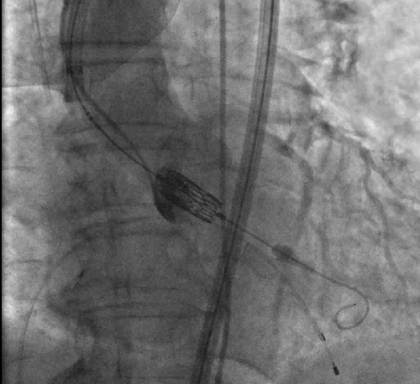
Picture A
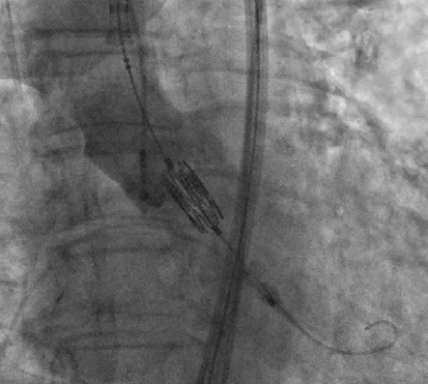
Picture B

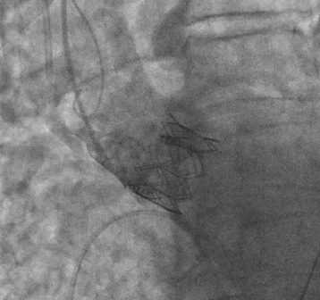
Picture C

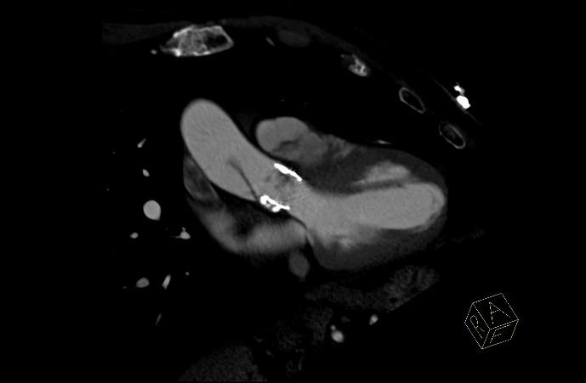
Picture D
Legend 1:
Picture A: Difficult positioning of TAVR valve to aortic annulus. Red arrow indicates necessity of reloading pusher to position the TAVR valve in a right position. Picture B: We noticed ascending aorta dissection before deploying a TAVR valve – blue arrow. Picture C: Dissection was seen also after TAVR deployment – green arrow. Picture D: First computer tomography angiography showed dissection of ascending aorta extending from TAVR valve 3 cm in ascending aorta – yellow arrow.

Figure 2

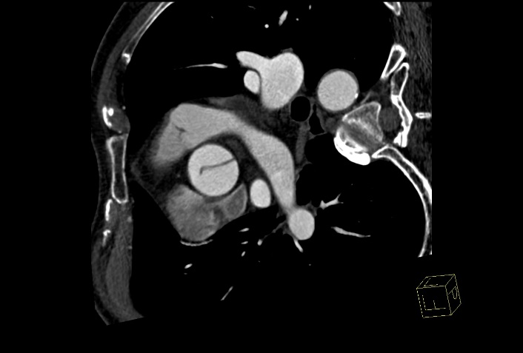
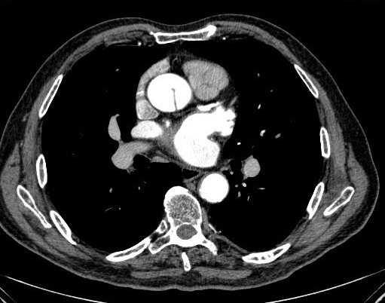
Picture E Picture F
Legend 2:
Picture E: Computer tomography angiography immediately after TAVR showing dissection of ascending aorta – red arrow. Picture F: computer tomography after 22 months follow up, showing no progression of dissection and no significant dilatation of ascending aorta – blue arrow.
Discussion
Aortic dissection during TAVR is relatively uncommon but serious complication. In meta-analysis of vascular complications in TAVR studies, regarding the Valve Academic Research Consortium (VARC) criteria, only two studies reported aortic dissection after TAVR appropriately. [5] Since the complication is relatively rear, and there are no evidence-based studies on how to solve dissection of the aorta, the reasoning and solution should be based on the team approach. Risk factors for aortic dissection may be a preexisting aortic disease (heavy atherosclerosis, calcification), aggressive balloon valvuloplasty, difficult positioning of artificial valve in its position, and excessive oversizing of the transcatheter heart valve. In our case we think, that difficult positioning of the transcatheter heart valve played a major role and that the intimal tear was most probably induced by leading edge of TAVR pusher. We might have escaped the complication with better BAV. There are various possible manifestations of aortic dissection, depending on the site of dissection, progression of the dissection, its severity (which layers of the aorta are involved) and organs involved in hipoperfusion, because of dissection. In our case intimal flap, it was enlarged to the size which respond the hemodynamic flow situation; there was adaptable flow through both lumina with the final stable position of flap in the middle. One of the most important things is the recognition of aortic dissection and team approach to its treatment. Since there is not a lot of experiences how to treat this kind of TAVR complications we did international consultations. Dr.Cribier A., Dr.Pichard A., dr.Vahanian A. and their teams suggested us conservative approach. There were also options for acute surgery or flap stenting with aortic graft or metal stent suggested by dr. Pašič M. In our case we decided for conservative therapy. Temporary the patient is doing well, without any clinical or CTA signs of dissection progression.
Conclusions
Until now there are no guidelines on managing per procedural aortic dissection during TAVR. Individual approach to each patient with rear type of procedural complication and cardiac team approach is mandatory.
References:
[1]Turina J, Hess O, Sepulcri F, et al. Spontaneous course of aortic valve disease. Eur Heart J. 1987;8(5):471-483.
[2]Iung B, Cachier A, Baron G, et al. Decision-making in elderly patients with severe aortic stenosis: why are so many denied surgery? Eur Heart J. 2005;26(24):2714-2720.
[3]Leon MB, Smith CR, Mack M, et al. Transcatheter aortic-valve implantation for aortic stenosis in patients who cannot undergo surgery. N Engl J Med. 2010;363(17):1597-1607.
[4]Toggweiler S, Webb JG. Challenges in transcatheter aortic valve implantation. Swiss Med Wkly. 2012 Dec 17;142:w13735. doi: 10.4414/smw.2012.13735. Review.
[5]Généreux P, Head SJ, Van Mieghem NM, et al. Clinical outcomes after transcatheter aortic valve replacement using valve academic consortioum definitions: a weighted meta-analysis of 3519 patients from 16 studies. J Am Coll Cardiol. 2012 Jun 19;59(25):2317-26.

