Age Estimation of Alqosh Main Landslide, North Iraq Using Exposure Dating Method

Varoujan K. Sissakian, Basim, R. Jabbo, Nadhir Al-Ansari^{3,} and Sven Knutsson

Abstract
Alqosh town is located in the central part of north Iraq, along the southern limb of Alqosh anticline, a rugged mountain with maximum elevation of 837 m (a.s.l.) in the study area. The exposed formation is Pila Spi (Eocene), it consists of thickly well bedded and hard dolostone, dolomitic limestone with some marl intercalations. The dip amount varies from (15 – 45) southwards. The southern limb of Alqosh anticline is densely dissected by deep valleys; some of them are in canyon form. The spacing between valleys ranges from (115 – 235) m, they all run almost in straight courses downslope, with some slight meandering.
Alqosh town is one of the old towns in the vicinity, it dates back to 1000 years B.C. with population of about 11 000 inhabitants. In the old part of the town, the houses are built of large blocks of dolostone and dolomitic limestone quarried from the Pila Spi Formation. Due to north of the town, a large and very old landslide exists, the toe has reached the extreme northern part of the town. Tens of houses are built on the toe area; indicating that the landslide is very old. The involved area by the landslide is about 50 000 m² with length and width of 500 m and (62 – 144) m, respectively.
To estimate the age of the landslide, field work was carried out to map the toe area, check about the slid materials and to measure the size of the existing slid blocks and any other evidence of the landslide. The exposure dating method is used to estimate the age of the landslide. The old living people in the town were asked about the age of the houses that are built on the toe to estimate the age of the landslide. Moreover, the covered materials of the toe and other parts of the landslide were carefully inspected to find indications for age estimation. Some archaeological data also were used for age estimation. Depending on all available data, the age of the landslide is estimated to be about 3000 (three thousand) years.
Keywords: Landslide, Historical events, Exposure Dating Method, Iraq

- Introduction
The northern and northeastern parts of Iraq are mountainous areas; characterized by domination of carbonate rocks that form the carapaces of main mountains, which usually represent anticlines. The area is also characterized by being active zone for different types of mass movements [1, 2, 3 and 4]. Hundreds of mass movements’ phenomena exist in the northern and northeastern parts of Iraq, mainly of landslides and mud flows.
The studied case concerns with an old and large landslide that occurs directly north of Alqosh town; part of the slid mass has reached the town. The exposed rocks in the site and even in the extreme northern part of Alqosh town belong to the Pila Spi Formation (Eocene age) [5 and 6]. The Pila Spi Formation consists of well thickly bedded dolomite, dolomitic limestone with rare marl intercalations [7].
The studied area is located in the central northern part of Iraq, about 75 Km northeast of Mosul city (Fig.1), the center of the landslide has the following coordinates; Latitude: 36. 741362, Longitude: 43.094841. The coverage area of the landslide is about 49684 m 2 ( 0.5 Km 2), the length is 496.84 m, whereas the width ranges from (144.2 – 61. 80) m; in the upper and lower parts, respectively.
The main of this study is to estimate the age of the landslide. The exposure age determination method [8] is used to estimate the age depending on some historical events besides other relevant geological data.
1.2. Previous Studies
Although the study area and surroundings are characterized by enormous amounts of mass movements’ phenomena, but none of the workers has studied a single phenomenon; including the presented phenomenon in the current study. However, the following workers have studied geological hazards including landslides in the surroundings of the studied area.
Sissakian [1] reported about the geological hazards in Iraq and considered the study area as to include many mass movements; among them are landslides.
Sissakian and Ibrahim [2] reported about the zonation of the geological hazards in Iraq and considered the studied area as a part of active mass movements’ zone.
Sissakian and Ibrahim [3] compiled the geological hazards map of Iraq at scale of 1:1000000 and considered the study area as a part of active mass movement zone.
Sissakian and Ibrahim [3] compiled the geological hazards map of Mosul Quadrangle at scale of 1: 250000 and presented the landslide at Alqosh of the current study in the compiled map.

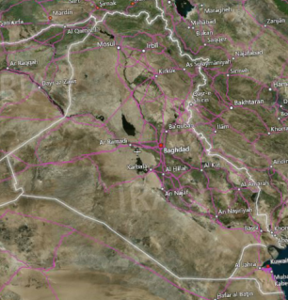
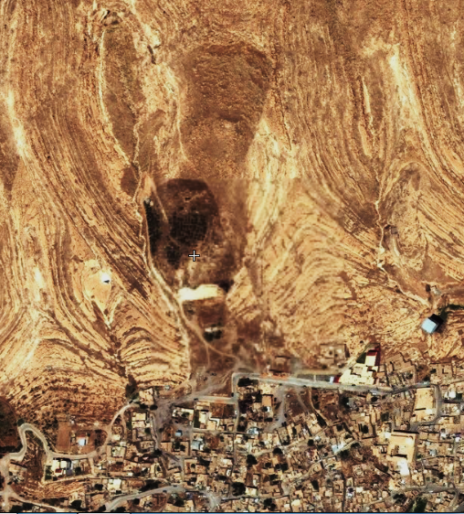
Figure 1: Flash Earth image showing the studied area

1.3. Materials and Methods
In order to achieve the main aim of this study, which is to estimate the age of the existing landslide in Alqosh, the following materials were used:
- Topographic and geological maps of different scales.
- Google Earth and FLASH Earth images.
- Different geological published articles and reports.
- Historical books.
- Field observation data.
Using the available topographical and geological maps of different scales with the help of FLASH Earth and Google Earth images, the parameters of the landslide were measured. Field work was carried out to check and map the exact limits of the landslide.
Old people and a journalist from Alqosh (Mr. Lateef Polla) were interviewed to ask about the landslide age and/ or the age of the very old houses; those which are surrounding the slid mass. Some of the very old houses are built on the toe area of the landslide, by knowing their ages; the age of the landslide can be estimated.

2 Geological Setting
The regional geology with emphasizing on the studied area is briefly mentioned hereinafter.

2.1. Geomorphology
The main geomorphological units in the studied area are:
- Anticlinal ridges: The well bedded carbonates of the Pila Spi Formation have formed obvious anticlinal ridge along the western limb of Alqosh anticline.
- Alluvial fans: Many large alluvial fans are developed in the surrounding area of the concerned landslide.
- Flat irons: These are well developed due to the well bedded carbonates of the Pila Spi Formation. Their height and widths range from (55 – 220) m and (60 – 290) m, respectively.
- Mass movements: Many small phenomena occur in the study area, like toppling and rock fall, beside the main landslide, which is concerned in this study.
2.2. Structural Geology and Tectonics
The study area is located on the southern limb of Alqosh anticline, which is an E – W trending double plunging anticline. The length is 25.7 Km, whereas the width in the eastern side is 4. 95 Km and in the middle part is 1.7 Km; as the narrowest width. The southern limb is very steep; up to 80°, whereas the northern limb is very gentle; not more than 20°; therefore, the the anticline shows acute asymmetry (Fig.2).

Tectonically, the studied area is located within the High Folded Zone of the Outer Platform (Unstable Shelf) of the Arabian Plate [9]. The zone is characterized by narrow and long anticlines with wide and shallow synclines. Some of the anticlines exhibit thrust faulting; where the northeastern limb is thrusted over the southwestern one or the northern limb is thrusted over the southern one.

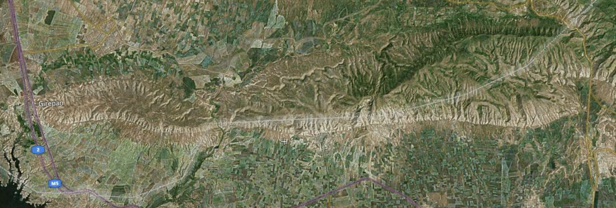
Alqosh

Figure 2: Flash Earth image of Alqosh anticline

2.3. Stratigraphy
The only exposed formation in the study area is the Pila Spi Formation (Eocene age) [5]. The formation consists of well thickly bedded to massive dolostone, dolomitic limestone with rare marl intercalations [7]. However, in some deeply cut valley few meters of the underlying Gercus Formation is exposed; it consists of red fine clastics. Moreover, the Pila Spi Formation is overlain by the Fatha Formation (Middle Miocene) [8] on top of which majority of Alqosh town is built.

3 The Main Landslide

3.1. Geometry
A large old landslide occur north of Alqosh town, its toe extends inside the town for about 105 m (Figs. 1, 3 and 4). The coverage area of the landslide area is about 49684 m 2 ( 0.5 Km 2), the length is 496.84 m, whereas the width ranges from (144.2 – 61. 80) m; in the upper and lower parts, respectively. The highest point in the crown is at elevation of 699 m (a.s.l.), whereas the lowest point is at elevation of 553 m (a.s.l.). The height if the cliff in the crown is 43 m, the eastern side cliff has maximum height of 18 m, whereas the western side cliff is 19 m; however, the western cliff is steeper than the eastern one. The length of the scarp is about 120 m. The scarp is still active area for rock fall and toppling with small blocks up to 1.5 m from the well bedded carbonate rocks (Fig. 3).

3.2. Other Land Slides
From the field check, it was found that after occuring of the main old landslide; many other small sildes had occurred from the same crown area (Fig.5), but the slid masses are very small as compared with the mass of the main silde (Figs.1, 3 and 4). The block sizes of the younger slides are also smaller than those of the main slide, the maximum observed size is less than 2 m (Fig. 5). Another slid mass occur few meters below the small one. It is not possible to decide if it is the upper limits of the main landslide mass or another small old slide (Fig.5).

3.3. Shear Plane
The shear plane along which the main slide had occurred is still obvious although very old (Fig. 6), it can be seen it is smoothed and smashed surface; as compared to other natural rough surfaces. The bedding planes can be seen only along the sides of the shear plane not within it (Fig.6).

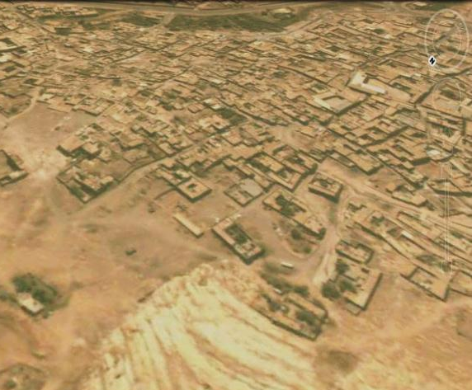
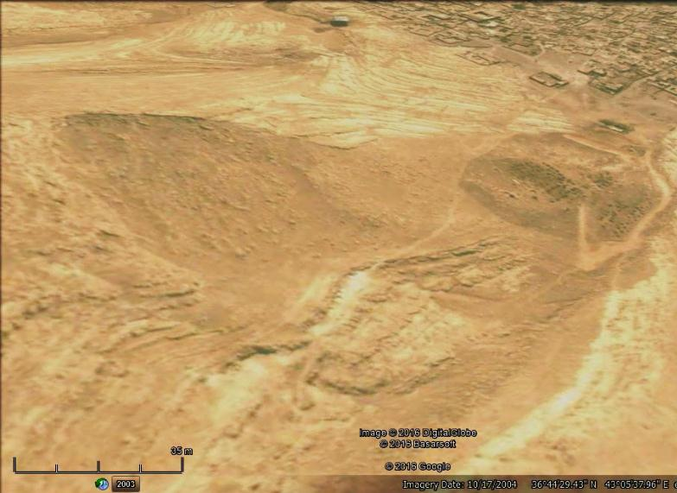
AH
Fig.3: Google Earth image, Left) The main scarp (marked by red line); note the fallen blocks on the slope, and the artificial hill (AH), Right) What remained from the toe area (marked by black) on top of which many houses of Alqosh town are built

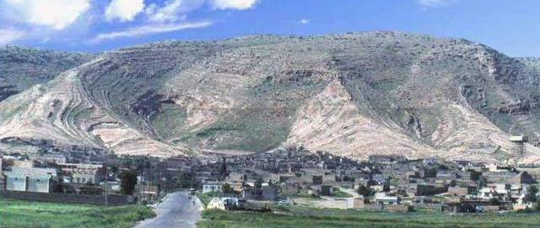
SL
Cr

Fig.4: General view of Alqosh main landslide, limited by black line.
Cr: Cown area. SL: Small landslide

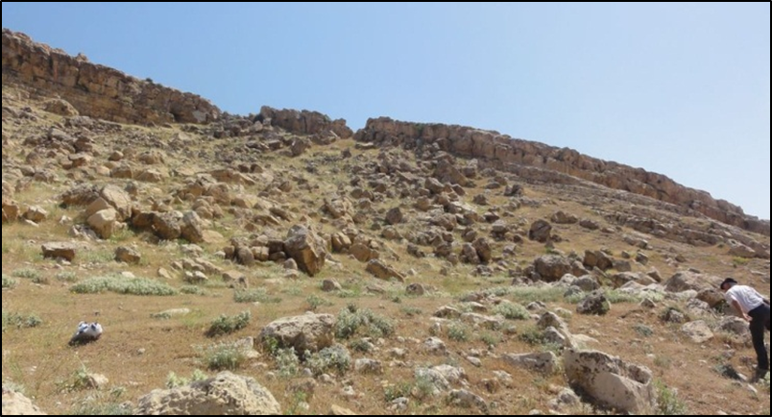
Fig.5: A small landslide (limited by black line) from the crown area of the main landslide. Note another very old slid mass (marked by red line)

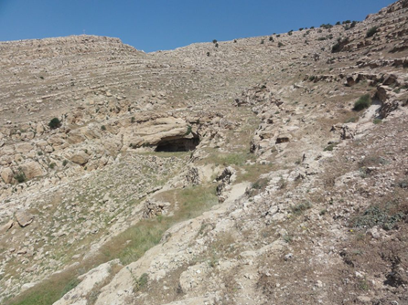

Fig.6: Note the smashed surface of the shear plane of the main slide
3.4. Toe Area
The toe area of the main old landslide is almost vanished (Figs. 1 and 3 Right). The remaining of the toe area near the outlet of the landslide area from the mountain is used as a residential area that forms the oldest part of Alqosh town. However, the original area of Alqosh town was in the valley where the landslide had occurred. Old people in Alqosh town and a historian from Alqosh (Mr. Lateef Polla) still remember the presence of large blocks of limestone in the toe area (Fig. 7 Right). The residences of the town have used those blocks in building of their houses during the beginning of the last century and may be older (Fig.7 Left). The remained blocks in the toe area are very rare, since majority of them are parted into smaller pieces and being used in building. They belong to the Pila Spi Formation and range in size from (< 0.5 ـ  1.0) m³.

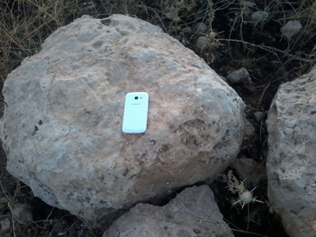
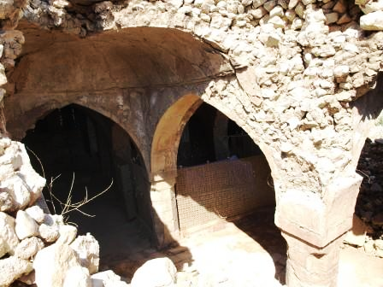

Fig. 7: Left) A collapsed old typical home in Alqosh town. Note the used rock in the building, all of them belong to the Pila Spi Formation. Right) A boulder derived from the Pila Spi Formation in the toe area; note the roundness of the boulder indicating long rolled distance and being very old; as a block

4 Landslide of Rabban Hurmuz Monastery

To the east of Alqosh town by about 3 Km an old monastery occur, it is called Rabban Hurmuz Monastery (Rabban is the Syriac for monk); it is carved out in the mountain (Fig. 8), founded on about the 640 AD [10]. A large landslide (Figs.7 and 8) has hit the monastery in 1640 [11 and 12] and had damaged large parts of the monastery. The date of the landslide is documented and almost all old people in Alqosh town know the event as passed to them from their grandfathers. The age of this landslide is used in dating of the main Alqosh landslide in this study, by comparing the status of the rocks and debris on both landslides.

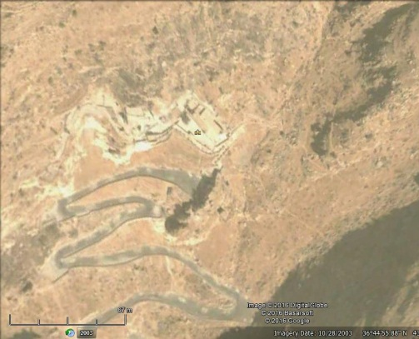
RHM
SB
Cr
Fig.8: Google Earth image showing Rabban Hurmuz Monastery (RHM).
Note the large slid block (SB) and the crown (Cr)

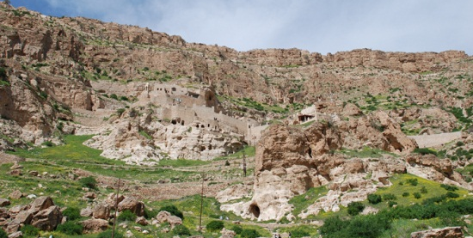
SM
MRH
FB

Fig.9: Monastery of Rabban Hurmuz (MRH).
Note the main slid mass (SM) and other fallen blocks (FB)

5 Date Estimation of the Landslide
The Exposure Dating Method [8] is used in estimating the age of the main landslide of Alqosh. The landslide area (Figs. 1, 3, 4 and 6) is inspected in the field in details; the status of the shear plane, crown area and the existing slid blocks in the toe area are compared with those of the Rabban Hurmuz landslide, which is of known age. Moreover, historical events and present buildings are used for the dating.

5.1 Artificial Hill
In the lower part of the landslide area, an artificial hill exists that is built be soil accumulation (Fig.10). The hill was built before some (900 – 1000) years B.C. [11 and 12] and was used as a watching tower during Assyrian Dynasty. Nowadays, it is used as agricultural field after being flattened (Fig.10; enlarged caption).

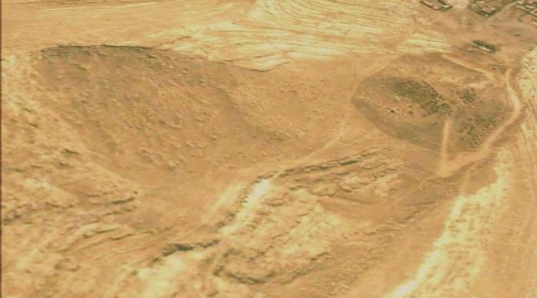

Fig.10: Google Earth image facing NE showing the artificial hil

5.2. Location of Goddess Seen Temple
Goddess Seen; the god of moon, was an Assyrian goddess its temple was built in the landslide area (Fig. 11 Left) with the sacrificing place (Fig.11 Right). The age of the temple is estimated to be about 3000 years [11 and 12].

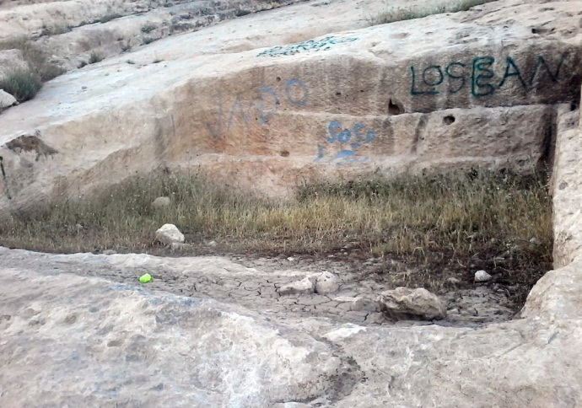
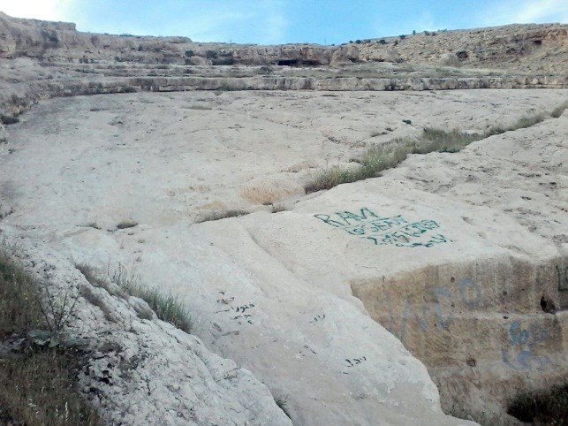

Fig.11: Left) Location of the Seen goddess temple,
Right) The sacrificing location for the goddess

5.3. Status of the Slid Mass and the Blocks
The status of the slid mass and those of individual blocks in both landslides of Alqosh (Figs. 1, 3, 6 and 7), and that of Rabban Hurmuz (Fig. 9) is compared, as the weathering traces is concerned to estimate the age of the former landslide. Moreover, the blocks of the main landslide of Alqosh and more recently toppled and/ or fallen blocks (Fig.12) are compared for the same reason. It is very clear that those of Alqosh landslide are older from that of Rabban Hurmuz.

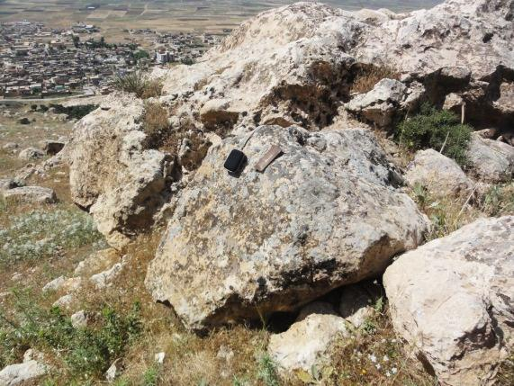
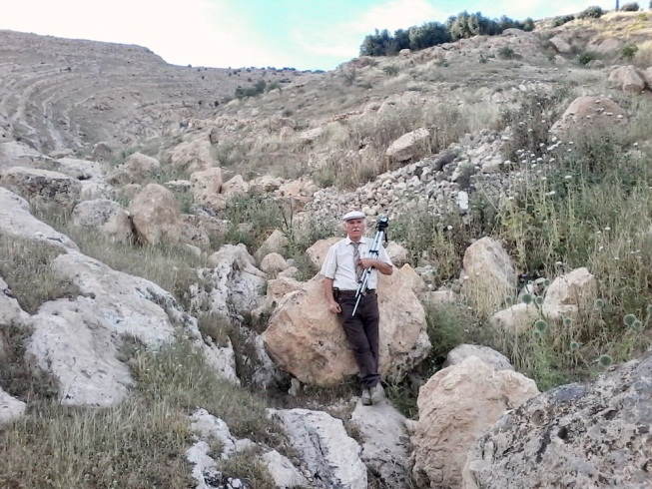
B
A

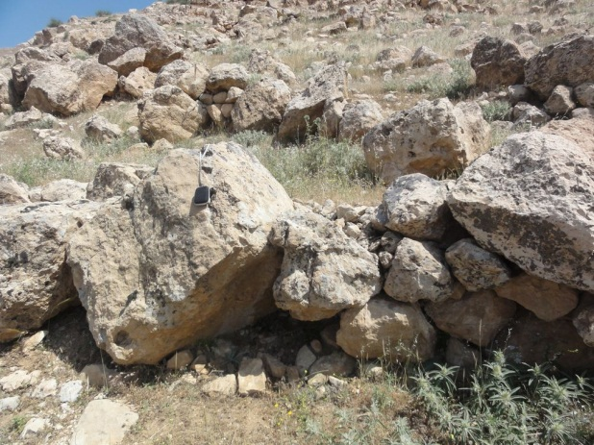
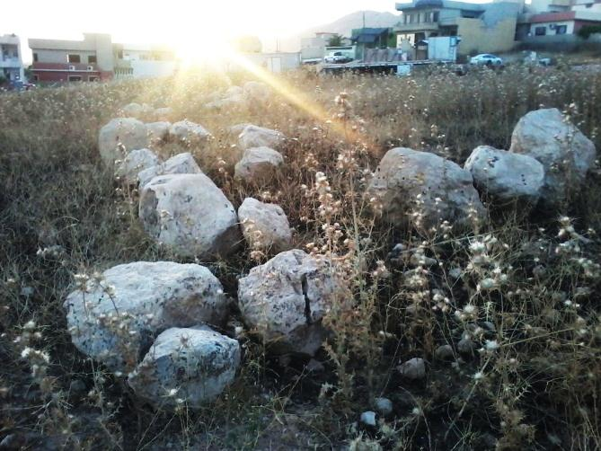
D
C

Fig.12: A) Compare the status of the old block and a recent one just behind
Mr. Lateef Polla, B) Blocks of the main Alqosh landslide, note their weatheringstatus,
C) Blocks of the toe area, almost rounded due to very long time weathering and erosion processes acting on them, D) Blocks of the main slide

6 Discussion

The main landslide in Alqosh town, north of Iraq is very old one. The historical evidences indicate it is about 3000 years old. The exposure dating method is used in this study to estimate the age of the landslide. Since it is very old; therefore, more historical evidences are used rather than geological. The used indications are discussed hereinafter in details.

6.1. Crown Area
The crown area of the main old landslide is almost vanished (Figs. 1, 3, 4 and 10). The remaining scarp is about 43 m in height; due to weathering and erosion factors that were acting on the area since the sliding had occurred. However, the crown area is still an active erosion area as indicated by recent toppled blocks (Fig.3) and few rock fall blocks with other small slides in the area (Fig.5).
6.2. Shear Plane
Although the landslide is very old; but the shear plane along which the slide had occurred is still visible (Fig.4), as indicated by the even surface of the plane; limited by two side scarps. However, some fallen blocks and small landslides have occurred and still can be see, especially in the uppermost part of the shear plane (Fig. 5).
6.3. Toe Area
The toe area of the landslide is within Alqosh town, which means the town is built on the toe area. The bulge shape of the toe is still partly clear (Figs. 1 and 3), although it is covered by the built houses during the long history of Alqosh town that returns back to about 1000 years B.C. Moreover, the old people still remember the existence of large strange blocks in the upper part of the town (the toe area), which were either removed during the beginning of the last century or were break down and were used for construction of the old houses (Fig. 7).
6.4. Other Geological Indications
As the method of exposure dating is based on existing geological data to estimate a geological phenomenon [8]; therefore, attention was paid during the field work and interpretation of satellite images to detect any geological event that can give help and estimating the age of Alqosh Landslide. Only two types of data were acquired, these are discussed in details; hereinafter.

6.4.1. Landslide of Rabban Hurmuz Monastery: A large landslide had hit the monastery of Rabban Hurmuz (Fig. 8 and 9), the slid mass is very clear; located few tens of meters southeast of the monastery; as well the crown area. The landslide is well known and documented in the archive of the monastery and the living monks there remember the event as passed from the previously living monks; it had happened in the year 1640. By comparing the crown area, shear plane, slid mass and toe area of both landslides (Alqosh and Rabban Hurmuz) to estimate the age of the former one; it was not possible to achieve an obvious idea. This is attributed to the fact that landslide of Alqosh is very old than that of Rabban Hurmuz.

6.4.2. Limestone Blocks: Different limestone blocks of the Pila Spi Formation were thoroughly investigated in the field to recognize the effect of the weathering on the status of the blocks. The investigated blocks were from the toe area, on the shear plane and recently toppled and/ or recent slides (Fig.12). It is clearly visible the age differences between the blocks; due to weathering and erosion effect, but again no age estimation for the fallen blocks was possible.

6.5. Archeological Indications
Beside the aforementioned geological indications, archeological indications were used for age estimation of Alqosh landslide. The following indications were used.

6.5.1. Artificial Hill: An artificial hill exists in the lower part of the landslide area (Fig.10) on the shear plane; therefore it is younger than the landslide. The hill was built before some (900 – 1000) years B.C. [11 and 12] and was used as a watching tower during Assyrian Dynasty. The dating depends on a found coin in the hill, which was examined in France and was found to be during the dynasty of Assyrian King Sargon (Mr. Lateef Polla, personal communication, 2016). The nowadays height of the hill is about 25 m; but as it was used as a watching tower; then the original height is believed to be higher.
6.5.2. Goddess Seen Temple and Sacrificing location: The god of moon was an Assyrian goddess, it was built on the shear plane of the landslide (Fig. 11); therefore, it is younger than the landslide. The nearby sacrificing location is also clear; nearby the temple and on the shear plane of the landslide too.

6.6. Integrated Data
Following the exposure dating method [12] to estimate the age of Alqosh Landslide; different geological and archeological aspects and indications were used together to estimate the age of the landslide, as integrated data. Consequently, it was found that the estimated age is around 3000 years.

7 Conclusions

The following can be concluded from this study:
- A large and old landslide exists north of Alqosh town.
- The details of the landslide; crown area, shear plane, toe area, side cliffs ….etc. are partly visible.
- The northern part of Alqosh town is built over the toe area of the landslide.
- An Assyrian temple of goddess Seen and sacrificing location were built over the shear plane of the landslide.
- An artificial hill exists on the shear plane of the landslide; the hill was a watching tower during Assyrian King Sargon.
- The used geological data in the landslide and that of Rabban Hurmuz Landslide of known age didn’t give relevant data for age estimation.
- The used archeological data indicates that the age of Alqosh Landslide is about 3000 years.

Acknowledgment
The authors would like to express their sincere thanks to Mr. Lateef Polla (a journalist and well acquainted person in history of Alqosh town), without his help and given historical data the authors wouldn’t be able to furnish the presented historical data in the current article.

References
[1] Sissakian, V.K., 2000. Report on The Geological Hazards in Iraq. Iraq Geological Survey Library internal report No. 2550, Baghdad, Iraq, 32 p.
[2] Sissakian, V.K. and Ibrahim, F.A., 2002. Zonation of Geohazards in Iraq. Iraq Geological Survey Library internal report No. 2757, Baghdad, Iraq, 19 p.
[3] Sissakian, V.K. and Ibrahim, F.A., 2002. Series of Geological Hazards Maps of Iraq, Mosul Quadrangle, Scale 1: 250000. Iraq Geological Survey Library internal report No. 2860, Baghdad, Iraq, 18 p.
[4] Sissakian, V.K. and Ibrahim, F.A., 2005. Geological Hazards Maps of Iraq; Scale 1: 1000000. Iraq Geological Survey Publications, Baghdad, Iraq.
[5] Sissakian, V.K. and Fouad, 2012. Geological Maps of Iraq; Scale 1: 1000000, 4th edition. Iraq Geological Survey Publications, Baghdad, Iraq.
[6] Sissakian, V.K., Hagopian, D.A. and Ma’ala, Kh. A., 1995. Geological Map of Mosul Quadrangle, scale 1: 250000. Iraq Geological Survey Publications, Baghdad, Iraq.
[7] Sissakian, V.K. and Saeed, Z.B., 2012. Lithological Map of Iraq, Compiled using GIS Techniques. Iraqi Bulletin of Geology and Mining, Vol. 8, No. 3, p. 1 – 13.
[8] Keller, E. A., and Pinter, N. 2002. Active Tectonics, Earthquakes, Uplift and Landscape. 2nd edition. New Jersey: Prentice Hall.
[9] Fouad, 2012. TectonicMaps of Iraq; Scale 1: 1000000 3rd edition. Iraq Geological Survey Publications, Baghdad, Iraq.
[10] Leroy, J. and Collin, P., 2004. Monks and Monasteries of the Near East. pp. 166 –167. ISBN 978-1-59333-276-1.
[11] Archbishop Babana, Y., 1979. Alqosh town across the History. Depositary No. 1158 in Iraqi National Library. (In Arabic).
[12] Polla, L.M., 2012. Sap of the life, Chapter: Facts in Documents. Al-Minarah Printing and Publishing Bureau, Erbil. (In Arabic).

Private Consultant, Erbil, Iraq. e-mail: varoujan49@yahoo.com
Retired Senior Chief Geologists, Iraq Geological Survey; Baghdad.
Lulea University of Technology, Lulea, Sweden. e-mail: nadhir.alansari@ltu.se, Sven.Knutsson@ltu.se Article Info: Received : January 10, 2011. Published online : July 17, 2012

