FISH DIVERSITY , PHYSICOCHEMICAL
PARAMETERS OF SOIL AND WATER, LENGTH-
WEIGHT RELATIONSHIPS AND CONDITION FACTOR
OF FISHES OF URBASHI DAM KARAK, KPK,
PAKISTAN
Kalim Ullah
ukalim696@gmail.com
Muhammad Afnan
Najia
Asma Nawaz
Kanwal Hameed
Department of Zoology Government Post Graduate College Karak, Khyber Pakhtunkhwa, Pakistan

Abstract
Biodiversity is the difference between life forms that highlights the abundance and significance of living organisms in the ecosystem. Physiochemical parameters of water and soil have extreme significance in the distribution of aquatic life and also in the breeding of aquatic organisms. Studies on the length-weight relationship are very important for fishery biology and stock assessment of fisheries resources. This research was carried out to elaborate on fish diversity, physicochemical parameters of water and soil, length-weight relationships (LWR) and condition factor (K) of fishes of the Urbashi dam in Karak, Khyber Pakhtunkawa, Pakistan. Fish samples were collected with the help of local fisherman through nets, drag nets, gill nets, and cast nets from October 2020 to July 2021. The specimens were preserved in a 10% formalin solution. The length and weight of fish samples were determined with the help of a measuring tape and a digital balance. The physiochemical parameters like conductivity, PH, temperature, color, taste, TS, and TDS of water and soil were examined by collecting (n=3) samples from different sites of the Urbashi dam, i.e., the start, mid, and end.
During the present study, seven species of the family Cyprinidae were identified at species level. The obtained values of each parameter such as conductivity, PH, temperature, color, taste, TS and TDS of water and soil were compared with the standared values set by the World Health Organization (WHO). According to the findings of this study, all physiochemical parameters were found to be within permissible ranges and non-harmful for culturing and growing fishes, as recommended by the (WHO). Labeo rohita and Tor khudree had positive allometric growth in the length-weight relationship (LWR), while Catla catla, Cirrhinus mrigala, Hypopthalmichthys molitrix, and Cyprinus carpio had negative allometric growth and Carassius auratus had isometric growth.The highest value of condition factor (K) was recorded in Carassius auratus, while the lowest was in Catla catla.
Hence, our study provided useful information about the diversity of ichthyofauna of Urbashi dam, which is beneficial for fisheries management as well as for further research. After analysis, it was concluded from the results that the physiochemical parameters of the water and soil of Urbashi dam lie within a suitable range which is suggested by WHO for fish growth, survival, and reproduction. Hence, the study aimed to enhance some more information in the aquaculture department of the country to narrate the population conditions of the fish species in the Urbashi dam.
Key words:
Biodiversity, Urbashi dam, cyprinidae, physiochemical parameter of water and soil, length- weight, isometric and allometric and World Health Organization (WHO).

- INTRODUCTION
Biodiversity study of fish is generally termed "ichthyodiversity". Biodiversity is an important field of science because it highlights the significance, abundance, and important role of living things in the ecosystem. Biodiversity is a vast field regarding the natural abundance of living entities in water, having a great deal to do with human beings, such as fishes. The biodiversity of fish fauna is the relative abundance of fishes in the targeted area [1.
Poikilothermic fishes are chordates with appendages developed as fins, whose chief respiratory organs are gills, and whose bodies are usually covered with scales [2]. Fishes are the most diverse group of vertebrates and have occupied almost every niche of the hydrosphere. Of the approximately 40,000 species of vertebrates, a total of 21,723 species belong to the super class Pisces [3]. In Pakistan, early work was done by in which the fish fauna of West Pakistan was described [4]. Many researchers have been working on the diversity of fish fauna found in different areas of the world. Furthermore, some of their work has also made its contribution to the study of fish fauna found in the freshwater resources of Pakistan. In Pakistan, more than 186 freshwater fish species have been described [5].
Contamination of water resources available for household use and drinking heavy elements, metal ions, and harmful microorganisms are essential to human beings for various activities, such as serious major health problems [6]. To handle this problem, it is necessary to make planning, management and water quality assessment [7]. Inappropriate management of water systems may cause serious problems with the quality and availability of water [8]. Contaminants in the water can affect the water quality and, consequently, the activities and water treatment plants. These contaminants are further categorized as microorganisms, inorganics, organics, radionuclides, and disinfectants [9].
Water quality is determined by all the physical and chemical parameters of water that influence the beneficial use of the water in drinking, irrigation, fish production, recreation and other purposes [10]. Physicochemical analysis is the prime consideration for assessing the quality of water for its best utilization like drinking, irrigation, fisheries, and industrial purposes, and it is helpful in understanding the complex processes and interactions between the climatic and biological processes in the water [11]. The physico-chemical parameters of water and the dependence of all life processes on these factors make it desirable to take as an environment. It is therefore necessary that the quality of drinking water be checked at regular intervals,because due to the use of contaminated drinking water, the human population suffers from a variety of water-borne diseases. It is difficult to understand the biological phenomenon fully because the chemistry of water reveals much about the metabolism of the ecosystem and explains the general hydro-biological relationship [12].
These procedures include the analysis of different parameters such as pH, turbidity, conductivity, total suspended solids (TSS), total dissolved solids (TDS), total organic carbon (TOC) and heavy metals. These parameters can affect the drinking water quality if their values are in higher concentrations than the safe limits set by the World Health Organization (WHO) and other regulatory bodies [13].
Temperature is one of the most important factors that has a direct impact on aquatic life. The temperature is regarded as the most important parameter of all metabolic activities of the organism within the water, as well as a significant biological factor [14]. There is a closed relationship between the atmospheric temperature and the water temperature. Air temperature is one of the most important ecological factors which controls the physiological behaviour of the aquatic system and the distribution of microorganisms[15].
Water temperature is the most essential and important parameter which governs most of the physical, chemical and biological properties of aquatic habitats. Water temperature influences the growth, liability, abundance, and distribution of fish. Freshwater fishes have an optimum growing temperature range of 25-30 °C at which they grow quickly. About 35°C is commonly considered as the maximum tolerated temperature for most aquatic life [16].
Water PH also plays a vital role in the biodiversity of fish fauna in the aquatic environment. The suitable pH value of fish production ranges from 6.5-9.0. The acidic death point of water is pH 4.0, the reproduction point is pH 4.0-5.0, the slow growth point is pH 4.6-6.5, and the alkaline death point is PH 11. In natural water such as streams, lakes, and rivers, all the chemical, physical, and biological processes may depend upon the change in PH value. For example, in natural water, the surface charge of colloids and their ability to coagulate ions completely depend upon the solubility of the dissolved ions and PH of the water[17].
Total dissolved solids are the sum of salts and minerals dissolved in water. These are inorganic salts such as sodium chloride, calcium, potassium, magnesium, and small amounts of organic matter that are dissolved in water. A TDS value higher than 500mg/L is not suitable for drinking and irrigation. Therefore, the appropriate concentration of salt is very important for aquatic plants and animals. Salinity beyond its normal value reduces fertilization rates of fish, productivity, growth in algae, and causes the death of aquatic organisms [18].
Dissolved oxygen is important for the decomposition of organic detritus, which breaks down the organic detritus essential for respiration and enables completion of biochemical pathways (4). The minimum level of dissolved oxygen is 5mg/L for fish reproduction. About 0.3-1.0 mg/L DO is dangerous for fish survival, and 3.5mg/L is incurable for many fish species within 20 hours. Water hardness is caused by alkaline earth metals such as Mg++ and Ca++ ions, as well as CaCO3 and MgCO3 [19].
Electrical conductivity (EC) is an expression that shows the ability of a water solution to carry an electric field. Electrical conductivity inside an aquatic ecosystem is an important element. Because the freshwater ecosystem supports abundant aquatic life [20]. High conductivity may lead to lowering the aesthetic value of the water by giving it a mineral taste. For industrial and agricultural activities, the conductivity of water is critical to monitor. Water with high conductivity may cause corrosion of the metal surface of equipment such as a boiler. It is also applicable to home appliances such as water heaters and faucets. Food-plant and habitat-forming plant species are also eliminated by excessive conductivity [21].
- MATERIALS AND METHODS
2.1 Study area
Karak is an area facing scarcity of drinking water located in the Northern Districts of Khyber Pakhtunkhawa, Pakistan, approximately 150 km from Peshawar on the Indus highway (N-55), i.e., from Karachi to Peshawar. Geographically, Karak is located at 37°7’12 North latitude and 71°5’41 East latitude. Actually, Karak is comprised of a hilly area which ranges from 600-1400 metres above sea level. The current study is concerned with the Urbashi dam in Tehsil Banda Daud Shah. This dam was constructed at the end of 2018 by the Khyber Pakhtunkhawa government as a small water reservoir project. Geographically, it is located at 33°16’14.0 North latitude and 70°46’35.5 East latitude. The venue of the dam is Gurguri Karak, KPK, Pakistan, about 27 km away from the Banda Daud Shah main chowk, which links to the highway (N-55). The area occupied by this dam is about 550 m in length, while its width ranges from 80-110 m, which has a high range of storing capacity. The depth of the dam ranges from 60 to 110 feet. It is a rainy dam (Barani) which is plentiful with water in the summer season but deficient in the spring.
2.2 Collection of Sampling
The sample of fishes were taken from the different points of Urbashi dam by the avail of native fisherman using different kinds of catching nets such as gill nets, drag nets, hand nets, cast nets, and different size of hooks with regular interval of time. A total of 118 fish sample were collected from Urbashi dam Karak , Khyber Pakhtunkhawa, Pakistan. The purpose of fishes collection was to find the length and weight relationship . Three samples of water and soil respectively were collected from start, mid and end point of the dam to analyze the physiochemical parameter of soil and water for finding out PH, total dissolved solids, temperature, color, order and electrical conductivity.These all collections were made in the duration from October, 2020 to July, 2021.
2.3 Preservation of Samples
Collected fish were photographed soon after being taken out of the water. The specimens were preserved in 10% formalin after giving an abdominal cut brought to the Laboratory of Zoology at the Government Post Graduate College Karak. To avoid microbial attack, they were preserved for a long time for further study. Collections of water and soil samples were carried in plastic containers and polyethylene bags, respectively.
2.4 Identification
In the concerned laboratory, each specie was carefully examined on the basis of colour pattern, shape of the body, specific spots, structure, position, and number of fins by using systematic and basic identification keys [22]. The aim was to determine WLR. These samples were carried into the laboratory, weighted by digital balance, and lengthened with the help of a measuring tape.
2.5 Procedure of Sample Analysis
The collected fishes were dissected with the help of a surgical knife at the specific position of the body to estimate length and weight with the aid of a measuring tape and digital balance, respectively. Three collected samples of soil and water from Urbashi dam were presented for further study. The samples of water were brought in properly washed and dried plastic containers, while the samples of soil were taken from the bottom and sealed in air-free polyethylene bags till analysis. The analytical study was done on the method of [23]. Examination of physical parameters like taste, odor, color, elasticity, and temperature of both soil and water samples was done easily on this occasion, as it does not need any laboratory assistance. While chemical parameters that include PH, conductivity, and TDS of the collected sample are brought to the laboratory and examined with the application of proper instruments and apparatus. PH, temperature, and conductivity were analyzed with the aid of a PH metre (Electrical JENWAY), a thermometer, and a conductivity metre (JENWAY model no.4520) respectively.
2.6 Physio-chemical Parameters
The physio-chemical parameters such as TDS (Total Dissolved Solids), EC (Electrical Conductivity), temperature, color, odor, hydrogen ion concentration, and elasticity of soil and water samples selected from Urbashi Dam were carefully studied. Physio-chemical parameters such as temperature, color, odor, and hydrogen ion concentration were measured with the help of an analytical procedure followed by [23]. The method of was used to determine the effects of some physical and chemical properties of the aquatic environment that play a vital role in the distribution, diversity, species richness, and growth factors of various organisms, including ichthyofauna and other small aquatic invertebrates [24].
2.6.1 Electrical Conductivity
Fishes are perceptive to the conductivity of water and have massively effected the osmotic pressure which applied on their cellular membranes. Conductivity of fresh water ranging between 50- 1500 μs/ml . Conductivity higher than this suitable limit of water and soil could be lethal for the survival of certain species of fishes and invertebrates [25] . It plays a vital role to estimated the purity of water. According to WHO optimum range of electrical conductivity is varies from 400-600 μS/cm . The Electrical conductivity of soil and water sample of Urbashi dam were measured by the aid of Conductivity meter JENWAY model no.4520.Conductivity meter was marked by 0.1M KCL (potassium chloride) solution and cleaned with distilled water and dried before dipped into each sample of water and soil to prevent the miscalculation. The EC value of the Urbashi Dam water and soil of the different sample taken from start point,mid point and end point are (0.25 μs/ml, 0.27μs/ml, 0.25μs/ml) and (0.22μs/ml, 0.24μs/ml, 0.21μs/ml) respectively.
2.6.2 Total Dissolve Solids
Total dissolved solids (TDS) is basically concerned with the different types of minerals found in water and soil. Such minerals may be salt, metal, cations or anions dissolved in water. The TDS values of the Urbashi Dam water and soil at the start point, mid point, and end point are (0.03 mg/100ml, 0.04 mg/100ml, and 0.02 mg/100ml) and (17 mg/100ml, 19 mg/100ml, and 16 mg/100ml) correspondingly.
2.6.3 Total solids
The TS value of Urbashi Dam water and soil of the start point, mid point, and end point are (0.04, 0.06, and 0.03) and ( 10.4, 9.8, and 9.6) respectively.
2.6.4 Temperature
The temperature was calculated with the aid of a thermometer following the APHA procedure [27]. The temperature of the Urbashi Dam water taken from the three different points, which are the following start point, mid point, and end point, are (28 ºC, 27 ºC, and 31 ºC) and the soil taken from the start point, mid point, and end point are (22 oC, 20 ºC, and 24 ºC) respectively.
2.6.5 Hydrogen ion concentration (PH)
PH is the negative logarithm of hydrogen ion concentration. The measurement of PH was determined according to the procedure followed by [28]. The PH of the Urbashi dam water taken from the three different points, which are the following: start point, mid point, and end point were (7.8, 7.9, and 7.3) and the PH of soil from the start point, mid point, and end point were (8.9, 8.4, and 8.8) respectively.
2.6.6 Color, Odor and Elasticity
The color is the wavelengths of ocular light that reflects from object. The water color like pale, greenish and light greenish is best for the fishes growth [29]. Urbashi dam Karak water and soil is slightly rotten and non-elastic, while the water and soil color was light green and brown yellowish respectively.
2.7 Length-Weight relationship (LWR)
Length-weight relationship (LWR) was separately evaluated for all individuals and grouped by sex (females and males). This relationship was computed to determine the growth patterns of fishes according to species by the application of the equation of Ricker [30] as follows: W = aLb
Where,
W = weight of fish expressed in gram (g),
L = Total length of fish in centimeter (cm),
a = the intercept and
b = the slope or the growth constant and represents the growth pattern of fish.
2.7.1 Condition Factor
The condition factor measures all the variations associated with physical conditions, season, food availability and maturity stages (E. D. Le Cren, 1951). The condition factor (K) was determined by using the expression by (William Edwin Ricker, 1975) .
K= 100 W/L3
Where,
K= Condition factor
W= Weight of fish in gram
L= Length of fish in centimeter

RESULTS
During the present study seven species of family Cyprinidae were identified upto species level such as Labeo rohita , Catla catla, Carassius auratus, Cirrhinus mrigala, Hypopthalmichthys molitrix, Cyprinus carpio and Tor khudree. The obtained values of each parameter such as conductivity, PH, temperature, color, taste, TS and TDS of water and soil were compared with the standared values set by the World Health Organization (WHO). The result of the present study makes clear that all the Physiochemical parameters were found to be in permissible range and non- harmful for culturing and growing fishes as recommended by the (WHO). In Lenght- weight relationship (LWR) the Labeo rohita and Tor khudree showed positive allometric growth, Catla catla, Cirrhinus mrigala, Hypopthalmichthys molitrix and Cyprinus carpio showed negative allometric growth and Carassius auratus showed isometric growth. The highest value of condition factor (K) was recorded in Carassius auratus, while lowest in Catla catla.

Diversity of Fishes
Table. No.1 Systematic position of Urbashi Dam Fishes
S/N | Fish Name | Phylum | Class | Order | Family | Genus | Species
01 | Rohu | Chordata | Actinopterygii | Cypriniformes | Cyprinidae | Labeo | L.rohita
02 | Thalla | Chordata | Actinopterygii | Cypriniformes | Cyprinidae | Catla | C.catla
03 | Gold Fish | Chordata | Actinopterygii | Cypriniformes | Cyprinidae | Carassius | C.auratus
04 | Mori | Chordata | Actinopterygii | Cypriniformes | Cyprinidae | Cirrhinus | C.mrigala
05 | Silver  Carp | Chordata | Actinopterygii | Cypriniformes | Cyprinidae | Hypopthal  michthys | H.molitrix
06 | Gulfam | Chordata | Actinopterygii | Cypriniformes | Cyprinidae | Cyprinus | C.carpio
07 | Mahaseer | Chordata | Actinopterygii | Cypriniformes | Cyprinidae | Tor | T.khudree

Physio-chemical Parameter of Soil and Water

Table. N0.2 Parameters of Soil of Urbashi dam
S/N | Parameter | Start Point | Mid Point | End Point
01 | Conductivity | 0.22 μs/ml | 0.24 μs/ml | 0.21 μs/ml
02 | TDS | 17 mg/100ml | 19mg/100ml | 16mg/100ml
03 | Temperature | 22°C | 20°C | 24°C
04 | PH | 8.9 | 8.4 | 8.8
05 | TS | 10.4 | 9.8 | 9.6
06 | Taste | Slightly saline | Slightly saline | Slightly saline
07 | Odor | Slightly rotten | Slightly rotten | Slightly rotten
08 | Elasticity | Non-elastic | Non-elastic | Non-elastic
09 | Color | Yellowish | Yellowish | Yellowish

Table No.3 Parameters of water of Urbashi dam
S/N | Parameter | Start Point | Mid Point | End Point
01 | Conductivity | 0.25 μs/ml | 0.27 μs/ml | 0.25 μs/ml
02 | TDS | 0.03 mg/100ml | 0.04 mg/100ml | 0.02 mg/100ml
03 | Temperature | 28°C | 27°C | 31°C
04 | PH | 7.8 | 7.9 | 7.3
05 | TS | 0.04 | 0.06 | 0.03
06 | Taste | Slightly saline | Slightly saline | Slightly saline
07 | Odor | Slightly rotten | Slightly rotten | Slightly rotten
08 | Elasticity | Non-elastic | Non-elastic | Non-elastic
09 | Color | Light green | Light green | Light green

Table:NO:4 Length and Weight relationship (LWR)
Species | Weight Range (gram) | Length Range (cm) | N | a | b | r2 | K | G.T
L.rohita | 4-400 | 7.5-30 | 23 | -2.045 | 3.13 | 0.99 | 1.48 | A+
C.catla | 2-24 | 7.3-16.9 | 10 | -2.086 | 2.94 | 0.97 | 0.49 | A-
C.auratus | 7-190 | 5.6-22 | 22 | -1.181 | 2.69 | 0.88 | 1.78 | I
C.mrigala | 27-312 | 13-28.8 | 17 | -1.89 | 3.00 | 0.99 | 1.30 | A-
H.molitrix | 15-235 | 8.9-23.9 | 20 | -1.31 | 2.80 | 0.90 | 1.72 | A-
C.carpio | 2-25 | 4.6-12.8 | 15 | -1.11 | 2.46 | 0.89 | 1.19 | A-
T.khudree | 3-282 | 6.5-30.6 | 11 | -2.098 | 3.10 | 0.99 | 0.98 | A+

N: Number of specimens, a: intercept,b: slope,r²: coefficient of determination, k: condition factor,G.T: growth types,I: isometric growth,A+: positive allometric growth and A-: negative allometric growth.

Graph No 1 : Temprature of water and soil taken from Urbashi dam
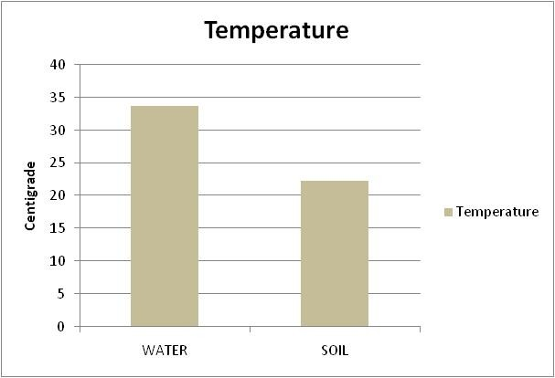
Graph No 2 : PH of water and soil taken from Urbashi dam Karak
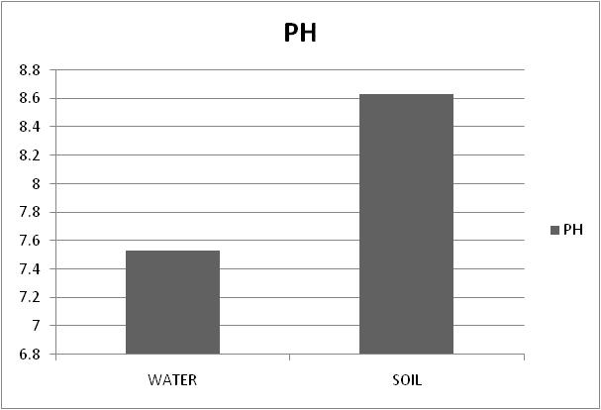

Graph No 3: TDS of water and soil taken from Urbashi dam
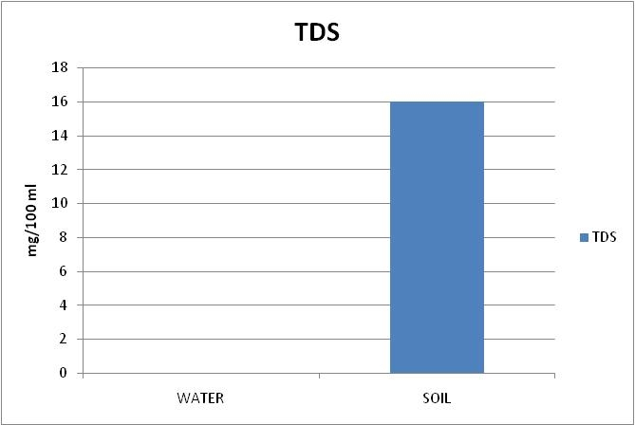
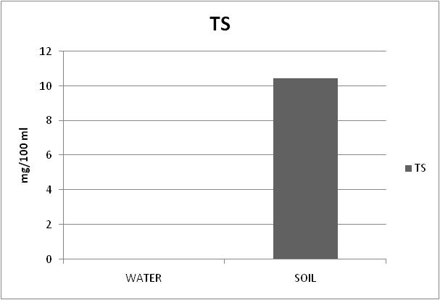
Graph No 4 : TS of water and soil taken from Urbashi dam

Graph NO 5: Conductivity of water and soil of Urbashi dam
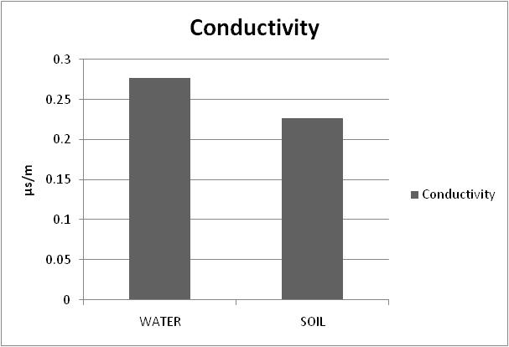

DISCUSSIONS
The results of the ichthyofauna of Urbashi dam in the District of Karak Khyber Pakhtunkhawa, with common and scientific names and their taxonomic rank up to species level, are given in table no.1. During the present survey, a total of 118 fish species were collected from Urbashi Dam in Karak, Pakistan. The classification of fishes represented the existence of seven species.
The seven reported species belong to a single phylum, Chordata, class Actinopterygii, order Cypriniformes, family Cyprinidae, with seven different genra and species. These seven species are Labeo rohita, Catla catla, Carassius auratus, Cirrhinus mrigala, Hypopthalmichthys molitrix, Cyprinus carpio and Tor khudree. Exploring the fish fauna of any area is very essential to provide basic knowledge about the species utilised for human consumption. This type of study also provides knowledge about the availability, abundance, population dynamics, and conservation status of fish species in an area. Our results show similarity to those of the attempt by Haseeb (2015). (Zaigham Hasan et al., 2014) who examined that a large number of species of the family Cyprinidae are dispersed throughout the freshwater reservoirs in different districts of KPK, Pakistan. IIyas reported the Cyprinidae with the following species at Zebi dam in District Karak: Labeo rohita, Catla catla, Carassius auratus, Cirrhinus mrigala, Hypopthalmichthys molitrix, Cyprinus carpio, Barilius vagra, Ctenopharyngodon idella, Puntitus ticto, and Puntius sophore. Butt explains 94 species of fish from the whole province of K.P. (Butt, 1986). Similarly, research conducted by Mirza et al. describes 13 species of the river Khuram [30]. Fish fauna of Dandy Dam in North Waziristan Ageny of FATA, KPK, Pakistan and identified five species such as Hypopthalmichthys molitrix, Cyprinus carpio, Cyprinus carpio, Ctenopharyngodon idella, Cirrhinus cirrhosus, and Tor tor. Nasir attempted research on the fishes of Tanda dam kohat and identified 23 species, among which 7 species are Barilius vagra, Hypopthalmichthys molitrix, Cyprinus carpio, Labeo rohita, Barilius pakistanicus, Mastacembelus armatus, and Crossocheilus latius [31,32]. (Rehman et al., 2015) identified 6 species from Ghandiali dam, District Kohat in 2015, which comprised of two orders, two families, five genera, and six species. Among them, five species come from the family Cyprinidae and only one species belongs to the Hypopthalmidae. The result of the current study revealed that the large number of species in Urbashi dam belong to a single family, the Cyprinidae. So habitats and environmental condition of Urbashi dam is more favourable for the growth of Cyprinid species.
Present study was conducted in order to analyze the physiochemical parameters such as temperature, PH, conductivity, total dissolve solids (TDS), color, elasticity, taste of water and soil samples collected from Ubashi dam Karak, KPK, Pakistan. Three samples of soil and water were collected from Urbashi dam for physiochemical analysis. The results of physiochemical parameter of soil and water of Urbashi dam are given in the table no.2 and table no.3 respectively.
CONCLUSIONS
It can be concluded from the present research study that Urbashi Dam Karak kept peaceful and favourable environmental conditions for the family Cyprinidae. The most common populated fish found in this study was Labeo rohita. All the physio-chemical parameters existed at their optimum limit, which had no detrimental effect on the survival, reproduction, and growth of both aquatic flora and fauna. Examining the physical and chemical properties of water, which were good for fish growth, soil was also found to be of the best quality. In length-weight relationships (LWR), all the b values were within the expected range from 2.46 to 3.13 for most of the species, and the K value of most species was greater than 1, which meant that the well-being of fish was best. Hence, from the current research study, we concluded that the ichthyofauna, physiochemical parameters, and length-weight relationship (LWR) of Urbashi dam fishes supply helpful knowledge to fish culturists and fisheries managers to enhance fish farming in the native region and to increase the economic and social benefits for the local population of district Karak. The government needs to take action and provide proper management to establish a well- developed aquaculture system, otherwise the aquaculture will lead towards destruction.

REFERNCES
- Rehman, H. (2015). Biodiversity of Fish Fauna of Darmalak Dam, Tehsil Lachi, District Kohat, KPK Pakistan. Global Veterinaria. doi:10.5829/idosi.gv.2015.15.01.95214
- Berra, T. M. (2001). Freshwater fish distribution: Academic Press.
- Jayaram, K. (2010). The Freshwater Fishes of the Indian Region (Revised second edition): Delhi, Narendra Publishing House, New Delhi, India.
- Ahmad, N. (1963). Freshwater fish fauna of West Pakistan. Agri. Pak, 14, 77-82.
- DiStefano, R. (2003). Helfrich, L. A.. and R. J. DiStefano. 2003. Crayfish biodiversity and conservation. In "Sustaining America's Aquatic Biodiversity: A Teacher's Guide. Edited by L. A. Helfrich, R. J. Neves and J. Parkhurst. U.S. Fish & Wildlife Service and Virginia Cooperative Extension Service Publication.
- Gupta, D., Sunita, S. J., & Saharan, J. (2009). Physiochemical analysis of ground water of selected area of Kaithal city (Haryana) India. Researcher, 1(2), 1-5.
- Seker, D., Göksel, Ç., Kabdasli, S., Musaoglu, N., & Kaya, S. (2003). Investigation of coastal morphological changes due to river basin characteristics by means of remote sensing and GIS techniques. Water science and technology : a journal of the International Association on Water Pollution Research, 48, 135-142. doi:10.2166/wst.2003.0558
- Radhakrishnan, R., Dharmaraj, K., & Kumari, B. (2007). A comparative study on the physicochemical and bacterial analysis of drinking, borewell and sewage water in the three different places of Sivakasi. Journal of environmental biology / Academy of Environmental Biology, India, 28, 105-108.
- Nollet, L. M., & De Gelder, L. S. (2000). Handbook of water analysis: CRC press.
- Shinde, S. E., Pathan, T., Raut, K., Sonawane, D., & Deshmukh, L. L. (2011). Studies on the Physico-chemical Parameters and Correlation Coefficient of Harsool-savangi Dam, District Aurangabad, India. Middle-East Journal of Scientific Research, 8, 544-554.
- Salve, B., & Hiware, C. (2006). Study of physico-chemical Nature of Wanparakalpa Reservoir, Nagapur, Near Parli-Vaijanth, dist. Beed, Marathwada region. National Journal of life sciences, 3(3), 327-331.
- Tyagi, S., Sharma, B., Singh, P., & Dobhal, R. (2013). Water Quality Assessment in Terms of Water Quality Index. American Journal of Water Resources, 1(3), 34-38. doi:10.12691/ajwr-1-3-3
- Dissmeyer, G. E. (2000). Drinking water from forests and grasslands: a synthesis of the scientific literature. Retrieved from https://www.fs.usda.gov/treesearch/pubs/1866
- Boyd, C. E. (2019). Water quality: an introduction: Springer Nature.
- Gilcreas, F. W. (1966). Standard methods for the examination of water and waste water. Am J Public Health Nations Health, 56(3), 387-388. doi:10.2105/ajph.56.3.387
- Dauwalter, D. C., Fisher, W. L., & Rahel, F. J. (2010). Warmwater streams. Inland fisheries management in North America, 3rd edition. American Fisheries Society, Bethesda, Maryland, 657-698
- Nazir, R., Khan, M., Masab, M., Rehman, H., Rauf, N., Shahab, S., . . . Shaheen, Z. (2015). Accumulation of Heavy Metals (Ni, Cu, Cd, Cr, Pb, Zn, Fe) in the soil, water and plants and analysis of physico-chemical parameters of soil and water Collected from Tanda Dam kohat.
- LeBlond, J. B., & Duffy, L. K. (2001). Toxicity assessment of total dissolved solids in effluent of Alaskan mines using 22-h chronic Microtox® and Selenastrum capricornatum assays. Science of The Total Environment, 271(1), 49-59. doi:https://doi.org/10.1016/S0048- 9697(00)00830-5
- Memon, S. H. (2012). An overview of mangrove restoration efforts in Pakistan. Sharing lessons on mangrove restoration, 51.
- Abbasi, S. (1998). Water quality: sampling and analysis: Discovery Publishing House.
- Agarwal, R. R., & Gupta, R. (1968). Saline-alkali soils in India. Saline-alkali soils in India.
- Katsoyiannis, I. A., & Zouboulis, A. I. (2013). Removal of uranium from contaminated drinking water: a mini review of available treatment methods. Desalination and Water Treatment, 51(13-15), 2915-2925. doi:10.1080/19443994.2012.748300
- Mirza, M. (1990). Pakistan ke taza pani, ke machlian. Urdu Science Board, Pakistan.
- Majeed, A., Mandokhail, B. M., Masood, Z., Rehman, H., Ullah, A., & Gul, N. (2015). Assessment study about the water quality criteria and heavy metals concentrations in different fish ponds of four districts of Balochistan Province, Pakistan. Global Vet, 14(3), 351-357.
- Naila, A., Flint, S., Fletcher, G. C., Bremer, P. J., & Meerdink, G. (2011). Chemistry and microbiology of traditional Rihaakuru (fish paste) from the Maldives. International Journal of Food Sciences and Nutrition, 62(2), 139-147.
- McCrady, M. (1966). Standard methods for the examination of water and waste-water: American Public Health Association.
- Torimiro, N., Bebe, P., Ogundipe, F., Esan, D., & Aduwo, A. (2014). The bacteriology and physicochemical analysis of fresh water fish ponds. International Research Journal of Microbiology, 5(3), 28-32.
- A.C, N., Anyanwu, E., & D.A, A. (2017). DYNAMICS OF WATER QUALITY IN TROPICAL EARTHEN FISH PONDS. Nigeria Journal of Fisheries, 14, 1289-1295.
- Beamish, R. J., Noakes, D. J., Noakes, D. L. G., & Beamish, F. W. H. (2003). William Edwin Ricker, OC, FRSC, LLD, DSc. Canadian Journal of Fisheries and Aquatic Sciences, 60(1), iii-v.
- Achakzai, W., & Saddozai, S. (2017). Zoological fauna of Khurum Dam and Muhabbat KhelDam of district Karak, Khyber Pakhtunkhwa, Pakistan. JOURNAL OF ENTOMOLOGY AND ZOOLOGY STUDIES, 5, 380-387
- Haseeb, A., & Ziba, H. (2018). Ichthyofauna of Dandy dam North Waziristan Agency of FATA, KPK, Pakistan. JOURNAL OF ENTOMOLOGY AND ZOOLOGY STUDIES, 4.
- Haseeb, A. (2015). An Investigation on Freshwater Fish Fauna of Tanda Dam in Kohat District, Khyber Pakhtunkhwa Province of Pakistan. Global Veterinaria, 14, 576-581.

