**ANALYTICAL MINI-REVIEW OF DIFFERENT CONFIGURATION SHEET PILE UTILIZATION FOR REDUCTION SEEPAGE PROBLEM WITH EXPLAIN SOME IRAQI DAMS ISSUES RELATED TO THE SEEPAGE PHENOMENON**

Omed Mohammed Pirota*, Kardo Sardar Mohammeda, Obeid Mahmoud Abdulsalamb, and Rashad Mohammedc

1. [Omed Mohammed pirot (Corresponding Author), MSc, [omed.muhammad@uor.edu.krd](mailto:omed.muhammad@uor.edu.krd) ],

[Kardo Sardar Mohammed,Phd, Kardo.mohammed@uor.edu.krd]

Research Center, University of Raparin,46012, Ranyah, Iraq

1. RUDN University, Moscow, Russia Federation. Phd student, mahmoud.obeid@yandex.com
2. College of Engineering, Salaheddin University, 42VG+932, Erbil, Iraq,Msc, Rashad.hassan@su.edu.krd

**Abstract**

Seepage is one of the main causes of dams and some other hydraulic structures' failure. Water movement beneath the dam’s base creates piping and uplift pressure under the structure, potentially leading to improper dam operation. The current review paper focuses on the utilization of a special technique to restrict the transfer of movement water via soil which includes sheet piles under the dam foundation. Sheet pile walls are interlocking pile segments that are embedded in soil to resist horizontal pressure, classified as a flexible retaining system, and capable of tolerating relatively large deformations. Sheet piles are made of various materials, such as wood, concrete, steel, and aluminum, which are suitable for different applications. The role of seepage can be affected by the cutoff utilization. In this review article, some Iraqi dam issues due to seepage are explained, also the geological stratum beneath the dam is briefly discussed. the potential use of sheet piles with different configurations has been reviewed to detect the optimum situation for seepage parameters reduction based on their numbers, interval distances, inclinations, and places.

*Keyword: Seepage, sheet piles, impermeable foundation, Iraqi dams issues and geological stratum*

1. **INTRODUCTION**

Seepage is water movement in ground layers. It causes water inflow in old underground structures like parking lots and subway tunnels originally built without proper waterproof lining. Seepage in dam foundations and other structures causes erosion, transportation, and ultimately failure [1]. Previous studies focused on erosion and bank instability resulting from seepage flow, including soil-water pressure, seepage gradient forces, and soil particle movement, and nearly 50% of structural failures are caused by seepage[2]. Poorly controlled seepage and pore pressures in dams lead to more piping and instability issues. At least two-thirds of the piping failures at the dam happened in the first five years of operation [3]. Three negative impacts can be considered due to the result of dam seepage including 1) uplift pressure causing dam failure, deformation, and stress 2) erosion and particle movement under the foundation, which endangers the stability of the dam 3) seeping problem in the dam foundation, the body also seep downward around the bank slopes at both ends of the dam[4]. Porosity and lack of compaction can cause natural dams to fail due to seepage or piping. Steel pipe utilization and their ' location, slope, and size can mitigate seepage that causes internal erosion and soil particle movement. During the seepage case, the caves are produced. Piping failure depends on the strength of dam materials. Piping and undermining caused the collapse of the landslide dam that impounded Lake Yashinkul in 1966 [5]. The report states that up to 26% of pipe failures may be related to inadequate filter design. The seepage issue depends on various elevations and path lengths concerning velocity[6].

Seepage failure faces the embankment dams and nearly 80% of United States dams are embankment dams. All dams and weirs are built to provide two conditions including water storage and hydraulic head, these make seepage case. Also, dam construction depends on several factors including water availability, storage or diversion requirements, and availability of local construction materials. Approximately 171,000 people lost their lives and nearly 11 million became homeless as a result of the several dam failures that occurred in China[7]. Many techniques are used to mitigate the seepage problem including compaction, using proper filters, and sheet piles. Sheet pile barriers extend the path of flow and reduce the hydraulic gradient. The flow vector is reduced by the sheet pile's length, which indicates lower water flow for longer pile lengths. Factor safety against the sheet pile depends on the sheet pile length directly. Shifting sheet piles to the upstream side results in an increase in the bending moment[8].

Number of the sheet piles, their length, and their distances impact the seepage flow. Minimum uplift pressure and minimum exit gradient exist in the intermediate pile for angles around 135o and 120o counter-clockwise. When the Distance between the upstream and intermediate sheet pile increases the exit gradient and uplift pressure reduce[9]. Inclined sheet piles change both uplift pressure and seepage. Using three sheet piles in upstream, middle point, and downstream one was tested in angles (14o, 26o, and 45o), this technique decreased uplift pressure under the structure[10]. The structure may collapse through a floor rupture if the pressure is not balanced by the weight of the floor. Numerous additional techniques are employed to manage the seepage phenomenon, such as an upstream blanket, sheet pile(cutoff), filter trench for the position downstream, and weep holes Subsurface drain on the downstream side. Each one has a different design, construction, and cost. The downstream cut-off is more effective than the upstream one. The most economical one is the upstream sheet pile[11]. The uplift force decreases when the intermediate pile is positioned to converge from the downstream direction [12].

Reducing the exit gradient is essential because, if it exceeds the foundation's critical gradient, Piping can occur caused by the gradual washing and removal of the subsurface particles. Position of the sheet piles from upstream, numbers, length change sheet pile role. Spaces among sheet piles also have a great role, when the distance increases, seepage, and uplift pressure increase too [13]. [14]studied suggest that an inclined rock toe and a trapezoidal internal core design perform better than those with a vertical rock toe or other shapes. Bligh's Creep theory estimates creep path by water traveling upstream to downstream. Lan's weighting theory considers the vertical creep three times more than the horizontal creep in over 200 dams. The estimated uplift pressure calculated by Khosla's Darcy equation recommended a correction because it ignored floor thickness, pile mutual interference, and floor slope. Several tools help calculate seepage and uplift pressure beneath barriers, including finite element programs like GEO-SLOPE and SEEP/W, as well as specialized lab equipment. However, soil layers, particle size, and porosity significantly impact these calculations [15]. The main objective of this paper is to review several previous articles related to the seepage problem in the dam and other barriers. Focusing on steel sheet pile utilization to mitigate the seepage problems. Analyzing and comparing data have been explained to achieve the optimum point. Explaining some Iraqi dam problem and their solution due best situation of cutoff utilization.

**2.0 FAILURE CASES IN DAMS AND OTHER STRUCTURES**

It's crucial to clarify words related to risk and hazard before talking about the failure mechanism. A hazard is a potential source of harm or danger. It's the event or situation that can cause damage or loss. Examples include earthquakes, floods, chemical spills, or system malfunction. Risk is the chance or likelihood of harm occurring due to the combination of a hazard [16]. Several hundred dams have failed, leading to disastrous outcomes and many deaths. Walter Bouldin, Alab dam was the earthen dam with a height of 52 m and a length of 3,407 m, it failed in 1975 due to a seepage problem[17]. The embankment dam is the common one that faces challenges and failure. In **Table 1**, common potential hazards identified for embankment dams are shown for some Malaysian dams[18]. Several studies have proven that internal erosion as well as external factors can lead to dam failures. Many factors can cause a dam to fail, including seepage, internal erosion, overflow from insufficient drainage, freeboard and settlement from earthquakes, and slope failure on the upstream dam body. There were more than 200 major dam failures in the world between 2000 and 2009[19].

**Table 1:**List of potential hazards for dam

|  |  |
| --- | --- |
| **Potential Dam Hazard** | **Common Causes** |
| Overtopping | Not enough freeboard for managing flooding and storms. |
| Internal erosion of embankment materials | Defects or cracks present, core material lacks cohesion or has a Plasticity Index below 7, and inadequate filter protection. |
| Internal erosion of foundation materials | Improper or absent treatment and a Plasticity Index of less than 7 are characteristics of the foundation material. |
| Erosion along embankment/structure interfaces | Because of inadequate design features, insufficient compaction near the structure, and a deficiency in filter and drainage protection, the compaction of the structure is inadequate. |
| Loss of freeboard, overtopping, and subsequent erosion | Earthquakes can cause settlement through seismic activity, the settling of embankment or foundation material, fault displacement, and reservoir landslides. |
| Instability of the downstream shoulder | The foundation's weakness results from shallow seams, inadequate preparation, poor drainage, insufficient shear strength, and the intense shaking experienced during earthquakes |
| Internal erosion of embankment materials | The foundation material shows dispersion, insufficient treatment, and a Plasticity Index below 7. |
| Internal erosion of embankment materials into foundation materials | Insufficient or improper foundation preparation, inadequate filter protection, and open joints at the interface. |

Most dam failures begin with a breach, a hole in the dam's body that causes collapse and releases water into downstream areas. The maximum outflow discharge in the breach can be estimated through this equation below.

***Qmax= 0.607 (Vw)0.295. (Hw)1.24 eq(1)***

Where ***Qmax*** is peak flow in (m3/s), ***Vw =*** volume of water during failure in the reservoir (m3) and ***Hw*** is water depth during failure above the final bottom of the breach(m)[20].

One of the third-world embankment dam failures due to the unsuitable spillway and other major dam failures refers to seepage and erosion particles along the seepage path. Protecting people's lives is the most important point in dam failure. Based on the Classification of the Federal Emergency Management Agency, the dam has been classified into three types depending on hazardous potential which is shown in the table **Table 2**, and **Table 3** some dam failure cases are given(Adamo et al., 2020) Also, **Figure 1** shows the main sources of dam failures in the world.

**Table 2:**Classification of dams according to their hazard potential

|  |  |  |
| --- | --- | --- |
| **Classification** | **Loss of Human Life** | **Economic, Environmental, Lifeline Losses** |
| Low | None Expected | Low and generally limited to the Owner |
| Significant | None Expected | Yes |
| High | Probable, one or more expected | Yes |

**Table 3**: Some dam failure cases[17].

|  |  |  |  |  |  |  |  |
| --- | --- | --- | --- | --- | --- | --- | --- |
| **Dam** | **Country** | **Year of Failure** | **Cause of Failure** | **Dam Type** | **Dam Height (m)** | **Volume of Reservoir**  **(hm3)** | **Number of Killed People** |
| Malpasset | French | 1954 | Flood | Arch dam | 66 | 47 | 420 |
| Machu | India | 1979 | Overflow | Earth fill dam | 26 | 101 | 2000 |
| Vajont | Italy | 1963 | Overflow | Arch dam | 262 | - | 2400 |
| Vega de Terra | Spain | 1987 | overflow | Buttress dam | 33 | 7.3 | 140 |
| Zerbino | Italy | 1935 | Stability | Gravity dam | 16 | 10 | 100 |
| Nanak Sagar | India | 1967 | Internal Erosion | Earth fill dam | 16 | 210 | 100 |
| Hell Hole, Calif. | USA | 1964 | piping | Rockfill dam | 67 | 30 | No Casualties |
| Walter Bouldin, Alab | USA | 1975 | seepage | Earth fill dam | 52 | 291.3 | No Casualties |

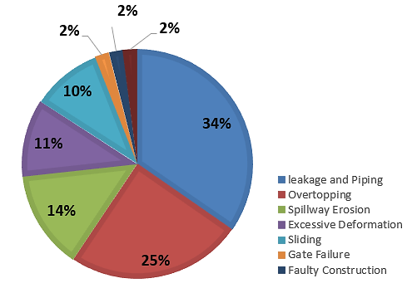

**Figure 1**:Main sources of dam failure [22]

[23]settlements of the crest and slopes are increased when the dam is situated on sediments. This increase is attributed to the compression of foundation materials resulting from the combined weight of the dam and the impounded water, particularly during subsequent stages. The distributions of pore pressure are primarily controlled by static factors, including the load due to self-weight and the distribution of stiffness. [24] [25]concluded that seepage pressure occurs due to friction between the percolating water and soil particles. Flowing water upward lifts the particles of sand. Sand starts to boil as a hydraulic gradient greater than the critical one. If (I > Ic) the discharge increases but the permeability coefficient remains constant however if (I=Ic) the value of the discharge increases and the coefficient of permeability also increases. The ICOLD Failure Categories are shown in **Figure 2**.

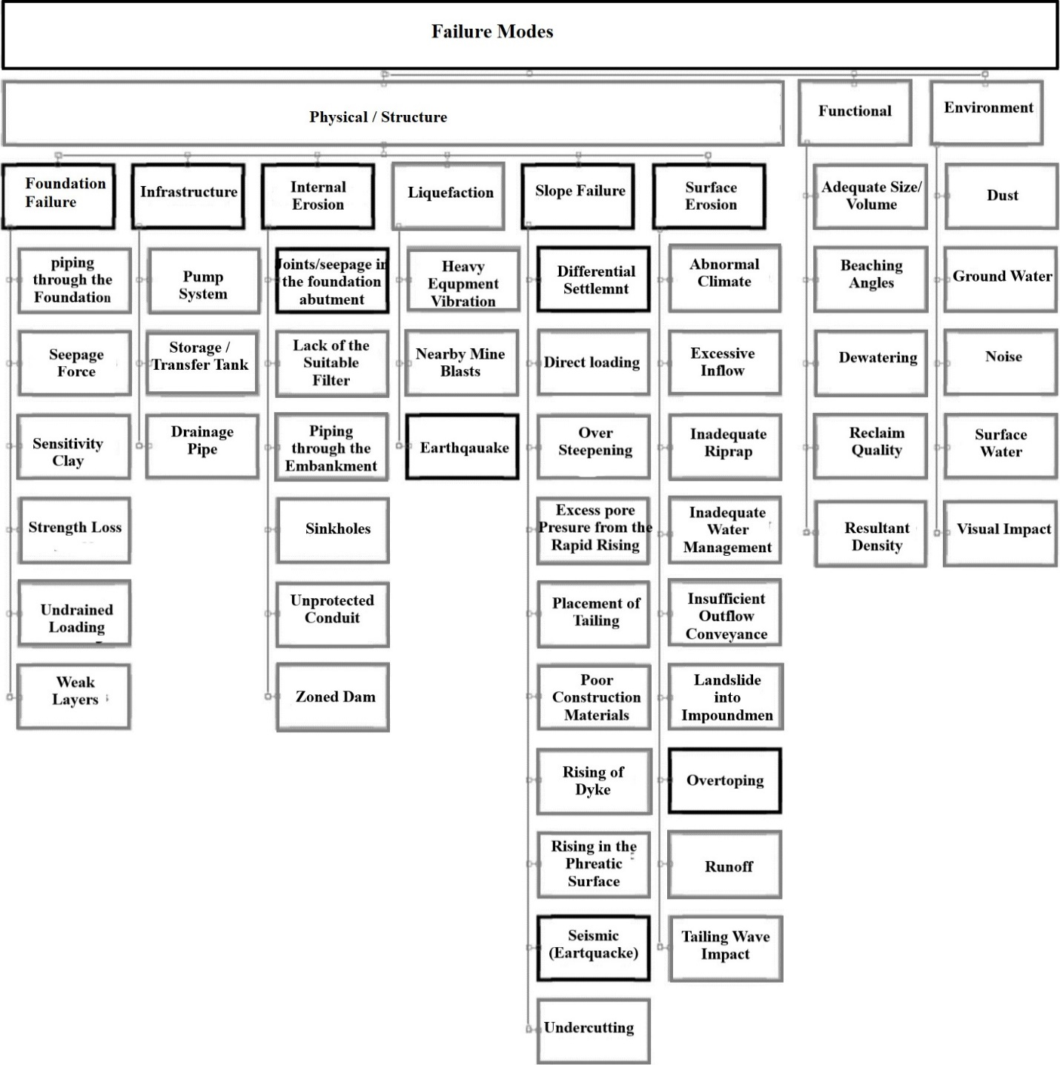

**Figure 2:**Hierarchy of failure modes[26]

**2*.1 Some Iraqi Dam Issues***

The Euphrates and Tigris are Iraq's two principal rivers. These rivers have contributed to the development of the economic and social sectors there. The Tigris and Euphrates Rivers' discharges are gradually decreasing, it is expected that they will dry up completely by 2040[27]. More than 30 different dams have been built in Iraq. It has 6 large dams: five are located in the Tigris and one in the Euphrates River. The territory of Iraq is located within the Arabian plate (a stable portion of the earth’s crust surrounded by tectonically active margins) and the Zagros fold and thrust belt [28]. The territory of northern Iraq in geological terms covers the north-eastern part of the Zagros fold and thrust belt of the north-western strike, in the northern and north-western parts of the Taurus, which has a latitudinal strike [29]Tectonically, the Iraqi territory is divided into three different areas **Figure 3**: Stable Shelf consists of buried anticlines and arches, with no surface anticlines; Unstable shelf with the presence of surface anticlines; Sutur Zagros, consisting of thrust scales of radiolarite, igneous and metamorphic rocks. The three listed areas contain tectonic groups with N-S strikes within the Stable Shelf and NW-SE or E-W in the Unstable Shelf zone and the Zagros Sutura. The N-S strike is associated with Paleozoic tectonic movements; E-W and NE-SW - with the Alpine orogeny from the Cretaceous to the present [30].

The Zagros folded belt (unstable shelf) is subdivided into three tectonic zones (from west to east): the Mesopotamian Zone (Quaternary molasse and buried structures), the Low folded Zone, and the High Folded Zone All of them are of meridional strike and are divided into blocks, which are limited by transverse faults oriented along the ENE-WSW line (with an offset to the NE-SW), with vertical and horizontal displacement[29]. In the Miocene, the territory of northeastern Iraq was an area of predominantly marine sedimentation, which began with the formation of carbonate and evaporite deposits of the Serikagni, Euphrates, Dhiban, and Jeribe formations in shallow epicontinental seas and lagoons in marginal basins. Marine conditions of accumulation were gradually replaced by isolated shallow marines and lagoons, periodically communicating with seas of normal salinity. This led to the formation of evaporite deposits of the regressive cycle of the Fatha Formation (Lower Fars) in the Middle Miocene. Shallow marine sedimentation in the Oligocene and early Miocene, combined with the southwest migration of the basin axis, led to the fact that narrow carbonate shelves were formed downdip relative to the older Paleogene margins. These shallow water carbonate platforms include the Asmari limestone in Iran and the Kirkuk formation in Iraq. Another uplift phase during the Burdigalian resulted in the outcropping and erosion of Paleogene-Lower Miocene carbonate platforms, and the unfilled center of the Paleogene basin was eventually filled with shallow evaporites and rare marine carbonates of the Fatha Formation in the middle Miocene. Tectonic deformation along the Zagros margin gradually became more intense starting from the middle Miocene, which led to the accumulation of fluvial to marine terrigenous deposits and, ultimately, coarser-grained deltaic and alluvial facies of the Injana Formation[31]. The upper boundary of the Transitional Layers of the Fatha and Jeribe formations, as well as the Euphrates/Serikagni formations, is the boundary of the main sequence of Lower Miocene formations in the northern part of the Arabian Plate. The evaporite deposits of the Salt-bearing strata of the Fatha and Dhiban formations are transgressive deposits of a low-standing tract formed during one-and-a-half sequences.

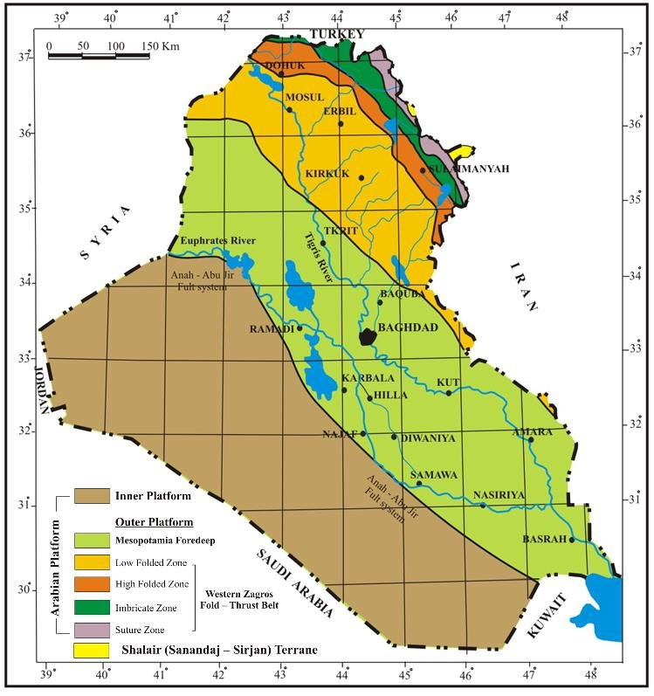

**Figure 3:**The tectonic divisions of Iraq[32]

***2.1.1 Mosul Dam***

It is an earth-fill dam with a central clay core, the largest dam in Iraq and fourth in the Middle East. Located 60 kilometers northwest of Mosul city and 80 kilometers from the Syrian and Turkish borders, the dam plays a crucial role in irrigation, hydropower generation, and flood control. The dam is susceptible to geological hazards, and without proper maintenance, it will fail[33]. The Fatha Formation, which is composed of multiple layers of marl, limestone, gypsum, and clay, is where the dam is located. There is high karstification in these beds of the formation. A series of sinkholes and springs were produced in downstream areas after the impounding dam in 1986 due to seepage and dissolution of gypsum in the dam ground layers[34]. The Mosul Dam's foundational rocks come from the Late Miocene Fatha Formation, originating from a sabkha and lagoonal environment. Sabkhas form in arid to semiarid conditions with low relief, typically less than 50 cm. Active sabkhas exhibit a complex geological composition, featuring eolian deposits, tidal-flood deposits, carbonates, and evaporite minerals that interact within a single geologic stratum in both horizontal and vertical directions[35]. The geological hazard of karstification has been rated at 5.5 degrees, not only in the dam site but across the entire Mosul Quadrangle at a 1:250,000 scale, encompassing an area of approximately 30,000 square kilometers[36].

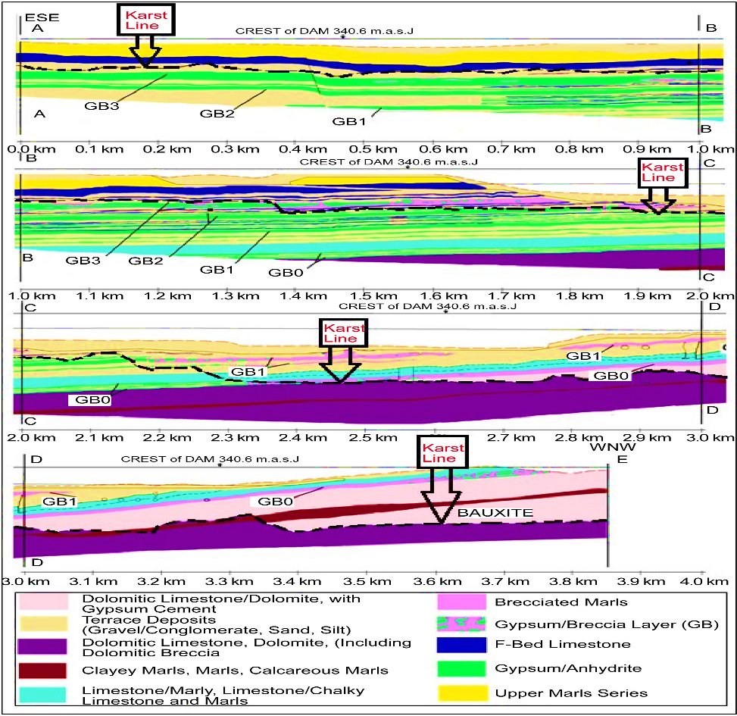

**Figure 4:**Lithological cross sections show the karstification line along the axis of the Mosul dam[37].

***2.1.2 Haditha Dam***

It is an earth-fill dam on Euphrates River and located the 270 km northwest of Baghdad between latitudes 34° 11' 30'' - 34°13' 30'' north, and longitudes 42°20' 00" - 42°23'30" east, (7) Kilometers away north Haditha city Abu Shabur area[38]. The storage capacity of the dam average is 9800MCM[39]. Seepage and leakage have been investigated as a main issue in the dam refers to the dissolution of the gypsum formations. For another Iraqi dam, using plastic core and clay soil mixed with materials 5% lime and 6% silica-fume as the core of earth dam has been detected, they decreased peaceability cases by more than 70% for the second technique. [40]concluded that computer software (SEEP/ W, 2012) is a successful method for computing seepage and indicated that the results displayed that the asphaltic diaphragm in good condition and efficient on the right and left sides of the dam. Also, the following equation below is used to use for modeling of SEEP/W program:

$\frac{∂}{∂x}\left(k_{x}\frac{∂H}{∂x}\right)+\frac{∂}{∂y}\left(k_{x}\frac{∂H}{∂y}\right)+Q=\frac{∂θ}{∂t}$***eq(*2*)***

Where ***H*** is a hydraulic head, ***kx*** is hydraulic conductivity at ***x*** direction, ***ky*** hydraulic conductivity

at y directions, Q is boundary flux, T is the domain time and $θ$ is volumetric water content (%). Using dolomite rock as a low permeable rock[41], an asphaltic concrete diaphragm for the central core and grout curtain reduces the seepage issues.

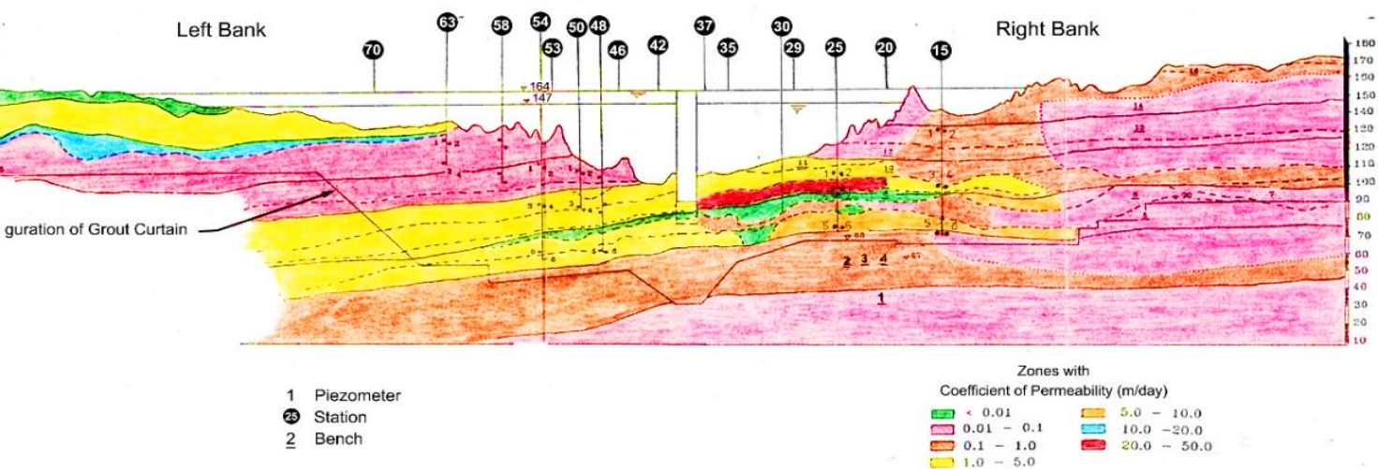

**Figure 5:**Geological layers formation according to the permeability of dam foundation [42]

The Haditha Dam is situated on the Euphrates geological formation of the characterized by basal conglomerate. This particular layer contributes to the formation of sinkholes and influences water circulation. The conglomerate layers are also covered by hard dolomitic limestone. The karstified rock layer depth is about 50 where the dam is situated [42]. [43]mentioned that in 1986 more than 55 sinkholes in different dimensions and shapes existed around the dam. Karstification is the main issue for Haditha Dam. Karstified and dissolution channels are also present in the dam foundations but using the long grout Curtain was saucerful for the reduction of the seepage problem under the dam.

**Table 4:**Simple differences between Mosul Dam and Haditha Dam geological formation [42]

|  |  |  |
| --- | --- | --- |
| **Aspect** | **Mosul Dam** | **Haditha Dam** |
| Stratigraphy and Type of the rocks | The dam rests on the Fatha Formation, which is recognized for its cyclic sedimentation. Each cycle consists of layers of marl, limestone, and gypsum. | The dam site is situated within the Euphrates Formation, which consists of basal conglomerate, resilient dolomite, chalky limestone, and undulating limestone |
| Karstification | The karstified rocks extend to a depth of approximately 300 meters, and sinkholes form in the gypsum beds. These sinkholes are of the solution type | The karstified rocks extend to a depth of around 50 meters, with sinkholes forming on the limestone bed. These sinkholes are of the collapse type. |

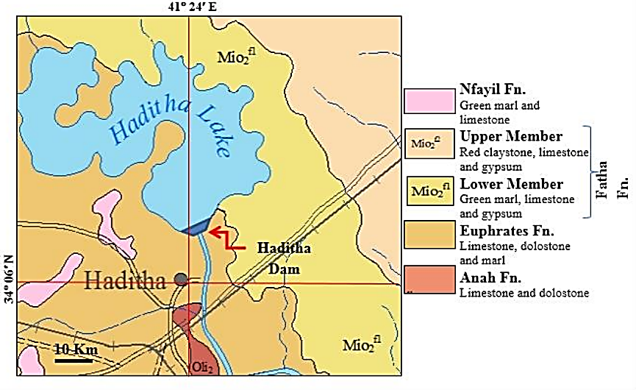

**Figure 6:** Geological map of layers formation around the dam [42]

***2.1.3 Hemrin Dam***

It is an earth masonry dam with a length of 3500m on the Diyala River and 100km away from north Baghdad. This dam is used for multipurpose including irrigation, flood control, and hydropower. The seepage issue has been discovered under the foundation zone in (1E-05 m/s). The lowest value of seepage flux can be considered at the maximum water level (107.5 meters) is (2.90E-09 m3/s/m2)[44]. The horizontal and vertical filters were constructed to reduce the seepage and piping through the dam body. These filters are made of loose sand the vertical one is 35.9 meters long and 2.5 meters wide and the other is 64 meters long and 2.5 meters wide. The permeability ratio of the foundation is about 1.46e-10 m/s and cohesion 40kPa[45], it can be assessed as low permeable soil[46]. It has been investigated that when the water level in the reservoir reaches the maximum level during the flood event, the downstream part gets some problems due to seepage and leakage.

[47]concluded that the annual sediment deposition is a great problem for dam reservoirs and it is about 3.25×106ton in 3.45×106ton. The dam is situated on the Mesopotamia Foredeep Tectonic and it extends to the Arabian Gulf. It is characterized by a flat terrane covered by Miocene to Holocene deposits, including restricted marine and continental (molasse) sediment(Fouad, 2015).mainly, the sediment of this layer consists of pebbly sand, sandy gravel, and silty clay and it has been considered as flood plain sediments[49] and groundwater table in this zone is between 10 to 30m[50].

***3.1.4 Badush Dam***

It is an earthfill concrete dam on the Tigris River and is located 40 km south of the Mosul dam. The main purpose of constructing this dam is to protect the living community after the Mosul dam failure. The dam crest level is 312 masl for an annual average discharge of 667 m3/s. The dam power capacity production is about 170Mw[51]. The geological situation of this dam is similar to the Mosul dam referred to as the karstification of the gypsum layer under the dam foundation with a seepage problem Fatha layer, a grouting method is used to protect the dam foundation. Sinkholes also are developed in various sizes and shapes due to activate the karstification process. Limestone bedrock is also observed. The depth of the Fatha layer varies, measuring 117m on the left side and 300m on the right side of the river. The floodplain that exists along the riverbank is composed of sand, silt, and clay. The grouting works on the dam are typically 100 meters deep, with the deepest gypsum beds reaching 150–200 meters, particularly on the left side where the thickness of the Fatha Formation is 300 meters[52]. The Fatha layer is also divided to the Fatha lower member and upper member. Each member is composed of recurring sediments, encompassing green marl, limestone, and gypsum, while the Upper Member contains reddish-brown claystone. The gypsum and limestone layers exhibit pronounced karstification[53].

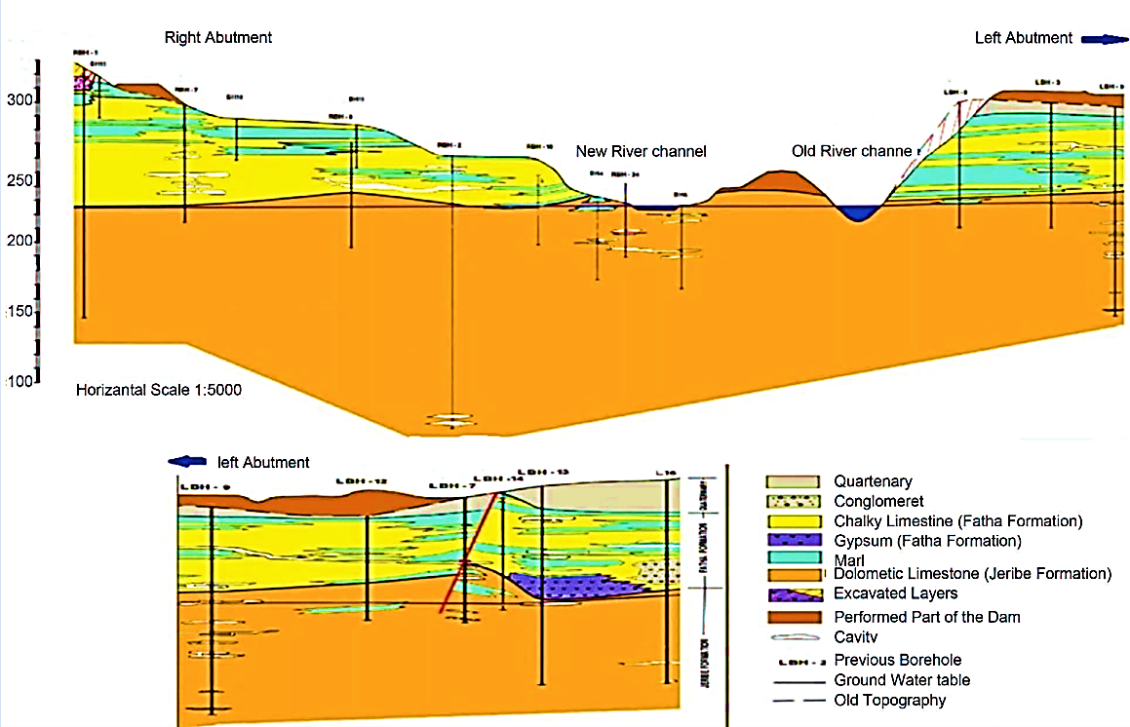

**Figure 7:**Geological formation under the Badush Dam [53]

**3.0 SHEET PILE**

It is an anti-seepage technique, used under the barrier foundation, easy to install, economical method, simple and fast. [54] showed the enclosed wall of steel sheet piles is created through the process of interlocking and sealing. The steel sheet pile is high-strength and generally U-shaped shape and exhibits strong strength, particularly at the joint, high bending strength, and resistance to leaking. The number of sheet piles, interval distance, and difference between upstream and downstream sheet piles have a great influence on seepage and water contamination[55]. [56] concluded that the sheet piles are produced in steel, concrete, plastic, aluminum, and low-permeable material. Sheet pile walls are resilient retaining structures composed of interconnected pile segments embedded in soils, designed to endure significant deformations and withstand horizontal pressures. Metal sheet piles are driven into the soil and interlocked together, but the concrete sheet pile is constructed due to jetting fresh concrete into a special excavated hole. Steel sheet piles are the easiest ones for initialization and have long life service with high resistance to high stress. Traditional sheet pile shapes are “Z” type and “U” type. The Hat-Type sheet pile 900 significantly contributes to lowering both construction costs and durations. [57] concluded that the interlocks of the sheet-pile sections are shaped like a thumb-and-finger or ball-and-socket joint for watertight connections. The designated permissible flexural stress for the steel sheet piles is as stated below:

**Table 5:** Standard allowable stress for different types of steel sheet pile

|  |  |
| --- | --- |
| **Type of Steel** | **Allowable Stress** |
| ASTM A-328 | 170 MN/m2 (25000Ib/in2) |
| ASTM A-572 | 210 MN/m2 (30 000Ib/in2) |
| ASTM A-690 | 210 MN/m2 (30 000Ib/in2) |

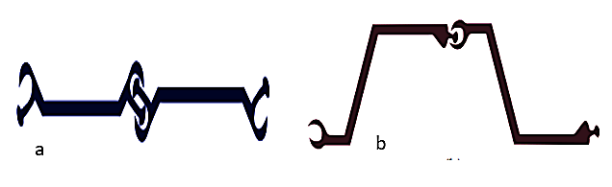

**Figure 8:** Sheet Pile Connection a) Thumb and Finger Type b) Ball and Socket Type [57].

To design sheet pile walls, we need to determine the necessary depth of penetration and maximum bending moment. water quality, depth of the sheet piles, service year and supporting load with soil minerals affect the steel sheet pile quality and design. During the design phase, one can consider various options such as zinc coatings, paint layers, "duplex" coating, and the use of corrosion-resistant steel. It is also possible to incorporate appropriate measures to account for potential corrosion[58]. The maximum thickness reduction for the steel sheet pile is shown in **Table 6**.

**Table 6:** Thickness reduction in steel profiles, in mm acc.

|  |  |  |  |  |  |
| --- | --- | --- | --- | --- | --- |
| **Design Time of Structure Usage (year)** | **5** | **25** | **70** | **50** | **100** |
|  | **Thickness reduction in steel profiles(mm)** | | | | |
| Undisturbed natural soils (sands, clays) | 0 | 0.3 | 0.6 | 0.9 | 1.2 |
| Normal fresh water: water table line | 0.15 | 0.55 | 0.9 | 1.15 | 1.4 |
| Sea water: full submersion & rippling zone | 0.25 | 0.9 | 1.75 | 2.6 | 3.5 |
| Sea water: splashing and low water level zone | 0.55 | 1.9 | 3.75 | 5.6 | 7.5 |

[59] studied that leakage in sheet pile walls below the hydraulic structure's floor has minimal impact on seepage losses, exit hydraulic gradients, and uplift force. The area and position of the leakage have a significant impact. The sheet pile with an area hole is used when the hole areas are about 2.5% and 10% of the wall area for a single sheet pile at 4m length. The worst case involved leakage in the upper central area of the barrier wall, as the flow path beneath the structure was less and the seepage was larger. The flow efficiency in the barrier can be shown below.

***EQ =*  *eq(3)***

Where ***EQ*** is flowing efficiency, ***Q*** is flow through the barrier and ***Q0*** is flow without sheet pile.

[60]discovered that the existence of the slot has a great effect on the water contamination under the ground. Flow through the slot depends on the sheet pile depth and slot position. slot increases the contamination discharge.Also, seepage discharge and its characteristics depend on the slot exitance in sheet piles. He investigated the steady-state seepage and contamination problem in the numerical model (Geo-Studio) to solve groundwater movement, and with the help of the results of (SEEP/W), the module (CTRAN/W) solves contamination time of traveling and concentration distribution. The space diameter was 0.1 m, depth of the sheet pile varied from 8m,10m,12m,14m, and 16 m, where the space depth from the ground was 2m,3m,4m, and so on and coefficient of hydraulic conductivity was 1x10-7 m/s. Soil porosity and distance from the contaminated source are 0.5m and 10m respectively. both discharge under the sheet pile and discharge in the slot were computed.

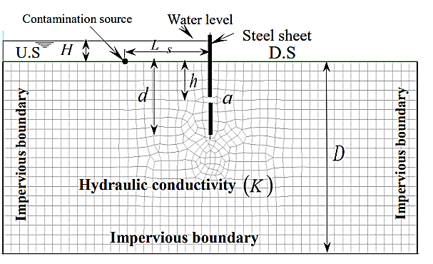

**Figure 9:** Dimensions of the model with slot in the sheet pile and model of the boundary condition

The result indicated the present slot causes to increase in seepage discharge and contamination flux compared to no slot. Relative depth ***(h*=h/d*)** and relative discharge **(*q*tot*=*qtot /q)*** in which ***qtot = qin+qund*** where (***qin*** is the discharge through the slot, ***qund*** is thedischarge under the sheet pile and ***q*** is the discharge under the sheet pile without slot). When the slot is close to the ground surface, seepage increases by around 80%. As the slot depth approaches 0.8m from the ground surface, seepage rises by approximately 10%. This equation below was derived based on the relative depth and relative discharge with a correlation of 0.980. on the other hand, When the slot approaches the bottom of the sheet pile, the discharge through the slot decreases, leading to the maximum discharge under the sheet piles.

***qtot*= -0.336ln(h*) +1.0415 eq(4)***

[61]investigated the effect of sheet piles to control saltwater intrusion. The relative depth ***db/d*** (depth of the barrier to aquifer depth) was considered for the saltwater concentration reduction purpose. The work was conducted in a sandbox model in which the specific gravity ***Gs*** = 2.64, bulk density = 1.93g/cm3, and dry density =1.5 g/cm3, fresh and saltwater were used for different trials. The barrier wall was penetrated 15cm away from the saltwater. The findings indicate that raising the ratio of embedment of the barrier wall ***(db/d)*** from 0.44 to 0.67 resulted in a rise in the repulsion ratio (***R***), ranging from 20.8% to 46.87%.

[62] discovered the effect of the sheet pile to mitigate the soil lead contamination problem. The analysis of lead contaminant transport involves the utilization of two software products, including SEEP/W and CTRAN/W. lab model consisted of two soil layers with the same thickness (8m) and their hydraulic conductivity and water content for the first layer (0.01 m/s and 0.3) and the second layer (0.10 m/s and 0.5). A sheet pile was driven to varying depths (2.0, 4.0, 4.75, 6.0, and 8.0) meters at a distance of (1.0m) from the source side over (10 years). Different lead (***Pb***) contamination concentration was used including (0.013g/m3, 0.022 g/m3, 0.031 g/m3, 0.088 g/m3). The project result showed us the application of the steel sheet pile method, with a decline depth of (4.75m) at a distance of (1.0m) from the source contaminant, resulting in the same concentration of lead (***Pb***) that can be introduced on the source side. An isolation method to mitigate the same issue was used. The construction of a trapezoidal protected area using a non-permeable concrete slab (1:1.5:3) and compacted boulder layer costs $300 per meter along the 5.0m slope side. [63] studied the influence of the sheet pile to mitigate the groundwater contamination phenomenon. Five simulation models were designed, incorporating varied cases, to examine the impact of cut-off wall width, penetration depth, and arrangement on contamination transit and diffusion. The study area was modeled as an unconfined aquifer with dimensions of 1000 meters in length and 400 meters in width. the soil hydraulic conductivity was 5x10-3 m/s, the horizontal hydraulic conductivity ratio to vertical is 10:1 and the aquifer layer effective porosity was 0.3 for the coarse sand layer. The landfill area was simulated as 40 m x 40 m and located on the ground surface with a depth of 4 m. The sheet pile was located 50m away from the source and the observation well point was located 100 away from the source. The following results below were given.

**Table 7:**Investigation on the influence of cut-off wall to groundwater contamination

|  |  |  |  |  |
| --- | --- | --- | --- | --- |
| **Cases** | **Model** | **Variable** | **Evaluation criteria** | **Result** |
| **Cases 1** | Model 1 | No cut-off wall | Presence of cut-off wall | The cut-off wall successfully retained the contaminant, preventing it from further downstream transport beyond the contaminated site. The presence of a cut-off wall along the contaminated transport pathway has slowed the movement of the pollutant plume, effectively limiting its migration within the groundwater aquifer. the relative concentration for 3 years of observation is 0.43 for without sheet pile cases and 0.41 for using it. |
| Model 2 | 100-m width cut-off wall |
| **Cases 2** | Model 2 | 100-m width cut-off wall | Width of the cut-off wall | The increased width of the wall has led to an extended travel distance, resulting in a longer duration for the contaminant plume to migrate downgradient from the contaminated site. The relative concentration for the special observation points after three years has reached 21% for Model 2 and 7% for Model 3. |
| Model 3 | 200-m width cut-off wall |
| **Cases 3** | Model 2 | 12-m depth cut-off wall (keyed-in) | Depth of cut-off wall | Reducing the depth of the cut-off wall from 12 m (keyed-in) to 8 m (hanging) has diminished the effectiveness of the cut-off wall in constraining the movement of contaminants. In Model 4, the concentration at observation point OW1 reached 44%, which was higher than the concentration of 21% observed in Model 2. |
| Model 4 | 8-m depth cut-off wall (hanging) |
| **Cases 4** | Model 2 | Downgradient wall | Position of the cut-off wall | The transport of the contaminant plume was identified to be confined between the two cut-off walls positioned upgradient and downgradient of the contaminated site. The results indicate that installing an upgradient cut-off wall successfully impedes groundwater flow, leading to a reduction in both the concentration and spread of the contaminant plume originating from the contaminated site. The upgradient cut-off wall redirected groundwater discharge, creating a buffer zone and reducing the contaminant plume's movement towards the second cut-off wall compared to Model 2. The relative concentration at observation point OW1 was 21% for Model 2, whereas it decreased to 16% in Model 5 |
| Model 5 | Upgradient and Downgradient walls |

***3.1 Position of the cut-off wall on seepage characteristics***

[64] studied in the core earth dam and detected the best position for installing the cut-off based on some Iranian dams Inclined the core layer, also finite element GeoStudio SEEP/W software was used. The position of the cutoff depends on the connection with lower permeable layers. The height and top crest width of the dam are 40m and 5m also the side slope is 1V:3H. The dam foundation layer thickness is 40m as shown in **Figure 9**. The cutoff was penetrated to the dam body and extended to the dam foundation. Distance of the sheet pile from the endpoint from the crest was denoted by (***x***) and it was 0, 5, 15, 25, and 45 m. Embedded depth in the dam has been denoted as (***d***) and varied by 20, 30, 50, and 60 m. The following results have been collected: The best point to embed the cut-off is 5m away from the dam crest toward the upstream. Seepage from the dam was equal to (0.0000090 m3/s) for all different penetrations of d (20, 30, 50, and 60m). Also, the flux through the dam foundation for the same distance of (***x***) was about (0.00085 m3/s/m) for d (20, 30, and 50m). cutoff wall locations of ***x*** = 5 m can be assessed as an optimum point and the cutoff length and its position in the dam body to detect their influences on seepage, uplift pressure, and exit gradient. SEEP/W program has been used too.

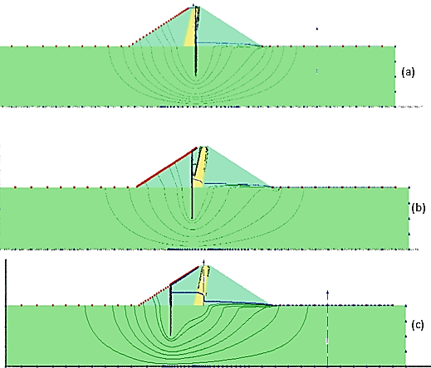

**Figure 10:**The phreatic line and flow path for analysis cases with partially embedded cutoff wall of d = 20 m and various locations for cutoff wall; (a) x = 0, (b) x = 15 m, and (c) x = 45 m.

[65]investigated the optimum location to install the inclined sheet pile for reduction of the exit gradient and uplift pressure under the barrier. Different inclined angles were used, including 00, 300, 600, 900, 1200, 1350, and 1500. The cutoff was penetrated at the upstream, midpoint, and downstream points. The foundation was homogenous, and an anisotropic soil, (ANSYS V.11.0) program was used to get the following results:

1. ***Hydraulic Structure with Inclined Downstream Cutoff***

If the cutoff is positioned at the toe, elevated exit gradient values occur when the cutoff is inclined toward the upstream side and (Ө < 90°) also uplift pressure is higher than the vertical cut-off there. The exit gradient increases when (Ө > 90°) and the maximum exit gradient reduction was for Ө = 120° and started increasing for Ө = 1350. Employing a downstream cutoff inclined toward the downstream side, with an angle (Ө) of less than 120°, proves advantageous in enhancing the safety factor against the piping phenomenon.

1. ***Hydraulic Structure with Inclined Upstream Cutoff***

It is observable that elevated values for both exit gradient and velocity are generated when the cutoff is inclined towards the upstream side (Ө is less than 90°). The cutoff inclination angle does not affect the uplift pressure head. The best angle for there is (90°).

1. ***Hydraulic Structure with Mid-Distance Cutoff***

The cut-off at the hydraulic structure base results in high exit gradient and velocity values when inclined towards the upstream or downstream side. The uplift head is more than the vertical cutoff and becomes smaller as the inclination angle increases. The cut-off should be placed near the hydraulic structure's toe, at a 120° inclination angle and it is the optimum situation.

[66] studied the sheet pile position (at the dam heel, at the mid floor of the dam, and at the dam toe) influence on the seepage phenomenon in sandy soil with cavity soil (Al-Najaf soil city). He used a simple model to do this research as shown in **Figure 10**. Najaf soil contains limestone rock and gypsum in sedimentary deposits, dissolved by groundwater movement, forming cavities at various locations and shapes. It has been determined that the best location for penetrating the sheet piles for seepage reduction purposes depends on the (***Xc/B***) ratio, where ***Xc*** is the distance from the cavity center to upstream and ***B*** is the base width or creep length for water flow. The optimum position for cutoff initialization is at the dam toe according to cavity location (***Xc/ B*** = 0 and 0.5). When (***Xc/ B*** ≥1) the best location is at the dam heel. Finite elements and suitable computer programs have been used. It was clear when dealing with a negative cavity position towards the upstream side, that the optimal location for initiating sheet pile installation is in the middle of the base.

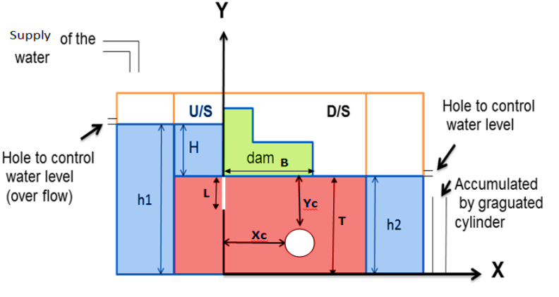

**Figure 11:** Model of the dam, soil with a cavity system

[67] investigated the sheet pile wall influence on the seepage cases under the low concrete gravity dam isotropic soil layers with different permeability and thickness. The study examined 54 hypothetical dam models with varying depths, angles, and positions of sheet piles obtaining numerical solutions for seepage flow conditions using the finite element technique and Geo-Studio - SEEP/W model software. The following result below was obtained.

**Table 8:** The influence of the sheet pile positions on seepage discharge and pore water pressure.

|  |  |  |  |  |  |  |  |  |
| --- | --- | --- | --- | --- | --- | --- | --- | --- |
|  | **Seepage (m3/s)** | | | | **PWP (k.p.a)** | | | |
| **L1&L2 (Distance from the upstream and downstream ends in unit meter)** | | | | **L1&L2 (Distance from the upstream and downstream ends in unit meter)** | | | |
| **Distance from the upstream end of the dam base** | **0** | **2** | **3** | **4** | **0** | **2** | **3** | **4** |
| **0** | 0.0005 | 0.0004 | 0.0004 | 0.0004 | 150 | 150 | 150 | 150 |
| **10** | 0.0005 | 0.00065 | 0.0005 | 0.0005 | 100 | 100 | 100 | 100 |
| **20** | 0.00063 | 0.00063 | 0.00063 | 0.00063 | 80 | 80 | 80 | 80 |
| **30** | 0.0007 | 0.0007 | 0.0007 | 0.0007 | 60 | 60 | 60 | 60 |
| **40** | 0.00062 | 0.0006 (0.0004 for L2) | 0.00062 | 0.0006 | 0 | 0 | 0 | 0 |

**Table 9:**The influence of the sheet pile position on X, Y exit gradient

|  |  |  |  |  |  |  |  |  |
| --- | --- | --- | --- | --- | --- | --- | --- | --- |
|  | **X, Y Exit Gradient** | | | | **X, Y Exit Gradient** | | | |
| **L1 (Distance from the upstream ends in unit meters)** | | | | **L2 (Distance from the downstream ends in unit meters)** | | | |
| **Distance from the upstream end of the dam base** | **0** | **2** | **3** | **4** | **0** | **2** | **3** | **4** |
| **0** | 0.2 | 0.24 | 0.3 | 0.3 | 0.2 | 0.2 | 0.2 | 0.2 |
| **10** | 0.16 | 0.15 | 0.12 | 0.12 | 0.16 | 0.16 | 0.16 | 0.16 |
| **20** | 0.18 | 0.18 | 0.17 | 0.17 | 0.17 | 0.17 | 0.17 | 0.17 |
| **30** | 0.18 | 0.16 | 0.16 | 0.16 | 0.16 | 0.14 | 0.12 | 0.12 |
| **40** | 0.2 | 0.2 | 0.2 | 0.2 | 0.2 | 0.18 | 0.10 | 0.08 |

The conclusion drawn is that using a sheet pile at the upstream location results in a significant reduction in uplift pressure forces compared to the scenario where no sheet pile is used. According to the information provided, the upstream sheet pile causes a decrease of 75% in uplift pressure forces.[68] Investigated the cutoff of various placements with different angles on the uplift pressure in the diversion dam foundation using the Seep/w model. Poisson’s Equation for water movement in a porous medium was used as shown below. The underlying soil was isotropic with a permeability of (10-5 m/s), while the cutoff wall was constructed using a low-permeability material (10-9 m/s). There were 10 different cases detected based on ratio ***(b1/b)*** including 0,0.1,0.2,0.3,0.4,0.5,0.6,0.7,0.8,0.9 in which (***b1***) is the distance from sheet pile to upstream end and (***b***) is the dam base length. Therefore, it can be concluded that the optimal location for the cutoff aimed at reducing uplift force, is at the upstream (heel) of the dam. The intensity factor at the heel of the dam was 0.35 and this equation below was obtained.

$k_{x}\frac{∂^{2}h}{∂x^{2}}+k_{y}\frac{∂^{2}h}{∂y^{2}}=q$***eq (5)***

***y = 1.3475x + 0.3599 eq (6)***

Where ***x*** is the relative position of cutoff, ***y*** is the intensity factor, ***R2*** = 0.9999, ***h*** = total head, and ***q*** = discharge flow rate. Installing the cutoff either upstream or downstream leads to the lowest seepage discharge value, while placing it in the middle of the dam resulted in the highest discharge. When the cutoff wall was placed at the upstream heel of the dam, it resulted in the minimum total uplift force and maximum exit gradient. It is recommended to position the cutoff wall within a relative range of 0.5 downstream of the dams when the project faces hazards due to hydraulic gradient. [69] investigated the cutoff position on seepage characterized in the Sabalan rockfill dam. It is located 55 km from the northwest of Ardebil-Iran, the dam storage capacity is 105x106m3, crest height is 77 m, and base width is about 330m. The following dam parameters are given below. In this research, the SEEP/W software was employed due to its proficiency in simulating seepage phenomena. The dam's core on both the upstream and downstream sides consists of three filter layers. This study was examined based on the cutoff depth ***(d),*** and position of the cutoff wall in the clay core base ***(X)*** based on the relative distance***(X/L)*** for 0,0.25,0.5,0.75 and 1.

|  |  |
| --- | --- |
| **Table 10:** Dam parameters and permeability  for different layers. | |
| |  |  |  | | --- | --- | --- | | **Dam Parameters** | | **Value** | | Dam height from the riverbed | | 77m | | Height from foundation | | 87m | | Length of crest | | 304m | | Width of crest | | 12m | | The thickness of the cutoff wall | | 1m | | The depth of the cutoff wall | | 50m | | The thickness of the core in the crest | | 6m | | The thickness of the core on the foundation | | 40m | | **Permeability** | **Layer** | **Value (m/s)** | | Clay core | 1×10–7 | | Filter 1 | 1×10–5 | | Filter 2 | 5×10–5 | | Filter 3 | 1×10–4 | | Rock fill shell | 1×10–3 | | Cutoff wall | 1×10–9 | | Alluvium | 1×10–5 |     **Figure 12:**Cross section and finite elements meshing for Sabalan rockfill dam with variable parameter |  |

The hydraulic gradient reaches the minimum amount at the shell. In addition, the hydraulic gradient decreases by transferring the position of the cut-off wall from the heel to the toe of the clay core, and the difference percentage between the two hydraulic gradients of the place of the cut-off wall in the heel and toe of the dam is about 34%. Therefore, the optimal position of the cut walls to reduce the hydraulic gradient is at the toe of the dam core. By further shifting the position of the cutoff wall from the heel to the toe of the dam core, there is an increase in seepage. The percentage difference in seepage values between the left (heel) and right (toe) positions of the cutoff wall is approximately 0.2%. The best case for mitigation of the seepage and uplift pressure is to penetrate the sheet pile in the midpoint with an increase in its length to meet the impermeable layer. It is evident that a deeper cutoff is preferable for minimizing seepage and reducing uplift pressure, but opting for a deeper cutoff requires a greater financial investment. The variance in seepage percentages between the shortest cutoff (12.75m) wall and the deepest cutoff wall (75m) in both the dam body and its foundation is 4.33% and 49.31%, respectively. So, the best position for penetration of the short sheet pile for uplift pressure and seepage discharge mitigation is the heel point. [70]studied the effect of the cut-off position on seepage flow, within a homogenous isotropic soil, under a concrete dam along the floor length in the ratio (0, 0.25, 0.50,0.75 1). The quadrature element method (DQEM) as a numerical technique is investigated. Penetration of the exit gradient at the end of the floor has an obvious effect on the exit gradient and caused a reduction of 10% to correspond to it at the beginning of the floor.

[8]discovered the influence of the cutoff position on seepage characterized below the earth dam that was made of homogenous soil. The dam's base width is specified at 17 meters, with a side slope ratio of 2 H:1 V. Soil properties were tested and included ***k =1.45x10-8 m/s, Ɵ =50, ʋ=0.3, γ=17.40Kn/m3 and c = 18.7 Kn/m2***, the has been analyzed by FLAC 2D. Indeed, there were a total of 12 trials, organized into four distinct cases. Each trial involved the variation of both sheet pile depth and its position. The four cases investigated different sheet pile depths (5m, 10m, 15m, and 20m). For every case, the sheet pile position was modified from the downstream end, specifically at intervals of B/8, 2B/8, and 3B/8, with B representing the base width of the dam. The bending moment in the sheet pile raised as the sheet pile was shifted towards the upstream side. The properties of the sheet pile are shown below.

**Table 11:** Properties of the sheet piles

|  |  |
| --- | --- |
| **properties** | **Value** |
| Area of cross-section per meter | 0.03 (m2) |
| Young’s Modulus ***Esteel*** | 2 × 1011 (N/m2) |
| Moment of inertia per meter | 0.00225 (m4) |
| Poisson’s ratio | 0.22 |

The result indicated if the sheet pile position shifts away from the downstream end, the exit gradient increases. When the sheet pile remains in a fixed position, the exit gradient decreases as the length of the sheet pile increases. The best case was a sheet pile depth of 20m and fixed at the dam toe or at least at B/8. At the mentioned point the value of the exit gradient was 0.5 while was equal to 1.8 for 3B/8. The factory safety decreased when the sheet pile moved away from the downstream end. The sheet pile position shifts towards the downstream end, increasing average flow length and decreasing exit gradient, enhancing safety against piping. As the exit gradient decreases, the safety factor against piping increases, reducing the likelihood of piping failure. Increased sheet pile length also extends the seepage path and reduces the exit gradient. As the sheet pile position shifts from B/8 to 3B/8 away from the downstream end, there is an increase in the bending moment on both the positive and negative sides [71]concluded that factor safety against the piping is a ratio must be greater than 1 to ensure this structure is in a safe situation and can be shown below:

***F.s = $\frac{I_{c}}{I_{e}.}>1$ eq(7)***

***Ic $=\frac{G_{s}-1}{1+e}$ eq(8)***

Where ***F.s =*** factor of safety, ***Ic =*** critical exit gradient, ***Ie =*** exit gradient, ***Gs =*** specific gravity of the soil, and ***e =*** void ratio. Exit gradient is the ratio of the total difference head per flow path length. It depends on the flow length depth, inclination, number, and position of sheet piles under the floor. The type of filter trench also impacts the exit gradient. It has been indicated that the downstream (D/S) cutoff is more efficient than the U/S one for the case of exit gradient reduction, although utilizing the upstream (U/S) cutoff is more cost-effective.

[72]studied the detection optimum design of the sheet pile position and inclination under the barrage by using a genetic algorithm (GA) model coupled with finite element modeling. More than 3500 different cases were analyzed to detect the optimum exit gradient and minimum uplift pressure with minimum concrete floor thickness. The investigation focused on different scenarios involving the differential head (***H***) across a range of values (1 to 10 meters). Additionally, six distinct depth-to-floor length ratios (***d/b***) of the cutoff were examined, spanning from 0.1 to 0.6. For each depth-to-floor length ratio (***d/b***), the study explored six different cutoff locations (***b1/b***) with location ratios of 0.0, 0.2, 0.4, 0.6, 0.8, and 1. Within each location ratio, the analysis considered 10 inclined angles (***θ***) at intervals of 15°, covering a range from 15° to 165°. These investigations were carried out in the context of isotropic homogeneous soil, where the coefficient of permeability was 30 m/year. The extensive set of runs aimed to capture a thorough understanding of the system under various conditions The model of the boundary and foundation properties is shown below. Indeed, the cutoff's impact is distinct depending on its location. Upstream positions experience a significant reduction in uplift pressure with only a minor influence on the exit gradient. Conversely, downstream placements effectively decrease the exit gradient but concurrently elevate uplift pressure beneath hydraulic structures. This equation below used to detection:

***Min ( $\frac{I_{g d}}{H})=f(\frac{b1}{b},Ɵ)$ eq (9)***

$$\left(\frac{I_{g d}}{H}\right)=C0+C1Ɵ_{1}+C2\left(\frac{b1}{b}\right)+C3Ɵ^{2}+C4{\left(\frac{b1}{b}\right)}^{2}+C5Ɵ{\left(\frac{b1}{b}\right)}^{2}$$

$+C6Ɵ^{3}+C7{(\frac{b1}{b})}^{3}+C8Ɵ{(\frac{b1}{b})}^{2}+C9Ɵ^{2}(\frac{b1}{b})$***eq (10)***

***H*(under the gate) =+ +***

***eq(11)***

Where $\left(\frac{I_{g d}}{H}\right)$ is the speciﬁc exit gradient function that should be minimized; ***Ig*** is the exit gradient; ***d*** is the depth of cutoﬀ; and ***H*** is diﬀerential head ***h1- h2; h1, h2*** are respectively piezometric head on upstream and downstream of the structure ***(L).*** There are two decision variables: ***b1/b*** is the relative location of the cutoﬀ and ***θ*** is the angle of incline in degree***. (C0 toC9) and (a0 to a9)*** are the regression variables for each ***(d/b). b1*** is the distance between upstream to sheet pile location.

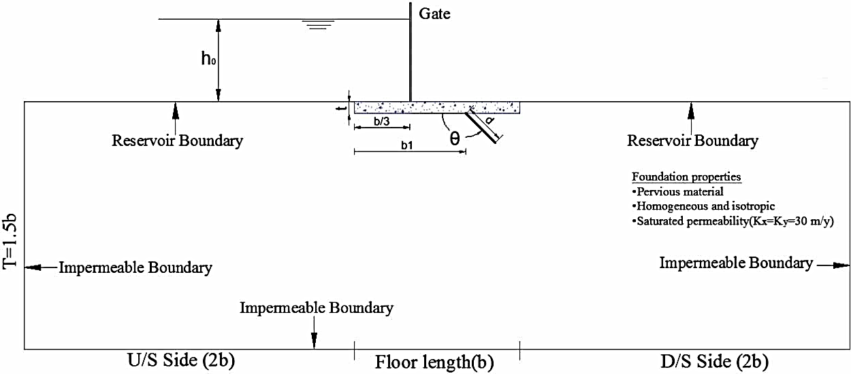

**Figure 13:** Sketch of boundary conditions and the foundation properties

The following result were obtained. The most effective way to improve the factor of safety against piping is to implement a cutoff at positions around 0.8 times the base distance. This cutoff should be inclined towards the downstream side at inclination angles (θ) of 30°, 123°, and 145° to achieve optimal results. This approach reduces the exit gradient for relative depths of 0.1, 0.2, and 0.3, respectively. Moreover, the necessary floor thickness is lower compared to similar structures without a cutoff. The optimum exit gradient was identified at an angle ranging from approximately 59° to 68° when utilizing an upstream cutoff for relative cutoff depths of 0.4, 0.5, and 0.6. There was a indirect relative relationship between the cutoff length and exit gradient value for whole cases.



**Figure 14:**Flow net of the optimum model within (d/b = 0.2) in relative cutoﬀ location of (0.839) from the upstream

***3.2 Inclination of The Cut-Off Wall on Seepage Characteristics***

[73]Proved the cutoff angle has a great role in the seepage flow, exit gradient reduction, and minimizing the uplift pressure, a simple technique with high effectiveness. Different inclination angles have been detected from 00 to 1800 in a clockwise direction using the GeoStudio 2007 SEEP/W computer program. The cutoff was installed in the upstream position and coefficient permeability of about 2.5x10-5 m/s, and the difference head between upstream and downstream was 4m. pore water pressure at the beginning of the dam after the cut-off wall to the dam toe varied between 43Kpa to 22 Kpa respectively. Mnium values for seepage flow were obtained for angles about 600 because it elongates the water path, requiring water molecules to traverse a longer distance from higher to lower potential energy points. While the study revealed that the minimum pore water pressure occurred at an angle approximately ranging from 120° to 135° additionally the minimum value for exit gradient was determined for cutoff angles between 450 to 750. [74]conducted research to investigate how the inclination and placement of sheet piles impact the exit gradient, seepage, and uplift pressure beneath the barrier in both single and multi-layer soil foundations. The study involved employing sheet piles both upstream and downstream, as well as using them in both positions. The research utilized SLIDE v.5.0 along with piezometric tubes, and the outcomes of the various scenarios were summarized based on the cutoff inclination and position with reduction cases.

**Table 12**:Influence of the sheet pile inclination and position on seepage, exit gradient, and uplift pressure reduction.

|  |  |  |  |  |  |  |  |
| --- | --- | --- | --- | --- | --- | --- | --- |
| **Upstream Cutoff** | | | | **Downstream Cutoff** | | **Double Cutoff at U/s and D/S** | |
|  | **Ɵ =450** | **Ɵ =900** | **Ɵ =1200** | **Ɵ =900** | **Ɵ =1200** | **U/S, D/s Ө=900** | **U/S Ө =450,**  **D/s Ө=1200** |
| **Uplift pressure** | 40.31% | 31.25% | 24.68% | 3.75% | 10% | 50% | 42.01% |
| **Exit Gradient** | 1.25% | 1.78% | 3.21% | 3.57% | 5.35% | 5.35% | 8.03% |
| **Seepage** | 28.50% | 23% | 6.34% | 12.60% | 28.75% | 30.15% | 30.30% |
| **Figures** |  | | |  | |  | |

The conclusion drawn is that using a sheet pile at the upstream location results in a significant reduction in uplift pressure forces compared to the scenario where no sheet pile is used. According to the information provided, the upstream sheet pile causes a decrease of 75% in uplift pressure force. [75]discovered the upstream cutoff inclination efficiency under the concrete foundation dam to mitigate the seepage characterizes risk. The angles will vary from 0° to 180°, progressively increasing at an interval of 30°, the model of the study was analyzed due to finite element geotechnical software – PLAXIS 2D. All angles were measured in the counter-clockwise direction. The seepage discharge beneath the toe points at angles (0°, 30°, 60°, 90°, 120°, 150°, and 180°) amounted to (1.164x10-3, 1.087x10-3, 1.045x10-3, 1.003x10-3, 1.098x10-3, 1.334x10-3, 1.509x10-3) m³/s, respectively. The lowest discharge rates were observed at angles 60° and 90°, with the minimum discharge occurring beneath the cutoff wall point at 600 this is because, in this arrangement, the water path is maximally extended. This essentially results in an increased duration for water molecules to traverse from areas of higher potential energy to points of lower potential energy. Uplift pressure and seepage are closely related to each other because as water flows through the soil profile, it generates upward pressure on the horizontal base of the dam the test results were (20.89, 21.16, 21.12, 20.82, 20.73, 21.31 and 21.06KN/m2) respectively. The minimum uplift pressure was for angle 1200 and this upward force has a great role in foundation dam stability, if the dam weight is unsuitable to resist this force, it may cause a reduction in the shear stress between the dam and soil causing the structure's floor to rupture, ultimately resulting in a collapse. [65]discovered when the cut-off is located at the toe, increased exit gradient values are observed if the cut-off is inclined towards the upstream side (Ө is less than 90°), the maximum exit gradient decreases when Ө equals 1200 and begins to increase when Ө equals 1350 while the safety factor against the piping started to increasing if Ө less than 1200. The uplift head indirectly changed with increasing the angles. Installing the cutoff in the dam upstream heel does not affect the exit gradient.

[76]studied the downstream cutoff inclination on the exit gradient for anisotropic soils. The solution was formulated utilizing the Schwarz-Christoffel transformation. The test result indicated the downstream exit gradient of an inclined sheet pile typically decreased as its inclination angle increased measured in the clockwise direction. As the inclination angle exceeds 90°, the protective length diminishes with a further increase in the angle of inclination. Beyond an inclination angle of 2π/6, the necessary protective length to attain a factor of safety against piping typically decreases as the angle of inclination increases.[77] investigated the sheet pile inclination and their space with length on uplift pressure and exit gradient. The safety against the uplift pressure and the piping was introduced. Flowing water under the structure creates an uplift force on the structure floor. If this problem cannot be fixed by the weight of the structure, it causes failure, it needs safety against uplift pressure technique. Water seepage beneath the structure, induced by variations in the head, carries foundation particles downstream. If the exit gradient exceeds the critical gradient for the foundation and remains unresolved, it leads to settlement this needs safety against piping phenomenon technique. The test was done in homogenous isotropic soil while the base width of the concrete gravity dam was about 40m. The role of the U/S and D/S cutoff inclination was tested separately for angles 10o, 20o, 30o, 40o…150o in the counterclockwise direction and total difference head was 30m. The most effective angle for an upstream (U/S) cutoff to minimize uplift pressure was found to be 90o, but as inclination angles increased, uplift pressure began to rise. However, the presence of a cutoff at the downstream (D/S) toe resulted in increased uplift pressure compared to cases with no cutoff walls. Downstream cutoff inclination angles significantly influenced the maximum exit gradient, with the optimal angle being 135 degrees and the minimum exit gradient was obtained there. In contrast, upstream angles did not play a significant role in reducing the exit gradient, and it increased after reaching a 90o inclination.

[78]studied the influence of the intermediate sheet pile inclination angles on the seepage properties under the hydraulic structure for homogenous soil using the computer program SEEP/W software. During the software testing phase, various situations were analyzed. The best separation distance for three sheet piles and determining the optimal depth for these three sheet piles were detected. Also, the incline angles for the second one was (30°, 45°, 60°, 90°, 120°, 135°, 150°) degree. In three cases for first and third sheet piles angles included (Ө =30,60,90) degree, the total difference head was 4.5m and the permeability of soil (k=10-4 m/s) and overall run included 1136 runs. The lowest exit gradient occurred when the intermediate sheet pile was inclined at a counterclockwise angle of 135 degrees and the other following results were obtained below however the minimum value of seepage discharge related to Ɵ2=1200 counterclockwise and the minimum value for uplift pressure occurred as the second angle around 150o, this indicated that the best angle for minimizing the exit gradient is 135o.

**Table 13:** The whole test results for uplift pressure and exit gradient

|  |  |  |  |  |  |  |  |  |
| --- | --- | --- | --- | --- | --- | --- | --- | --- |
| **Ɵ2** | | **30o** | **45o** | **60o** | **90o** | **120o** | **135o** | **150o** |
| **Exit Gradient** | **for Ɵ1,Ɵ3=30o** | 0.28 | 0.26 | 0.258 | 0.24 | 0.238 | 0.225 | 0.23 |
| **for Ɵ1,Ɵ3=60o** | 0.282 | 0.28 | 0.26 | 0.258 | 0.243 | 0.23 | 0.238 |
| **for Ɵ1,Ɵ3=90o** | 0.24 | 0.238 | 0.23 | 0.228 | 0.23 | 0.218 | 0.23 |
| **Uplift**  **Pressure, (p)** | **for Ɵ1,Ɵ3=30o** | 13.46 | 13.47 | 13.5 | 13.46 | 13.45 | 13.447 | 13.445 |
| **for Ɵ1,Ɵ3=60o** | 13.540 | 13.545 | 13.580 | 13.580 | 13.552 | 13.550 | 13.548 |
| **for Ɵ1,Ɵ3=90o** | 13.65 | 13.65 | 13.66 | 13.67 | 13.7 | 13.652 | 13.65 |

[79]investigated the different positions of the cutoff inclination on the steady-state two-dimensional water seepage through the foundation of a dam structure using FORTRAN 90. The inclination cutoff was embedded in U/S, mid-base, and D/S places. Inclination angles were measured as the counterclockwise direction for (0, 30°, 45°, 60°, 90°, 105o,120°, 150°). The maximum ranges for uplift ratios were obtained when (Ɵ < 90o) counterclockwise for the upstream sheet pile, then it decreased when the angle ratio was between 90o to 120o and started to increase again. Uplift heads for various points on the dam base were identified using the parameter (Xm/Ld = 0.0, 0.1, 0.2, 0.3, 0.4, 0.5, 0.6, 0.7, 0.8, 0.9, 1.0), where Xm represents the target point and Ld is the length of the dam base. For midpoint sheet pile installation, the minimum uplift head was observed at 150 degrees for different points. The optimal condition for minimizing uplift pressure was associated with angles (Ɵ ≥ 90 degrees), and a rapid decrease in the uplift head was noted for (Xm/Ld ≥ 0.5) towards the downstream direction. The maximum value for exit gradient was noted when the inclination angle was almost equal to 150o for both U/S and mid-base cutoff positions. The downstream (D/S) exit gradient of the dam structure for D/S cutoff penetration diminished as the angle (Ɵ) increased towards the downstream side (Ɵ ≥90°). This trend continued until the cutoff inclination angle reached approximately 120°, beyond that the exit gradient developed with further increases in (Ɵ). The optimum angles for U/S, Mid base, and D/S sheet pile for minimum seepage achievement were around 60o, 105o and 120o respectively.

[80]studied the effect of two inclination sheet piles under the small hydraulic structures on the seepage problem and analyzed different cases by using Geo studio software. The test was investigated in the lab through the small model of the tank 2 m long, 0.5m wide, and 1m high the tank bottom was filled by sandy soil in K= 42.3 m/day fine sand. U/S and D/S were installed to detect their length and angles. Their angles were measured in the clockwise direction and included (60o, 70o, 80o, 90o, 100o, 110o, 115o, 120o and 130o). The examination results showed that the acceptable minimum uplift pressure along the base of the dam was confirmed when the downstream cutoff angle (Ɵ2) was approximately 130 degrees clockwise for the upstream cutoff angle (Ɵ1 = 90 degrees). However, there was no significant change in the exit gradient when varying the upstream cutoff angle (Ɵ1) within the range of 60 to 130 degrees, with the downstream cutoff angle fixed at 90 degrees, however, the existence of the U/S could reduce the exist gradient from 0.48m to 0.15 from 10m away at U/S source. Uplift pressure also decreased slightly along the floor when Ɵ1 was greater than 90o and Ɵ2 was fixed at 90o. The optimum angle to get the minimum pressure head along the floor was 120o, pressure head decreased from zero distance at upstream 6.3m to 4m at 10m away from source. When the inclination angles for both cutoffs were changed the following results below were approved:

**Table 14**: Different cases of uplift pressure and exit gradient for different U/S and D/S cutoff inclination angles.

|  |  |  |  |  |
| --- | --- | --- | --- | --- |
| **Cases** | **Ɵ1** | **Ɵ2** | **Exit Gradient** | **Uplift Pressure** |
| 1 | >90o | <90o | The maximum exit gradient value decreased; however, the exit gradient values for the remaining downstream distances were observed to be higher than those linked to vertical cutoffs. As a result, extra protection is necessary for the downstream side of the structure to address the heightened exit values | No dramatic change with compared to vertical sheet piles |
| 2 | <90o | >90o | The exit gradient achieved was greater than that of vertical cutoffs. | A significant reduction was observed when compared to vertical cutoffs |
| 3 | >90o | >90o | The maximum exit gradient value increased, while the exit gradient values for the remaining downstream distances showed no change compared to those associated with vertical cutoffs | A notable decrease in the uplift head is achieved in this scenario. |
| 4 | <90o | <90o | Compared to the vertical cutoffs case, there was an observation of both a high exit gradient and a substantial increase in uplift head. | High with compared to vertical cutoff |

***3.3 Depth of The Cut-Off Wall on Seepage Characteristics***

Sheet pile depth has a great role in seepage mitigation due to increasing flow path. [81]investigated the sheet pile length and its role in seepage characteristics. SEEP/W, a component of GeoStudio, was employed to carry out numerical analyses. The dam face had a slope inclination of 30.96° relative to the horizontal axis, with a ratio of 10:6 for horizontal to vertical components, for both the upstream and downstream faces. This same slope was applied consistently across all models. Soil types for foundation layers included clay and silty clay with permeability values of 1x10-9 m/s and 5x10-7 m/s respectively. Concrete impermeable wall material was used to construct the cut-off wall in dimensions (2m length x 1m width) and (3m length x 1m width) in two different cases. The result indicated the length of the sheet pile has the role on seepage characterizes modifications. Pore water pressure is reduced by increasing the sheet pile length. Changing the cutoff depth for silty clay is better than clay only. length cutoff was enlarged the flow line. as the cutoff length extends, it intersects with an increased number of flow lines, resulting in a decline in velocity with the growing length of the cutoff wall. The value for total head along the foundation decreased with increasing the cutoff length also sheet pile length changed indirectly with seepage discharge and the best position to penetrate the cutoff with a suitable length was the downstream s the length of sheet piles has a great effect on the seepage and reduced seepage also decreases the exit gradient and uplift pressure under the dam. The chosen permeability for the materials at the cutoff in both horizontal and vertical orientations was 1 x 10-9 m/sec, and the thickness was set at 1 meter. Sattarkhan Earth Fill Dam was selected to examine this research in Northwest Iran. cutoff length was 5,10 and 15m and penetrated in different positions in the dam core. the cutoff was installed in 7 different places in the dam foundation from the dam upstream heel as7, 26.7, 46.5, 53, 59.5, 80 and 100 m as shown in the figure below.

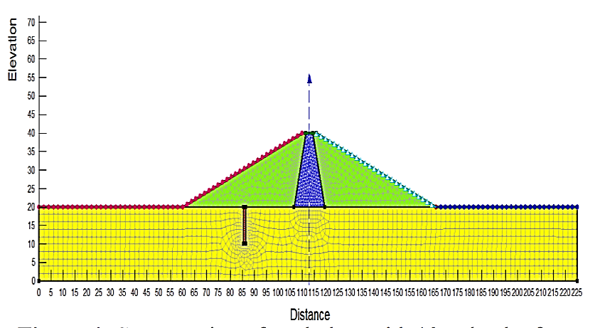

**Figure 15:**Sattarkhan Dam section with installing the cut-off

The seepage discharge has been calculated by SEEO/W software based on the Darcy Law that is shown below.

***Q = $-k.A.(\frac{∂h}{∂l})$***

The variations in seepage discharge from both the body and foundation of the earth dam are detected according to the cutoff wall length and its position. The cut-off point near the dam foundation reduces seepage discharge from the dam body and its foundation, it was the optimal position for seepage and piping reduction. Consequently, the most effective location for the cutoff to mitigate uplift pressure is at a distance of 46.5 meters from the dam's upstream side. The minimum uplift pressure values have occurred at the cut off point at the central core's beginning from the dam upstream and minimum uplift pressure and seepage discharge were obtained with longest sheet pile there. The result shown in the figure below.

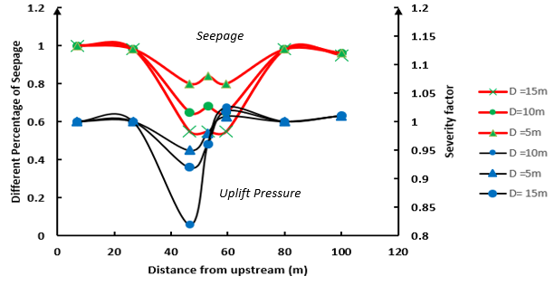

**Figure 16:**Effect of the cutoff position and length on the seepage and uplift pressure

[82]Studied in the same Hele-Shaw Model to detect the influence on sheet pile position and its penetration on seepage and flux internal the dam body on in the foundation. He recommended the formula below to detect the permeability based on Darcy's Law.

***Q = $-$ K.i.A***

***Q = $-$ K . $\frac{dy}{dx}$. (y*1)***

***Q $\int_{x}^{Dw}{dx=-K\int_{D}^{y_{2}}{ydy}}$***

***Q (Dw - $x )=-K[\frac{y^{2}}{2}]_{D}^{y_{2}}$***

***Q = $-\frac{K}{2(D_{w-x)}}[(H+D-∆h1-∆h2-∆h3)^{2}-D^{2}]$***

***K= $\frac{2Q(D_{w}-x)}{[(H+D-∆h1-∆h2-∆h3)^{2}-D^{2}]}$***  ***eq(12)***

The following results below have been achieved as shown in **Figure 16** . The relative depth between the penetration depth of cutoff(d) to depth of the permeable foundation (D). Where the foundation depth varied at (15, 22.5, 30, 45 and 60 cm) and the relative depth has been assessed as (0.2, 0.4, 0.6, 0.7 and 1). The minimum total discharge for seepage occurred in the minimum foundation. However, the foundation depth increases the seepage and coefficient increase directly.

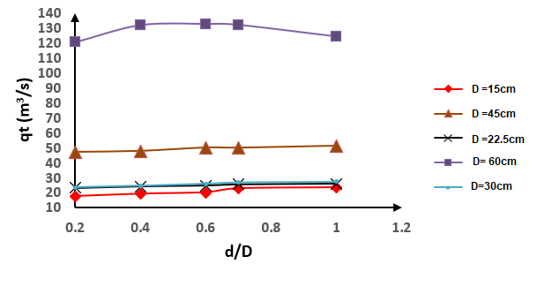

**Figure 17:** Graph between relative depth and total discharge

[83] researched to examine how the uplift force and exit hydraulic gradient in gravity dams are affected by varying the location, quantity, and depth of cutoff walls. The goal was to identify the optimal configuration that minimizes the values of these parameters. focused on assessing the effects of employing multiple cutoff walls at six distinct depths and intervals. The considered dam was (Pine Flat Dam), the dam height, base width, and alluvial foundation depth were 150m, 96m and 29m respectively. The foundation soil was a homogeneous and isotropic porous medium, characterized by a saturated hydraulic conductivity value (ksat) for the soil material was 2x10-4m/s and zero permeability for the cutoff wall. Single cutoffs in length range 3m to 28m and double or three cutoffs in the range 5m to 28m were tested. The test result indicated the uplift pressure and exit gradient reduction was brained for resulting in a 51.58% reduction in uplift pressure and a 49.33% reduction in the exit hydraulic gradient for cutoff wall depth 28m compared to the non-cutoff wall state. The test result showed the role of the sheet pile length in seepage prevention and indicated as the cutoff depth increases, pressure head and exit gradient values reduce based on the sheet pile positions. The best place for minimizing the exit gradient is 96m away from the heel but for uplift pressure is at the heel directly.

**Table 15:** Test result for different cutoff depths related to uplift pressure and exit gradient

|  |  |  |  |  |  |  |  |  |  |  |  |  |
| --- | --- | --- | --- | --- | --- | --- | --- | --- | --- | --- | --- | --- |
| **Different Cutoff Depth (m)** | | | **3** | **6** | **9** | **12** | **15** | **18** | **21** | **24** | **27** | **28** |
| Uplift Pressure (m) | Cases for one cutoff penetration for different position at upstream heel | at heel point | 5338.7 | 5090.7 | 4943.3 | 4724.2 | 4544.3 | 4223.7 | 3922.1 | 3551.3 | 3006.8 | 2705.1 |
| 48m from U/S | 5517.8 | 5517.7 | 5517.5 | 5517.2 | 5516.8 | 5516.4 | 5515.8 | 5515 | 5514.3 | 5513.2 |
| 96m from U/s | 5707.9 | 5974.6 | 6184.7 | 6408.8 | 6650.4 | 6916.2 | 7219.6 | 7653.6 | 8136.3 | 8437.8 |
| Exit Gradient | at heel point | 3.0164 | 2.9244 | 2.823 | 2.7096 | 2.6515 | 2.44 | 2.271 | 2.0599 | 1.7458 | 1.5708 |
| 48m from U/S | 3.0965 | 3.0574 | 2.9943 | 2.9027 | 2.7856 | 2.6381 | 2.4537 | 2.2152 | 2.0013 | 1.6609 |
| 96m from U/s | 2.4066 | 1.6682 | 1.3394 | 1.1408 | 1.0015 | 0.8927 | 0.7965 | 0.7065 | 0.5911 | 0.5311 |

[84]used the software program to detect the seepage phenomenon with different locations, different lengths, and double soil layers on the seepage case. Using ANN networking with the SEEP/W program showed that the differences are 5%, 2%, and 6% for the exit gradient, discharge, and uplift pressure, respectively, at the base of the hydraulic structure. The length of the cutoff can control the flow properties as concluded by[85]. The whole test results included following different cases with 729runs bases on the space distance different soil layers and sheet pile depth, both cutoffs were penetrated at U/S and D/S heel and toes points and second layer has lower permeability than first one, the whole test parameters and values shown below.

**Table 16:** Test parameters and values

|  |  |
| --- | --- |
| **Parameters** | **Values** |
| Depth of first sheet pile (d1) | 2.5, 4.5 and 5.5m |
| Depth of second sheet pile (d2) | 2, 2.5 and 4.5m |
| Depth of first soil layer(S1) | 3, 3.5and 4m |
| Depth of second soil layer(S2) | 3.5, 4.5 and 5.5 |
| Permeability of first soil layer (K1) | 10-2,10-3 and 10-4 m/s |
| Permeability of second soil layer (K2) | 10-5 , 10-6 and 10-7 m/s |
| Upstream head (H) | 6m |

The test result indicated the discharge variation decreased where both sheet pile extended to second layer. And it decreased by about 60.5% where the downstream one depth increased from 2.m to 4.5m for most cases. Changing layer thickness also changed the uplift pressure and discharge where the higher permeable layer thickness increased the uplift pressure increased and discharge increased proportionally. The discharge decreased of about (5.6%) with an increase in (d2) from (2m) to (2.5m). there was an approximately (60.5%) reduction in discharge when (d2) increased from (2.5m) to (4.5m). Uplift pressure depended on soil discharge proportionally. It decreased related to (d1/d2) ratio, it had an indirect relationship with downstream cutoff depth. It increased at 31% to 90% where d2 increased from 2m to 4.5m respectively. The best situation for decreasing the uplift pressure is to extend the first cutoff to penetrate the low permeable layer, decreasing the soil permeability help to reduce discharge and uplift pressure as concluded by [86]. The exit gradient is influenced by the permeability of the soil; if the second layer with lower permeability is increased relative to the first layer, the exit gradient also increases. This is because water, unable to infiltrate the deeper layer, moves laterally and reaches the surface more easily. it can be concluded the sheet pile length has a great role in reducing the uplift pressure and seepage. The optimum situation is to extend the sheet piles to meet the impermeable layer with consideration of its position and inclination. [87] examined the impact of varying sheet pile depths at upstream***(d1),*** downstream***(d2)***, and intermediate***(d3)*** locations on water seepage through a uniform and isotropic soil foundation. Utilized the SEEP/W code within the GeoStudio software (2018) to analyze steady-state flow. The finding indicated as the sheet pile depth increases; the seepage ratio decreases. dam foundation hydraulic conductivity was 1x10-11 m/s, upstream water depth, impermeable layer depth, and dam base width were 25m, 25m, and 23m respectively, and space between sheet pile was computed as (X = 0.0, 11.5, and 23 m, respectively). The following cases below were obtained.

1. **Case I:** when the only downstream sheet pile was penetrated. The flow line was near the upstream base of the dam. ***d2* = 15m**, flow line passed near the heel. The maximum pressure head near the dam heel was 48m compared to the toe was 35 to 42m. This proves that the pressure head changes directly with the flow line location. Extending sheet pile depth helps to take the flow line away from the foundation. Dropping uplift head depending on the sheet pile length for D/S one, for depths (5, 10, and 15m) were equal (55.58m, 40.96m, and 30.82m), but the best position is to install the cutoff at the heel point. seepage rate decreased with increasing the sheet pile length for example, the rate of seepage (***q/kh***) for relative distance(***X/B***) and ***d***=5,10 and 15m is shown below respectively. Where ***X*** is the distance between the sheet pile center to heel.

**Figure 18:** Seepage rate variation (**q/kh**) with different sheet pile length

The rate of exit gradient reduction is reduced by extending sheet pile depth gradually. A notable decrease in the relative exit gradient was achieved at its highest point when the sheet pile was driven into the toe for example (95.07%, 93.20%, and 89.38%) for cutoff length (5,10 and 15m respectively), as previously noted, the exit gradient is influenced by the flow pattern and uplift pressure. The extension of sheet piles near the toe results in diverting the flow line away from the toe, leading to the removal of the flow line at the toe and the occurrence of soil boiling further downstream, as previously discussed[88]. The most optimum cases related to reduction the pressure head is to penetrating sheet pile near the heel.

1. **Case II:** when Upstream and downstream sheet pile used, their depth changed (***d1***= 5, 10 and 15m), (***d2*** =6.5,11.5, and 16.5m) at heel and toe points. The flow pattern varied and lines was farther at upstream and downstream base with compared to previous case. The following result below was obtained.

**Table 17:** Seepage Parameters reduction related to utilization both U/S and D/S sheet pile with different length with compared to single sheet pile utilization.

|  |  |  |  |  |
| --- | --- | --- | --- | --- |
| **d1**  **(m)** | **d2**  **(m)** | **Exit Gradient Reduction** | **Uplift Pressure Reduction** | **Seepage Rate Reduction** |
| 5 | 6.5 | 92.02% | 56.97% | 48% |
| 10 | 11.5 | 95.04% | 51.60% |
| 15 | 16.5 | 96.63% | 49.19% |
| 5 | | 95.07% | 89.65% | 35.65% |
| 10 | | 93.20% | 91.45% |
| 15 | | 89.38% | 93.36% |

The research findings indicated that employing a double sheet pile was more effective than using a single one. There was an improvement in exit gradient and a reduction in seepage. Alterations in flow pattern lines were observed, impacting the result values. The adoption of a double sheet pile led to a displacement of lines by 15m at the dam base. The total water head beneath the dam base was approximately 38m, in contrast to 48m for a single sheet pile. The ultimate conclusion of the study affirmed that utilizing intermediate sheet piles with diverse locations and lengths provides the most optimal conditions for maintaining the dam's health. The flow pattern shapes is shown below.

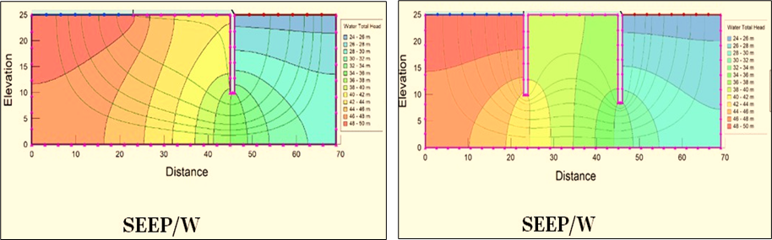

**Figure 19:** flow line pattern for single sheet pile and double sheet pile utilization

**5.0 CONCLUSION**

Seepage is the movement of water beneath a structure's foundation, flowing from a higher water level upstream to a lower level downstream. This phenomenon creates uplift pressure, displaces soil particles beneath the foundation, and leads to the development of gaps between the dam base and the soil. Seepage is one of the prevalent causes of dam failures, also in Iraqi dams this issue is widespread. Weak geological layers in Iraq and the presence of gypsum leading to karstification, contribute significantly to the prevalence of seepage in such situations. After brief reviewing of previous scientific work for utilization sheet pile to mitigate seepage purpose the flowing optimum outcome achievements have been collected.

1. Approximately 30% of dam failures are referred to seepage issues. Karstification represents a primary hazard associated with seepage, it threatens to some Iraqi dams, particularly the Mosul Dam, leading to potential failure if is not adequately treated. Tectonically, all dams located within the low folded zone and the intense karstification appears of lineaments (Such as faults, folds, joints and fractures), which formed as a result of the two main normal faults of E-W trend. Dissolution of gypsum beds of Fatha formation has a high risk and hazards on the dam’s foundation, because the dissolution of gypsum increase the mass equivalent permeability.
2. Seepage rate, uplift pressure and exit gradient depend on different head water, soil characteristics and flow pattern. Flow pattern net depends on flow path and affected by initialization sheet piles in categorizes. Using sheet pile is easiest way and most economical method to mitigate seepage issue. Cutoff material and its size have a great role, presence hole (slot) reduce the cut off effective in water treatment and seepage reduction, it increases waste water discharge. Slot places near the end of sheet pile body better than near the head or center. There is a direct relationship between slot size and waste water discharge. Steel sheet piles are the easiest ones for initialization and have long life service with high resistance to high stress with considering its quality and corrosion process. The Hat-Type sheet pile 900 significantly contributes to lowering both construction costs and durations.
3. Sheet pile numbers, depth, interval distances and their position can play the role of cutoff application on parameters. The best situation is installing three sheet piles in heel, toe and base midpoint the following cases below were obtained:

* When the sheet pile used inside the dam body for rock fill and earth dam, the optimum situation is to penetrate it near the core center or 5m away in core center and extending its length to meet the impermeable layer beneath the foundation for mitigation seepage and uplift pressure. the maximum drop in the phreatic line is produced at the same point. The optimal position of the cut walls to reduce the hydraulic gradient is at the toe of the dam core.
* Using double sheet pile is better than single one and triple sheet pile utilization is given the optimum situation. Elevated exit gradient values occur when the downstream toe cutoff is inclined toward the upstream side and (Ө < 90°) also uplift pressure is higher than the vertical cut-off there. The exit gradient increases when (Ө > 90°) and the maximum exit gradient reduction and uplift pressure reduction can be obtained where Ө = 120° for single sheet pile utilization in this position. When the single upstream cutoff is used the best clock wise angle is 45o to 120o for uplift pressure reduction and gives the most optimum case. The optimum case respect to seepage reduction for single sheet pile utilization scenario is to install the upstream heel sheet pile at angle 45o to 90o clockwise.



* The optimal location for sheet pile installation is at the midpoint of the dam's base. Seepage reduction, exit gradient, and efficiency are notably higher compared to the heel and toe positions. As the length of the sheet pile increases, the parameters gradually reduce. An angle ranging from 90 to 130 degrees is recommended for installation for single sheet pile case.
* Using double sheet pile is better than single one. The best position is to penetrate them at heel and toe points directly with considering their angles and length. U/S sheet pile angles as 45o to 60o and D/S at 90o to 130o clock wise if upstream is in right side have been confirmed respect to uplift pressure and exit gradient reduction. The minimum seepage can be obtained if the U/S sheet pile is inclined at 45o to 60o in clockwise direction toward the upstream.
* To optimize the use of mid sheet piles, it's recommended to insert the intermediate sheet pile at an angle ranging from 120 degrees to 150 degrees counterclockwise, aligning with the rotation of upstream and downstream sheet pile angle.

**REFERENCES**

[1] D. Sterpi, “Effects of the Erosion and Transport of Fine Particles due to Seepage Flow.,” *INTERNATIONAL JOURNAL OF GEOMECHANICS*, 2003, doi: 10.1061/ASCE1532-364120033:1111.

[2] Z. Huang, Y. Bai, H. Xu, Y. Cao, and X. Hu, “A theoretical model to predict the critical hydraulic gradient for soil particle movement under two-dimensional seepage flow,” *Water (Switzerland)*, vol. 9, no. 11, Oct. 2017, doi: 10.3390/w9110828.

[3] N. Adamo, N. Al-Ansari, V. Sissakian, J. Laue, and S. Knutsson, “Dam Safety Problems Related to Seepage,” online) Scientific Press International Limited, 2020.

[4] J. Li, X. Chen, C. Gu, and Z. Huo, “Seepage comprehensive evaluation of concrete dam based on grey cluster analysis,” *Water (Switzerland)*, vol. 11, no. 7, Jul. 2019, doi: 10.3390/w11071499.

[5] R. Awal, H. Nakagawa, K. Kawaike, Y. Baba, and H. Zhang, “Experimental study on piping failure of natural dam,” *Annual Journal of Hydraulic Engineering, JSCE*, vol. 55, pp. 157–162, 2011.

[6] K. S. Richards and K. R. Reddy, “Critical appraisal of piping phenomena in earth dams,” *Bulletin of Engineering Geology and the Environment*, vol. 66, no. 4, pp. 381–402, Nov. 2007, doi: 10.1007/s10064-007-0095-0.

[7] P. Talukdar and A. Dey, “Hydraulic failures of earthen dams and embankments,” *Innovative Infrastructure Solutions*, vol. 4, no. 1, Dec. 2019, doi: 10.1007/s41062-019-0229-9.

[8] S. Tung, G. Bhandari, and S. Mukherjee, “Behavior of sheet pile as seepage cutoff below earthen dam,” *International Journal of Geotechnical Engineering*, vol. 10, no. 2, pp. 162–173, 2016, doi: 10.1080/19386362.2015.1105620.

[9] I. H. Salim and B. S. Othman, “The Effect of inclined intermediate Sheet Pile on Seepage Properties Under Hydraulic Structure Using SEEP/W Program,” *IOP Conf Ser Mater Sci Eng*, vol. 1076, no. 1, p. 012131, Feb. 2021, doi: 10.1088/1757-899x/1076/1/012131.

[10] R. H. Irzooki, “The Influence of Piles Status on The Uplift Pressure Under Hydraulic Structures,” *Tikrit Journal of Engineering Sciences*, vol. 3, no. 1, pp. 1–21, 2006.

[11] A. S. W. A.-M. AA Al-Delewy, “Optimum Design of Control Devices for Safe Seepage  under Hydraulic Structures,” *Journal of Engineering and Development*, vol. 10, pp. 66–87, 2006, doi: https:// www.iasj.net/iasj/article/10146.

[12] W. Sameer Mohammed-Ali, “The effect of middle sheet pile on the uplift pressure under hydraulic structures,” 2011. [Online]. Available: http://www.europeanjournalofscientificresearch.com

[13] P. Talukdar and A. Dey, “Hydraulic failures of earthen dams and embankments. Innovative Infrastructure Solutions,” *Geotechnical Applications*, vol. 4, pp. 135–142, 2016.

[14] M. M. Sazzad, “Effect of Clay Blanket and Chimney Filter against Seepage Failure,” *International Journal of Advanced Structures and Geotechnical Engineering*, vol. 06, no. 2, 2017, [Online]. Available: https://www.researchgate.net/publication/319288786

[15] M. Rasool, “Effect of mutual interference piles on seepage properties under hydraulic structures.,” *Kufa Journal of Engineering*, vol. 9, no. 4, pp. 273–285, Jun. 2021, doi: 10.30572/2018/kje/090419.

[16] A. Güven and A. Aydemir, *Springer Tracts in Civil Engineering Risk Assessment of Dams*. Springer, 2021. [Online]. Available: http://www.springer.com/series/15088

[17] G. Tsakiris, V. Bellos, G. Tsakiris, V. Bellos, and C. Ziogas, “Embankment Dam Failure: A Downstream Flood Hazard Assessment,” 2010. [Online]. Available: https://www.researchgate.net/publication/260298456

[18] S. I. N. S. Hashim, S. H. A. Talib, and M. S. Abustan, “An overview on the potential dam hazard and pre-qualitative analysis on the selected critical dam in Malaysia,” in *IOP Conference Series: Earth and Environmental Science*, Institute of Physics, 2023. doi: 10.1088/1755-1315/1205/1/012019.

[19] H. M. Eldeeb *et al.*, “Assessment of Dams’ Failure and Flood Wave Hazards on the Downstream Countries: A Case Study of the Grand Ethiopian Renaissance Dam (GERD),” *Water (Switzerland)*, vol. 15, no. 8, Apr. 2023, doi: 10.3390/w15081609.

[20] D. C. Froehlich, “Peak outflow from breached embankment dam,” *J Water Resour Plan Manag*, 1995.

[21] N. Adamo, N. Al-Ansari, V. Sissakian, J. Laue, and S. Knutsson, “Dam Safety Problems Related to Seepage,” online) Scientific Press International Limited, 2020.

[22] A. Sangodoyin, I. Adesola Oke, and U. A. B, “On the Causes and Effects of Earth Dams Failures in North-Eastern Nigeria,” *International Journal of Engineering and Technology* , vol. 3(2):2978-2985, 2014, [Online]. Available: www.ijert.org

[23] C. Deangeli, G. P. Giani, B. Chiaia, and A. P. Fantilli, “Dam failures,” in *WIT Transactions on State-of-the-art in Science and Engineering, 36.*, vol. 36, WIT press, 2009. doi: 10.2495/978-1-84564-2-/14.

[24] by Narita, “Design and construction of embankment dams,” Aichi Institute of Technology.

[25] K. Terzaghi, R. B. Peck, J. Wiley, N. York, and S. London, “Soil Mechanics in Engineering Practice Second Edition,” in *Soil mechanics in engineering practice*, 1967, pp. 1–729.

[26] L. Clarkson and D. Williams, “An Overview of Conventional Tailings Dam Geotechnical Failure Mechanisms,” *Mining, Metallurgy and Exploration*, vol. 38, no. 3. Springer Science and Business Media Deutschland GmbH, pp. 1305–1328, Jun. 01, 2021. doi: 10.1007/s42461-021-00381-3.

[27] N. A. Al-Ansari, “Management of Water Resources in Iraq: Perspectives and Prognoses,” *Engineering*, vol. 05, no. 08, pp. 667–684, 2013, doi: 10.4236/eng.2013.58080.

[28] T. , J. S. Z. Buday, *The Regional Geology of Iraq, Tectonism, Magmatism, and Metamorphism. // State Establishment of Geological Survey and Mineral Investigation*, vol. Vol. 2, 352 p. Baghdad, Iraq, 1987.

[29] A. I. Al-Juboury, T. McCann, and M. M. Ghazal, “Provenance of Miocene sandstones in northern Iraq: constraints from framework petrography, bulk-rock geochemistry and mineral chemistry,” *Russian Geology and Geophysics*, vol. 50, no. 6, pp. 517–534, Jun. 2009, doi: 10.1016/j.rgg.2008.09.005.

[30] G. J. C. , H. A. D. , S. F. Aqrawi A.A.M., “Petroleum Geology of Iraq,” *Scientific press Lt Po box 21, Beaconsfield, Bucks HP9 1NS, UK. −2010. − 424 p.*, 2010.

[31] S. Z. Jassim and J. C. (Jeremy C. ) Goff, *Geology of Iraq*. Czech Republic: Dolin, 2006.

[32] S. F. Fouad, “TECTONIC MAP OF IRAQ, SCALE 1: 1000 000, 3 rd EDITION, 2012,” 2015.

[33] N. A. Al-Ansari, “Management of Water Resources in Iraq: Perspectives and Prognoses,” *Engineering*, vol. 05, no. 08, pp. 667–684, 2013, doi: 10.4236/eng.2013.58080.

[34] N. Adamo, N. Al-Ansari, I. E. Issa, V. K. Sissakian, and S. Knutsson, “Mystery of Mosul Dam the most Dangerous Dam in the World: Problems Encountered During and after Impounding the Reservoir,” online) Scienpress Ltd, 2015.

[35] C. J. Mcgrath, “ERDC TR-07-10, Geologic Setting of Mosul Dam and Its Engineering Implications,” 2007. [Online]. Available: <https://www.researchgate.net> /publication/ 235208177

[36] N. Al-Ansari, I. E. Issa, V. Sissakian, N. Adamo, and S. Knutsson, “Mystery of Mosul Dam the most Dangerous Dam in the World: The project,” online) Scienpress Ltd, 2015.

[37] V. K. Sissakian, N. Adamo, N. Al-Ansari, S. Knutsson, and J. Laue, “Defects in Foundation Design Due to Miss-Interpretation of the Geological Data: A Case Study of Mosul Dam,” *Engineering*, vol. 09, no. 07, pp. 683–702, 2017, doi: 10.4236/eng.2017.97042.

[38] A. M. Ibrahim, S. A. Salih, and R. H. Irzooki, “Evaluation of Seepage on the Right Side of Haditha Dam, West of Iraq,” in *IOP Conference Series: Earth and Environmental Science*, Institute of Physics, Sep. 2022. doi: 10.1088/1755-1315/1080/1/012012.

[39] R. Kadhum Mohammed, “Optimum Operation of Haditha Dam,” *Engineering & Technology Journal*, vol. 28, no. 24, pp. 7058–7068, 2010.

[40] M. K. Malik and I. R. Karim, “Seepage and Slope Stability Analysis of Haditha Dam using Geo-Studio Software,” in *IOP Conference Series: Materials Science and Engineering*, IOP Publishing Ltd, Nov. 2020. doi: 10.1088/1757-899X/928/2/022074.

[41] E. Krogulec, K. Sawicka, S. Zabłocki, and E. Falkowska, “Mineralogy and permeability of gas and oil dolomite reservoirs of the zechstein main dolomite basin in the lubiatów deposit (Poland),” *Energies (Basel)*, vol. 13, no. 23, Dec. 2020, doi: 10.3390/en13236436.

[42] V. K. Sissakian, N. Adamo, N. Al-Ansari, S. Knutsson, J. Laue, and M. Elagely, “A Comparative Study of Mosul and Haditha Dams, Iraq: Geological Conditions,” online) Scienpress Ltd, 2018.

[43] V. K. Sissakian, N. Adamo, N. Al-Ansari, J. Leaue, and S. Knutsson, “Karstification Problems in the Haditha Dam, West Iraq,” *UKH Journal of Science and Engineering*, vol. 5, no. 1, pp. 111–118, Jun. 2021, doi: 10.25079/ukhjse.v5n1y2021.pp111-118.

[44] M. Th Al-Hadidi, N. Al-Nedawi, H. -Maysam Th Al, and N. M. -Nada Al, “Seepage and Slope Stability Analysis for Hemrin Earth Dam in Iraq Using Geo-Studio Software 2 Hadidi Seepage and Slope Stability Analysis for Hemrin Earth Dam in Iraq Using Geo-Studio Software,” 2020. [Online]. Available: www.solidstatetechnology.us

[45] F. F. Abdalhassan and Q. H. Jalut, “Effect of Using Vertical Drainage Column in Hemrin Dam on Factor of Safety Under Seismic Load,” in *E3S Web of Conferences*, EDP Sciences, Sep. 2023. doi: 10.1051/e3sconf/202342701011.

[46] A. R. Schwyter and K. L. Vaughan, *Introduction to soil science laboratory manual (schwyter and vaughan) Intro to Soil Science Laboratory Manual Introduction to Soil Science Laboratory Manual*. University of Wyoming Libraries Mountain Scholar, 2020. [Online]. Available: https://LibreTexts.org

[47] T. H. Abdullah, Q. H. Jalut, and Y. W. Ameen, “Hydrologic Modeling for Sedimentation in Hemrin Reservoir Using HEC-HMS,” *Diyala Journal of Engineering Sciences*, vol. 11, no. 4, pp. 67–72, 2018, doi: 10.26367/DJES/VOL.11/NO.4/10.

[48] S. F. Fouad, “TECTONIC MAP OF IRAQ, SCALE 1: 1000 000, 3 rd EDITION, 2012,” 2015.

[49] V. K. Sissakian, N. Al-Ansari, and N. Adamo, “Geomorphology, Stratigraphy and Tectonics of the Mesopotamian Plain, Iraq: A Critical Review,” *Geotectonics*, vol. 55, no. 1, pp. 135–160, Jan. 2021, doi: 10.1134/S001685212101012X.

[50] H. K. Al-Jiburi and N. H. Al-Basrawi, “HYDROGEOLOGICAL MAP OF IRAQ, SCALE 1: 1000 000, 2 nd EDITION, 2013,” 2015.

[51] N. Adamo, V. K. Sissakian, N. Al-Ansari, S. Knutsson, and J. Laue, “Badush Dam: Controversy and Future Possibilities,” online) Scienpress Ltd, 2018.

[52] V. Sissakian, N. Al-Ansari, S. Knutsson, and J. Laue, “Geological and Geotechnical Study of Badush Dam, Iraq,” in *Athens Institute for Education and Research*, Athens Institute for Education and Research (ATINER): In 6th Annual International Forum on Water, Athens, Greece, Jul. 2012. [Online]. Available: www.atiner.gr/papers.htm

[53] N. Adamo, N. Al-Ansari, V. Sissakian, J. Laue, and S. Knutsson, “Badush Dam: A Unique Case of Flood Wave Retention Dams Uncertain Future and Problematic Geology,” *Engineering*, vol. 11, no. 04, pp. 189–205, 2019, doi: 10.4236/eng.2019.114014.

[54] W. Zhao, Z. Tu, J. Yao, and X. Liu, “New Structure of Impervious Steel Sheet Pile in Foundation Slab,” in *IOP Conference Series: Earth and Environmental Science*, IOP Publishing Ltd, Sep. 2020. doi: 10.1088/1755-1315/568/1/012032.

[55] A. M. Armanyous, S. M. Ghoraba, I. M. H. Rashwan, and M. A. Dapaon, “A study on control of contaminant transport through the soil using equal double sheet piles,” *Ain Shams Engineering Journal*, vol. 7, no. 1. Ain Shams University, pp. 21–29, Mar. 01, 2016. doi: 10.1016/j.asej.2015.11.009.

[56] L. Eskandari and B. Kalantari, “Basic Types of Sheet Pile Walls and Their Application in the Construction Industry-a Review,” *ُEJGE*, 2011, [Online]. Available: https://www.researchgate.net/publication/267920552

[57] Braja M. Das, *Principles of Foundation Engineering*, 7th ed. Christopher M. Shortt, 2011.

[58] D. Sobala and J. Rybak, “Steel Sheet Piles - Applications and Elementary Design Issues,” in *IOP Conference Series: Materials Science and Engineering*, Institute of Physics Publishing, Nov. 2017. doi: 10.1088/1757-899X/245/2/022072.

[59] A. A. Ahmed, H. T. Johnston, and L. Oyedele, “Hydraulic structures with defective sheet pile walls,” *Dams and Reservoirs*, vol. 23, no. 1, pp. 29–37, Mar. 2013, doi: 10.1680/dare.13.00017.

[60] F. A. Arafat, I. M. H. Rashwan, M. F. Sobieh, and A. Fathy Ellayn, “Effect of Steel Sheet Piles Defects on Seepage and Contamination Transport through the Soil,” ERJ, 2022.

[61] A. M. Armanuos, M. G. Ibrahim, W. E. Mahmod, J. Takemura, and C. Yoshimura, “Analysing the Combined Effect of Barrier Wall and Freshwater Injection Countermeasures on Controlling Saltwater Intrusion in Unconfined Coastal Aquifer Systems,” *Water Resources Management*, vol. 33, no. 4, pp. 1265–1280, Mar. 2019, doi: 10.1007/s11269-019-2184-9.

[62] A. Elamin El Nimr, K. Salah Abdul Wahab, and A. Ibrahim, “Soil Protection from Lead Contaminant Using Sheet Pile or Isolation Methods

[63] M. Z. , & K. W. K. Nor’ain, “Investigation on the Influence of Cut-off Wall to Groundwater Contamination using Numerical Method,” *In Proceedings of Civil Engineering Colloquium* , pp. 129–135, 2020.

[64] H. F. Aghajani, M. M. Anzabi, Z. Sheikhi, and R. Shokri, “Selecting Optimum Cutoff Wall Position for Rehabilitation of an Inclined Core Earthfill Dam,” in *Proceedings of GeoShanghai 2018 International Conference: Multi-physics Processes in Soil Mechanics and Advances in Geotechnical Testing*, Springer Singapore, 2018, pp. 252–260. doi: 10.1007/978-981-13-0095-0_29.

[65] S. I. Khassaf Al-Saadi, H. T. Nimnim Al-Damarchi, and H. Ch Dekhn Al-Zrejawi, “Optimum Location and Angle of Inclination of Cut-off to Control Exit Gradient and Uplift Pressure Head under Hydraulic Structures,” 2011.

[66] L. Aziz and M. Abdallah, “SUITABLE LOCATION OF SHEET PILE UNDER DAM RESTING ON SANDY SOIL WITH CAVITY,” *Kufa Journal of Engineering*, vol. 9, no. 2, pp. 168–188, Jun. 2021, doi: 10.30572/2018/kje/090213.

[67] H. D. Student and S. A. Behaya, “Sheet Piles Walls Effect on Seepage Characteristics under Low Concrete Gravity Dams Abbas Raddam Hamad,” 2022. [Online]. Available: www.ijert.org

[68] B. Mansuri, F. Salmasi, and B. Oghati, “Effect of Location and Angle of Cutoff Wall on Uplift Pressure in Diversion Dam,” *Geotechnical and Geological Engineering*, vol. 32, no. 5, pp. 1165–1173, Oct. 2014, doi: 10.1007/s10706-014-9774-3.

[69] R. Norouzi, F. Salmasi, and H. Arvanaghi, “Uplift pressure and hydraulic gradient in Sabalan Dam,” *Appl Water Sci*, vol. 10, no. 5, May 2020, doi: 10.1007/s13201-020-01195-2.

[70] A. Bakr, E.-M. A. A, A. Masria, and H. A. Abdelgawad, “Effect of Cut off Position and Inclination on Seepage Characteristics under Heading-up Structure Using Differential Quadrature Element Method,” *International Journal of Scientific & Engineering Research* , vol. 10, no. 11, pp. 541–548, Nov. 2019, [Online]. Available: http://www.ijser.org

[71] A. A. , S. A. H. K. , & A.-M. W. H. Al-Delewy, “Optimum design of control devices for safe seepage under hydraulic structures.,” *Journal of Engineering and Sustainable Development*, 2006.

[72] W. H. Hassan, “Application of a genetic algorithm for the optimization of a cutoff wall under hydraulic structures,” *Journal of Applied Water Engineering and Research*, vol. 5, no. 1, pp. 22–30, Jan. 2017, doi: 10.1080/23249676.2015.1105161.

[73] A. Kareem Esmat, “The effect of cutoff wall angle on seepage under,” *Journal of Engineering*, vol. 17, no. 05, pp. 1109–1135, 2011.

[74] H. Kathem Taeh Alnealy, “Analysis of Seepage Under Hydraulic Structures Using Slide Program,” *American Journal of Civil Engineering*, vol. 3, no. 4, p. 116, 2015, doi: 10.11648/j.ajce.20150304.14.

[75] M. Angelov and A. A. Asr, “The Effect of Cut-off Wall Angle on Seepage and Uplift Pressure under Dams,” in *In UK Association for Computational Mechanics (UKACM) Conference 2021 proceedings. Loughborough University*, UK, 2021.

[76] R. H. Al-Suhaili, “Analytical Solution for Exit gradient Variation Downstream of Inclined Sheet Pile,” in *The 6th  Engineering Conference of  Engineering College, College  of Engineering, University of  Baghdad, Iraq.*, The 6th  Engineering Conference of  Engineering College, College  of Engineering, University of  Baghdad, Iraq., 2009.

[77] A. Moharrami, G. Moradi, M. H. Bonab, J. Katebi, and G. Moharrami, “Performance of Cutoff Walls Under Hydraulic Structures Against Uplift Pressure and Piping Phenomenon,” *Geotechnical and Geological Engineering*, vol. 33, no. 1, pp. 95–103, Feb. 2015, doi: 10.1007/s10706-014-9827-7.

[78] I. H. Salim and B. S. Othman, “The Effect of inclined intermediate Sheet Pile on Seepage Properties Under Hydraulic Structure Using SEEP/W Program,” *IOP Conf Ser Mater Sci Eng*, vol. 1076, no. 1, p. 012131, Feb. 2021, doi: 10.1088/1757-899x/1076/1/012131.

[79] H. Obead, “Effect of Position and Inclination Angle of Cutoff Wall on Seepage Control in the Foundation of Dam Structure,” 2013.

[80] M. Samir Saleh, D. W. Abbood, R. H. AL-Suhaili, and A. S. LecDr May Saleh, “Experimental Analysis of Seepage Flow under Small Hydraulic Structure with Two Inclined Cutoffs,” *Abbood Association of Arab Universities Journal of Engineering Sciences Prof. Dr. Rafa H. AL-Suhaili NO*, no. 3, 2017, doi: 10.13140/RG.2.2.21383.04005.

[81] A. Moharrami, G. Moradi, M. H. Bonab, J. Katebi, and G. Moharrami, “Performance of Cutoff Walls Under Hydraulic Structures Against Uplift Pressure and Piping Phenomenon,” *Geotechnical and Geological Engineering*, vol. 33, no. 1, pp. 95–103, Feb. 2015, doi: 10.1007/s10706-014-9827-7.

[82] M. A. Razek, A. A. Salam, and M. Attia, “Analysis and Estimation of Seepage Through Earth Dams with Internal Cut Off,” 2021, doi: 10.21203/rs.3.rs-298691/v1.

[83] N. Sartipi, F. Salmasi, J. Abraham, and A. H. Dalir, “Investigation of the effect of depth and distance between cutoff walls on uplift force for gravity dams,” *International Journal of Environmental Science and Technology*, vol. 18, no. 6, pp. 1361–1378, Jun. 2021, doi: 10.1007/s13762-020-02867-x.

[84] A. Abdul and J. Jamel, “Effect of Two Sheet Piles In Double Soil Layers on Seepage Properties Under Hydraulic Structure Using SEEP/W Program,” *Journal for Engineering Sciences (NJES)*, vol. 20, no. 1, pp. 194–205, 2017.

[85] M. M. Sazzad, “Effect of Width, Length and Position of Cutoff Wall on the Seepage Characteristics of Earth Dam,” 2019, doi: 10.5281/zenodo.2543420.

[86] A. Abdul and J. Jamel, “Effect of Intermediate Sheet Piles in Non-Homogenous Soil on Seepage Properties Under Hydraulic Structure Using SEEP/W Program,” *Tikrit Journal of Engineering Sciences*, 2016, doi: 10.25130/tjes.v23i3.646.

[87] T. K. Hamad, J. M. S. Suleimany, and T. H. Aurahman, “Seepage Quantity Analysis Beneath Concrete Dams with Various Sheet Piles using Different Numerical Models,” *Tikrit Journal of Engineering Sciences*, vol. 30, no. 2, pp. 114–121, May 2023, doi: 10.25130/tjes.30.2.12.

[88] A. A. Ahmed and A. M. Elleboudy, “Effect of Sheetpile Configuration on Seepage beneath Hydraulic Structures,” *Scour and Erosion*, pp. 511–518, 2010.