**ANALYSIS OF HAND-BREWED COFFEE-TAKETAIWAN COFFEE BEANS AS AN EXAMPLE**

**Hung,Pei-Ling**

Manager of COFFEELAND Inc

ORCID：0000-0002-6330-7785

**Chang ,Yu-Cheng**

Asia University, Department of Leisure and Recreation Management

ORCID:0000-0001-9583-3045

**Lai, Cheng-Hao**

Asia University, Department of Leisure and Recreation Management

ORCID:

**Pan, Hsuan-Yu**

Agricultural Technology Research Institute

ORCID：0000-0003-2143-6439

**Abstract**

This study uses the research structure of the experimental design, taking Taiwan specialty coffee beans as an example, and selects four aspects which are a coffee grind, brewing water temperature, coffee blooming, and coffee water powder ratio that is most likely to affect the coffee extraction rate and coffee concentration. Brewing with hand brewing equipment which is easier to buy in daily life, and obtain data analysis, and then conduct experiments and comparisons with coffee beans from other countries. The results of this study found that coffee beans from different producing areas can be slightly adjusted for different brewing techniques to reduce the consumption of coffee beans and reduce costs, to provide consumers and subsequent researchers with references and suggestions.

**Key Word:** Taiwan Coffee Bean, Brew Coffee, Variation Analysis, and Gold Cup.

**JEL Codes:** O13, P32, Q15

**1. Introduction**

This study explores the evolution of the coffee wave and the evolution of Taiwanese coffee history, as well as Taiwanese consumers' purchasing trends in Taiwanese coffee in recent years, and experimentation with the pour-over coffee experience. This study uses a fixed grinder and Alishan coffee beans of the same product to discuss how to obtain the best flavor, taste change and the best sensory evaluation with the best coffee cost, combined with coffee grinding degree and brewing differences. Discuss the difference analysis. This study obtained data through experiments to find out the ideal coffee extraction rate and coffee concentration. After data analysis, the differences in flavor, sensory evaluation and preference were discussed. The Taiwan Alishan coffee beans selected in this paper, because of the characteristics of Taiwan Alishan coffee green beans and the commercial coffee beans are generally light roasted and medium roasted, so this experiment uses Taiwan Alishan coffee beans with sun drying and washing. Two different processing methods were used for blending to increase the richness of aroma and taste, and then the medium and light roasted coffee beans were used as samples for comparative experimental analysis. Using the four aspects of coffee grinding degree, coffee brewing water temperature, coffee blooming and coffee water powder ratio, three different comparison experiments, a total of 12 samples were used as experimental research, and data analysis and discussion were obtained.

**2. Literature Review**

This study explores the evolution of coffee and Taiwanese coffee history, Taiwanese consumers' purchasing trends in Taiwanese coffee in recent years, and experimentation with the pour-over coffee experience. In this study, under the condition that the grinder and the source of coffee beans remain unchanged, explore how to combine coffee grinding and brewing to achieve the best flavor and mouth feel a difference at the best coffee cost. This study obtained data through experiments and found the ideal coffee extraction rate and coffee concentration. After data analysis, three aspects of a flavor difference, sensory evaluation, and preference were discussed.

The Taiwan Alishan coffee beans are selected in this research. Due to its characteristics and the commercial coffee beans are generally light roasted and medium roasted in the market, these experiments use sun drying and washing Taiwan Alishan coffee beans, these two different processing methods were used for blending to increase the richness of aroma and taste, and then the medium and light roasted coffee beans were used as samples for comparative experimental analysis. Using the four aspects of coffee grinding degree, coffee brewing water temperature, coffee blooming, and coffee water powder ratio, three different comparison experiments, a total of 12 samples were used for experimental research, and data analysis and discussion were obtained.

**2.1 Characteristics of Taiwanese Coffee**

In recent years, due to the improvement of Taiwan's agricultural planting technology, Taiwan's coffee has performed very well in the world, especially Alishan coffee, which is a high-quality boutique in Taiwan's coffee. Every November to March of the next year belongs to the mature coffee picking period. The coffee beans must be hand-picked throughout the entire process. After sophisticated processing methods, Alishan coffee green beans often win domestic coffee competitions and are also repeatedly evaluated in foreign countries. Won the coffee evaluation award. Its price is comparable to the world's top green beans Wu Yixuan(2021).

**Hand-Brewed Coffee**

The factors that affect the different flavors of hand-brewed coffee can be divided into two categories. One is the flavor of the coffee beans themselves and their effects during brewing. The coffee beans themselves are affected by the origin, processing method, or roasting of the coffee beans. The performance of coffee is related to the grinding degree and grinding method of the coffee; the other is the flavor effect produced when brewing, including the time of coffee blooming. The coffee blooming is also known as pre-extraction. Its purpose is to exchange the gas in the coffee powder with the water. If the coffee blooming and extraction time is too long, the phenomenon of over-extraction will occur, and the sour taste in the coffee will also be extracted. The brewing water temperature is also one of the influencing factors. When the brewing water temperature is higher, it is easier to extract the taste, and at the same time, the sour and bitter tastes will be extracted Taguchi Mamoru (2004).

James Hoffmann (2016) wrote that three variables affect the flavor of coffee when making hand-brewed coffee. The key principles are the grinding thickness of the coffee powder, the contact time, and the amount of coffee powder.

**Size of the Ground Coffee**

The particle size of the ground coffee will directly affect the extraction rate and extraction concentration of coffee powder. The smaller the coffee powder particles, the higher the extraction concentration; on the contrary, the larger the coffee powder particles, the lower the extraction concentration.

Finding the corresponding fineness of ground coffee is not easy work, and using Fine, Medium, and Coarse to represent it doesn't help much, as using grinders from different manufacturers There are different settings for the grinding fineness. Therefore, when a grinder of a brand model is used to set the grinding fineness of such as No. 5, and another brand grinder is used to adjust the grinding fineness to the same No. 5, it is not sure that the same coarse and fine particles can be milled, and even the same model will have some errors.

**Contact Time**

The coffee contact time refers to how fast the water can pass through the coffee powder layer, including how long it takes to refill the water. The purpose of prolonging the brewing time can be achieved by slowly filling the water, to improve the extraction rate of the coffee. Contact time can also be called coffee blooming, which refers to the time of water and coffee powder are in contact. According to Taguchi Mamoru (2011), the most suitable time for smothering is between 20 and 30 seconds.

**The Quantity of Coffee Powder**

The more coffee powder is used, the more time it will take to pass through the coffee powder layer, and the longer the contact time will be. The ratio of water to coffee powder will directly affect the concentration of coffee liquid extraction. The higher the ratio of water to coffee, the higher the concentration; conversely, the smaller the ratio, the lower the concentration. In this study, the International Specialty Coffee Association (SCA) research proposed that the water-to-powder ratio of 1:15~1:22 can be called the golden cup range, but it does not mean that the brewed product is equal to the golden cup.

However, there is also an important key for the coffee brewing water temperature, which refers to the temperature of the water that starts to contact the coffee powder at the equilibrium temperature after the water is boiled. According to the Specialty Coffee Association (SCA), the optimum water temperature for coffee is between 195°F~205°F (90°C~96°C) (Specialty Coffee Association SCA, 2018). And Taguchi Mamoru (2004) mentioned that the water temperature of coffee can be applied to all roasted coffee beans when the water temperature is 82℃~83℃.

In a cup of coffee, water plays a very important role. In hand-brewed coffee, water accounts for 98.5% of the importance, while espresso accounts for about 90%. If the water itself is not delicious, the brewed coffee will never be delicious. If you can taste the chlorine gas in the water, the brewed coffee should also have a terrible taste. Consumers want to brew a cup of delicious coffee at home, as long as they use a water filter containing activated carbon, they can effectively remove the bad taste, but it may not be published by the International Specialty Coffee Association (SCA). Recommendations for the perfect water quality for brewing coffee James Hoffmann, (2016).

**Sensory Evaluation**

Coffee is a palatable drink, and drinkers will pay special attention to the enjoyment of the senses. Hsuan-Yu, Pan (2020) pointed out that coffee belongs to the first-line service industry in the catering industry, and all purposes are people-oriented, but people are always the biggest research variable; the way the coffee industry currently operates is shaped by the accumulation of drinkers over time. There are many things that seem unreasonable but are often the result of people's natural selection. The origin and type of coffee, the processing of the beans, and how they are roasted and brewed can all change the flavor of a cup of coffee. Each flavor is unique, making every cup of coffee different. However, a good cup of coffee should also have an evaluation system and theoretical criterion formula that is convenient for communication, so as to uniformly define the quality and flavor of coffee.

**3. Methodology**

The framework of this study is to research the various factors affecting coffee brewing. This study uses Taiwan Alishan coffee beans blended with light roast and medium roast and with the same grinder and hand brewer. Then conduct experiments based on the coffee grinding degree, water temperature, coffee blooming, and water-to-powder ratio of coffee beans, and then calculate the extraction rate and concentration. According to the data results, select the brewing conditions that meet the theoretical range of Golden Cup, and then experiment with the coffee from different producing areas.

In this study, Taiwanese specialty coffee was used for the experiment. As people's requirements for quality of life continue to improve, the source control of coffee raw materials is the most significant and important factor. Consumers attach great importance to food safety awareness, which is an issue that the coffee industry must face seriously. The source of coffee raw materials needs to be carefully controlled by operators and confirmed to be safe. Jai-Houng Leu & Hsuan-Yu Pan (2019), this is the reason of selected high-quality coffee beans as the research object of this research.

Grinded by the same brand of coffee grinder, with a fixed water volume of 300ml and the same brewing utensils (hand pour pot, filter cup, filter pot, and filter paper), to carry out the brewing experiment. In this study, experiments were conducted in four aspects: coffee grinding degree, water temperature, coffee blooming, and coffee water-to-powder ratio. Three different variation factors were set for brewing experiments. 12 different coffee extraction rates and coffee concentration data were obtained after calculation. Select the top two coffees that meet the brewing specifications for the gold cup range calculation.

**Research Design**

This research will be based on the same grinder, Taiwanese coffee beans produced in the same batch, and a unified water volume of 300ml, to study the optimal coffee grind degree, water temperature, coffee blooming, and water-to-powder ratio for brewing coffee. The impact factor and level value are compared through their experimental differences.

**Coffee Grind Degree**

The particle size of the ground coffee will directly affect the extraction rate and extraction concentration of coffee. The smaller the coffee powder particles, the higher the extraction concentration; conversely, the larger the coffee powder particles, the lower the extraction concentration.

In this study, three codes are selected: fine (A1), medium (A2), and coarse (A3) to represent the fine grinding displayed in the grinder (the scale on the grinder selects No. 3), medium grinding (the scale on the grinder selects No. 5). ), and coarse grinding (the scale on the grinder selects No. 7). Grinded coffee with the three grinding degrees respectively, with the same water volume of 300ml, the water temperature of 90°C, coffee blooming of 30 seconds, and coffee powder volume of 20 grams. After brewing, the weight of the finished coffee and the coffee concentration is obtained, and then the coffee extraction rate can be calculated and analyzed.

**Water Temperature**

According to the Specialty Coffee Association (SCA), the optimum water temperature for coffee is between 195°F~205°F (90°C~96°C) (Specialty Coffee Association SCA, 2018). And Taguchi Mamoru (2004) wrote in the book that the water temperature of coffee can be applied to all roasted coffee beans when the water temperature is 82℃~83℃.In this study, a water filter (Brita) containing activated carbon was used to filter the water. Grind at the same grinding degree (No. 5 on the grinder scale), the same water volume of 300ml, the coffee blooming of 30 seconds, and the coffee powder volume of 20 grams, set three codes to represent three different water temperatures for brewing coffee, which means to start brewing in contact with coffee grounds at water temperatures of 82°C (B1), 90°C (B2) and 96°C (B3), get the result. After the weight of the finished coffee product and the coffee concentration, the data of the coffee extraction rate can be calculated and analyzed.

**Coffee Blooming**

The coffee blooming refers to the time after the water and the coffee powder come into contact. Hot water will be injected into the brewing process and release carbon dioxide to make the coffee powder expand. The optimum of coffee blooming is between 20-30 seconds according to Taguchi Mamoru（2004）.

In this study, grind at the same grinding degree (No. 5 on the grinder scale), the same water volume of 300ml, the water temperature of 90°C, and the coffee powder amount of 20g. Three codes are set to represent three different coffee blooming, with 20 seconds (C1 ), 30 seconds (C2), and 40 seconds (C3) for brewing to obtain the finished coffee weight and coffee concentration, and then calculate and analyze the coffee extraction rate.

**Coffee water-to-powder ratio**

The ratio of water to coffee powder will directly affect the concentration of coffee extraction. The higher the ratio of water to the coffee powder, the higher the concentration; on the contrary, the smaller the ratio of water to the coffee powder, the lower the concentration. In this study, the International Specialty Coffee Association (SCA) research proposed that the water-to-powder ratio of 1:15~1:22 can be called the golden cup range, but it does not mean that the brewed product is equal to the golden cup.

This research is based on grinding at the same grinding degree (No. 5 on the grinder scale), the water temperature of 90°C, the coffee blooming of 30 seconds, and water volume of 300ml. According to the International Specialty Coffee Association (SCA), the golden cup range of 1:15~1:22 is used to set three codes to represent three different water-to-powder ratios, namely 1:15 (D1), 1:18 (D2), and 1:22 (D3). When setting 1:15 (D1), the amount of powder required for brewing is 20g, when setting 1:18 (D2), the amount of powder required for brewing is 16.7g, and when setting 1:22 (D3), the amount of powder required for brewing is 13.6g; obtain the finished coffee weight and coffee concentration after brewing, and then calculate and analyze the coffee extraction rate.

**Brewing Comparison**

Using two different brands of coffee beans and different producing areas, the coffee beans are divided into two codes, namely (E) and (F). Code (E) uses Central America coffee beans with a light to medium roast; another code (F) uses African coffee beans with a medium roast.

In this study, under the same optimal brewing conditions (coffee grinding degree, brewing water temperature, coffee blooming, and water-to-powder ratio), use coffee beans from different producing areas with similar roasting degrees to brew, whether it can also calculate the coffee extraction rate and concentration, and meet the conditions of the golden cup extraction theory.

**4. Results**

Based on the same grinder, the same batch of Taiwanese coffee beans, and 300ml of brewing water, this study investigated four factors that affect the optimal coffee grind, water temperature, steaming time, and water-to-powder ratio, to determine the experimental difference when brewing coffee, set four brewing parameters, use the coffee densitometer to test the coffee concentration, and then calculate the coffee extraction rate and analyze the coffee flavor.

**Grinding**

In this study, three codes are selected: fine (A1), medium (A2), and coarse (A3) to represent the fine grinding displayed in the grinder (the scale on the grinder selects No. 3), medium grinding (the scale on the grinder selects No. 5). ), and coarse grinding (the scale on the grinder selects No. 7). Grinded coffee with the three grinding degrees respectively, with the same water volume of 300ml, the water temperature of 90°C, coffee blooming of 30 seconds, and coffee powder volume of 20 grams. After brewing, the data of the finished product weight and coffee concentration of three different codes are obtained. As shown in Table 1.

**Table 1 Grinding experiments**

|  |  |  |  |
| --- | --- | --- | --- |
| Codes | Grinding | Weight (ml) | Concentration (%) |
| A1 | Fine | 258.5 | 1.61 |
| A2 | Medium | 263.3 | 1.38 |
| A3 | Coarse | 266.3 | 1.26 |

**Brita**

In this study, a water filter (Brita) containing activated carbon was used to filter the water. Grind at the same grinding degree (No. 5 on the grinder scale), the same water volume of 300ml, the coffee blooming of 30 seconds, and the coffee powder volume of 20 grams, set three codes to represent three different water temperatures for brewing coffee, which means to start brewing in contact with coffee grounds at water temperatures of 82°C (B1), 90°C (B2) and 96°C (B3), get the result. After brewing, the data of the finished product weight and coffee concentration of three different codes are obtained. As shown in Table 2.

**Table 2 Brita experiments**

|  |  |  |  |
| --- | --- | --- | --- |
| Codes | Temperatures | Weight (ml) | Concentration (%) |
| B1 | 82℃ | 266.3 | 1.42 |
| B2 | 90℃ | 263.3 | 1.38 |
| B3 | 96℃ | 260.6 | 1.55 |

**Coffee Blooming**

In this study, grind at the same grinding degree (No. 5 on the grinder scale), the same water volume of 300ml, the water temperature of 90°C, and the coffee powder amount of 20g. Three codes are set to represent three different coffee blooming, with 20 seconds (C1), 30 seconds (C2), and 40 seconds (C3) for brewing to obtain the finished coffee weight and coffee concentration. After brewing, the data of the finished product weight and coffee concentration of three different codes are obtained. As shown in Table 3.

**Table 3 Coffee Blooming Experiments**

|  |  |  |  |
| --- | --- | --- | --- |
| Codes | Coffee Blooming | Weight (ml) | Concentration (%) |
| C1 | 20 second | 262.7 | 1.39 |
| C2 | 30 second | 263.3 | 1.38 |
| C3 | 40 second | 263.1 | 1.36 |

**Brew Ratio**

This research is based on grinding at the same grinding degree (No. 5 on the grinder scale), the water temperature of 90°C, the coffee blooming of 30 seconds, and water volume of 300ml. According to the International Specialty Coffee Association (SCA), the golden cup range of 1:15~1:22 is used to set three codes to represent three different water-to-powder ratios, namely 1:15 (D1), 1:18 (D2), and 1:22 (D3). When setting 1:15 (D1), the amount of powder required for brewing is 20g, when setting 1:18 (D2), the amount of powder required for brewing is 16.7g, and when setting 1:22 (D3), the amount of powder required for brewing is 13.6g. Obtain the finished coffee weight and coffee concentration after brewing. Calculate the data of coffee extraction rate and coffee concentration of three different codes. As shown in Table 4.

**Table 4 Brew Ratio Experiments**

|  |  |  |  |
| --- | --- | --- | --- |
| Codes | Brew Ratio | Weight (ml) | Concentration (%) |
| D1 | 1:15 (20g) | 263.3 | 1.38 |
| D2 | 1:18 (16.7g) | 270.9 | 1.12 |
| D3 | 1:20 (13.6g) | 272.6 | 0.92 |

The brewed coffee liquid was first weighed and recorded the weight of the finished coffee, and then the coffee concentration data was obtained by the coffee concentration meter, then the data was collected and then used the coffee extraction rate formula to calculate the coffee extraction rate of each difference experiment with EXCEL, as shown in Table 5. Then use the experimental data in Table 5 to analyze the four influencing factors, three groups of different experimental controls, and summarize the data of coffee concentration and coffee extraction rate, as shown in Figure 1 &2.

In the above Figures 1 &2, the experimental data is analyzed by the impact factor drop point, and the difference between the coffee concentration and the coffee extraction rate of each different facet of coffee can be seen from the figure, and the facet with significant difference is the coffee grinding degree, brewing water temperature and coffee water-to-powder ratio. The less obvious difference is the coffee blooming.

**Table5 Experiments Data**



**Gold Cup**

In the golden cup theory, if the coffee extraction rate is below 18%, it reflects insufficient extraction, which is prone to sharp sourness and astringency, and will present an incomplete flavor; if the coffee extraction rate exceeds 22%, it is easy to produce bitterness and bitterness it is showing over-extraction, will extract the bad taste in coffee (SCA, 2015). And coffee concentration, also known as total dissolved solids, the ideal value should be between 1.2% and 1.4%, which reflects the strength and weakness of the coffee flavor, that is, the strength of the coffee when you drink it. The data can be obtained from the coffee concentration tester or calculated using the formula.

**Figure 1 Analysis Chart of Four Impact Factors**

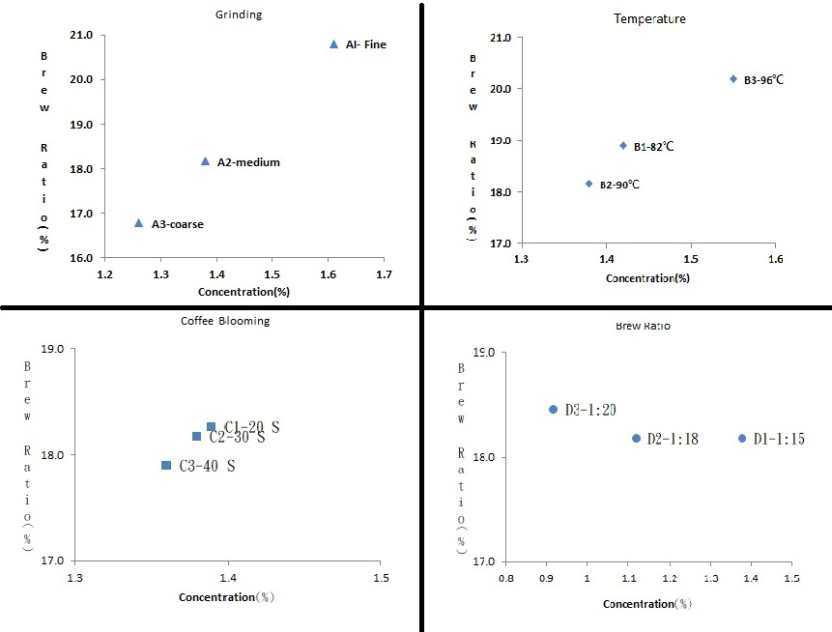

Therefore, this study uses the golden cup theory to calculate the coffee extraction rate and coffee concentration, and the coffee with the extraction rate and concentration in the golden cup theory is used as the benchmark value for each group, and the difference in different aspects of each group is the control value. After calculation, it is found that the steaming time of code C1 is 20 seconds, which also reaches the ideal range in the golden cup theory. As shown in Figure 2.

**Figure 2 Gold Cup**

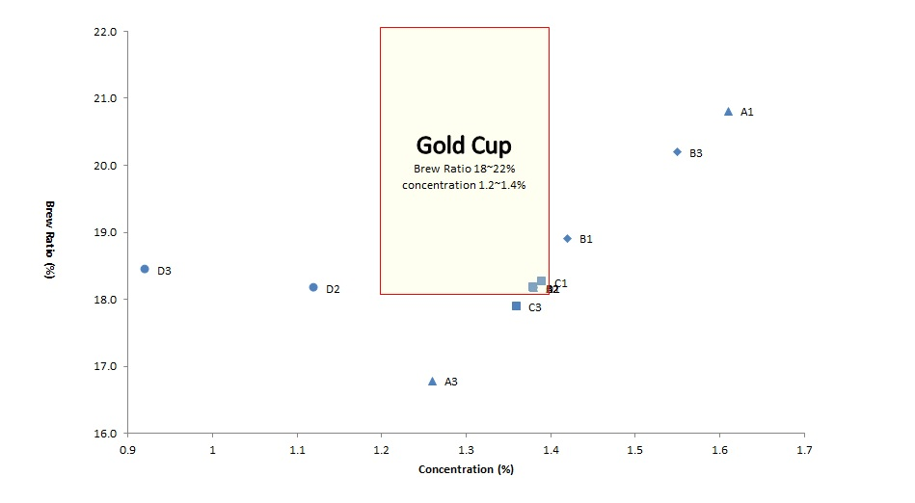

**Brewing Analysis**

This study uses the golden cup theory to conduct experiments with Taiwanese coffee beans to calculate the coffee extraction rate and coffee concentration. The coffee with the extraction rate and concentration in the golden cup theory is used as the benchmark value for each group, and the difference in different aspects of each group is the control value. After calculation, it was found that the brewing method of the reference value and the coffee blooming of the code C1 was 20 seconds, which were all within the ideal range of the golden cup theory, and then the comparison experiment was carried out with coffee beans from two different producing areas.

**Central America Coffee Bean Brewing Analysis**

One is Central American coffee beans, code-named E, and two brewing conditions in the theoretical range of the golden cup in the above Figures 1 &2 are carried out for comparative analysis. One is medium grinding (No. 5 grinding degree), the water temperature of 90°C, coffee blooming of 20 seconds, and water-to-powder ratio 1:15, codenamed (E1); the other is medium grinding (No. 5 grinding degree), the water temperature of 90°C, coffee blooming of 30 seconds and water-to-powder ratio 1:15, codenamed (E2), carry out the comparative analysis of brewing research experiments, as shown in Table 6.

**Table6 Central American Coffee Beans**

|  |  |  |  |  |  |
| --- | --- | --- | --- | --- | --- |
| Codes | Water | Grinding | Temperature | Coffee Blooming | Brew Ratio |
| E1 | 300 | Medium | 90℃ | 20 Second | 1:15 |
| E2 | 300 | Medium | 90℃ | 30 Second | 1:15 |

In this study, brewing the coffee with the same medium grinding (no. 5 on the scale of the grinder), the water volume of 300ml, water temperature of 90°C, and the amount of coffee powder of 20 grams, coffee blooming (referring to the time of contact between water and coffee powder) for 20 seconds (E1) and 30 seconds (E2). After brewing, the data of the weight and coffee concentration of the coffee products with two different codes are obtained. As shown in Table 8.

**Table7 Central American Coffee Beans - Experimental Data on the Weight and Concentration of Finished Coffee**

|  |  |  |  |
| --- | --- | --- | --- |
| Codes | Coffee Blooming | Weight (ml) | Concentration (%) |
| E1 | 20 Second | 255.5 | 1.34 |
| E2 | 30 Second | 260.7 | 1.17 |

**Africa Coffee Bean Brewing Analysis**

One is African coffee beans, code-named F, and two brewing conditions in the theoretical range of the golden cup in the above Figures 1 &2 are carried out for comparative analysis. One is medium grinding (No. 5 grinding degree), the water temperature of 90°C, coffee blooming of 20 seconds, and water-to-powder ratio 1:15, codenamed (F1); the other is medium grinding (No. 5 grinding degree), the water temperature of 90°C, coffee blooming of 30 seconds and water-to-powder ratio 1:15, codenamed (F2), carry out a comparative analysis of brewing research experiments, as shown in Table 7.

**Table 8 Africa coffee bean - Experimental Data on the Weight and Concentration of Finished Coffee**

|  |  |  |  |  |  |
| --- | --- | --- | --- | --- | --- |
| Codes | Water | Grinding | Temperature | Coffee Blooming | Brew Ratio |
| F1 | 300 | Medium | 90℃ | 20 Second | 1:15 |
| F2 | 300 | Medium | 90℃ | 30 Second | 1:15 |

In this study, brewing the coffee with the same medium grinding (no. 5 on the scale of the grinder), the water volume of 300ml, water temperature of 90°C, and the amount of coffee powder of 20 grams, coffee blooming (referring to the time of contact between water and coffee powder) for 20 seconds (F1) and 30 seconds (F2). After brewing, the data of the weight and coffee concentration of the coffee products with two different codes are obtained. As shown in Table 8.

**Table 9 African Coffee Beans - Experimental Data on the Weight and Concentration of Finished Coffee**

|  |  |  |  |
| --- | --- | --- | --- |
| Codes | Coffee Blooming | Weight (ml) | Concentration (%) |
| F1 | 20 Second | 259.1 | 1.21 |
| F2 | 30 Second | 264.2 | 1.13 |

The first measure and record the brewed coffee liquid, then use the coffee concentration meter to obtain the coffee concentration value, collect the data, and then use the coffee extraction rate formula or EXCEL to calculate the differences. As shown in Table 10. Based on the experimental data in Table 10, the differences between the two influencing factors in the two groups of experiments were analyzed, and the data on coffee concentration and coffee extraction rate were aggregated.

**Table10 Experimental Data**

|  |  |  |  |  |  |  |  |  |
| --- | --- | --- | --- | --- | --- | --- | --- | --- |
| Code | Water  (ml) | Grinding | Temper  ature | Coffee Blooming  (second) | Power weight  (g) | Weight (ml) | Concen  tration (%) | Brew Ratio  (%) |
| E1 | 300 | Medium | 90 | 20 | 20 | 255.5 | 1.34 | 17.1 |
| E2 | 300 | Medium | 90 | 30 | 20 | 260.7 | 1.17 | 15.3 |
| F1 | 300 | Medium | 90 | 20 | 20 | 259.1 | 1.21 | 15.7 |
| F2 | 300 | Medium | 82 | 30 | 20 | 264.2 | 1.13 | 14.9 |

**5. Conclusion**

The experiments of this study show that, in the analysis of brewing differences of different dimensions, it is known that the coffee grinding degree has the most significant effect on the coffee extraction rate and concentration. When the grinding degree is fine grinding, the coffee extraction rate, and coffee concentration belong to over-extraction in the Golden Cup Theory, when the grind is coarse, the coffee extraction rate and coffee concentration can be defined as under-extraction in the Golden Cup Theory.

Then it is the coffee water-to-powder ratio because the water-to-powder ratio is changed by the amount of coffee powder so that the coffee has a strong or weak concentration, so the performance in the extraction rate is less significant, but the difference in coffee concentration is more significant. If the water-to-powder ratio is at 1:20 in the experiment, the flavor of the whole cup of coffee brewed is too weak, and it will also be expressed as under-extraction in the golden cup theory, so it is suggested that to find the appropriate balance ratio for each cup of coffee before brewing.

The water temperature during brewing is also one of the factors that affect the extraction rate and concentration of coffee. This study found that water temperature between 82°C and 96°C is significant for coffee extraction rate, but not for coffee concentration. With the soluble substances in coffee, the sour taste in coffee is first extracted, followed by sweetness, and finally bitterness. When brewing at different water temperatures, the substances released by coffee powder are also completely different. The higher the water temperature during brewing, the faster the extraction speed, so it is easy to over-extract, making the coffee flavor more prone to bitterness or burnt flavor; on the contrary, if the brewing water temperature is not high enough, there will be under-extraction, and the coffee will have a more sour taste.

The coffee blooming is the pre-infusion stage of coffee brewing, and it has the least significant effect on the extraction rate and concentration of coffee, and both difference factors can enter the scope of the golden cup theory. The difference in extraction rate between 20 seconds and 30 seconds of coffee blooming is only 0.1%, and the difference in concentration is only 0.01%. In the future, the gap between the different factor can be increased to make the difference in the research results more significant. The reason for this may be the coffee blooming has no obvious effect on the extraction rate and concentration of medium-light roasted coffee, but there may be more significant differences in sensory taste.

This class of explanation uses the best brewing conditions for coffee beans from Taiwan and compares and analyzes the brewing skills of coffee beans from other producing areas, and finds that there are different brewing conditions for coffee beans from different coffee producing areas. Geographical location, growth factors (temperature, sunshine time, humidity, wind speed, rainfall, etc.), and the impact on the hardness, characteristics, and flavor of the coffee beans themselves are important key factors. It is suggested that follow-up researchers can further study the coffee beans grown in other regions of Taiwan for research. Different brewing techniques can be used to reduce the number of coffee beans required for brewing to reduce the cost of consumption. It can also improve coffee during brewing. The flavor and taste of the coffee beans can enhance the competitiveness of the specialty coffee beans grown in Taiwan, and achieve good results in the international area, so the more local the Taiwanese agricultural spirit is, the more international it is.

**References**

Jerry Liu(2004). Discover the hometown of Taiwanese coffee - Gukeng, Yunlin Gukeng Township Office, 1-2.

Hong Fufeng(2009). The Disarray of Taiwan Coffee Industry, 1st Annual Conference on Development Research Proceedings.

Huang Dinglun & Wang Yuqing (2014).A discussion on the combination of coffee creative industry in Pingtung Military Village Cultural Park.Cultural and Creative Industries Academic Symposium, 109-119.

Wu Yixuan(2021/12/08).Alishan coffee is ripening, rare and limited beans are listed, China Times.

Taguchi Mamoru (2004)。Coffee Encyclopedia of Taguchi protection. NHK Publishing, Inc.

James Hoffmann(2016). The World Atlas of Coffee. Firefly Books.

Han Huaizong(2012). Specialty Coffee Science (Part 2). Taiwan, Tuishou Cultural and Creative Co., Ltd.

Taguchi Mamoru (2011)，Specialty coffee Encyclopedia. NHK Publishing, Inc.

Hsuan-Yu,Pan (2020).Preliminary Study on Key Success Factors of Independent Cafe Operation in Taiwan. Advances in Management & Applied Economics, 10-3, 1-11.

The Specialty Coffee Association of America. (2015). Golden Cup.

The Specialty Coffee Association of America. (2016). Guidelines for Using By-Pass in the Drip Coffee Brewing Process.

Jai-Houng Leu & Hsuan-Yu Pan (2019). Investigation and analysis of the significant data of the management of raw materials of coffee in independent coffee shops — Take Taiwan as an example. Journal Basic &Clinical Pharmacology & Toxicology, 125,193-194.