**AN EVALUATION OF CHEMICAL QUALITY OF GROUNDWATER IN A CONTACT GEOLOGICAL TERRAIN; A CASE STUDY OF LAPAI, NORTH CENTRAL NIGERIA**

Ojieriakhi, S. A., Idris-Nda, A & Waziri, N.M.

Department of Geology, Federal University of Technology, Minna, Nigeria

Corresponding Author: [idrisnda@futminna.edu.ng](mailto:idrisnda@futminna.edu.ng) +234 8036273815

**ABSTRACT**

A study aimed at determining the chemical quality of groundwater in a heterogeneous geological terrain was undertaken. The study area is underlain by rocks of the Pre-Cambrian crystalline Basement Complex and the Cretaceous sedimentary rocks. The crystalline rock is represented mainly by granite gneiss while the sedimentary portion is made up of sandstone and clay. Hydrogeological studies were conducted using hand dug wells and boreholes. Chemical analysis was conducted using various analytical methods on 35 water samples from wells and boreholes. Results of the studies show that Lapai area is underlain partly by granite gneiss which is fractured and well jointed, and also by sandstone belonging to the Bida Basin. Lapai is therefore situated on a geological contact area. Groundwater occurs in the weathered and fractured parts of the basement and also in the sandstone. Hand dug wells in the basement areas have an average depth of 4 to 7 meters while in the sedimentary part the depth ranges from 10 to 25 meters. Water level in the basement part is 2 to 3 meters while in the sedimentary parts water level ranges between 10 and 15 meters. Direction of groundwater flow is in the NW-SE, meaning that recharge is mostly from the sedimentary area. Water level is noticeably shallow in the basement area compared to the sedimentary area and consequently more vulnerable to pollution. The water has an elevated concentration of sodium, chloride and nitrate, the iron and copper content is also relatively high indicating some level of pollution from anthropogenic sources. The water plots as a sodium-sulphate-chloride water.

**Background to the Study**

One of the main sources of fresh water in most parts of developing countries is groundwater; this is because of its less vulnerability to pollution when compared with surface water. The development of groundwater as a natural resource is aimed at sustainable use for the present and future benefit of mankind. In the acquisition of fresh water for domestic, agricultural and industrial purposes, the development of groundwater is relatively cheaper when compared with surface water development. Also considering the fact that the biological and chemical components of groundwater are relatively constant; thereby requiring minimal to no treatment which makes groundwater to be readily available and potable for such use. However, its proper development and management has been of a great challenge (Nwankwoala, 2009).

In most part of developing world today, groundwater development/management has generally not been emphasised in national water legislations, neither has proper implementation being taken where role- players are aware of its necessity (Kathrin, 2011).Groundwater occurs more widely than surface water (Marsh, 1966) and because of this, the use of groundwater has being on the increase; therefore, the need for proper and adequate knowledge on the study of groundwater resources of a developing country such as Nigeria must be emphasised (Nwankwoala, 2009). The use of groundwater is based on its quality and economy, of which both are embodied in the ability of an aquifer to serve mostly as a filtration plant, a reservoir and also as a transmitter (Kazman, 1965).

**Statement of the Problem**

Due to inadequate supply of potable water to municipal areas in Nigeria, attention has turned fully to groundwater development in urban to semi-urban areas as the main source of water supply or in some cases to complement existing but inadequate water supply system. In rural areas, groundwater has become the main source of water supply both for domestic and agricultural purposes (Idris-Nda *et al*., 2013).

Groundwater occurrence and availability in any area depend greatly on a combination of the geology and climate of that area. The storage and transmission of groundwater is the responsibility of the geology and it is this storage and transmission of groundwater that determines its availability for future use while the climatic factor is responsible for groundwater recharge and together they form an integrated circle known as the hydrologic circle.

Aquifers in hard rock/basement rock which are crystalline in nature are usually different from aquifers in soft rock/sedimentary rock which are layered in nature. In hard rock groundwater occur mostly in fractures and weathered regolith while in layered rocks groundwater occurs in pore spaces of porous and permeable semi-consolidated to unconsolidated Sandstones (Idris-Nda, 2014).Water supply in Lapai presently is by individuals through provision of hand dug wells and boreholes. However, it is not everywhere in the area that groundwater is available. Some areas have high groundwater potential and consequently higher density of boreholes and wells, with its attendant problems, while in other areas it is the contrary.

**Aim and Objectives**

This research is therefore aimed at determining the chemical quality of groundwater across the two geologic terrains in Lapai area with a view to ascertaining its suitability for domestic uses potential, development and management in a mixed geological terrain.

The objectives include the following:

1. Establish the geological boundary and their characteristics.
2. To ascertain which of the geological terrain in the area is more favourable for the storage and transmission of groundwater from the density of wells and their individual yields.
3. Determining the water levels in wells and boreholes.
4. To produce geological and hydrogeological maps of the area.
5. To determine the water quality of wells in both terrain.

**Study Area Description**

The study area Lapai, is located in north central Nigeria between latitudes 9o02'30"N to 9o02'56"N and longitudes 6o33'53"E to 6o34'30"E. It is the capital of Lapai Local Government Area in Niger State.Lapai town is situated south west of Paiko Sheet 185, on a scale of 1:100,000, the total area covered by this study is 4 km2. It has an estimated population of 143, 899 projected to 2014 from the 2006 population census population of 110,127 inhabitants. Figure 1 is the map of Nigeria showing Niger State and Lapai. The study area can be accessed by Paiko-Lapairoad which leads into Lapai town from Paiko, Bida-Lambata major road which passes through the town and other minor roads and foot paths connecting smaller villages and settlements to the town.

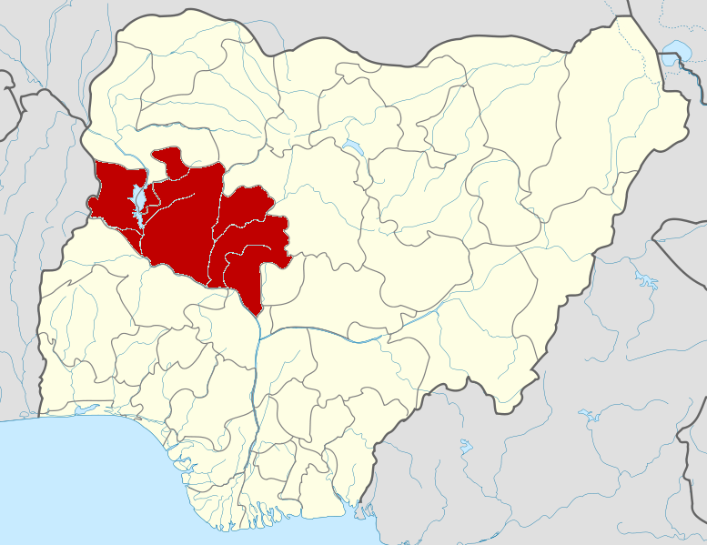

**N**

Study Area

LEGEND

Rivers and streams

International boundary

State boundary

14°N-

4°N-

3°E

14°E

**LAPAI**

20m

10

2Km

0

1

Niger State

Figure1: Modified Map of Nigeria showing Niger State and the study area (source: http/www.nigeriamaps.com/nigerstate).

The study area falls within the semi-arid region of Nigeria, the climatic condition of the area can be divided into two distinct seasons, the dry season and the wet season. The annual rainfall of the area usually varies between 1600mm in the southern part to about 1200mm in the northern part of the area. The duration of the wet season mostly lasts from 150 days to 210 days which occurs between April and October, although it can be more from north to south (Tsepav *et al.*, 2014).

The average maximum temperature of the area remains mostly high throughout the year between 32oC and 37oC especially in March and June while the lowest temperature that can be experienced in the area is between 25oC and 29oC which occurs usually between December and January; at this period the climate of the area is being influenced by the tropical continental air mass that is from the north (Tsepav *et al.,* 2014).

Lapai is covered by the Southern Guinea Savannah vegetation that is made up of tall grasses and woodland that have tall species such as palm tree. Although apart from settlements that the land is used for, land in Lapai is majorly used for farming activity (Tsepav *et al.,* 2014).

The relief is for the most part of a plain land with gentle slopes. The northern part of the area has slightly high topography with elevation above sea level varying between 146m and 192m. Drainage as observed from the topographical map of the study area is of dendritic pattern with River Danko as the major river and smaller streams as its tributaries. The direction of flow of the rivers is from the north western part towards the south eastern part of the study area.

Niger state is underlain by two major rock types, the Cretaceous sedimentary rocks and the Pre-Cambrian Basement Complex (Figure 2). The Basement Complex rocks occur in the northern part of the area and basically made up of the Migmatite-Gneiss complex, the Schist Belts and the Older Granites. To the south of the state is the sedimentary rock which is made up of sandstones and alluvial deposits, especially along the Niger valley, part of Gulu, Muye and the eastern parts of the study area (Idris-Nda *et al.*, 2010). Lapai is located in the transition zone of the two rock types in the south-eastern part of the state and is underlain by rocks belonging to the Pre Cambrian Basement Complex and the Cretaceous sedimentary formation.

Bida Basin

Sokoto Basin

Basement Complex

.

Kontagora

.

Minna

.

Bida

Ibbi

.

.

Borgu

.

Lapai

.

Mokwa

.

Rijau

.

Kagara

.

Agwara

.

Mashegu

Km

0

50

100

N

7o 15

4o 00E

8o 15

11o15

Study Area

Figure 2: Geological map of Niger State (Modified after Idris-Nda, Dodo, and Jimada,2013).

**METHODS**

**Water sampling**

Samples of water were collected from wells in the two geologic terrains of the study area using the random sampling method and a total number of 35 samples were collected while 20 samples were selected for chemical analysis; the samples were collected inproperly washed and dried empty plastic bottles. The collected samples were stored in a cooler containing ice to keep it under a room temperature of 37oC while in the field before being sent to the laboratory for all necessary chemical analysis. Each sample was labelled and dated.

During the water sampling, physical parameters such as temperature, pH and ElectricalConductivity (EC) were carried out in the field using a portable field meter, YOKOGAWA Personal pH meter (used to measure pH and temperature of samples)Model PH82 and YOKOGAWA Personal SC meter (used to measure electrical conductivity and temperature of samples) Model SC82 produced by Yokogawa Denkiki K.K. Electric Corporation. Sample locations and their coordinates are shown in figure 3.

**Laboratory Analysis**

Samples for hydrochemical analyses was collected in accordance to the set standard procedures that have been described in the sampling guide, (UNEP/WHO, 2006) and sent to the laboratory. Analysis was done using Titrimetry, Flame photometry and colorimetry methods.

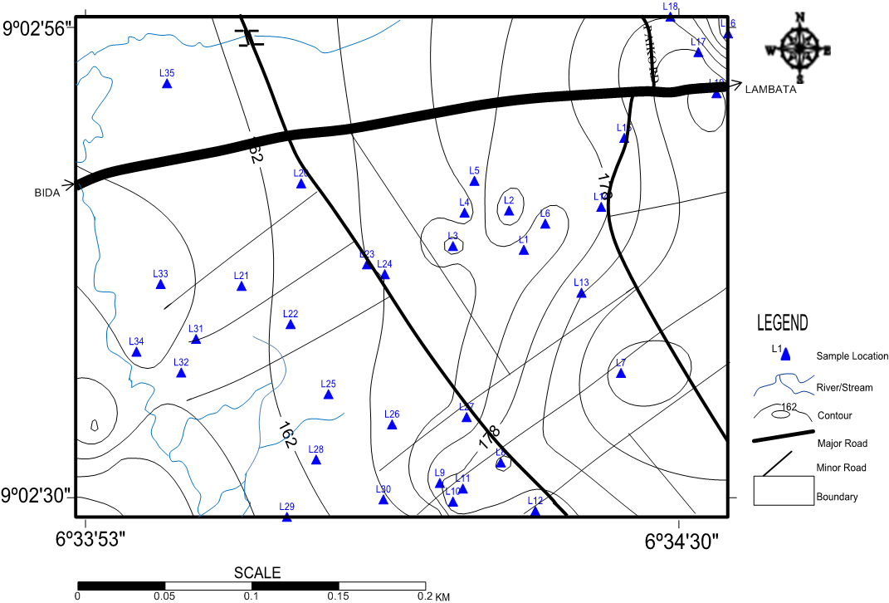

Figure 3: Map of study area showing sample locations.

**Data Interpretation**

Results of chemical analyses were interpreted using a variety of methods, including XY plots using MS Excel. Piper tri-linear diagrams and Stiff plots for water classification were produced with the aid of Rockworks while Principal Component Analysis (PCA) was carried out using SPSS version 16 for Windows. The exploratory PCA was carried out at the default Eigen Value of 1 along with Varimax orthogonal rotation and Kaiser Normalization.

**RESULTS AND DISCUSSION**

**Water Quality**

Table 1 is the summarized result of physical parameter measured in groundwater of parts of Lapai compared with WHO and SON/NSDWQ required standard, Figure 6 is the graph of the measured parameters.

Table 1 Summarised results for measured physical parameters

|  |  |  |  |  |
| --- | --- | --- | --- | --- |
| Parameters | Ranges | mean values | SON/NSDWQ Standard (2010) | WHO Standard (2011) |
| Ph | 27.0-32.0 | 6.7 | 6.5-8.5 | 6.5 |
| Temp. (ºC) | 5.4-7.2 | 30.0 | Ambient | Ambient |
| Conductivity (µS/cm) | 81.7-1095 | 506.3 | 1000 | 1000 |
| T. hardness (mg/L) | 57.8-220 | 158.6 | 150 | 100 |

SON/NSDWQ = Standard Organisation of Nigeria/Nigeria Standard for Drinking Water Quality. WHO = World Health Organisation.

The electrical conductivity (EC) of the groundwater in parts of Lapai was measured and represented in micro Siemens per centimetre (µS/cm). The EC values ranges from 081.7µS/cm to 1095µS/cm with a mean value of 485.1µS/cm. The value for the EC is within the permissible limits of 1000µS/cm for both WHO (2011) and NSDWQ (2010) except for locations 4, 9 and 23 with an EC of 1095µS/cm, 1034µS/cm and 1040µS/cm respectively that are slightly above the recommended permissible limits of both WHO (2011) and NSDWQ (2010).

The temperature of groundwater of parts of Lapai has values ranging from 27ºC to 32ºC with a mean value of 29.3ºC. The total hardness of the groundwater in parts of Lapai which is known as the cumulative concentrations of Ca2+ and Mg 2+expressed as calcium carbonate, gave a value that ranges from 57.8mg/l to 220mg/l with average value of 145.5mg/l that indicates that the groundwater of parts of Lapai is within moderately hard to hard water as seen in table 4.5 below. The hardness of water can result to the production of scums on skins and clothes which cannot be easily removed by just rinsing because of its sticky nature and insolubility when used for domestic purposes; therefore the use of synthetic detergents is preferable for such water. Table is the classification of water based on the hardness.

Table 2 Water classification based on total hardness

|  |  |
| --- | --- |
| Hardness | Water classification based on concentration (mg/l) as CaCO3. |
| Soft Water | 0 to 17.1 |
| Slightly Hard Water | 17.1 to 51.3 |
| Moderately Hard Water | 51.3 to 119.7 |
| Hard Water | 119.7 to 179.55 |
| Very Hard Water | Over 179.55 |

Table 3 is the results of the analysed chemical parameters while Table 4 is a summarised result of the chemical parameters comparing the mean values obtained to the World Health Organisation (WHO, 2011) and Nigerian standards (NSDWQ, 2007). Concentration graphs of all analysed parameters are shown in Figures 5 to 9.

Table 3: Result of analysed chemical parameters (mg/L) in groundwater in parts of Lapai.

|  |  |  |  |  |  |  |  |  |  |  |  |  |  |
| --- | --- | --- | --- | --- | --- | --- | --- | --- | --- | --- | --- | --- | --- |
| Parameter | Ca2+ | Mg2+ | Na2+ | K+ | HCO3- | CO3- | NO3- | SO4- | Cl- | F- | Cu2+ | Fe2+ | Cr+ |
| Point 1 | 32 | 19 | 75 | 29 | 5 | 0 | 10 | 15 | 110 | 0.31 | 0.04 | 0.09 | 0.02 |
| Point 2 | 36 | 17 | 80 | 33 | 11 | 0 | 8 | 20 | 116 | 0.39 | 0.02 | 0.11 | 0.04 |
| Point 3 | 30 | 18.1 | 73 | 42 | 5 | 0 | 9 | 14 | 99 | 0.25 | 0.03 | 0.26 | 0.02 |
| Point 4 | 31 | 30 | 104 | 55 | 40 | 0 | 9 | 10 | 128 | 0.64 | 0.06 | 0.07 | 0.05 |
| Point 5 | 39 | 13 | 86 | 42 | 12 | 0 | 15 | 12 | 120 | 0.29 | 0.04 | 0.27 | 0.02 |
| Point 6 | 33 | 21 | 97 | 32 | 9 | 0 | 11 | 18 | 154 | 0.23 | 0.02 | 0.19 | 0 |
| Point 7 | 34 | 16.2 | 82 | 38 | 10 | 0 | 8 | 19 | 109 | 0.54 | 0.02 | 0.10 | 0.04 |
| Point 8 | 29 | 28.5 | 51 | 28 | 38 | 0 | 13 | 9.5 | 102 | 0.19 | 0.05 | 0.07 | 0.01 |
| Point 9 | 46 | 25 | 67 | 42 | 10 | 0 | 15 | 14 | 86 | 0.22 | 0.04 | 0.08 | 0.05 |
| Point 10 | 20 | 3.42 | 61 | 23 | 4 | 0 | 6 | 11 | 56 | 0.47 | 0.02 | 0.1 | 0.03 |
| Point 11 | 37 | 12.4 | 99 | 54 | 11 | 0 | 9 | 17 | 110 | 0.20 | 0.03 | 0.09 | 0.02 |
| Point 12 | 20 | 16 | 61 | 57 | 7 | 0 | 4 | 10 | 70 | 0.33 | 0.1 | 0.11 | 0.05 |
| Point 13 | 31 | 26 | 74 | 43 | 24 | 0 | 6 | 18 | 105 | 0.7 | 0.03 | 0.1 | 0.01 |
| Point 14 | 31 | 20 | 75 | 52 | 9 | 0 | 13 | 11.4 | 140 | 0.26 | 0.03 | 0.18 | 0.04 |
| Point 15 | 44 | 24 | 86 | 26 | 10 | 0 | 5 | 13 | 87 | 0.33 | 0.02 | 0.08 | 0.03 |
| Point 16 | 19 | 3 | 62 | 32 | 4 | 0 | 7 | 10 | 70 | 0.40 | 0.03 | 0.17 | 0.03 |
| Point 17 | 19 | 15 | 68 | 49 | 7 | 0 | 6 | 10 | 102 | 0.28 | 0.02 | 0.10 | 0.04 |
| Point 18 | 29 | 25 | 100 | 50 | 23 | 0 | 11 | 17 | 96 | 0.60 | 0.09 | 0.10 | 0.02 |
| Point 19 | 42 | 22.6 | 73 | 38 | 9 | 0 | 3 | 18.1 | 100 | 0.5 | 0.04 | 0.06 | 0.007 |
| Point 20 | 28 | 23.5 | 61 | 39 | 22 | 0 | 5 | 16.2 | 112 | 0.22 | 0.07 | 0.10 | 0.04 |

Table 4: Summarized result of chemical analysis of groundwater in parts of Lapai compared with WHO (2011) and SON/NSDWQ (2010) standards.

|  |  |  |  |  |  |
| --- | --- | --- | --- | --- | --- |
| Parameters | Ranges Mg/L | Mean Value (Mg/L) | WHO (2011) Permissible Limit | WHO (2011) Maximum Permissible Limit | SON/NSDWQ (2010) |
| Calcium | 19 – 46 | 32 | 100 | 300 | 200 |
| Magnesium | 3.25 – 30 | 19 | 50 | 150 | 100 |
| Sodium | 51 – 104 | 77 | 100 | 200 | 200 |
| Potassium | 23 – 57 | 40 | 20 | 50 | 50 |
| Bicarbonate | 3.8 – 40 | 13.4 | - | - | - |
| Carbonate | 0 | 0 | - | - | - |
| Nitrate | 3.4 – 15 | 9 | 50 | 100 | 50 |
| Sulphate | 9.5 – 20 | 14.2 | 100 | 250 | 100 |
| Chloride | 56 – 154 | 104 | 200 | 300 | 100 |
| Fluoride | 0.19 - 0.7 | 0.4 | 0.5 | 1.5 | 1 |
| Copper | 0.02 - 0.1 | 0.04 | 1 | 2 | 1 |
| Iron | 0.06 - 0.27 | 0.12 | 0.3 | 0.3 | 0.33 |
| Chromium | 0 - 0.05 | 0.03 | 0.015 | 0.05 | 0.05 |

Figure 5: Concentration of analysed chemical parameters in groundwater in part of Lapai

Figure 6Comparison of mean concentration of Cations of groundwater in Lapai with Nigerian Standard of Drinking Water Quality (2010) and World Health Organisation (2011)

Figure 7: Comparison of mean concentration of Anions of groundwater in Lapai with Nigerian Standard of Drinking Water Quality (2010) and World Health Organisation (2011)

Figure 8: Comparison of mean concentration of Trace metals of groundwater in Lapai with Nigerian Standard of Drinking Water Quality (2010) and World Health Organisation (2011)

**Groundwater Characterisation**

Groundwater characterisation of parts of Lapai was done using Piper (1944), Langguth (1966) and Stiff (1951) plots. The Piper diagram is a representation of the chemistry of the water of an area. The cations and anions are shown by ternary plots, when the two are projected onto a diamond shaped diagram which is a matrix transformation of the graphs of cations and anions, it becomes possible to characterise the water by naming according to the dominant cations and anions. The Piper diagram not only shows graphically the nature of a given water sample, but also dictates the relationship to other samples. The classification of Langguth is based on measured concentration of the four major cations and the four major anions. In Piper trilinear method, eight (8) major ions (Na+, K+, Mg2+, Ca2+, HCO3-, CO32-, Cl- and SO42-) concentrations are indicated on the trilinear plot while Na+ and K+, representing the cations and HCO3- and CO32- representing the anions are used for the characterisation thereby reducing the total number of parameters that can be used for its plotting.

Based on the original classification by Piper (1944), water can be classified into five major types (type I to type V, but for the emphasis of this research, four major types which is type I to type IV) were used to get the results. This classification was later modified by Langguth (1966) into three (3) major types (type 1, type 2 and type 3) and each of these types were further subdivided to give a total of seven (7) sub types (type1= a, b and c, type 2= d and e, type 3= f and g). Figures 10 to 13 are the Piper and Langguth plots for groundwater in Lapai area.

****Figure 10: Result of chemical analysis of groundwater in parts of Lapai presented on a piper diagram (After Piper, 1944)

**A**



Figure 11: Result of chemical analysis of groundwater in parts of Lapai presented on a Langguth diagram (After Langguth, 1966)



Figure 12: Result of chemical analysis of groundwater in parts of the Sedimentary Basin in Lapai presented on a Langguth diagram, (After Langguth, 1966).



Figure 13: Result of chemical analysis of groundwater in parts of the Basement Complex area in Lapai presented on a Langguth diagram (After Langguth, 1966)

Table 5: Rotated Component Matrix for Water from parts of Lapai, showing four components.

|  | Component | | | |
| --- | --- | --- | --- | --- |
|  | 1 | 2 | 3 | 4 |
| Na+ | .887 | .057 | .036 | -.042 |
| Cl- | .694 | .225 | -.136 | .429 |
| SO2-4 | .595 | .006 | -.511 | -.340 |
| Mg2+ | .263 | .894 | -.050 | .047 |
| HCO-3 | .081 | .860 | .181 | -.002 |
| K+ | .444 | .095 | .787 | .034 |
| Cu | -.074 | .438 | .651 | -.101 |
| Cr | -.174 | -.022 | .618 | -.075 |
| Ca2+ | .447 | .313 | -.519 | .153 |
| NO-3 | .215 | .193 | -.030 | .803 |
| F- | .291 | .142 | .133 | -.731 |
| Fe2+ | .227 | -.551 | .061 | .607 |
|  | | | | |
|  | | | |  |

The Stiff diagram on the other hand displays the composition of water with regards to its major ion as a polygonal shape made from four parallel level axes stretching out on either side of a vertical zero axes. Anions are plotted on the right half of the zero axes while cations are plotted in milliequivalents per litre on the left half of the zero axes. Stiff plots are helpful in making a fast examination between water from distinctive sources. Stiff diagrams are also quite useful in visualisingionically related waters from which a flow can be resolved, or if the flow way is identified, to indicate how the ionic composition of a water body changes over space and/or time, figure 14 is the Stiff plot of groundwater in Lapai area.

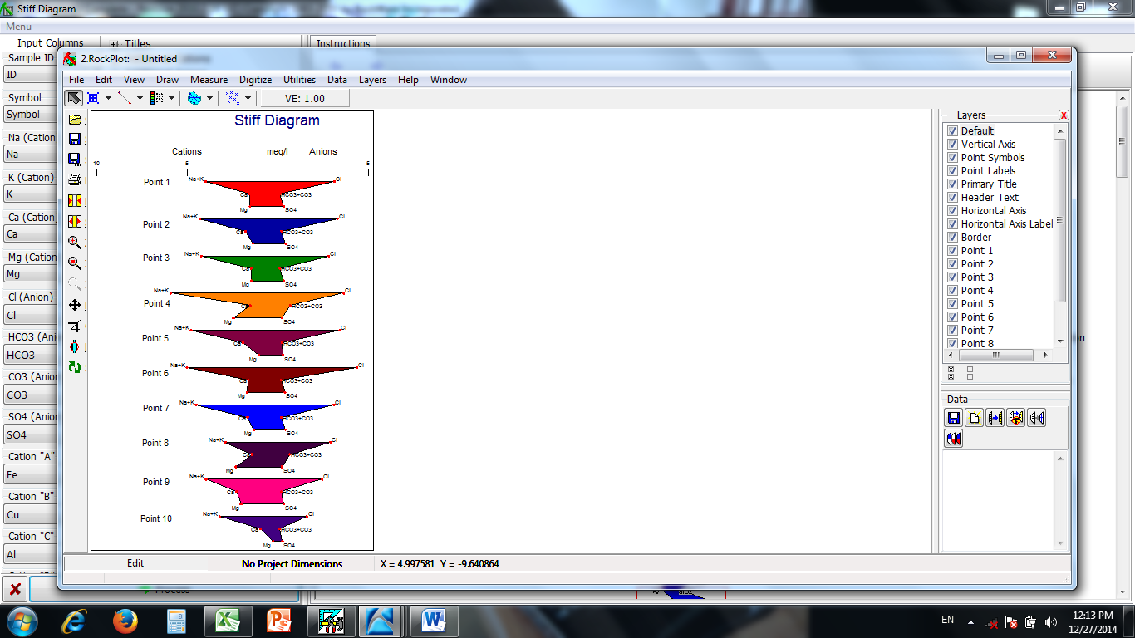

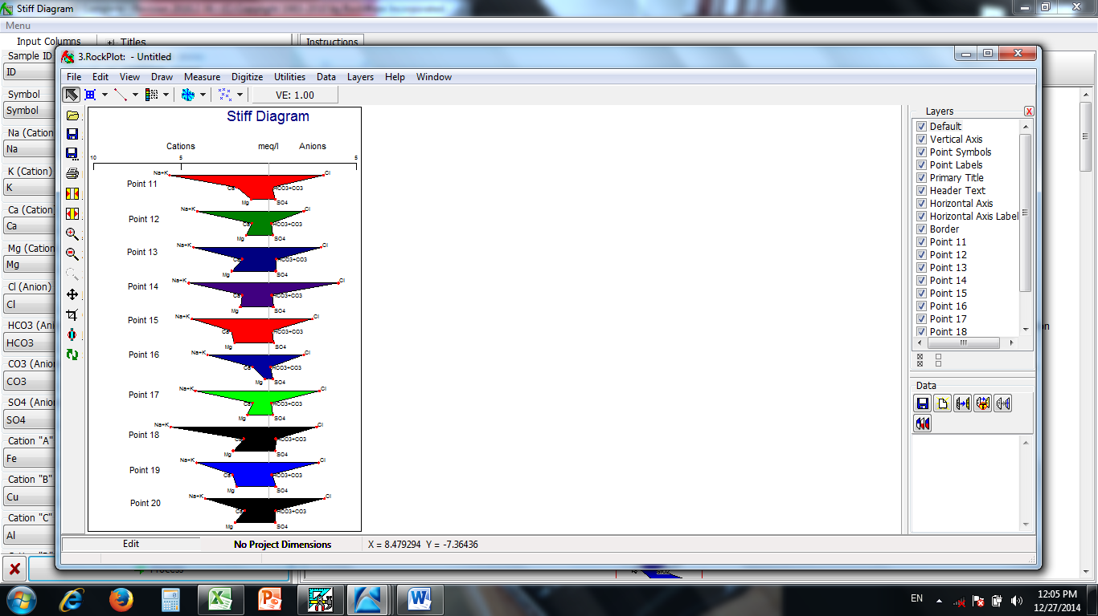

Figure 14: Plot of the HydrochemicalFacies in groundwater of parts of Lapai (After Stiff, 1951)

The value of the calcium component of the groundwater sample obtained from the study area ranges between 19mg/l to 46mg/l with average value of 32mg/l. While the value for the magnesium is from 3.25mg/l to 30mg/l with average value of approximately 19mg/l. The hardness of any water (surface or groundwater) is usually tied to the presence and the concentration of calcium and magnesium in that water; therefore, these values indicate that groundwater in Lapai and its environs is between soft to moderately hard water.Na+ and K+are both alkali metals thus they are also always jointly analysed for.

From the chemical analysis result given in Table 3, the value of Na+concentration differs from 51mg/l to 104mg/l with average value of approximately 77mg/l; while the concentration value of K+ differs from 23mg/l to 57mg/l with a mean value of approximately 40mg/l. Potassium on its own does not really pose any public health threat. It is also observed that sodium followed by potassium respectively are the most dominant cations in the groundwater of Lapai area as shown in figure 4.5 and 4.6 above.

Chloride ion (Cl-) as one of the major inorganic ion in freshwater was analysed and observed to have values varying from 56mg/l to 154mg/l with a mean value of approximately 104mg/l. Chloride is the most dominant anion as shown in figure 4.2 and figure 4.3 above. The source of chloride in the groundwater of Lapai can be ascribed to the aeration of the upper aquifer (which can lead to oxidation), which can be controlled by regulation of groundwater exploration in the area, another source of increased chloride is from environmental pollution (from activities of leachate from domestic waste in the area since there are no industrial sources of waste generation in the area), this also can be controlled by proper design of septic tanks in the area. Excess of chloride ion in water often have negative impacts on plumbing material, when it becomes noticeable in the taste and odour of the water then it shows that the contaminant is on the high side which can further become a threat to public health.

The concentration of SO42- analysed varied from 9.5mg/l to 20mg/l with a mean value of 14.2mg/L and this value falls within safe recommended limits of WHO (2011) and NSDQW/SON (2010). The presence of sulphate in this environment indicate agricultural activity, this is because its major source in the area is from the application of fertilizer on farm lands and gardens. NO3- in the groundwater analysed has values ranging from 3.4mg/l to 15mg/l with a mean value of approximately 9mg/l. It is observed that, point 5 and point 9 had the highest nitrate concentration of 15mg/l each, though point 5 has a shallow well depth of 4.5meters while point 9 has a very deep depth of 60meters, the nitrate concentration in both location can be attributed to their possible closeness to latrines and unhygienic environmental practise observed in the area where the wells are sited.

There is no evidence of carbonate in all the samples analysed from the study area. This may be attributable to the pH of the groundwater since carbonates are precipitated at low pH values. The concentration of bicarbonate ranges from 3.8mg/l to 40mg/l with a mean value of 13.4mg/l. The acidity of water is expected to increase as bicarbonate concentration increases. Thus the contribution of bicarbonate to acidity of water in the area is moderate.

The trace metals analysed in the groundwater of Lapai are copper, iron and chromium. Copper concentration has values ranging from 0.02mg/L to 0.1mg/L with a mean value of 0.04mg/L which falls within the acceptable limit of WHO (2011) and NSDWQ (2010). Presence of copper concentration in the water can cause coloration of sanitary wares and staining of clothing. The sources of copper present in the groundwater of Lapai are from improper disposal of waste effluent, pesticides used to prevent pests from homes and farm lands. Iron (Fe²+)which has the highest concentration amidst the trace metals, is a mineral that occurs naturally from rocks and sediments. Its concentration has a value that ranges from 0.06mg/L to 0.27mg/L with a mean value 0.12mg/L. The sources of iron concentration in the groundwater of the area can be attributed to waste effluents from improper methods of waste disposal in the area, corroding metals and also from rock and sediments in the area.

The excessive presence of iron in water usually gives it a bitter taste and causes discoloration to clothes when used for washing.The concentration of chromium in the groundwater of Lapai ranges from 0.00mg/L to 0.05mg/L with a mean value of 0.03mg/L and these values are within the permissible limit of 0.05mg/L. The groundwater of parts of Lapai, from the cations triangle, belong to the sodium (Na+) type and for the anions, the water can be said to be influenced highly by chloride (Cl-).

Therefore, the primary type of groundwater in the area is the type IV which represents Sodium-Sulphate-Chloride water; and the secondary type of groundwater in Lapai falls within the type I water which represents Calcium-Magnesium-Sulphate-Chloride water.

Based on the Langguth (1966) classification the groundwater of parts of Lapai can be classified into two main groups; the type 2 and type 3 groups.

The type 2 water, which is an Earth Alkaline freshwater with Alkali, further falls within the **e-type** group which is mostly Sulphate water; while the type 3 water, which is areas of alkali freshwater, further falls within the **g-type** group which is mostly Sulphate-Chloride water. Also when considering the groundwater of each of the terrain (Basement Complex and sedimentary area) analysed, it is observed that the groundwater within the sedimentary basin can be classified according to Piper (1944), into two groups which are type IV and type I water (primarily the Sodium Sulphate Chloride water and secondarily the Calcium Magnesium Sulphate Chloride water). While based on Langguth’s (1964) classification, the water falls within the group 3 and group 2 respectively and further into that of g-type (mostly Sulphate-Chloride water) in group 3 which indicates areas with Alkali freshwater, and e-type ( mostly Sulphate water) in group 2 which is areas of earth Alkaline freshwater with Alkali. According to Piper (1944), the groundwater of the Basement Complex of Lapai can be classified into the group IV which is Sodium-Sulphate-Chloride water. While in accordance to Langguth (1966), the water can be classified into the type 3 which indicates areas with Alkali freshwater and it further falls into the g-type of that group which is mostly Sulphate-Chloride water type.

Analysis of the Stiff plot shows two groups of water, the first group has a high concentration Na + K and Cl with a corresponding medium to high Mg and SO4, this mostly represents water from the basement areas. Water from the sedimentary areas shows reduced Na + K and Cl but has a much lower concentration of Mg and SO4 as compared to the first group. However a greater percentage of water in Lapai area did not show major differences in composition, implying that the water is mostly from a common origin, which is direct recharge from rainfall.

The PCA results which explain about 71 % of the variance show four main components in the water of Lapai area (Table 5). Component 1 is dominated by the loadings of sodium, chloride and sulphate and this corroborates the Piper interpretation which indicated the water to be mainly of Na-Cl-SO42- type. Component is dominated by magnesium and bicarbonate, probably an indication of carbon dioxide consumption and pyroxene dissolution.

**5.1 Conclusion**

Groundwater occurs in the slightly weathered part of the basement and also within fracturing in the bedrock. However due to the crystalline nature of the granite fracturing is not extensive within it and those that occur are more widely spaced apart. This accounted for fewer boreholes and hand dug wells in the area underlain by hard rock. Water in the sedimentary part occurs at two levels, the first level or upper aquifer occurs at a shallow depth of 15 to 25 meters, while the second level or lower aquifer occurs at 50 to 80 meters. Most boreholes in the area tap water from the upper aquifer which has depleted so much that some of the boreholes have ran dry. Below the aquifer is a layer that can best be described as an aquitard, this is not a water bearing layer and any well placed in it will not yield any water. Groundwater flow is in the NW – SE direction, this implies that water is flowing from the sedimentary portion to the basement area, this will explain the relative uniformity in chemical composition of water from both terrains.

Groundwater recharge for the lower aquifer may therefore not be localised since the underlain aquitard will only permit limited amount of water to pass through it.

Groundwater chemistry shows that the water is relatively potable as all measured values are within the recommended standards for drinking water based on both national and international standards. However elevated concentrations of sodium, chloride and nitrate shows effect of gradual pollution from anthropogenic (human) factors. Better and improved sanitary conditions will go a long way in checking groundwater pollution from these sources.

Challenges of groundwater development in Lapai area covered by this study is mainly from geology. Poor understanding of the geology will lead to erroneous conclusions and subsequent poor design of boreholes and wells. Understanding the geology, along with geophysical surveys will reveal the thickness of the overburden or sedimentary pile which will aid in planning for water supply using boreholes or hand dug wells.

**REFERENCES**

Idris-Nda, A., (2010).The Groundwater Potential of Parts of the Birnin-Gwari Shist Belt around Zungeru and Minna, North-Central Nigeria. *Journal of The Nigerian Association of Hydrogeologists. (ISSN: 0795-6495), 20(2),*43-53

Idris-Nda, A., Amadi, A.N. and Ismaila, M., (2010). Geotechnical Properties of a Mixed Geologica Terrain for Road Foundation. A case study of Lapai-Gulu road, Niger state, North Central Nigeria. *Nature and Applied Science Journal;* (ISSN: 1119-9296). 11(2), 174-180.

Idris-Nda, A., Dodo, U. and Jimada, A.M., (2013). Challenges facing the attainment of the Millinium Development Goals (MDGs) in the water sector: The Niger State sample, Central Nigeria. *Journal of Sceintific Research and Report.* Retrieved from: [www.sciencedomain.org/abstract.php?id=22&aid=3835](http://www.sciencedomain.org/abstract.php?id=22&aid=3835)

Kathrin, K., (2011). Groundwater management important for South Africa. *Water SA; 37(1),* 67-79. Retrieved from: [www.wrc.org.za](http://www.wrc.org.za)

Kazman, R.G., (1965). Modern Hydrogeology, New York: Herper and Row Publishers, incorporated. pp.161.

Langguth, H.R. (1966), Groundwater verlhaltisse in. bereich des. Velbertersatues Der –

Minister for Emahrung land. Wistschaft andForstern. NWR. Dusseldorf, Germany.

Marsh, H.J., (1966). “Groundwater versus Surface water” *Johnson Drillers Journal, (Sept.-Oct.1966).*pp.1-5.

Montgomery, C.W.(2002). Environmental geology (5th ed.), Boston: McGraw–

Hill Higher education, pp 385 – 410.

Niger State setting: Retrieved from [www.onlinenigeria.com/links/nigeriadv.asp](http://www.onlinenigeria.com/links/nigeriadv.asp)

Nigeria standard for drinking water quality, NSDWQ (2010): Retrived fromwww.unicef.org>nigeria>media

NSDWQ (2010). Nigerian Standard for Drinking Water Quality published by Nigerian Industrial Standard NIS: 554, pp 1- 14

Nwankwoala, H.O., (2009). Sustainable Groundwater Development and Management in Nigeria: Mission Achievable or Mission Impossible?

Piper, A. M., (1953). A Graphic Procedure in Geochemical Interpretation of Water Analyses. *American Geophysical Union, 25,* 914-923.

Stiff, H.A., (1951). The interpretation of chemical water analysis by means of patterns. *Journal of Petroleum Technology, 3(10)*, 15-17.

Tsepav, M. T., Bello, A. and Gbedako, A.A, (2014). Geo-electric investigation of some parts of Ibrahim Badamasi Babangida University, Lapai, Nigeria. *Physical Science International Journal, 4(4),* 623-635. Retrieve from [www.sciencedomain.org](http://www.sciencedomain.org)

UNEP/WHO, (2006). Water Quality Monitoring. In James, B. & Richard, B. (Eds.), A practical guide to the design and implementation of freshwater quality studies and monitoring programmes (pp. 65-67).Great Britain: TJ Press..

United Nation Children Fund (2014), UNICEF Annual Report 2014. [www.unicef.org](http://www.unicef.org)

World Health Oranization, (2006). Guideline for drinking water quality, WHO recommendations, Geneva. 1, pp. 130.