AN APPRAISAL OF URBAN LAND USE LAND COVER CHANGES IN JOS SOUTH LOCAL GOVERNMENT AREA OF PLATEAU STATE, NIGERIA USING REMOTE SENSING AND GIS.

*VIVAN EZRA LEKWOT¹, ALI ANDESIKUTEB YAKUBU², OKAFOR, CHRISTIAN I.³ AND ABDULRAHMAN AHMED SAHABO⁴.

¹ DEPARTMENT OF ENVIRONMENTAL MANAGEMENT,
FACULTY OF ENVIRONMENTAL SCIENCES
KADUNA STATE UNIVERSITY, NIGERIA.

² Ph.D CANDIDATE,
DEPARTMENT OF GEOGRAPHY AND PLANNING,
UNIVERSITY OF JOS, NIGERIA.

³ UN- HABITAT,
JUBA, SOUTH SUDAN.

⁴DEPARTMENT OF URBAN AND REGIONAL PLANNING,
ADAMA MODIBBO UNIVERSITY YOLA,
ADAMAWA STATE, NIGERIA

*Corresponding Author Email Address: ezrav540@gmail.com
Mobile Phone Numbers: +2348032880342, +2348097601269

Abstract
Jos South Local Government Area of Plateau State in Nigeria is witnessing rapid urban land use and land cover changes largely due to high population growth. This study attempts the use of GIS and Remote Sensing in mapping land use and land cover in the study area between 1993, 2003 and 2013 so as to detect the changes that may have taken place in the study area between these periods. The study utilized data from field surveys, remote sensed data and geographical information system technique, four main methods of data analysis were adopted in this study namely calculation of the Area in hectares of the resulting land use/land cover types for each study year and subsequently comparing the results, Markov Chain and Cellular Automata Analysis for predicting change, Overlay Operations and Maximum Likelihood Classification. Subsequently, an attempt was made at projecting the observed land use and land cover changes in the next 10 years. The result revealed that some features will be lost to other features and possible reasons for that were evaluated. Suggestions were therefore made at the end of the work on ways to use the information as contained therein optimally.
Keywords: Land use, Land cover, Changes, Remote sensing, Jos south, GIS.

Introduction
The terms land cover and land uses used interchangeably in change detection studies, their actual meanings are quite distinct (Seto et al., 2002, Shao and Reynolds, 2006). Land cover refers to the surface cover on the ground, whether vegetation, urban infrastructure, water, bare soil or other. Identifying, delineating and Mapping of land cover are important for global monitoring studies, resource management, and planning activities (Foody and Atkinson, 2002; Aspinall and Hill, 2008). Land use applications involve both baseline mapping and subsequent monitoring, since timely information is required to know which current quantity of land and Which type of use and to identify the land use changes from year to year (Sabins, 1997;Read and Lam, 2002; Campbell, 2002)..
Humans have been altering land cover since prehistory through the use of fire to flush out game and, since the advent of plant and animal domestication, through the clearance of patches of land for agriculture and livestock (De-Sherbinin, 2002). In the past two centuries the impact of human activities on the land has grown enormously, altering entire landscapes, and ultimately impacting the earth's nutrient and hydrological cycles as well as climate. Most major metropolitan cities face the growing problems of urban sprawl, loss of natural vegetation and open space and a general decline in wildlife habitat. This problem is observed when residential and commercial development replaces undeveloped land around them. Cities have changed from small, isolated population centers to large, interconnected economic physical and environmental features. According to USGS fact sheet 188-99 in 1999, one hundred years ago, approximately 15% of the world population was living in urban areas. Today the percentage is nearly 50%.
In their research Francis et al. (2013) observed that; With major changes being Arable land use giving way to residential land use in the peri urban area and residential land uses giving way to commercial land uses in the city, access to Arable land is drastically reduced causing food insecurity problems. Commercial development in the city can only take the form of redevelopment of old structures. This has led to alteration of the land use plan of the city. Hence, effective land use planning should be based on promotion of policies.
Musa et al (2014) revealed that the land use and land cover in the study area changed over time whereby some increased while others reduced in terms of spatial extent. Mangrove, arable, sparse vegetation and primary forest were on the negative side while built up areas, water and secondary forest continue to increase. The decrease in the arable in the study area is evidence that the lands meant to be used for farming have been acquired for building and construction and this is an indication that food production may decrease over time and the growing population might be faced with serious famine.
The conversion of Arable lands to urban development is a phenomenon currently affecting countries as their population grows. Although urban sprawl may not threaten overall Arable productivity of a country it does result in the alterations and declines in local Arable activities and to the loss of Arable land as highlighted by the literature. Organisation for Economic Cooperation and Development, OECD (1979) has documented the loss of peripheral Arable land to sprawl in some European countries such as Netherlands and Norway which respectively lost 4.3 percent and 1.6 percent of their land annually to sprawl. Also the United States of America and Canada lose 4,800sqkm of prime cropland annually to roads, buildings, reservoirs and other non-Arable Uses (Atu et al., 2011). Also the United States of America and Canada lose 4,800sqkm of prime cropland annually to roads, buildings, reservoirs and other non-Arable uses. Lopez et. al., (2001) in a study on, ‘Urban Expansion and the Loss of Prime Arable Lands in Puerto Rico’, shows that between 1977 and 1994 the urban area of Puerto Rico increased from 11.3 percent to 27.4 percent. They therefore concluded that if the pattern of encroachment by urban growth into arables continues Puerto Rico’s potential for production in the future will be dimmed.
In their findings ( Atu, et al., 2011) indicated that urban sprawl has impacted negatively on Arable lands in Calabar, Nigeria by reducing their spatial extent and density and fragmenting them into smaller sizes of less than 100m². Hence, the challenge in the sustainability of Arable activities lies in the conservation and management of existing fragments in the face of very rapid urbanization. This same trend of rapid land use and land cover changes have been observed to be taking place in Jos South Local Government Area.
Objectives of the Study
The primary objective of the study is to assess land use and land cover changes in Jos South L.G.A. from 1993-2013.While the specific objectives are to:
- Generate various land use, land cover maps of the study area for three different years (1993, 2003 and 2013).
- Identify the rate and magnitude of land use and land cover changes in the study area.
- Predict the trend of changes in land use and land cover by 2023.

Study Area
Jos south local government area is located between latitudes 9° 30’ to 10° N and longitude 8° 30’ E. It is situated at the north western part of the state with its headquarters at Bukuru, which is about 15 km from the state capital, Jos. The local government area has four districts: Du, Gyel, Kuru and Vwang districts as shown in figure 1 below. The local government area has total land area of about 1,037 km² with a population of 306,716 (NPC, 2006). It has a cool climatic condition due to its altitude. The coldest period is between November and February with an average mean daily temperature of 18°C, while it gets warm between March and April before the onset of rain. The rainy season, which is between the months of May and October, has its peak in August. The mean annual rainfall varies between 1347.5 and 1460 mm per annum (Michael, 2012).
The people of Jos south were predominantly farmers and hunters, Common food crops grown in the area include Irish potato, sweet-potato, maize, millet, Acha, tomato and many other varieties of vegetables. Due to the ever green vegetation and tse-tse-free nature of the area, cattle rearing and grazing has been quite profitable and poultry farming is a viable business in the area. The conducive environment for cattle rearing has attracted investors such as the Integrated Dairy farm, Vom (formerly WAMCO) which produces dairy products, as well as ECWA Rural Development Company Limited which also deals in poultry production and other veterinary services (Gwom, 1992).

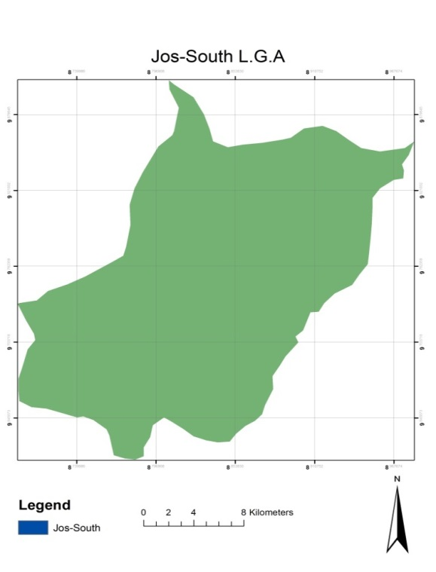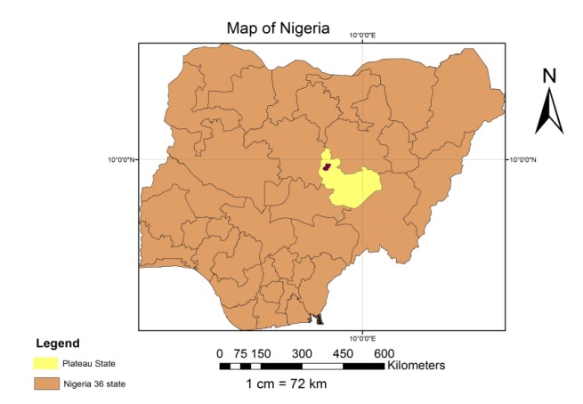

Fig. 1. Map of Study Area (source: NCRS, Jos 2014)
Materials and Methods
In the course of this study, software and hardware were the main materials used. As for the software, ArcGIS 9.3 version was employed for the delineation of the study area from the map, clipping of the Image to the study area and preparation of the image for analysis. Google Earth Pro is internet based software employed to download an internet image representing the study area which served as a referenced image and a complementary to reconnaissance survey. IDRISI Taiga is GIS software that was employed in this study to do all the necessary analysis on the image leading to the final results. While on the other hand, the hardware include: Computer being the main laboratory equipment used in this study where all the laboratory work were done in it. For the purpose of reconnaissance survey, Global positioning system (GPS) was used to identify various locations within the study area as (Appendix I). Land cover data was extracted from the United States Geological Service (USGS) web site (http://www.usgs.gov). This land cover raster coverage was originally built from 30 meter Landsat 5 Thermal Mapping (TM) data from the early 1990, Landsat 30m ETM for the year 2003 and 2013 Landsat 8 OLI image. Google earth image covering the study area was also downloaded free from Google image website using Google Earth software, which will be used as a reference image and will complement the groundthruting exercise. The study area is a local government area, therefore a digital local government boundary map and Nigerian Administrative map was also obtained from National Center for Remote Sensing (NCRS) Jos for mapping out the study area from the satellite image. Below are the characteristics of all the data obtained. Based on the prior knowledge of the study area for many years, and a brief reconnaissance survey with additional information from previous research in the study area, a classification scheme was developed for the study area after Anderson et al (1971).
The classification scheme developed gives a rather broad classification where the land use land cover was identified by a single digit.
Table 1: Classification Scheme
Code Land Use/Land Cover Categories Description
- Bare Soil Areas with no vegetation cover, stock quarry, stony areas, uncultivated Arable lands

- Built-up Area All Residential, commercial and industrial areas, Villages and other settlements.
- Arable land Area occupied by farming activities

- Vegetation Sparsely and dense trees, shrubs and grassland.

- Water Body Soil surface area occupied by stream, pond or river, Dam
Source: Anderson et al., 1971
Additional spatial data were collected with a handheld GPS (Global Positioning System) during reconnaissance survey (Appendix 1). Locations of settlements, watering points, and cultivated areas were recorded. The GPS had an accuracy of plus or minus 5 meters, so for consistency, the reading at each point was taken at or close to the front of the intended land use type. The recorded points were used during training site creation and also reserve for accuracy assessment. The Landsat satellite imageries of 1993, 2003 and 2013 downloaded from United States Geological Service (USGS) web site (http://www.usgs.gov), using the path and Row 188/053 of the area of interest on the map search interface. Geo-referencing and coordinate system creation was not necessary at this point as it was already pre-geo-referenced and ortho-rectified from the source using Universal Transverse Mercator (UTM) as its projection and WGS84 as its ellipsoid. The downloaded Google earth image of the area was geo-referenced and digitized. The digital map of the local government was digitized and used as a frame to subset the Google image and individual band of Landsat images which were individually exported and staked into IDRISI Tiger environment one at a time. The study area was sub-mapped and enhanced using the contrast stretching techniques of the global contrast enhancement method, the spectral band were combined to obtain a colour composite by formation of bands 4, 3 and 2 for both 1986 and 1999 respectively, the result of the colour composite is shown below in figure 2 and 3 respectively. Image classification is a conventional change detection method which provides an avenue to create series of Land cover maps, and in order to produce land use land cover maps after classification that will the various changes that occur due to loss of Arable in the study area., the satellite imageries of Landsat TM of 1986 and Landsat ETM of 1999 was classified using maximum likelihood classification algorithm
The images were imported into IDRISI Taiga for classification that is the process of extraction of differentiated classes or theme from raw remotely sensed digital satellite data (Meyer, 1995). Each cluster of observations is a class. A class occupies its own area in the feature space i.e. a specific part of the feature space corresponds to a specific class. Once the classes have been defined in the feature space, each image pixel observation can be compared to these classes and assigned to the corresponding class. Classes to be distinguished in an image classification need to have different spectral characteristics, which can be analyzed by comparing spectra reflectance curve.
Training sites were generated on the images by on-screen digitizing for each land cover classes derived from image of different band combination. A supervised (full Gaussian) maximum likelihood classification was implemented for the three images. Dedicated field observation help in familiarizing with the study area whereby the spectra characteristics of the classes in the sampled area has been identified. Ground truth information was used to assess the accuracy of the classification.
Methods of Data Analysis
Four main methods of data analysis were adopted in this study.
(i) Calculation of the Area in hectares of the resulting land use/land cover types for each study year and subsequently comparing the results.
(ii) Markov Chain and Cellular Automata Analysis for predicting change
(iii) Overlay Operations
(iv) Maximum Likelihood Classification
The first three methods above were used for identifying change in the land use types. Therefore, they have been combined in this study.
The comparison of the land use land cover statistics assisted in identifying the percentage change, trend and rate of change between 1993 and 2013.
In achieving this, the first task was to develop a table showing the area in hectares and the percentage change for each year (1993, 2003 and 2013) measured against each land use land cover type. Percentage change to determine the trend of change can then be calculated by dividing observed change by sum of changes multiplied by 100
$$\left(Trend\right)Percentage Change=\frac{Observed Change}{Sum of Change}*100$$
In obtaining annual rate of change, the percentage change is divided by 100 and multiplied by the number of study year 1993 – 2003 (10years) 2003 – 2013 (10years)
Markov Chain Analysis and Cellular Automata Analysis were used in modeling land use change and addition of spatial character to the changes.
Overlay operations which is the last method of the three, identifies the actual location and magnitude of change although this was limited to the built-up land. Boolean logic was applied to the result through the reclass module of idrisi32 which assisted in mapping out separately areas of change for which magnitude was later calculated for.

RESULTS AND DISCUSSION
The results are presented inform of maps, charts and statistical tables. They include the static, change and projected land use land cover of each class.
Land Use Land Cover Distribution
The static land use land cover distribution for each study year as derived from the maps are presented in the table below
Table 2: Land Use Land Cover Distribution (1993, 2003, 2013)
LANDUSE/LAND COVER  CATEGORIES | 1993  AREA(Ha.) AREA (%) | 2003  AREA (Ha.) AREA (%) | 2013  AREA (Ha.) AREA (%)
BARE LAND 32211.45 62.95 28124.46 54.96 24571.63 48.02
BUILT-UP AREA 4833.63 9.45 6132.51 11.98 9589.29 18.74
ARABLE LAND 10054.62 19.65 13449.33 26.28 11820.22 3.10
WATER BODY 967.93 1.89 1436.65 2.81 2084.95 4.07
VEGETATION 3104.37 6.07 2029.05 3.97 3105.91 6.07
TOTAL 51,172.00 100 51,172.00 100 51,172.00 100
The figures presented in table 4.1 above represents the static area of each land use land cover category for each study year. Water body in 1993 occupies the least class with just 1.89% of the total classes. The local government occupied the largest land mass among the three local government that makes up Jos metropolis and farming is the major occupation among the indigenes. That’s why there is more open land of 62.95% and arable land of 19.65% in 1993. Because of abundant land mass built-up increases through 2003 and 2013 respectively. Built up area were coming up leading to the encroachment of arable land that are close to the town that reduces their size in 2003 and 2013 respectively.
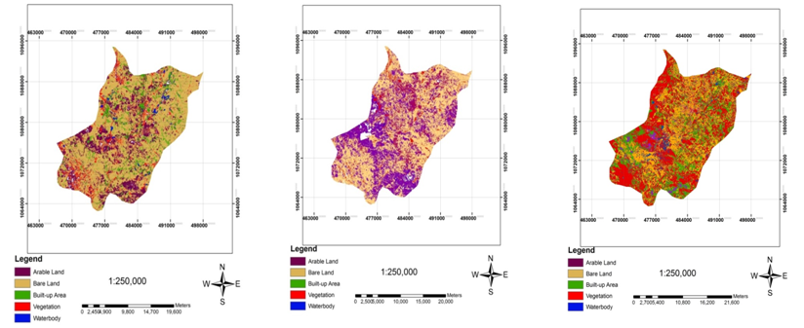
Fig.2:Classified image of 1993 Fig.3 Classified image of 2003 Fig.4 Classified image of 2013

LANDUSE/LAND  COVERCATEGORIES | 1993 – 2003  AREA  (Ha.) %CHANGE | 2003 – 2013  AREA  (Ha.) %CHANGE | ANNUAL RATE  OF CHANGE  93 – 03 03 - 13
BARE LAND -4086.99 -13 -3552.83 -13 -1.08 -1.3
BUILT- UP AREA 1298.88 27 3456.79 56 2.25 5.6
ARABLE LAND 3394.71 34 -1629.11 -12 2.83 -1.2
WATERBODY 468.72 48 648.30 45 4 4.5
VEGETATION -1075.32 -35 -1076.86 53 -2.91 5.3
Table 3: Land use land cover change of Jos-South: 1993, 2003 and 2013
Source: Authors’ field work, 2014

Transition Probability Matrix
The transition probability matrix records the probability that each land cover category will change to the other category. This matrix is produced by the multiplication of each column in the transition probability matrix be the number of cells of corresponding land use in the later image.
For the 5 by 5 matrix in table 3, the rows represent the older land cover categories and the column represents the newer categories. Although this matrix can be used as a direct input for specification of the prior probabilities in maximum likelihood classification of the remotely sensed imagery, it was however used in predicting land use land cover of 2023.
Table 3: Transitional Probability table derived from the land use land cover map of 1986 and 2001
CLASSES | Bare  Land | Built-up  Area | Arable  Land | Water  body | Vegetation
Bare Land 0.35 190.27 770.01 970.03 880.1119
Built-up Area 0.03 100.30 540.04 260.02 100.0000
Arable Land 0.04 940.37 280.20 030.02 860.1489
Water body 0.27 180.05 950.03 080.25 180.2860
Vegetation 0.12 390.20 370.02 480.03 460.3130

Row categories represent land use land cover classes in 2013, whilst column categories represent 2023 classes. As seen from the table, bare land has a 0.3519 will remain. Also built-up having the highest with 0.3054 will not change in 2023.Arable land with 02003 has a probability of changing to built-up. Vegetation during this period will likely reduce its position to built-up. Water body which has a 0.2518 probability of changing to bare land; which may not however be a true projection of this class except there is an occurrence of drought in the region.
Table 4: Projected Land use land cover for 2023
LAND USE LAND COVER CLASSES |  | Bare Land | Built-up  Area | Arable  Land | Water  Body | Vegetation
2023 | AREA IN  HECTARES 22,381.58 13,161.03 8321.13 2175.67 5132.59  AREA IN  PERCENTAGE 43.77 25.72 16.26 4.21 10.03

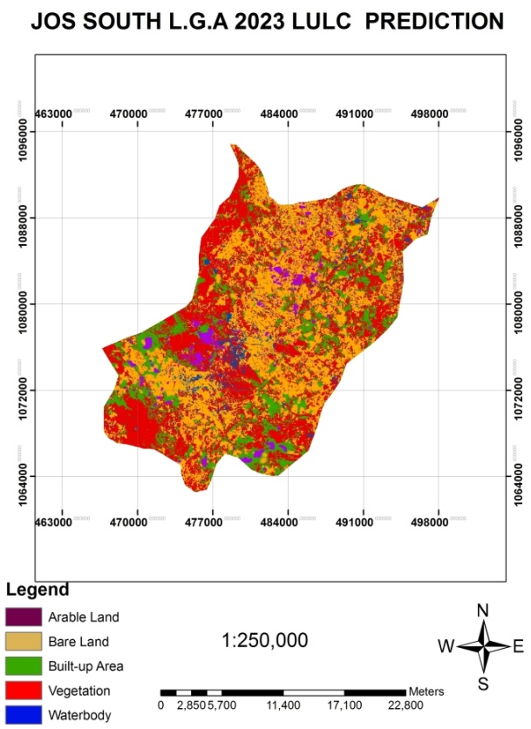

Fig.5 Predicted image of 2023
Table 4 shows the statistic of land use land cover projection for 2023. Comparing the percentage representations of this table and that of table 2, there exist similarities in the observed distribution particularly in 2013. This may tend to suggest no change in the classes between 2013 and 2023, but a careful look at the area in hectares between these two tables shows a change though meager. Thus in table 4, bare land still maintains the highest position in the class whilst water body retains its least position. vegetation takes up the next position, followed by arable land and finally, built-up area.
CONCLUSION AND RECOMMENDATION
This study work demonstrates the ability of GIS and Remote Sensing in capturing spatial-temporal data. Attempt was made to capture as accurate as possible five land use land cover classes as they change through time. Except for the inability to accurately map out some area of the water body in 2003 but the size was complemented when compared with the total land mass.
The five classes were distinctly produced for each study year but with more emphasis on built-up land as it is a combination of anthropogenic activities that make up this class; and indeed, it is one that affects the other classes. In achieving this.
However, the result of the work shows a rapid growth in built-up land between 2003 and 2013 this may be attributed to relocation of many people from the city centre to a new layout around the local government.. It was also observed that change by 2023 may likely follow the trend in 2003/2013 all things being equal.
In conclusion, Jos south local government is experiencing a fast developmental growth where government allocated land for building at the detriment of farm land which need to be looked in to. With the changes shown on the map, if precautionary measures were not taken land for agricultural purposes will start to have a set back and may affect the agricultural activities of the area.
Recommendations
The following recommendations were given as:
- All land meant for building must be registered with government before building commence.
- Fertile areas must be protected against any development.
- At a particular interval government should take into cognizance of Land use and Land cover to ascertain changes that are taking place.

REFERENCES
Anderson, J. R., (1971) Land use classification schemes used in selected recent geographic applications of remote sensing: Photogramm.Eng., v. 37, no. 4, p. 379-387.
Aspinalls, R. J. and Hill, M. J. (2008) Land use change, science policy and management. New York CRC Press, Taylor and Francis Group.
Atu, J. E., Offiong R. A., Eni, D.I., Eja, E. I and Essien, O. E., (2011) The Effects of Urban Sprawl on Peripheral Arable Lands in Calabar. Nigeria International Review of Social Sciences and Humanities. 2 (2):68-76
Campbell, J. B. (2002) Introduction to remote sensing.(3rd ed.), Taylor and Francis.
De Sherbinin, A., K. Kline and K. Raustiala, (2002) Remote sensing Data; valuable support for environmental treaties. Enviroment,44(1):20-31.
Foody. G. M. and Atkinson, P. M. (2002) Uncertainty in remote sensing and GIS. JohnWiley and Sons, London.
Francis Z. N., Romanus D. D., and Raphael K. K. (2013) Urbanization and Its Impact on Arable Lands In Growing Cities In Developing Countries: A Case Study Of Tamale In Ghana. Modern Social Science Journal, 2(2):256-287
Gwom SL (1992). The Berom Tribe of Plateau State Nigeria. First edition. Jos. Fab Anieh Nigeria Ltd., p. 15.
Michael A. A., (2012) Effect of mining on farming in Jos South Local Government Area of Plateau State. Federal College of Land Resources Technology, Kuru, Plateau State. Nigeria. Journal of Soil Science and Environmental Management. 3(4):77-83.
Meyer W B, (1995) Past and Present Land Use and Land Cover in the USA. In:Consequences 1: 25-33.
Musa I.T., Yakubu M.T., Ya’u H., Muhammad Z.S., Ishaya M and Vivan E.L. (2014) Analysis of forest cover changes in Nimbia Forest Reserve, Kaduna State, Nigeria using Geographic Information System and Remote Sensing techniques. International Journal of Environmental Monitoring and Analysis; 2(2): 91-99.
National Population Commission (2006) Population and Housing Census of the Federal Republic of Nigeria. Federal Government Press. Lagos
Organisation for Economic Co-operation and Development (OECD), Agriculture and Biodiversity, Developing Indicators for Policy Analysis, (1979).
Read, J. M. and Lam, N. S. N.(2002) Spatial methods for characterizing land cover and detecting land cover changes for the tropics. International Journal of Remote Sensing, 23(12): 2457-2474.
Sabins, F. F. 1997. Remote sensing, principles and interpretation. (3rd ed). W. H. Freemanand Company, New York.
Seto, K. C., Woodcock, C. E., Song, C. Huang, X., LU. and Kaufmann,R. K. (2002).Monitoring landscape change in the Pearl River Delta using Landsat TM. International Journal of Remote Sensing, 23 (10): 1985-2004.
Shao, and Reynolds, K. M. (2006) Computer applications in sustainable forest management: including perspectives on collaboration and integration. Springer Netherlands

APPENDIX A1
GPS points at the study area
S/N | LOCATION | LATITUDE (N) | LONGITUDE  (E) | ELAVATION
1 | Zarmaganda | 09⁰ 49. 362¹ | 08⁰ 51.957¹ | 1241m
2 | Before bukuru junction (bridge) | 09⁰ 48. 888¹ | 08⁰ 52.084¹ | 1234m
3 | Bukuru L.G.A secretarial | 09⁰ 47. 951¹ | 08⁰ 51.698¹ | 1247m
4 | Gyal ‘A’ gero road | 09⁰ 48. 129¹ | 08⁰ 51.101¹ | 1222m
5 | Bukuru town (market) | 09⁰ 37. 331¹ | 08⁰ 51.991¹ | 1277m
6 | Police staff college | 09⁰ 45. 508¹ | 08⁰ 51.627¹ | 1258m
7 | Mararrabanjama’a | 09⁰ 43. 200¹ | 08⁰ 51.948¹ | 1264m
8 | Sabonlayi road (kuru). New road | 09⁰ 42. 644¹ | 08⁰ 50.334¹ | 1308m
9 | Government science school kuru | 09⁰ 42. 040¹ | 08⁰ 50.189¹ | 1319m
10 | Zawan | 09⁰ 44. 722¹ | 08⁰ 52.596¹ | 1275m
11 | Du (zawan road to Du) | 09⁰ 45. 518¹ | 08⁰ 53.143¹ | 1299m
12 | Loti (Du) | 09⁰ 45. 423¹ | 08⁰ 52.748¹ | 1272m
13 | Rabin (Du) | 09⁰ 45.716 ¹ | 08⁰ 53.349¹ | 1295m
14 | Shen road (Du) | 09⁰ 46.608 ¹ | 08⁰ 53.648¹ | 1295m
15 | Shen village | 09⁰ 46.310 ¹ | 08⁰ 54.615¹ | 1317m
16 | Dwei Du | 09⁰ 48.732¹ | 08⁰ 55.246¹ | 1322m
17 | Dura | 09⁰ 49.939¹ | 08⁰ 55.257¹ | 1312m
18 | Rayfield | 09⁰ 50.247¹ | 08⁰ 54.960¹ | 1300m
19 | Kwang | 09⁰ 50.817¹ | 08⁰ 55.758¹ | 1318m
20 | Lamingoraod | 09⁰ 53.980¹ | 08⁰ 56.096¹ | 129m

