Can a Game-based Productivity Tool Improve Procrastination?

Kuo-chen Li, Shein-Yung Cheng, Chi-Wei Wang
Department of Information Management
Chung-Yuan Christian University
Tao-Yuan, Taiwan
kuochen@cycu.edu.tw, kadarwang14@gmail.com

Abstract
One of the effective management of work-load is to avoid procrastination. With the popularity of the Internet access, Internet addiction makes avoiding procrastination even more challenging. Many productivity tool Apps were designed to avoid procrastination caused by mobile device addiction. However, the effect is not significant. To improve the effectiveness of productivity tools, this research surveyed the procrastination factors, and proposed a game-based learning framework which combines the procrastination factors with gaming factors. The proposed work induces the sustainability of game-based design to ensure the user engagement. Based on the proposed framework, a game-based productivity tool app is developed to evaluate the results. Semi-structural interviews of domain experts are carried out prior conducting the experiments. Experiments adopted TAM model to verify the significant factors and the effectiveness of the proposed work.

Keywords—Procrastination; Gamification; productivity tool

- INTRODUCTION
Overcome procrastination has always been a challenging task for productivity. Research shows that procrastination may result in delays of responsibilities, duties and important decisions [1]. Procrastination could lead to the low working performance, depression and self-doubt. Different types of procrastination have been addressed in research studies. In general, procrastination has been defined as “self-regulation failure” [2].
Effective time management skills are usually considered to help avoid procrastination. Other than promoting the time management comprehension, tools that help to manage tasks in the manner of time are also the key efforts to avoid procrastination [3]. Tools such as calendar, reminders, and alarms are effectively used to remind or help to schedule tasks. However, with rapid development of the information technology, these time management tools are transformed into software or apps existing in the mobile devices. For apps or software that help to manage tasks or time are classified into a category called productivity tool software.
Although most productivity tools provide complete functions of management tactics, the effectiveness of stopping procrastination is still limited. Lack of intention of adopting tools is the main concern. The low continuance of using productivity tools also decreases the outcome of the objectives. Finding productive reasons for engaging in tasks seems to point out the direction of solving this problem. To stimulate the motivation or maintain the continuance of software, studies have proven that the game-based design could successfully transit the stickiness of playing game to the dedicated task.
This research aims to address the issues listed below:

Find key factors of productivity tools based on procrastination theory
  - Design game-based framework for productivity tool that combing gaming factors with procrastinating factors
  - Evaluate the effectiveness of the proposed framework

- RELATED WORKS

  - PROCRASTINATION THEORY
Procrastination is usually considered as the irrational delay of behavior [4]. It is unreasonable behavior that people tend to do it even know the delay would cause the negative consequences. Several complementary definitions can be found by different researchers. Lay and Ferrari both define the procrastination is the delays of the beginning or completing of an intended task [5][6]. The observation lies on the dimension of timeline. Chu and Choi claim that the procrastination is the forced behavior when people face the pressure of the intended task suffering the fear of failure, depression, or anxiety [7].
The procrastinators could be generally divided into two major groups, active procrastinator and passive procrastinator. The active procrastinator is capable of completing the tasks on time. However, in order to focus on more important task, the active procrastinator would rather delay the less important task on purpose [8]. On the other hand, the passive procrastinator would not delay tasks intentionally. Procrastination usually occurs due to lack of planning and inadequate time management skills. The pressure of due date makes passive procrastinator doubt himself the capability of completing tasks. In the meantime, the active procrastinator uses the pressure as motivation to engage the intended task [9].
Factors concerning procrastination have been studied by many researches. Ferrari developed the procrastination rating scale to measure the effective factors of procrastination [6]. The principle component analysis indicated that four main components namely dilatory behaviors, indecision, lack of punctuality, and lack of planning. Steel conducted meta- analysis regarding causes of procrastination and effective factors [10]. The results concluded the main reasons of procrastination as follows:
- Task aversiveness: When facing bored or unpleasant tasks, individuals tend to avoid or delay the tasks.
- Time of reward/punishment: The procrastination varies from different timing of reward or punishment during the process.
- Impulsiveness: The decision of procrastination is impulsive and irrational. Individuals tend not to have temporal-oriented plans.
- Conscientiousness: Procrastination is highly related to social factors such as competitiveness, super-ego strength.
Based on the above studies, this research focused on designing a productivity tool to reduce the effects caused by the designated procrastination factors: task aversiveness, time of reward/punishment, and conscientiousness. The proposed productivity tool aims to help passive procrastinators to avoid unwanted delays.
  - GAMIFICATION
Gamification is the term defined by a programmer Nick Pelling in 2002. The concept is to apply the gaming factors and technology to non-gaming scenes. In education, gamification is first used to stimulate the learning motivation. The strong motivation and the pleasure experience of gaming attract numerous researches developing game-based learning platforms [11]. Several researches validated the effectiveness of applying game-based theory for learning [12][13][14].
The purpose of gamification is not only adding “fun” to the non-gaming contexts, but also taking the advantage of “stickiness” of the game to achieve the goals. Werbach and Hunter defined gamification from three different aspects: game elements, game-design techniques and non-game context. The game elements could be modeled by a pyramid structure. Top layer of the structure is dynamics with the middle layer mechanics and the bottom layer components.
The dynamic layer is the highest conceptual level in a gamified system. Elements include constraints, emotions, narratives, goals, etc [15]. The mechanic layer concerns the processes of engaging players to continue on the game. Elements in this layer need to relate to the elements defined in the dynamic layer. Challenges, feedback, rewards, Turns, etc. can be considered the elements in this layer to accomplish the goals[15]. The base of the pyramid structure concludes all the other elements in the gamified system. The elements in this layer are more specific such as achievements, teams, levels, and points etc [15].
McGonigal defined four major features for games: goals, rules, feedback system and voluntary participation [16]. Goals in the game system keep players focus on the game and bring players senses of purpose and achievement. Rules set the constraints to assure players in the fair game. Feedback system plays the important roles of motivating players to complete the tasks. Last but not the least, voluntary participation keeps the sense of free will in games. Players could decide whenever and wherever enter or leave the games. The voluntary participation reveals the social awareness in the world of gaming.

3. MODELS
3.1 SYSTEM MODEL
This research examines the procrastination factors and tends to use gamification features to reduce or avoid procrastination for passive procrastinators. The proposed framework is shown in Fig.1. Three-layer structure maps game factors to corresponding procrastination factors. Based on each game factor, designated game functions are developed for the productivity purposes.
The details of mapping game factors to procrastination factors are discussed as follows:
- Task aversiveness
To reduce the task aversiveness, this study maps the game factor, goals to this procrastination factor. The goals in game are the key factors in the dynamic layer. Narratives and goals in the game could transfer the unpleasant, boring or uninteresting task goals to more interesting and motivating goals. The story narrative leads users transiting the focus of the original tasks to the story of game.
Two functions relating to goals of productivity tool can be gamified as game instance and clock countdown. Based on the characteristics of tasks, several different game instances can be developed representing different types of tasks. Countdown of the due date is the common feature for most productivity tool. However, combining the game story and counting down the due date of gaming assignment instead of real task create different and fun atmosphere.
B. Time of reward/punishment
Time of reward and punishment is highly related to the procrastination. Reward and punishment are also the key factors of gamification. In the mechanic layer, reward and punishment are usually shown as the forms of feedback in the game.
Achievement and role-playing are the common functions representing the reward and punishment for a gaming system. Studies have shown the significant improvement of performance by gamifing the tasks with virtual rewards and role formation.

Figure 1. System model
C. Impulsiveness
To reduce the effect of impulsiveness on procrastination, rules in game could keep players on the track of task process. Setting the due date and using the reminders consistently remind player being in the process of game assignment. The other function, locker, is also the common feature of productivity tool which blocks the communications of mobile device and keeps the distractions from the players.
D. Conscientiousness
Social awareness has been the motivation in game developing to engage players continuing on the game. Social awareness fulfills the intrinsic needs of players and leads to stronger motivation and engagement. Functions relating to social awareness are interacting with social network or questionnaire. The progresses of the game could be posted to the social network to create social interactions. The competence or encouragement driven by the social network could be the strong force pushing players forward.

3.2 Implementation
This research developed a productivity tool app called, RPG Life, based on the proposed framework. Fig. 2(a) shows the portal of the app. On the portal page, several functions mentioned in the above section are arranged here. Users could receive the most important information all in the same page.
The role-playing character appearing on the left-top corner with the current achievement shows rewards and punishments. The middle section of the portal reveals the information of current tasks (goals) and the unfinished tasks. When the user decides to add a task to the game, the task will be gamified to a game-related task and added to the list as shown in fig. 2(b).
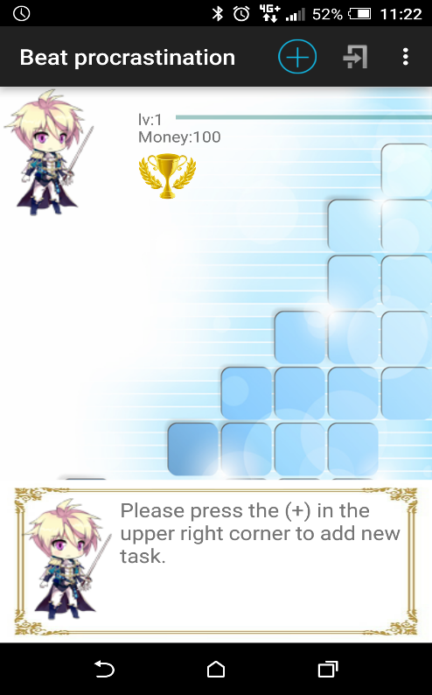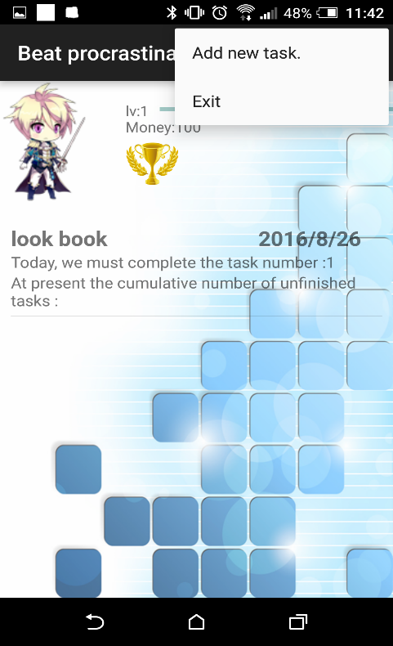
(a) App portal (b) Task management
Figure 2. App portal and task management
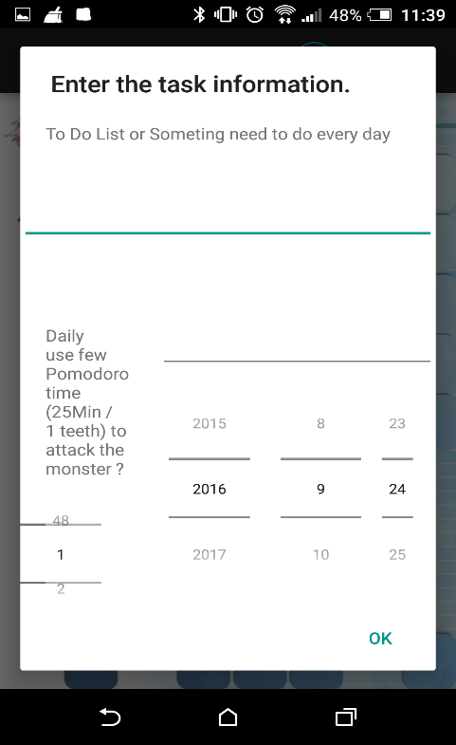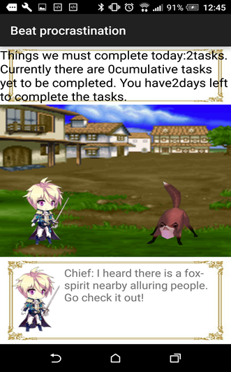
(a) Task information (b) Gamification task
Figure 3. Task information and gamification task

When the user decides to perform the task by clicking the task list, the user will be guided to the next page. The due dates will appear to remind the user finishing the task on time. The task will be separated into several small chunks of work time for the user to be able to finish the task little by little shown in Fig. 3(a). In addition, the task will be wrapped with a story narrative, which sugarcoats the original task goal. Fig. 3(b) converts the original task into gamification task such as guarding the village. Different types of the task can be predefined to different game assignments and corresponding rewards.
After the user commit to execute the task, the user can start working on the task and the system will move to the next phase shown in Fig. 4(a). The game instance will take over and the countdown of the task will appear on the top of the page. Moreover, the system triggers the locker to block the communications of the device to stop any distraction while working on the task. In this phase, game instance and countdown shapes the gaming goals again using figures or video to reduce the aversiveness of the task. Meanwhile, using system lock as other productivity tools can prevent the impulsive moves from unpredictable incoming distraction. Last but not least, in the bottom of this page, user can choose to leave the game anytime by clicking the button. The system keeps the important factor of voluntary participation and uses social awareness to encourage conscientiousness. Whether the users finish the task or decide to interrupt the task, the message will be posted to the social network as shown in fig. 4(b). Through revealing information on the social network, the system uses social interactions to create social awareness for the users.

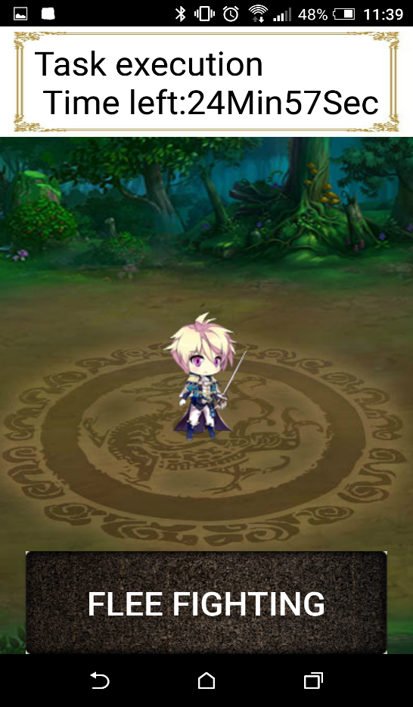
(a) Task execution (b) Social application
Figure 4. Task execution and social application

  - EXPERIMENT

The quantitative experiment is carried out to evaluate the effects for the proposed framework. The productivity tool app based on the proposed framework was demoed and tested by 81 users. After the test run, a technology acceptance model (TAM) questionnaire was conducted to validate the effectiveness of the system [17]. Table 1 shows the distribution of education for the testers. Most testers have degree of college or above. Other characteristics for testers were also observed such as gender, occupations, age, etc. For instance, 53% of testers are students. 61% of testers are male and up to 56% of testers are between 21 to 25 years old.
- Table Styles
Education | num | percentage
doctor | 1 | 1.2
master | 23 | 28.4
college | 49 | 60.5
high school | 5 | 6.2
junior high school | 3 | 3.7
total | 81 | 100.0

The TAM model is commonly used to evaluate how users come to accept and use a technology. Evaluating factors include: perceived usefulness, perceived ease of use, attitude toward using, and behavioral intension. The hypothesizes for this model are listed as follows:
H1: Perceived usefulness is positively related to attitude toward using for this game-based productivity framework.
H2: Perceived ease of use is positively related to attitude toward using for this game-based productivity framework.
H3: Perceived usefulness is positively related to perceived ease of use for this game-based productivity framework.
H4: Attitude toward using is positively related to intention to use for this game-based productivity framework.
H5: Perceived usefulness is positively related to intention to use for this game-based productivity framework.
Fig. 5. shows the results of significance test of hypothesizes. As shown, the perceived usefulness is significantly related to attitude toward using for this game-based productivity framework. It shows most users agree that the proposed game-based framework does provide useful features to avoid procrastination. However, the perceived usefulness is not significantly related to the intension of using the proposed framework. The qualitative research will follow to clarify the possible reason. The result also shows the perceived usefulness is significantly related to perceived ease of use for this game-based productivity framework. It shows the interfaces of game-based designs ease the use of productivity tools.
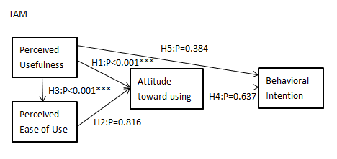
Figure 5. TAM model

  - CONCLUSION
Stopping or avoiding procrastination is always the challenge task even with the aids of information technology. This research targets procrastination factors: task aversiveness, time of reward and punishment, impulsiveness and conscientiousness to design a productivity tools based on procrastination theory. To address the issues, the system designed a game-based framework that combing gaming factors with procrastinating factors. A demo system, RPG Life was implemented to validate the proposed framework. The productivity app is introduced and tested by 81 users. Lastly, A TAM model is carried out and shown the effectiveness of the proposed work.
Some future works could be considered to extend this research. The mechanic of converting real world tasks to story goals could be refined. How to accurately monitor the user progress hasn’t been address in this study yet. In addition, the behavior changes of using the proposed framework could be discussed.

REFERENCES
[1] Dilmac, B., 2009. “An Analysis of Teachers’ General Tendency to Procrastinate, Perception of Professional Efficiency/Self Efficiency and Altruism”. Electronic Journal of Research in Educational Psychology. &(3), P. 1328.
[2] Morford, Z.H., 2008, “Procrastination and Goal-setting Behaviors in the College Population: an Exploratory Study”. Georgia Institute of Technology. P. 3.
[3] Hillary Rettig (2011), The 7 Secrets of the Prolific: The Definitive Guide to Overcoming Procrastination, Perfectionism, and Writer's Block
[4] Schraw, Gregory; Wadkins, Theresa; Olafson, Lori (2007). "Doing the things we do: A grounded theory of academic procrastination". Journal of Educational Psychology 99: 12.
[5] Lay, C. H. (1986). At last, my research article on procrastination. Journal of Research in Personality, 20(4), 474–495.
[6] Ferrari, J. R., Johnson, J. L., & McCown, W. G. (1995). Procrastination and task avoidance: Theory, research, and treatment. Springer.
[7] Chun Chu, A. H., & Choi, J. N. (2005). Rethinking procrastination: Positive effects of“ active” procrastination behavior on attitudes and performance. The Journal of Social Psychology, 145(3), 245–264.
[8] Choi, J. N., & Moran, S. V. (2009). Why not procrastinate? Development and validation of a new active procrastination scale. The Journal of Social Psychology, 149, 195-211.
[9] Corkin, D. M., Yu, S. L., & Lindt, D. F. (2011). Comparing active delay and procrastination from a self-regulated learning perspective. Learning and Individual Differences, 21, 602-606.
[10] Steel, P. (2007). The nature of procrastination: a meta-analytic and theoretical review of quintessential self-regulatory failure. Psychological Bulletin, 133(1), 65.
[11] Vogel, J.J., Vogel, D.S., Cannon-Bowers, J., Bowers, C.A., Muse, K. and Wright, M. (2006).‘Computer gaming and interactive simulations for learning: a meta-analysis’, Journal of Educational Computing Research, 34, 3, 229–243.
[12] Spires, H.A., Rowe, J.P., Mott, B.W., and Lester, J.C. (2011). ‘Problem solving and game-based learning: effects of middle grade students' hypothesis testing strategies on learning outcomes’, Journal of Educational Computing Research, 44, 4,453–472.
[13] Schaaf, R. (2012). ‘Does digital game-based learning improve student time-on-task behavior and engagement in comparison to alternative instructional strategies?’ Canadian Journal of Action Research, 13, 1, 50–64.
[14] Papastergiou, M. (2009). ‘Digital game-based Learning in high school Computer science education: impact on educational effectiveness and student motivation’, Computers and Education, 52, 1, 1–12.
[15] Werbach, K., & Hunter, D. (2012). For the win: How game thinking can revolutionize your business. Wharton Digital Press.
[16] McGonaigal, J. (2010). Gaming can Make a Better World. TED https://www.ted.com/talks/jane_mcgonigal_gaming_can_make_a_better_world, on March, 2016
[17] Davis, F. D. (1993). User acceptance of information technology: system characteristics, user perceptions and behavioral impacts. International Journal of Man-Machine Studies, 38(3), 475–487. http://doi.org/10.1006/imms.1993.1022

