A Dynamic Approach to the Cost Method in Real Estate Appraisal

**Abstract**

In this article, we presented a dynamic approach to the so-called cost method in real estate appraisal by simulating a project cash flow method and considering equivalent occurrence times instead of regular cash flows.

The presented methodology does not introduce any difficulty of application since it simplifies the establishing of cash flows with the introduction of the concept of equivalent time allowing the appraiser to obtain sustainable values based on the real estate market rates.

The goal is to address an easy to use more precise tool to find an appraisal value via the so-called Cost Method.

# Introduction

Several authors have cleared up the different real estate appraisal methods for providing a quantitative measure of the ownership of the real estate [1, 2]. All of them must follow the established International Standards principles [3, 4, 5] where the market value of an asset must reflect its highest and best use according to its potential and considered legality, and financial viability, independently of either is a new or the continuation of an asset’s existing use or still for some alternative use.

Of those, three the most used approaches or methods are the Comparative Approach or Market Method, the Profit Approach or Income Method and the Cost Approach sometimes denoted as the Cost Method, the latter is treated with some detail in the next section.

Where there is the possibility of making price comparisons – within a stabilized real estate market – the so-called comparative method is the most used. In this case, the appraisal infers a market value after a proper adjustment of comparable units to the one to be evaluated. This valuation approach is generally defined as the Comparative or Market Method.

If the number of sales is scarce, making it not feasible to determine a comparable value, the presumed market value depends on the potential of the cash flow that the property may create. That cash flow is determined by the average occupancy rate and income or production. Property is purely regarded as a unit of production, and it is the valuer's role to assess the economic rent for the property from first principles. In long term property investments with a considerable amount of periodical rents, the property/investment value is calculated by assessing the potential revenue to be expected each period, deducting the unavoidable costs to “run the business” and, by dividing the net operating income of the property by an appropriate factor, the capitalization rate return. This valuation approach is generally called as the Profit Approach or Income Method.

# Cost Method

The Cost Method (CM) allows establishing a property value considering an economic perspective of transformation or assets exploitation, to which are necessarily associated costs and benefits, leading to possible market value. It lies behind an approach where a real estate value is presumed taking for basis the cost of building a comparable property. The value of a property is equal to the cost of land plus the overall cost of construction, minus depreciation if applicable. Adding a profit margin to these costs, as a measure of the return on the investment determines the property value. The CM may yield a most likely value to establish a price when the property is new, and no comparison data is available for similar or equivalent real estate.

There are two forms of utilizing the CM, both based on a putative or actual cost project: (i) the reproduction method which considers that a new or a replica of a property is built utilizing the same original materials and, (ii) the replacement method that assumes that the new property has the same function but with modern construction materials and processes and an updated design as well.

In both forms, if comparable, either vacant land is not available, or similar building materials are unattainable, a less accurate cost value must be estimated for these items which may result in an unseemly real estate evaluation.

A straightforward way to assess the real estate value using the CM is to assign a specific unit cost (per sq.m) of construction in the property’s region, considering the quality or type of construction. For different types of building areas, e.g., offices, dwellings, commercial, and industrial, among others, those unit costs are available and easily obtained.

To obtain more precise building cost estimation for the construction cost, cost indexes, usually are available depending on the region and construction type and quality. If a rigorous analysis is imposed, design data and detailed drawings must be available so that contractors budgets can be obtained. To this so-called direct construction cost, it is necessary to add the value of the land, which in some locations or instances has a very significant weightiness and also other indirect costs, such as administrative cost, tax laws, and intermediation commission fee to estimate of the overall cost.

In estimating the presumed market value (PMV) of property, whether to be transformed or not, the real estate appraiser will “add” a profit margin to reflect the return obtained on the investment.

## Land Value and the Cost Method

The market value of the land can be obtained starting from a redeveloped form, using either the comparative method or the profit method and deducing from this gross development value all costs that are incurred in putting the property into the form that creates the market value. These costs include demolition costs, infrastructure works, construction costs, professional fees, tax laws, and the developer’s profit. By deducting these liabilities or charges from the final market value, the land value is the residual value, which represents the maximum capital expenditure for buying the land. This procedure is similar to the derivation of the net present value (NPV) of an investment if its cash flow can be established or can be regarded as the residual value of an investment. Both approaches are usually identified as the Residual Value appraisal method to assess the market value of land and buildings in their existing form or as part of a development project.

# Static Approach

In a static approach estimating a presumed market value (PMV) is based on all the cost to materialize the real estate and assuming a given "profit margin" disregarding time effects such as construction periods, deadline tasks, marketing, and sales timing as well as all other inherent activities associated with the value formation. This approach considers all values co-occure while ignoring the schedules related to the different stages of the investment process. The profit margin represents in a heuristic form the return on investment independently of time consumption necessary for the formation of the value.

The presumed market value (PMV) of real estate can be obtained using a square format cf. Expression .



Where:

 – Hard or direct costs referred to tangible assets needed to attain the complete construction;

– Soft or indirect costs typically associated with nontangible items of the construction costs;

– Profit margin.

Hard costs besides the cost of the land () include construction costs () and site and landscaping cost (), cf. Expression .



Construction costs are those required to complete the whole building or structure and may include site or infrastructure costs, e.g., all utilities including underground, aerial, water systems, drains, fire, paving, grading, etc. Landscaping works include all surrounding vegetation, lawns, trees, mulch, plants defined by the architectural project.

Soft costs are associated with nontangible items, such as architectural and engineering design fees (), administrative costs (A) and marketing fees, cf. Expression .



Examples of administrative costs are those related to the property transaction, required insurance costs, real estate costs associated with the legal process, inspection and project management fees, and local and State taxes. Marketing fees () may include other costs such as advertising and other marketing products, public relations, and general marketing campaigns.

Another simple format to establish a formula to compute the PMV of real estate using the CM is englobing land costs and design fees (L), construction, site, and landscaping costs (C, nontangible or immaterial costs (I), and the profit margin (P):



This last expression is more comprehensive and is better adjusted, in terms of time and sequence, with the real estate value or price formation: first the land and project, then the construction, and finally the revenue.

Indirect or soft cost may be assessed as a percentage of the PVM in the same manner that drawing fees are estimated as a percentage of the construction costs. Typical values for soft costs, including drawing fees, may vary between 20% and 30% [6]. The land value may also be estimated as a percentage of the PMV depending on several factors, such as public services proximity, solar orientation, etc. Typical values may vary between 10% and 50% [7]. Profit margin depends on the type of investment region and market circumstances. Average profit margins are difficult to ascertain, although data from previous transactions may indicate average values [8]. For example, in the U.S.A from 2006 to 2016, the average profit margin ranged from about 11% to 29% [9].

One typical form of determining a PMV taking as a basis the cost of construction is using Expression in the following format:



Where:

 percentage of the value of land (L) about the PMV;

 percentage of the indirect costs (I) about the PMV;

 the profit margin percentage of the PMV.

On the other hand, if a market value (PMV) for the real estate can be established using either the comparative method or the profit method, the land value (L) may be determined as follows:



# Dynamic Approach

Estimating profit margin by disregarding time consumption to complete all the tasks that reflect either the reproduction or the replacement forms of the cost approach is incoherent and also very difficult if a reasonably accurate estimation of the PMV of the real estate is expected. When the total cost for a project is estimated, it must be established on the basis that a program has been drawn up for the time performance of the work involved. Cost is unavoidably linked with carrying out the project in terms of a schedule or program. For instance, if the duration of a certain part of a project, tangible or not, changes, in most of the situations, the cost of realizing that part will also change. It is, therefore, inevitable to control the cost of carrying out a given task together with the time performance that is concomitantly linked.

In a dynamic approach, a cash flow of the project must be defined to take into account the time value of money. In other words, a scheme/program for the investment shall be defined throughout its cash flow, i.e., the inflows and the outflows, so that a discount rate can be applied.

The inflows are the land costs and design fees (L), the total construction costs , the nontangible costs (I), and the duration corresponding periods and deadlines as well. The outflow is the PMV to be determined and the selling deadline as well. The internal rate return or yield of the investment is easily defined. This procedure corresponds to a dynamic approach of the CM.

Project cost control and management in construction are disciplines that deal in detail with concepts of facility investment evaluation, including time preference for consumption, opportunity cost, an acceptable rate of return, cash flows over the planning horizon and profit measures [10, 11].

Economic evaluation methods such as the net present value method, the equivalent uniform annual value method, the benefit-cost ratio method, and the internal rate of return method, among others, may be applied to a specific project if adequate data and information are available. Each particular project requires less or deeper analysis depending on its economic importance. Particular and important projects demand specific analysis, and these may include different factors that affect cash flows, to name a few, depreciation and tax effects, price level changes, treatment of risk and uncertainty, methods of financing, public policies and the interaction between operational and financial planning.

When the cost method is used for real estate appraisal evaluation concerns the PMV, or the land value can be estimated using less sophisticated techniques.

## Discounted Cash Flow (DCF)

In a broad sense, when evaluating a real estate investment at a given “t=0” instant,­ the initial costs (inflows) are the land cost and land-related transaction costs together with design fees denoted by (L) in Expression . The following costs are the direct construction cost  that is concomitant with administrative construction-related costs, and marketing fees (A). Marketing fee costs may occur since the beginning of the construction until the assumed deadline for selling.

Discounted cash flow (DCF) analysis finds the present value of the expected future cash flows, in and out, using a discount rate. The present value of cash flow is used to evaluate a potential investment. In real estate appraisal, the present value of cash flow must be positive for a given or established discount rate. The discount rate accounts for the time value of money has to be broken down in two parcels: the risk-free rate plus a return on the risk they are taking. Depending on the purpose of the investment, there are different ways to find the appropriate discount rate.

In this context in a DCF analysis, the discount rate refers to the “interest rate” is used to assess the viability of a potential project via the net present value (NPV) of its cash flow. The NPV of a project must be positive to proceed with a given investment or project. This condition defines a limit for the value of a given asset.

The formula for the discounted cash flow of a project leading to its net present value analysis is:



Where:

 – net cash flow of investment project in a given period *i*;

*r* – discount rate;

*n* – total number of periods corresponding to the duration of an investment project.

## Equivalent occurrence time and duration

To get feasible results on applying Expression the duration of each period, *i,* must be small enough to capture the current worth of a future sum of money or stream of cash flow given a specified rate of return. In other terms, there must be enough number of periods, *i*. In real estate, the appraiser may easily estimate the overall costs of each parcel and its duration as well.

Given this, an equivalent occurrence time, , for the realization of a lump sum of values can be determined, assuming that its value is uniformly distributed in small parcels along a given period of duration.

Consider for example a series of 20 cash flows of 1000 monetary units (m.u.) each corresponding to a lump sum of 20.000 m.u. If a discount rate of 10% is assumed the present value of the cash flows is, according to the Expression equal to:



The occurrence time, , measured in the same period units of the cash flows, for their lump sum and a given discount rate, is given by:



In general terms, the equivalent instant of occurrence, , of an activity established as a series of uniformly distributed cash flows, with lump sum value V, starting at the time,  and deadline  may be derived by solving Equation considering Figure 1.

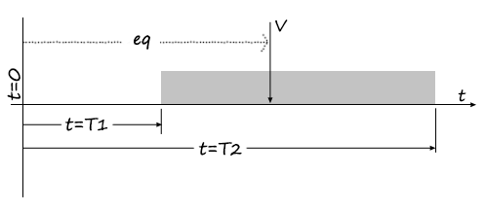

Figure 1– Equivalent occurrence time, eq, of activity with lump sum value, V



Solving Equation  is given by:



With:

;

;

r – discount or return rate;

V – Lump sum value of the cash flows taken as continuous;

 – Starting time of the series of cash flows;

– Deadline of the series of cash flows.

When  means that the activity starts at the beginning of a given scheduled project, than Expression results simplified. Substituting which is the duration of the activity its equivalent duration is defined as :



Table 1 gives the instant of occurrence of a lump sum value to continuous cash flow for different discount rates and activity duration periods. To obtain the equivalent occurrence time of an activity given the starting time and the equivalent duration merely add both values:



Table 1 - Instance of equivalent occurrence of an instantaneous value to a continuous cash flow

|  |  |  |  |  |  |  |  |  |  |  |
| --- | --- | --- | --- | --- | --- | --- | --- | --- | --- | --- |
| D. Rate | Activity duration period | | | | | | | | | |
|  | 2 | 3 | 4 | 5 | 6 | 7 | 8 | 9 | 10 |
| 1% | 0.50 | 1.00 | 1.50 | 1.99 | 2.49 | 2.99 | 3.48 | 3.97 | 4.47 | 4.96 |
| 3% | 0.50 | 1.00 | 1.49 | 1.98 | 2.47 | 2.96 | 3.44 | 3.92 | 4.40 | 4.88 |
| 5% | 0.50 | 0.99 | 1.48 | 1.97 | 2.45 | 2.93 | 3.40 | 3.87 | 4.34 | 4.80 |
| 7% | 0.50 | 0.99 | 1.47 | 1.95 | 2.43 | 2.90 | 3.36 | 3.82 | 4.27 | 4.72 |
| 9% | 0.50 | 0.99 | 1.47 | 1.94 | 2.41 | 2.87 | 3.32 | 3.77 | 4.21 | 4.64 |
| 11% | 0.50 | 0.98 | 1.46 | 1.93 | 2.39 | 2.84 | 3.29 | 3.72 | 4.15 | 4.57 |
| 13% | 0.49 | 0.98 | 1.45 | 1.92 | 2.37 | 2.82 | 3.25 | 3.68 | 4.09 | 4.50 |
| 15% | 0.49 | 0.98 | 1.45 | 1.91 | 2.36 | 2.79 | 3.22 | 3.63 | 4.03 | 4.43 |
| 17% | 0.49 | 0.97 | 1.44 | 1.90 | 2.34 | 2.77 | 3.18 | 3.59 | 3.98 | 4.36 |
| 19% | 0.49 | 0.97 | 1.43 | 1.88 | 2.32 | 2.74 | 3.15 | 3.54 | 3.92 | 4.29 |
| 21% | 0.49 | 0.97 | 1.43 | 1.87 | 2.30 | 2.72 | 3.12 | 3.50 | 3.87 | 4.23 |
| 23% | 0.49 | 0.97 | 1.42 | 1.86 | 2.29 | 2.69 | 3.08 | 3.46 | 3.82 | 4.17 |
| 25% | 0.49 | 0.96 | 1.42 | 1.85 | 2.27 | 2.67 | 3.05 | 3.42 | 3.77 | 4.11 |
| 27% | 0.49 | 0.96 | 1.41 | 1.84 | 2.25 | 2.65 | 3.02 | 3.38 | 3.72 | 4.05 |
| 29% | 0.49 | 0.96 | 1.40 | 1.83 | 2.24 | 2.63 | 2.99 | 3.34 | 3.68 | 3.99 |
| 31% | 0.49 | 0.96 | 1.40 | 1.82 | 2.22 | 2.60 | 2.96 | 3.31 | 3.63 | 3.94 |
| 33% | 0.49 | 0.95 | 1.39 | 1.81 | 2.21 | 2.58 | 2.94 | 3.27 | 3.59 | 3.88 |
| 35% | 0.49 | 0.95 | 1.39 | 1.80 | 2.19 | 2.56 | 2.91 | 3.23 | 3.54 | 3.83 |
| 37% | 0.49 | 0.95 | 1.38 | 1.79 | 2.18 | 2.54 | 2.88 | 3.20 | 3.50 | 3.78 |
| 39% | 0.49 | 0.95 | 1.38 | 1.78 | 2.16 | 2.52 | 2.86 | 3.17 | 3.46 | 3.73 |

# Establishing Cash flows

The PMV of real estate using a dynamic cost approach is determined in a similar way of the static approach as in Expression considering the time consumption for each activity of the project: land costs and design fees (L), construction, site, and landscaping costs C, nontangible or immaterial costs (I).

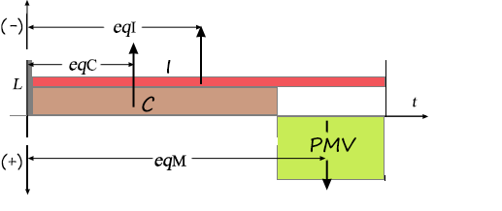

Figure 2 – Simplified Gant diagram for an Investment project

Referring to Figure 2 a simple Gantt chart is presented with the horizontal axis showing the period for all the duration of a real estate project broken down in the abovementioned 4 tasks. The Land costs are assumed to occur at t=0. The other items are considered to flow continuously. Their equivalent occurrence time is , and for the direct costs (C), indirect costs (I) and the income representing the presumed market value (PMV). More refined scheduling may be established for the diagram depending on the accurateness of the appraisal, for instance, the indirect costs can be split into real administrative costs and marketing fees, the former during the construction process and the later during the sales period.

Thus, the following expression can be written:



The expression may be used to determine the PMV (Expression or the Land value (L) (Expression ) if the PMV is known through any other method such as the Market or Profit method:





## Discount Rate

Expressions to consider implicitly that the discount rate, *r*, is the internal rate return for the real estate investment under appraisal. By this, the appraiser must be aware that as in all investments, a certain degree of forecasting and judgment has to be made under risk where the internal rate of return (IRR) represents the interest an investor would expect including the inherent risk premium.

The risk premium is commonly divided into three parts:

* the required risk premium representing the return over the risk-free rate that an investor must realize to justify the uncertainties;
* the historical Market Risk Premium (MRP) reflecting the historical difference between returns from the market over the Risk-Free Rate (RFF) on investments such as Treasury bonds;
* the Risk-Free Rate.

Over the last century, the historical market risk premium in the U.S.A. has averaged between 3.5% and 5.5% [12].

An example of an assumed risk-free rate is treasury bonds. In Figure 3 historical Treasury nominal rates for short maturity (3 months) and long maturity (5 years) of the U.S.A Treasury is presented from 2016 to 2019 [13].

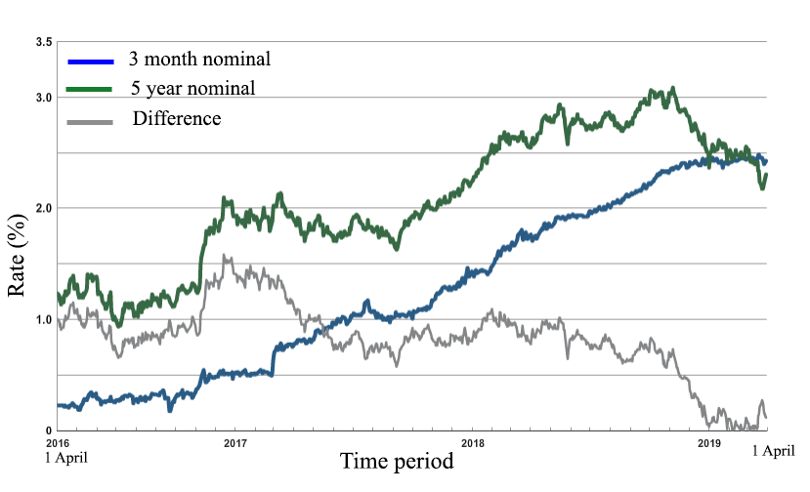

Figure 3 – Nominal Treasury Rates in U.S.A. bonds from 2016 April 01 to 2019 April 01

Studies made between 2010 and 2017 to calculate the required return to equity in different countries about Risk-Free Rate (RFR) and the Market Risk Premium MRP used in several countries exhibits values below 10% [14, 15]. An example of the results of one of these studies is plotted in Figure 4 to determine the discount rate used in 41 countries in 2015 [16].

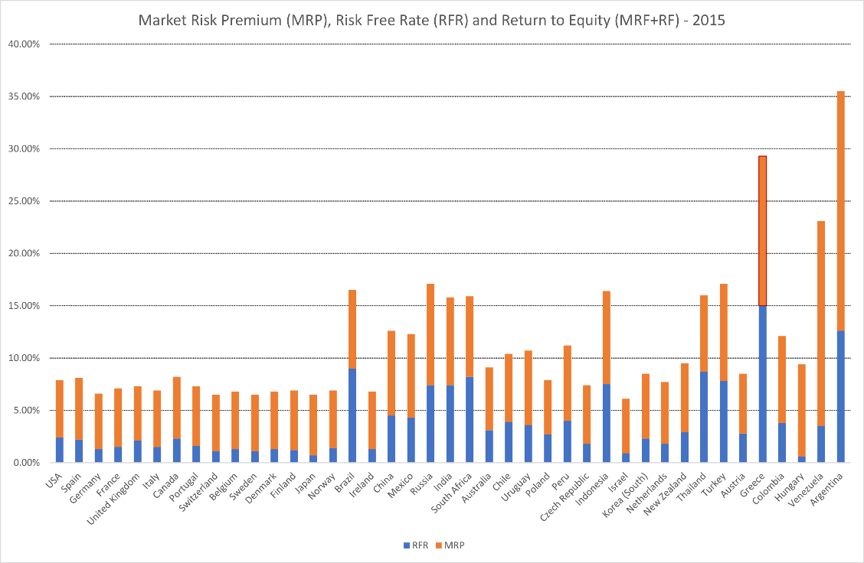

Figure 4 - Market Risk Premium (MRP)and Risk-Free Rate (RFR) used for 41 countries in 2015 [16]

It cannot be presumed that a given investment is regarded profitable if its IRR does not exceed the cost of capital by an agreed amount so that the risk of proceeding is seen to be within acceptable, viable parameters. For example average annual returns in long-term real estate investing in the U.S.A depending on the area of concentration in the sector running at around 10% to 12% [17]. Also, studies in the UK as in many other countries performed by developers and consultants give information about different expected returns [18] and also the relationship between the profit and interest allowances used in traditional residual appraisal models and the IRR that they seem to indicate [19].

# Application Example

A real estate investment is being considered by a landowner to develop a residential project. To estimate a marketing value (PMV) for the project the appraiser has to use a cost approach method.

Considering a Market Risk Premium MRP equal 4% and Risk-Free Rate equal to 3% the investor considers that an IRR of 10 %, compensates the inherent risk to justify some of the uncertainties of developing the project.

The completion of the project takes 48 months and a total cost of 1 010 000.00 Monetary Units (MU). Their value is depicted in Table 2. The expected scenario considers that purchase and sale begin immediately within 6 months of finishing construction.

Table 2 – Cost and duration for development and marketing period

|  |  |  |  |
| --- | --- | --- | --- |
| **Description** | **Cost (MU)** | **Activity duration** | |
| (Months) | (Years) |
| Land Cost | 250 000.00 | – |  |
| Design Fees | 30 000.00 | – |  |
| Construction and landscaping costs | 600 000.00 | 42 | 3.5 |
| Indirect Costs | 130 000.00 | 48 | 4.0 |
| Value | PMV? | 6 | 0.5 |

## Dynamic Approach

The equivalent occurrence time for each activity is defined according to Expression and

Table 3 – Cost and duration for development and marketing period

|  |  |  |  |
| --- | --- | --- | --- |
| Description | Equivalent occurrence time, at 10%  (years) | | |
|  |  |  |
| Land Cost | 0 | 0 | 0 |
| Design Fees | 0 | 0 | 0 |
| Construction and landscaping costs | 0 | 1.70 | 1.70 |
| Indirect Costs | 0 | 1.94 | 1.94 |
| Sales (PMV) | 3.5 | 0.25 | 3.75 |

the PMV is determined by means of Expression:



## Static Approach

In a static approach it is difficult, if not impossible, to know what profit margin to use.

The value of the investment cost (€ 1,010,000.00) and the PMV value of 1 284 240 MU includes the profit margin,  which determined from Expression:



Any other value used for the margin would lead to a different valuation value. In this case and with the values understudy one gets according to Expression the same value for the PMV:



## Residual Value

Consider, for example, that the project corresponds to a set of six houses with a market value of 250 000 MU each.

In this hypothesis, the value of the land can be estimated using the residual value method considering the same assumptions of the problem.

The application of the Expression would give a land value of 430 920 MU including design fees:



# Conclusions

The cost method commonly used in the valuation of real estate assets is based on the estimated presumed global value (costs and income) assuming a static margin of profit leading to values ​​that may deviate from the reality of the market.

The societal relevance of the paper could be explained by the gap filling in the scientific gap current related research that already has been published by other authors. The goal is to address an easy to use more precise tool to find an appraisal value when using the so-called Cost Method.

In this approach methodology, simulated cash flow is used considering equivalent occurrence times instead of uniform flows, keeping the operands of the equation problem as in the extensively used Cost Method.

An example of an application is presented in which was concluded that the estimation of the presumed value of the investment is easily and more trustingly achieved. On the other hand, it is found to be a very suitable method to appraise the land value with the so-called residual approach method.

The presented methodology does not introduce any difficulty of application since it simplifies the establishing of cash flows with the introduction of the concept of equivalent time allowing the appraiser to obtain sustainable values ​​based on the real estate market rates.

# References

|  |  |
| --- | --- |
| [1] | E. Pagourtzi, V. Assimakopoulos, T. Hatzichristos and N. French, "Real estate appraisal: a review of valuation methods," *Journal of Property Investment & Finance,* vol. 21, no. 4, pp. 384-401, 2003. |
| [2] | "Valuation Methods and Appraisals," Reality Mogul, [Online]. Available: https://www.realtymogul.com/knowledge-center/article/valuation-methods-and-appraisals. [Accessed March 2019]. |
| [3] | International Valuation Standards Council, "International Valuation Standards (Pre-publication Draft: IVS)," IVSC, London, 2017. |
| [4] | The European Group of Valuers’ Associations, European Valuation Standards - EVS, eighth edition ed., Bruxelles: TEGoVA, 2016, p. 378. |
| [5] | The Appraisal Foundation, "Uniform Standards of Professional Appraisal Practice (USPAP)," The Appraisal Foundation, Washington DC, 2019. |
| [6] | small business, "Breakdown of Soft Costs in Construction Projects," [Online]. Available: https://www.thebalancesmb.com/understanding-soft-costs-844542. [Accessed March 2019]. |
| [7] | R. d. S. Camposinhos, "Avaliação de terrenos," 23 10 2013. [Online]. Available: https://www.academia.edu/4863711/AVALIA%C3%87%C3%83O_DE_TERRENOS. [Accessed March 2019]. |
| [8] | B. Keythman, "How to Figure a Profit Margin With Sales & Rent Revenue," [Online]. Available: https://smallbusiness.chron.com/figure-profit-margin-sales-rent-revenue-33991.html. [Accessed March 2019]. |
| [9] | Property management Insider, "An Inside View on Real Estate Profit Margins," [Online]. Available: https://www.propertymanagementinsider.com/an-inside-view-on-real-estate-profit-margins. [Accessed March 2019]. |
| [10] | R. Pilcher, Project cost control in construction, Oxford: Blackwell Scientific Publications, 1994. |
| [11] | C. Hendrickson and T. Au, Project Management for Construction: Fundamental Concepts for Owners, Engineers, Architects and Builders, Pittsburgh, PA, First Edition originally printed by,, 1989 with co-author: Prentice Hall, 1989. |
| [12] | Investopedia, "What is the historical market risk premium?," [Online]. Available: https://www.investopedia.com/ask/answers/040715/what-historical-market-risk-premium.asp. [Accessed March 2019]. |
| [13] | U.S. Department of the Treasury, "Historical Treasury Rates," [Online]. Available: https://www.treasury.gov/resource-center/data-chart-center/interest-rates/Pages/Historic-LongTerm-Rate-Data-Visualization.aspx. [Accessed 04 April 2019]. |
| [14] | P. Fernandez, A. Ortiz and F. A. Isabel, "Market Risk Premium used in 71 countries in 2016," IESE Business School. University of Navarra, Navarra, Spain, 2016. |
| [15] | P. Fernandez, V. Pershin and I. Acín, "Fernandez, Pablo and Pershin, Vitaly and Fernández Acín, Isabel, Discount Rate (Risk-Free Rate and Market Risk Premium) Used for 41 Countries in 2017: A Survey (April 17, 2017)," IESE Business School, Navarra, Spain, 2017. |
| [16] | P. Fernandez, V. Pershin and I. Acín, "Discount Rate (Risk-Free Rate and Market Risk Premium)," IESE Business School, Navarra, Spain, 2015. |
| [17] | Investopedia, "The Average Annual Return for a Long Term Investment in the Real Estate Sector," [Online]. Available: https://www.investopedia.com/ask/answers/060415/what-average-annual-return-typical-long-term-investment-real-estate-sector.asp. [Accessed march 2019]. |
| [18] | C. Coleman, N. Crosby, P. McAllister and P. Wyatt, "Development appraisal in practice: some evidence from the planning system," *Journal of Property Research,* vol. 30, no. 2, pp. 144-165, 2013. |
| [19] | N. Crosby, S. Devaney and P. Wyatt, "The implied internal rate of return in conventional residual valuations of development," Henley Business School, University of Reading, Reading, U.K., 2017. |