Interplay and Implications on Urban Renewal When Two Laws are Implemented Simultaneously - An Agent-Based Model Simulation Analysis

Ju-Hung Yu and Bin-Tzong Chie

Abstract

This article focuses on the impact of the simultaneous implementation of the two laws on the implementation of urban renewal. In particular, in the case of a combination of two types of laws with different success rates, how can cases that adopt the general law account for a higher proportion of the total area of urban renewal and reconstruction? We refer to the agent-based model used in the development study of the City of Los Angeles by Acevedo et al (2003). However, to be more in line with the current situation, we further used data from the Geographic Information System (GIS) to replace the virtual grid. Taiwan is currently actively implementing the “Urban Renewal Act” and “Statute for Expediting Reconstruction of Urban Unsafe and Old Buildings.” Two laws and regulations are promoting urban renewal. We used the data from Daan District in Taipei City, which has a high proportion of implementation, for simulation. The research findings indicate that widening the gap between the two laws is essential to achieve the intended purpose of law enforcement, increasing the average completion area of all cases, and preventing direct conflicts between the regulations. Therefore, it is crucial for both laws to clearly outline their scope and implementation conditions.

Keywords: Urban Renewal, Agent-Based model, GIS, NetLogo

1. Introduction
Cities are aging, making urban renewal crucial for modern city development. This process involves considering various factors, including long construction periods, high capital needs, significant environmental changes, and substantial human and economic impacts. Urban renewal typically unfolds over an extended period, often driven by urban planning regulations in major cities. This entails executing renewal and renovation initiatives to revitalize old structures and regions.
The urban system is intricate, with impacts exceeding expectations. It encompasses housing, transportation, work, food, and living conditions, among others. These factors intertwine, complicating urban planning and revitalization efforts. Due to ever-evolving environmental conditions in cities, existing urban renewal laws frequently fall short of meeting current requirements. Consequently, when standard urban renewal laws prove inadequate or ineffective, authorities resort to crafting specialized legislation to address the issue.
Conflicts between general law and special law is often arise, affecting urban renewal planning. Special laws can remove limitations of general laws, leading to misconceptions about urban renewal goals. Incorrect perceptions may prioritize interests over urban development direction, neglecting the fundamentals of renewal.
In this paper, an agent-based model with GIS is applied to simulate the results of urban renewal implementation in two different scenarios within the urban development environment. The first scenario involves implementing a single urban renewal law, while the second scenario involves the simultaneous implementation of general and special urban renewal laws. By analyzing the simulation results of these scenarios, we aim to identify the key factors that require special attention when establishing urban renewal laws, particularly a special law.
The Taiwanese government is currently actively promoting urban renewal through a general decree and a 10-year period special decree for another to address related issues. These decrees include the “Urban Renewal Act” and the “Statute for Expediting Reconstruction of Urban Unsafe and Old Buildings.” Our focus is on Taipei, Taiwan, in alignment with our research.
Next section of this paper consists of a literature review that examines previous works on urban renewal, agent-based modeling, and the integration of NetLogo and GIS. Section three explains the utilization of Taipei City's zoning data as a model for establishing parameters and conducting experiments in alignment with Taiwan's existing urban renewal regulations. Section four delves into the discussion and depiction of the experimental outcomes. Finally, Section five provides a summary of the experimental findings, assesses the limitations of the study, and proposes potential future avenues for research.

2. Literature review
The process of urban development is like a complex system, and agent-based modeling is one of the potential methodologies for dealing with complex systems. In this case, we used an agent-based model to simulate urban renewal. This section first discusses the origins and problems of urban renewal, then introduces the literature on urban complex systems, and then introduces how to deal with urban complex systems through agent-based modeling. Finally, NetLogo with GIS is used to implement an effective agent-based model.

2.1 Origin and development of urban renewal
Between 1945 and 1950, after World War II, countries such as the United States, the United Kingdom, and Japan undertook major urban development projects to improve the quality of life for their people. In 1949, the U.S. government enacted the Housing Act to support this effort. By 1953, the Act had been amended to include the clearance and redevelopment of slum areas, leading to the emergence of urban renewal. This law authorized the government to acquire these dilapidated areas, renovate them, and then sell them to developers for urban revitalization, subsequently providing them to those in need. However, this strategy received criticism for potentially displacing low-income residents and favoring the wealthy, prompting widespread backlash at the time (Colean, 1954).
The two policies adopted in the Housing Act, public housing and urban renewal, are aimed at the elimination of slums and the revitalize neighborhoods. However, twenty-five years after implementation, many scholars have found that the scheme has actually had the opposite effect of its intended purpose (Hoffman, 2000).

2.2 Complex Urban Systems
With the aid of information technology, the concept of complex urban systems has seen significant advancements. Originating in the 1950s, urban systematization aligns well with general systems theory in biology, as it undergoes evolutionary changes akin to ecosystems. Bertalanffy (1969) affirmed that the general systems theory employs mathematical and logical structures to partition the environment into distinct elements, linking interactions among these elements to create systems. Early urban system theories were initially seen as monolithic systems, with their principles centered around the interaction of various elements like architecture and transportation. Because of the simplicity of the architecture, researchers often focus on how to control the urban system so that an equilibrium situation is achieved. Consequently, such research is often biased towards the application of economic activities.
According to Batty (2005), several characteristics of cities prevent what researchers call equilibrium, including the following:
Nonlinearity: The changes in urban systems are not linear, and the relationship between the outputs and inputs of each performance is not a simple ratio, but a more complex and nonlinear relationship.
Multi-level system: A city combines subsystems at different levels, such as buildings, roads, vehicles, etc. Each subsystem contains its elemental characteristics, and through the interaction between elements, it produces activities.
Non-equilibrium: The city is constantly in a state of change, such as the increase and decrease of population, the demolition, and expansion of buildings, the change of social activities, the development of commercial activities, etc., so the structure and behavior of the city are also constantly changing, and there is no fixed state.
Uncertainty: Urban system evolution is influenced by various uncertainties, such as economic, social, and political factors. The interactions and impacts of these factors and changes are frequently nonlinear and random, making the overall structure and behavior of urban systems uncertain and unpredictable.
To sum up, the city is an open system, composed of various elements and subsystems, and the subsystems overlap with each other, so the city is a dynamic system that is constantly in an unbalanced situation. Urban systems are not linear and are subject to constant turbulence and change. In such a situation, most cities cannot meet the expected planned development.
For these reasons, it seems more appropriate to use the concept of complex systems to deal with urban problems. In such systems, each element is usually referred to as an agent, and there will be interactions between agents as well. In complex systems, researchers are more concerned with the feedback of inter-agent activities. This level of development is to use the bottom-up method to construct a model of the city, and then generate a pattern of events and so on. In this way, unexpected emergence properties can be generated to help researchers think about various situations. In this type of study, real-time, unbalanced feedback can be generated to provide in-depth discussion among the researchers (Epstein, 1996).
Agent-based modeling (ABM) has the features of handling complex urban systems, and numerous studies employ ABM to simulate urban development. With the enhancement of computer processing power, the emphasis on reproducibility in experiments by ABM, and the scrutiny of experts and real data, the modeling approach has grown more refined and stringent in recent years, establishing ABM as a significant research method for complex systems (Grimm, 2010).
ABM is an alternative to conventional theories and models. In dynamic modeling, traditional approaches require validation against simulated data. However, agent-based models introduce randomness, leading to varying results and challenging validation. Consequently, numerous repeated simulations, including sampling, are essential for validation, utilizing the distribution of outcomes as a validation reference.

2.3 Combine NetLogo with GIS
This study utilizes the NetLogo, widely adopted in academia, in conjunction with a geographic information system as its modeling tool for selecting tools and materials.
Developed by Northwestern University, NetLogo is based on the Logo language programming concept. Under Professor Wilensky's leadership, the software has maintained its freedom and openness, providing good maintenance for the programming language. It also enhances compatibility with other platforms, supports parallel computing, and processes dynamic systems, making it an excellent research and development tool (Tisue & Wilensky, 2004).
Researchers utilize NetLogo to construct a simulated world by merging patches, creating agents (turtles), and running various programs and interactions. Acevedo et al. (2003) employed this approach to analyze the evolution of Los Angeles City from its inception. They utilized each grid to be two hundred meters square to generate a virtual map simulating the urban growth of Los Angeles spanning from 1907 to 1995. Nevertheless, since this is a simulation, ensuring its alignment with reality through effective sampling methods is a crucial aspect to consider. NetLogo offers numerous advanced features and libraries, such as integration with Geographic Information System (GIS).
The first real GIS in the world, developed jointly by the United States and Canada in the 1960s, primarily focused on researching and analyzing land, resources, population, and other related projects. With the rapid advancement of computerization, the use of GIS has become increasingly widespread.
GIS is a blend of automated information mapping, data processing, and spatial analysis technology. In GIS, a map is segmented into layers, each depicting different data types. This segregation prevents data from being muddled with information from other layers. The adoption of GIS by cities as their information processing solution has led to its technological advancement. Currently, most city-provided GIS includes urban map data, topology, land and property records, and spatial characteristics (Huxhold, 1991).
Many GIS archives contain vector drawing materials. When NetLogo is integrated with GIS, the simulation system can utilize the unit data and classification method directly from the GIS database, rather than relying on a grid-based approach. This allows for the importation of relevant data into the model, creating a simulation world that closely mirrors reality. By combining NetLogo with GIS data, the model can incorporate additional information and facilitate the design of visually enhanced effects in the simulation environment. This, in turn, aids researchers in observing and interpreting benchmarks more effectively (Walker & Johnson, 2019).

2.4 Taipei City, the subject of the study
Taiwan is situated in a high-risk earthquake zone, and many buildings older than 30 years fail to comply with current building safety standards. Consequently, ensuring building safety is a critical aspect of urban revitalization. To address the issue of outdated structures, government authorities have prioritized building reconstruction as a key policy measure. The Urban Renewal Act (UR_Act), enacted on 11 November 1998, offers substantial floor space incentives to incentivize building owners to undertake real estate maintenance and reconstruction for the public interest.
As of 2016, nearly 20 years have passed since the implementation of the MUR Ordinance. By that time, there were still only about 455 approved applications for urban renewal nationwide, including those from government units. The reason for such a delay is mainly due to the high compliance conditions of the subject matter and the problems that are prone to problems in preliminary planning and coordination. To this end, the government launched the "Statute for Expediting Reconstruction of Urban Unsafe and Old Buildings" (ER_Act) in mid-2017. The purpose of this special law is not only to strengthen the timeline UR_Act the unconstitutional amendment, but also to arouse the willingness of residents and builders to participate in urban renewal by promoting the redevelopment of dangerous old buildings. The ER_Act operates under a fixed implementation period, spanning from 2017 to 2027, with a total timeline of 10 years.
In dealing with the challenge of urban renewal integration, ER_Act is now seen as a superior option to UR_Act by residents and developers. One key advantage is the absence of size restrictions, along with the elimination of preliminary steps like public hearings or neighbor consultations, and a simplified review process. Consequently, numerous urban renewal applicants opt for ER_Act over better land consolidation and incentives to minimize development time and risk. Given this choice, large-scale urban renewal projects that were initially planned to be carried out in collaboration with neighboring areas are frequently abandoned in favor of smaller-scale alternatives.
In the aforementioned scenario, Taipei City emerges as a fitting focal point for this research. Taipei City has an urgent need for urban renewal, and the competent authorities hope to speed up the implementation of the UR_Act. However, due to the high restrictions on the subject matter, many cases are difficult to implement because the subject matter either does not meet the requirements or there are disputes between the households of the joint development, so they turn to a special law with short time to speed up or reduce the area of the base. As expected, many urban renewal cases have shifted to lex specialis.
However, when considering the parallel of the two laws, does it have a positive or negative impact on urban renewal? We aim to observe the functioning of this model.

3. Data and model construction
In order to comprehend the evolution process of contemporary cities. Acevedo et al. (2003) utilized the agent-based model by NetLogo to craft a research model for urban development in Los Angeles. We followed the same approach as NetLogo to build the model. To make the simulation more in line with present circumstances, we refer to the research method of Tisue & Wilensky (2004) and use GIS data as the foundation.

3.1 Introduction to the model
Regarding the choice of cities and materials, given Taiwan's active pursuit of urban renewal and the concurrent implementation of both the UR_Act and ER_Act, Taipei City represents over half of the urban renewal projects in Taiwan, thus we selected Taipei City as our simulation subject.
To better align with the actual urban structure and distinguish from the general urban model, we devised a new urban renewal model. The primary implementation involves three key stages: configuring the environment, creating new scenarios, and evaluating the outcomes. Following each iteration, the map undergoes a redrawal to enable real-time visualization of the data.
In the model, there are relevant executions and variables related to the UR_Act, and we use UR as the prefix letter. If there are relevant executions and variables about ER_Act, we use ER as the prefix letter.

3.2 Adoption of Data
During the model construction, urban geographic data is sourced from data published by relevant government authorities. The fundamental GIS data utilized in this research is the Taipei City Urban Planning Data released by the Taipei City Government on December 17, 2019.
The GIS data of Taipei City is divided by administrative district. There are a total of 12 administrative districts in Taipei City, and there are a total of 15,210 records in the GIS file of Taipei City Metropolitan Plan. Among them, each data represents an independent use of partitions, as shown in Figure 1, this is a comparison of the two, in which the number of use partitions in each administrative district can be as high as 1,000, but the distribution is not even, mainly because of the different characteristics of the land, so that the size of the area is different.

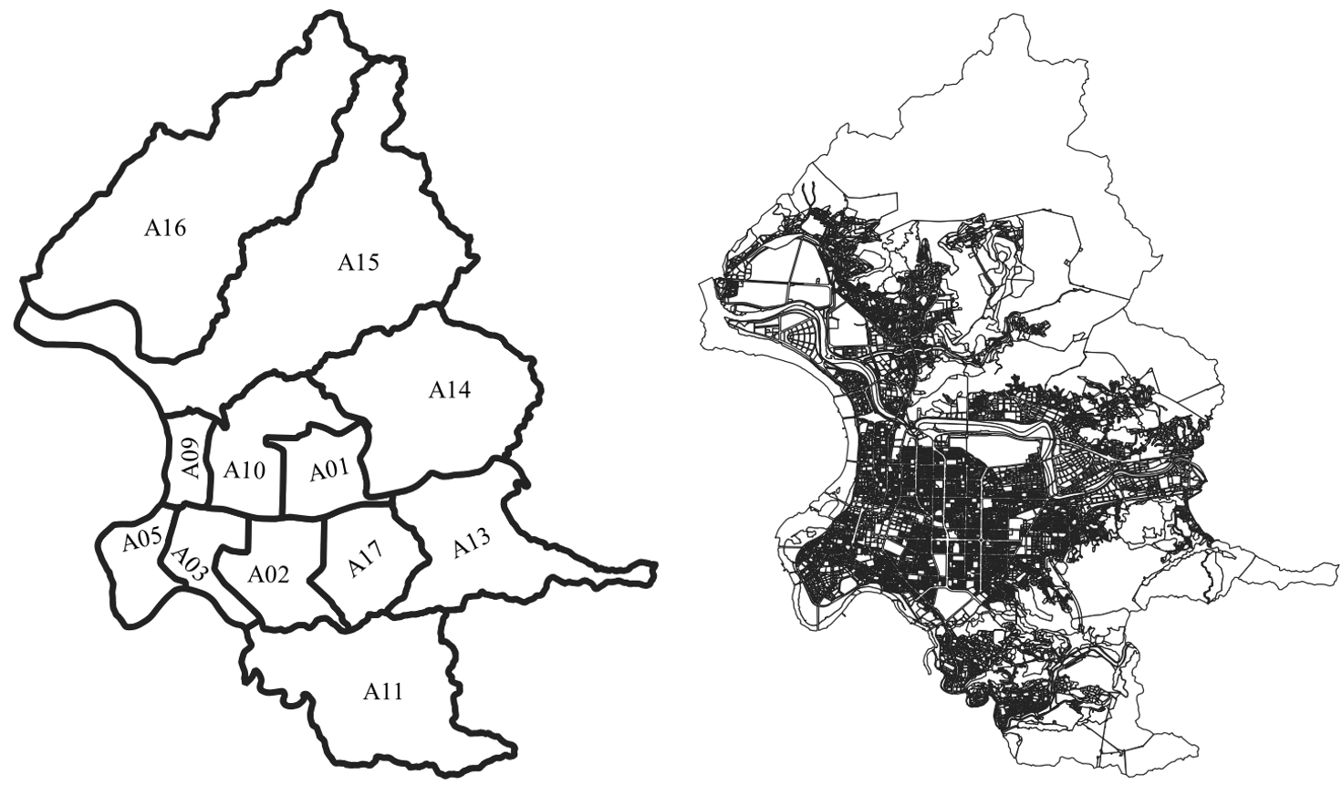
Fig 1 The Comparison between Taipei City Administrative District Map and Urban Plan (2019, December 17)

Different from the typical model-based processing, we utilize GIS in this urban plan for data processing. Each district serves as the simulation object, and data is transferred from the GIS file to create a comprehensive administrative district map world. In this microcosm, each partition functions as a patch, with varying sizes based on real-world conditions, thus aligning more closely with reality.

3.3 Model construction
In this model, each urban renewal case is a separate event. In this stand-alone case, we simulated the reality of the case from the owner's willingness to proceed with the case until the event was approved by the government within the time limit. Once it is approved by the government within the time limit, it is considered successful in the model. Approval within the set timeframe denotes success in the model. Failure is declared if success is not achieved within the allowable period.

3.3.1 Model Environment Settings

Table 1 Important variables at a glance
variable name | illustrate | Default value
p | Total Rounds of Simulation (Months) | 120
 | The number of zones that can be used for urban renewal | 1,479
 | A collection that qualifies for urban renewal and uses zoning
 | The size of each independent partition
 | The area that has been rebuilt
 | Area not yet redeveloped
 | Case collection using UR_Act
 | Case collection using ER_Act
 | Only implement UR_Act, and the degree of willingness to participate in urban renewal | 2, 3, 4, 5
 | UR_Act and ER_Act two regulations are implemented at the same time, and the degree of willingness to participate in urban renewal | 5
、 | Using UR_Act, the lower limit and upper limit of the operation month | 24, 60
、 | Using ER_Act, the lower limit and upper limit of the operation month | 6, 24
 | Only implement UR_Act, the success rate of each period | 0.5% , 1% , 1.5%
 | UR_Act and ER_Act two regulations are implemented at the same time, the success rate of each period | 2% , 4% , 6%
: < 500 m²  : < 1,000 m²  : < 2,000 m²  : > 2,000 | UR_Act and ER_Act are the times when two acts are executed at the same time. Within the scope of different regions, the probability of using UR_Act. | %  , 70%，90%  : 70%，90%,  0%

In this model, we utilize Taipei City’s historical urban renewal case application data to identify use zones suitable for urban renewal. The focus this time is on residential and commercial areas. An important restriction to consider is the floor area ratio, with a minimum limit set at 225% in this simulation. Given these criteria, we assign a variable, , to represent the filtered number. Subsequently, we establish a case collection, , for the filtered instances.

(1)

In the simulation interface created with NetLogo, each represents a grid (patch). The division is clearly visible on the interface.

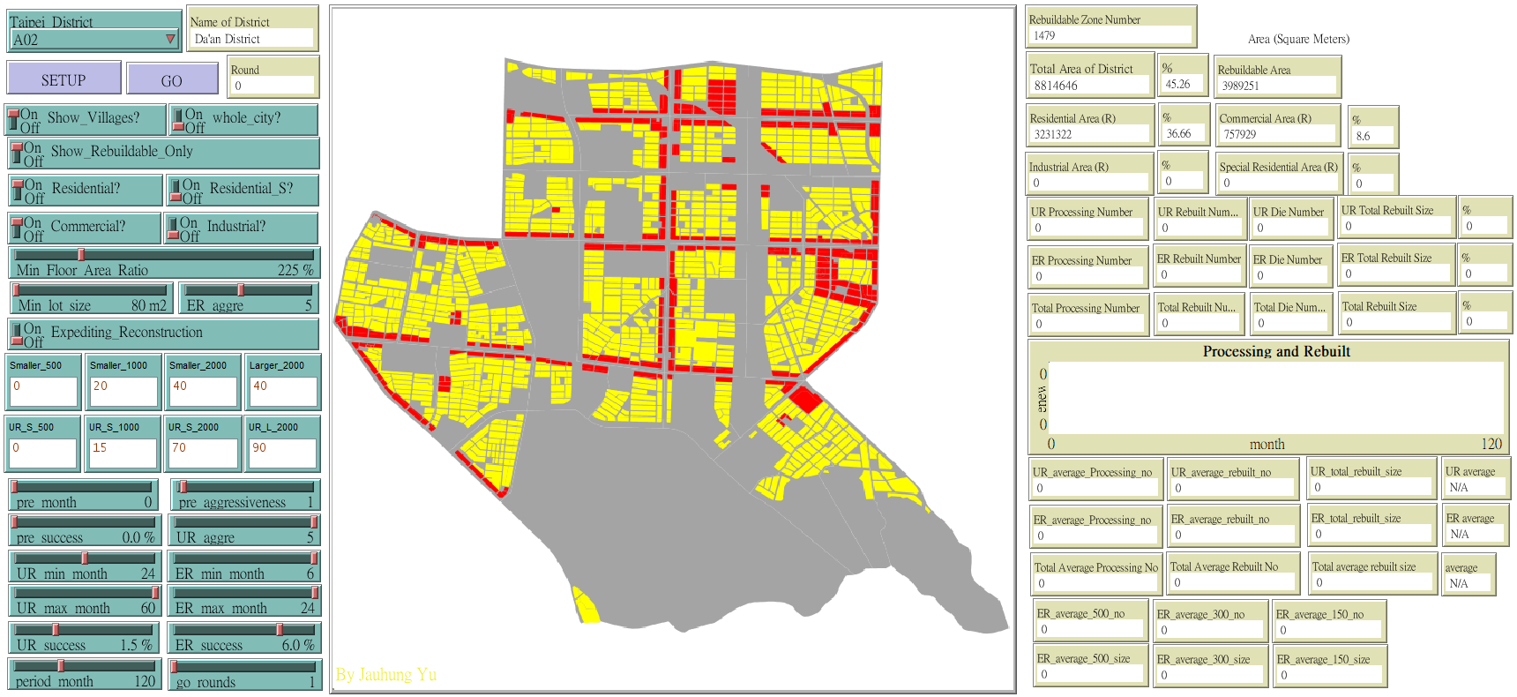
Fig 2 Using Netlogo Extended Library and GIS to Create User Operation Interface (A02, Da'an District, Taipei City)

In each case , along with items linked to the GIS database, additional items are also defined: - representing the zone's area, - urban renewal completed area , - pending urban renewal area respectively. This was used as an inspection site when the new urban renewal project was launched.
Different color settings are also set for each type of partition in this interface. During the implementation process, the color depth of the same use area is changed. It is worth noting that the usage area is larger than the proportion of the area occupied by the application case, and the colors of each type of usage area are different, with residential areas in yellow and commercial areas in red. As the proportion of urban renewal cases in the use area increases, the color becomes darker, and the color depth is calculated by .

3.3.2 Legal Description
We begin by creating two sets. The initial set employs UR_Act for case construction, named . The second set employs ER_Act for case construction, named . Below is an elucidation of the variances resulting from the utilization of these two statutes.
When the UR_Act was adopted, the size of the site and the application conditions were stringent, but the incentives provided by the government were also higher, and the maximum allowable floor area was 1.5 times that of the original law. In terms of the area limit of the base, the minimum required area varies according to the difference of each case, and most of them are more than 1000 square meters. The period between the initiation of the case and the approval of the government is also a long time. Generally speaking, it takes at least 2 years from the time the resident wishes to the time when the application is approved. When the operation period exceeds 5 years, it usually means that there is a dispute between residents or a problematic case, and the whole case may have to be replanned.
When utilizing ER_Act, restrictions are significantly eased. Primarily, the area limit is removed, allowing ER_Act for reconstruction as long as the area is under 500 m². Application cases with an area of less than 1,000 square meters also mostly adopt this law. Moreover, the review criteria are relatively lenient, typically resulting in a completion period of 6 to 24 months. Despite the high approval rate for applications, government incentives are lower. The maximum allowable floor area increase is capped at 1.3 times the original decree.

3.3.3 Urban renewal cases are generated
The main focus of this article is the implementation of urban renewal in the region under the implementation of two different laws. The first situation is that UR_Act is executed alone, and the second situation is that both UR_Act and ER_Act are executed in parallel at the same time. We delineate the attributes of these two execution conditions, each spanning a simulation period of p months.
When UR_Act is performed alone, we use to indicate the market's willingness to participate in urban renewal. In this case, the number of cases generated each month is .

) | (2)

When UR_Act and ER_Act regulations run concurrently, we utilize to show the market's willingness in urban renewal. With the expanded availability of ER_Act, the application process and complexity are lessened, without any area restrictions, and operation limitations are greatly reduced. Under such circumstances, due to the increase in cases with an area of less than 500 square meters, the number of cases every month is relatively high.

(3)

In the actual environment, each case applying for urban renewal is independent, and it is impossible to determine the probability area size of each case. Therefore, this model observes the base area size and percentage of urban renewal cases in Taipei City based on the data from 2017 to 2021, as the probability of occurrence of urban renewal case base area.
Therefore, when cases occur every month and UR_Act performs alone, the case area size will be randomly generated based on the past case status in Taipei City. Among the cases approved by UR_Act, 10% is less than 1000 m²; 45% is between 1000~2000 m²; 45% is greater than 2000 m². After completion, the information will be added to the collection.
If UR_Act and ER_Act are carried out simultaneously, based on past data from Taipei City, properties with an area less than 80 square meters are all considered exceptions. Hence, the distribution of area sizes in Taipei City's historical data is as follows: less than 500 square meters accounts for approximately 40%, 500 to 1,000 square meters for 20%, 1,000 to 2,000 square meters for another 20%, and over 2,000 square meters for the remaining 20%.
When both UR_Act and ER_Act regulations are simultaneously enforced, what is the utilization ratio of UR_Act? This pertains to historical data. All locations with a base area below 500 m² will adhere to ER_Act. For instances with a base area size ranging from 500 to 1000 m², 15% of users will utilize UR_Act; for area size between 1000 and 2000 m², the usage of UR_Act will be 70%; and for size exceeding 2000 m², the adoption rate of UR_Act will be 90%.
After the data is confirmed, the newly generated cases will be added to the collection of or depending on the usage laws.

3.3.4 Determine the success or failure of the case
Judging whether a case is successful or not is mainly based on two data, namely the success rate of the case in that month and whether the case operation time exceeds the upper limit of the required period. With UR_Act, we designate as the success rate variable; with ER_Act, we use . Every month, each piece of data in the urban update collection will be randomly judged based on the success rate to determine whether the case passes the review in this round. If it cannot pass, but does not exceed the upper limit of the operation period or , the case will be kept until the next month. If unsuccessful and exceeds the operation period limit, the case will be deleted.

3.4 Experimental design
First, in terms of the experimental design, we focus on a single administrative region as the simulation target. This is done to account for the unique characteristics of each administrative region. Each region may have varying levels of implementation due to their distinct characteristics. Therefore, it is more suitable to compare based on a single region rather than conducting assessments across different regions.
We choose to use A02 Daan District as the target, and the data is taken from Taipei City Urban Planning (2019, December 17). The conditions are set as the minimum floor area ratio must be above 225%, and the zoning category can only be residential or commercial. In A02, for those who meet the above conditions, 1,479 zones can be used for simulated reconstruction, and the total area that can be simulated for reconstruction is 3,989,251 square meters, which accounts for 45.26%.
Secondly, we set the simulation period to 120 months. This is because, as cities grow and develop, the impact of regulations will evolve over time, and regulations may undergo revisions. Thus, the earlier simulation approach is inadequate for evaluating long-term enforcement status. Consequently, considering the current scenario, we establish the UR_Act cycle as 24~60 months and the ER_Act cycle as 6~24 months.

3.4.1 Setting of the monthly success rate
The simulation of UR_Act and ER_Act under real circumstances depends not only on the production ratio but also on the difference in case success rates between the two regulations. In cases involving UR_Act, the success rate is relatively low due to the low number of applications and the diverse statuses of each case. Conversely, with ER_Act, where conditions are simple and no expert review is needed, the success rate is expected to be significantly higher. This study compares various combinations of monthly case success rates: 0.5%, 1%, and 1.5% for UR_Act, and 2%, 4%, and 6% for ER_Act.
To calculate the expected success rate of an individual case based on monthly approval rates, the formula can be outlined as follows: E represents the case's expected success rate, p denotes the monthly expected success rate, and n signifies the maximum number of months.
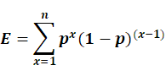 | (4)
From the above description, it is evident that implementing both UR_Act and ER_Act laws simultaneously results in a total of 9 combinations for the success rate of each case. UR_Act has a single option, with 3 choices available. As shown in Table 2:

Table 2 Monthly success rate combined
Enforcement | Monthly success rate | The maximum number of months that can be worked | Case success rate
UR_Act | 0.5% | 60 | 25.97%
UR_Act | 1.0% | 60 | 45.28%
UR_Act | 1.5% | 60 | 59.62%
ER_Act | 2.0% | 24 | 38.42%
ER_Act | 4.0% | 24 | 62.46%
ER_Act | 6.0% | 24 | 77.35%

3.4.2 Area allocation ratio
When the UR_Act and ER_Act regulations are implemented at the same time, changes in regulations and changes in the environment will affect the selection ratio. Therefore, we use the adoption ratio of UR_Act for evaluation. In different area ranges, if the usage ratio of UR_Act changes, will it have an impact on the overall urban renewal case? To do this, we created 3 additional combinations, as shown in the table below:

Table 3 Use the UR_Act ratio
Enforcement | <500 m² | 500~1000 m² | 1000~2000 m² | >2000 m²
UR_Act | 0% | 15% | 70% | 90%
UR_Act + ER_Act | 0% | 15% | 70% | 90%
UR_Act + ER_Act | 0% | 70% | 70% | 90%
UR_Act + ER_Act | 0% | 15% | 95% | 95%

3.4.3 Postivity
The number of urban update cases generated each month is randomly generated. The variable used is or . The randomly generated number is between 0 and the variables. Referring to past data, if UR_Act and ER_Act are executed at the same time. The variable represented is , which we set to 5.
However, if there is only a single enforcement UR_Act, it is more difficult to judge the case, so for the variables representing the positiveness, we set the range from 2 to 5, and the success rate of the cooperation is 0.5%, 1.0%, and 1.5%, with a total of 12 combinations. Each set of simulations performs 200 rounds.
But if UR_Act is executed alone, it will be difficult to determine the occurrence of the case. Therefore, for the variable representing " Postivity", we set it to 2, 3, 4, and 5. The success rates are set at 0.5%, 1.0% and 1.5%. There are 12 combinations in total. We simulated 200 rounds for each group.

3.4.4 Total number of experiments
The focus of the experiment is the comparison between two execution conditions, including the execution of UR_Act alone, and the simultaneous execution of both UR_Act and ER_Act. Combining the two parameters of success rate and area ratio, it can be seen that there are a total of 27 different sets of experiments. Each group performs 200 rounds.
Including the variations in “Postivity,” there are a total of 39 different combinations in this study. Each set of simulations runs for 200 rounds, generating a total of 8,800 experimental data points. The outcomes are then observed and assessed based on various combinations and attributes.

4. Experimental results
How to evaluate whether the implementation of urban renewal is good or bad, the evaluation criterion is not only the number of successful cases, but also the overall success of the application for approval. Observed items include the total area, the area ratio between UR_Act and ER_Act, and the average area of UR_Act. How the law needs to be designed to achieve the desired goal has become the focus of discussion.
We examine 37 sets of various parameter configurations, success rates, area ratio combinations, and enforcement laws in urban change scenarios. Our goal is to understand how UR_Act and ER_Act can mitigate conflicts between laws, boost the prevalence of UR_Act, and enhance regulatory harmony. The findings are categorized into four sections and illustrated across four tables.
In Table 4, simulations are performed with UR_Act executed alone. As there will be no difference in the legal constraints in the short to medium term, the average size of reconstruction cases will not be affected regardless of the success rate of approvals. However, the degree of positivity represents the degree to which the leading unit promotes urban renewal, and the success rate represents the strictness of the review unit's requirements for the case. Therefore, if the government vigorously promotes urban renewal, the success rate of approval will increase as the positivity increases, leading to an increase in the number of cases.

Table 4 The results of UR_Act simulation based on the combination of monthly approval success rate and positivity
Approval success rate | Postivity | Total number of completions | Average area (m²) | Total area completed (m²).
0.5% | 2 | 11.3 | 2,347 | 26,425
0.5% | 3 | 15.2 | 2,349 | 35,589
0.5% | 4 | 19.5 | 2,367 | 46,116
0.5% | 5 | 23.8 | 2,360 | 56,229
1.0% | 2 | 21.6 | 2,374 | 51,072
1.0% | 3 | 28.8 | 2,357 | 67,663
1.0% | 4 | 35.4 | 2,374 | 83,899
1.0% | 5 | 43.1 | 2,369 | 102,139
1.5% | 2 | 29.7 | 2,352 | 69,893
1.5% | 3 | 40.6 | 2,355 | 95,436
1.5% | 4 | 49.0 | 2,345 | 114,901
1.5% | 5 | 59.6 | 2,360 | 140,725

For the case where the two regulations UR_Act and ER_Act are executed at the same time. We made a few different choices. In type 1, we set the area ratio based on the current situation data and only make changes in the success rate of the case. The relevant data obtained from the simulation execution are shown in Table 5 below. We can note that the average areas of UR_Act and ER_Act will not change due to changes in the approval and success rates. But as the approval success rate increases. When the total number of cases completed increases, the proportion of the total completed area of UR_Act will increase significantly.
If you observe the execution status of the two methods, you can find that the completion area ratio is mainly affected by the success rate of UR_Act. As long as the success rate of UR_Act is low, the proportion of total completed area of all urban renewal projects will be low.

Table 5 Simulation results based on monthly success rate combination (dual regulations in parallel)
Approval success rate |  | Total number of completions |  | Average area (m²) |  | Total area completed (m²). |  |  | ratio
UR | ER | UR | ER | UR | ER | UR | ER | Total | UR
0.5% | 2.0% | 8.0 | 77.6 | 2,491 | 471 | 19,782 | 36,522 | 56,304 | 35.1%
0.5% | 4.0% | 8.7 | 133.2 | 2,428 | 471 | 20,955 | 62,763 | 83,718 | 25.0%
0.5% | 6.0% | 8.3 | 171.6 | 2,405 | 470 | 20,027 | 80,606 | 100,633 | 19.9%
1.0% | 2.0% | 16.0 | 78.0 | 2,334 | 473 | 36,349 | 40,005 | 76,355 | 47.6%
1.0% | 4.0% | 15.7 | 132.9 | 2,022 | 471 | 29,504 | 67,108 | 96,612 | 30.5%
1.0% | 6.0% | 15.8 | 173.3 | 1,943 | 471 | 28,211 | 82,472 | 110,683 | 25.5%
1.5% | 2.0% | 21.8 | 77.6 | 2,461 | 469 | 53,735 | 36,416 | 90,151 | 59.6%
1.5% | 4.0% | 21.7 | 132.0 | 2,452 | 473 | 53,130 | 62,468 | 115,597 | 46.0%
1.5% | 6.0% | 21.3 | 171.5 | 2,455 | 468 | 52,383 | 80,250 | 132,633 | 39.5%

In type 2, the impact of the use of the proportional method for the two ordinances in different areas is to understand the impact of the two ordinances in the UR_Act and the ER_Act ordinances at the same time. We try to increase the proportion of UR_Act used in a small area. The design method is to increase the proportion of UR_Act to 70% for cases with an area of 500~1000 square meters. Through the simulation results, it is found that under this adjustment, the total number of UR_Act completions increased slightly, but the average completed area decreased. In such a situation, even though the UR_Act area ratio increases, the average area completed decreases. For urban renewal, such a change is a bad outcome. As shown in Table 6:

Table 6 Pull up UR_Act ratio to 70% in area of 500 m² to 1000 m² (dual regulations in parallel)
Approval success rate |  | Total number of completions |  | Average area (m²) |  | Total area completed (m²). |  |  | Area ratio
UR | ER | UR | ER | UR | ER | UR | ER | Total | UR
0.5% | 2.0% | 13.8 | 64.5 | 1,776 | 414 | 24,544 | 26,756 | 51,300 | 47.8%
0.5% | 4.0% | 13.9 | 108.0 | 1,779 | 412 | 24,708 | 44,447 | 69,156 | 35.7%
0.5% | 6.0% | 13.6 | 142.5 | 1,807 | 418 | 24,606 | 59,657 | 84,263 | 29.2%
1.0% | 2.0% | 25.5 | 64.5 | 1,854 | 418 | 44,938 | 26,710 | 71,648 | 62.7%
1.0% | 4.0% | 25.9 | 110.4 | 1,852 | 419 | 44,514 | 45,865 | 90,379 | 49.3%
1.0% | 6.0% | 25.5 | 142.2 | 1,871 | 425 | 43,602 | 59,826 | 103,428 | 42.2%
1.5% | 2.0% | 35.6 | 64.1 | 1,800 | 416 | 64,043 | 26,610 | 90,653 | 70.6%
1.5% | 4.0% | 36.0 | 109.8 | 1,790 | 416 | 64,351 | 45,668 | 110,019 | 58.5%
1.5% | 6.0% | 35.5 | 140.8 | 1,793 | 413 | 63,458 | 58,235 | 121,693 | 52.1%

In type 3, the purpose is to understand what happens when the difference in proportions between two regulations increases significantly. To this end, we aim that When the two regulations UR_Act and ER_Act are implemented at the same time, the proportion of urban renewal cases using UR_Act to handle an area of less than 1,000 m² will remain unchanged, but the proportion using UR_Act to handle an area larger than 1,000 m² will be significantly increased to 95%. The information obtained is shown in Table 7. At this time, the total completed area will not be higher than that of UR_Act executed alone, but the benefits include that the total number of cases remains at a certain level, while the average completed area of UR_Act and its proportion increase.

Table 7 The difference between the restrictions of UR_Act and ER_Act has widened significantly (dual regulations in parallel)
Approval success rate |  | Total number of completions |  | Average completed area (m²) |  | Total area completed (m²). |  |  | Area ratio
UR | ER | UR | ER | UR | ER | UR | ER | Total | UR
0.5% | 2.0% | 9.0 | 73.0 | 2,615 | 393 | 23,516 | 28,700 | 52,216 | 45.0%
0.5% | 4.0% | 9.5 | 118.6 | 2,603 | 387 | 24,793 | 48,402 | 73,195 | 33.9%
0.5% | 6.0% | 9.2 | 154.4 | 2,595 | 388 | 23,799 | 63,148 | 86,947 | 27.4%
1.0% | 2.0% | 16.5 | 69.4 | 2,200 | 397 | 31,722 | 48,570 | 80,292 | 39.5%
1.0% | 4.0% | 17.3 | 118.8 | 2,748 | 403 | 44,205 | 49,296 | 93,501 | 47.3%
1.0% | 6.0% | 16.9 | 154.0 | 2,708 | 397 | 44,568 | 61,242 | 105,811 | 42.1%
1.5% | 2.0% | 24.1 | 68.6 | 2,614 | 389 | 62,901 | 28,585 | 91,486 | 68.8%
1.5% | 4.0% | 24.0 | 118.0 | 2,606 | 389 | 62,553 | 48,925 | 111,478 | 56.1%
1.5% | 6.0% | 23.6 | 153.1 | 2,598 | 390 | 61,365 | 62,653 | 124,018 | 49.5%

Based on the data provided, the total area of urban renewal completed by executing UR_Act alone is simply affected by the Positivity and success rate, whereas the average area remains relatively unaffected. However, if cases with a scope of less than 500 square meters can also apply, the two regulations UR_Act and ER_Act must be implemented at the same time. However, if we hope to promote large-scale urban renewal projects, the project area should be promoted as large as possible. Only in this way can urban renewal comply with the arrangements of the urban plan. Therefore, expanding the selection gap between UR_Act and ER_Act would be a beneficial decision.
To compare the results of three different conditions when the two regulations UR_Act and ER_Act are implemented at the same time, we take the proportion of the completed area of the case using UR_Act as a consideration, as shown in Figure 3. In comparison, if we want to increase the proportion of the completed area of cases that adopt the UR_Act Act for urban renewal, the best way is to maintain the success rate of cases that adopt the ER_Act under a certain limit, but those cases that adopt the UR_Act Act The success rate of cases should be improved.
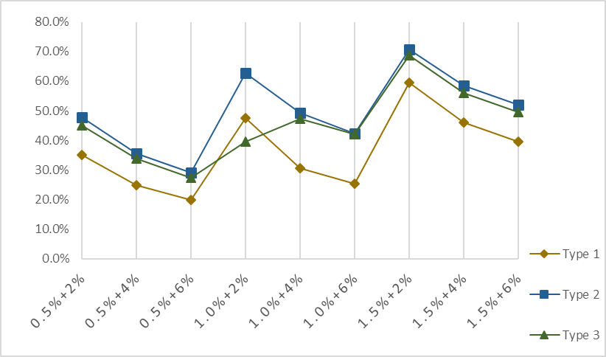
Fig 3 In 3 different situations, the proportion of the completed area of the UR_Act case is used

5. Discussion

5.1 Discussion

By simulating various parameters, this study conducted a total of 37 experiments. The experimental results were collected, and analyzed, and key points of interaction and observation between the two laws were obtained as follows:
1. The number of completed cases is based solely on the success rate and Positivity of the law itself. After selecting different legal provisions, the total number of completed cases will only be affected by the success rate of the selected legal provisions themselves, and the impact between the interactions is not high. If you want to change the law, it usually takes a long time to implement and consider, so it will not be affected by the other party. The Positivity of the households arranged by the government and the success rate of the law represent the only reasons for the success.
2. The difference in success rate will affect the area ratio of UR_Act and ER_Act.
In formulating long-term urban plans, the Government should aim to develop a large area as a whole and avoid the renewal of small buildings with a single detached as much as possible. This is because a small area of redevelopment can destroy the integrity of the overall usage zoning. When UR_Act the implementation of the law, for cases where UR_Act is adopted, the norms can be adjusted as much as possible to maximize the success rate, and more observations and restrictions should be made for cases where ER_Act is adopted.
3. Widening the gap between the two regulations would be a better option. If we want to increase the number of urban renewal cases on a large scale, the gap between the two laws will inevitably widen. The way to increase it is to make a clear choice of the area requirements between the two. Only UR_Act can be selected for large-area cases, and only ER_Act can be selected for small-area cases. In this way, there will be no conflict between the laws and regulations, and there will be no hesitation between the two options when the residents negotiate.
Taipei City is an example. The simultaneous implementation of the Taipei City UR_Act and ER_Act regulations has raised a series of problems because the two have similar goals, principles, and enforcement methods, which can lead to a conflict between the two choices.
Firstly, it is important to comprehend the fundamental principles and objectives of UR_Act and ER_Act. UR_Act typically seeks to enhance the urban environment, encourage urban renewal, optimize land use, and foster sustainable urban development. ER_Act primarily concentrates on refurbishing and upkeeping hazardous old structures to safeguard residents' safety. Despite both regulations being connected to urban development and enhancement, they differ in their focus and goals.
At present, there is overlap in the implementation of the two ordinances at the same time, and the main problem is that the permissible limits of the two laws are too close. In order to solve this problem, the easiest way is to revert to a single enforcement of the urban renewal ordinance, but at the same time, take into account the reasons why the current residents choose to ER_Act, and revise the content of the provisions. This ensures that urban renewal is planned and executed more consistently and in line with the urban plan.
Currently, there are overlapping issues in the simultaneous implementation of the two regulations. The main issue is that the allowable limits of the two laws are too close. To address this, the simplest solution is to revert to a single implementation of urban renewal regulations. However, given the high proportion of residents currently opting for the ER_Act, relevant regulations need to be adjusted to ensure consistency in urban renewal planning and execution.
Another approach is to avoid a direct conflict between the two regulations by widening the gap between the two regulations and setting clearer implementation scope and conditions for implementation. For example, in different area ranges, the applicable conditions can be made more explicit. It is also possible to adjust the restrictions of the regulations in different regional environments. By defining the scope of application more precisely, conflicts in implementation can be minimized, allowing for better cooperation between the regulations.
In addition, to enhance implementation efficiency, a dedicated coordination body can be established to oversee the unified planning and execution of urban renewal and the refurbishment of hazardous old structures. This entity can align the interests of all stakeholders and guarantee that the enforcement of the two regulations not only avoids conflicts but also complements each other to attain superior urban development outcomes.
To address the issue of enforcing two regulations simultaneously, whether by reinstating one regulation or increasing the gap between the two restrictions, it is essential to carefully separate cases during formulation and implementation. This will reduce overlap, ensuring smoother case selection and a more balanced implementation.

5.2 Research and development proposals
The key to completing urban renewal in urban planning is still determined by the government's legal planning. People's participation and success rate are crucial factors, mainly influenced by the restrictions on the law's content and the feasibility of enforcement. This is a topic that requires the government's special attention.
The decisive factors for the success of the case are mainly divided into two parts, one is the content and restrictions of the law, and the other is the cooperation of the residents. Regardless of the Act chosen, each case varies widely based on factors like size, location, and cost. Future research should focus on building trust among residents.
In addition, since Taipei City is an area with high building density, there is a substantial demand for redevelopment projects. For instance, in Taipei's Daan District, the current urban renewal eligibility spans almost 4 million square meters, while the estimated urban renewal area in 10 years will only be 100,000 square meters. According to the design and implementation of the current law, it is not possible to achieve the desired urban renewal goals. Consequently, exploring alternative approaches will emerge as a key area of future research.

References
- AcevedoL. Gaydos, J. Tilley, C. Mladinich, J. Buchanan, S. Blauer, K. Kruger and J. J. U. G. S. SchubertW.,. (2003). Urban land use change in the Las Vegas Valley. US Geological Survey, last modified Dec.
- BattyM. (2005). Network geography: Relations, interactions, scaling and spatial processes in GIS. Re-presenting GIS, 149-170.
- BattyM. (2009). Cities as Complex Systems: Scaling, Interaction, Networks, Dynamics and Urban Morphologies.
- Bertalanffyv.L. (1969). General system theory: Foundations, development, applications.
- ColeanL.Miles. (1954). Renewing Our Cities. American Political Science Review, 569.
- EpsteinM. & R. AxtellJ. (1996). Growing artificial societies: social science from the bottom up. Brookings Institution Press.
- GrimmU. Berger, D. L. DeAngelis, J. G. Polhill, J. Giske and S. F. J. E. m. RailsbackV.,. (2010). The ODD protocol: a review and first update.
- HoffmanVon. (2000). A study in contradictions: The origins and legacy of the Housing Act of 1949. Housing policy debate 11(2), 299-326.
- HuxholdE.W. (1991). An introduction to urban geopraphic information systems. OUP Catalogue.
- TisueS.U., & Wilensky, U. (2004). NetLogo: A Simple Environment for Modeling Complexity.
- Walker, B., Johnson, T. (2019,March). NetLogo and GIS: A Powerful Combination. CATA, 257-264.

Department of Industrial Economics, Tamkang University.
Department of Industrial Economics, Tamkang University.

