Agile MC Pricing Mechanism Model for Profit Maximization by
IOETL and OEE
PhD. Li-Hsing, Ho¹, Alang, Manglavan², PhD. Chung-Cheng, Fu³
^{1,2,3} Chung-Hua University, Department of Management,
Hsinchu 30012, Taiwan
ho@chu.edu.tw¹, alang44690@gmail.com², mark.c.fu@gmail.com³

Abstract
To align the production capability in order to increase marketing share and profit with financial resources, the marginal cost (MC) pricing mechanism is agile strategy using for businesses producing in small quantities and high diversity while facing market competition. Endogenous variables fusion can be adopted by using MC pricing to correspond to overall equipment effectiveness (OEE) under nomological network. This approach reflects the dynamic game in a timely independent variables manner based on activity-based integration to entire original inputs as follow as I/O, extract, transfer and load (IOETL). In practice, Workflow Management measures key indexes of throughput yield based on IOETL interface, the I/O must be essential raw data under OEE. the objective is to eliminate misaligned and static pricing problem. The correspondence of both MC and OEE deduced and verified in this paper, the model uses Lingo to calculate the quotient as the beta coefficient found by OEE dividing indexes of performance (P)* availability (A)* quality (Q). This realizes timely examination and alignment of cost variance under individual MC. One case study is employed to explain agile MC pricing strategy in industry.

Keywords: MC; IOETL; OEE; Beta coefficient
- Introduction
The Workflow Management needs well support of full-constructed data from the outset in front of standard operation procedure (SOP), it is so-called IOETL interface. The performance of OEE is worked by the adaptive gain of the activation function, the gain values change as adaptive for each node. Normally strategic alignment is an important issue for pricing architecture. The alignment concept may have many facets of OEE, it comprises indexes as P, A, and Q. These three indexes reconcile the MC in optimization of marginal revenue (MR). The OEE is a powerful metric used to improve the effective use of resources (Fast, 2018). When machines running at rated speed every time, the production capacity is well constant, the average cost (AC) curve of the economics of scale is higher than the MC curve (Hsu, 2013). This is the pricing mechanism of the average business in industry, as illustrated in Fig. 1 (Margetts, 2017). Usually, using the AC for price setting and using the fixed cost, variable cost, and price floor to determine the pricing mechanism result in distorted cost accuracy, leaving a gap in cost pricing, this does not well profit for businesses (Noreen, 1998). System effectiveness is often expressed as one or more figures of merit representing the extent to which the system is able to perform the intended function. If it happens however, to have an unscheduled downtime, this downtime must be at the very minimum. This is very important because as the unscheduled overtime increases, production decreases, as shown in Fig. 2 (Stamatis, 2019).
The OEE is the product of three indexes based on throughput yield mechanism, these indexes are also crucial factors for measuring businesses management. Lots of studies have discussed the relevant technical aspects and measurement methods between of throughput yield and OEE. However, few studies have discussed mathematical models of MC and OEE that can be used to calculate demanding beta coefficient. Using mathematical model of beta coefficient to update pricing mechanism of MC demonstrates the unique feature of a study, and the beta coefficient is the product of OEE dividing by P*A*Q after collection of quality, time, and speed available. Models are used established based on theories and experiment. This provides the manufacturing industry with an optimized beta coefficient competitive strategy for effective agile pricing mechanism.
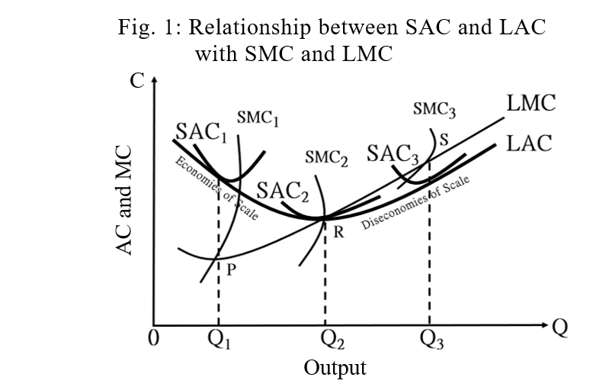
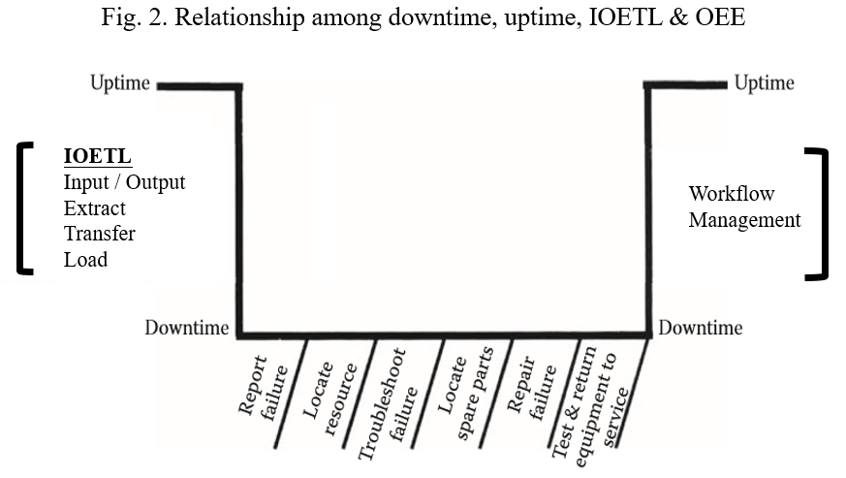
- Literature Review
A detailed statement of work (SOW) is the best way to address all three problems at outset of project under IOETL interface, such as lack of user input and incomplete requirements and specifications or changing requirements and specifications (Martin, 1998). When product capacity is constant, because of the law of diminishing marginal productivity, increased production capacity and time cause a shift in dynamic volatility. The SMC curve is lower than the average SAC curve; this characteristic has become the pricing mechanism of the average business (Hsu, 2013). If production capacity is increased, AC pricing is superior to marginal opportunity cost (MOC) pricing. This is because MOC pricing cannot be associated with a consumer surplus increase (Carter & Milon, 1992). Moreover, their cost structures should be distinguished. To ensure profitability under short-run costs, the fixed allocation rate must be reduced. Short-run AC pricing must respond to market needs to achieve the goals of consumer purchases and profit maximization (OIG, 2013). The goal of the MC pricing strategy is to achieve the lowest sellable price of a product, enabling businesses to survive during times of economic difficulty. Because sunk fixed costs are ignored, the MC pricing strategy enables businesses to theoretically operate without loss (Gramlich and Ray, 2015).
In a hybrid management environment with new and old equipment, businesses optimize their effectiveness in identification, measurement, and decision making to reduce their various losses. These losses include ineffectiveness, low equipment availability, and inconsistent quality. Technology can affect equipment functioning, but high OEE depends entirely on training and implementing (Irhirane et al., 2017). The essence of OEE, reliability, and maintainability is to establish system effectiveness. That means that a machine individually or as part of a subsystem or as a system must be operating as designed. If it happens however, to have an unscheduled downtime, this downtime must be at the very minimum. This is very important because as the unscheduled overtime increases, and production decreases (Stamatis, 2019). The capital-intensive manufacturing industry invests heavily in precision equipment. Continual investment and the production of different equipment types can be combined using a coherent procedure. The first priority is in operation efficiency. Market orientation is used to respond to the supply and demand relationship of precision computation. Supply chain relationship management is developed to respond to OEE.
According to total productivity management and lean maintenance, the space for potential efficiency improvement can be separated into spaces for addressing internal process loss and external market demands. The OEE had successfully implemented in industrial application which are accounting and finance, health and medicine, engineering and manufacturing, marketing and general applications. For example, reducing the amount of idle equipment, having equipment maintenance periods, and increasing the efficiency of mold upload and download can all contribute to profit maximization (Starr et al., 2010). Using OEE, manufacturing performance and production equipment can be managed and maintained to increase profitability. Specifically, OEE is determined in five steps: (1) production equipment check, (2) qualified operator check, (3) production process allocation and classification, (4) total productivity management and lean maintenance implementation, and (5) calculation of the efficiency rate, availability, and quality (Hansen, 2002). OEE should reflect the work efficiency, equipment speed, and quality of goods and hence be an indicator of operational performance, indicator of equipment availability, and standardization of quality judgement. Additionally, OEE should fit meet various needs but be standardized across different industries. This is the optimized decision-making tool for manufacturing (Dal et al., 2000).
In the classifying phase, To giving a consideration to businesses’ product quality and customer satisfaction, total quality management and quality function deployment (QFD) were developed in the United States and Japan, respectively. This prompted connection between engineering design, manufacturing, and customer service. The contributions being made by businesses are discovering the voices of customers, identifying the needs of related parties, and meeting those needs (Griffin and Hauser, 1991). Typically, the biggest reductions to utilization are due to set-ups and maintenance downtime. To reduce the impact of set-up times on machine throughput, you must measure and report the time spent on set-ups as a discrete measure for each machine. It can do the same for time spent on project managers. Maximum efficiency is usually defined as the production of maximum satisfaction through investment in each product. Data should be collected so that accounting can calculate the variance, positive and negative with the standard. In terms of education, the focus of efficiency is to reduce costs and improve learning outcomes (Sage & Burrello, 1994). Resource loading describes the condition of various resources required by the manufacturing process and personnel within a specific period. All businesses have limited resources, and production must be completed under this constraint, as must manufacturing scheduling. The work outcomes of manufacturing management must satisfy internal and external demands and the requirements of employees; additionally, dimensions such as quality, range, time, and cost must be balanced. Manufacturing planners and personnel must ensure that worksite satisfaction is high through resource allocation and resource leveling. It strongly recommends the use of the RTY (rolled throughput yield) as the much more accurate measure. Resource leveling is also referred to as resource smoothing and balances all the resources required during manufacturing (Ho et al., 2019).
Resource leveling heuristics is a type of network analysis method that determines scheduling by considering resource availability and manageability. The purpose of leveling manufacturing resources is to ensure that the resources required throughout manufacturing are relatively constant over time, thereby ensuring robustness in output on basis of resource availability and manageability. When resource over authorization or imbalance occurs, factors such as resource reconcilement and limitation can be considered; additionally, time extensions and communication flexibility can be used to conduct resource leveling and thereby provide the optimal manufacturing equipment and personnel utilization. Resource leveling methods include the float method and task division method. Time paths are usually longer than the original time path when resource leveling is applied (Gilbert, 2013).

- Model development
A mathematical model that improves demanding MC pricing is developed in this chapter. Especially, the right models must be launched to develop and improve key business architecture elements. The model includes the following quality index, performance index, and equipment availability index under OEE.
Quality criterion normally follow a rating range as external variables of three categories such as excellent (±1 sigma), good (±2 sigma) and loose (±3 sigma) as index as 0.68, 0.95 and 0.99. This emphasizes the importance of a quality index’s correspondence with the MC. Moreover, the personnel discipline performance is poor, its effect on the MC pricing is stronger. Finally, when equipment utilization index is essential to product effectiveness, understanding the adequate use condition of equipment is crucial. With changes in workmanship dynamics, the QFD responds entire quality criterion with excellent as index as 0.68 for matching up CRM. The personnel performance index, and equipment effectiveness index responds differently indexing. Similarly, the personnel performance index may be excellent, good, and loose in the first, medium-term, and third stages. Respectively, the equipment effectiveness index is the excellent, good, good in the first, second, and third stages. Detailed information is shown in Table 1.

Table 1 The beta coefficient model
Parameter |  | $$Experimental level$$
 |  | I | II | III
_{X1} | q_{1j} | Excellent | Excellent | Excellent
 | p_{1j} | p₁₁ | p₁₂ | p₁₃
 | a_{1j} | a₁₁ | a₁₂ | a₁₃
Parameter |  | Experimental level
 |  | I | II | III
$$x_{2}$$ | q_{2j} | Excellent | Excellent | Excellent
 | p_{2j} | p₂₁ | p₂₂ | p₂₃
 | a_{2j} | a₂₁ | a₂₂ | a₂₃
Parameter |  |  | Experimental level
 |  | I | II | III
$$x_{3}$$ | q_{3j} | Excellent | Excellent | Excellent
 | p_{3j} | p₃₁ | p₃₂ | p₃₃
 | a_{3j} | a₃₁ | a₃₂ | a₃₃
Where q_{ij} is the quality index of quality i at stage j; p_{ij} is the performance index of employee i at stage j; and a_{ij} is the performance index of equipment i at stage j. Production orders are separated into three batches—x1, x2, and x3—and each batch was separated into stages 1–3. The index of product OEE importance is determined using the quality indexes, operational performance indexes, and equipment availability indexes. The mutual contagion model of the three crucial OEE indexes corresponds to the ultimate key index of demanding beta coefficient. The quotient of beta coefficient derives from OEE = P*A*Q，when OEE = 1, then leveling at OEE = β* (P*A*Q), and then a substitution formula as β = OEE / P*A*Q. The objective of this study is to construct a mathematical model that includes all the aforementioned factors. A model for calculating the optimal beta coefficient can be constructed as
$Max T= \sum_{j=1}{\sum_{j=1}{\sum{qj pij}}}$
$$S.T. βi=T /\sum_{j=1}{Tij} i=1 …m$$
$$\sum_{i=1}^{ m}{βi}≤u$$
$$aij=f (pij)$$
$$0≤pij ≤vi$$
where T is the OEE; $T=1$; $βi$ is the corresponding index of SMC; and $u$ is upper limit of the corresponding index of SMC. The vi is upper limit of performance indexes.

- Case discussion
The effectiveness of the model proposed in this study is illustrated using a case study. The hypothetical production order of SMC can be separated into three stages. Additionally, a production order has three batches (x1–x3). The indexes and changing index for each production order in the three stages are displayed in Table 2.
The OEE of performance indexes for the three stages of a production order is calculated, as shown in Table 2. The performance and validity of the OEE changes according to the production order batch. In production order x1, the OEE is relatively high, lower, and even lower in the early, medium-term, and late stages, respectively. In production order x2, the OEE is relatively low, relatively high, and even higher in the early, medium-term, and late stages, respectively.

Table 2 Beta coefficient model for the case study
Parameter |  | $Experimental level$
 |  | I | II | III
$x$₁ | q_{1j} | Excellent (0.68) | Excellent (0.68) | Excellent (0.68)
 | p_{1j} | p₁₁ | p₁₂ | p₁₃
 | a_{1j} | a₁₁ | a₁₂ | a₁₃
_{Parameter} |  |  | Experimental level
 |  | I | II | III
$$x_{2}$$ | q_{2j} | Excellent (0.68) | Excellent (0.68) | Excellent (0.68)
 | p_{2j} | p₂₁ | p₂₂ | p₂₃
 | a_{2j} | a₂₁ | a₂₂ | a₂₃
Parameter |  |  | Experimental level
 |  | I | II | III
$$x_{3}$$ | q_{3j} | Excellent (0.68) | Excellent (0.68) | Excellent (0.68)
 | p_{3j} | p₃₁ | p₃₂ | p₃₃
 | a_{3j} | a₃₁ | a₃₂ | a₃₃
Finally, in production order x3, the OEE is low in the early stage and equally high in the medium-term and late stages. Numerical analysis of the OEE shows that the performance of x1 in the early stage is q11 = 0.68, medium-term stage is q12 = 0.68, and late stage is q13 = 0.68. The corresponding values for x2 are q21 = q22 = q23 = 0.68 and for x3 are q31 = q32 = q33 = 0.68. Following analysis of the aggregative index in Table 2, the parameters were set as T ₌ 1, u = 9, a_{ij} =p_{ij}²–p_{ij}+ index, q₁₁ = q₁₂ = q₁₃ = 0.68, q₂₁ = q₂₂ = q₂₃ = 0.68, q₃₁ = q₃₂ = q₃₃ = 0.68, obtaining the following overall model:
Max T/((T₁₁+T₁₂+T₁₃) + (T₂₁+T₂₂+T₂₃) + (T₃₁+T₃₂+T₃₃))
S.T. β₁= T/(T₁₁+T₁₂+T₁₃)
β₂= T/(T₂₁+T₂₂+T₂₃)
β₃= T/(T₃₁+T₃₂+T₃₃)

β₁+β₂+β₃<= 9;
q11 = 0.68;
q12 = 0.68;
q13 = 0.68;
q21 = 0.68;
q22 = 0.68;
q23 = 0.68;
q31 = 0.68;
q32 = 0.68;
q33 = 0.68;
0.9 < p11 <= 0.95;
0.85 < p12 <= 0.90;
0.8 < p13 <= 0.85;
0.8 < p21 <= 0.85;
0.8 < p22 <= 0.90;
0.9 < p23 <= 0.95;
0.8 < p31 <= 0.85;
0.85 < p32 <= 0.90;
0.85 < p33 <= 0.90;
a₁₁ = p_{11^2 –} p₁₁ + 0.90;
a₁₂ = p_{12^2 –} p₁₂ + 0.85;
a₁₃ = p_{13^2 –} p₁₃ + 0.80;
a₂₁ = p_{21^2 –} p₂₁ + 0.85;
a₂₂ = p_{22^2 –} p₂₂ + 0.85;
a₂₃ = p_{23^2 –} p₂₃ + 0.90;
a₃₁ = p_{31^2 –} p₃₁ + 0.80;
a₃₂ = p_{32^2 –} p₃₂ + 0.85;
a₃₃ = p_{33^2 –} p₃₃ + 0.90;
End
By using Lingo to seek solutions, the maximum beta coefficient of 8.06 is obtained. The quality index, performance index, effective index, and overall index at each stage are listed in Table 3. Because the beta coefficient (β) reflects the OEE changing index, these values indicate that process-based throughput yield of the first, second, and third batches were 1.27, 1.26, and 1.19. These final yields correspond to the MC costs in real operations.

Table 3 Beta coefficient model for case study
Parameter |  | $Experimental level$
 |  | I | II | III
$X$₁ | q_{1j} | 0.68 | 0.68 | 0.68
 | p_{1j} | 0.9 | 0.85 | 0.8
 | a_{1j} | 0.81 | 0.72 | 0.64
T1j |  | 0.50 | 0.42 | 0.35
β1 |  | 1.27
_{Parameter} |  |  | Experimental level
 |  | I | II | III
$$x_{2}$$ | q_{2j} | 0.68 | 0.68 | 0.68
 | p_{2j} | 0.8 | 0.8 | 0.9
 | a_{2j} | 0.69 | 0.69 | 0.81
T2j |  | 0.38 | 0.38 | 0.50
β2 |  | 1.26
Parameter |  |  | Experimental level
 |  | I | II | III
$$x$$ | q_{3j} | 0.68 | 0.68 | 0.68
 | p_{3j} | 0.8 | 0.85 | 0.85
 | a_{3j} | 0.64 | 0.72 | 0.72
T3j |  | 0.35 | 0.42 | 0.42
β3 |  | 1.19

Following explanation of production order separation batches from a practical perspective, the OEE of each batch indicates the indexes displayed in Fig. 3. T1j is 0.50, 0.42 and 0.35, and the cost factor of β1 = 1.27, higher than the set value for $100 of MC cost under OEE = 1. T2j is 0.38, 0.38, and 0.50, and the unit actual factor is β2 = 1.26, higher than the set value for $100 of MC cost under OEE = 1. T_{3j} is 0.35, 0.42, and 0.42, and the unit actual factor is β3 = 1.19, higher than the set value for $100 of MC cost under OEE = 1, as illustrated in Table 4. In practice, the cost pool is reconciled with the dynamics of manufacturing indexes, and a higher beta coefficient corresponds and monitors to a higher cost and greater deviation from fixed MC pricing.
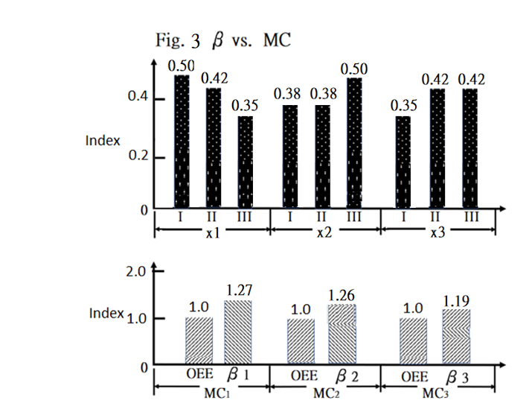
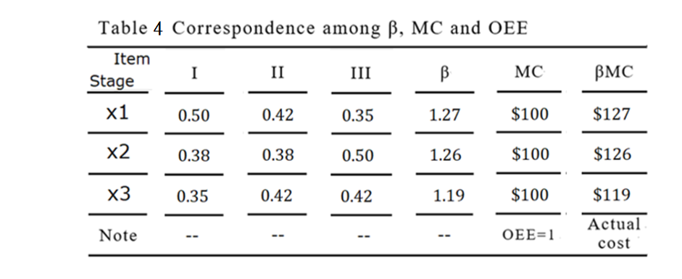

- Conclusion
Meanwhile in a perfectly competitive market, the fundamental reason for increasing the MC is the diminishing marginal product. The short-term balance condition for firms is MR equal to MC. Conditions of long-term balance in firms in a perfectly competitive market exist within short time periods. At this stage, the rate of production increase exceeds the rate of cost increase. Consequently, the MC decreases as production capacity increases. Although firms facing perfect competition can achieve balance, they cannot adjust production size and may experience losses to achieve short-term OEE balance when the production capacity is constant. When the scale is small and diversity of production is high, the production capacity of business equipment is not adequately used. The beta coefficient goes up due to poor data fusion at outset of SOW and IOETL interface in process-based as shown as the case study.
The OEE should be improved to enhance the quality index, performance index, and availability index. These three indexes reflect the losses incurred by defective goods, human training and machine idle time. The MC and IOETL interface correspond to beta coefficient under OEE, and the objective is to determine increases and decreases in the beta coefficient for individual production order in a timely manner. This prevents arbitrary allocation of illogical costs in the Q, P, and A. Simple calculation can apply for any metric definition for which there is varying industry accepted formulas, thereby obtaining profitable demanding MC pricing that correspond to the beta coefficient. Accordingly, business profit maximization can be optimized.

References
Carter, W. David, and J. Walter Milon. (1992). Marginal Oppotunity Cost vs. AC Pricing of Water Service: Timing Issues for Pricing Reform, https://pdfs.semanticschalar.org

Dal, Bulent, Phil Tugwell and Richard Greatbanks. (2000). Overall equipment effectiveness as a measure of operational improvement - A practical analysis. International Journal of Operations & Production Management. New Zealand.

Griffin, Abbie and John Hauser. (1991). The Voice of the Customer. John Wiley & Sons Ltd. U.S.A.

Gilbert, Kalila. (2013). PMBOK 5th Edition. Project Management Institute, Inc. U.S.A.

Gramlich, P. Jacob and Korok Ray. (2015). Reconciling Full-Cost and MC Pricing. Finance and Economics Discussion Series Divisions of Research & Statistics and Monetary Affairs Federal Reserve Board, Washington, D.C. U.S.A.

Hansen, Robert C. (2002). Overall equipment effectiveness: a powerful production/maintenance tool for increased profits. Industrial Press. NY. U.S.A.

Ho, Li-Hsing, Alang Manglavan and Chung-Cheng, Fu. (2019). Model for An Alert under Getting OEE into Old Shoes of Pricing Mechanism. International Journal of Research-Granthallayah Vol. 7, Issue 7, India

Hsu, Hwa. (2013). Natural monopolized pricing - either MCing or ACing. China Academic Journal Publishing House, China

Irhirane, Elhassan, Ahmed Bounit and Badr Dakkak. (2017). Estimate of Overall Equipment Effectiveness Objective from Classical OEE.
International Journal of Performability Engineering, Vol. 13, pp. 135-142. Totem Publisher, Inc., Texas 75024, U.S.A

Margetts, Steve. (2017). Short Run and Long Run. Revision Guru, www.revisionguru.co.uk

Martin, Michael G. (1998). Statement of Work: The Foundation for Delivering Successful Service Projects. PM Network, 12(10), 54-57. Project Management Institute, www.pmi.org

Noreen, W. Eric and Burgstahler. (1998). Full Cost Pricing and the Illusion of Satisficing. Journal of Management Accounting Research, Seattle, WA U.S.A.

OIG. (2013). Short-Run Costs and Postal Pricing, U.S. Postal Service Office of Inspector General, RARC-WP-13-004, U.S.A

Stamatis, D.H. (2019). The OEE primer: understanding overall equipment effectiveness, reliability, and maintainability. CRC Press, FL USA

Starr, Andrew, Farhad Anvari and Rodger Edwards. (2010). Evaluation of overall equipment effectiveness based on market. Journal of Quality in Maintenance Engineering, V. 16, issue 3. United Kingdom

Sage, Daniel D. and Leonard C. Burrello. (1994). Leadership in Educational Reform: An Administrator's Guide to Changes in Special Education. Paul H. Brookes Publishing Co. MD, U.S.A.

