Study of the profile regarding anthropometric measurements, education of parents, chronic non-communicable diseases with family history and life habits of university students from undergraduate courses
Antonia Dalla Pria Bankoff¹, Ieda Maria Gonçalves Pacce Bispo², Maicon Douglas Rodrigues³, Carlos Aparecido Zamai^{4.}
¹Departamento de Ciências do Esporte da Faculdade de Educação Física-Universidade Estadual de Campinas- SP-Brazil.
²Departamento de Enfermagem Universidade Federal de Mato Grosso do SUL- Campus de Três Lagoas-MS- Brazil.
³ Departamento de Enfermagem Universidade Federal de Mato Grosso do SUL- Campus de Três Lagoas-MS- Brazil.
⁴Departamento de Ciências do Esporte da Faculdade de Educação Física-Universidade Estadual de Campinas- SP-Brazil.
Corresponding author- Drª Antonia Dalla Pria Bankoff⁻ Departamento de Ciências do Esporte Faculdade de Educação Física-Universidade Estadual de Campinas- SP-Brazil- Tel.55-19-9-96259775. E-mail dallabankoff@bol.com.br; bankoff@fef.unicamp.br

Abstract
Using a questionnaire developed for the project, we assessed university students from different undergraduate courses of both genders, being 140 men in the age group of 23.6 years and 140 women in the age group of 22.5 years. The questionnaire prioritized questions relating to eating habits, level of inactivity, lifestyle, chronic non-communicable diseases and corporeality. The university students were invited to be part of the research at random and then we exposed and explained the questionnaire to them. At the same time, they signed an informed consent to participate. Height and weight measurements were taken on a digital scale, Filizola brand, with capacity of up to 150 Kg. Results: Regarding BMI, both genders are within the normal range. Regarding NCD-Family history, obesity, hypertension, cardiovascular diseases and diabetes had the highest percentage for male students; for females they were obesity, hypertension and diabetes. Consumption of red meat and alcohol was higher for males, physical inactivity was higher for females and the consumption of soft drinks was high for both genders. Conclusion: Considering the results obtained by the family history, physical inactivity and habits of life of the university students are strong candidates for early chronic non-communicable diseases.
Keywords: Habits of life. Chronic non-communicable diseases. Family history. Physical inactivity.

1.Introduction
In recent decades, a large number of evidence has emerged linking physical inactivity or lack of regular exercise practice to the emergence of various organic disorders. Inappropriate habits and lifestyles decisively contribute to the onset of chronic degenerative diseases that are often capable of compromising a better quality of life. Chronic degenerative diseases include, among others, cardiovascular diseases as high blood pressure and coronary heart diseases, as well as obesity and diabetes mellitus. Physical inactivity has become today one of the main health risk factors [1,2].
The population starts to have a lifestyle dominated by physical inactivity or lack of regular exercise practice, which is a habit of life that can often harm the health of individuals and contribute to the emergence of chronic non-communicable diseases, which are often the root cause of some important limitations and disabilities that impair their quality of life. Thus, physical inactivity and life habits become the main risk factors for health. In the Chinese culture, the binomial of physical activity and health has already been mentioned; however, only in recent decades experimental and clinical studies of better epidemiological approach have confirmed that low levels of physical activity are a crucial factor for the development of organic disorders [3,4,1]
The high rate of physical inactivity of the population points to the growing and current need for intervention programs that encourage the habit of physical activity. That is no different with university students, as they enter the university and gradually become sedentary and change their life habits. In addition to that, we have included behavioral changes at the expense of studies, the pressures from professors and new environments as items that make the university student vulnerable to early non-communicable chronic diseases [5].
According [5], Brazilian universities have responsibilities related to the quality of life of university students while they remain in the university and/or academic environment. They should provide programs that include good nutrition, programs for physical activity and health and/or physical exercises, programs for psychological support and spaces for the development of culture and leisure.
Of the nutritional diseases, obesity has increased not only in rich countries but also in developing countries. An entire system of inadequate lifestyle probably favors this type of pathology, being it: physical inactivity, inadequate family eating habits, excess food, excess carbohydrates in the diet, meals not done on the proper time, snacks with excess fat and consumption of candy, which have led obesity to high levels [6,7,8].
The main aspects related to a positive energy balance have been the change in food consumption with increased energy supply by the diet and reduced physical activity, setting up what might be called as the Western contemporary lifestyle that, in Brazil, refers to nutritional transition (characterized by the reduction of the prevalence of child malnutrition and the increase in obesity in children and adolescents), regarding the secular changes in nutritional standards and thus resulting in changes in the structure of the diet of individuals correlated with the economic, social and demographic changes and those related to health [9,10].
Obesity in Brazil is being treated as a public health problem, and its prevalence has never been at such epidemic degree as today. Among the nutritional aggravations, malnutrition was a problem in the developing world and obesity a problem in developed countries. Today this rule is not valid since countries do not fall in this homogeneous unit anymore, either for the incidence of malnutrition or obesity[11]. In the university environment, the problems of obesity and other chronic non-communicable diseases arise early and on a scale without limits making them a population of sedentary individuals [12].
[13,14,15,16] Comment that considerable changes are happening in relation to postural habits, eating and lifestyle of individuals as they spend several hours in passive activities as watching TV and videos, being in front of the computer, doing administrative activities in offices and clinics and others, besides the locomotion in the large centers, which translates into minimum energy spending, opposed to the daily dietary intake.
[17] Have studied the cardiovascular risk factors and excess adiposity in American overweight children and adolescents and found 94% with excess adiposity, representing more than two million children affected by this extreme type of obesity, with predisposition of being obese adults. These authors have also quantified the cardiovascular and metabolic risk factors (including dyslipidemia, hypertension and hyperinsulinemia) in higher percentiles of BMI. There is strong evidence that dietary habits and lifestyle during adolescence are risk factors related to chronic non-communicable diseases in adulthood [18].
[19] Have studied in Iran 14,880 students aged 6-18 years, between 2011 and 2012, selected by conglomerates of thirty provinces. Weight, height, waist circumference (WC), hip circumference (HC), waist-hip ratio (WHR), waist-height ration (WHeR), as well as the systolic and diastolic blood pressure (SBP and DBP) were measured. The results showed that consumption of candy was significantly associated with anthropometric indices and BP levels. In addition, there was a significant association between the consumption of fast food and BP levels and anthropometric indices (except WHeR and WHR). The consumption of sugary drinks was significantly associated with anthropometric indices, but the consumption of salty snacks was significantly associated with stature, HC and WHR. The risk of general obesity (OR: 0.75, CI of 95%: 0.65-0.87) and abdominal obesity (OR: 0.81, CI of 95%: 0.72-0.92) among participants who rarely ate candy was smaller than among those who consumed it daily. The risk of general obesity (OR: 0.85, CI of 95%: 0.74-0.97) among students who rarely consumed sugary drinks was smaller than among the individuals that consumed them daily.
The prevalence of obesity is increasing worldwide and general and abdominal obesities are the main problem of the public and social health [20]. The most important consequences of obesity include type 2 diabetes, hypertension, hyperlipidemia, coronary diseases, ischemic cerebrovascular accident, certain types of cancer, osteoarthritis, kidney diseases and sleep disorders. Some of these complications are related to metabolic abnormality associated with obesity and others are directly related to obesity.
[21]Report that changes in body weight status from adolescence to adulthood can be associated with different social and vocational factors and the economic and educational results that can differ by gender. Moreover, through research, they have shown differences in the results by gender for different changes in body weight status in the transition to adulthood. The same authors report that the transition from adolescence to adulthood is also marked by many important development factors, such as leaving home, finishing university, getting married, becoming a parent and starting a professional career. Weight maintenance or weight gain during this critical period of development can be associated with different results.
A recent study on obesity in Arabian adolescents has shown that approximately 20% of school children aged 15-18 in Damascus were overweight and 6% were obese [22]. High consumption of fast food is a major risk factor for obesity. The study showed that only 14% of the adolescents consumed fast food more than four times a week. This is almost half the number reported in Bahrain and Saudi Arabia. Researchers are concerned about the low intake of fruits and vegetables and the high consumption of fast food and other junk foods and their early relationships with chronic non-communicable diseases in children, adolescents and university students. [23] Describe their concern of how an inadequate intake of these foods may not protect against certain chronic diseases, including obesity, cardiovascular disease and some cancers.
Chronic non-communicable diseases (NCD) currently are the ones that cause the most deaths in Brazil and worldwide. Every human being is subject to the daily routines of life, regardless of age and socioeconomic status. It is within our home and within the family that we learn our daily habits of life, which accompany us. As for college students, when they enter, most of them become sedentary, and also because of the circumstances they acquire not very healthy eating habits, making them more vulnerable to chronic noncommunicable diseases early [24].
The aim of this study was thus to study the eating habits, prevalence of overweight, obesity, level of inactivity, blood pressure, family chronic non-communicable diseases among university students of both genders with prospects for changes in lifestyle.

2.Methodological description of the study
Target population: University students of both genders.
2.1 Development of the Research
Using a questionnaire developed for the project, we assessed university students of both genders, being 140 men in the age group of 23.6 years, with standard deviation of 4.591, and 140 women in the age group of 22.5 years, with standard deviation of 4.007. The questionnaire prioritized questions relating to eating habits, level of inactivity, lifestyle, chronic non-communicable diseases and corporeality.
2.2 Data acquisition
The university students were invited to be part of the research at random and then we exposed and explained the questionnaire to them. At the same time, they signed an informed consent to participate. Height and weight measurements were taken on a digital scale, Filizola brand, with capacity of up to 150 Kg.
3.Results

Table 1 - Data distribution of mean values and standard deviation of the variables: age, weight and height of female (140) and male (140) university students.
Female | Mean | Standard Deviation
Age | 22.5 | 4.007
Weight | 68.69 | 14.333
Height | 1.64 | 6.187
BMI | 25.54 | 5.482
Male
Age | 23.64 | 4.591
Weight | 80.61 | 13.885
Height | 1.76 | 0.074
BMI | 26.02 | 5.823
Table 2 - Percentage of NCD-family history and life habits - 140 male students
Variables Percentages
Obesity 56.12%
Hypertension 48.34%
Diabetes 43.79%
Cardiovascular Diseases 45.26%
Consumption of Red Meat 96.83%
Consumption of Alcoholic Beverages 97.24%
Physical Inactivity 67.71%
Consumption of Soft Drinks 92.37%

Table 3- Percentage of NCD-family history and life habits - 140 female students
Variables Percentages
Obesity 67.85%
Hypertension 62.14%
Diabetes 54.28%
Cardiovascular Diseases 24.38%
Consumption of Red Meat 98.12%
Consumption of Alcoholic Beverages 84.43%
Physical Inactivity 97.67%
Consumption of Soft Drinks 92.47%

Table 4 - Statement of the statistical analysis for the male (N = 140) and female groups (N = 140) related to the variables NCD-family history and life habits.
MALE | FEMALE
Contingency Table = 2 x 8 | Contingency Table = 2 x 8
Chi-square = 33.4591 | Chi-square = 42.6321
Contingency Coefficient C = 0.1556 | Contingency Coefficient C = 0.1730
Degrees of freedom = 7 | Degrees of freedom = 7
(p) = < 0.0001 | (p) = < 0.0001
For statistical analysis, we used the program BioStat 5.3. We applied the correlation test using the Contingency Coefficient C as stated in Table 3. For statistical analysis, we consider for column 1 the value of 100%, and for column 2 the actual values found in the research and we obtained significant results for both groups with p = < 0.0001. With these results, the research participants considering the family history are strong candidates for chronic non-communicable diseases and also because of the sedentary lifestyle and excessive consumption of soft drinks.
Below we will present the charts in the form of superposed column in which the orange color represents the female and the dark blue represents the male students.

Chart 1:
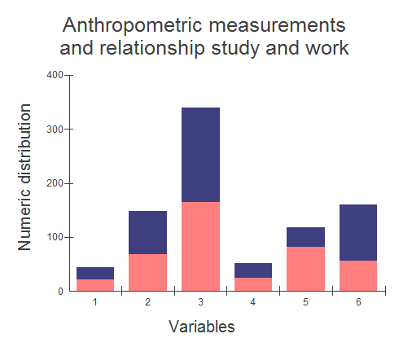
Variables: 1- age; 2- weight; 3- height; 4- BMI; 5- only study; 6- study and work.
Assessment of chart 1 - In relation to the anthropometric measurements of the males in relation to age, the mean is greater, that is, they are older than the females. Men weigh more than women and are also higher. Regarding BMI, both genders are within the normal range. For the relationship of work and study, the number of women who just study is greater and the number of women who study and work is smaller.

Chart 2.
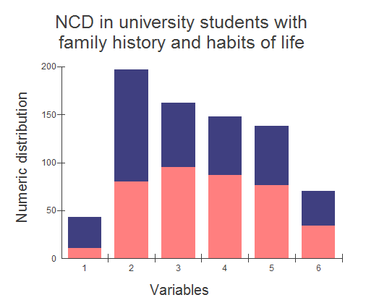
Variables: 1- consumption of tobacco; 2- consumption of alcoholic beverages; 3- obesity in the family; 4- hypertension in the family; 5- diabetes in the family; 6- cardiovascular diseases in the family. Total assessed: 140 women and 140 men.
Assessment of chart 2 - The lifestyle related to the use of tobacco and alcohol is more prominent in men. When we analyze chronic non-communicable diseases in relation to family history, we can see that obesity, hypertension and diabetes are higher for women. Cardiovascular diseases are higher for men.

Chart 3
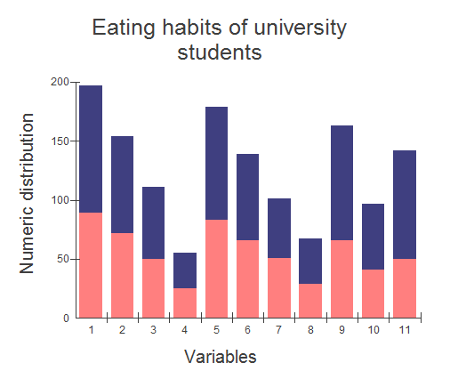
Variables: 1- consumption of red meat; 2- consumption of white meat; 3- consumption of pasta; 4- consumption of cereals; 5- consumption of greens; 6- consumption of vegetables; 7- consumption of fruits; 8- other; 9- consumption of snacks in the cafeteria; 10- consumption of candy in the cafeteria; 11- consumption of soda drinks in the cafeteria. Total assessed: 140 women and 140 men.
Assessment of chart 3 - Regarding eating habits, men consume more meat and pasta. Vegetables and greens are well consumed by both genders. There is little consumption of cereals, which means that the consumption of this food is not a cultural process of the researched groups. The consumption of fruits was well below 50% of the studied population. In the item ‘other’, we found the most consumed items: tapioca, cooked cassava and cassava biscuit. Regarding the consumption in the cafeteria, the snacks are not frequently consumed; however, the consumption of soft drinks is very high.

Chart 4
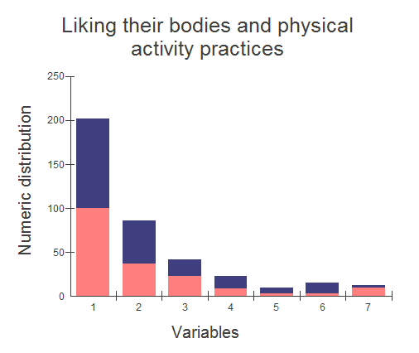
Variables: 1- like their bodies; 2- practice of physical activity; 3- gym; 4- walking; 5- weight lifting; 6- cycling; 7- other.
Assessment of chart 4 - Regarding liking their bodies, we found 40 women and 38 men who said they do not like their bodies; therefore, the percentage is higher for those who like. We separated these questionnaires and verified that these university students were overweight and obese. Regarding the practice of physical activities, only 49 women and 62 men practice physical activities. Physical inactivity prevailed over the participants. Among the practices carried out, we can mention: going to the gym, walking, weight lifting and cycling.

Chart 5.
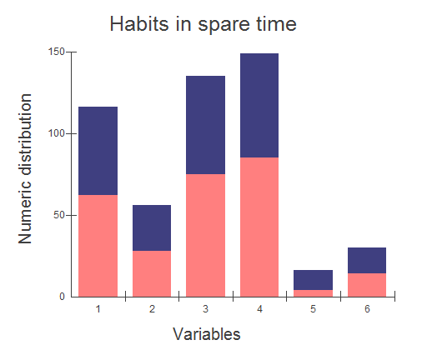
Variables: 1- watching TV; 2- playing video games; 3- using the computer; 4- studying; 5- chatting with friends, 6- other.
Assessment of chart 5 - In their spare time, watching television, using the computer and studying were the most pointed variables by the participants. Chatting with friends, specifically for women is practically non-existent. In the variable ‘other’, we find: taking care of the house, taking care of children, going to the square and walking around the city lake.

Chart 6.
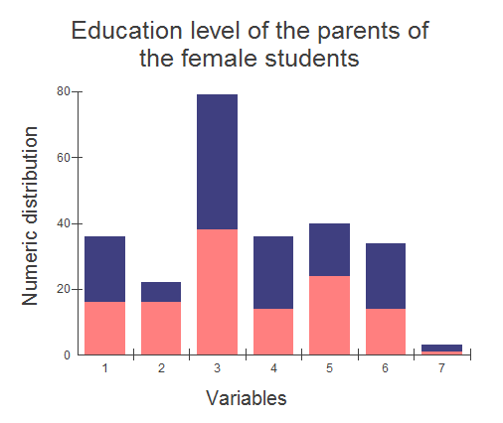
Variables: 1- complete higher education; 2- incomplete higher education; 3- complete high school; 4- incomplete high school; 5- complete primary education; 6- incomplete primary education; 7- illiterate. The orange color represents the education of the mother and the blue color the education of the father.
Assessment of chart 6 - Regarding the level of education of the parents of the female students, the levels of complete high school and complete primary education prevailed. The level of complete higher education and complete high school is greater for the father category, for female students. Only the level of complete primary education and incomplete higher education is greater for the mother category, for female students.

Chart 7.
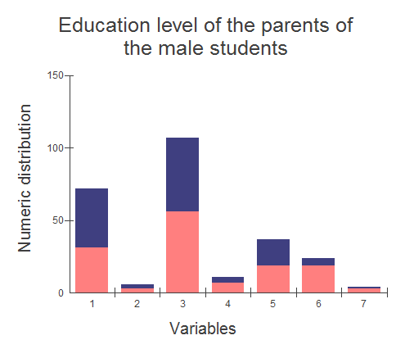
Variables: 1- complete higher education; 2- incomplete higher education; 3- complete high school; 4- incomplete high school; 5- complete primary education; 6- incomplete primary education; 7- illiterate.
Assessment of chart 7 - Regarding the level of education of parents for both genders, the levels of complete higher education and complete high school prevailed; however, the complete higher education prevailed for the father category, for male students.
These figures show once again the difficulties are greater for females taking into account several factors: difficulty in attending school, marrying early, study not being the priority, stop studying after getting married and others.
4.Discussion
This research, working to observe the anthropometric measurements, the relationship of study and work, the education level of the parents, the chronic non-communicable diseases with family history, the habits considered as harmful to health, the eating habits, the physical inactivity and what university students do in their spare time, for both genders, in morning and evening undergraduate courses, was very constructive regarding the opportunity to have greater relationship with them and to be able to hear them about their daily life.
The discussion of the family heritage of chronic non-communicable diseases is not an easy task because there is little literature that discusses this subject. The knowledge on the epidemiology of chronic non-communicable diseases, treatments and methodologies of studies constitutes the knowledge of many publications; however, the knowledge on family heritage is still incipient in research studies. When we speak of family heritage, we are speaking about the same habits that we learn from our family and their successively continuance [5]. The habits of life, in particular for food, are learned in our family. When children and adolescents do not have the opportunity to go shopping, they eat what the parents buy for food. Dietary habits can remain for decades in a family, becoming the family food heritage, and, along with it, there is the possibility of developing the same diseases of grandparents, uncles, aunts, parents and others from the same family [5].
The epidemics of the risk factors for chronic non-communicable diseases are inside our houses, starting with the lifestyle of individuals and their eating habits and also habits considered as harmful to health, such as, for example: many children start using tobacco and alcoholic beverage because they see their parents doing so indoors [1,5].
In our research, from the results of the anthropometric measurements we can state that the men are older, taller and with higher BMI than the women. For the relationship of study and work, the number is higher for men who study and work and lower for those who only study. In chart 2, we can observe that the consumption of tobacco and alcohol beverages is greater for males. Obesity, hypertension and diabetes on the family history are greater for females. Cardiovascular diseases are virtually tied in the results. For both groups, the epidemic of risk factors are strong for the emergence of early NCD taking into account the eating habits and physical inactivity. Chart 3 refers to the variables regarding food consumption on a daily basis. The consumption of red meat is greater than the consumption of white meat for both groups. Pasta is little consumed by both groups. Cereals still seem to not be part of the menu of Brazilians. The consumption of greens is greater than the consumption of vegetables. Regarding the consumption of fruits, it seems that Brazilians have not developed the habit of eating them every day, at least the amount that is recommended by the World Health Organization, five servings a day. Variable 8 (other) of the chart refers to the consumption of yoghurt, white cheese, cream cheese, etc. The consumption of snacks and soft drinks in the cafeteria is quite high. The consumption of candy is greater for males. The variable ‘like their bodies’ is greater for both groups. For the practice of physical activities, in both groups the number is greater for physical inactivity; however, men are more active compared to women.
Habits in spare time (chart 5), such as, watching TV, using the computer and studying, were the most chosen answers. The item ‘chatting with friends’ was the least responded. Regarding the level of education of the parents of the female students (chart 6), the levels of complete high school and complete primary education for the mother were higher. For the father, the levels of complete higher education, complete high school and incomplete primary education were the highest. Regarding the level of education of the parents of the male students (chart 7), the level of complete high school prevailed for the mother, and the levels of complete higher education and complete high school prevailed for the father. According to [25], based on the Monitoring Survey of the Risk and Protection Factors for Chronic Diseases by Telephone Interview, hypertension reaches 22.7% of the adult Brazilian population. The diagnosis in women (25.4%) is more common than among men (19.5%). The frequency of the disease progresses over the years. If between 18 and 24 years only 5.4% of the population have reported having been diagnosed as hypertensive, at 55 years the proportion is ten times higher, reaching more than half of the population (50.5%) studied. After 65 years, the same condition is observed in 59.7% of the Brazilians. The higher frequency of diagnosis in women occurs in all age groups. The research also points out that the level of education has a strong influence on the diagnosis of the disease among the female population. While 34.4% of the women with up to eight years of education claimed to have medical diagnosis of hypertension, the percentage is smaller - 14.2% - among women with higher level of education.
5.Conclusion
Considering the results obtained by the family history, physical inactivity and habits of life of the university students are strong candidates for early chronic non-communicable diseases.
Funding

This survey received support from the National Council for Scientific and Technological Development - CNPq- Brazil.

Acknowledgments
To the undergraduate students of the Federal University of Mato Grosso do Sul - UFMS for the
interest in participating in the research.
Conflicts of Interest
The authors declare no conflict of interest.

6.References
1.Bankoff ADP, ZAGO LC (2014) Studies of anthropometric indicators and their relationship with metabolic variables. Open Journal of Preventive Medicine 04: 64-68.
2.Zamai CA et al (2008) Estudo dos fatores de risco para o desenvolvimento de doenças crônicas não transmissíveis entre funcionários.Revista Conexões 6: 14-30.
3.Guedes DP (1995) Composição Corporal. (^{2nd} edn). Londrina, 132-156.
4.Guedes DP, Guedes, JER. (1998) Controle do Peso Corporal. (^{1nd} edn). Londrina,87-101.
5.Bankoff ADP, Bispo, IMP, Rodrigues, MD. (2015) Doenças Crônicas não Transmissíveis: História familiar e hábitos de vida. In 2º Congresso da Associação Latino Americana de Ciências do esporte, Educação Física e Dança, 14 a 19 de setembro de 2015, Juiz de Fora- Minas Gerais, 129-131.
6.Fisberg GM. (1995) Obesidade na infância e adolescência (^{2nd} edn) São Paulo,157-162.
7.Bankoff ADP, Cremonesi LN, Zamai CA, Ferro F, Barros DD, Crivelli DM (2002). Estudar as condições de esforço físico em Adolescentes Obesos: Perspectivas para a Prática de Atividades Físicas. Revista da Educação Física 13: 27-33.
8.Bankoff ADP, Ferro F, Cremonesi LN, Zamai CA, Crivelli DM, Barros DD (2003) Estudo da Aptidão Física através das variáveis: Pressão Arterial e Freqüência Cardíaca de Adolescentes Obesos em diversas Atividade Físicas.. Revista de Educação Física de Maringá 13: 53-65.
9.Mendonça CP, Anjos LA (2004) Aspectos das práticas alimentares e da atividade física como determinantes do crescimento do sobrepeso/obesidade no Brasil. Cad. Saúde Pública, Rio de Janeiro 20: 698-709.
10.Monteiro CA (2005) Velhos e novos males da saúde no Brasil.- A evolução do país e de suas doenças (^{1nd} edn). São Paulo, 86-107.

11.Pinheiro ARO, Freitas STF, Corso ACT(2004) Uma abordagem epidemiológica da obesidade. Rev. Nutr. Campinas 2004 1: 523-533.

12.Bankoff ADP (2012) Doenças Crônicas Não Transmissíveis em Crianças e Adolescentes. In Carlos A. Zamai e Alan A. Rodrigues. (Org.). Saúde Escolar: A Responsabilidade de Ensinar (^{1nd} edn) Jundiaí, 11-38

13.Bankoff ADP, Zamai CA et al. (2005) Programa de Convivência e atividade Física na Unicamp: responsabilidade social em ação. Anais 5° Congresso Brasileiro de Atividade Física & Saúde. Florianópolis, 15-17.
14.Bankoff ADP, Bueno, E (2007) Programa de Convivência e atividade Física na Unicamp: relato de experiência. Anais VII Fórum de Educação Física dos Países do Mercosul, Foz do Iguaçu, 15-18.
15.Bankoff ADP, Zamai CA, Bueno E, Bergantin M, Carvalho THPF (2008) Implantação do programa de convivência e atividade física na Unicamp – Mexa-se. Anais II Simpósio de Profissionais da Unicamp -II Simtec, Campinas, 21-24
16.Zamai CA, et al (2005) Atividade física, saúde e doenças crônico-degenerativas: avaliação do nível de conhecimento entre escolares de Campinas. Revista Movimento & Percepção, Espírito Santo de Pinhal, 5: 42-58.

17.Freedman DS, Ogden CL, Flegal L K, Serdula MK; William MH. Dietz MD (2007) Childhood Overweight and Family Income MedGenMed, 9: 123-134
18.World Health Organization WHO (2002) Diet, Nutrition and the Prevention of Chronic Diseases. Technical Report Series 916. Geneva, Switzerland.
19.Moloud P, Shirin HR, Bagher L (2014) Whether all obese subjects both in metabolic groups and non-metabolic groups should be treated or not Journal of Diabetes & Metabolic Disorders , 13: 87-96 doi:10.1186/2251-6581-13-21
20.World Health Organization WHO (2000) Diet, Nutrition and the Prevention of Chronic Diseases. Technical Report Series. Geneva, Switzerland.
21.Chung AE, Skinner AC, Maslow GR, Halpern CT, Perin EM (2014) Sex Differences in Adult Outcomes by Changes in Weight Status From Adolescence to Adulthood: Results From Add Health Academic Pediatrics, 14:448-455.
22.Gharib N, Rasheed P (2011) Energy and macronutrient intake and dietary patterns among school children in Bahrain: a cross-sectional study. Nutrition Journal,10: 62- 73.
23.Hung HC; Joshipura KJ; Jiang R; Hu FB; Hunter D, Smith WSA, Colditz GA, Rosner B, Spiegelman D, Willet, WC (2004) Fruit and vegetable intake and risk of major chronic disease. J Natl Cancer Inst. 21:1577-84.
24. Bankoff ADP, Bispo IMGP, Rodrigues MD, Zamai CA. (2018) In 23º Annual Congress of the European College of Sport Scince, Irland 1:24-25.
25. Ministério da Saúde (2011) Vigilância de fatores de risco e proteção para doenças crônicas por inquérito telefônico, Brasília, 17-24.

