Journal of Applied Finance & Banking
ISSN: 1792-6580 (print version), 1792-6599(online)
https://doi.org/
Scientific Press International Limited

Pharmaceutical and Telecommunications Sector Weak Form Market Efficiency Study in Indonesian Capital Market
2017-2020

Cheng-Wen Lee, Taufiqquddin Ande*

Abstract
This study aims to examine the efficiency of the weak form market in the pharmaceutical and telecommunications sectors in the Indonesian capital market during the 2017-2020 period (1 January 2017 – 30 December 2020) and the 2020 Covid-19 period (1 January 2020 – 30 December 2020). The data used in this study is daily stock closing prices. Jarque-Bera normality test, Ljung Box autocorrelation test to assess serial dependencies, run test, and Augmented Dickey Fuller (ADF) to test the random walk hypothesis were among the statistical tests utilized. The pharmaceutical and telecommunications sectors were in poor shape during the research period, according to the findings. This research offers guidance to potential funders as well as future researchers.

JEL Classification: G14, G19
Keywords: Efficient Market Hypothesis, Random Walk Hypothesis, Covid-19

- INTRODUCTION
When the market receives information about stock securities, it has the potential to produce a new equilibrium price shift, and if the market reacts swiftly to this information and develops a new equilibrium price, the market is considered to be efficient. According to efficient market theory, market efficiency occurs when market prices accurately reflect all available information (E. F. Fama, 1970). Price movements in an efficient market cannot be forecast using historical stock prices, but they do follow a random walk that takes into account all of the available information. Based on the evidence available, Fama (1970) divides the Efficient Market Hypothesis (EMH) into three categories: weak (weak form), semi strong (semi-strong form), and strong (strong form) (strong form). Past information has little effect on current pricing if the market is inefficient in a weak form and follows a random walk pattern.
Information about the Covid-19 pandemic, for example, can have an impact on market efficiency, causing a market reaction that leads to a global financial catastrophe. The stock price in the capital market has dropped as a result of this situation. The return on the Indonesian capital market in early 2020 fell from 9.7% in 2019 to -24.7 percent in 2020, down from 9.7% in 2019. (Emerging Markets Returns, 2020). Jain et al., (2013) conducted previous research on the weak form efficient market hypothesis, finding that the Indian capital market was weak form efficient during the global financial crisis of 2008.
Previous research in Indonesia has found that the Indonesian capital market is efficient in the weak form (Andrianto & Rishad Mirza, 2016; Yulianti & Jayanti, 2020). Meanwhile, Alia, (2017) conducted research on the efficiency of the weak form of efficient market in Indonesia during the crisis, testing the effectiveness of the weak form of market during the global financial crisis of 2008, according to the findings of his research, the Indonesian capital market was efficient in its weak form before the crisis and inefficient during the crisis. Surprisingly, there hasn't been much testing of the efficacy of the weak form of the market during the crisis, particularly during the Covid-19 outbreak.
On the Indonesia Stock Exchange (IDX), this study will evaluate the hypothesis of weak form market efficiency during the crisis caused by the Covid-19 pandemic, particularly in the pharmaceutical and telecommunications sectors, from 2017 to 2020. The pharmaceutical and telecommunications sectors have been suggested sectors during the Covid-19 epidemic due to a boost in sales of multivitamins and a surge (traffic) in the use of internet data. Based on this description, the researchers are interested in doing study to determine whether market efficiency in Indonesia is poor (weak form) or not over the stated period: “Pharmaceutical and Telecommunications Sector Weak Form Market Efficiency Study in Indonesian Capital Market 2017-2020

- lITERATUR REVIEW
Previous study has focused on research that evaluates the efficiency of the weak form of the market during a crisis, particularly the global financial and economic crisis, and is related to the Efficient Market Hypothesis (EMH) theory. Hamid et. al., (2017) used parametric and non-parametric research methods and applied statistical tests such as the Ljung-Box test, run test, and ADF test in his previous research on weak form market efficiency, which was titled "Weak Form Market Efficiency in the Capital Markets of Indonesia, Malaysia, and South Korea During the 2008 Global Economic Crisis Period." His findings reveal that it yields mixed evidence in the years leading up to, during, and after the global economic crisis.
Ndubuisi, P., & Okere, K. (2018) found that the Nigerian capital market is efficient in a weak form in all sectors except the financial sector, consumer goods, oil and gas, and Islamic equity, in his study "Weak-form Efficiency After Global Financial Crisis: Emerging Stock Market Evidence" on the Nigerian capital market in the post-global financial crisis period. Further research was conducted by Jain et al., (2013) with the title "A Study on Weak Form of Market Efficiency during the Period of Global Financial Crisis in the Form of Random Walk on Indian Capital Market," whose findings show that the Indian stock market is inefficient in a weak form during recessions. The study "Market Efficiency in G-20 Nations: The Paradox of Financial Crisis" conducted by Vieito et al. (2013) in G-20 countries using Augmented Dickey Fuller (ADF) concluded that the stock markets of G-20 countries were efficient in a weak form.

- DATA AND METHODOLOGY
The following are the research objectives to be met: The pharmaceutical and telecommunications sectors on the Indonesia Stock Exchange (IDX) are used as research objects in this study. The pharmaceutical and telecommunications sectors were chosen for this study because they were the suggested sectors during the Covid-19 pandemic. Panel data, which is a blend of time series and cross section data, is used in this study.
This study relies on secondary data, specifically data from daily stock price closing data during a four-year period. Twelve firms were studied, including eight in the pharmaceutical industry and four in the telecommunications industry. The research period was then separated into two parts: the entire period from 2017 to 2020 (the entire period) and the Covid-19 pandemic phase (the entire time) (in 2020). The sample selection strategy used in this investigation is as follows.

  - Variable Research
The major variable in this analysis is stock returns from the pharmaceutical and telecoms industries. The most important step in this research is to gather information on the daily closing price (closing price) of all stock samples that will be used to calculate the return using the formula below (Khajar, 2008).

r_{i}(t,m) = ln p_{i}(t,m) – ln p_{i}(t - 1,m) (1)
  - Data Analysis Method
The serial correlation test is used in this study to determine whether there is a relationship between past and current values. This study uses data analysis methods such as normality test, autocorrelation test, and random walk hypothesis test using run test as a non-parametric statistical test to determine randomness or whether the stock market is efficient or inefficient in weak form to determine the efficiency of the weak form in the Indonesian capital market to determine the stationarity of the data utilized, and a parametric test utilizing Augmented Dickey Fuller (ADF) as a unit root test (unit root test) (Alia, 2018).
    - Normality Test (Jarque-Bera)
The normality test was used in this study to assess if the confounding variables (residual) in the regression model were normally distributed or not (Ghozali, 2018). The Jarque-Bera (J-B) statistical test is used to determine whether the residuals are normally distributed or not. The kurtosis and skewness values of the residuals are examined. The Jarque-Bera (J-B) test compares how far the asymmetry and kurtosis measures stray from the normal distribution values' features (Domodar, 2010).

JB = [n / 6] [S² + (K – 3)²/4] (2)
If a variable is normally distributed, S = 0 and K = 3, and the residuals are normally distributed, the Jarque-Bera statistic will be zero (Alia, 2018). The following is the rationale for making decisions on the Jarque-Bera test (J-B).
    - Autocorrelation Test (Ljung Box)
The autocorrelation test is used to see if there is a link between the confounding error in period t and the confounding error in period t-1 (prior) in a linear regression model (Ghozali, 2018, p. 111). An autocorrelation problem occurs when there is a correlation. The autocorrelation test is a test used to evaluate the Random Walk Hypothesis in various weak form market efficiency studies (Ndubuisi, P., & Okere, K. 2018). No autocorrelation or a random stock market imply a weak form of efficient stock market; nevertheless, if the stock market moves not randomly or there is autocorrelation, the stock market is inefficient in the weak form (Alia, 2018).
The Ljung-Box statistical test is used to explain the autocorrelation test in this study. The Ljung-Box statistical test was performed to determine whether there was autocorrelation with a lag of greater than two years (Ghozali, 2018, p. 119). If there is no correlation between the present price set and the lag value, the market is considered to be weak form efficient (Bajaj & Sethi, 2016).
    - Run Test
The run test is a non-parametric statistical test that determines if there is a high correlation between residuals or not; if there is no correlation, the residuals are said to be random (Ghozali, 2018, p. 121). Run tests are used to establish whether price movements are serial or random, and they are also ideal for evaluating the market's efficiency in a weak form (Jain et al., 2013). A run test is performed by comparing the number of observed runs (R) to the number of expected runs (m) using the equation below (Forejt et al., 2011).
$m= \frac{N\left(N+1\right)-\sum_{i=1}^{3}{n_{i}^{2}}}{N}$ (3)
Where N denotes the number of observations (price or return change), and $ηi$ denotes the number of price changes in each category (plus, minus, and no change). The expected number of runs (m) is normally distributed with a standard deviation for a large number of observations (N > 30) using the formula below.
$σ_{m}=\left[\frac{\sum_{i=1}^{3}{n_{i}^{2}\left[\sum_{i=1}^{3}{n_{i}^{2}+N\left(N+1\right)}\right]-2N\sum_{I=1}^{3}{n_{i}^{3}-N^{3}}}}{N^{2}\left(N-1\right)}\right]$ (4)

The following equation can be used to compute the Z test for a run test.
$z=\frac{R-m±0.5}{σ_{m}}$ (5)
    - Unit Root Test
The random walk hypothesis must be tested using the stationarity test. The Augmented Dickey Fuller (ADF) test was employed in this investigation. The presence of a unit root in a time series of price changes was tested using the Augmented Dickey Fuller (ADF) test (Hamid et al., 2010).
- RESULTS AND DISCUSSION
Descriptive statistical testing is a type of data analysis that involves describing or characterizing the data collected. Descriptive statistical tests are used to provide a description of stock price changes over a given time period. The results of descriptive statistical tests of daily stock returns for the pharmaceutical and telecommunications sectors during the 2017-2020 timeframe, as well as the 2020 Covid-19 pandemic period, are shown in the table below.
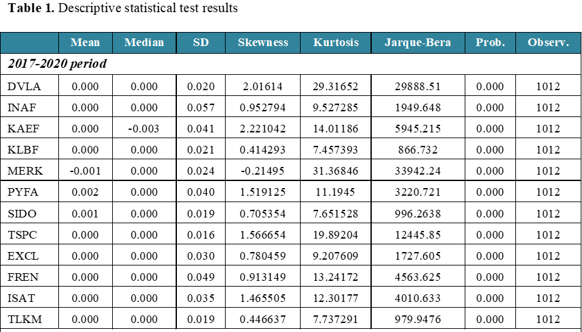
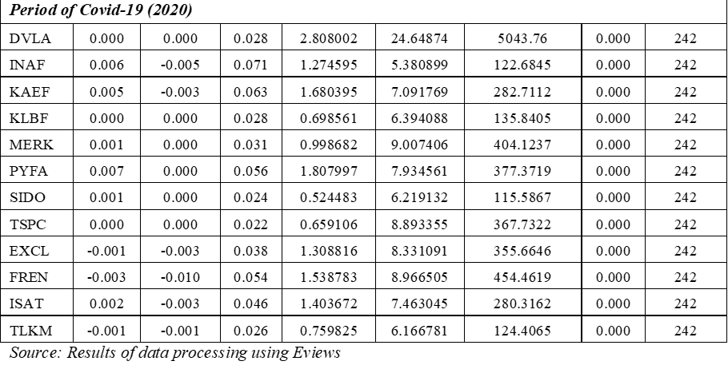
In the period 2017-2020, the average daily stock return (mean) tends to be positive, as shown in Table 1. The pharmaceutical sector has a positive average daily stock return, with the exception of BRAND, which has a negative average daily return of -0.001. Meanwhile, the average daily stock return value in the telecoms sector is positive. The average daily stock return value of the pharmaceutical industry is positive in the Covid-19-time frame in 2020. Meanwhile, EXCL -0.001, FREN -0.003, and TLKM -0.001 are all negative figures in the telecommunications industry.
The Kurtosis value in table 4.1 is larger than the normal distribution, indicating that the pharmaceutical and telecommunications industries were leptokurtic during the study period.

  - Results of the Jarque-Bera Test for Normality
To evaluate if the distribution of return data is regularly distributed, a normality test was performed. If the stock return data is regularly distributed, it follows a random walk pattern, which means that the price will fluctuate randomly, making it impossible to anticipate (Alia,2018).
H0 is rejected (stock returns are regularly distributed) if the probability value is less than 0.05, and H0 is accepted if the probability value is more than 0.05. The Jarque-Bera Test residual normality test was used in conjunction with the E-views software. The following recapitulation includes the results of the Jarque-Bera normalcy test.

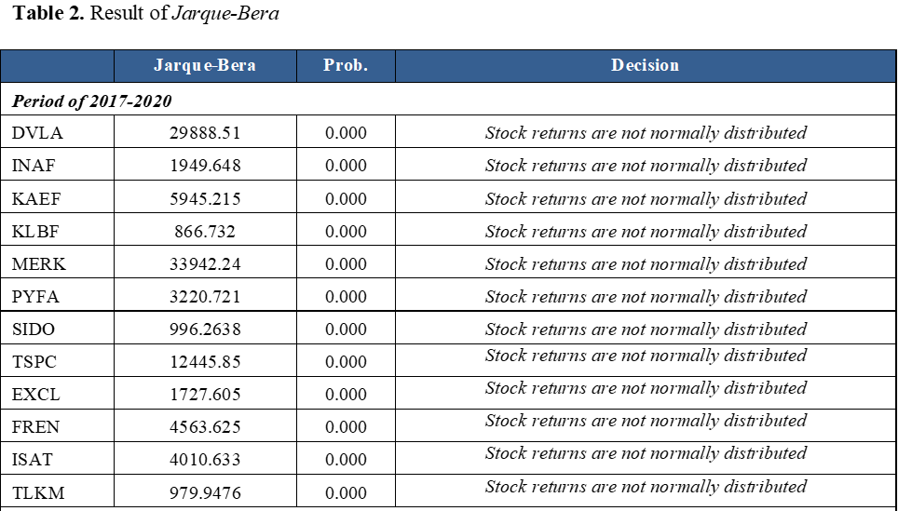
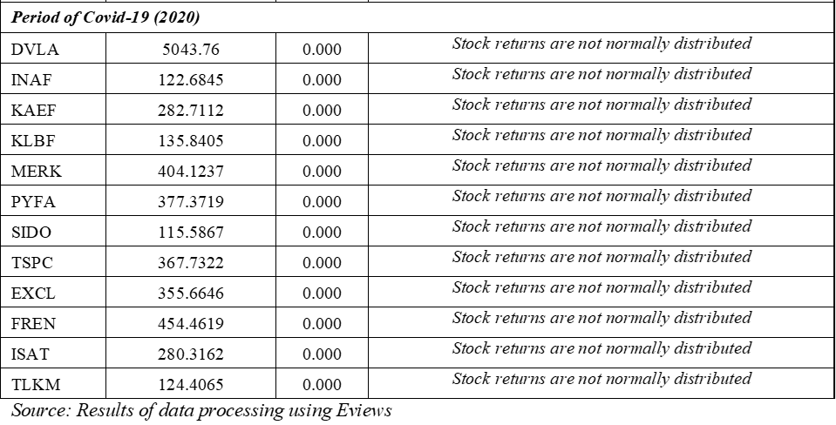
Table 2 reveals that the stock return data in both the pharmaceutical and telecommunications industries is not regularly distributed in the 2017-2020 period and the 2020 Covid-19 period, based on the results of the tests conducted. In all eras, the Jarque-Bera test findings reveal a value larger than 5.991 (if JB > 5.991) in the pharmaceutical and telecommunications industries. Because the probability value is 0.05, H0 is rejected, indicating that the residual data is not normally distributed.
Because the return data is not regularly distributed, the movement of stock returns does not follow a random walk pattern, according to the test results. This test is in line with Alia (2018) findings, which show that stock return data is not regularly distributed. Returns will follow a random walk pattern if they are regularly distributed, making future prices impossible to predict based on past values (Prakash, 2014).
    - Results of the Autocorrelation Test (Ljung Box Test)
The serial autocorrelation test determines if historical returns are linearly related (Alia 2018). The autocorrelation test is used to evaluate the Random Walk Hypothesis in a variety of weak form market efficiency studies (Ndubuisi, P., & Okere, K. 2018). If the probability value is less than 0.05, then H0 is rejected, indicating that there is an autocorrelation (inefficient market in weak form). Meanwhile, H0 is accepted if the Ljung-Box test findings indicate a probability value of 0.05, indicating that there is no autocorrelation (weak form efficient market).

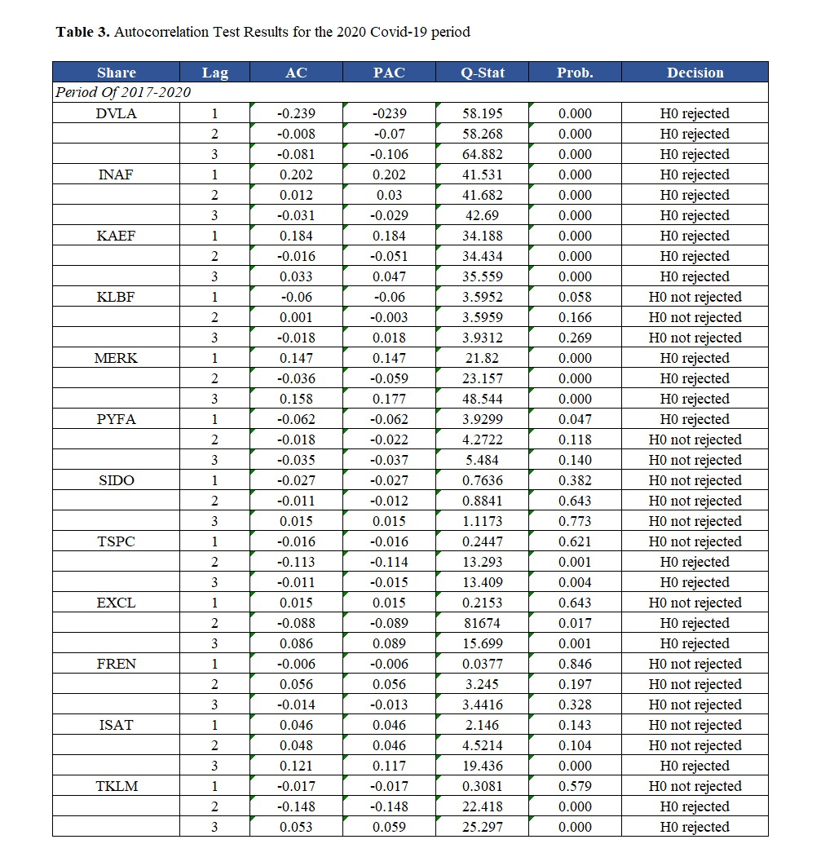

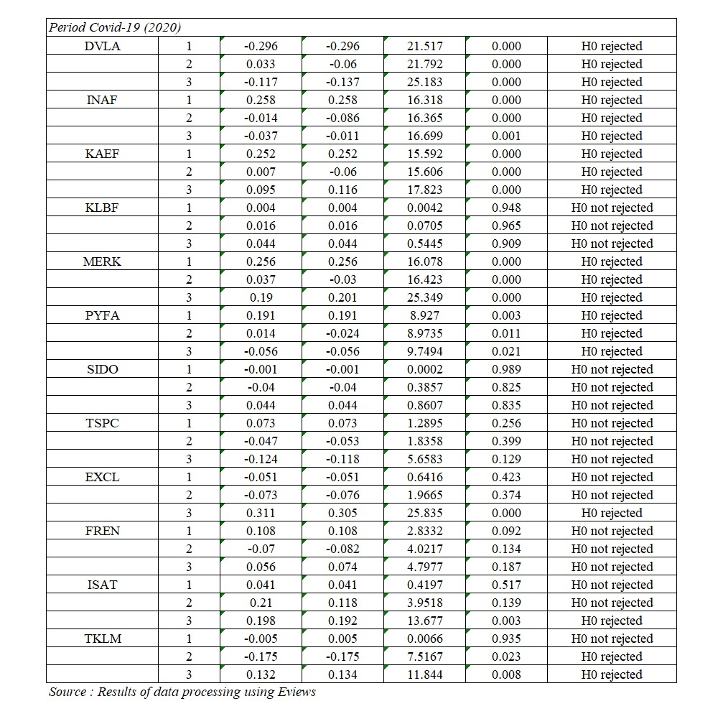

In the 2017-2020 period, Table 3 illustrates the results of the Ljung Box autocorrelation test, with the majority of stocks at lags 1, 2, and 3 having a probability value of 0.05. Except for KLBF, PYFA, SIDO, and TSPC stocks, test findings in the pharmaceutical sector tend to reveal that H0 is rejected 0.05 at lag 1, 2, and 3. At lags 1, 2, and 3, the test results on KLBF and SIDO stocks reveal a probability value of 0.05. At delays 2 and 3, PYFA has a probability value of 0.05. At lag 1, TSPC displays a probability value of 0.05.
In the telecommunications sector, the test results tend to show a probability value of 0.05, specifically H0 is accepted especially in FREN stocks, whereas EXCL, ISAT, and TLKM have varied findings for each lag. H0 is approved at lag 1 in EXCL and TLKM stocks. At lags 1 and 2, H0 is approved in ISAT stocks, according to the likelihood value.
Table 3 also shows the results of the Ljung Box autocorrelation test in the Covid-19 era in 2020, which tend to yield probability outcomes of less than 0.05, indicating that H0 is rejected. Except for KLBF, SIDO, and TSPC stocks, the pharmaceutical industry tends to display probability values of less than 0.05 or H0 is rejected. Meanwhile, the telecommunications industry produces variable outcomes in each lag, but the probability value tends to indicate a value of 0.05 or H0, which is acceptable. The test results in FREN stock reveal that H0 is approved at lags 1, 2, and 3. In the meantime, the stocks EXCL and ISAT show that H0 is rejected at lags 1 and 2. At delays 2 and 3, TLKM demonstrates that H0 is rejected.
There was no autocorrelation based on the findings of the Ljung Box autocorrelation test done in the 2017-2020 term and the 2020 Covid-19 period. Returns have no autocorrelation, indicating that the market is efficient in its current state. No autocorrelation or a random stock market imply a weak form of efficient stock market; nevertheless, if the stock market moves not randomly or there is autocorrelation, the stock market is inefficient in the weak form (Alia, 2018). The results of this autocorrelation test agree with those of Khajar (2008), who found no autocorrelation in stock returns, indicating that the market is efficient in a weak form.
    - Results of the Run Test
The run test is a non-parametric statistical test that determines if there is a high correlation between residuals or not; if there is no correlation, the residuals are said to be random (Ghozali, 2018a, p. 121).
The test criteria are that if the p-value is less than 0.05, H0 is rejected, and if the p-value is greater than 0.05, H0 is accepted. H0 is rejected if the computed z value is less than or more than the crucial z value of 1.96, and H0 is accepted if the calculated z value is between -1.96 and +1.96.

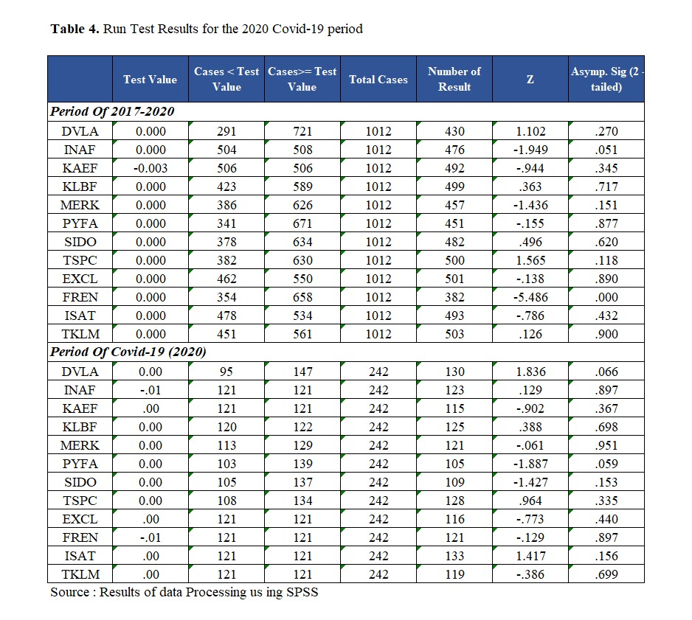

Except for FREN stocks, which have a probability value of 0.05, the results of the run test in the 2017-2020 period show a probability value of 0.05 and the critical value of z is at a significance level between -1.96 and +1.96, according to table 4. The findings of this run test reveal that the pharmaceutical sector has a random stock return pattern over the period 2017-2020, indicating that the market is efficient in a poor form. Meanwhile, with the exception of FREN stocks, the majority of stocks in the telecommunications sector have a random stock return pattern, making it a weak form of efficient market.
The run test results in the Covid-19 era in 2020 show a probability value of 0.05 and the crucial value of z is at a significance level between -1.96 and +1.96, according to table 4.8. During the 2020 Covid-19 pandemic, the results of this run test show a pattern of random stock returns in the pharmaceutical and telecommunications sectors, indicating that the market is efficient in a weak form.
This study supports the findings of Andrianto & Rishad Mirza (2016), who found that the Indonesian capital market is efficient in a weak form when run test testing is used. The results of the run test which reveal that prices fluctuate randomly, show that technical analysis alone cannot be used to predict future prices based on past prices (Alia, 2018).

    - Results of the Unit Root Test
The random walk hypothesis was tested using a stationarity test. The Augmented Dickey Fuller (ADF) test was employed in this investigation. The presence of a unit root in a time series of price changes was tested using the Augmented Dickey Fuller (ADF) test (Hamid et al., 2010). H0 is rejected if the return does not have a unit root if the probability value of augmented dickey fuller is less than 0.05. (stationary).

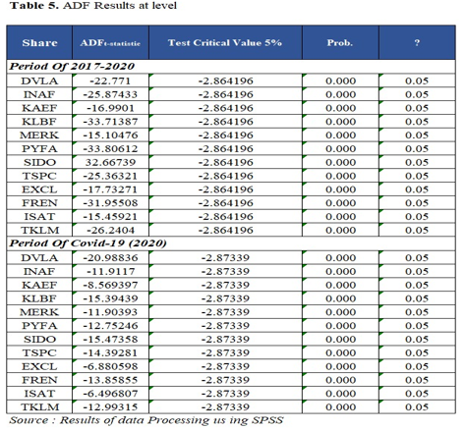

The ADF test results in table 5 reveal that both the pharmaceutical and telecommunications sectors have unit root at the level in the 2017-2020 and 2020 Covid-19 periods. All stock returns are stagnant if the probability value is less than 0.05. The findings of this ADF test reveal a random stock pattern, indicating a weakly efficient market.

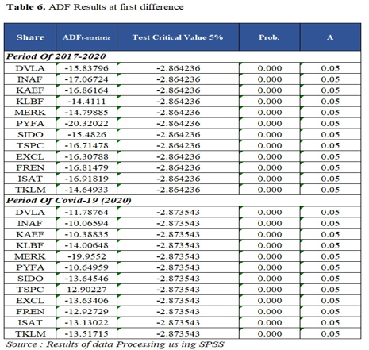

The ADF test results in table 6 reveal that both the pharmaceutical and telecommunications sectors have a unit root at the first difference level in the 2017-2020 and 2020 Covid-19 periods. All stock returns are stagnant if the probability value is less than 0.05. The findings of this ADF test reveal a random stock pattern, indicating a weakly efficient market.
The unit root test results indicate that the market was inefficient in a weak form during the research period. The results of this test are consistent with those of Alia, (2018), who found that the ADF test results were stationary, indicating that the stock market was efficient in a weak form. A random walk pattern indicates that the historical price of each stock in the market cannot be utilized to predict future stock price.

  - Discussions
Based on the Ljung Box test, run test, and unit root test (ADF) autocorrelation test, the results of tests conducted in the pharmaceutical and telecommunications sectors for the period 2017-2020 reveal that the Indonesian capital market is inefficient in a weak form. Stock returns move randomly or in a random walk pattern, according on the test results. As a result of the test results, the hypothesis H1 is accepted.
Stock prices move randomly or follow a random walk pattern, according to the Ljung Box autocorrelation test, run test, and ADF done between 2017 and 2020. The findings of this study support the Efficient Market Hypothesis' weak form, in which the security price represents all historical/past information (past price changes) available in the market.
The random walk theory is connected to the weak form of market efficiency, in which previous information has little bearing on the current value or price in the capital market (Khajar, 2008, p. 150). Investors cannot predict when issuers will offer new information based on randomly produced data (Hamid et al., 2017). The findings of this study back up research by Alia, (2018) and Khajar (2008), who claim that the Indonesian capital market is efficient in its current state.
Based on the Ljung Box test, run test, and unit root test (ADF) autocorrelation test, the results of tests conducted in the pharmaceutical and telecommunications industries for the Covid-19 period in 2020 reveal that the Indonesian capital market is inefficient in a poor form. Stock returns move randomly or in a random walk pattern, according on the test results. As a result of the test results, the hypothesis H2 is accepted.
Because historical information has been absorbed in stock prices in the prior period, random stock returns suggest an efficient market in a weak form, where past prices cannot be utilized to predict current prices (Khajar, 2008). According to the findings of this study, stock price movements are random or follow a random walk pattern. The Random Walk hypothesis assumes that future price movements cannot be foreseen, hence price rises at one moment do not necessarily reflect future price increases or decreases (Lim, et al., 2008).
During the Covid-19 pandemic, the Indonesian capital market was severely impacted. Investors are hesitant to make decisions when stock prices fluctuate dramatically, so they tend to sell their shares. According to Town's research, the best moment to invest in stocks was during the Covid-19 outbreak since most people would sell their equities, causing stock prices to plummet.

- CONCLUSIONS
Based on the findings of a study on weak form market efficiency in the Indonesian capital market (Study of Weak Form Market Efficiency in the Indonesian Capital Market: For the 2017-2020 timeframe and the Covid-19 period in 2017, it may be concluded that the Indonesian capital market is inefficient in a weak shape in the pharmaceutical and telecommunication sectors. 2020, based on the autocorrelation test results of the Ljung Box test, run test, and unit root test (ADF). For investors who want to make the most money on the stock market, information is crucial. According to the findings of the research, investors who wish to invest should use information to reduce losses and be cautious while investing because stock investments have a high risk/high reward ratio.
Future researchers who want to examine the efficiency of weak form markets should employ longer time periods to demonstrate that prior information has no effect on current prices and that prices move randomly.

References

- Alia Tri Utami (2018). Efisiensi Pasar Bentuk Lemah Pada Pasar Modal Indonesia, Malaysia dan Korea Selatan Periode Krisis Ekonomi Global 2008. Journal Inspirasi Bisnis dan Management Vol2(2):101-116

- Andrianto & Rishad Mirza, (2016). A Testing of Efficient Markets Hypothesis in Indonesia Stock Market. Procedia - Social and Behavioural Sciences 219:99-103. https://doi.org/10.1016/j.sbspro.2016.04.048.

- Damodar N. G (2010). Dasar-dasar Ekonometrika in 1. https://doi.org/10.1109/ACCES.2017.2777102

- Emerging Markets Performance, (2020) Retrieved from https://novelinvestor.com/emergingmarkets-performance/

- Eugene F. Fama (May, 1970). Efficient Capital Markets: A Review of Theory and Empirical Work. Vol. 25, No. 2, Papers and Proceedings of the Twenty-Eighth Annual Meeting of the American Finance Association New York, N.Y. December, 28-30, 1969 (May, 1970), pp. 383-417 (35 pages). https://doi.org/10.2307/2325486.

- Ghozali, I. 2018. Multivariate Analysis Application with IBM SPSS 25 Program. Semarang:Diponegoro University

- Hamid, K., Suleman, M. T., Ali Shah, S. Z., & Imdad Akash, R. S. (2017). Testing the Weak Form of Efficient Market Hypothesis: Empirical Evidence from Asia-Pacific Markets. Ssrn, 58(58). https://doi.org/10.2139/ssrn.2912908.
- Jain, P., Vyas, V., & Roy, A. (2013). A study on weak form of market efficiency during the period of global financial crisis in the form of random walk on Indian capital market. Journal of Advances in Management Research, 10(1), 122–138. https://doi.org/10.1108/09727981311327802.

- Joao Paulo Vieito, K.V Bhanu Murthy and Vanita Tripath (2013). Market Efficiency in G-20 countries: The Paradox of Financial Crisis. Annals of Financial Economics vol.8(1). https://doi.org/10.1142/S2010495213500036
(10) Khajar, I. (2008). Pengujian Efisiensi Dan Peningkatan Efisiensi Bentuk Lemah Bursa Efek Indonesia Pada Saat Dan Sesudah Krisis Moneter Pada SahamSaham LQ-45. Jurnal Manajemen Teori Dan Terapan, Tahun 1, No.3: 154, (3), 144–164.

(11) Lim, K. P., Brooks, R. D., & Kim, J. H. (2008). Financial crisis and stock market efficiency: Empirical evidence from Asian countries. International Review of Financial Analysis, 17(3), 571–591. https://doi.org/10.1016/j.irfa.2007.03.001

(12) Ndubuisi, P., & Okere, K. (2018). Stock Returns Predictability and the Adaptive Market Hypothesis in Emerging Markets: Evidence from the Nigerian Capital Market. (1986-2016). Asian Journal of Economic Modelling, 6(2), 147–156. https://doi.org/10.18488/journal.8.2018. 62.147.156
(13) Prakash, S. (2014). Efficient Market Hypothesis: Examining the Case of South Asian Stock Markets. Ssrn. https://doi.org/10.2139/ssrn.2463788

(14) V. Forejt, M. Kwiatkowska, G. Norman, D. Parker, Automated verification techniques for probabilistic systems, in: M. Bernardo, V. Issarny (Eds.), Proceedings of the Formal Methods for Eternal Networked Software Systems (SFM), Springer, Berlin, Heidelberg, 2011, pp. 53–113. DOI: https://doi.org/10.1007/978-3-642-21455-4_3

(15) Yulianti & Jayanti, (2020). Penerapan Model Garch Untuk Menguji Efisiensi Pasar Bentuk Lemah. Sains Jurnal Manajemen dan Bisnis 12(2):153. https://doi.org/10.35448/jmb. v12i2.7235.

Department of International Business, Chung Yuan Christian University 200 Zhong Bei Road, Zhong Li, Taoyuan City, Taiwan 320314.
* Ph.D. Program in Business, College of Business, Chung Yuan Christian University 200 Zhong Bei Road, Zhong Li, Taoyuan City, Taiwan 320314. Corresponding author.

