Groupon, m-commerce and mobile apps: perceptions of small business owners and consumers

ABSTRACT

This study analyzes the digital and mobile commerce market from the perspective of consumers and small business owners in a particular geographic region. Two surveys were conducted, one from a consumer perspective and the second from the small business owners' perspective. The survey asked about use of and perceptions of Groupon and other mobile deals. Preliminary findings suggest that while consumers are likely to use mobile apps to make purchases and save money, small business owners consider Groupon deals risky and are less likely to use them to help drive sales and attract new customers.
Keywords: mobile apps, Groupon, mobile deals, digital marketing, small business, entrepreneurs

I. Evolution of brick and mortar to e-Commerce to m-Commerce
Over the past decade the rapid adoption of smart phones by consumers and the proliferation of smartphone apps for connecting with and selling to consumers has profoundly affected traditional notions of doing business and can be considered disruptive (Einav, Levin, Popov & Sundaresan, 2014) (Brynjolfsson, Hu & Rahman, 2013). According to the Pew Research Internet project, as of January 2014, 90% of American adults have a cell phone, and 58% have a smartphone. There is quite a bit of variation among age groups, with 83% of people between 18 and 29 owning smartphones, while only 49% of people between 50 and 64 own them. A 2013 study by Mobileinsurance.com found that smartphone owners spend an average of 90 minutes per day on their phones, which amounts to 23 entire days per year on their phones. It is easier than ever for consumers to instantly research, review and buy products with a small device in their hands, while waiting for the train or finding a free moment during a busy day. They can compare items and get special deals on a platform driven to sell a mass amount of product or services and gain awareness for the business. Mobile-based loyalty cards and digital payment options, from PayPal to Google Wallet and Apple Pay are transforming the manner in which transactions occur, which can increase customer convenience and value and at the same time provide a wealth of new sources of data on consumer behavior (Einav, et. al. 2014).
Consumers are not the only people positively affected though, and in many ways business as a whole is transforming as well. Businesses can now reach their customers anywhere, at any time of the day. Through promotions, social media, email, advertising, and mobile apps businesses can virtually reach an existing customer or new customer at any time. The purpose of this paper is to describe preliminary findings from two recent surveys which provide evidence that consumers are adopting mobile apps for commerce and using mobile deals and coupons like Groupon to save money, and at the same time small businesses in our sample are less likely to be launching deals on Groupon, and they have many reservations about these types of deals. Since data collection is still in process, this paper explores the preliminary findings from a qualitative perspective, and the next stage of this research process will include quantitative analysis of a larger sample pool.
This transition to instantaneous transactions and immediate gratification for buyers and sellers using electronic devices did not occur overnight, and the history of e-Commerce dates several decades (Einav et. al., 2014). The Electronic Data Interchange (EDI) and Electronic Funds Transfer (EFT) laid the ground work for the e-Commerce proliferation. The first known example of e-Commerce was the Boston Computer Exchange, which was a market to buy and sell used computer parts in 1982. In the 1980s the use of credit cards, emergence of ATMs, and “telephone banking” took over the business market, another step in the development of e-Commerce. The 90’s decade highlighted with concepts such as data mining, data warehousing, and enterprise resource planning (ERP). The turning point for futuristic e-Commerce was in 1994. Security and high speed internet really became more of a focal point. Due to these developments, experts began to predict that e-Commerce would soon be a vital source of markets for businesses in the near future, and the emergence of eBay and Amazon in the 1990’s, pioneers in bringing mass market acceptance to the practice of e-Commerce helped bring this prediction to reality. (Hazelton, 2009). In 2000 the infamous dot.com failures occurred and many internet based companies went out of business. Even with these failures, many brick and mortar businesses established an e-Commerce strategy. In 2001 B2B (business to business) e-Commerce sales were over seven hundred billion dollars. The “first mover” failures served a purpose, however, helping businesses understand what not to do and how to approach the dot.com world (Reinhart, 2014).
A more recent extension of e-Commerce, is the rise of mobile apps, a market that was accelerated heavily by the release of the first Apple iPhone in 2007 (Einav et. al., 2014). There have been many studies quantifying the rapid growth in mobile app adoption and predicting future growth. In the article “Invasion of the Mobile Apps”, Anthes, (2011) predicted that there would be 17.7 billion mobile app downloads in 2012, which was a 116% increase. All of these downloads would drive $15 billion in business revenues. By 2014 that number would increase to 185 billion downloads. In 2010, Spring Partners, a software start-up, had 40,000 customers, and in the course of fourteen short months that number rose to 1.6 million, generating a 3,900% (Anthes, 2011). Anthes goes further to discuss how apps have strongly influenced human life and routines, and asserts that one can’t underestimate the impact of smart phones and apps on our behavior around and outside of the buying process. Mobile app companies all note that online app stores offer great benefits, such as lowering operating costs for development, marketing, distribution, and supporting lower capital requirements for getting into certain markets.
Another interesting aspect of the mobile market is age. Yang (2013) used the Theory of Planned Behavior to “predict young American consumers’ mobile apps attitudes, intent, and use.” The web survey of 555 American college students in 2011 led Yang to predict that by 2015 the app market would reach revenues of $36.7 billion. He also quoted an IBM study of more than 1,700 chief marketing officers showing\ that 80% of respondents plan to use mobile applications more extensively in the next three to five years. Yang (2013) concluded that the most important criteria for predicting mobile app acceptance and attitude towards apps were perceived usefulness, ease of use advantages, perceived ubiquity, expressiveness, enjoyment, behavioral control, social or normative influences, technology self-efficacy, innovativeness, trust, social risk, communication intensity, user’s experiences, content relevancy, perceptions of price, and cultural values.

II. Mobile Apps and Mobile Deals/Groupon
Alongside the growth in smartphone adoption, m-commerce and mobile apps, are the rise in new businesses in the area of social discounts and social coupons, helping to connect businesses to customers through steep discounts and profiting from revenue-sharing arrangements with small and large business clients. An article from Forbes outlines three recent trends that have taken over and essentially changed business: mobile, social, and cloud. The majority of the changing environment of the business world is because of three dynamics. “These trends change what we connect, how we connect and how we transact” (Lopez, 2012).
Mobile itself has changed specifically what is connected. Phones and tablets are now connected to heavy machinery and other devices. It is predicted that in 2020 fifty billion devices will be connected together in what has been termed the “Internet of Things.” Eighty percent of employees will be mobile by that point. The social aspect of innovation and business has greatly changed how businesses interact with and market to consumers. Social is also changing mobile apps themselves, “game mechanics are being used in retail for B2C but also in businesses environment for rewards” (Lopez, 2012). Social matters so much in the business and mobile industry because of the many new ways people can interact with their favorite businesses but more importantly to their friends and family about those businesses.
One mobile app that has set itself apart by allowing consumers to save money while marketing a company’s products and services is Groupon. The group deals site founded in 2008 by Andrew Mason and Eric Lefkofsky, offers daily deals for all types of businesses, products and services that customers can buy through Groupon and then redeem at a specific business or retailer. Groupon and the whole idea of social mobile coupons has been very popular with consumers and has been followed by similar deals-oriented business, such as Living Social, Yipit, ShopKick and others. Amazon now has a large stake in the business with Amazon Local and Amazon Deals, and other tech giants like Facebook and Google are moving in on this market as well. These apps allow consumers to access discounts are given for restaurants, retail stores, hotels and vacation packages, spas, dance classes, theaters and a variety of other purchases.
Groupon and its competitors are in a fast growing industry, but one that has risen and fallen in the eyes of investors and some consumers. Groupon’s Initial Public Offering in 2011 has been called a “disaster” and a “disappointment,” particularly after the previous $6 billion takeover offer by Google the year before and high hopes and expectations from analysts. Groupon currently has boosted the number of markets where it operates to 500 and has 70 million subscribers, with over 50 million active users over a 12-month period. It has a staff of 1,500 working at locations in cities throughout the U.S. and across 29 countries. The company generated over $750 million in revenue in 2014, which was short of expectations (Ogg, 2014).
There have been a number of studies that examine the influence of Groupon deals on small businesses. A study of 16,000 deals across 20 U.S cities (Byers, Mitzenmacher & Zervas, 2012) analyzed how the reputation of a business changed before and after the Groupon promotion. They did this by monitoring the deal itself while collecting 56,000 Yelp reviews for 2,332 merchants, and on the side they also followed how many Facebook likes and traffic the company got during and after the deal. The researchers found that reviews are ten percent lower on the day of the promotion. By pinpointing the words “Groupon” and “coupon,” they found that the review was ten percent lower than the reviews that did not include those keywords, indicating that Groupon customers are statistically more likely to post a negative review for a business, therefore potentially hurting the business’s reputation.
Another Harvard Business Review study (Edelman, Jaffe & Kominers, 2013) casts doubt on the profitability of the voucher discount model by specifically examining price discrimination and advertising effects related to Groupon offers, and another Rice University study (Dholakia, 2011) found that almost 80% of deal users are first-timers, and only 20% of them become repeat customers of businesses offering deals through services like Groupon, LivingSocial and OpenTable. The researcher also found that just 36% of customers buy goods or services beyond what was offered in the deal, which is negative for the small business because revenues and sales outside the parameters of the deal would not require revenue-sharing with the deal company.
On the other side of the spectrum, other researchers have found that Groupon deals are effective in engaging customers and retaining new customers for businesses. One study (Roggio, 2011) explains exactly what Groupon does well in the industry, which is that it gives customers real value, which is essentially the only thing they are looking for and that will motivate them to try something new. The article points out the while Groupon is a site and a mobile app, there is nothing extraordinarily high tech about the business and that it is user-friendly. The consumer scrolls through, hits buy, and enters their information. Groupon simply accumulates all of that data together (Roggio, 2011).
The first lesson from Groupon is to create excitement within the customer base as well as provide real value. Groupon as a company “takes an active role in writing the promotional copy and positioning the offer for success. It selects offers it can believe in and then gets behind them.” Groupon first worries about the real value the customer will be receiving and then considers how to market that deal so that not only a sale will be made but also the consumer will be excited about the product or service. Secondly, Groupon focuses on building relationships with its customer base. This base includes a hundred million names, fifty million of those contacts being in the United States. There is certainly a level of trust and respect between the customer and Groupon for them to be bombarding their email, sometimes sending two to three a day. The customer recognizes that if Groupon is sending of these emails, then the deal must have a great value and be worth it for them (Roggio, 2011). While the literature and the general media offer many examples of how Groupon deals can hurt small businesses, the promise and hope of retained and repeated customers may be enough for companies to take the leap.

III. Methodology
The main research questions this study seeks to explore are whether consumers want and use mobile deals to save money on local purchases and gauge their level of satisfaction with such purchases. In addition, the study asks whether small business owners are familiar with these deal sites, and whether they have used a Groupon or similar deal or considered using one to drive sales and attract customers.
The data collection process for this research is still in process, and as of January, 2015, 2 sets of survey data results are in the process of being evaluated to provide insight into the motivation and experience of consumers with mobile apps, particularly mobile coupons and Groupon deals, and also the attitude of small business owners in an urban area regarding use of digital media for business and marketing, and specifically on using Groupon or other deals to drive sales.
The consumer survey questions were adapted from Yang’s 2013 study on mobile app acceptance by young consumers, and was administered via Survey Monkey using a convenience sample of college students, faculty and staff and acquaintances of the Principal Investigators (Yang, 2014). The survey link was sent to respondents via email, Facebook and LinkedIn. There were 141 respondents to the consumer survey, and this data was initially used in writing an undergraduate honors thesis (Reinhart, 2014).
The second survey was created for small business owners of local businesses in Jersey City and Hoboken, NJ to gauge the adoption rate of digital media and mobile apps by small businesses and observe perceived differences in embracing new technologies into business strategies among owners of different ages, gender, race and ethnicity or type of product or service offered. The survey contained 31 questions, with the first 10 dealing primarily with use of online and mobile deals, delivery services, such as Delivery.com and Grub Hub and also perceptions of online reviews and reputation, like Yelp ratings (Naatus, 2014). This survey also engaged student researchers in the process, who collected data via face to face surveys. The response rate to the initial surveys on Survey Monkey administered via email, Twitter, LinkedIn and Facebook was very low, and also perhaps somewhat biased in nature, since those likely to respond to a survey that reached them via the web or mobile device are more likely to be using those same methods for their business. A team of student researchers and one faculty member then went door to door to survey business owners face to face, and these surveys accounted for 78% of the total 50 surveys collected from business owners.

IV. Results and Findings
The results of the consumer survey confirm findings from previous studies that in general, consumers like to save money and that adoption of new mobile app technology and social deals like Groupon is spreading. 42 percent of the survey respondents answered that they use mobile apps to save money and that Groupon is the most common app after individual retailer apps and coupons, such as Target, Walmart, Shop Rite, etc. The categories that respondents use mobile deals for vary, but products was the number one category, with services and entertainment in second and third (see Figure 2). On average respondents reported saving less than $25 when using the mobile deals (38), but 15 reported saving between $25-$50 and surprisingly 2 respondents reported saving more than $100 on a purchase. The survey respondents who have used apps to save money were overwhelmingly positive, with no respondents rating the app as not helpful (see Figure 3).

Figure 1: Type of apps respondents use to save money, N=141
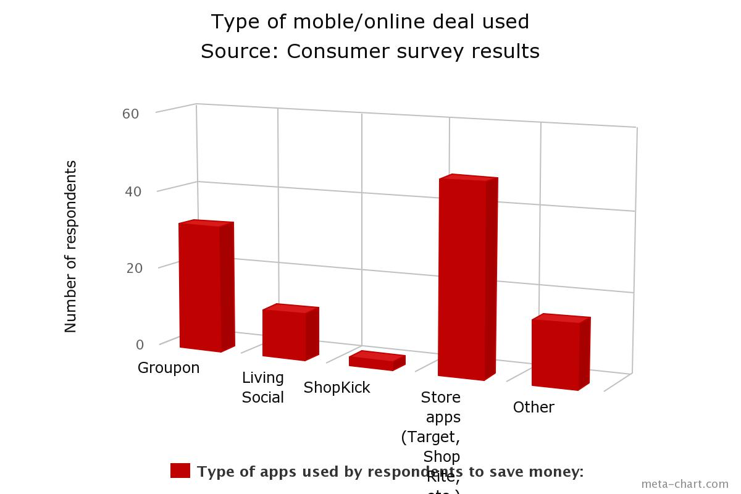

Figure 2: Types of purchases consumers like to save on with mobile coupons, N=141
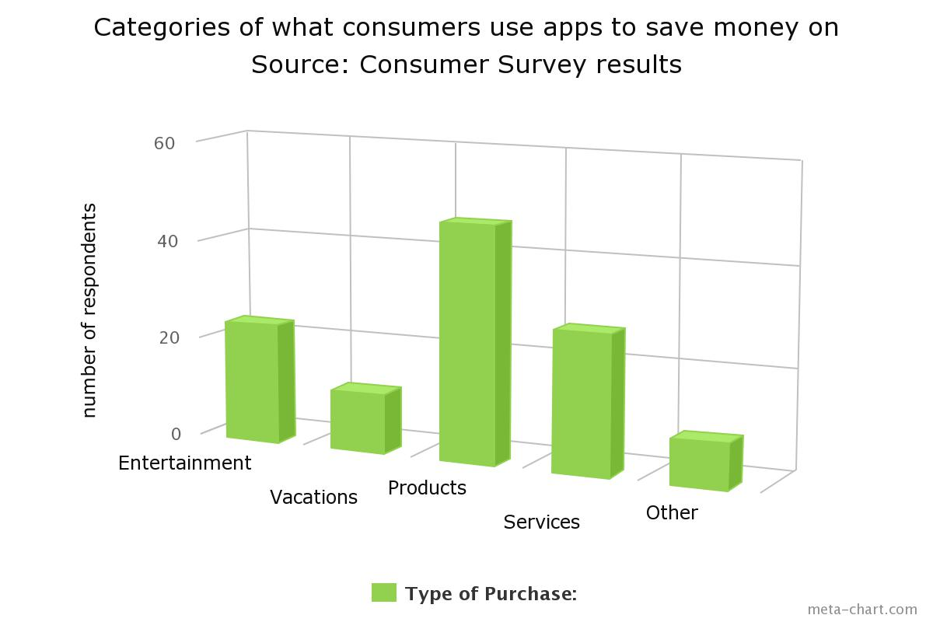

Figure 3: Consumer rating of coupon app experience, N=57
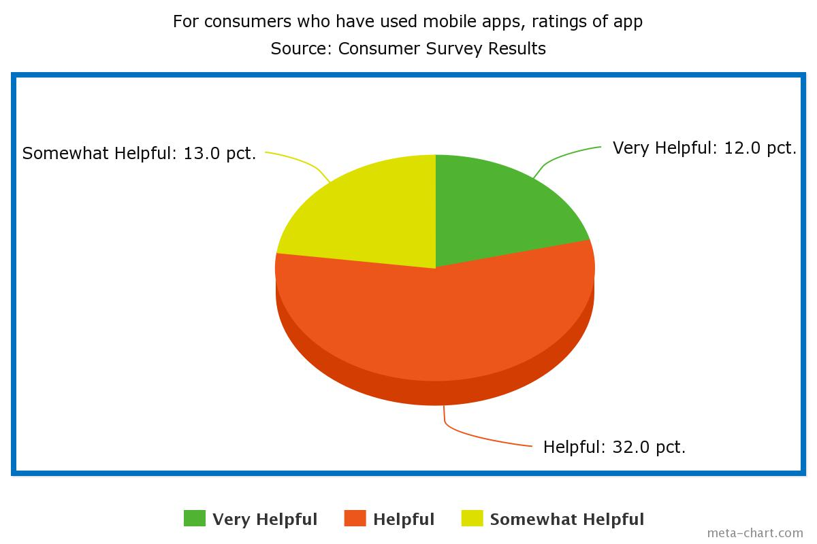

While the consumer survey data indicates that consumers desire Groupon deals and similar deals to save money and that those who use them are generally satisfied with the experience, the results of the small business survey reveal that the vast majority in the local sample pool have serious reservations about launching a Groupon-type deal for their particular business. Out of 50 business surveyed, only 26% had tried using an online deal and an additional 8% indicated that they had not yet used one, but that they were considering doing so in the future. Of those 26% that had used a deal, about half were satisfied while the other half were disappointed or neutral in terms of whether the deal attracted new customers. When those in the affirmative pool were asked how they tracked Groupon customers to see if they returned or if the Groupon deal customers spent any additional money beyond the money paid for the deal, all of them were unsure of specific percentages and numbers, but those that had a more favorable experience said that yes, the deals attracted new customers and that some of them returned after the deal expired, which is positive. At this point in the research process, we don’t have any significant insight from those who have used a deal in our survey pool, and we will reach back out to them to see if they are willing to share more about their experience, and at the same time identify more local businesses who have used deals in order to get more qualitative data.
We did glean some insight from a few owners who have not used a Groupon deal and who say they would not consider doing so. These 3 businesses were in the restaurant category, and the reasons they cited for not considering a Groupon or other online/mobile deal is due to bad experiences they had heard about anecdotally from colleagues in the industry and also “horror” stories in the media about food businesses that had lost $10,000 and upwards due to a Groupon deal that was not well planned and executed. One of these restaurant owners said that she thought a Groupon deal could be more useful for a service-based business, such as a salon, where the loss of revenue to the discount and the percentage fee to Groupon or other deal-provider, would not entail actual losses on physical products. Of the 13 respondents that responded that they have used a Groupon deal, eight of them were between 25-34 years old, three were between 35-44 and two were between 45-54. For the businesses with older owners, it was usually a younger employee or family member in charge of digital media on online/mobile coupon deals. The majority were family owned businesses that had been in business for varying time periods (see Table 2), with no seeming correlation between age of the business and use of and satisfaction with the deal. In order to identify any type of pattern, a much larger sample is necessary, but at this state the researchers feel that the type of planning and preparation related to the Groupon deal had a direct influence on success of the deal and level of satisfaction afterwards.

Table 1: Data on business owners who used Groupon Deals
Category | Satisfied (1-5 scale w. 5 very satisfied) | Race/ethnicity | Owner’s age | Longevity of Bus (yrs)
Services-co-working space | 4 | White | 25-34 | 1.5
Product | 3 | No answer | 35-44 | 2
Restaurant | 4 | Asian | 45-54 | 11
Restaurant | 5 | Hispanic | 25-34 | 10
Restaurant | 2 | White | 25-34 | 8
Services-Real Estate | 2 | Hispanic | 25-34 | 5
Restaurant | 2 | White | 35-44 | 38
Restaurant | 5 | Black | 35-44 | 55
Restaurant | 1 | Asian | 25-34 | 5
Product | 5 | Asian | 25-34 | 40
Services-IT/Web | 3 | Asian | 25-34 | 7
Product | 3 | White | 45-54 | 6
Restaurant | 3 | White | 25-34 | 47

V. Limitations
There are several limitations to this study, including the convenience sample for the consumer survey and the limited geographic area and relatively low number of respondents for the small business survey. In addition, at this point in time the data has not been put through rigorous quantitative analysis, but the purpose of an early presentation is to seek input from colleagues on relevant analyses and theoretical contributions prior to the advent of mobile commerce research that might be applicable here.
For the small business surveys conducted in person, several business owners initially responded that yes, they had used a Groupon or other mobile deal, but when the research team clarified that we were asking if they used an offer for the business and not as a consumer for other businesses, they changed their answer to no. The team may contact these respondents again, since they were clearly familiar with social coupon apps and had used them as customers, but had not yet used them for their businesses. In addition to increasing the survey pool of business owners, we will also seek additional qualitative data from the owners that have used mobile deals. In spite of the limitations, the qualitative findings in terms of perceptions of owners and consumers are worth exploring further.

VI. Recommendations and Future Research
Based on the preliminary findings, the authors would recommend the trial of an online/mobile deal for a service-oriented business that would not lose a significant amount of money per unit and that the total amount of deals sold is very limited. Dance classes, children’s gyms, hotels and inns, salons, martial arts and yoga studios, are examples of businesses that could benefit from mobile deals.
However, for product-based businesses, including restaurants, we recommend that owners use Groupon and related deals with caution, since the redemption of the deals can lead to initial financial losses, depending on whether the revenue generated and kept by the business (after the steep discount and revenue sharing) is greater than the marginal cost of running the deal. In addition, since running a deal might impact quality and consumer satisfaction (Yang, 2013) and hurting the business’s reputation, owners should carefully consider options and plan well.
For all business owners considering using an online deal, it’s important to track the success of the deal and the conversion rate of customers. Are they new customers? Do these customers return/are they retained? What is the lifetime value of the customer? Technology makes this easier, but not all business owners have the internet in their businesses and would know how to make sense of the data in order to evaluate effectiveness. In order to exploit the potential benefit of running a Groupon deal, since the sales generated are not likely to lead to short-term profit, there must be a strategy in place to gather contact information on first-time customers, who only came to the business via the Groupon deal and reach out to them to try to convert them into a return customer, even without the benefit of the significant price cut.
Groupon deals can be especially helpful for new businesses with little brand recognition in the local market. Potential customers may not be aware of new businesses, but Groupon’s social network can help get the business and brand name out to consumers who fit a certain profile.
Consumers are embracing mobile app-based coupons and deals, and while only 42% of respondents report they use apps to save money, of that category more than 40% use them more than 3 times per month and report that the apps are helpful or very helpful. There is a lot of room for growth in the realm of online deals and savvy business owners can create their own marketing campaigns and deals using other platforms, such as Facebook, in order to avoid the revenue-sharing component of Groupon and Amazon Deals.
When designing the deal itself, studies have found that offering a dollar amount for purchase, such as offering $100 worth of services for $50, is a better bet than offering a freebie, such as a free haircut, since freebie deals are less likely to lead to customers spending any additional money beyond the cost of the Groupon deal (Dholakia, 2012). The dollar deal is more conducive to cross-selling opportunities as well. Staff and employees should be prepared to engage customers who come as a result of a mobile coupon and work to enhance satisfaction with the experience, thus leading to repeat purchases and sales.
As a final thought, Groupon and online coupons are not a magic bullet, nor are other digital media that many business evangelists tout as amazing new ways to target and attract consumers. They may be, but only if they are built around a solid marketing strategy that gathers and analyzes data along the way. With online deals, owners should be very conservative in terms of the number of deals offered at any given time in order to avoid filling the business to over-capacity, which will lead to stress, unsatisfied customers and a lose-lose situation (except for Groupon).

Works Cited

Anthes, Gary. 2011. Invasion of the Mobile Apps. Communications of the ACM 54(9),
16-18. Business Source Premier.

Brynjolfsson, E., Hu, Y. J., and Rahman, M. S. 2013. Competing in the age of

omnichannel retailing. MIT Sloan Management Review, 54(4). Accessed Nov. 10, 2014 from < http://sloanreview.mit.edu/article/competing-in-the-age-of-omnichannel-retailing/>

Byers, J. W., Mitzenmacher, M. & Zervas, G. 2012. The Groupon effect on Yelp ratings:

A root cause analysis. In Proceedings of the 13th ACM Conference on Electronic Commerce, New York, NY, USA, pp. 248–265. ACM.

Dholakia, U. M. 2011. How Businesses Fare with Daily Deals: A Multi-Site Analysis of

Groupon, Livingsocial, Opentable, Travelzoo, and BuyWithMe Promotions. Available

at SSRN: http://ssrn.com/abstract=2091655 orhttp://dx.doi.org/10.2139/ssrn.2091655

Edelman, B., Jaffe, S. & Kominers, D. 2011. To Groupon or Not to Groupon: The

Profitability of Deep Discounts. Working Paper, Harvard Business School. Accessed

Dec. 1, 2014 from < http://www.hbs.edu/faculty/Publication%20Files/11-

063_42425cdb-81ee-4d66-9420-4ebdb809358f.pdf>

Einav, L., Levin, J., Popov, I., & Sundareson, N. 2014. Growth, Adoption, and Use of

Mobile E-Commerce. American Economic Review Papers and Proceedings. Accessed Dec. 1, 2014 from < http://web.stanford.edu/~jdlevin/Papers/Mobile.pdf>
Hazelton, B. 2009. History of E-Commerce. Spirecast. Spirecast, Inc. Accessed Apr. 26,
2014 from <http://www.spirecast.com/history-of-e-commerce/>
Lopez, M. 2012. Three trends that change business: Mobile, Social and Cloud." Forbes.
Accessed Apr. 26, 2014 from <http://www.forbes.com/sites/maribellopez/2012/01/28/ three-trends-that-change-business-mobile-social-and-cloud/>
Ogg, G. 2014. Is Everyone Turning Against Groupon? 24/7 Wall Street. Accessed Jan. 5,
2015 from <http://247wallst.com/investing/2014/08/06/is-everyone-turning-against-groupon/>
Naatus, M. 2014. The Yelp Effect: Impact of Online Reputation in the Digital Era.
International Journal of Business and Applied Sciences. Vol. 3(2), p. 49-64.

Reinhart, L. 2014. Consumer Perspectives of the Mobile Shopping Experience and
Digital Commerce. Unpublished Undergraduate Honors Thesis, Saint Peter’s University, Jersey City, NJ.
Roggio, A. 2011. Two Lessons that Groupon Can Teach Ecommerce Merchants.
Practical Ecommerce. Accessed Feb. 10, 2014,
<http://www.practicalecommerce.com/articles/2503-Two-Lessons-that-Groupon-Can-
Teach-Ecommerce-Merchants>.
Yang, H. 2013. Bon Appétit For Apps: Young American Consumers' Acceptance of
Mobile Applications.Journal Of Computer Information Systems 53(3), 85-95.

