Site Characterization for Soil and Groundwater Remediation using Electrical Resistivity Tomography: Case study of Korokoro Well-3, Rivers State, Nigeria

TKS Abam¹, FD Giadom², P Mogabo³ and IL Nwankwo⁴

- Institute of Geosciences and Environmental Management/ Centre for Advancement and Linkages, Rivers State University, PortHarcourt, Nigeria

Hydrocarbon Remediation Project (HYPREP), Portarcourt, Nigeria

Groundscan Services Nigeria Limited, Portharcourt, Nigeria

International Committee of the Red Cross, GRA, PortHarcourt, Nigeria

Abstract
Several years of hydrocarbon exploration and production and the associated oil spills in the Niger delta region have left extensive contaminated puddles concealed in the soils and groundwater. Oil spills on the surface and those trapped within the soil become weathered over time and sometimes degraded with exposure to solar radiation. The characteristic high rainfall in the region, exacerbated by pervious soil encouraged contaminant migration downwards until groundwater is intercepted. The most widespread method of intrusive soil characterization are expensive, time consuming and expose the subsoil and groundwater to further contamination. This study is focused on the use of non-intrusive Electrical Resistivity Tomography (ERT) in delineating contaminated areas. Multiple overlapping VES was acquired and analyzed using RES-3D and Earth-Imager softwares to generate geo-electric ground models. Resistivity signature for mature oil contamination was determined as cutoff and used to discriminate between hydrocarbon contamination and other geo-electric horizons. These ground models were further used to compute volumes of materials to be remediated. Predictions of ERT were validated by soil boring. Results suggest that ERT with its minimum footprint and negligible cost can become a standard method for the assessment and delineation of hydrocarbon polluted site.

Keywords: Site characterization, crude oil, pollution, remediation, Electrical Resistivity Tomography

Introduction

Following successful finds and export of crude oil in commercial quantities in 1957, the Niger delta became a theatre of intense oil Exploration and Production (E&P) (Fig.1). With active government collaboration, the entire region was divided into Oil Mining Leases (OML). The years that followed witnessed construction of extensive networks of pipelines, flow stations, refineries, oil depots etc. As these facilities aged beyond their service life, they became more susceptible to failure. Indeed, many oil spills have been attributed to equipment failure. Also, vandalization of oil and gas facilities have been widely reported and occasionally blamed for oil spills. Analysis of this statistics indicates that 77% of oil spills occurred in only three states (Fig. 2) and that about 43,000 barrels of oil were lost in 881 cases of oil spillage from 2019 to May 1 2022 (NOSDRA 2022).

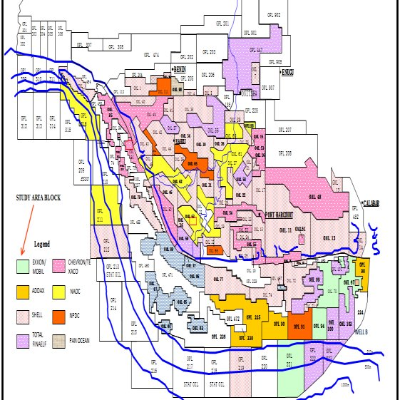

Fig.1: Map of Niger Delta showing OML Hectarages

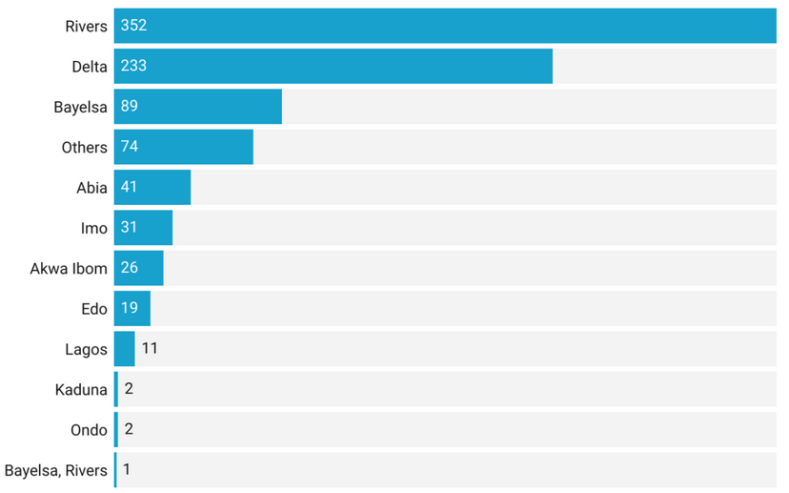
Fig. (2): The State by state distribution of Oil spill incidents is presented in

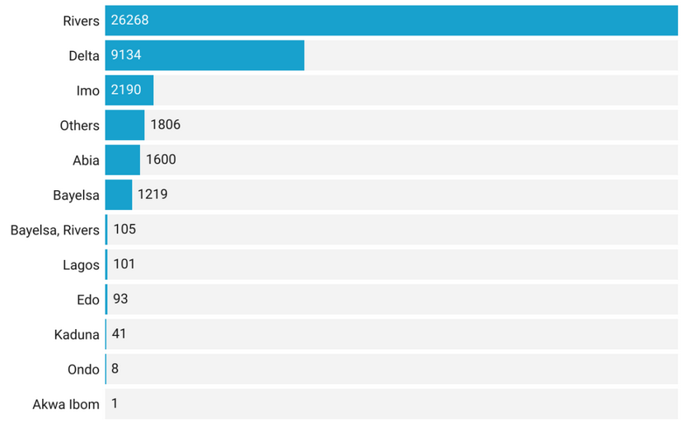
Fig. (3): State by state distribution of Oil spill volumes (Barrels)

By the governing laws, oil companies must close off oil spill sites within 24 hours of being notified of an oil spill on their fields. Regrettably, this is hardly the case in the region due to inaccessibility of some oil spill sites and lack of cooperation from the communities. Over time, these spills seep into the ground and contaminant soil and groundwater and become concealed from public view in the medium and long-terms. This paper explores the use of ERT, a non-intrusive technique with minimal footprint and cost to detect and quantify contaminated area and volumes.
The suitability of a non-intrusive technique such as electrical resistivity and ground penetrating radar for detecting crude oil have been evaluated by several authors (Olhoeft 1992, Sauck and Mcneil, 1994, Godio and Naldi 2003, Shevnin et al 2003, 2006, Arrubarrena-Moreno, Arango-Galván1;2013). The success of these tools clearly depends on both physical principles of the technique and on the nature of the anomalies. Crude oil contaminated soils do not necessarily produce significant density contrast with the surrounding environment as to promote gravity or seismic techniques. Electrical Resistivity Tomography measures resistivity which is a bulk physical property of materials that describes how difficult it is to pass an electrical current through the material. The Resistivity technique is a useful method for characterizing the sub-surface materials in terms of their electrical properties. Five critical aspects of the geological environment have been identified in conducting geoelectrical studies in relation to oil contamination (Arrubarrena-Moreno1 and Arango-Galván1; 2013)). These include: EM and/or geological noise level, depth of groundwater level, groundwater mineralization, age of the spill and physical conditions of the ground surface. The work of Shevnin and Delgado, (2002) clearly show that variations in electrical resistivity (or conductivity) typically correlate with variations in lithology, water saturation, fluid conductivity, porosity and permeability, which may be used to map stratigraphic units, geological structure, sinkholes, fractures and groundwater.
The resistivity contrast between an oil-polluted area and the surrounding rock depends on the spill age. The low resistivity anomaly in polluted areas appears three to four months after the spill (“mature spill”), but in the case of a fresh spill the presence of a high resistive anomaly is expected. Therefore, the age of spill influences the selection and optimization of the applied technology. Low resistivity findings in oil-polluted zones appeared rather recently (Sauck and McNeil, 1994; Modin et al., 1997; Sauck, 1998, 2000; Atekwana et al., 2001; Abdel-Aal et al., 2001). According to Sauck (1998), the source of low resistivity is a leachate from an acid environment, created by intense bacterial action on residual hydrocarbons near the base of the vadose zone. This low resistivity zone is produced by high total dissolved solids in the zone where microbial activity is maximal (Sauck, 1998; 2000; Atekwana et al., 2001). The leachate is a result of chemical reactions between organic
acids, CO₂ and mineral grains and grain coatings.
Clay materials, metallic oxides, and sulphide minerals are the only common sedimentary materials that can carry significant electrical current through the material itself. As such, the resistivity of most near surface sedimentary materials is primarily controlled by the quantity and chemistry of the pore fluids within the material. Any particular material can have a broad range of resistivity responses that is dependent on the level of saturation, the concentration of ions and the presence of organic fluids (Abdel-Aal, et al; 2001.
ERT requires a high data density and good coverage of the earth surface for high-resolution images of subsurface targets. Data processing is based on an iterative routine involving determination of a two-dimensional (2D) simulated model of the subsurface, which is then compared to the observed data and revised (Loke and Barker, 1996). Convergence between theoretical and observed data is achieved by non-linear least squares optimization. The extent to which the observed and calculated theoretical models agree is an indication of the validity of the true resistivity model (indicated by the final root-mean-squared (RMS) error).
The true resistivity models are presented as colour contour sections revealing spatial variation in subsurface resistivity. The 2D method of presenting resistivity data is limited where highly irregular or complex geological features are present and a 3D survey maybe required. Geological materials have characteristic resistivity values that enable identification of boundaries between distinct lithologies on resistivity cross-sections. At some sites, however, there are overlaps between the ranges of possible resistivity values for the targeted materials which therefore necessitate use of other geophysical surveys and/or drilling to confirm the nature of identified features.

Method of study
The acquisition of resistivity data involves the injection of current into the ground via a pair of electrodes and then the resulting potential field is measured by a corresponding pair of potential electrodes. As a precaution, electrodes are embedded properly since readings can be affected by poor electrical contact at the surface. An increased electrode array length is required to locate increased depths of interest therefore the site layout must permit long arrays. However, it must be understood that resolution of target features decreases with increased depth of burial.
The resistivity survey consisted of thirteen profiles, some of 200 m length, using a Wenner array. The field set-up requires the deployment of an array of regularly spaced electrodes, which are connected to a central control unit via multi-core cables. Resistivity data are then recorded via complex combinations of current and potential electrode pairs to build up a pseudo cross-section of apparent resistivity beneath the survey line. The depth of investigation depends on the electrode separation and geometry, with greater electrode separations yielding bulk resistivity measurements from greater depths. The sequence of measurement adopted for the ERT is as shown in Fig. (4).

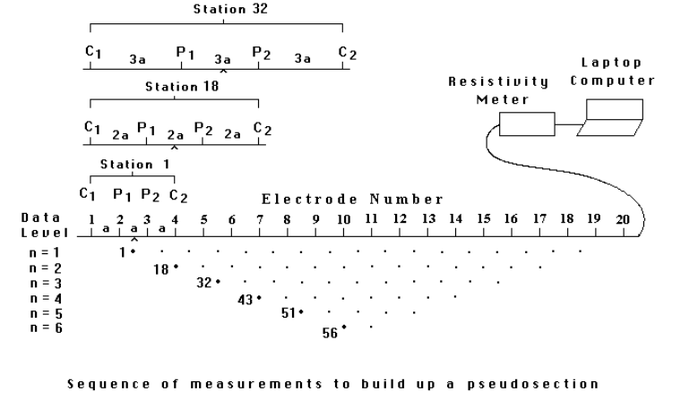
Fig. 4. The arrangement of electrodes for a 2-D electrical survey and the sequence of
measurements used to build up a pseudosection.

The same process is repeated for measurements with “3a”, “4a”, “5a” and “6a” spacing. To obtain the best results, the measurements in the field were carried out in a systematic manner so that, as far as possible, all the possible measurements are made to ensure a reliable interpretation. According to Dahlin and Loke (1998) this will enhance the quality of the interpretation model obtained from the inversion of the apparent resistivity measurements.
ERT data are rapidly collected with an automated multi-electrode resistivity meter. The recorded data are transferred to a PC for processing. The process of geological noise filtering by the Median algorithm has been described before (Modin et al., 1997; Ritz et al., 1999, Shevnin et al., 2002). This operation is based on characteristics of distortions caused by superficial inhomogeneities. The algorithm was checked and adjusted on modeling and field data and has now about ten years of practical application. In order to derive a cross-sectional model of true ground resistivity, the measured data are subject to a finite-difference inversion process via RES2DINV (ver 5.1) software. ERT profiles consist of a modeled cross-sectional (2-D) plot of resistivity (Ω·m) versus depth. ERT interpretations, supported by borehole data or alternate geophysical data, accurately represent the geometry and lithology and/or hydrology and/or petrology of subsurface geologic formations
Results and Discussions

Investigations followed a 2-prong approach using the non-intrusive Vertical Electrical Sounding to predict occurrence of contaminated soil/water and then deploying the intrusive boring to confirm the prediction of the ERT. The design of the survey lines was informed by understanding of the possible mechanism of contaminant dispersion. In this case, it was understood that the spills emanated from the Well head and were spread on the surface, implying that the topography would provide indication as to the possible directions of surface dispersion. This led to a topographic survey (Fig.6) which greatly assisted in the construction of a conceptual model (Fig.7). On the basis of the conceptual model, and considering the necessity for good spatial coverage, an initial layout of the survey lines was determined (Fig.8).

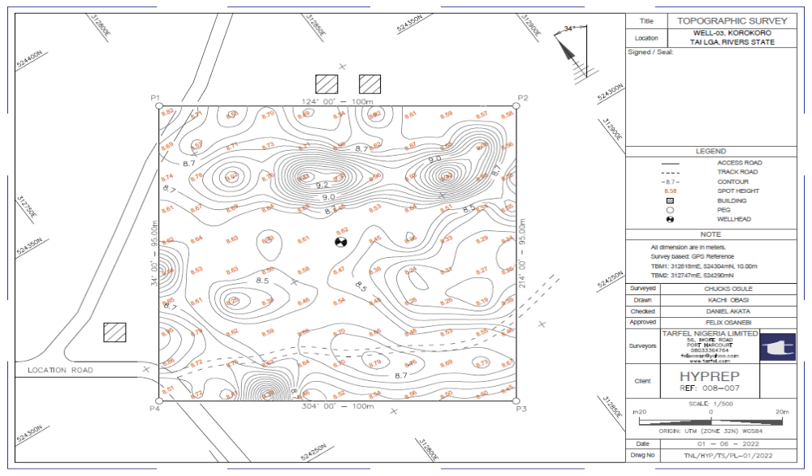

Fig. (6) Topographic contours around the Korokoro Well 3

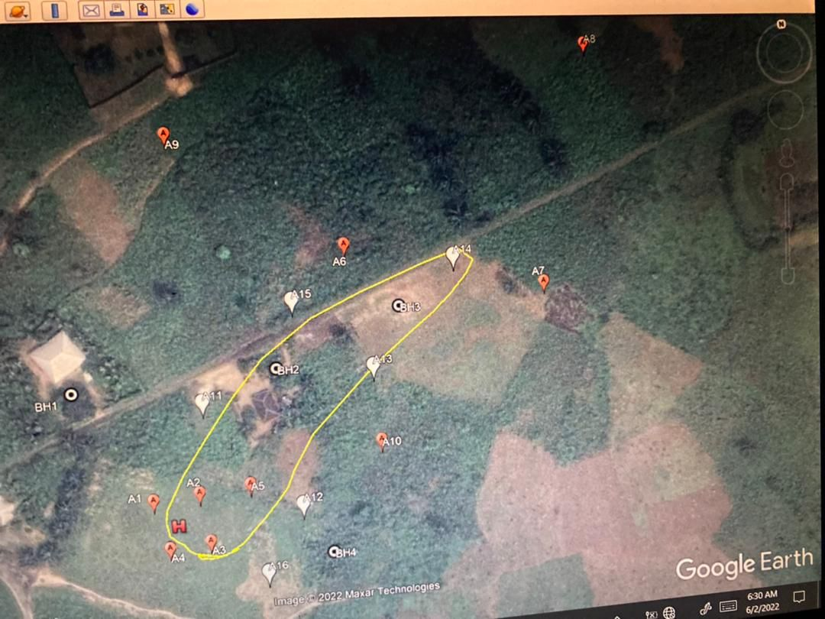

Fig. (7) Conceptual modeling of surface runoff

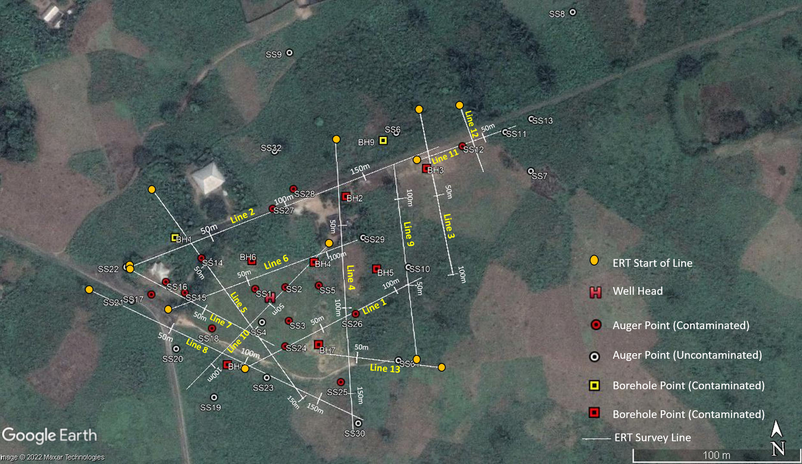
Fig. (8) ERT Survey lines

These surveys are made to intercept each other as much as possible to enable concatenation of the lines. The results of pseudo section and tomographs based on the electrical resistivity are selectively presented in Fig. (9 to 12). Three types of images are used frequently for analysis of a geoelectrical situation, i.e. vertical apparent resistivity cross-sections along profiles, apparent resistivity maps and statistical apparent resistivity distributions. All imaging is performed after removing the geological noise.

The vertical cross-section of apparent resistivity is a traditional presentation for soundings along a profile.

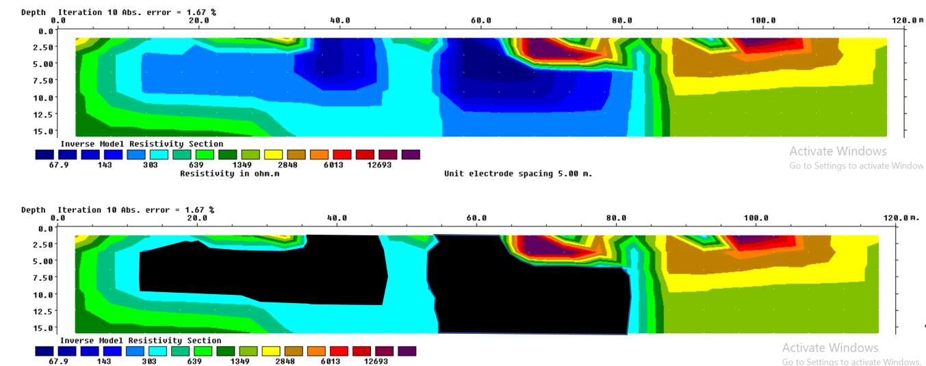

Fig. (9) Electrical Resistivity Tomographs from Geo-electric Profiles of Line 1

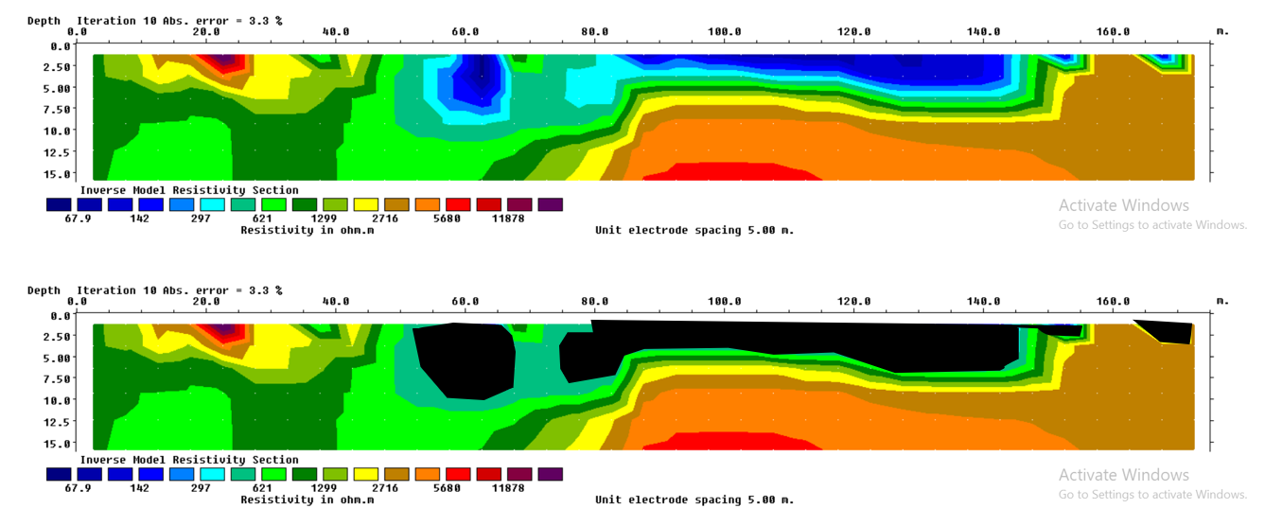
Fig. (10) Electrical Resistivity Tomographs from Geo-electric Profiles of Line 2

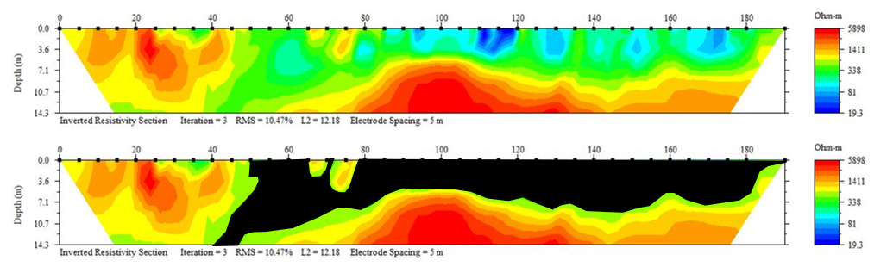
Fig. (11) Processed electrical resistivity tomogram for Line 2 using Earth-Imager software (dark area highlited on second tomogram shows oil contaminated zones with resistivity values ≤600 Ωm)

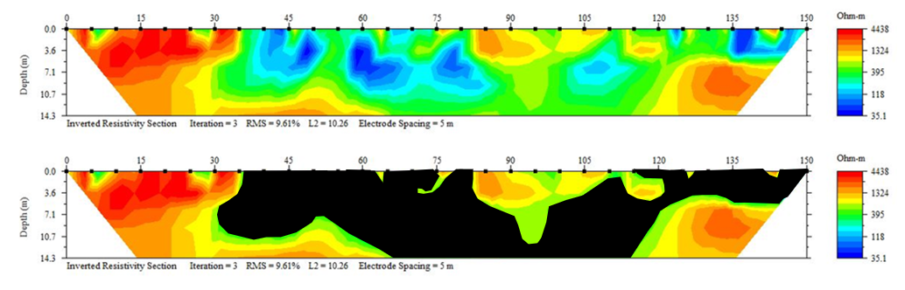
Fig. (12) Processed electrical resistivity tomogram for Line 5 using Earth-Imager software (dark area highlited on second tomogram shows oil contaminated zones with resistivity values ≤600 Ωm)

Based on the tomographs, the lateral and vertical extents of contamination were delineated. For convenience, only a selection of these are presented in Figs (13 to 19).
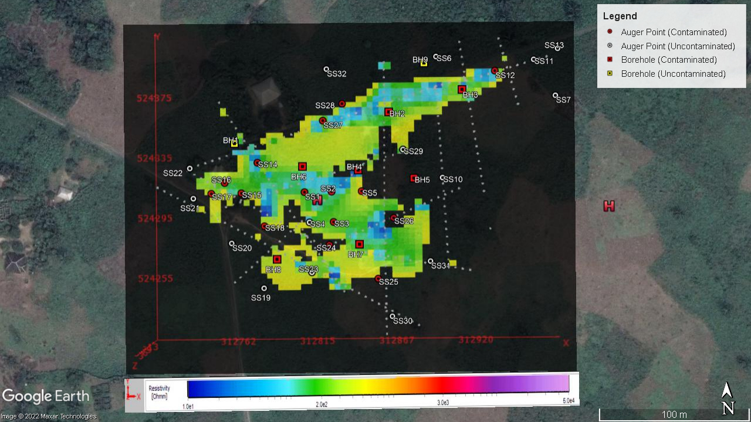
Fig. 13: Contaminated area at 1m Depth
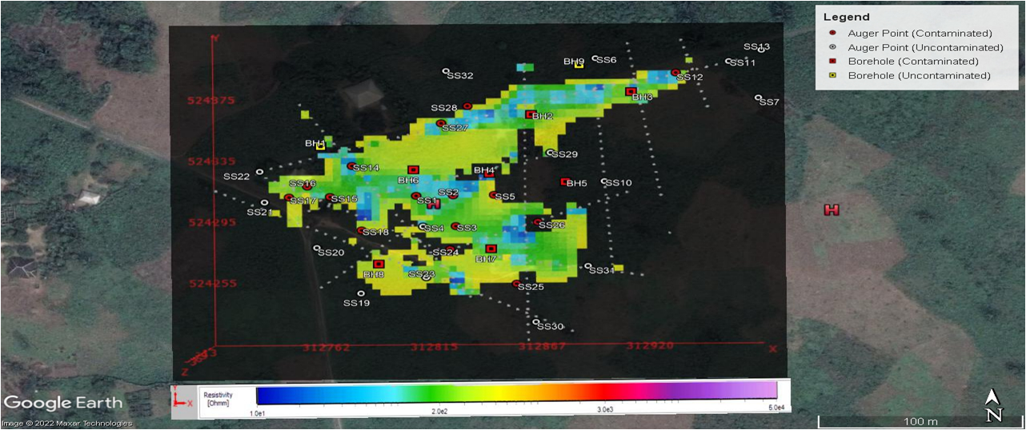
Fig. 14: Contaminated area at 2m Depth
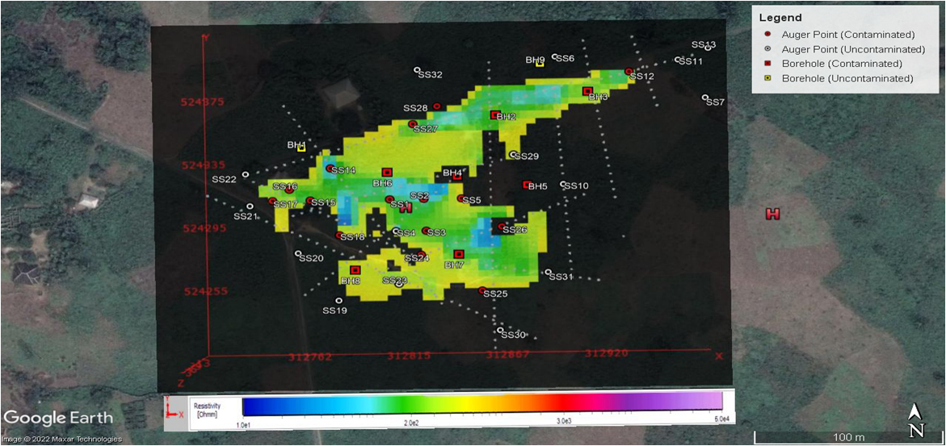
Fig. 15: Contaminated area at 3m depth
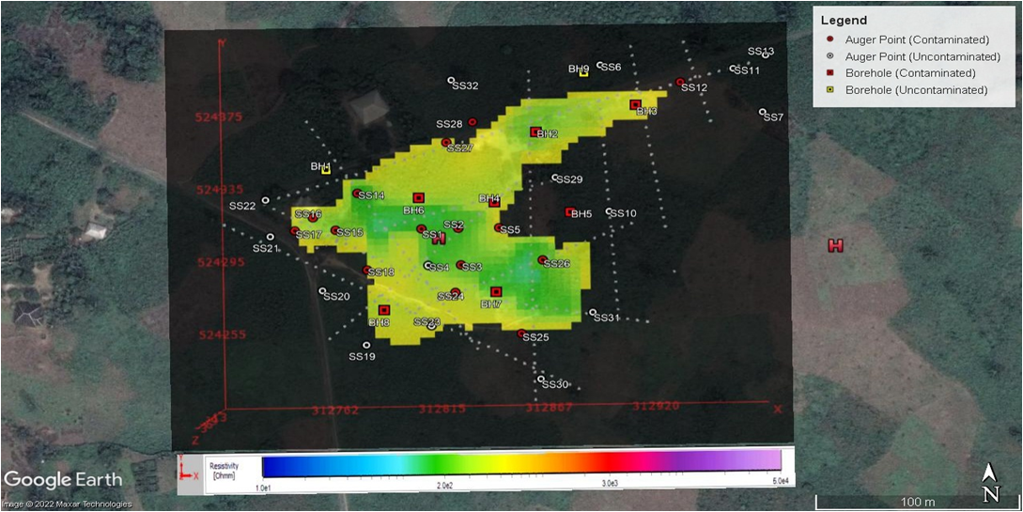
Fig. 16: Contaminated area at 5m depth
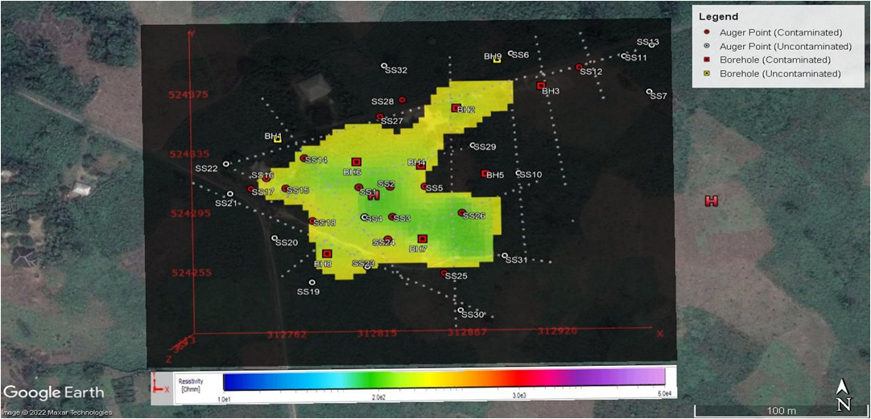
Fig. 17: Contaminated area at 8m depth
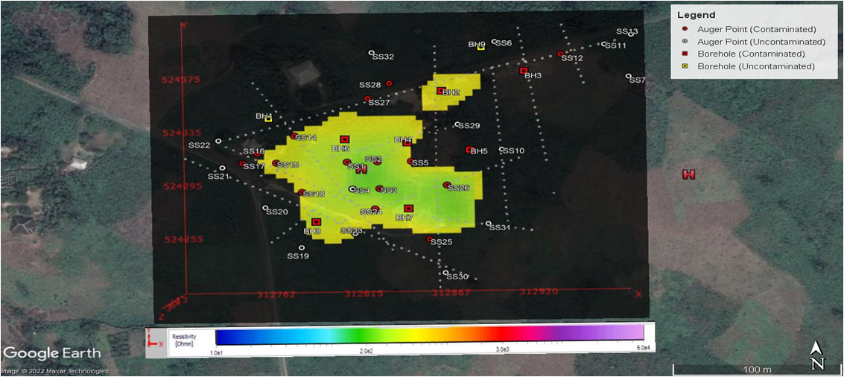
Fig. 18: Contaminated area at 12m depth
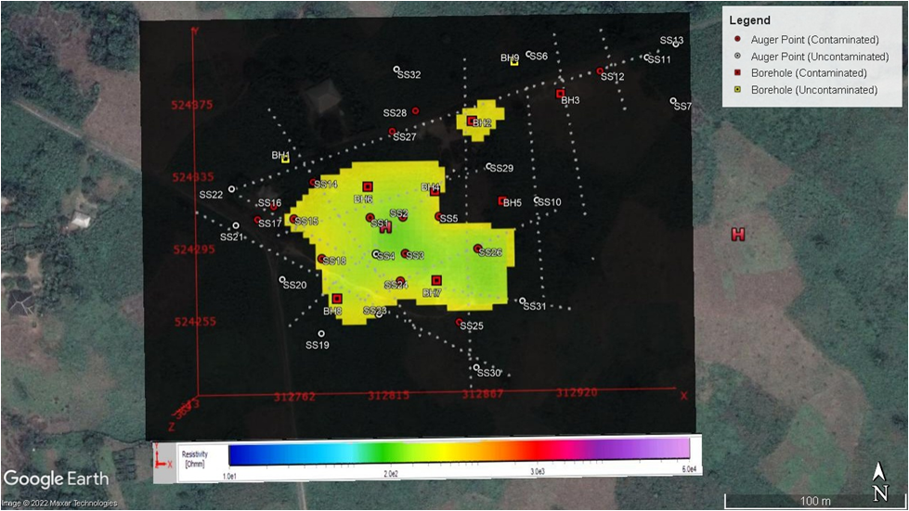
Fig. 19: Contaminated area at 16m depth

The auger boring and monitoring boreholes which were installed at positions as advised by the ERT served the purpose of not only confirming the ERT findings but also to monitor possible future migration of contaminants in the locality. Again, selected lithologs from both auger boring and monitoring wells are presented in Figs. (20 to 22).

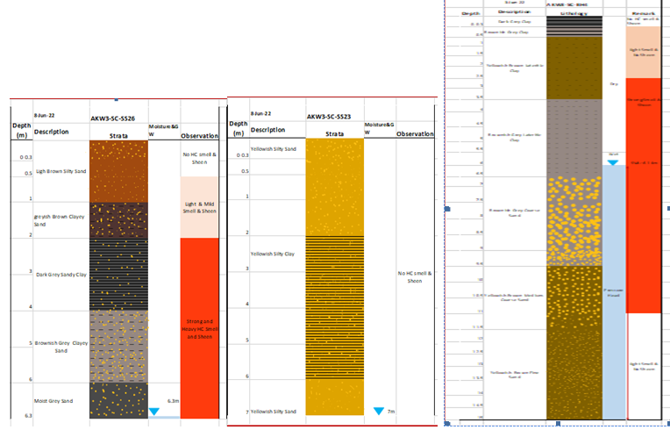
Fig.20: litholog showing contaminated zones for Hand Auger Boring 23/26 near ERT line-1

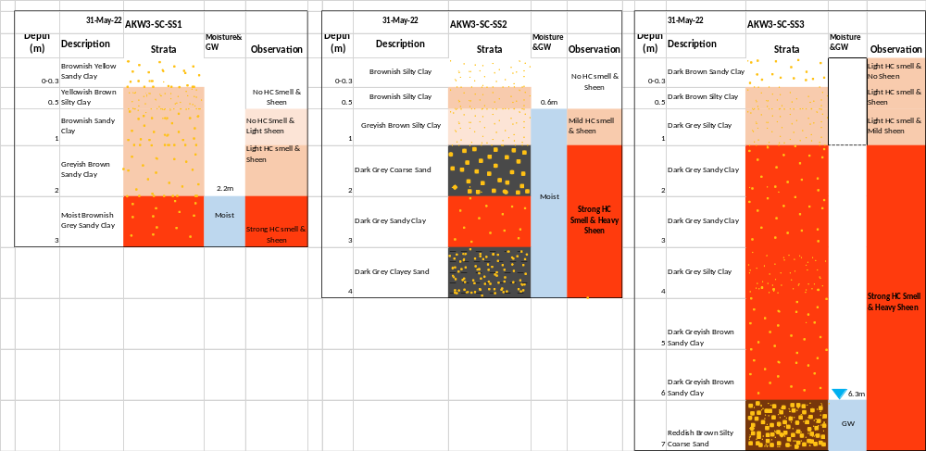

Fig.21: litholog showing contaminated zones for Hand Auger Boring 1/2/3 near ERT line-10

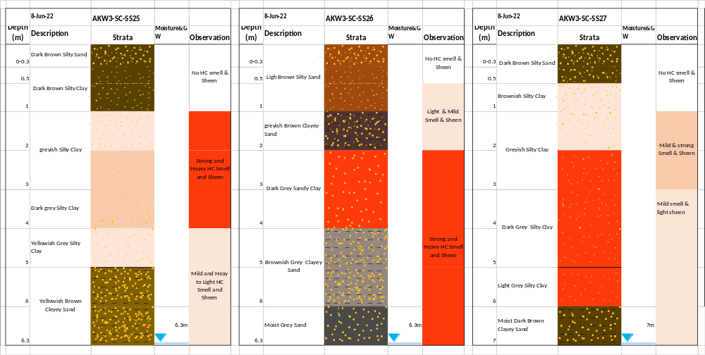

Fig. (22) litholog showing contaminated zones for Hand Auger Boring 25/26/27 near ERT line-1

A composite 3-D litholog from borings was generated to show both vertical and spatial distribution of contamination within the area of investigation (Fig. 23).
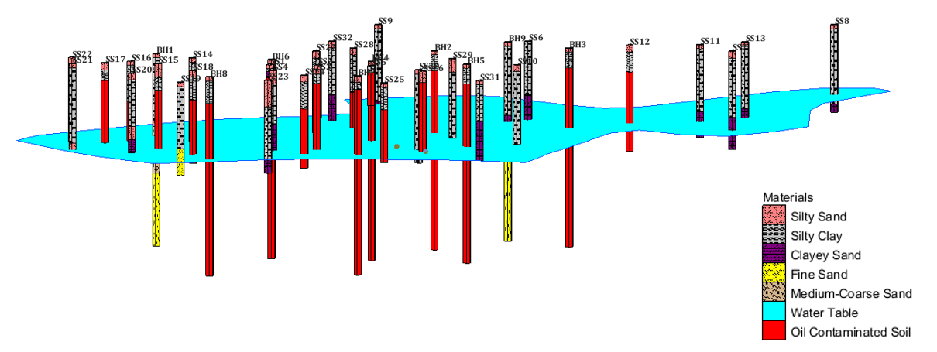
Fig.(23) Composite lithologs in 3-D Layout showing contaminated soil horizons

Based mainly on visual observation and smell, the generated detailed lithology (with hydrocarbon contamination sensing) were used to calibrate VES Geo-electric ground model. The spatial and vertical distribution of contaminated soil based on the combination of auger boring and monitoring wells is selectively presented in Fig. ( 24 to ).

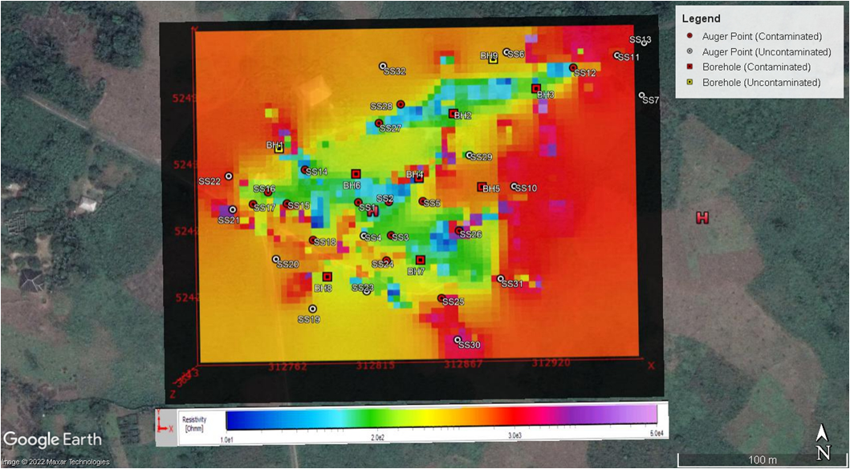
Fig. 24: Contaminant distribution at 1m depth
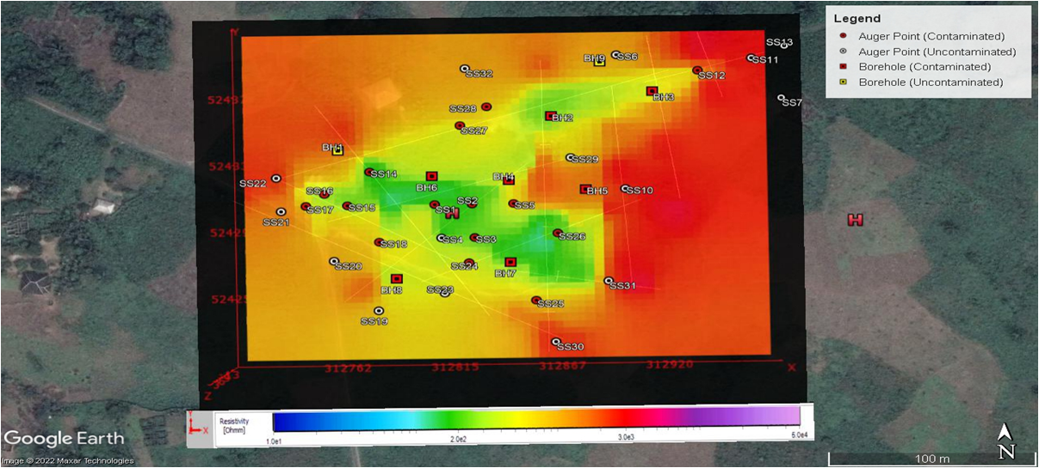
Fig. 25: Contaminant distribution at 5m depth

Using an alternate software, Earthpoint in conjunction with GoogleEarth, the total area of contaminated soils are precisely computed which in the case of Korokoro is 10,323 m² (Fig. 26).

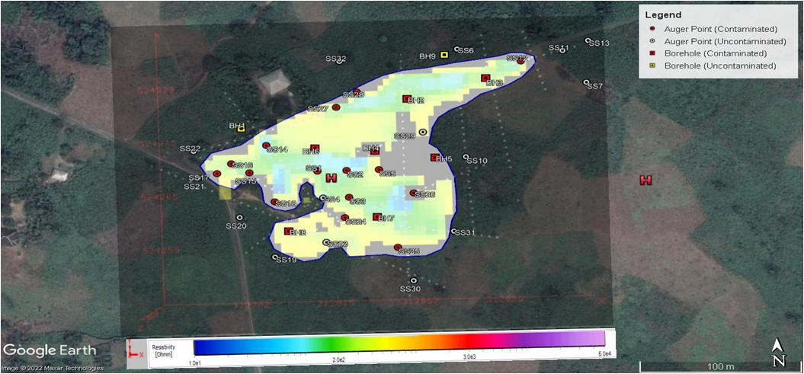
Fig. 26: Computed total contaminated area

Since this procedure can be repeated for each depth horizon, the total volume of soil contaminated by hydrocarbon can be precisely determined for remediation control.

In order to further explore risk assessment of the area, groundwater flow direction was determined by first measuring the spot height at the boring locations and reducing the measured groundwater level to datum. This resulted in the groundwater level contours indicating the equipotential lines from which indicative groundwater flow directions are drawn (Fig. 27).
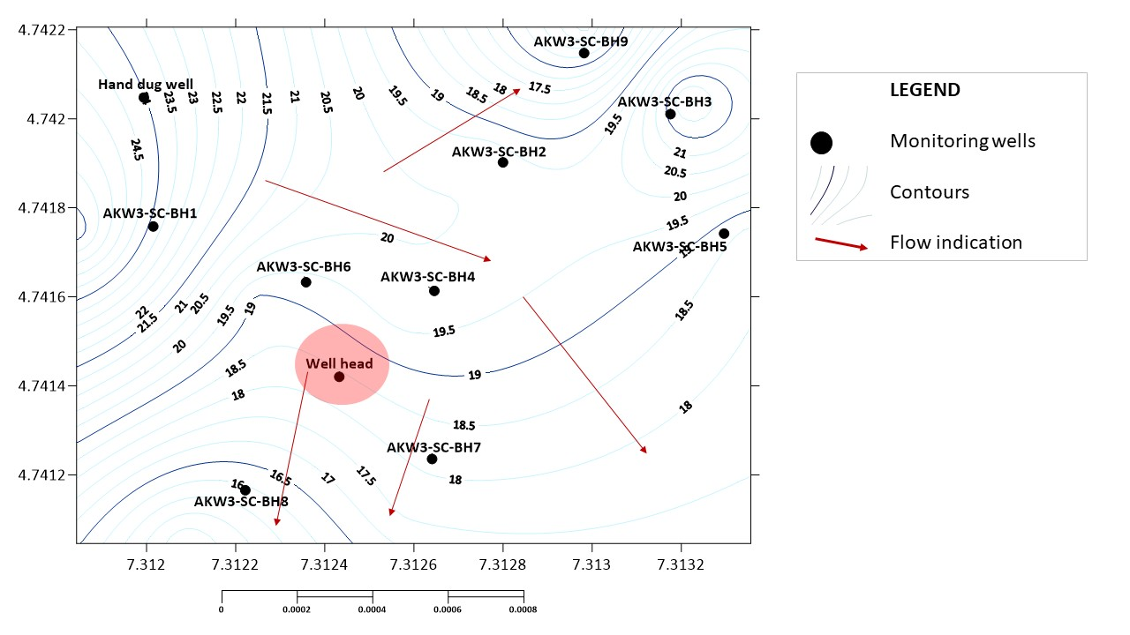
Fig.(27)Determination of groundwater flow direction

The monitoring wells installed were designed based on the understanding of the nature of the contaminant of concern and the environmental variables. Hydrocarbon is known to exist in three phases as contaminant free phase which largely floats on the surface of groundwater, dissolved phase which is in solution with groundwater and that which is co-mingled with soils. The monitoring well (Fig. 28) has therefore been designed to promptly register the presence of contaminant irrespective of the phase and takes into account the seasonal variability of the groundwater level.

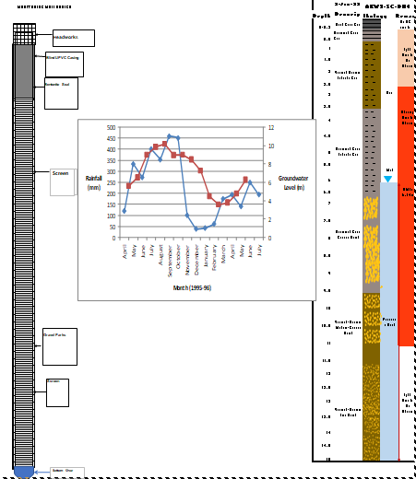

Fig. (28) Design of monitoring wells

Conclusion
Assessment of the source and geometry of contaminated soils by hydrocarbon spills is the first step towards designing an effective remediation programme. Accurate interpretation of geoelectric profiles and tomographs in the Niger Delta requires knowledge of the lithology of the site of contamination which could easily be obtained by shallow drilling or pitting

ERT deserves an increased attention since it is a low-cost and high-resolution technique that can rapidly image states and processes. ERT has also proved effective in the identification of contaminated zones with medium fraction hydrocarbons. The comparison between the results obtained with the hydrocarbon concentration in the soil and the geophysical models was effective in showing that higher hydrocarbon concentration is related to lower resistivity values, as has been already suggested by several authors. Finally, the effectiveness of the method depends on basic knowledge of the geology of the area.

Repetition of the characterization process with time intervals on the order of one year may help to monitor the effectiveness of an eventual remediation process. Comparison between chemical and geophysical data allow us to assess the sensitivity of the physical property to the presence of the contaminant, and it was possible to visualize that electrical resistivity varies depending on volume and residence time of the hydrocarbon in the ground.

References
- Abdel-Aal, G. Z., D. D. Werkema, W. A. Sauck JR. and E. Atekwana, (2001). Geophysical investigation of vadose zone conductivity anomalies at a former refinery site, Kalamazoo, MI. In: Proceedings of the Symposium on the Application of Geophysics to Engineering and Environmental Problems, 1–9

- Atekwana, E., D. P. Cassidy, C. Magnuson, A. L. Endres, D. D. Werkema, JR. and W. A. Sauck, (2001). Changes in geoelectrical properties accompanying microbial degradation of LNAPL. In: Proceedings of the Symposium on the Application of Geophysics to Engineering and Environmental Problems, 1–10.

- Bailey, N. J. L., H. R. Krouse, C. R. Evans and M. A. Rogers, (1973). Alteration of Crude Oil by Waters and Bacteria - Evidence from Geochemical and Isotope Studies. Am. Assoc. Petrol. Geol. Bull., 57, 1276 –1290.

- Blome, M., Maurer, H. and Schmidt, K. (2009), Advances in three-dimensional geoelectric forward solver techniques. Geophys. J. Int. 176: 740-752, 2009.

- Blome, M., Maurer, H. and Greenhalgh, S., Geoelectric experimental design – Efficient acquisition and exploitation of complete pole-bipole data sets. Geophysics 76: F15-F26, 2011.

- Dahlin, T. and Loke, M. (1998) Resolution of 2-D Resistivity Imaging Wenner as Assessed by Numerical Modeling. Journal of Applied Geophysics, 38, 237-249.
https://doi.org/10.1016/S0926-9851(97)00030-X

- Godio, A., Naldi, M., (2003), Two-dimensional electrical imaging for detection of hydrocarbon contaminants: Near Surface Geophysics, 1, 131-137.

- Gunther, T., Rucker, C. and Spitzer, K., (2006) 3-d modeling and inversion of DC resistivity data incorporating topography - Part II: Inversion. Geophys. J. Int. 166: 506-517, 2006.

- Keller, G. and F. Frischknecht, (1966). Electrical Methods in Geophysical Prospecting. MODIN, I. N., V. A. SHEVNIN et al., 1997. Investigations of oil pollution with electrical prospecting methods. In:Proceedings of the 3rd EEGS-ES Meeting. Aarhus, Denmark, 8-11 September 1997, 267-270.

- LaBrecque, D. J., Miletto, M, Daily, W., Ramirez, A. and Owen, E.,(1996) The effects of noise on Occam’s inversion of resistivity tomography data, Geophysics 61; 538? 548, 1996.

- LaBrecque, D. J., and Yang, X., Difference Inversion of ERT Data: a Fast Inversion Method for 3-D in Situ Monitoring: J. Environ. Eng. Geophys. 6: 83, 2001.

- Loke, M.H., (2010), Tutorial, 2D and 3D electrical imaging surveys: available on <http://www.landvizer.biz/forall/RES2DINV/CourseNotes.pdf>

- Loke, M.H., Barker, R.D., (1996), Rapid least-squares inversion of apparent resistivity pseudosections using a quasi-Newton method: Geophysical Prospecting, 44, 131-152.

- Manuel Arrubarrena-Moreno1, Claudia Arango-Galván1(2013) Use of electrical resistivity tomography in the study of soil pollution caused by hydrocarbons: Case study in Puebla (México) Boletín de la Sociedad Geológica Mexicana Volumen 65, núm. 2, 2013, p. 419-426

- Nash, M. S., E. Atekwana and W. A. Sauck, (1997). Geophysical investigation of anomalous conductivity at a hydrocarbon contamination site. In: Proceedings of the Symposium on the Application of Geophysics to Engineering and Environmental Problems, 675-683

- NOSDRA (2022) Nigerian Oil Spill Monitor 2022 Edition. https://nosdra.oilspillmonitor.ng/

- Olhoeft, G. R., (1992). Geophysical detection of hydrocarbon and organic chemical contamination. In: Proceedings of the Symposium on the Application of Geophysics to Engineering and Environmental Problems, 587-595.

- Ritz, M., H. Robain, E. Pervago, Y. Albouy, CH. Camerlynck, M. Descloitres and A. Mariko, (1999). A. Improvement to resistivity pseudosection modeling by removal of near-surface inhomogeneity effects: application to a soil system in south Cameroon". Geophys. Prospect., 47, 85–101.

- Rucker, C., Gunther, T. and Spitzer, K., 3-d modeling and inversion of DC resistivity data incorporating tomography - Part II: Inversion. Geophys. J. Int. 166: 495-505, 2006.

- Sauck, W. A. and J. Mcneil, (1994). Some problems associated with GPR detection of hydrocarbon plumes; Fifth International Conference on Ground Penetrating Radar (GPR’94).

- Sauck, W. A., (1998). A conceptual model for the geoelectrical response of LNAPL plumes in granular sediments. In: Proceedings of the Symposium on the Application of Geophysics to Engineering and Environmental Problems, 805-817.

- Shevnin, V., A. Ryjov, E. Nakamura, A. Sánchez, V. Korolev and A. Mousatov, 2002. Study of oil pollution in Mexico with resistivity sounding. In: Proceedings of the Symposium on the Application of Geophysics to Engineering and Environmental Problems.

- Shevnin, V. and O. Delgado, (2002). Application of resistivity sounding method for oil pollution study in urban and rural areas. In: Proceedings of the Symposium on the Application of Geophysics to Engineering and Environmental Problems.

- Shevnin, V., Delgado-Rodríguez, O., Fernández-Linares, L., Zegarra- Martínez, H., Mousatov, A., Ryjov, A., (2005), Geoelectrical Characterization of an oil-contaminated site in Tabasco, Mexico: Geofísica Internacional, 44, 251-263.

- Shevnin, V., Delgado-Rodríguez, O., Mousatov, A., Flores-Hernández, D., Zegarra-Martínez, H., Ryjov, A., (2006), Estimation of soil petrophysical parameters from resistivity data: Application to oil-contaminated site caracterization: Geofísica Internacional, 45, 179-193.

- Vladimir Shevnin, Omar Delgado-Rodríguez, Aleksandr Mousatov, Edgar Nakamura-Labastida and Abraham Mejía-Aguilar (2003) Oil pollution detection using resistivity sounding. Geofísica Internacional (2003), Vol. 42, Num. 4, pp. 613-622

