Design and construction of gabions for shoreline protection: a case review of Diobu Creek, PortHarcourt, Nigeria

Tamunoene KS Abam⁺, Dakori AK George*, Benjamin S Udota**, Ifeyinwa L Nwankwo** and Victor A Ichi*

+Institute of Geosciences and Environmental Management/ Centre for Advancement and Linkages, Rivers State University, PortHarcourt
E-mail: abam.kingdom@ust.edu.ng,

*Bureau for Special Projects, Point Block, Secretariat Complex, PortHarcourt, Rivers State, Nigeria

**Groundscan Services Nig. Ltd, Lydia Abam Lane, Peter Odili Road, PortHarcourt, Nigeria

Abstract
This paper presents the shoreline protection component of the integrated improvement of the Creek involving dredging, reclamation, creation of navigation paths and shoreline protection. The superficial geology beneath the riverbed consists of very soft to soft (0-4m) and medium size sand of medium relative density (4-30m). The design of the shoreline protection involved (i) sand filling and regrading of the riverbank slope, excavation of the very soft to soft layers upto 2m below LLW to a suitable firm formation for the installation of a stone base footing and foundation, placement of the prefabricated-tensioned zink coated baskets, placement of crushed stone base and the construction of anchor beams. The paper also highlights the challenges of construction below water level, the strategies for management of saturated soft sediments, geotechnical stability considerations for slope selection, the sizing of the stone base against the basket mesh and the depth of embedment of the shoreline protection foundation.

Keywords: Shoreline erosion protection, gabion, geotextiles, riverbed, stability

Introduction

Rivers are a resource and serve other important functions such as recreation and transportation. The Diobu Creek is one of three major arterial channels that drain the city of Port Harcourt and continues to support flood control efforts. The Creek traverses the GRA, the Building material sections of Mile 3 Market, the Ikoku Mechanics workshops and Mile 1 Market (Fig. 1); with diverse occupational activities and wastes make up. With a long history of enduring poor waste management practice, the creek has transported waste debris of diverse composition most of which have now been deposited in its channel (Fig.2). With over 100 years of silting monotonically without any maintenance, the creek channels have widened to accommodate the discharge, causing erosion in the process. Such shoreline changes would have been evaluated as in several region wide shoreline surveys in which Remote sensing has been used [Kumaravel et al, 2013, Vinayaraj et al 2011, Le Cozannet et al; 2013, Muthukumarasamy 2013], to provide quantitative estimation of coastal changes along selected reaches [Vinayaraj et al 2011]. Thus, it became imperative to develop an integrated plan of river improvement with a strong shoreline protection component.

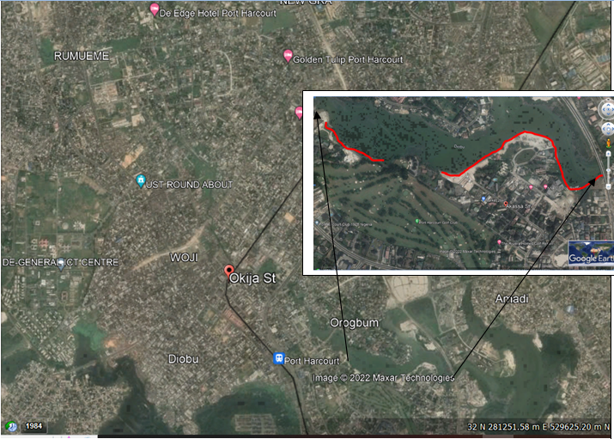

Fig. (1) Section of Shoreline protected

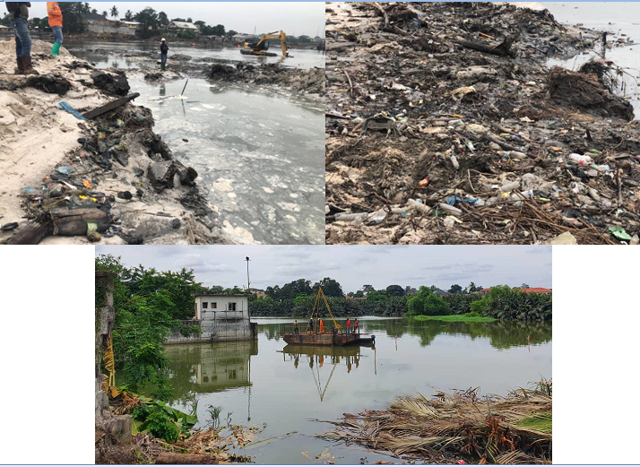

Fig.2: Different make up of debris in Diobu Creek

There are economic, natural protection, erosion prevention reasons why it’s important to have a stable shoreline. Not only is visiting local beach areas a popular pastime, many people build homes along the shore. The shores and beaches are also economically important, providing income from fishing, boating, tourism and more. Besides, shore protection is important for preserving the natural resources and investments along the shores of creek. Shorelines are their own ecosystem, and protecting them is critical for preserving the health and diversity of the area’s fish and wildlife. By protecting the natural shoreline, we can protect the key functions and values provided by this essential ecological transition zone.
Types of Coastal Protection
Coastal protection is deemed necessary to protect the completed profile of the reclaimed land. Coastal protection prevents erosion caused by wave, current, tide and flooding by the open sea. On the other hand, coastal protection also protects leaching of reclaimed material from the reclaimed land, which could occur because of groundwater flow. Sometimes coastal protection is provided to divert the pattern of the current, which is affected by the newly reclaimed land.

Shoreline protection can also be viewed from the perspective of soft or natural, environmental or hard. Soft or natural approaches to shoreline stabilization are recognized now as being more environmentally effective [Nesshöver 2017]. When shoreline repair or stabilization becomes necessary, these methods should be considered first. Natural approaches seek to restore hydrological and ecological balance by using methods that are structurally sound as well as economically feasible and ecologically sustainable. While there are many ways to protect an existing shoreline or restore an eroded one, choosing appropriate materials and design is important. Soft methods may include planting native, deep-rooting vegetation, as well as bioengineering. The role of vegetation in living shorelines as estuarine habitat conservation strategies described by Bilkovic [2016; 2017]. One advantage of the bio-engineering approach to shoreline stabilization is the relatively short time required for full adaptation [Cheongst al 2013] and the resilience it provides [Davis et 2015]. In all cases, the proposed stabilization method should follow the natural contour of the shoreline.

Hard approaches should be considered only where erosive forces are severe, and softer approaches would not be effective structurally. However, hard approaches different disadvantages. Dugan et al [2018] and Gittman [2016] described the generalized ecological effects as well as consequences of shoreline armoring across soft sediment environments. Lawless [2014] documented the effects of shoreline stabilization and environmental variables on benthic infaunal communities in the Lynnhaven River System of Chesapeake Bay. When a site requires the use of “harder” structures, steps should be taken to reduce potential adverse effects by limiting the project area to the smallest possible footprint necessary; by protecting the toe or base of vertical structures with rip rap or stone; and, if appropriate, by incorporating passage areas to facilitate movement of wildlife to and from the water. The “fix” should follow the natural contour of the shoreline to the greatest extent possible.
Where reclamation is required, coastal protection is usually constructed after the formation of the reclaimed land. Although coastal protection prevents erosion by waves and current, the structure also serves an additional purpose to retain the soil behind the structure and also serve as a berth or jetty if the structure is a vertical wall.

There are several types of hard shoreline protection measures. These include: Rip-rap, retaining rock bund, breakwater, headland, vertical wall, cantilever, counterfort and gravity walls, sheet pile wall, caisson, box gabion, quay wall and the composite retaining structures.
Rip-rap is a single-layer shore protection structure, which protects the reclaimed land from erosion, wave, current, and tide actions, and leakage of material. It is usually constructed in a less dynamic environment with a shallow seabed. Rip-rap usually has a single stable slope of 1:3 to 1:7 and some graded stones are generally provided between the armor stones and the sand fill. Nowadays the thickness and layers of graded stones have been reduced and a geofabric layer is provided instead. The size of the armor stones is selected based on the expected force of the waves and currents.
A retaining rock bund is usually provided where the seabed is deep and has more dynamic waves and currents. A more systematic layering of graded stones is required for a retaining rock bund.
A breakwater on the other hand is usually constructed to break the waves which are directed towards the reclamation. Such structures are long arms protruding from the reclaimed land to protect the land from strong waves and currents. The structure is usually constructed with armor stones. The whole structure has either a rock or sand core with a shell of armor stones depending upon the force of the waves and currents. The length of the shore protection is generally determined based on the hydraulic model.
Headlands are an alternative for breaking the waves and currents. Headlands are normally constructed perpendicular to the wave direction. Such headlands are provided when beaches are required to be formed at the edge of the reclaimed land. When a headland is provided, tabular shaped beaches are naturally formed in the process of coastal action. When headlands are required, the shore protection structure is constructed only to a certain level, usually under water. Headlands are constructed at the crest of the lower bund and beaches with gentle slopes are formed behind the headlands. Headlands are formed with rock.
Vertical walls are constructed when there is a constraint in area, such as a limited navigation channel or a deep seabed. When reclamation is carried out for a seaport and jetty, vertical walls are deemed necessary since sufficient draft is required for ship berthing. Several types of vertical walls are described in the following sections.
Cantilever walls are suitable for shallow seabed conditions. These walls are usually placed before the filling at the periphery area. For cantilever walls, sufficient weep holes are required in order to maintain the groundwater level behind the wall to be the same as the sea level in front. Insufficient weep holes would result in poor drainage from the groundwater flow and the wall will have to carry unnecessary additional water pressure. In order to improve the drainage, vertical drainage is usually provided behind the wall. Vertical drainage is formed with geotextile at the drainage core.
A sheet pile wall is an alternative type of retaining wall generally used for deep and soft seabed conditions. For a soft seabed condition, sufficient penetration depth is required for sheet pile installation. The sheet piles are usually supported by raker pipe piles at reasonable intervals. Raker piles give support from the passive side and these piles are usually strengthened again by toe pins. On the active side the piles are usually pulled back by internal anchors.
A caisson is an alternative vertical wall structure. This type of structure is usually used in reclamation for port and harbor construction. Caissons are either circular or square in shape. Inside the caisson are several sub-divided cells and these hollow cells are filled with granular material after the caisson is positioned at predetermined locations. Whenever the foundation is not sufficiently strong, either a sand key, a sand blanket, a rock key, or a rock blanket is provided below the caisson.
A quay wall is usually constructed for a port facility. This type of wall is either of masonry or a rock structure. A berthing facility can be constructed in front of a rock structure using pile foundation. There are some retaining structures that are constructed with a combination of methods [Sharma 2016] in order to strengthen the foundation or in order to achieve a stable retaining structure. There are several combinations of structures to form a wharf or berthing facility depending on the nature of the foundation soil.
Gabions are wire mesh baskets filled with cobbles or crushed rock. They are filled in-situ, often with locally available material and therefore have a relatively low capital cost compared to other methods [Gittman 2017]. The cost advantage was also evident in the work of Narayan [2016] on the effectiveness, costs and coastal protection benefits of natural and nature-based defenses. Because they are flexible and porous they can absorb some wave and wind energy, thereby reducing the scour problems associated with impermeable sea defenses such as concrete seawalls. Gabions become unsightly and dangerous if they are damaged and not properly repaired. Released cobbles are not a problem to coastal processes, but can detract from the general shoreline/beach environment and may accelerate damage to adjacent baskets.
Exposed gabions tend to trap strand line debris. As with all fixed defenses the gabions will interfere with the natural dynamic interchange of material between beach and dune. They will also influence the longshore transfer of sand, modify dune habitats, disrupt the natural landform and potentially result in localized dune face scour at their terminal ends. The rocks deflect the impact of the waves, and the gaps between them trap and slow the flow of water, dissipating the energy from the water. Because riprap and gabions are permeable, they allow water to drain freely and prevent the buildup of hydrostatic forces behind them. The major component of this method, rocks, are generally readily available. Broken concrete also may be used as long as it’s clean and free of other materials.
Methodology

Field and Laboratory Investigations
Surveys to establish levels were conducted. Fig. (1) show the satellite imagery outline of the protected shoreline. High and Low-Low Water was established in order to determine the base of the foundation. The shoreline configuration, existing river bank slopes, were determined to compute the volumes of sandfill required for nourishment as well as reclamation and regarding of sections of the shoreline. Regular updates on the tidal cycle was obtained and used in scheduling work activities, particularly the excavation of the footing which was generally below LLW and placement of bolder sized crushed stones.

However, for the purpose of generating relevant data input to determine the quantity and quality of sand present in the area for either direct use of the project, commercial or private purpose, it was imperative that the site be geotechnically characterized through comprehensive subsoil investigation. This involved drilling within the channel area of three (3Nos) geotechnical boreholes to 12.0m depth below riverbed, the establishment of significant subsoil types and profile beneath the riverbed, determining the engineering characteristic of all such sub soils; and
Using the data so obtained to generate a sub riverbed model to facilitate sand dredging operation.

Results

Surveys
Results of layout and survey detailing of shoreline to be protected are presented in Fig 2 and 3 while of the bathymetric surveys of the surrounding riverbed is shown as Fig. 4.

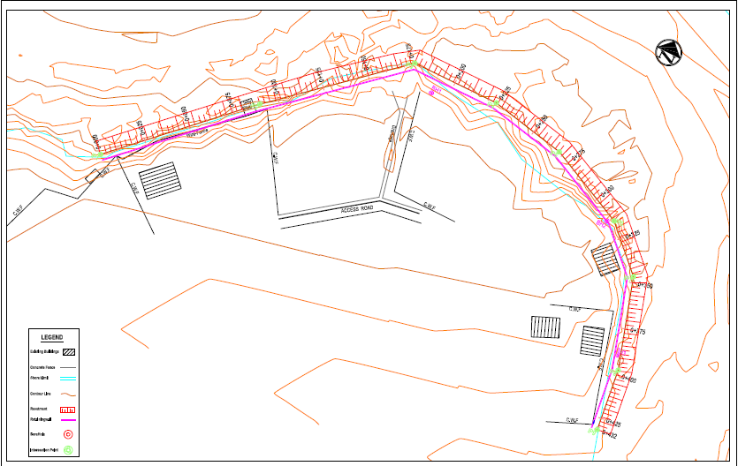

Fig.3 Layout and survey detailing of shoreline to be protected

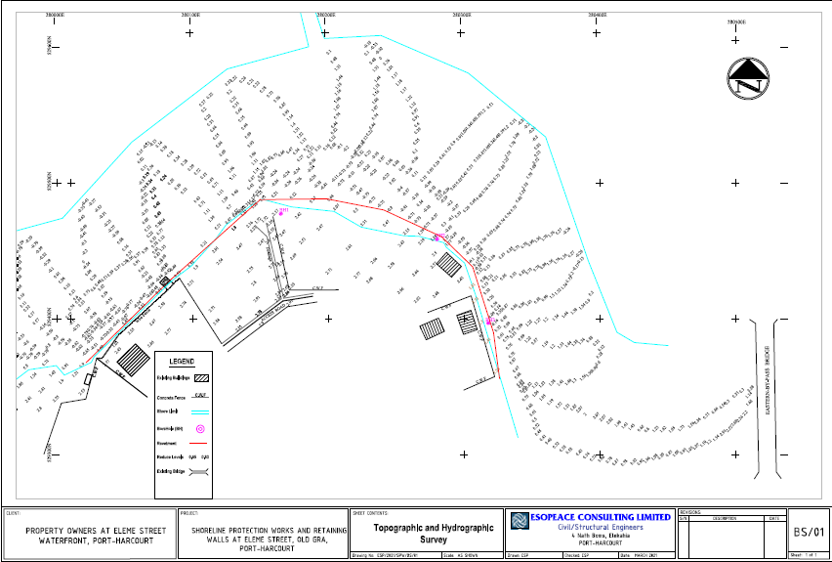

Fig.4: Bathymetric survey of river channel

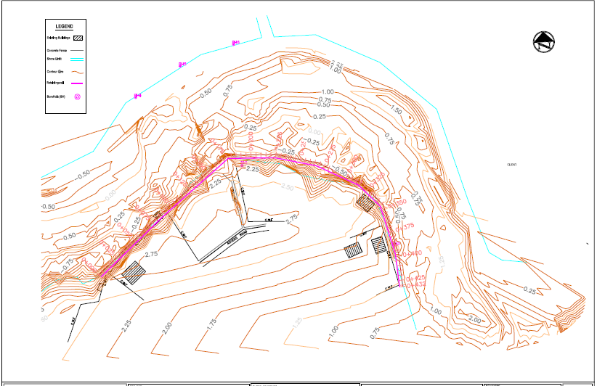

Fig. 5: Bathymetry of river channel

Soil Stratigraphy
A composite litholog of the boreholes is presented in Fig. (6), with summary description of the litholog in Table (1). It is apparent that the soil deposition pattern across the riverbed is similar, as observed from the boreholes indicating that the stratigraphy is fairly uniform. The riverbed consists of a thin very soft to soft organic silty clay varying from 1.2 to 1.6m thin thickness, followed by grey to light grey medium grained uniform sand which extends to the termination of the borehole at 12m depth below mudline.

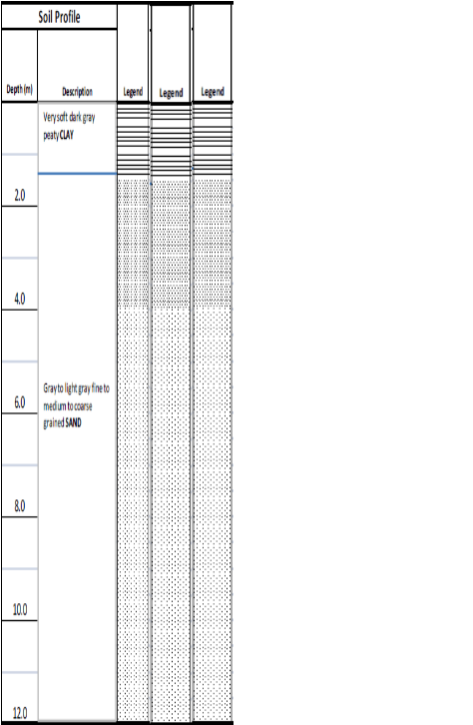
Fig.6: Composite litholog of borings in River channels

Table (1) Lithological sequence below channel bed
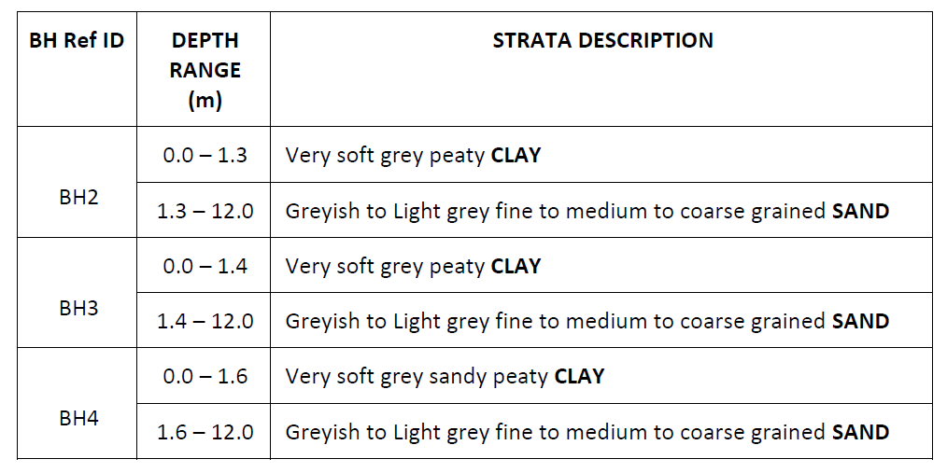
Sandy samples retrieved from the borings were subjected to sieve analysis and direct shear test in order to determine their particle size distribution and angle of internal friction. Both properties are required for assessing the drainage characteristics and the shearing resistance respectively. The particle size distribution is presented in Fig. 7 and shows a well sorted uniformly graded sand with permeability of 4.41x10⁻³m/s estimated empirically using Hazen’s method where permeability is expressed as: K=C*D₁₀² m/sec, where C is a constant approximately 100, D₁₀ is effective particle size.
.

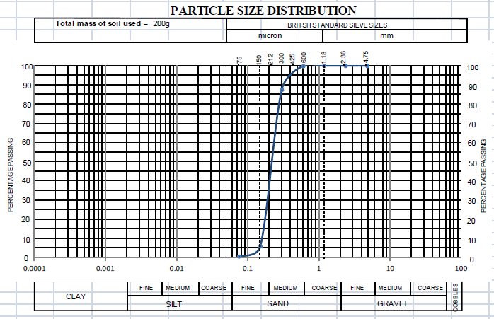
Fig.7: Particle size distribution of sandbed materials

A typical result of the direct shear test is presented in Fig.8. The angle of internal friction which is the slope of the normal and shear stress plot gives an average value of 34º. This angle, also called the angle of repose corresponds to the sand slope angle at FS=1.
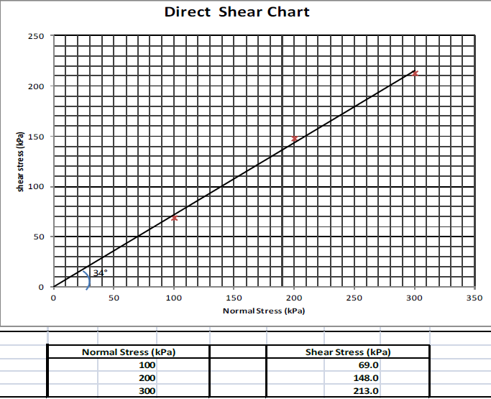
Fig.8: Direct shear result showing Angle of internal friction of sandbed material

Design Considerations and installation of Shoreline Protection Measure
The purpose of a gabion revetment is to provide short term (5-10 years) protection from backshore erosion by absorbing wave energy along the shore face. As they are sloping and porous structures they will tend to trap sand and allow the growth of vegetation under favourable conditions. Gabions used in lower energy or estuary situations can use PVC coated wire. However, under more active conditions the PVC coating can easily crack, becoming relatively useless in preventing corrosion. In general galvanised wire of a larger diameter provides better service than finer non-galvanised wire with a PVC coating. When damaged, gabions can become a public safety hazard and in releasing non-indigenous cobbles onto the beach.
The sequence of shoreline protection began with sand filling and regrading of the shoreline to a slope of 1:2.5, giving a slope of 23º. With an angle of repose of 34º, this implies a FS=34/23=1.48 with respect to slope. The regrading of the shoreline has an additional purpose to adequately bed the baskets. Periodically, due to supersaturation of the sand arising from heavy rainfall, the regraded slope may fail (Fig.9). When this experienced, the failed section is infused with crushed stones and compacted to restore stability.
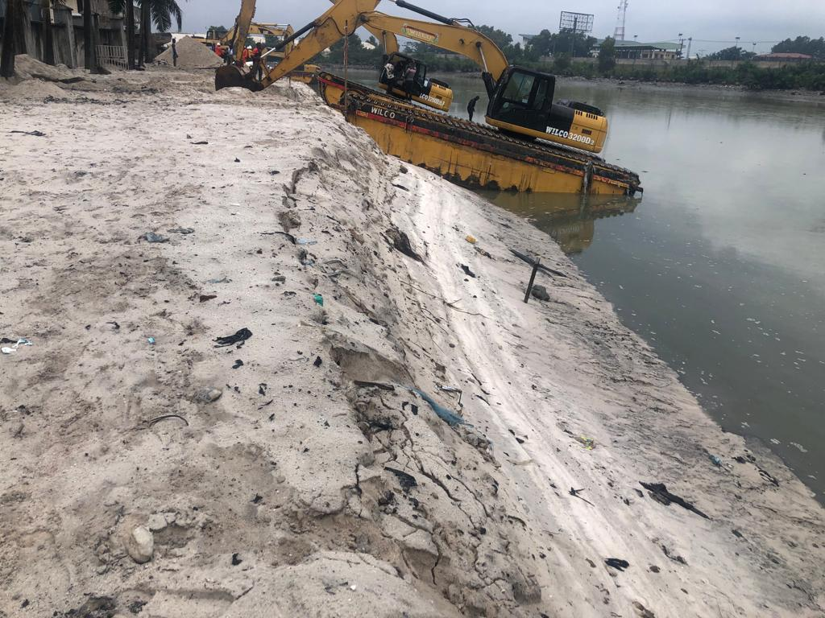
Fig.9: Slip failures in formed sand slope
The regrading was extended to the toe area of the shoreline protection structure. Due to the very soft to soft consistency of the riverbed soils, excavation of the footing of the structure experienced frequent instabilities. However, this was temporarily overcome by mixing the soft clay with sand. To ensure reasonable degree of foundation stability, 0.45m thick crushed stone was placed as footing for the toe foundation of the gabion system (Fig.10).
A suitable woven geotextile 1.17mm thick, with broad attributes of density 350gm/m², UV resistance of 80% retained at 500hours, mean tensile strength of 50kN/m, resistance to static puncture of 6,700N, dynamic perforation resistance of 6mm), hydraulic attributes of (characteristic opening size of 0.24ꙡm, and water permeability normal to plane 13.6mm/s) was then placed over the sand slope be used to prevent the underlying sand from being washed out through the gabions. At the edges were carefully placed to prevent exposure of unsightly lengths of textile. Landward edges were buried to fix the geotextile during gabion placement and filling. Seaward edges were trimmed or firmly secured. A geotextile filter layer when over the fine-grained soils helps to hold the soil in place and prevents the particles from being lost through the spaces between the stones and still allows water from the banks to seep back into the waterway.
As with all engineered shoreline structures, gabion revetments are likely to suffer from local scour and possible outflanking at the junction between structure and adjacent unprotected shore face. This problem can be minimized by turning the revetment face back onshore and burying the end into the dune face. This feathered end may extend alongshore over 20m-40m and may end 5m-10m landward of the main structure face. These dimensions will depend on the expected rate of short and long term erosion.
Zinc coated box-shaped gabion baskets containers made primarily of galvanized steel wire mesh are laid over the geotextile on the slope. The mesh, or netting is woven. In welded baskets, it is made of high-tensile steel and usually has square or diamond-shaped openings. In woven baskets, it consists of twisted wires and has hexagonal openings.
Gabions are manufactured so the sides, ends, lid, and any diaphragms can be assembled at the construction site. Gabions require diaphragms, or interior walls, when the length of the gabion is more than one and a half times longer than its horizontal width. Adjoining gabions are attached with lacing wire or another type of fastener along the vertical edges and the top edges with the thicker perimeter and edge wires of the mesh, which then enable the gabion to withstand stress. The gabions may stretch a minimum amount to achieve the optimum alignment. The gabions are then filled with clean, hard crushed stones ranging from 4 to 8 inches on the largest side and secure the lids with a closure tool. Additional geofabric is then placed over both the gabions and the backfill. The larger stones are preferentially placed at the toe, to provide toe loading and ensure stability of the entire gabion system.
Regular basket maintenance is required to maximize the life of gabions. Severely damaged baskets should be refilled and closed with new mesh panels. Replacement mesh should be laid over the entire structure if abrasion or corrosion is widespread. Under exposed conditions a maximum life of 10 years should be anticipated, after which time a replacement structure may be required. Schemes are best implemented in the spring low tide when work windows are least restricted by water and the shoreline has the greatest chance to stabilize before extended high water periods start to erode.
The gradation of the stones influences the resistance to erosion, and therefore affects the design as well as the need for a filter layer or geotextile. A well-graded distribution has a wide range of rock sizes to fill the void spaces in the rock matrix. The shape of the stones also affects the design. While both angular and rounded rock can be used, rounded stones don’t interlock as well as angular ones. Their thickness should be at least a third of their length. They should be dense and free of defects that would cause them to break down.
The crushed stones may be placed by hand or with equipment such as a track-mounted backhoe or a power crane with a clam shell or orange peel bucket to a minimum design thickness of 12 to 18 inches. It was placed from the lowest to the highest elevation to allow gravitational forces to minimize void spaces and help lock the rock matrix together. It should extend up the bank to a point where the existing vegetation or other proposed treatments can resist the forces of the water. In this case, a reinforced concrete beam (Fig. 10).

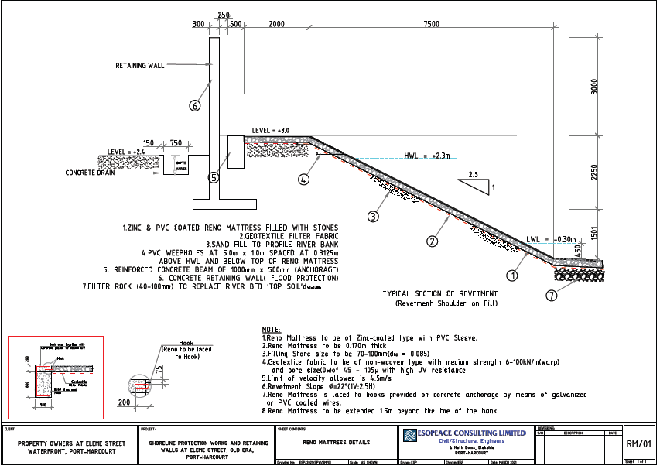

Fig.10: Design of shoreline protection works

Photographs depicting the sequence of activities in the shoreline protection works are presented in Figs 11 to 17.
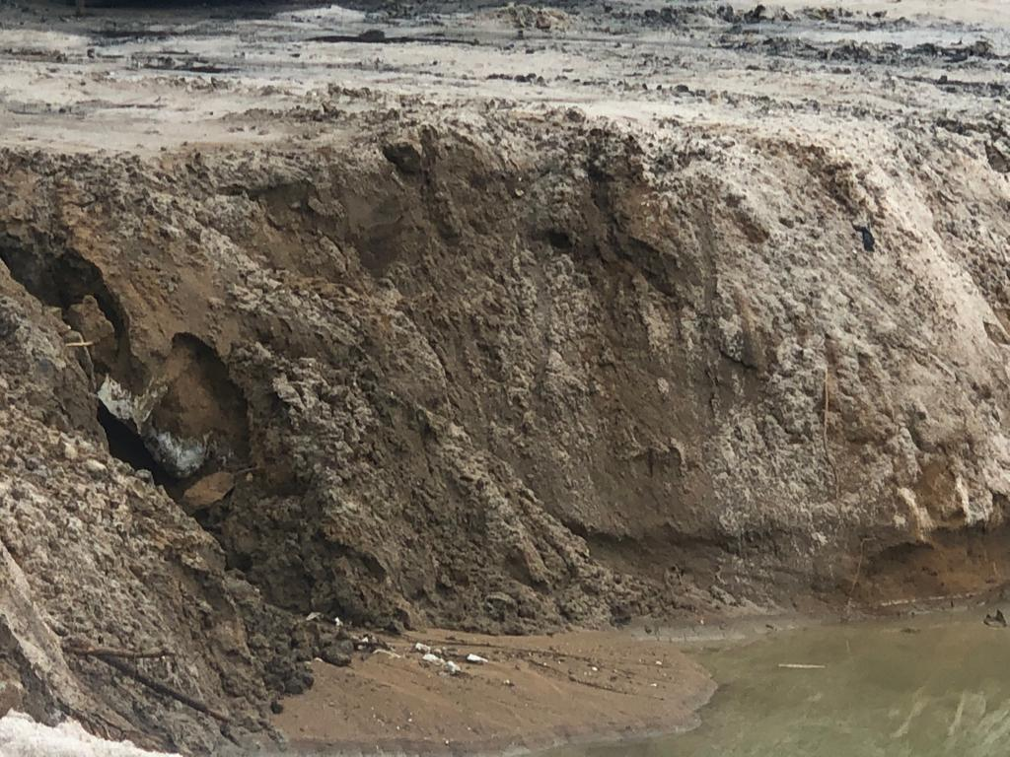
Fig.11: River bank before protection

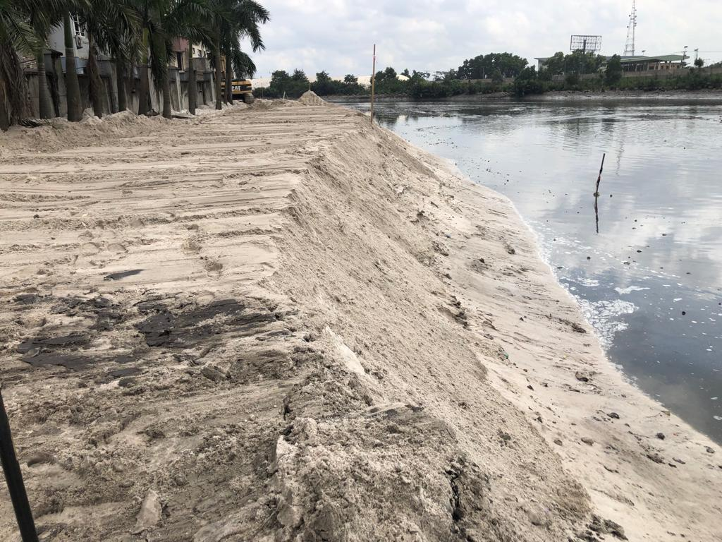
Fig. 12: Regrading of shoreline slope with sand

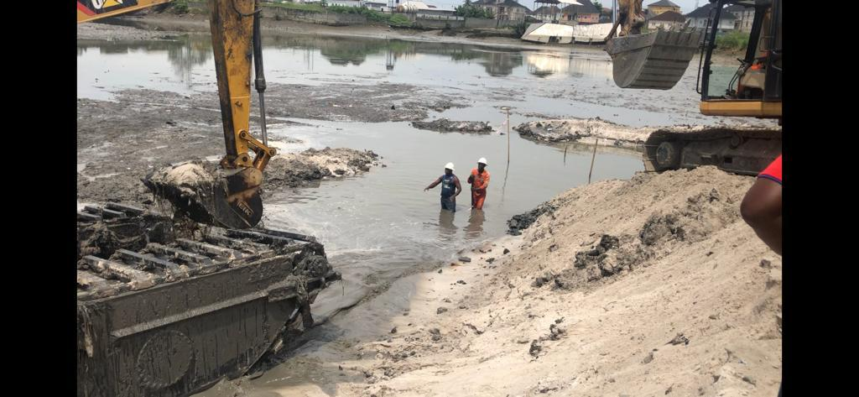
Fig.13: Foundation excavation
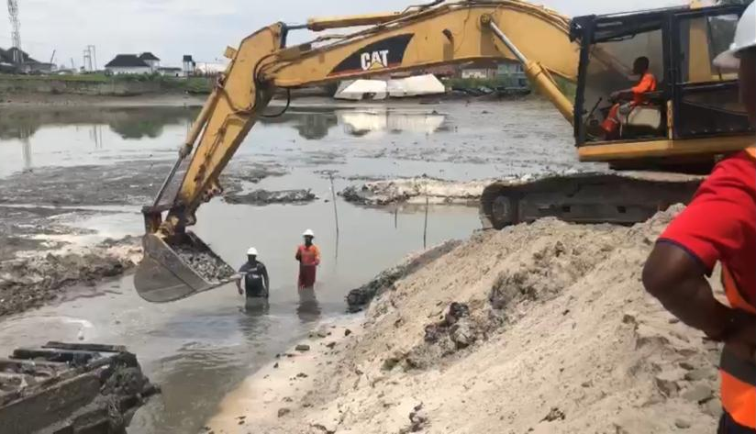
Fig.14 Placement of crushed stone footing

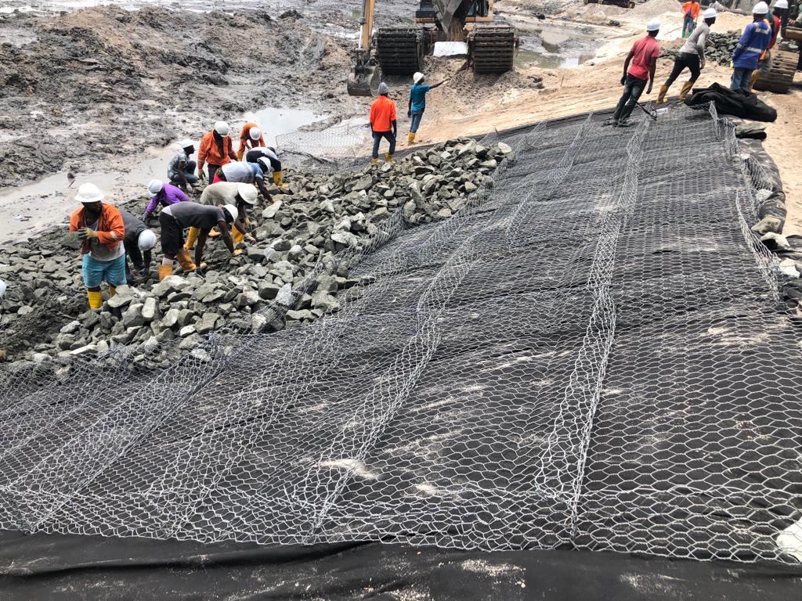
Fig.15:Filling of gabion gauges with crushed stones

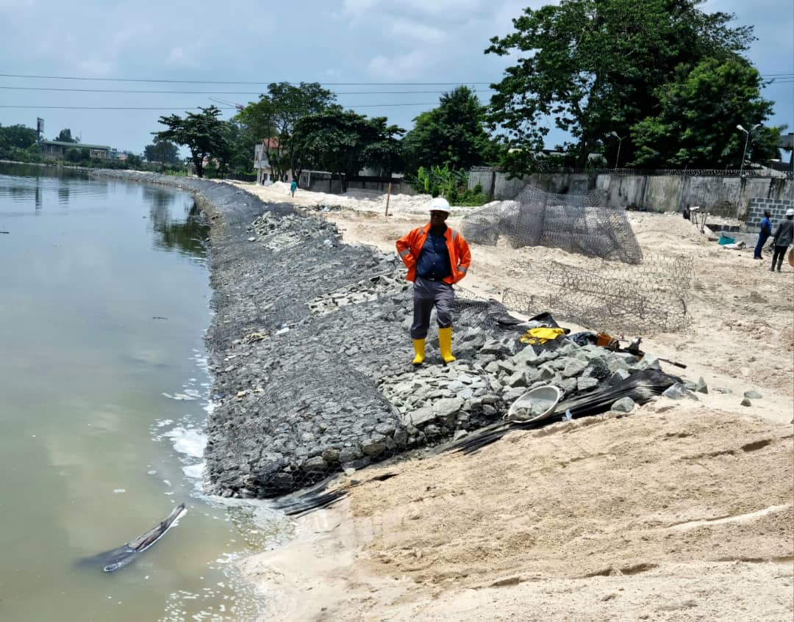
Fig.16: Partly constructed Gabion revetment

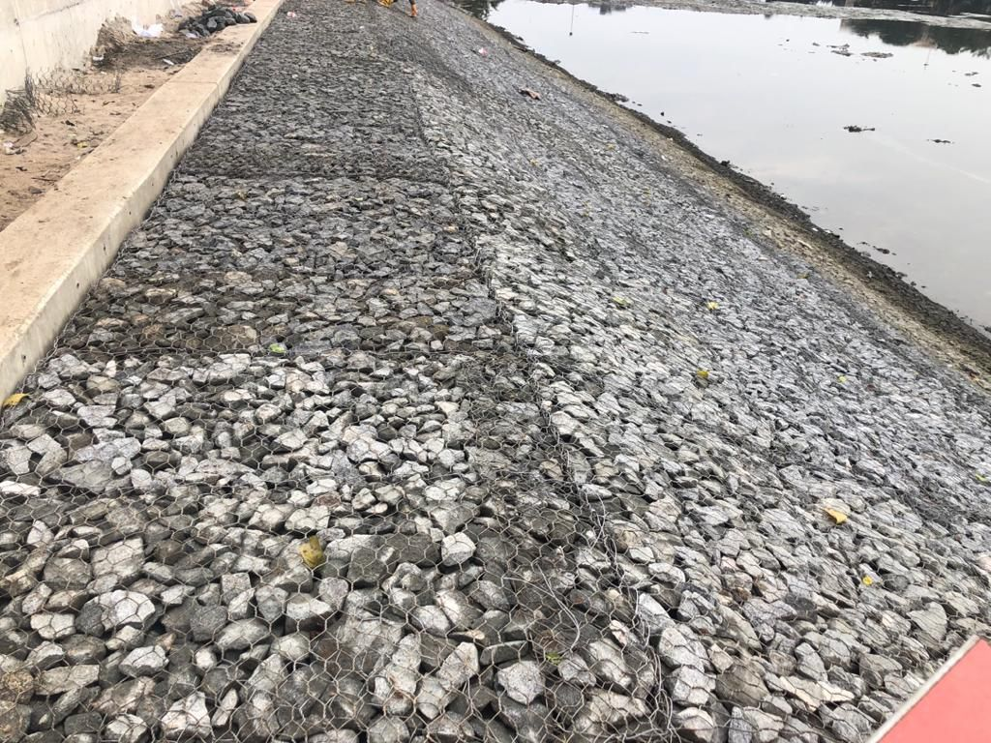
Fig.17: Fully constructed shoreline protection

Conclusion
Sloping gabions can provide durable erosion protection. When used together, gabions and Reno mattresses can help mitigate erosion and protect our shorelines from disappearing. They are often more acceptable and comparatively less. By protecting the natural shoreline, you can help protect the key functions and values provided by this essential ecological transition zone. When fully realized, the project locality would become a tourist hot spot for aquatic recreation with extended benefits for improvement in the quality of life of the people.

References
- Kumaravel, S., Ramkumar, T., Gurunanam, B., Suresh, M. and Dharanirajan, K. (2013) An Application of Remote Sensing and GIS Based Shoreline Change Studies - A Case Study in the Cuddalore District, East Coast of Tamilnadu, South India. International Journal of Innovative Technology and Exploring Engineering (IJITEE), 2, 211-215.

- Vinayaraj, P., Johnson, G., Udhaba Dora, G., Sajiv Philip, C., Sanil Kumar, V. and Gowthaman, R. (2011) Quantitative Estimation of Coastal Changes along Selected Locations of Karnataka, India: A GIS and Remote Sensing Approach. International Journal of Geosciences, 2, 385-393. http://dx.doi.org/10.4236/ijg.2011.24041

- Davidson, M.A., Splinter, K.D. and Turner, I.L. (2013) A Simple Equilibrium Model for Predicting Shoreline Change. Coastal Engineering Journal, 73, 191-202.

- Le Cozannet, G., Garein, M., Bulteau, T., Mirgon, C., Yates, M.L., Mendez, M., Baills, A., Idier, D. and Oliveros, C.(2013) An AHP Derived Method for Mapping the Physical Vulnerability of Coastal Areas at Regional Scales. Natural Hazards Earth Systems, 13, 1209-1227. http://dx.doi.org/10.5194/nhess-13-1209-2013

- Muthukumarasamy, R., Mukesh, M.V., Tamilselvi, M., Singarasubramanian, S.R., Chandrasekaran, A. and Sabeen,H.M. (2013) Shoreline Changes Using Remote Sensing and GIS Environment: A Case Study of Valinokkam to Thoo-thukudi Area, Tamil Nadu, India. International Journal of Innovative Technology and Exploring Engineering (IJITEE),2, 72-75.
- Bilkovic, D. M., Mitchell, M., Mason, P., and Duhring, K. (2016). The role of living shorelines as estuarine habitat conservation strategies. Coast. Manag. 44, 161–174. doi: 10.1080/08920753.2016.1160201
- Bilkovic, D. M., Mitchell, M. M., Peyre, M. K. L., and Toft, J. D. (2017). “Living shorelines the science and management of nature-based coastal protection,” in A Primer to Living Shorelines, eds D. M. Bilkovic, M. M. Mitchell, M. K. La Peyre, and J. D. Toft (Boca Raton, FL: CRC Press), 3–10.
- Cheong, S.-M., Silliman, B., Wong, P. P., Van Wesenbeeck, B., Kim, C.-K., and Guannel, G. (2013). Coastal adaptation with ecological engineering. Nat. Clim. Chang. 3:787. doi: 10.1038/nclimate1854
- Davis, J. L., Currin, C. A., O'Brien, C., Raffenburg, C., Davis, A., Currin, C. A., et al. (2015). Living shorelines: coastal resilience with a blue carbon benefit. PLoS ONE 10:e0142595. doi: 10.1371/journal.pone.0142595
- Dugan, J. E., Emery, K. A., Alber, M., Alexander, C. R., Byers, J. E., Gehman, A. M., et al. (2018). Generalizing ecological effects of shoreline armoring across soft sediment environments. Estuar. Coasts 41, S180–S196. doi: 10.1007/s12237-017-0254-x
- Gittman, R. K., and Scyphers, S. B. (2017). The cost of coastal protection: a comparison of shore stabilization approaches. Shore Beach 85, 19–24.
- Gittman, R. K., Scyphers, S. B., Smith, C. S., Neylan, I. P., and Grabowski, J. H. (2016a). Ecological consequences of shoreline hardening: a meta-analysis. Bioscience 66, 763–773. doi: 10.1093/biosci/biw091
- Lawless, A. S., and Seitz, R. D. (2014). Effects of shoreline stabilization and environmental variables on benthic infaunal communities in the Lynnhaven River System of Chesapeake Bay. J. Exp. Mar. Bio. Ecol. 457, 41–50. doi: 10.1016/j.jembe.2014.03.010
- Mitchell, M., and Bilkovic, D. (2019). Embracing dynamic design for climate-resilient living shorelines. J. Appl. Ecol. 56, 1099–1105. doi: 10.1111/1365-2664.13371
- Mitsch, W. J. (2012). What is ecological engineering? Ecol. Eng. 45, 5–12. doi: 10.1016/j.ecoleng.2012.04.013
- Narayan, S., Beck, M. W., Reguero, B. G., Losada, I. J., Van Wesenbeeck, B., Pontee, N., et al. (2016). The effectiveness, costs and coastal protection benefits of natural and nature-based defences. PLoS ONE 11:e0154735. doi: 10.1371/journal.pone.0154735
- Nesshöver, C., Assmuth, T., Irvine, K. N., Rusch, G. M., Waylen, K. A., Delbaere, B., et al. (2017). The science, policy and practice of nature-based solutions: an interdisciplinary perspective. Sci. Total Environ. 579, 1215–1227. doi: 10.1016/j.scitotenv.2016.11.106
- Sharma, S., Goff, J., Cebrian, J., and Ferraro, C. (2016). A hybrid shoreline stabilization technique: impact of modified intertidal reefs on marsh expansion and nekton habitat in the northern Gulf of Mexico. Ecol. Eng. 90, 352–360. doi: 10.1016/j.ecoleng.2016.02.003

