The sustainable service innovation model in the chain restaurant industry: circular economy perspective

Li-Min Chuang1 , Tsung-Shih Kuo2 and Guei-Yun Luo3

Abstract

This study is based on the circular economy perspective, emphasizes the user-based development of a new sustainable service model, and is based on the four stages of service innovation (innovation element exploration, requirement analysis, innovation model conceptualization, innovation model verification) to effectively develop and validate the sustainable service innovation model. The research results show that the enterprise believes that in the main dimensions of the chain restaurant sustainable service innovation model, as compared to the “Pre-service” dimension, the “During-service” dimension, the “Post-service” dimension, the “Leftover food” dimension, and the “Support system and service” dimension, the “NG vegetable and fruit” dimension is more critical. The empirical results of both the enterprise and the customer show that [Leftover food service] is the least valued. [NG fruits and vegetables] is valued by the enterprise, but the customer does not pay attention to it. [Support system and technology] is valued by the customer, but it is least valued by the enterprise

Keywords: Sustainable service innovation model, circular economy, service blueprint, chain restaurant industry, NG fruits and vegetables, Leftover food service.

1 Department of International Business, Chang Jung Christian University, Tainan 71101, Taiwan;
² Ph.D. Program in Business and Operations Management, Chang Jung Christian University, Tainan 71101, Taiwan
³ MBA Program in Business and Operations Management, Chang Jung Christian University, Tainan 71101, Taiwan

Introduction
A. Research Background and Motives
“Food is the paramount necessity of the people”, and catering is an industry that never fails. However, with the changes of the social structure, as well as the increase of people’s income, people pay more and more attention to their diet, and attach more and more importance to quality, as well as its connotations. In the past, the catering market in Taiwan was unable to improve its international competitiveness due to its small market size. However, years of experience in the international catering industry has brought new stimulation to Taiwanese restaurants, and competition in the catering industry has become increasingly fierce. The family-style traditional management method cannot overcome and break the status quo. Only by adopting the enterprise management method can small family-style restaurants continue to grow and thrive, and absorb better catering talents. Therefore, the chain management system of the catering industry has gradually matured and become the mainstream. The chain restaurant industry usually adopts a central kitchen, concentrates on resources, and reduces costs through extensive procurement and intensive production processes. However, countries around the world are facing the problems of uneven resource allocation and food waste. Important global organizations and governments have identified the food distribution problem and are actively proposing and promoting solutions. The Ellen MacArthur Foundation (EMF) [1] has proposed the 3R concept for a circular economy:
- Recycle: the first method is to collect the leftovers produced during the stages of production, processing, transportation, and households. Such edible food is distributed to those in need, such as food banks and shared refrigerators in communities. This model is relatively simple, and has scale and reproducibility, which is the first line of action to reduce leftovers;
- Recover: the second method is to reproduce leftovers, and make the leftovers become new products through cooking, processing, and manufacturing;
- Reuse: when food is out of date, and due to expire, it can also be used to achieve its last value through recycling; for example, kitchen garbage is made into compost or renewable energy. Through redesigning products and business models, it carries out layered “cycles” (including repair, reuse, distribution, refurbishment, remanufacturing and recycling) for used products, in order to increase the use value of raw materials and reduce waste, and thus, reduce the burden on the environment. Such back-end factors make the issue of a circular economy become increasingly important.
In recent years, after the catering industry in Taiwan experienced a storm of food safety, consumers and restaurants have paid more and more attention to the source of food material, pursuing sustainable development, and environmental awareness. The catering industry is constantly pursuing the provision of innovative and sustainable services to consumers, and combines the use of resources in agriculture, tourism, community, and digital resources to change consumers' opinions of catering. Faced with the trend of the global pursuit of a circular economy, the business strategy of chain restaurants cannot be limited to traditional chain catering services, meaning that the chain restaurant sustainable service innovation model must meet the changing needs of customers. Therefore, chain restaurant sustainable service innovation will be the future direction of the catering industry. In the past, many scholars proposed the concept of sustainable service innovation for hotels and the tourism industry, and believed that sustainable service innovation helps balance the 3 dimensions of economy, environment, and society [2-8]. The scope of service innovation is quite extensive. Service innovation refers to new developments that are different from existing products or services [9]. Service innovation rarely limits changes in the service product itself [10]. However, consumer awareness is on the rise, and the catering industry is facing the challenge of increasingly commoditized products and services. At the same time, it also opens up a new model of competition. Therefore, service innovation does not only refer to the successful development of new services or new products, it also includes all innovative activities, both slight and great, that can modify and improve existing products, services, and delivery systems. As service innovation development issues became more common, and thus, formed periodicity [11,12], service-dominant logic began to appear in the market[13-15], which re-examined the innovation rules in service delivery, and defined this as involvement in the entire organization through the products and services in the process [16]. In addition, the multi-dimension phase often involves customer engagement and innovation issues [17-19]. Therefore, the development of many service innovation models has introduced the method of service design to conduct research. Service design is mainly based on customer experience, including: pre-, during-, and post-experience of service; it can provide useful products and services that customers can use and want to use. In addition, it helps companies improve organizational efficiency and effectiveness [20]. Through the service blueprint, this study attempts to construct chain restaurant sustainable service innovation for chain restaurants from the perspective of customers.
A circular economy has become the development trend of the future. From the stage of production in farms and pastures, the stage of processing and manufacturing, the stage of sales channels to the stage of consumer households, it provides countermeasures for restaurant sustainable services regarding food waste and food loss. The EMF pointed out that the business opportunity application of a circular economy in the catering industry could be divided into two categories:
- Effective recycling and reuse of food through the transparency of information in the food supply chain, which is also the common application mode in the current catering and restaurant service industry; for example, Tesco in the UK has launched an app that helps charities control the leftovers of each branch. Winnow, a British company, has launched specific information system and data analysis tool for restaurants to help the industry reduce food waste.
- Improve the value of leftovers by using a comprehensive recycling mechanism and refining technology; for example, New York startup Industrial/Organic has developed a refining technology that can be used indoors to turn leftovers into almost odor-free fertilizers for reuse. Sustainable service is the focus of the catering industry development. The development of sustainable service provides a number of innovative service methods and process frameworks. In addition to improving green living, it can change the operating model of the industry by simplifying and reducing operating costs. In response to the evolution of sustainable service, catering companies should propose a sustainable service innovation model. A circular economy may improve the transparency of information in the food supply chain, and use a comprehensive recycling mechanism and refining technology to promote NG fruits and vegetables, and thus, enhance the value of leftovers. Sustainable and service innovation model development is a goal that the current chain restaurant industry must strive to develop. Most previous research on the circular economy focused on manufacturing [1,21], and there are few empirical studies on the service industry. Kirchherr, Reike, and Hekkert [22] also pointed out that the research goal of a circular economy is mainly to explore economic prosperity and environmental quality, and there have been few researches on the impact of social equity. Among them, only, Allwood et al. [23] , Song et al. [24], and Ness and Xing[25]mentioned the concept of waste hierarchy in the definition of circular economy. This study believes that this topic can be applied to the construction of a chain restaurant sustainable service innovation model.
In view of this, and based on the perspective of a circular economy, this study uses the relevant methods of service design (innovation element exploration, requirement analysis, innovation model conceptualization, innovation model verification) to collect relevant domestic and foreign theories and literature on sustainable development, circular economy, service innovation and service blueprint, chain restaurant industry servitization, and a new service blueprint. Through the summarization of a large number of secondary data and the integration of expert opinion, this study creates a sustainable service innovation model that corresponds to the demand for the operation mode of the chain restaurant industry. Compared with scholars that studied sustainable service innovation in the past, this paper offers more revisions and developments for the sustainable development of the chain restaurant industry, including the expansion and clarification of chain restaurant sustainable service innovation content. Moreover, this study adds various service innovation modules. These practices may help to enhance the reliability and validity of the chain restaurant sustainable service innovation model built in this study. The above viewpoints are important research motives for this study.

B. Research Purpose
The research purposes of this study are, as follows:
- Through the integration and analysis of relevant literature on the chain restaurant industry, sustainable development, circular economy, service innovation, and service blueprint, this study deconstructs the connotations of chain restaurant sustainable service innovation, and conducts analysis from the circular economy perspective.
- Based on related case integration of EMF, Taiwan Circular Economy Network and Social Enterprise Insights, this study uses benchmarking case analysis, content analysis, and static model analysis to analyze the attributes of current sustainable service innovation. In addition, through literature, this study analyzes the connotations of the chain restaurant industry, as well as the analysis dimensions of sustainable service innovation and the required elements of sustainable service innovation.
- Through the integration of benchmarking cases, this study collects relevant domestic and foreign cases, conducts content analysis and static model analysis, and analyzes the needs, connotations, and important dimensions related to chain restaurant sustainable service innovation.
- Through integrating the above-mentioned sustainable service innovation element exploration and sustainable requirement analysis, this study conducts sustainable service innovation blueprint modeling, constructs a service blueprint, and conducts hierarchical analysis empirical research.
- Verify the sustainable service innovation model, as constructed by sustainable service modeling.
- Based on the research results, this study proposes research propositions, conclusions, and recommendations for follow-up researchers and chain restaurants.

Construction of the chain restaurant sustainable service innovation model
A. Research framework
This study explores the construction of a chain restaurant sustainable service innovation model, which is mainly composed of three researches. Among them, Research 1: Carry out discussions and research on the sustainable service innovation model of EMF, Taiwan Circular Economy Network and Social Enterprise Insights, and conduct content analysis and keyword screening by using the benchmark cases as the analysis object. After coding, the effective categories are screened according to each dimension, and static model analysis is constructed; Research 2: The design and construction of a service blueprint for the chain restaurant industry in Taiwan. Its content is mainly focused on how to carry out requirement analysis for the sustainable service innovation model under the impact of a circular economy, as well as the construction of an innovative service blueprint through process mapping and process detail analysis on the service blueprint content; Research 3: Conduct weight analysis based on the primary evaluation criteria and secondary evaluation criteria in the hierarchical structure of the chain restaurant sustainable service innovation model. Regarding consumers, multivariate analysis is conducted for the chain restaurant sustainable service innovation model, which is then compared and discussed. The research framework is shown in Fig 1.

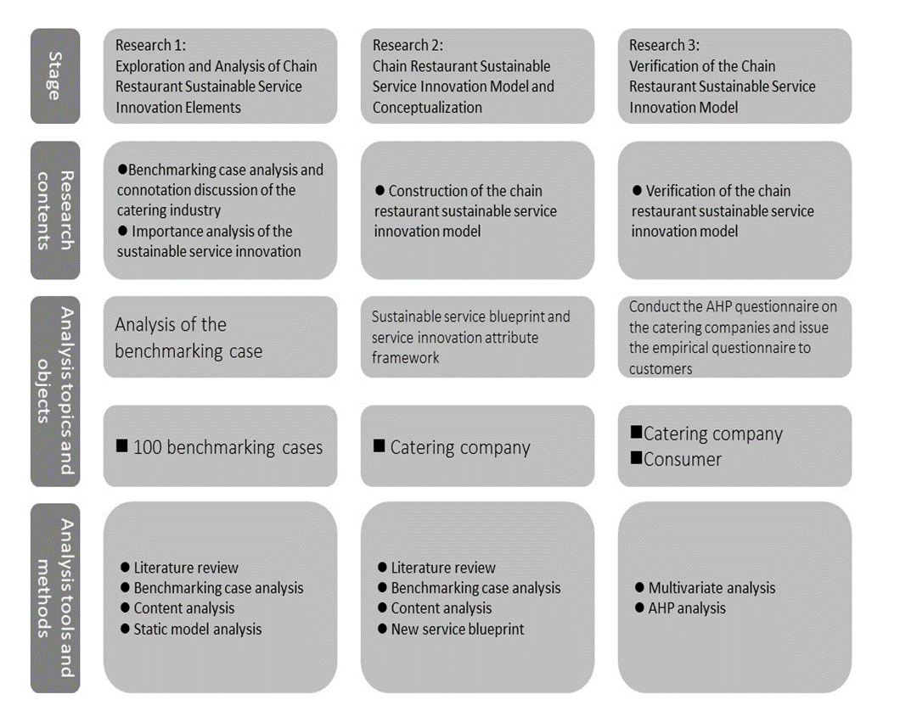

Figure 1. Research framework

B. Exploration and analysis of chain restaurant sustainable service innovation elements (Research 1)
This study develops research on chain restaurant sustainable service innovation and conducts analysis of the benchmarking cases. The data sources include literature discussion on the chain restaurant industry, sustainable development, circular economy, and service innovation, as well as secondary data and benchmark case analysis. The researchers also explored the capabilities required to develop chain restaurant sustainable service innovation, as well as improve the internal performance of enterprises and provide service innovation. Then, through content analysis and research, this study conducts repeated verification of the qualitative data. The data collection methods include:
    - LITERATURE REVIEW AND SECONDARY DATA COLLECTION.
First, this study collected statistical material of chain restaurant sustainable service innovation through academic journals, public newspapers and magazines, online and official publications, industry analysis reports, research reports, etc. In addition, it collected press releases issued by the EMF Promotion Program “CE100”, Taiwan Circular Economy Network and the Supervision and Management Committee of the Social Enterprise Insights, as well as the promoted measures, internal documents, and various reports, in order to continuously observe the industry dynamics and accumulate relevant knowledge. Then, this study formed the prototype of the key components of the chain restaurant sustainable service innovation.

    - EXECUTION PROCESS OF THE CASE ANALYSIS
This study established the prototype of the components of chain restaurant sustainable service innovation, conducted benchmark case analysis through the case study of the EMF Program “CE100”, Taiwan Circular Economy Network and Social Enterprise Insights, conducted research through the benchmark case content analysis method, and summarized cases related to the sustainable service process descriptions and service highlights. In addition, all sustainability and service innovation content were marked. After the event, the text was completed according to the record summary and related literature as the basis for category analysis, which were summarized and organized by qualitative software NVIVO through the content analysis method, and according to the content essence of each concept. Data analysis and coding were carried out by three coders, the elements of sustainable service innovation in the chain restaurant industry were separated, and important categories and key static models were extracted. The description and characteristics of the case source object are, as follows:

(1) Description of the case source object
(a)EMF
The EMF was established in 2010 to accelerate the transition to a circular economy. Since its establishment, this Foundation has become a global thought leader by adding the concept of a circular economy to the agenda of business, political, and academic decision makers.

(b)Taiwan Circular Economy Network
Mr. Charles Huang initiated the “Taiwan Circular Economy Network”, which aims to promote the new model of Taiwan’s economic renewal by promoting the concept of a circular economy, and become an important platform for Taiwanese youth, enterprise, and government to determine industrial development policies and implement business models.

(c)Social Enterprise Insights
This is the first “Platform for Chinese Social Enterprise Information Insights” in Taiwan, as founded in 2012 by Sunny Lin, Michael Chen, and Ching-En Chin et al. It is an online community media with the theme of “social enterprise”, which shares the latest information and resources of global and Chinese social enterprises. Through the introduction of “social enterprise”, it accumulates the knowledge and intelligence of “how to use business power to change social problems”, in order to allow social entrepreneurs in different fields and regions, as well as people who are enthusiastic about social enterprises, to communicate and interact with each other, and practice these win-win ideals.
(2)Characteristics of the case source object
In this study, EMF, Taiwan Circular Economy Network and Social Enterprise Insight is used as the source object for research and investigation of cases. The criteria for selecting the respondents include:
(a)it should belong to the catering industry and bring the circular economy into the industry;
(b)it should have specific empirical evidence that proves the company is representative of sustainable service innovation;
(c)it should have gradually promoted relevant practices, indicating that it has considerable relevance to this study. Based on the above, this study selects cases in the development experience of the catering industry for research and analysis.

(3)ANALYSIS AND DEFINITION OF CHAIN RESTAURANT SUSTAINABLE SERVICE INNOVATION
This study first introduces cases of the EMF program “CE100”, Taiwan Circular Economy Network and Social Enterprise Insight through qualitative software NVIVO. The three coders that participated in the in-depth interviews are all master and doctor students, and carried out the following three steps:
(a)defining the analysis unit;
(b)constructing the category;
(c)explaining the category definition and establishing the category and definition extracted by this study.

(4)THE STATIC MODEL OF THE KEY DIMENSION OF THE CHAIN RESTAURANT SUSTAINABLE SERVICE INNOVATION MODEL
After encoding the category analysis, this study screens out effective subcategories based on the dimensions, and with the NVIVO qualitative software, draws the diagram shown in Fig. 2 according to statistics, and provides in-depth explanations of the following dimensions:
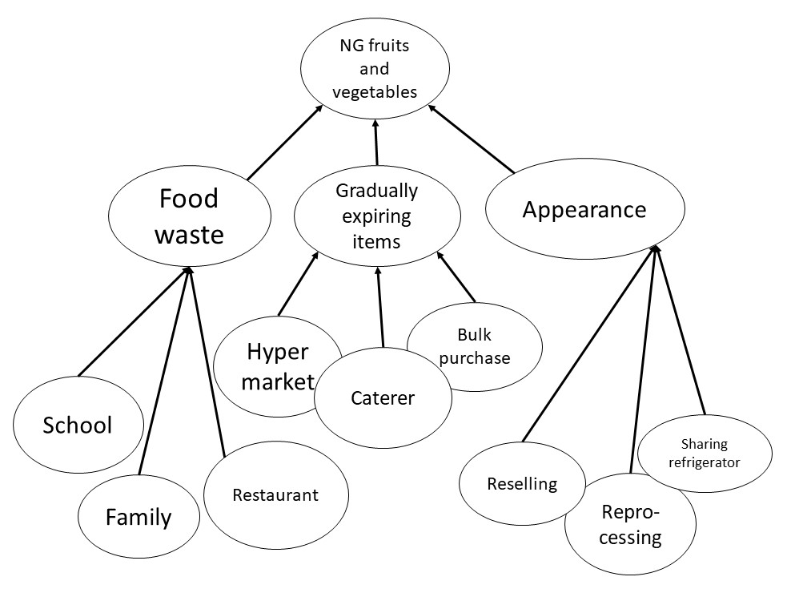
1.NG fruits and vegetables
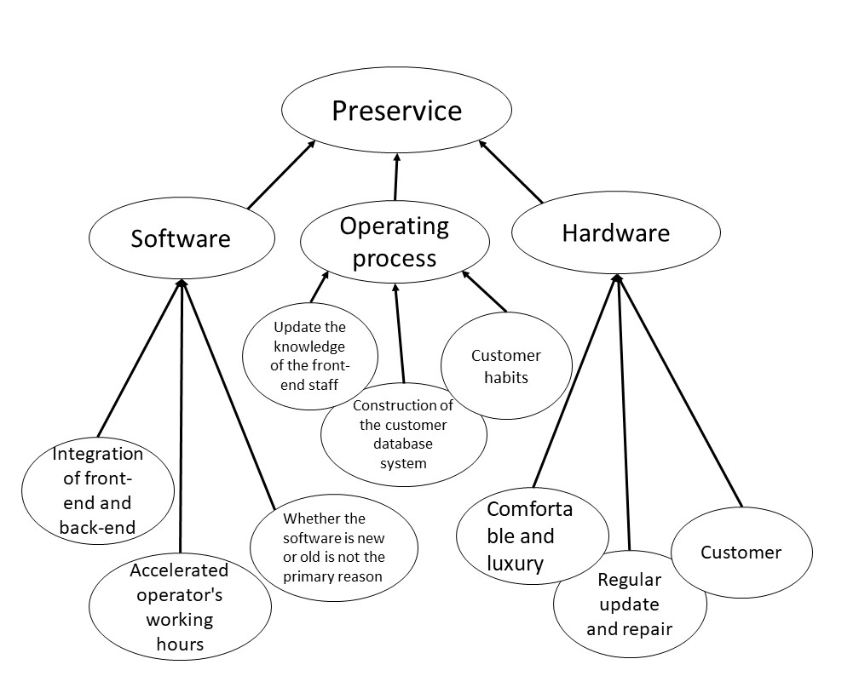
2. Pre-service
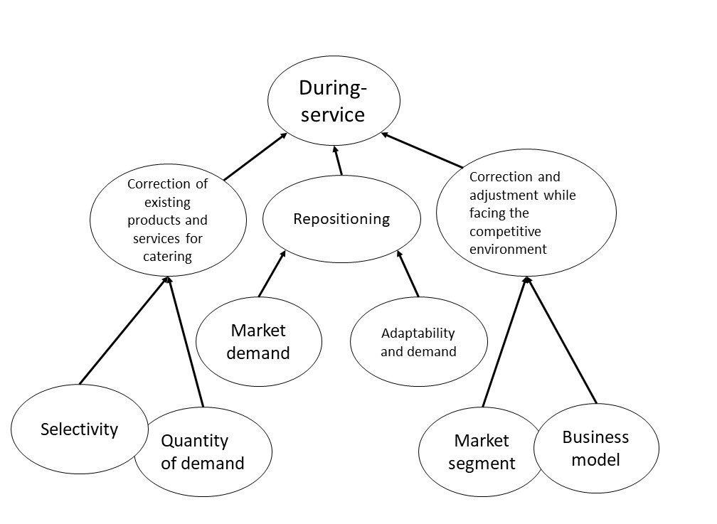
3.During-service
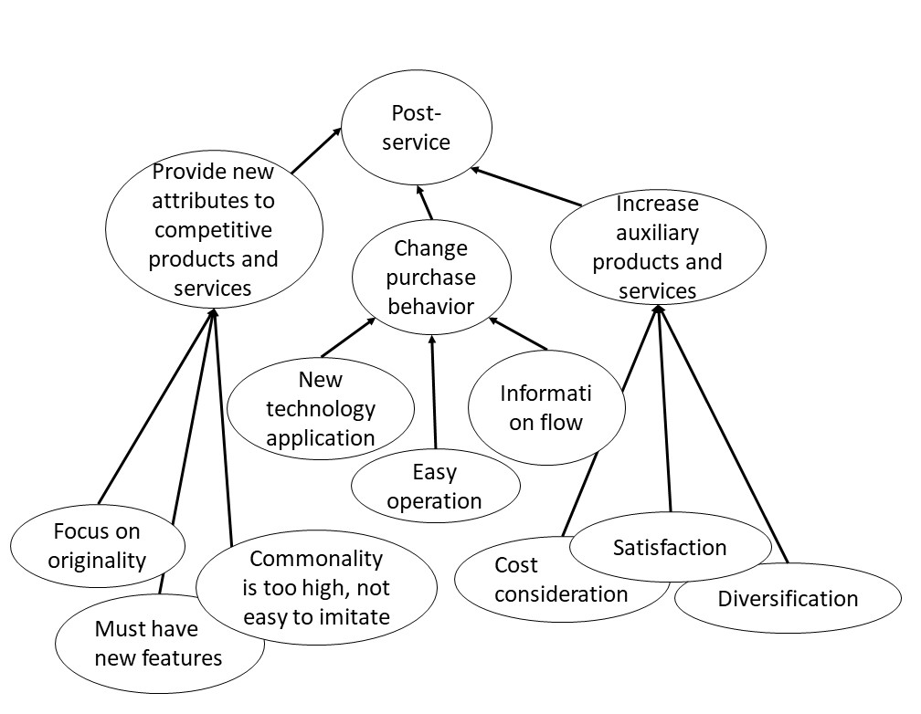
4. Post-service
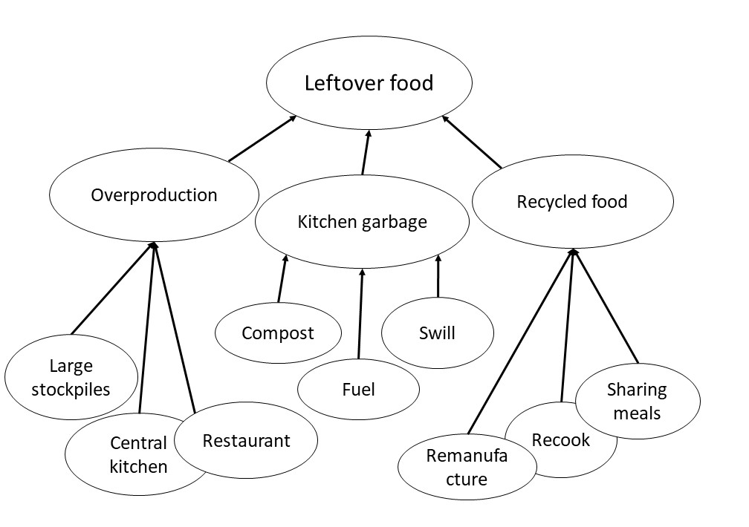
5.Leftover food service
6. Support system and technology
Figure 2. Static model of the key dimension of the chain restaurant sustainable service innovation model

C. Chain restaurant sustainable service innovation model conceptualization (Research 2)
Sorting and analysis of the internal and external data collected by this study shows the interactions between the various stages of NG fruits and vegetables, including pre-service, during-service, post-service, and leftover food, with “icons”. In addition, this study clearly describes the service process at each stage, derives the “existing touch points” and corresponding “visible activities and new service development activities by enterprises”, and explores the case support technology, as well as system and service failure points. According to the enterprise-side benchmark case content analysis, static model analysis, and new service blueprint requirement analysis, this study takes the “6 major dimensions of the chain restaurant sustainable service innovation model” as the core, uses “NG fruits and vegetables” and “leftover food” as the means, and implements these dimensions into “chain restaurant sustainable service innovation”. As shown in Fig. 2, with the “touch point” as the boundary, the back-end field supports “service process” and “visible activities and new service development activities by enterprises” with “support technology and system”. This study takes customers going to restaurants for consumption as an example to explore the NG fruits and vegetables, as well as pre-service, during-service, post-service, and leftover food, which is transmitted to the “back-end” through the “front-end” to respond to the needs of consumers. In the process of researching the service blueprint architecture, and after integration of the blueprint for sustainable service and service innovation of the chain restaurant industry, the conceptual framework diagram of the chain restaurant sustainable service innovation is developed. Using the concept diagram, the service blueprint front end of the chain restaurant industry is introduced into the NG fruits and vegetables, the service back end is added to the leftover food service, and digital technology is imported into the back-end to establish the conceptual sustainable service innovation model, as shown in Fig. 3.
D. Verification of the chain restaurant sustainable service innovation model (Research 3)

(1)HIERARCHICAL FRAMEWORK VERIFICATION OF THE MODEL FOR THE CHAIN RESTAURANT SUSTAINABLE SERVICE INNOVATION MODEL: VERIFICATION FROM THE ENTERPRISE SIDE.
According to the analysis results of the content of the benchmarking case, the “static model of the key dimension of the chain restaurant sustainable service innovation model” was developed, and then, the “hierarchical analysis framework of the chain restaurant sustainable service innovation model” was developed. The main dimensions of the analysis framework include: The 6 main dimensions of “NG vegetables and fruits”, “Pre-service”, “During-service”, “Post-service”, “Leftover food service”, and “Support system and service”. The secondary dimensions include: The 17 main dimensions of “Food Loss”, “Gradually expiring items”, “Appearance”, “Software”, “Operation process”, “Hardware”, “Revise existing products and services in catering”, “Repositioning”, “Correction and adjustment while facing the competitive environment”, "Provide new attributes to competitive products and services", "Change purchase behavior", "Increase auxiliary products and services", "Food waste", "Kitchen garbage", "Recycled food”, "Visual", and "Entity". These dimensions were developed into the analysis framework of Research 3, and used to conduct empirical study on the viewpoints of the enterprise community. The questionnaires in this study were mainly carried out on the senior executives of Taiwan's chain restaurant industry. A total of 24 AHP questionnaires were distributed, and the research results are shown in Fig. 4. In addition, this study proposes the following seven important propositions:
Proposition 1: In the main dimensions of the chain restaurant sustainable service innovation model, as compared to the “Pre-service” dimension, the “During-service” dimension, the “Post-service” dimension, the “Leftover food” dimension, and the “Support system and service” dimension, the “NG vegetable and fruit” dimension is more critical.
Proposition 2: In the main dimension of “NG fruits and vegetables” in the chain restaurant sustainable service innovation model, the secondary dimension of “Food loss” is more critical.
Proposition 3: In the main dimension of “Pre-service” in the chain restaurant sustainable service innovation model, the secondary dimension of “Software” has obvious influence.
Proposition 4: In the main dimension of “During-service” in the chain restaurant sustainable service innovation model, the secondary dimension of “Revise existing products and services in catering” is more critical.
Proposition 5: In the main dimension of “Post-service” in the chain restaurant sustainable service innovation model, the secondary dimension of “Provide new attributes to competitive products and services” is more critical..
Proposition 6: In the main dimension of “Leftover food” in the chain restaurant sustainable service innovation model, the secondary dimension of “Food waste” is more critical.
roposition 7: In the main dimension of “Support system and service” in the chain restaurant sustainable service innovation model, the secondary dimension of “Visual” is more critical.

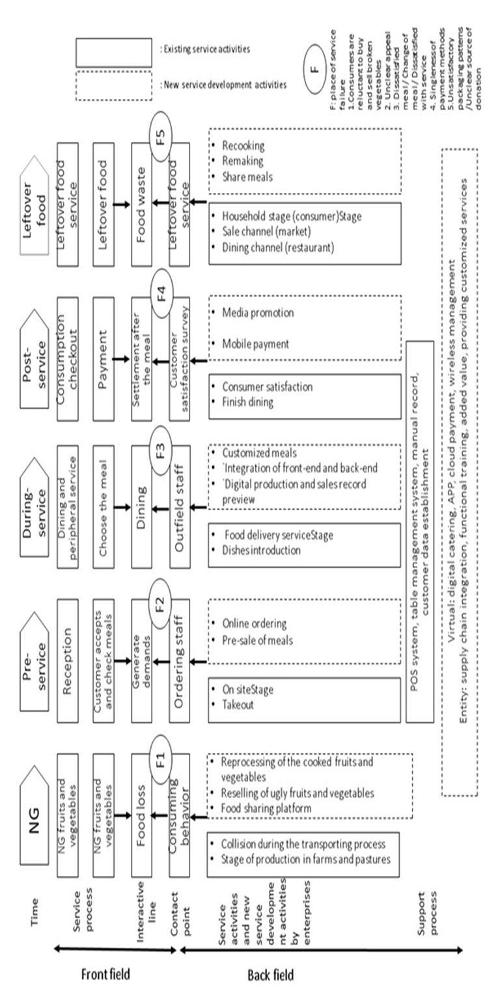
Figure 3.Chain restaurant sustainable service innovation model: service blueprints

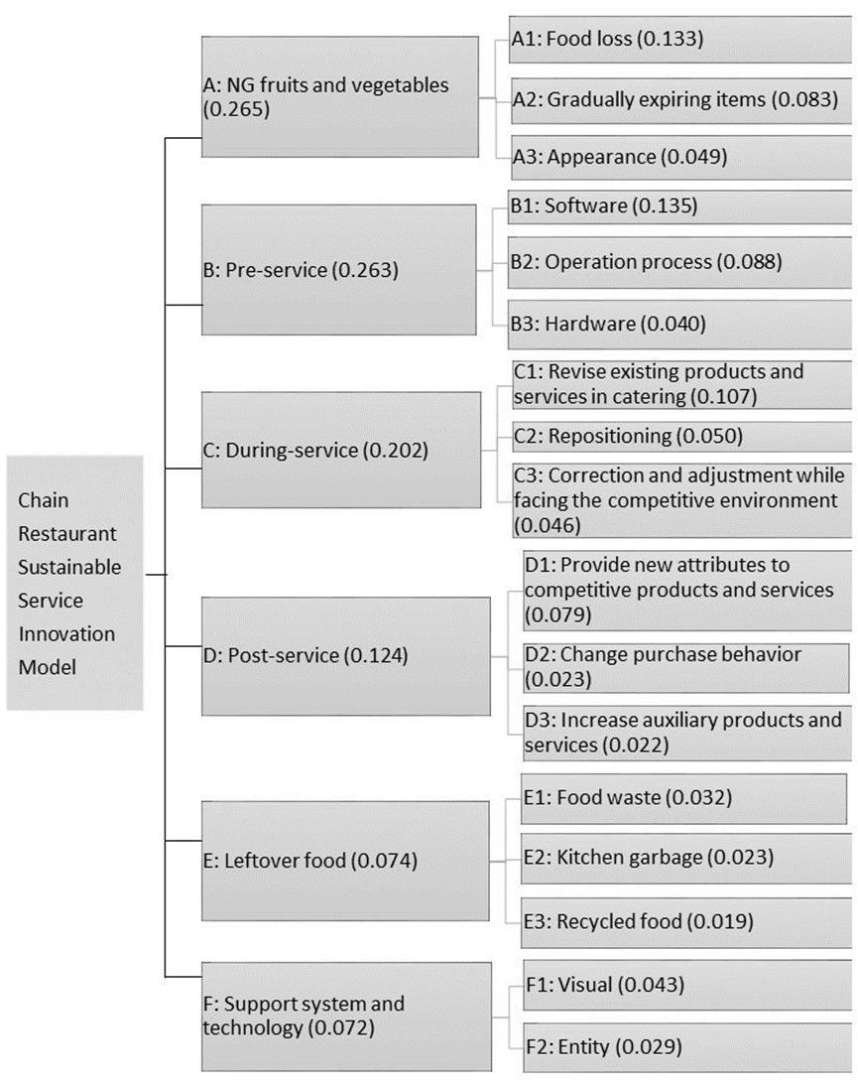
Figure 4.Hierarchical analysis framework of the chain restaurant sustainable service innovation model: enterprise side view(C.R.<0.1)

2) EMPIRICAL RESULT ANALYSIS OF CHAIN RESTAURANT SUSTAINABLE SERVICE INNOVATION: VERIFICATION FROM THE CUSTOMER SIDE
The verification part from the customer side is mainly based on the content of the new service development in Fig. 3 to develop the questionnaire content, which has a total of 16 questions(Extract from “new service development activities”). Regarding the object of empirical analysis, this study takes the customers of chain restaurants as the object for issuing the questionnaires. The convenience sampling method was used to issue 200 questionnaires, and a total of 174 valid questionnaires were collected.
After calculation, Cronbach's α coefficients of the 6 dimensions in the formal questionnaire reliability test are between 0.851 and 0.928, and most of them reach 0.7 or more, as recommended by Nunnally (1978). The item-to-total correlation coefficient of the 16 question items is between 0.734 and 0.883, and most of the coefficients are greater than 0.5. Validity verification is verified by content validity, which shows good overall surface validity. It can be seen from the above that, in this study, each assessment dimension has a high degree of internal consistency.

Table 1 Consumers' views on various dimensions and question items of chain restaurant sustainable service innovation
Dimension | Content of the question item | Mean | S.D. | item-to-total correlation | Cronbach‘sα
NG fruits and vegetables | Reprocessing of cooked fruits and vegetables | 4.21 | 1.399 | 0.742 | 0.928
 | Reselling of ugly fruits and vegetables | 4.59 | 1.143 | 0.855
 | Food sharing platform | 4.72 | 1.151 | 0.786
Pre-service | Online ordering | 5.22 | 0.720 | 0.775 | 0.851
 | Pre-sale meals | 4.93 | 0.922 | 0.875
During-service | Customized meals | 5.16 | 0.725 | 0.781 | 0.898
 | Integration of front-end and back-end | 5.01 | 0.843 | 0.770
 | Digital production and sales record preview | 5.20 | 0.765 | 0.874
Post-service | Media promotion | 5.12 | 0.754 | 0.883 | 0.858
 | Mobile payment | 4.93 | 0.991 | 0.783
Leftover food service | Recooking | 3.21 | 1.423 | 0.734 | 0.922
 | Remaking | 3.26 | 1.469 | 0.802
 | Share meals | 4.37 | 1.395 | 0.813
Support system and technology | Catering digitalization | 5.24 | 0.633 | 0.854 | 0.876
 | APP | 5.13 | 0.795 | 0.792
 | Cloud payment | 4.68 | 1.102 | 0.838

The research construct contains: [NG fruits and vegetables], [Pre-service], [During-service], [Post-service], [Leftover food service], and [Support system and technology]. This study conducted descriptive statistical analysis of the main dimensions, which is mainly based on the quantitative data of the mean values and standard deviations. According to Table 1, it is known that “Catering digitalization” (mean value of 5.24) in the support system and technology attaches the most attention of customers, followed by “Digital production and sales record preview” (mean value of 5.20), with “Customized meals” (mean value of 5.16) ranking third in terms of importance. Interestingly, “Re-cooking” (mean value of 3.21) is the least valued, followed by “Re-making” (mean value of 3.26), with “Reprocessing of the cooked fruits and vegetables” (mean value of 4.21) ranking third. Obviously, the empirical results of both the enterprise and the customer show that [Leftover food service] is the least valued. While [NG fruits and vegetables] are valued by enterprises, customers do not pay attention to it. While [Support system and technology] is valued by the customer, it is least valued by the enterprise.

Conclusion and suggestions
A.Conclusion and managerial implications
Through rigorous analysis processes, the study obtains the research results through the 3 stages of exploration, construction, and verification. The important contributions of this study include: through case study and content analysis, it has developed static model analysis of the chain restaurant sustainable service innovation model. Based on this static model, this study developed a blueprint for chain restaurant sustainable service and the hierarchical analysis framework of the chain restaurant sustainable service innovation model, and conducted empirical research on both the enterprise side and the consumer side. The important theoretical implications of this study are, as follows:

(1)SUSTAINABILITY AND SERVICE COMPLEMENT EACH OTHER, AND THIS IS THE DEVELOPMENT DIRECTION OF SERVICE INNOVATION IN THE FUTURE CATERING INDUSTRY
Sustainable service is one of the innovations in sustainable catering service, which can explain the future catering industry from two perspectives. The first perspective is “sustainability” and the second perspective is “service”. “Sustainability” requires us to recognize that wasted food materials will affect our sustainable style, thus, the waste of food materials will change with the behavior of consumers during food transactions; in terms of “service”, service methods change along with digital technology. As catering itself is an intermediary, consumer's food consumption affects the catering industry's requirements for serving staff, meaning restaurants still require service sales. The reason is that the changes in the digital technology environment have shaped consumers' current needs for various food consumption processes, meaning consumers do not need to go to a physical store in person. Changes in food consumption methods will affect the changes of restaurant styles. In other words, a service restaurant will affect the stores in the physical channels, and there will be the gradual formation of unmanned restaurants. Unmanned restaurants also have prototypes abroad; as food consumption habits have changed, the business model of the overall sustainable restaurant service industry has also changed. The costs of such restaurants include food materials, equipment, and personnel. Changes in consumption patterns lead to changes in business models.

(2)STRICT CONTROL OF FOOD LOSS
Food loss is the riskiest process before food materials enter the market. The usual process of supplying fruits and vegetables includes the process of screening and distribution first, where food loss usually takes place. First, during the stage of production in farms and pastures, foods are selected before being delivered to the market for sale, where some food materials may be eliminated due to scars or damage on their surface. Those food materials that cannot be sold will be abandoned and cannot be turned into merchandise for sale.
(3)DURING THE “PRE-SERVICE” STAGE OF THE CHAIN RESTAURANT SUSTAINABLE SERVICE INNOVATION MODEL, THE DEVELOPMENT AND PLANNING OF “SOFTWARE” IS INCREASINGLY IMPORTANT
In the past, when catering supply chain software was mentioned, many people would think of chaotic scenes, where expensive pricing and product function were not professional developments aimed at catering. This has made many catering companies avoid catering supply chain software. Through the application of innovative software into digital catering, a digital catering system that integrates procurement, sales, and inventory is constructed, which is uniformly connected with front-end food-ordering and POS software. Through a digital catering software system, catering companies can establish the crucial components of a comprehensive catering management system that integrates remote control, online management, intelligent procurement, and efficient optimization, which is also connected to the Internet. In catering software that integrates the front end and back end, the amount of raw materials available in the store is efficiently matched with the dish management of the front end. Through one-click procurement, suppliers can deliver goods directly to the store, which brings great convenience to both the front end and back end of the service.

(4)DURING THE “DURING-SERVICE” STAGE OF THE CHAIN RESTAURANT SUSTAINABLE SERVICE INNOVATION MODEL, THE DEVELOPMENT AND PLANNING OF “REVISE EXISTING PRODUCTS AND SERVICES IN CATERING” ARE INCREASINGLY IMPORTANT
In fact, all innovative products or services are constantly being revised to provide customers with the most satisfactory service. In addition to the importance of “Repositioning”, analyzing customer habits, determining business opportunities, and identifying customer needs will become a part of learning between industries. In particular, regarding the chain restaurant industry, its success indicator is to allow customers to receive attentive service when they go to a restaurant for consumption. The chain restaurant industry must always serve a wide range of customer groups. In addition to implementing the correct construction of the customer database, it should effectively use the acquired customer consumption habits to merge and analyze customer data. Then, it should use the acquired customer knowledge to interact with the customer. How to transform customer-related data into decision-making information, and discover and create the best value from it, will be the best tool for future business operations.

(5)DURING THE “POST-SERVICE” STAGE OF THE CHAIN RESTAURANT SUSTAINABLE SERVICE INNOVATION MODEL, THE DEVELOPMENT AND PLANNING OF “PROVIDE NEW ATTRIBUTES TO COMPETITIVE PRODUCTS AND SERVICES” IS INCREASINGLY IMPORTANT
In order to cooperate with the Takeout Doubling Program and attract foreigners to go sightseeing in Taiwan, the chain restaurant industry should develop more complete and sophisticated services to attract customers. In the development of innovative services for the chain catering industry, in addition to strengthening the current physical catering services and hard equipment, the most important thing is to sell intangible goods - services. How to use innovative concepts to create a new service atmosphere, and then, fully and continuously implement it, is worthy of investigation by the chain catering industry.
(6)BOTH ENTERPRISES AND COSTUMERS SHOULD ATTACH MORE IMPORTANCE TO THE “NG FRUITS AND VEGETABLES” DIMENSION AND THE “LEFTOVER FOOD” DIMENSION IN THE CHAIN RESTAURANT SUSTAINABLE SERVICE INNOVATION MODEL
NG fruits and vegetables belong to one of the innovations in sustainable catering service. The era of sustainable service innovation makes it more possible to conduct sustainable operations without wasting food materials. Consumer consumption behavior without waste is the core spirit of sustainable service innovation. Among them, food distribution and advocacy-driven transfer capability without waste are the driving forces behind the circular economy to promote its development. In the absence of novelty, any new services offered by the catering industry will be less interesting if they do not provide a refreshing feel for customers. The leftover food service dimension is to recook food materials that have not been eaten, or to remake them into new products for donation or sharing with others. Due to food safety concerns in Taiwan, meaning the hygienic conditions and sources are not transparent enough, consumers still have many misunderstandings regarding leftover food services.

B. Suggestions for future research

(1)CONSTRUCTING A MORE COMPLETE MEASUREMENT MODEL THROUGH OTHER RESEARCH METHODS
innovation model, the sustainable service innovation has many objectives, thus, it has many features. For example, it is difficult to measure, has ambiguity, and involves cognitive behavior, etc. Therefore, the establishment of a complete and rigorous measurement model must be completed through the long-term integration of academic and business experts. It is suggested that follow-up researchers should use different research methods from different perspectives and directions to conduct research on the chain restaurant sustainability and service innovation.

(2)STRENGTHENING VALIDITY RESEARCH METHODS
This study used secondary data collection and the AHP method as the main analytical methods. Therefore, it is suggested that future researchers can add business model innovation elements (big data, mechanical automation) to conduct in-depth discussions on the subject of this study.

(3)CONSULTING THE OPINIONS OF MORE EXPERTS AND SCHOLARS
The questionnaire constructed by this study used the focus group technology of academic and industrial communities to derive the propositions through the content analysis to construct the questionnaire. It is suggested that follow-up researchers should invite experts and scholars from government, schools, and industry to participate, and revise the contents together, in order to make the questionnaire construction more mature and consistent.

(4)EXPANDING THE NUMBER OF SAMPLES FOR THE STUDY
In this study, 3 institutional data sources (in the qualitative phase) and 24 Taiwanese chain restaurant industry players (in the quantitative phase) were used as the object of the AHP questionnaires, and 174 consumers were taken as the object of the questionnaires. Such data sources should be able to combine more samples of the current benchmarking enterprises of chain restaurant sustainable service innovation, in order to further explore the chain restaurant sustainable service innovation model.

(5)VERIFYING THE CHAIN RESTAURANT SUSTAINABLE SERVICE INDICATORS, AS CONSTRUCTED IN THIS STUDY
This study constructed many subcategories through content analysis and static model analysis; however, this study did not validate the validity of the indicators for these subcategories. It is suggested that follow-up researchers can conduct confirmatory factor analysis (CFA) for these indicators, and construct a complete chain restaurant sustainable service innovation model..

References
- Ellen MacArthur Foundation. Accelerating the scale-up across global supply chains. Towards the Circular Economy. 2014, 3, 1-41.
- Hu, M.-L., Horng, J.-S., & Sun, Y. H. C. . Hospitality teams: Knowledge sharing and service innovation performance. Tourism Management, 2009, 30(1), 41-50.
- Hjalager, A.-M. Regional innovation systems: The case of angling tourism. Tourism Geogr. 2010, 12, 192-216.
- Shaw, G.; Bailey, A.; Williams, A Aspects of service-dominant logic and its implications for tourism management: Examples from the hotel industry. Tourism manag. 2011, 32, 207-214.
- Horng, J.-S.; Hu, M. L., Hong, J. C., & Lin, Y. C.. Innovation strategies for organizational change in a tea restaurant culture: A social behavior perspective. Social Behavior and Personality, 2011, 39 (2), 265-274.
- Hsu, C.-W.;Kuo, T.-C; Shyu, C.-S.; Chen, T.-S.. Low carbon supplier selection in the hotel industry. Sustainability , 2014, 6, 2658-2684.
- Horng, J.-S.;Wang C.-J.; Liu, C.-H.; Chou, S.-F.; Tsai, C.-Y.. "The Role of Sustainable Service Innovation in Crafting the Vision of the Hospitality Industry," Sustainability, 2016, 8(3), 1-18.
- Chou, S.-F.; Horng, J.-S.; Liu, C.-H.; Huang, Y.-C.; Chung, Y.-C. Expert Concepts of Sustainable Service Innovation in Restaurants in Taiwan. Sustainability . 2016, 8, 739.
- Johne, A.; Storey, C. New service development: a review of the literature and annotated bibliography. European Journal of Marketing . 1998, 32(3/4), 184-251.
- den Hertog, P.; van der Aa, W.; de Jong, M.W. Capabilities for managing service innovation: towards a conceptual framework. Journal of Service Management. 2010, 21(4), 490-514.
- Kindström, D.; Kowalkowski, C. Development of industrial service offerings-A process framework. Journal of Service Management. 2009, 20(2), 156-172.
- Lenfle, S.; Midler, C. The launch of innovative product-related services: Lessons from automotive telematics. Research Policy. 2009, 38(1), 156-169.
- Vargo, S. L., & Lusch, R. F. . Evolving to a new dominant logic for marketing. Journal of marketing. 2004, 68 (1), 1-17.
- Vargo, S.L.; Lusch, R. F.. Service-dominant logic: Continuing the evolution. Journal of the Academy of Marketing Science. 2008, 36(1), 1-10.
- Vargo, S.L.; Lusch, R.F. From goods to service(s): Divergences and convergences of logics. Industrial Marketing Management. 2008, 37(3), 254-259.
- Chen, J., Tsou, H., and Huang, Y. , “Service delivery innovation: Antecedents and impact on firm performance,” Journal of Service Research. 2009, 12 (1), 36-55.
- Alam, I. Removing the fuzziness from the fuzzy front-end of service innovations through customer interactions. Industrial Marketing Management. 2006, 35(4), 468-480.
- Carbonell, P.; Rodríguez-Escudero, A. I.; Pujari, D. Customer involvement in new service development: An examination of antecedents and outcomes. Journal of Product Innovation Management. 2009, 26(5), 536-550.
- Magnusson, P.R. Exploring the contributions of involving ordinary users in ideation of technology-based services. Journal of Product Innovation Management. 2009, 26(5), 578-593.
- Mager, B.; Sung, T. J. Special issue editorial: Designing for services. International Journal of Design. 2011, 5(2), 1-3.
- Ghisellini, P.; Cialani, C.; Ulgiati, S. A review on circular economy: the expected transition to a balanced interplay of environmental and economic systems. Journal of Cleaner Production. 2016, 114, 11-32.
- Kirchherr, J.; Reike, D.; Hekkert, M. Conceptualizing the circular economy: An analysis of 114 definitions. Resources, Conservation and Recycling. 2017, 127, 221-232.
- Allwood, J. M; Ashby, M. F.; Gutowski, T. G.; Worrell, E. Material efficiency: a white paper. Resources, Conserv. Recycling. 2011, 55 (3), 362-381.
- Song, Q. Li, J., Zeng, X. Minimizing the increasing solid waste through zero waste strategy. J. Clean. Prod. 2015, 104 , 199-210.
- Ness, D.-A., Xing, K. Toward a resource-Efficient built environment: a literature review and conceptual model. J. Ind. Ecol. 2017, 21, 572-592..

